BRAND DOCUMENTATION


Brand Folder Guide
How to find the right Alok Plastics logo, every time
DOCUMENT VERSION | 1.0
PREPARED FOR | Alok Plastics
PREPARED BY | Manhar Creatives
COVERS | Logos, Brand & Identity_Master Folder_Alok Plastics (114 files)
READ TIME | About 5 minutes
DATE OF ISSUE | 1 October 2026

This guide explains the master folder Logos, Brand & Identity_Master Folder_Alok Plastics. It is written for anyone who needs the right logo quickly: an employee, a designer, a printer or an AI tool. Read Section 01 and you will have the answer in most cases.

01 The 10-second answer
Look at the background behind the logo, then pick a row. Every file below is inside the master folder.
THE ONE RULE
Light background: primary logo. Burgundy background: white logo. Black or dark photo: primary-on-dark logo.
Choose the file that says Transparent unless you need a ready-made square picture.

Background or job | Use this file | Folder
White or light background | Primary_Transparent for LightBG_Logo.png | 02_Primary_Logos
Burgundy background (#581C25) | White_Transparent for PrimaryBG_Logo.png | 02_Primary_Logos
Black or dark photo | Primary_Transparent for DarkBG_Logo.png | 02_Primary_Logos
One colour only (stamp, newspaper ad) | Black_Transparent for LightBG_Logo.png | 03_Transparent_Logos
Profile picture (WhatsApp, Instagram, LinkedIn) | 512_512_DP_Primary_BGWhite.png | 05_Icon_Only
Big print, or sending to a printer | Alok_Plastics_Logo_Vector_pdf.pdf | 01_Logo_Master_Files

Shortcut: four of the most-used logos are also copied to the top level of the master folder: Primary LightBG_Logo.png, Primary_Transparent for LightBG_Logo.png, White_PrimaryBG_Logo.png and White_Transparent for PrimaryBG_Logo.png.

02 The logo family at a glance
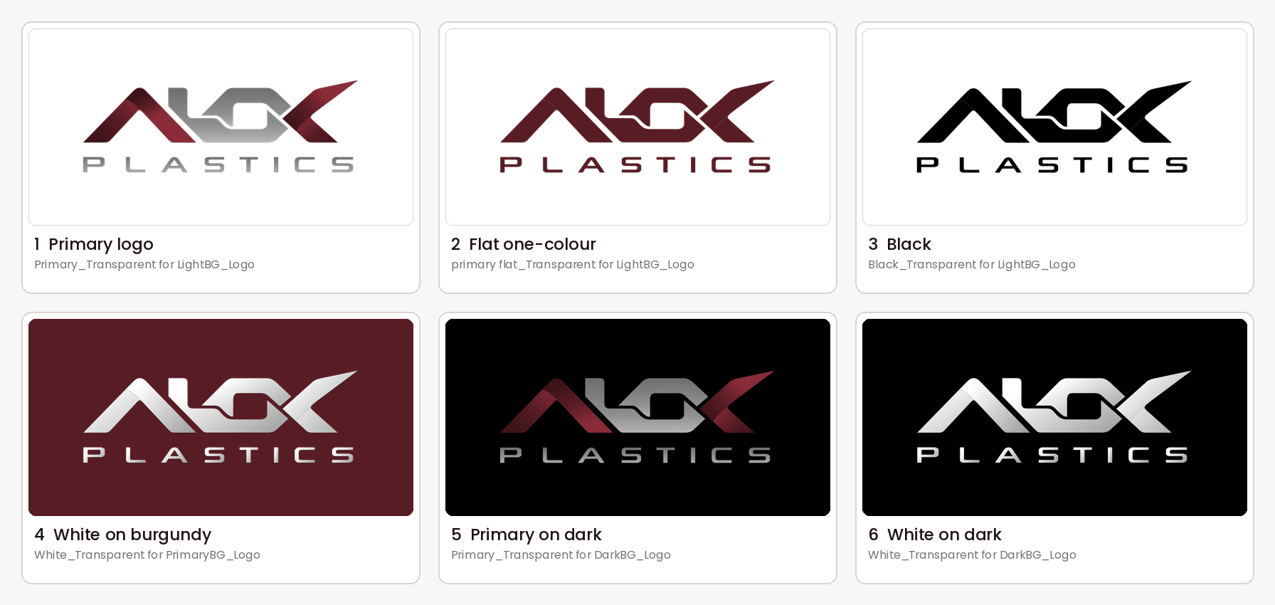
Logos 1 to 3 are for light backgrounds, 4 for burgundy, 5 and 6 for dark backgrounds. The file names shown are exact.

03 Map of the folder
Folder | What is inside | Use it for
(top level) | 4 PNG logos: quick copies of the most-used versions | Everyday use without searching
01_Logo_Master_Files | Original artwork: .ai (Illustrator), .cdr (CorelDRAW, plus a zipped copy), vector .pdf and .svg | Designers, printers and sign makers. Work on copies, never on the originals
02_Primary_Logos | The full-colour logo: 8 PNG versions, plus Primary_PDF and Primary_SVG sub-folders | Documents, social media, website
03_Transparent_Logos | Only the no-background versions (primary, flat, black, white), plus Transparent_SVG | Placing the logo on colours, photos, slides and Canva
04_Monochrome_Logos | One-colour black and white versions, plus Monochrome_PDF and Monochrome_SVG | One-colour printing, stamps, embossing
05_Icon_Only | Square profile-picture (DP) versions in 6 sizes (16 to 1080 px) and 5 styles, plus Icon_SVG | WhatsApp, Instagram and LinkedIn pictures, browser-tab and app icons
06 | There is no folder 06. The numbering goes from 05 to 07 | —
07_Wallpapers | 4 JPG wallpapers: desktop and phone, light and dark | Company computers and phones
08_Linkedin Cover | LinkedIn company-page cover, 4200 × 700 px | LinkedIn page
09_Documentation | These guides | Learning how to use the brand

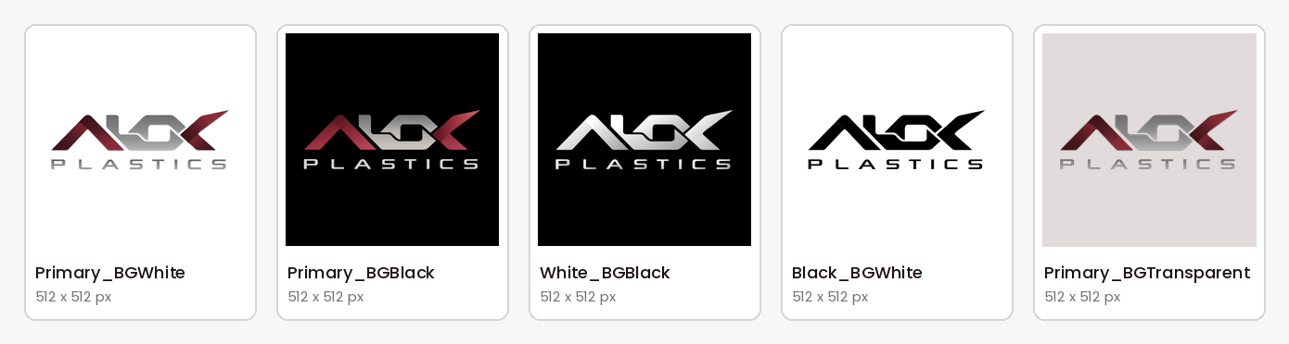
Inside 05_Icon_Only: square DP versions (512 × 512 px shown).
GOOD TO KNOW
The files in 05_Icon_Only show the full logo centred in a square. They are not a separate symbol. At 16 to 48 px the word PLASTICS is too small to read.

04 How the files are named
Every logo file follows one pattern: Style_Background_Logo.format
WORKED EXAMPLE
Primary_Transparent for LightBG_Logo.png
Primary (full-colour logo) + Transparent for LightBG (no background, made for light backgrounds) + Logo + .png (file type)

Word in the file name | What it means
Primary | The main full-colour logo: burgundy and silver-grey
primary flat | One flat burgundy colour, no gradients. Good for simple printing
Black | Solid black, one colour
White | The white (white-to-silver) logo for burgundy or dark backgrounds
LightBG | Made for white or light backgrounds
DarkBG | Made for black or very dark backgrounds
PrimaryBG | Made for the brand burgundy background (#581C25)
Transparent for … | No background colour at all. Sits cleanly on any surface of that type
No word “Transparent” | The file comes with its own background square (white, black or burgundy)
DP | Display picture: a square for profile pictures
512_512 | Size in pixels (width_height). Sizes available: 16, 32, 48, 180, 512, 1080
BGWhite, BGBlack, BGTransparent | Background of the square picture
_PDF, _SVG folders | The same logo as vector files. Only the ending changes

Icon files use a second pattern: Size_Size_DP_Style_Background.png, for example 512_512_DP_Primary_BGWhite.png. Suggested sizes: 16, 32 and 48 px for browser tabs and small icons, 180 px for phone home screens, 512 px for WhatsApp and LinkedIn pictures, 1080 px for Instagram and sharper uses.

05 Which logo for which job
Job | Use this logo (exact file) | Why
Website and digital
Website header on a light page | Primary_SVG/Primary_Transparent for LightBG_Logo.svg (in 02_Primary_Logos) | Sharp at every size
Website footer or burgundy banner | Primary_SVG/White_Transparent for PrimaryBG_Logo.svg (in 02_Primary_Logos) | Readable on burgundy
Browser tab and app icon | 32_32_DP_Primary_BGWhite.png or 48_48_DP_Primary_BGWhite.png (in 05_Icon_Only) | Ready-made small squares
Email signature, Word, PowerPoint | Primary_Transparent for LightBG_Logo.png (in 02_Primary_Logos) | No white box; works in every Office app
Slide with a burgundy or dark background | White_Transparent for PrimaryBG_Logo.png or Primary_Transparent for DarkBG_Logo.png | Matches the background
Print
Letterhead, invoice, quotation, catalogue pages | Primary_Transparent for LightBG_Logo.png (3000 px, high resolution) | Clean on white paper
Business card front (white) and back (burgundy) | Front: Primary_Transparent for LightBG_Logo.png. Back: White_Transparent for PrimaryBG_Logo.png | Right version for each side
Catalogue or brochure cover in burgundy | White_Transparent for PrimaryBG_Logo.png | White stands out on burgundy
Product label, box, sticker (simple printing) | primary flat_Transparent for LightBG_Logo.png or Black_Transparent for LightBG_Logo.png | No gradients, so easy to print
Stamp, newspaper ad, engraving, embossing | Black_Transparent for LightBG_Logo.png (03 or 04) or Monochrome_PDF/Black_LightBG_Logo.pdf | Pure one colour
Flex, hoarding, shop board, vehicle | Vector files in 01_Logo_Master_Files: Alok_Plastics_Logo_Vector_pdf.pdf, Alok_Plastics_Logo_Vector.svg, or .ai / .cdr for the sign maker | Never enlarge a PNG
Uniform or bag printing | primary flat_… on light fabric, White_… on dark fabric. Confirm with the printer | Gradients are hard to reproduce
Social media and profile
WhatsApp Business, Instagram, Facebook, LinkedIn picture | 512_512_DP_Primary_BGWhite.png (or 1080_1080_DP_Primary_BGWhite.png for extra sharpness) | Square, centred, fits round frames
Post with a light design | Primary_Transparent for LightBG_Logo.png | Full colour on light
Post with a burgundy design | White_Transparent for PrimaryBG_Logo.png | White on burgundy
Post on a dark photo | Primary_Transparent for DarkBG_Logo.png. On a busy photo use White_Transparent for DarkBG_Logo.png | White is the most readable
LinkedIn company cover | 08_Linkedin Cover/Company_Page_LinkedIn_Cover Page_Alok_Plastics.jpg | Ready to upload
Computer or phone wallpaper | Pick light or dark from 07_Wallpapers | Four ready files

06 Which file type
Type | Use it for
PNG | Screens, Word, PowerPoint, Canva, WhatsApp. The everyday choice
SVG | Websites and designers. Stays sharp at any size
PDF | Printers and vector printing
AI / CDR | Source files for designers (Illustrator, CorelDRAW). Edit copies only
JPG | Wallpapers and the LinkedIn cover, never for logos

07 Do and don’t
Do | Don’t
Pick the logo by looking at the background | Put the full-colour logo on burgundy: the burgundy parts disappear
Use Transparent files on colours, photos and slides | Use a LightBG file on a coloured page: a white box appears
Keep clear space around the logo, at least the height of the letter A in ALOK | Stretch, squeeze, rotate, recolour or add shadows and outlines
Keep it at least 25 mm wide in print or 120 px on screen | Enlarge a small PNG or icon. Use vector files instead
Work on copies of the master files | Redraw or retype the logo

08 Quick fixes
Problem | Usual cause | Fix
White box around the logo | A LightBG file was used on a coloured page | Switch to the Transparent file
Logo disappears on burgundy | The full-colour logo was used | Use White_Transparent for PrimaryBG_Logo.png
Logo looks blurry in print | A small PNG was enlarged | Use the PDF or SVG from 01_Logo_Master_Files
PLASTICS is unreadable | Logo is too small | Make it larger or use a DP square picture
Colours look different in print | Screen and print colours differ | Ask the printer for a proof before the full run

CREATED BY
Manhar Creatives
We Design, We Build, You Grow.
Digital Solutions · Web Development · Business Growth
www.manharcreatives.com

