BRAND COLOUR SYSTEM


Brand Colour Guide
Colour codes, roles and usage rules for designers, staff and AI tools
DOCUMENT VERSION | 1.0
PREPARED FOR | Alok Plastics
PREPARED BY | Manhar Creatives
PRIMARY COLOUR | Alok Burgundy #581C25
THEME | Light
DATE OF ISSUE | 1 October 2026

This guide gives the approved colours of Alok Plastics, their exact codes and where each one goes. It is written for designers, staff, printers and AI tools. If you only read one thing, read the box below.
QUICK READ FOR DESIGNERS AND AI TOOLS
Primary colour (only one): Alok Burgundy #581C25
Secondary colour: Metal Grey #737171. Theme: light. Main canvas is Soft White #F8F7F7; cards and forms are White #FFFFFF.
Text: headings Ink #1E1115, body text #4A3D40. Never use pure black #000000 for text.
Balance: about 61% light surfaces, 28% burgundy, 11% grey, text and photos. Burgundy is used in a few strong blocks, not everywhere.
Buttons: main button burgundy with white text. WhatsApp button green #0F7B6C. Green is for WhatsApp only (plus form status messages).
Logo: colour logo on light, white logo on burgundy, bright logo on dark. See the Brand Folder Guide (document 01).

01 The colours at a glance

Primary and secondary
 | Name | HEX | RGB | Use it for
 | Alok Burgundy PRIMARY | #581C25 | 88, 28, 37 | The one primary brand colour: logo, heading accents, buttons, banners, footer
 | Metal Grey SECONDARY | #737171 | 115, 113, 113 | The second colour of the logo: icons, thin lines, captions, secondary text

Light surfaces (the light theme)
 | Name | HEX | RGB | Use it for
 | White | #FFFFFF | 255, 255, 255 | Cards, forms, product photo backgrounds, print paper
 | Soft White MAIN CANVAS | #F8F7F7 | 248, 247, 247 | Main page background (canvas) of every light layout
 | Light Grey | #F1EEEF | 241, 238, 239 | Alternate sections, table stripes, quiet panels
 | Mist Grey | #ECE7E8 | 236, 231, 232 | Website header bar, input backgrounds
 | Cloud Grey | #E1DBDC | 225, 219, 220 | Soft borders and dividers
 | Warm Silver | #D8D4D0 | 216, 212, 208 | Fine lines, card borders, the silver in the logo
 | Silver Grey | #909090 | 144, 144, 144 | Decoration only: icons and ornaments. Too light for text

Burgundy support shades
 | Name | HEX | RGB | Use it for
 | Night Burgundy | #2E0A0F | 46, 10, 15 | Very dark panels and deep shadows (rare)
 | Deep Burgundy | #3E131A | 62, 19, 26 | Button hover, gradient end, dark footer strip
 | Bright Burgundy | #8A2C38 | 138, 44, 56 | Link hover, highlights, charts
 | Rose | #C35A61 | 195, 90, 97 | Accent on dark backgrounds, small highlights
 | Pale Rose | #E3B5B8 | 227, 181, 184 | Text accent on burgundy, soft outlines
 | Soft Pink | #F3DFE0 | 243, 223, 224 | Tags, hover panels, text on burgundy
 | Blush | #FAF1F1 | 250, 241, 241 | Callout boxes and note panels

Text and functional colours
 | Name | HEX | RGB | Use it for
 | Ink | #1E1115 | 30, 17, 21 | Headings and key text (warm near-black)
 | Body Text | #4A3D40 | 74, 61, 64 | Paragraphs and normal text
 | Muted Text | #6B5F62 | 107, 95, 98 | Helper text, placeholders, footnotes
 | WhatsApp Green | #0F7B6C | 15, 123, 108 | WhatsApp buttons and links only
 | Success | #2E7D32 | 46, 125, 50 | Form success messages only
 | Warning | #8A5A00 | 138, 90, 0 | Form warnings only
 | Error | #B3261E | 179, 38, 30 | Form errors only
 | Info | #1F5F8B | 31, 95, 139 | Notices only

HEX and RGB values come from the approved logo files and the approved website design. Printed colours can look slightly different from a screen, so always check a printed proof before a large print run.

02 How much of each colour
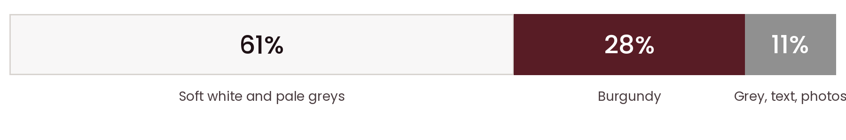
Approximate share of each colour in the approved website design.
- Light first. Every page starts on Soft White or White.
- Burgundy in blocks. Use it for strong blocks: category cards, the enquiry banner, the footer, buttons and small accents. Inner pages use a burgundy banner and footer only.
- One burgundy per area. Do not mix many burgundy shades inside one block.
- Grey is the helper. Metal Grey for lines, icons and captions. It never replaces burgundy as the main colour.
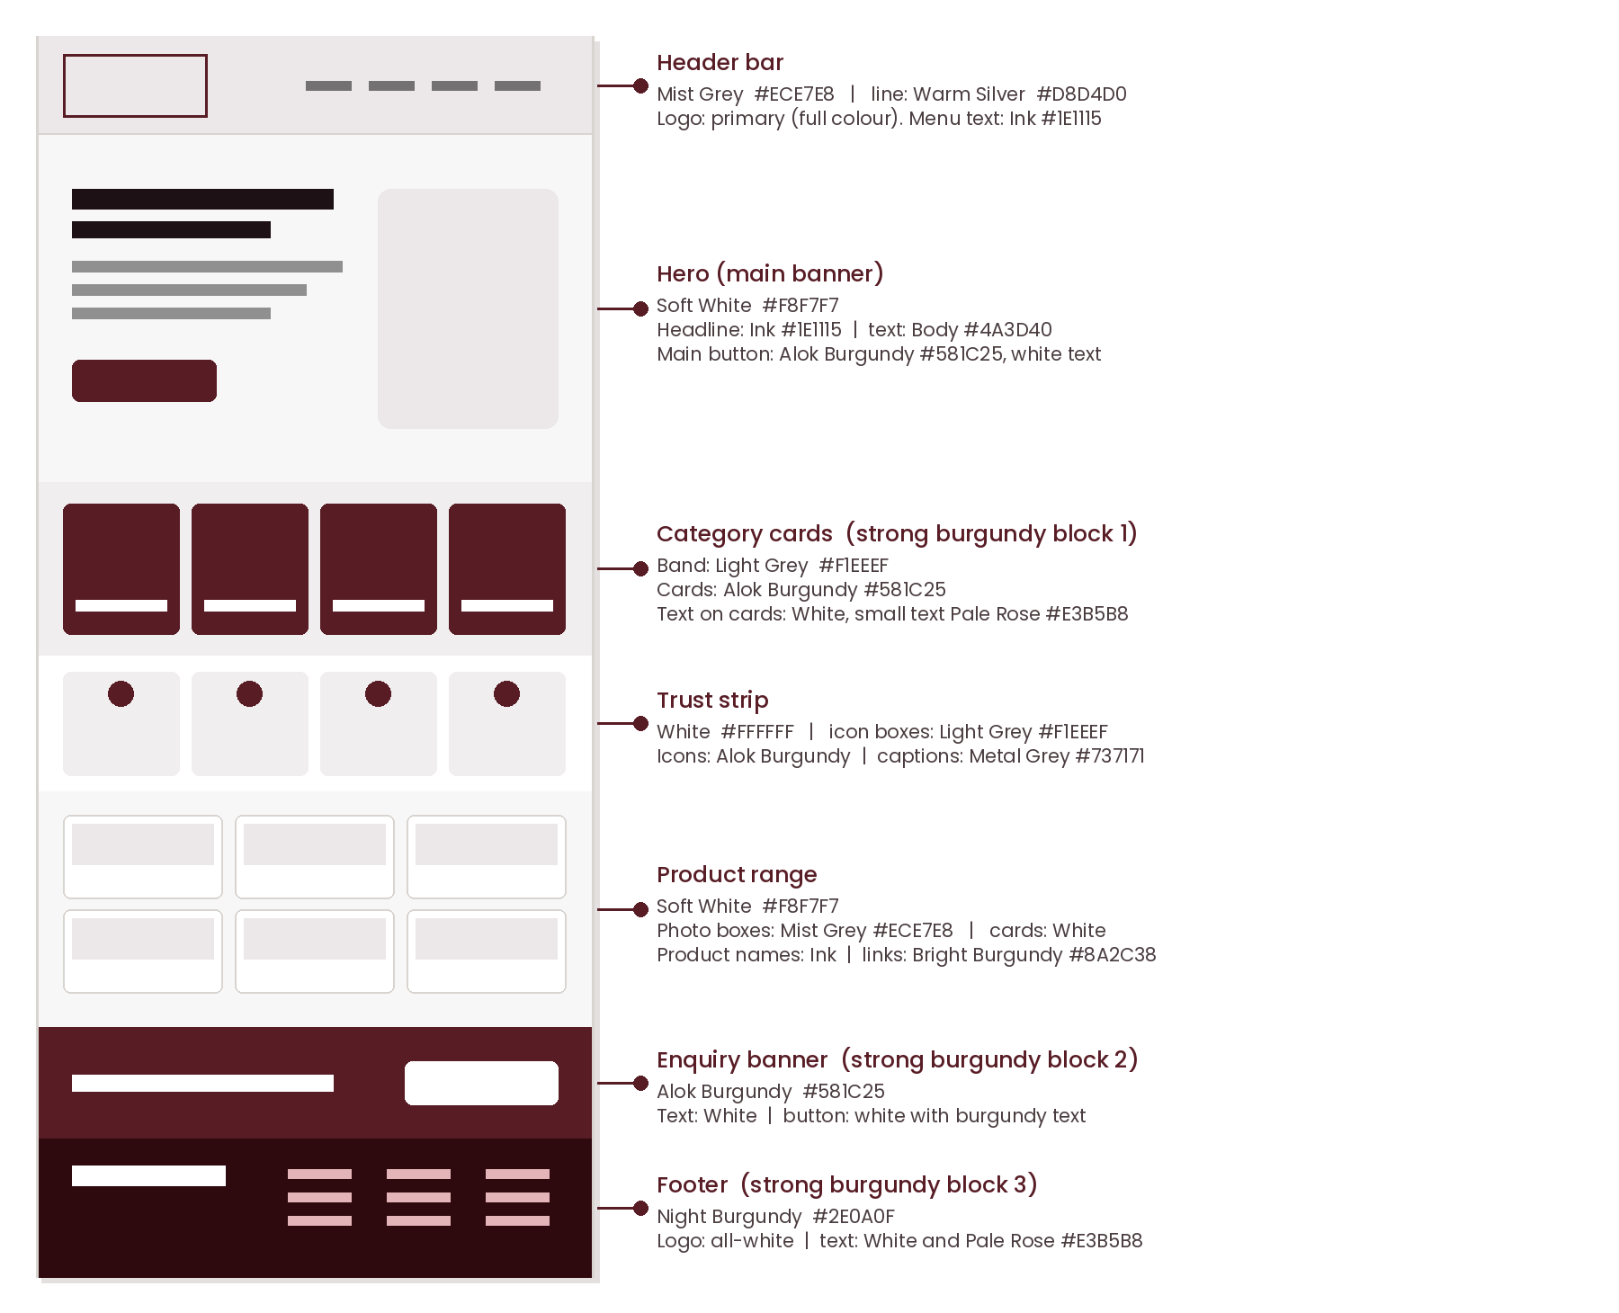
Website section map with the colour of each section.

03 Which colour goes where
Find the job in the first column. Background, text and accent colours follow.
Where | Background | Text | Accent / logo
Website
Page canvas | Soft White #F8F7F7 | Ink #1E1115, body #4A3D40 | Colour logo
Header | Mist Grey #ECE7E8, line #D8D4D0 | Ink #1E1115 | Colour logo
Category cards, enquiry banner, footer | Alok Burgundy #581C25 | White #FFFFFF | White logo, Pale Rose #E3B5B8 for small text
Product cards | White #FFFFFF, border #D8D4D0 | Ink for names, body for details | Burgundy for price and links
Main button | Burgundy gradient #581C25 to #3E131A (or flat #581C25) | White | Hover: Deep Burgundy #3E131A
Second button | White, border #581C25 | Burgundy #581C25 | Hover: Blush #FAF1F1
WhatsApp button | WhatsApp Green #0F7B6C | White | Only for WhatsApp
Links | — | Burgundy #581C25 | Hover: Bright #8A2C38
Form field | White, border #D8D4D0 | Ink; placeholder #6B5F62 | Focus border #581C25
Tag or badge | Blush #FAF1F1 | Burgundy #581C25 | For product category tags
Social media
Light post | Soft White #F8F7F7 | Ink #1E1115 | Burgundy band, colour logo
Burgundy post | Alok Burgundy #581C25 | White | Pale Rose #E3B5B8, white logo
Dark product photo post | Product photo | White | Bright logo for dark backgrounds
LinkedIn cover, profile picture | Ready-made files | — | Use the files from the master folder
Print and office
Catalogue pages | White #FFFFFF | Ink headings, body #4A3D40 | Table header burgundy with white text; stripes #F8F7F7
Catalogue cover, poster, flyer | White or Alok Burgundy | Ink on white; White on burgundy | Matching logo version
Letterhead, invoice, quotation | White paper | Ink #1E1115 | Thin burgundy line, colour logo
Business card | Front white, back burgundy | Ink / White | Colour logo / white logo
Product label, sticker, box | White | Ink or black | Flat one-colour logo; one colour is cheaper to print
Signboard, banner, vehicle | Burgundy panel or white panel | White / Ink | White logo / colour logo
Digital everyday
Presentation | Title slide burgundy; content slides Soft White | White / Ink | Matching logo
Email signature, WhatsApp Business | White | Name in Ink, role in Metal Grey | Links in burgundy

04 Readable colour pairs
Contrast ratio is how easy text is to read. 4.5 or more is good for normal text; 3 or more is fine for large text only.
Text on background | Ratio | Result | Use
Ink #1E1115 on Soft White | 17.1 | Excellent | Headings
Body #4A3D40 on Soft White | 9.7 | Excellent | Paragraphs
Burgundy #581C25 on Soft White | 12.2 | Excellent | Links, highlights
White on Burgundy | 13.1 | Excellent | Buttons, banners, footer
Pale Rose #E3B5B8 on Burgundy | 7.2 | Good | Small accents on burgundy
Muted #6B5F62 on Soft White | 5.7 | Good | Helper text
Metal Grey #737171 on Soft White | 4.5 | Minimum pass | Captions, not long text
White on WhatsApp Green #0F7B6C | 5.2 | Good | WhatsApp button
Silver Grey #909090 on Soft White | 3.0 | Too low | Never for text; decoration only
Rose #C35A61 on Night Burgundy | 4.3 | Large text only | Big headings on very dark panels

05 Logo on colour
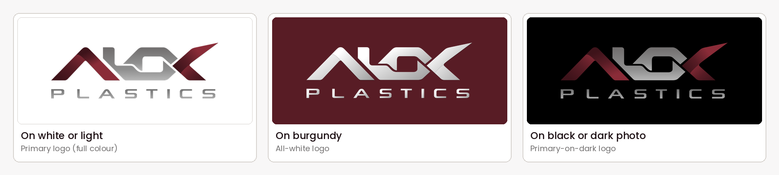
Choose the logo by background. Exact files are listed in the Brand Folder Guide (document 01).
- Soft White, White, light greys: colour logo.
- Alok Burgundy: white logo. The colour logo disappears here.
- Black or dark photos: bright logo for dark backgrounds.
- Any other colour: do not place the logo on it. Use a white panel.

06 Do and don’t
Do | Don’t
Start every layout on Soft White or White | Fill a whole page with burgundy
Use burgundy for buttons, banners and key blocks | Use many burgundy shades in one block
Use Ink and Body Text for text | Use pure black #000000 for text
Use Metal Grey for quiet details | Use grey for headlines or buttons
Keep green for WhatsApp only | Add blue, orange or green as brand colours
Copy the HEX codes exactly | Pick a “similar” colour by eye
Check print colours with a proof | Assume screen and print look the same

07 Instructions for AI tools
Give an AI tool this folder and this page. Or paste the brief below into the prompt.
COPY-PASTE BRIEF
Brand: Alok Plastics (B2B spare parts for water coolers, display counters and deep freezers). Theme: LIGHT.
Primary colour (only one): Alok Burgundy #581C25. Secondary: Metal Grey #737171.
Backgrounds: Soft White #F8F7F7, White #FFFFFF, Light Grey #F1EEEF, Mist Grey #ECE7E8. Text: Ink #1E1115 for headings, #4A3D40 for body. Never pure black.
Support: Deep Burgundy #3E131A, Bright Burgundy #8A2C38, Pale Rose #E3B5B8, Soft Pink #F3DFE0, Blush #FAF1F1, Warm Silver #D8D4D0.
Balance: about 61% light surfaces, 28% burgundy, 11% grey, text and photos. Burgundy in a few strong blocks only.
Logo: colour logo on light; white logo on burgundy; bright logo on dark. Pick the exact file from the master folder. Never recolour, stretch or redraw the logo.
Do not invent specifications, certifications or claims. Use only verified catalogue information.

Colour tokens (for developers)
--brand-primary: #581C25; --brand-secondary: #737171;
--canvas: #F8F7F7; --surface: #FFFFFF; --surface-alt: #F1EEEF; --header: #ECE7E8;
--border: #D8D4D0; --border-soft: #E1DBDC; --text-heading: #1E1115; --text-body: #4A3D40; --text-muted: #6B5F62;
--burgundy-deep: #3E131A; --burgundy-bright: #8A2C38; --burgundy-night: #2E0A0F;
--rose: #C35A61; --rose-pale: #E3B5B8; --pink-soft: #F3DFE0; --blush: #FAF1F1;
--whatsapp: #0F7B6C; --success: #2E7D32; --warning: #8A5A00; --error: #B3261E; --info: #1F5F8B;

CREATED BY
Manhar Creatives
We Design, We Build, You Grow.
Digital Solutions · Web Development · Business Growth
www.manharcreatives.com

