BRAND PHILOSOPHY
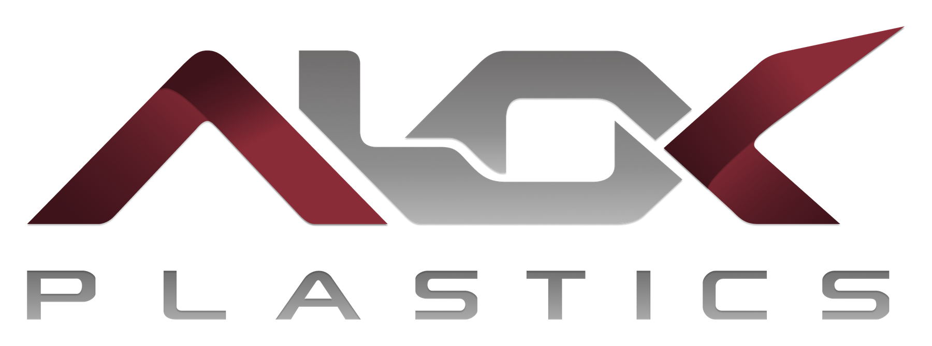

Brand Story &
Logo Philosophy
The idea, meaning and logic behind the Alok Plastics identity
DOCUMENT VERSION | 1.0
PREPARED FOR | Alok Plastics
PREPARED BY | Manhar Creatives
COVERS | Name, logo, colour theme and tagline
READ TIME | About 15 minutes (skim in 3)
DATE OF ISSUE | 1 October 2026

This document explains why the Alok Plastics identity looks and sounds the way it does. Use it to brief a designer, train new staff, write a company profile, or answer a customer who asks: “What does your logo mean?”
THE BRAND IN ONE MINUTE
Alok (आलोक) means light. The logo turns that idea into a strong, engineered mark: burgundy ribbons frame a silver-grey metal core, and every surface catches the light like polished metal.
The colours say strength and precision. The Sanskrit line भारते शिल्पितम्, विश्वय निर्मितम् says crafted in Bharat, made for the world.
Together they present Alok Plastics as an Indian manufacturer of water cooler, display counter and deep freezer spare parts, designed to stand beside international suppliers.

Element | The idea | Shown by
Name | Light, clarity, trust | ALOK (आलोक), a Sanskrit word
Logo | Strength, precision, connection, upward movement | Burgundy ribbons around a silver-grey core
Colour | Depth, seriousness, engineering | Alok Burgundy and Metal Grey on a light canvas
Tagline | Indian craft, global ambition | Sanskrit in Devanagari script

01 The foundation: who Alok Plastics is
Alok Plastics supplies spare parts and components for water coolers, display counters and deep freezers, from Chandigarh. The company’s catalogue includes float valves, F-bushes, connecting bushes, ventilation jalli, adjustable leg inserts, waste pipes, door locks, hinges, gaskets and push cocks, in materials such as nylon, HDPE, PPCP and brass.
These parts are small and rarely noticed, yet every machine depends on them. A cooler needs its float valve to control the water level; a sliding door needs its bush to move smoothly. That is the heart of the brand.
BRAND IDEA
The small parts that keep big machines running. Alok means light, and the brand’s job is to bring these essential parts into the light: visible, trusted and easy to choose.

What the identity has to express
Quality | What it means for Alok | How the identity shows it
Professional | Clear, organised, businesslike | Clean wordmark, light layouts, one set of colour rules
Reliable | A supplier buyers can trust again and again | Deep burgundy; a wide, low logo shape that feels stable
Industrial | Made for machines, workshops and factories | Metallic grey, squared-cut letters, folded-sheet forms
Modern | Current, not old-fashioned | Sharp diagonals, light gradients, generous white space
Technically credible | Precise and exact | Exact colour codes, engineered lettering
Clean | Easy to read, no clutter | Light theme on a soft white canvas
Scalable | Works from a tiny icon to a large signboard | Logo versions and vector files; a system that can grow
B2B-ready | Speaks to dealers, distributors and equipment businesses | Serious palette and a practical tone

02 The name: ALOK
Alok (आलोक) comes from Sanskrit and means light, brightness, a clear view. It is also a familiar name in India, so Indian customers recognise it at once, while four letters and two syllables (A-LOK) make it easy for anyone in the world to say.
Quality of the name | Why it helps the business
Meaning | Light stands for clarity, honesty and guidance: what a buyer wants from a supplier. In Indian culture light is also a symbol of knowledge and new beginnings.
Sound and length | Short, strong, easy to say in Hindi, Gujarati, English and beyond. Easy to remember and to type.
First letter A | Appears first in alphabetical lists, directories and catalogues.
Indian roots | Sanskrit origin, written in Devanagari as आलोक.
Brand + descriptor | ALOK is the brand. PLASTICS tells customers the field. One word carries the identity, the other gives the explanation.
Light as a theme | The name is the reason the brand theme is light and the logo catches light on its surfaces.

How to write and say it
- In running text write Alok Plastics. Use ALOK PLASTICS in capitals only where it matches the logo.
- Always Plastics, never “Alok Plastic”. Say it as “AA-lok”.

03 The logo, piece by piece
The logo is a wordmark: the letters themselves carry the symbol. There is no droplet, snowflake or gear. Those images are common in this sector, and a mark built from letters is easier to remember and to reproduce.
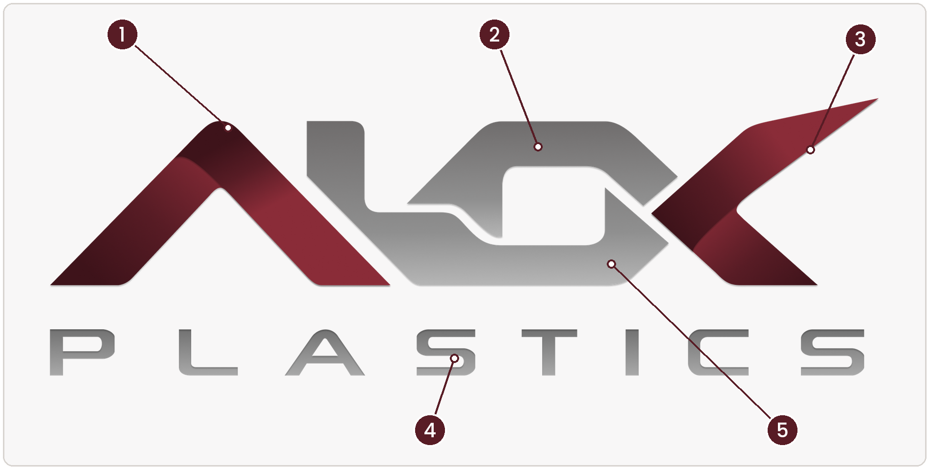
The five parts of the Alok Plastics logo.
# | Part | What you see | What it stands for
1 | The A | A burgundy ribbon folded into a peak | Rising and growth; a roof that protects; the folded-sheet look of formed material, which links to making things
2 | The L and O | A silver-grey block where two letters lock into one shape, like a chain link or bracket | Connection and strength. The catalogue is full of parts that join and hold: connecting bushes, brackets, hinges
3 | The K | A burgundy arm sweeping up and to the right to a sharp point | Forward movement and reach: the brand looks outward
4 | PLASTICS | Wide-spaced letters with squared, cut corners in metallic grey | Stability and precision. Technical lettering with a calm, corporate, international feel
5 | The light effect | Dark-to-light shading across every shape | Light catching polished metal or a moulded surface: the name Alok made visible, with a premium, three-dimensional look

The structure as a whole
- Balance. Burgundy, grey, burgundy: two strong outer letters frame a steady core.
- Direction. Both outer letters point up and to the right: growth and forward movement.
- Shape. Wide and low, so it feels stable and grounded, and fits headers, labels and stamps easily.
- Two materials. Burgundy is the brand, grey is the metal. The logo reads as identity and engineering working together.

Why this logo fits Alok Plastics
Design choice | Logic | Benefit
Letter-built wordmark | Name and symbol in one | Fewer things to remember; nothing to explain
Two-colour structure | Burgundy for brand, grey for material | Recognisable even when small or in one colour
Heavy strokes, sharp angles | An industrial, engineered feel | Stays readable when reduced
Horizontal shape | Matches headers, letterheads and labels | Easy to place everywhere
Gradient and flat versions | Premium on screen, practical in print | One identity for websites, labels and stamps
Versions for light, burgundy and dark backgrounds | The logo stays readable on any surface | Consistent look in every situation

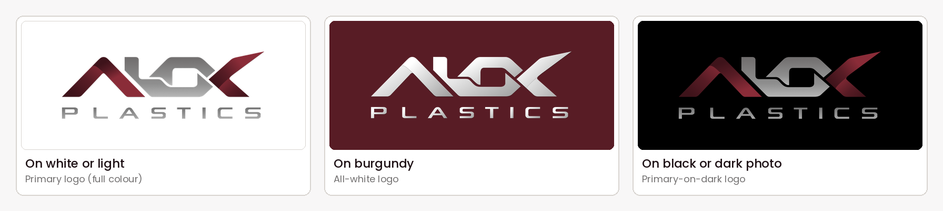
The three main versions. The Brand Folder Guide (document 01) lists the exact files.

04 The colour theme: the philosophy
Colour was chosen to say strength, precision and clarity, and to look different from the blues and greens that usually stand for plastic, water and cooling.
 | Colour | What it says | Role
 | Alok Burgundy #581C25 | Depth, strength, seriousness, a premium feel. In Indian life deep maroon and wine shades carry richness and tradition; here they are used in a modern, restrained way | The one primary brand colour
 | Metal Grey #737171 | Metal, machinery, precision, neutrality | The logo’s second colour; lines, icons, captions
 | Soft White #F8F7F7 | Clarity and space: the “light” of Alok. Products and text are easy to see | The light canvas of the brand
 | Ink #1E1115 | Strong, readable text, warmer than pure black | Headings and key text

A light theme, used like a signature
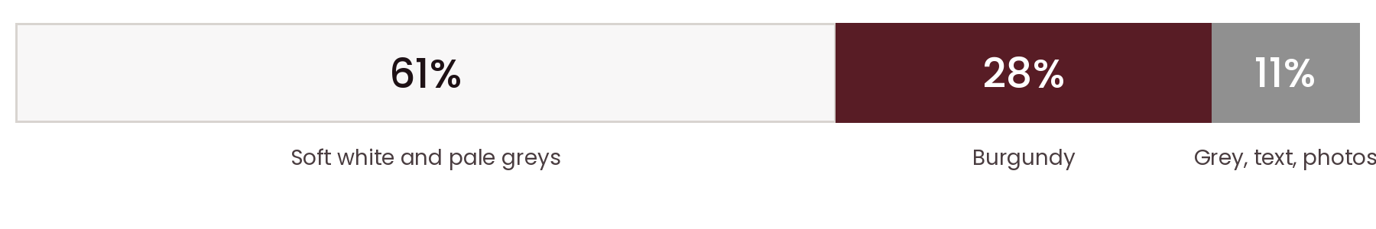
Approximate share of each colour in the approved website design.
- Light is Alok. A light canvas is the brand name in colour form.
- Easy to read. Buyers read sizes and materials on phones, often in workshops and shops. Light backgrounds keep text and photos clear.
- Burgundy stands out. Because it is used in a few strong blocks, buttons and banners get attention.
The full colour codes and rules are in the Brand Colour Guide (document 03).

05 The tagline
भारते शिल्पितम्, विश्वय निर्मितम् means Crafted in Bharat, made for the world.
Word | Root | Meaning
भारते | Bhārat | In Bharat (India). Bharat is India’s own ancient name, which gives the line a proud, rooted tone
शिल्पितम् | śilpa | Crafted, skilfully shaped. Śilpa is the art of skilled making: care, skill and craftsmanship
विश्वय | viśva | For the world. Viśva means world, everyone, all
निर्मितम् | nirmāṇa | Built, made, constructed. Nirmāṇa is construction and manufacturing

Why the line works
- Two halves, two steps. The first half says where we come from (Bharat). The second says where we are going (the world). The line moves from local roots to global reach. On the LinkedIn cover the first half is burgundy and the second grey, echoing the logo.
- Two different verbs. शिल्पितम् speaks of craft: skill and care. निर्मितम् speaks of construction: scale and engineering. A manufacturer needs both.
- A built-in rhyme. Both halves end in “-tam”, so the line has rhythm and is easy to remember and repeat.
- Sanskrit and Devanagari. Heritage and quality in a script that stands out beside English letters.
- Identity, not a promise. It states who we are and where we aim, without claiming prices or numbers, so it is safe to use everywhere.

How to use it
- Place it below or beside the logo, never inside it.
- Use one official spelling everywhere. Burgundy and grey, as on the LinkedIn cover, for large sizes; Ink for small text.
- Where readers may not read Devanagari, add the English line beneath: “Crafted in Bharat, made for the world”.

06 How the brand represents India
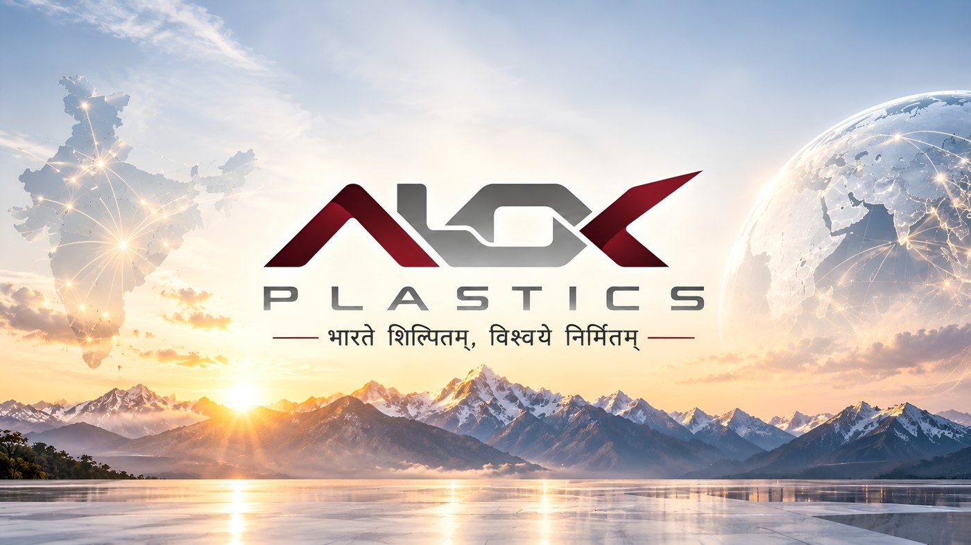
The light wallpaper brings the ideas together: India, joined by lines of light to the wider world, under a sunrise.
- Name. A Sanskrit root that sounds Indian at first hearing.
- Tagline. Sanskrit in Devanagari, using the word Bharat.
- Colour. Deep burgundy brings tradition and depth; silver-grey brings modern industry. Together: tradition and technology.
- Restraint. No flag colours and no clichés. Confident and understated, the way strong industrial brands present themselves.
- Imagery. The wallpapers show India joined to the globe, a Himalayan sunrise and, in the dark version, plastic granules becoming finished parts. The story: raw material, finished component, the world.
What this means for company culture. The identity asks for pride in craft, discipline in delivery and openness to the world. These are the values the brand is designed to express.

07 Standing on the world stage
An international buyer judges a supplier in seconds, from its logo, its website and its documents. The identity is built to pass that test.
- A global design language. Geometric, technical lettering, wide spacing and a metallic finish: the vocabulary of modern engineering brands.
- A simple, disciplined palette. Two brand colours and a light canvas, reproducible anywhere.
- Two languages, one identity. English name and PLASTICS for the world; a Sanskrit tagline for character.
- A complete system. Logo versions for every background, vector files for printers, wallpapers and a LinkedIn cover in the same look.
- Room to grow. The same identity can carry a catalogue, a website, packaging, social media and later an online ordering system for dealers.

08 Personality and voice
The brand is… | In words and design
Professional | Short, clear sentences. No slang. Tidy layouts.
Reliable | Facts from the catalogue: size, material, use. No exaggeration.
Technical | Correct part names and sizes. Exact values only when verified.
Proud but humble | Mention Bharat with pride and let the quality speak.
Helpful | Every page leads to a next step: Enquire Now, WhatsApp Us, Get a Quote.

09 Say it in your own words
THE 30-SECOND ANSWER
“Alok means light. Our logo shows two burgundy ribbons holding a silver-grey core, because we make the small, strong parts that hold coolers, display counters and freezers together. Burgundy is our strength, grey is our metal, and our line, crafted in Bharat, made for the world, says where we come from and where we are going.”

Question | Short answer
What does Alok mean? | Light, brightness, a clear view (Sanskrit आलोक).
Why burgundy? | Depth, strength and seriousness, and different from the colours usually used for plastic and cooling.
Why is part of the logo grey? | Grey is the metal: precision, machinery and engineering.
What does the logo show? | The letters ALOK built like folded, connected engineered parts, catching light.
What does the tagline say? | Crafted in Bharat, made for the world.
Why is the theme light? | Light is Alok. It keeps products and text clear.
Can I change the logo colours? | No. Use the versions in the master folder (see document 01).

CREATED BY
Manhar Creatives
We Design, We Build, You Grow.
Digital Solutions · Web Development · Business Growth
www.manharcreatives.com

