|  |  |
| --- | --- |
| https://user-cdn.uef.edu.vn/newsimg/files/logo%20nhan%20dien%20TH/3.jpg | MINISTRY OF EDUCATION AND TRAINING  **UNIVERSITY OF ECONOMICS AND FINANCE** |

**PROJECT REPORT**

**Mobile Device Programing**

**TOPIC**

**Project Management**

Major: **Information Technology**

Minor: **Software engineering**

**Supervisor**: Lê Viết Linh

**215051882:Trương Hùng Dũng**

**215051241:Nguyễn Hòa Hồng Đức**

**215051286:Nguyễn Văn Mạnh**

**Class:** A02E

**Ho Chi Minh City, 2024**

MINISTRY OF EDUCATION AND TRAINING

**UNIVERSITY OF ECONOMICS AND FINANCE**

**PROJECT REPORT**

**Mobile Device Programing**

**TOPIC**

**Project Management**

**Supervisor**: Lê Viết Linh

**215051882:Trương Hùng Dũng**

**215051241:Nguyễn Hòa Hồng Đức**

**215051286:Nguyễn Văn Mạnh**

**Class:** A02E

**Ho Chi Minh City, 2024**

# TABLE OF CONTENTS

TABLE OF CONTENTS 3

TABLE CATEGORIES 3

INTRODUCTION 1

CHAPTER 1. PROJECT OVERVIEW 2

**1.** **OBJECTIVES – SCOPE OF THE TOPIC** 2

**1.1.** **Objective** 2

**1.2.** **Topic scope** 2

**1.** **PARTICIPATING MEMBERS** 2

CHAPTER 2. Database 3

**1.** **Project Table** 3

**2.** **Task Table** 4

**3.** **Option Table** 5

CHAPTER 3. FUNCTIONS 6

**1.** **LAYOUTS** 6

1.1. **Home Fragment** 6

**1.1.1.Home Fragment Layout** 6

**1.1.2.Home Fragment layout description** 8

1.2. **Search Fragment** 8

**1.2.1.Search Fragment Layout** 8

**1.2.2.Search Fragment layout description** 9

1.3. **Chart Fragment layout** 10

**1.3.1.Chart Fragment Layout** 10

**1.3.2.Chart Fragment layout description** 11

1.4. **Setting Fragment** 11

**1.4.1.Setting Fragment Layout** 11

**1.4.2.Setting Fragment layout description** 13

1.5. **Add Project Activity** 13

**1.5.1.Add Project Activity Layout** 13

**1.5.2.Add Project Activity layout description** 15

1.6. **Add Task Activity** 15

**1.6.1.Add task Activity Layout** 15

**1.6.2.Add Task Activity layout description** 16

**1.7.1.Edit project Layout Activity** 17

**1.7.2.Edit Project Activity layout description** 19

**1.8.1.Edit task Layout Activity** 19

**1.8.2.Edit Task Activity layout description** 20

**1.9.1. Project Detail Layout Activity** 21

**1.9.2.Project Detail Activity layout description** 23

CHƯƠNG 4. TESTING 24

**1.** **TEST CASE 1** 24

**2.** **TEST CASE 2** 25

**3.** **TEST CASE 3** 26

**4.** **TEST CASE 4** 26

**5.** **TEST CASE 5** 28

6. **TEST CASE 6** 29

References 29

DRAWING CATALOGUE

Figure 2.1.1 Code of Project Table in Project Management 4

Figure 2.2.1 Code of Task Table in Project Management 5

Figure 2.3.1 Code of Option Table in Project Management 6

Figure 3.1.1 Home Fragment 7

Figure 3.1.2 Search Fragment 9

Figure 3.1.3 Chart Fragment 11

Figure 3.1.4 Setting Fragment 12

Figure 3.1.5 Add Project Activity 14

Figure 3.1.6 Add Task Activity 16

Figure 3.1.7 Edit Project Activity 18

Figure 3.1.8 Edit Task Activity 20

Figure 3.1.9 Edit Task Activity Layout 22

Figure 4.1 Adding Project 24

Figure 4.2 Updating project 25

Figure 4.3 Adding task 26

Figure 4.4 Updating task 27

Figure 4.5 Deleting projects 28

Figure 4.6 Deleting task 29

## TABLE CATEGORIES

Table 2.1.1 Project table 3

Table 2.2.1 Task Table 5

Table 2.3.1 Option Table 5

# INTRODUCTION

Nowadays, Information Technology has a great influence on all aspects of social life, creating a breakthrough development. Opening up new horizons, new creative discoveries for people in all fields of finance, communication, education. Previously, information technology was not developed, not widely applied, the work related to Managing a project model... took a lot of time and wasted human resources. But when technology developed strongly and rapidly, at the same time, some subjects were introduced into teaching, the limitations were resolved promptly. Especially the subject of Mobile Device Programming. In this subject, we have learned the theory, models, methods and tools used in the process of designing and creating a mobile application. We have built this topic with the desire to help management be easy, convenient, accurate and avoid errors. Although we have tried, we certainly cannot avoid mistakes. We look forward to your support and comments. We sincerely thank you.

# CHAPTER 1. PROJECT OVERVIEW

## **OBJECTIVES – SCOPE OF THE TOPIC**

### **Objective**

Based on the knowledge taught in Mobile Device Programming, this project designs a project management system that includes the following functions: Project Management, Project Task Management, Background Music Playback, Project Progress Chart, Project Search.

### **Topic scope**

* The project is based on the scope of the subject Mobile Device Programming.
* The scope of the project includes the knowledge learned about building and developing a project on the Android platform.

## **PARTICIPATING MEMBERS**

|  |  |  |  |
| --- | --- | --- | --- |
| **Num** | **Student ID** | **Name** | **Email** |
| 1 | 215051286 | Nguyễn Văn Mạnh | manhnv21@uef.edu.vn |
| 2 | 215051882 | Trương Hùng Dũng | dungth21@uef.edu.vn |
| 3 | 215051241 | Nguyễn Hòa Hồng Đức | ducnhh21@uef.edu.vn |

# CHAPTER 2. Database

## **Project Table**

|  |  |  |  |  |
| --- | --- | --- | --- | --- |
| STT | Attribute | Type | Binding | Key |
| 1 | PROJECT_ID | TEXT | NOT NULL,UNIQUE | PRIMARY KEY |
| 2 | PROJECT_NAME | TEXT | NOT NULL |  |
| 3 | PROJECT_DESC | TEXT | NOT NULL |  |
| 4 | START_DATE | TEXT | NOT NULL |  |
| 5 | END_DATE | TEXT | NOT NULL |  |
| 6 | FINAL_DATE | TEXT | NOT NULL |  |
| 7 | STATUS | INT | NOT NULL |  |
| 8 | DEV_NAME | TEXT | NOT NULL |  |

Table 2.1.1 Project table

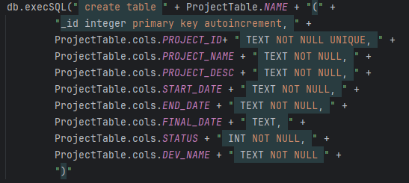

Figure 2.1.1 Code of Project Table in Project Management

## **Task Table**

|  |  |  |  |  |
| --- | --- | --- | --- | --- |
| STT | Attribute | Type | Binding | Key |
| 1 | TASK_ID | TEXT | NOT NULL,UNIQUE | PRIMARY KEY |
| 2 | PROJECT_ID | TEXT | NOT NULL | FOREIGN KEY |
| 3 | TASK_NAME | TEXT | NOT NULL |  |
| 4 | TASK_DEV | TEXT | NOT NULL |  |
| 5 | TASK_ENDDATE | TEXT | NULL |  |
| 6 | TASK_STARTDATE | TEXT | NULL |  |
| 7 | TASK_ESTIMATEDAY | INT | NOT NULL |  |

Table 2.2.1 Task Table

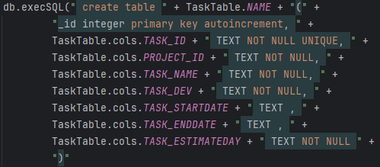

Figure 2.2.1 Code of Task Table in Project Management

## **Option Table**

|  |  |  |  |  |
| --- | --- | --- | --- | --- |
| STT | Attribute | Type | Binding | Key |
| 1 | OPTION_ID | TEXT | NOT NULL,UNIQUE | PRIMARY KEY |
| 2 | OPTION_NAME | TEXT | NOT NULL |  |
| 3 | OPTION_VALUE | INT | NOT NULL |  |

Table 2.3.1 Option Table

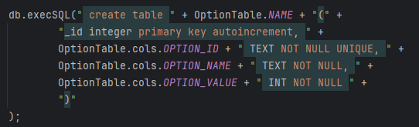

Figure 2.3.1 Code of Option Table in Project Management

# CHAPTER 3. FUNCTIONS

## **LAYOUTS**

### **Home Fragment**

#### **1.1.1.Home Fragment Layout**

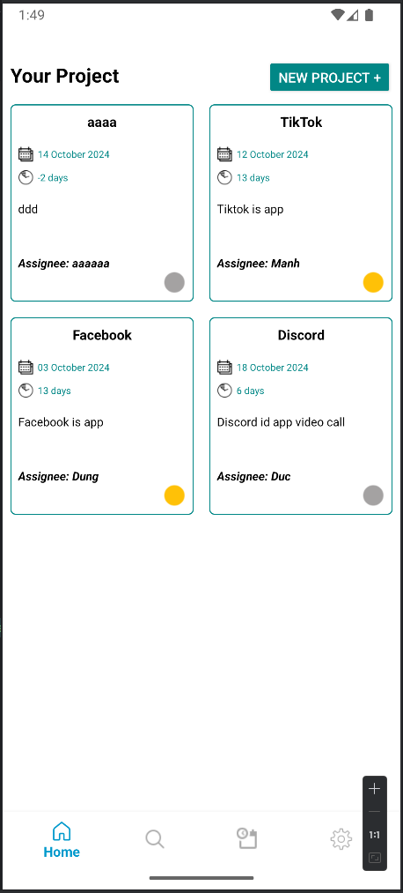

Figure 3.1.1 Home Fragment

#### **1.1.2.Home Fragment layout description**

->Layouts that show all the projects that the user has created

-> Use Recyclerview to render items (using a layout named item_project.xml). Then shoot the data from the DB into the Recyclerview Adapter to display it to the user.

-> You can Mutiple Select these items and delete them and delete the Tasks in those projects (which will be reviewed in **the Testing** section).

->Clicking on any item will show a Model bottom sheet for users to edit or view project details (will be reviewed in **the Testing** section)

### 

### **Search Fragment**

#### **1.2.1.Search Fragment Layout**

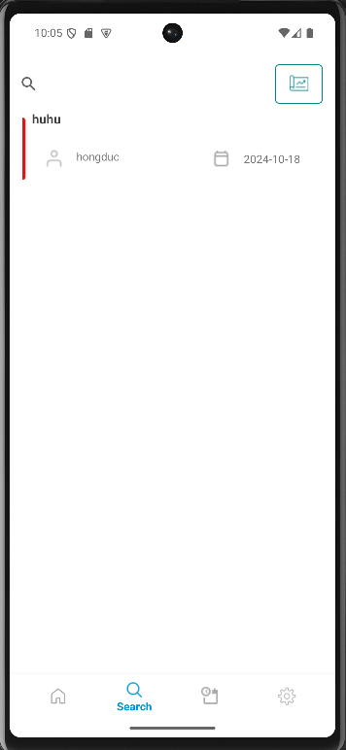

Figure 3.1.2 Search Fragment

#### **1.2.2.Search Fragment layout description**

-> is the Project list display screen based on search

-> Use Recyclerview to display items (using layout named item_searcch.xml) based on edittext user entered to display item

-> User can search project name or person name by clicking the button next to Edittext**Chart Fragment layout**

#### **1.3.1.Chart Fragment Layout**

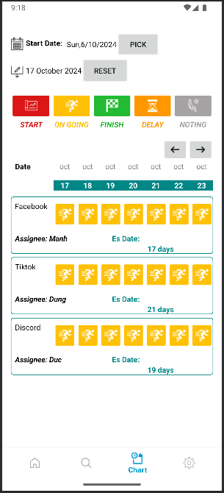

Figure 3.1.3 Chart Fragment

#### **1.3.2.Chart Fragment layout description**

-> As a roadmap display for each project

->Users can pick a date to check which projects are in the process of running for the next 7 days

-> If you don't pick the date, the app will take the current date to the next 7 days and show up the projects that are in those 7 days

-> In the 7 days that are displayed in the user layout, it is possible to view the details of each day in these 7 days, by clicking on the date the user wants to view and a **BottomSheet Modal Date Details** will appear (which will be reviewed in **the Testing** section).

**BottomSheet Modal Date Details** in this screen:

-> is the modal containing the project information and the date selected by the user

->The date gap in this Modal will be calculated from **the project's Enddate - the date the user wants to view**

-> Adjust project status to delay or Resume

-> Adjust the project status to Completed

### **Setting Fragment**

#### **1.4.1.Setting Fragment Layout**

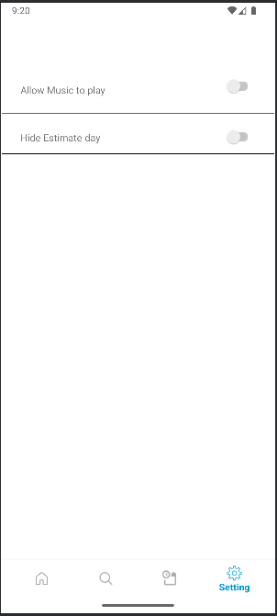

Figure 3.1.4 Setting Fragment

> It is a setting screen that allows the user to hide or display the Estimate day and turn on or turn off the music .

-> After the user clicks on the switch to turn on music, it will allow a service that is PlayMusicSevice, to launch and when turned off, it will disable the PlayMusicService.

->The user after clicking on the hidden estimatedate will update the hidden status of the estimatedate in the project detail by storing it in the databse and editing the SetVisibility. (Gone) of the TextView.

#### **1.4.2.Setting Fragment layout description**

### 

### **Add Project Activity**

#### **1.5.1.Add Project Activity Layout**

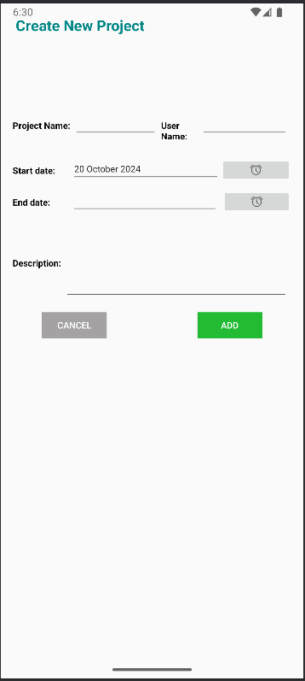

Figure 3.1.5 Add Project Activity

#### **1.5.2.Add Project Activity layout description**

->This is a screen that allows users to create a new project and save it in the database.

->Users will enter the project name and Dev name using the phone's keyboard.

-> Enter the startdate and enddate by clicking the button with the clock icon to open the DatePicker Model and select the date.

->If the user does not enter anything or is missing a field, the application will fire a message informing the user that they need to fill in all.

-> After entering all the information and clicking the "Save" button, it will proceed to save it in the database.

### **Add Task Activity**

#### **1.6.1.Add task Activity Layout**

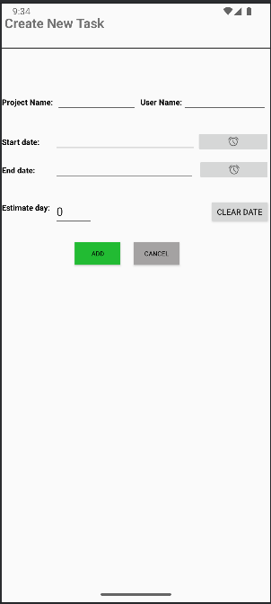

Figure 3.1.6 Add Task Activity

#### **1.6.2.Add Task Activity layout description**

->This is the Add Task screen in a previously selected project from "Edit Project Activity".

->The users will enter the Task name and Dev name using the phone's keyboard.

-> Enter the startdate and enddate by clicking the button with the clock icon to open the DatePicker Model and select the date.

In the Estimate day field, users have 2 options:

+If the user selects the Start Date and End Date fields, the Estimate day field will automatically calculate the Date Range and will not be entered by the user.

+If the user does not select the Start Date and End Date, the application will force the user to enter the Task name, Dev name, and Estimate day.

#### **1.7.1.Edit project Layout Activity**

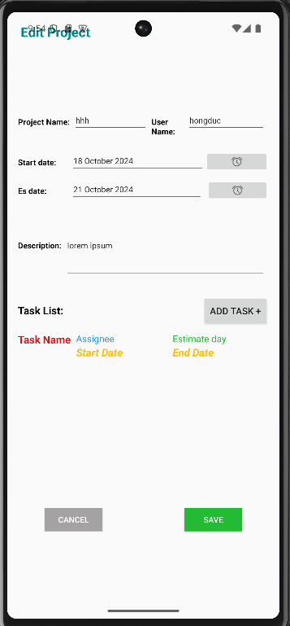

Figure 3.1.7 Edit Project Activity

#### **1.7.2.Edit Project Activity layout description**

->This is a screen where users can edit the project's information and update the project's data in the database.

->The user enters the information of the project to be edited in the Edittext and selects the start and end dates of the project by clicking on the clock icon to open a DatePicker Model and select the date.

-> Users can add tasks to the project. A project will be able to have one or more tasks, but this is not required.

->Users can write a description for the project by typing characters from the keyboard into EditText .

-> Users will be able to update the project by clicking the "Save" button to save the information to the database.

-> If you press "Cancel", you will cancel the update progress and return to the previous activity.

#### **1.8.1.Edit task Layout Activity**

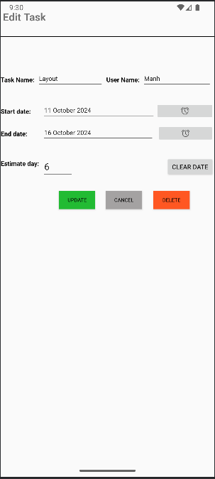

Figure 3.1.8 Edit Task Activity

#### **1.8.2.Edit Task Activity layout description**

->This is a screen where users can edit the information of the task and update that information to the database.

->The user enters the information of the task to be edited into the Edittext and selects the start and end dates of the task.

-> Users can reset the startdate, enddate, and estimate date by clicking the "CLEAR DATE" button.

-> Users will be able to update the task by clicking the "Update" button to save the information to the database.

-> If you press "Cancel", you will cancel the update progress and return to the previous Activity.

* 1. Project Detail Layout Activity

#### **1.9.1. Project Detail Layout Activity**

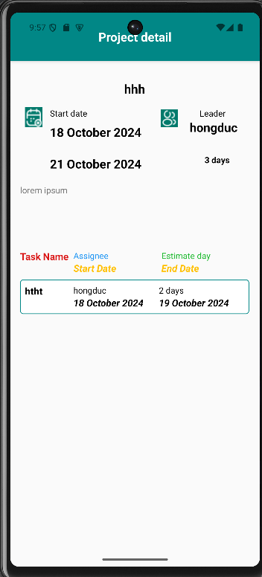

Figure 3.1.9 Edit Task Activity Layout

#### **1.9.2.Project Detail Activity layout description**

->This is the screen that displays the information of the project including: Project name, dev name, startdate, enddate, estimeday.

->In addition, display the information of the task including: Task name, dev name, startdate, enddate, estimeday.

-> This screen only retrieves information from the database and displays on the edittext and has no additional functions. (just to see).

# CHƯƠNG 4. TESTING

## **TEST CASE 1**

### 

Figure 4.1 Adding Project

## **TEST CASE 2**

## 

Figure 4.2 Updating project

## **TEST CASE 3**

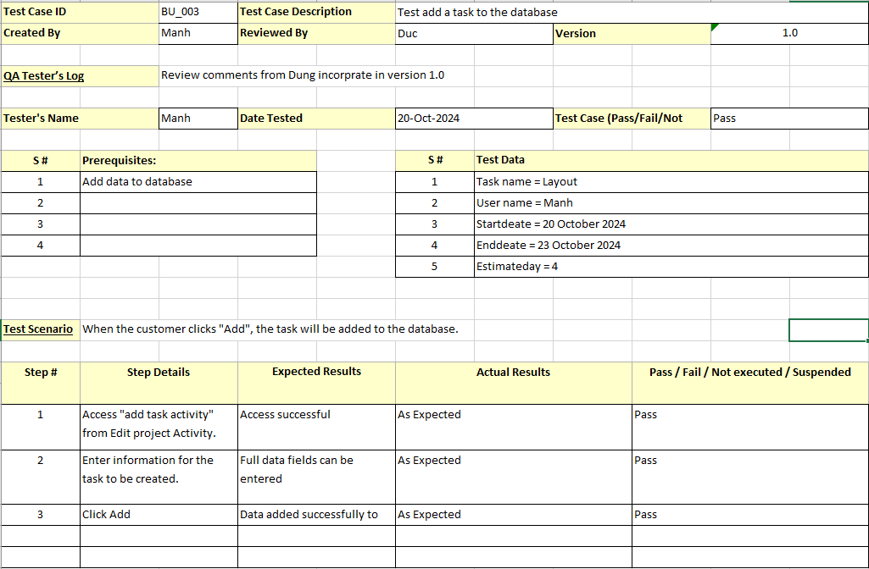

Figure 4.3 Adding task

## **TEST CASE 4**

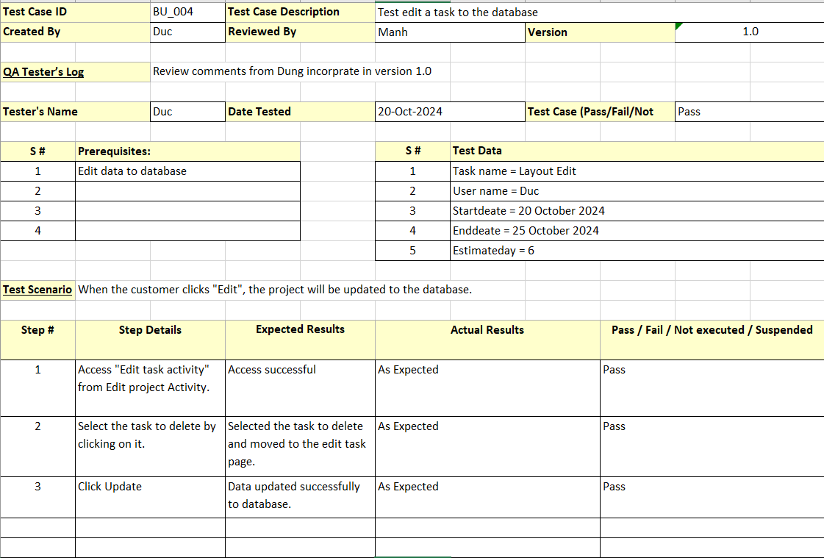

Figure 4.4 Updating task

## **TEST CASE 5**

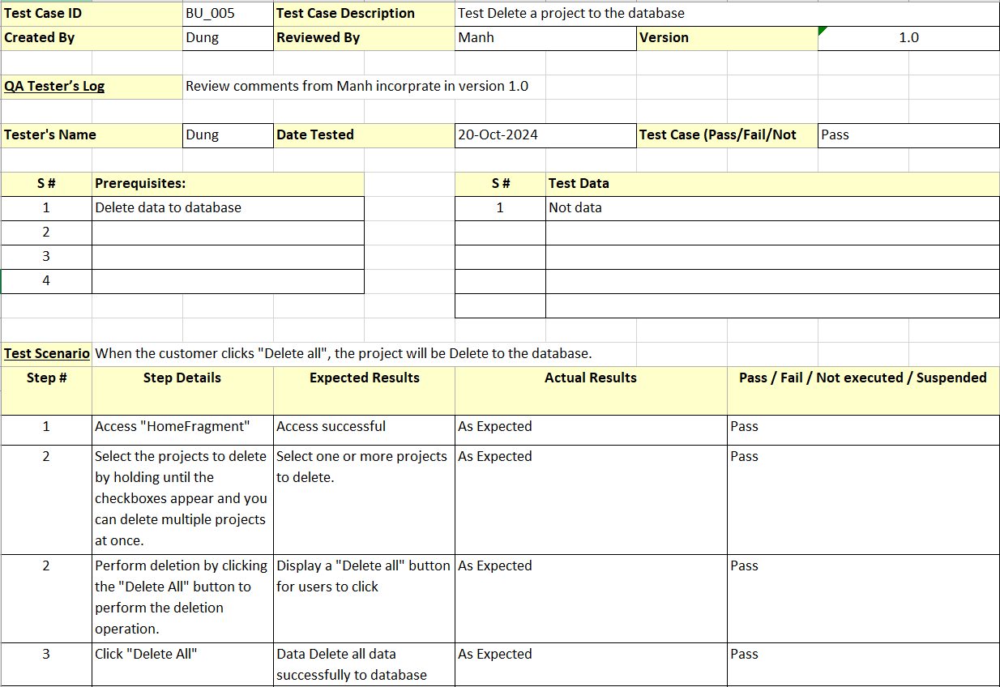

Figure 4.5 Deleting projects

## **TEST CASE 6**

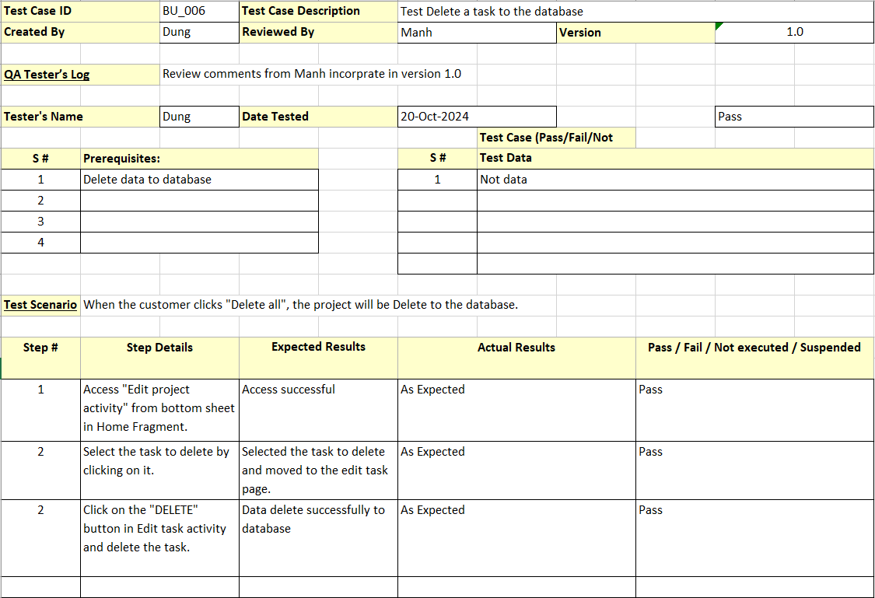

Figure 4.6 Deleting task

# References

Student book UEF:

Android Programming The Big Nerd Ranch Guide (Bill Phillips, Chris Stewart, Kristin Marsicano).