**WEEK 2**

**Combinational Logic Circuit**

**Exercise 1**

Here's the Verilog HDL RTL code for the circuit:

And here's the test bench:

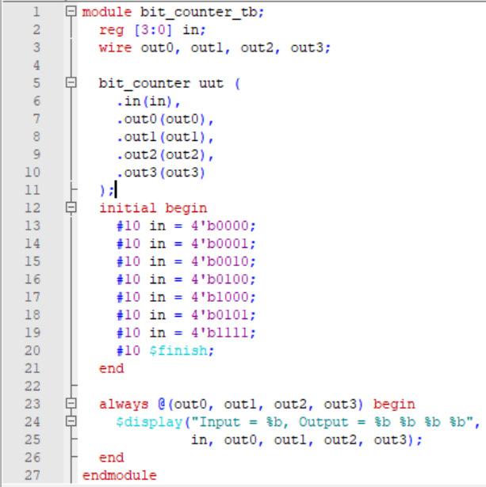

Waveform:

**Exercise 2**

To generate a 1 Hz output signal from an input clock frequency of 125 MHz, we need to use a counter that counts up to a certain value and then resets back to zero. The counter's output can then be connected to a flip-flop to divide the frequency by two and generate a square wave with a 50% duty cycle. Finally, the output of the flip-flop can be connected to an LED to blink it on and off. Here is the structural Verilog code for the circuit:

We can simulate this circuit using the following test bench:

Waveform:

**Exercise 3**

To design a 7-segment LED decoder, we need to map each possible 4-bit input to a corresponding 7-bit output that will display the appropriate number or letter on the 7-segment LED display. We can use a truth table to map the inputs to outputs, and then use logic gates to implement the decoder. Here is a truth table for the 7-segment LED decoder:

|  |  |
| --- | --- |
| IN | OUT |
| 0000 | 0111111 |
| 0001 | 0000110 |
| 0010 | 0110110 |
| 0011 | 1001111 |
| 0100 | 1100110 |
| 0101 | 1101101 |
| 0110 | 1111101 |
| 0111 | 0000111 |
| 1000 | 1111111 |
| 1001 | 1101111 |
| 1010 | 1110111 |
| 1011 | 1111100 |
| 1100 | 1010000 |
| 1101 | 1111001 |
| 1110 | 1110000 |
| 1111 | 1111000 |

We can see that each possible input has a corresponding 7-bit output. We can implement the decoder using a combination of AND, OR, and NOT gates. Here is the Verilog code for the module:

The IN is a 4-bit binary input signal, and the OUT is a 7-bit output signal for the 7-segment LED display. The enable input controls whether the LEDs are turned on or off. If enable is 0, the LEDs are turned off, and if enable is 1, the LEDs display the output corresponding to the input

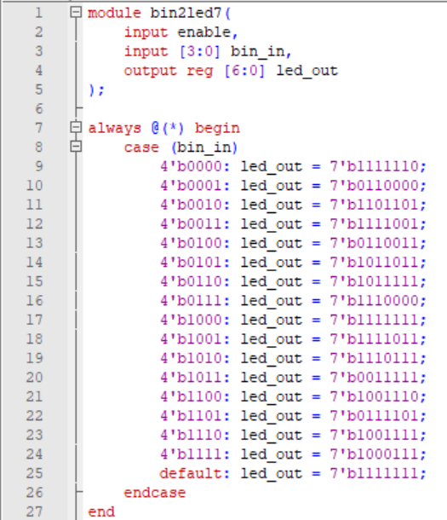

Testbench:

Waveform:

**Exercise 4:**

Testbench:

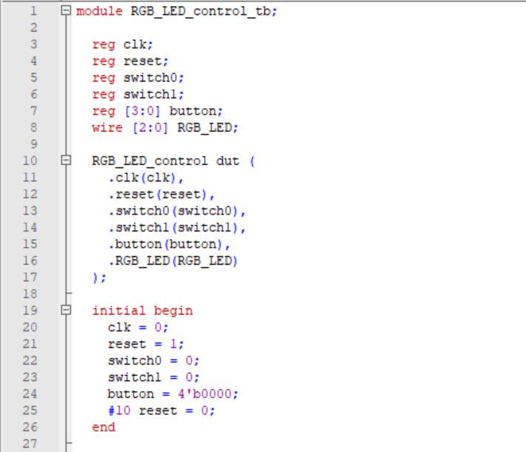

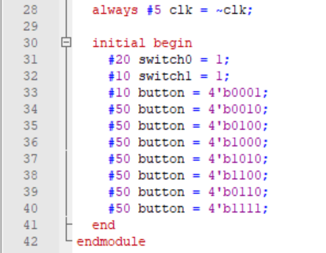

Waveform:

