1. What is Boolean? Write down 3 different expression that results a Boolean type (i.e. 5 == 6)

Boolean is a type of variables, it value either True or False.

3 expression:

5 != 6

(False)

“manh” == “Manh”

(False)

1 == 2 or 3 == 3

(True)

1. What is a flow chart? Draw flow chart for the following code snippet: (you can draw on a paper, take a picture of it)

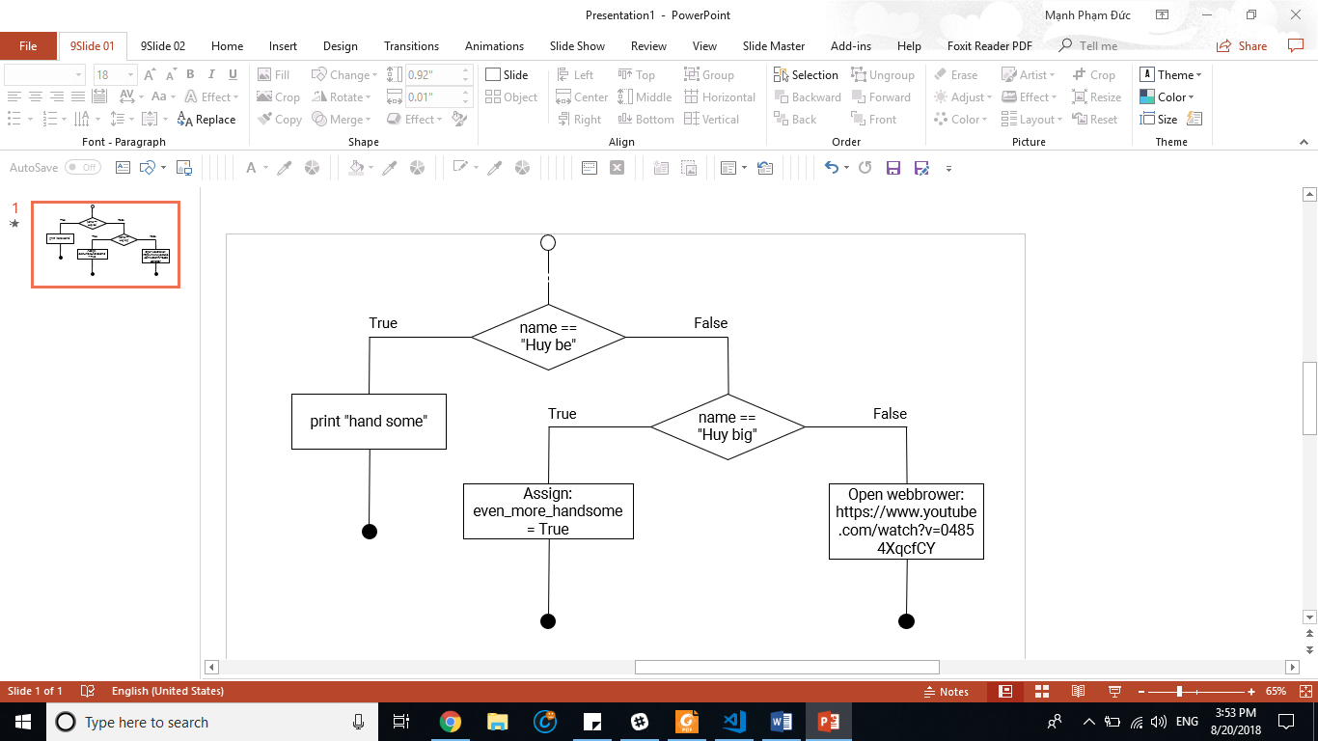

1. What is nested conditionals? Write a piece of code that uses nested conditionals

Nested conditionals is the situation when a if function (conditional) is placed in a block of another if function (conditional).

if username == “c4e”:

if password == “codethechange”:

print(“welcome, c4e!”)

else:

print(“wrong password”)

else:

print(“You don’t have permission to access”)