YOLO-SGC: Scale-Guided Context Fusion Neck for Efficient Multi-Distance Crop Row Detection with Edge Deployment
Manh V. Hoang^{*,1}, Nam Do¹ and Thang M. Pham¹
¹University of Engineering and Technology, Vietnam National University, Hanoi 10000, Vietnam
* Correspondence should be sent manhhv87@vnu.edu.vn

Abstract: Autonomous navigation in row-crop agriculture requires reliable detection of crop rows at both near and far distances for steering correction and trajectory planning. In conventional pipelines, crop rows are first detected as bounding boxes, and a guidance line is formed by linking their centroids, making detection accuracy, especially in the far field, critical for stable navigation. However, the Feature Pyramid Network (FPN) and Path Aggregation Network (PAN) necks commonly used in YOLO-based detectors fuse features uniformly across all spatial locations without adapting to local scale context. This limitation weakens far-field detection and increases model complexity for edge deployment. To address this, we propose the Scale-Guided Context (SGC) neck, a lightweight replacement for FPN/PAN that introduces scale-aware feature fusion. The SGC neck consists of three components: (i) an Adaptive Multi-Receptive-Field block for multi-scale context extraction, (ii) a ScaleMap head that generates a spatial scale prior from early backbone features, and (iii) an SGCBlock for adaptive scale-conditioned fusion. Two variants, SGC-P345 and SGC-P45, are developed for different accuracy–efficiency operating points. Experiments across four YOLO backbones (v5s, v8s, v9s, and v11s) show consistent gains of up to 1.7% in mAP@50 while reducing parameter count by 18–46%. Notably, far-field detection improves by 4.2%, which is critical for robust guidance-line construction.
Keywords— object detection, scale-aware feature fusion, crop-row detection, autonomous navigation, YOLO.

Introduction
Autonomous field robots are transforming precision agriculture, replacing manual scouting with continuous, real-time crop monitoring. At the heart of these platforms lies a deceptively simple navigational task: follow the crop rows. A forward-facing camera captures the scene, a detector localizes crop rows as bounding boxes at successive distances, and a guidance line is constructed by connecting the centroids of those boxes from the bottom of the image toward the vanishing point. The steering controller of robot then tracks this guidance line to maintain a straight, centered path between rows. The entire navigation pipeline, from perception to actuation, depends on the ability to produce accurate of the detector, consistent bounding boxes across the full range of distances visible in a single frame [1–3].
This dependence on multi-distance detection creates a distinctive challenge. Near-field crop rows fill large image regions and are texture-rich, making them relatively easy to detect. Far-field rows, by contrast, shrink to just a few pixels, pack tightly together, and often blur into the background soil or neighboring vegetation. The apparent area of the same crop row class can vary by more than an order of magnitude from foreground to horizon within a single image. Crucially for navigation, the far-field detections anchor the upper end of the guidance line and therefore exert disproportionate influence on the planned trajectory, a single missed or mislocalized far-field box can bend the guidance line and produce a steering error that propagates forward in time [4–6].
Modern YOLO-family detectors [7–10] address multi-scale variation through Feature Pyramid Networks (FPN) [11] or Path Aggregation Networks (PAN) [12], which fuse backbone features at strides {8, 16, 32} via top-down and bottom-up pathways. While these architectures support multi-scale detection via pyramid-level assignment, their fusion weights are shared across all spatial positions within each feature map and do not adapt to local scale context. In forward-facing agricultural cameras, where perspective projection causes object apparent size to vary with vertical image position, this spatial invariance weakens feature representation for distant, small-scale objects. Weighted variants such as BiFPN [13] and topology-searched designs such as NAS-FPN [14] improve upon the standard FPN architecture; however, neither incorporates an explicit spatial scale prior into the fusion weights. Further exacerbating this issue, the FPN/PAN neck often accounts for a considerable proportion of the total model parameters and FLOPs, creating a significant bottleneck for deployment on memory- and compute-constrained edge hardware (e.g., NVIDIA Jetson Nano with 4 GB RAM) typically used in agricultural robots.
In this paper, we propose the Scale-Guided Context (SGC) neck, which replaces FPN/PAN entirely with three tightly integrated modules. Firstly, we introduce the AMRF block, which captures multi-scale context through three dilated depthwise convolution branches (d ∈ {1, 2, 3}) fused via learned channel attention, achieving multi-receptive-field aggregation at $O(C)$ rather than $O(C^{2})$ parameter cost. Next, we propose the ScaleMapHead, a lightweight module that generates a single-channel spatial scale prior $S∈R^{1×H×W}$ from early backbone features (stride 4), learning to encode depth-dependent scale information without explicit supervision. Finally, we design the SGCBlock, which fuses multi-level features conditioned on the scale map through spatially varying softmax weights, enabling position-dependent receptive field selection. Two variants (SGC-P345 and SGC-P45) are validated across four YOLO generations on a crop row navigation (collected by ourself) and the VisDrone datasets [15].

Related work

Multi-scale feature fusion in object detection
The idea of building semantically rich, multi-scale feature representations through top-down fusion was formalized by Lin et al. [11] in the Feature Pyramid Network. Liu et al. [12] extended this paradigm with a bottom-up pathway (PAN), strengthening localization by re-injecting fine-grained spatial detail into deeper feature maps. Subsequent work explored richer connectivity: Tan et al. [13] introduced learnable importance weights for bidirectional fusion in BiFPN, Ghiasi et al. [14] used neural architecture search to discover the NAS-FPN topology, and Yang et al. [16] proposed an asymptotic feature pyramid network (AFPN) that supports direct interaction between non-adjacent levels and incorporates adaptive spatial fusion. Despite these advances, most widely used neck architectures such as FPN, PANet, NAS-FPN, and BiFPN perform spatially uniform fusion, where fusion weights do not vary across spatial locations within a feature map. This uniformity can be particularly costly in ground-level agricultural imagery, where object scale strongly depends on depth and where accurate far-field detections are critical for maintaining a stable downstream guidance line.

Lightweight detection for edge deployment
The pursuit of efficient detection has yielded depthwise separable convolutions [17], structured pruning [18], knowledge distillation [19], and compound scaling [20]. Within the YOLO family, successive generations including YOLOv5 [7], YOLOv8 [8], YOLOv9 [9] (introducing programmable gradient information), and YOLO11 [10] have introduced architectural and training refinements aimed at improving real-time performance. MobileNet [17] and MobileNetV2 [21] demonstrated that depthwise separable operations can drastically reduce the computation of convolutional layers compared with standard convolutions.

Scale-aware detection
Scale-aware methods can be broadly grouped by where they intervene. Singh and Davis [22] proposed SNIP, which trains and evaluates at multiple image scales while selectively back-propagating gradients only for appropriately sized objects. Singh et al. [23] extended this idea to SNIPER for efficient multi-scale processing. At the backbone level, Li et al. [24] introduced TridentNet, which routes features through parallel branches with dilation rates {1, 2, 3}. Yu et al. [25] earlier showed that dilated convolutions can systematically aggregate multi-scale context. While TridentNet’s multi-dilation design shares conceptual kinship with our AMRF block, it operates within the backbone and does not exploit spatial scale guidance.

Vision-based navigation in row-crop agriculture
Deep learning-based detection has been widely adopted in agriculture for crop row identification [26], weed detection [27], fruit counting [28], and disease diagnosis [29]. For autonomous navigation, a common paradigm is centroid-based guidance: a detector identifies crop rows (for example via bounding boxes or row segments) at multiple distances, their centroids are projected into a common coordinate frame, and a guidance line or spline is fitted through these points to steer the robot [30,31]. The quality of this guidance line depends mainly on detection completeness and localization accuracy across all distance ranges, particularly in the far field where even a few missing or inaccurate detections can cause the fitted line to deviate from the true row direction. Many current approaches handle multi-distance variation through data augmentation or multi-scale training and inference. In this work, we explicitly change the neck architecture by embedding scale awareness directly into the feature fusion mechanism, with the goal of improving far-field detection and, in turn, guidance-line stability.

Proposed method
The SGC neck is designed as a replacement for FPN/PAN, preserving the upstream backbone and downstream detection head (Fig. 1). Given an input image $I∈R^{3×H×W}$, the backbone produces feature maps $\{C_{\text{2}},C_{\text{3}},C_{\text{4}},C_{\text{5}}\}$ at strides {4, 8, 16, 32}, where $C_{l}∈R^{c_{l}×(H/s_{l})×(W/s_{l})}$. Instead of fusing these features through a fixed cascade of upsampling, concatenation, and convolution operations, the SGC neck routes them through three dedicated modules, namely AMRF, ScaleMap, and SGCBlock, each of which is described below.

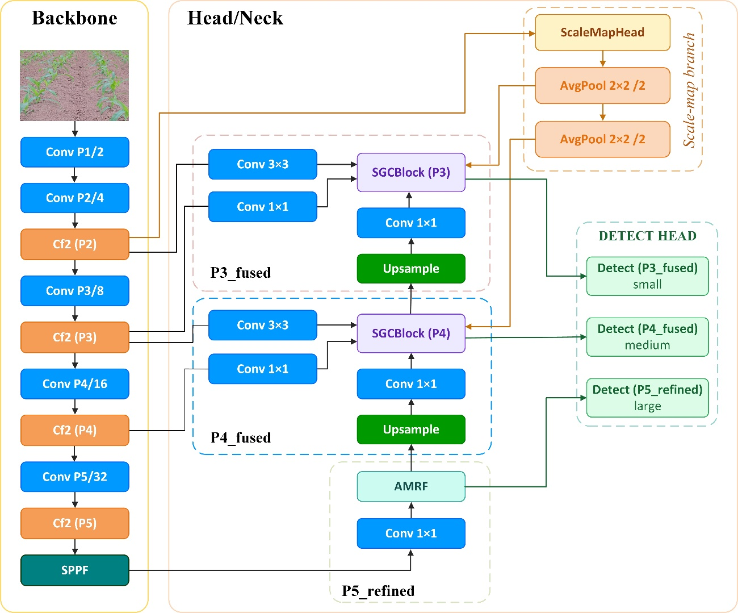
Figure 1: The proposed YOLO-SGC model architecture.

Adaptive Multi-Receptive-Field (AMRF) block
The AMRF block enriches a single feature level with multi-scale context (Fig. 2). Given an input $x∈R^{C×H×W}$, three parallel depthwise convolution branches with dilation rates d ∈ {1, 2, 3} produce features whose effective receptive fields span 3×3, 5×5, and 7×7.

$$\begin{aligned}f_{k}=σ​\left(BN​\left({DWConv}_{3×3, d=k}\left(x\right)\right)\right), k∈\left\{1,2,3\right\} \#\left(1\right)\end{aligned}$$

where DWConv denotes depthwise convolution [17], BN is batch normalization [32], and $σ$ is the SiLU activation. Each branch requires only $9C$ parameters (kernel 3×3, $C$ groups), compared with $9C^{2}$ for a standard convolution.

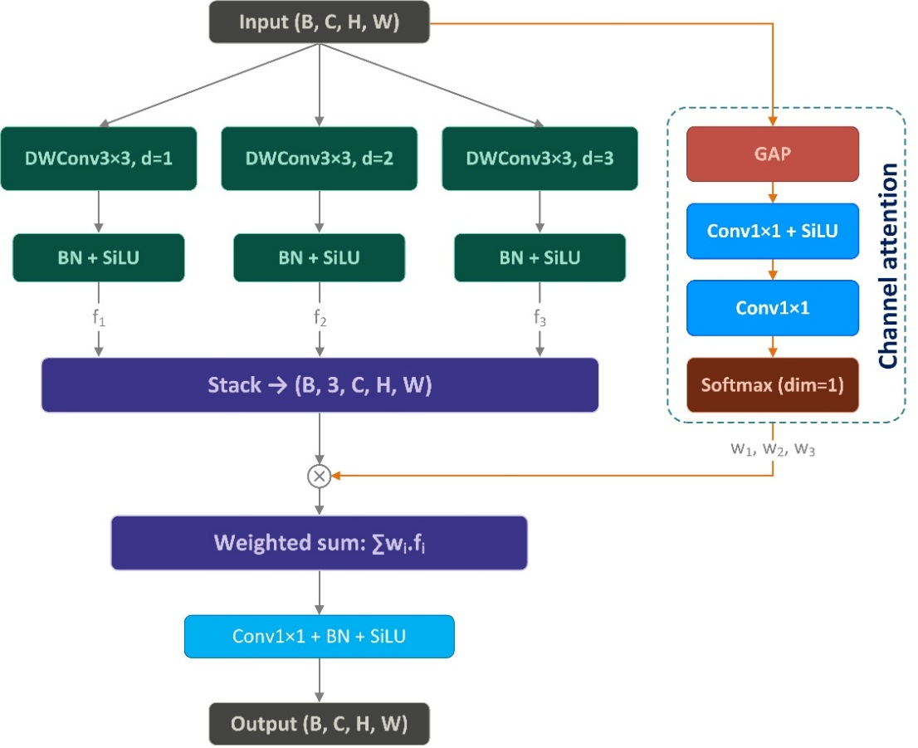
Figure 2: AMRF block architecture. Three depthwise convolution branches with dilations d ∈ {1, 2, 3} capture progressively wider context. Channel attention via GAP and FC layers produces softmax weights for adaptive branch fusion.

To let the network decide how much weight each receptive field deserves, we apply a lightweight channel attention mechanism. Global average pooling compresses the input into a channel descriptor $z∈R^{C×1×1}$, which is then passed through two fully connected layers (with reduction ratio $r$) and a softmax to yield three branch weights.

$$\begin{aligned}\begin{aligned}z=GAP\left(x\right)∈R^{C×1×1}, \\ \left[w_{1},w_{2},w_{3}\right]=Softmax​\left(W_{2} σ\left(W_{1}z\right)\right)\end{aligned} \#\left(2\right)\end{aligned}$$

where $W_{1}∈R^{\frac{C}{r}×C}$ and $W_{2}∈R^{3×\frac{C}{r}}$. The final output is the attention-weighted sum, refined by a 1×1 convolution.

$$\begin{aligned}AMRF\left(x\right)=σ\left(BN\left({Conv}_{1×1}\left(\sum_{k=1}^{3}{w_{k}}f_{k}\right)\right)\right)\#\left(3\right)\end{aligned}$$

The total number of parameters in the AMRF block is $C^{2}\left(1+\frac{1}{r}\right)+27C+\frac{3C}{r}$, which, for $C≥64$ and $r=4$, amounts to roughly one-fifth of a standard 3×3 convolution’s parameters, decreasing toward $(1+1/r)/9≈14\%$ as C grows.

ScaleMap generation
The ScaleMap head takes the earliest high-resolution backbone features, $C_{2}$ (stride 4), as input because they retain fine-grained texture gradients such as edge density, local frequency content, and apparent object size that correlate with depth in a perspective scene (Fig. 3). It consists of two consecutive 3×3 convolutions, each followed by batch normalization and SiLU activation, with a final 1×1 convolution that projects the output to a single-channel spatial scale prior. This prior encodes the expected spatial distribution of near-field and far-field crop rows, enabling downstream fusion to adapt its behavior according to distance.

$$\begin{aligned}S_{2}={Conv}_{1×1}\left(σ\left(BN\left({Conv}_{3×3}\left(σ\left(BN\left({Conv}_{3×3}\left(C_{2}\right)\right)\right)\right)\right)\right)\right)∈R^{1×\frac{H}{4}×\frac{W}{4}} \#\left(4\right)\end{aligned}$$

Resolution-matched scale maps for each detection level are then obtained by successive 2×2 average pooling.

$$\begin{aligned}S_{l}={AvgPool}_{2×2}\left(S_{l-1}\right), l∈\left\{3, 4, 5\right\}\#\left(5\right)\end{aligned}$$

Importantly, the final 1×1 convolution is applied without an activation function, allowing the scale map to assume unconstrained real values. This design choice is deliberate because the downstream SGCBlock’s weight convolution can freely interpret these values through its learned parameters, thereby avoiding the information bottleneck imposed by a bounded activation function.

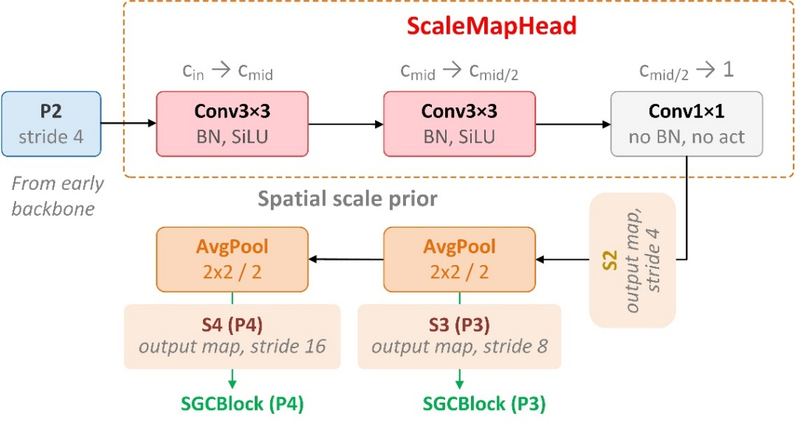
Figure 3: ScaleMap generation. $C_{2}$ backbone features (stride 4) are processed through two 3×3 convolutions (each followed by batch normalization and SiLU) and a 1×1 projection to produce a single-channel spatial scale prior, which is then downsampled via successive 2×2 average pooling to match P3/P4/P5 resolutions.

Scale-Guided Context Fusion Block (SGCBlock)
The SGCBlock is the core of the proposed architecture (Fig. 4). It receives three feature maps $f_{1},f_{2},f_{3}∈R^{C×H×W})$, drawn from different backbone or neck levels but aligned to the same spatial stride, together with the corresponding scale map $S_{l}∈R^{1×H×W}$. Each input is first enriched by a dedicated AMRF block.

$$\begin{aligned}{\hat{f}}_{k}={AMRF}_{k}\left(f_{k}\right), k∈\left\{1,2,3\right\}\#\left(6\right)\end{aligned}$$

The enriched features and the scale map are then concatenated along the channel dimension and passed through a 1×1 convolution followed by a spatial softmax, producing fusion weights that vary at every spatial location.

$$\begin{aligned}\left[w_{1},w_{2},w_{3}\right]=Softmax​\left({Conv}_{1×1}\left(\left[{\hat{f}}_{1};{\hat{f}}_{2};{\hat{f}}_{3};S_{l}\right]\right)\right)∈R^{3×H×W}\#\left(7\right)\end{aligned}$$

where [;] denotes channel-wise concatenation and ${Conv}_{1×1}$ maps $(3C+1)$ channels to 3. The fused output is

$$\begin{aligned}F={Conv}_{3×3}\left(\sum_{k=1}^{3}{w_{k}}⊙{\hat{f}}_{k}\right)∈R^{C×H×W} \#\left(8\right)\end{aligned}$$

where $⊙$ denotes element-wise multiplication (with broadcasting along $C$) and the final 3×3 convolution refines the fused representation. Unlike BiFPN [13], whose learned fusion weights are spatially invariant scalars, the fusion weights in Eq. 7 are spatially varying and conditioned on the scale prior $S_{l}$, so that each spatial position receives a different combination of pyramid-level features. The overhead is minimal: the weight convolution adds only $(3C+1)×3=9C+3$ parameters.

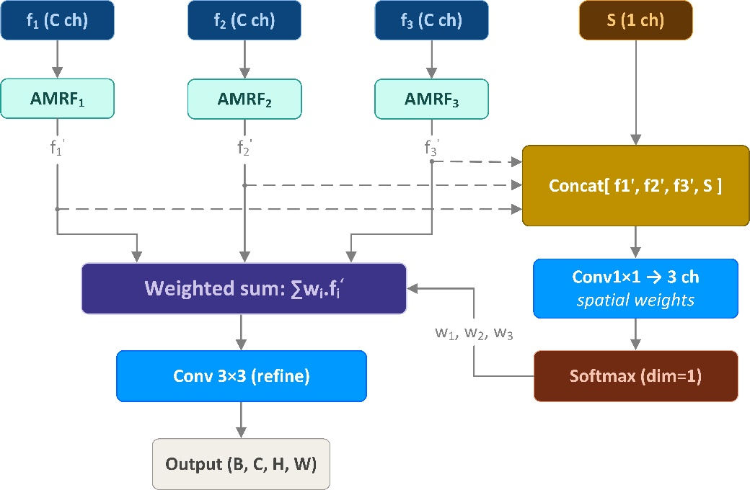
Figure 4: SGCBlock fusion mechanism. Three feature branches, each processed by an independent AMRF block, are concatenated with the scale map $S_{l}$ and passed through a 1×1 convolution followed by softmax to produce spatially varying fusion weights (Eq. 7–8).

SGC-P345 and SGC-P45 configurations
We develop two neck configurations to span a range of accuracy–efficiency trade-offs. SGC-P345 applies an SGCBlock at P4 (stride 16) and P3 (stride 8), with P5 (stride 32) processed by AMRF alone, feeding three detection heads. SGC-P45 removes the P3 branch entirely, applying a single SGCBlock at P4 and retaining AMRF at P5, yielding two detection heads. This eliminates one SGCBlock, one detection head, and all P3-level computation. Both configurations replace only the neck of YOLOv5s [7], YOLOv8s [8], YOLOv9s [9], and YOLO11s [10], with the backbone kept unchanged.

Experimental setup

Datasets
Crop row dataset: We collected and annotated a crop row dataset using a forward-facing camera mounted on a custom ground-level agricultural robot navigating between corn rows. The data were captured in an open field in Dan Phuong, Hanoi, Vietnam. The dataset contains 2500 images, split into 1500 for training, 500 for validation, and 500 for testing. It includes four classes that represent the distance between the robot and each detected row segment: near, mid_near, mid_far, and far. This distance-based labeling aligns directly with the navigation pipeline, where each class corresponds to a depth layer along the guidance path, ranging from the immediate steering region (near) to the longer-range trajectory planning horizon (far).
VisDrone 2019 [15]: The VisDrone-DET benchmark comprises 10 object classes captured from drone-mounted cameras across diverse urban scenes. We adopt the standard train (6471 images), validation (548 images), and test-dev (1610 images) splits. Unlike the crop row dataset, scale variation in VisDrone is primarily driven by altitude rather than ground-level perspective, allowing us to evaluate the SGC neck in a different multi-scale setting.

Implementation details
All models were trained using the Ultralytics framework on a single NVIDIA RTX 5060 Ti GPU (16 GB VRAM) with SGD (momentum 0.937, weight decay 5×10⁻⁴), a cosine-annealing learning rate schedule (initial lr = 0.005), and an input resolution of 640×640. Training ran for a maximum of 200 epochs on both datasets, with early stopping applied at a patience of 15 epochs. Augmentation included mosaic (p = 0.1), HSV jittering (h = 0.015, s = 0.5, v = 0.3), and horizontal flip (p = 0.5). Backbone weights were initialized from COCO-pretrained checkpoints; all SGC neck modules were initialized with Kaiming initialization [33].

Pruning protocol
Structured pruning was performed using Torch-Pruning [34] with L2-norm magnitude importance. The pruner was configured with a pruning ratio of 0.67 applied in a single iterative step. Detection heads, scale-map projection layers, channel-attention layers (AMRF FC), and scale-conditioned fusion weights (SGCBlock) were excluded from pruning to preserve task-critical structures. After pruning, models were retrained under the same training configuration described above until convergence.

Hardware and evaluation metrics
GPU inference speed was measured on an NVIDIA RTX 5060 Ti (16 GB VRAM). Edge inference was evaluated on an NVIDIA Jetson Nano 4 GB, the same platform used on our agricultural robot. FPS values are reported as the mean over 1,000 iterations at batch size 1, following a 100-iteration warm-up. We report Precision (P), Recall (R), F1-score, mAP@50, and mAP@50–95, where AP metrics follow the COCO evaluation protocol [35]. For the navigation use case, mAP@50 is the primary metric of interest, since the guidance line is constructed from bounding-box centroids rather than tight box boundaries, meaning that classification confidence and coarse localization matter more than fine-grained box regression.

Results and Discussion

Pre-pruning results
Table 1 summarizes detection performance for the four YOLO baselines [7–10] and their SGC variants on the crop row dataset before pruning.

Table 1: Detection performance on the crop row dataset (pre-pruning). GPU FPS measured on RTX 5060 Ti; Nano FPS on Jetson Nano 4 GB (FP32).
Model | P | R | F1 | mAP@50 | mAP@50–95 | Params (M) | GFLOPs | GPU FPS | Nano FPS
YOLOv5s | 0.954 | 0.944 | 0.949 | 0.955 | 0.631 | 9.11 | 23.8 | 121.3 | 5.0
YOLOv5s-SGC-P345 | 0.959 | 0.964 | 0.962 | 0.968 | 0.638 | 5.81 | 21.5 | 108.8 | 4.5
YOLOv5s-SGC-P45 | 0.962 | 0.961 | 0.962 | 0.968 | 0.623 | 4.82 | 12.8 | 148.2 | 7.6
YOLOv8s | 0.945 | 0.929 | 0.937 | 0.947 | 0.614 | 11.13 | 28.4 | 113.3 | 4.5
YOLOv8s-SGC-P345 | 0.962 | 0.956 | 0.959 | 0.964 | 0.612 | 6.02 | 19.8 | 113.4 | 5.2
YOLOv8s-SGC-P45 | 0.953 | 0.949 | 0.951 | 0.951 | 0.618 | 5.66 | 14.8 | 146.5 | 7.3
YOLOv9s | 0.950 | 0.949 | 0.950 | 0.962 | 0.621 | 7.17 | 26.7 | 84.8 | 4.2
YOLOv9s-SGC-P345 | 0.962 | 0.959 | 0.961 | 0.968 | 0.626 | 5.86 | 21.4 | 91.3 | 4.6
YOLOv9s-SGC-P45 | 0.958 | 0.943 | 0.950 | 0.962 | 0.625 | 5.39 | 15.3 | 108.2 | 5.8
YOLO11s | 0.958 | 0.939 | 0.948 | 0.954 | 0.584 | 9.41 | 21.3 | 118.0 | 4.5
YOLO11s-SGC-P345 | 0.959 | 0.962 | 0.961 | 0.969 | 0.627 | 5.94 | 19.0 | 113.1 | 5.2
YOLO11s-SGC-P45 | 0.958 | 0.948 | 0.953 | 0.960 | 0.623 | 5.86 | 17.4 | 147.6 | 6.1

It is shown in Table 1 that incorporating the SGC neck yields consistently improved accuracy and a more favorable accuracy-efficiency trade-off compared to the corresponding YOLO baselines. For example, on YOLOv5s, SGC-P45 increases mAP@50 from 0.955 to 0.968 while reducing parameters from 9.11M to 4.82M and GFLOPs from 23.8 to 12.8, and simultaneously boosts GPU FPS from 121.3 to 148.2 and Nano FPS from 5.0 to 7.6. On YOLOv8s, SGC-P45 raises mAP@50 from 0.947 to 0.951, cuts parameters from 11.13M to 5.66M and GFLOPs from 28.4 to 14.8, and improves GPU FPS from 113.3 to 146.5 and Nano FPS from 4.5 to 7.3. Similar trends hold for YOLOv9s and YOLO11s. YOLO11s-SGC-P45, for instance, increases mAP@50 from 0.954 to 0.960 while reducing parameters from 9.41M to 5.86M and raising GPU FPS from 118.0 to 147.6 and Nano FPS from 4.5 to 6.1. Within the SGC variants, the P345 variant have higher accuracy, for example, YOLO11s-SGC-P345 attains mAP@50 of 0.969 versus 0.960 for the YOLO11s-SGC-P45. However, it has higher computational cost than P45 (higher Params and GFLOPs, less GPU FPS and Nano PFS). In summary, the results show that introducing scale-aware fusion in the neck can improve the detection accuracy. Compared to SGC-P345, SGC-P45 variants consistently provides better balance between higher accuracy and higher computational efficiency. It offers higher real time performance, and hence is more suitable for embedded deployment on field robots.

Post-pruning results
Performance of structures after pruning is presented in Table 2. From this table we can see that pruning substantially improves computational efficiency while preserving the accuracy. SGC variants remain better accuracy than the YOLO baselines and SGC-PS45 still have the lowest computational cost among all.

Table 2: Detection performance after structured pruning.
Model | P | R | F1 | mAP@50 | mAP@50–95 | Params (M) | GFLOPs | GPU FPS | Nano FPS
YOLOv5s | 0.947 | 0.937 | 0.942 | 0.955 | 0.630 | 3.09 | 9.8 | 155.5 | 10.7
YOLOv5s-SGC-P345 | 0.954 | 0.956 | 0.955 | 0.964 | 0.635 | 2.08 | 9.0 | 122.0 | 7.2
YOLOv5s-SGC-P45 | 0.963 | 0.961 | 0.962 | 0.969 | 0.620 | 1.45 | 3.9 | 159.8 | 15.3
YOLOv8s | 0.945 | 0.925 | 0.935 | 0.948 | 0.605 | 3.60 | 10.8 | 154.2 | 10.3
YOLOv8s-SGC-P345 | 0.960 | 0.947 | 0.953 | 0.965 | 0.633 | 1.87 | 7.0 | 126.5 | 9.3
YOLOv8s-SGC-P45 | 0.952 | 0.946 | 0.949 | 0.959 | 0.614 | 0.49 | 1.3 | 155.3 | 27.7
YOLOv9s | 0.964 | 0.950 | 0.957 | 0.963 | 0.633 | 4.18 | 17.2 | 103.9 | 5.7
YOLOv9s-SGC-P345 | 0.959 | 0.941 | 0.950 | 0.963 | 0.616 | 3.30 | 12.5 | 96.2 | 6.3
YOLOv9s-SGC-P45 | 0.959 | 0.962 | 0.960 | 0.969 | 0.643 | 2.98 | 8.4 | 117.2 | 8.1
YOLO11s | 0.946 | 0.941 | 0.943 | 0.952 | 0.614 | 3.63 | 8.4 | 144.7 | 8.9
YOLO11s-SGC-P345 | 0.963 | 0.958 | 0.961 | 0.961 | 0.626 | 2.06 | 6.3 | 120.2 | 9.8
YOLO11s-SGC-P45 | 0.964 | 0.942 | 0.953 | 0.964 | 0.624 | 1.99 | 5.0 | 151.0 | 13.5

After pruning, all models are significantly reduced in size. YOLOv5s, for instance, shrinks from 9.11M parameters and 23.8 GFLOPs to 3.09M and 9.8 GFLOPs. At the same time, GPU and Nano FPS improve from 121.3 and 5.0 to 155.5 and 10.7, with almost no change in mAP, remaining at 0.955 for mAP@50 and slightly decreasing from 0.631 to 0.630 for mAP@50–95. A similar trend appears in SGC variants. YOLOv5s-SGC-P45 is reduced from 4.82M parameters and 12.8 GFLOPs to 1.45M and 3.9 GFLOPs. Nano FPS doubles from 7.6 to 15.3, while mAP@50–95 drops only slightly from 0.623 to 0.620. Across all YOLO generations, SGC models maintain or slightly improve their advantage over baseline models. The pruned YOLOv8s-SGC-P45 reaches an mAP@50–95 of 0.614 compared to 0.605 for the pruned baseline, with similar GPU FPS and much higher Nano FPS, 27.7 versus 10.3. In YOLO11s, the pruned SGC-P45 achieves 0.624 mAP@50–95 compared to 0.614 for the baseline, while using about 45% fewer parameters and running faster on both GPU and Nano. Overall, pruning leads to strong compression across all models. Models with SGCBlock consistently deliver higher accuracy. Notably, SGC-P45 achieves both better accuracy and lower computational cost compared to the standard YOLO, before and after pruning.

Pareto analysis of the accuracy-efficiency trade off
To complement the tabulated results, Fig. 5 presents the mAP@50–parameter Pareto frontier of all models in both pre- and post-pruning cases. A model is dominant only if no other model attains equal or higher mAP@50 with fewer parameters. It is shown in this figure that the global Pareto frontier contains only two models: the pruned YOLOv8s-SGC-P45 (0.49M parameters, mAP@50 = 95.86%) and the pruned YOLOv5s-SGC-P45 (1.45M parameters, mAP@50 = 96.93%). All remaining variants are dominated, meaning that their accuracy can be matched or exceeded by a model of lower complexity. From a deployment perspective, the frontier defines two practical operating regimes. YOLOv8s-SGC-P45 is the most efficiency option, minimizing memory footprint and maximizing edge throughput. YOLOv5s-SGC-P45 is the accuracy-oriented option, requiring an additional 0.96M parameters in exchange for roughly +1.0 percentage-point mAP@50.

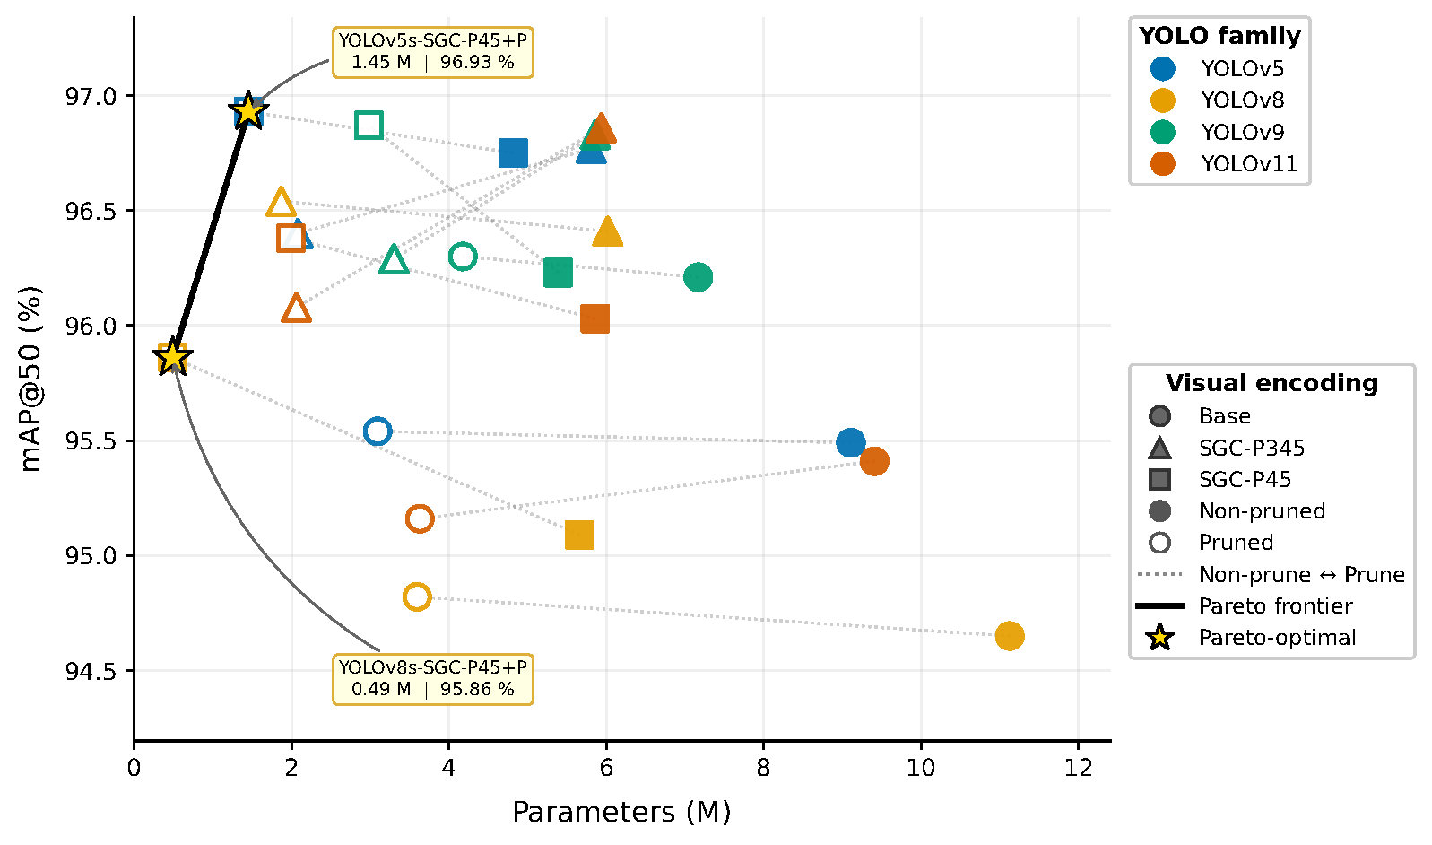
Figure 5: Pareto plot of mAP@50 versus parameter count for all baseline and SGC variants before and after structured pruning. Circles denote non-pruned models, squares denote pruned models, dotted segments connect each model to its pruned counterpart, and stars mark Pareto-optimal operating points.

Ablation study
To isolate the contribution of each module, we present a systematic ablation study on YOLOv8s-SGC-P345 using the crop row dataset, as shown in Table 3.

Table 3: Ablation study on YOLOv8s-SGC-P345. FPS on GPU RTX 5060 Ti and Jetson Nano 4 GB.
Variant | AMRF | Scale | Adpt.W | mAP@50 | mAP@50-95 | Params (M) | GFLOPs | GPU FPS | Nano FPS
YOLOv8s (FPN) | ✗ | ✗ | ✗ | 0.947 | 0.614 | 11.13 | 28.4 | 113.3 | 4.5
AMRF+FPN | ✓ | ✗ | ✗ | 0.961 | 0.611 | 11.28 | 28.6 | 112.1 | 4.5
Minimal | ✗ | ✗ | ✓ | 0.952 | 0.601 | 6.32 | 21.4 | 119.3 | 5.9
w/o AMRF | ✗ | ✓ | ✓ | 0.955 | 0.614 | 6.32 | 21.4 | 137.1 | 5.9
w/o ScaleMap | ✓ | ✗ | ✓ | 0.947 | 0.590 | 6.02 | 19.8 | 111.6 | 5.2
w/o Adapt. W. | ✓ | ✓ | ✗ | 0.958 | 0.618 | .02 | 19.8 | 113.7 | 5.7
Full SGCBlock | ✓ | ✓ | ✓ | 0.964 | 0.612 | 6.02 | 19.8 | 113.4 | 5.2

AMRF contribution: Adding the AMRF block to the standard FPN (AMRF+FPN) improves mAP@50 by 1.4 percentage points (0.947→0.961) with only a +0.15M increase in parameters, indicating that multi-receptive-field fusion provides the largest individual improvement.
ScaleMap contribution: Removing the scale prior from Eq. 7 (w/o ScaleMap) reduces mAP@50 to 0.947, matching the FPN baseline, despite retaining AMRF and adaptive weighting. This suggests that, without scale information, the adaptive weights cannot effectively distinguish spatial regions. Reintroducing ScaleMap (Full SGCBlock vs. w/o ScaleMap) improves mAP@50 by 1.7 percentage points (0.964 vs. 0.947).
Adaptive weighting: The uniform-weight variant achieves slightly higher mAP@50–95 (0.618 vs. 0.612), indicating more precise localization at stricter IoU thresholds. In contrast, adaptive weighting improves mAP@50 (0.964 vs. 0.958), suggesting more reliable object detection under a looser criterion. This pattern points to a trade-off between detection robustness and bounding box precision. For the navigation pipeline, which relies on object centroids rather than precise box boundaries, this trade-off is acceptable.

Per-class ScaleMap analysis by distance
Table 4 compares per-class mAP@50 between the Full SGCBlock and the w/o ScaleMap variant to test whether the scale prior captures genuinely distance-dependent information. The results show that the contribution of the ScaleMap follows a monotonic trend with object distance with ΔAP = –0.1% for near, +0.6% for mid_near, +2.3% for mid_far, and +4.2% for far class. The near-class mAP@50 of 0.995 is already very high, leaving little room for improvement. The far class benefits most clearly, as distant crop rows are small, visually ambiguous, and most dependent on scale-informed disambiguation.
This monotonic pattern matters for two key reasons. First, it provides direct evidence that the ScaleMap learns a meaningful spatial depth encoding without any explicit depth supervision. Second, and more importantly for navigation, far-class detection is where guidance-line accuracy is most sensitive. Far-field centroids anchor the upper portion of the guidance line and determine the robot’s planned heading over the next several meters. The +4.2% mAP@50 improvement in the far class therefore leads to a more stable and reliable trajectory estimate, making it the most impactful benefit of the SGC neck for real-world deployment.

Table 4: Per-class mAP@50 effect of the ScaleMap by distance class.
Variant | near | mid_near | mid_far | far | mAP@50
YOLOv8s (FPN) | 0.995 | 0.987 | 0.941 | 0.862 | 0.946
w/o ScaleMap | 0.995 | 0.989 | 0.941 | 0.861 | 0.947
Full SGCBlock | 0.994 | 0.995 | 0.964 | 0.903 | 0.964
$Δ$ (Full-NoScale) | –0.1% | +0.6% | +2.3% | +4.2% | +1.7%

Fig. 6 visualizes the learned scale map, providing qualitative evidence of depth awareness. Regions closer to the robot receive higher activation values (≈ 0.85), while farther regions receive lower values (≈ 0.68). This activation varies smoothly across the image, forming a consistent gradient from near to far. Although the model was not trained with any explicit depth labels, it has learned a representation that correlates with distance. In other words, the scale map behaves like a continuous depth signal, where higher values indicate proximity and lower values indicate distance.

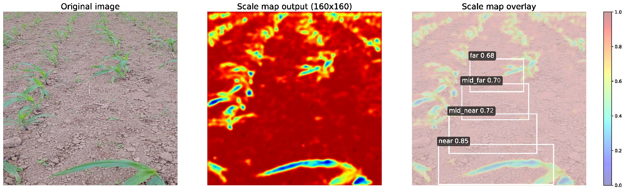
Figure 6: ScaleMap visualization on crop row imagery. Left: original image. Center: raw scale map output (160×160). Right: overlay with distance annotations. Activation values decrease from near (0.85) to far (0.68), suggesting learned depth encoding without explicit supervision. Cool regions (blue/cyan) correspond to crop vegetation; warm regions (red) correspond to soil.

Cross-domain evaluation on VisDrone
To test whether the SGC neck remains effective beyond the agricultural domain, we report results on the VisDrone 2019 [15] benchmark in Table 5, focusing exclusively on YOLOv8s variants.

SGC-P345 improves mAP@50 by +1.1% over the YOLOv8s baseline (0.368→0.379) while using 46% fewer parameters and running 4% faster on the GPU. The mAP@50–95 gain (+0.8%) indicates that the benefits extend to localization as well as classification. SGC-P45 shows a –2.1% mAP@50 drop, which is expected: VisDrone contains abundant small objects (pedestrians, bicycles) that depend on the P3-level features SGC-P45 discards [15]. This result shows that the P45 configuration is best suited to scenarios, such as crop row navigation, where the smallest objects (near-field rows) are already well resolved, rather than to dense small-object detection in general. Notably, precision of SGC-P345 increases by +3.4% while recall decreases by –1.8%, suggesting that scale-guided weighting suppresses ambiguous predictions, yielding fewer but more confident detections.

Table 5: Cross-domain evaluation on VisDrone 2019 [15].
Variant | P | R | F1 | mAP@50 | mAP@50–95 | Params (M) | GFLOPs | GPU FPS
YOLOv8s | 0.464 | 0.275 | 0.346 | 0.368 | 0.230 | 11.13 | 28.5 | 158.9
YOLOv8s-SGC-P345 | 0.498 | 0.257 | 0.339 | 0.379 | 0.238 | 6.02 | 19.8 | 164.7
YOLOv8s-SGC-P45 | 0.483 | 0.210 | 0.293 | 0.347 | 0.217 | 5.66 | 14.8 | 188.3

Training convergence
Fig. 7 plots the training and validation curves of YOLOv8s-SGC-P345 over 130 epochs on the crop row dataset. All three loss components (box, classification, and distribution focal) decrease sharply in the first 20 epochs and plateau thereafter. The mAP@50 reaches approximately $0.96$ by epoch 50 and remains stable for the rest of training. Validation losses closely follow their training counterparts, indicating no overfitting.

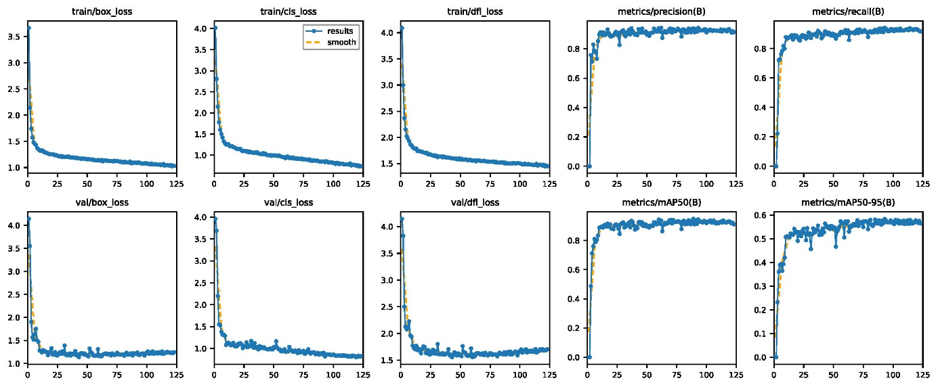
Figure 7: Training and validation curves of YOLOv8s-SGC-P345. Top: training losses and metrics. Bottom: validation losses and mAP.

Conclusions
We have presented the Scale-Guided Context (SGC) neck, a lightweight replacement for the conventional FPN/PAN neck in YOLO detectors. The SGC neck introduces spatial scale awareness into feature fusion through three components: AMRF for multi-receptive-field context aggregation, ScaleMap for unsupervised spatial depth encoding, and SGCBlock for scale-conditioned adaptive fusion.
Experiments spanning four YOLO generations (YOLOv5s, YOLOv8s, YOLOv9s, and YOLO11s) demonstrate consistent mAP@50 improvements of up to +1.7% with 18–46% parameter reductions. For the crop row navigation task that motivates this work, the ScaleMap contribution grows monotonically with object distance, reaching +4.2 percentage points AP for far-field objects, the detection range that most directly affects guidance-line stability and steering accuracy. This pattern emerges entirely without depth supervision. After structured pruning, the most compact variant (YOLOv8s-SGC-P45) achieves 27.7 FPS on a Jetson Nano 4 GB with only 0.49 M parameters and an mAP@50 of 0.959, meeting the real-time requirements of onboard navigation. Cross-domain evaluation on VisDrone confirms that SGC-P345 remains effective beyond agriculture, with a 1.1% mAP@50 gain.

Acknowledgments
This work has been supported by Vietnam National University of Engineering and Technology under project number CN24.20.

Contributions
Conceptualization, investigation, and formal analysis: Manh V. Hoang, Nam Do and Thang M. Pham; methodology, validation: Manh V. Hoang; software and writing: Manh V. Hoang. All authors were involved in its revision. All authors read and approved the final manuscript.

References
- Rajitha De Silva et al. “Deep learning-based crop row detection for infield navigation of agri-robots”. In: Journal of field robotics 41.7 (2024), pp. 2299–2321. https://doi.org/10.1002/rob.22238.
- Rajitha De Silva, Grzegorz Cielniak, and Junfeng Gao. “Vision based crop row navigation under varying field conditions in arable fields”. In: Computers and Electronics in Agriculture 217 (2024), p. 108581. https://doi.org/10.1016/j.compag.2023.108581.
- Md Nazmuzzaman Khan et al. “Real-time crop row detection using computer vision-application in agricultural robots”. In: Frontiers in Artificial Intelligence 7 (2024), p. 1435686. https://doi.org/10.3389/frai.2024.1435686.
- M Kise, Q Zhang, and F Rovira Mas. “A stereovision-based crop row detection method for tractor-automated guidance”. In: Biosystems engineering 90.4 (2005), pp. 357–367. https://doi.org/10.1016/j.biosystemseng.2004.12.008.
- Rajitha De Silva, Grzegorz Cielniak, and Junfeng Gao. “Vision based crop row navigation under varying field conditions in arable fields”. In: Computers and Electronics in Agriculture 217 (2024), p. 108581. https://doi.org/10.1016/j.compag.2023.108581.
- J Reid and S Searcy. “Vision-based guidance of an agriculture tractor”. In: IEEE Control Systems Magazine 7.2 (2003), pp. 39–43. DOI: 10.1109/MCS.1987.1105271.
- Glenn Jocher and et al. Ultralytics YOLOv5. Ultralytics GitHub repository, accessed April 2, 351 2026. 2020. url: https://github.com/ultralytics/yolov5.
- Glenn Jocher, Ayush Chaurasia, and Jing Qiu. Ultralytics YOLOv8. Ultralytics GitHub repository, accessed April 2, 2026. 2023. url: https://github.com/ultralytics/ultralytics.
- Chien-Yao Wang, I-Hau Yeh, and Hong-Yuan Mark Liao. “Yolov9: Learning what you want to learn using programmable gradient information”. In: European conference on computer vision. Springer. 2024, pp. 1–21
- Glenn Jocher and Jing Qiu. Ultralytics YOLO11. GitHub repository, accessed April 2, 2026. 2024. url: https://github.com/ultralytics/ultralytics. url: https://github.com/WongKinYiu/yolov9.
- Tsung-Yi Lin et al. “Feature pyramid networks for object detection”. In: Proceedings of the IEEE conference on computer vision and pattern recognition. 2017, pp. 2117–2125.
- Shu Liu et al. “Path aggregation network for instance segmentation”. In: Proceedings of the IEEE conference on computer vision and pattern recognition. 2018, pp. 8759–8768.
- Mingxing Tan, Ruoming Pang, and Quoc V Le. “Efficientdet: Scalable and efficient object detection”. In: Proceedings of the IEEE/CVF conference on computer vision and pattern recognition. 2020, pp. 10781–10790.
- Golnaz Ghiasi, Tsung-Yi Lin, and Quoc V Le. “Nas-fpn: Learning scalable feature pyramid architecture for object detection”. In: Proceedings of the IEEE/CVF conference on computer vision and pattern recognition. 2019, pp. 7036–7045.
- Dawei Du et al. “VisDrone-DET2019: The vision meets drone object detection in image challenge results”. In: Proceedings of the IEEE/CVF international conference on computer vision workshops. 2019, pp. 0–0.
- Guoyu Yang et al. “AFPN: Asymptotic feature pyramid network for object detection”. In: arXiv preprint arXiv:2306.15988 (2023). https://doi.org/10.48550/arXiv.2306.15988.
- Andrew G Howard et al. “Mobilenets: Efficient convolutional neural networks for mobile vision applications”. In: arXiv preprint arXiv:1704.04861 (2017). https://doi.org/10.48550/arXiv.1704.04861.
- Determine Filters’Importance. “Pruning filters for efficient convnets”. In: arXiv preprint arXiv:1608.08710 3 (2016). https://doi.org/10.48550/arXiv.1608.08710.
- Geoffrey Hinton, Oriol Vinyals, and Jeff Dean. “Distilling the knowledge in a neural network”. In: arXiv preprint arXiv:1503.02531 (2015). https://doi.org/10.48550/arXiv.1503.02531.
- Mingxing Tan and Quoc Le. “Efficientnet: Rethinking model scaling for convolutional neural networks”. In: International conference on machine learning. PMLR. 2019, pp. 6105–6114.
- Mark Sandler et al. “Mobilenetv2: Inverted residuals and linear bottlenecks”. In: Proceedings of the IEEE conference on computer vision and pattern recognition. 2018, pp. 4510–4520.
- Bharat Singh and Larry S Davis. “An analysis of scale invariance in object detection snip”. In: Proceedings of the IEEE conference on computer vision and pattern recognition. 2018, pp. 3578–3587.
- Bharat Singh, Mahyar Najibi, and Larry S Davis. “Sniper: Efficient multi-scale training”. In: Advances in neural information processing systems 31 (2018). url: https://github.com/MahyarNajibi/SNIPER/.
- Yanghao Li et al. “Scale-aware trident networks for object detection”. In: Proceedings of the IEEE/CVF international conference on computer vision. 2019, pp. 6054–6063.
- Fisher Yu and Vladlen Koltun. “Multi-scale context aggregation by dilated convolutions”. In: arXiv preprint arXiv:1511.07122 (2015). https://doi.org/10.48550/arXiv.1511.07122.
- Rajitha De Silva et al. “Deep learning-based crop row detection for infield navigation of agri-robots”. In: Journal of field robotics 41.7 (2024), pp. 2299–2321. https://doi.org/10.1002/rob.22238.
- Shengzhou Li et al. “PD-YOLO: a novel weed detection method based on multi-scale feature fusion”. In: Frontiers in Plant Science 16 (2025), p. 1506524. https://doi.org/10.3389/fpls.2025.1506524.
- Steven W Chen et al. “Counting apples and oranges with deep learning: A data-driven approach”. In: IEEE Robotics and Automation Letters 2.2 (2017), pp. 781–788. DOI: 10.1109/LRA.2017.2651944.
- Yiheng Qian, Zhiyong Xiao, and Zhaohong Deng. “Fine-grained crop pest classification based on multi-scale feature fusion and mixed attention mechanisms”. In: Frontiers in Plant Science 16 (2025), p. 1500571. https://doi.org/10.3389/fpls.2025.1500571.
- Hao Zheng and Qiang Wang. “Extracting the central crop row with CCRDNet for universal in-row navigation in agriculture”. In: Frontiers in Plant Science 17 (2026), p. 1744637. DOI: 10.3389/fpls.2026.1744637.
- Dongfang Li et al. “E2CropDet: An efficient end-to-end solution to crop row detection”. In: Expert Systems with Applications 227 (2023), p. 120345. https://doi.org/10.1016/j.eswa.2023.120345.
- Sergey Ioffe and Christian Szegedy. “Batch normalization: Accelerating deep network training by reducing internal covariate shift”. In: International conference on machine learning. pmlr. 2015, pp. 448–456.
- Kaiming He et al. “Delving deep into rectifiers: Surpassing human-level performance on imagenet classification”. In: Proceedings of the IEEE international conference on computer vision. 2015, pp. 1026–1034.
- Gongfan Fang et al. “Depgraph: Towards any structural pruning”. In: Proceedings of the IEEE/CVF conference on computer vision and pattern recognition. 2023, pp. 16091–16101.
- Tsung-Yi Lin et al. “Microsoft coco: Common objects in context”. In: European conference on computer vision. Springer. 2014, pp. 740–755. DOI: https://doi.org/10.1007/978-3-319-10602-1_48.

