Software Requirements Specification

Revo

Prepared by RevoTeam
Manh Nguyen Tien
Hiep Hoang Ho

26th June, 2017

1. Overview

1.1 Purpose
The purpose of this document is to give a detailed description of the requirements for the “Revo” software. This document is primarily intended to be proposed to a customer for its approval and a reference for developing the first version of the system for the development team.

1.2 Scope
Revo is web application which helps manage programming classes, from class registration to fee status, attendance and assignment reports. It is intended for teachers to use. The user will access it on a desktop computer.
The teacher is able to access the forms, approve or discard them, update the fee and attendance status of the students for each class, and manipulate assignment reports.
For better user experience, we design the software to be a single page web application backed by a server application. While an user is interacting with the application, it constantly fetches and pushes data from/to the server.

1.3 Definitions, acronyms and abbreviations
Term | Definition
User/Administrator | The person who manages the class
Register | An action that let students submit a registration form for a class

1.4 References
830-1998 - IEEE Recommended Practice for Software Requirements Specifications

1.5 Overview

2. Overall description
This section will give an overview of the whole system, it describes the subsystems and how they interact with each other.

2.1 Product perspective
The system consists of two parts: the web portal and a server application. The web is used as the main user interface and it help user interact with data stored on the server.
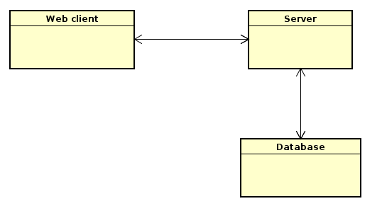
The web only renders user interface and have no interactions with database. So it basically runs on client’s machine (web browser) only. Based on user’s behavior, this web application will build propriate requests and send to a remote server. For security reason, all requets must be authenticaed with a valid token to verify a safe session between the server and client.
Server application’s role is to provide and receive data correctly when processing client’s requests.

2.2 Product functions
On the web client, user will have a functions to submit, view the registration forms, see and edit fee status as well as attendance and assignment reports for specific students of each class.

2.3 User characteristics
There two user characteristics that interact with the systems: public user (the students), and administrator (the class manager).
The students can only access one function to submit the registration form to the server without authentication.
Before the administrator can interact with the system, he must log in with an username and password.

2.4 Constraints
The product’s performance is constrained by database throughput and internet connection speed. Although our user count is very small, the response time can get slower when the database is big.

2.5 Assumptions and dependencies
There is one assumtion is that the manager will almost use the product on the computer. He will depends on an up-to-date web browser to access the system.

2.6 Apportioning of requirements
In the case that this project is delayed, there are some requirements could be transferred to the next version.

3. Specific requirements
This section contains all functional and non-functional requirements of the system. It gives a detailed description of system and its features.

3.1 External interfaces
This section provides a detailed description of all inputs into and outputs from the system. It also gives a description of the hardware, software and communication interfaces and provides basic prototypes of the user interface.

3.1.1 User interfaces
As a single page application, the UI must respond fast and the page should never reload.
When a user opens the application for the first time, he has access to only login and form submission feature. After login, more features are added to the navigation menu.
Forms page will display all submitted forms, the users can click on a form to view individual one.
Form page shows the form content and has buttons to approve or go back to the Forms page.
The Fee page contains fee status of all students and also has data filters to show only who has payed the fee, who hasn’t or show all. User can update fee status directly on this page.
Attendance page will have an combobox for selecting class and a date picker. Once the user supplies these inputs, the page lists students of class and attendance information of the provided day. User should be able to edit attendance on this page.
In the Assignments pages, in order to view and update grade reports, user must choose a class, so there’s one combobox input for this page. Then he can view and update the grades for each student.

3.2 Functional requirements

3.3 Non-functional requirements

