Software Design Document

Revo project

Prepared by RevoTeam
Manh Nguyen Tien – SE04004
Hiep Hoang Bui - SE03463

https://github.com/zer0-x/Revo
https://github.com/zer0-x/Revo-backend
26th June, 2017

Table of Contents
1. Overview 4
1.1 Scope 4
1.2 Purpose 4
1.3 References 4
2. Module design 4
2.1 Overview 4
2.1.1 Client overview 4
2.1.2 Server overview 4
2.2 Client design 5
2.3 Server design 5
2.4 Use case diagram 6
2.5 Deployment diagram 6
3. Database design 7

1. Overview

1.1 Scope
This document specify high level design and technology for Revo project. It covers the web client and API server’s architecture as well as database design, security and performance decisions that are required to meet the Software Requirements Specification (SRS).

1.2 Purpose
The design description described in this document serves the following purposes:
- Describe functional structure to be implemented
- Identify system resources
- Verify compliance with requirements
- Help maintenance activities

1.3 References
1016-2009 - IEEE Standard for Information Technology--Systems Design--Software Design Descriptions

2. Module design

2.1 Overview
The system is designed with 2 major parts: the client and server application.

2.1.1 Client overview
Node.js and React are selected as the platform and tool to implement client application. The code later is transformed so it can run flawlessly on a web browser. This application receives user interactions and communicate with server to fetch and update data. Thanks to React, we are able to use JavaScript to create user interface rather than dealing with bare HTML code. Node.js and React’s ecosystem also provide many tools and libraries for building application faster.

2.1.2 Server overview
For the ease of development, the server will be implemented with Ruby on Rails (ROR). Ruby has an intuitive syntax and is easy to write. Rails framework can provide an API structure that we need to implement services.

2.2 Client design
A class should be written for each of the pages in the client application. We have following classes:
1. Home
2. Register
3. Login
4. Forms
5. Fee
6. Attendance
7. Assignment
There are other classes that doesn’t require user interface:
8. Logout (Redirects to Home page)

2.3 Server design
To serve as an API server, this application have 2 parts: resource and controller.
The resource describes system data and the controller provides interface to create, modify or destroy that data.
Each controller function is triggered via a REST API call from client application.
Name | Description
User | The user that is in the system
Session | Authentication status of that user on the server
Form | A registration form submitted by the client
Student | Once a form is approved, a student is created
Fee | Fee status of each student per course
Attendance | Presence status of each student in the course per date
Assignment | The assignment reports of students per course
Table 1: Resource list

2.4 Use case diagram
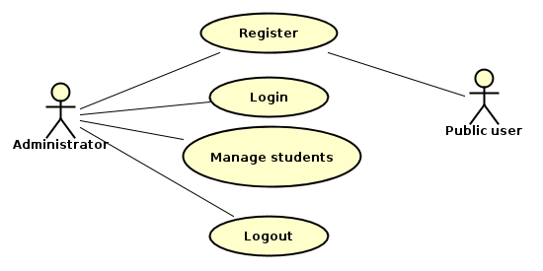
Manage students include: see/approve forms, see/update fee status, see/update attendance and see/update assignments.

2.5 Deployment diagram
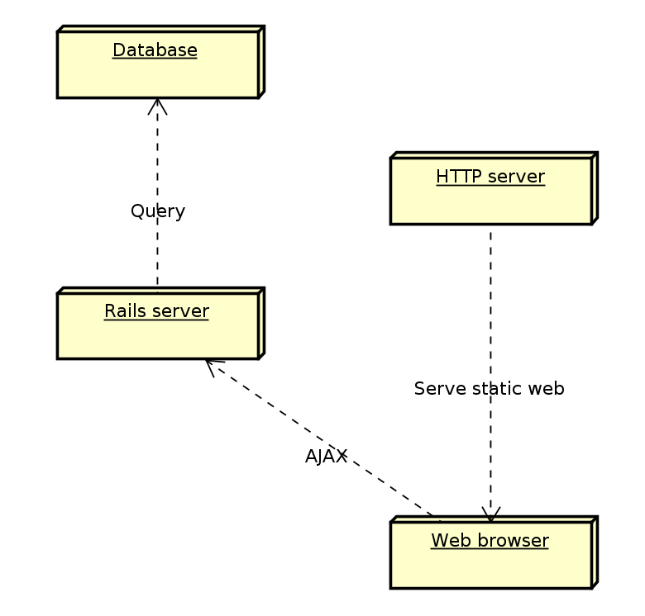

Note: HTTP server and Rails server can be deployed on single node instance.

3. Database design
