# Sign Up

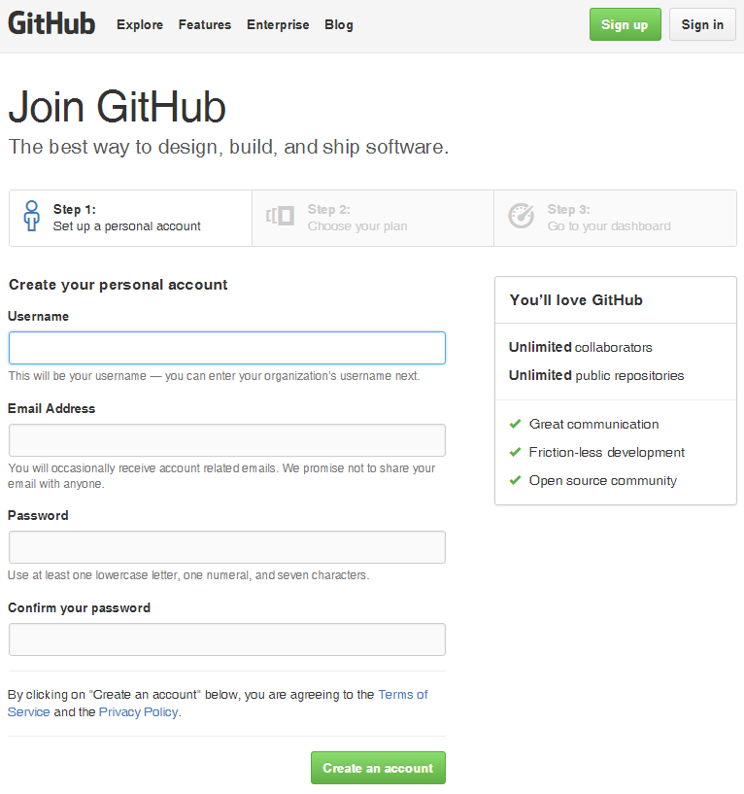

# Sign In

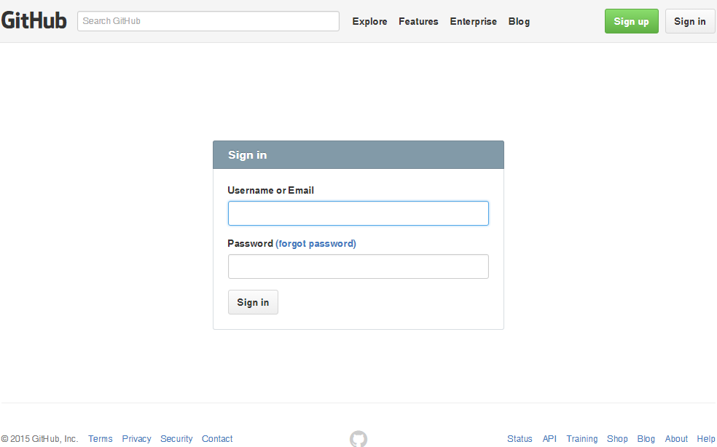

# Forgot password

## Forgot password

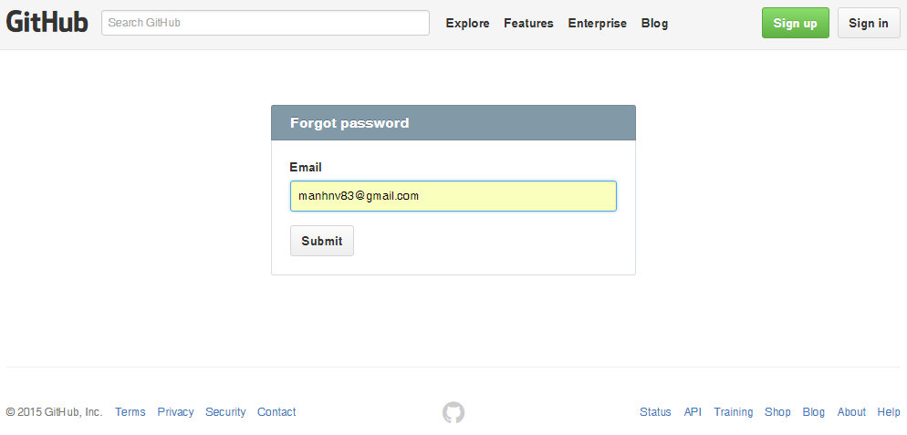

## Send email to change password

From: [noreply@github.com](mailto:noreply@github.com)

To: [manhnv83@gmail.com](mailto:manhnv83@gmail.com)

Subject: [GitHub] Please reset your password

We heard that you lost your GitHub password. Sorry about that!  
  
But don’t worry! You can use the following link within the next day to reset your password:  
  
<https://github.com/password_reset/000773523ea9978f039bc98bf311e59b504853ec3807579092ce55c2bcfe82a5656d61696cb26d616e686e76383340676d61696c2e636f6da5666f726365c2>  
  
If you don’t use this link within 24 hours, it will expire. To get a new password reset link, visit <https://github.com/password_reset>  
  
Thanks,  
Your friends at GitHub

# Change password

## Change password

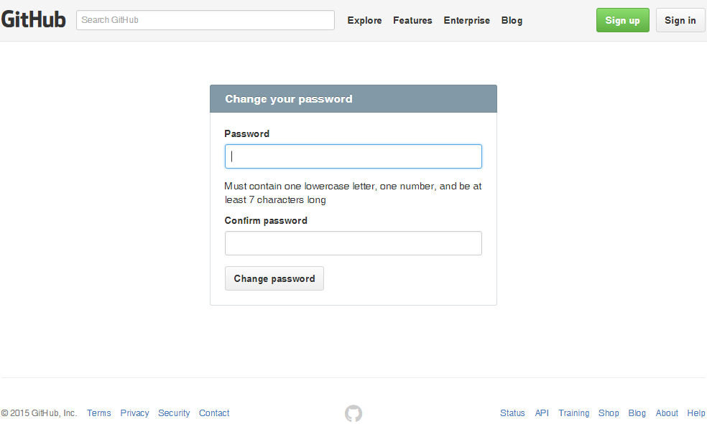

## Validate

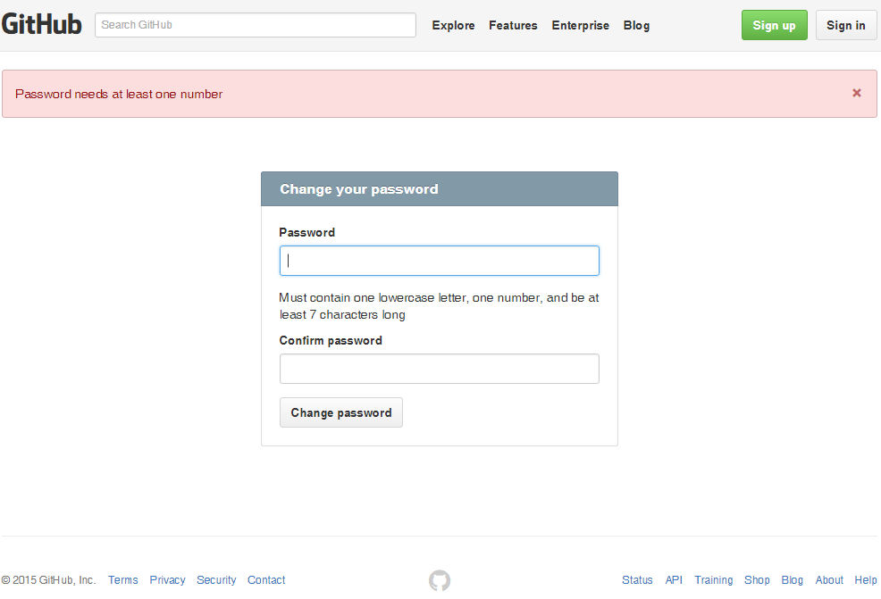

## Sent an email to user

From: [noreply@github.com](mailto:noreply@github.com)

To: [manhnv83@gmail.com](mailto:manhnv83@gmail.com)

Subject: [GitHub] Your password has changed

Hello manhnv83,  
  
We wanted to let you know that your GitHub password was changed.  
  
If you did not perform this action, you can recover access by entering [manhnv83@gmail.com](mailto:manhnv83@gmail.com) into the form at <https://github.com/password_reset>.  
  
To see this and other security events for your account, visit <https://github.com/settings/security>.  
  
If you run into problems, please contact support by visiting <https://github.com/contact> or replying to this email.

## Go to the login screen

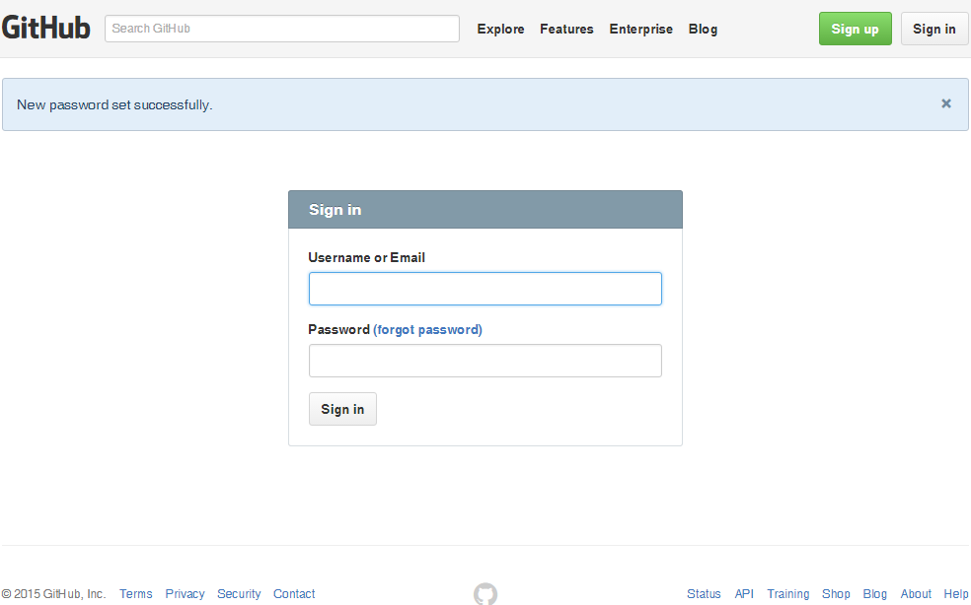

From: [noreply@github.com](mailto:noreply@github.com)

To: [manhnv83@gmail.com](mailto:manhnv83@gmail.com)

Subject: [GitHub] A new public key was added to your account

The following SSH key was added to your account:  
  
GitHub for Windows - ManhNV  
c1:6f:b7:9a:4d:73:17:0b:85:a2:7a:f4:3b:0b:93:34  
  
If you believe this key was added in error, you can remove the key and disable  
access at the following location:  
  
<https://github.com/settings/ssh>