Econ4274_problem_set_4

Man Adrian Ho Hin

2023-05-21

# Question 1a

rm(list=ls())  
set.seed(1)  
  
n = 200  
e = rnorm(n,0,1)  
x = rgamma(n,2)  
beta_0 = 1  
beta_1 = 0.5  
y = beta_0+beta_1*x+e  
  
DATA = cbind(y, x)

# Question 1b

m1 = lm(y~x)  
print(c("The beta_1_hat: ", summary(m1)$coefficients[2]))

## [1] "The beta_1_hat: " "0.471193719116018"

print(c("The standard error: ", summary(m1)$coefficients[4]))

## [1] "The standard error: " "0.0427031742366915"

# Question 1c

B=500  
n=200  
w=cbind(x,y)  
initial=rep(0.1,2)  
  
Q<-function(beta){  
 ehat=y-beta[1]-beta[2]*x  
 RSS=sum(ehat^2)  
 return(RSS)  
}  
  
bbetamat=NULL  
for (b in 1:B){  
 brow=sample(1:n,n,replace=TRUE)  
 bsample=w[brow,] #bootstrap sample  
 x=bsample[,1]; y=bsample[,2]   
 nls=optim(initial,Q)  
 bbeta=nls$par  
 bbetamat=rbind(bbetamat,bbeta)  
}  
bse2=sd(bbetamat[,2])  
print(c("The bootstrap standard error for beta_1: ", bse2))

## [1] "The bootstrap standard error for beta_1: "  
## [2] "0.0491346347951763"

# Question 1d

S = 500  
n = 200  
  
betamat=NULL  
for (s in 1:S){  
 #Generate a new sample using the known DGP  
 e = rnorm(n,0,1)  
 x = rgamma(n,2)  
 y = beta_0+beta_1*x+e  
 #estimte beta for each newly drawn sample  
 nls=optim(initial,Q)  
 betahat=nls$par  
 betamat=rbind(betamat,betahat)  
}  
truese2=sd(betamat[,2])  
print(c("The bootstrap standard error for beta_1: ", truese2))

## [1] "The bootstrap standard error for beta_1: "  
## [2] "0.0504802217684573"

# Question 1e

rm(list=ls())  
set.seed(1)  
  
B = 500  
S = 500  
n_mat = c(100,200,500)  
  
initial=rep(0.1,2)  
  
Q<-function(beta){  
 ehat=y-beta[1]-beta[2]*x  
 RSS=sum(ehat^2)  
 return(RSS)  
}  
  
for (n_m in n_mat){  
 n = n_m  
 e = rnorm(n,0,1)  
 x = rgamma(n,2)  
 beta_0 = 1  
 beta_1 = 0.5  
 y = beta_0+beta_1*x+e  
   
 # asympotic  
 m1 = lm(y~x)  
 ase = summary(m1)$coefficients[4]  
   
 # bootstrap  
 w=cbind(x,y)  
 bbetamat=NULL  
 for (b in 1:B){  
 brow=sample(1:n,n,replace=TRUE)  
 bsample=w[brow,] #bootstrap sample  
 x=bsample[,1]; y=bsample[,2]   
 nls=optim(initial,Q)  
 bbeta=nls$par  
 bbetamat=rbind(bbetamat,bbeta)  
 }  
 bse2=sd(bbetamat[,2])  
   
 # True  
 betamat=NULL  
 for (s in 1:S){  
 #Generate a new sample using the known DGP  
 e = rnorm(n,0,1)  
 x = rgamma(n,2)  
 y = beta_0+beta_1*x+e  
 #estimte beta for each newly drawn sample  
 nls=optim(initial,Q)  
 betahat=nls$par  
 betamat=rbind(betamat,betahat)  
 }  
 truese2=sd(betamat[,2])  
   
 cat("N =",n_m,":")  
 print(c(ase,bse2,truese2))  
}

# Question 2a

library(FNN)  
library(np)

## Nonparametric Kernel Methods for Mixed Datatypes (version 0.60-17)  
## [vignette("np_faq",package="np") provides answers to frequently asked questions]  
## [vignette("np",package="np") an overview]  
## [vignette("entropy_np",package="np") an overview of entropy-based methods]

rm(list=ls())  
DATA = read.csv("ipod.csv")  
  
DATA=DATA[order(DATA$BIDRS),]   
  
OLS1 = lm(PRICE~BIDRS, data=DATA)  
KNN1 = knn.reg(DATA$BIDRS,y=DATA$PRICE,k=1)  
KNN5 = knn.reg(DATA$BIDRS,y=DATA$PRICE,k=5)  
KNN10 = knn.reg(DATA$BIDRS,y=DATA$PRICE,k=10)  
KNN15 = knn.reg(DATA$BIDRS,y=DATA$PRICE,k=15)  
bw = npregbw(PRICE~BIDRS,data=DATA,bwmethod="cv.ls")

## Multistart 1 of 1 |Multistart 1 of 1 |Multistart 1 of 1 |Multistart 1 of 1 /Multistart 1 of 1 |Multistart 1 of 1 |

npest=npreg(bw)  
  
# OLS  
plot(DATA$PRICE~DATA$BIDRS,pch=20,main="OLS")  
lines(DATA$BIDRS,OLS1$fitted.values,col=2)

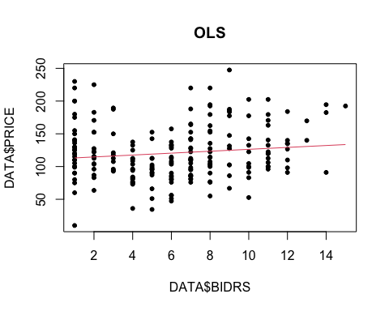

# KNN1  
plot(DATA$PRICE~DATA$BIDRS,pch=20,main="K=1")  
lines(DATA$BIDRS,KNN1$pred,col=2)

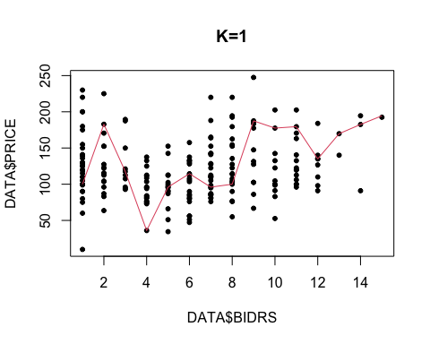

# KNN5  
plot(DATA$PRICE~DATA$BIDRS,pch=20,main="K=5")  
lines(DATA$BIDRS,KNN5$pred,col=2)

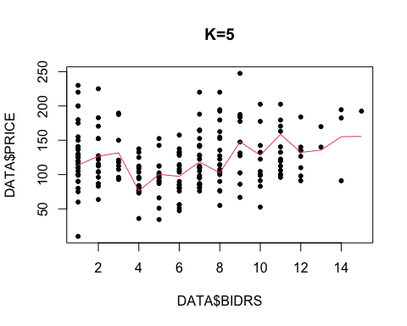

# KNN10  
plot(DATA$PRICE~DATA$BIDRS,pch=20,main="K=10")  
lines(DATA$BIDRS,KNN10$pred,col=2)

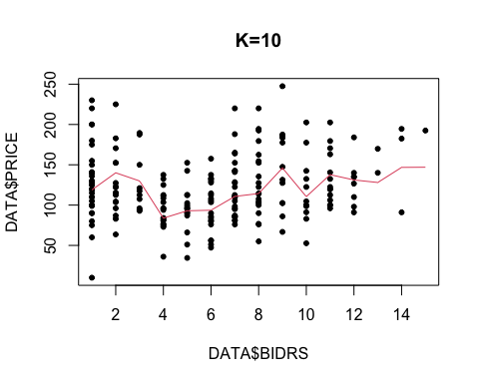

# KNN15  
plot(DATA$PRICE~DATA$BIDRS,pch=20,main="K=15")  
lines(DATA$BIDRS,KNN15$pred,col=2)

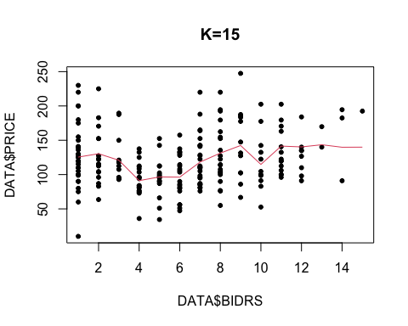

# npest  
plot(npest, main="Nonparametric Regression")  
points(PRICE~BIDRS,data=DATA,pch=20)

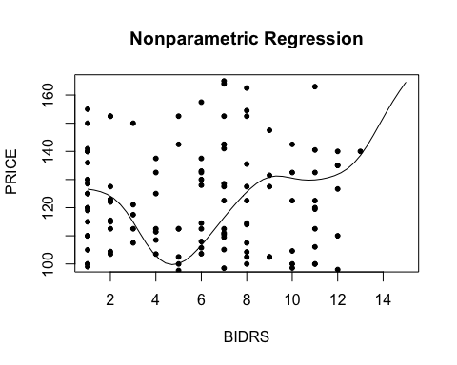

# Question 2b

x=cbind(DATA$BIDRS,DATA$PRICE)  
k2=kmeans(x,centers=2)  
k3=kmeans(x,centers=3)  
k4=kmeans(x,centers=4)  
k5=kmeans(x,centers=5)  
  
plot(DATA$BIDRS,DATA$PRICE,pch=20,col=k2$cluster,main="k=2")

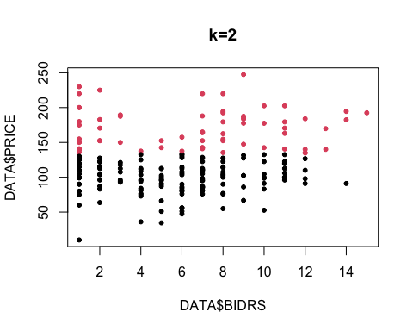

plot(DATA$BIDRS,DATA$PRICE,pch=20,col=k3$cluster,main="k=3")

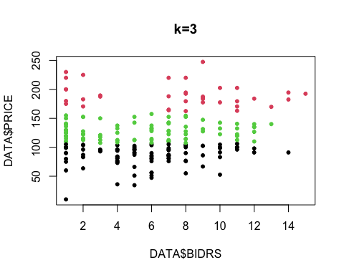

plot(DATA$BIDRS,DATA$PRICE,pch=20,col=k4$cluster,main="k=4")

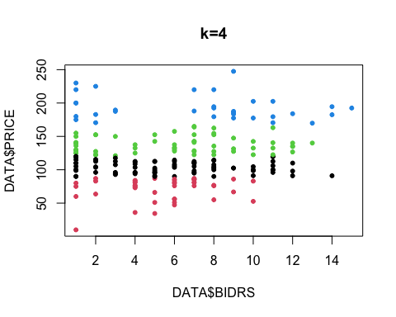

plot(DATA$BIDRS,DATA$PRICE,pch=20,col=k5$cluster,main="k=5")

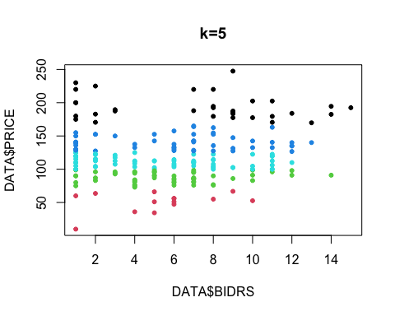

# Question 3a

rm(list=ls())  
DATA = read.csv("psid.ps5.csv")  
y=DATA$wagert  
x=as.matrix(DATA)[,-5]  
  
OLS = lm(y~x, data=DATA)  
R2_OLS = summary(OLS)$r.squared  
R2_OLS

## [1] 0.236601

# Question 3b

library(lars)

## Loaded lars 1.3

set.seed(1)  
  
lasso=lars(y=y,x=x,type="lasso",trace=TRUE)

## LASSO sequence  
## LARS Step 0 : 3 Variables with Variance < eps; dropped for good  
## Computing X'X .....  
## LARS Step 1 : Variable 4 added  
## LARS Step 2 : Variable 5 added  
## LARS Step 3 : Variable 3 added  
## LARS Step 3 : Variable 10 collinear; dropped for good  
## LARS Step 4 : Variable 1 added  
## LARS Step 5 : Variable 6 added  
## LARS Step 6 : Variable 22 added  
## LARS Step 7 : Variable 15 added  
## LARS Step 8 : Variable 19 added  
## LARS Step 9 : Variable 21 added  
## LARS Step 10 : Variable 29 added  
## LARS Step 11 : Variable 8 added  
## LARS Step 12 : Variable 27 added  
## LARS Step 13 : Variable 34 added  
## LARS Step 14 : Variable 18 added  
## LARS Step 15 : Variable 17 added  
## LARS Step 16 : Variable 14 added  
## LARS Step 17 : Variable 28 added  
## LARS Step 18 : Variable 11 added  
## LARS Step 19 : Variable 9 added  
## LARS Step 20 : Variable 30 added  
## LARS Step 21 : Variable 35 added  
## LARS Step 22 : Variable 13 added  
## LARS Step 23 : Variable 24 added  
## LARS Step 24 : Variable 26 added  
## LARS Step 25 : Variable 32 added  
## LARS Step 26 : Variable 2 added  
## LARS Step 27 : Variable 25 added  
## LARS Step 28 : Variable 12 added  
## LARS Step 29 : Variable 33 added  
## LARS Step 30 : Variable 23 added  
## Max |corr| = 0; exiting...  
## Computing residuals, RSS etc .....

plot(lasso)

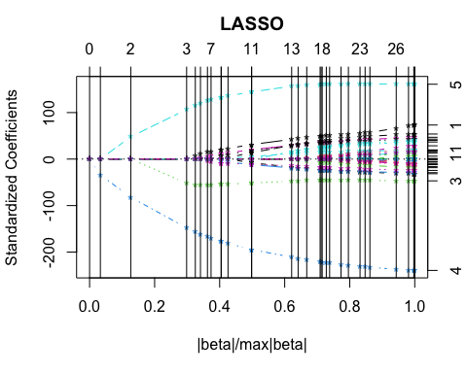

# Question 3c

cvlasso=cv.lars(y=y,x=x,type="lasso",trace=TRUE)

## LASSO sequence  
## LARS Step 0 : 3 Variables with Variance < eps; dropped for good  
## Computing X'X .....  
## LARS Step 1 : Variable 4 added  
## LARS Step 2 : Variable 5 added  
## LARS Step 3 : Variable 3 added  
## LARS Step 3 : Variable 10 collinear; dropped for good  
## LARS Step 4 : Variable 1 added  
## LARS Step 5 : Variable 22 added  
## LARS Step 6 : Variable 15 added  
## LARS Step 7 : Variable 19 added  
## LARS Step 8 : Variable 6 added  
## LARS Step 9 : Variable 29 added  
## LARS Step 10 : Variable 8 added  
## LARS Step 11 : Variable 34 added  
## LARS Step 12 : Variable 21 added  
## LARS Step 13 : Variable 27 added  
## LARS Step 14 : Variable 17 added  
## LARS Step 15 : Variable 14 added  
## LARS Step 16 : Variable 18 added  
## LARS Step 17 : Variable 30 added  
## LARS Step 18 : Variable 9 added  
## LARS Step 19 : Variable 35 added  
## LARS Step 20 : Variable 11 added  
## LARS Step 21 : Variable 13 added  
## LARS Step 22 : Variable 28 added  
## LARS Step 23 : Variable 32 added  
## LARS Step 24 : Variable 26 added  
## LARS Step 25 : Variable 24 added  
## LARS Step 26 : Variable 2 added  
## LARS Step 27 : Variable 12 added  
## LARS Step 28 : Variable 25 added  
## LARS Step 29 : Variable 33 added  
## LARS Step 30 : Variable 23 added  
## Max |corr| = 0; exiting...  
## Computing residuals, RSS etc .....  
##   
## CV Fold 1   
##   
## LASSO sequence  
## LARS Step 0 : 3 Variables with Variance < eps; dropped for good  
## Computing X'X .....  
## LARS Step 1 : Variable 4 added  
## LARS Step 2 : Variable 5 added  
## LARS Step 3 : Variable 3 added  
## LARS Step 3 : Variable 10 collinear; dropped for good  
## LARS Step 4 : Variable 6 added  
## LARS Step 5 : Variable 1 added  
## LARS Step 6 : Variable 15 added  
## LARS Step 7 : Variable 22 added  
## LARS Step 8 : Variable 21 added  
## LARS Step 9 : Variable 19 added  
## LARS Step 10 : Variable 34 added  
## LARS Step 11 : Variable 27 added  
## LARS Step 12 : Variable 8 added  
## LARS Step 13 : Variable 11 added  
## LARS Step 14 : Variable 29 added  
## LARS Step 15 : Variable 35 added  
## LARS Step 16 : Variable 30 added  
## LARS Step 17 : Variable 18 added  
## LARS Step 18 : Variable 17 added  
## LARS Step 19 : Variable 13 added  
## LARS Step 20 : Variable 12 added  
## LARS Step 21 : Variable 28 added  
## LARS Step 22 : Variable 9 added  
## LARS Step 23 : Variable 25 added  
## LARS Step 24 : Variable 24 added  
## LARS Step 25 : Variable 2 added  
## LARS Step 26 : Variable 14 added  
## LARS Step 27 : Variable 32 added  
## LARS Step 28 : Variable 33 added  
## LARS Step 29 : Variable 26 added  
## LARS Step 30 : Variable 23 added  
## Max |corr| = 0; exiting...  
## Computing residuals, RSS etc .....  
##   
## CV Fold 2   
##   
## LASSO sequence  
## LARS Step 0 : 3 Variables with Variance < eps; dropped for good  
## Computing X'X .....  
## LARS Step 1 : Variable 4 added  
## LARS Step 2 : Variable 5 added  
## LARS Step 3 : Variable 3 added  
## LARS Step 3 : Variable 10 collinear; dropped for good  
## LARS Step 4 : Variable 1 added  
## LARS Step 5 : Variable 22 added  
## LARS Step 6 : Variable 6 added  
## LARS Step 7 : Variable 29 added  
## LARS Step 8 : Variable 15 added  
## LARS Step 9 : Variable 8 added  
## LARS Step 10 : Variable 19 added  
## LARS Step 11 : Variable 27 added  
## LARS Step 12 : Variable 21 added  
## LARS Step 13 : Variable 34 added  
## LARS Step 14 : Variable 18 added  
## LARS Step 15 : Variable 17 added  
## LARS Step 16 : Variable 28 added  
## LARS Step 17 : Variable 14 added  
## LARS Step 18 : Variable 11 added  
## LARS Step 19 : Variable 9 added  
## LARS Step 20 : Variable 13 added  
## LARS Step 21 : Variable 26 added  
## LARS Step 22 : Variable 24 added  
## LARS Step 23 : Variable 30 added  
## LARS Step 24 : Variable 31 added  
## LARS Step 25 : Variable 33 added  
## LARS Step 26 : Variable 35 added  
## LARS Step 27 : Variable 2 added  
## LARS Step 28 : Variable 32 added  
## LARS Step 29 : Variable 23 added  
## LARS Step 30 : Variable 12 added  
## Max |corr| = 0; exiting...  
## Computing residuals, RSS etc .....  
##   
## CV Fold 3   
##   
## LASSO sequence  
## LARS Step 0 : 3 Variables with Variance < eps; dropped for good  
## Computing X'X .....  
## LARS Step 1 : Variable 4 added  
## LARS Step 2 : Variable 5 added  
## LARS Step 3 : Variable 3 added  
## LARS Step 3 : Variable 10 collinear; dropped for good  
## LARS Step 4 : Variable 1 added  
## LARS Step 5 : Variable 22 added  
## LARS Step 6 : Variable 6 added  
## LARS Step 7 : Variable 19 added  
## LARS Step 8 : Variable 29 added  
## LARS Step 9 : Variable 8 added  
## LARS Step 10 : Variable 34 added  
## LARS Step 11 : Variable 15 added  
## LARS Step 12 : Variable 24 added  
## LARS Step 13 : Variable 27 added  
## LARS Step 14 : Variable 14 added  
## LARS Step 15 : Variable 18 added  
## LARS Step 16 : Variable 17 added  
## LARS Step 17 : Variable 11 added  
## LARS Step 18 : Variable 21 added  
## LARS Step 19 : Variable 30 added  
## LARS Step 20 : Variable 28 added  
## LARS Step 21 : Variable 13 added  
## LARS Step 22 : Variable 9 added  
## LARS Step 23 : Variable 35 added  
## LARS Step 24 : Variable 32 added  
## LARS Step 25 : Variable 25 added  
## LARS Step 26 : Variable 26 added  
## LARS Step 27 : Variable 2 added  
## LARS Step 28 : Variable 12 added  
## LARS Step 29 : Variable 23 added  
## LARS Step 30 : Variable 31 added  
## Max |corr| = 0; exiting...  
## Computing residuals, RSS etc .....  
##   
## CV Fold 4   
##   
## LASSO sequence  
## LARS Step 0 : 3 Variables with Variance < eps; dropped for good  
## Computing X'X .....  
## LARS Step 1 : Variable 4 added  
## LARS Step 2 : Variable 5 added  
## LARS Step 3 : Variable 3 added  
## LARS Step 3 : Variable 10 collinear; dropped for good  
## LARS Step 4 : Variable 1 added  
## LARS Step 5 : Variable 15 added  
## LARS Step 6 : Variable 6 added  
## LARS Step 7 : Variable 19 added  
## LARS Step 8 : Variable 22 added  
## LARS Step 9 : Variable 29 added  
## LARS Step 10 : Variable 8 added  
## LARS Step 11 : Variable 21 added  
## LARS Step 12 : Variable 34 added  
## LARS Step 13 : Variable 27 added  
## LARS Step 14 : Variable 17 added  
## LARS Step 15 : Variable 18 added  
## LARS Step 16 : Variable 26 added  
## LARS Step 17 : Variable 11 added  
## LARS Step 18 : Variable 35 added  
## LARS Step 19 : Variable 9 added  
## LARS Step 20 : Variable 28 added  
## LARS Step 21 : Variable 32 added  
## LARS Step 22 : Variable 14 added  
## LARS Step 23 : Variable 13 added  
## LARS Step 24 : Variable 33 added  
## LARS Step 25 : Variable 24 added  
## LARS Step 26 : Variable 2 added  
## LARS Step 27 : Variable 30 added  
## LARS Step 28 : Variable 12 added  
## LARS Step 29 : Variable 23 added  
## LARS Step 30 : Variable 31 added  
## Max |corr| = 0; exiting...  
## Computing residuals, RSS etc .....  
##   
## CV Fold 5   
##   
## LASSO sequence  
## LARS Step 0 : 3 Variables with Variance < eps; dropped for good  
## Computing X'X .....  
## LARS Step 1 : Variable 4 added  
## LARS Step 2 : Variable 5 added  
## LARS Step 3 : Variable 3 added  
## LARS Step 3 : Variable 10 collinear; dropped for good  
## LARS Step 4 : Variable 1 added  
## LARS Step 5 : Variable 21 added  
## LARS Step 6 : Variable 6 added  
## LARS Step 7 : Variable 15 added  
## LARS Step 8 : Variable 19 added  
## LARS Step 9 : Variable 29 added  
## LARS Step 10 : Variable 8 added  
## LARS Step 11 : Variable 27 added  
## LARS Step 12 : Variable 18 added  
## LARS Step 13 : Variable 14 added  
## LARS Step 14 : Variable 11 added  
## LARS Step 15 : Variable 17 added  
## LARS Step 16 : Variable 9 added  
## LARS Step 17 : Variable 28 added  
## LARS Step 18 : Variable 30 added  
## LARS Step 19 : Variable 24 added  
## LARS Step 20 : Variable 35 added  
## LARS Step 21 : Variable 13 added  
## LARS Step 22 : Variable 23 added  
## LARS Step 23 : Variable 26 added  
## LARS Step 24 : Variable 2 added  
## LARS Step 25 : Variable 34 added  
## LARS Step 26 : Variable 32 added  
## LARS Step 27 : Variable 25 added  
## LARS Step 28 : Variable 12 added  
## LARS Step 29 : Variable 22 added  
## LARS Step 30 : Variable 33 added  
## Max |corr| = 0; exiting...  
## Computing residuals, RSS etc .....  
##   
## CV Fold 6   
##   
## LASSO sequence  
## LARS Step 0 : 3 Variables with Variance < eps; dropped for good  
## Computing X'X .....  
## LARS Step 1 : Variable 4 added  
## LARS Step 2 : Variable 5 added  
## LARS Step 3 : Variable 3 added  
## LARS Step 3 : Variable 10 collinear; dropped for good  
## LARS Step 4 : Variable 6 added  
## LARS Step 5 : Variable 15 added  
## LARS Step 6 : Variable 1 added  
## LARS Step 7 : Variable 22 added  
## LARS Step 8 : Variable 29 added  
## LARS Step 9 : Variable 19 added  
## LARS Step 10 : Variable 21 added  
## LARS Step 11 : Variable 8 added  
## LARS Step 12 : Variable 27 added  
## LARS Step 13 : Variable 34 added  
## LARS Step 14 : Variable 14 added  
## LARS Step 15 : Variable 28 added  
## LARS Step 16 : Variable 30 added  
## LARS Step 17 : Variable 18 added  
## LARS Step 18 : Variable 9 added  
## LARS Step 19 : Variable 32 added  
## LARS Step 20 : Variable 35 added  
## LARS Step 21 : Variable 17 added  
## LARS Step 22 : Variable 2 added  
## LARS Step 23 : Variable 13 added  
## LARS Step 24 : Variable 25 added  
## LARS Step 25 : Variable 11 added  
## LARS Step 26 : Variable 24 added  
## LARS Step 27 : Variable 12 added  
## LARS Step 28 : Variable 33 added  
## LARS Step 29 : Variable 31 added  
## LARS Step 30 : Variable 23 added  
## Max |corr| = 0; exiting...  
## Computing residuals, RSS etc .....  
##   
## CV Fold 7   
##   
## LASSO sequence  
## LARS Step 0 : 3 Variables with Variance < eps; dropped for good  
## Computing X'X .....  
## LARS Step 1 : Variable 4 added  
## LARS Step 2 : Variable 5 added  
## LARS Step 3 : Variable 3 added  
## LARS Step 3 : Variable 10 collinear; dropped for good  
## LARS Step 4 : Variable 1 added  
## LARS Step 5 : Variable 22 added  
## LARS Step 6 : Variable 6 added  
## LARS Step 7 : Variable 15 added  
## LARS Step 8 : Variable 19 added  
## LARS Step 9 : Variable 21 added  
## LARS Step 10 : Variable 29 added  
## LARS Step 11 : Variable 8 added  
## LARS Step 12 : Variable 27 added  
## LARS Step 13 : Variable 34 added  
## LARS Step 14 : Variable 14 added  
## LARS Step 15 : Variable 18 added  
## LARS Step 16 : Variable 17 added  
## LARS Step 17 : Variable 28 added  
## LARS Step 18 : Variable 30 added  
## LARS Step 19 : Variable 9 added  
## LARS Step 20 : Variable 35 added  
## LARS Step 21 : Variable 31 added  
## LARS Step 22 : Variable 26 added  
## LARS Step 23 : Variable 11 added  
## LARS Step 24 : Variable 32 added  
## LARS Step 25 : Variable 13 added  
## LARS Step 26 : Variable 2 added  
## LARS Step 27 : Variable 33 added  
## LARS Step 28 : Variable 12 added  
## LARS Step 29 : Variable 25 added  
## LARS Step 30 : Variable 23 added  
## Max |corr| = 0; exiting...  
## Computing residuals, RSS etc .....  
##   
## CV Fold 8   
##   
## LASSO sequence  
## LARS Step 0 : 3 Variables with Variance < eps; dropped for good  
## Computing X'X .....  
## LARS Step 1 : Variable 4 added  
## LARS Step 2 : Variable 5 added  
## LARS Step 3 : Variable 3 added  
## LARS Step 3 : Variable 10 collinear; dropped for good  
## LARS Step 4 : Variable 6 added  
## LARS Step 5 : Variable 1 added  
## LARS Step 6 : Variable 19 added  
## LARS Step 7 : Variable 15 added  
## LARS Step 8 : Variable 22 added  
## LARS Step 9 : Variable 29 added  
## LARS Step 10 : Variable 21 added  
## LARS Step 11 : Variable 8 added  
## LARS Step 12 : Variable 34 added  
## LARS Step 13 : Variable 27 added  
## LARS Step 14 : Variable 18 added  
## LARS Step 15 : Variable 17 added  
## LARS Step 16 : Variable 14 added  
## LARS Step 17 : Variable 30 added  
## LARS Step 18 : Variable 28 added  
## LARS Step 19 : Variable 31 added  
## LARS Step 20 : Variable 24 added  
## LARS Step 21 : Variable 11 added  
## LARS Step 22 : Variable 35 added  
## LARS Step 23 : Variable 13 added  
## LARS Step 24 : Variable 9 added  
## LARS Step 25 : Variable 2 added  
## LARS Step 26 : Variable 26 added  
## LARS Step 27 : Variable 12 added  
## LARS Step 28 : Variable 25 added  
## LARS Step 29 : Variable 32 added  
## LARS Step 30 : Variable 23 added  
## Max |corr| = 0; exiting...  
## Computing residuals, RSS etc .....  
##   
## CV Fold 9   
##   
## LASSO sequence  
## LARS Step 0 : 3 Variables with Variance < eps; dropped for good  
## Computing X'X .....  
## LARS Step 1 : Variable 4 added  
## LARS Step 2 : Variable 5 added  
## LARS Step 3 : Variable 3 added  
## LARS Step 3 : Variable 10 collinear; dropped for good  
## LARS Step 4 : Variable 1 added  
## LARS Step 5 : Variable 6 added  
## LARS Step 6 : Variable 22 added  
## LARS Step 7 : Variable 19 added  
## LARS Step 8 : Variable 15 added  
## LARS Step 9 : Variable 29 added  
## LARS Step 10 : Variable 8 added  
## LARS Step 11 : Variable 27 added  
## LARS Step 12 : Variable 34 added  
## LARS Step 13 : Variable 21 added  
## LARS Step 14 : Variable 18 added  
## LARS Step 15 : Variable 17 added  
## LARS Step 16 : Variable 9 added  
## LARS Step 17 : Variable 13 added  
## LARS Step 18 : Variable 11 added  
## LARS Step 19 : Variable 35 added  
## LARS Step 20 : Variable 30 added  
## LARS Step 21 : Variable 28 added  
## LARS Step 22 : Variable 2 added  
## LARS Step 23 : Variable 26 added  
## LARS Step 24 : Variable 14 added  
## LARS Step 25 : Variable 32 added  
## LARS Step 26 : Variable 12 added  
## LARS Step 27 : Variable 24 added  
## LARS Step 28 : Variable 25 added  
## LARS Step 29 : Variable 23 added  
## LARS Step 30 : Variable 31 added  
## Max |corr| = 0; exiting...  
## Computing residuals, RSS etc .....  
##   
## CV Fold 10

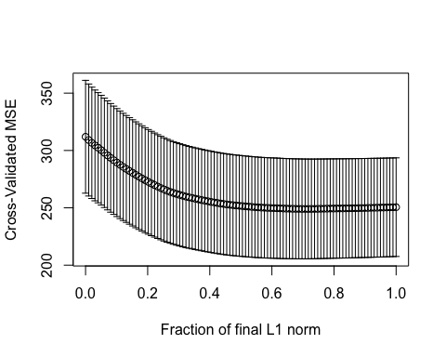

modelno=which.min(cvlasso$cv)  
t=cvlasso$index[modelno]   
  
lassobeta=coef(lasso,newx=x,s=t,mode="fraction")  
  
yhat=predict(lasso,newx=x,s=t,mode="fraction")$fit  
  
R2_lasso=sum((yhat-mean(y))^2)/sum((y-mean(y))^2)  
  
print(c("The R2 of OLS: ", R2_OLS))

## [1] "The R2 of OLS: " "0.236600953019591"

print(c("The R2 of lasso (best model): ", R2_lasso))

## [1] "The R2 of lasso (best model): " "0.19117476881647"

Therefore the lasso has a smaller R2 with comparing to OLS.