

AWS First Cloud AI Journey – Project Plan

[H-HNQS]

FPT University

AWS Serverless Application Deployment with Full IaC & Security Automation

30/11/2025
Table of Contents
1 BACKGROUND and motivation 3
1.1 executive summary 3
1.2 PROJECT SUCCESS CRITERIA 3
1.3 Assumptions 3
2 SOLUTION ARCHITECTURE / ARCHITECTURAL DIAGRAM 3
2.1 Technical Architecture Diagram 3
2.2 Technical Plan 4
2.3 Project Plan 4
2.4 Security Considerations 4
3 Activities AND Deliverables 5
3.1 Activities and deliverables 5
3.2 OUT OF SCOPE 5
3.3 PATH TO PRODUCTION 5
4 EXPECTED AWS COST BREAKDOWN BY SERVICES 5
5 TEAM 6
6 resources & cost estimates 6
7 Acceptance 7

BACKGROUND and motivation

executive summary
The project operates a serverless application on AWS with a fully automated CI/CD pipeline. When code is pushed to GitLab, the pipeline automatically scans for security vulnerabilities (Semgrep, Trivy), builds containers, provisions infrastructure via Terraform, and deploys images to Amazon ECR. Users access the application through Route 53 → CloudFront → WAF → API Gateway, authenticated by Cognito, invoking Lambda functions for business logic and storing data in DynamoDB. The system continuously monitors through CloudWatch, CloudTrail, and GuardDuty, sending alerts via EventBridge → SNS upon incidents or threats.
Problem Statement Many organizations struggle with deploying serverless applications due to error-prone manual processes, lack of security controls, and scalability challenges. Specific issues include:
- Manual deployment processes lack consistent security checks, often missing vulnerability scanning and automated testing steps.
- Existing systems do not provide high-performance content delivery (CDN) nor application-layer protection against DDoS and bot attacks.
- Secrets, encryption keys, and IAM permissions are difficult to manage end-to-end across the CI/CD pipeline while maintaining least-privilege principles.
- Limited observability causes slow incident response and delayed threat detection.
Solution The project delivers a complete serverless architecture with automated CI/CD, integrated security, and comprehensive monitoring. The deployment pipeline automates from GitLab through CodePipeline, CodeBuild, Semgrep (SAST), Trivy (container scanning), Terraform (IaC), and CodeDeploy, ensuring every change is tested and security-scanned. The delivery layer uses Route 53, CloudFront, and WAF to accelerate and protect the application. The serverless backend with Cognito (authentication), API Gateway, Lambda, DynamoDB, Secrets Manager, and KMS ensures data security. A multi-layer monitoring system (CloudWatch, CloudTrail, GuardDuty, EventBridge, SNS) detects and alerts on incidents instantly.

PROJECT SUCCESS CRITERIA
- Automation: Full automation reduces deployment time by 80-90% and eliminates manual errors.
- Security: Integrated security reduces vulnerability risks; pervasive data encryption is applied.
- Performance: CDN and serverless architecture ensure high performance with automatic scaling and low latency.
- Observability: Centralized monitoring enables 70-80% faster incident detection (surfaces incidents instantly).
- Cost Efficiency: Operational costs are estimated at ~$20-40/month for small to medium scale, with 60-70% reduction in operational labor costs and no upfront hardware investment.
- ROI: Expected payback period is 1-2 months.

Assumptions
- Assumption 1: No hardware expenditure is required as the solution is fully cloud-native (Serverless).
- Assumption 2: Actual spend varies with traffic and configuration; costs can drop further by shutting down dev/test environments.
- Risk 1 (Undetected vulnerabilities): High impact, Medium likelihood. Mitigation: Mandatory Semgrep/Trivy scans, periodic manual reviews.
- Risk 2 (Misconfigured Terraform): High impact, Low likelihood. Mitigation: Peer review Terraform plans, use staging environments, back up state.
- Risk 3 (Cost spikes): Medium impact, Medium likelihood. Mitigation: AWS Budgets, tune CloudFront cache policies.

SOLUTION ARCHITECTURE / ARCHITECTURAL DIAGRAM

Technical Architecture Diagram
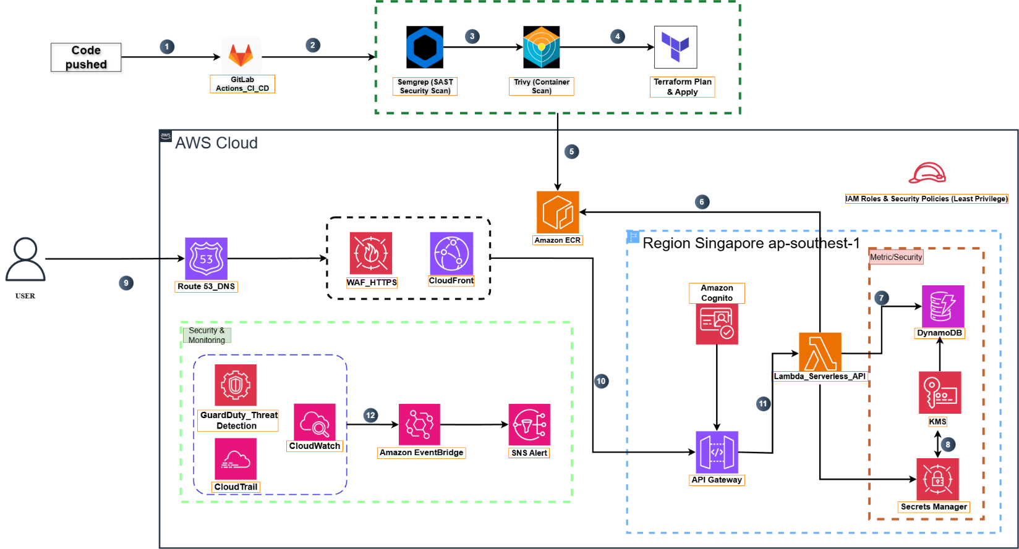
The architecture is divided into three domains:
- CI/CD Pipeline: Running on GitLab and AWS CodePipeline to build containers, scan security (Semgrep, Trivy), provision infrastructure via Terraform, and deploy images to Amazon ECR.
- Content Delivery & Protection Layer: Using Route 53, AWS WAF, and CloudFront to accelerate and secure user access.
- Serverless Application Core: Located in ap-southeast-1 region with Cognito (authentication), API Gateway, Lambda (business logic), DynamoDB (storage), KMS and Secrets Manager (security), and the observability suite (CloudWatch, CloudTrail, GuardDuty, EventBridge, SNS).
Tools Used:
- CI/CD: GitLab Actions, AWS CodePipeline, CodeBuild, CodeDeploy
- Security Scanning: Semgrep, Trivy
- Infrastructure: Terraform, Amazon ECR
- Compute & App Integration: Amazon Cognito, Amazon API Gateway, AWS Lambda, Amazon DynamoDB
- Networking & Content Delivery: AWS WAF, Amazon CloudFront, Amazon Route 53
- Security & Compliance: AWS Secrets Manager, AWS Key Management Service (KMS)
- Management & Governance: Amazon CloudWatch, AWS CloudTrail, Amazon GuardDuty, Amazon EventBridge, Amazon SNS

Technical Plan
Implementation Steps:
- Model the infrastructure with Terraform: Create logical VPC boundaries, least-privilege IAM roles, API Gateway, Lambda, DynamoDB, and security controls.
- Configure GitLab CI/CD: Set up integration with AWS CodePipeline/CodeBuild/CodeDeploy using cross-account IAM roles.
- Enforce Security Scans: Implement Semgrep and Trivy scans in every pipeline run, configuring builds to fail on high-severity findings.
- Define Terraform Modules: Create modular code for Lambda (container images in ECR), API Gateway, CloudFront, WAF, and Cognito resources.
- Enable Observability: Configure CloudWatch log groups, metric filters, GuardDuty, and CloudTrail; create EventBridge rules that fan out to SNS alerts.
- Automated Rollback: Implement automated rollback mechanisms via CodeDeploy deployment groups and versioned Terraform state.

Project Plan
The project will follow a phased approach focusing on security and automation first.
- CI/CD: A Git push triggers the pipeline to run Semgrep (SAST), build containers in CodeBuild, scan with Trivy, execute Terraform Plan/Apply, and deliver via CodeDeploy.
- Delivery & Protection: Route 53 handles DNS → CloudFront caches content → WAF filters malicious traffic before reaching the APIs.
- Application Services: Cognito issues tokens, API Gateway validates requests and forwards them to Lambda.

Security Considerations
- Access: Least-privilege IAM roles are enforced via Terraform. Cognito handles user authentication (with backup user pool strategy).
- Infrastructure: Infrastructure as Code (Terraform) with version control and peer reviews. Staging environments used before production.
- Data: Secrets Manager stores sensitive information; KMS encrypts data and keys.
- Detection: GuardDuty detects threats; CloudTrail records audit trails.
- Incident Management: EventBridge routes anomalies to SNS notifications for instant alerting. Automated rollbacks via CodeDeploy for critical failures.

Activities AND Deliverables

Activities and deliverables

Project Phase | Timeline | Activities | Deliverables/Milestones | Total man-day
Kick-off | Week 1 | Requirements intake, detailed design, IAM role matrix | Detailed Design Document, IAM Matrix | 3 MD
IaC & CI/CD Setup | Week 2 | Terraform baseline, GitLab pipeline, CodePipeline integration | Terraform Repo, Working Pipeline | 5 MD
Security Integration | Week 3 | Semgrep, Trivy, WAF rules, Cognito, Secrets Manager | Security Scan Reports, WAF Config | 4 MD
Backend Completion | Week 4 | Lambda handlers, API Gateway routes, DynamoDB schema, unit tests | API Endpoints, Database Schema | 5 MD
Deployment & Testing | Week 5 | End-to-end pipeline run, integration and CDN performance testing | Test Reports, StagingEnvironment | 3 MD
Operations & Handover | Week 6 | Optimize monitoring systems, configure intelligent alerting, finalize documentation | Monitoring Dashboard, Handover Docs | 2 MD
Post-Deployment | Week 7 | Continuous performance/cost monitoring, configuration optimization | Operational Report | 1 MD

OUT OF SCOPE
- Application frontend development (focus is on backend and infrastructure).
- Legacy data migration (unless explicitly specified in future phases).
- Hardware provisioning (Serverless architecture assumes no hardware management).

PATH TO PRODUCTION
Contingency & Optimization:
- Security Incidents: Upon detection of critical vulnerabilities, immediately rollback to the previous version via CodeDeploy, isolate affected resources, notify the security team, and proceed with patching.
- Downtime from Misconfiguration: Use Terraform state backup to restore previous configuration, temporarily route traffic to staging environment if needed, and maintain a runbook for quick rollback.
- Authentication Failures: Switch to a backup Cognito user pool in another region and utilize API Gateway caching to reduce load.
- Future Expansion: The infrastructure foundation is extensible for future features or additional AWS Regions.

EXPECTED AWS COST BREAKDOWN BY SERVICES
Budget Estimation:
AWS Service | Primary Billing Factor | Estimated Cost (USD)
AWS Lambda & API Gateway | 250,000 requests/month | ~$1.00 - $3.00
Amazon DynamoDB | 5 GB storage, 5 RCU/5 WCU (Provisioned) | ~$5.00 - $10.00
CI/CD (CodePipeline/CodeBuild) | 5 deployments (250 build minutes) | ~$2.25 - $4.00
Amazon ECR | 5 GB image storage ($0.10/GB) | ~$0.50 - $1.50
Route 53 | 1 Hosted Zone + queries | ~$0.54
CloudFront / WAF | 15 GB Data Transfer Out, basic WAF usage | ~$9.50 - $15.50
Security & Monitoring | GuardDuty, KMS, Secrets Manager, minimal logs | ~$2.00 - $5.00
Total Cost |  | ~$20.79 - $39.54

TEAM
Partner Executive Sponsor
Name | Title | Description | Email / Contact Info
Duong Viet Huy | Project Lead | Overall project owner, responsible for architectural approval, progress coordination, supporting team members, and ensuring successful delivery | huydvse184528@fpt.edu.vn
Project Stakeholders
Name | Title | Stakeholder for | Email / Contact Info
Duong Viet Huy | Project Lead | Architecture review, task assignment, progress coordination, testing, cost control, report approval | huydvse184528@fpt.edu.vn
Dao Manh Quang | Backend & DevOps Engineer | Serverless backend API, IaC (Terraform, Trivy, Semgrep), CI/CD pipeline, Python development, Docker setup, repository management | quangdmhe186515@fpt.edu.vn
Nguyen Thanh Nguyen | Cloud Engineer | Terraform code, enabling HTTPS with ACM, configuring AWS WAF, preparing documentation & report materials | nguyen.fridayed@gmail.com
Ho Hoang Hiep | Cloud Security Engineer | Configuring GuardDuty, CloudWatch, CloudTrail, EventBridge → SNS, system simulation, operations & IaC monitoring | otakebenson@gmail.com
Tran Anh Son | Cloud & IAM Engineer | Cognito setup, CloudFront Distribution, IAM permissions, ECR image workflow, client configuration | trananhson2005th@gmail.com
Partner Project Team
Name | Title | Role | Email / Contact Info
Duong Viet Huy | Project Lead | Project Manager, Architecture Reviewer, Final Approver | huydvse184528@fpt.edu.vn
Dao Manh Quang | Backend & DevOps Engineer | Serverless backend API, Terraform IaC, CI/CD pipeline, Python codebase, Docker configuration, source control | quangdmhe186515@fpt.edu.vn
Nguyen Thanh Nguyen | Cloud Engineer | Terraform development, ACM HTTPS, AWS WAF configuration, documentation | nguyen.fridayed@gmail.com
Ho Hoang Hiep | Cloud Security Engineer | GuardDuty, CloudWatch, CloudTrail, EventBridge → SNS, monitoring & simulation | otakebenson@gmail.com
Tran Anh Son | Cloud & IAM Engineer | Cognito, CloudFront, IAM policies, ECR image push, client setup | trananhson2005th@gmail.com
Project Escalation Contacts
Name | Title | Role | Email / Contact Info
Duong Viet Huy | Project Lead | Primary Escalation Contact | huydvse184528@fpt.edu.vn
Dao Manh Quang | Backend & DevOps Engineer | Secondary Escalation Contact | quangdmhe186515@fpt.edu.vn

resources & cost estimates

Resource | Responsibility | Rate (USD) / Hour
Solution Architects (1) | Architecture review, system design validation, progress coordination | $25/hr
Engineers (4) | Backend development, DevOps, IaC (Terraform), Security setup, Cloud services configuration, documentation | $15/hr each

Project Phase | Solution Architects (hrs) | Engineers(hrs) | Other  (Please specify) | Total Hours
Assessment | 4 | 12 |  | 16
Base Infrastructure Setup | 6 | 20 |  | 26
Component 1 Development | 4 | 24 |  | 28
Component 2 Development (Security + CI/CD + Services) | 4 | 28 |  | 32
Testing & Go-Live | 4 | 20 |  | 24
Handover & Documentation | 2 | 10 |  | 12
Total Hours | 24 hrs | 114 hrs |  | 138 hrs
Total Cost | $600 | $1,710 |  | $2,310

Cost Contribution distribution between Partner, Customer, AWS:
Party | Contribution (USD) | % Contribution of Total
Customer | $0 | 0%
Partner | $0 | 0%
AWS | $2,310 (Covered via AWS Promotional Credits) | 100%

Acceptance
To conclude the project, the acceptance process is defined as follows:
- Completion of Deliverables
At the end of each project phase, the project team will submit the completed deliverables for internal review, including:
  - Infrastructure components provisioned via Terraform
  - Backend serverless APIs
  - CI/CD pipeline configuration
  - Security configurations (GuardDuty, WAF, IAM, CloudWatch, CloudTrail, EventBridge)
  - Documentation and architecture diagrams
- Internal Review Process
The Project Lead will review each deliverable to ensure it meets the functional, security, and architectural requirements defined in the project scope.
Any issues or gaps identified during the review will be reported back to the responsible engineer for correction.
- Correction & Resubmission
Team members will address feedback, correct defects, and resubmit the deliverable for a second review.
The Project Lead will validate only the updated components to confirm compliance.
- Final Acceptance
A deliverable is considered accepted when:
  - It meets the defined acceptance criteria
  - It functions properly in the deployed environment
  - All identified issues have been resolved
  - Documentation is complete
- Implicit Acceptance
If no issues are raised within five (5) days after submission of a deliverable, the deliverable will be considered accepted by default.
- Scope of Acceptance
Since this is a non-commercial academic project funded entirely by AWS Credits, acceptance signifies:
  - Completion of planned project objectives
  - Readiness for demonstration
  - Compliance with AWS best practices

