Tuan Doan  Haaga-Helia University of Applied Sciences  Python Programming - SOF004AS2AE-3009 | Written Assignment  25.3.2026

Written Assignment Week 8
  - a)
- first print output: The population of the small country is 12222
- second print output: The population of India is 12222
  - When the european_countries takes the object of nordic_countries, every attempts to modify the list will affect the nordic_countries as well as the european_countries. Therefore, when it goes to print(*nordic_countries) it will print exactly the same with print(*european_countries), and it will print (Finland, Sweden, Norway, Denmark, Iceland)
  - 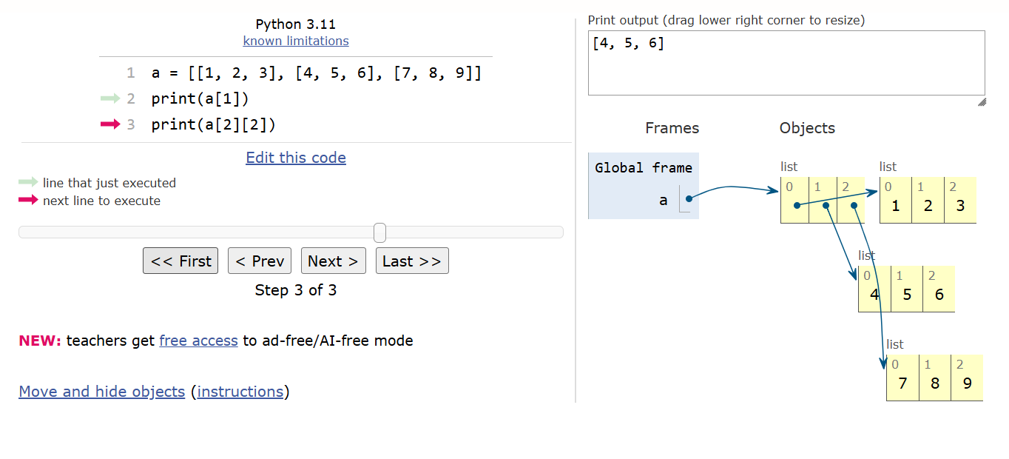
4 lists are on displayed, including 1 outer and 3 inner lists
  - 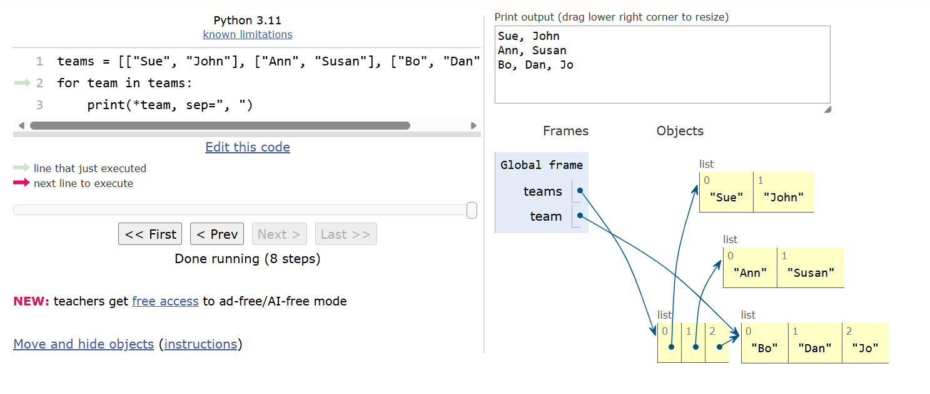
4 lists are on displayed, including 1 outer and 3 inner lists
  - Python tutor tool
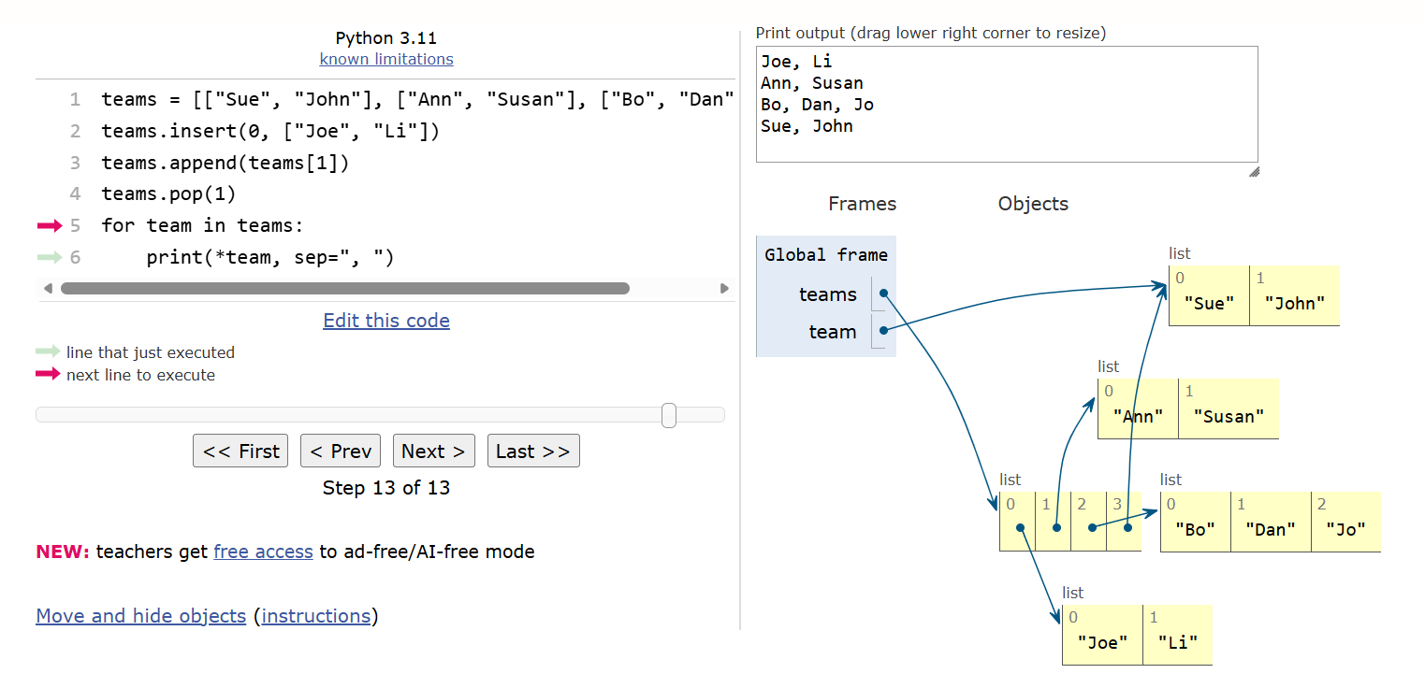
There are 5 lists, the outer list + the inserted list + 3 original lists. The code line teams.append(teams[1]) doesn’t create a new list, but adds a reference to an existing list.
  - Python Tutor does not show everything that happens in real Python memory. It makes the picture simpler. In real Python, every variable and every list element is actually a reference (a pointer) to an object. But Python Tutor does not draw all these arrows, because it would look too messy. Instead, it only shows one arrow to each object, even if many variables or list items point to the same thing. Therefore, the visualisation is easier to read, but not exactly the same as what happens inside Python.
  - 2 string objects are stored in the memory. Python Tutor does not create a new string object every time the same text appears. Instead, it saves the string only one time in the memo, and then it uses the same string again when needed. So even if the string shows many times in the code, there are only a few real string objects in the memory.

