Student Management System
Full Stack CRUD Web Application Project Report
Submitted by
Manikandan M
Register Number 922525243113
B Tech Artificial Intelligence and Data Science
II Year 3 Semester
V S B Engineering College Karur
Project repository github com mani 538 student management system

Abstract
The Student Management System is a full stack web application developed to replace slow and error-prone manual student record handling with a centralized digital workflow. The application supports the complete create, read, update, and delete cycle for student records through a responsive browser interface. A Django REST Framework backend validates requests, applies business rules, and persists data through the Django object relational mapper to an SQLite database. The frontend uses HTML, CSS, and JavaScript to communicate with the REST API using JSON.
The implemented system validates names, email addresses, courses, and student ages at both client and server levels. It also provides real-time search, clear success and error feedback, safe text rendering, confirmation before deletion, and responsive layouts for desktop and mobile devices. Verification included 11 automated Django API tests, 22 passing Postman assertions, and browser tests of CRUD operations, validation, search, and responsive behavior.

Contents
- Introduction
- Requirements Analysis
- Technology Stack
- System Architecture
- Database Design
- Application Implementation
- REST API Documentation
- Validation Security and Error Handling
- Testing and Results
- Application Screenshots
- Installation and Execution
- Challenges and Solutions
- Future Enhancements
- Conclusion
- References
- A Demonstration Checklist

1 Introduction

1.1 Project Overview
The Student Management System is a lightweight administrative application for maintaining student contact and course information. It provides a single interface for registering students, displaying stored records, correcting existing information, removing obsolete records, and searching the displayed data. The frontend and backend are separated so that the user interface communicates with the server through defined HTTP endpoints.

1.2 Problem Statement
Paper registers and disconnected spreadsheets make student information difficult to validate, search, and maintain. Duplicate email addresses, incomplete fields, invalid ages, and outdated course information can reduce data quality. The project addresses these problems through structured database storage, automatic validation, searchable records, and a consistent CRUD workflow.

1.3 Objectives
- Develop a responsive web interface for managing student records.
- Implement RESTful endpoints for all CRUD operations.
- Store records using Django ORM and SQLite.
- Apply client-side and server-side validation.
- Test successful operations and common failure conditions.
- Maintain reproducible setup instructions and source control history.

1.4 Scope
The project manages one primary Student entity with name, email, course, and age fields. It includes CRUD operations, search, validation, responsive presentation, API testing, and documentation. Authentication, role-based access, bulk import, and deployment to a public production server are outside the current mini-project scope.

2 Requirements Analysis

2.1 Functional Requirements
ID | Requirement | Expected Result
FR1 | Create a student using valid form data | A new record is stored and displayed
FR2 | Read all student records | The interface displays the current database contents
FR3 | Update a selected student | Modified values replace the previous values
FR4 | Delete a selected student after confirmation | The selected record is removed
FR5 | Search by name email or course | Matching records are filtered in real time
FR6 | Reject invalid or duplicate data | Clear field-level errors are displayed

2.2 Non Functional Requirements
- Usability: labels, action buttons, notifications, and empty states are clear.
- Responsiveness: the interface adapts to desktop, tablet, and mobile widths.
- Maintainability: frontend, API, serializer, model, and database responsibilities are separated.
- Reliability: automated tests cover CRUD behavior and invalid input cases.
- Security: user-controlled values are rendered with textContent and server input is validated.

3 Technology Stack
Layer | Technology | Purpose
Frontend | HTML5 CSS3 JavaScript | Responsive interface and client-side behavior
Backend | Python Django | Application configuration routing and ORM
API | Django REST Framework | Serialization validation and CRUD endpoints
Database | SQLite | Local relational data persistence
Integration | Fetch API and JSON | Browser-to-server communication
Testing | Django APITestCase and Postman | Automated and manual API verification
Version Control | Git and GitHub | Source history backup and submission

4 System Architecture
The solution follows a separated client-server architecture. The browser sends JSON requests to REST endpoints. Django REST Framework routes each request to a viewset, the serializer validates and normalizes the data, and Django ORM performs the database operation. The API then returns a JSON response that the frontend uses to update the interface.
Browser Frontend | REST API | Serializer | Django ORM | SQLite Database
Figure 1 Application request and data flow

5 Database Design
The current application uses a single Student table because each record is independent and no additional entities are required for the defined scope. The email column is unique, while Django supplies the primary key and timestamps. Model validators constrain the accepted age range.
Field | Data Type | Constraint | Description
id | Integer | Primary key auto generated | Unique record identifier
name | String 100 | Required | Student full name
email | Email string | Required and unique | Normalized contact address
course | String 100 | Required | Academic course
age | Positive integer | 16 to 100 | Validated student age
created_at | Date time | Automatic on create | Creation timestamp
updated_at | Date time | Automatic on update | Last modification timestamp

6 Application Implementation

6.1 Backend Implementation
The students Django application defines the Student model, registers it in the administration interface, and exposes it through a StudentViewSet. StudentSerializer controls the public fields, marks generated values as read-only, trims text, converts email addresses to lowercase, checks email uniqueness without case sensitivity, and enforces the age range. Django REST Framework DefaultRouter creates the collection and detail routes.

6.2 Frontend Implementation
The frontend is a single-page interface built with plain HTML, CSS, and JavaScript. JavaScript fetch calls load records and send POST, PUT, and DELETE requests. Editing reuses the main form and changes its state from Add Student to Update Student. Search filters records by name, email, or course without another server request. The CSS layout changes from two columns to a compact single-column presentation on narrow screens.

6.3 CRUD Workflow
Operation | User Action | API Action | Interface Result
Create | Complete and submit form | POST collection endpoint | New row and success message
Read | Open or refresh page | GET collection endpoint | Current records displayed
Update | Select Edit and submit changes | PUT detail endpoint | Updated row displayed
Delete | Confirm Delete | DELETE detail endpoint | Record removed from view

7 REST API Documentation
Method | Endpoint | Purpose | Success
POST | /api/students/ | Create a student | 201 Created
GET | /api/students/ | List students | 200 OK
GET | /api/students/<id>/ | Retrieve one student | 200 OK
PUT | /api/students/<id>/ | Replace a student record | 200 OK
PATCH | /api/students/<id>/ | Update selected fields | 200 OK
DELETE | /api/students/<id>/ | Delete a student | 204 No Content

Invalid payloads return 400 Bad Request with field-level messages. Requests for an unknown student identifier return 404 Not Found. JSON is used for request and response bodies.

8 Validation Security and Error Handling
Area | Implemented Control
Required data | Name email course and age are mandatory
Text values | Whitespace-only name and course values are rejected
Email | Format validation lowercase normalization and case-insensitive uniqueness
Age | Integer range restricted to 16 through 100
Duplicate requests | Submit button is disabled while a request is pending
Browser output | API values are inserted with textContent to reduce XSS risk
Deletion | Confirmation is required before a DELETE request
Connectivity | A helpful message is shown when the backend is unavailable

9 Testing and Results

9.1 Django Automated Tests
The backend test suite uses Django REST Framework APITestCase. Eleven tests cover successful CRUD requests, whitespace validation, malformed email addresses, duplicate email addresses, both age boundaries, and lookup of a nonexistent record. The final run completed with 11 passed tests, 0 failures, 0 errors, and no Django system-check issues.

9.2 Postman API Tests
A Postman Collection v2.1 executes 12 requests in sequence. Collection variables carry the dynamically created student identifier and email into later requests. The collection checks status codes, JSON shapes, returned values, validation responses, deletion, and the final 404 response. The recorded collection run produced 22 passed assertions and 0 failed assertions.

9.3 Browser Tests
Scenario | Expected Result | Result
Initial load | Form search controls counter and records display | Passed
Create | Valid student is stored and displayed | Passed
Search | Name email and course matches filter immediately | Passed
Update | Selected record changes and form resets | Passed
Delete | Confirmed record is removed | Passed
Validation | Invalid age is rejected with a message | Passed
Responsive layout | Mobile view has readable controls and records | Passed

10 Application Screenshots
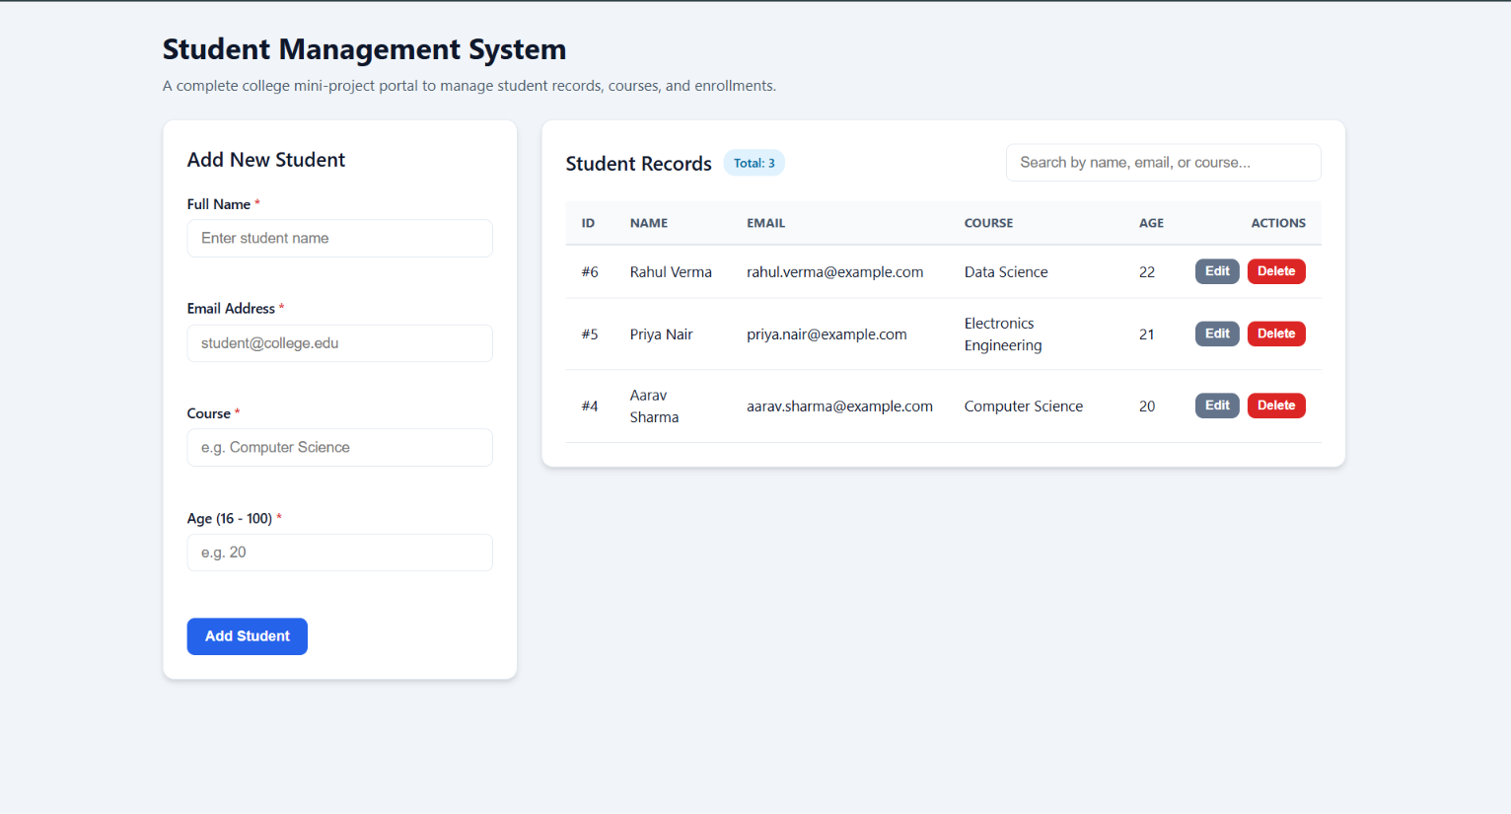
Figure 2 Desktop dashboard with demonstration student records

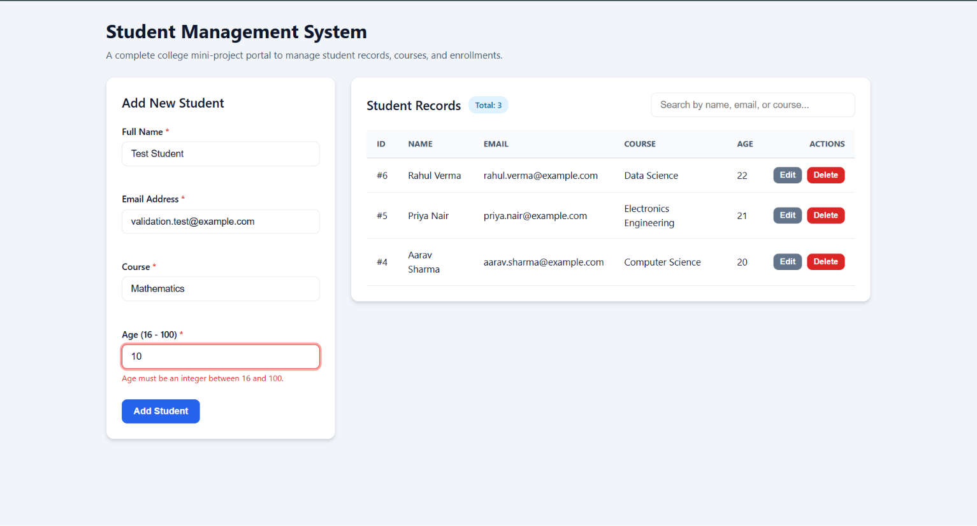
Figure 3 Client-side validation rejects an age below the allowed range

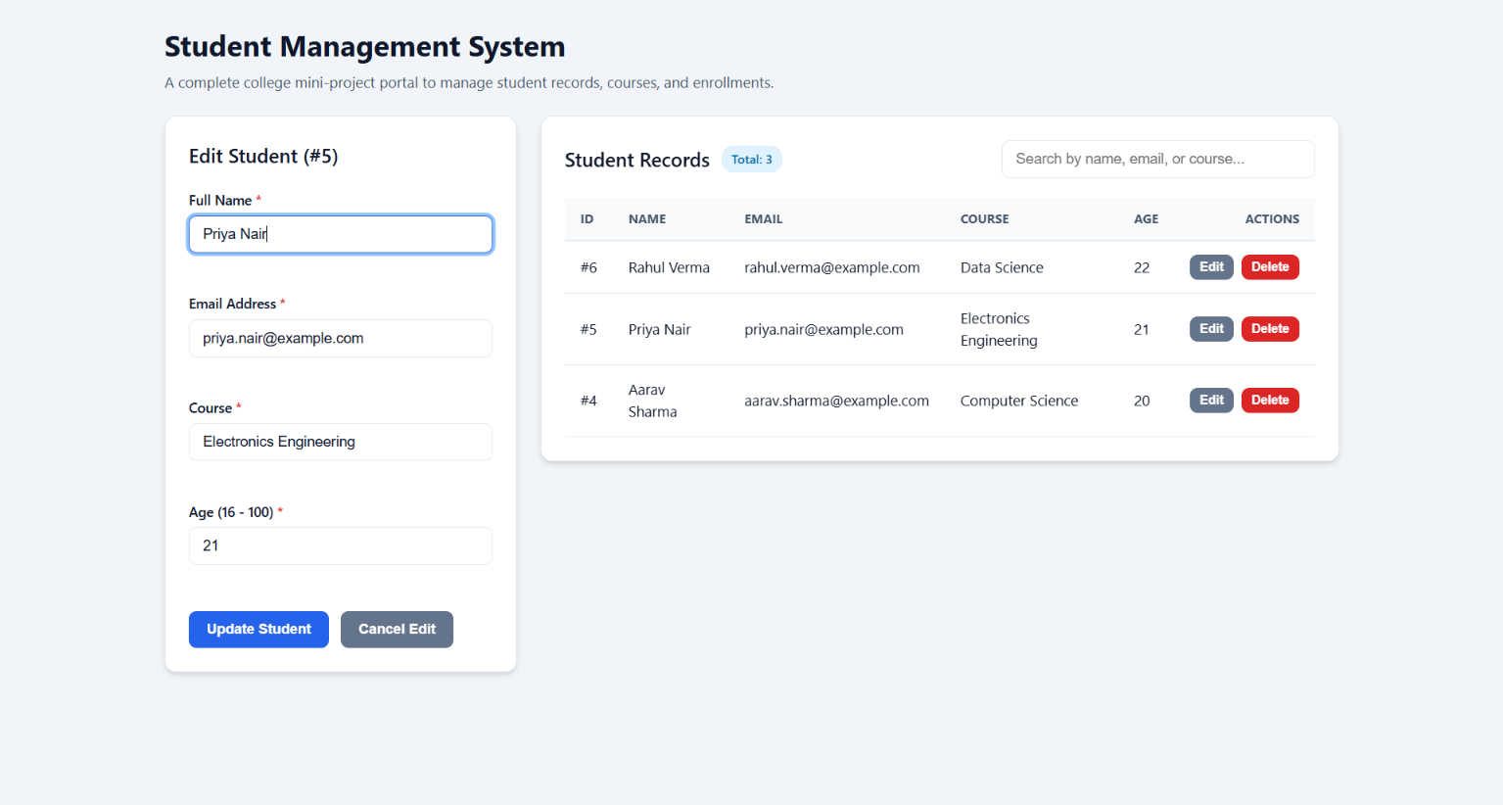
Figure 4 Student update mode with populated form values

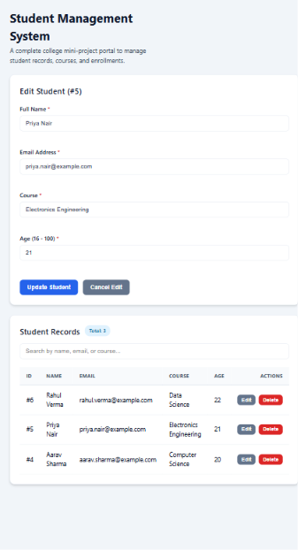
Figure 5 Responsive application layout at mobile width

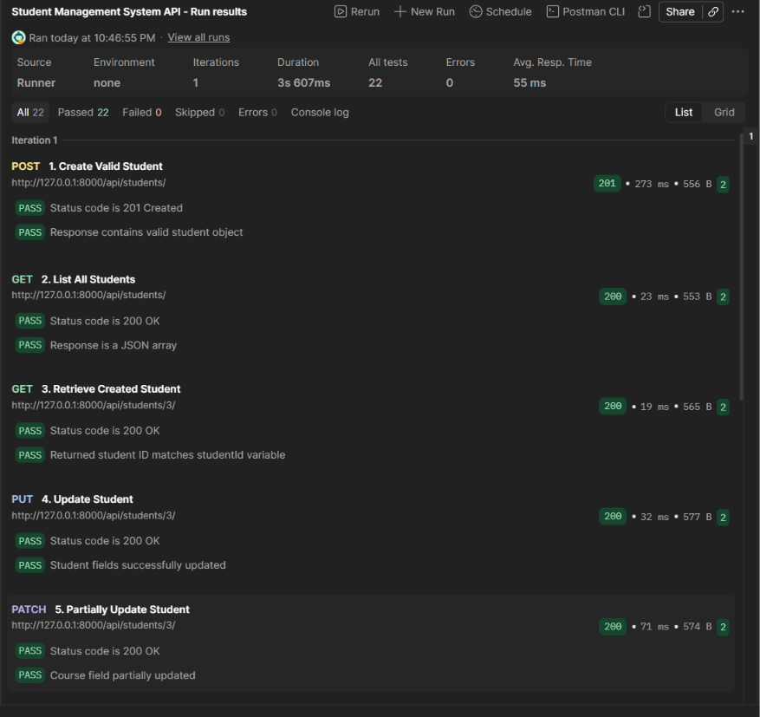
Figure 6 Postman collection run with 22 passed and 0 failed assertions

11 Installation and Execution
- Clone the repository using git clone https://github.com/mani-538/student-management-system.git
- Enter the directory with cd student-management-system
- Create the virtual environment using python -m venv .venv
- Install dependencies using .\.venv\Scripts\pip.exe install -r requirements.txt
- Apply migrations using .\.venv\Scripts\python.exe backend\manage.py migrate
- Start the API using .\.venv\Scripts\python.exe backend\manage.py runserver
- In a second terminal start the frontend using .\.venv\Scripts\python.exe -m http.server 5500 --directory frontend
- Open http://127.0.0.1:5500 in a browser.

11.1 Running Automated Tests
Run .\.venv\Scripts\python.exe backend\manage.py test from the project root. The Postman collection is stored under docs/postman and can be imported into Postman Desktop while the backend server is running.

12 Challenges and Solutions
Challenge | Solution
Preventing invalid and duplicate student data | Applied validation in the browser serializer and model constraints
Keeping frontend and backend independent | Used a REST API JSON responses Fetch API and CORS middleware
Updating the interface after CRUD requests | Reloaded the authoritative API data after each successful operation
Avoiding unsafe HTML rendering | Created DOM nodes and assigned user values with textContent
Testing dependent API operations | Stored dynamic ID and email values as Postman collection variables

13 Future Enhancements
- Add authenticated administrator accounts and role-based permissions.
- Add server-side pagination and sorting for larger datasets.
- Introduce Department and Enrollment entities with relational links.
- Support CSV and PDF exports and bulk student import.
- Deploy the backend and frontend to a secured production environment.
- Add audit history for record creation modification and deletion.

14 Conclusion
The project satisfies the core requirement for a complete CRUD-based web application. It combines a responsive frontend, REST API, relational database, validation, exception-aware feedback, automated tests, Postman verification, documentation, and Git version control. All four CRUD operations were demonstrated successfully, and the recorded tests confirm correct handling of both valid requests and common invalid conditions.

15 References
- Django documentation https://docs.djangoproject.com/
- Django REST Framework documentation https://www.django-rest-framework.org/
- MDN Web Docs https://developer.mozilla.org/
- Postman Learning Center https://learning.postman.com/
- Project repository https://github.com/mani-538/student-management-system

Appendix A Demonstration Checklist
Check | Status
Application starts without errors | Verified
Database migrations and connection work | Verified
Create operation works | Verified
Read and list operation works | Verified
Update operation works | Verified
Delete operation works | Verified
Validation messages work | Verified
Search filtering works | Verified
API endpoints are available for demonstration | Verified
Source code documentation and test evidence are available | Verified

