**Real-time chat application**

**DEVELOPED BY:**

MANIKANDAN C

HARIPRAKASH S

THIRUPATHI S

SHENBAGARAJAN V

**Sign-up page:**

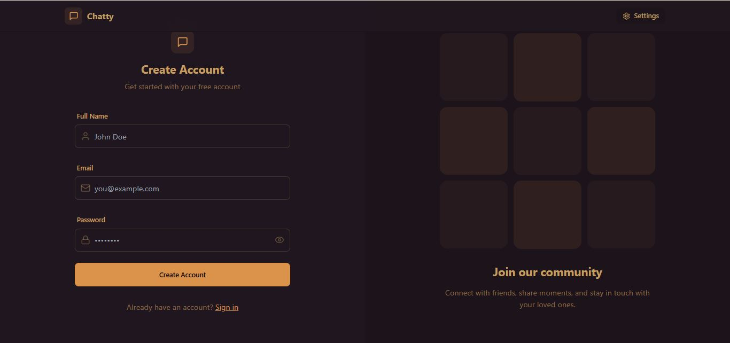Fig1:Sign-up page

**Login Page:**

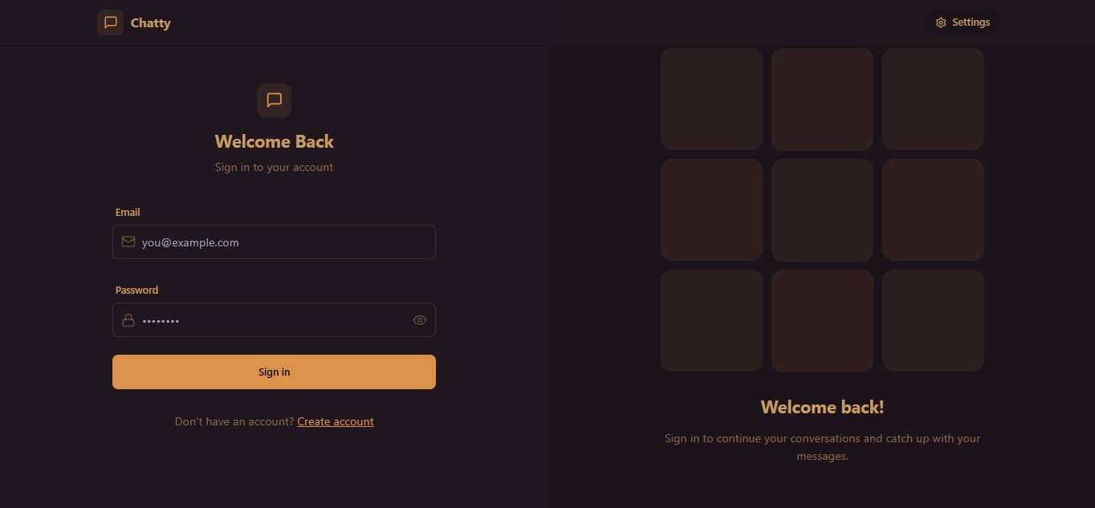

**DASHBOARD:**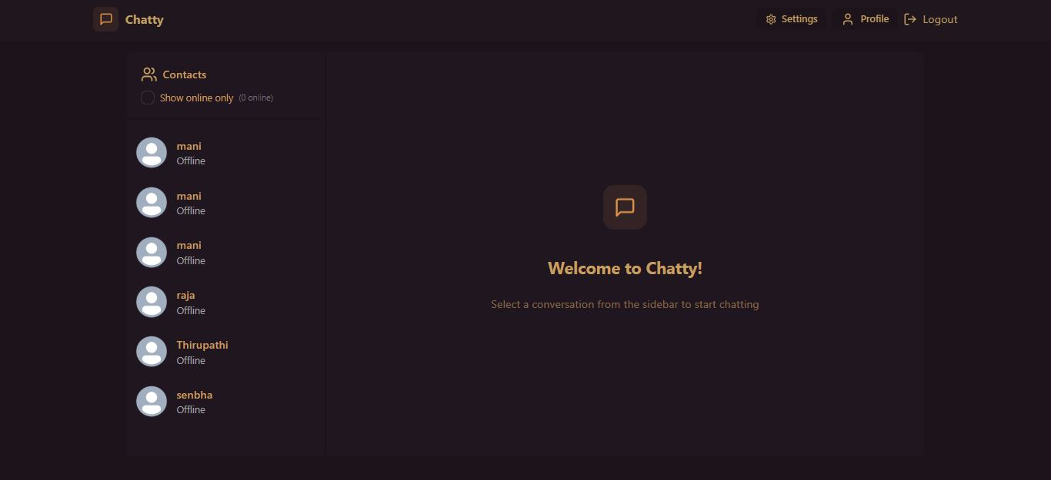

Fig 1.3: Dashboard

**PROFILE:**

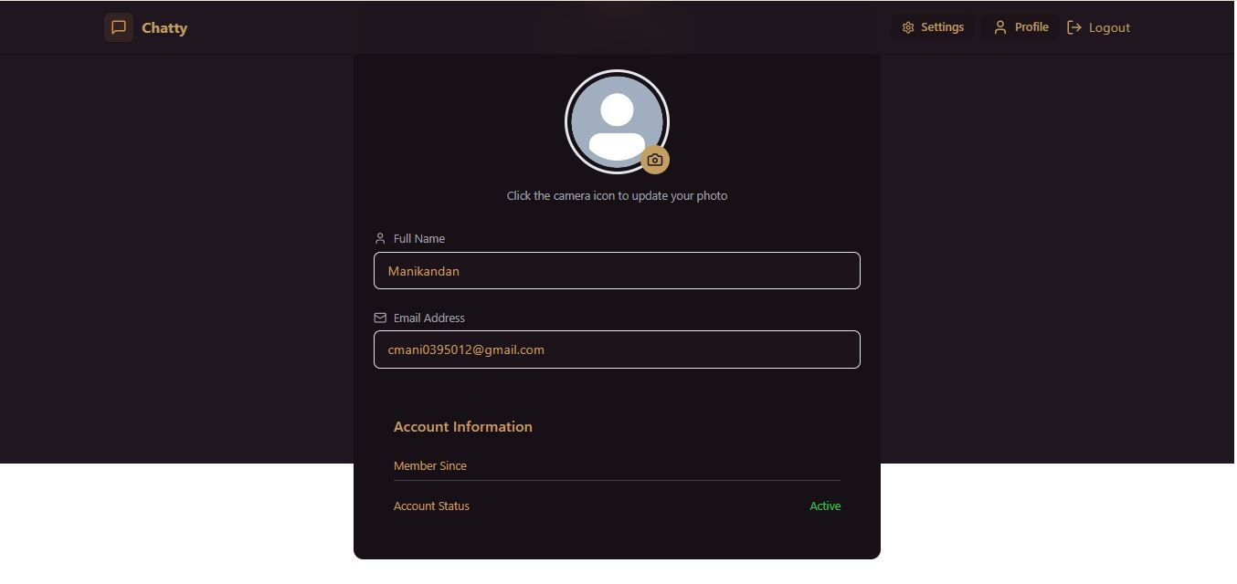

Fig 1.4: profile-page

**PERSONAL CHAT:**

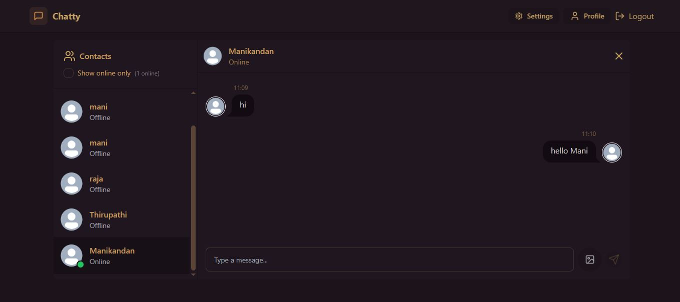

Fig 2.1: personal chat page

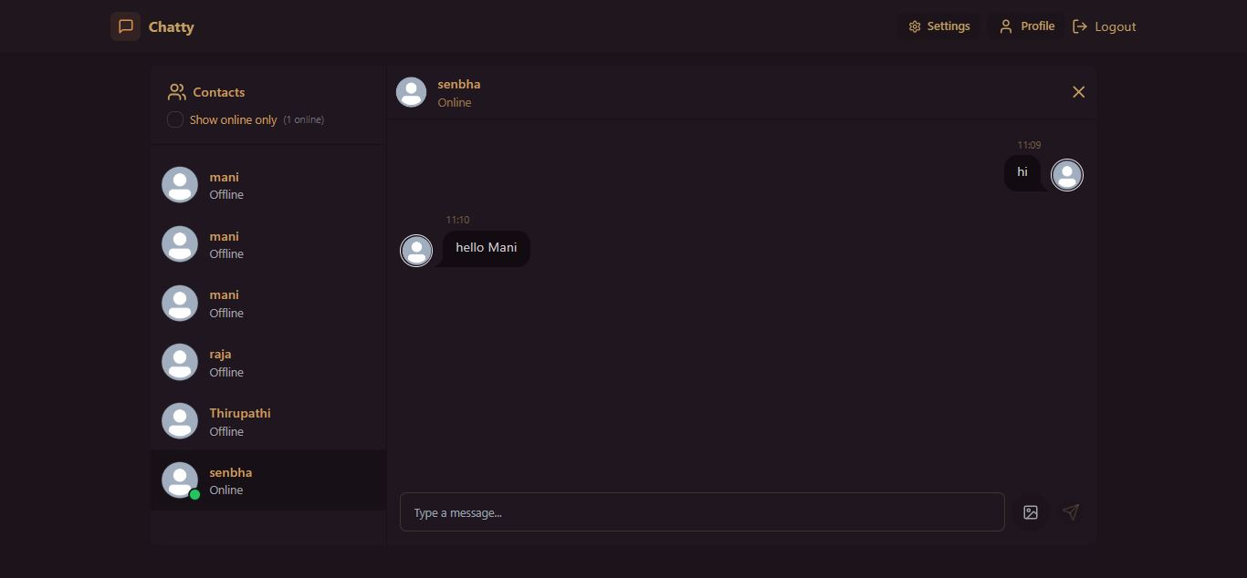

Fig 2.2: personal chat page