Quantization
Ref: https://huggingface.co/docs/transformers/main/en/quantization/concept_guide#quantization-concepts

What is it?
It’s the process of reducing the precision (eg: From FP16 to 4-bit or 8-bit quants) of the weights (sometimes activations and caches) of LLMs. It helps:
- Reduce model’s memory footprint
- Increase Inference speeds through less data movement from memory and specialized hardware operations like FP4, INT4, INT2 compute untis.
- Reduced energy utilization through smaller memory transfer.
The weight matrices are lowered to lower precision from FP16 to 4-bits, for example, using a quantization method that groups weights into ‘blocks’ (usually 32 or 256 weights at a time) and it has a ‘scaling-factor’ in higher precision (FP16) and these blocks are stored as compressed 4-bit integers (int8_t type). To get the weights back, with some loss in accuracy, you’d multiply the ‘scaling-factor’ with ‘blocks’

How does it work?
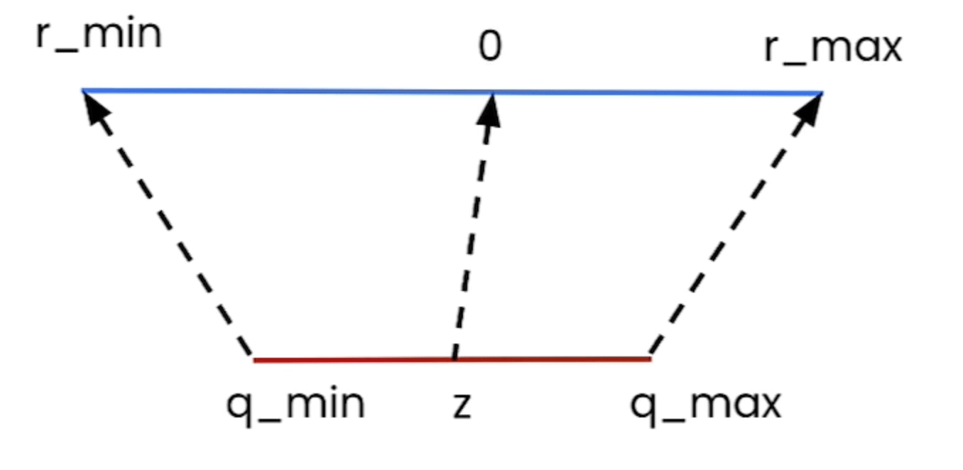

Sometimes during training, but mostly during inference. During inference, computations like matrix multiplication are performed using the int8 (int8_t) values, and the results are dequantized back to FP32(often using a higher-precision accumulation type like int32 internally) before it is passed to the next layer. Inference engines like vLLM does this for you during inference.

Where is it used?

Quantization Methods
Methods to convert FP16 → FP4/INT4/INT8, etc.
PTQ (Post-Training Quantization): Quantization is applied after the model is fully trained.
Quantization-Aware Training (QAT): Quantization effects are simulated during training by inserting “fake quantization” ops that simulate the rounding errors of quantization. This lets the model adapt to quantization, and usually results in better accuracy, especially at lower bit-widths.

.GGUF Model format
It’s primarily used for llama.cpp, it combines meta-data (model architecture, model layers, num_heads, etc.), tokenizer informations, and weight tensors. The quantization is per-tensor. Eg: Q4_K_M (has few weight blocks in 4-bit and others few weight blocks in 6-bit, along with norms (normalization layers), embed in FP16).
llama.cpp inference flow (GPU offload via CUDA/Metal backend):

- mmap(model.gguf) -> kernel maps the GGUF file into virtual address space, and tensor data is selectively loaded or pinned into GPU VRAM (depending on offload layer count).

- Parse header, metadata, and tensor info -> construct in-RAM index mapping tensor pointers.

- For each generation step:
a. Tokenize input via embedded BPE/SentencePiece tokenizer.
b. For each transformer layer:
- Stream compressed GGUF quantized weight blocks directly from VRAM into the GPU's streaming multiprocessor (SM) or compute unit registers.
- Perform on-the-fly dequantization and matrix multiplication fused into high-performance custom CUDA/Metal kernels against FP16/FP32 activations.
- Accumulate results in FP32, apply norm, attention, and FFN blocks.
- Write computed Key and Value pairs into the KV cache allocated in VRAM (stored in FP16 by default, or quantized if configured).
c. Sample next token, append to context window, and output result.

KV cache stays in VRAM in FP16/BF16 (or quantized formats if --kv-cache-dtype is specified).

