ASM-WAF-SQS-MQ-Assignment-01

ASM
- Task Title: Securely retrieval of database URL and database password from the Parameter Store using EC2
- Objective:
To securely store database connection details in AWS Systems Manager Parameter Store and retrieve them at runtime from an EC2 instance using IAM roles, without hardcoding sensitive information.
- Prerequisites:
• AWS account with access to Systems Manager, IAM, and EC2

- Step-by-Step Implementation (With Evidence):
Step 1: Create parameters in AWS Systems Manager Parameter Store
• Console path / CLI command: AWS Systems Manager → Parameter Store → Create parameter
• Explanation:
Created two parameters:
– Database-URL-from-PS as a String parameter to store the database URL
– Database-Password-from-PS as a SecureString parameter encrypted using the default AWS KMS key
This ensures separation of configuration and secrets with encryption for sensitive data.
Evidence: 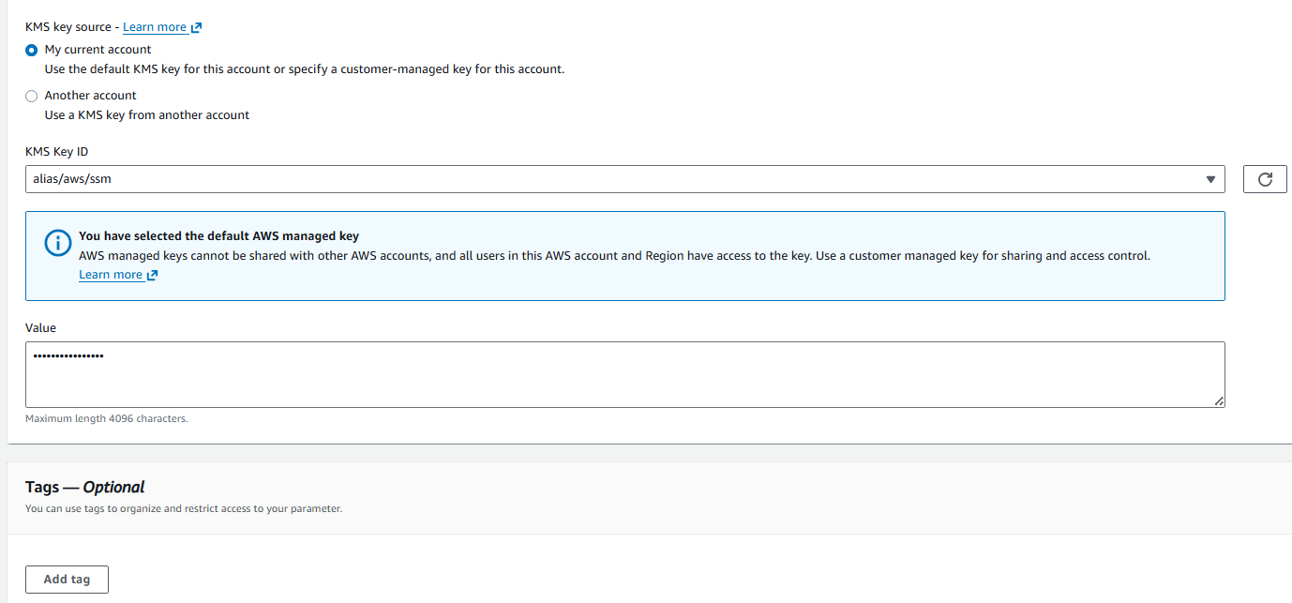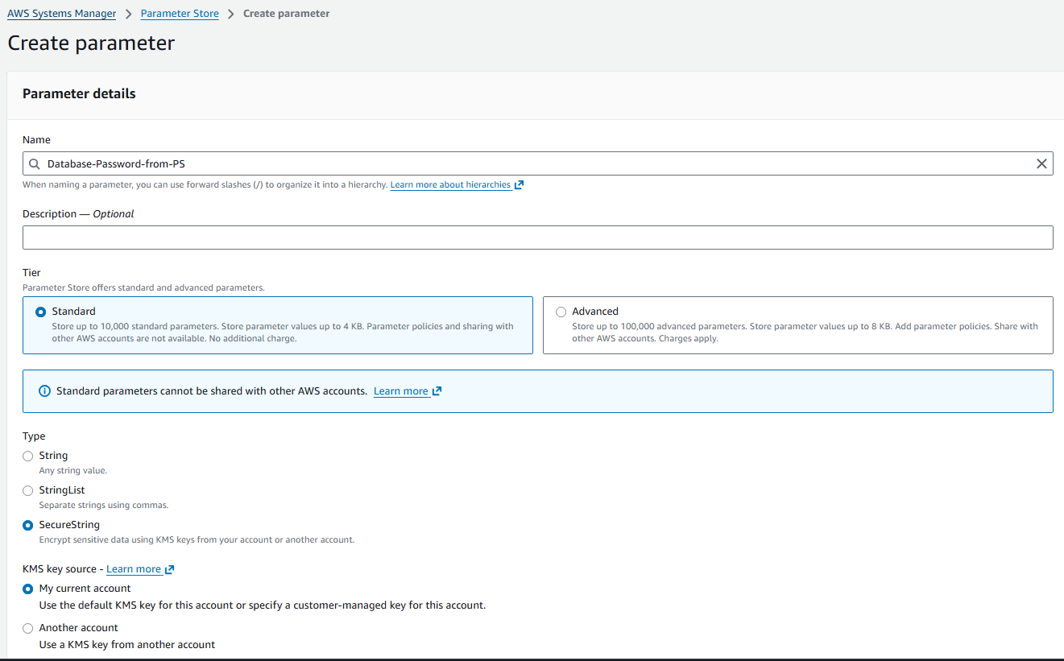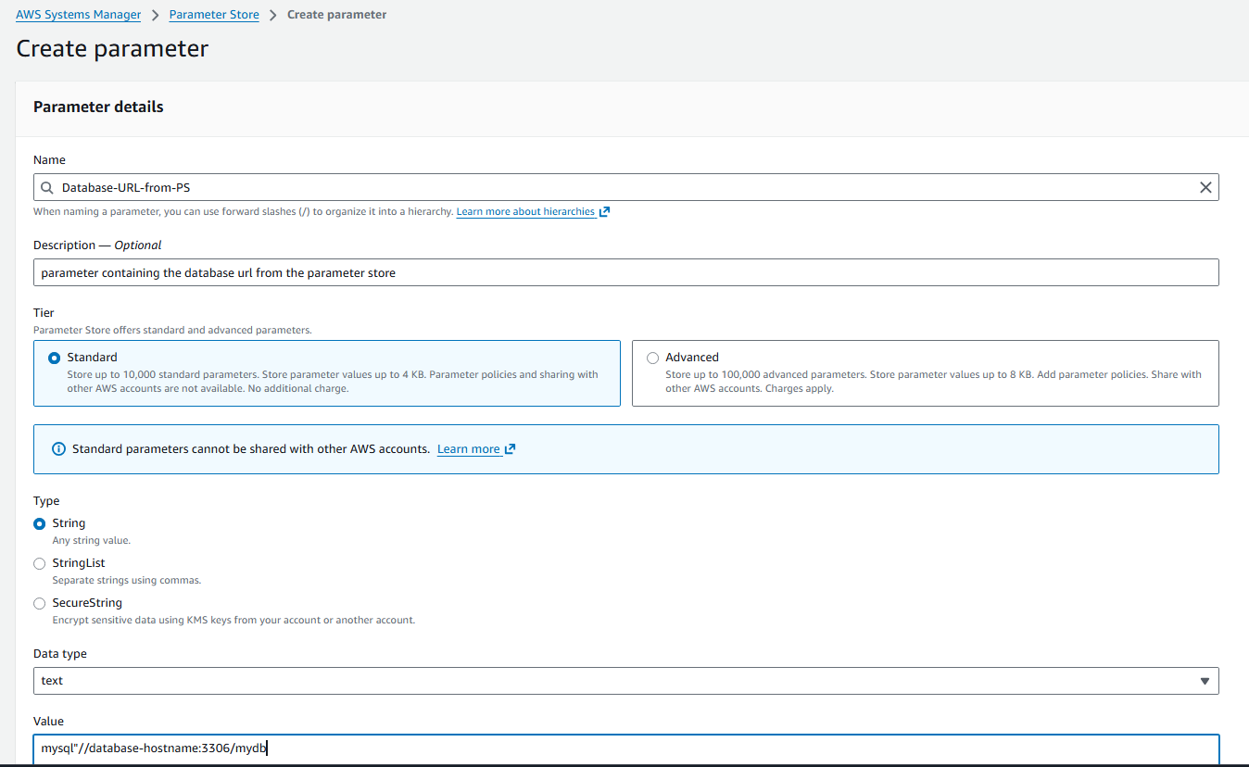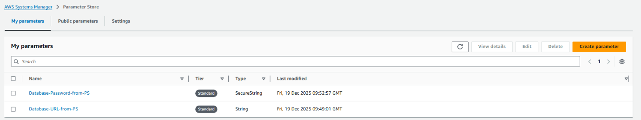Step 2: Create IAM role with Parameter Store access
• Console path / CLI command: IAM → Roles → Create role
• Explanation:
Created an IAM role for EC2 with AWS managed policy AmazonSSMReadOnlyAccess to allow read access to SSM parameters.
Configured the trust relationship to allow EC2 service to assume the role.
Evidence: 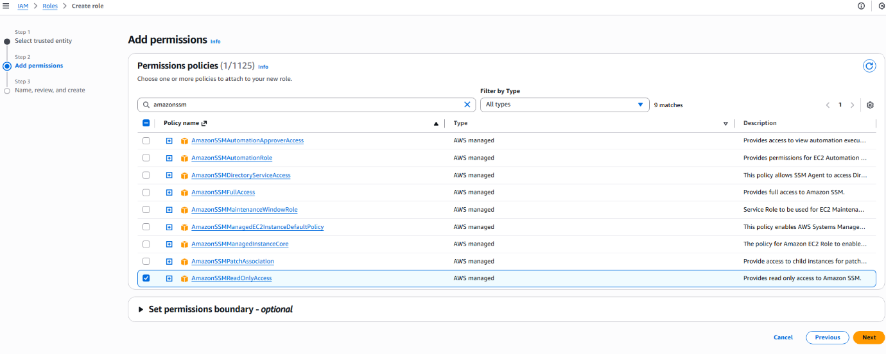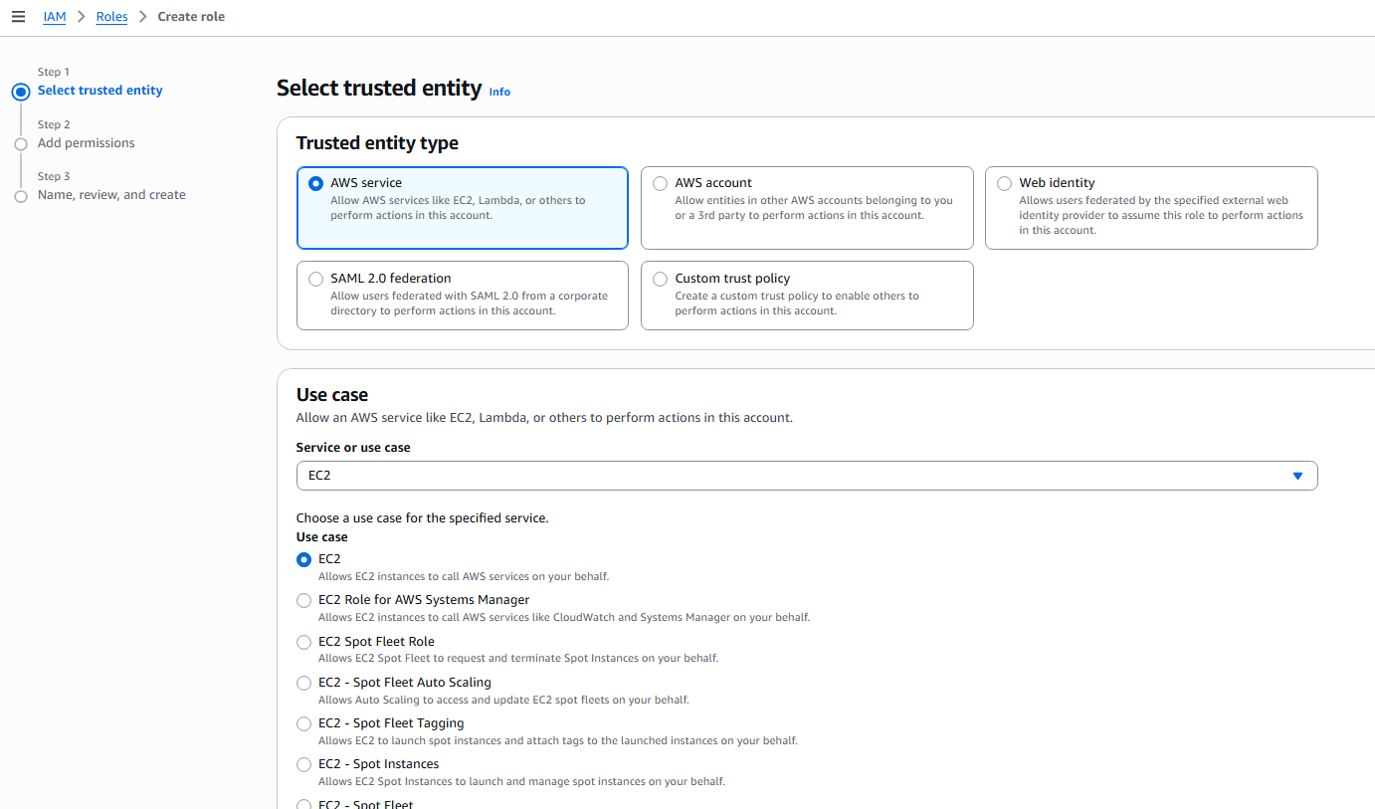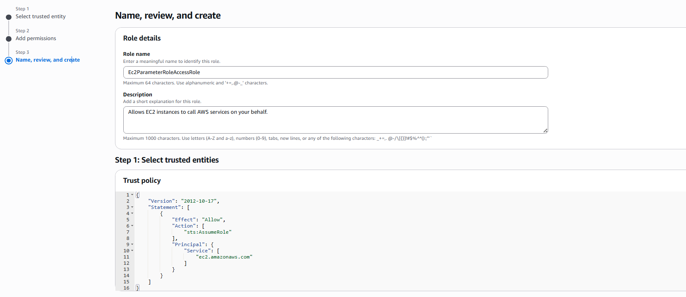
Step 3: Launch EC2 instance with IAM role and user data
• Console path / CLI command: EC2 → Instances → Launch instance
• Explanation:
Launched an Amazon Linux EC2 instance and attached the IAM instance profile created earlier.
Added a user data script to retrieve parameters using the AWS CLI get-parameter command and write the values into a local configuration file.
#!/bin/bash

# Exit immediately if a command exits with a non-zero status.
set -e

# Update system packages
echo "Starting system update..."
sudo yum update -y
echo "System update complete."

# Define the region once to keep the commands clean
REGION="us-east-1"

# Retrieve the database URL using --query to extract the value directly
echo "Retrieving Database URL from Parameter Store..."
DB_URL=$(aws ssm get-parameter --name "Database-URL-from-PS" --query 'Parameter.Value' --output text --region "$REGION")

# Use correct variable syntax ($DB_URL) when writing to the file
# Using > for the first line to create/overwrite the file
echo "DatabaseURL: $DB_URL" > /home/ec2-user/db-config.txt

# Retrieve the database password securely
echo "Retrieving Database Password from Parameter Store..."
# Note: For SecureString parameters, you should add the --with-decryption flag if needed.
DB_Password=$(aws ssm get-parameter --name "Database-Password-from-PS" --query 'Parameter.Value' --output text --region "$REGION")

# *** THIS LINE PRINTS THE PASSWORD TO YOUR TERMINAL ***
echo "Retrieved Password: $DB_Password"
# *******************************************************

# Append the password to the file using >>
echo "DatabasePassword: $DB_Password" >> /home/ec2-user/db-config.txt

echo "Configuration written to /home/ec2-user/db-config.txt"
Evidence: 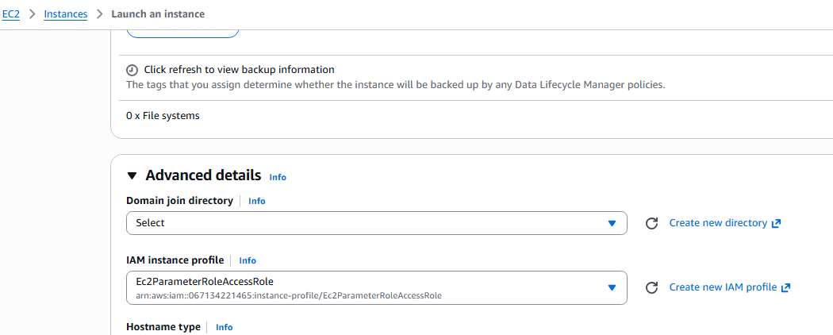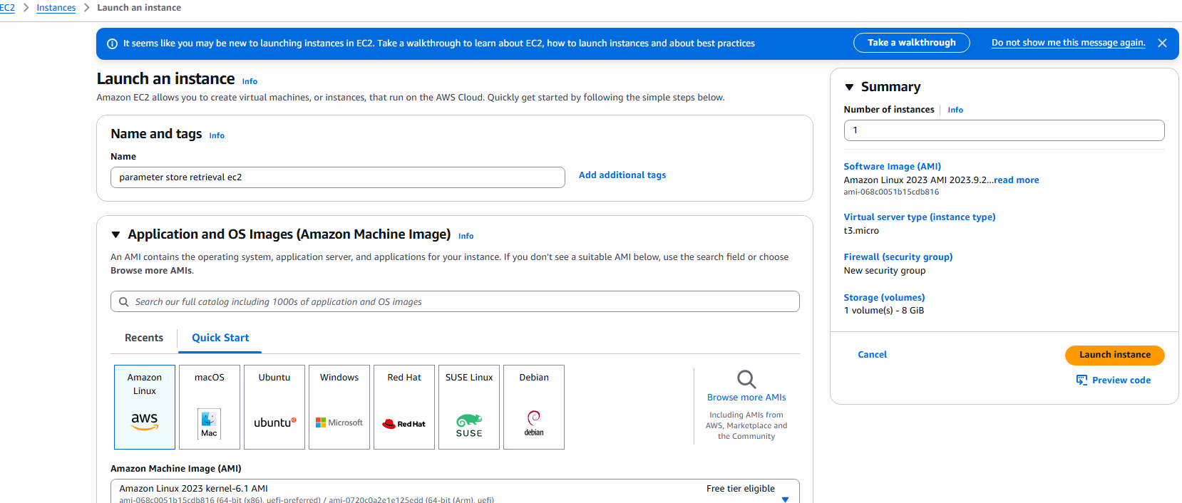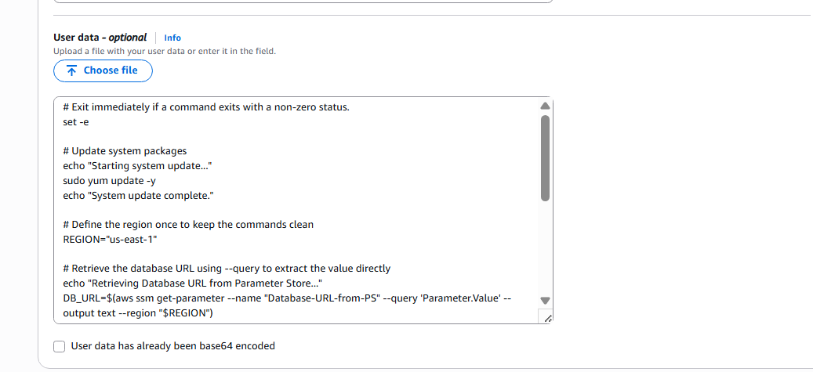
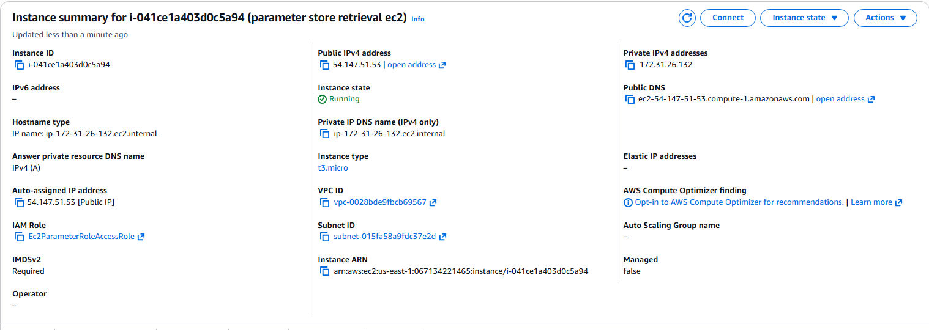
Validation Steps (Mandatory, With Evidence):
Access Check
Evidence:
SSH into EC2 and verify contents of the generated configuration file.
Evidence: db-config.txt file contains the database URL in plain text and encrypted password output retrieved securely.
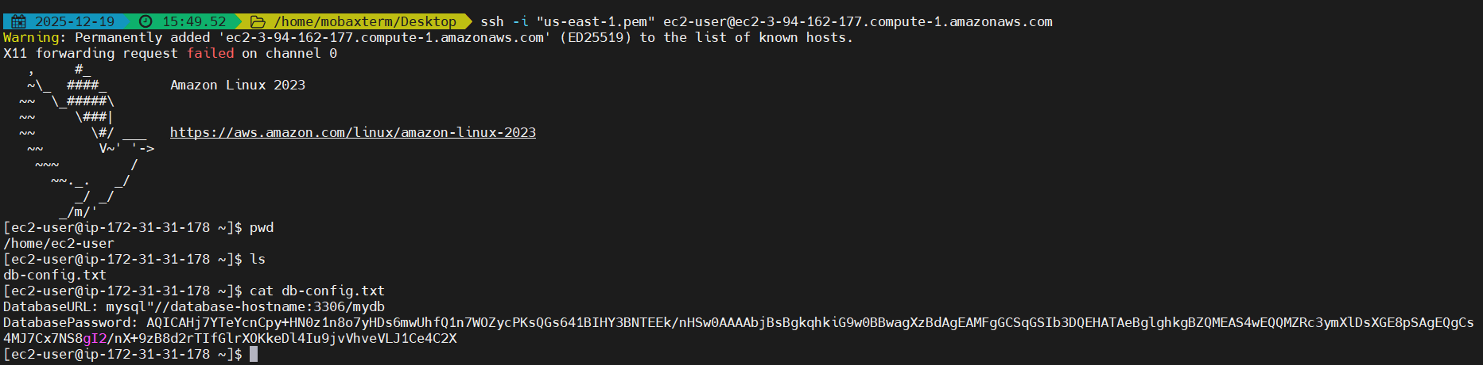

- Issues Faced (Optional):
Initially while writing the script inside the userdata I have forgotten to include #!/bin/bash in the beginning of the script I have rebooted the instance with the corrected userdata and the script went running and pulled the parameters into the db_config.txt file.
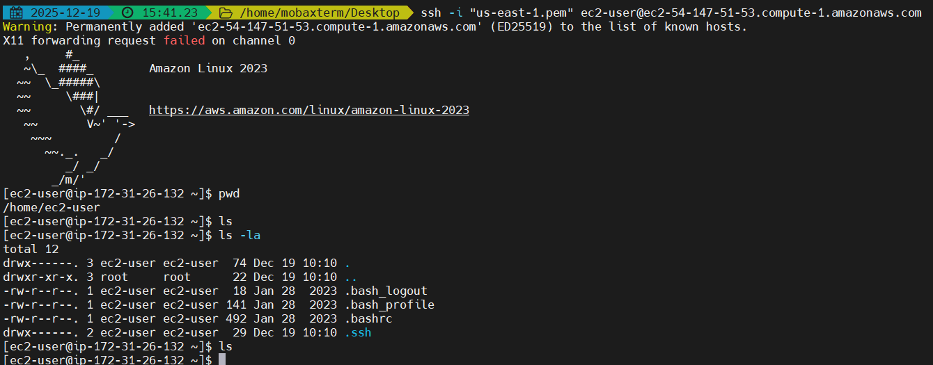
- Conclusion:
The database URL and password were securely stored in Parameter Store and successfully retrieved by the EC2 instance using an IAM role.

AWS WAF

- Task Title
AWS WAF with Application Load Balancer (IP-based access control)
- Objective
To deploy an internet-facing Application Load Balancer backed by an EC2 instance and protect it using AWS WAF by creating a Web ACL with an IP set rule to block or allow traffic based on source IP address.
- Prerequisites
• AWS account with required permissions (EC2, VPC, ELB, WAF)
• VPC with at least two subnets in different Availability Zones
• Internet Gateway attached to the VPC
• EC2 instance with web server installed
• Application Load Balancer and Target Group
• Known client IP address for WAF IP set testing
- Step-by-Step Implementation (With Evidence)
Step 1: Create VPC
• Console path: VPC → Your VPCs → Create VPC
• Explanation: Created a custom VPC with IPv4 CIDR 10.0.0.0/24 to host all networking resources.
• Evidence: 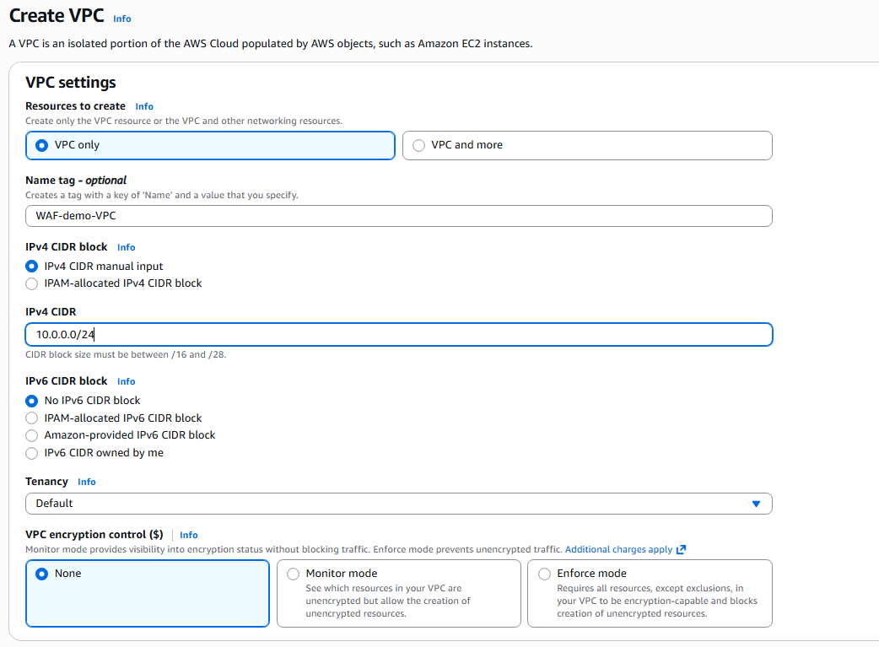
Step 2: Create and Attach Internet Gateway
• Console path: VPC → Internet Gateways → Create internet gateway → Attach to VPC
• Explanation: Internet Gateway enables internet access for public subnets.
• Evidence: 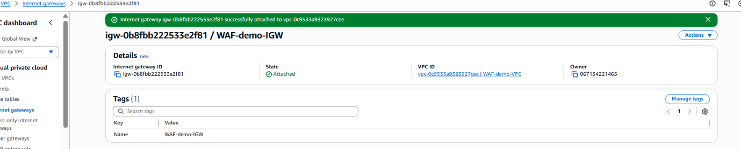
Step 3: Create Subnets in Multiple AZs
• Console path: VPC → Subnets → Create subnet
• Explanation: Created two subnets (10.0.0.0/26 and 10.0.0.64/26) in us-east-1a and us-east-1b for high availability.
• Evidence: 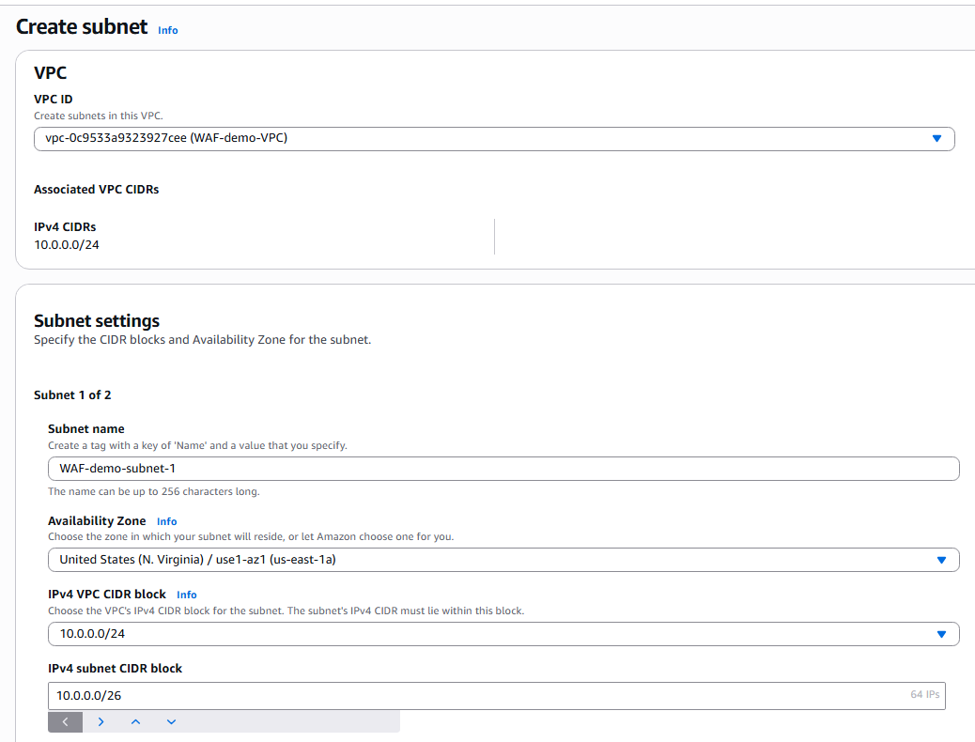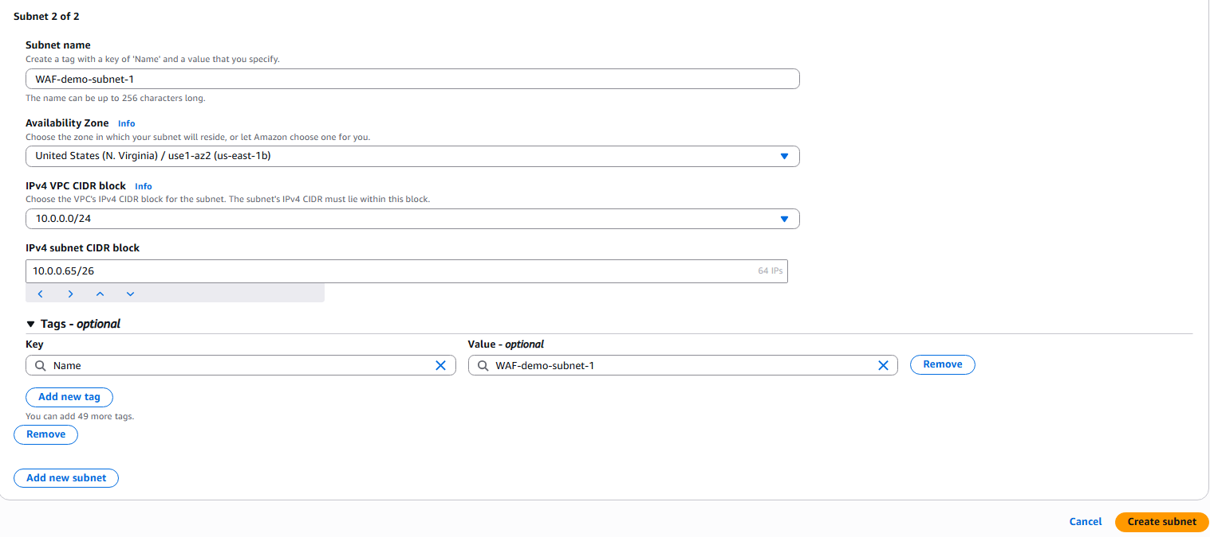
Step 4: Configure Route Tables
• Console path: VPC → Route Tables
• Explanation: Associated subnets with route tables and ensured local routing within VPC.
• Evidence: 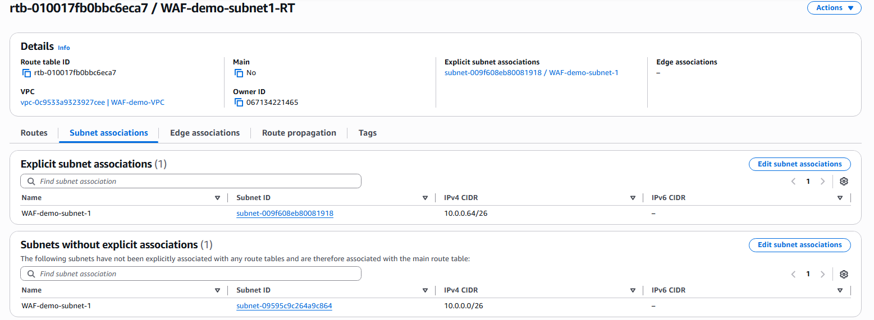
Step 5: Launch EC2 Instance
• Console path: EC2 → Instances → Launch instance
• Explanation: Launched Amazon Linux EC2 instance with HTTP and SSH access. User data installs Apache and serves a test page.
• Evidence: 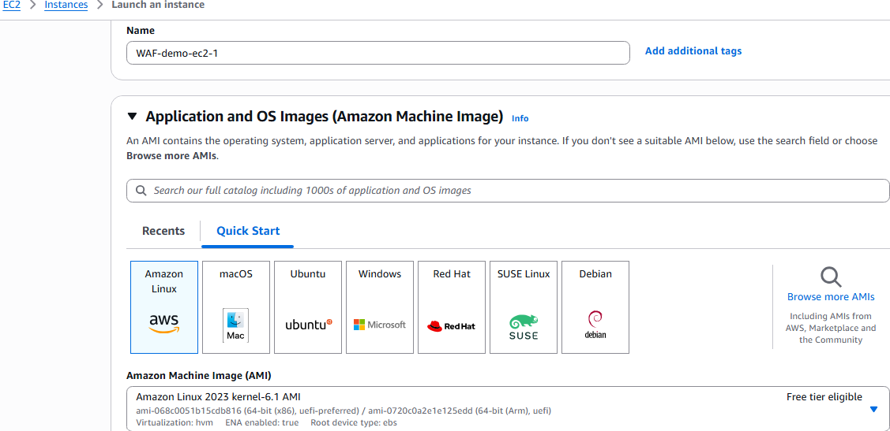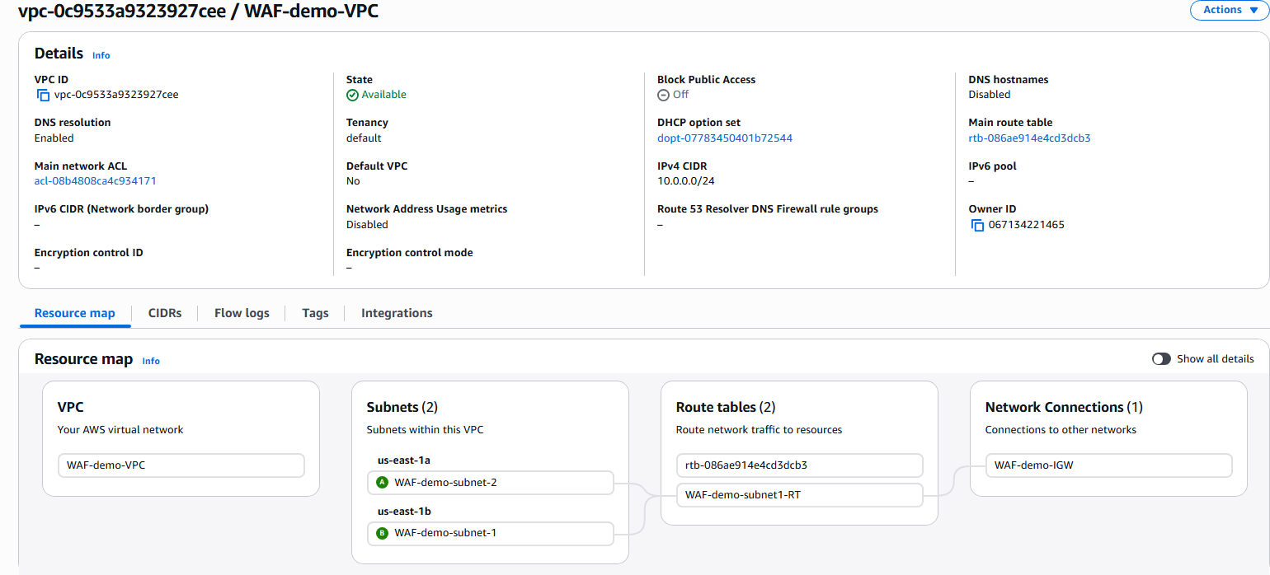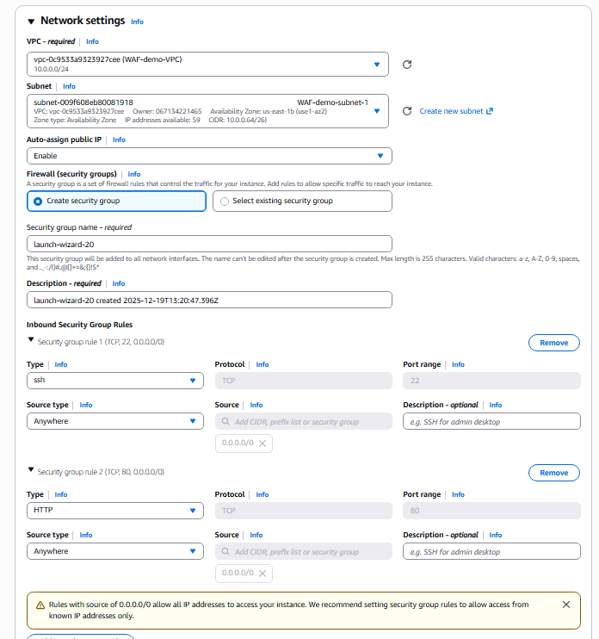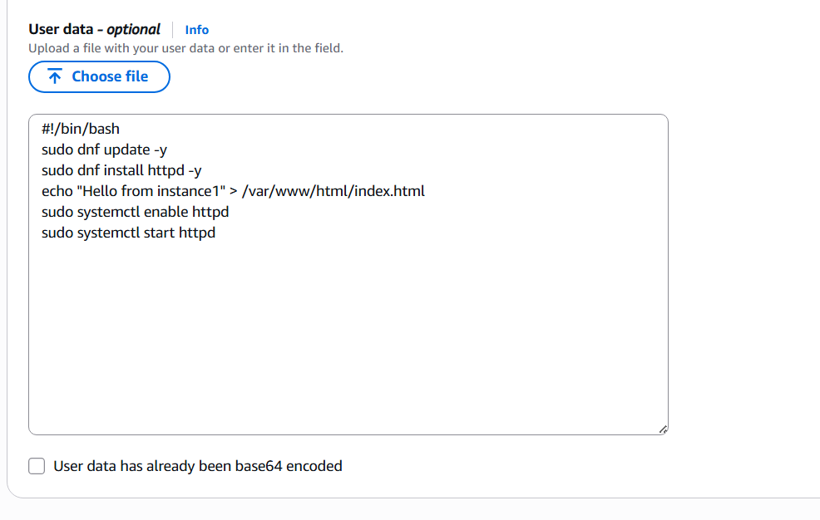
Step 6: Verify EC2 Instance
• Console path: EC2 → Instances → Instance ID
• Explanation: Confirmed instance is running with public IP assigned.
• Evidence: 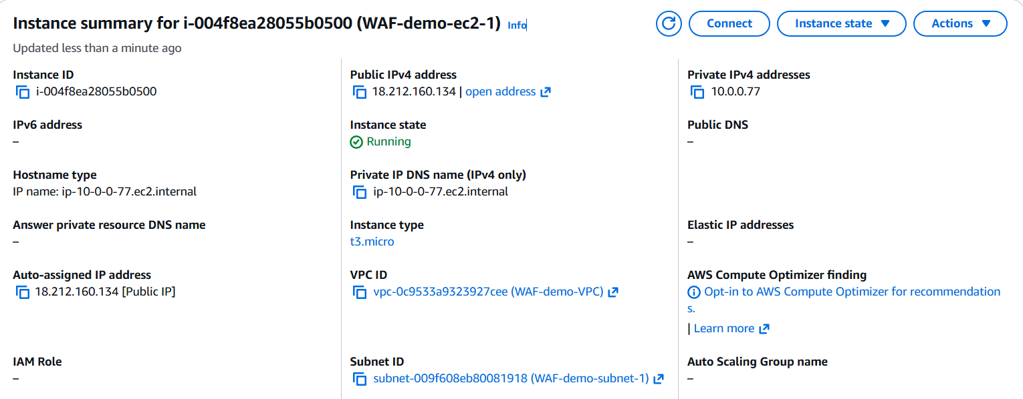
Step 7: Create Target Group
• Console path: EC2 → Target Groups → Create target group
• Explanation: Created HTTP target group on port 80 and registered EC2 instance.
• Evidence: 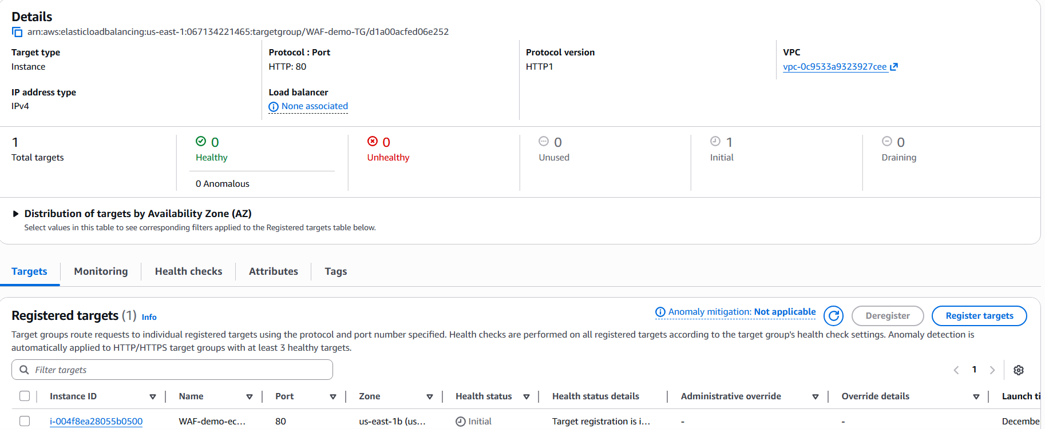
Step 8: Create Application Load Balancer
• Console path: EC2 → Load Balancers → Create load balancer
• Explanation: Created internet-facing ALB across two subnets and attached listener on HTTP:80 forwarding to target group.
• Evidence: 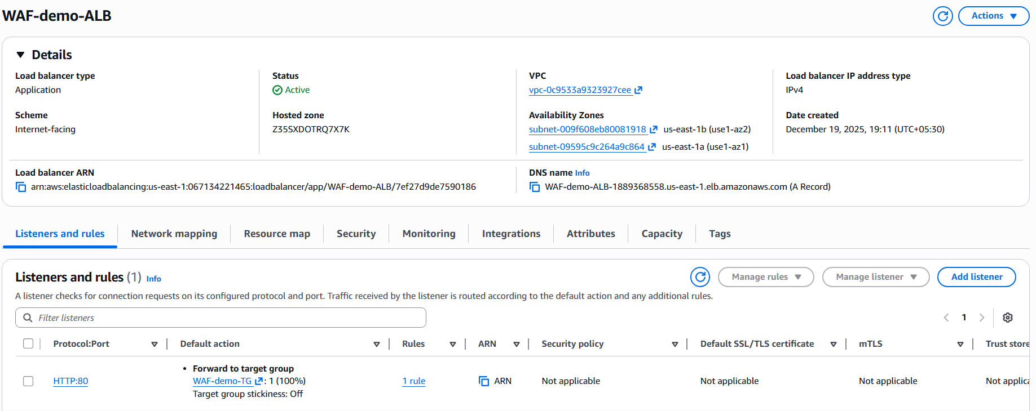
Step 9: Verify ALB Listener and Target Group Association
• Console path: EC2 → Load Balancers → Listeners
• Explanation: Confirmed traffic is forwarded to target group with 100% weight.
• Evidence: 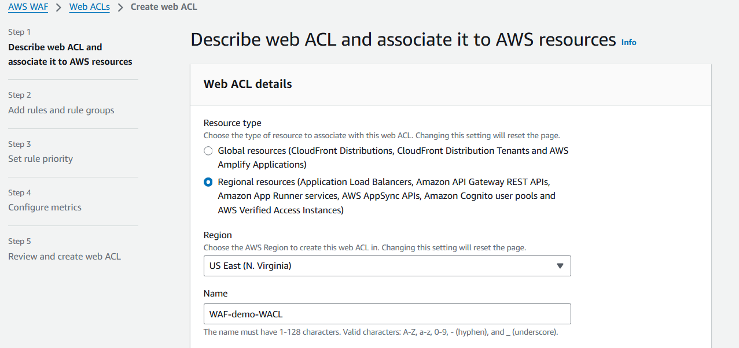
Step 10: Create Web ACL
• Console path: AWS WAF → Web ACLs → Create web ACL
• Explanation: Created a regional Web ACL for Application Load Balancer in us-east-1 region.
• Evidence: 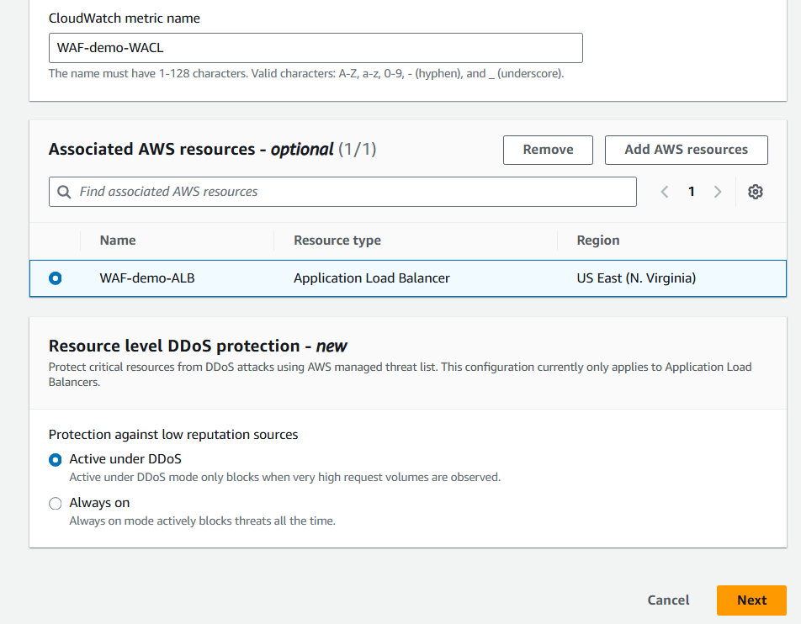
Step 11: Associate Web ACL with ALB
• Console path: AWS WAF → Web ACLs → Associated AWS resources
• Explanation: Associated Web ACL with WAF-demo-ALB to protect incoming traffic.
• Evidence: 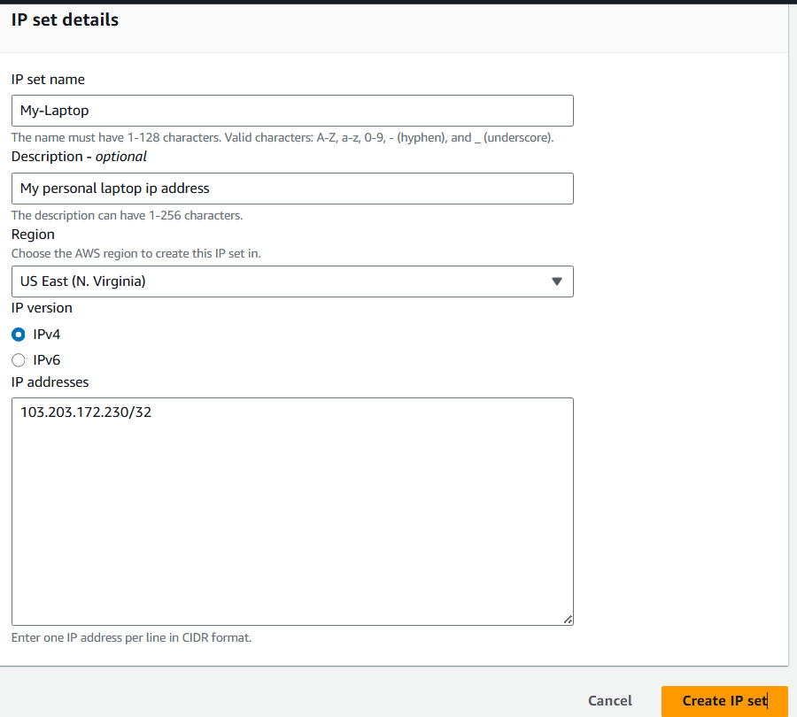
Step 12: Create IP Set
• Console path: AWS WAF → IP sets → Create IP set
• Explanation: Created IP set named My-Laptop containing personal public IP address in /32 format.
• Evidence: 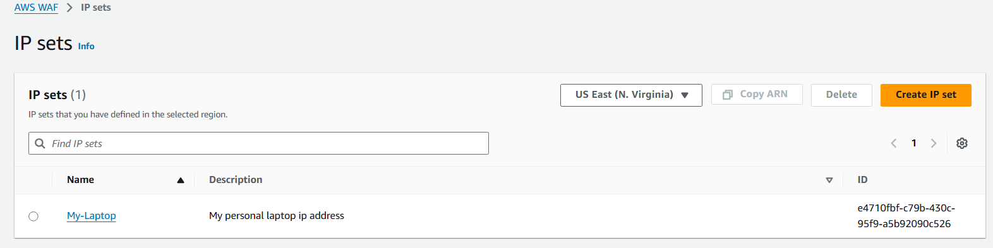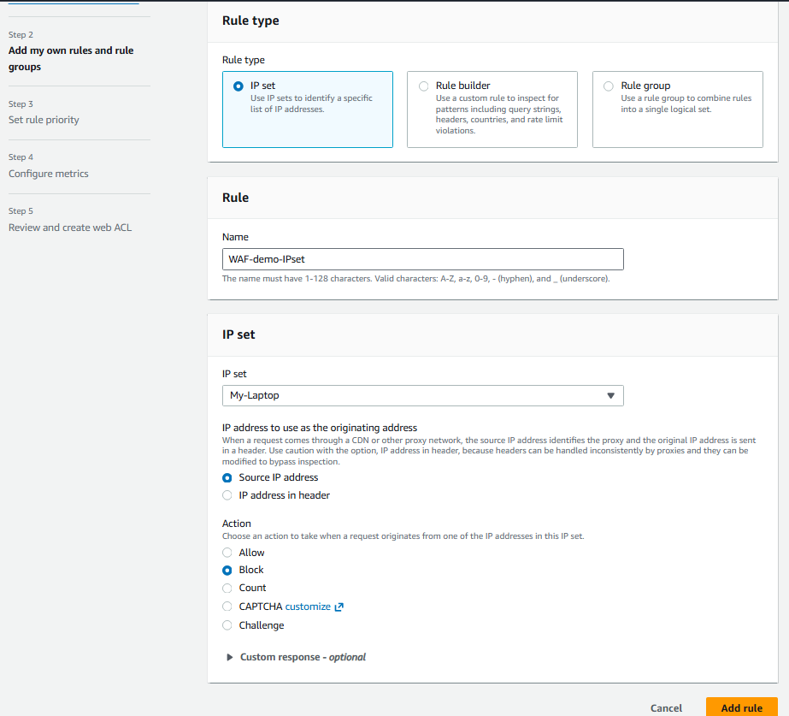
Step 13: Create WAF Rule Using IP Set
• Console path: AWS WAF → Web ACLs → Rules → Add rule
• Explanation: Created rule to inspect source IP and block requests matching IP set.
• Evidence: 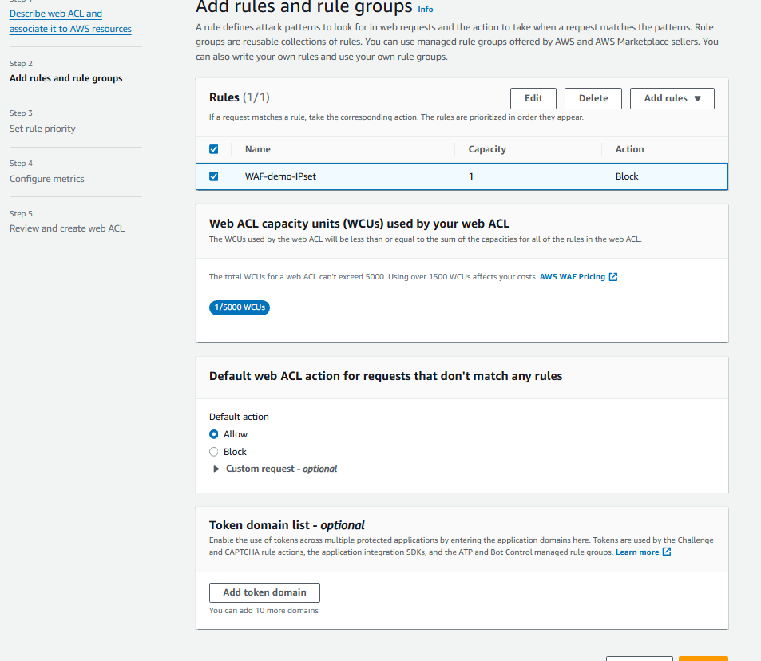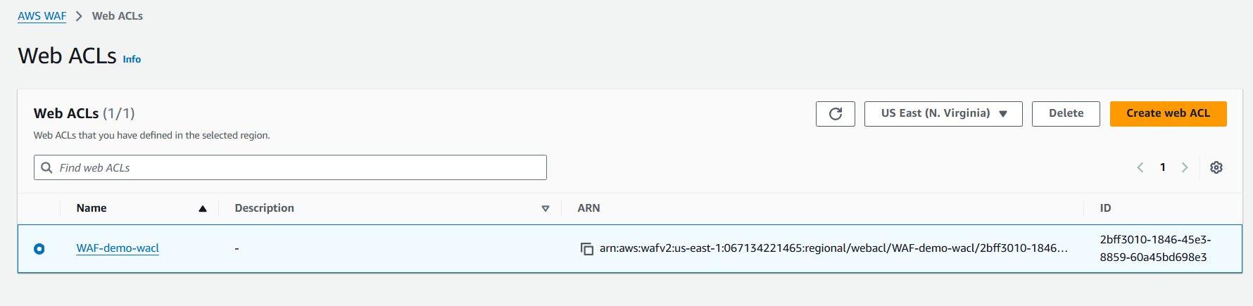
Step 14: Modify Rule Action for Validation
• Console path: AWS WAF → Web ACLs → Rules → Edit rule
• Explanation: Updated rule action from Block to Allow to validate positive access scenario.
• Evidence:
- Validation Steps (Mandatory, With Evidence)
Validation 2: Blocked access from the laptop Ip address
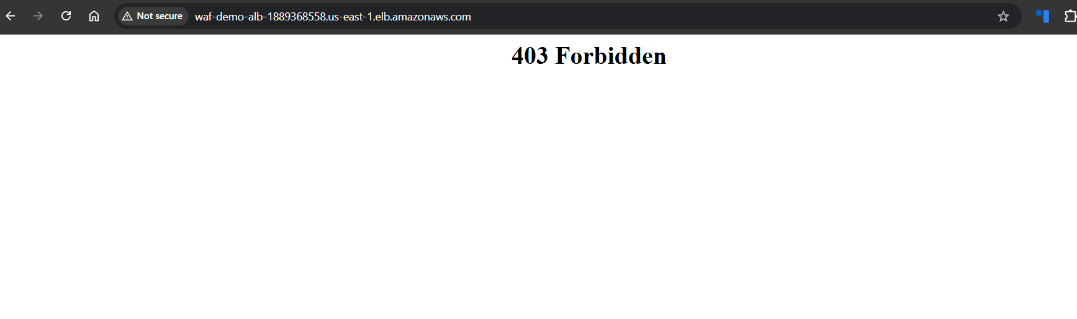
Validation 2: Allowed Access in the action
• Example: After changing WAF rule action to Allow, web page loads successfully showing “Hello from instance1”.
• Evidence: 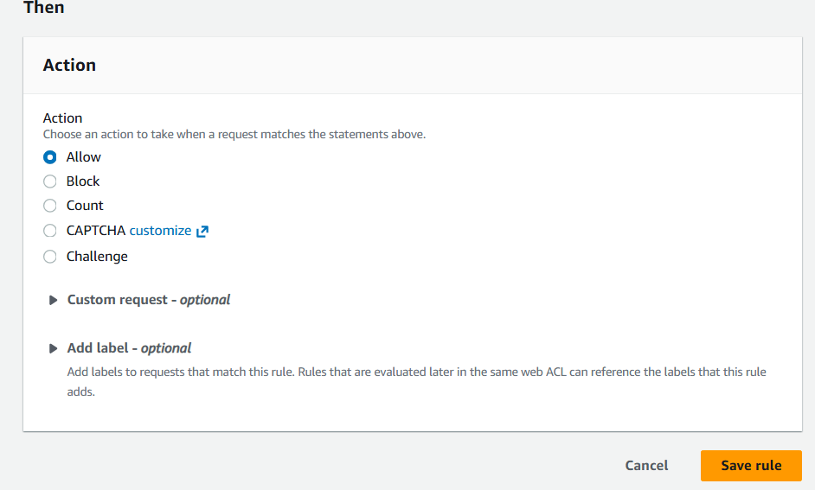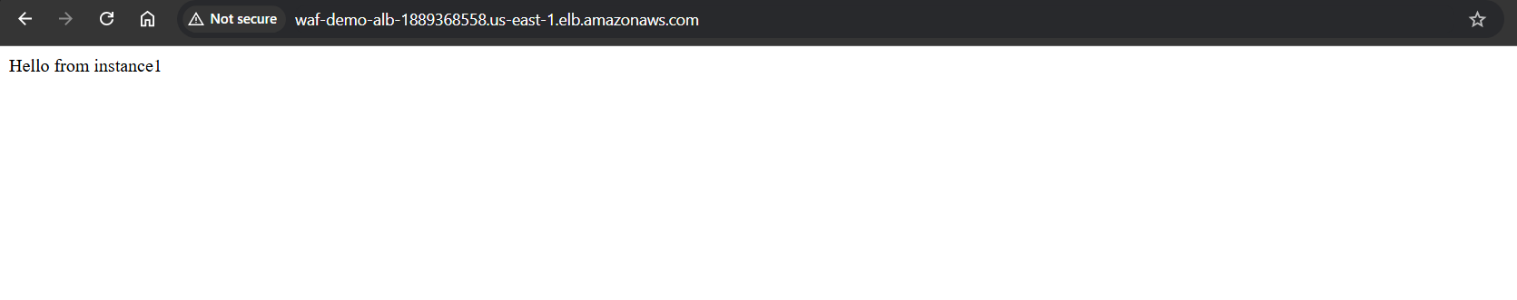
- Issues Faced (Optional)
• Initial 403 Forbidden error occurred due to WAF IP set rule blocking client IP.
• Resolved by modifying rule action to Allow for validation.
- Conclusion
Successfully deployed an Application Load Balancer protected by AWS WAF using IP-based access control.

AMAZON SQS

- Task Title: AWS SQS + Lambda Integration
- Objective:
To configure an AWS Lambda function that is triggered by messages published to an Amazon SQS queue and to verify successful message processing using CloudWatch logs.
- Prerequisites:
• AWS account with required permissions
• Amazon SQS standard queue created
• AWS Lambda service access
• IAM role with Lambda basic execution permissions
• IAM permissions to allow Lambda to poll SQS
- Step-by-Step Implementation (With Evidence):
Step 1: Create the Lambda Function
• Console path / CLI command:
AWS Console → Lambda → Functions → Create function
• Explanation:
A new Lambda function is created from scratch using Python runtime. A custom execution role is selected to later allow SQS access.
Evidence: 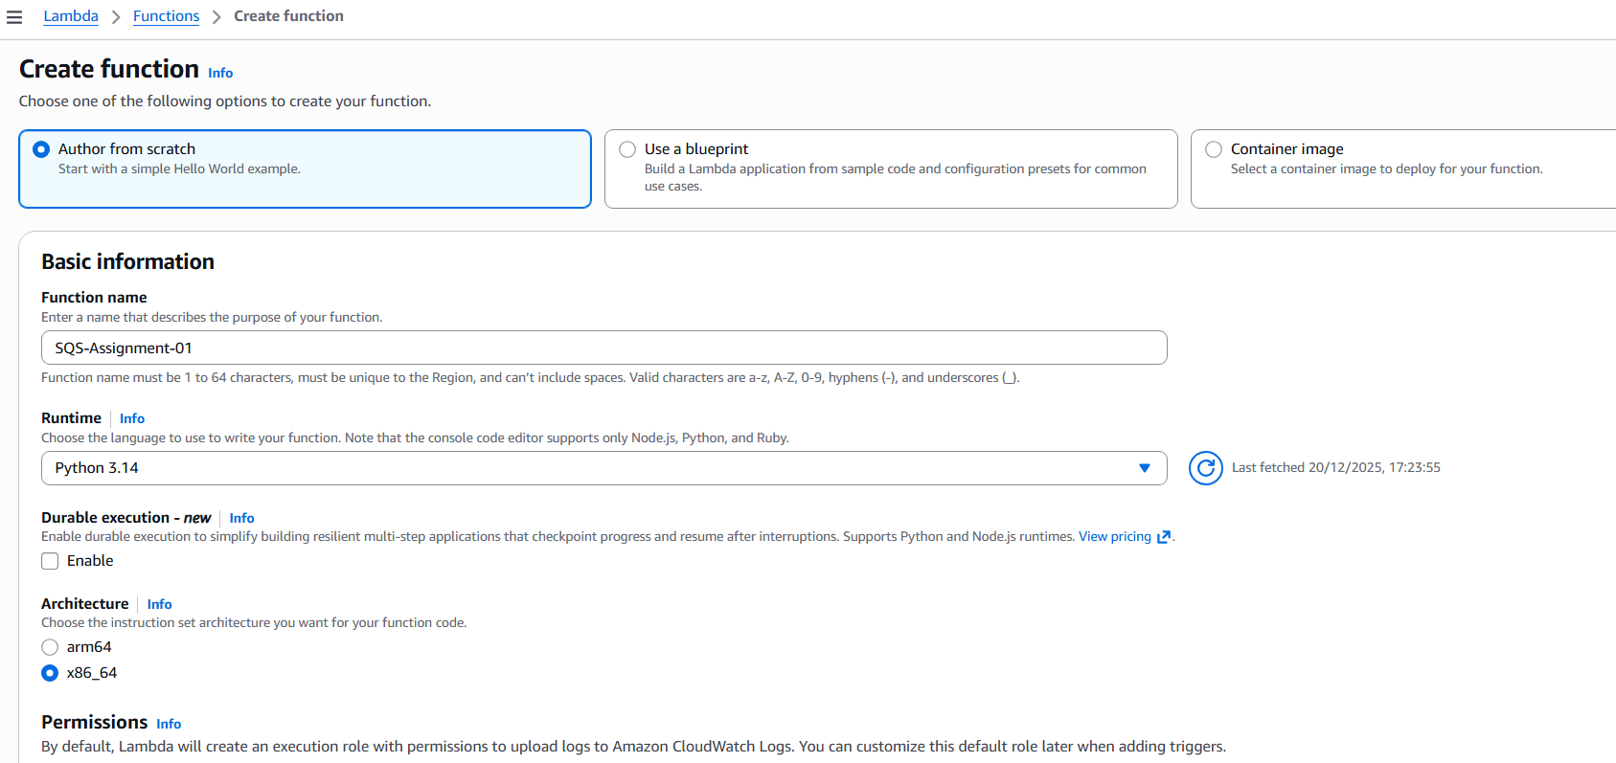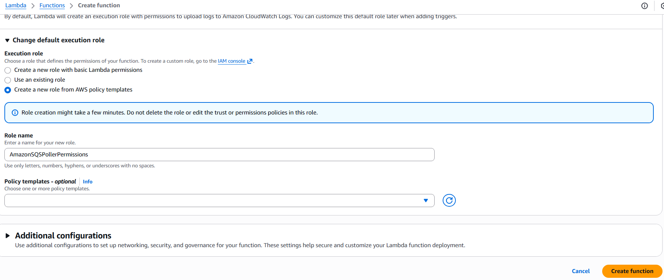
Step 2: Add Lambda Function Code
• Console path / CLI command:
Lambda → Functions → SQS-Assignment-01 → Code
• Explanation:
The Lambda function code is updated to read records from the SQS event payload and print message bodies to CloudWatch logs.
Evidence: 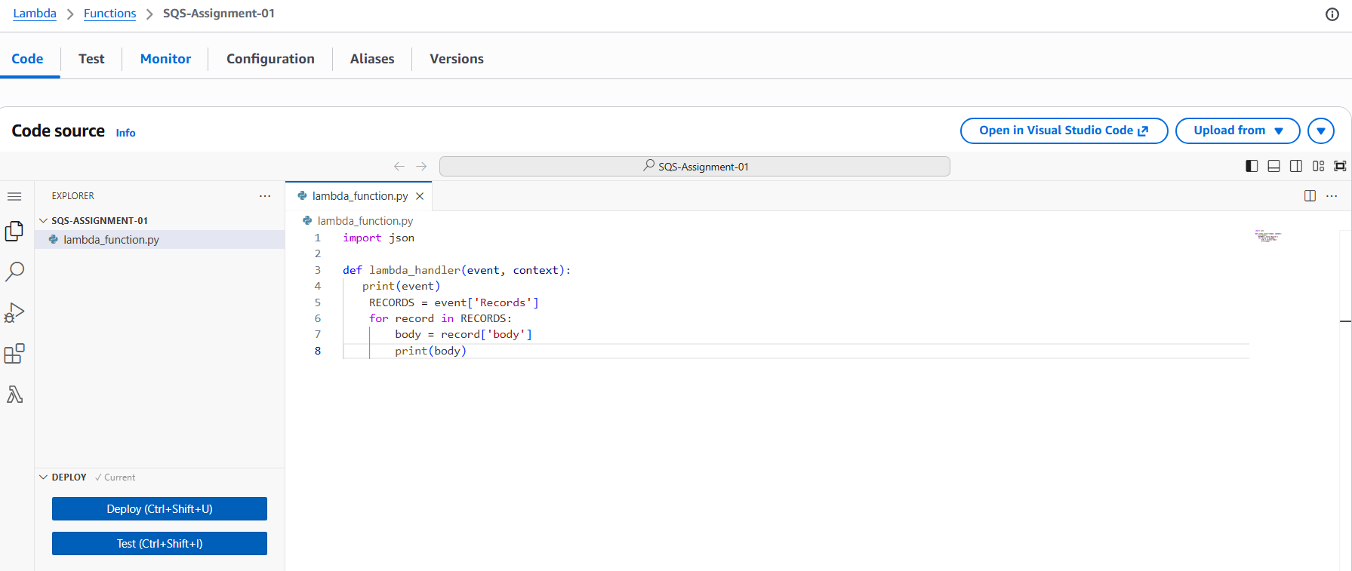
Step 3: Create an SQS Queue
• Console path / CLI command:
AWS Console → Amazon SQS → Queues → Create queue
• Explanation:
A standard SQS queue is created to act as the event source for the Lambda function.
Evidence: 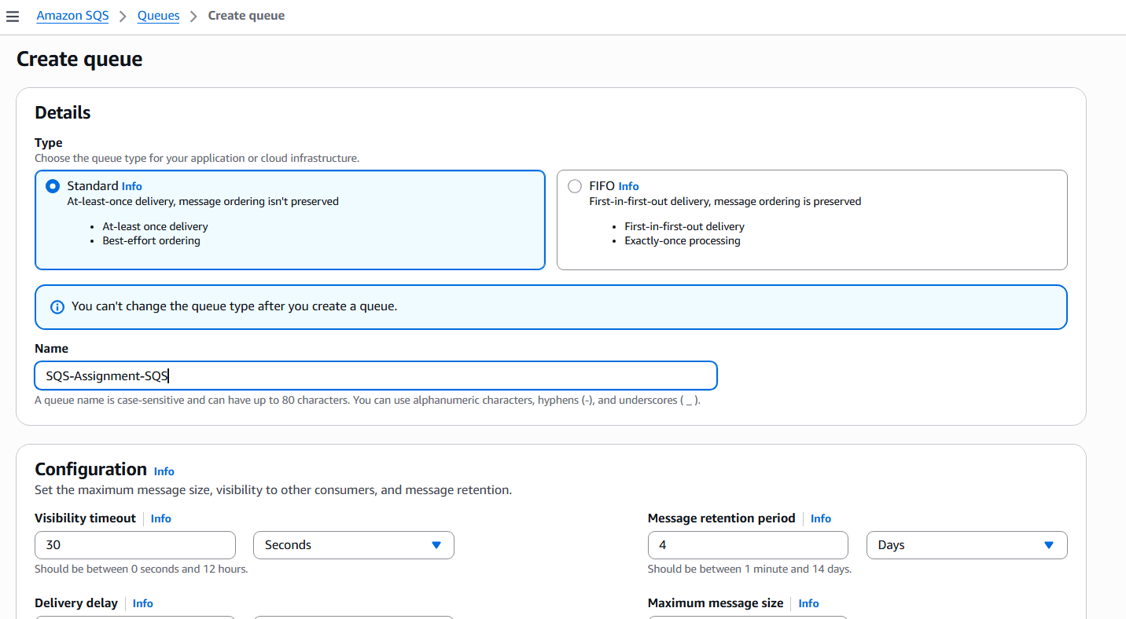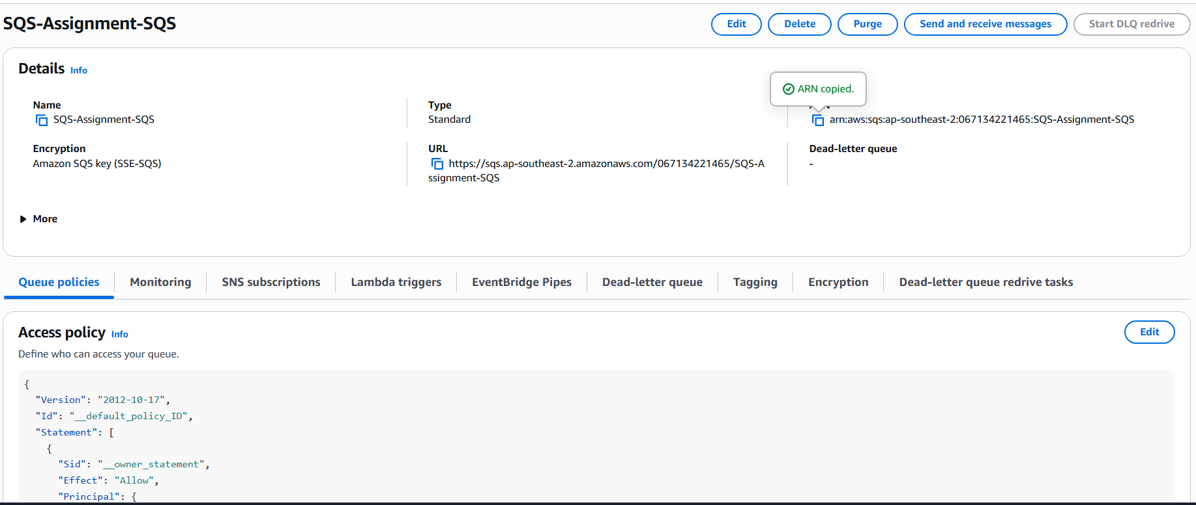
Step 4: Attach SQS Trigger to Lambda
• Console path / CLI command:
Lambda → Functions → SQS-Assignment-01 → Add trigger → SQS
• Explanation:
The created SQS queue ARN is selected and configured as an event source mapping for the Lambda function.
Evidence: 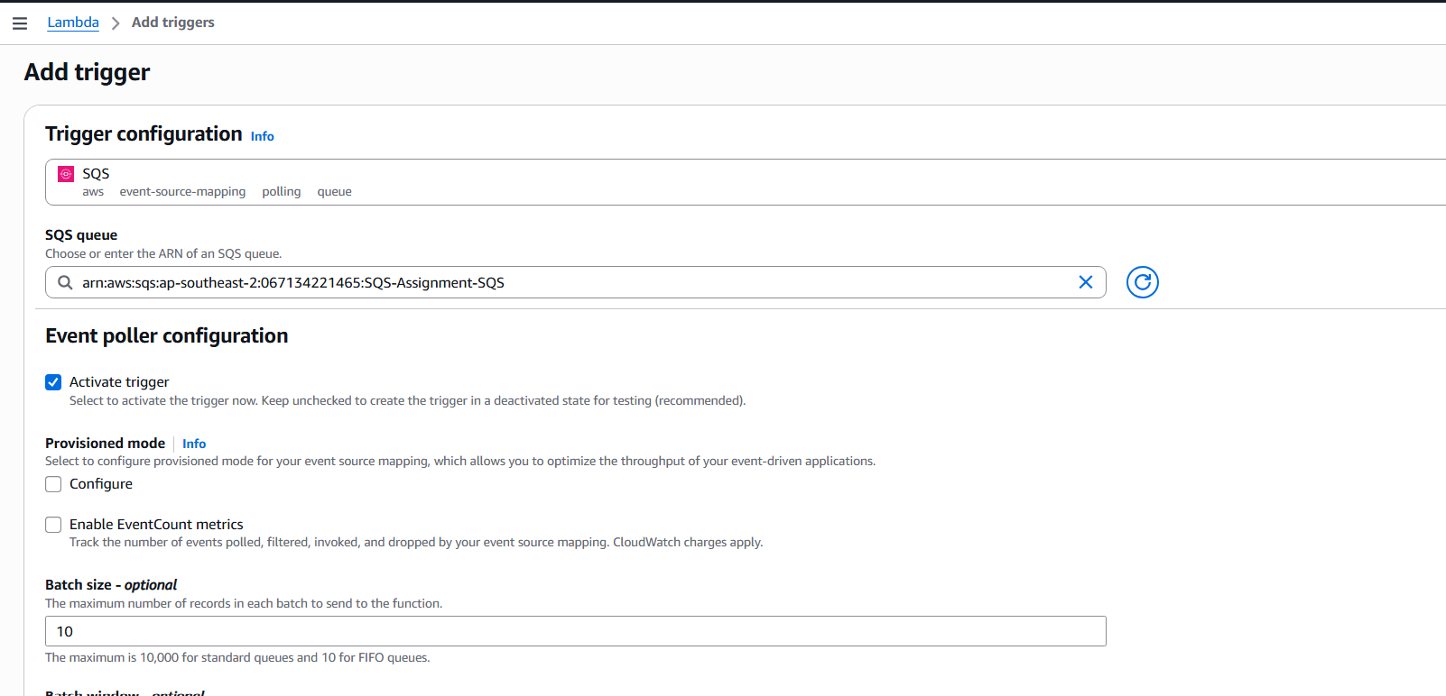
Step 5: Update IAM Role Permissions
• Console path / CLI command:
IAM → Roles → Lambda execution role → Add permissions
• Explanation:
The execution role is updated to allow required SQS actions such as ReceiveMessage, DeleteMessage, and GetQueueAttributes. This resolves trigger creation errors.
Evidence: 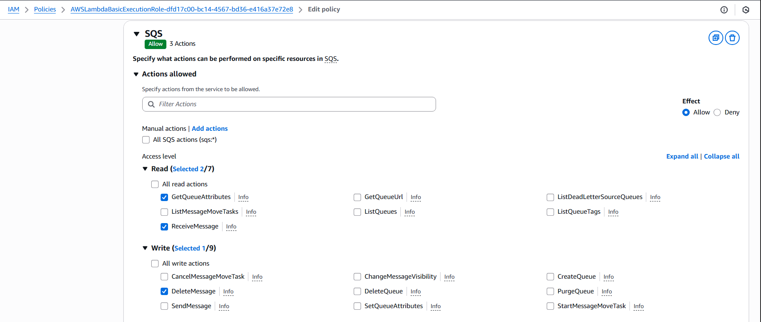
Step 6: Send Messages to SQS Queue
• Console path / CLI command:
Amazon SQS → Queues → SQS-Assignment-SQS → Send and receive messages
• Explanation:
Test messages are manually sent to the SQS queue to validate end-to-end integration.
Evidence: 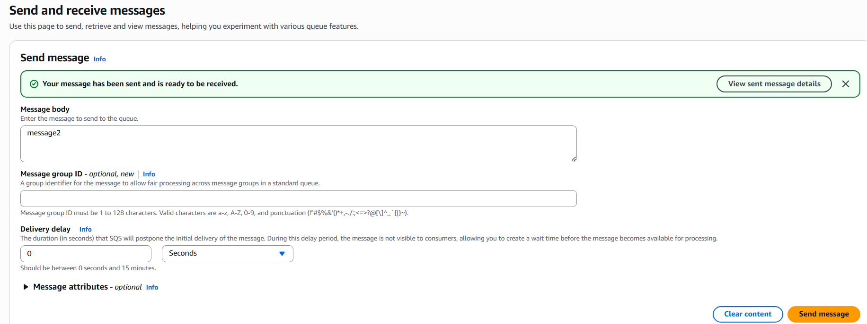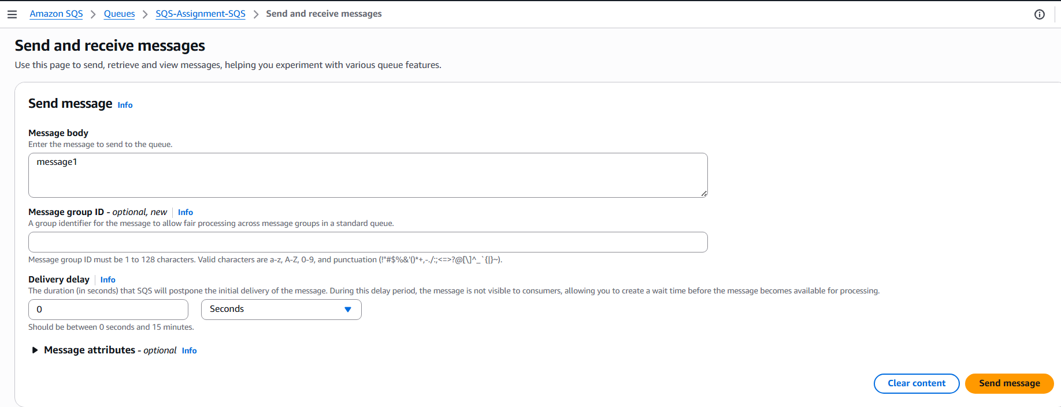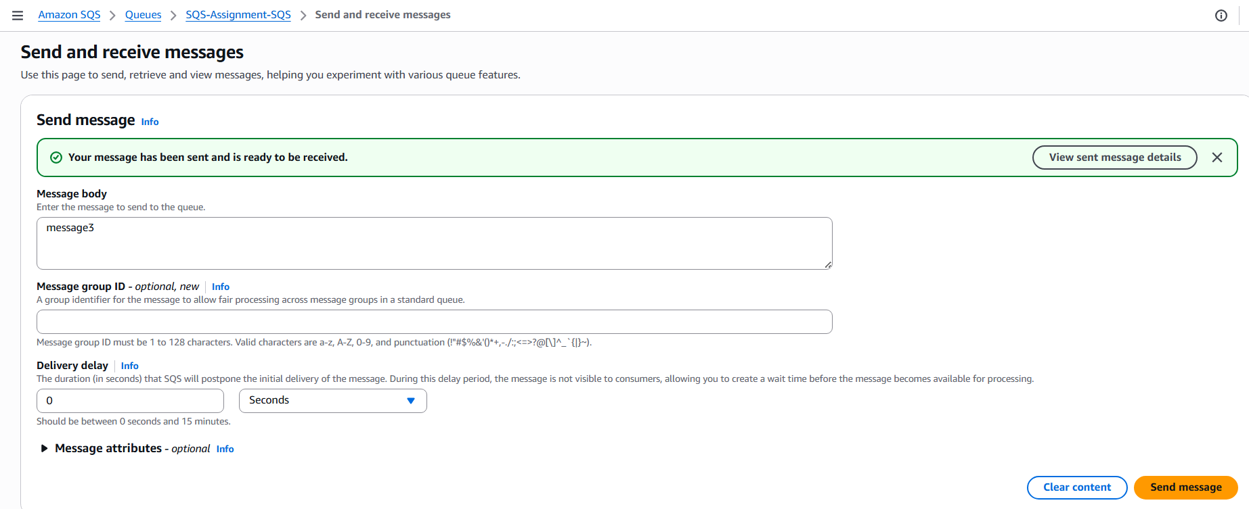
- Validation Steps (Mandatory, With Evidence):
Access Check
Example:
role permissions allow Lambda to call ReceiveMessage on SQS without errors.
Evidence: 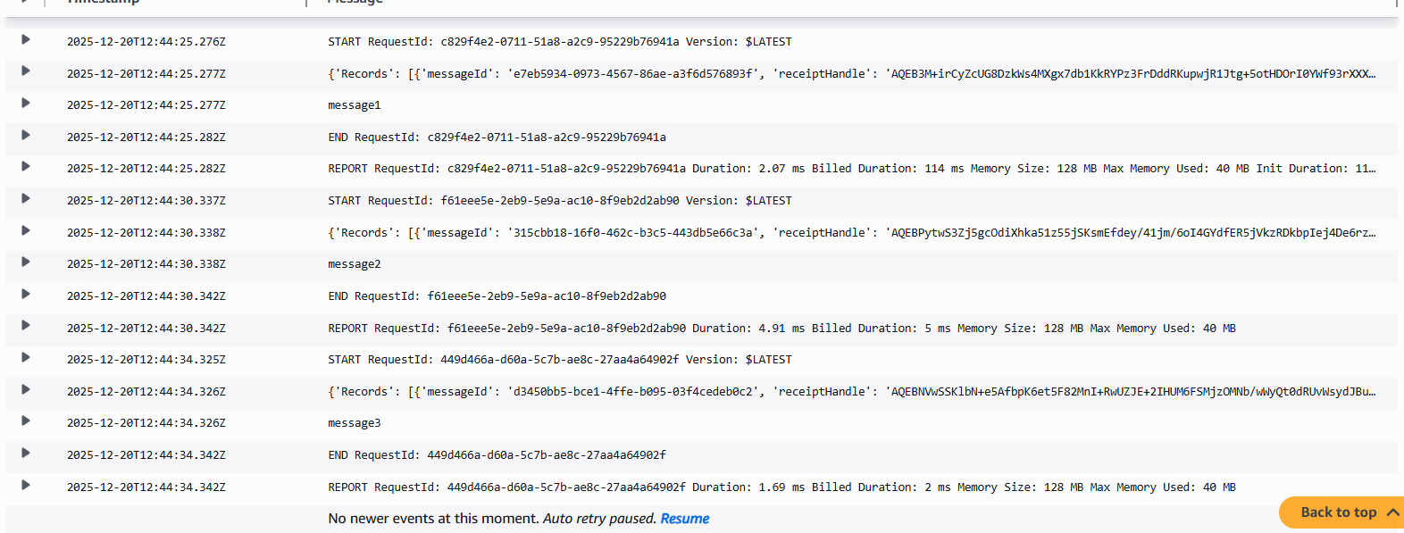
- Issues Faced (Optional):
The Lambda trigger initially failed with an error stating that the execution role lacked ReceiveMessage permission on SQS. This was resolved by explicitly adding required SQS permissions to the IAM role.
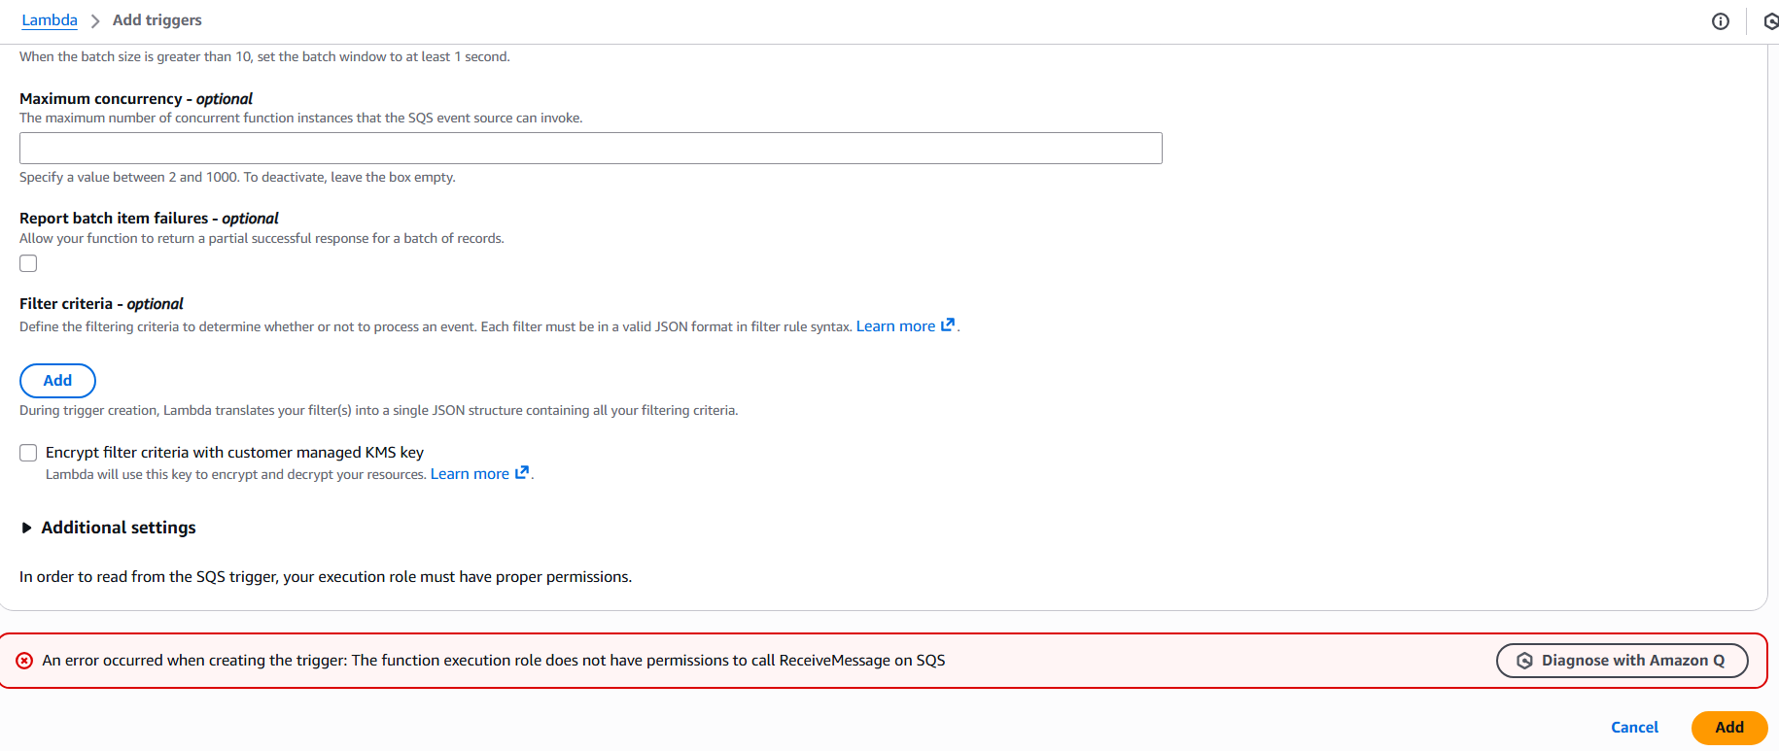
- Conclusion:
The AWS SQS and Lambda integration was successfully configured. Messages published to the SQS queue triggered the Lambda function as expected, and message processing was verified through CloudWatch logs

AWS MQ

- Task Title: AWS MQ
- Objective:
To create and configure an Amazon MQ RabbitMQ broker, enable secure access, and verify connectivity through the RabbitMQ web console for message brokering use cases.
- Prerequisites:
• AWS account
• Basic understanding of message brokers and RabbitMQ
- Step-by-Step Implementation (With Evidence):
Step 1:
• Console path / CLI command: Amazon MQ > Brokers > Create broker
• Explanation: Selected RabbitMQ as the broker engine to deploy a managed RabbitMQ message broker using Amazon MQ.
Evidence: 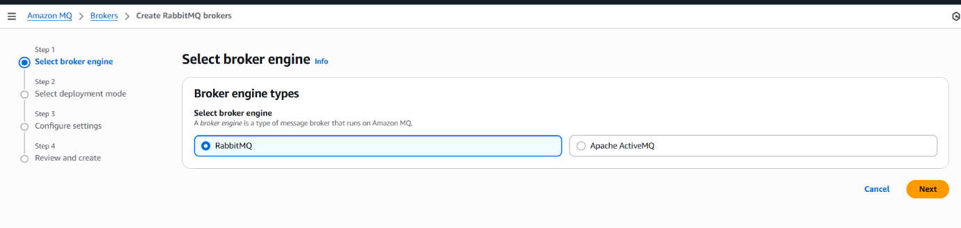
Step 2:
• Console path / CLI command: Amazon MQ > Brokers > Create broker > Select deployment mode
• Explanation: Selected Single-instance broker deployment mode suitable for development and testing workloads.
Evidence: 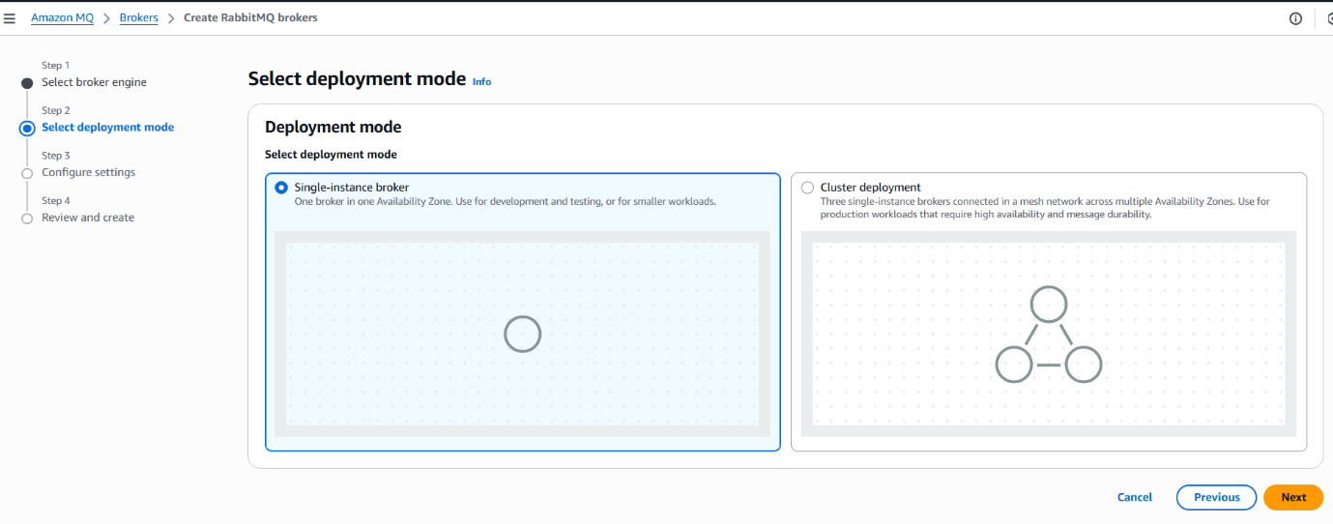
Step 3:
• Console path / CLI command: Amazon MQ > Brokers > Create broker > Configure settings
• Explanation: Provided broker name, selected instance type (mq.m7g.medium), and configured RabbitMQ access credentials (username and password).
Evidence: 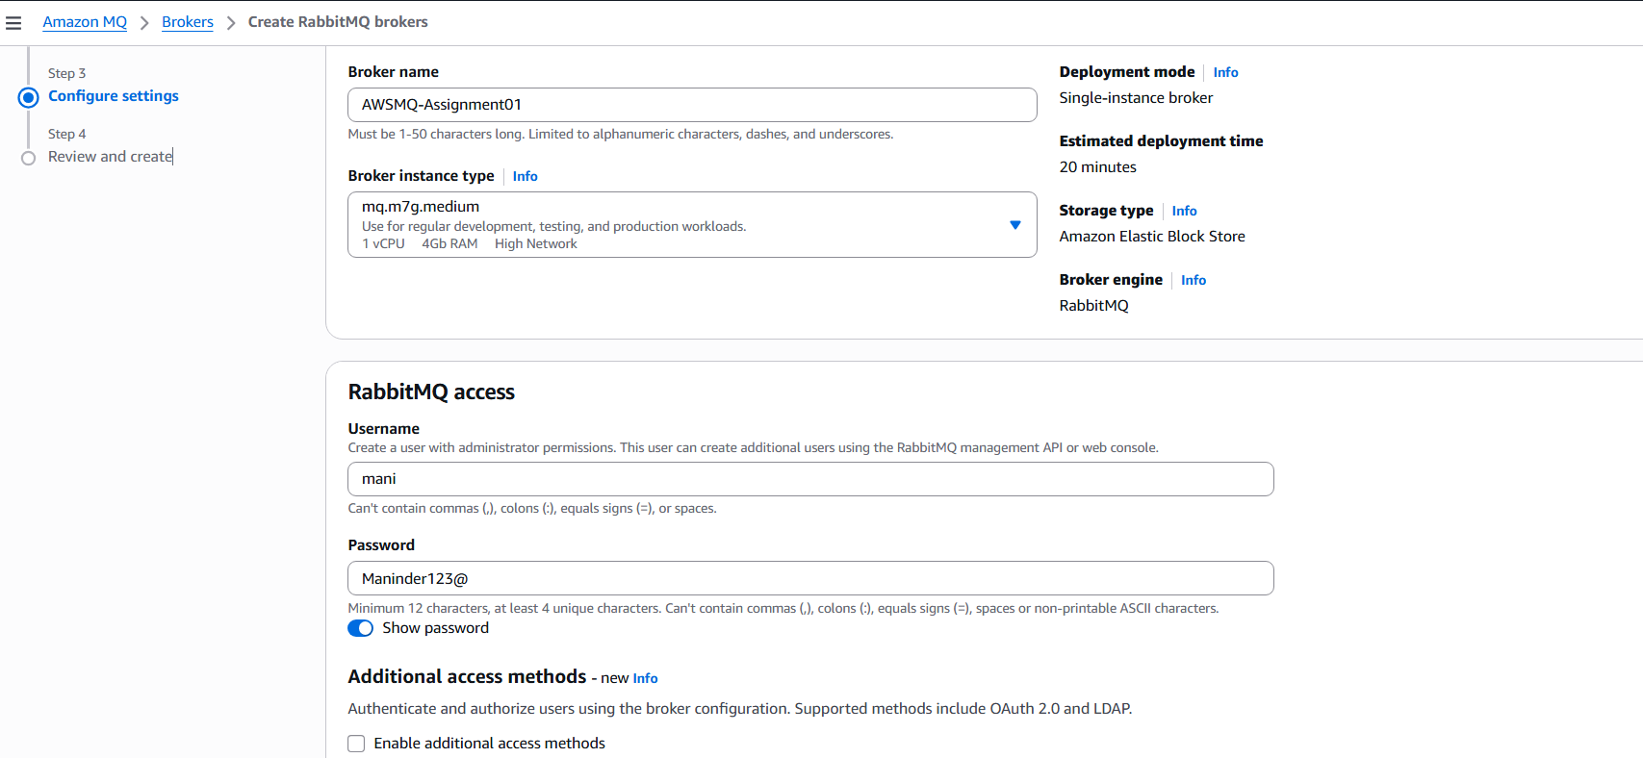
Step 4:
• Console path / CLI command: Amazon MQ > Brokers
• Explanation: Broker creation initiated and monitored until status changed from “Creation in progress” to “Running”.
Evidence: 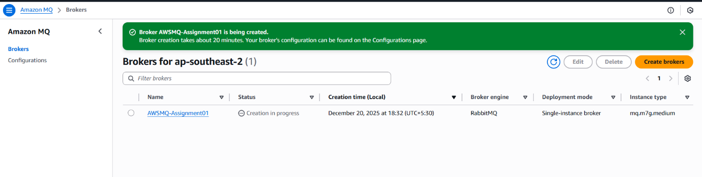
Step 5:
• Console path / CLI command: Amazon MQ > Brokers > Broker details > Connections
• Explanation: Retrieved RabbitMQ web console URL and AMQPS endpoint to access and integrate applications with the broker.
Evidence: 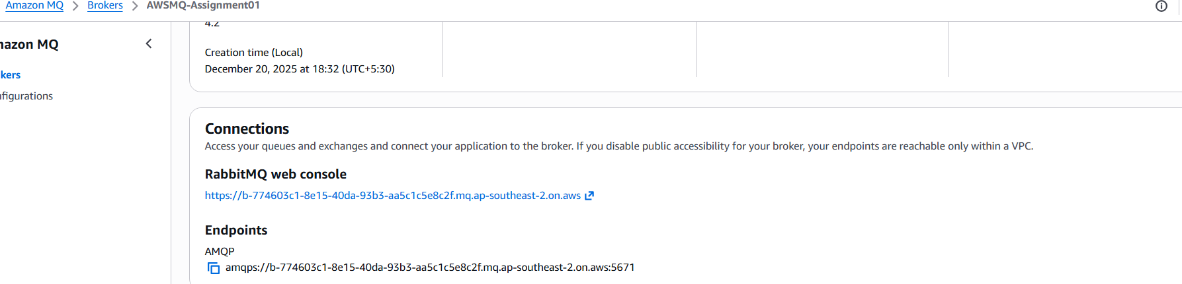
Validation Steps (Mandatory, With Evidence):
Access Check
Example: Successfully authenticated to RabbitMQ web console using created admin user.
Evidence: RabbitMQ login page and post-login dashboard.
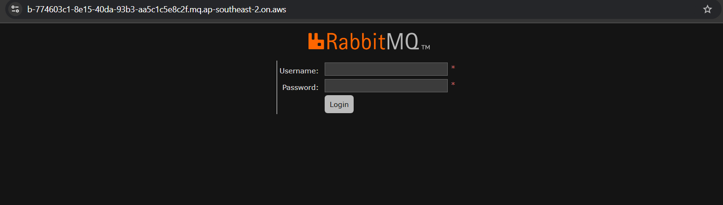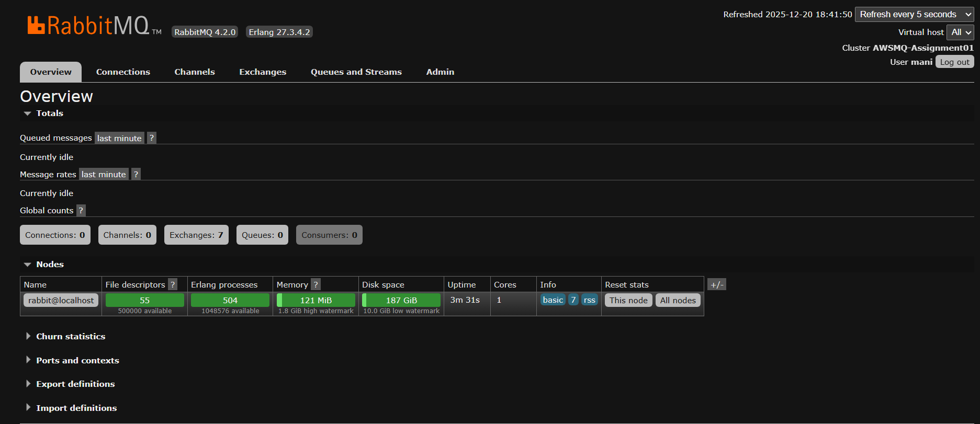
- Issues Faced (Optional):
• Broker creation takes approximately 20 minutes, which may appear as stalled if not monitored carefully.
- Conclusion:
Amazon MQ RabbitMQ broker was successfully created, configured, and validated. The broker is accessible via the RabbitMQ web console and ready for application-level message queuing and integration.

