Git installation
sudo apt update
sudo apt install git
git –version
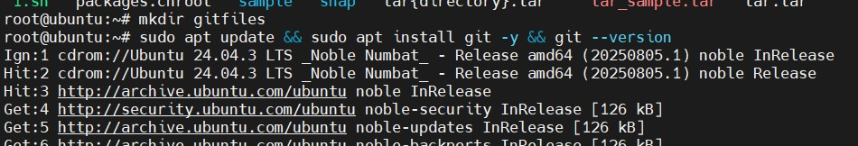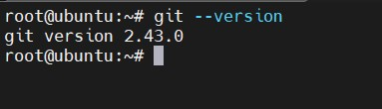

Initialising git
git init
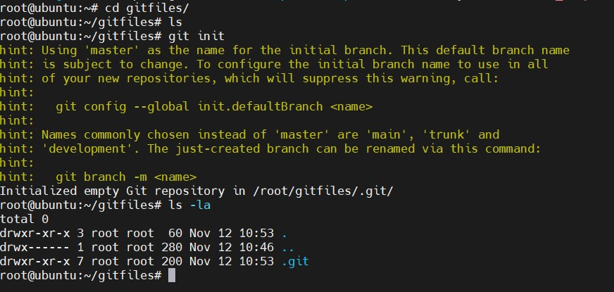
Configuring Git
git config --global user.name “Maninder Reddy”
git config --global user.email mani.maninder4444@gmail.com
git config –list
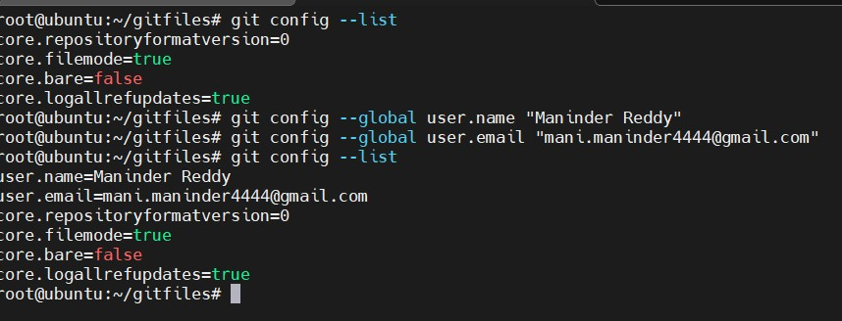
Git add command: it will add the files to the tracking area.
Git add will add the files to the tracking state
Touch {a..d}.txt
Git add a.txt
Git add . ( all files)
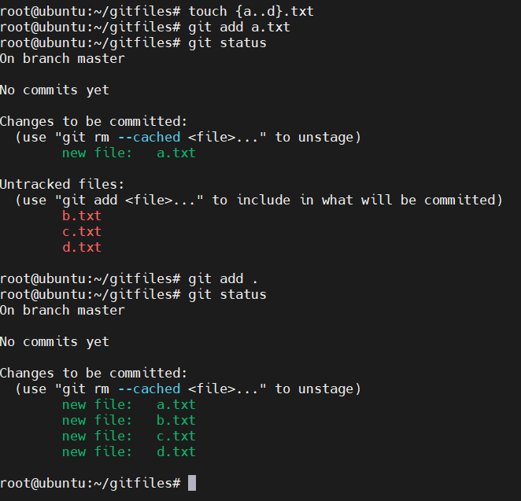
Git commit: commit command will commit changes to the local machine and stores te copy in the local machine
git commit -m “First commit”
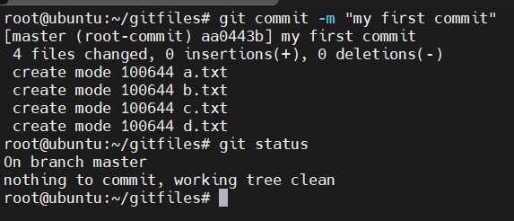

Git log: git log will show the logs of the committed history
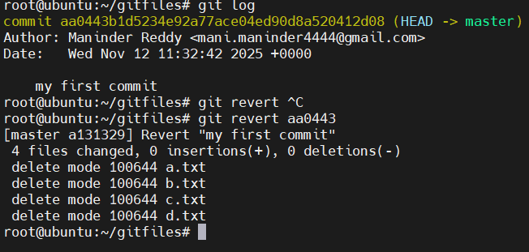

Git remote server connectivity: git will allow us to push the source code to the central repository using the git push command for that we need to configure the git repository
To check the git remote connectivity, we use git remote -v to check if we have any remote connectivity.
Create a git hub repository
I have created repo https://github.com/mani-u4444/maninder.git

Add git remote repo
git remote add origin https://github.com/mani-u4444/maninder.git

if we try to push the files to the remote repo it says permission denied so we need to generate the ssh key using ssh-keygen and add the public key to the github settings
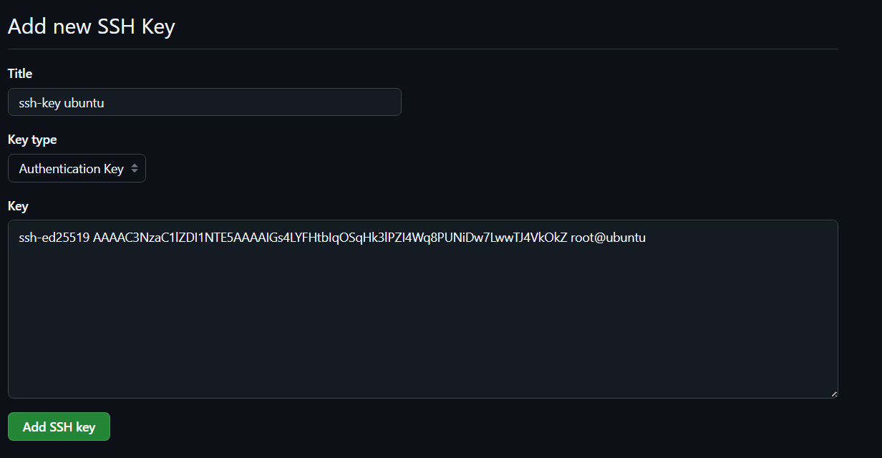

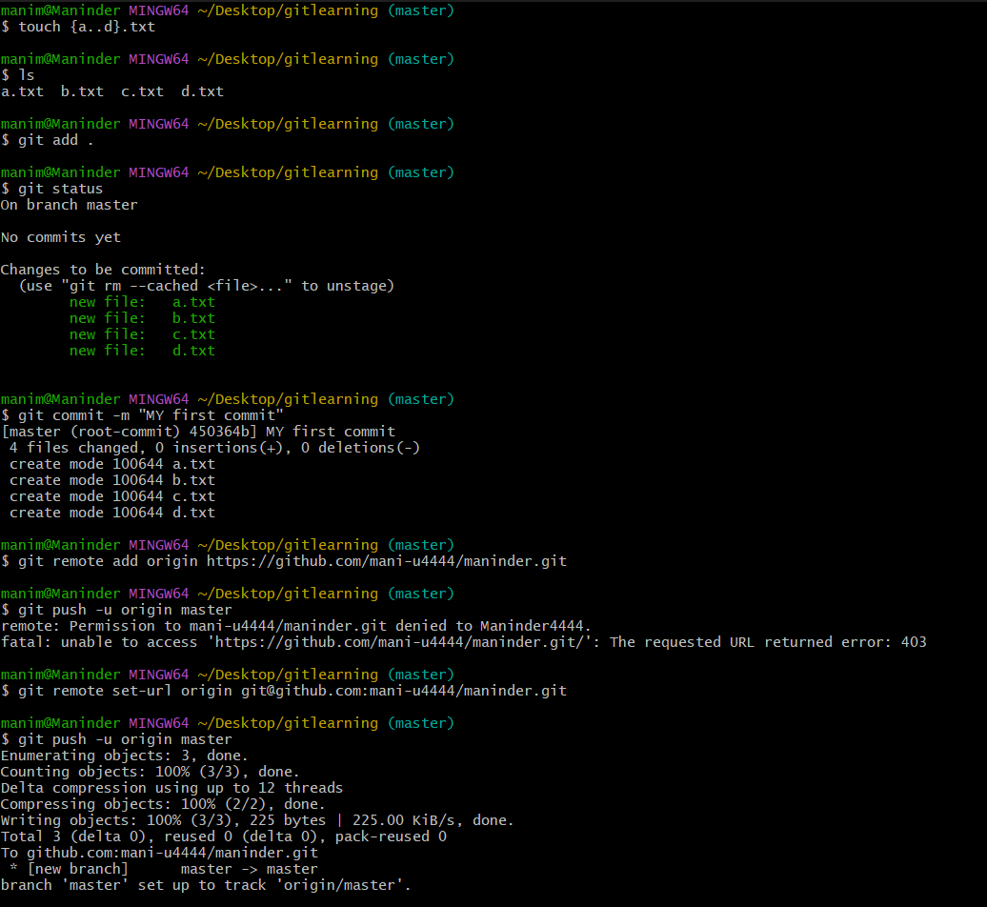
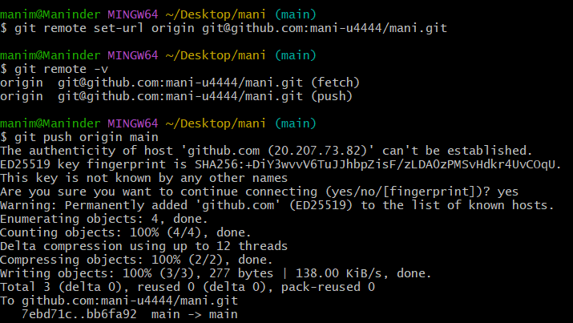
Used command: git remote set-url origin git@github.com:mani-u4444/maninder.git
All the files are being pushed to the repository from the local file system
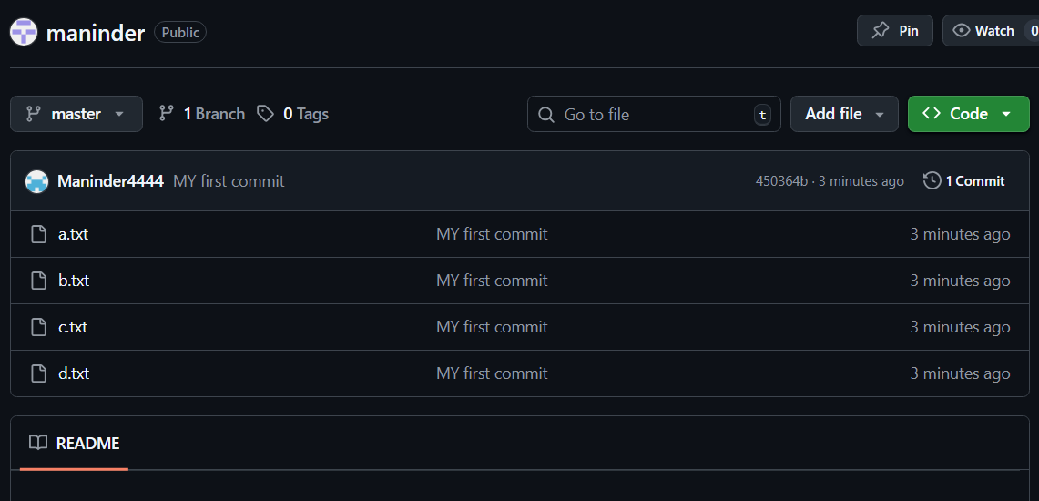

Now let say that the file was deleted in the local machine and we want the changes to be reflected on the github repository
rm d.txt
git add .
git commit -m " d.txt deleted "
git push -u origin master
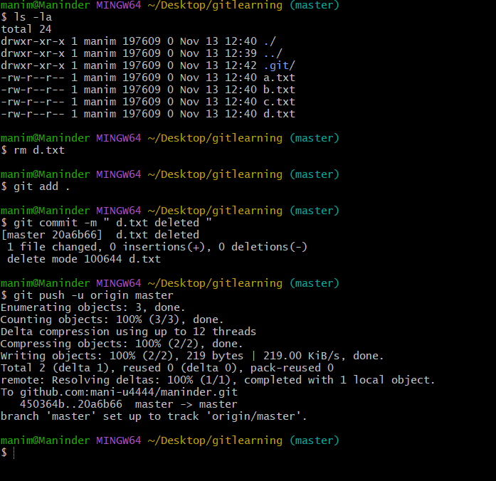
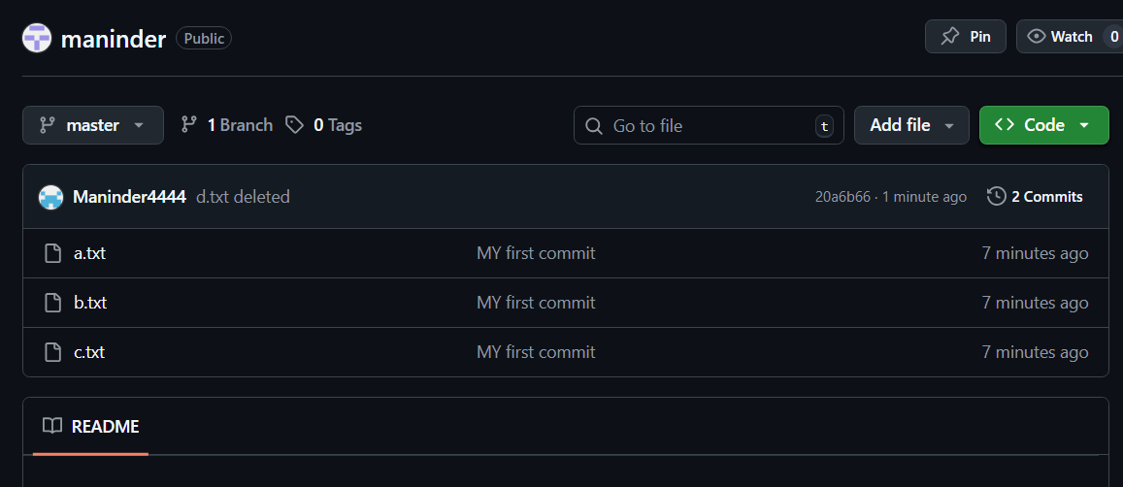

Now the condition is like we are now created a file in the GitHub console and that file is not present in the local machine and also new files are created on the local machine. And if the git push command is executed then the push request will be rejected.
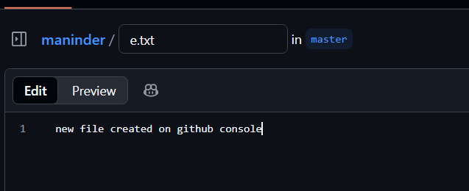
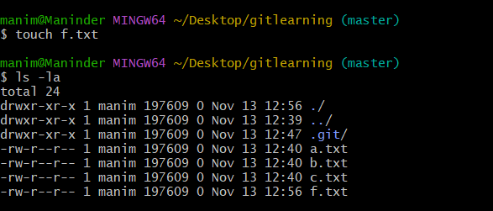
git pull
git push -u origin master
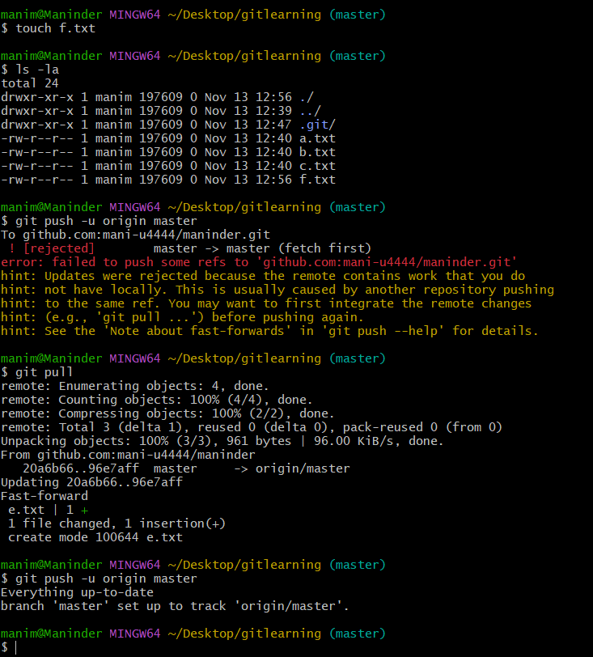
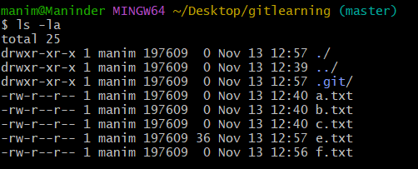
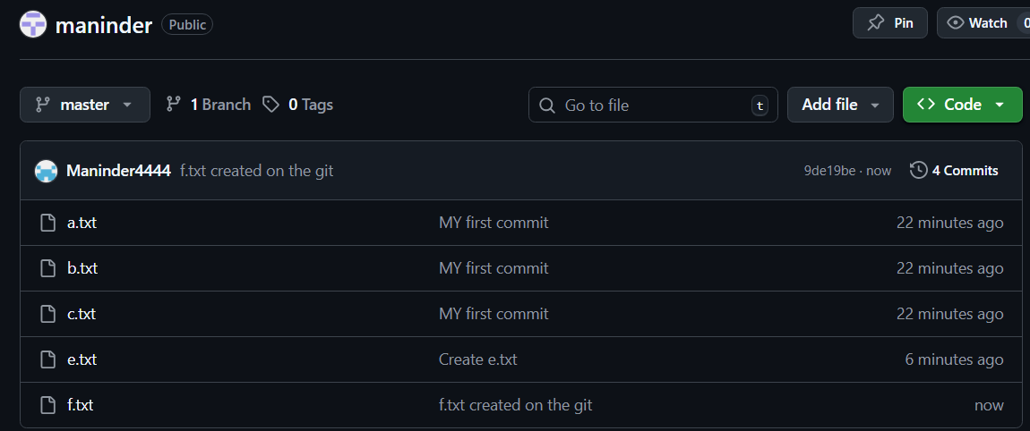

*** Local machine and central machine should always should be same.

Git clone:

Git clone is used to clone the entire repository in to the local machine.
git clone <url>
suppose the whole file system in the local machine gets deleted then
executing the git pull will not work for the first time, it will only work if we have the files related to the repository.
In that situation we use git clone to clone the entire repository to the local machine.

Git revert:
Git revert is used to revert to the previous state of the commit history, suppose if we want the changes to revert to the previous or the desired commit then we will execuete the git log and copy the commit id of the desired commit and execuete the following command
git revert <commit_id>
Git reset:
Git reset is used to revert the files from tracking state or staging state to the untracking state.
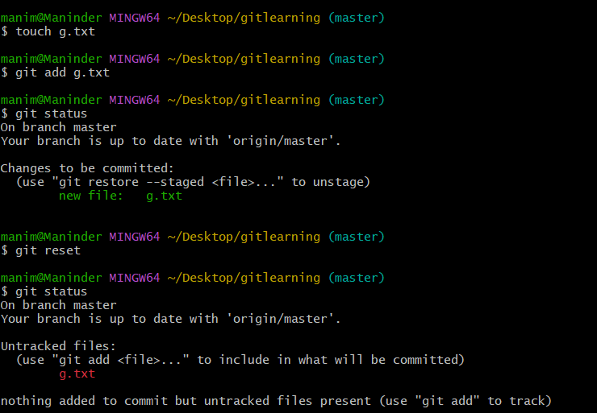
Set up MFA (Multi-Factor Authentication) for the GitHub account using a mobile app.
Goto github settings-> password and authentication->enable two factor authentication
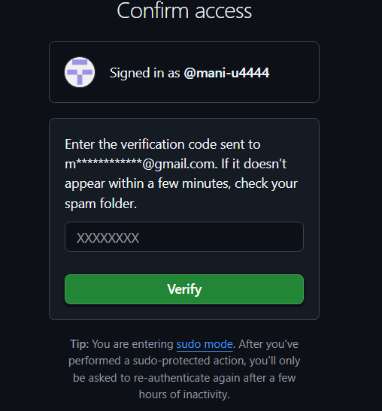
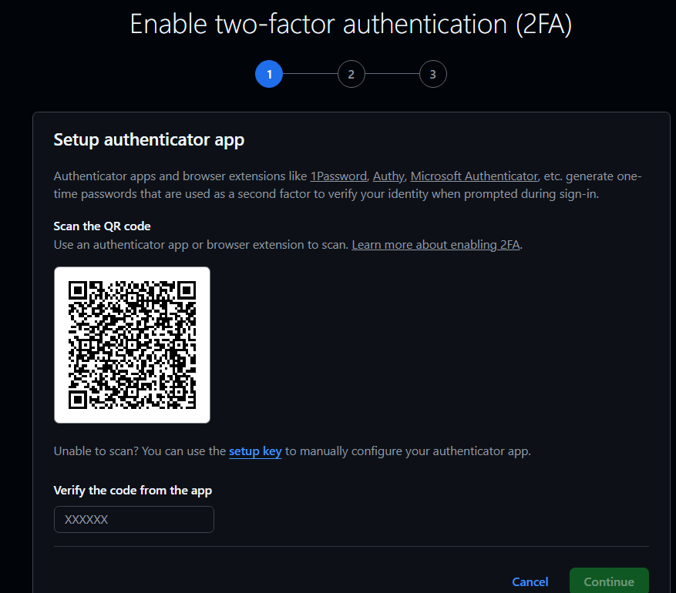
Download authenticator on the mobile and scan the QR code


