- Create user with name Techie and provide sudo access to user.
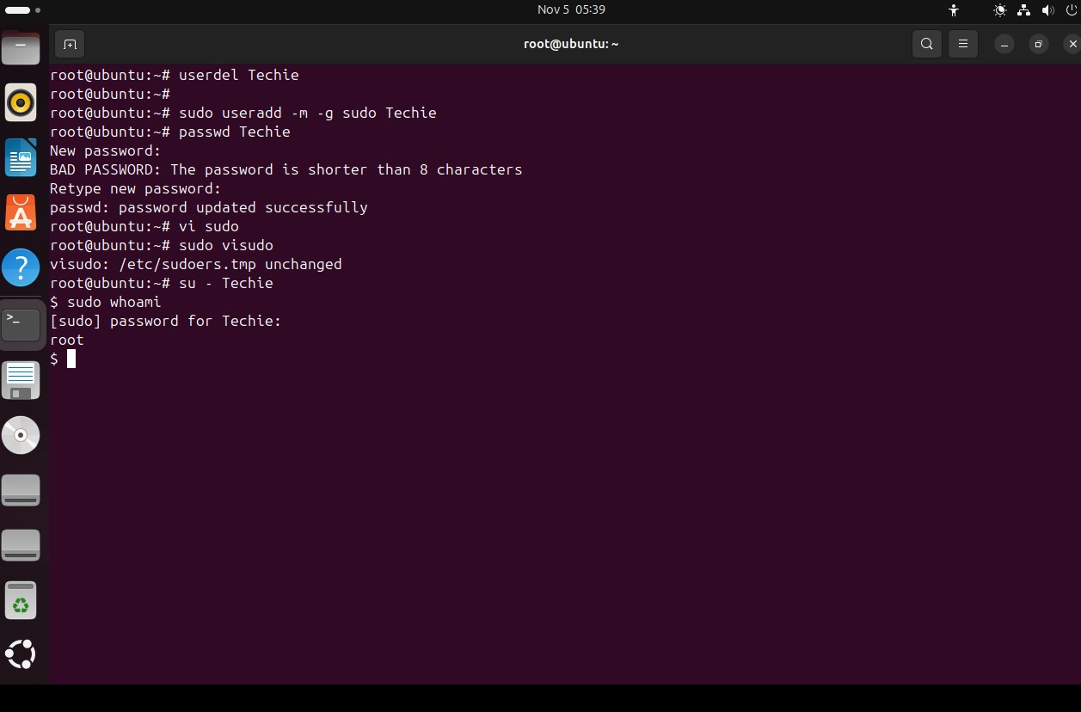
- Navigate to the home directory.
We can use: cd ~ for the present user
cd /home/Techie


- Create a new directory.
Command used: mkdir newdirectory
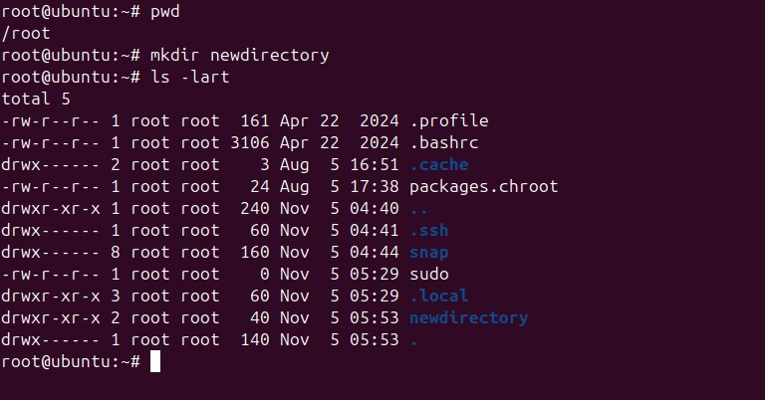
- List the contents of a directory.
Created a file using the touch command and execueted “ls -lart” to view the contents of the directory
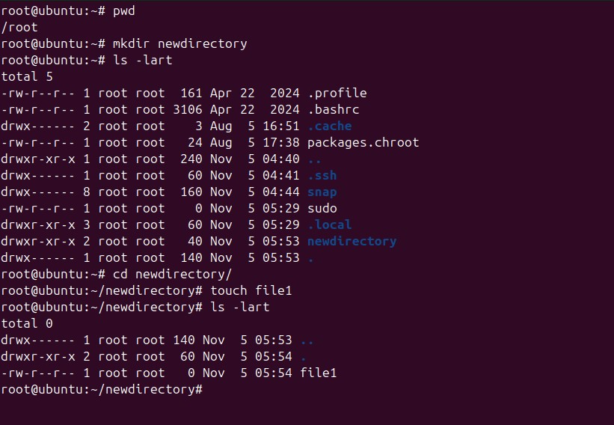
- Change the current directory.
To change the current directory we use cd command
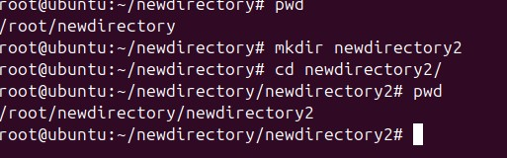
- Create a new empty file.
We can create an empty file using “touch command”
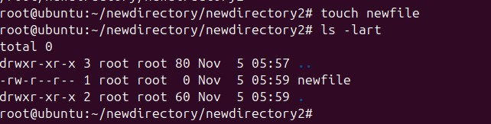
- View the contents of a file.
The contents in a file can be viewed using the “cat” command
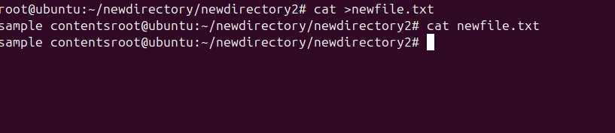
- Copy a file to another location.
Command used: “cp”

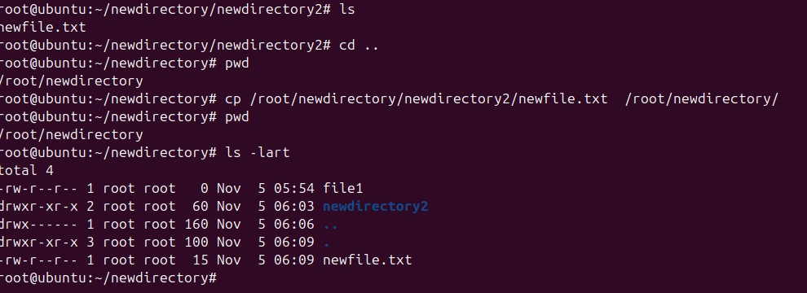
- Move a file to another location.
Command used: “mv”
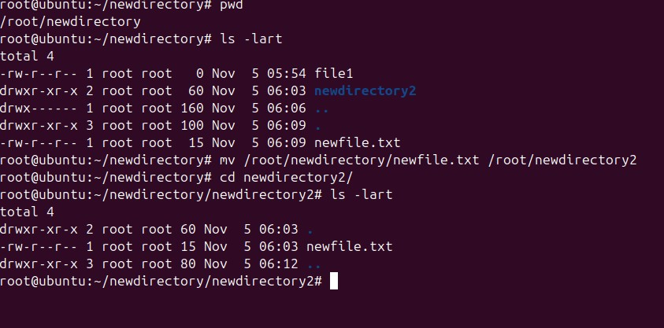

- Rename a file.
Command used: “mv”
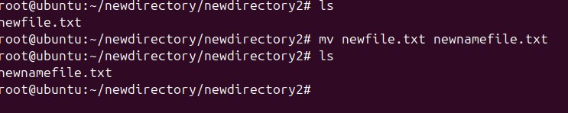
- Delete a file.

Command used: “rm”
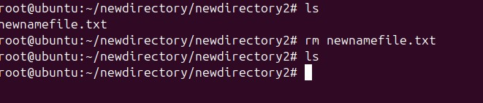
- Grant or revoke permissions on a file or directory.
Created a file called sample.txt and used command “chmod 766 sample.txt” to grant the permission to -rwxrw-rw-
And used command “chmod 744 sample.txt” to revoke the permissions
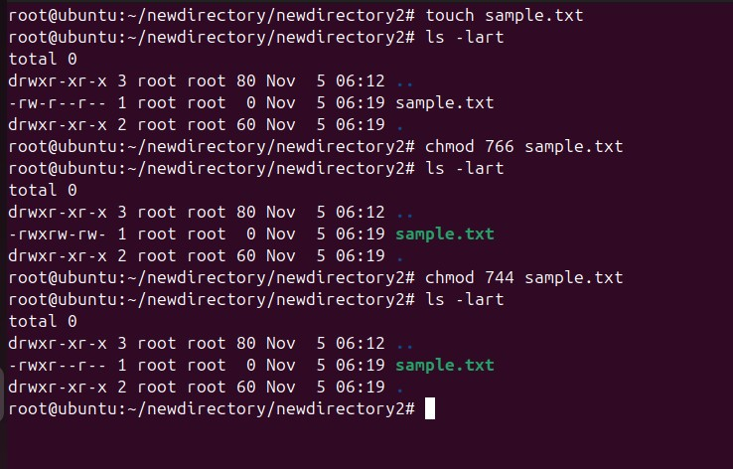
- View the current date and time.
Command used: “date”
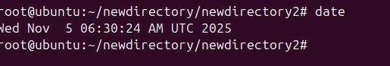
- Check the system uptime.

Command used: “uptime”
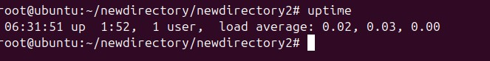
- View the running processes.
Command used: “top”
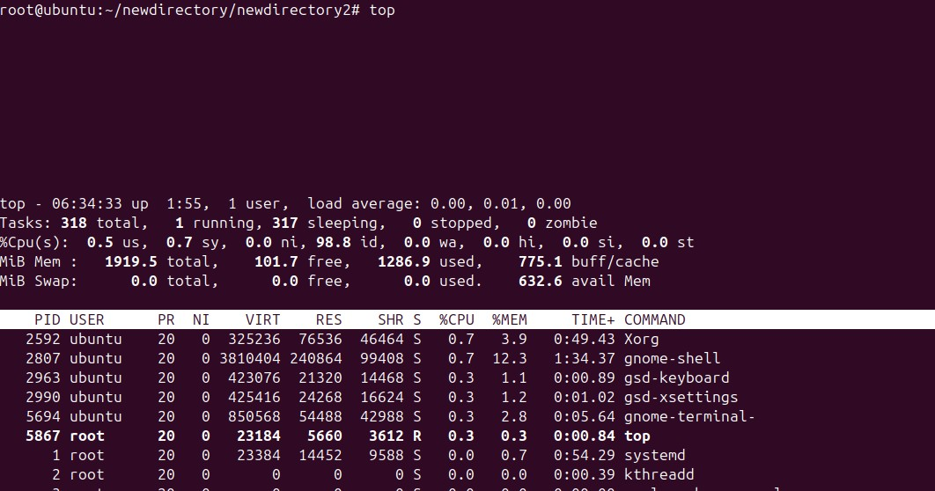
- Kill a running process.
Command used: “pkill <processname>”
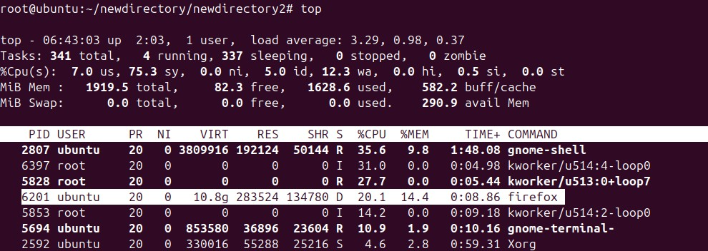

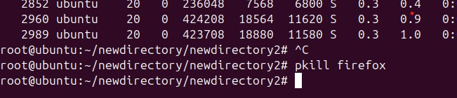

- Install a package using the package manager (e.g., apt or yum).
Command used: I have installed tree package and used “sudo apt install tree -y”
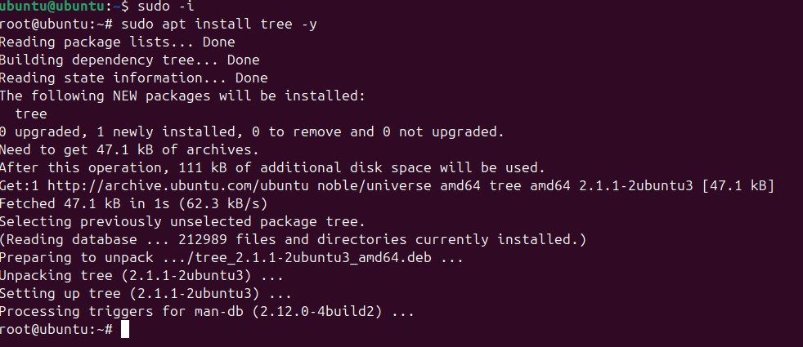

- Update the system packages.
Command used: “sudo apt update -y”
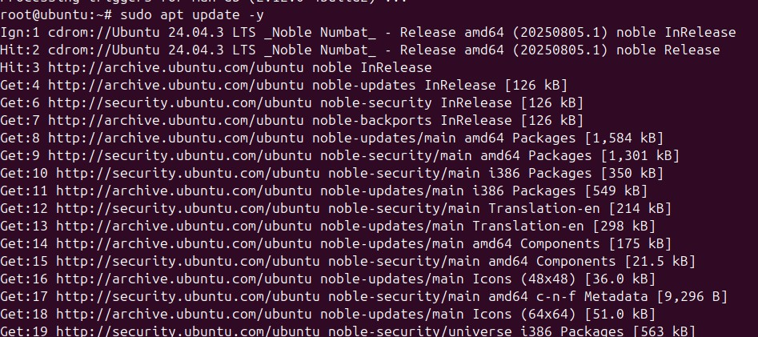
- Create a symbolic link.
I have file1 and I have created a symbolic link in newly created folder called linksdir using the command “ln -s /root/newdirectory/newfile /root/newdirectory/linksdir/”
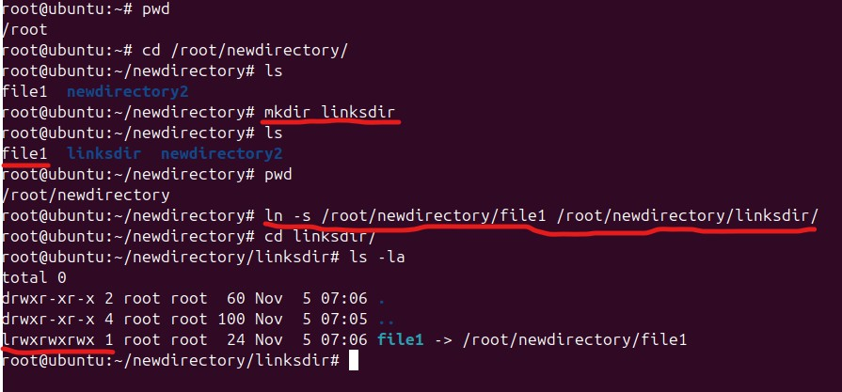
- Search for files using the find command.
I have created four files namely name1.txt, name2.doc, name3.xml, name4.xml and I have used “find . -name “*.xml” to display only the xml files from the present directory
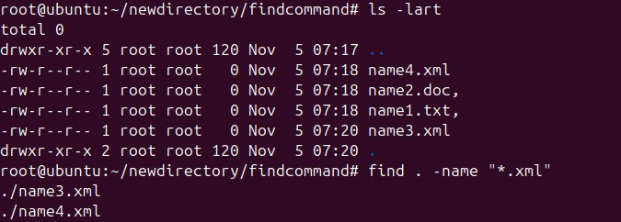
- Compress and decompress files using tar.

To compress: “tar -czf compresstar.tar.gz . “ in the present directory
To view the compressed folder files: “tar -tzf compresstar.tar.gz . “
To decompress: “tar -xzf compresstar.tar.gz . “
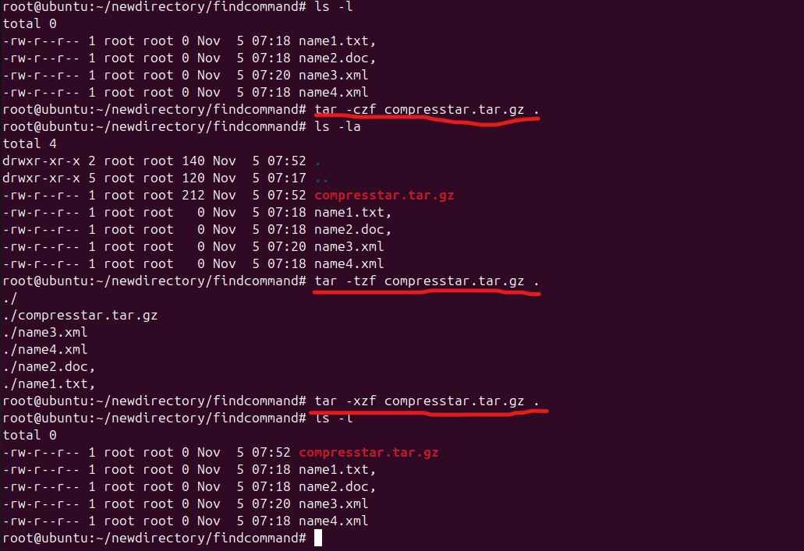
- Monitor system resources with top or htop.
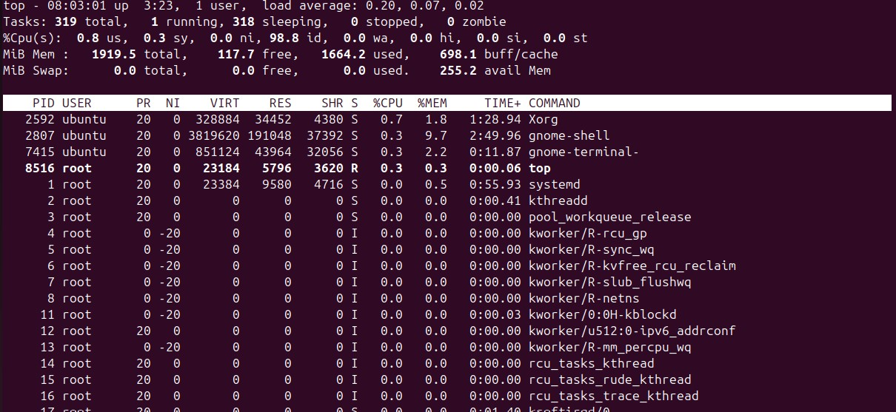
- Create and manage user groups.
Create a new group: groupadd <name>
Adding user to group: usermod -aG <groupname> <user>
Remove user from group: gpasswd -d <user> <groupname>
Remove group: groupdel <groupname>
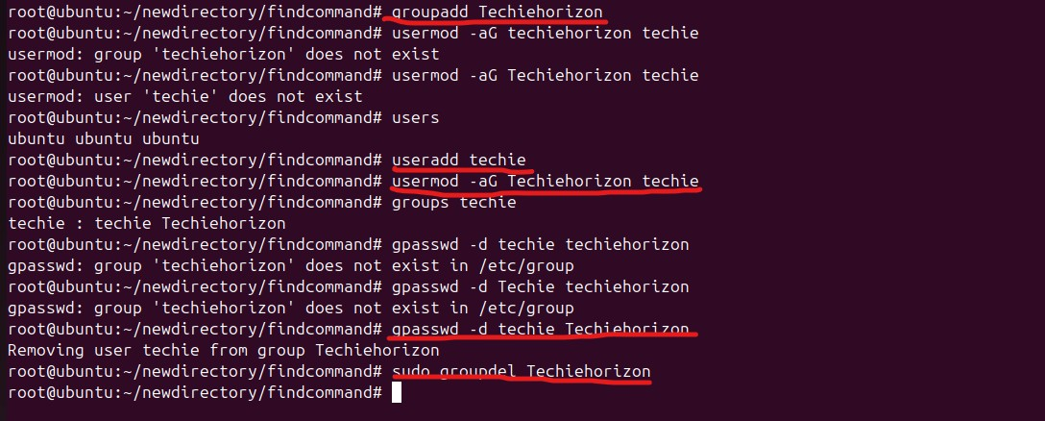
- Set up SSH password less authentication.
I have generated the ssh keys using the command ssh-keygen -t rsa -b 4096 -C maninder@gmail.com
And I have navigated to the c:/user/.ssh folder containing the public key where I have launched the git bash from there and I entered the command ssh-copy-id -i id_rsa.pub ubuntu@192.168.58.147 upon logging with command ssh -p 22 ubuntu@192.168.58.147 I was able to login without password
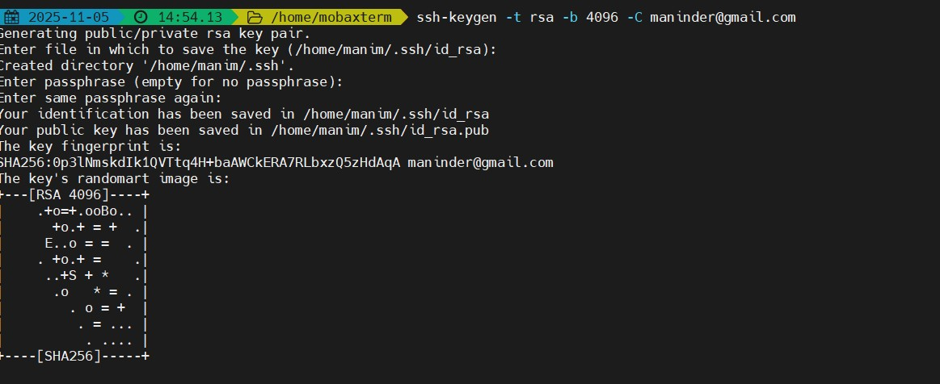
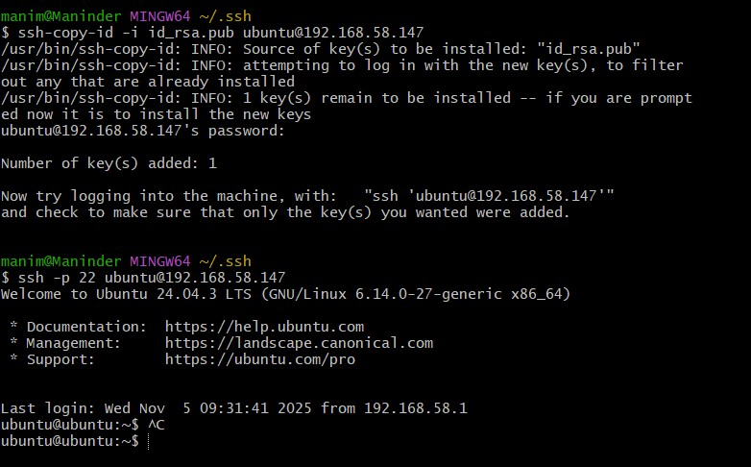
- Monitor log files using tail or grep.
Command using the tail command “ tail -n 5 logfile.txt” it will display 4 last line of file
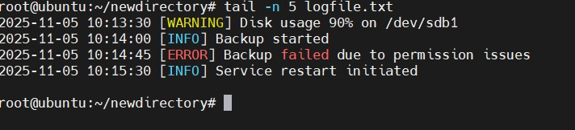
Command using the grep command “grep -i disk usage logfile.txt
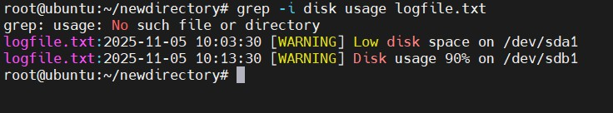
- Set up a web server (e.g., Apache or Nginx).
Command used: sudo apt update && sudo apt install apache2 && sudo systemctl start apache2 && sudo systemctl enable apache2 && sudo systemctl status apache2

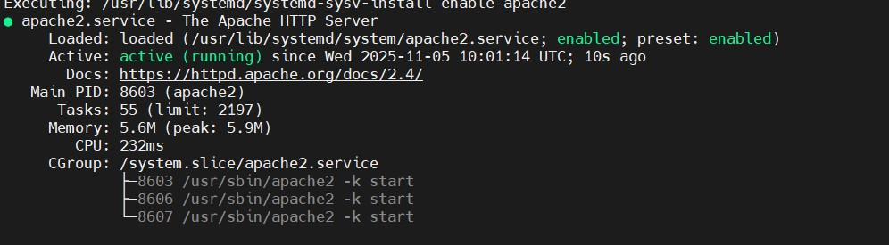
- Configure and secure a MySQL Database.
Command used; sudo apt update && sudo apt install mysql-server && sudo systemctl status mysql && sudo mysql_secure_installation

- Set up a Application Server (e.g.,Apache Tomcat)
The following commands have been execueted
sudo apt update && sudo apt install openjdk-11-jdk&& java -version
wget https://downloads.apache.org/tomcat/tomcat-9/v9.0.111/bin/apache-tomcat-9.111.tar.gz && sudo tar -xvzf apache-tomcat-9.0.56.tar.gz && sudo mv apache-tomcat-9.0.56 /opt/tomcat && sudo chown -R $USER:$USER /opt/tomcat
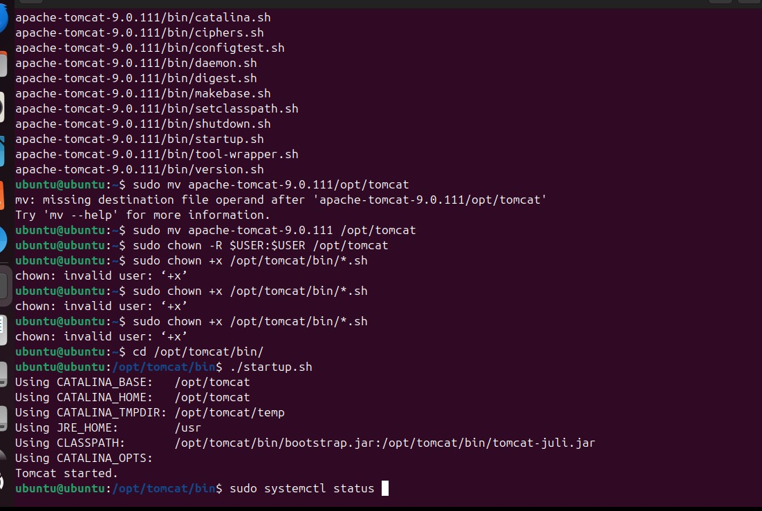

- create a service file for Apache Tomcat.(Should execute by using systemtctl command)
commands execueted: sudo vi /etc/systemd/system/tomcat.service

[Unit]
Description=Apache Tomcat Web Application Container
Documentation=http://tomcat.apache.org
After=network.target
[Service]
Type=forking
Environment=JAVA_HOME=/usr/lib/jvm/java-11-openjdk-amd64
Environment=CATALINA_HOME=/opt/tomcat
Environment=CATALINA_BASE=/opt/tomcat
Environment=CATALINA_PID=/opt/tomcat/temp/tomcat.pid
ExecStart=/opt/tomcat/bin/startup.sh
ExecStop=/opt/tomcat/bin/shutdown.sh
User=tomcat
Group=tomcat
UMask=0007
Restart=always

[Install]
WantedBy=multi-user.target

sudo systemctl enable tomcat
sudo systemctl start tomcat
sudo systemctl status tomcat
- Print specific columns from a delimited file.
Commands executed: cut -d "," -f 1 file.txt
cut -d "," -f 2 file.txt
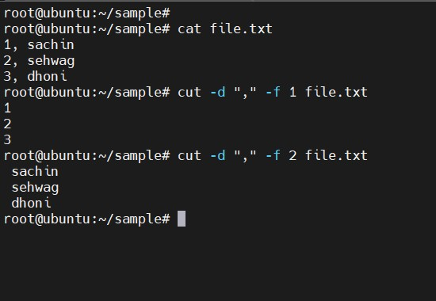

- Filter and print lines based on a specific pattern or condition.
for filtering lines using a specific condition we can
use awk command and also grep ‘^A filename.txt
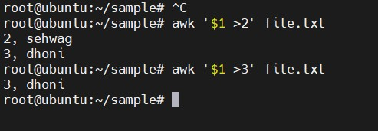
- Calculate and print the average, sum, or other statistics of a column.
Commands execueted: awk '{sum += $1} END { print sum}' file.txt
awk '{sum += $1} END { print sum/NR}' file.txt
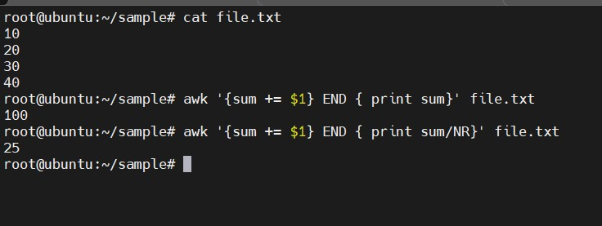
- Perform string manipulation, such as extracting substrings or changing case.
Commands execueted: we use ‘cut’ command for extracting substrings and use ‘tr’ to change the case.
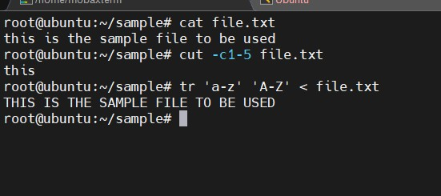
- Count the occurrences of a specific pattern in a file.
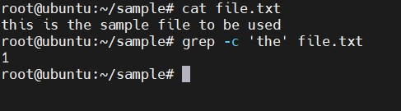
- Sort lines based on a specific field or column.
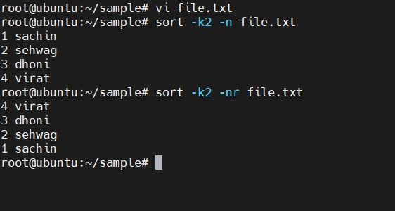
- Merge multiple files based on a common field or column.
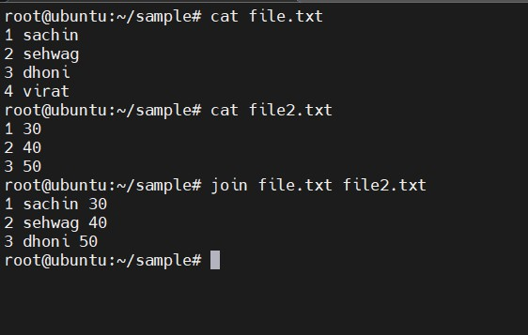
- Substitute text in a file using search and replace.
Command used: we can use “sed” command to replace the text
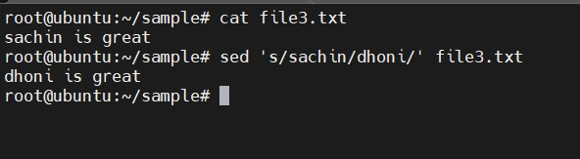
- Delete specific lines based on a pattern or line number.
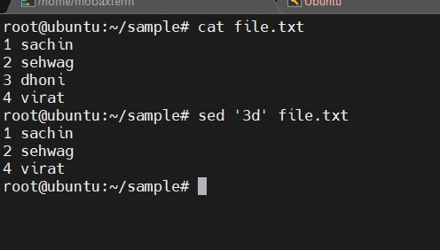
- Append or insert text before or after a specific pattern or line.
Commands execueted; sed '/pattern/i text_to_insert' file – before pattern
sed '/pattern/a text_to_insert' file
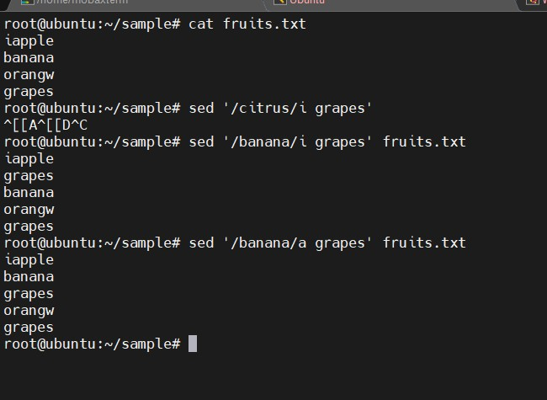
- Print only specific lines from a file.
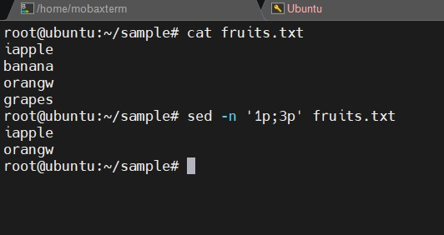
- Copy file from linux to windows machine

- 5 use cases for AWK and 5 use cases for sed

1. Extract specific columns from CSV:
awk -F ',' '{print $1, $3}' file.csv

2. Sum numbers in a column:
awk '{sum += $2} END {print sum}' file.txt

3. Replace text based on condition:
awk '{if ($2 >= 70) print $1 " Passed"; else print $1 " Failed"}' file.txt

4. Filter based on multiple conditions:
awk '$2 == "A" && $3 > 400' orders.txt

5. Format data into a table:
awk '{printf "%-10s %-10s\n", $1, $2}' file.txt
1. Replace all occurrences of a word:
sed 's/apple/orange/g' file.txt

2. Delete lines containing a pattern:
sed '/banana/d' file.txt

3. Insert text before a pattern:
sed '/apple/i Text before apple' file.txt

4. Replace text on a specific line:
sed '3s/old_text/new_text/' file.txt

5. Convert text to uppercase:
sed 's/.*/\U&/' file.txt

