Create a bash script to check if a directory is available or not.

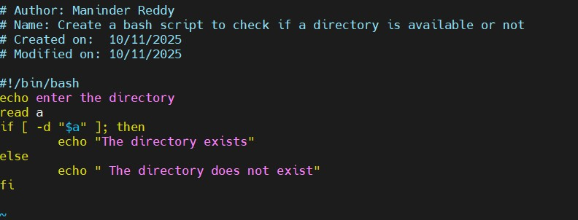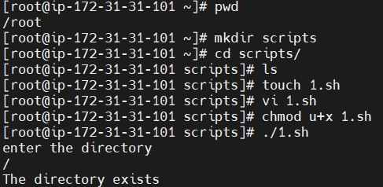ls

Create a bash script to create multiple files.
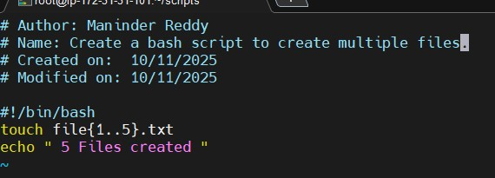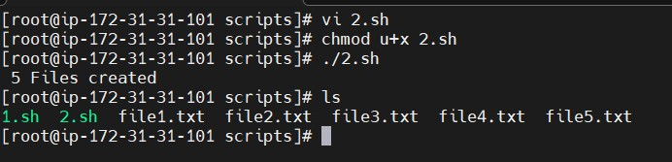

Create a bash script to take a backup of a directory.
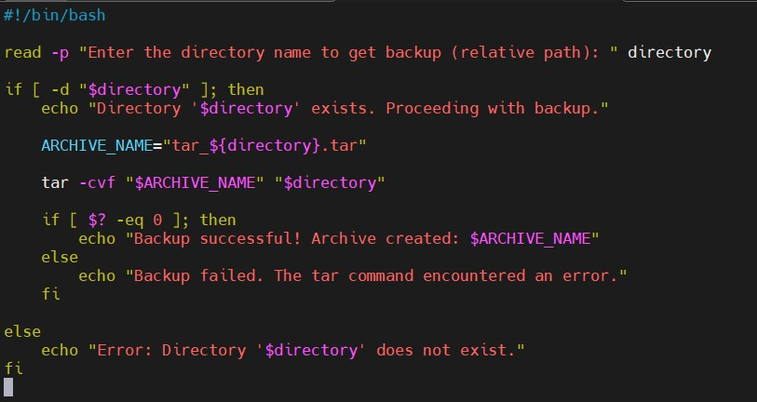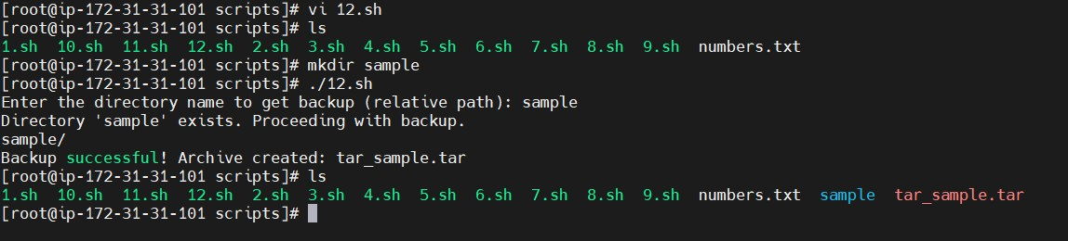

Create a bash script to install Nginx on an EC2 server.
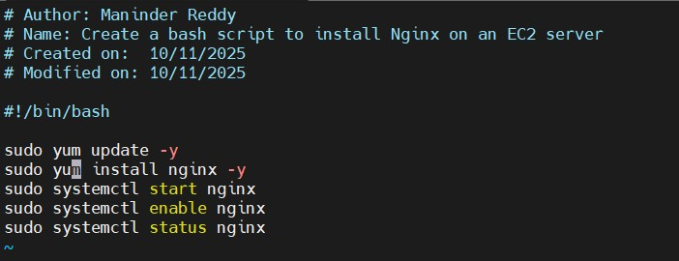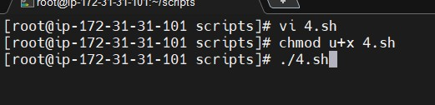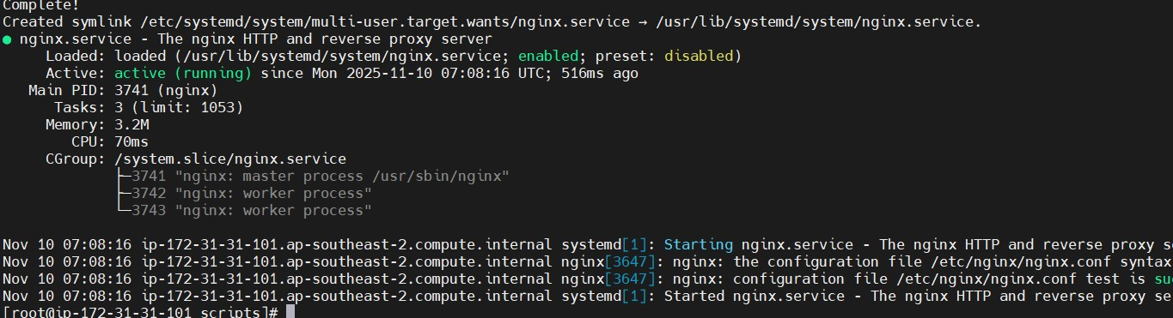

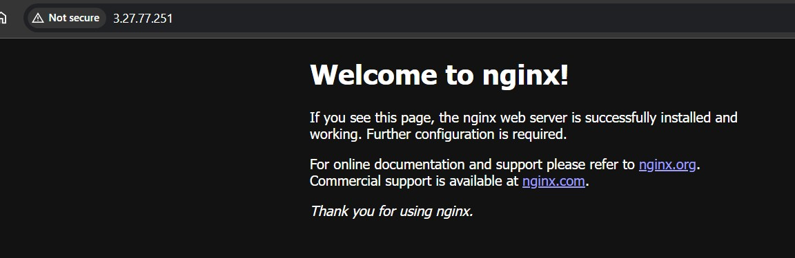

Create a bash script to install Apache Tomcat on an EC2 server.
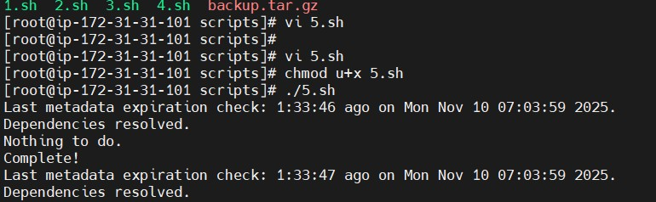
I have executed the following script

--------------------------------------------------------------------------------------------------------------------------------------
# Name: Create a bash script to install Apache Tomcat on an EC2 server.
# Created on: 10/11/2025
# Modified on: 10/11/2025

#!/bin/bash
sudo dnf update -y
sudo dnf install java-17-amazon-corretto -y
java -version
sudo groupadd tomcat || true
sudo useradd -g tomcat -d /opt/tomcat -s /bin/nologin tomcat || true
cd /tmp
wget https://dlcdn.apache.org/tomcat/tomcat-9/v9.0.111/bin/apache-tomcat-9.0.111.tar.gz
sudo mkdir -p /opt/tomcat
sudo tar -xvf apache-tomcat-9.0.111.tar.gz -C /opt/tomcat --strip-components=1
sudo chown -R tomcat:tomcat /opt/tomcat
sudo chmod -R 755 /opt/tomcat
cat <<EOF | sudo tee /etc/systemd/system/tomcat.service
[Unit]
Description=Apache Tomcat Web Application Server
After=network.target

[Service]
Type=forking
User=tomcat
Group=tomcat
Environment="JAVA_HOME=/usr/lib/jvm/java-17-amazon-corretto"
Environment="CATALINA_PID=/opt/tomcat/temp/tomcat.pid"
Environment="CATALINA_HOME=/opt/tomcat"
Environment="CATALINA_BASE=/opt/tomcat"
ExecStart=/opt/tomcat/bin/startup.sh
ExecStop=/opt/tomcat/bin/shutdown.sh
RestartSec=10
Restart=always
[Install]
WantedBy=multi-user.target
EOF
sudo systemctl daemon-reload
sudo systemctl start tomcat
sudo systemctl enable tomcat
sudo systemctl status tomcat
--------------------------------------------------------------------------------------------------------------------------------------

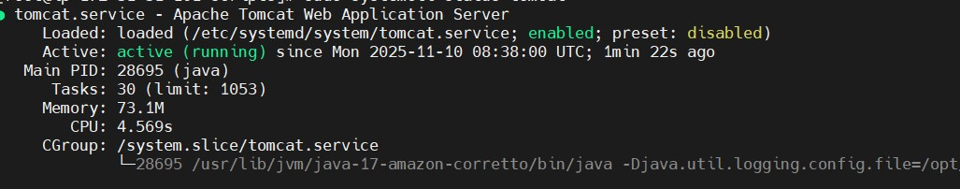

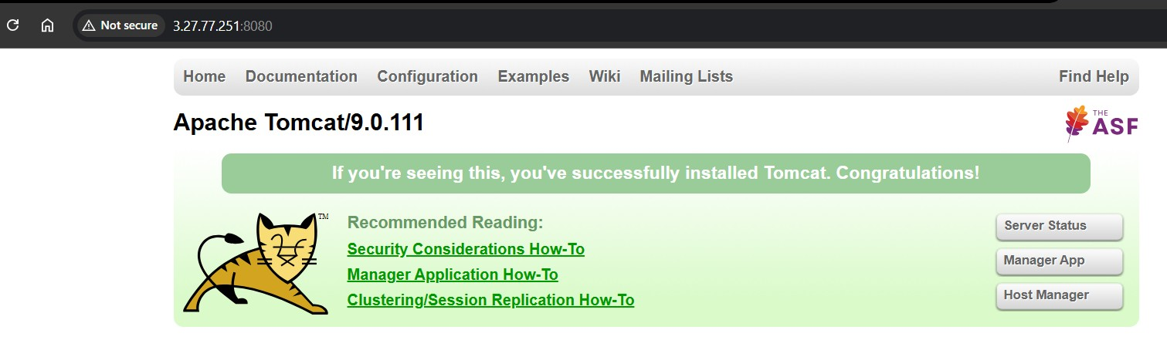

Create a bash script to check if the Nginx service is running, if not running then script should start the service.

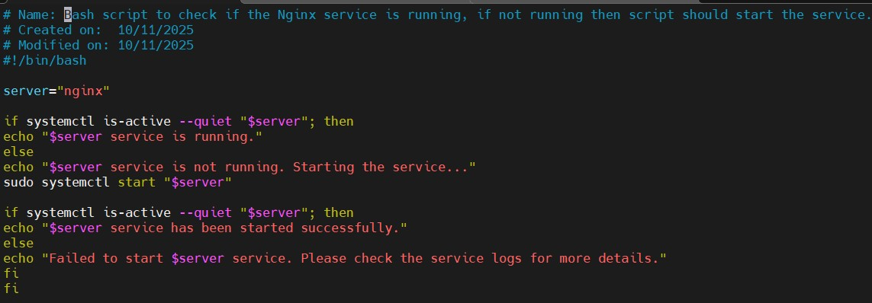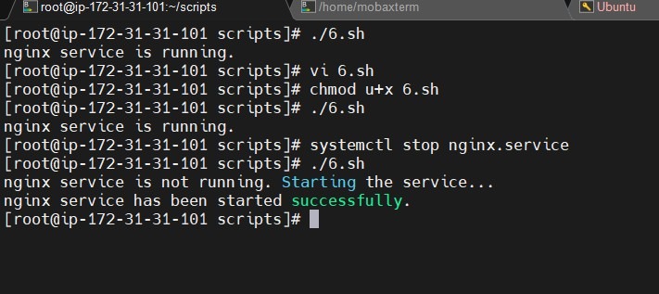

Create a bash script for a calculator.

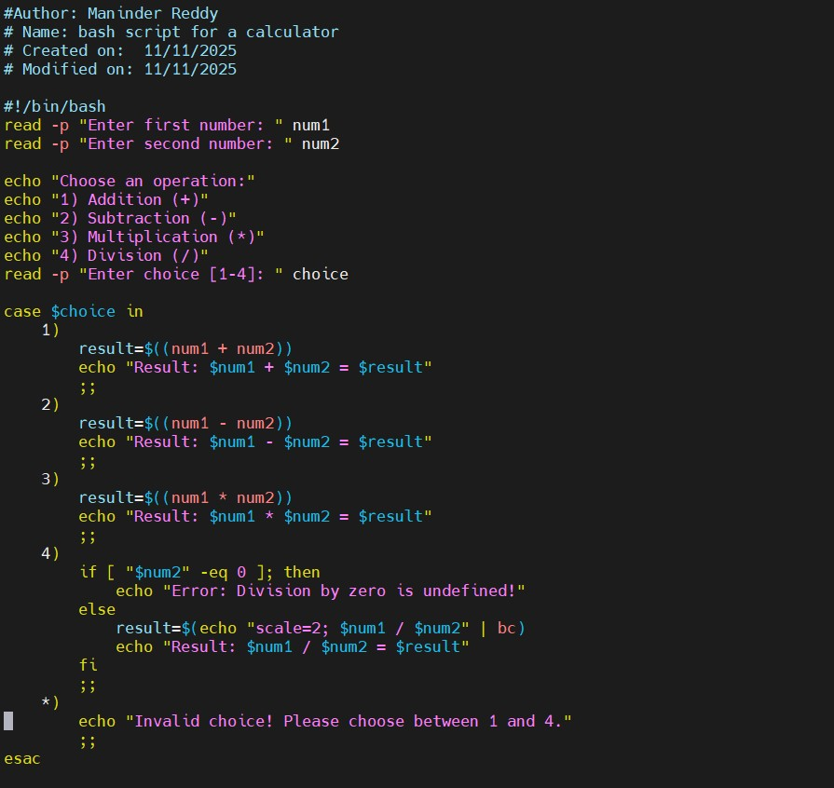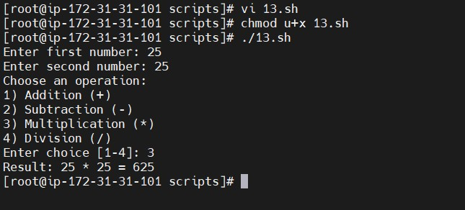

Create a bash script to check if a directory exists, if not then create a directory.

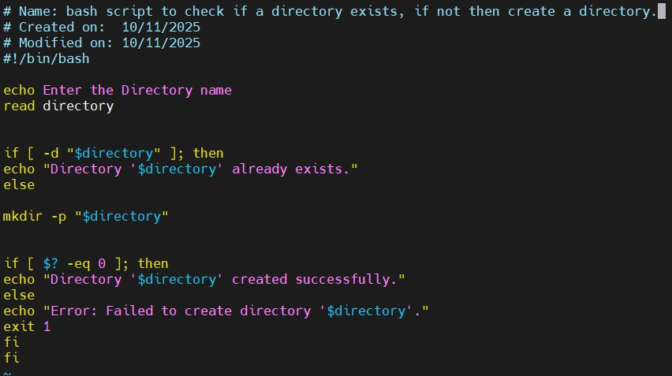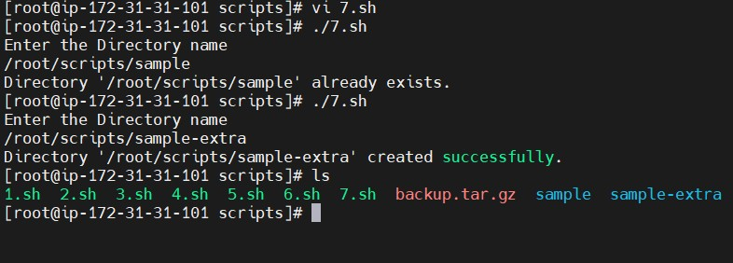

Create a bash script to delete the last 3 lines of a file.

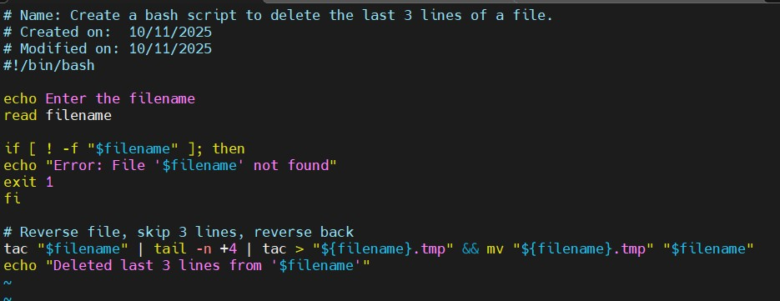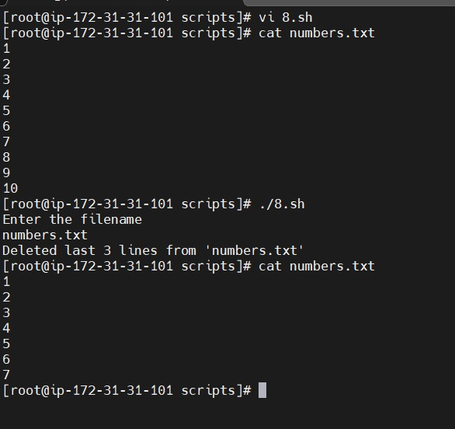

Bash script to monitor cpu and if it is more than 80% then send email notification.
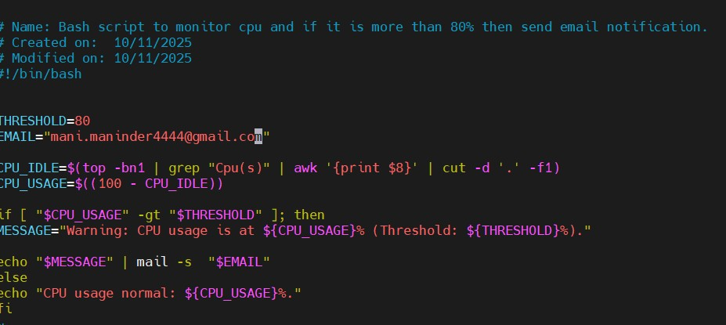
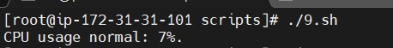

Bash script to monitor disk space and if it is more than 80% then send email notification.
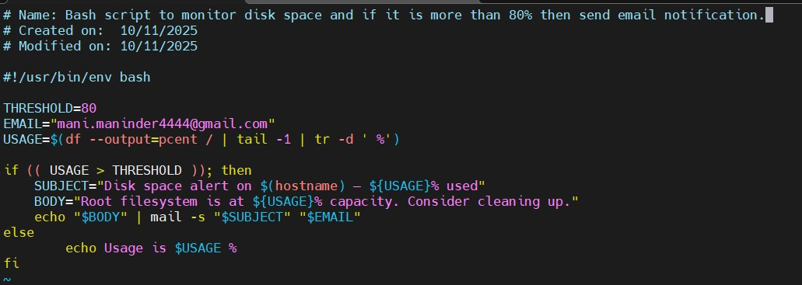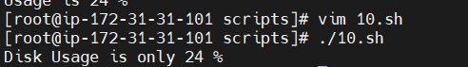

Bash script to monitor memory and if it is more than 80% then send email notification.

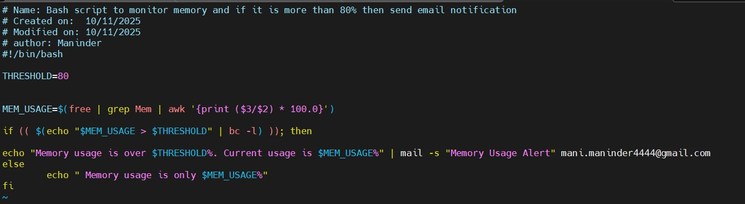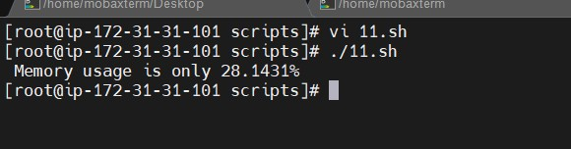

Exercise: Crontab Entries
April 5th Midnight
5th of Every November, January, June if it is a Thursday
At 05 and 27th minutes of 9, 10, 11 hours every day
34 minutes of 9th hour on 15th August
Every midnight
Every Weekend (Saturday night 11:59 PM)
After every reboot

# Install the cron daemon package
yum install -y cronie
# Enable cron service to start on boot
systemctl enable crond
# Start cron service now
systemctl start crond

