IAM-Assignment-1

- Create one IAM user and assign EC2 and S3 full access roles.

Create a new user in the IAM service
Launch the IAM service and go to users, and clicke ‘Create user’, Assign the name of the user(Maninder)
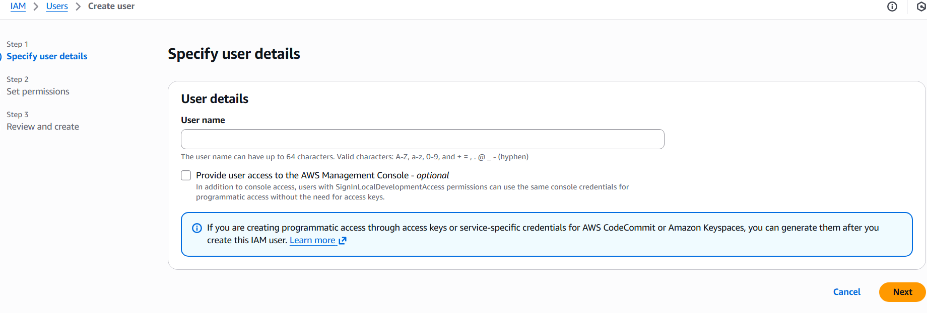
Goto to next, select ‘Attach policies directly’ attach AWS managed policies “AmazonEC2FullAccess” and “EC2FullAccess” Permissions

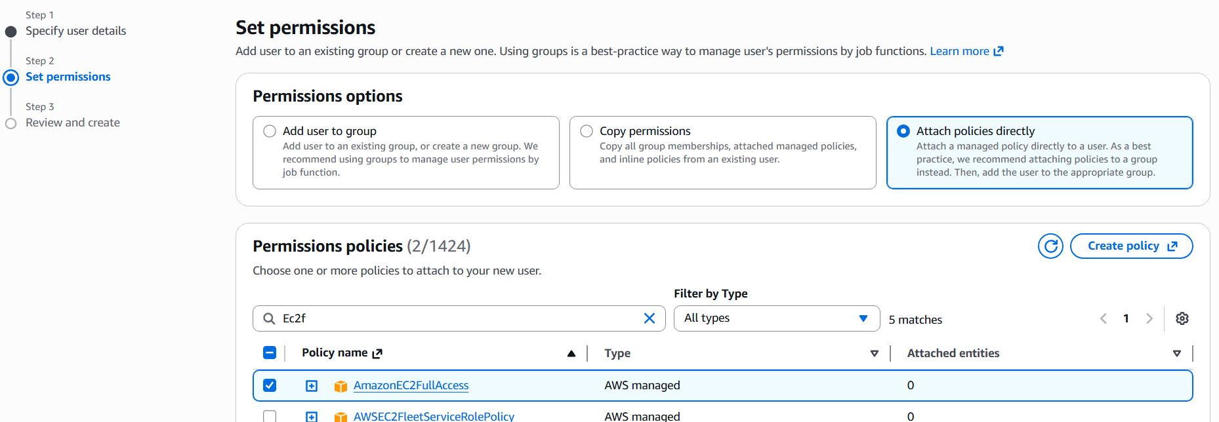
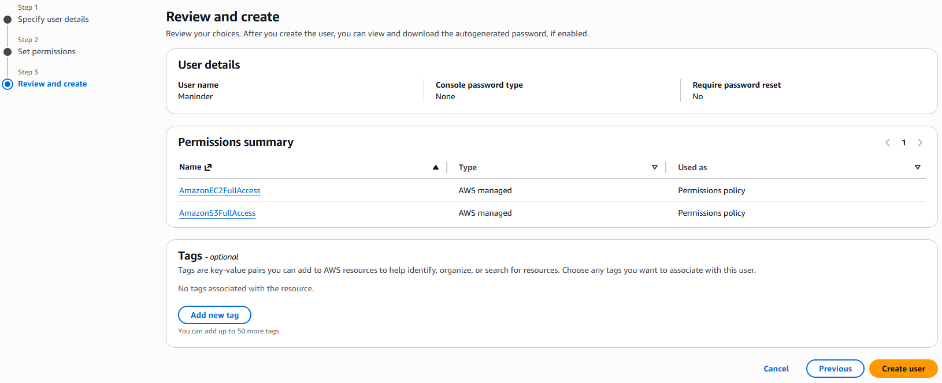
In the step-3 Review and ‘create user’
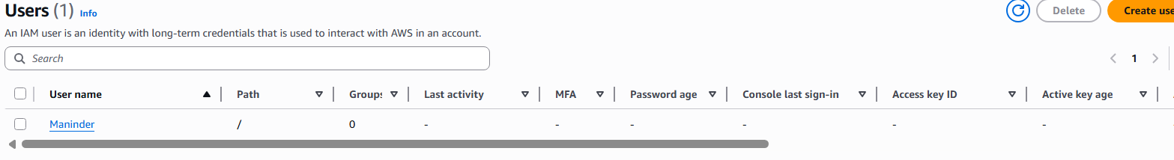

- Create one group in IAM and assign read access for EC2.
Go to user group in the IAM home page and click on ‘Create user group’
Assign the name and pass AmazonEC2ReadOnlyAccess permissions and click ‘create user group’
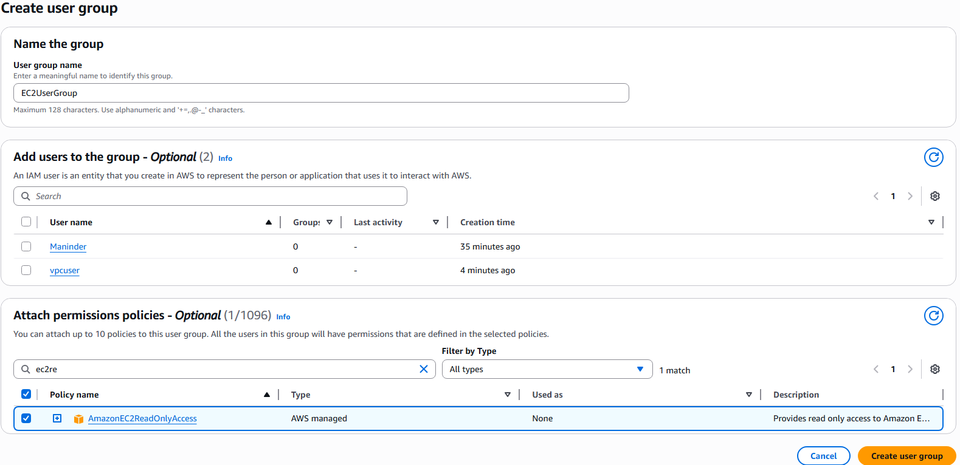

- Create a new user named "Devops" and add to the group created in task 2.
Go to users and click ‘create users’ and assign name ‘Devops’
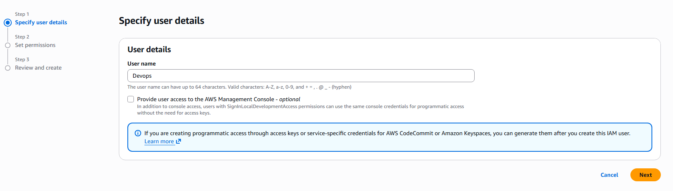
Go to permisions and go to permissions options and select ‘Add user to group’
Select ‘EC2UserGroup’ created earlier with ec2readonly access permissions.
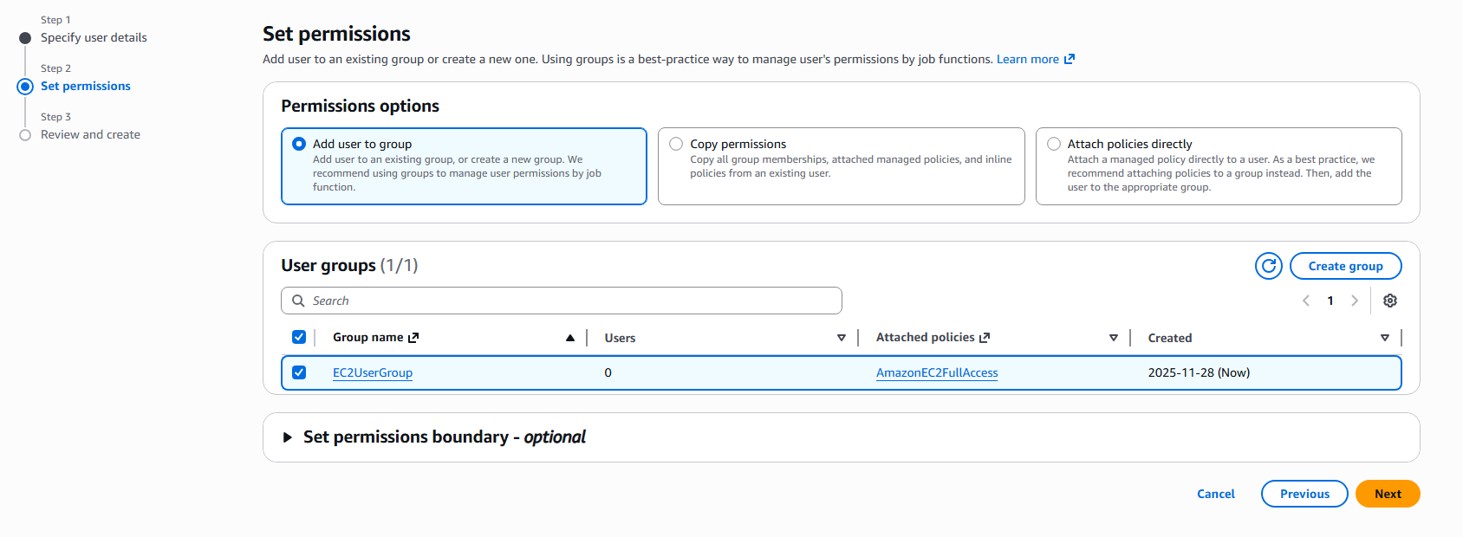

- Write a bash script to create an IAM user with VPC full access.
Launch the ec2 instance and execuete the command ‘aws configure’
Give the root user access key and secret key details, enter the region and also the output format.

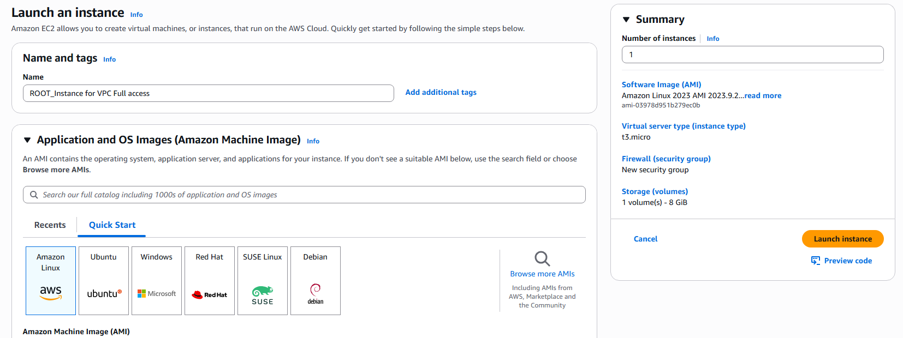

Create a shell script with the following script 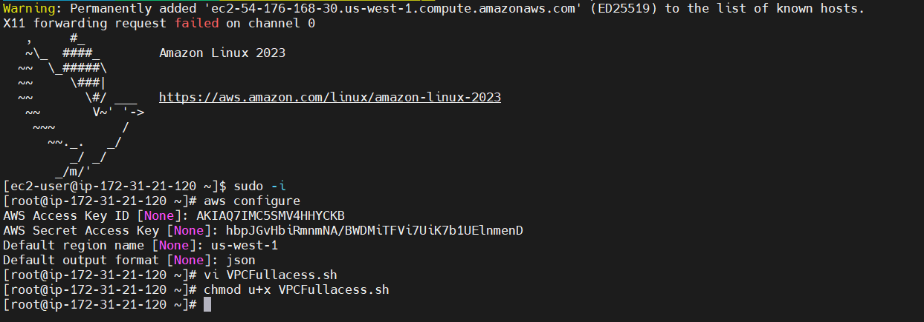
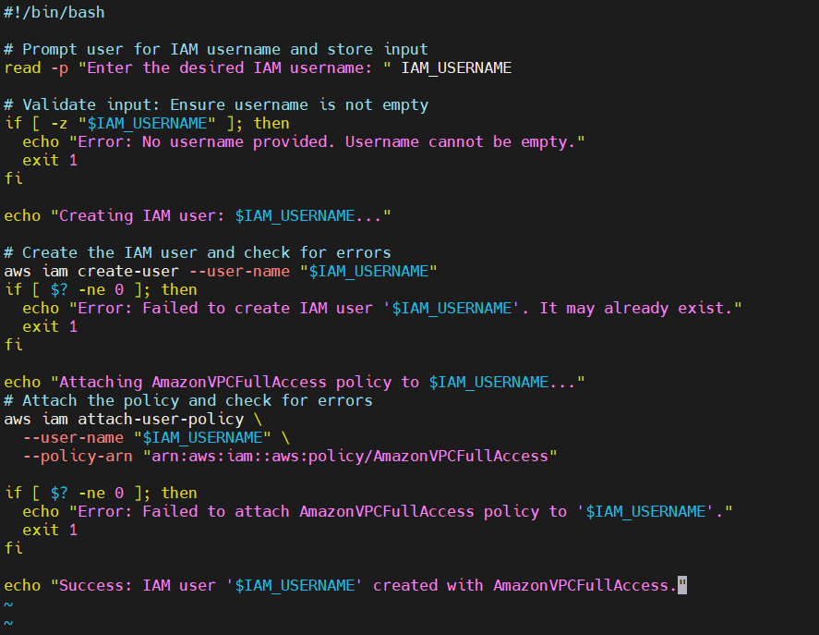

Execuete the shell with the proper executable permissions
Upon executing the script user is created.

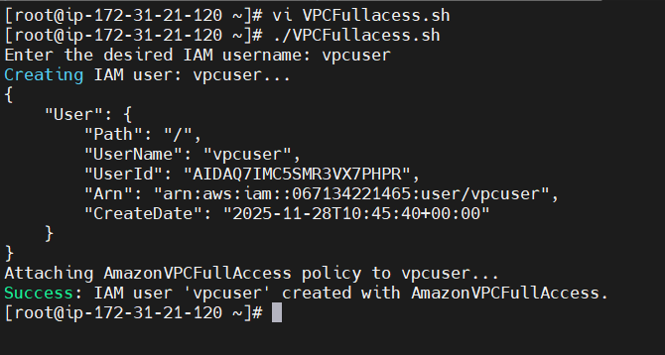
Go to aws console and go to IAM service and click users to check if the user is created or not. On checking user ‘vpcuser’ is created.
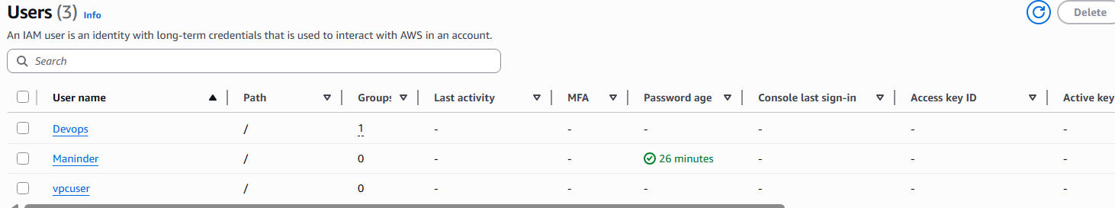

- Create an IAM policy to allow EC2 access for a specific user in specific regions only.

Goto policies and select ‘ create policy’
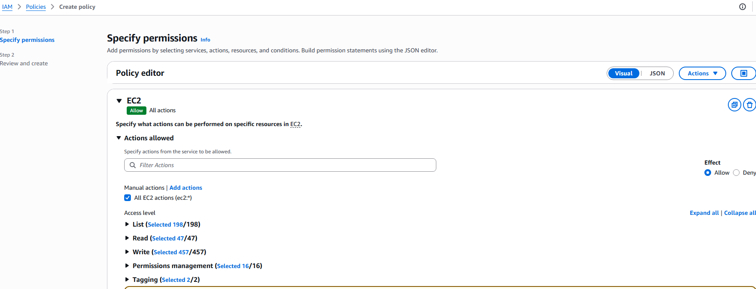

Go to request conditons and enter the condition key ‘aws:RequestRegion’
Qualifier: default
Operator: StringsEquals
Value: us-east-1

Here I took region as us-east-1
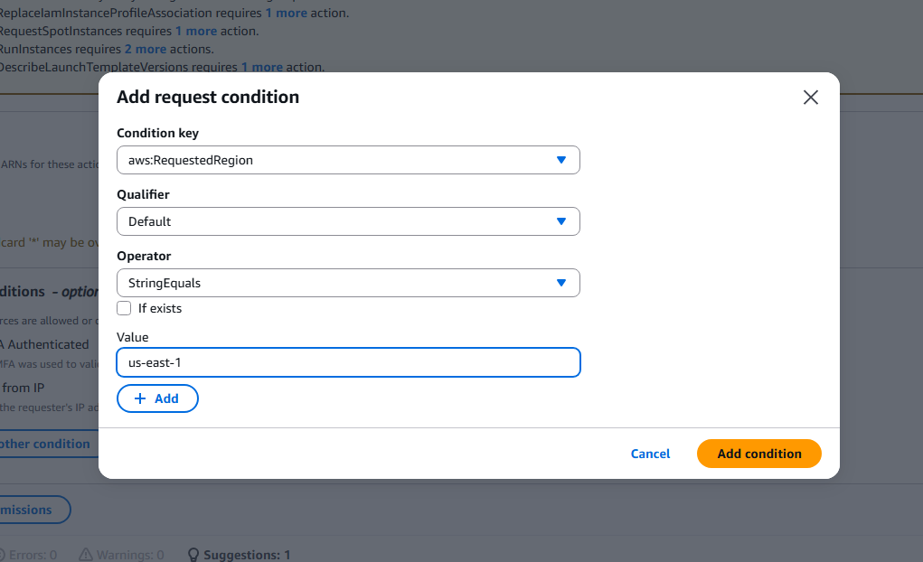

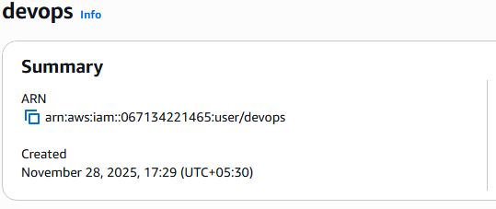
Add another request condition
Conditionkey: aws:Principalarn
Operator: stringequals
Value; arn:aws:iam::067134221465:user/devops

Here I took the user: devops

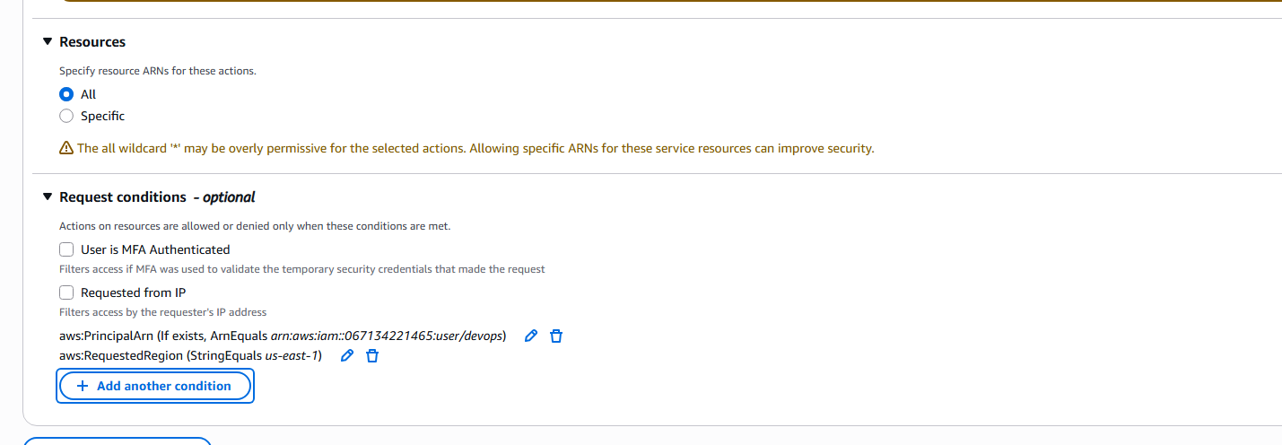

Given the name ‘EC2userspecificuserspecificregion’
Click the create policy and checked the policy created as customer managed policy as follows.
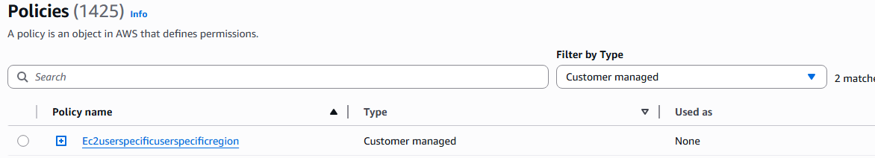
Here is the json format of the created policy
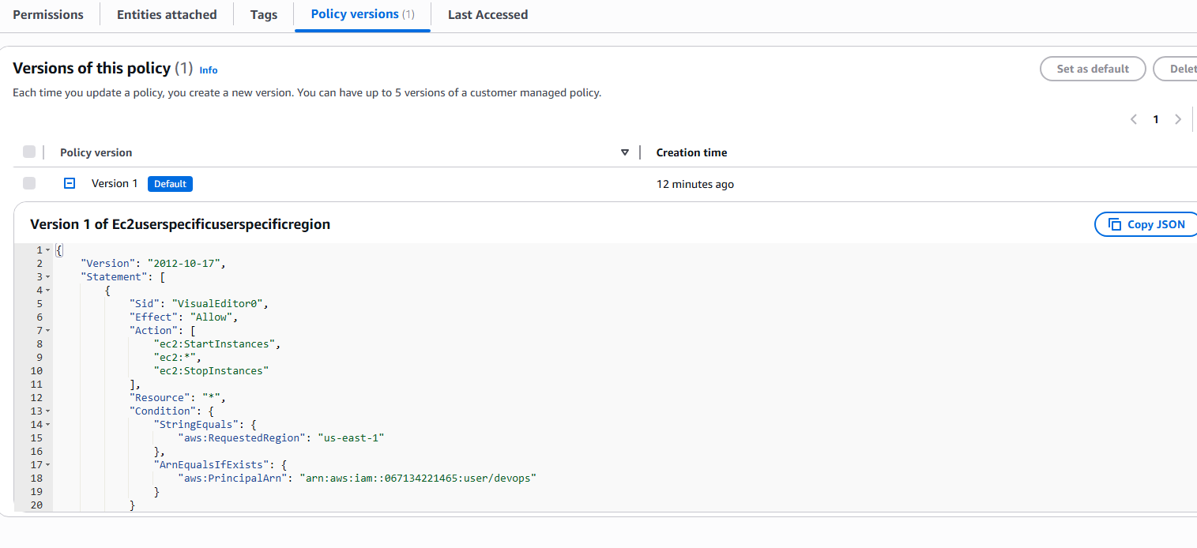

- We have two accounts: Account A and Account B. Account A user should access an S3 bucket in Account B.

The following is the flow chart that explains how I have done,
I want to access the s3 bucket of prashanth account( Account-B).

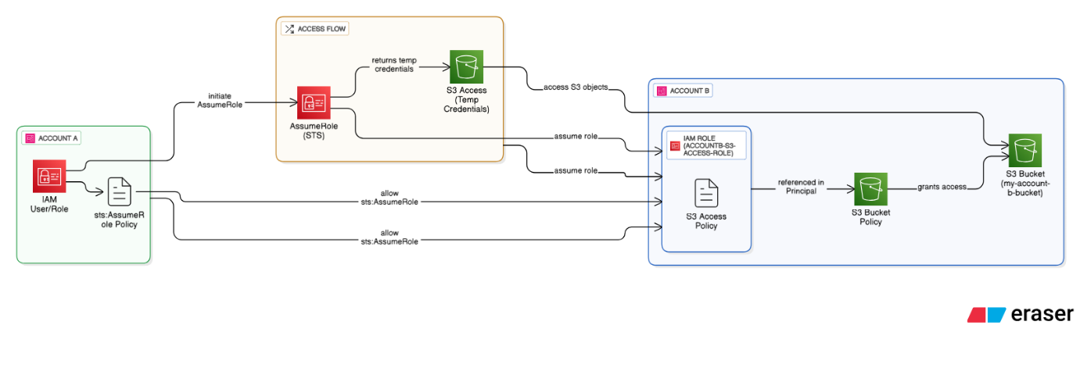
Part-1)
The following are the process carried out on the Account-B. (which was done by prashanth)
first am accessing as account B with Maninder account A
first created role with another account A id and entered account-A account number
created role
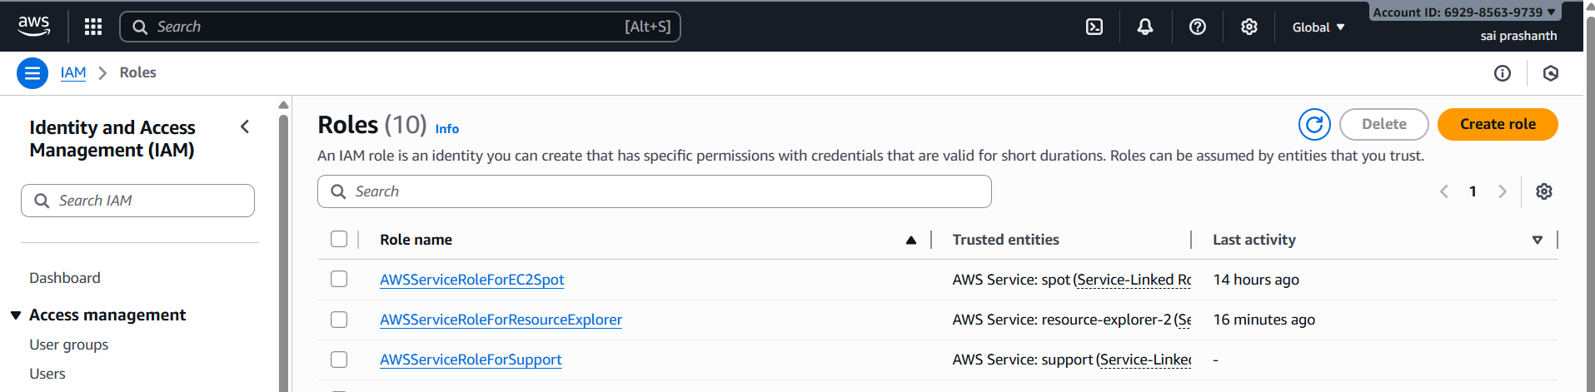
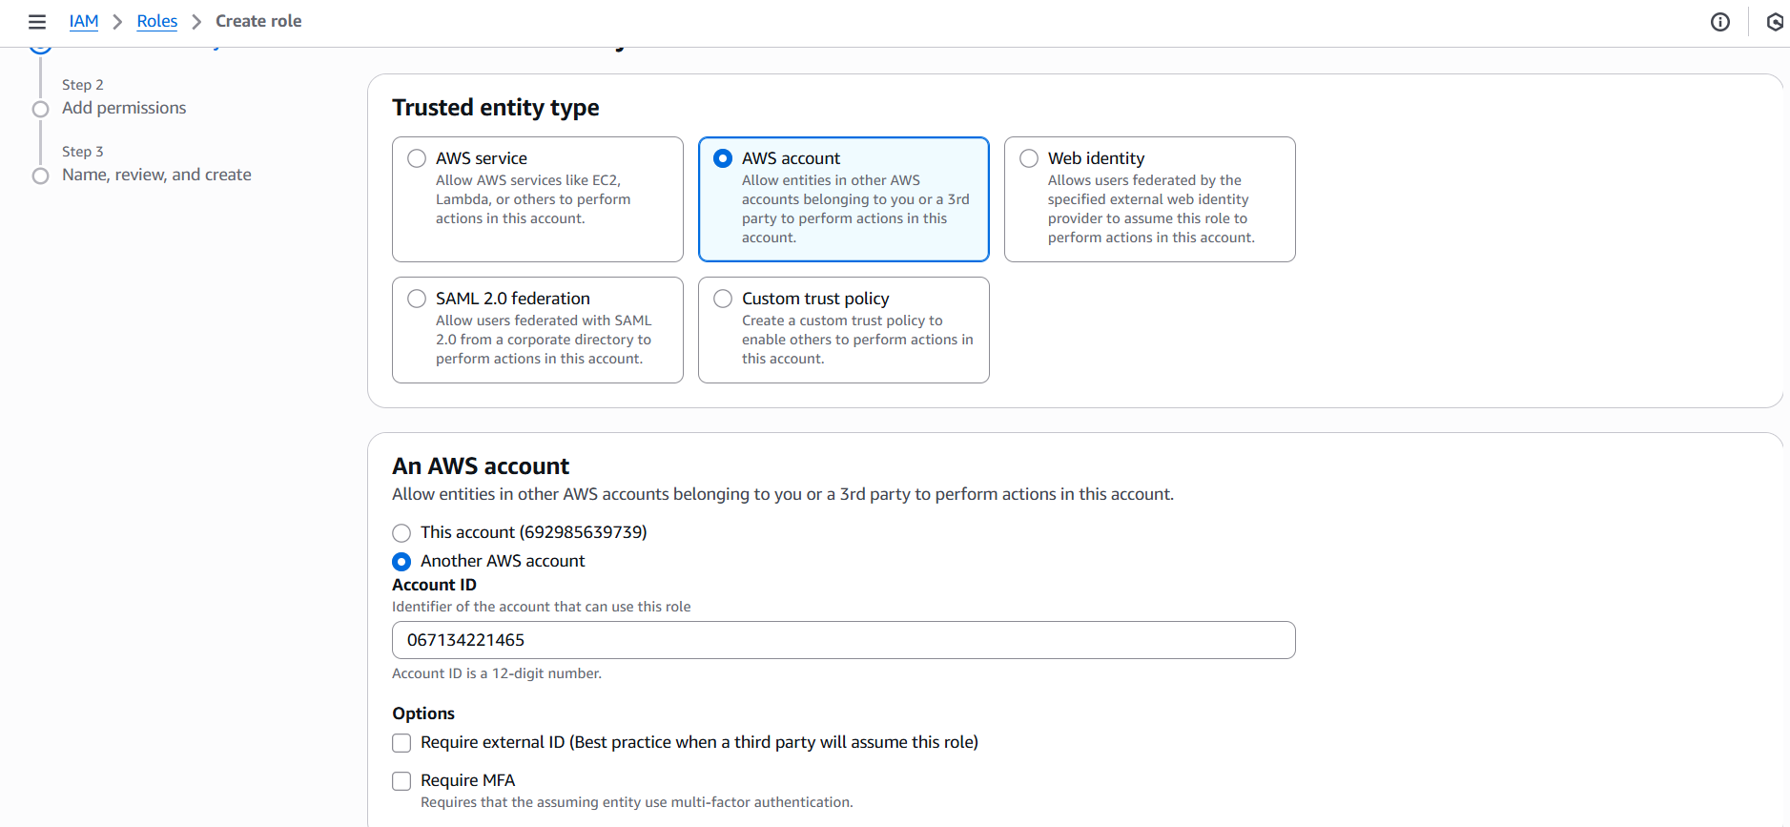
I have entered following json content in the policy editor which will give access to my bucket
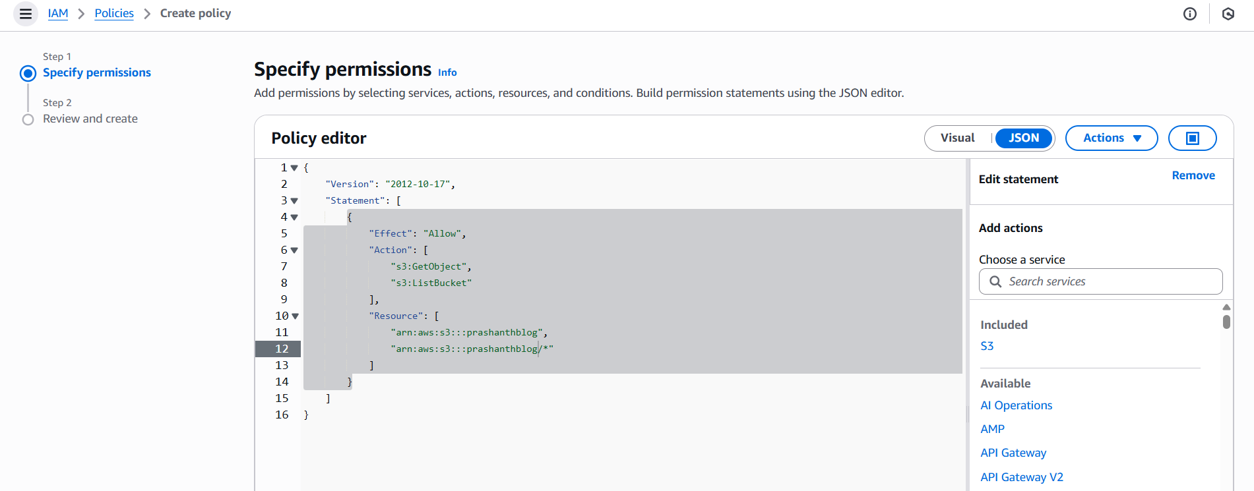
now clicked on created policy
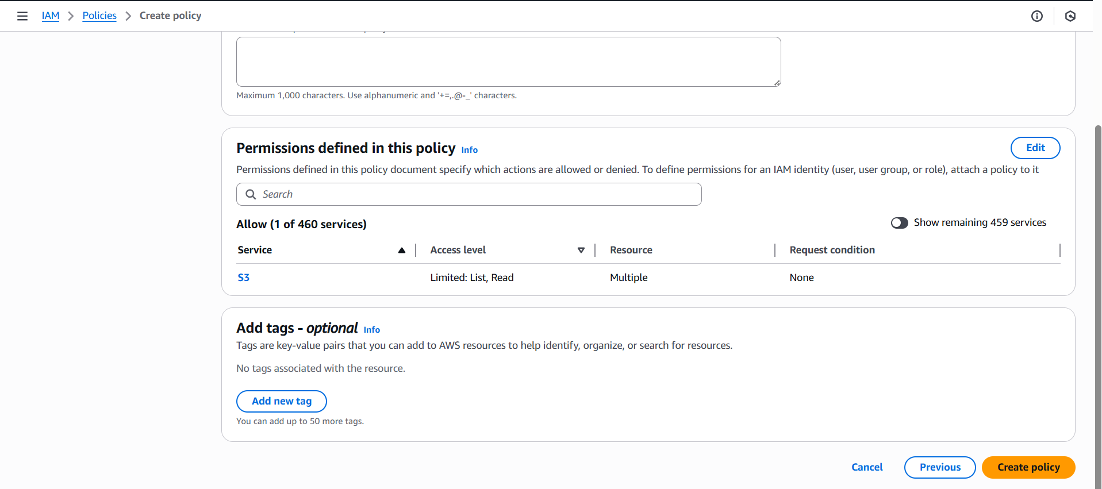
now attached the policy to the role which have been created earlier
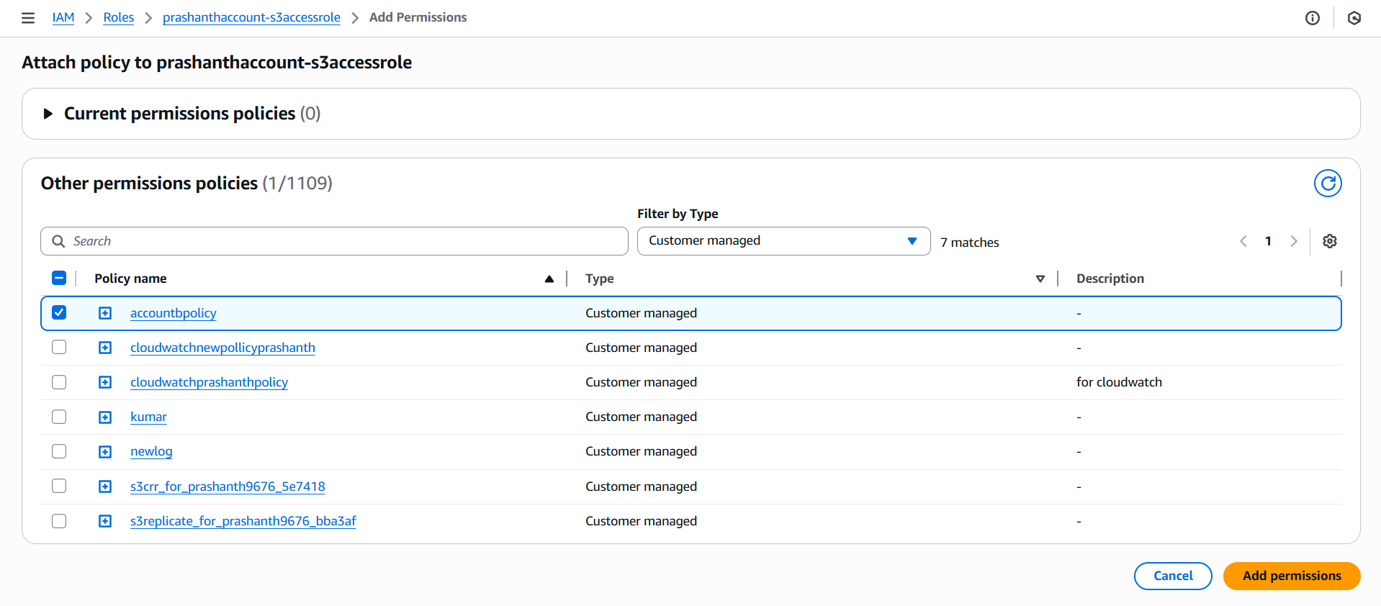
npw go to bucket Prashanthblog and edit bucket policy and now added the arn role number in the principle section and also given the bucket arn numbers
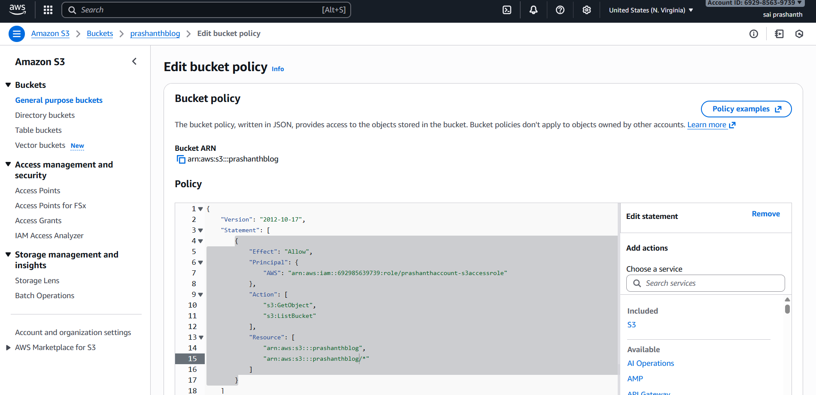

Part-02)

This is the process carried out on the Account-A which is mine (IAM user).
Update the IAM Policy for the User/Role in Account A
Attach a policy to the IAM User that needs S3 access. This policy grants the sts:AssumeRole permission.

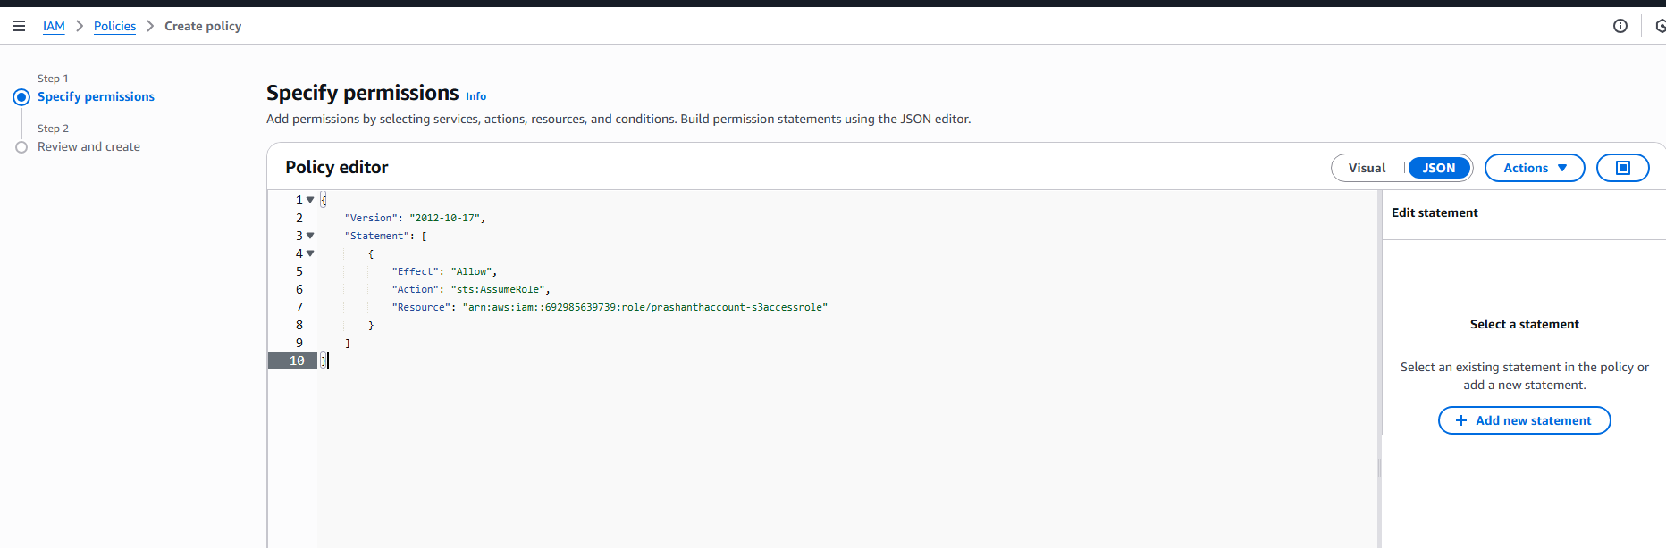
{
"Version": "2012-10-17",
"Statement": [
{
"Effect": "Allow",
"Action": "sts:AssumeRole",
"Resource": "arn:aws:iam::692985639739:role/prashanthaccount-s3accessrole"
}
]
}

Name the policy name ‘policyForprashanthS3bucketaccess-stsAssumerole’
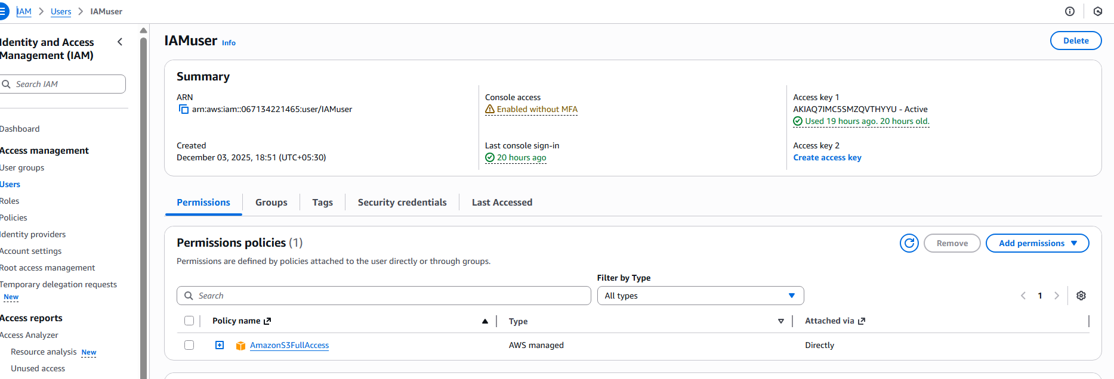
Now attach the policy to the IAMuser

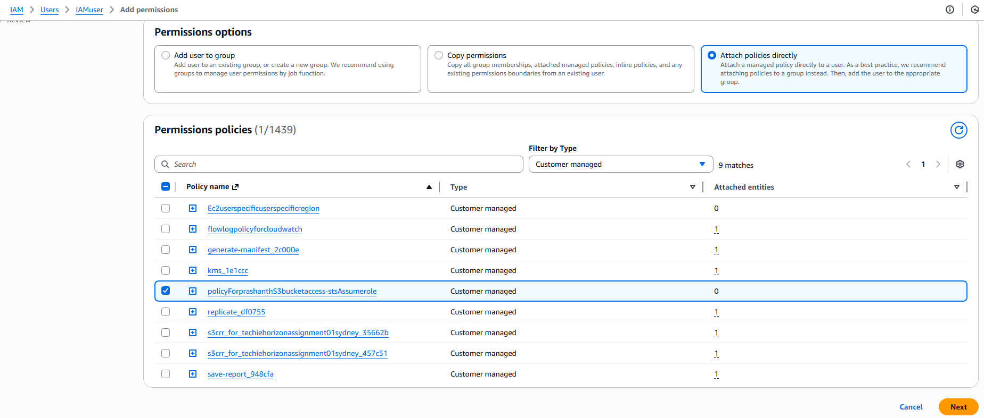
Now go the aws configure and give the iam access key and secret key details as follows

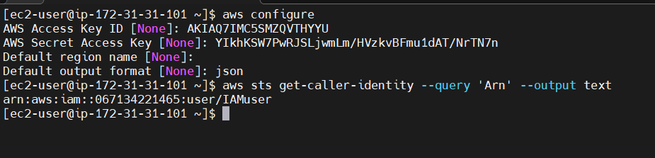
aws sts assume-role \
--role-arn "arn:aws:iam::692985639739:role/prashanthaccount-s3accessrole" \
--role-session-name "SessionNameForManinder"
After executing the the above command, we will get the temporary access key and secret key and session token to access the bucket
After configuring the aws with access key, secret key and session token, execute the command ‘aws s3 ls s3://prashanthblog/’ to access the objects and we can see the objects are shown in the below.
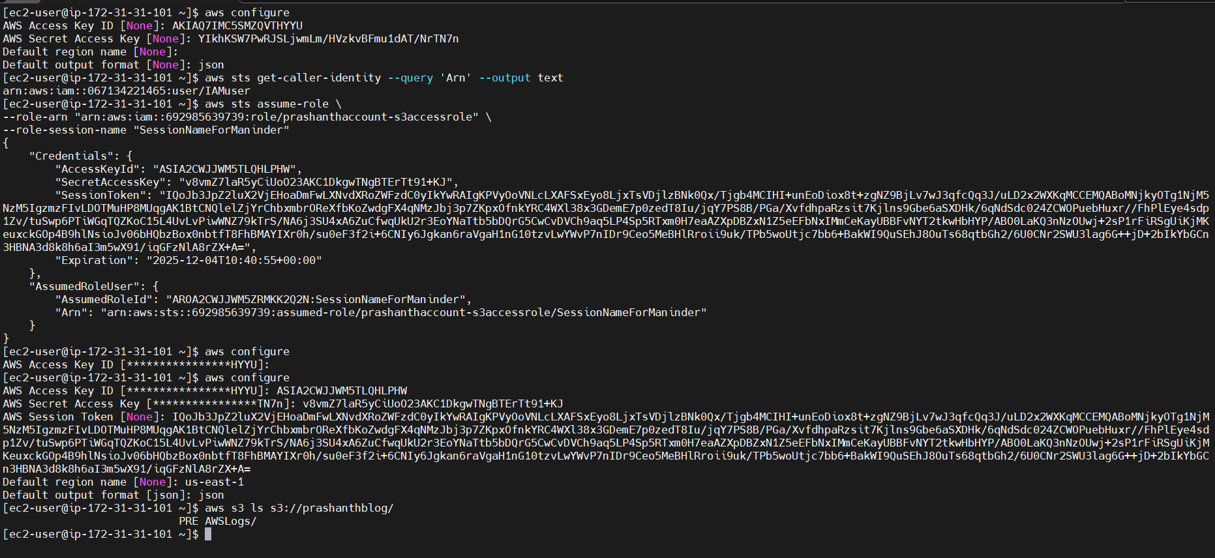
The following is the screenshot from the prashanth’s account containing only one directory named AWSLogs/
