S3-Assignment-01

- Create an S3 bucket and upload some objects to S3.
Go to s3 services in the AWS services and click on create bucket to create bucket
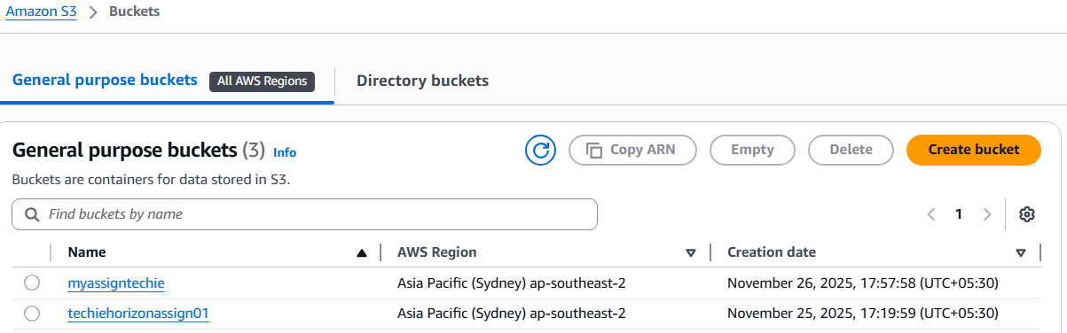
Enter the name of the bucket and untick the block public access settings for this bucket and tick I knowledge the current settings might result in the bucket and objects within becoming public

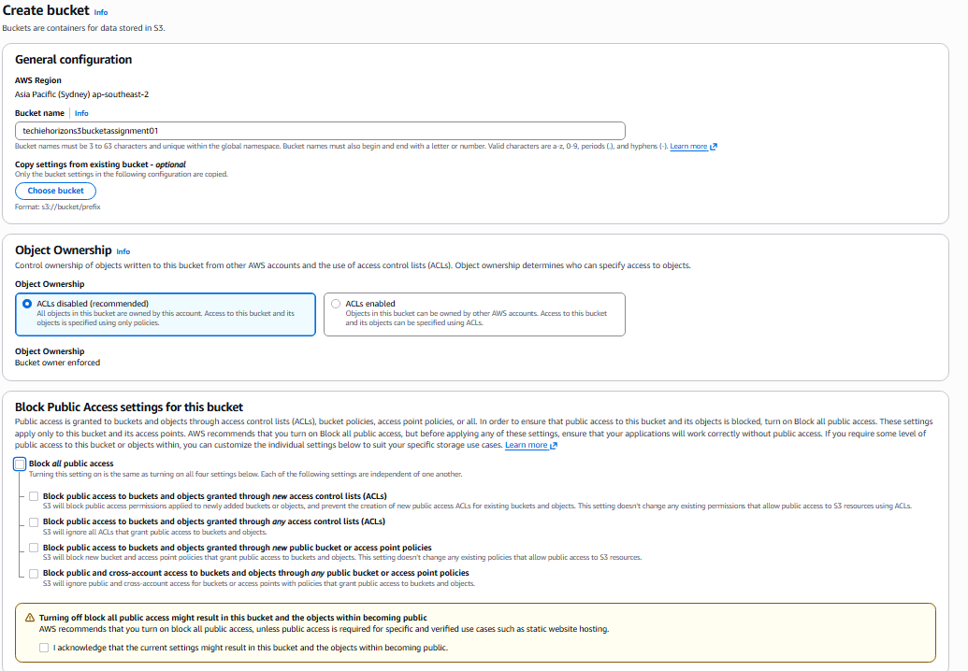

Create upload to upload the objects inside the bucket

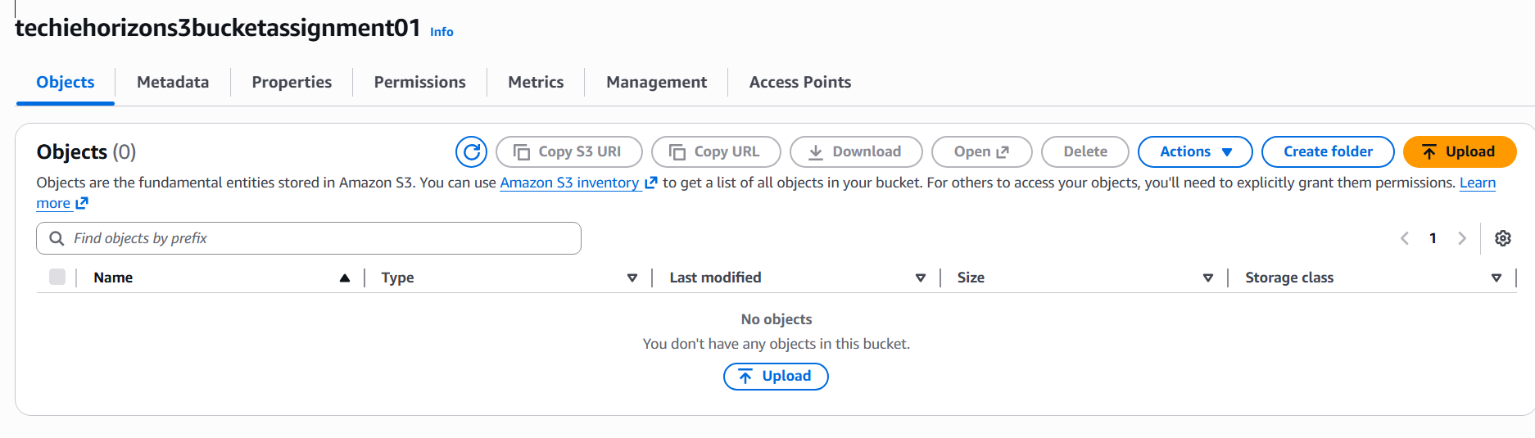
Click on Add files to upload the files
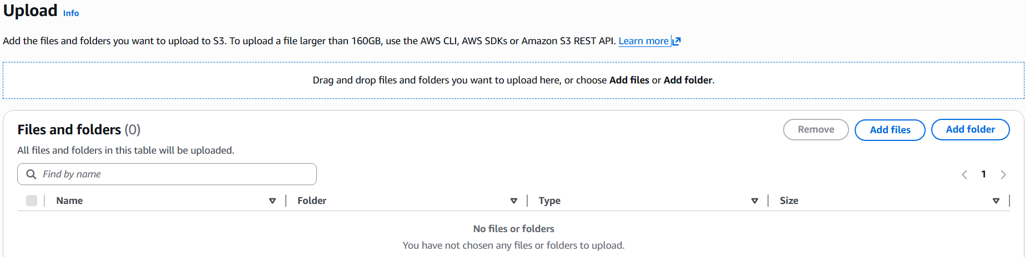
I took one of the file named aws.txt and selected object actions to make public using ACL

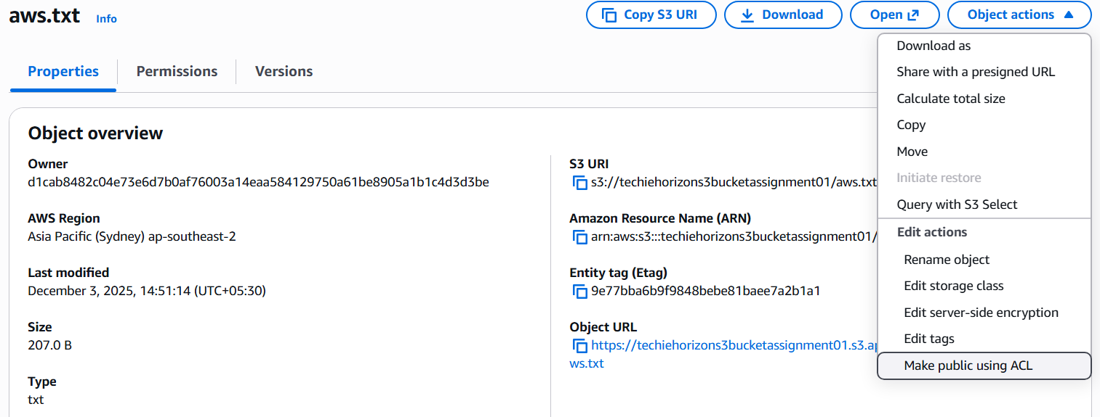

Now go to the object URL and copy the url and open the URL in the browser to access the contents of the text file

The result are as follows
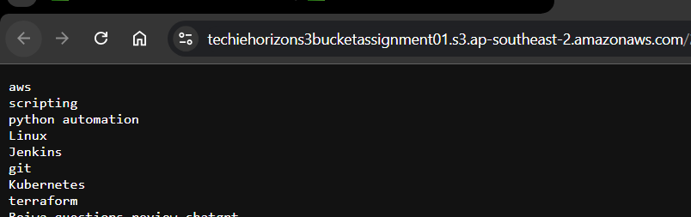

- Deploy a static website in the S3 bucket.

Downloaded the html page from the url: https://www.tooplate.com/view/2149-strategic-consulting

After downloaded the html page, extracted the folder and uploaded the folder to the s3 bucket
Goto the properties and go to the static website hosting
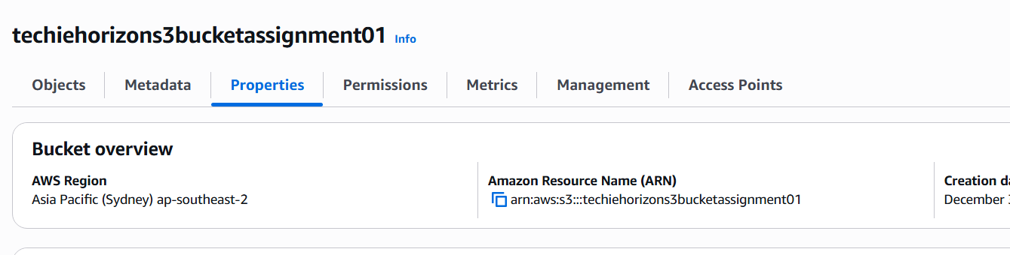

Enable static website hosting
Enter the index.html and also the error.html in the index and error document sections.
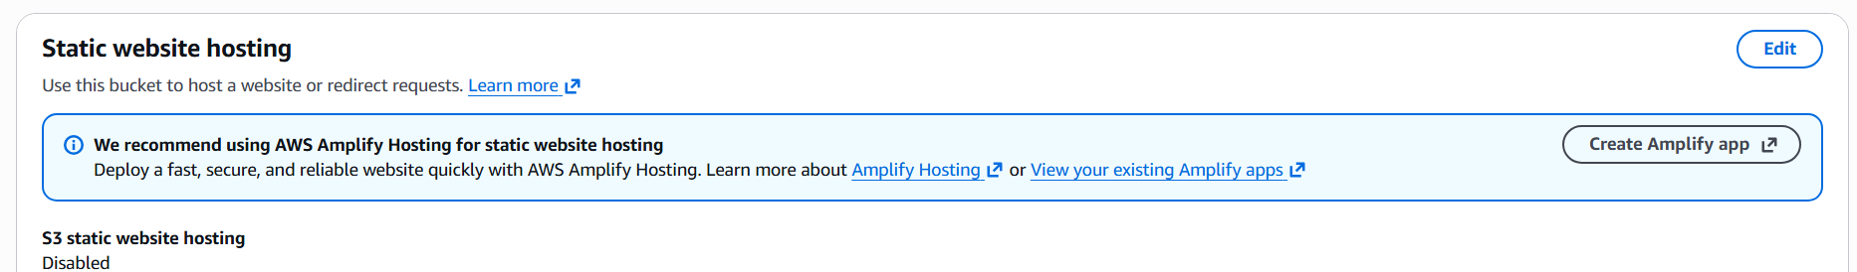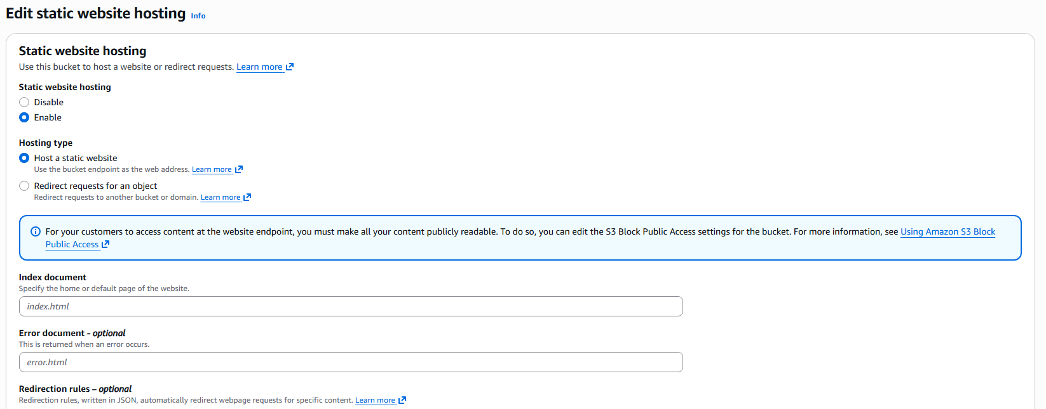

Now to to the contents in the folder and make every object in the folder as make it public using ACL

Now goto the index.html and click on the object url, copy the url and paste the
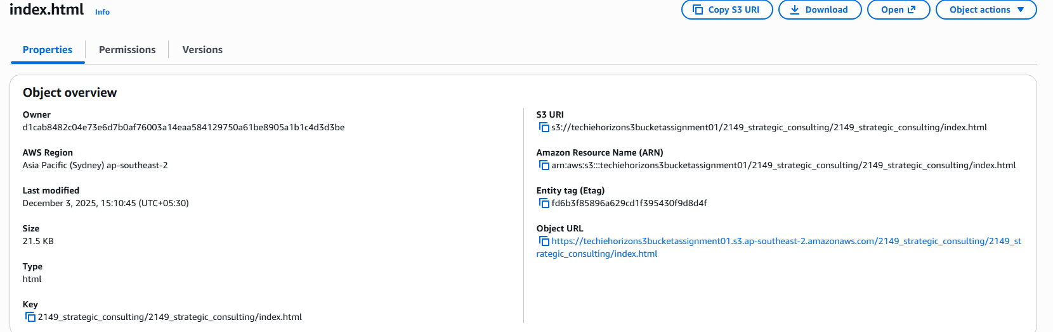

The result is the static website hosted on the s3 bucket as follows.
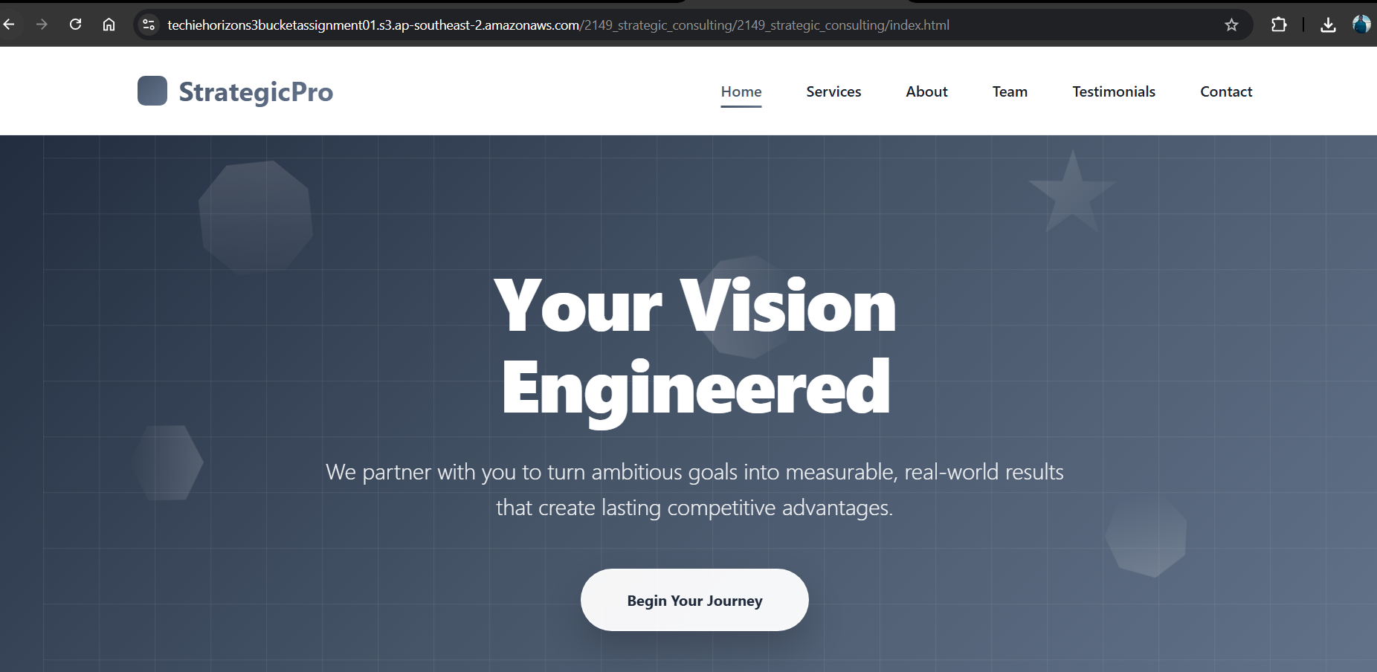

- Enable cross-region replication on S3 buckets.
For this task, I have created two buckets in the two regions 1) Sydney 2) Mumbai
Goto mumbai region and create bucket named ‘techiehorizonassignment01mumbai’

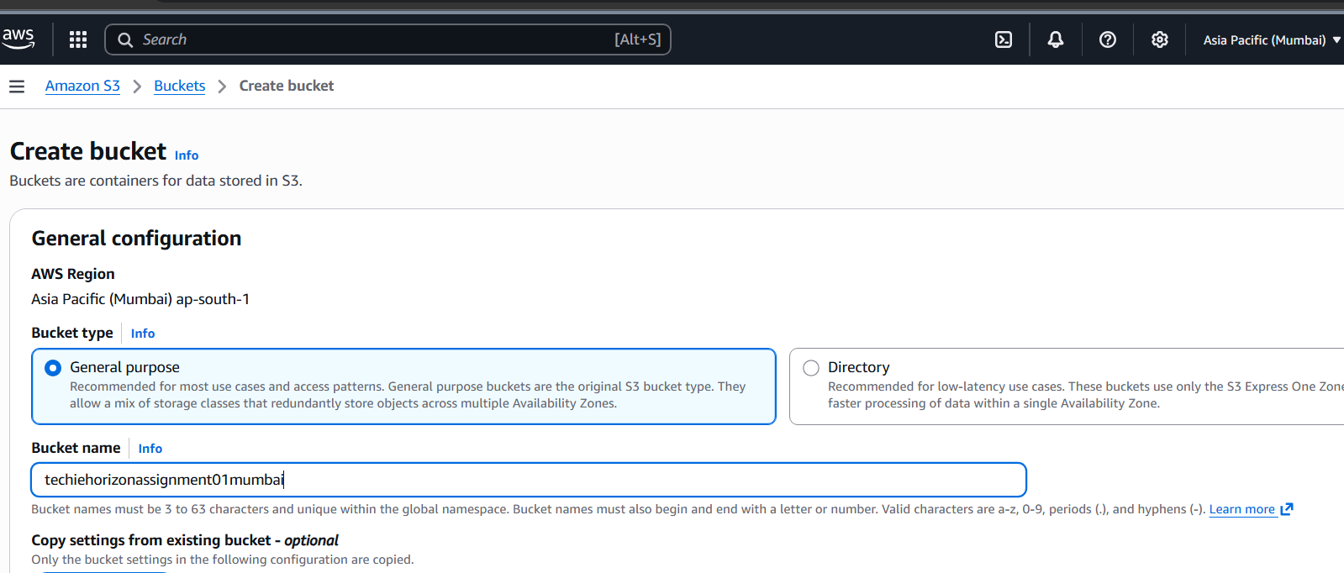

Tick out block all public access and acknowledge below and enable bucket versioning
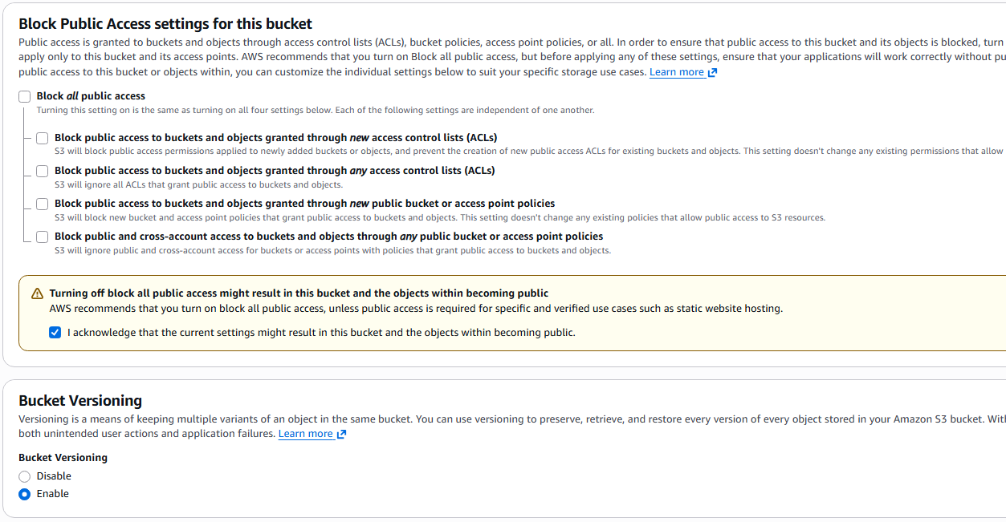
Goto sydney region and create bucket named ‘techiehorizonassignment01sydney’
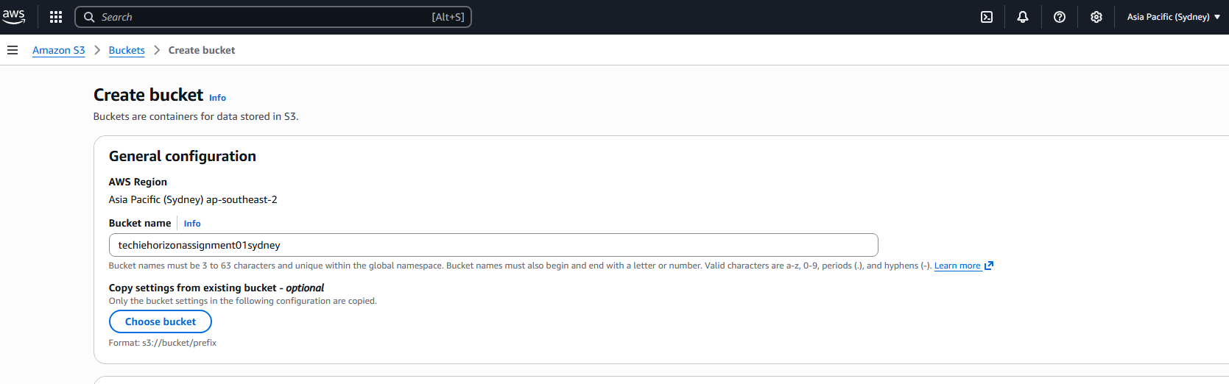
Tick out block all public access and acknowledge below and enable bucket versioning

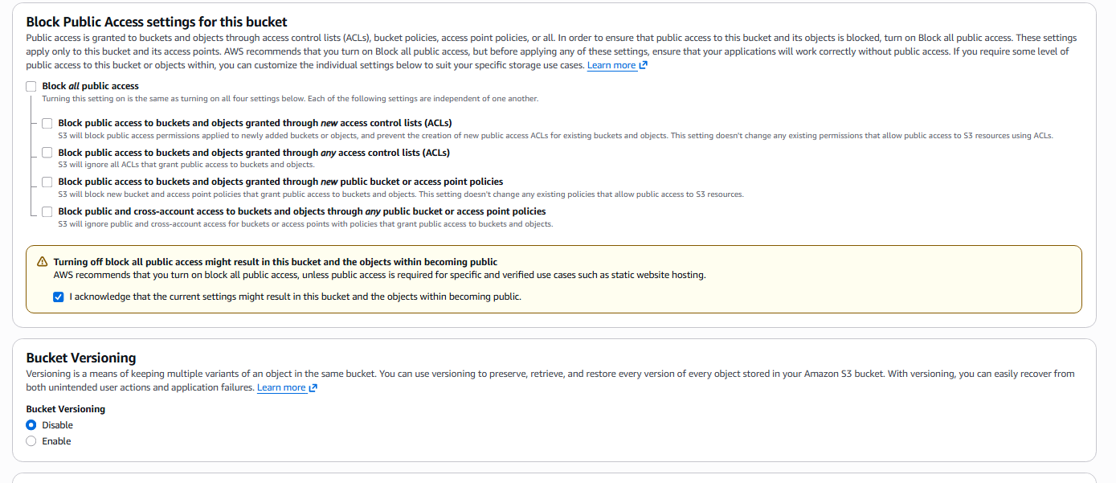
The buckets created are as follows:
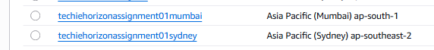
Now go to the mumbai region bucket and go to the management options and click ‘create replication rule’
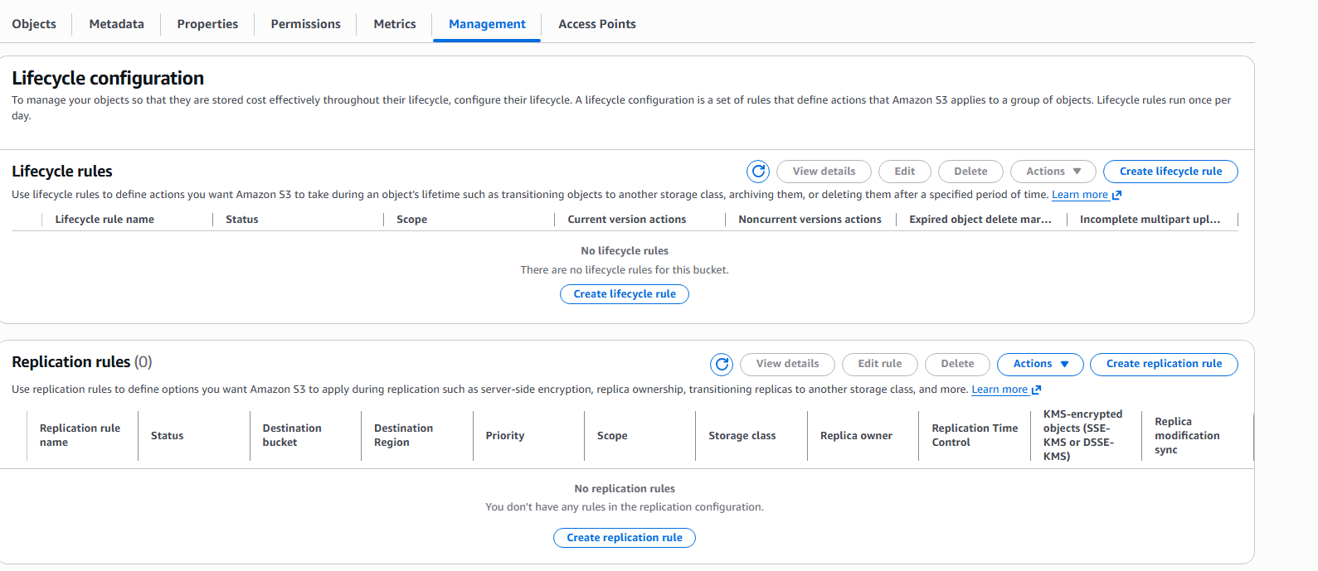
Give a name and select the rule scope to apply to all objects in the bucket and select the browse s3 to select destination bucket, select IAM role to ‘select a new role’
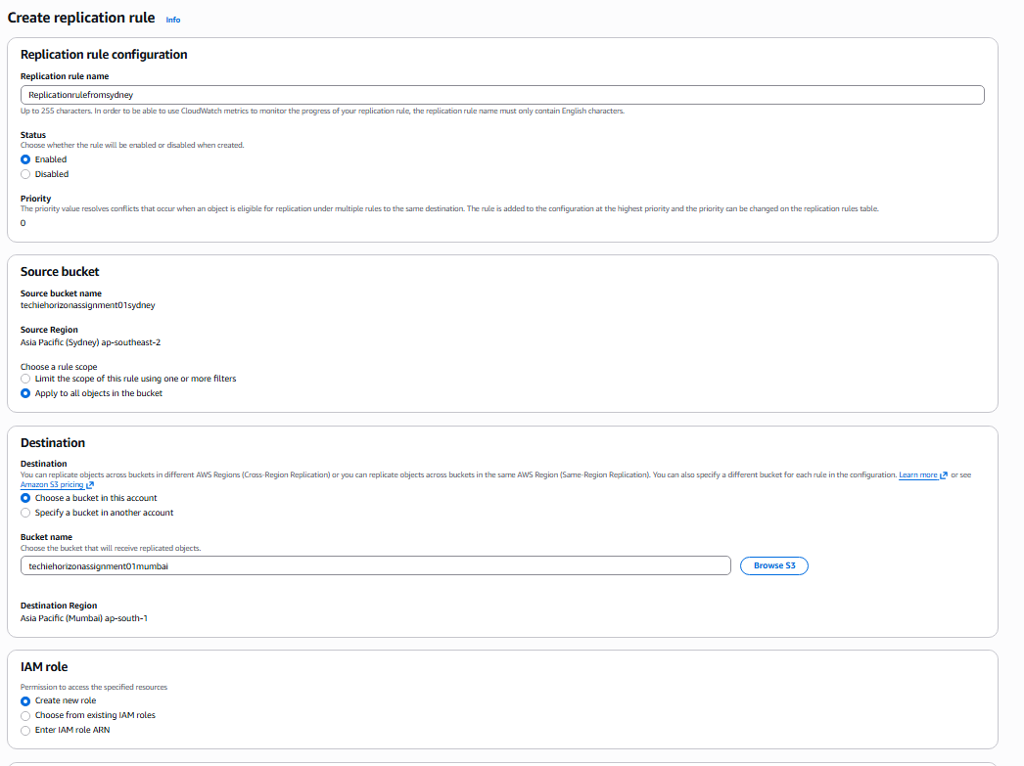
Go to batch operations and click create job
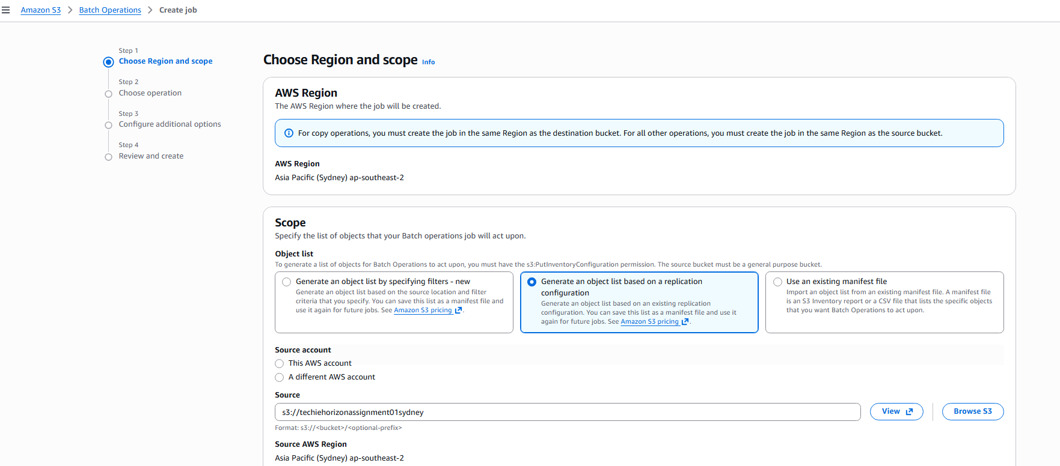
Select next after selecting replicate operation
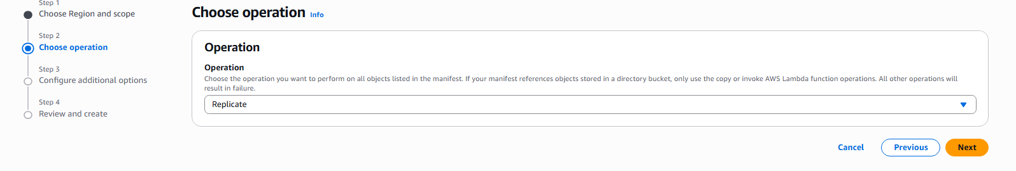
Leave everything default

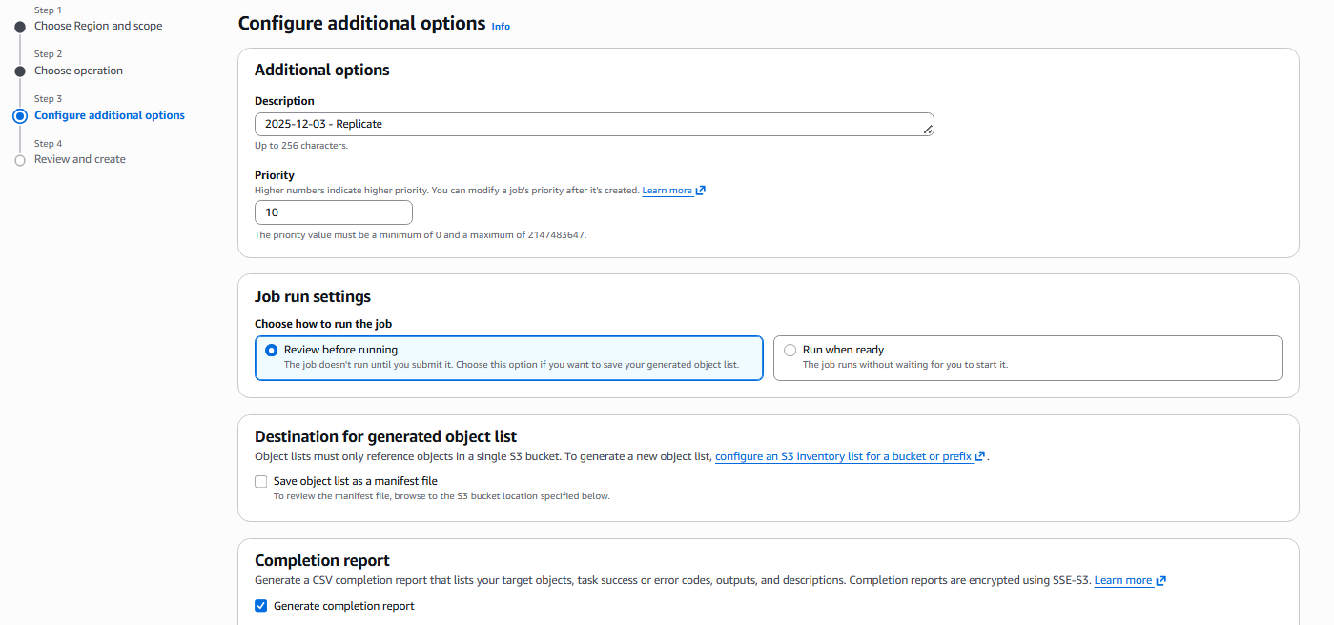

Go to permissions and select create new IAM role and click create job
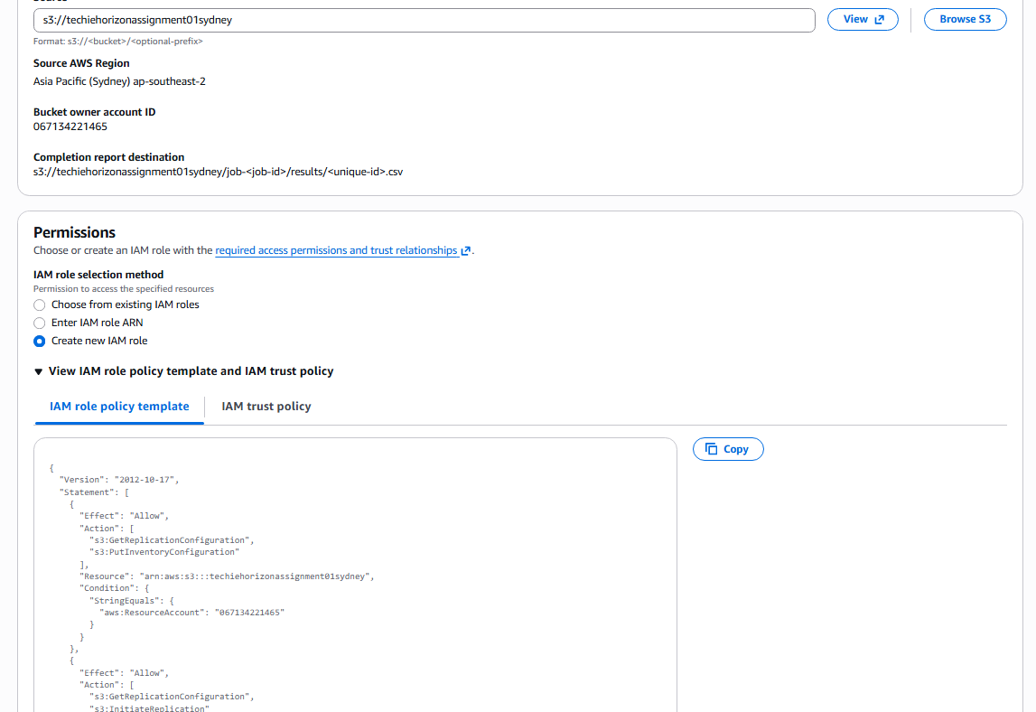
The job is created as follows:
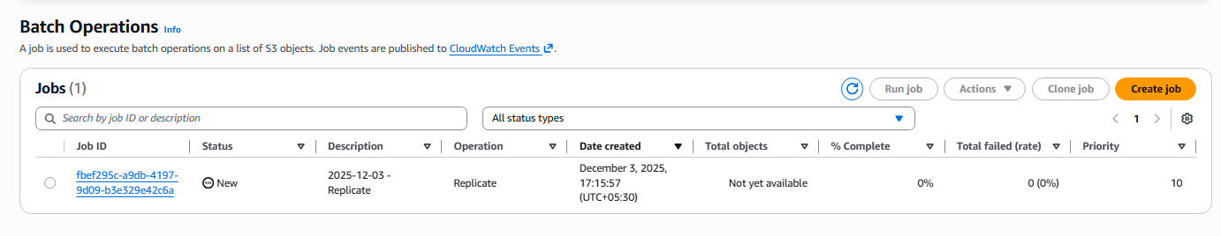
Now go to the bucket in Sydney and add files in the bucket to see if the same files are reflecting on the bucket in mumbai
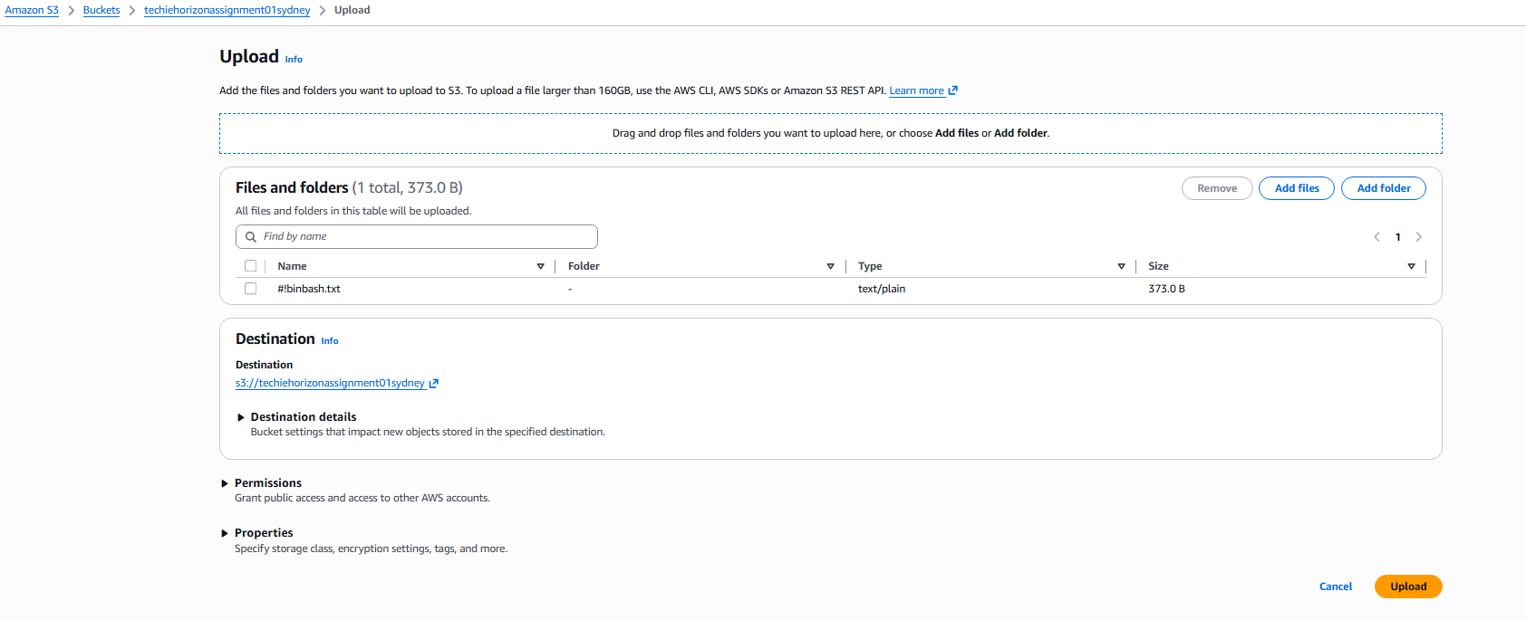
Now we can see the file uploaded is visible in the Mumbai region.
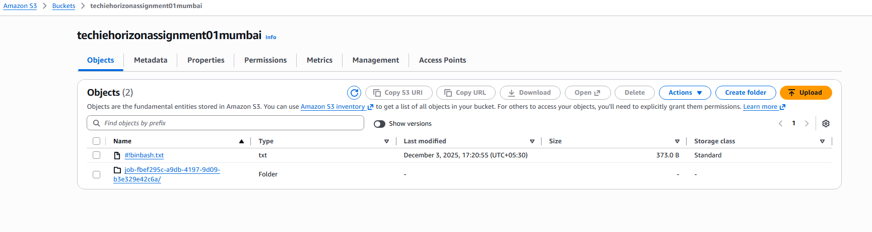

- Configure a bucket policy so only the Admin user can see the objects of the S3 bucket.
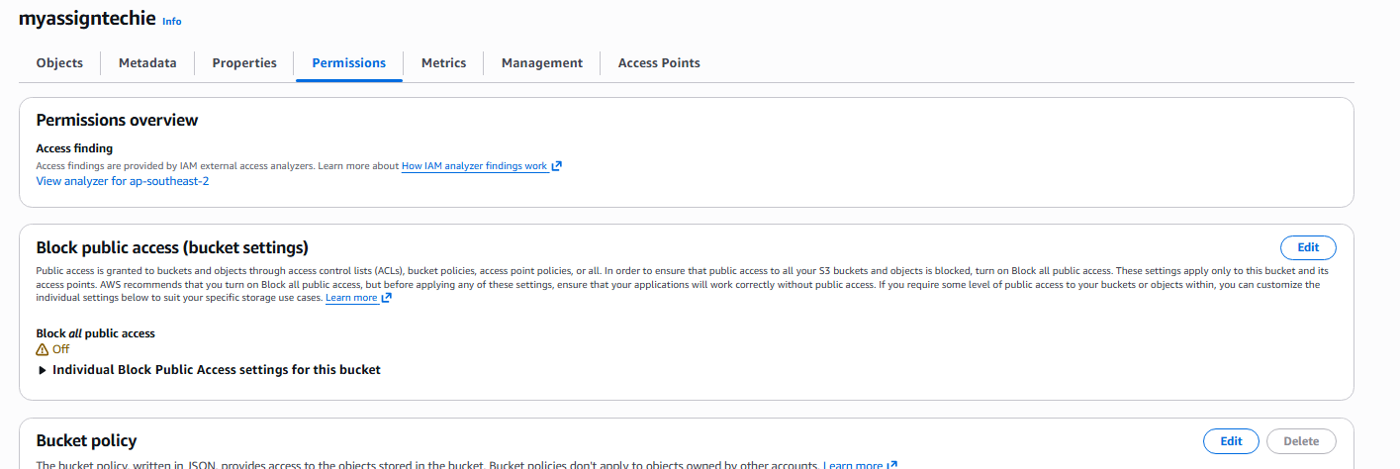
AWS Console:
- Go to S3 → Your Bucket → Permissions tab
- Click Edit next to Bucket policy
- Paste the JSON policy
- Replace:
  - your-bucket-name → myassigntechie
  - YOUR-ACCOUNT-ID → 067134221465
- Click Save changes

{
"Version": "2012-10-17",
"Statement": [
{
"Sid": "AllowRootRead",
"Effect": "Allow",
"Principal": {
"AWS": "arn:aws:iam::067134221465:root"
},
"Action": [
"s3:GetObject",
"s3:ListBucket",
"s3:GetBucketLocation"
],
"Resource": [
"arn:aws:s3:::myassigntechie",
"arn:aws:s3:::myassigntechie/*"
]
},
{
"Sid": "DenyNonRootRead",
"Effect": "Deny",
"Principal": "*",
"Action": [
"s3:GetObject",
"s3:ListBucket",
"s3:GetBucketLocation"
],
"Resource": [
"arn:aws:s3:::myassigntechie",
"arn:aws:s3:::myassigntechie/*"
],
"Condition": {
"ArnNotLike": {
"aws:PrincipalArn": "arn:aws:iam::067134221465:root"
}
}
}
]
}

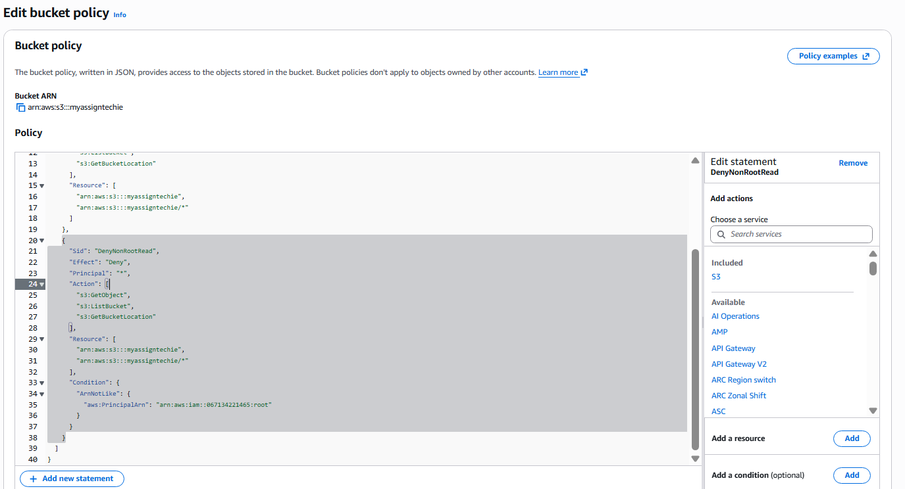

Go to moboxterm and access the ec2 instance
Configure the aws using the commands ‘aws configure’
Give access key and secret key
Now initiate the command ‘ aws s3 ls s3://myassigntechie’
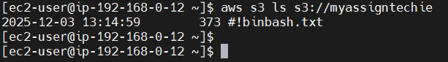
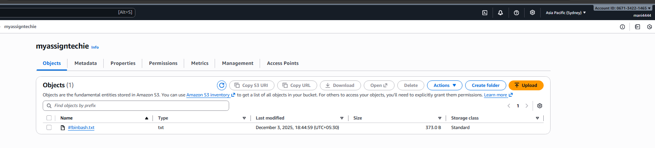

Now I will use the IAM user configuration details and I will check if I can able to see the s3 buckets from that IAM account.

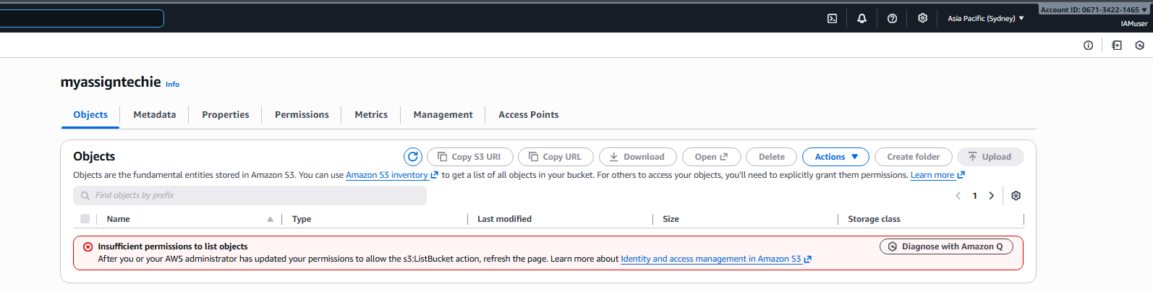

- Set up lifecycle policies to automatically transition or delete objects based on specific criteria.

To create the lifecycle policy for out bucket go to management
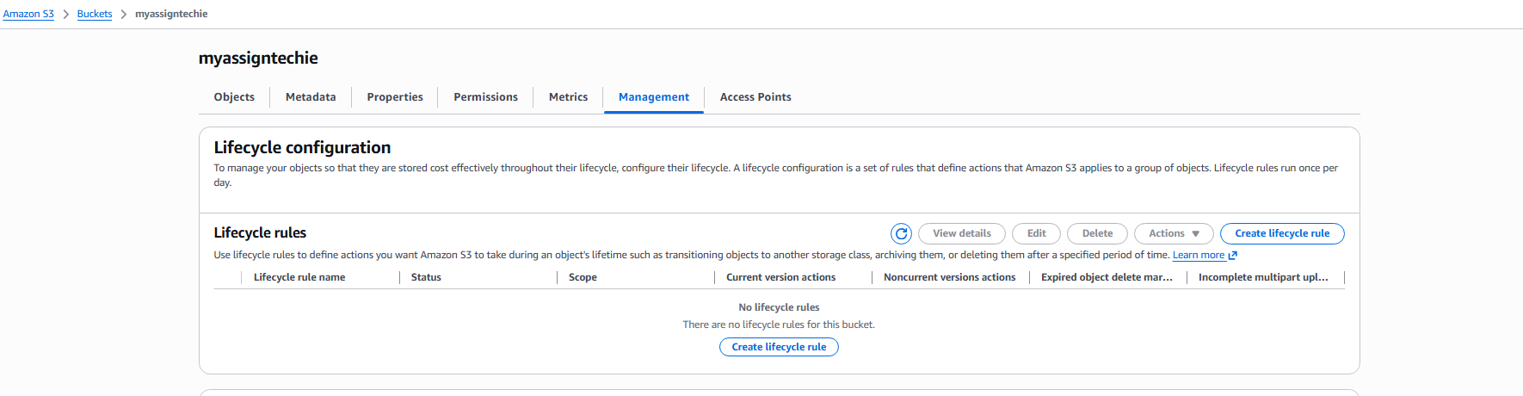
Click ‘Create lifecycle rule’

Give the name of the lifecycle rule ‘lifecycle-Assignment’
Choose a rule scope -> apply to all objects
Lifecycle rule actions-> Transition current objects to storage classes

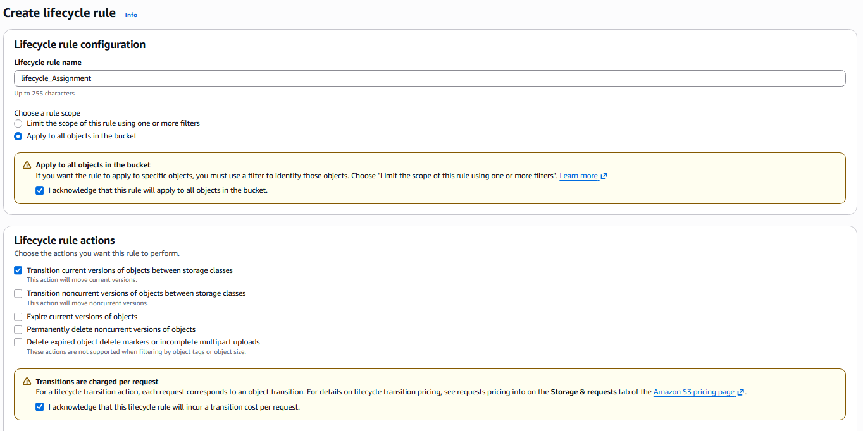
Choose your storage classes and the object duration in the transition current versions of objects between storage classed
Here I choose standard-1A for 30 days, Glacier instant Retrieval to 60 days and Glacier Deep Achieve to 350 days
This storage classes will facilitate the cost saving for the data stored in the s3

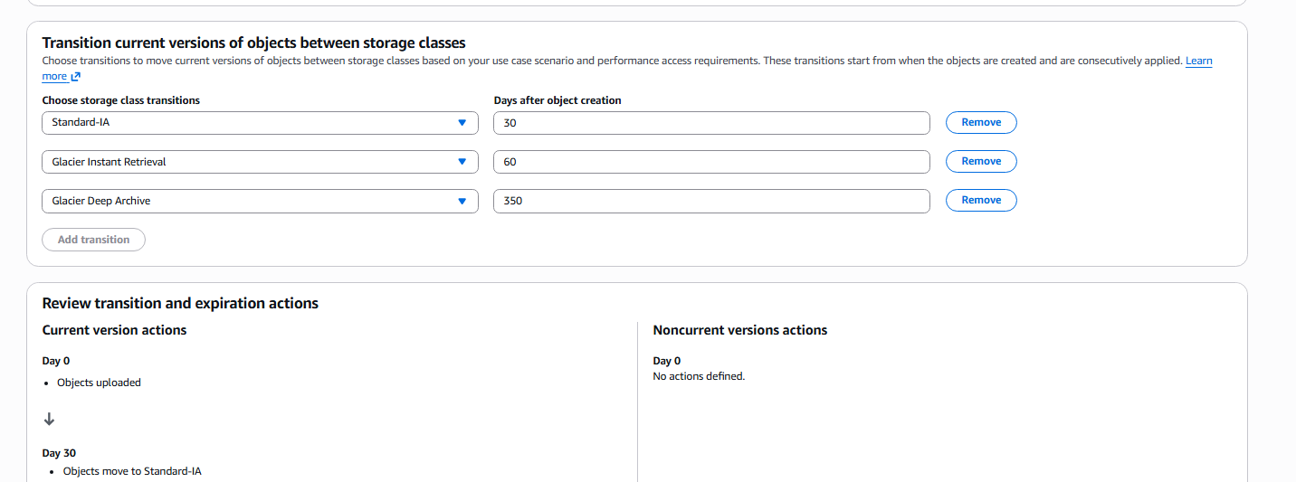
The Lifecycle rule configured is as follows:

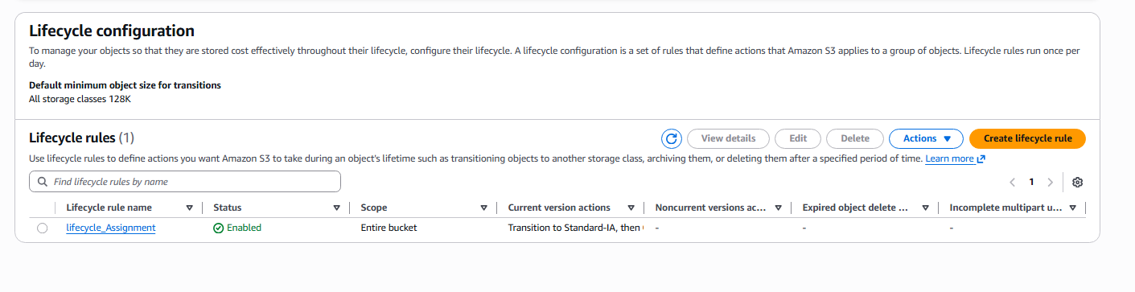

- Push some objects to S3 using the AWS CLI.
To push the objects to s3 using the AWS CLI I have configured the aws cli with access key and secret key
I have listed the files in the s3 bucket name myassigntechie using the command ‘aws s2 ls s3://myassigntechie

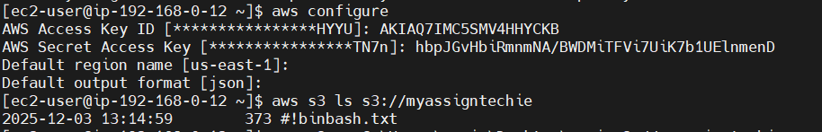
Now create a sample file named ‘sample.txt’
Now use the command ‘ aws s3 cp sample.txt s3://myassigntechie’ we can able to push the object file named sample.txt to the bucket
To list the bucket object we have used the command ‘aws s3 ls s3://myassigntechie’ and we can see the file is uploaded to the bucket

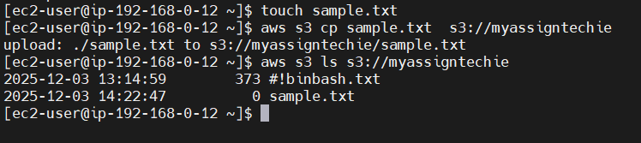
We are also conforming it in the aws console
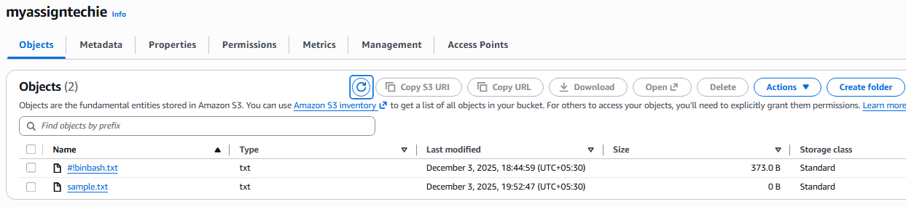

- Write a Bash script to create an S3 bucket.
Below is the script which will create a s3 bucket name “myassigntechie011”

#!/bin/bash

BUCKET_NAME="myassigntechie011"
REGION="us-east-1"

aws s3api create-bucket \
--bucket "$BUCKET_NAME" \
--region "$REGION"

echo "Bucket created: $BUCKET_NAME"

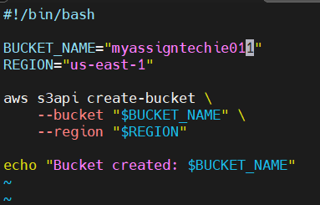

We can see the script was successfully executed
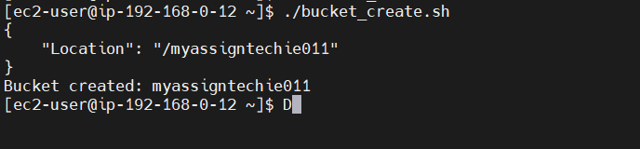

Now we can able to confirm in the AWS console.
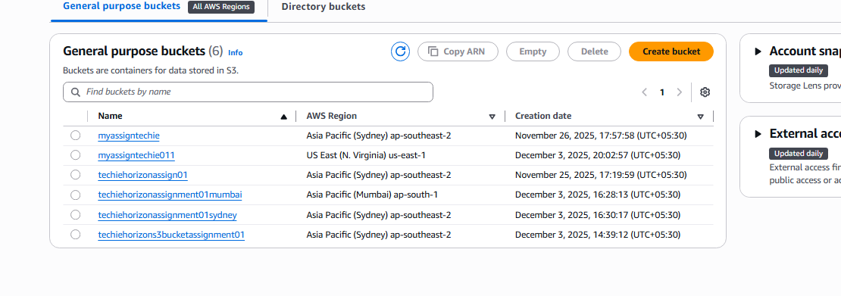

- Upload a 1 GB file to S3 using the CLI.
For this task I have generated a file of size 1GB using the command ‘dd if=/dev/zero of=1gbfile.bin bs=1M count=1024’
aws cp 1gbfile.bin s3://myassigntechie will push the 1GB file to the bucket
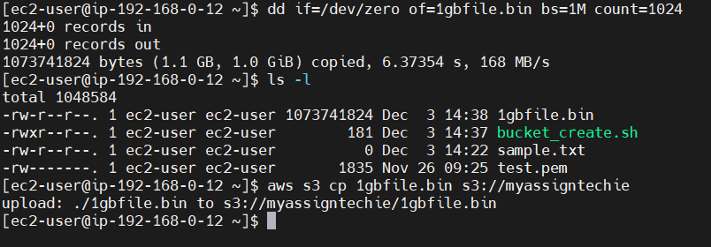

We can confirm the file was uploaded on the aws console.
