Use Case: Setting up Transit Gateway and VPC Endpoints for a Multi-VPC Architecture
Scenario:
A large organization is migrating its on-premises infrastructure to the AWS cloud.
The organization's architecture involves multiple VPCs for different departments and applications, each requiring secure communication with centralized services and external resources.
The IT team needs to design and implement a scalable and efficient network architecture to accommodate the organization's growth and ensure robust connectivity between VPCs and external services.
Objectives:
- Design and deploy a scalable network architecture using AWS Transit Gateway to simplify network connectivity between multiple VPCs.
- Configure VPC endpoints to securely access AWS services without internet gateways or NAT gateways, ensuring data privacy and minimizing exposure to external threats.

For this task, I have deployed following VPC’s
VPC Name VPC CIDR Public Subnet CIDR Private Subnet CIDR
Challenge1 192.168.0.0/24 192.168.0.0/25 192.168.0.128/25
Challenge2 192.168.1.0/24 192.168.1.0/25 192.168.1.128/25
Challenge3 192.168.2.0/24 192.168.2.0/25 192.168.2.128/25
Challenge4 192.168.3.0/25 192.168.3.0/26 192.168.3.64/26
And I will also deploy the AWS Transit Gateway for their connectivity

Go to vpc and select the option ‘create vpc’
Give the name of the vpc and assign the range of the vpc of challenge1 as 192.168.0.0/24
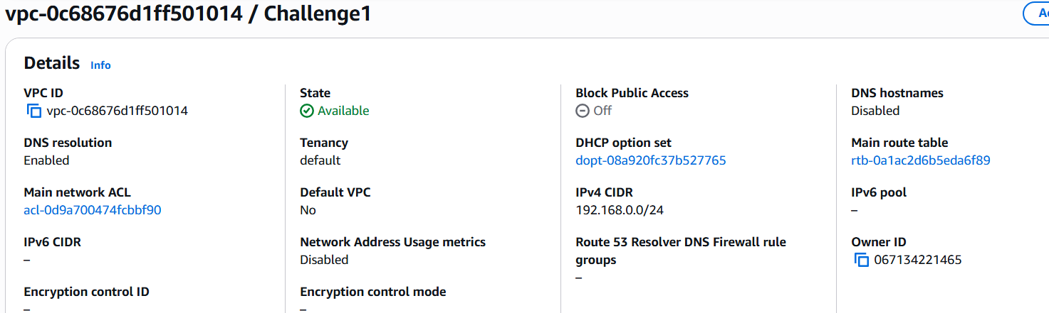
Go to vpc and select the option ‘create vpc’
Give the name of the vpc and assign the range of the vpc of challenge2 as 192.168.1.0/24

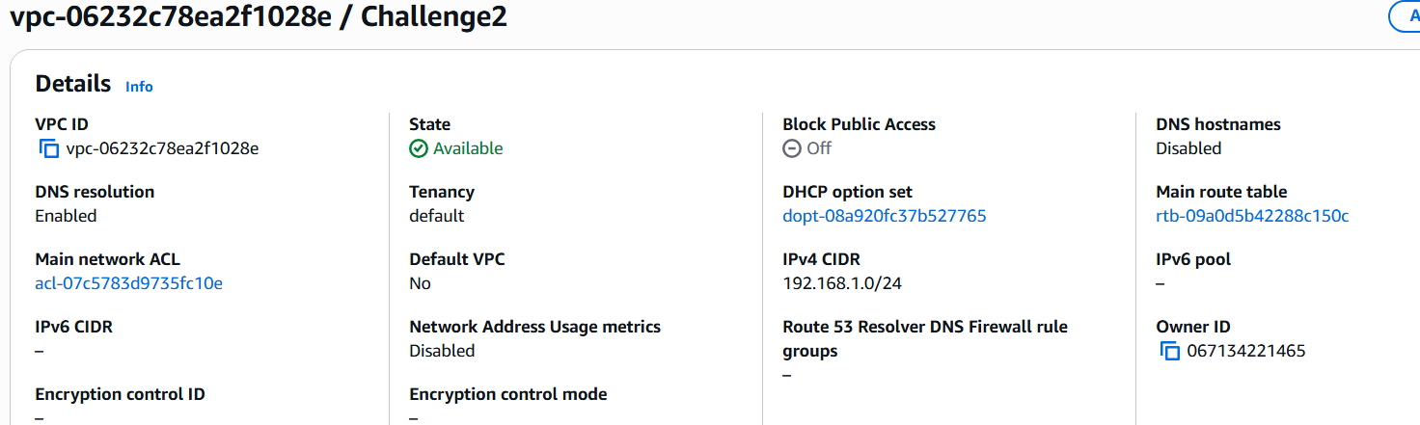
Go to vpc and select the option ‘create vpc’
Give the name of the vpc and assign the range of the vpc of challenge3 as 192.168.2.0/24
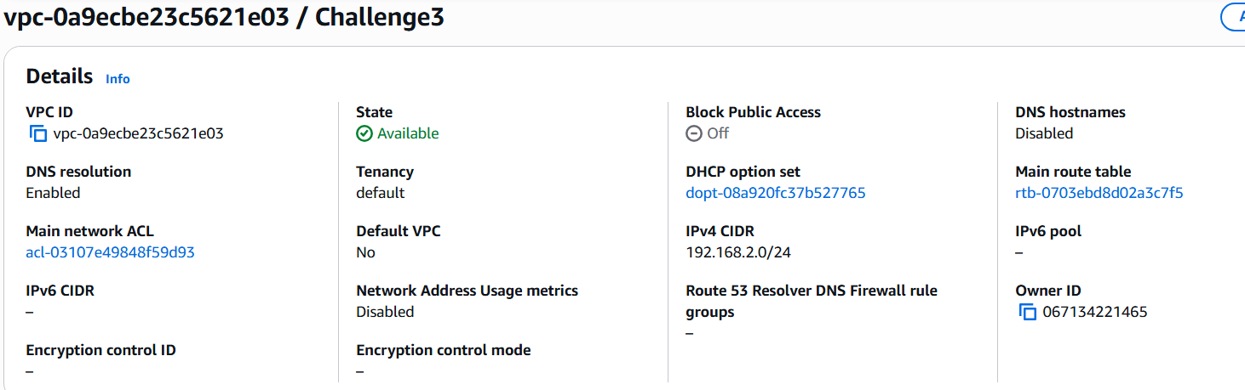

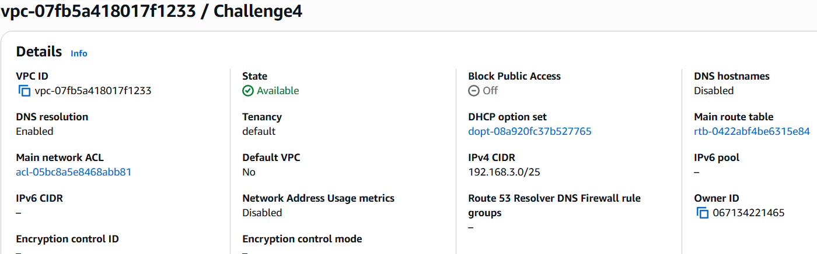Go to vpc and select the option ‘create vpc’
Give the name of the vpc and assign the range of the vpc of challenge4 as 192.168.3.0/25

Created the public and private subnets as challenge1public subnet and challenge1 private subnet along with the routing table as challenge1-private-RT, Challenge1-Public-RT, and give route the challenge1-IGW to the public
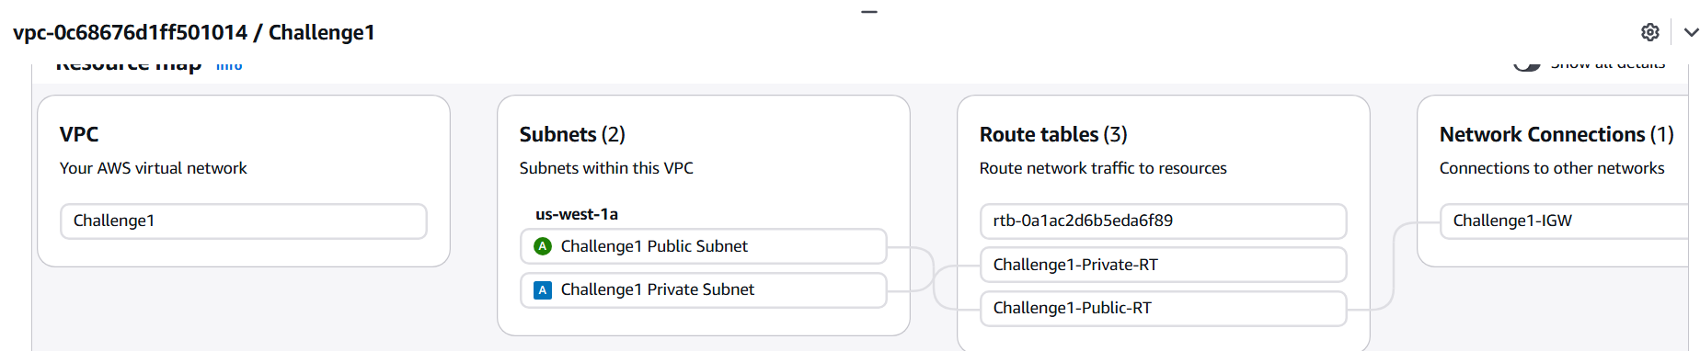

Created the public and private subnets as challenge1public subnet and challenge2 private subnet along with the routing table as challenge2-private-RT, Challenge2-Public-RT, and give route the challenge2-IGW to the public
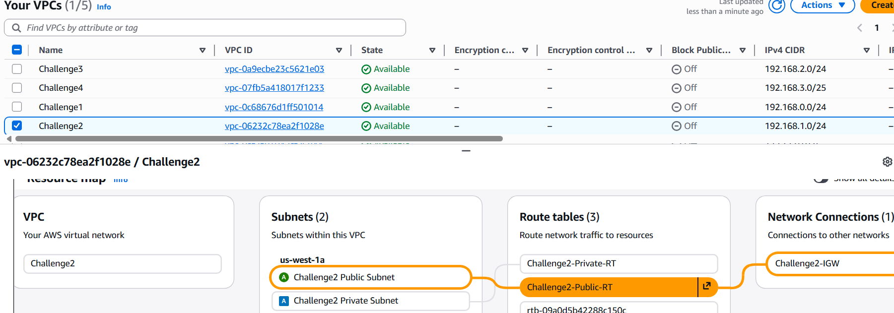

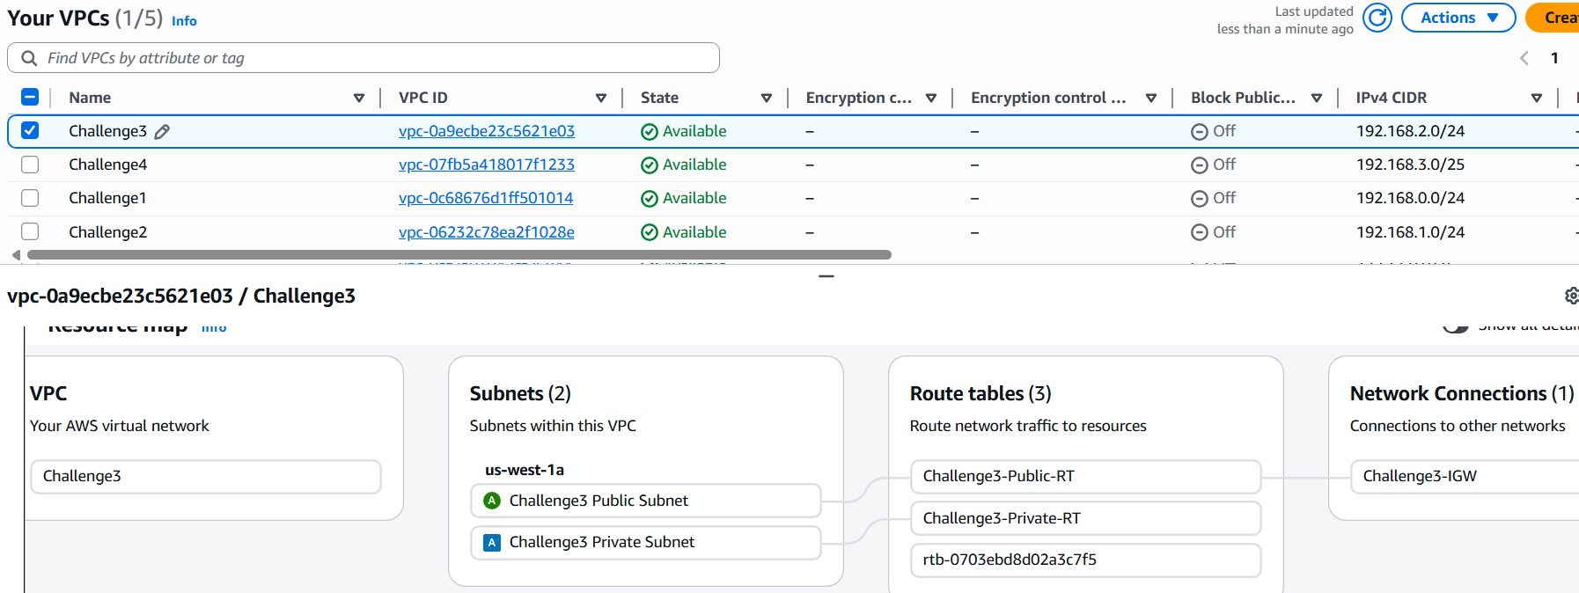

Created the public and private subnets as challenge3public subnet and challenge3 private subnet along with the routing table as challenge3-private-RT, Challenge3-Public-RT, and give route the challenge3-IGW to the public

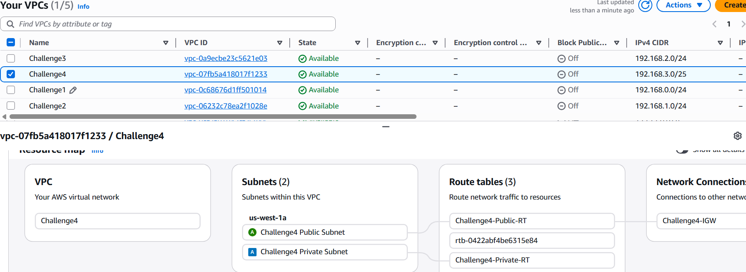

Created the public and private subnets as challenge4public subnet and challenge4 private subnet along with the routing table as challenge4-private-RT, Challenge4-Public-RT, and give route the challenge4-IGW to the public

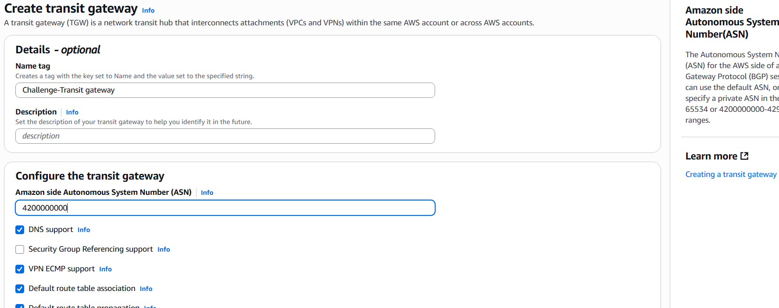

Create a transit gateway with name Challenge-Transit gateway and assign the ASN as 4200000000

Created transit gateway attachment ‘Challenge-Transit gateway-attachment-1” define the vpcid challenge1 and choose the public subnet.
Created transit gateway attachment ‘Challenge-Transit gateway-attachment-2” define the vpcid challenge2 and choose the private subnet.
Created transit gateway attachment ‘Challenge-Transit gateway-attachment-3” define the vpcid challenge3 and choose the private subnet.
Created transit gateway attachment ‘Challenge-Transit gateway-attachment-4” define the vpcid challenge4 and choose the private subnet.

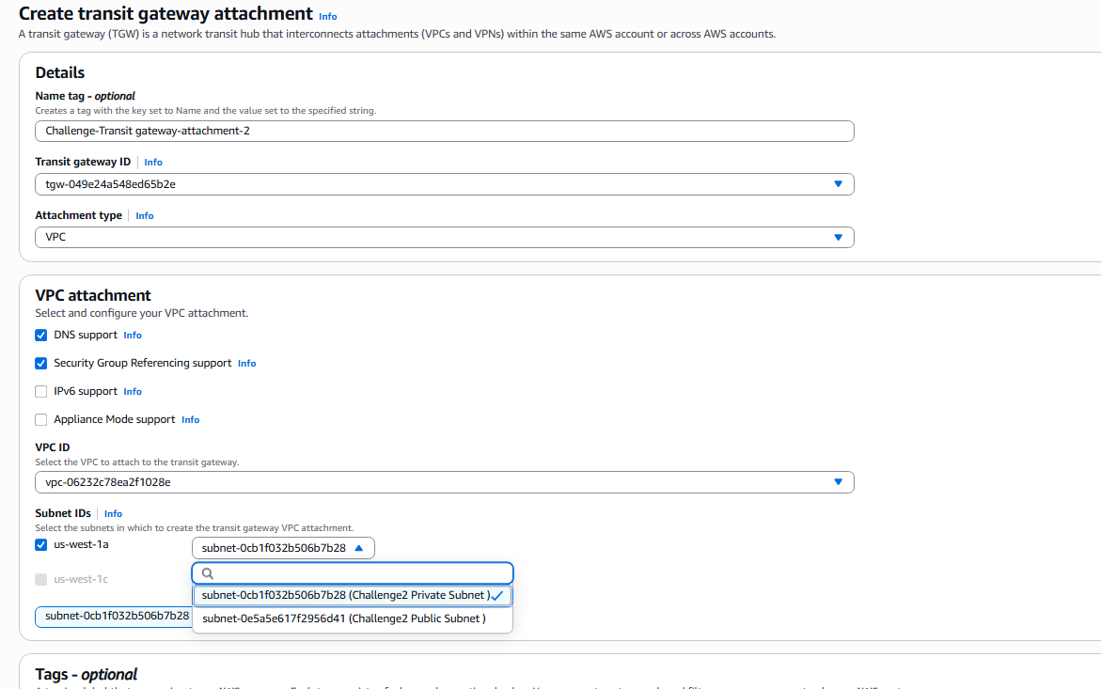

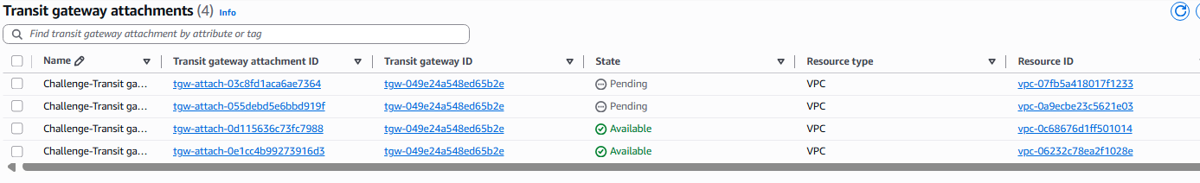
Go to Transit gateway attachment and create Transit gateway attachment give the name Challenge Transit gateway attachment-1 and select the attachment type to VPC and slect VPC ID to Challenge1VPC and select the Subnet ID to public subnet of that particular VPC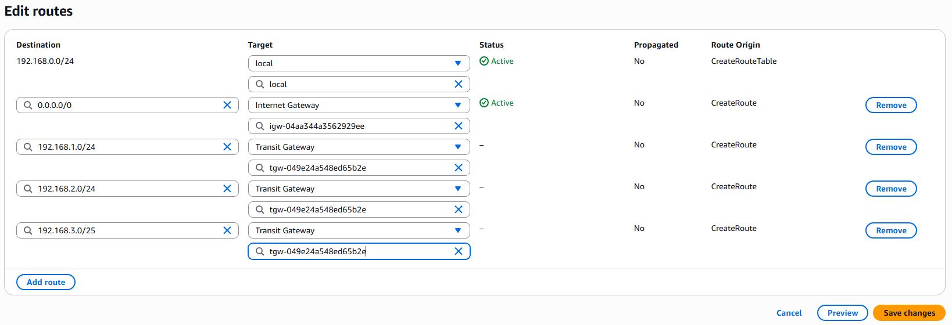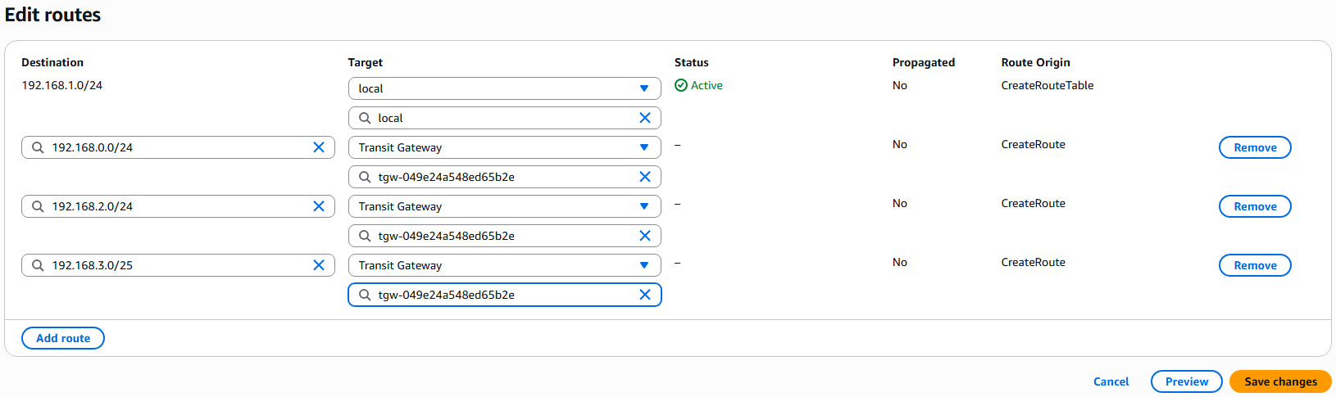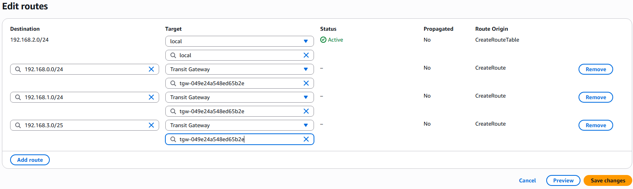

Updated the Route tables of Public route tables of challenge1 and private route tables of challenge2 challenge3 and challenge4 VPC’s.

Now I have provisioned the EC2 instance in public subnet of challenge1 and 3 other EC2 instances in private subnets of challenge2, challenge3, challenge4 VPC’s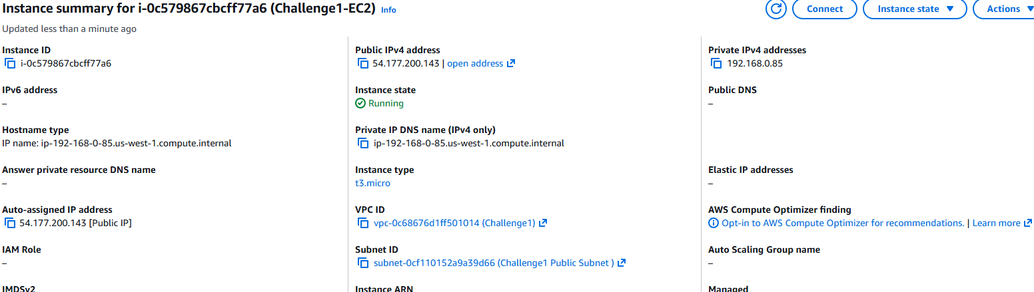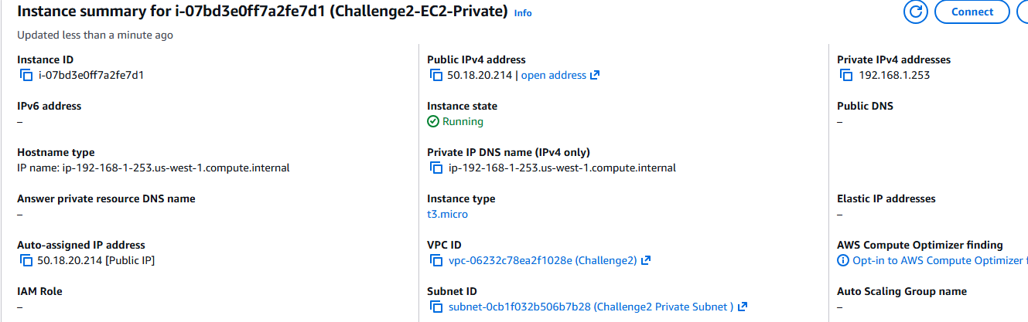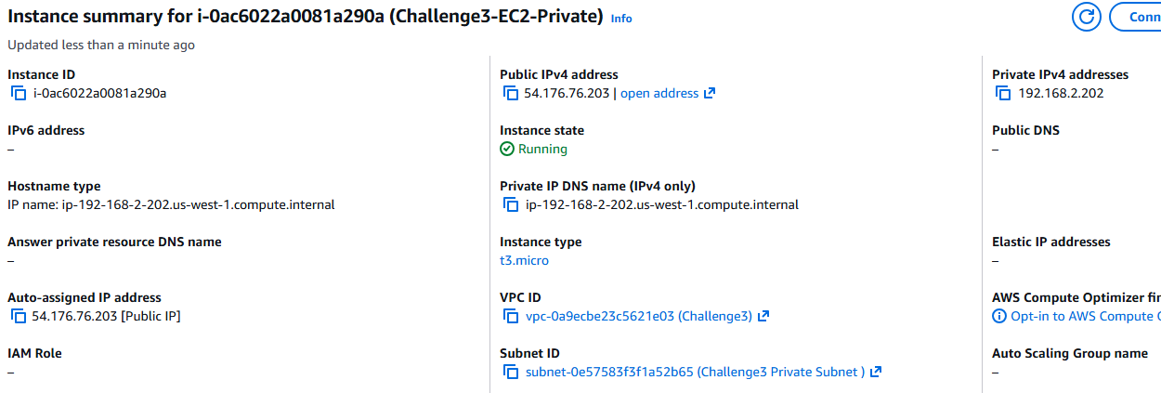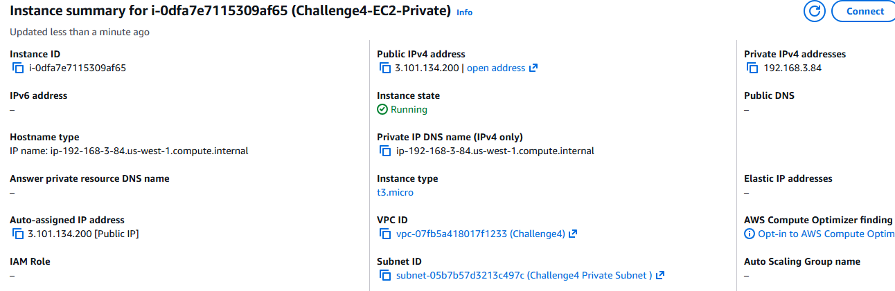
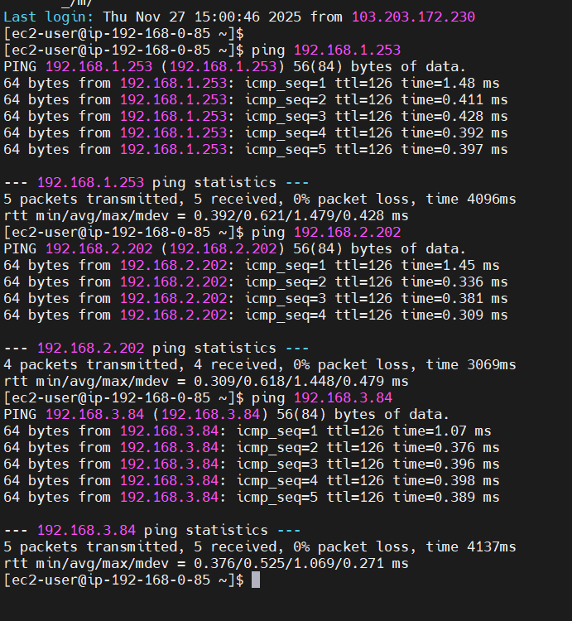

After the Ec2’s are started logged on to the public ec2 and executed ping request to all 3 private instances and the ping request’s are succesful as shown in the above.

----------------------------------------------------------------------------------------------------------------------------------------------------------------------------------------------------------------------------------------------------------------------------

Part-2

Out of the Four VPC’s created earlier iam implementing endpoint connection in the Challenge1 of range 192.168.0.0/24
The details of the VPC are as follows.

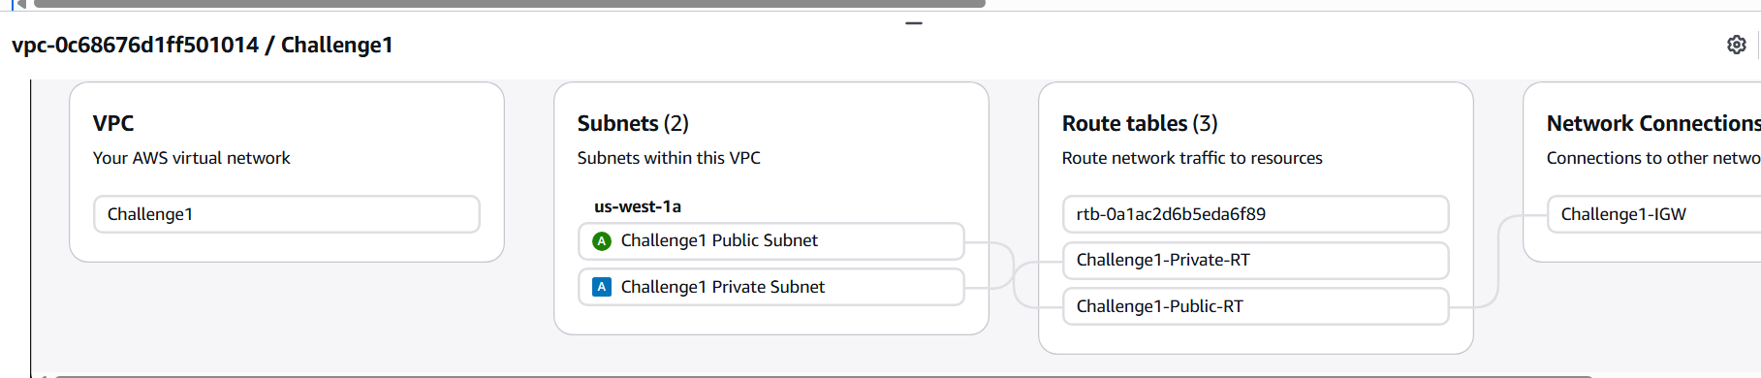

I have provisioned an instance in the private instance of the challenge1 vpc and details are as follows

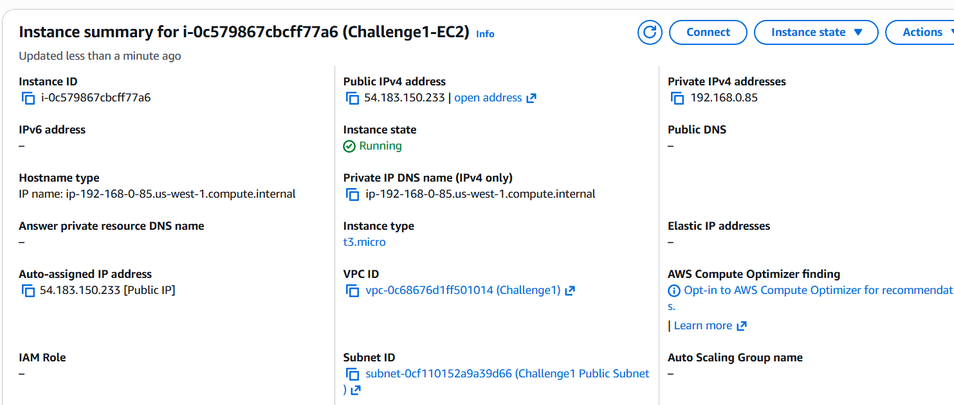

I have also provisioned an EC2 in the private subnet of the Challenge1 VPC and the details are of the follows
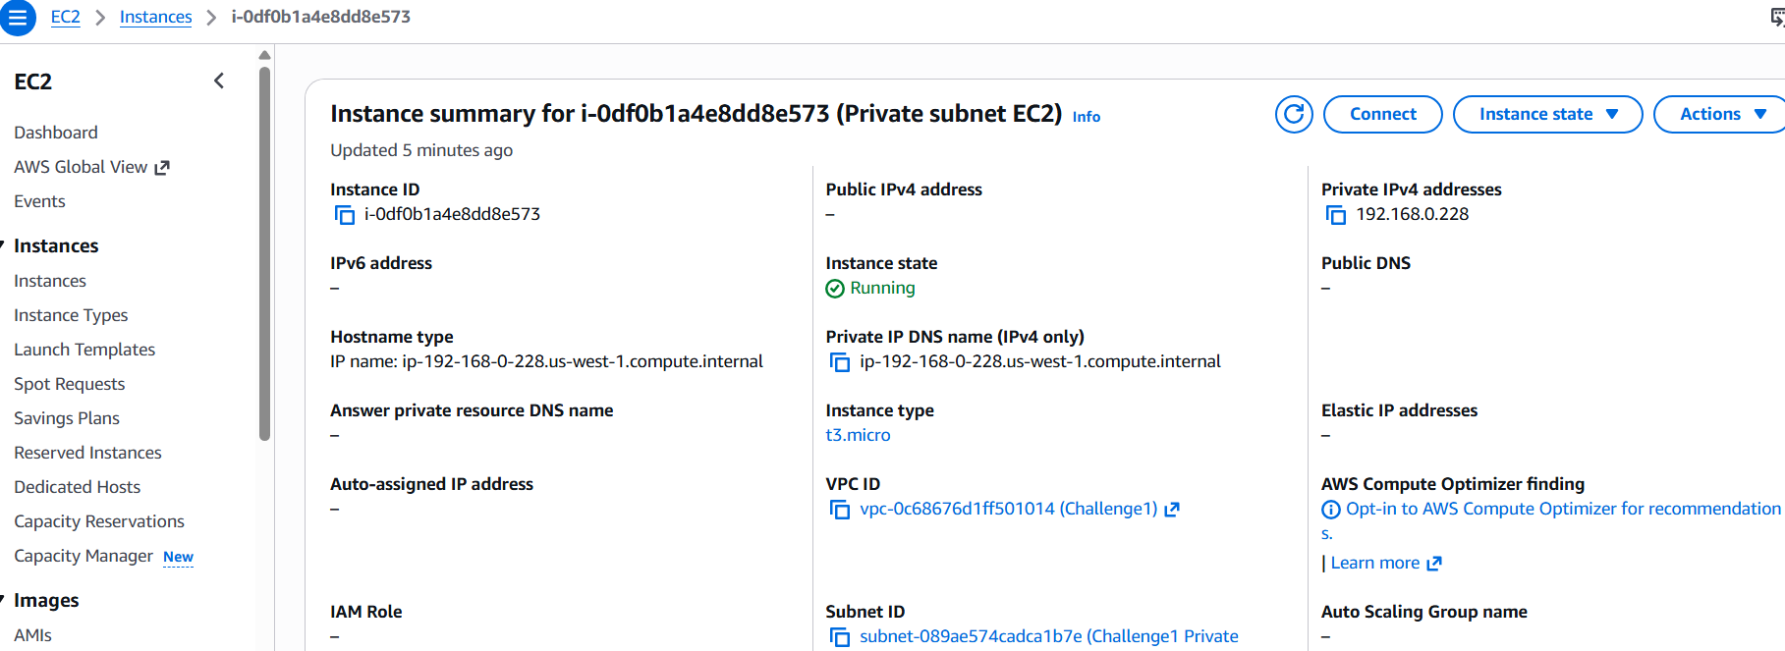

Go to the public EC2 instance and executed the ‘aws configure’ command to enter the access key and secret key details along with the default region and the output format
After succesful configuration, see if we can able to see the s3 buckets in our account are visible or not and we can see that the buckets are visible from the public subnet since the request goes through the internet gateway
Now I have used jump server strategy to log in to the private instance by copying the key to the new created pem file created on the public instance and initiated ssh connection to the private instance.
After login to the private instance, initiated ‘ aws configure’ command and entered the access key and secret key and all other details.
Here the aws buckets are not visible since the request has no way of reaching to the outside world, so there is no response to the ‘aws s3 ls’ command.
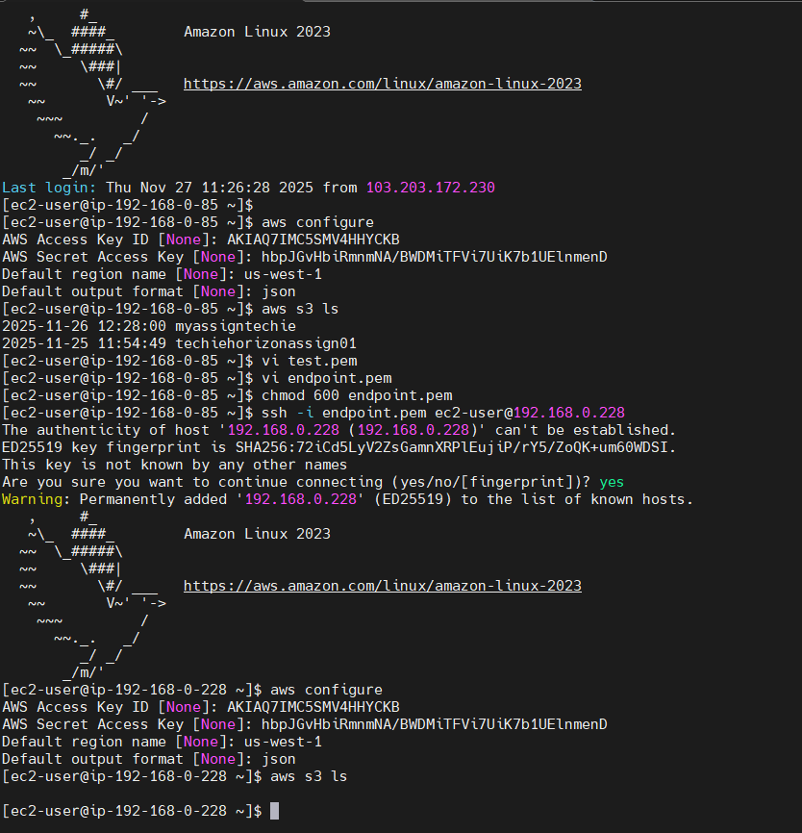

Now, I have to create the endpoint, Goto endpoint menu, click ‘create endpoint’ and give the name ‘Challenge_Endpoint”.
choose type “Service” and select “Service name= com.amazonaws.us-west.1.s3” - Gateway
From the route table select the private subnet of the challenge1 VPC
Choose policy VPC endpolicy access to service to “full” acess.
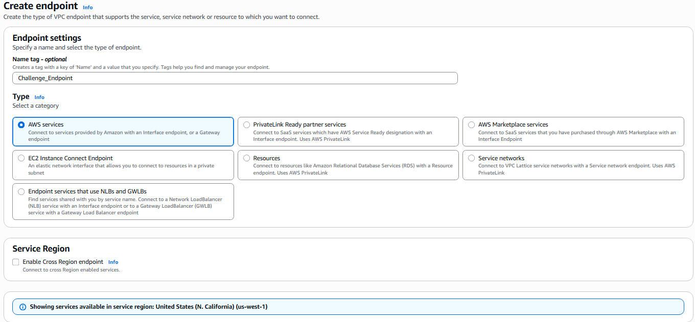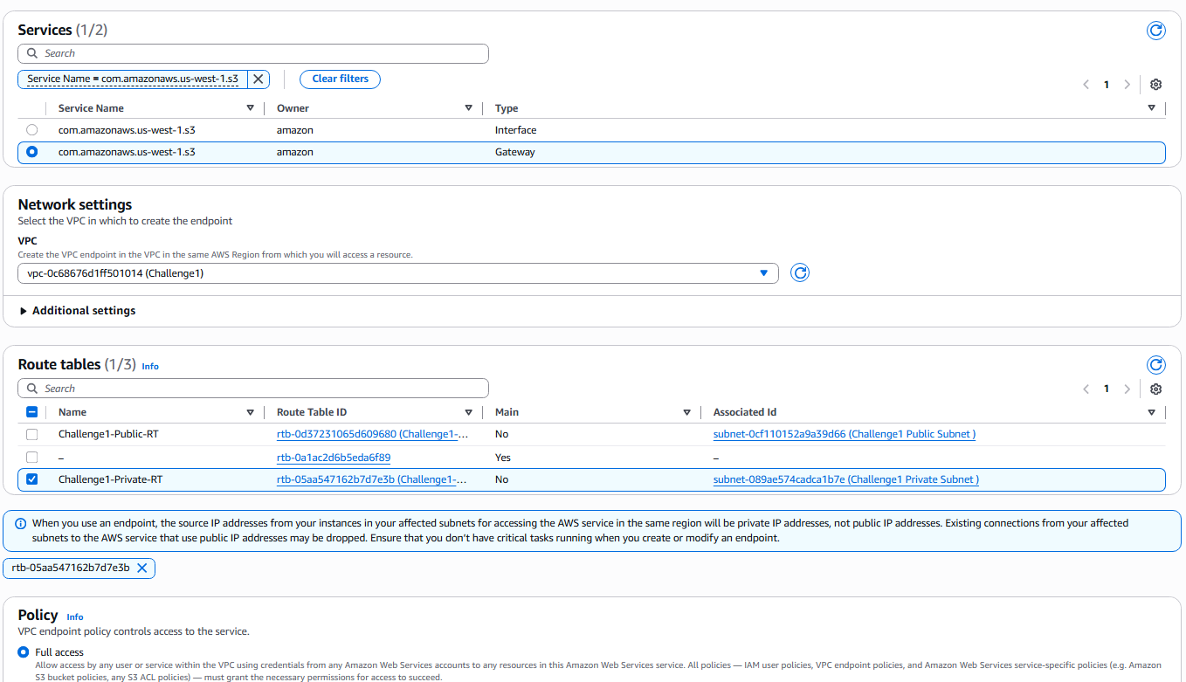
The Endpoint created is as follows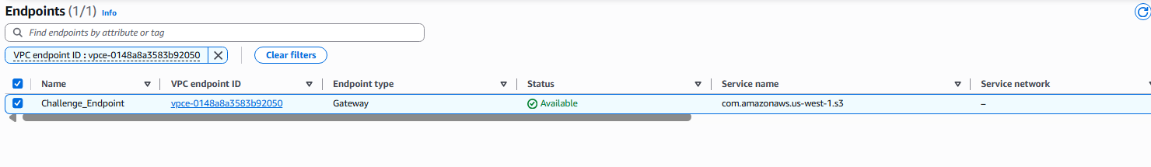
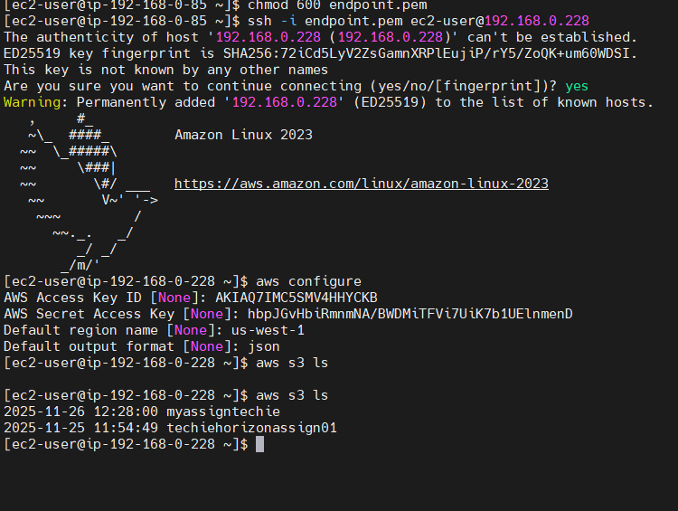
After configuring the endpoint execute “aws s3 ls” and we can see the s3 bucket list shown as above

