CloudTrail, SNS, CloudWatch – 1

Enable cloudtrail monitoring and store the events in s3 and cloudwatch log events.

1) Task Title: Enable cloudtrail monitoring and store the events in s3 and cloudwatch log events.
2) Objective: To enable CloudTrail monitoring and store the events in S3 and CloudWatch Logs, the objective is to set up AWS CloudTrail to capture all API activity across your AWS account, ensuring it is logged securely and is accessible for analysis or troubleshooting. This helps to meet security, compliance, and auditing requirements by storing logs in S3 and sending logs to CloudWatch for further analysis, alerts, and monitoring.
3) Prerequisites:
AWS Account
Cloud Trail
Cloud watch
S3 Bucket
IAM role

4) Step-by-Step Implementation (With Evidence):

Step 1: Create a CloudTrail Trail
Console Path:
AWS Console → CloudTrail → Trails → Create Trail
Explanation:
Creates a trail to capture management Events
Evidence:
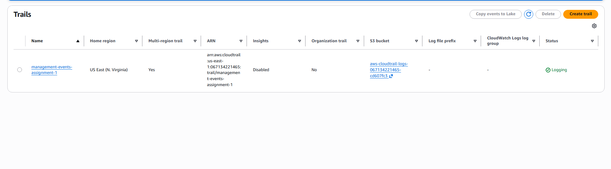

Step 2: Configure S3 Bucket for CloudTrail
• Console path: S3->logonto created bucket-> go to last folder
• Explanation: S3 bucket stores all CloudTrail logs.
Evidence: 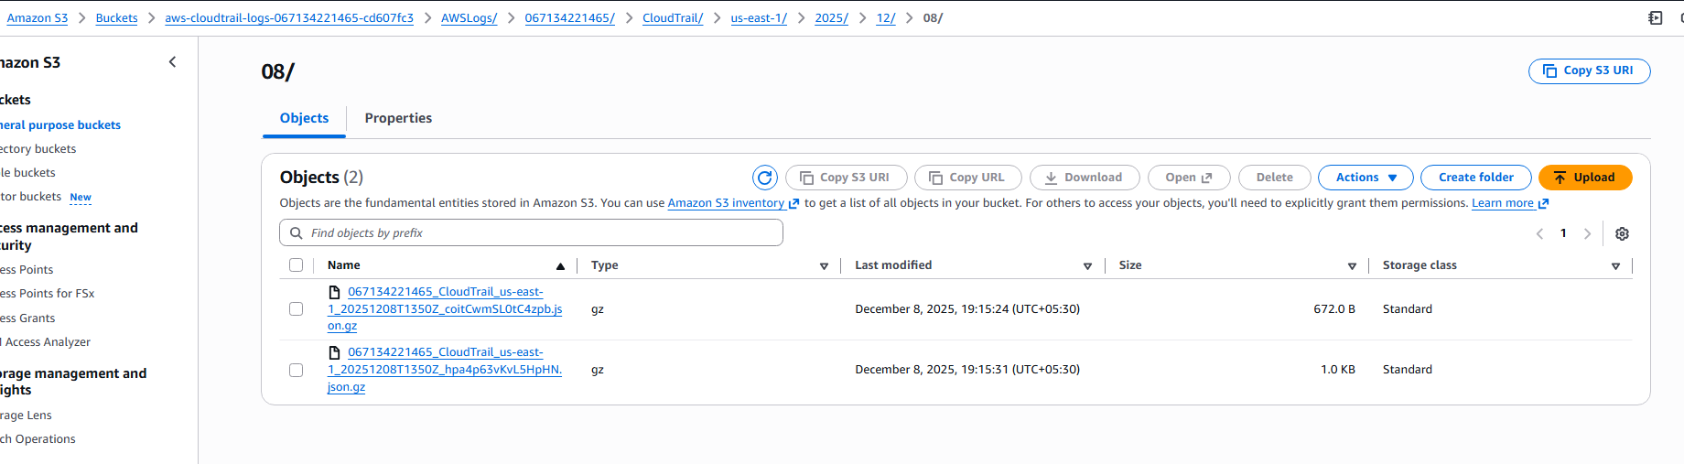

Step 3 Enable CloudWatch Logs Integration
• Console path: Trail settings → CloudWatch Logs → Enable
• Explanation: CloudTrail creates logs and also roles
Evidence: 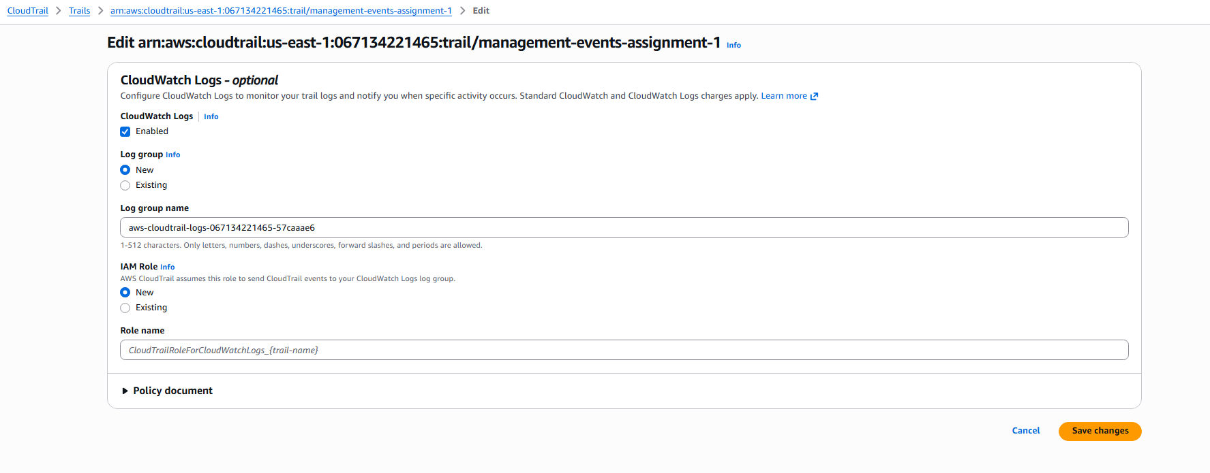
Step 4: Your trail is been created
• Console path:
• Explanation:
Evidence: 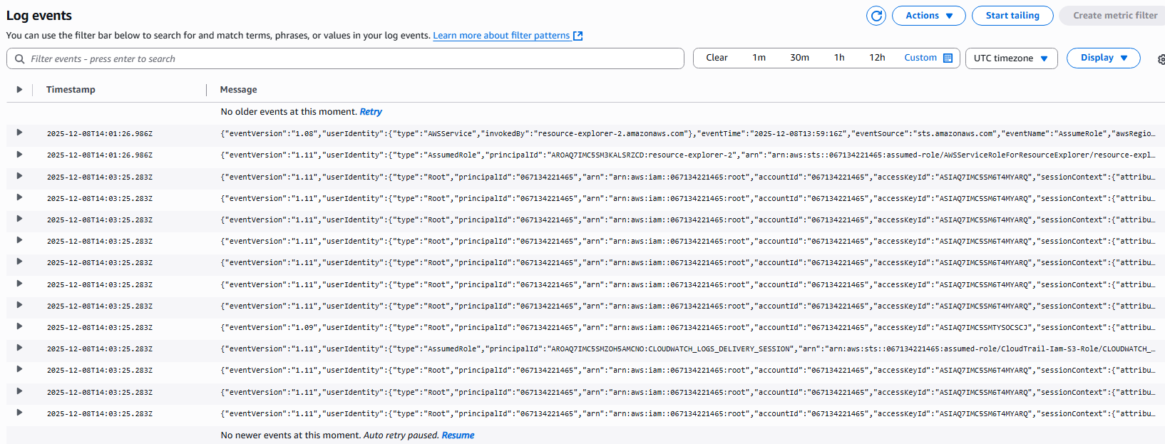

5) Validation Steps (Mandatory, With Evidence):

Validation 1: CloudTrail Logging Status
CloudTrail → Trails-> select the create trail
Evidence: 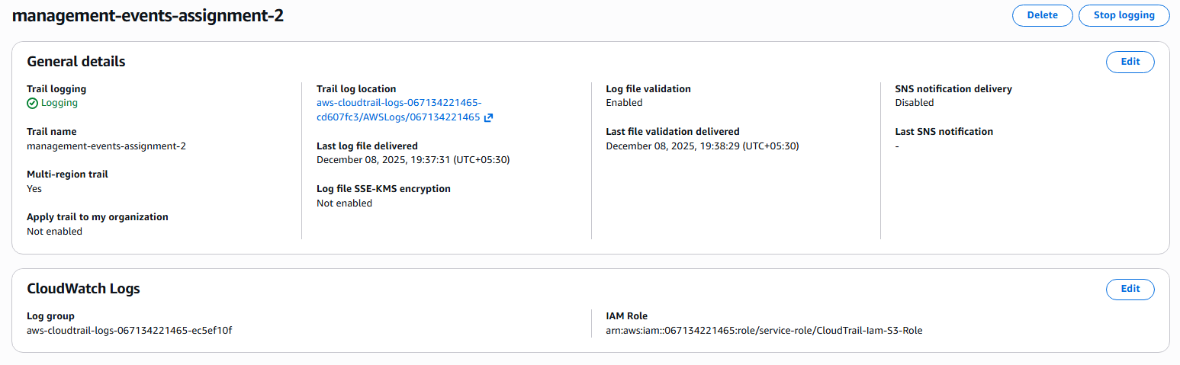

Validation 2: Logs in S3
Example:
Evidence: 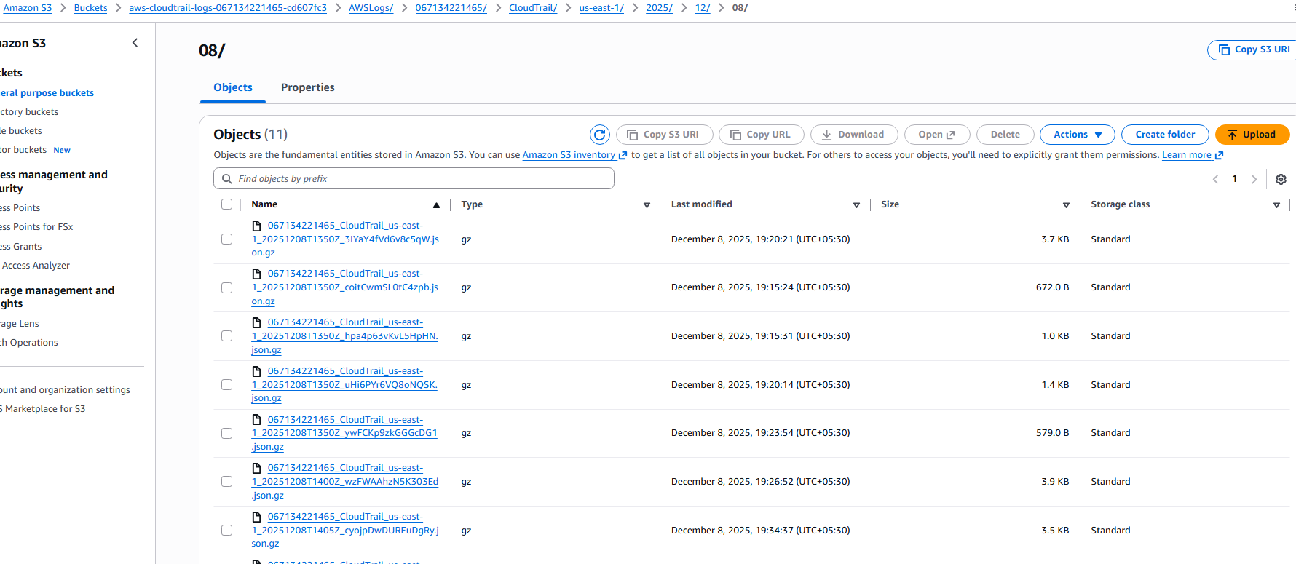

6) Issues Faced (Optional):
When I tried to create trail I have encountered the error ‘ExpiredTokenException The security token included in the request is expired’ because I have disabled the access key and secret key, I have enabled the access key and secret key and the error was rectified.
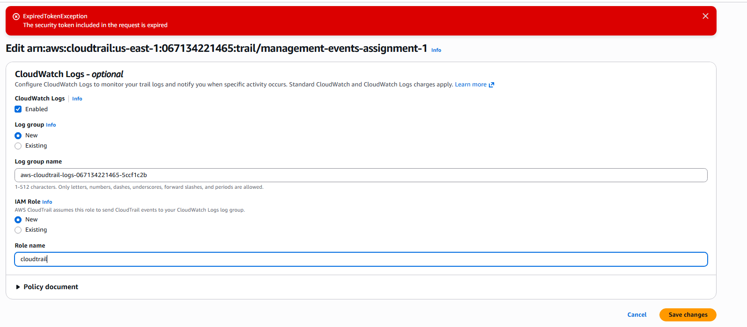

7) Conclusion: CloudTrail successfully enabled and configured to send logs to S3 and CloudWatch

Enable SNS for cloudtrial to send alert on email.

1) Task Title: Enable SNS for cloudtrial to send alert on email.
2) Objective: To enable Amazon SNS (Simple Notification Service) for CloudTrail to send email alerts when specific events occur.
3) Prerequisites:
CloudTrail
CloudWatch Logs
email address
IAM SNS permissions
4) Step-by-Step Implementation (With Evidence):

Step 1: Create an SNS Topic
• Console path: SNS → Topics → Create Topic
• Evidence:
: 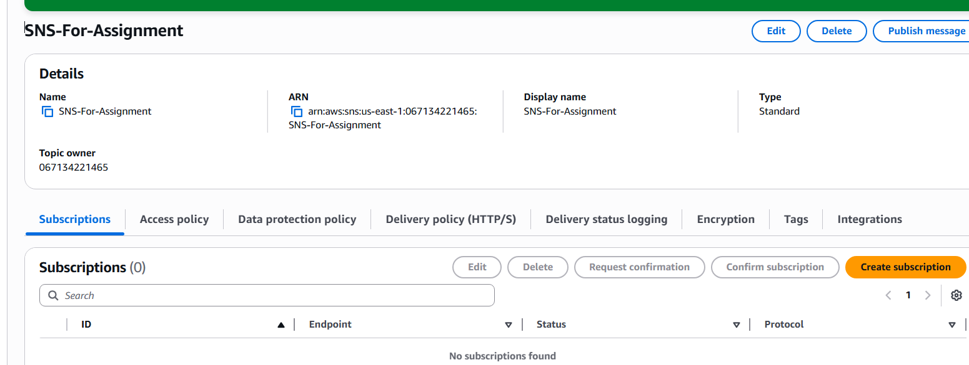

Step 2: Subscribe Email
• Console path: Select the protocol to email and give the name in the subscription
• Explanation:
Evidence: 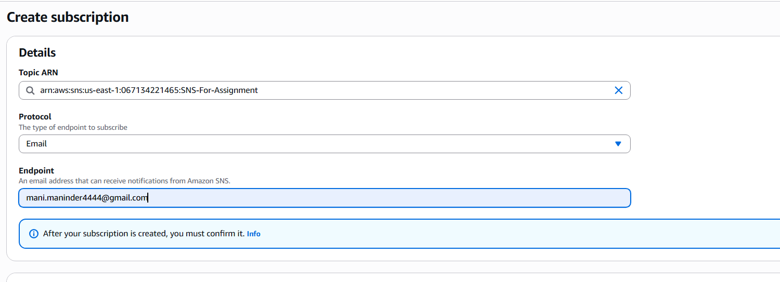
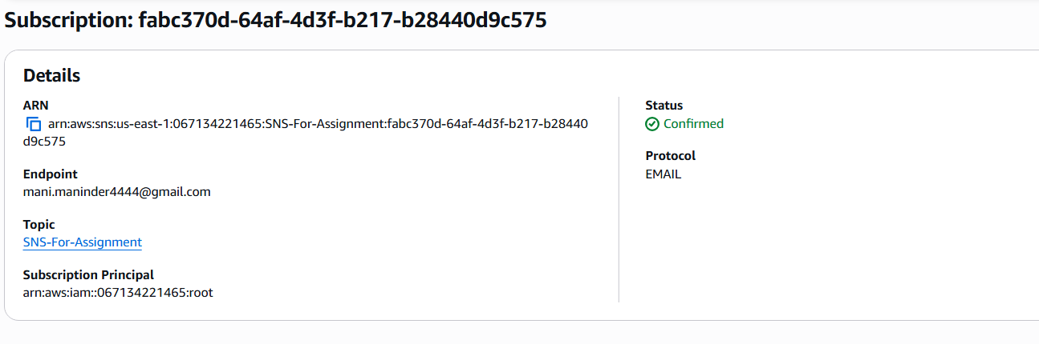

Step 3: Create CloudWatch Metric Filter
• Console path: CloudWatch → Logs → Log Groups → /aws/cloudtrail/mytrail
• Explanation:
Evidence:

5) Validation Steps (Mandatory, With Evidence):

Validation 1: confirmation email on subscription confirmed
Example:
Evidence: 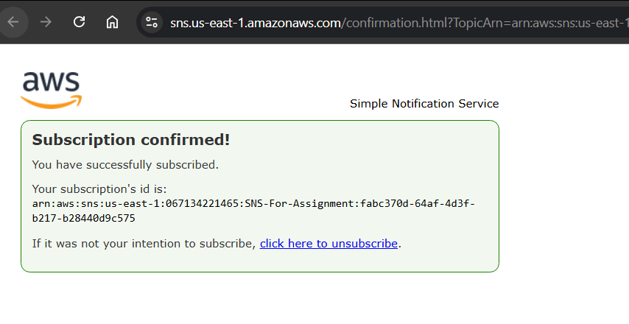

6) Issues Faced (Optional):
First when I tried to create the topic in SNS, I choose FIFO type instead of Standard.
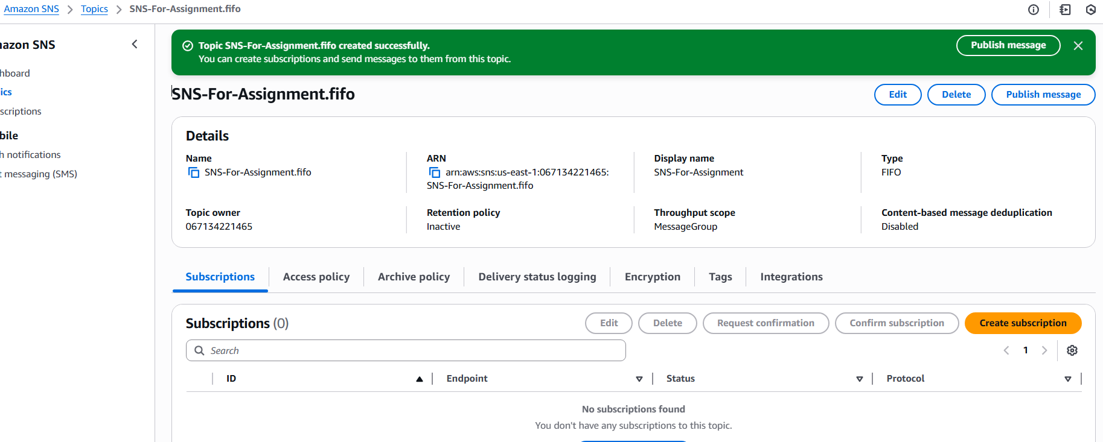
Later on when I tried to select the email protocol I have not seen the option, later I have deleted the FIFO type topic and relaunched the topic with the standard type and I have found the email protocol.
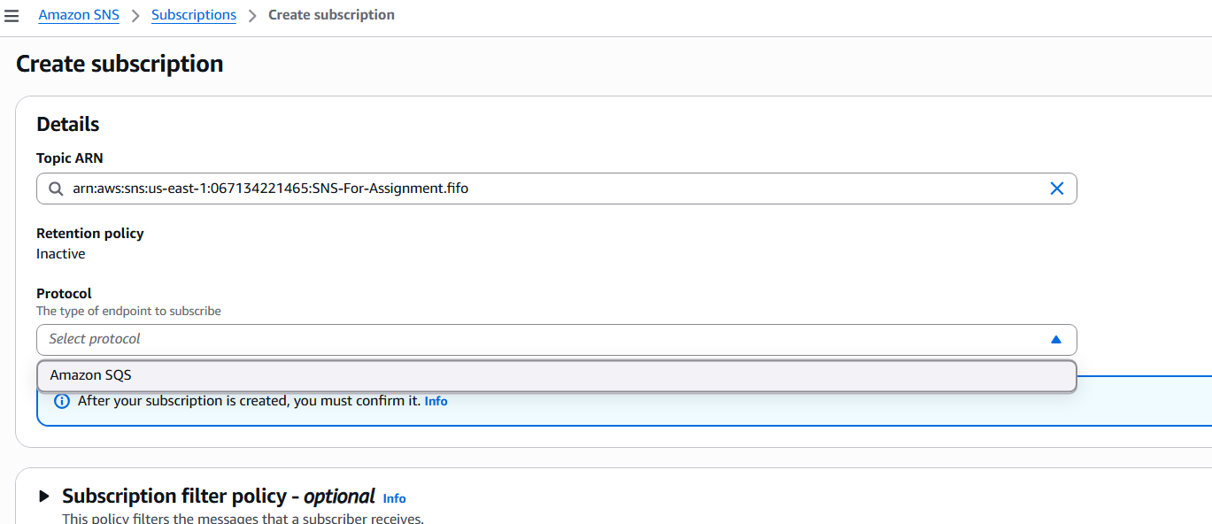
7) Conclusion: By enabling SNS for CloudTrail, now I can easily get email notifications for specific activities or events captured by CloudTrail. This is a great way to stay informed about changes or actions in AWS environment.

Configure cloud watch monitoring and record the CPU utilization and other metrics of ec2.

1) Task Title: Configure cloud watch monitoring and record the cpu utilization and other metrics of ec2.
2) Objective: Enables continuous monitoring of the instance's performance metrics, set alarms for thresholds, and analyse metrics for resource optimization and troubleshooting.
3) Prerequisites:
EC2 instance
IAM Role with CloudWatch permissions
SSH Access
4) Step-by-Step Implementation (With Evidence):

Step 1: Identify EC2 instance details
• Console path:

EC2 Console → Instances → Select Instance

• Explanation: 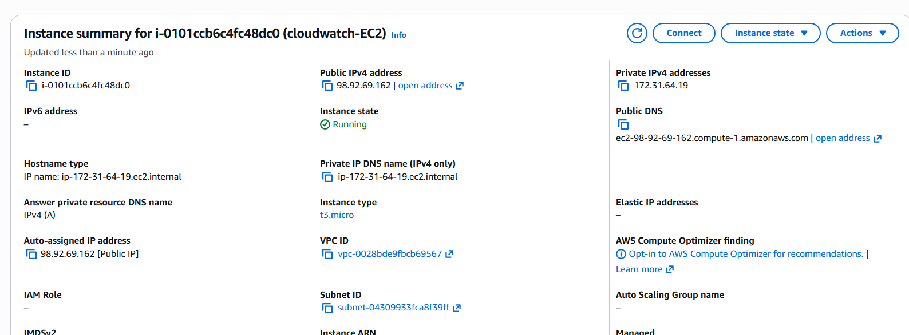

We first verify the EC2 instance information, including Instance ID, Private/Public IP, VPC, Subnet, Instance type, and instance state (Running).

Step 2: Open CloudWatch Metrics and Locate EC2 Metrics
• Console path:

CloudWatch → Metrics → EC2 → Per-Instance Metrics

• Explanation:

CloudWatch automatically collects EC2 metrics every 5 minutes.
We search for CPUUtilization, CPUCreditBalance, and EBSReadBytes metrics.

• Evidence: 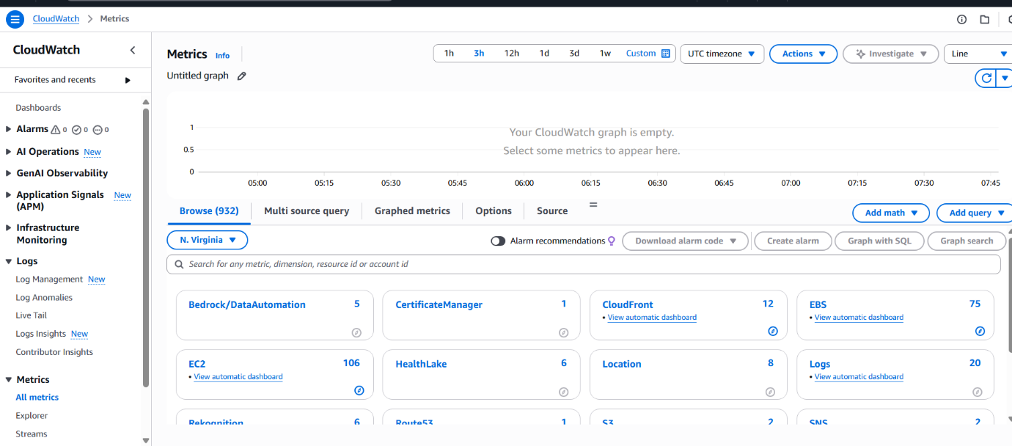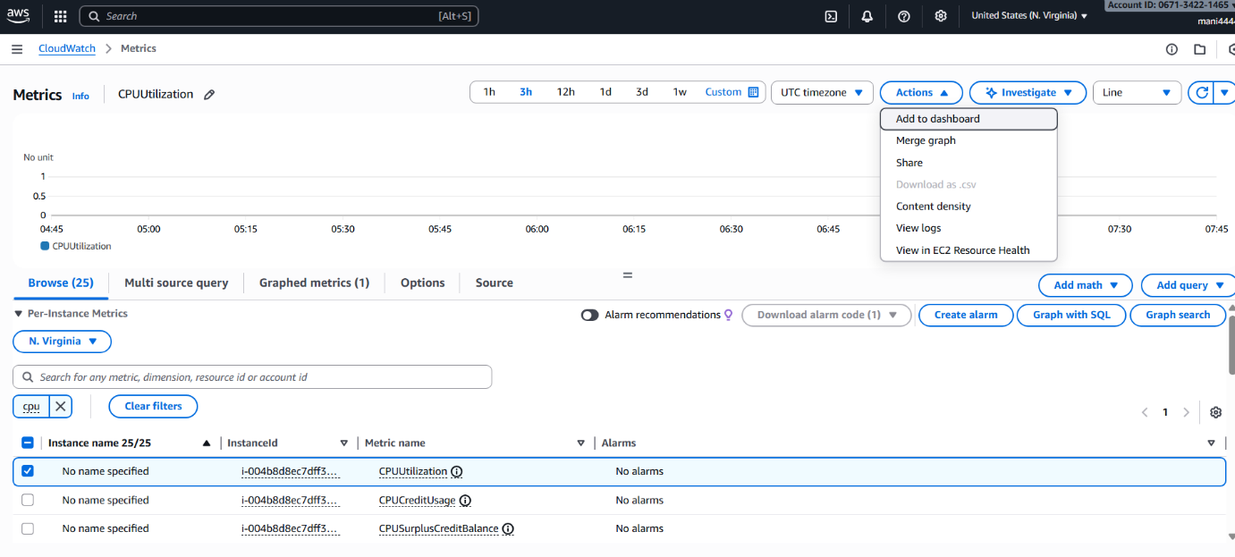

Step 3: Add EC2 CPU Metric to CloudWatch Dashboard
• Console path:

CloudWatch → Metrics → Select Metric → Actions → Add to Dashboard

• Explanation:

A new dashboard named Cpu_Metrics was created.
A Number widget and Graph widget were added to visualize CPUUtilization and other metrics.

• Evidence: 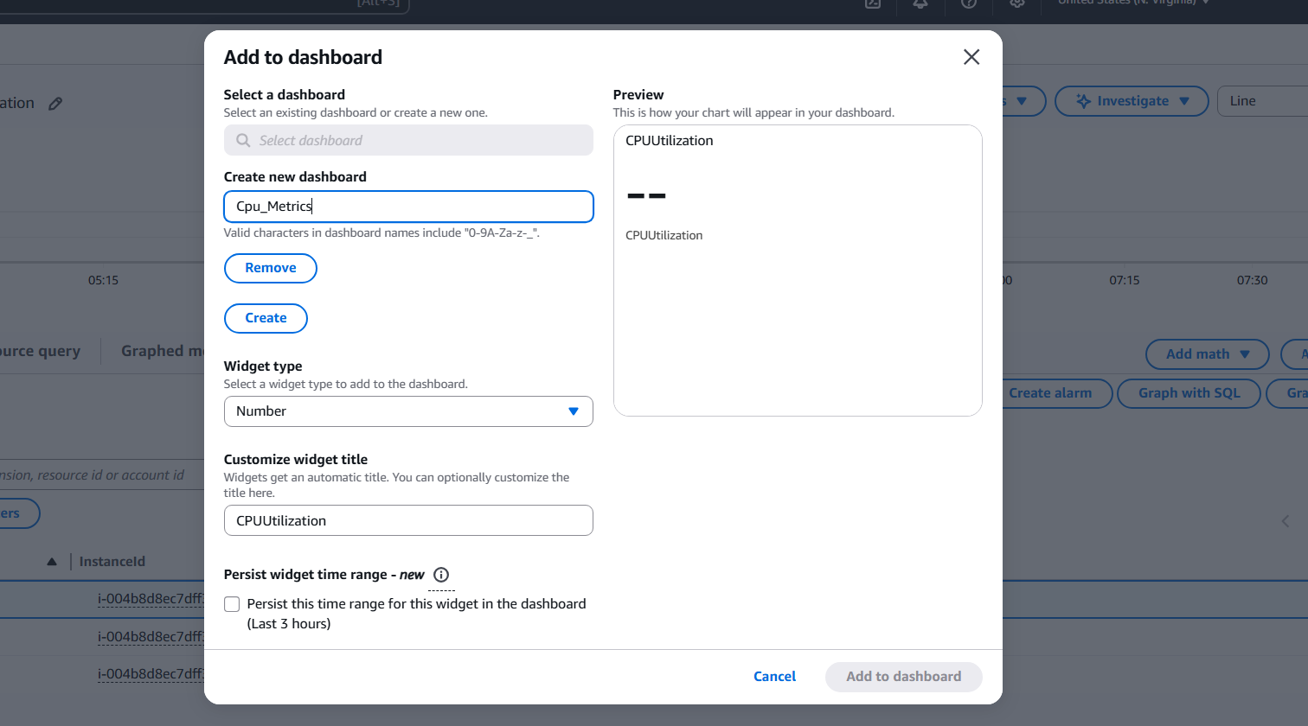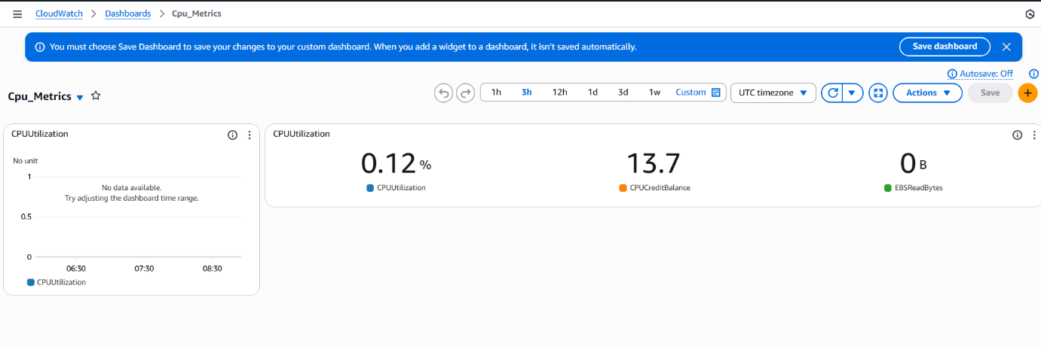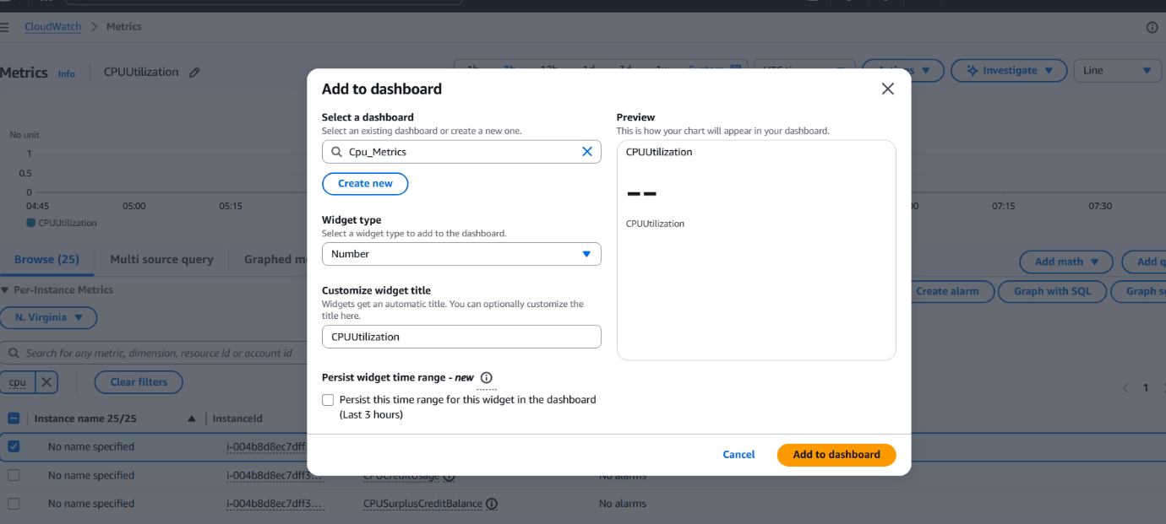
Step 4: Generate CPU load on EC2 instance
• CLI commands used (inside EC2 terminal):
yes > /dev/null &
yes > /dev/null &
yes > /dev/null &
yes > /dev/null &
yes > /dev/null &

• Explanation:

Running multiple yes commands creates 100% CPU load.
This is necessary to validate that CloudWatch monitoring updates correctly.

• Evidence: 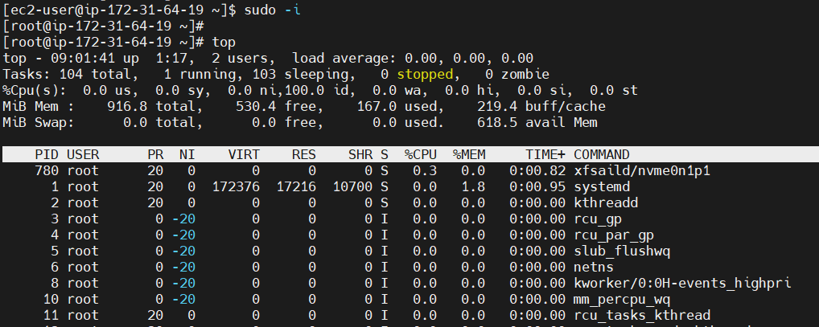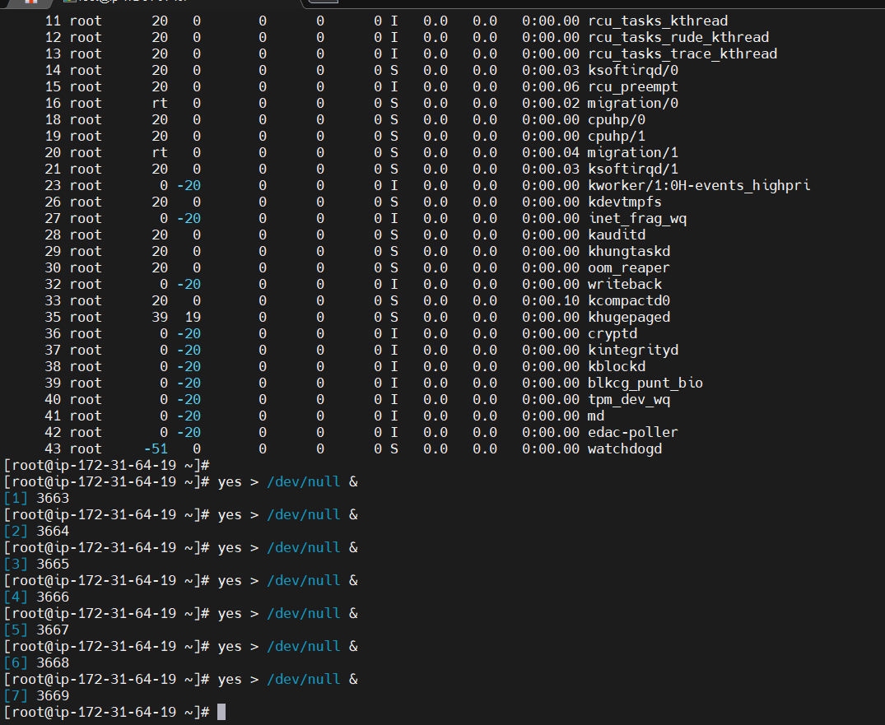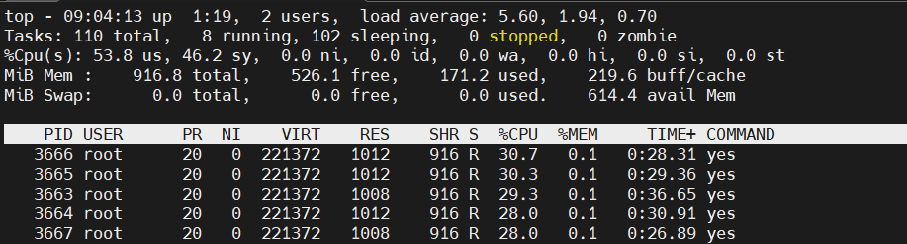

Step 5: Validate CPU Metrics Updated on CloudWatch Dashboard
• Console path:

CloudWatch → Dashboards → Cpu_Metrics

• Explanation:

The dashboard now reports 100% CPUUtilization, proving the load script affected CloudWatch metrics.

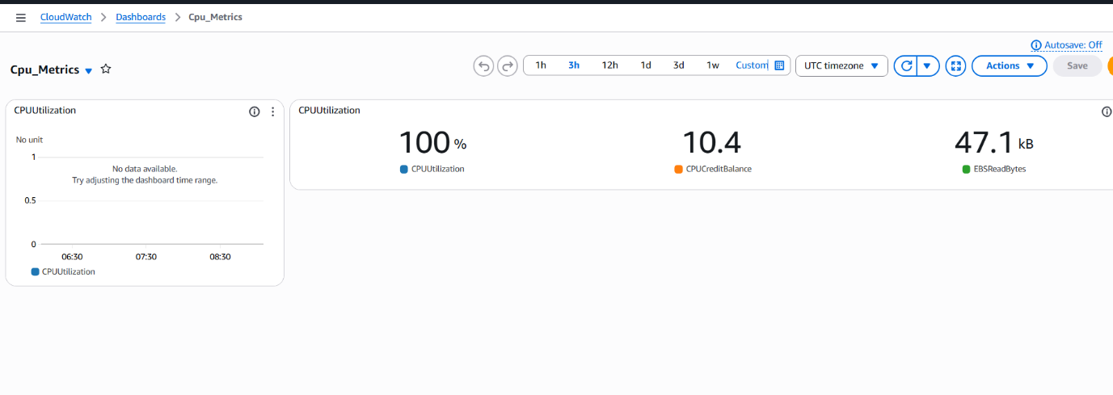
6) Issues Faced (Optional)

No major issues.
CloudWatch metrics took a few minutes to refresh (expected due to 5-minute default metric interval).
7) Conclusion

CloudWatch monitoring was successfully configured for the EC2 instance.
We captured real-time CPU utilization, CPU credits, and EBS metrics by creating a custom CloudWatch dashboard.
By generating artificial CPU load, we verified that CloudWatch collects and displays accurate performance data.
This setup is ready for production monitoring, alert creation, and automati

Create one alarm to send alert to email if the cpu utilization is more than 70 percent.

1) Task Title: Create one alarm to send alert to email if the cpu utilization is more than 70 percent.
2) Objective: Create a CloudWatch metric alarm that monitors the EC2 instance’s CPUUtilization and sends an email notification (via SNS) whenever the CPU usage exceeds 70% for the configured period.
3) Prerequisites:
• CloudWatch, EC2, SNS, verified email address
4) Step-by-Step Implementation (With Evidence):

Step 1 — Select CPUUtilization Metric
• Console Path
CloudWatch → Metrics → Browse → cloudwatch-EC2 → CPUUtilization
• Explanation
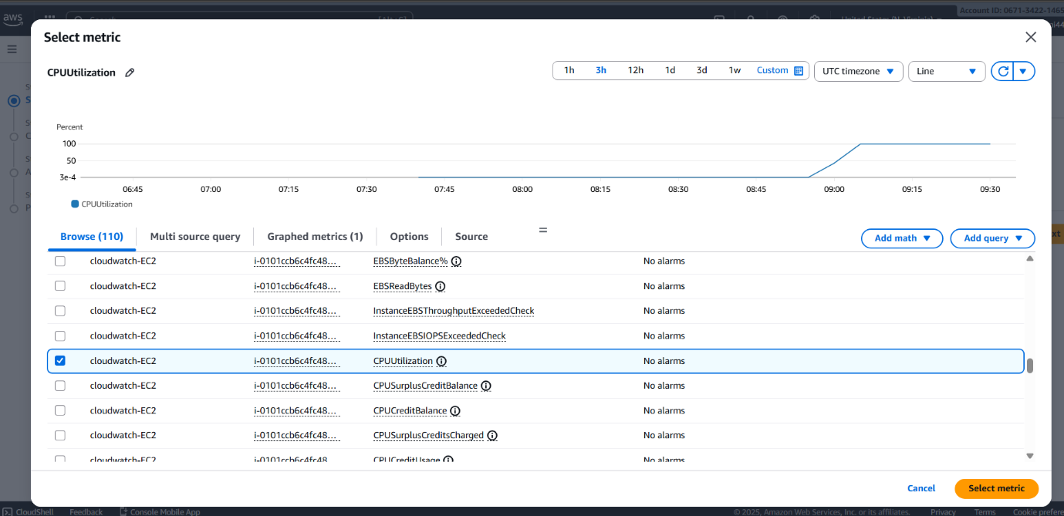
step 2 — Configure Alarm Threshold
• Console Path
CloudWatch → Alarms → Create alarm → Select metric → Define conditions
• Condition Details
Threshold type: Static
Whenever CPUUtilization is: GreaterThan: 70
• Explanation
This alarm triggers when the CPU exceeds 70%.

• Evidence 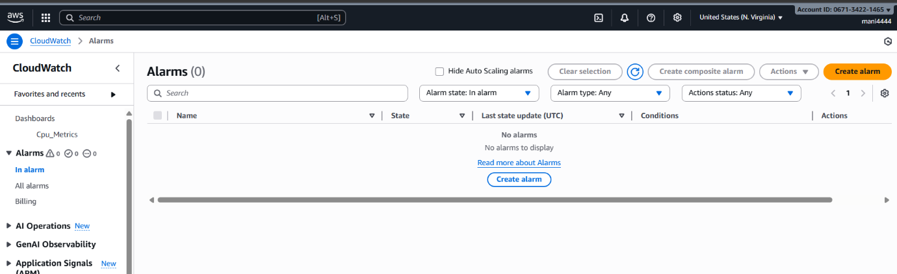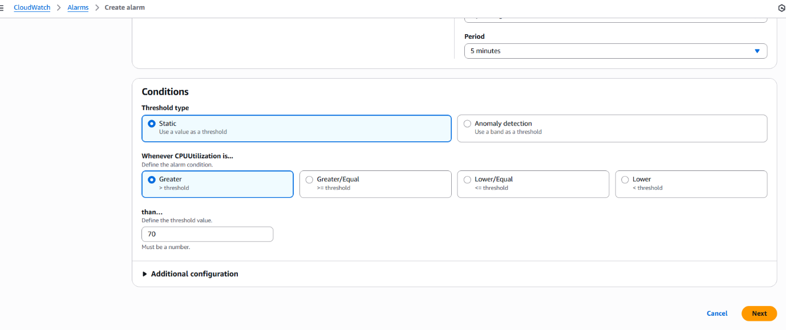

Step 3 — Configure Notification (SNS Email)
• Console Path
Configure actions → Select SNS topic → Choose email endpoint
• Explanation
SNS topic SNS-For-Assignment is used to notify mani.maninder4444@gmail.com
• Evidence 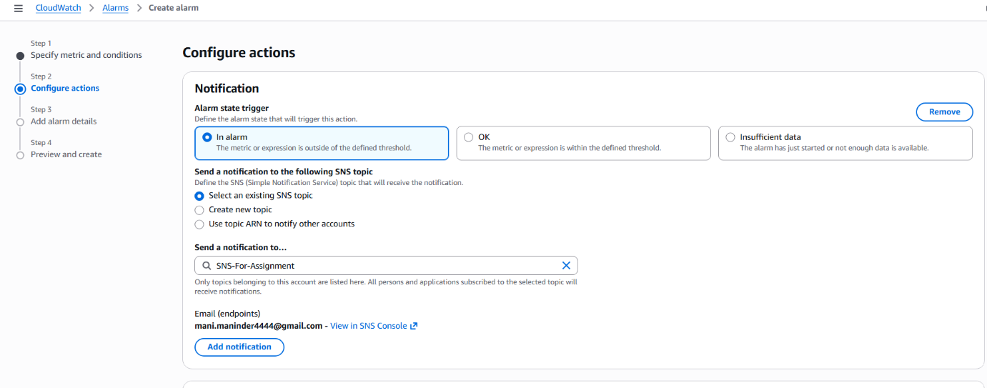 step 4 — Name the Alarm and Create It
• Console Path
Add alarm details → Preview → Create alarm
• Alarm Name : Cloudwatch-alarm-cpu-greaterthan-70

• Explanation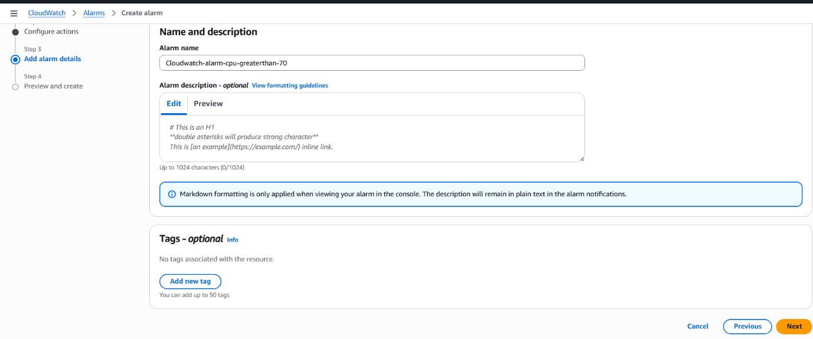
Step 5 — Verify the Alarm is Created
• Console Path
CloudWatch → Alarms → All alarms
• Explanation
The alarm appears in the list and initially enters INSUFFICIENT_DATA, then ALARM state once CPU usage increases.

• Evidence 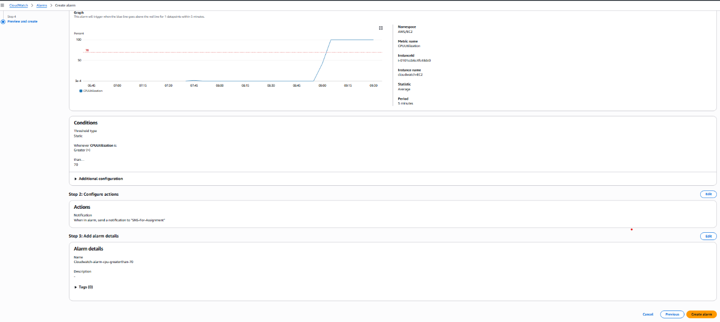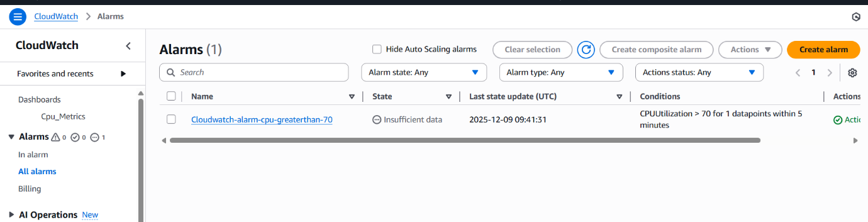

5) Validation Steps (Mandatory, With Evidence):
Validation 1: Validate Email Notification Triggered
Explanation
Once CPU goes above 70%, SNS sends an email alert.

• Evidence 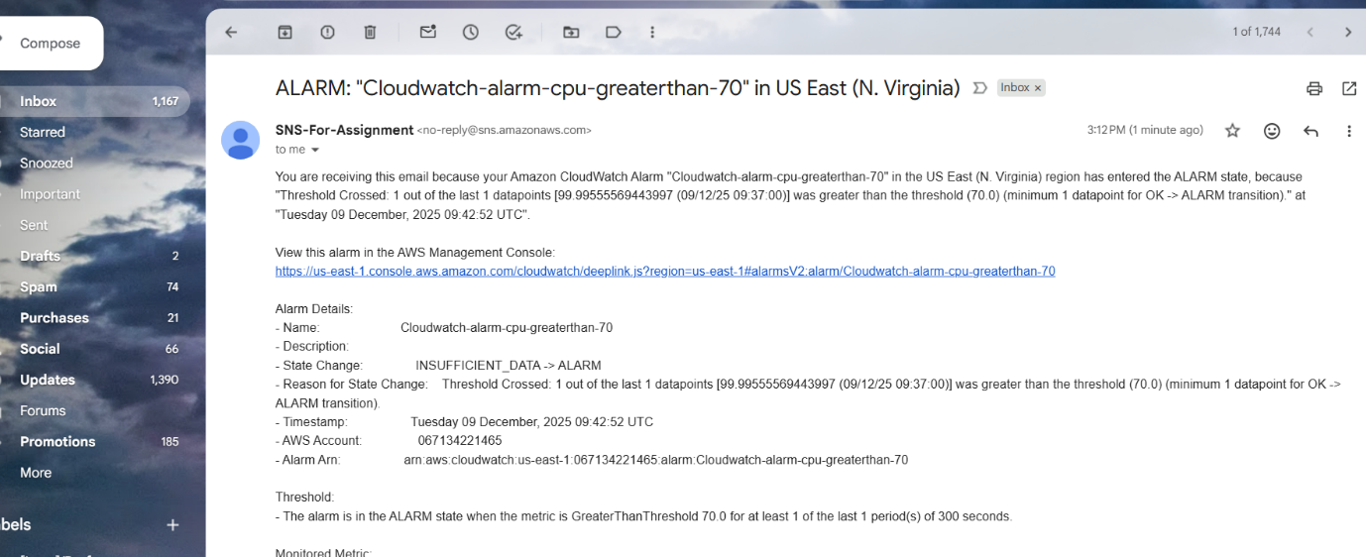

6) Issues Faced (Optional):

7) Conclusion: The CloudWatch alarm was created successfully to monitor EC2 CPUUtilization > 70%.
The alarm triggered when CPU load increased, and the SNS email notification was successfully delivered to mani.maninder4444@gmail.com
This confirms CloudWatch → SNS → Email integration is working perfectly.

Create Dashboard and monitor tomcat service whether it is running or not and send the alert.

1) Task Title: Create Dashboard and monitor tomcat service whether it is running or not and send the alert.
2) Objective

To install Apache Tomcat on an EC2 instance, configure it as a systemd service, push Tomcat service health to CloudWatch using a custom metric, create a CloudWatch Dashboard, and configure a CloudWatch Alarm that alerts via SNS email when Tomcat service stops.
3) Prerequisites
EC2 instance (Amazon Linux)
IAM Role
SNS
Email
AWS CLI

STEP-BY-STEP IMPLEMENTATION (WITH IMAGE NAMES)
Step 1 — Connect to EC2 via SSH
I have connected using the key pair.
Evidence: 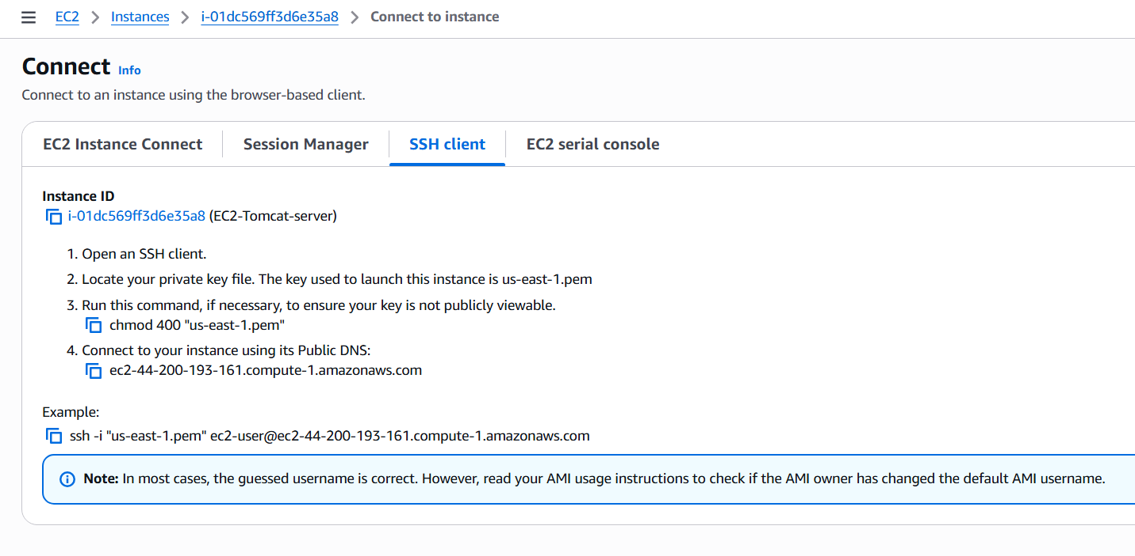
Step 2 — Create Tomcat Installation Script
I have created a script script.sh containing
#!/bin/bash
sudo dnf update -y
sudo dnf install java-17-amazon-corretto -y
java -version
sudo groupadd tomcat || true
sudo useradd -g tomcat -d /opt/tomcat -s /bin/nologin tomcat || true
cd /tmp
wget https://dlcdn.apache.org/tomcat/tomcat-9/v9.0.111/bin/apache-tomcat-9.0.111.tar.gz
sudo mkdir -p /opt/tomcat
sudo tar -xvf apache-tomcat-9.0.111.tar.gz -C /opt/tomcat --strip-components=1
sudo chown -R tomcat:tomcat /opt/tomcat
sudo chmod -R 755 /opt/tomcat
cat <<EOF | sudo tee /etc/systemd/system/tomcat.service
[Unit]
Description=Apache Tomcat Web Application Server
After=network.target[Service]
Type=forking
User=tomcat
Group=tomcat
Environment="JAVA_HOME=/usr/lib/jvm/java-17-amazon-corretto"
Environment="CATALINA_PID=/opt/tomcat/temp/tomcat.pid"
Environment="CATALINA_HOME=/opt/tomcat"
Environment="CATALINA_BASE=/opt/tomcat"
ExecStart=/opt/tomcat/bin/startup.sh
ExecStop=/opt/tomcat/bin/shutdown.sh
RestartSec=10
Restart=always[Install]
WantedBy=multi-user.target
EOFsudo systemctl daemon-reload
sudo systemctl start tomcat
sudo systemctl enable tomcat
sudo systemctl status tomcat

Evidence: 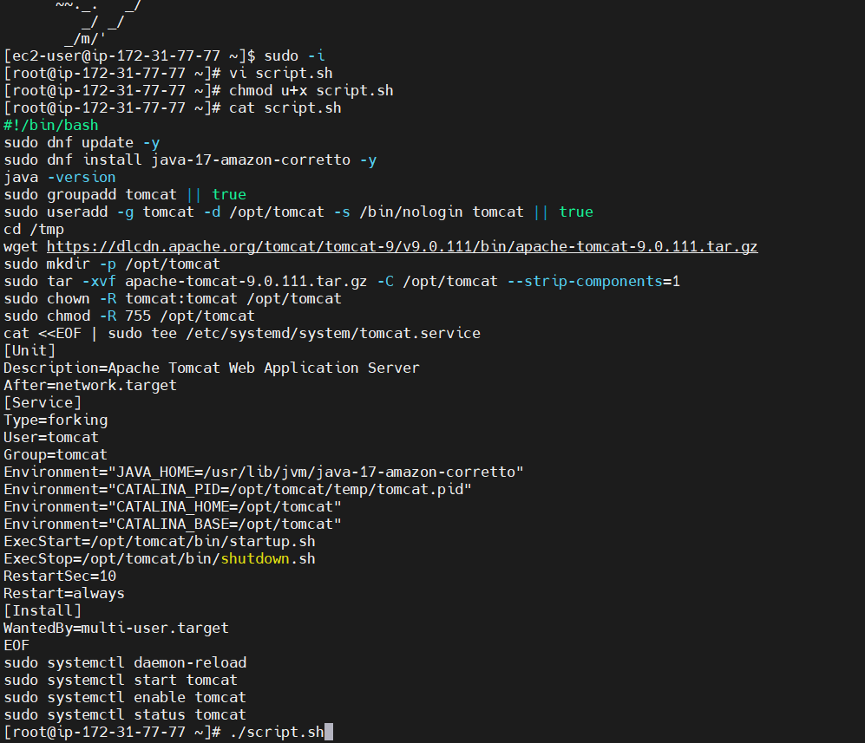

Step 3 — Execute the Script
Running:
chmod +x script.sh
./script.sh
Step 4 — Confirm Tomcat Service is Running
systemctl status tomcat
Evidence: 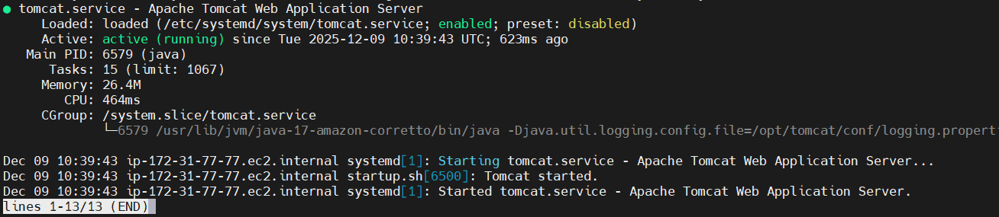

Step 5 — Validate Tomcat Web UI
Open browser:
http://<public-ip>:8080
Tomcat home page loads successfully.
Evidence: 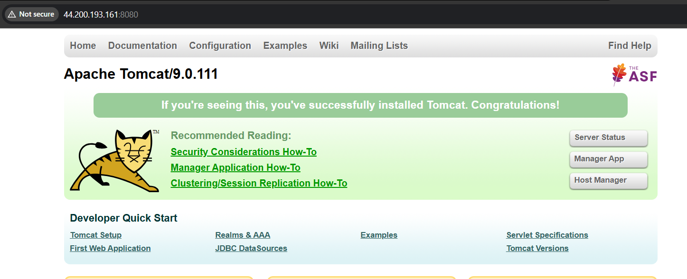

Step 6 — Create CloudWatch Custom Metric Script
File: /root/cldwtch.sh
Purpose: Send Tomcat service status value:
0 → service running
3 → service stopped
CloudWatch namespace: Custom/Tomcat
Metric name: TomcatStatus
Evidence: 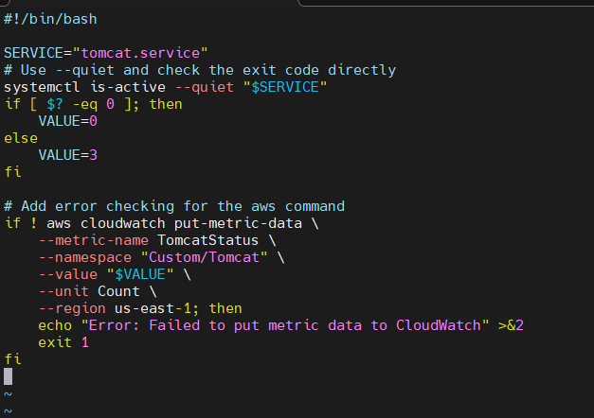

Step 7 — Create IAM Role for EC2
Step 7.1 — Select trusted entity
Trusted entity: EC2
Evidence: 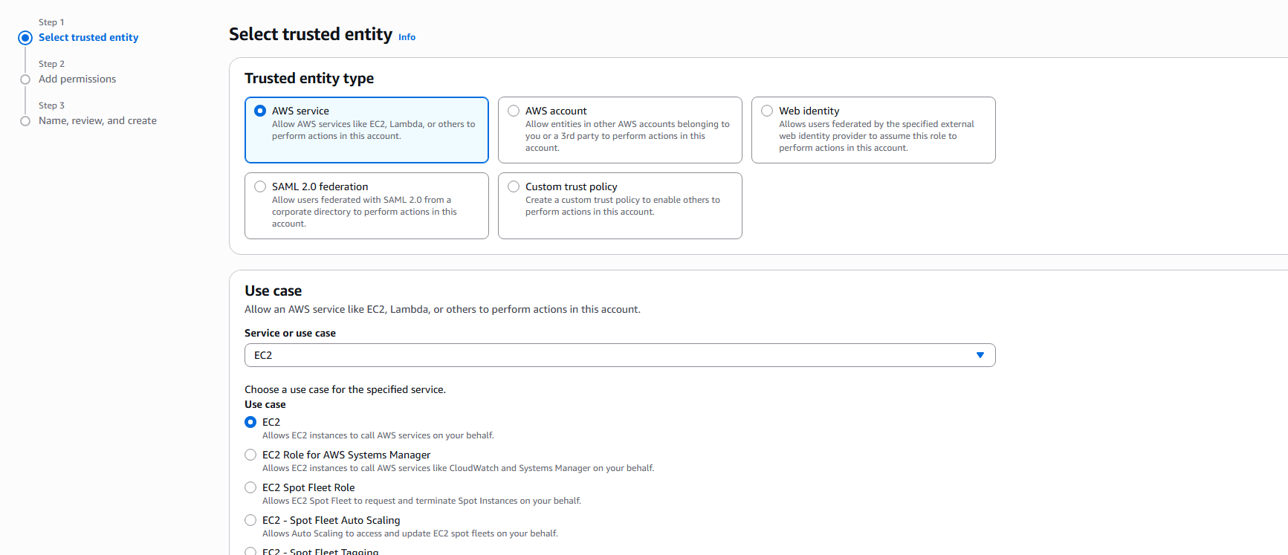

Step 7.2 — Attach required policies

I have selected:
AmazonEC2ReadOnlyAccess
AmazonSSMManagedEC2InstanceDefaultPolicy
Evidence: 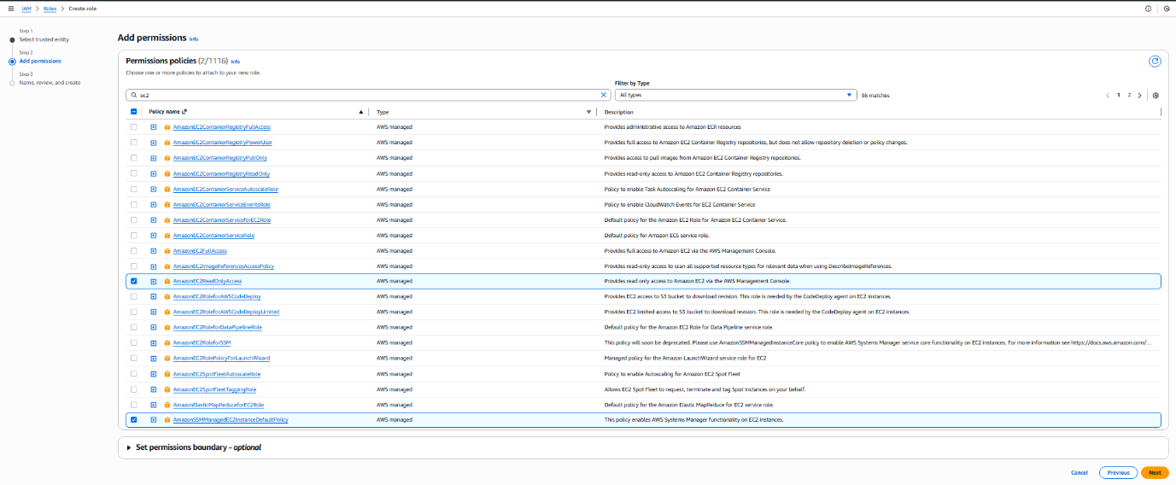

Step 7.3 — Name and create role
Role name: tomcatstatus
Evidence: 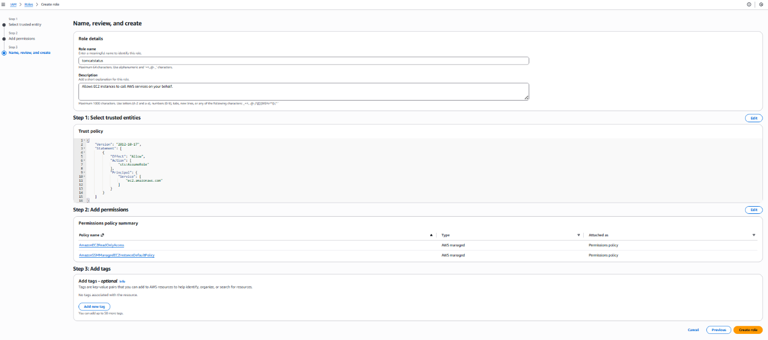

Step 8 — Attach IAM Role to EC2 Instance
Navigate:
EC2 → Instance → Actions → Security → Modify IAM Role
Select: tomcatstatus
Evidence: 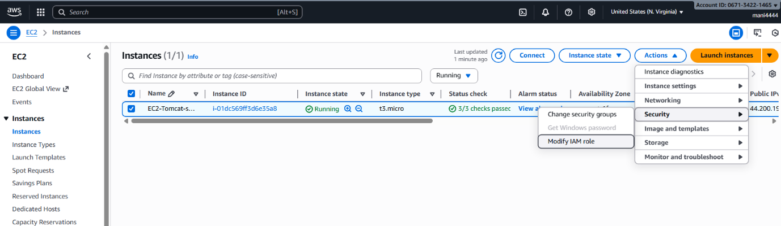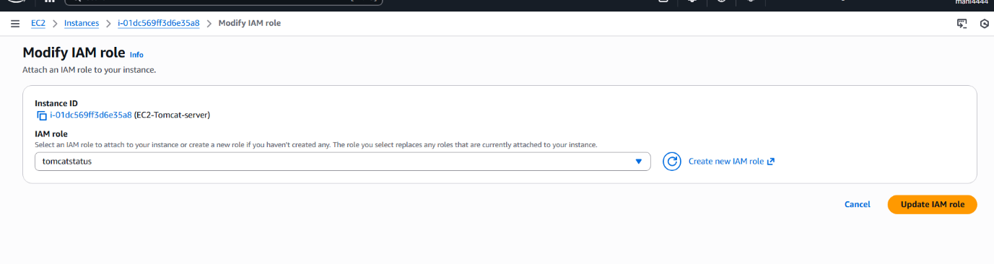

Step 9 — Create CloudWatch Dashboard
Dashboard name: Tomcatstatus
Evidence: 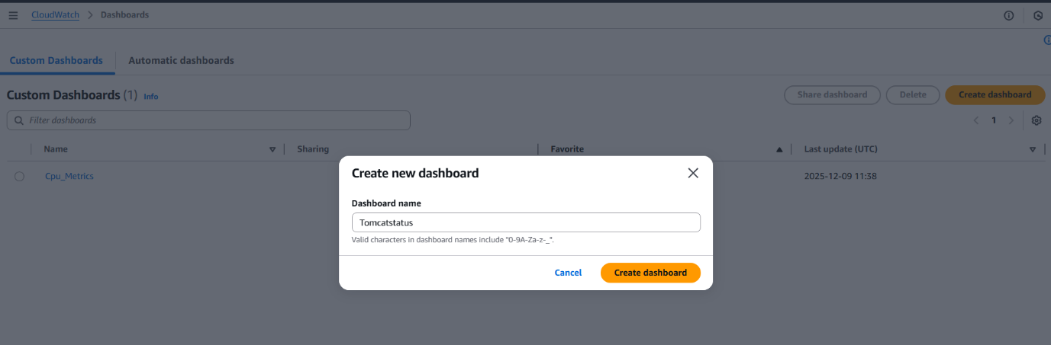
Step 10 — Add Widget for Custom Metric
Navigate:
CloudWatch → Dashboards → Tomcatstatus → Add widget

Select metric:
Namespace: Custom/Tomcat
Metric: TomcatStatus
Evidence: 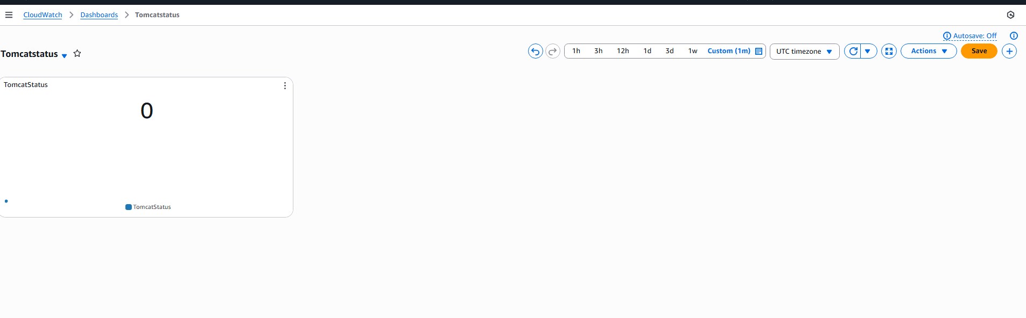
Dashboard updates with live widget.
Evidence: 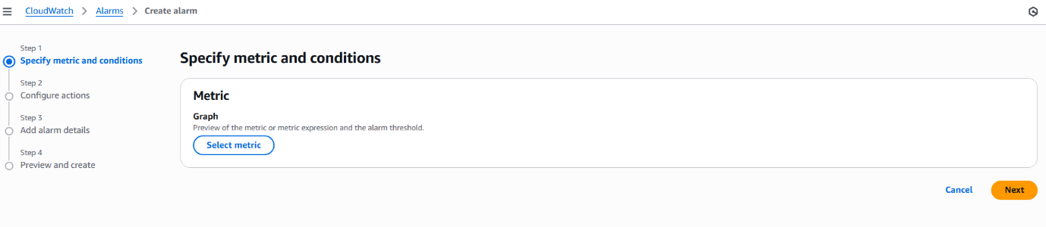

Step 11 — Create CloudWatch Alarm for TomcatStatus
11.1 — Select metric

Evidence: 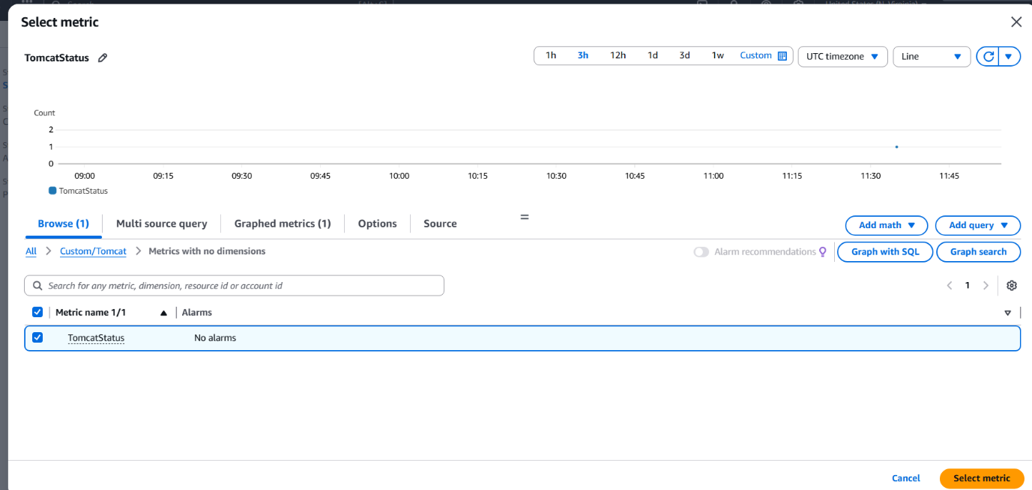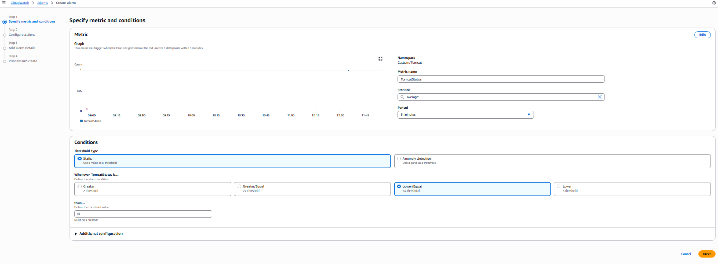
11.2 — Configure alarm conditions
Set:
Threshold type: Static
Condition: Lower/Equal
Threshold: 0
Period: 5 minutes
Meaning: If TomcatStatus <= 0 → alarm triggers
Evidence: 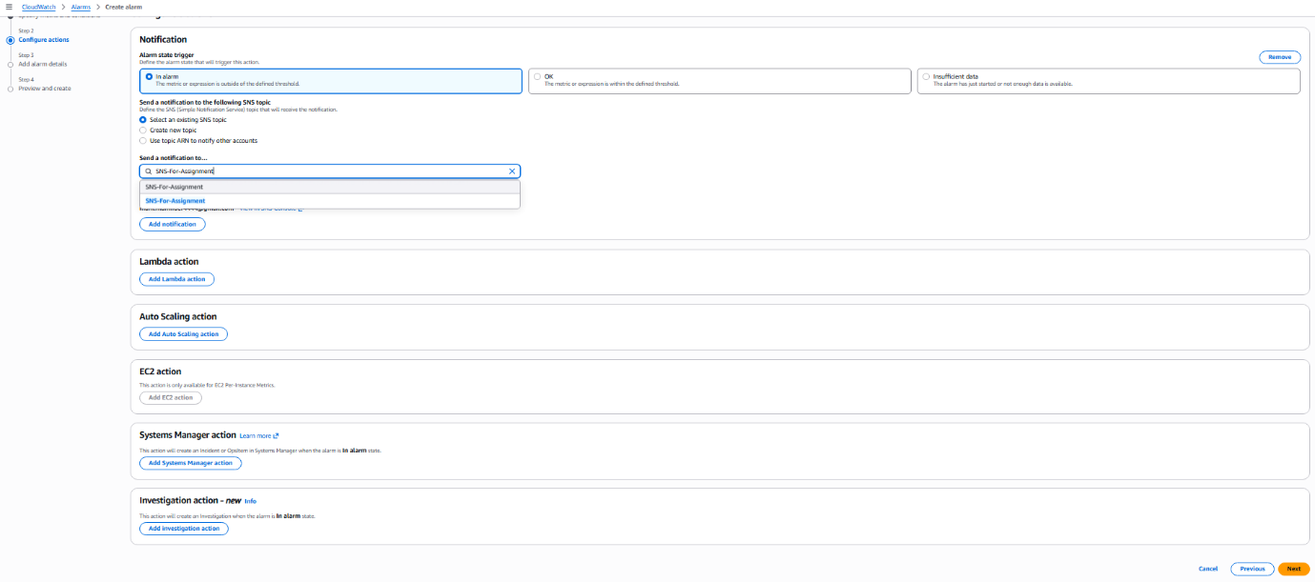

Step 12 — Configure SNS Notification
SNS Topic: SNS-For-Assignment
Evidence: 

Step 13 — Alarm Details
Alarm name: Tomcat-Alarm
Evidence: 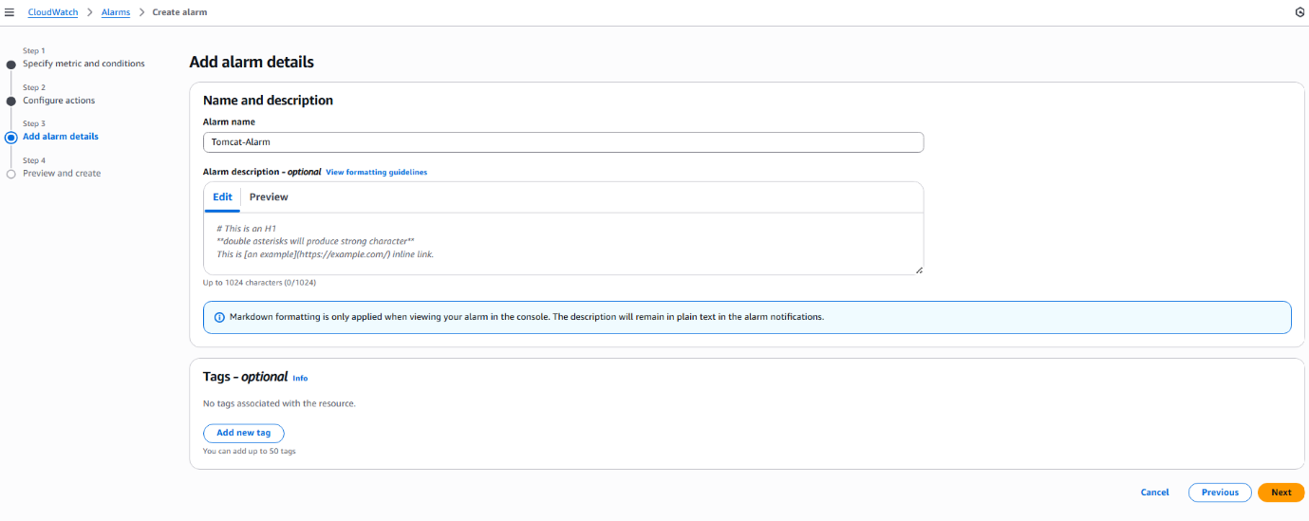

Step 14 — Alarm Created Successfully
State: INSUFFICIENT DATA (initial)
Evidence: 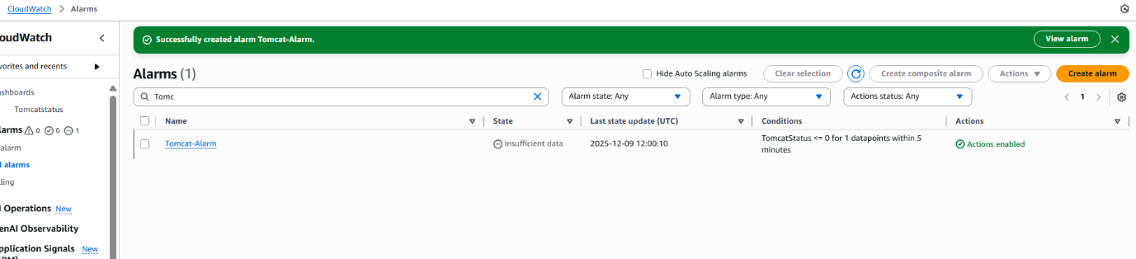

Step 15 — Install Cron Service
You installed cronie to schedule script execution.
Evidence: 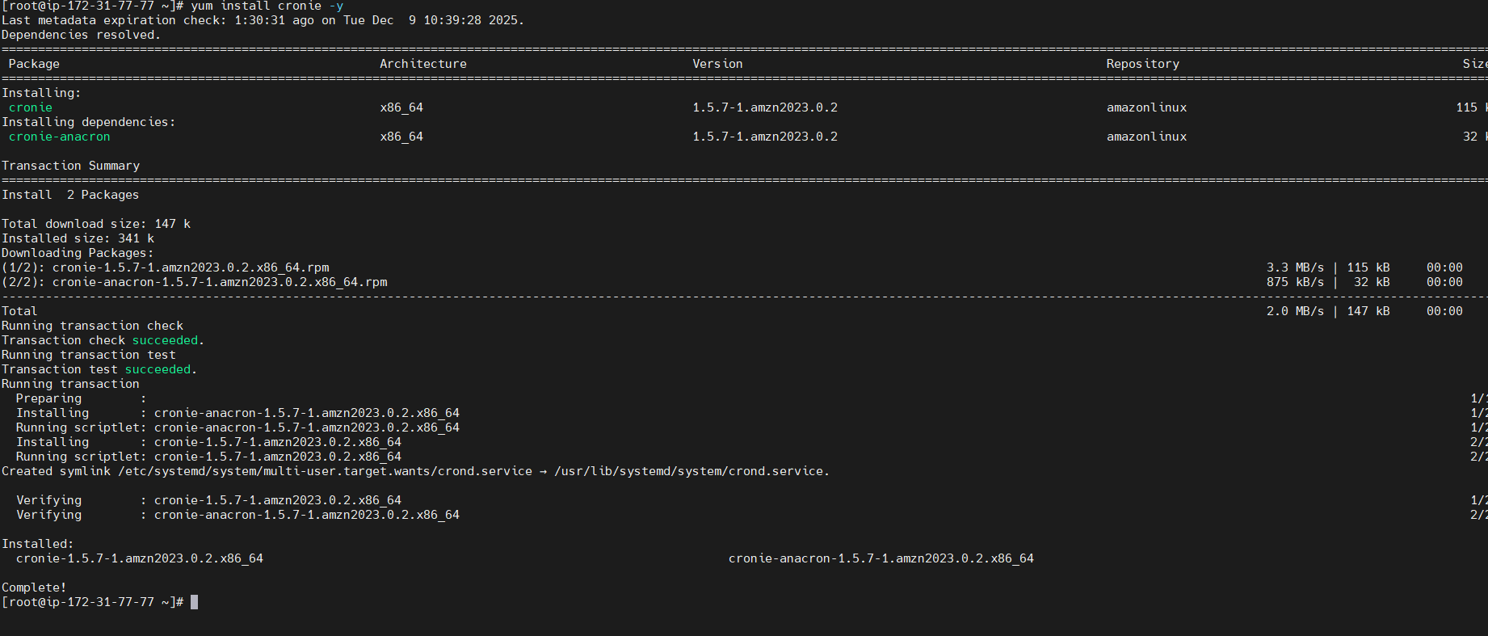

Step 16 — Configure Cron Job to Send Tomcat Metric
Cron entry:
* * * * * /bin/bash /root/cldwtch.sh >> /var/log/monitoring.log 2>&1
Evidence: 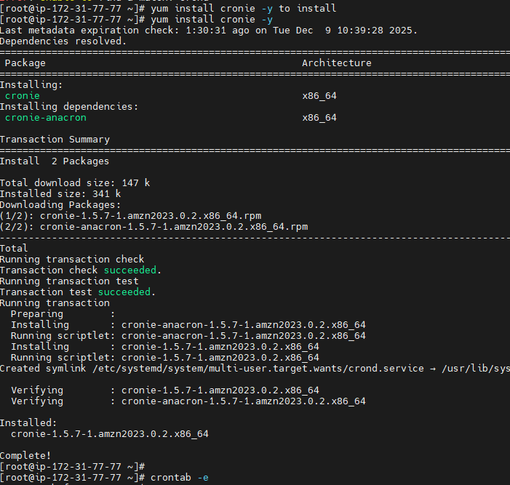
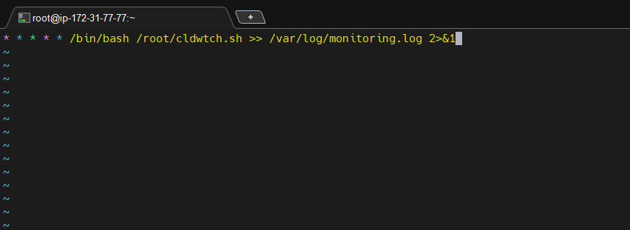
Step 17 — Stop and Start Tomcat to Trigger Alarm

You manually stopped:
systemctl stop tomcat
Custom metric script reported service as "stopped" → CloudWatch alarm triggered.

Evidence:
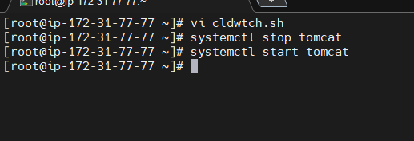

5) VALIDATION — SNS Email Notification Received
Email shows:
State change: OK → ALARM
Reason: TomcatStatus <= 0
Evidence: 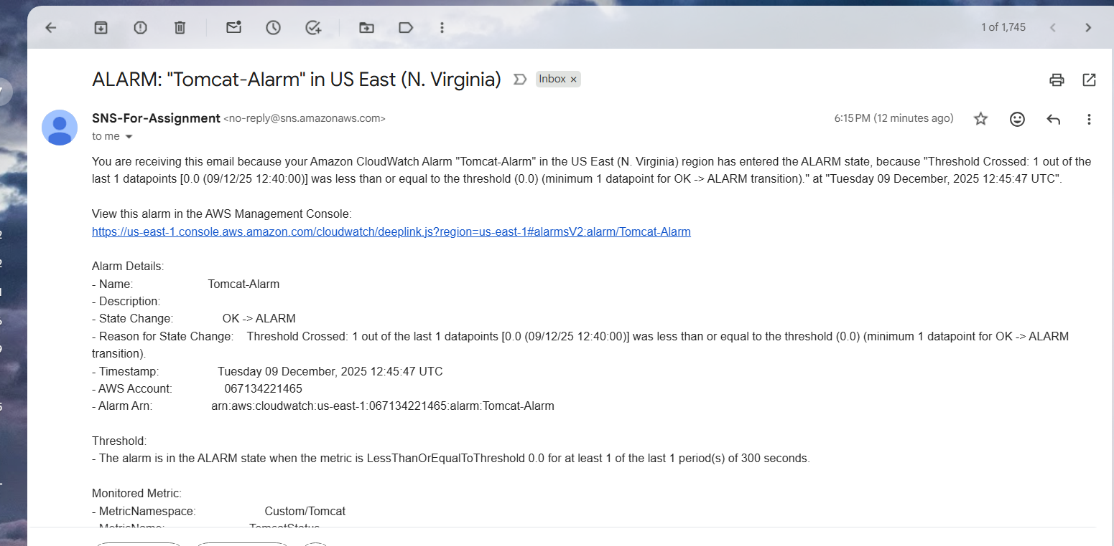

6) Troubleshooting: when I stopped the tomcat server the exit code generated was 3 since systemctl status –quiet tomcat would return 3.
I have started the tomcat which gave the exit status to 0, which means the tomcat is running
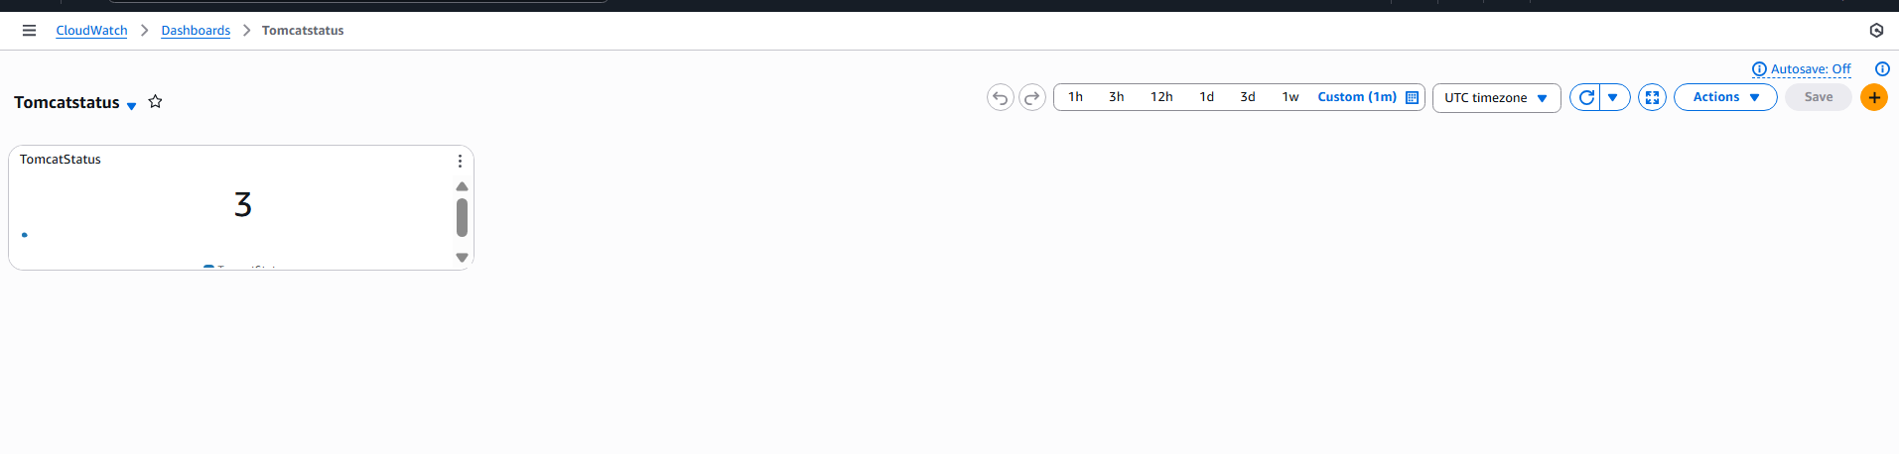
7) CONCLUSION
This implementation provides:
Automated Tomcat installation, CloudWatch monitoring, Real-time dashboard, Automated alerts when Tomcat stops,End-to-end CloudWatch + SNS integration, Cron-based continuous health reporting

Create Dashboard and monitor nginx service to send the alert if nginx is not running

1) Task Title: Create Dashboard and monitor nginx service to send the alert if nginx is not running
2) Objective: To install NGINX on an EC2 instance, push its service status as a custom CloudWatch metric, visualize it in a CloudWatch Dashboard, and configure a CloudWatch Alarm with SNS to alert when NGINX is NOT running.
3) Prerequisites:
• AWS EC2 Instance (Amazon Linux 2023)

C2 instance (Amazon Linux)
IAM Role with CloudWatch + EC2 Metadata permissions
SNS topic
AWS CLI installed
Cron installed
4) Step-by-Step Implementation (With Evidence):

Step 1: Install NGINX
• Console path / CLI command: yum install nginx -y
Evidence: 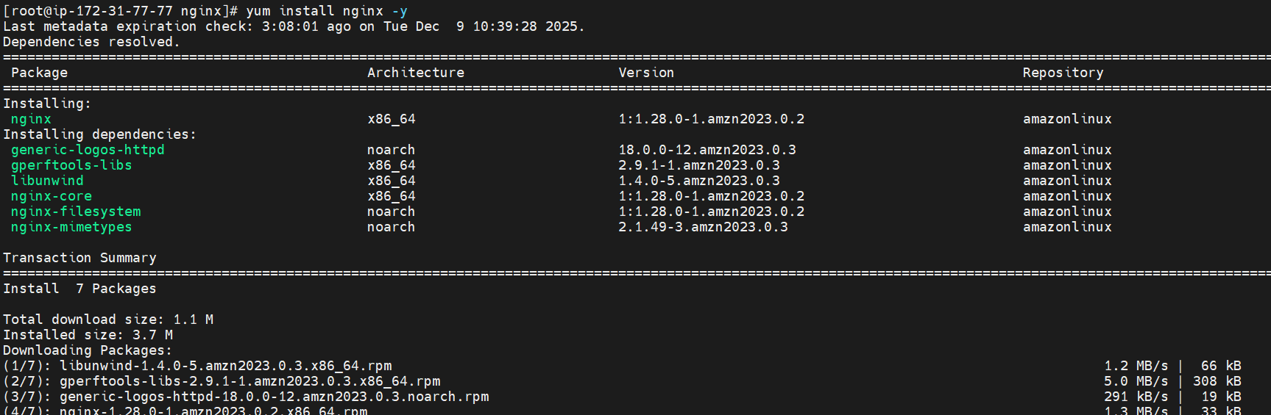

Step 2: Start & Enable NGINX
• Console path / CLI command: systemctl start nginx
systemctl enable nginx
systemctl status nginx
Evidence: 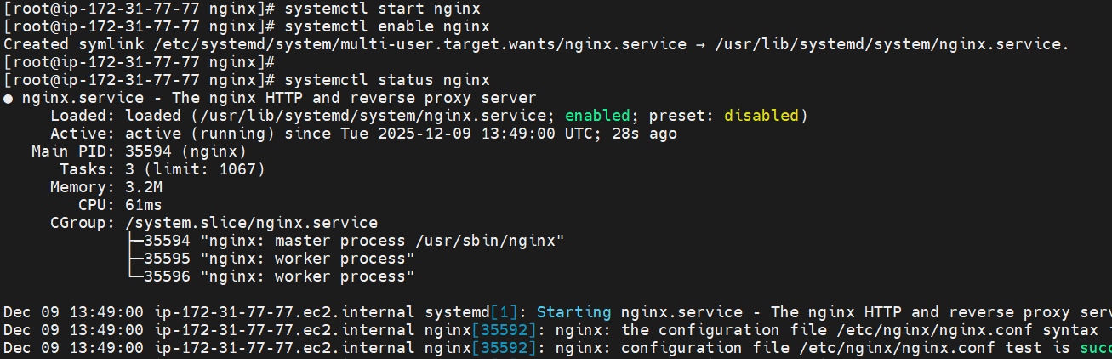

Step 3: Create Custom Metric Script
Commands:
vi script.sh
chmod +x script.sh
Your script contents shown in:
#!/bin/bash
REGION="us-east-1"
NAMESPACE="nginx"
METRIC_NAME="nginx_status1"
SERVICE_NAME="nginx"
AWS_CLI="/usr/bin/aws"
TOKEN=$(curl -s -X PUT "http://169.254.169.254/latest/api/token" \
-H "X-aws-ec2-metadata-token-ttl-seconds: 21600")
if [ -n "$TOKEN" ]; then
INSTANCE_ID=$(curl -s -H "X-aws-ec2-metadata-token: $TOKEN" \
http://169.254.169.254/latest/meta-data/instance-id)
else
INSTANCE_ID=$(curl -s http://169.254.169.254/latest/meta-data/instance-id)
fi
# Check NGINX
if sudo systemctl is-active --quiet "$SERVICE_NAME"; then
STATUS=1
else
STATUS=0
fi
# Push metric
$AWS_CLI cloudwatch put-metric-data \
--region "$REGION" \
--namespace "$NAMESPACE" \
--metric-name "$METRIC_NAME" \
--value "$STATUS" \
--dimensions Name=InstanceId,Value="$INSTANCE_ID"
Evidence: 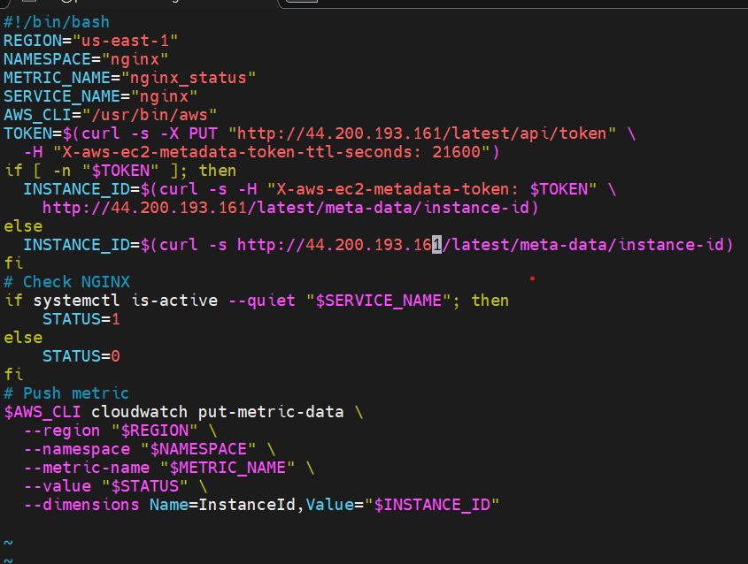
Step 4: Test Script Execution
Command:
./script.sh

Evidence: 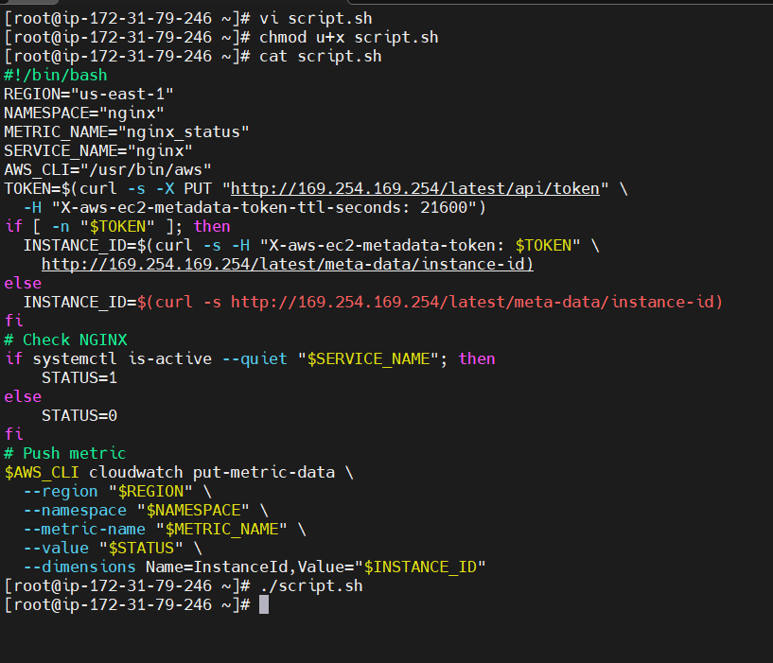

Step 5: Install Cron Service
Command:
yum install cronie -y
Evidence: 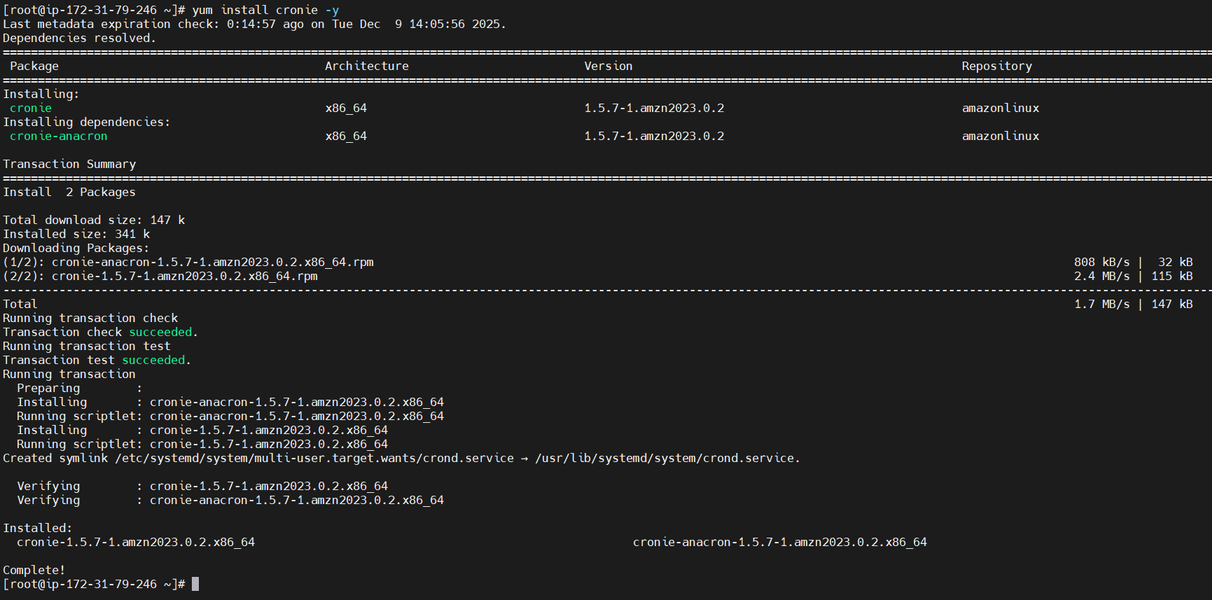

Add Cron Job to Run Script Every Minute
Command:
crontab -e
Cron entry:
* * * * * /root/script.sh >/dev/null 2>&1
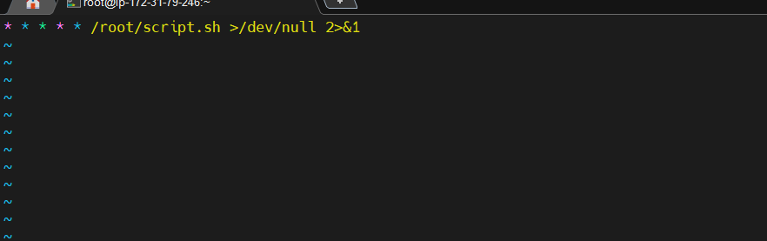

Step 7: Validate NGINX Metric in CloudWatch
Navigate:
CloudWatch → Metrics → Custom namespace → nginx
Evidence:
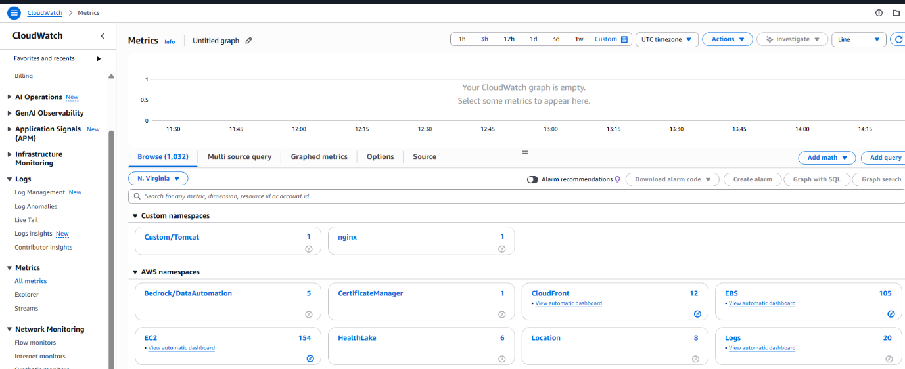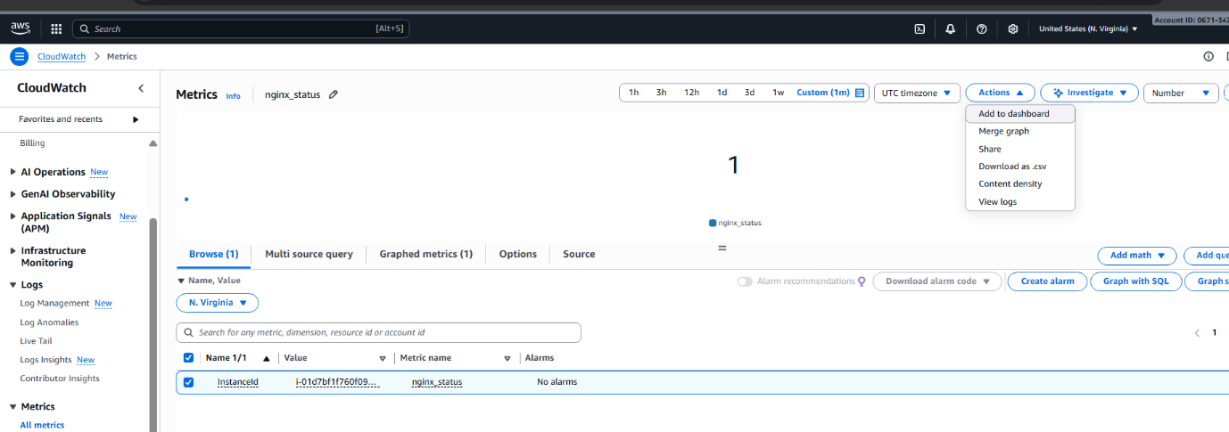

Step 8: Add Metric to Dashboard
Action:
Metrics → Select nginx_status → Actions → Add to Dashboard
Evidence: 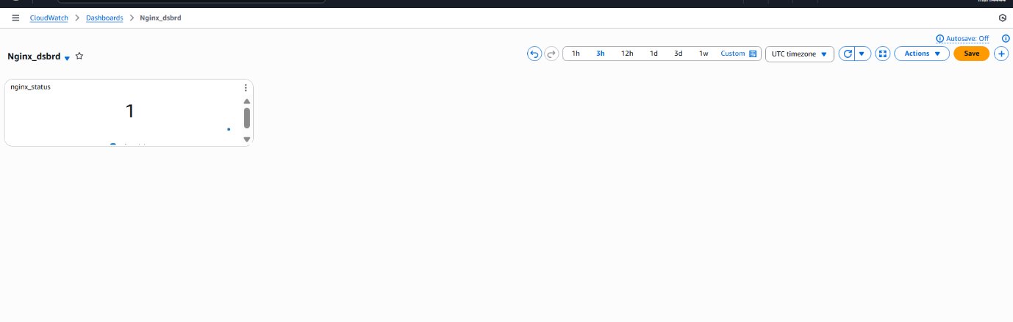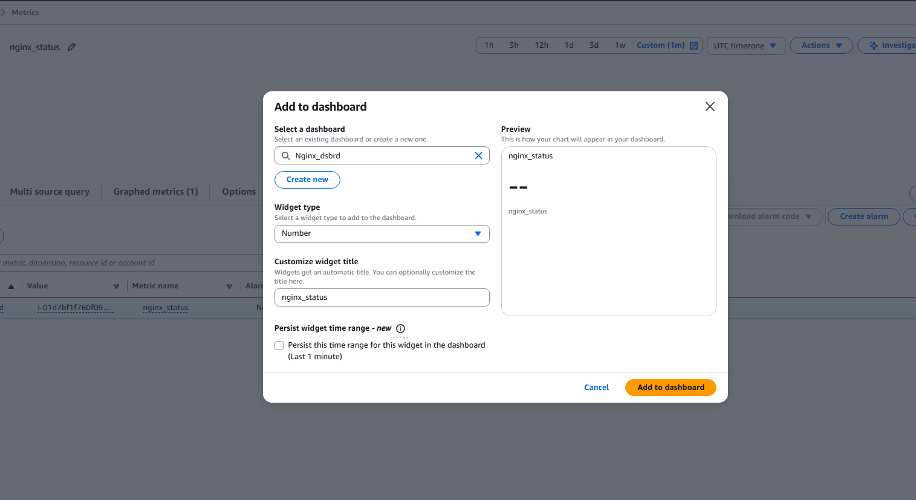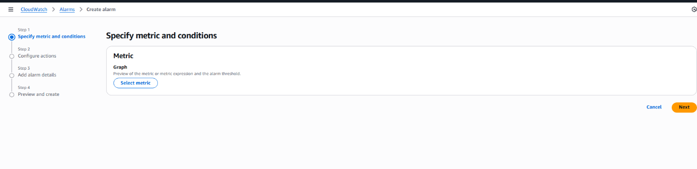

Step 9: Create CloudWatch Alarm
Steps:
Go to Alarms → Create Alarm
Select nginx_status metric
Evidence: 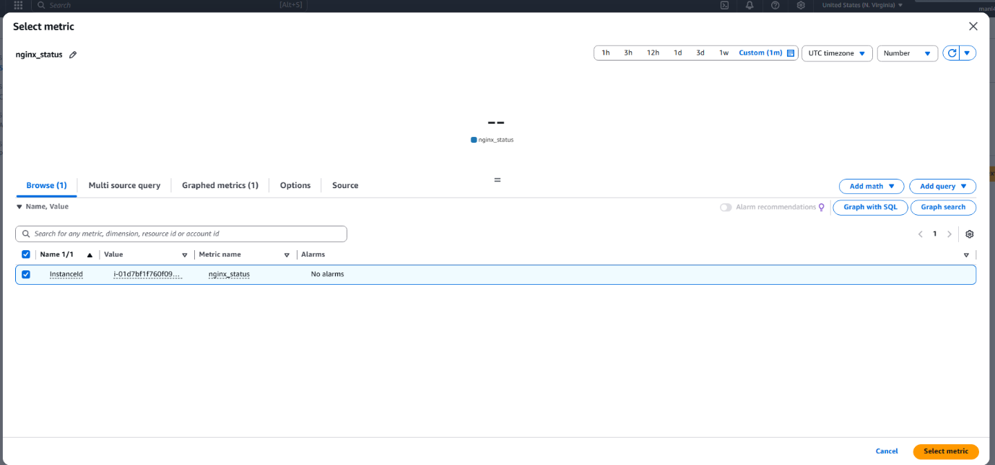
Step 10: Configure Alarm Conditions

Condition:

Whenever nginx_status is Lower

Than 1

Evidence: 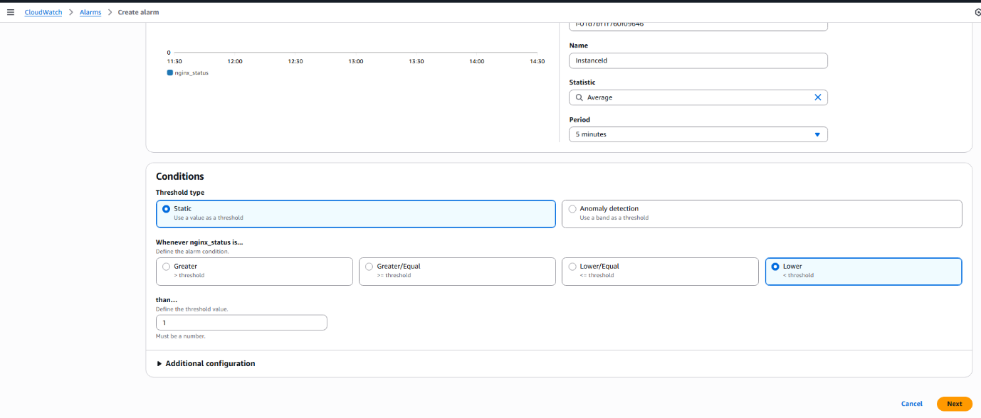 Step 11: Configure SNS Notification
Choose:
SNS Topic: SNS-For-Assignment
Notification: Email
Evidence: 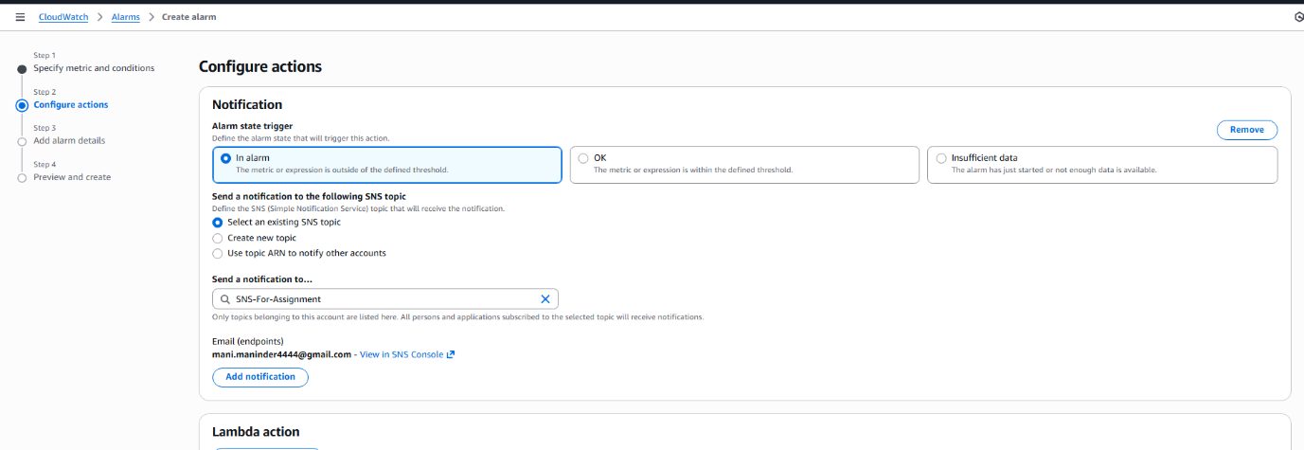 Step 12: Add Alarm Details
Alarm name: Nginx_alarm
Evidence: 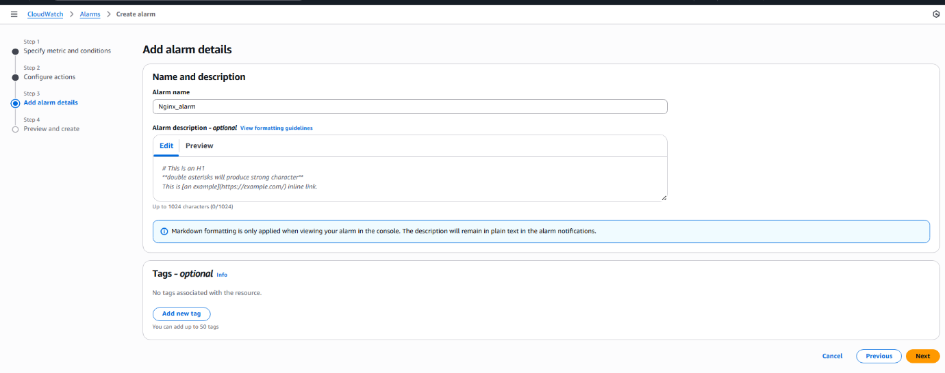 Step 13: Alarm Successfully Created
Evidence: 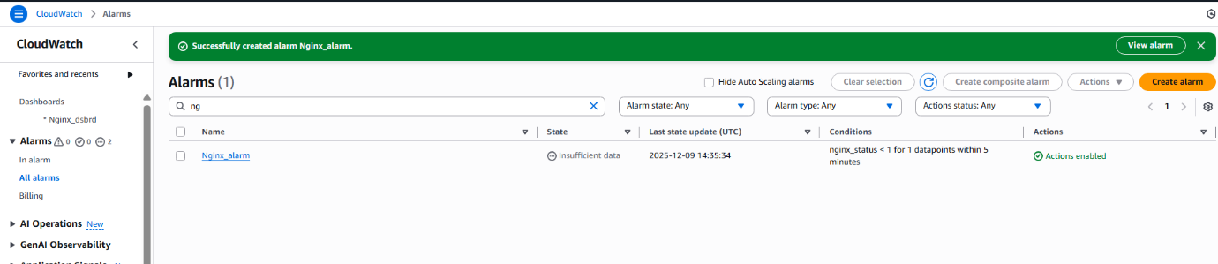
5) Validation Steps (Mandatory, With Evidence):

Validation 1: Email Alert Received When NGINX Stops
Evidence: 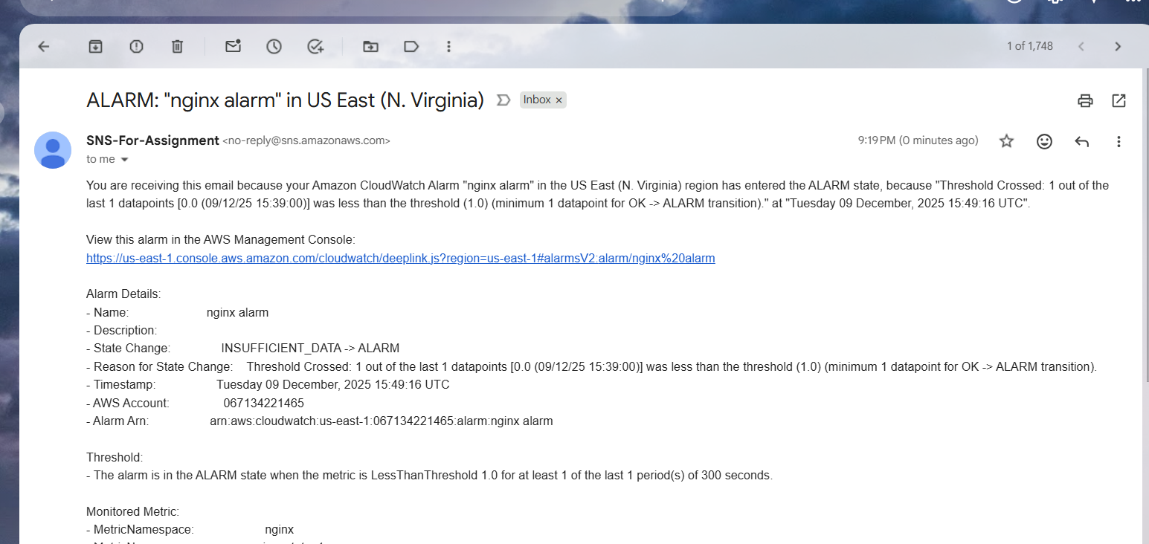

6) Issues Faced (Optional):

7) Conclusion: I have NGINX installed on EC2 instance, its status pushed as a custom CloudWatch metric, visualized on a CloudWatch Dashboard, and configured to alert via SNS when the NGINX service stops running.

