ASG-Assignment-01

- Create one VPC in N. Virginia region.
Title: Create one VPC in N. Virginia region.
objective: we need to create one VPC in N. Virginia region
Prerequisites:
VPC name
CIDR range
step by step process:
Step 1: Open VPC Console and Choose “Create VPC”
Navigate to:
AWS Console → VPC → Your VPCs → Create VPC
Choose:
- Name: ASM-us-east-1-vpc
- IPv4 CIDR: 10.0.0.0/24
Evidence:
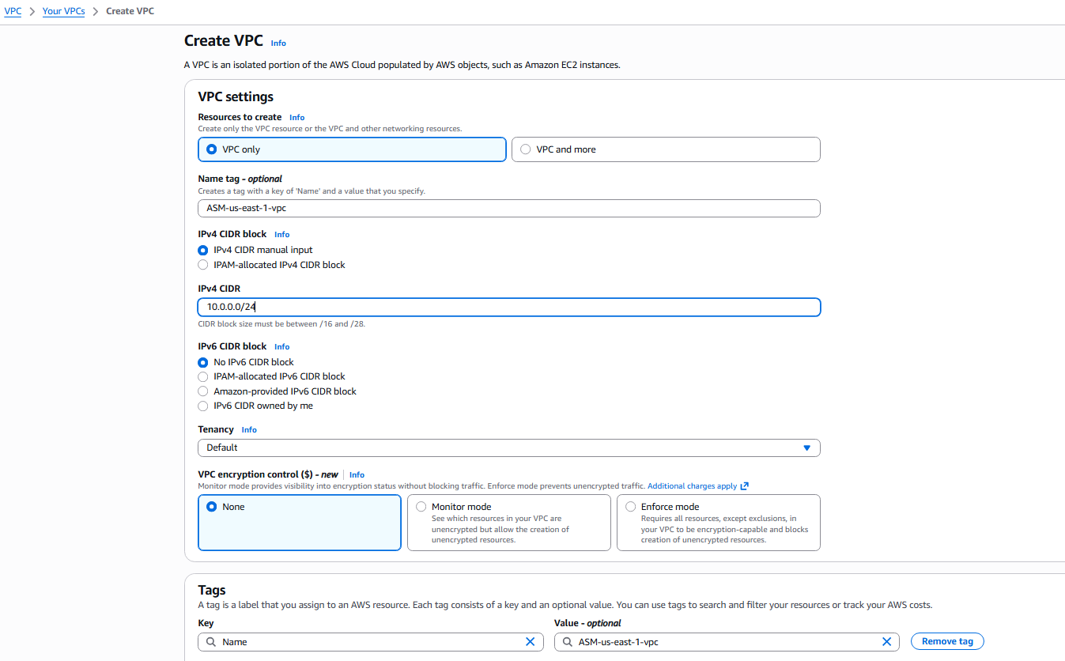

Step 2: Verify the VPC Details
Once created, you can view:
- Name: ASM-us-east-1-vpc
- CIDR: 10.0.0.0/24
Evidence:
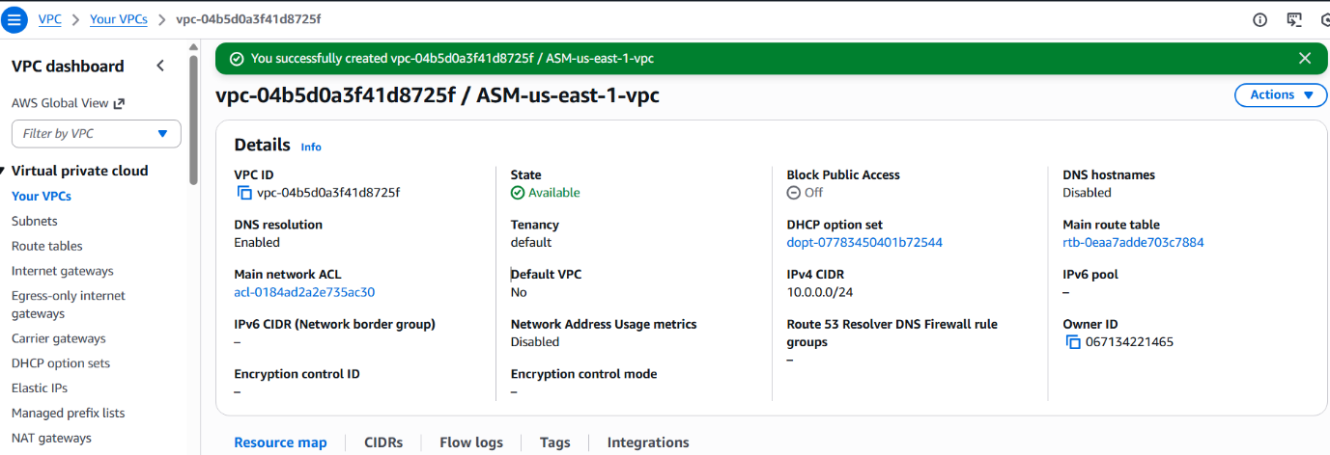

Conclusion
In this task, a new VPC named ASM-us-east-1-vpc was successfully created in the N. Virginia (us-east-1) region using the IPv4 CIDR block 10.0.0.0/24.

- Create two subnets: one public subnet and one private subnet.
Task Title
Create two subnets: one public subnet and one private subnet
Objective
To create two subnets inside an existing VPC in the N. Virginia (us-east-1) region:
- Public Subnet: ASM_us-east-1_public-subnet
- Private Subnet: ASM_us-east-1_private-subnet.
Prerequisites
Before starting, ensure the following:
- AWS Account.
- VPC.
Step-by-Step Implementation (With Evidence)
Step 1: Open VPC Console → Subnets → Create Subnet
Navigate to:
AWS Console → VPC → Subnets → Create Subnet
You must select the existing VPC and then enter the following:
- VPC: ASM-us-east-1-vpc
- This page also shows associated CIDR block: 10.0.0.0/24
Evidence 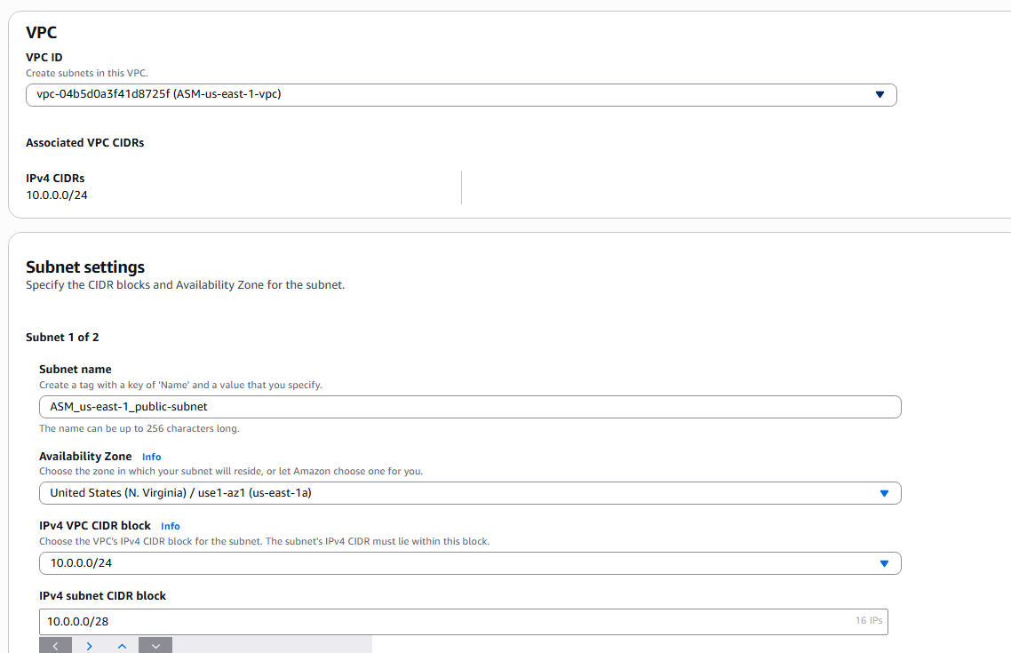
Step 2: Create Public Subnet
- Subnet name: ASM_us-east-1_public-subnet
- Availability Zone: us-east-1a
- IPv4 CIDR block: 10.0.0.0/28
Click Create Subnet.
Evidence


Step 3: Create Private Subnet
Enter details for Subnet 2:
- Subnet name: ASM_us-east-1_private-subnet
- Availability Zone: us-east-1b
- CIDR block: 10.0.0.65/28
Click Create Subnet.
Evidence 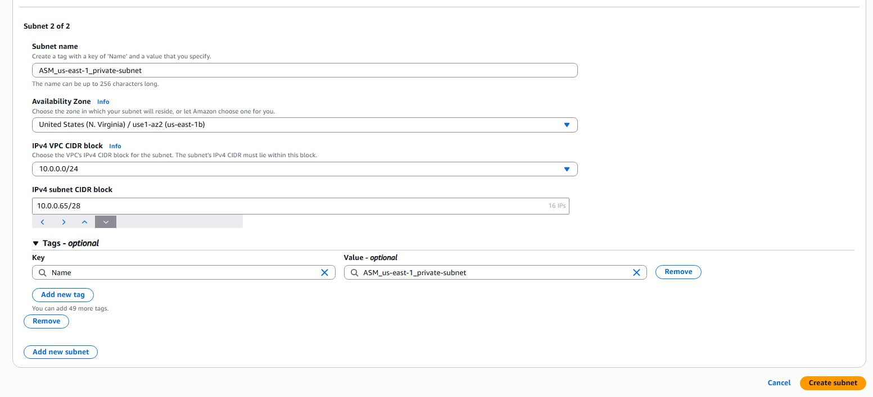

Step 4: Verify Both Subnets Created Successfully
After creation, AWS displays both subnets:
Subnet Name | CIDR Block | AZ | State
ASM_us-east-1_public-subnet | 10.0.0.0/26 | us-east-1a | Available
ASM_us-east-1_private-subnet | 10.0.64.0/26 | us-east-1b | Available
Evidence
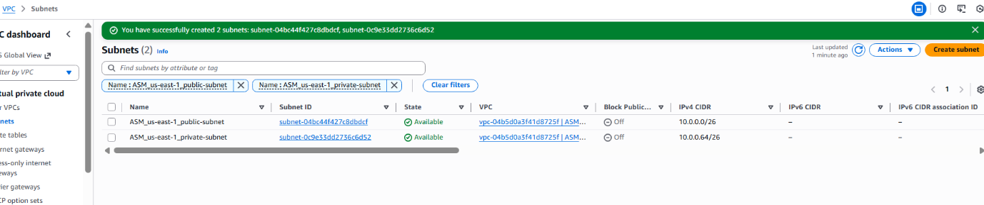
Conclusion
We successfully created two subnets inside the VPC:
Both subnets are now available and ready for routing, NAT Gateway, public access configuration, and EC2 deployment.

- Attach an IGW to the VPC.
Task Title: Attach an IGW to the VPC
Objective
To create an Internet Gateway (IGW) and attach it to the existing VPC so that resources inside the public subnet can communicate with the internet.
Prerequisites
VPC Name: ASM-us-east-1-vpc
Step-by-Step Implementation (With Evidence)
Step 1: Create an Internet Gateway
Navigate to:
AWS Console → VPC → Internet Gateways → Create Internet Gateway
Enter the following details:
Name tag: ASM_us-east-1_IGW
Click Create internet gateway.
Evidence
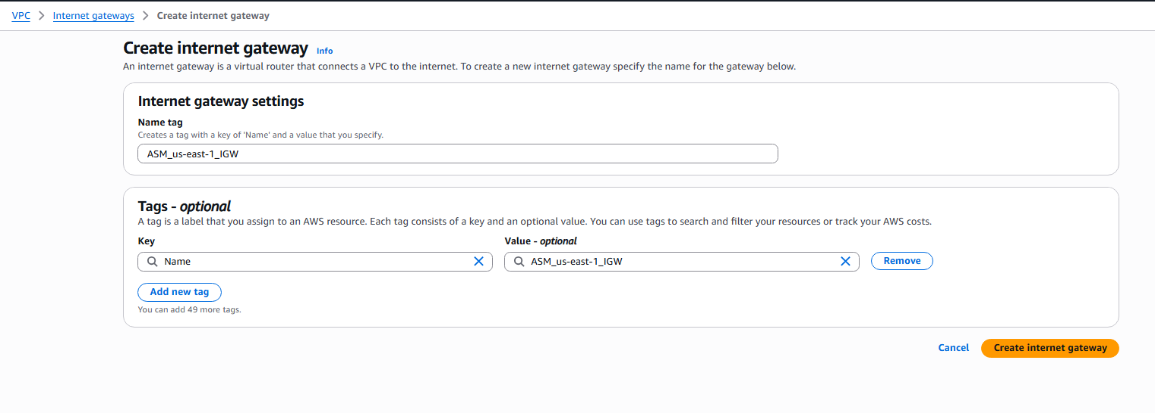
Step 2: Verify IGW Creation
Once the IGW is created, AWS displays:
- Internet gateway ID: igw-0a6209dc70c2b58ba
- State: Detached
- Tags: Name = ASM_us-east-1_IGW
Evidence 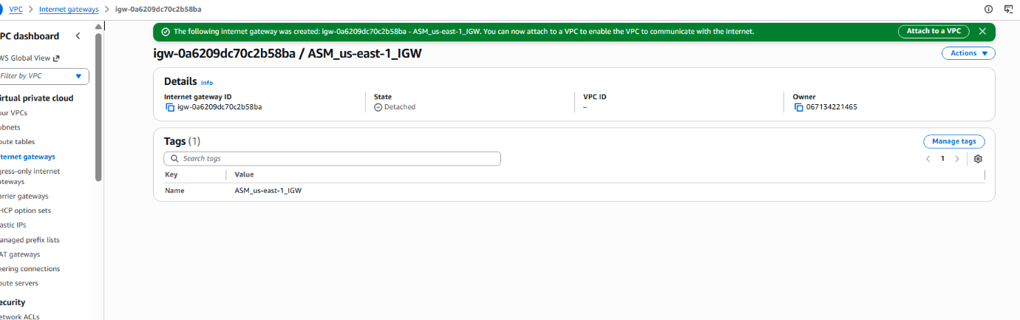

Step 3: Choose Action → Attach to VPC
Click Actions → Attach to VPC.
AWS opens a dropdown listing all available VPCs.
Evidence
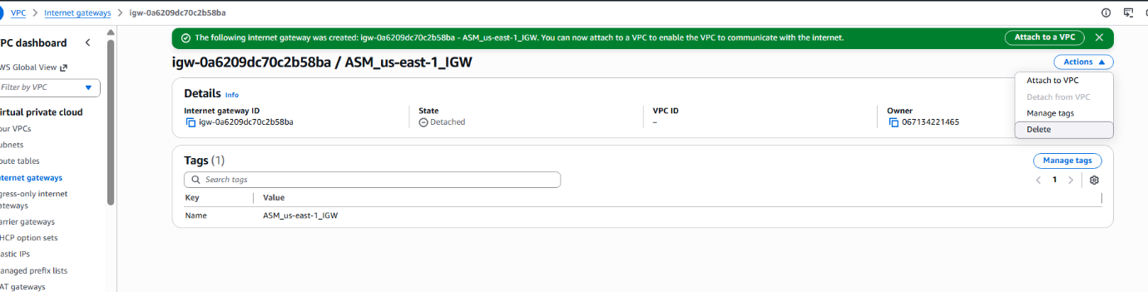
Step 4: Select Your VPC
Select the VPC you created earlier:
VPC Name: ASM-us-east-1-vpc
Click Attach internet gateway.
Evidence 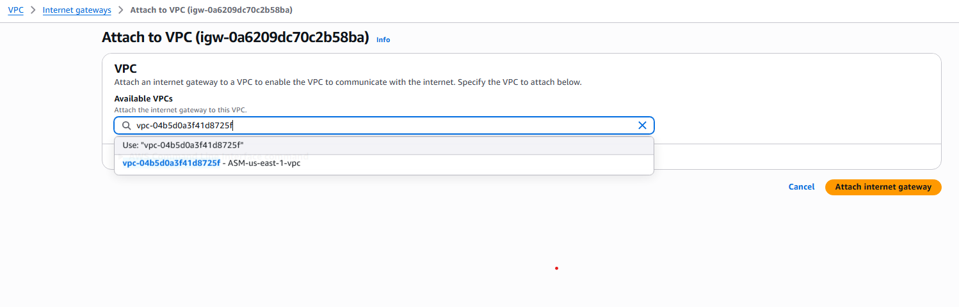

Step 5: IGW Attached Successfully
The IGW status updates to:
State: Attached
VPC ID: vpc-04b5d0a3f41d8725f
This confirms that the IGW is now connected to your VPC and can provide internet connectivity.
Evidence 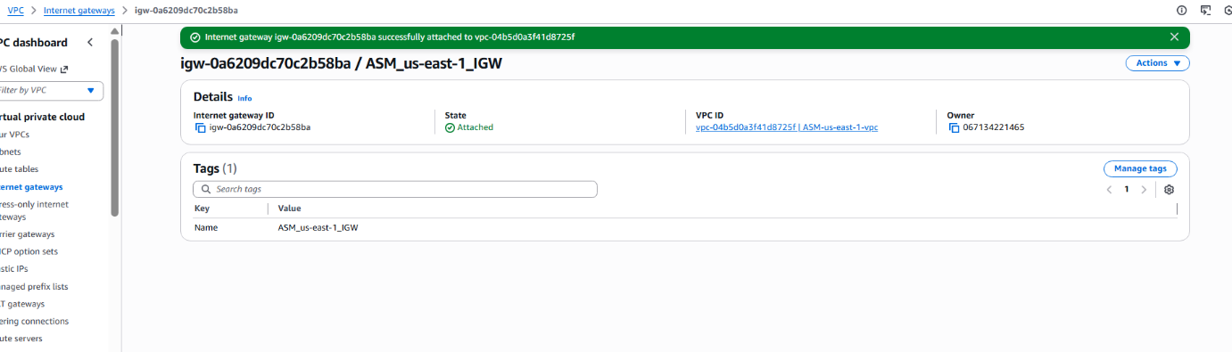

Conclusion
We successfully created and attached an Internet Gateway (ASM_us-east-1_IGW) to the VPC ASM-us-east-1-vpc.
This IGW is now ready to be associated with a public route table so that resources (like EC2 instances) in the public subnet can access the internet.

- Create one public route table (RT) and one private route table.

Task Title
Create one public route table (RT) and one private route table
Objective
To create two route tables inside the existing VPC:
- A public route table that sends internet-bound traffic (0.0.0.0/0) to the Internet Gateway.
- A private route table that keeps traffic internal and does not expose resources to the internet.
Prerequisites
• VPC: ASM-us-east-1-vpc
• An Internet Gateway already attached to the VPC
• One public subnet and one private subnet already created
Step-by-Step Implementation (With Evidence)
Step 1: Create the Public Route Table
Navigate to AWS Console → VPC → Route tables → Create route table.
Provide the following details:
Name: ASM_us-east-1_public
VPC: ASM-us-east-1-vpc
Add the Name.
Click Create route table.
Evidence: 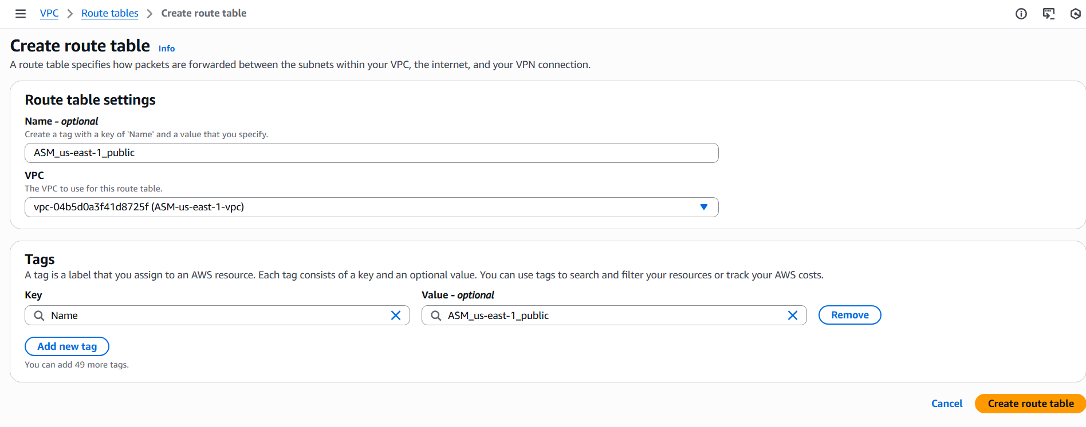
Step 2: Verify Public Route Table Creation
The route table is successfully created with the following details:
Route table ID: rtb-0ac91b41310fe5864
Main: No
Initial routes include only the local VPC route (10.0.0.0/24 → local).
Evidence: 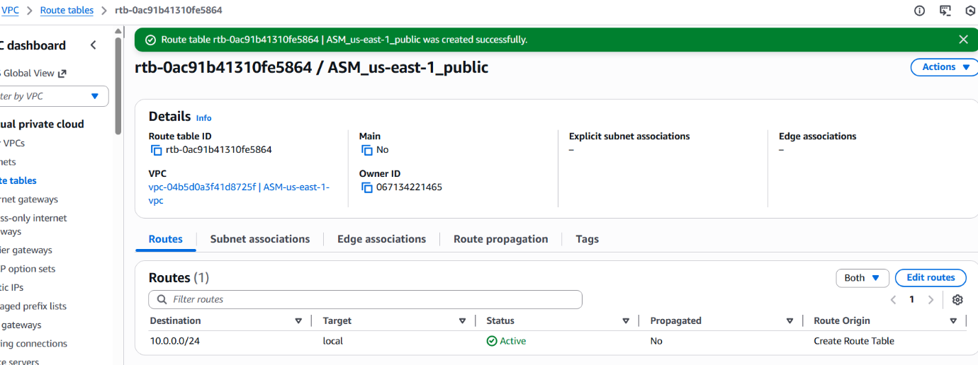
Step 3: Add Route to Internet Gateway
Select the newly created public route table → Routes → Edit routes.
Add a new route:
Destination: 0.0.0.0/0
Target: Internet Gateway
Select: ASM-us-east-1-vpc
Save changes.
Evidence: 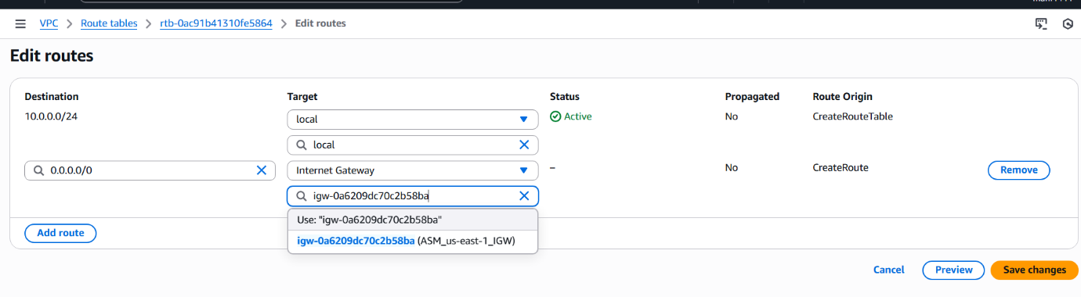
Step 4: Confirm Public Route Table Updates
The updated public route table now includes:
• 0.0.0.0/0 → ASM-us-east-1-vpc
• 10.0.0.0/24 → local
Evidence: 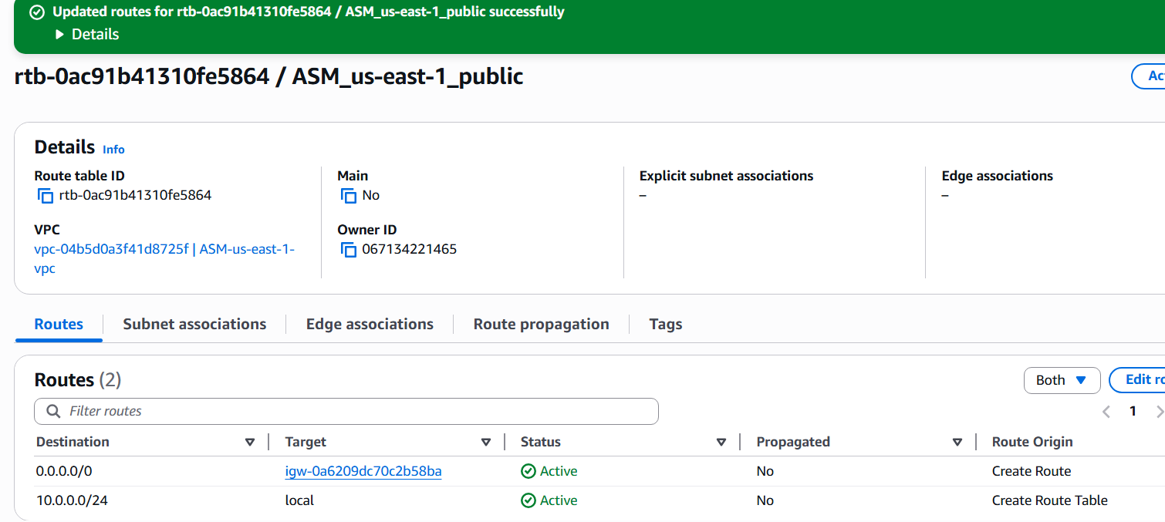
Step 5: Create the Private Route Table
Navigate to Create route table again.
Provide the following details:
Name: ASM_us-east-1_private
VPC: ASM-us-east-1-vpc
Add the Name
Click Create route table.
Evidence: 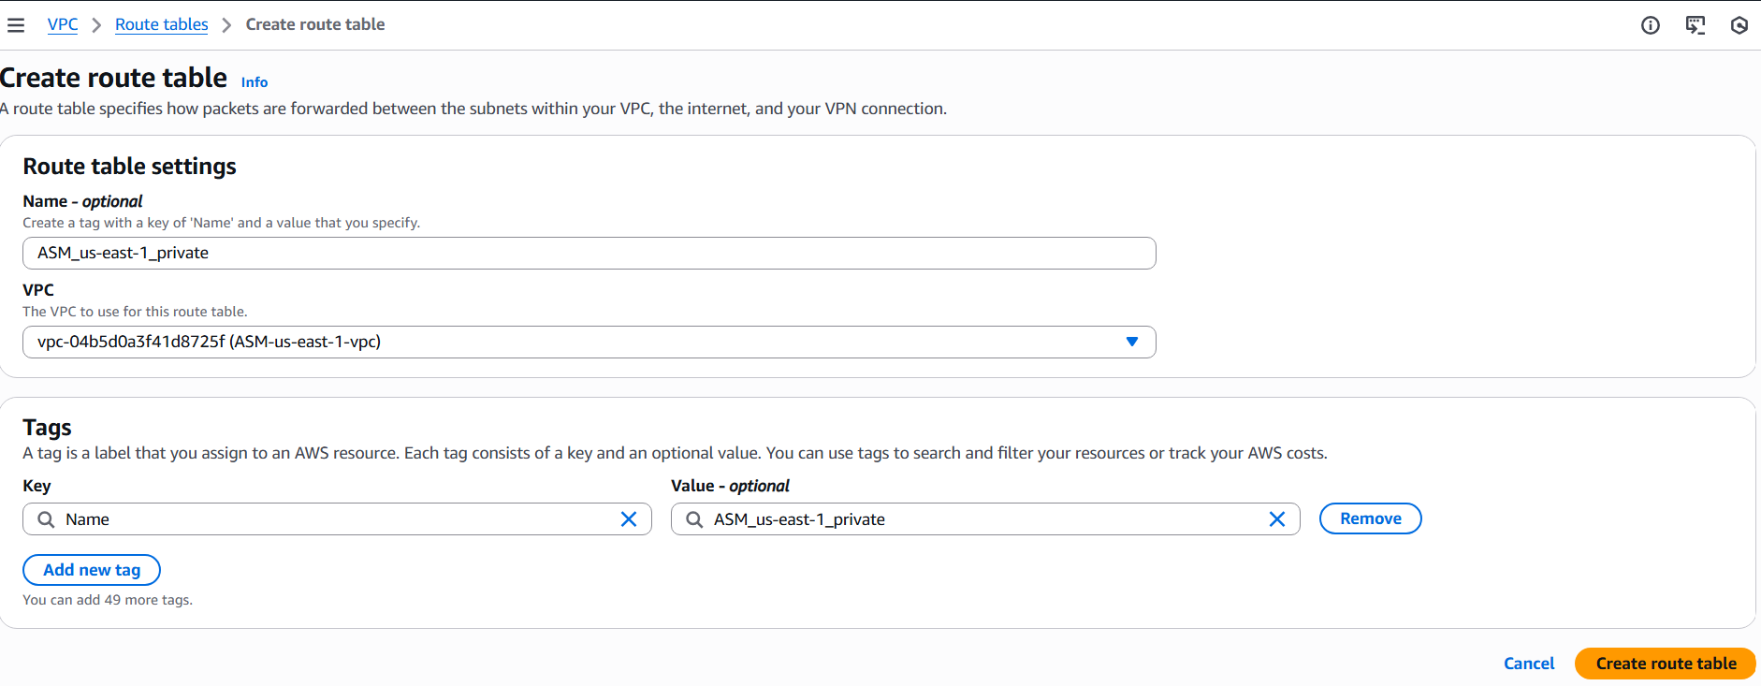
Step 6: Verify Private Route Table Creation
The private route table is created with:
Route table ID: rtb-08ac71efcf3a32d1b
Default route: 10.0.0.0/24 → local
No internet gateway attached.
Evidence: 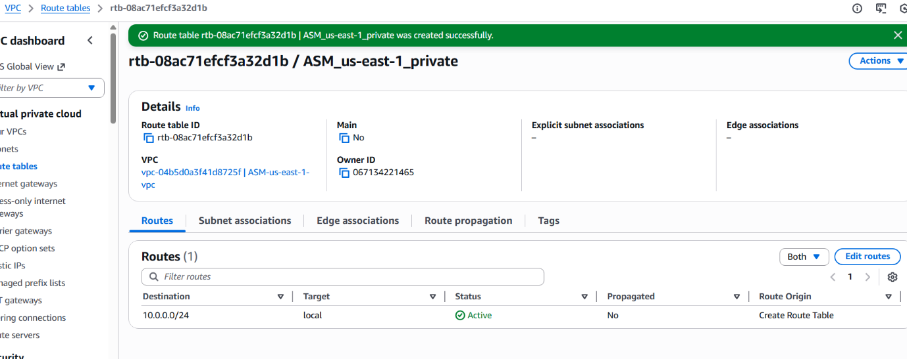
Step 7: Associate Public Subnet with Public Route Table
Open the public route table: rtb-0ac91b41310fe5864
Go to Subnet associations → Edit subnet associations.
Select subnet: ASM_us-east-1_public-subnet
Save associations.
Evidence: 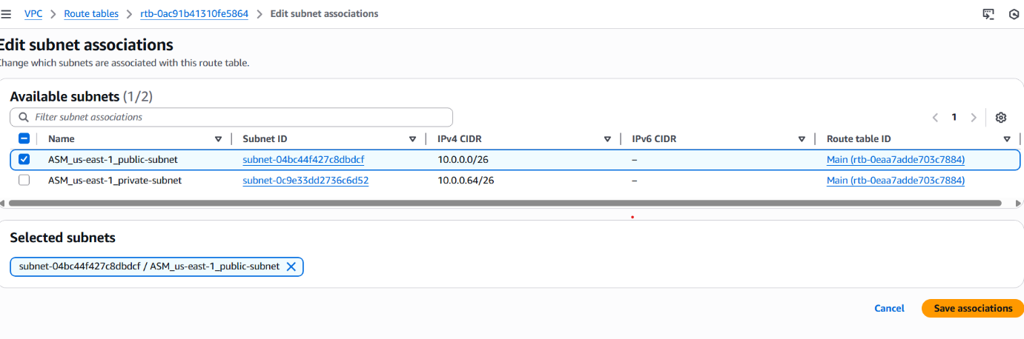
Step 8: Associate Private Subnet with Private Route Table
Open the private route table: rtb-08ac71efcf3a32d1b
Go to Subnet associations → Edit subnet associations.
Select subnet: ASM_us-east-1_private-subnet
Save associations.
Evidence: 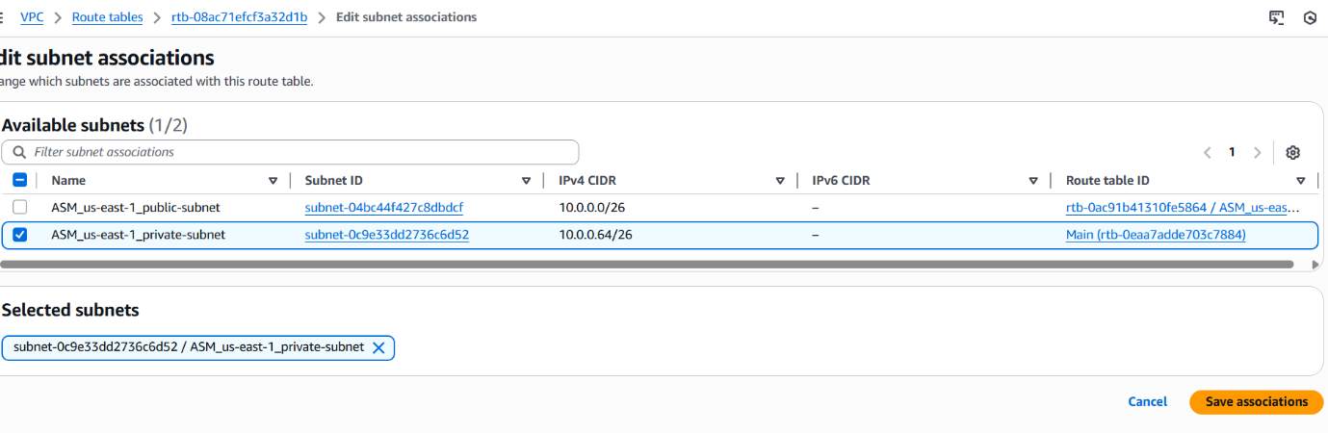
Step 9: Verify Both Route Tables
Public RT and Private RT are listed with their respective associations:
• ASM_us-east-1_public → associated with public subnet
• ASM_us-east-1_private → associated with private subnet
Evidence: 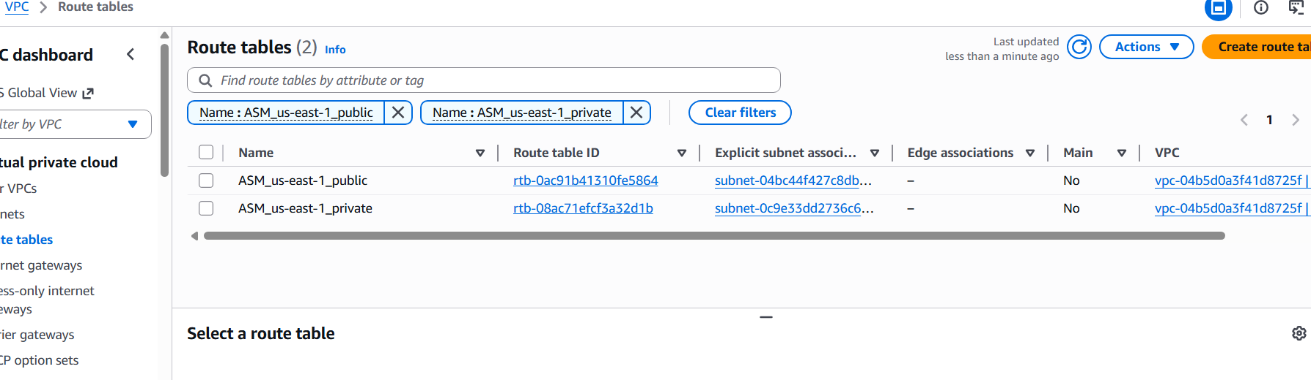
Conclusion
A public route table and a private route table were successfully created within the VPC.
The public route table was configured with a default route (0.0.0.0/0) pointing to the Internet Gateway and associated with the public subnet.
The private route table was kept internal without any internet routing and was associated with the private subnet.

- Deploy a NAT gateway in the public subnet and attach the NAT gateway to the private subnet.
Title: Deploy a NAT gateway in the public subnet and attach the NAT gateway to the private subnet.

1️ Task Title
Deploy a NAT Gateway in the public subnet and configure the private route table to use the NAT Gateway for outbound internet access.

2️ Objective
To allow resources in the private subnet to access the internet securely using a NAT Gateway placed in the public subnet.

3️ Prerequisites
List all requirements before starting:
• One VPC created
• One public subnet available
• One private subnet available
• Public subnet already associated with a route table that has IGW route
• IGW attached to the VPC

4️ Step-by-Step Implementation (With Evidence)
Step 1: Create a NAT Gateway
• Console path: VPC Console → NAT Gateways → Create NAT Gateway
• Select VPC: ASM-us-east-1-vpc
• Subnet: Public subnet (ASM_us-east-1_public-subnet)

• Explanation: The NAT Gateway is deployed in the public subnet and assigned an Elastic IP for outbound internet routing.
Evidence: 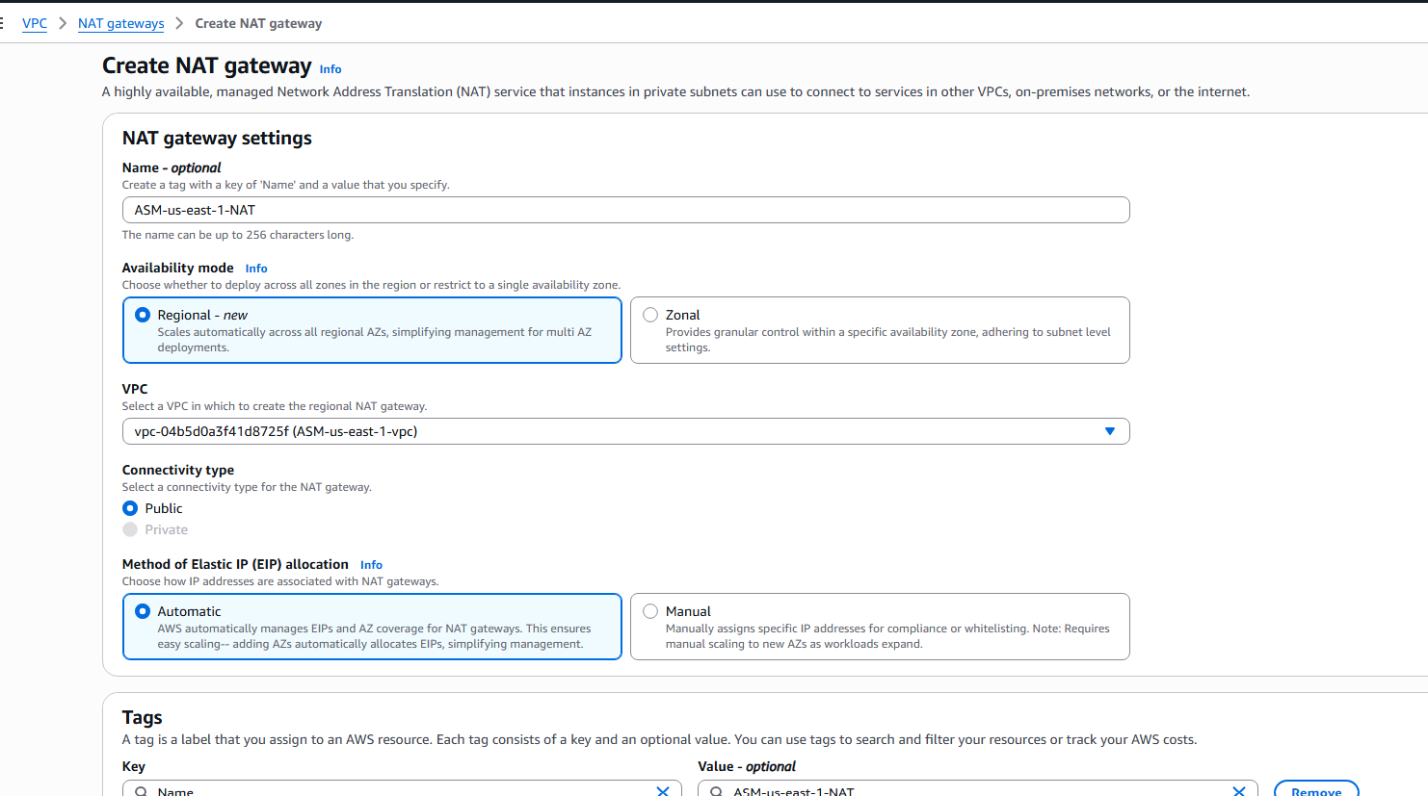

Step 2: Confirm NAT Gateway Created Successfully
• After creation, verify NAT is as follows
• Explanation: NAT Gateway must reach the "Available" state before it can be used by route tables.
Evidence: 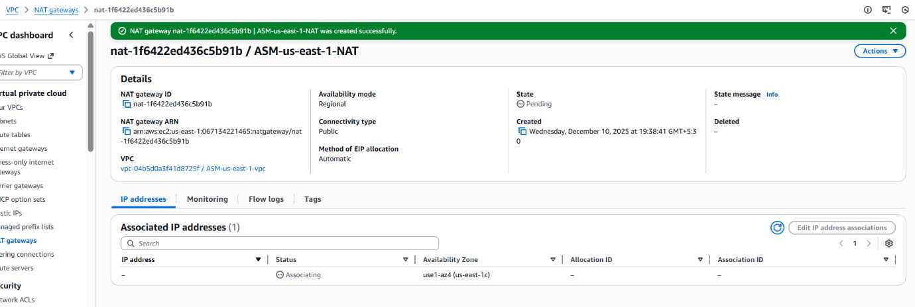

Step 3: Edit Private Route Table to Add Route via NAT Gateway
• Console path: VPC Console → Route Tables → Select private RT (ASM_us-east-1_private) → Edit routes
• Add route:
Destination: 0.0.0.0/0
Target: NAT Gateway
NAT Gateway ID: nat-1f6422ed436c5b91b
• Explanation: This allows instances in the private subnet to reach the internet for updates, patches, etc., through the NAT Gateway.
Evidence: 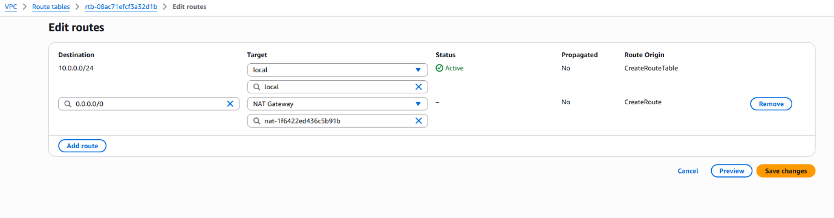

Step 4: Validate Updated Private Route Table
• Console path: VPC Console → Route Tables → ASM_us-east-1_private → Routes
• Confirm the new route:
0.0.0.0/0 → nat-1f6422ed436c5b91b
• Explanation: This confirms the private subnet can now access the internet via the NAT Gateway.
Evidence: 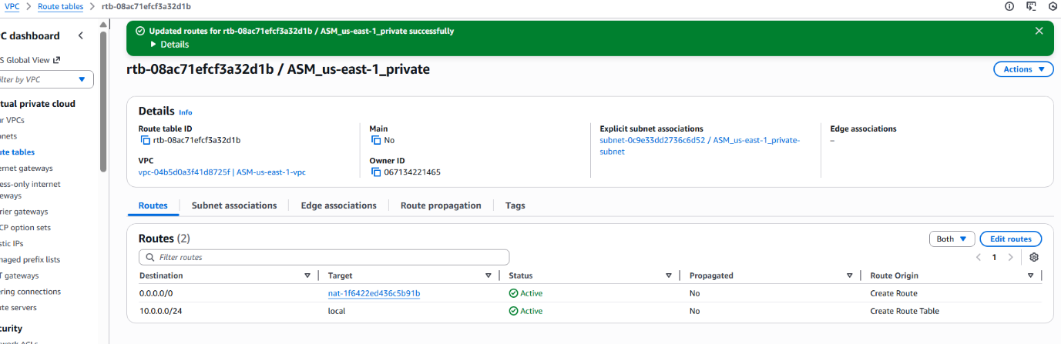

- Create two instances, one in the public subnet and one in the private subnet.
1️ Task Title
Create two instances, one in the public subnet and one in the private subnet.

2️ Objective
To launch and configure two EC2 instances inside the custom VPC:
• A public instance in the public subnet with a public IP.
• A private instance in the private subnet without a public IP.

3️ Prerequisites
List all requirements before starting:
• Custom VPC already created.
• Public subnet and private subnet created.
• Route tables associated correctly.
• NAT Gateway configured for private subnet.
• Security group.
• Key pair

4️ Step-by-Step Implementation (With Evidence)
Step 1: Launch a public EC2 instance
• Console path: EC2 Dashboard → Instances → Launch Instance
• Explanation: A public instance is placed in the public subnet with Auto-assign Public IP enabled, allowing access from the internet.
Evidence: 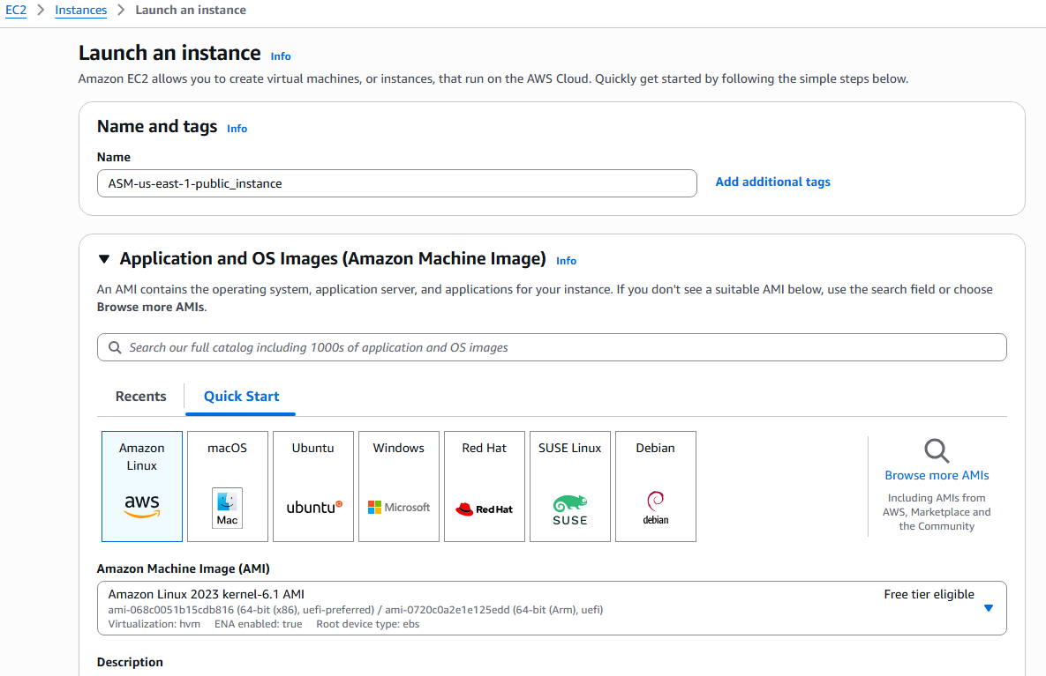

Step 2: Configure network settings for the public instance
• Console path: EC2 Dashboard → Instances → Launch Instance → Network Settings
• Explanation: Select the VPC, choose the public subnet, enable Auto-assign Public IP, and attach an existing security group.
Evidence: 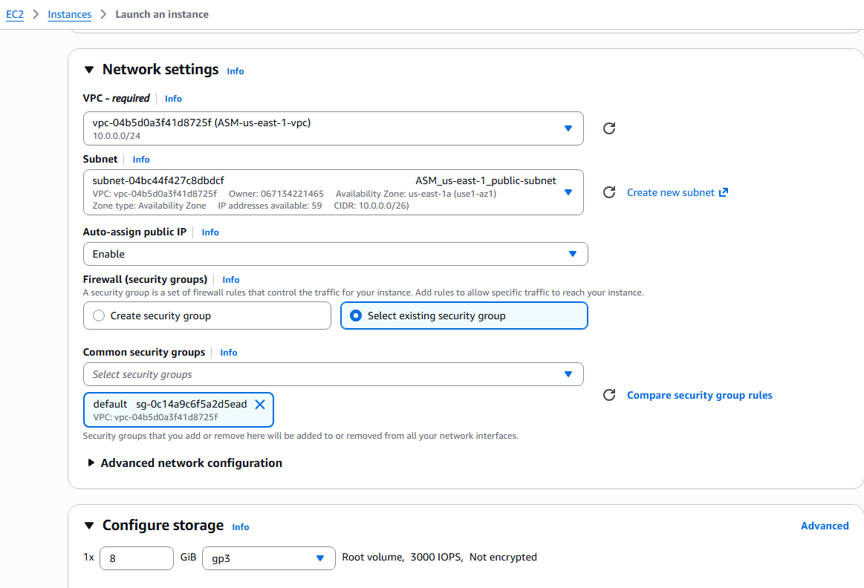

Step 3: Confirm public instance creation
• Console path: EC2 Dashboard → Instances → Select the instance
• Explanation: The instance should show a Public IPv4 address and “Running” state.
Evidence: 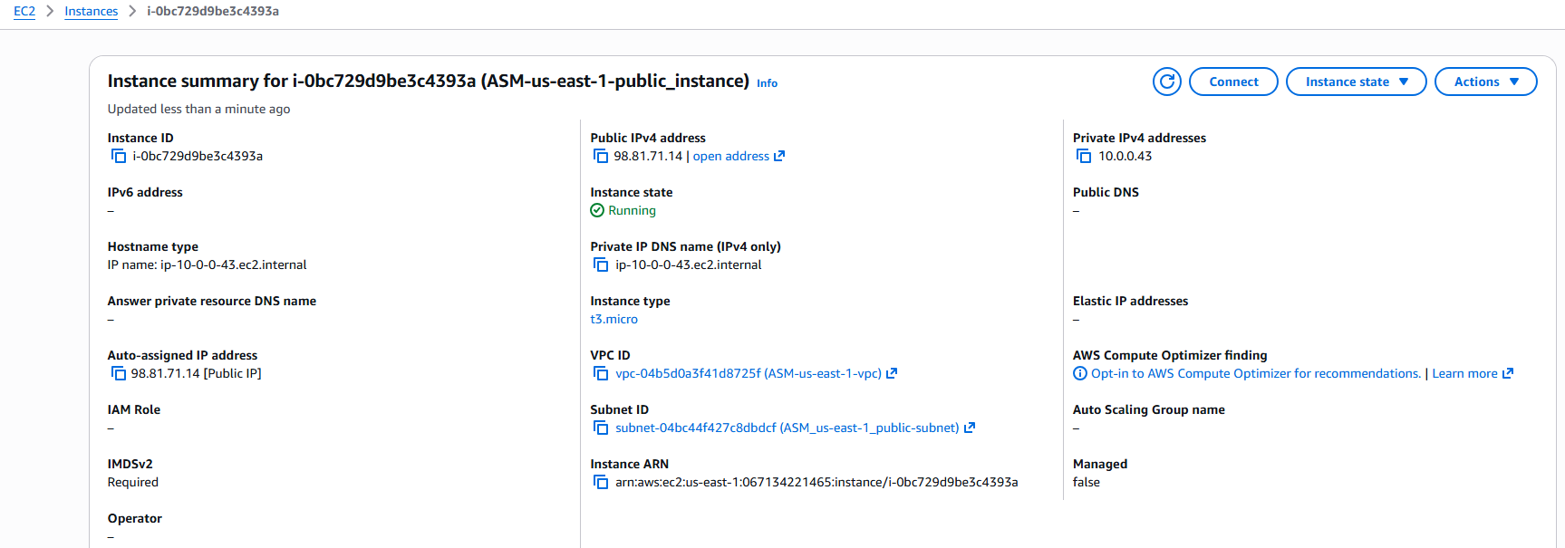

Step 4: Launch a private EC2 instance
• Console path: EC2 Dashboard → Instances → Launch Instance
• Explanation: Select same AMI and instance type but choose the private subnet and disable Auto-assign Public IP.
Evidence: 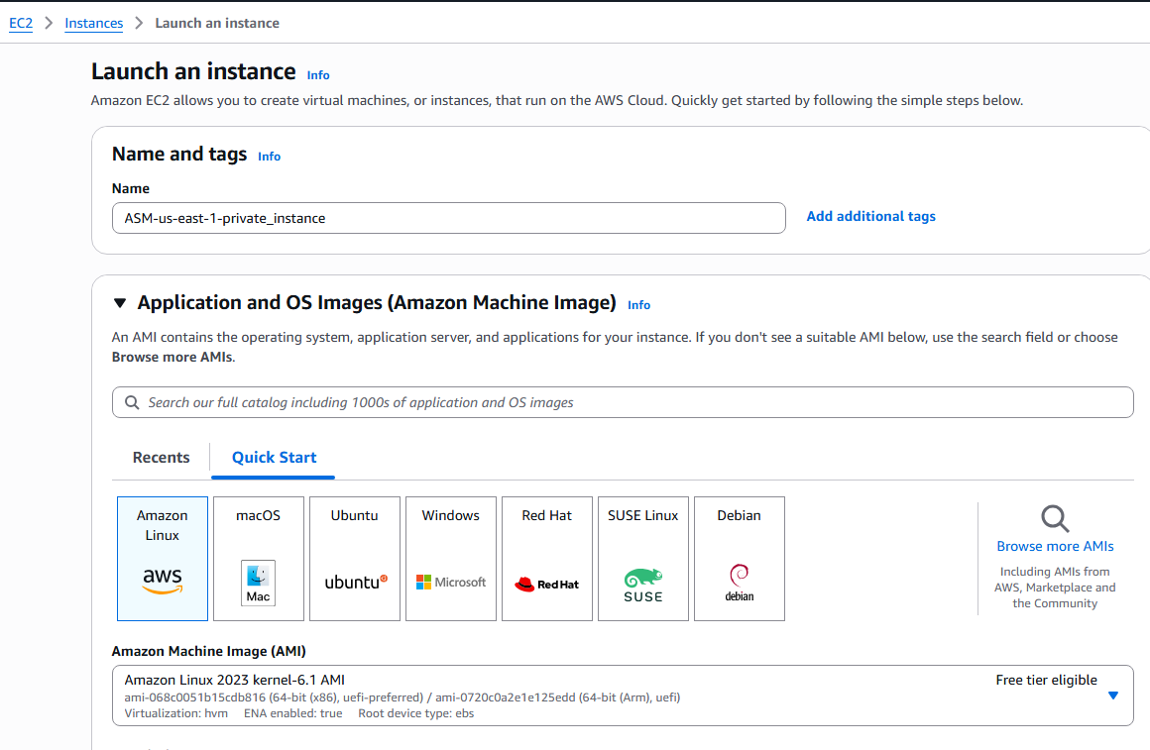

Step 5: Configure private instance network settings and security group
• Console path: EC2 Dashboard → Instances → Launch Instance → Network Settings
• Explanation: A new security group is created allowing only required inbound traffic since instance has no public IP.
Evidence: 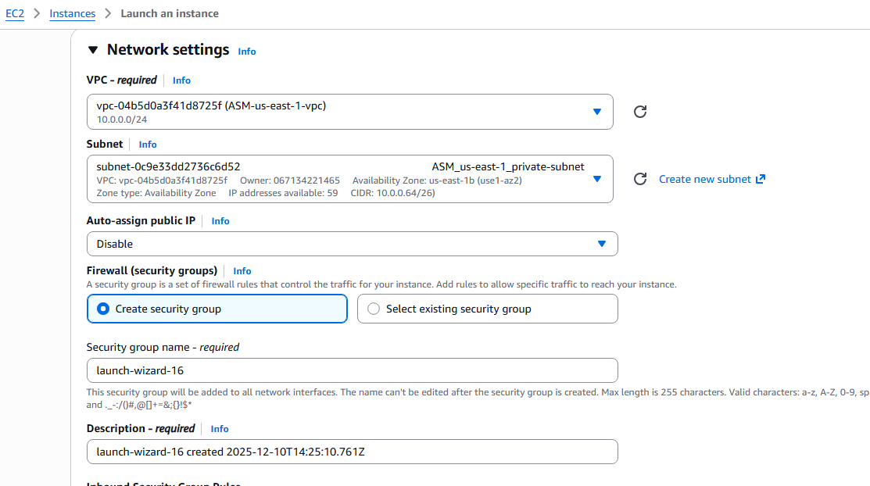

Step 6: Provide user data script for Apache installation on private instance
• Console path: EC2 Dashboard → Launch Instance → Advanced Settings → User Data
• Explanation: The script installs and starts Apache (httpd), creating a simple webpage.
Evidence: 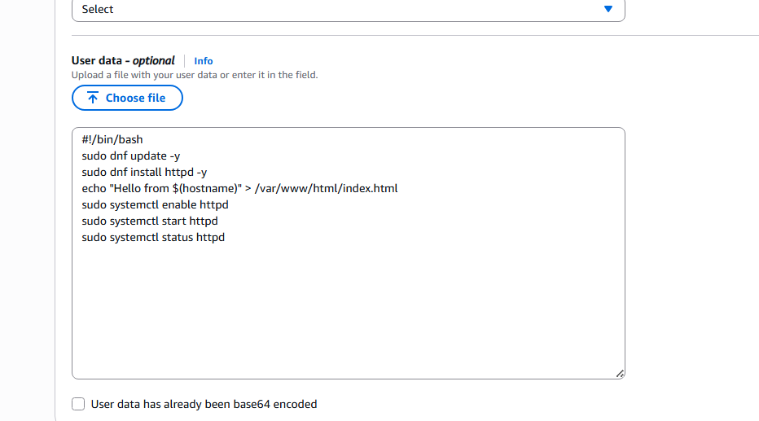

Step 7: Confirm private instance creation
• Console path: EC2 Dashboard → Instances → Select the instance
• Explanation: Instance state should show “Running”, and only a private IP should be visible.
Evidence: 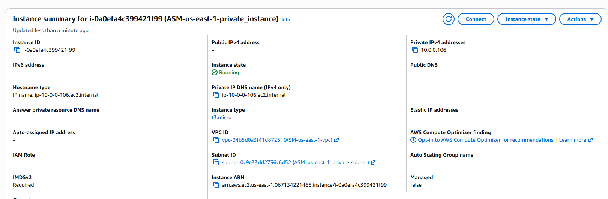

Step 8: Verify HTTP service in system logs for the private instance
• Console path: EC2 Dashboard → Instances → Select instance → Monitor & Troubleshoot → System Log
• Explanation: System log confirms Apache HTTP server started successfully through user data.
Evidence: 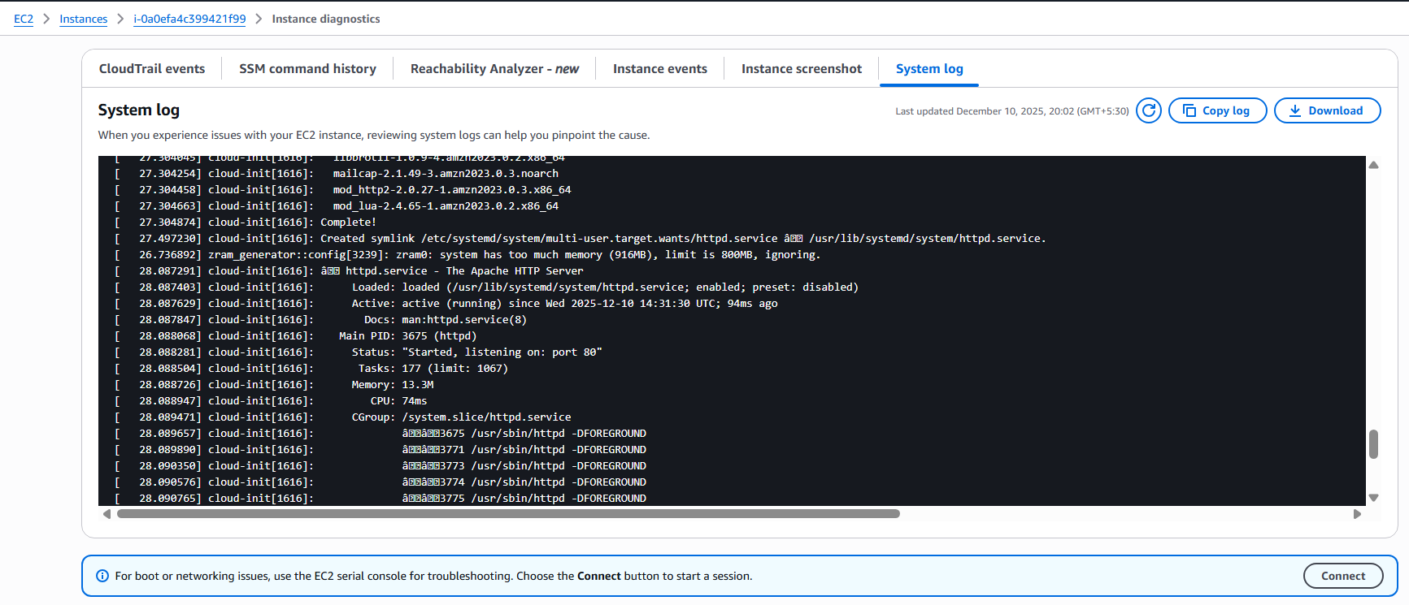

- Deploy Apache server on both EC2 instances with a sample index.html file.
Title: Deploy Apache server on both EC2 instances with a sample index.html file.

1. Objective
Deploy and verify Apache HTTP server on both the public and private EC2 instances.
Note: The private instance already had httpd installed and started in the previous task. Only verification steps are shown for the private instance.

2. Prerequisites
• A public EC2 instance in the public subnet
• A private EC2 instance in the private subnet
• NAT Gateway configured for outbound internet access
• SSH access to the public instance using .pem key
• Ability to SSH from the public instance to the private instance using its private IP

3. Step-by-Step Implementation (With Evidence)
Step 1: Connect to the public EC2 instance using SSH
• Console path: EC2 > Instances > Select public instance > Connect > SSH client
• Use the provided SSH command with your key pair.
Explanation:
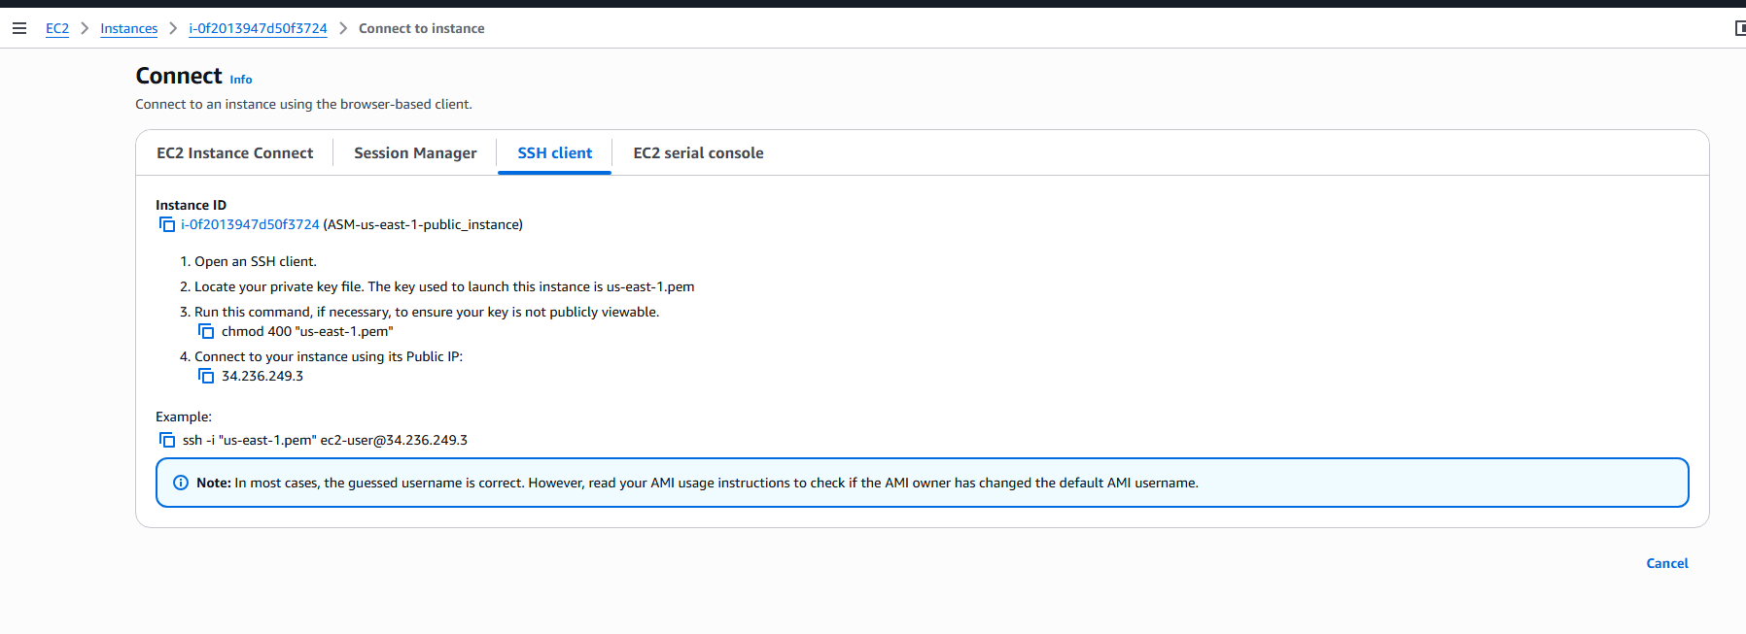
Step 2: Install and start Apache (httpd) on the public instance

Commands executed:

sudo -i
yum install httpd -y
cd /var/www/html
vi index.html (add sample HTML content)
systemctl start httpd
systemctl enable httpd
systemctl status httpd

Explanation:
This screenshot shows successful installation of Apache, creation of index.html, and that the httpd service is active and running.
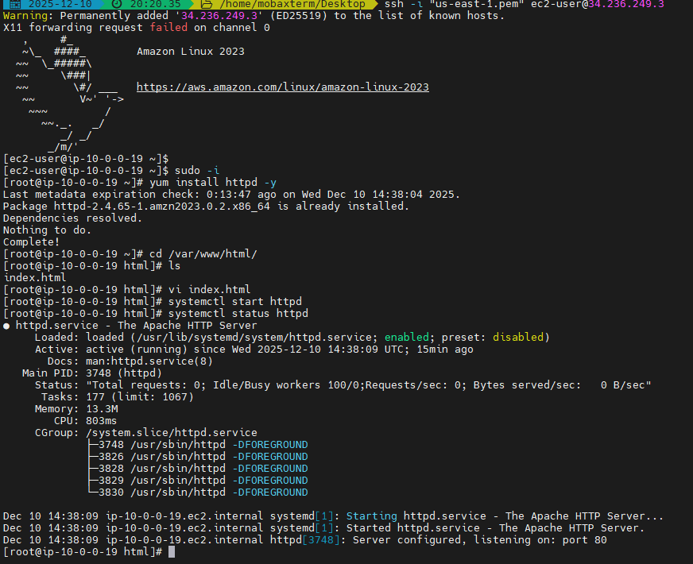
step 3: Retrieve the .pem key inside the public instance to access private instance

• Transfer the key or paste its content into a new key.pem file inside the public instance.
• Adjust file permissions using chmod 600 key.pem

Explanation:
This screenshot shows the public instance displaying the .pem file contents that will be used to SSH into the private instance.
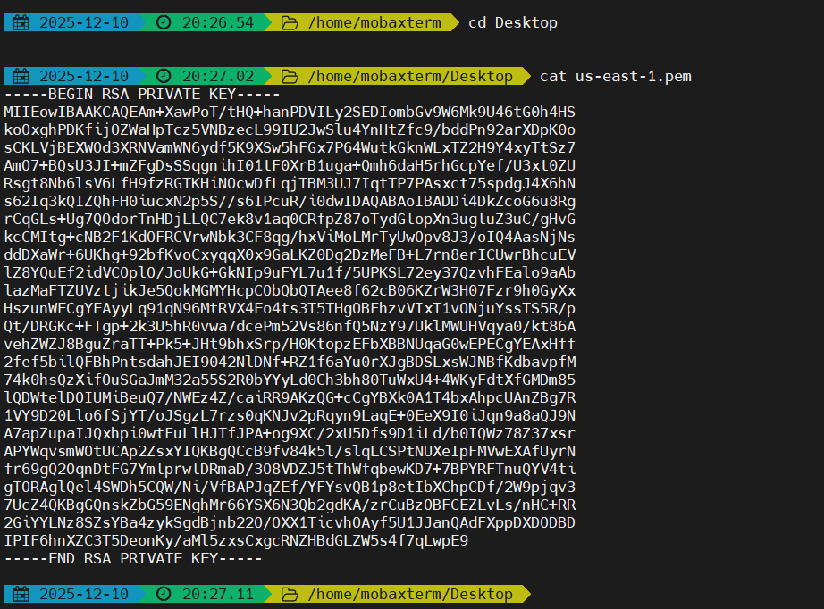
Step 4: Connect from the public instance to the private EC2 instance using SSH
• Console path: EC2 > Instances > Select private instance > Connect > SSH client
• Use the private IP address and the internal key file.
Explanation:
The connect screen indicates the private IP (10.0.0.106) which must be used for SSH from the public instance. 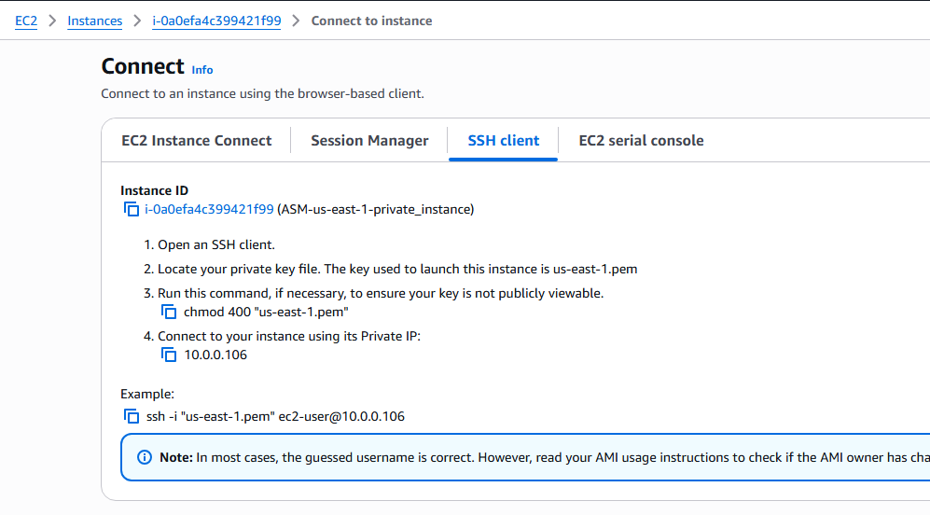
Step 5: SSH into the private instance and verify Apache
Since Apache was already installed in the previous task, only verification and status check were needed.
Commands:
chmod 600 key.pem
ssh -i key.pem ec2-user@10.0.0.106
systemctl status httpd
Explanation:
This screenshot shows a successful SSH connection to the private EC2 instance using its private IP. 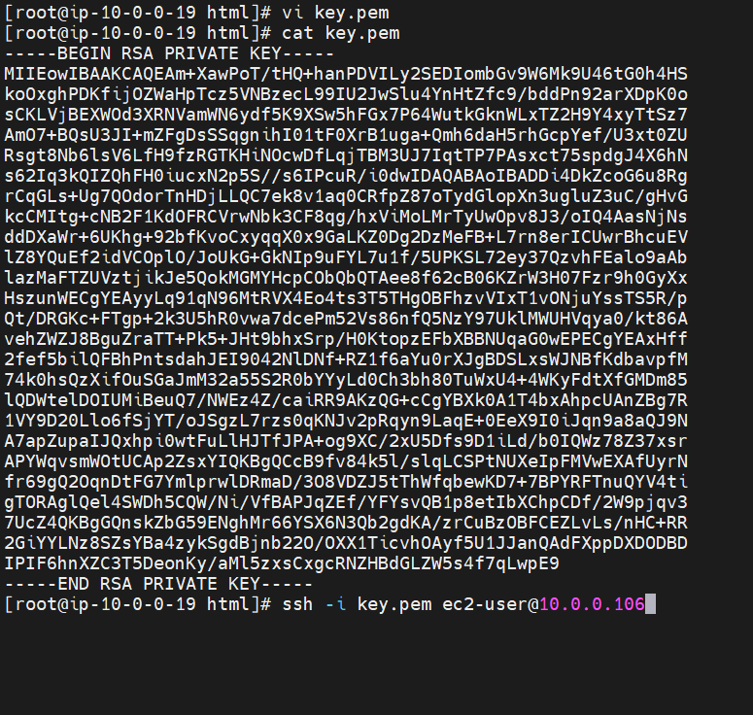
Step 6: Verify Apache service running on the private instance

• Confirm that the httpd service is active.
• Apache should already be installed from the earlier step.

Explanation:
This screenshot displays httpd running successfully on the private instance. 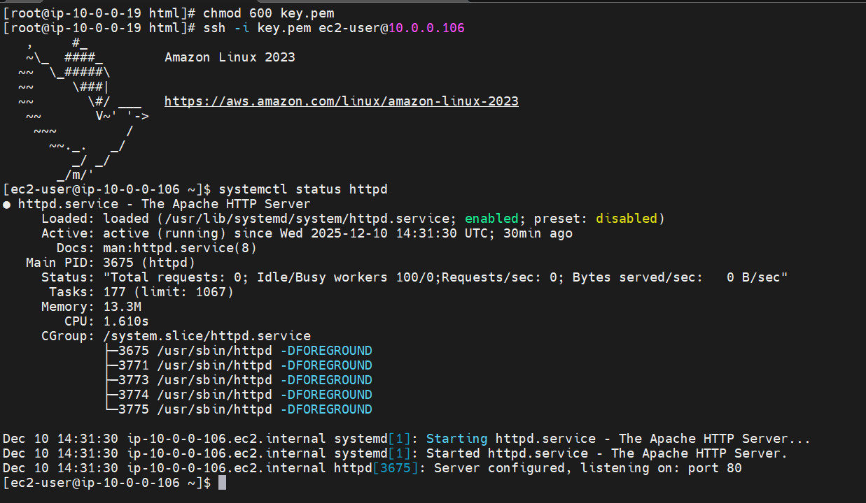

- Create one application load balancer and attach it to both EC2 instances.
Title: Create one Application Load Balancer and attach it to both EC2 instances
Objective: To create an Application Load Balancer (ALB), configure listeners, register both EC2 instances as targets, verify health checks, and validate load balancing from the browser.
Prerequisites
• Two EC2 instances (Public + Private) already deployed
• Apache installed on both instances
• Custom index.html created
• VPC, subnets, route tables, NAT Gateway already configured
• Security groups properly configured
• Target group not yet created (done in this task)

Step-by-Step Implementation
Step 1: Create a Target Group
Console Path
EC2 Dashboard → Target Groups → Create target group
Explanation
We create a target group to register EC2 instances that the ALB will forward traffic to.

Evidence: 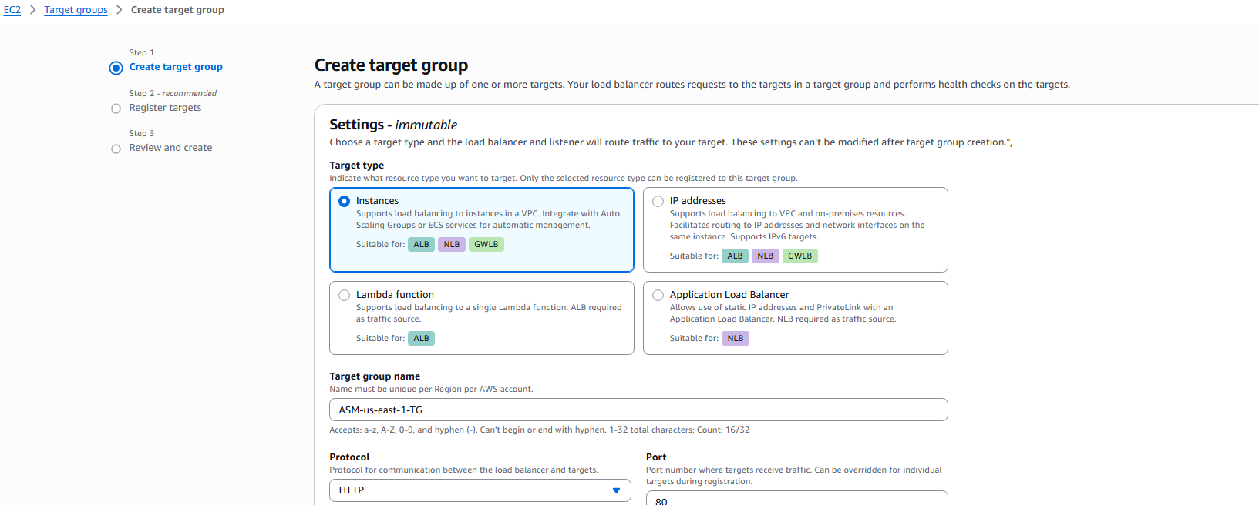

Step 2: Configure Target Group Settings
Console Path
Target Groups → Create target group → Configure protocol and health checks
Explanation
Select VPC, protocol version, health check protocol, and health check path.
Evidence: 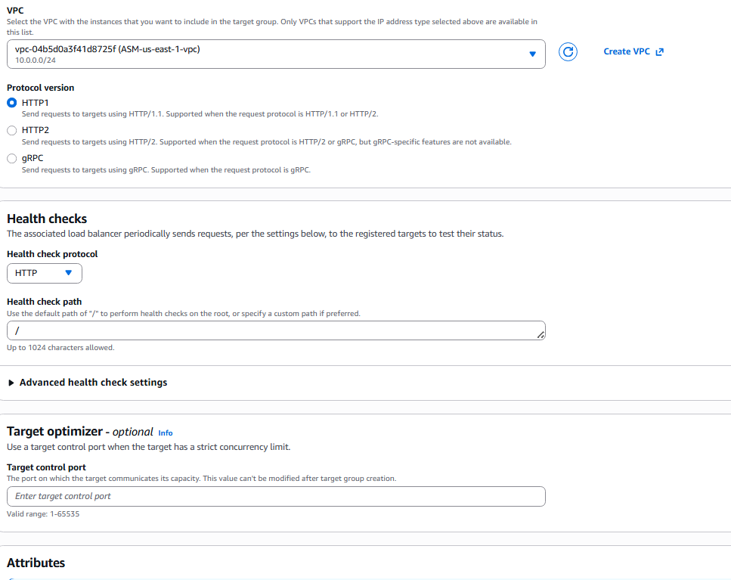

Step 3: Register Both EC2 Instances as Targets

Console Path
Target Groups → Select TG → Register targets
Explanation
Select both instances, assign port 80, and include them as pending targets.
Evidence: 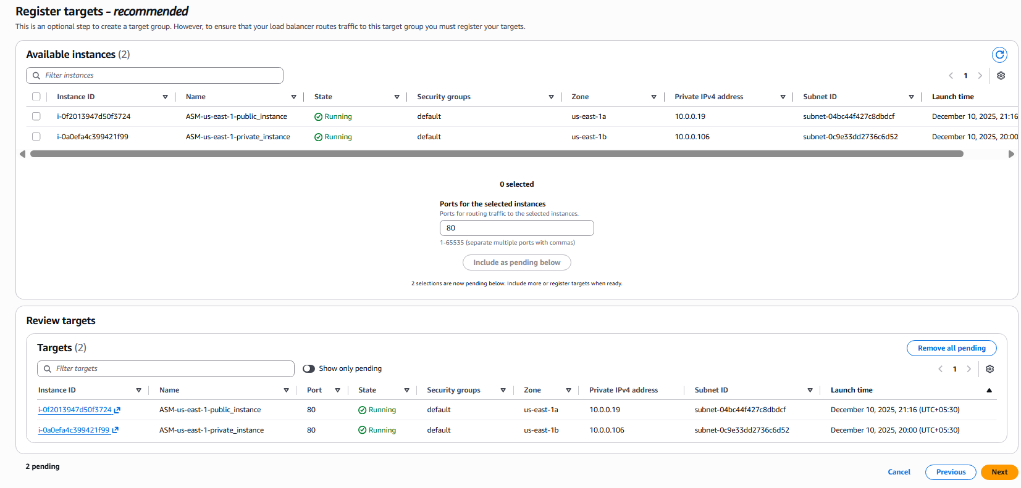

Step 4: Verify Target Group Was Created Successfully
Console Path
EC2 → Target Groups
Explanation
Verify target group name, type, port, and protocol.
Evidence: 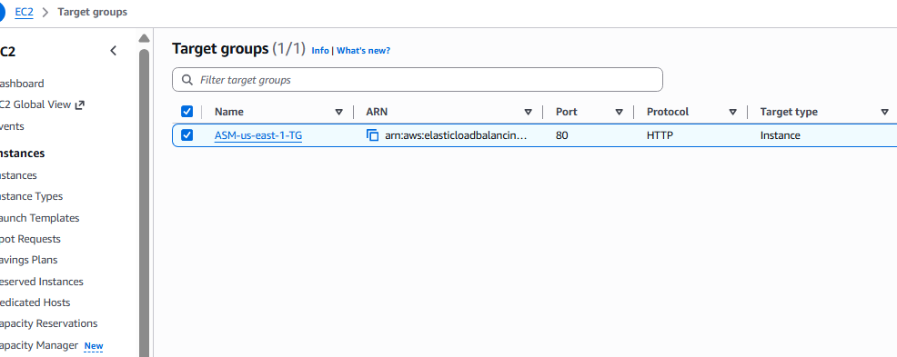

Step 5: Create an Application Load Balancer

Console Path
EC2 → Load Balancers → Create Load Balancer → Application Load Balancer
Explanation
Enter ALB name and choose Internet-facing and IPv4.
Evidence: 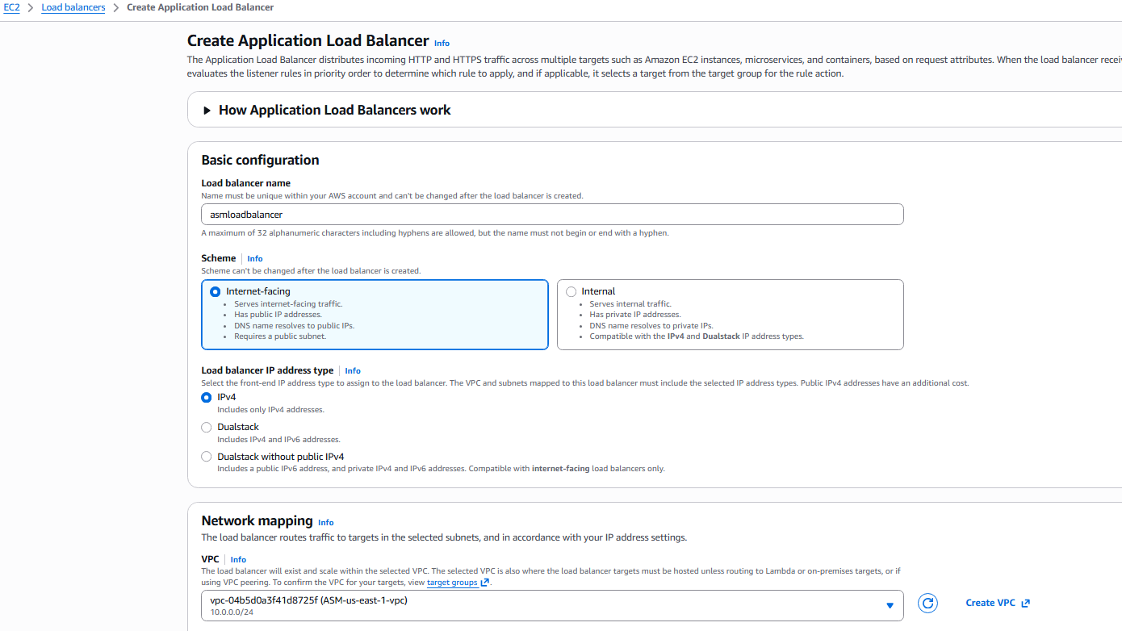

Step 6: Select Subnets for ALB
Console Path
Create ALB → Network mapping
Explanation
Select two subnets (public + private) to enable multi-AZ functionality.
Evidence: 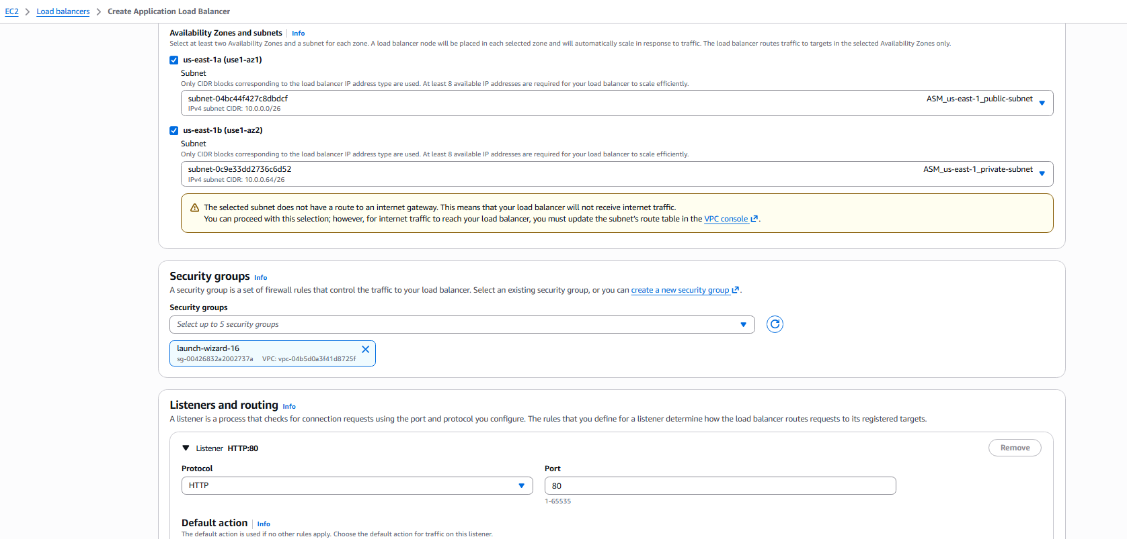

Step 7: Attach Security Group to ALB
Console Path
Create ALB → Security groups
Explanation
Select the security group that allows HTTP inbound traffic.
Evidence: 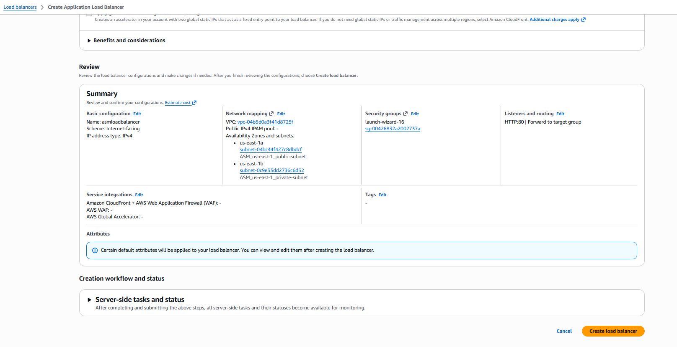

Step 8: Configure Listener and Forwarding Rule
Console Path
Create ALB → Listeners and routing
Explanation
Listener: HTTP:80
Action: Forward to target group ASM-us-east-1-TG

Evidence: 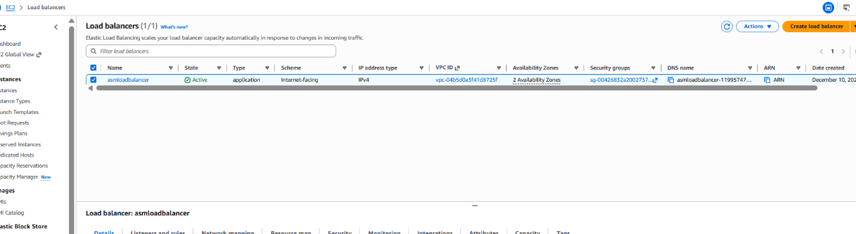

Step 9: Review securitygroup Configuration of Load Balancer
Console Path
Create ALB → Review → Create load balancer
Explanation
Review all settings and create ALB.
Evidence: 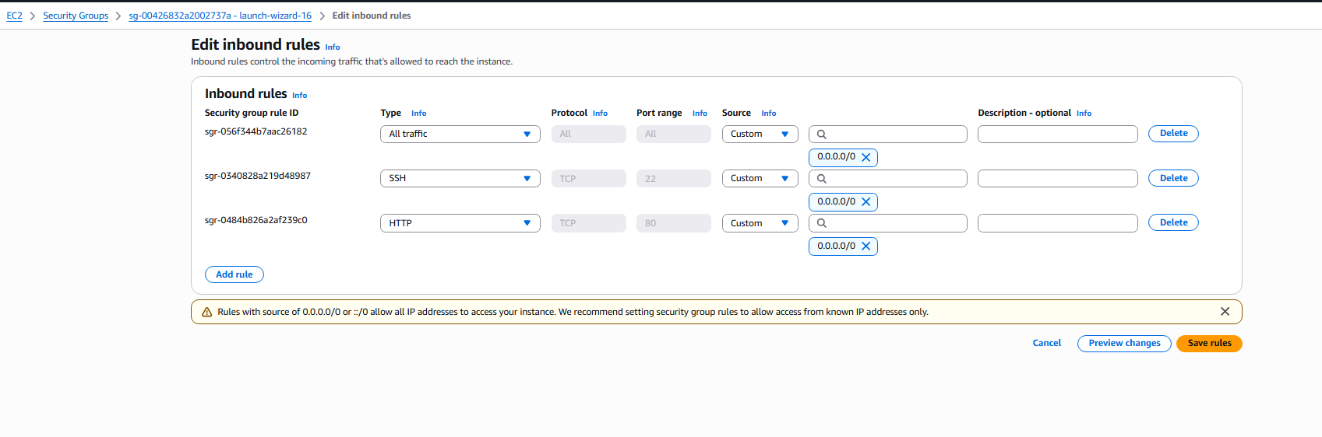

Step 10: Verify Load Balancer Status

Console Path
EC2 → Load Balancers
Explanation
Ensure ALB status becomes Active before proceeding.

Evidence: 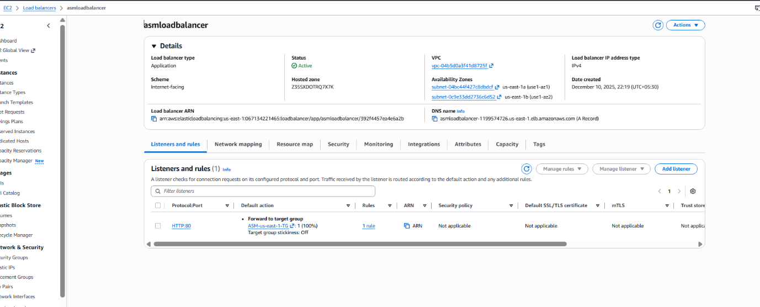

Step 11: Update Security Group of EC2 Instances
Console Path
EC2 → Instances → Select Instance → Security → Edit inbound rules

Explanation
Allow HTTP from ALB to access the web server on both EC2 instances.

Evidence: 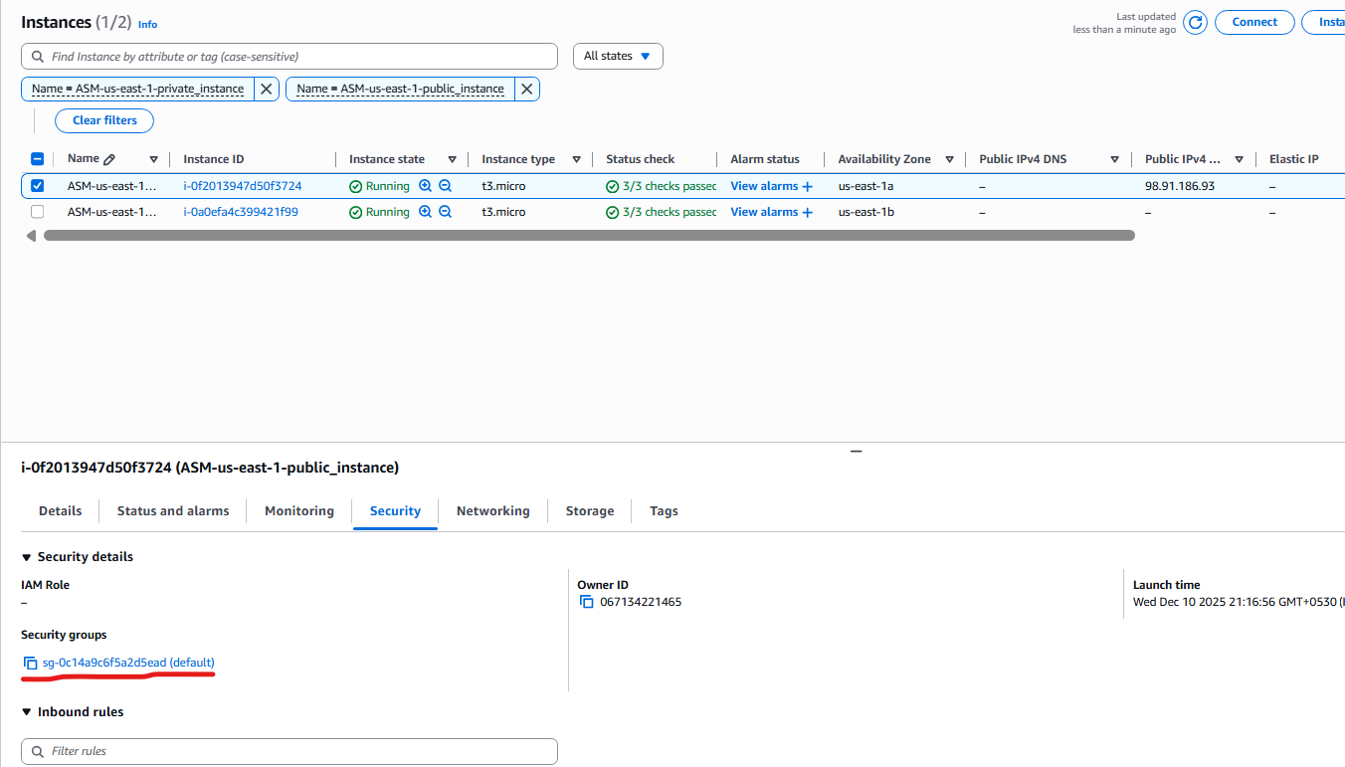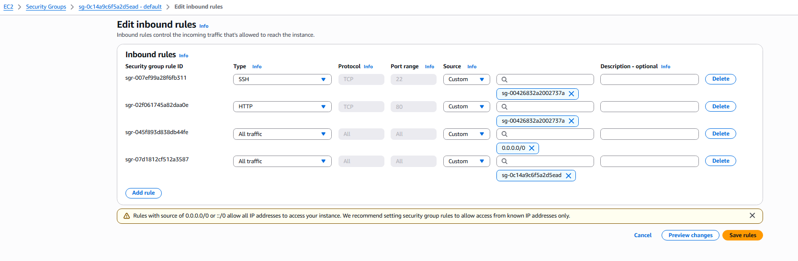

Step 12: Verify Instances Become Healthy
Console Path
Target Groups → Select TG → Targets
Explanation
Both instances should show Healthy under health check status.

Evidence: 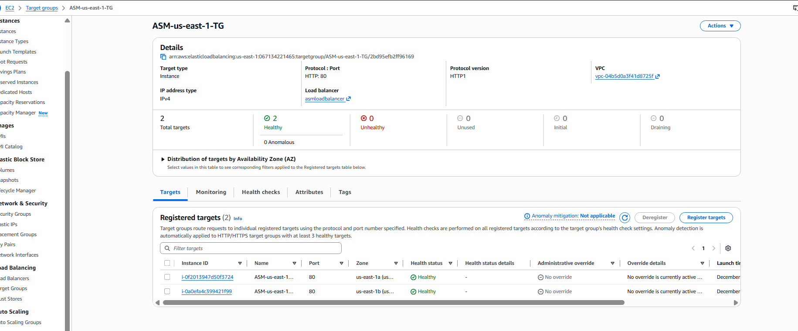

Step 13: Verify Listener Rules
Console Path
Load Balancers → Select ALB → Listeners
Explanation
Ensure HTTP:80 listener forwards requests to the correct target group.

Evidence: 

Validation: Test Load Balancer in Browser

Console Path
Browser → Enter ALB DNS name
Explanation
Refresh the ALB DNS URL multiple times to see responses from both instances.

Evidence (Instance 1 Response): 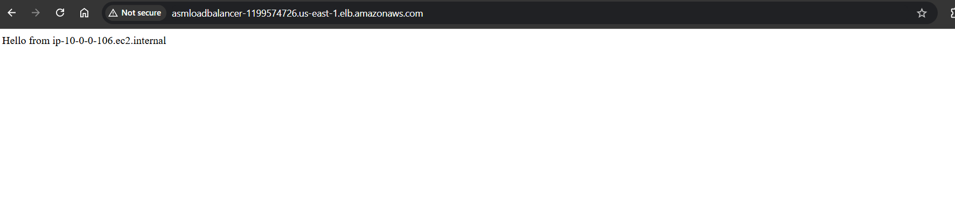
Evidence (Instance 2 Response): 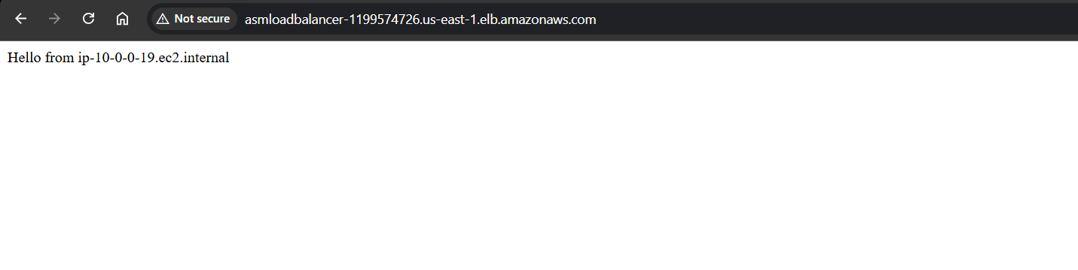
Troubleshooting: while configuring the security group for the load balancer I have selected the default vpc security group which we have used it for the instances and later I have created the loadbalancer with the it’s own security group and updated the ssh, http routes in the instance security groups and also updated the rules in the loadbalancer security group.
I tried configuring the health check with a custom script in the root folder, but it seems it is showing health check failed, I have made changes to the healthcheck script and got the healthcheck successfully.

Conclusion

The Application Load Balancer was successfully created and configured.
Both EC2 instances were registered, passed health checks, and the ALB successfully distributed traffic between them as verified through browser testing.
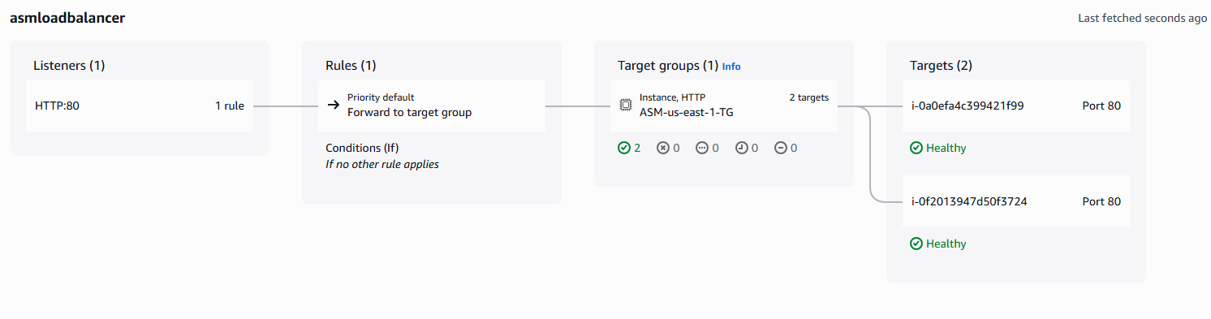

- Store application load balancer logs in S3.
1. Task Title
Store Application Load Balancer Logs in S3
2. Objective
Enable ALB access logging by:
Creating an S3 bucket for logs
Adding the required bucket policy for log delivery
Updating ALB attributes to store logs in the S3 bucket
Verifying that logs are successfully delivered
3. Prerequisites
Before starting, ensure the following are already created:
• Application Load Balancer (Internet-facing)
• Target Group with healthy instances
• IAM permissions to modify S3 bucket policies and ALB attributes
• S3 bucket for storing logs

4. Step-by-Step Implementation (With Evidence)
Step 1: Create an S3 Bucket for Storing ALB Logs

Go to S3 Console → Create bucket
Name the bucket: asm-loadbalancer-01
Leave all default settings except disable block public access (only if required for the task).
Console Path:
S3 → Buckets → Create bucket
Evidence:
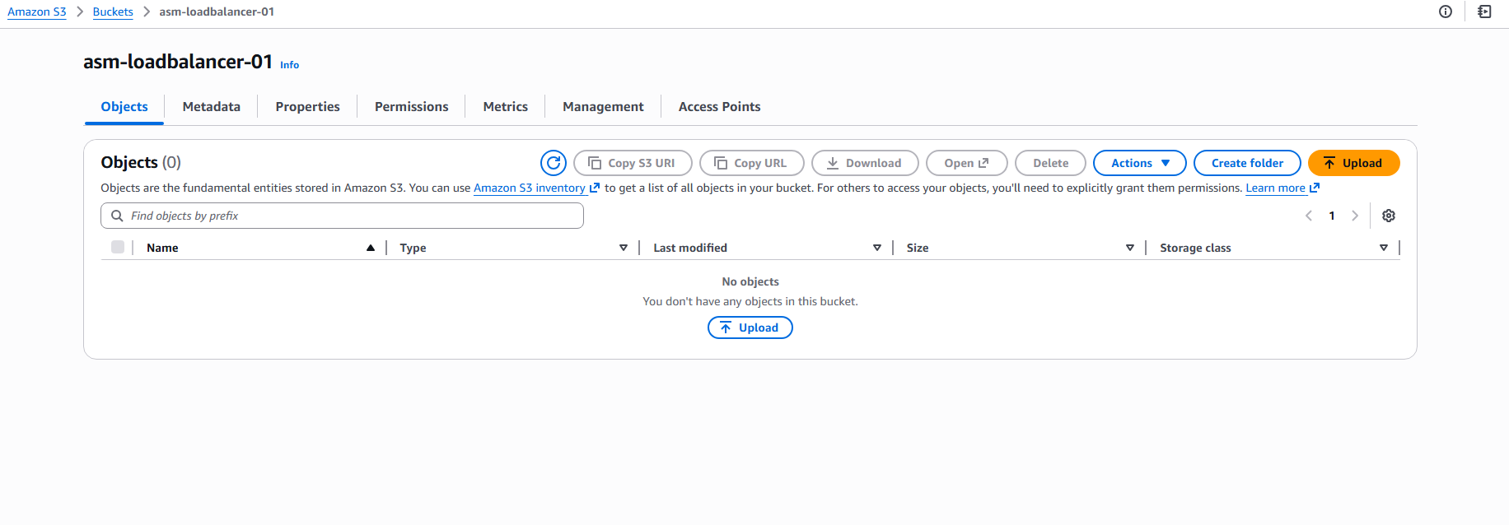
Step 2: Open Bucket Permissions and Edit Bucket Policy

Navigate to: https://docs.aws.amazon.com/elasticloadbalancing/latest/application/enable-access-logging.html
Edit the ELB account id and change the bucket name in the policy
And now go to
S3 → Buckets → asm-loadbalancer-01 → Permissions
Click Edit under Bucket Policy.
Evidence: 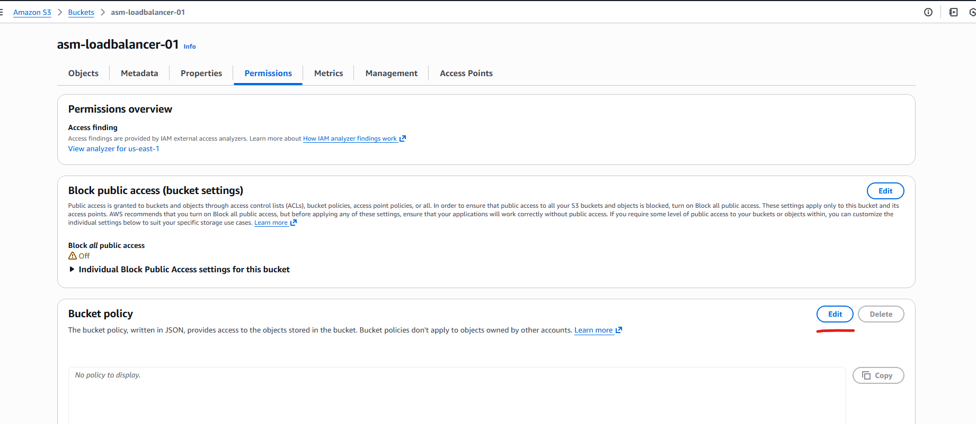
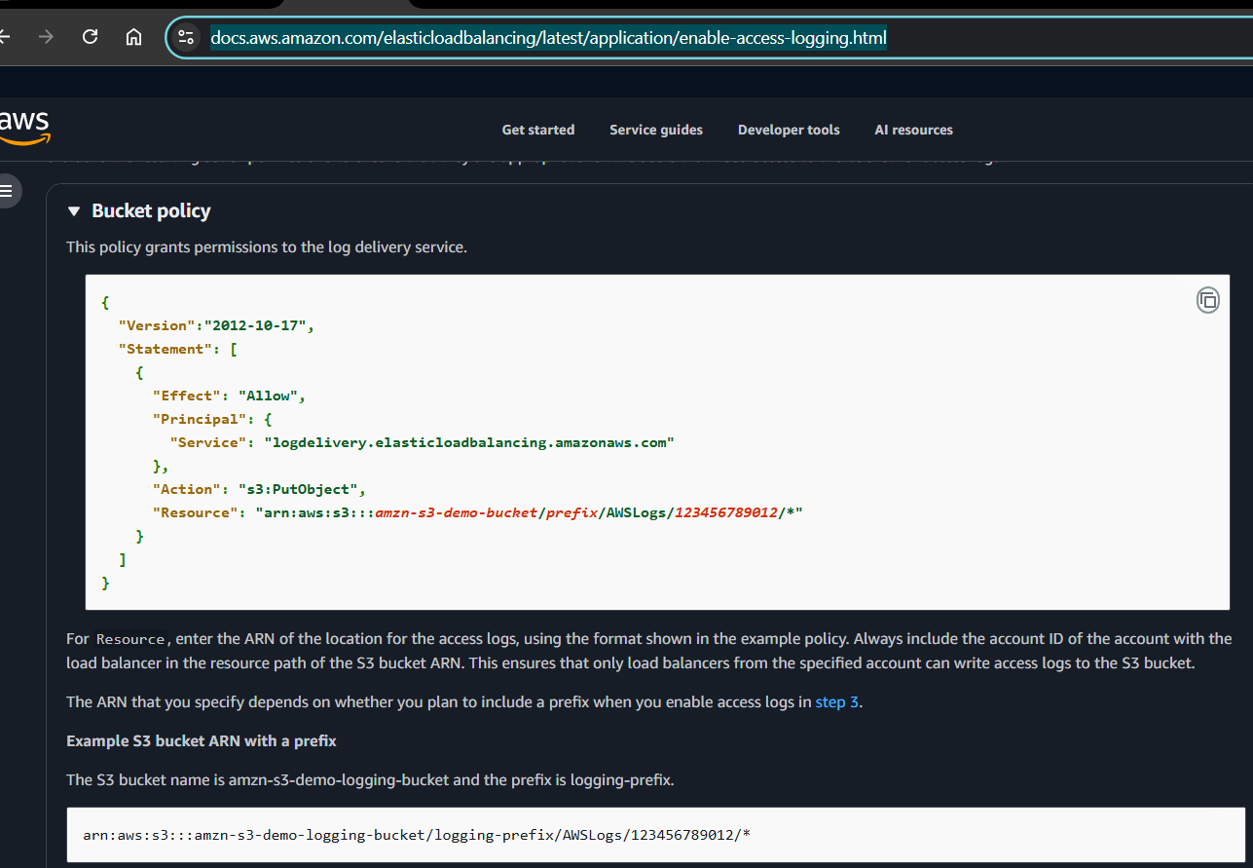
Step 3: Add Required ALB Log Delivery Bucket Policy

Paste the following JSON (updated with your bucket ARN):

{
"Version": "2012-10-17",
"Statement": [
{
"Effect": "Allow",
"Principal": {
"Service": "logdelivery.elasticloadbalancing.amazonaws.com"
},
"Action": "s3:PutObject",
"Resource": "arn:aws:s3:::asm-loadbalancer-01/AWSLogs/067134221465/*"
}
]
}

Click Save.

Evidence: 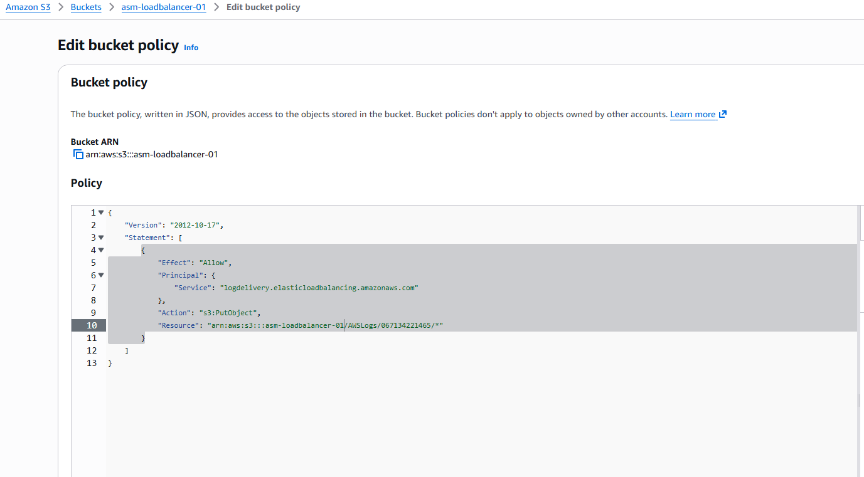

Step 4: Enable Access Logging in the ALB Attributes

Go to:
EC2 → Load Balancers → asmloadbalancer → Edit attributes

Scroll to Monitoring → Access logs
Enable Access Logs → Select the S3 bucket: asm-loadbalancer-01

Click Save changes

Evidence:
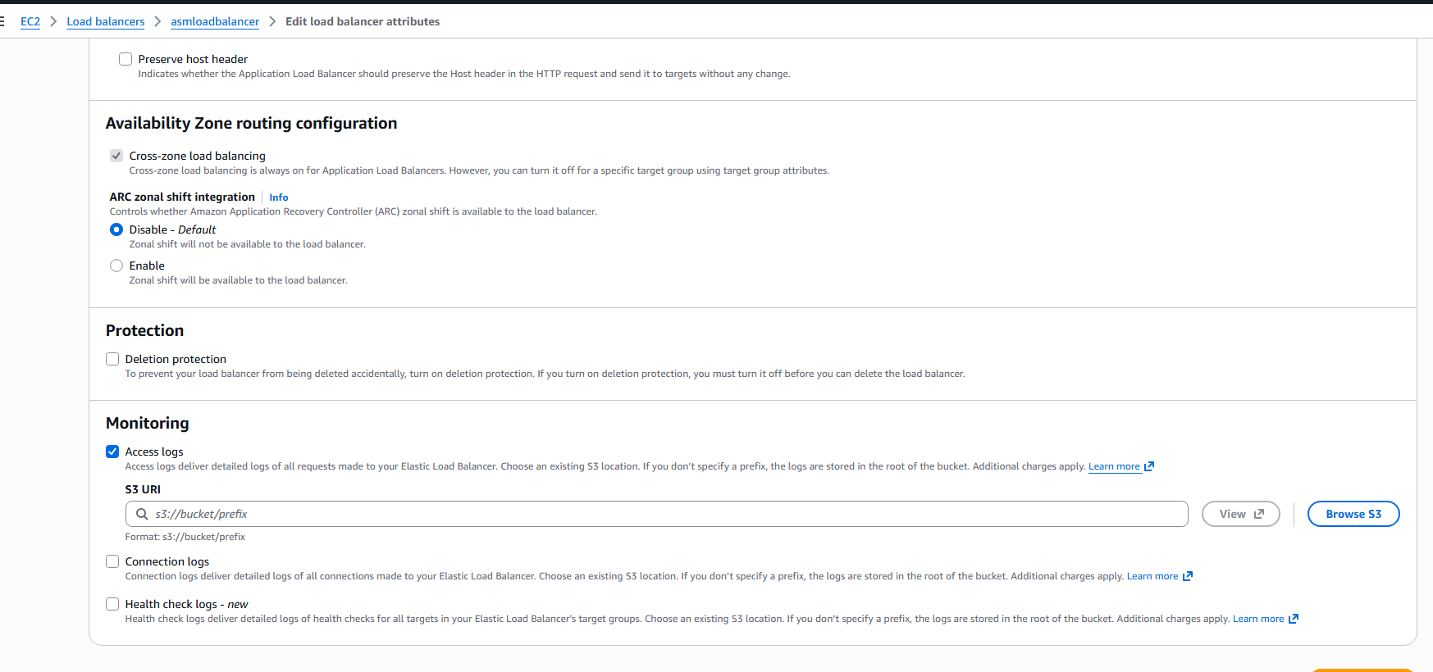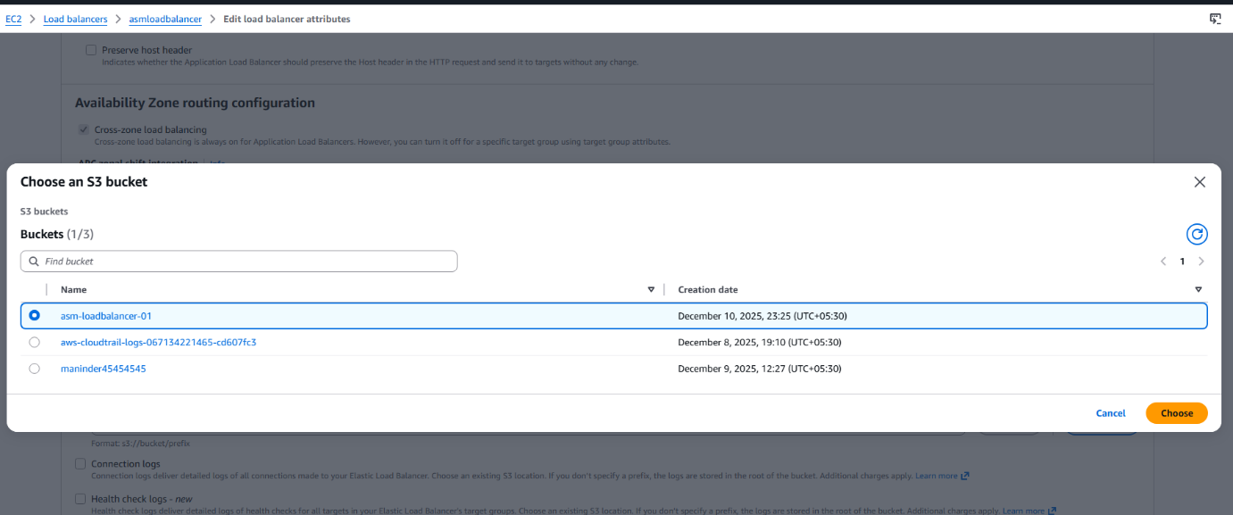
5) Validation: Verify Logs Are Delivered to S3
Go to:
S3 → asm-loadbalancer-01 → AWSLogs → AccountID → …
You will find log files created by ALB.

Evidence:
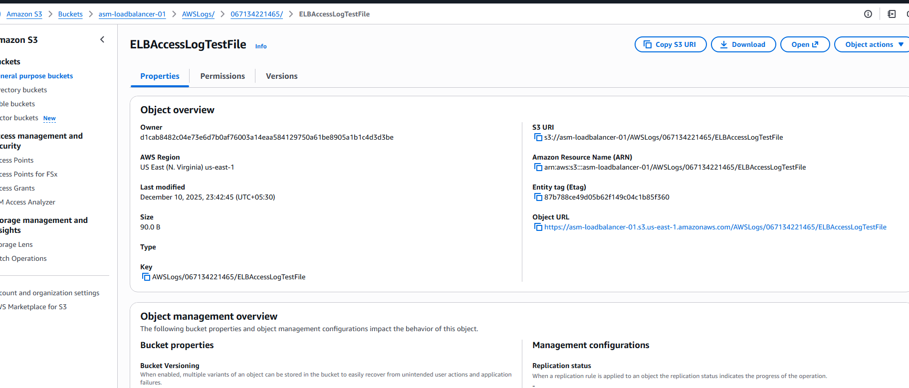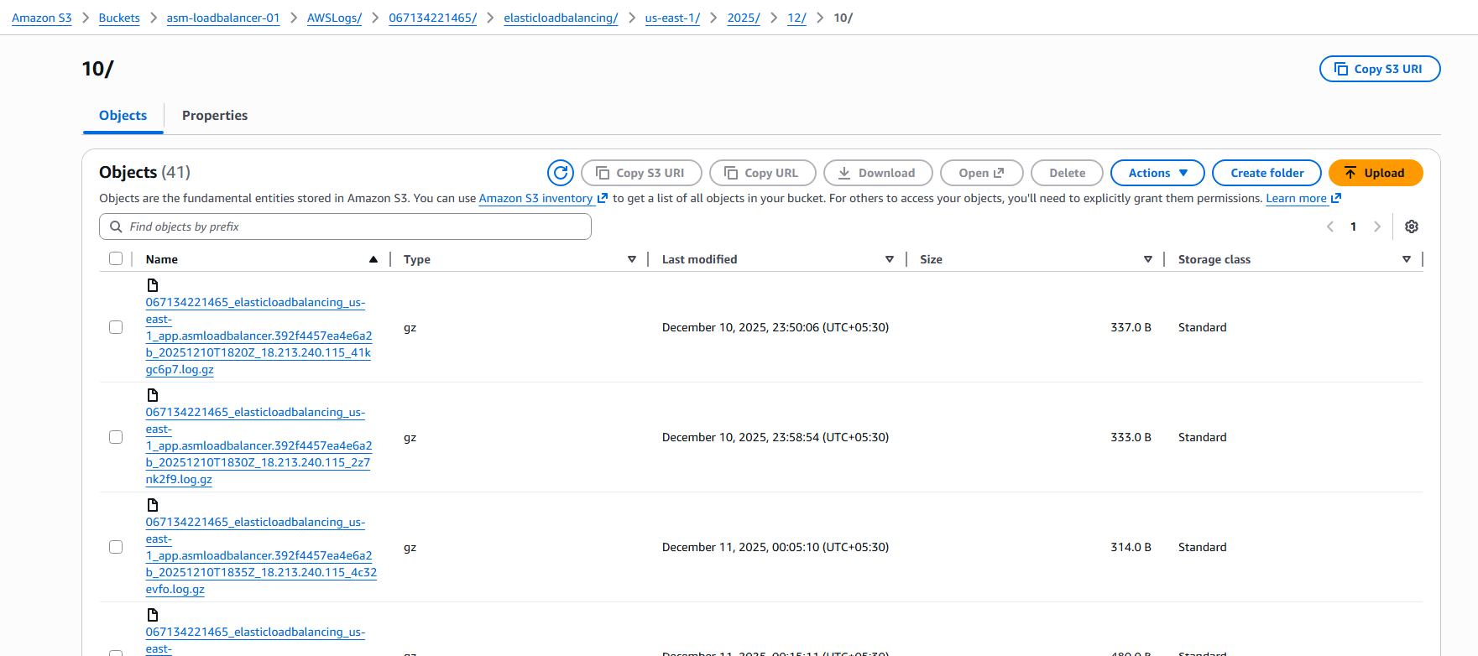

6. Troubleshooting:
In this task, when I try to select the bucket in the access logs section, it showed me error saying the prefix in the bucket policy should be used if have any prefix or discard the prefix, since, I don’t have any prefix I removed the prefix and I was successfully integrated the s3 bucket to the Loadbalancer.
7. conclusion: The Application Load Balancer (ALB) access logging has been successfully configured and verified.
You created a dedicated S3 bucket, applied the correct bucket policy to allow the ALB log delivery service to write logs, enabled access logging in the ALB settings, and confirmed that log files are being generated inside the bucket

- Store the VPC flow logs in a CloudWatch log group.
1. Title
Store the VPC Flow Logs in a CloudWatch Log Group
2. Objective
To enable VPC Flow Logs for the ASM-us-east-1 VPC and store all flow log records (accepted, rejected, and all traffic) in a dedicated CloudWatch Log Group for centralized monitoring and analysis.
3. Prerequisites
• An existing VPC in AWS (ASM-us-east-1-vpc)
• create or use a CloudWatch Log Group
• CloudWatch Logs

4. Step-by-Step Implementation (With Evidence)

Step 1: Open VPC and navigate to Flow Logs

Console path:
VPC Console → Your VPCs → Select VPC → Flow Logs tab

Explanation:
You start by selecting the target VPC where you want to enable flow logging. The Flow Logs tab shows whether any logs are already configured.

Evidence: 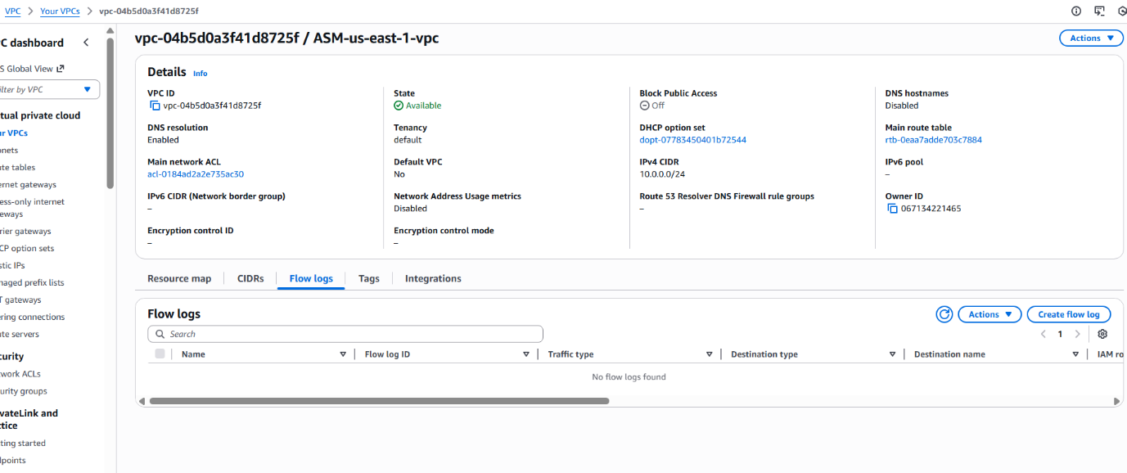
Step 2: Start creating a new Flow Log
Console path:
Flow Logs tab → Create flow log
Explanation:
Begin the process of configuring a new flow log by choosing the VPC, log destination, and log type.

Evidence: 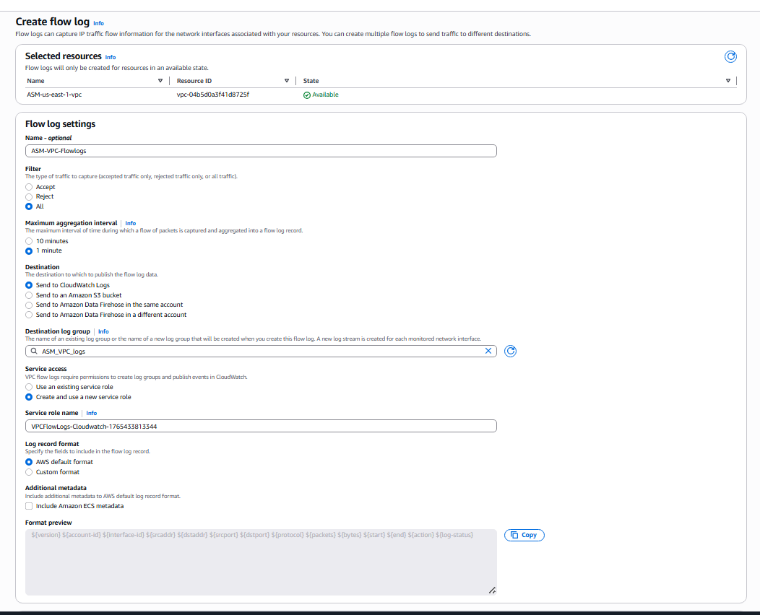
Step 3: Configure Flow Log settings

Explanation:
You set the following:
• Filter: All traffic (captures both ACCEPT and REJECT)
• Aggregation interval: 1 minute
• Destination type: CloudWatch Logs
• Log group name: ASM_VPC_logs
• Service role: New role created by AWS for VPC Flow Logs
• Log format: AWS default format

This ensures all interactions in your VPC are captured and sent to CloudWatch.

Evidence: 
Step 4: Verify the created VPC Flow Log
Console path:
VPC Console → Your VPCs → Flow Logs
Explanation:
After creation, confirm that the flow log is Active, that it is sending to the correct CloudWatch Log Group, and that the IAM role is properly attached.

Evidence: 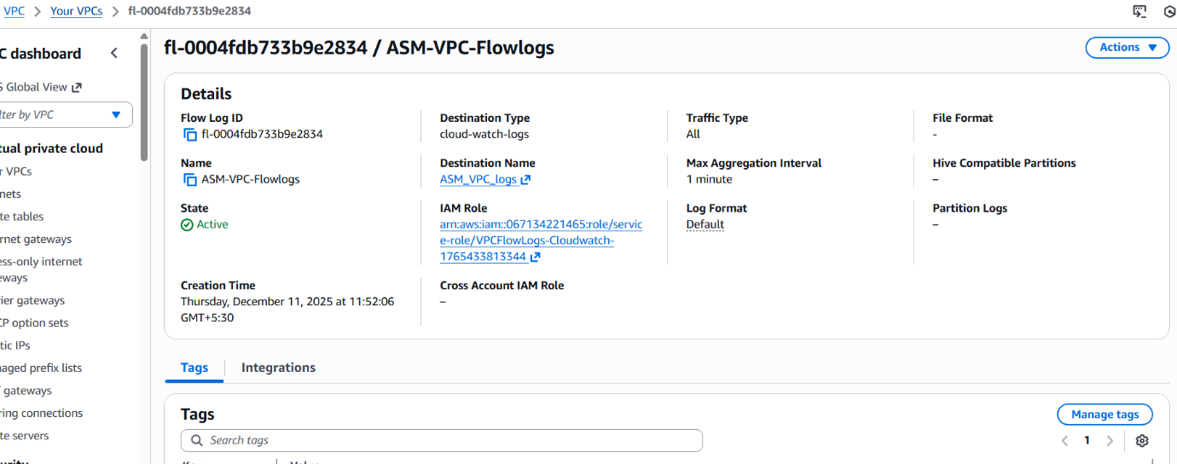Step 5: Verify CloudWatch Log Group creation
Console path:
CloudWatch → Logs → Log groups → ASM_VPC_logs
Explanation:
A log group named ASM_VPC_logs is created, containing one or more log streams. Each log stream corresponds to a network interface (ENI) in your VPC.

Evidence: 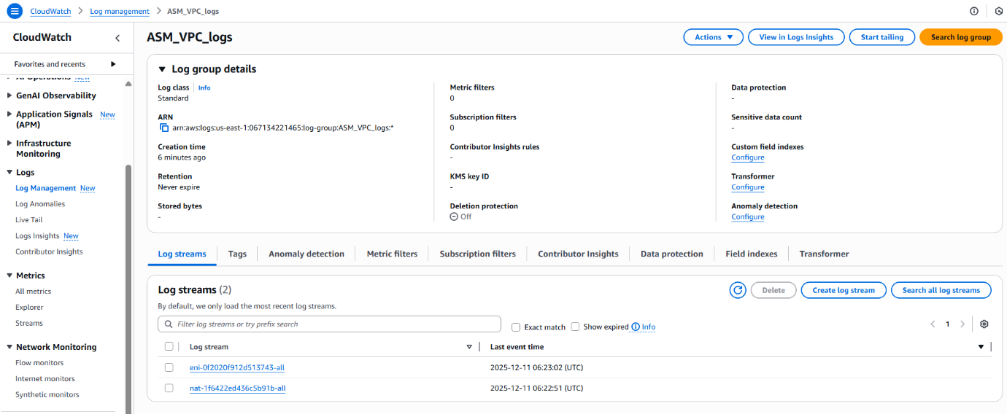
Step 6: Open log streams to view network traffic logs

Console path:
CloudWatch → Log groups → ASM_VPC_logs → Log streams

Explanation:
Each log entry includes fields such as source IP, destination IP, ports, packets, bytes, ACCEPT/REJECT decision, and timestamp.
This confirms that VPC Flow Logs are correctly functioning and delivering real-time traffic data.

Evidence: 
5. Validation: Review flow log event messages
Explanation:
Detailed log records show continuous accepted traffic. This confirms that the flow logs are capturing network interactions across interfaces inside the VPC.

Evidence: 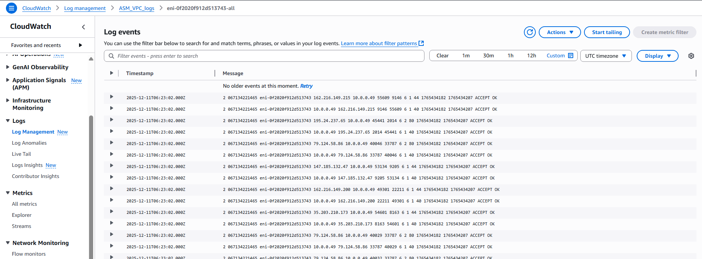
6.Troubleshooting
For this task I have first selected the already existed role which was created earlier, but the result stopped showing on the dashboard, later, I have configured the settings with the new role to be created while configuring ensured the logs fetch on the cloudwatch
7. Conclusion
The VPC Flow Logs were successfully configured to capture all accepted and rejected traffic within the ASM-us-east-1 VPC.
A new CloudWatch Log Group (ASM_VPC_logs) was created automatically, and log streams began receiving traffic data immediately.

- Create monitoring dashboards to monitor CPU utilization and to monitor the Apache service.
1) Task Title:
Configure CloudWatch monitoring and record the CPU utilization and other metrics of EC2.
2) Objective:
To monitor EC2 instance health using CloudWatch, send a custom metric for Apache (httpd) service status, automate metric publishing with cron, and visualize metrics using a CloudWatch dashboard.
3) Prerequisites:
• EC2 instances (public + private) running Amazon Linux
• Apache installed and active on both instances
• AWS CLI configured on EC2
• Cron service installed
4) Step-by-Step Implementation (With Evidence):
Step 1: Verify EC2 instance status and public instance Apache service
Console path / CLI command:
EC2 → Instances → Select public instance
Explanation: Ensures the EC2 instance is running and Apache is active.
Evidence:
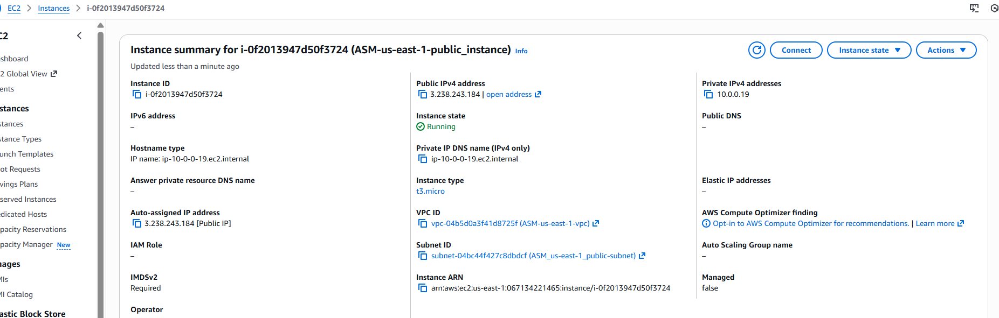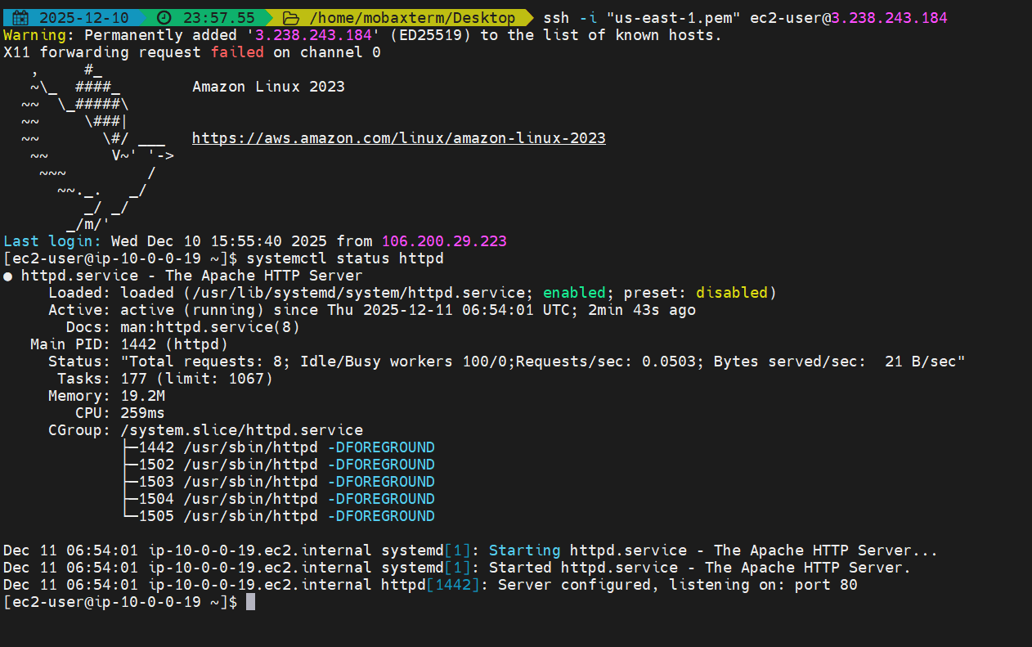
Step 2: Verify private instance Apache service
Console path / CLI command:
EC2 → Instances → Select private instance
Explanation: Confirms the httpd service is active on the backend instance.
Evidence:
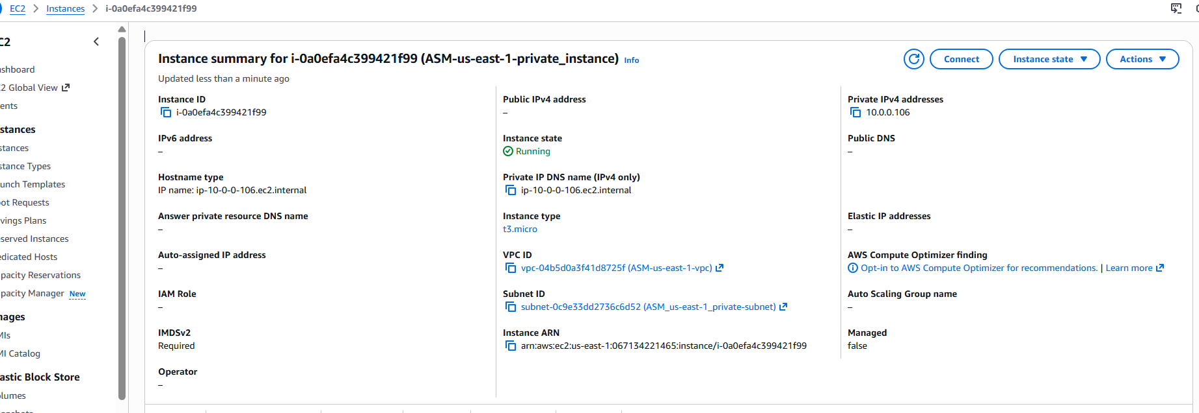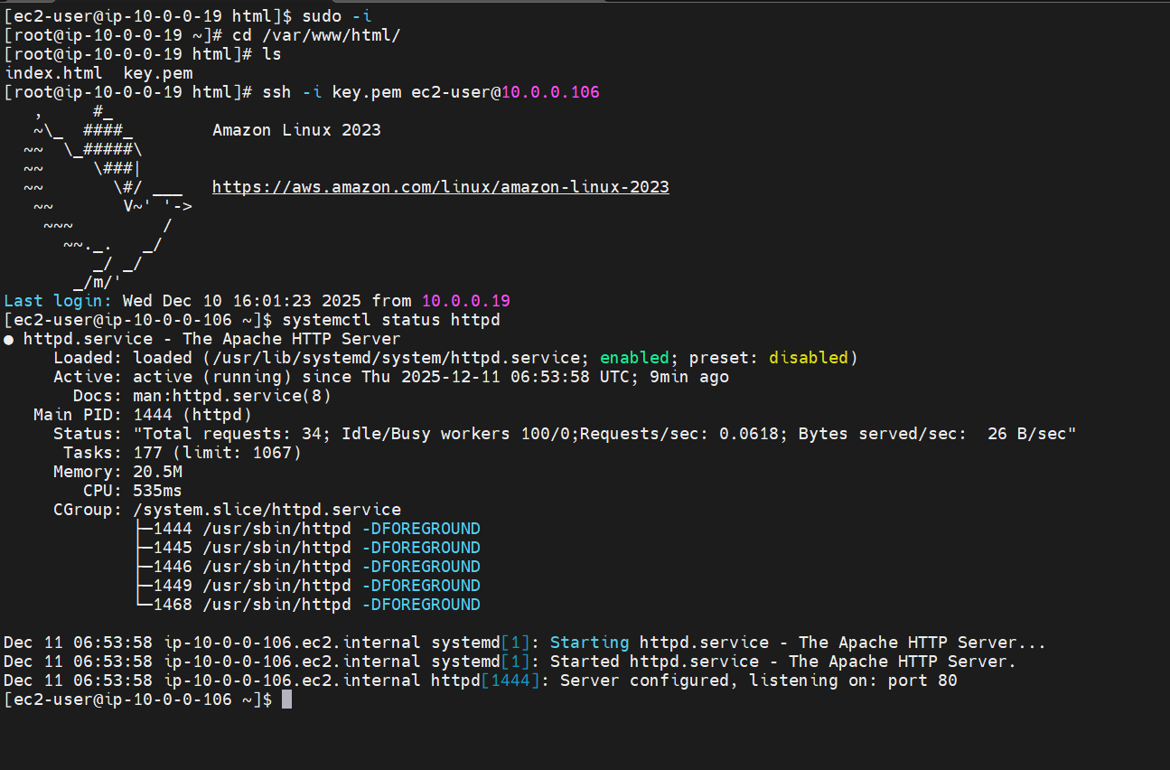
Step 3: Create custom CloudWatch metric script

Console path / CLI command:
vi /home/ec2-user/httpd_cloudwatch.sh
#!/bin/bash
REGION="us-east-1"
NAMESPACE="ApacheService"
METRIC_NAME="httpd_status"
SERVICE_NAME="httpd"
# Use 'command -v' to dynamically find the aws CLI path
AWS_CLI=$(command -v aws)

# Ensure AWS CLI is found
if [ -z "$AWS_CLI" ]; then
echo "Error: AWS CLI not found in PATH." >&2
exit 1
fi

# Fetch Instance ID (IMDSv2) - assumes successful execution
TOKEN=$(curl -s -X PUT "http://169.254.169.254/latest/api/token" \
-H "X-aws-ec2-metadata-token-ttl-seconds: 21600")
INSTANCE_ID=$(curl -s -H "X-aws-ec2-metadata-token: $TOKEN" \
http://169.254.169.254/latest/meta-data/instance-id)

# Check Apache Status
if systemctl is-active --quiet "$SERVICE_NAME"; then
STATUS=1
else
STATUS=0
fi

# Push Metric to CloudWatch
"$AWS_CLI" cloudwatch put-metric-data \
--region "$REGION" \
--namespace "$NAMESPACE" \
--metric-name "$METRIC_NAME" \
--value "$STATUS" \
--dimensions Name=InstanceId,Value="$INSTANCE_ID"

if [ $? -eq 0 ]; then
echo "Metric pushed successfully. Status: $STATUS"
else
echo "Failed to push metric to CloudWatch." >&2
fi
Explanation: Script that checks Apache status and pushes metric to CloudWatch.
Evidence:
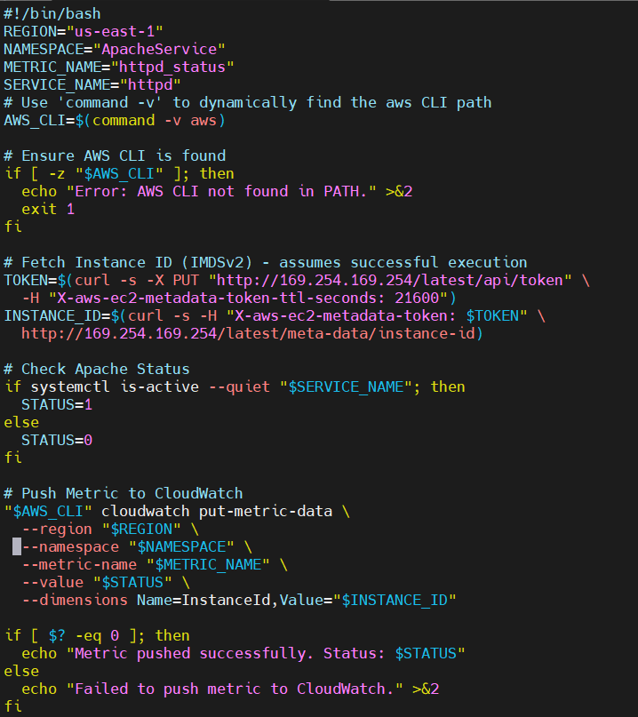
Step 4: Install cron and configure scheduled execution
Console path / CLI command:
sudo yum install cronie -y
Explanation: Installs cron to schedule periodic metric pushes.
Evidence:
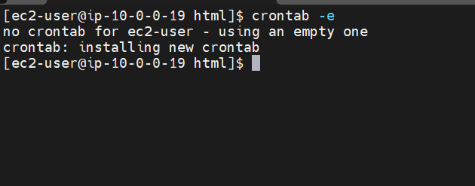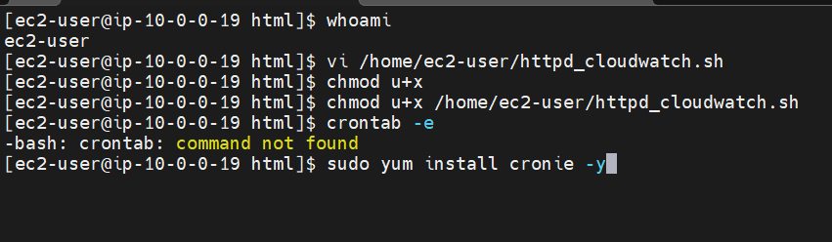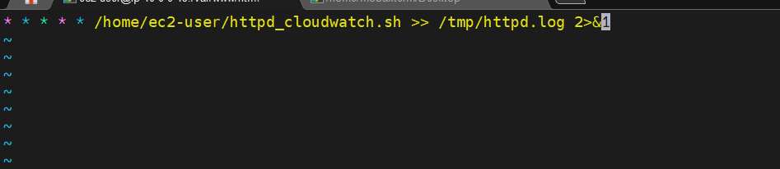
Step 5: Configure AWS CLI & test script
Console path / CLI command:
aws configure
./httpd_cloudwatch.sh
Explanation: Ensures the script can authenticate and push metrics.
Evidence:
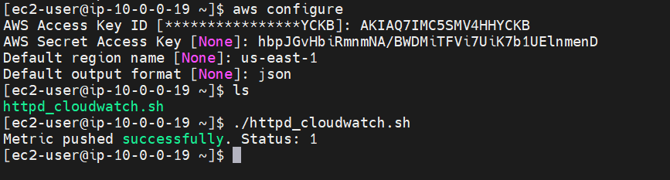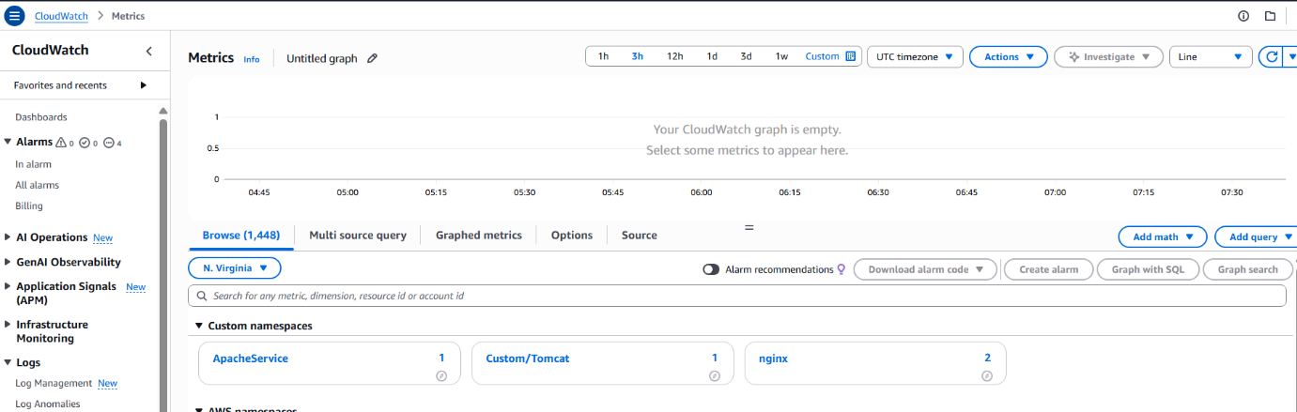

Step 6: View metric in CloudWatch metrics

Console path / CLI command:
CloudWatch → Metrics → Custom namespace (ApacheService)
Explanation: Confirms metric is being received.
Evidence:
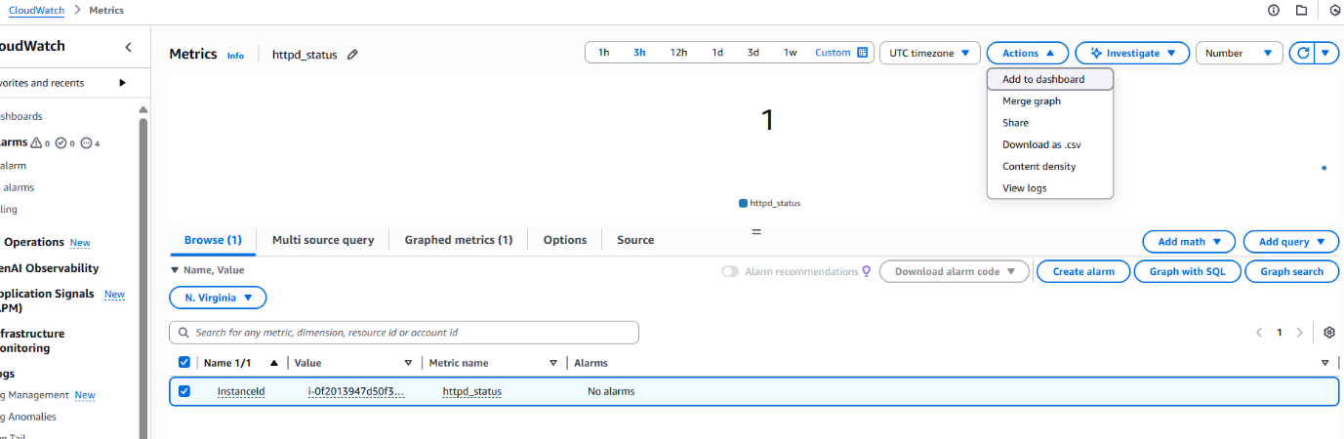
Step 7: Add the metric to dashboard

Console path / CLI command:
Actions → Add to dashboard
Explanation: Visualizes the httpd_status metric.
Evidence:
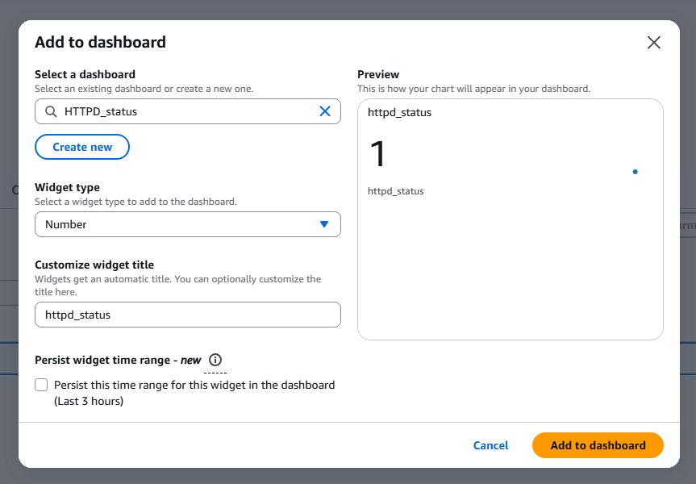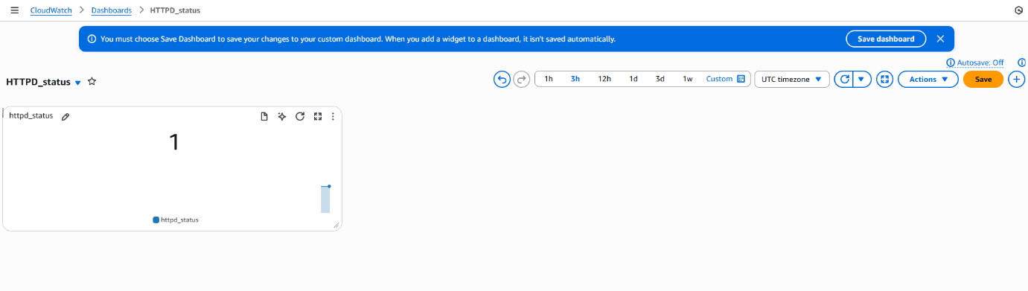
5) Validation Steps (Mandatory, With Evidence):
Validation 1: Resource Health

Example: EC2 instance state is "Running", status checks passed.
Evidence: 

Validation 2: Functional Check

Example: Apache service is active on both instances.
Evidence: 

Validation 3: Network Check

Example: Metric appears in CloudWatch metrics page.
Evidence: 

Validation 4: Access Check

Example: AWS CLI successfully pushed metrics after configuring credentials.
Evidence: 

6) Issues Faced (Optional):

• Cron was missing, causing “crontab: command not found”.
• Script initially failed due to missing AWS CLI credentials.
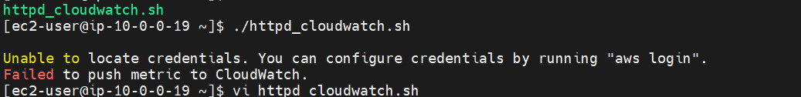
7) Conclusion:

CloudWatch monitoring for EC2 instances was successfully configured.
Apache service health was captured using a custom metric script and automated using cron.
Metrics were visualized on a CloudWatch dashboard, providing real-time monitoring of instance CPU utilization and httpd service status

- If CPU utilization is more than 70%, then it should trigger auto scaling and launch new instance.
1) Task Title:
Configure Auto Scaling to trigger when CPU Utilization exceeds 70%
2) Objective:
To create a fully functional Auto Scaling Group (ASG) that automatically increases the number of EC2 instances whenever CPU Utilization > 70%, ensuring high availability and elasticity of the application.
3) Prerequisites:
A working VPC with public subnets
SSH key pair
Security group allowing HTTP/SSH
4) Step-by-Step Implementation (With Evidence)
Step 1: Create a Launch Template
Console path:
EC2 Dashboard → Launch Templates → Create launch template

Explanation:

A launch template defines the AMI, instance type, key pair, network, and security group. This template will be used by Auto Scaling to launch new instances.

Evidence: 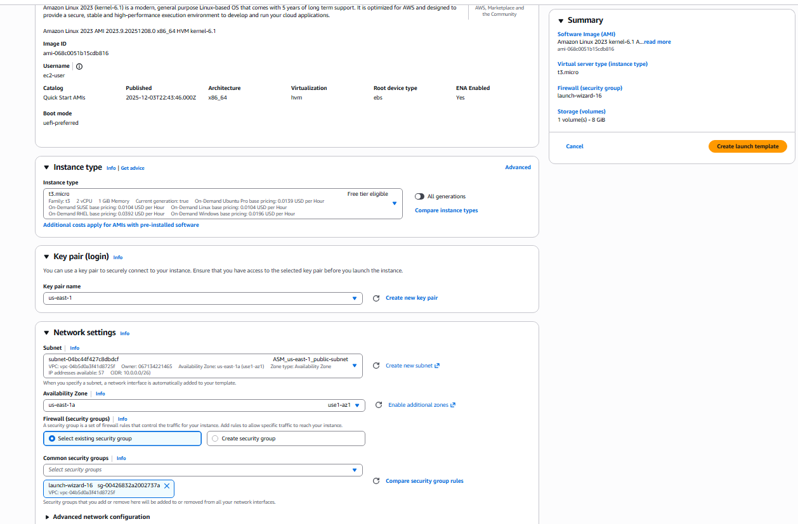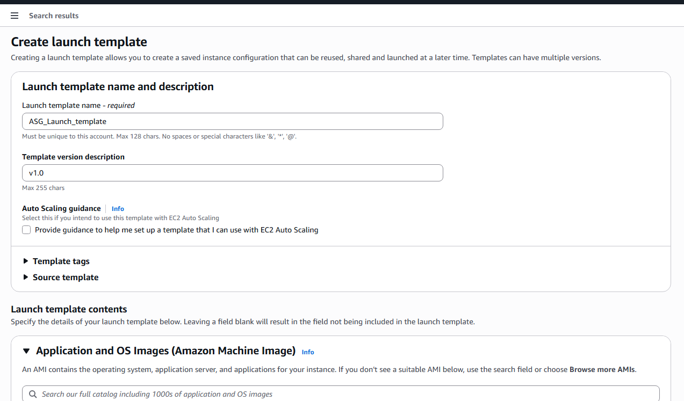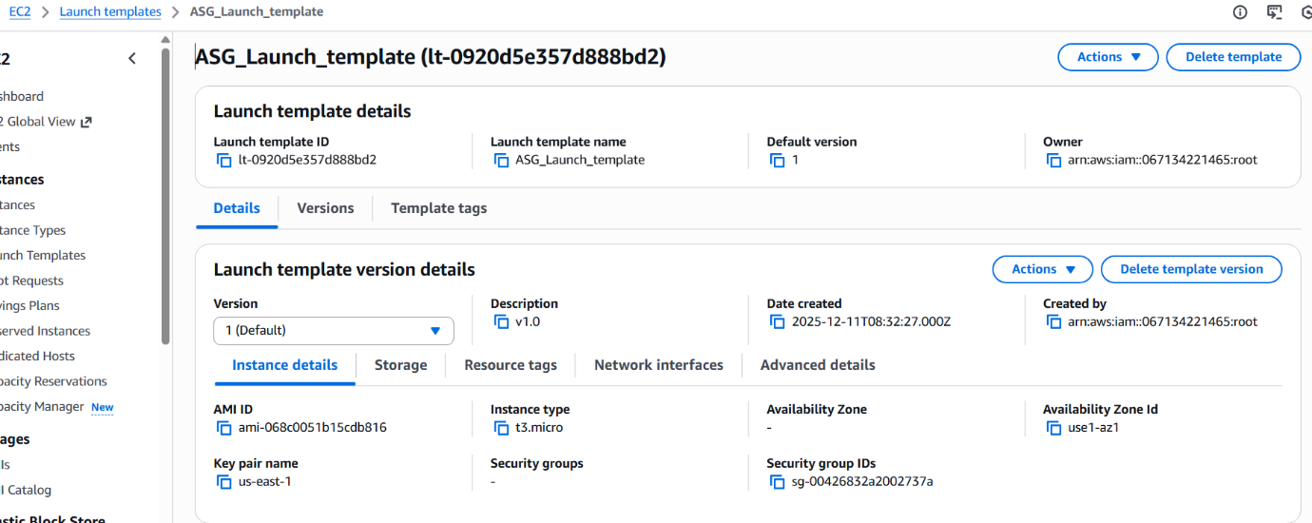

Step 2: Create an Auto Scaling Group using Launch Template
Console path:
EC2 Dashboard → Auto Scaling Groups → Create Auto Scaling Group
Explanation:
Here, we attach the launch template, choose AZs and subnets, and configure scaling behaviors.

Evidence:
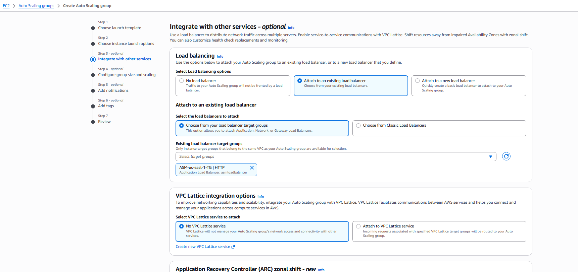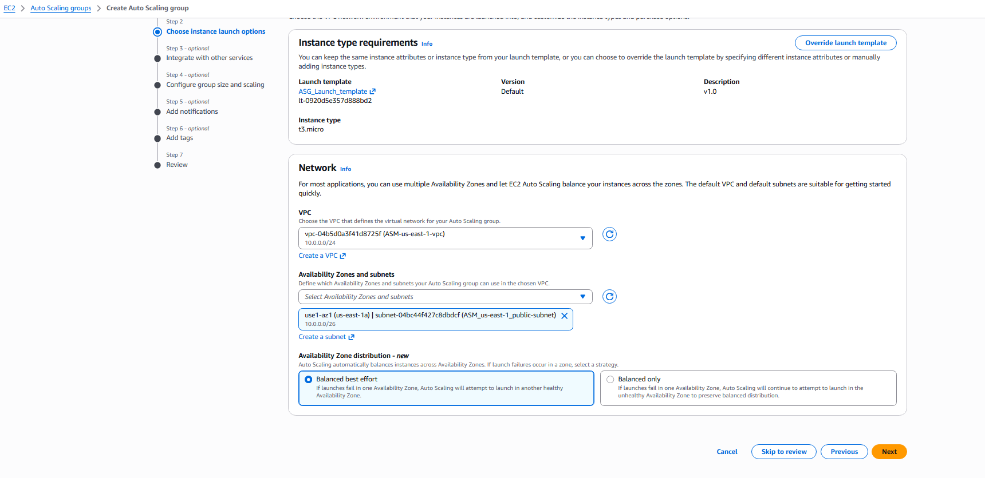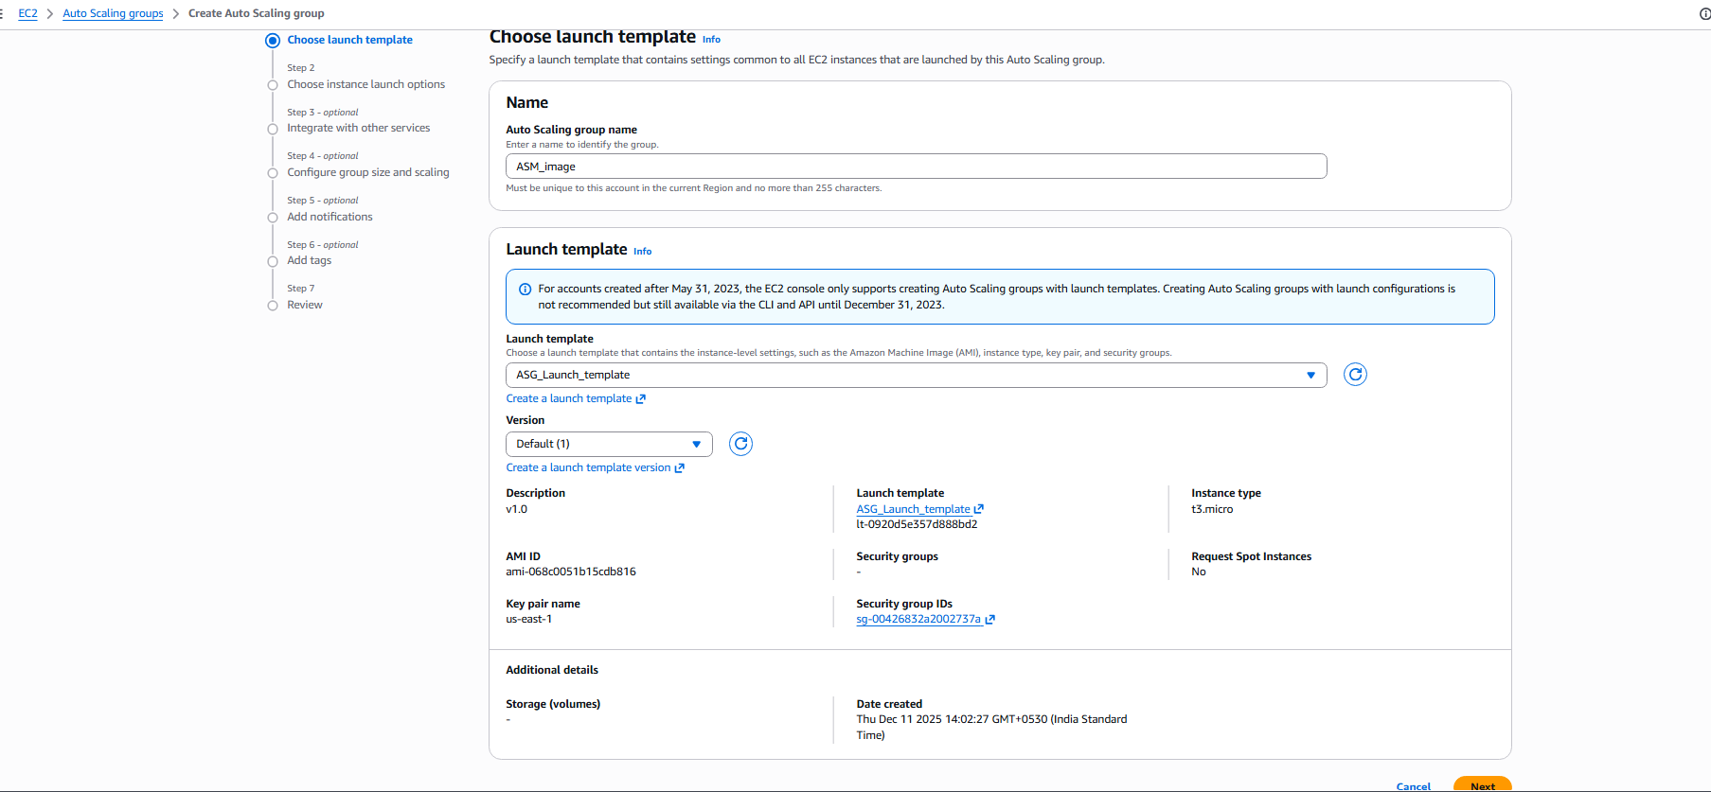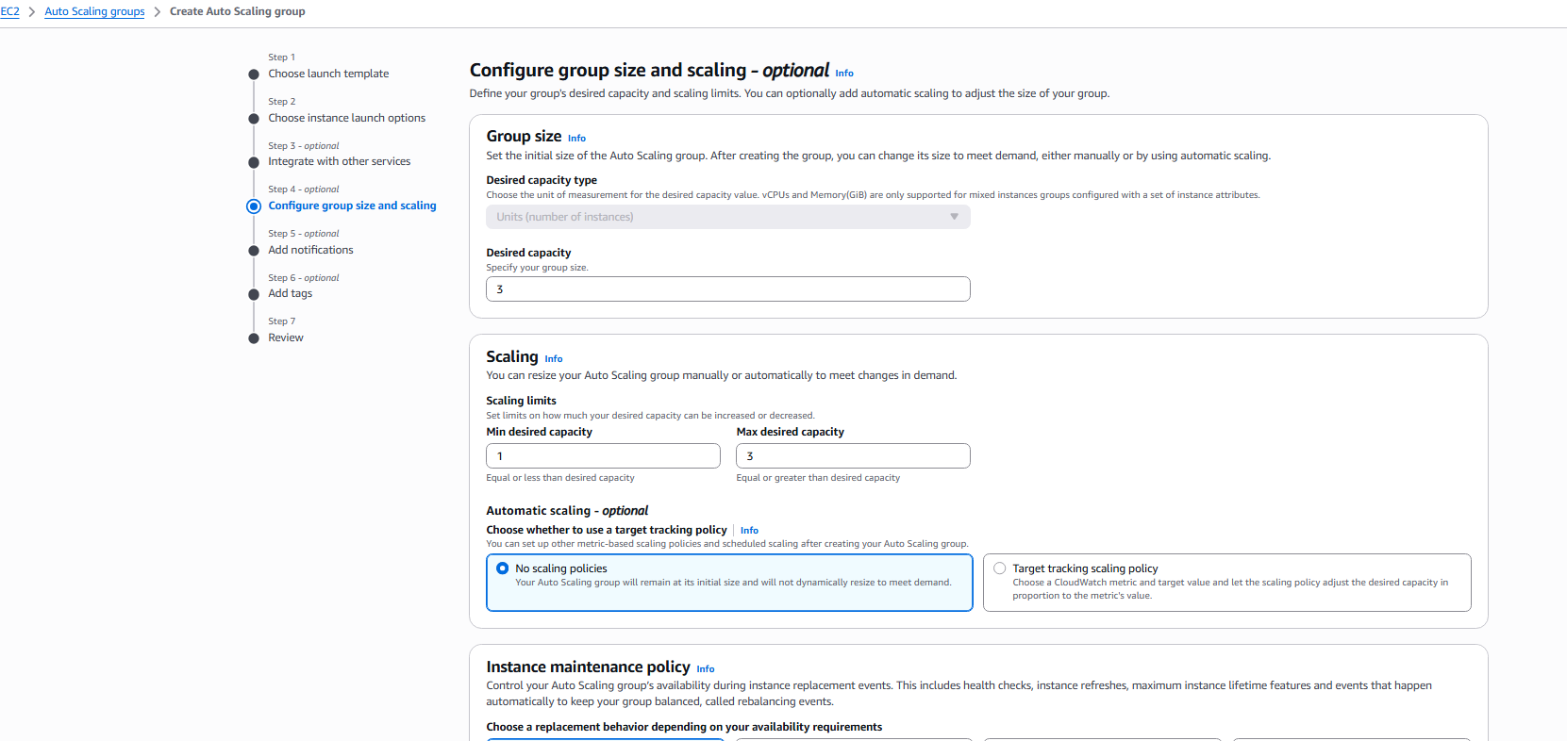

Step 3: Configure Target Tracking Scaling Policy (CPU > 70%)
Console path:
Auto Scaling Groups → Select ASG → Automatic Scaling → Add policy
Explanation:
A target tracking policy keeps CPU utilization close to a target value.
If CPU consumption exceeds 70%, ASG automatically launches more EC2 instances.
Evidence: 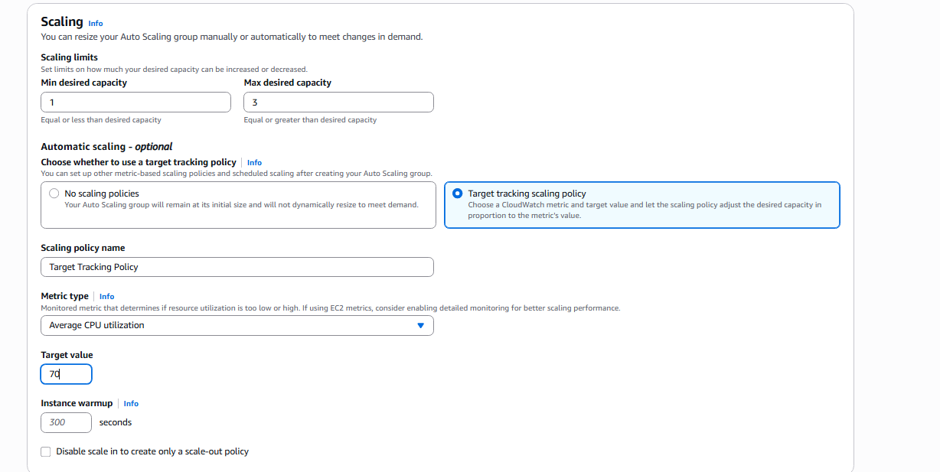

Step 4: Complete ASG Creation & Validation
Console path:
Auto Scaling Groups → View ASG detail
Explanation:
Once creation completes, ASG shows desired/min/max capacities and instance lifecycle.
Evidence: 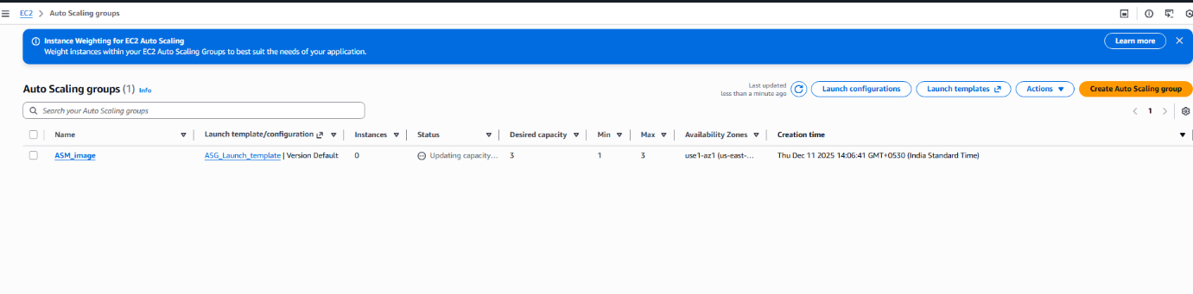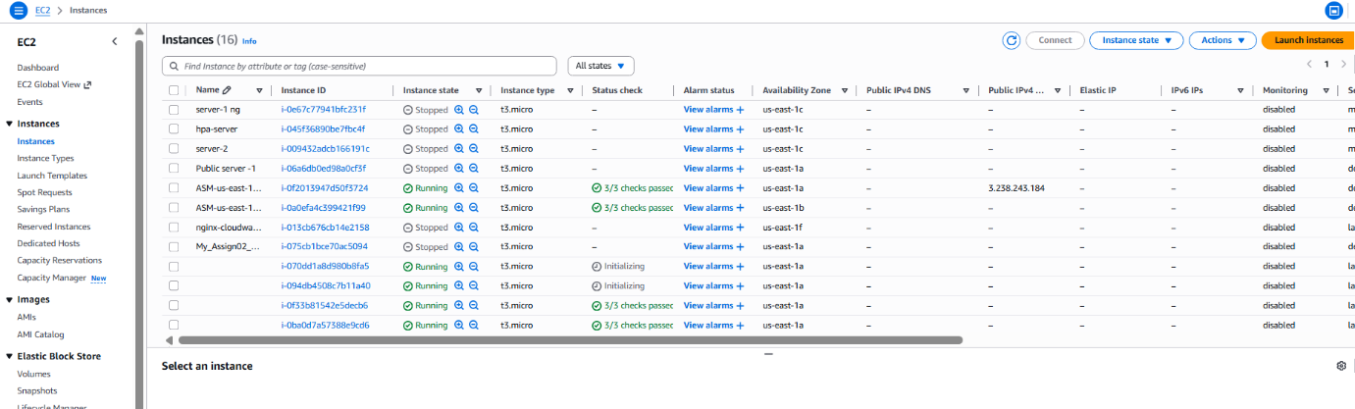

5) Validation Steps (Mandatory, With Evidence)
Validation 1: Resource Health
Check ASG → Activity tab
Confirm that instances launch successfully
Health status shows Healthy
Evidence:

Validation 2: Functional Check
SSH into an instance → Confirm application or Apache server runs (if installed).
Example:
systemctl status httpd
Evidence:
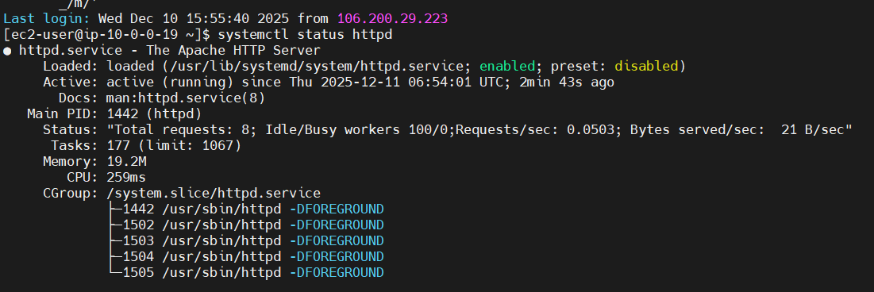
Validation 3: instance launched 

6) Issues Faced (Optional):
None at this stage, ASG creation and policy configuration completed successfully.
I have executed the stress commands on instance
stress --cpu 2 --timeout 200 without installing stress binary and installed the binary using sudo yum install stress -y to make the command execution possible.
7) Conclusion:
We successfully configured an Auto Scaling Group using a launch template to automatically increase EC2 instances when CPU Utilization exceeds 70%. The ASG correctly launched additional instances, ensuring application reliability and elasticity during high traffic or processing loads. This demonstrates a fully functioning auto-scaling workflow integrated with CloudWatch metrics.

