CloudFront&Route53-Assignment-1
- Configure VPC peering in cross regions.
Go to vpc-> create VPC
Created the VPC with names VPC-Cross-region-Us-east-1 and IPV4 CIDR range 10.0.0.0/24
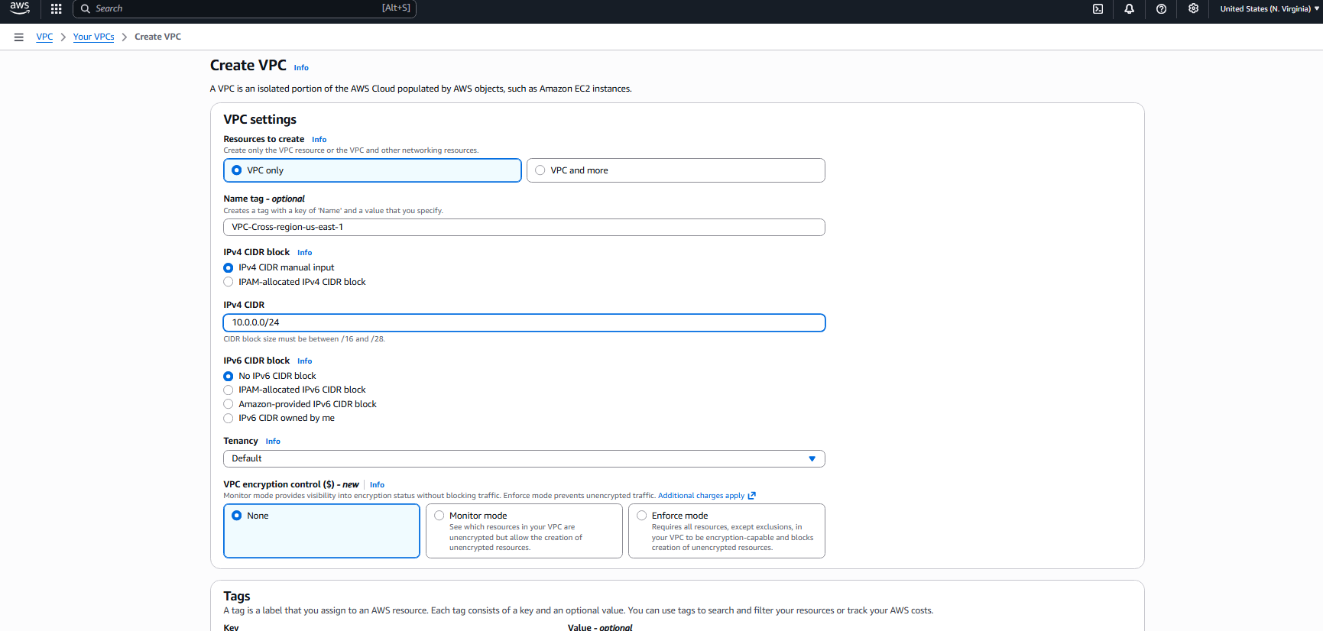
The vpc created as follows: 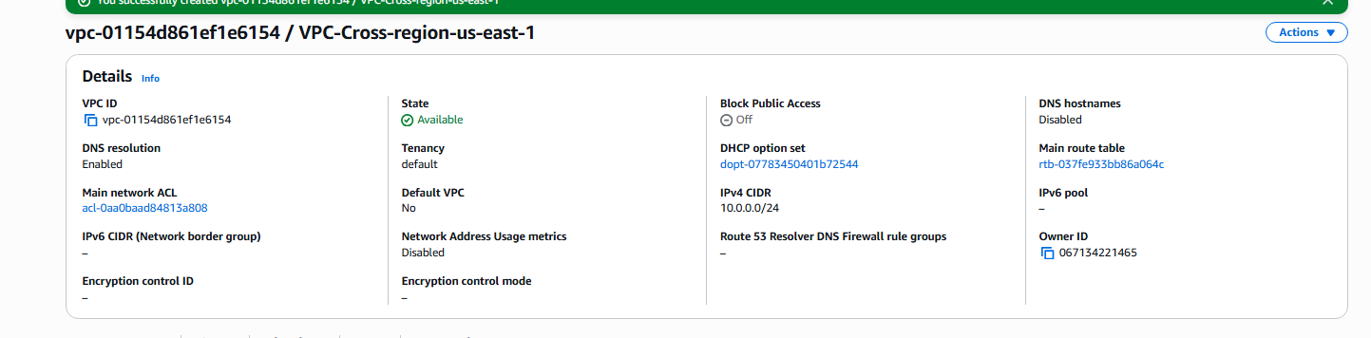

Created the public and private subnets of ranges 10.0.0.0/25, 10.0.0.128/25
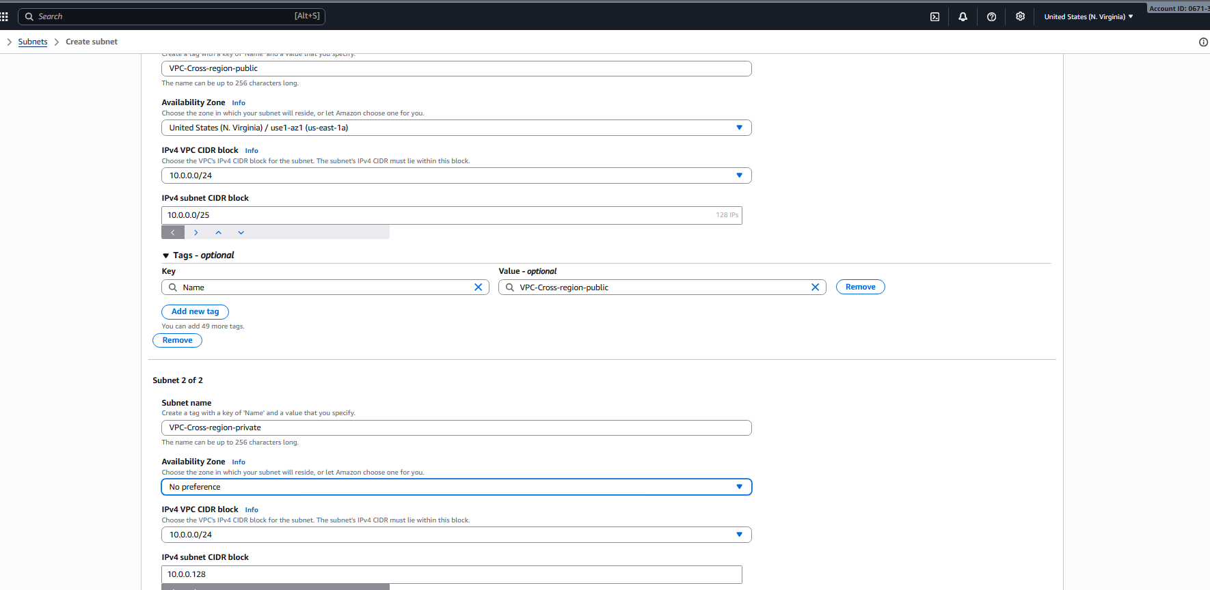
The subnets created as follows
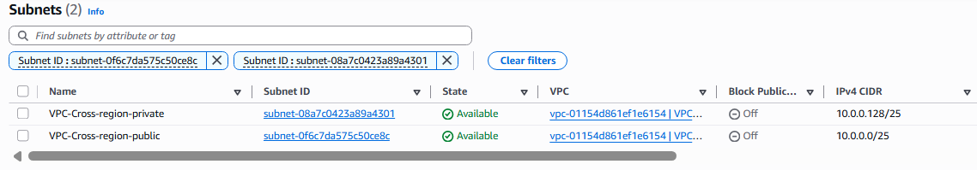
Created a Route table for the public subnet as follows and also connected to internet gateway
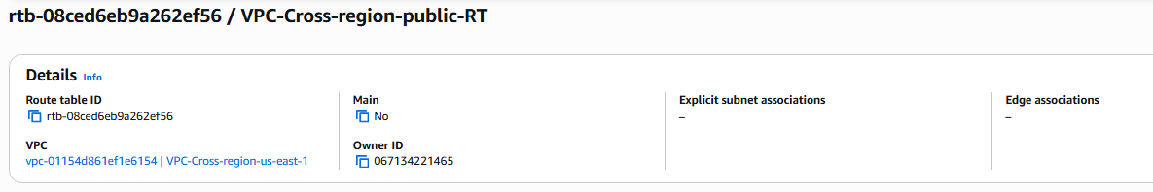
Created a route table for the private subnet as follows
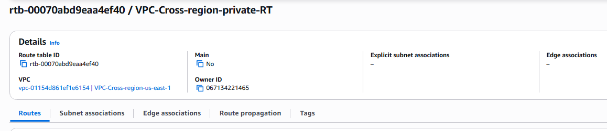

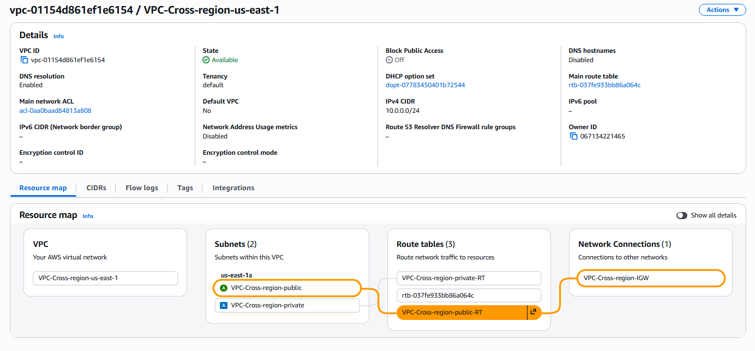
Go to vpc-> create VPC
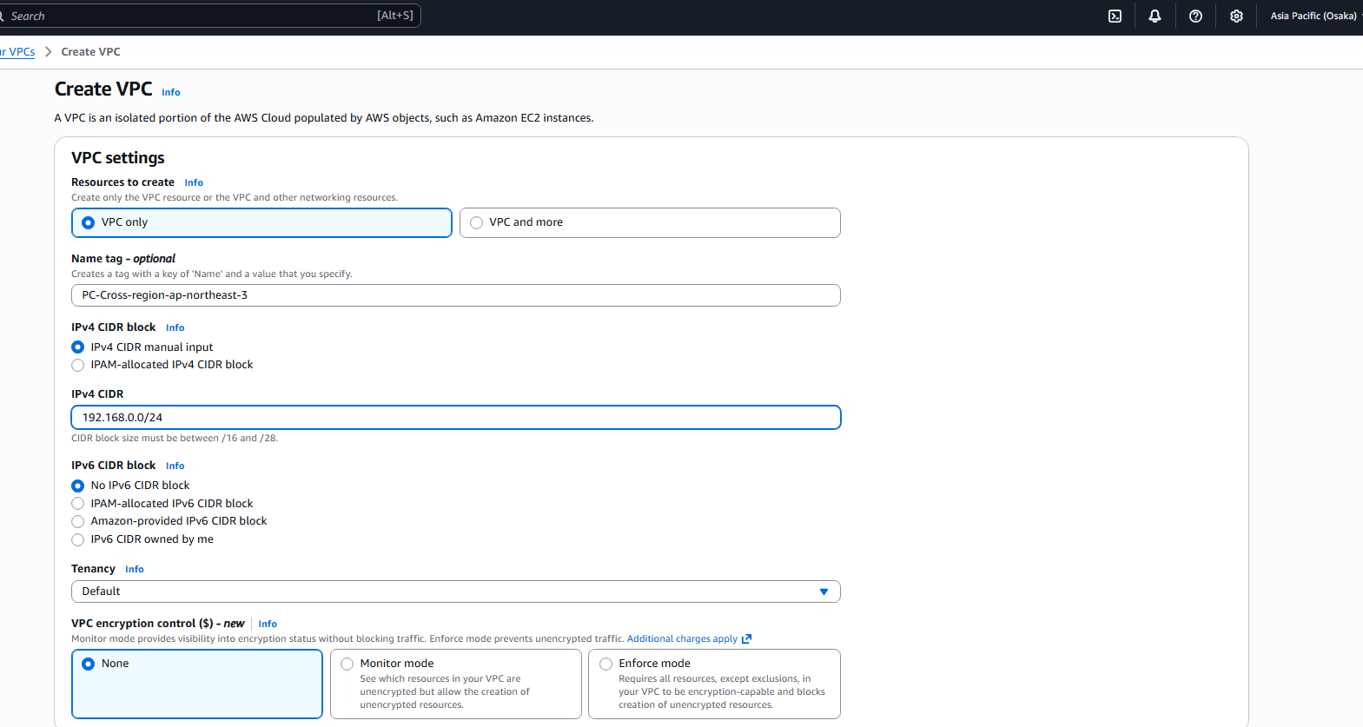
Created the VPC with names VPC-Cross-region-ap-northeast-3 and IPV4 CIDR range 198.168.0.0/24

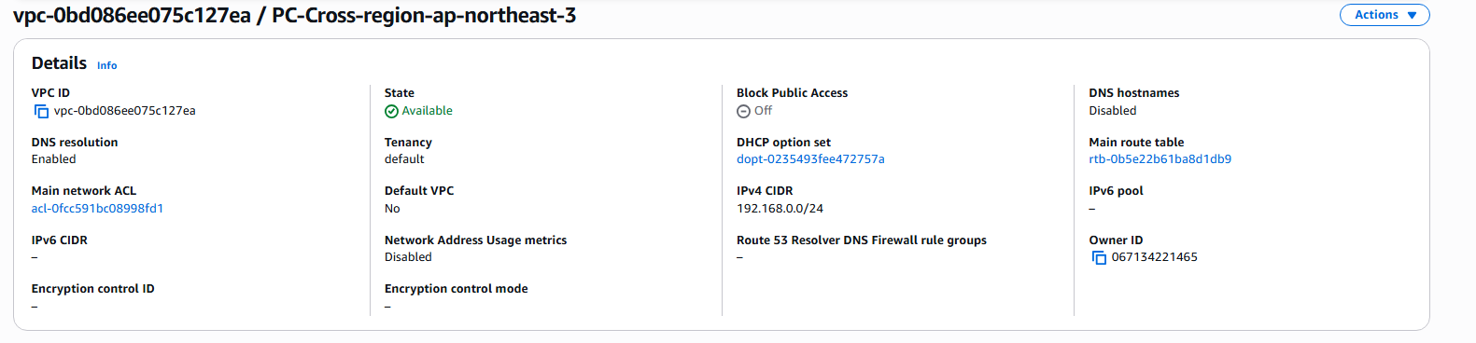
The private and public subnets created are as follows
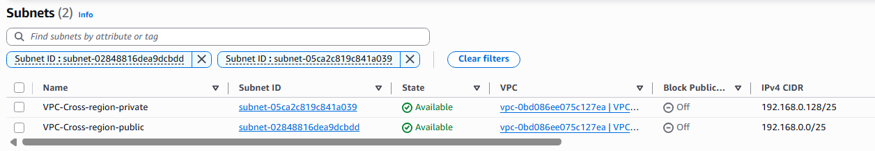
Created a Route table for the public subnet as follows and also connected to internet gateway
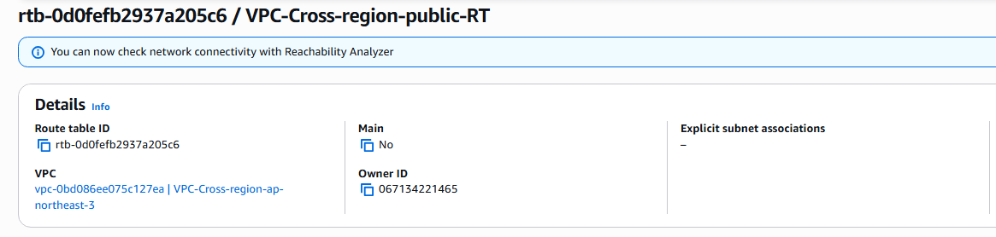
Created a route table for the private subnet as follows
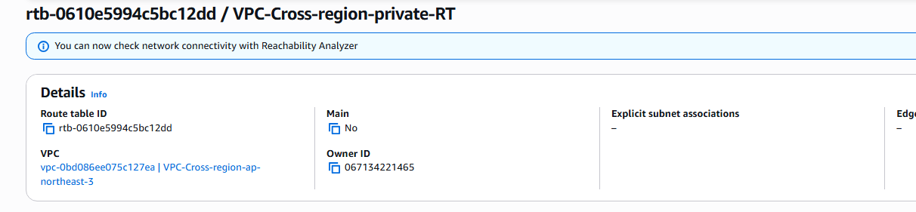
The vpc_cross-region-ap-northeat-3 details are as follows containing the resource map with subnets routetables are as follows
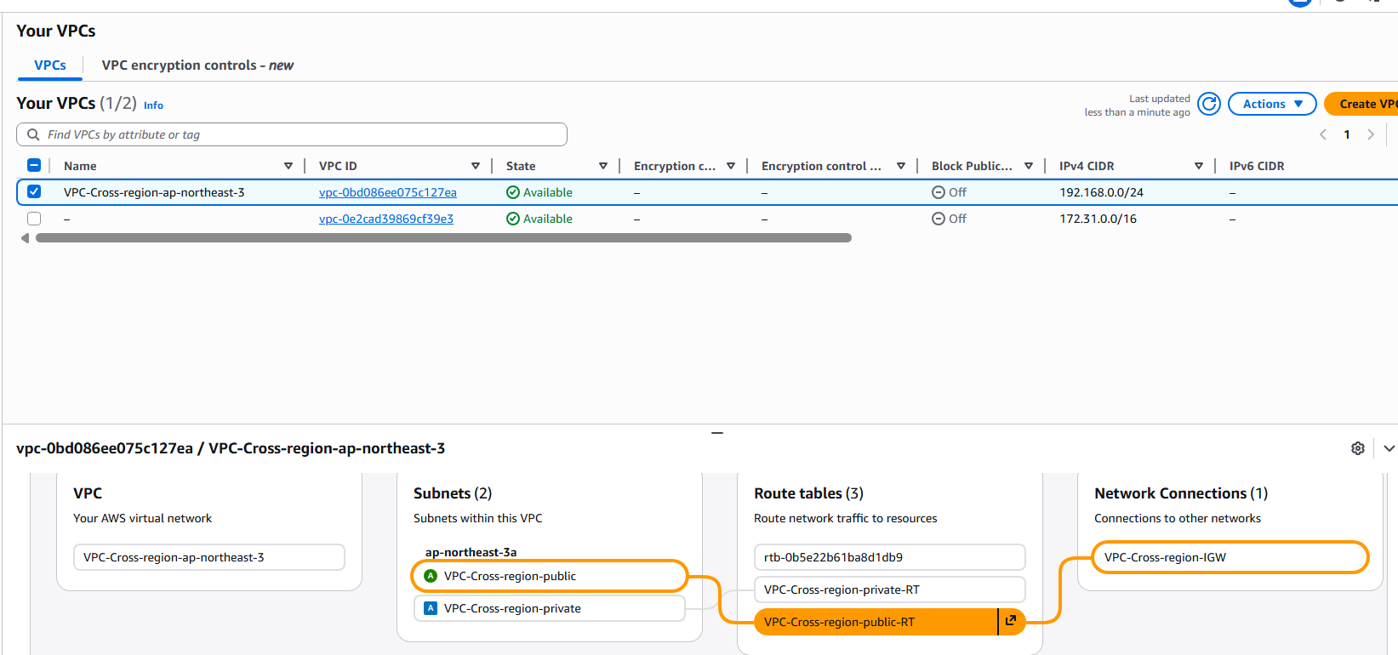

Now go to peering connection in the us-east-1 to initiate the peering request to the osaka region’s vpc, click the create peering connection and select the source vpc and select ‘same account’ and also select the region ‘osaka’ and give the destination vpc id and make request. The vpc peering connection has been requested as follows
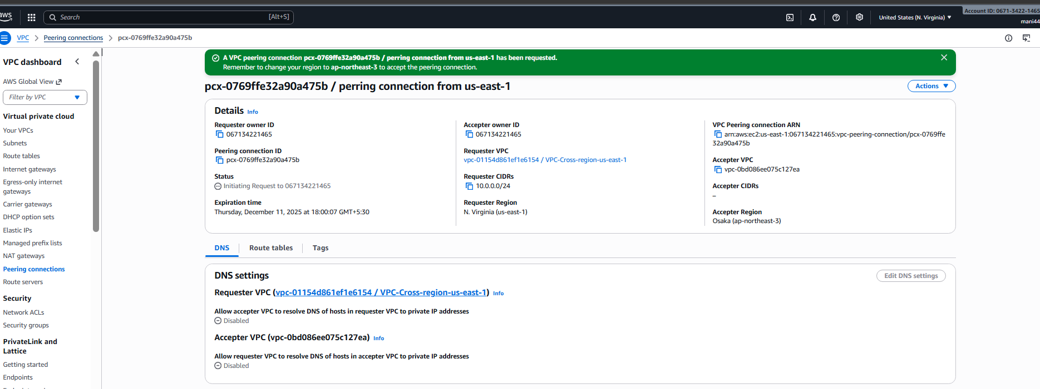
Now go to region osaka and go to peering connection to see the request from the us-east-1 vpc, go to Actions and click accept request
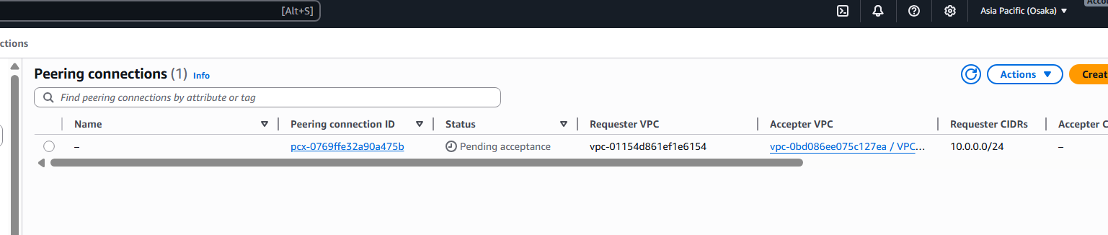
After the request is accepted we can see the that the vpc connection has been established.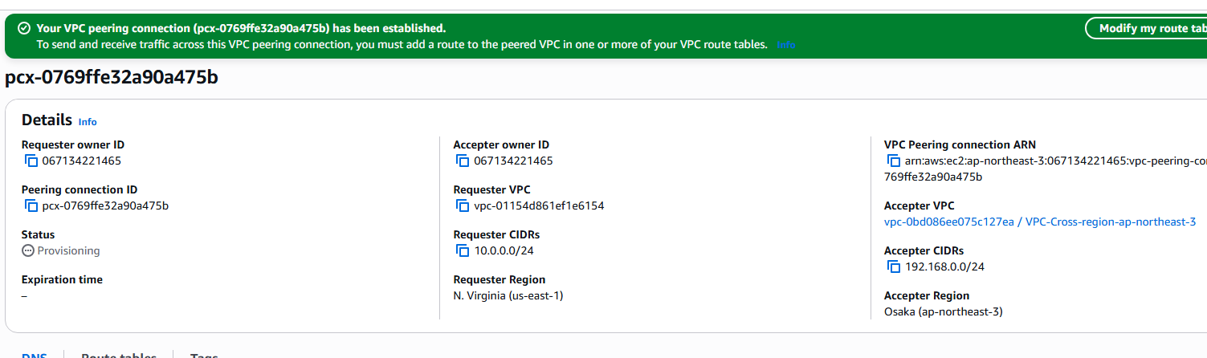
Now launch the instance in the vpc-1 in the public instance, I want to make the ping request from the vpc-1 to the private instance in the vpc-2. The instance in vpc-1 is launched as foll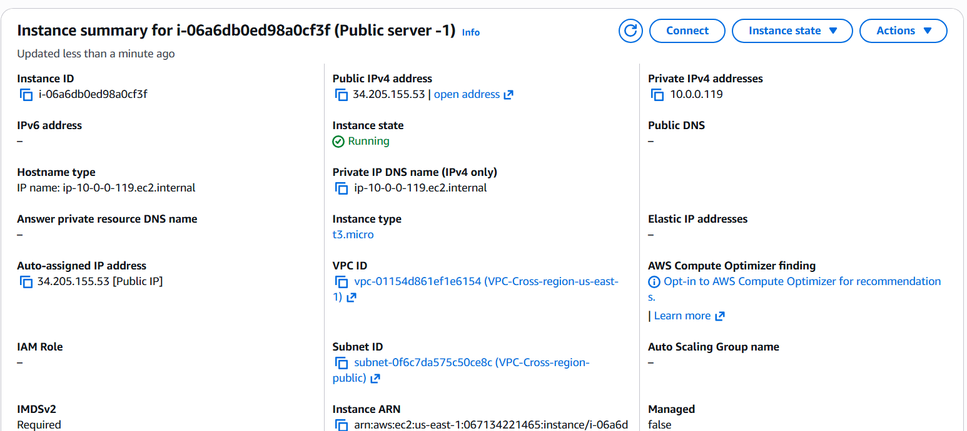
Now launch the instance in the vpc-2 ie.. osaka region in the private subnet. The instance launched is as follows
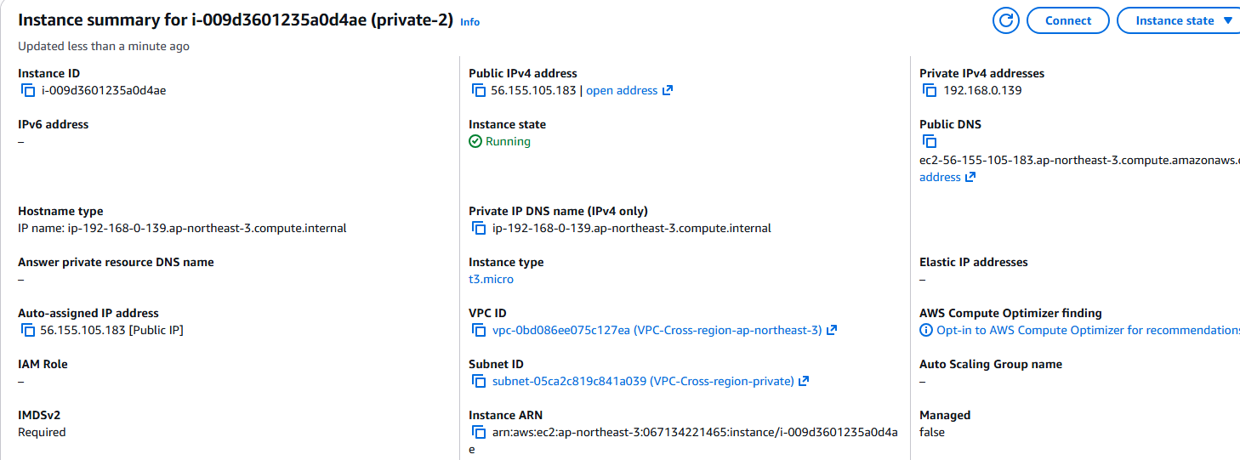
Now edit the routes in the private subnet in the us-east-1 with the vpc address in the peering connection target section. And save changes

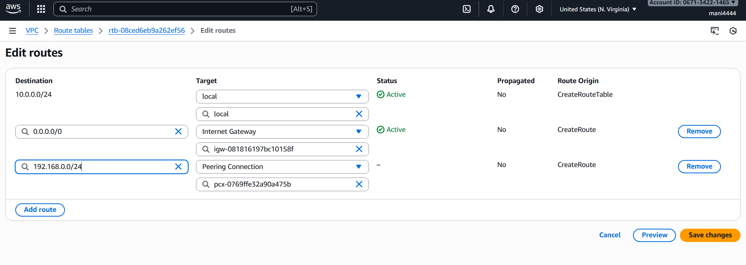

Now change the enter the vpc address of us-east-1 in the Osaka regions private route table in the target section peering connection and click save changes
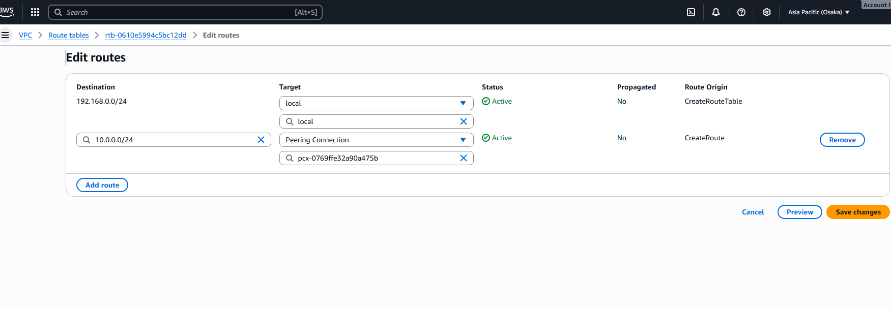
Log on to the vpc-1 public instance and initiate the ping request to the Osaka region’s private instance
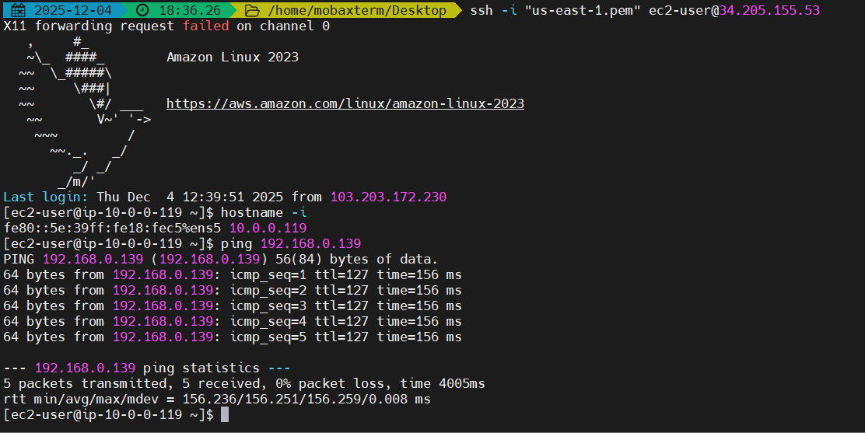
Troubleshooting steps:
At first, I have not changed the security group inbound rules, thinking the logon would be successful but later updated the ssh port as well as all traffic in the security group and also updated the same in the Osaka region private instance as well.
I have updated the route table in the public route table in the Osaka region and tried to make the ping request but I realised that I have to update the private Route table to make the ping request in the private subnet.

- Purchase one domain from GoDaddy.
Go to GoDaddy.com and signup for GoDaddy and search for the domain you want to buy.
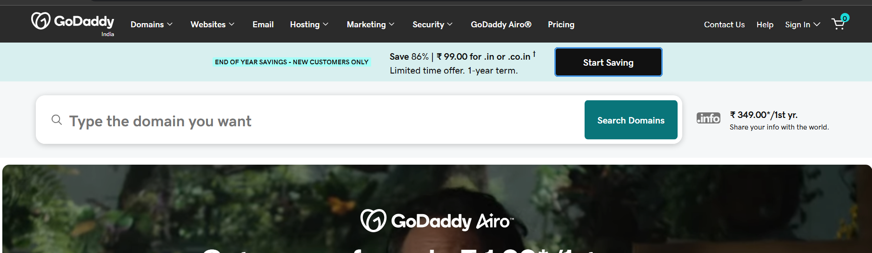

I have selected maninder4444.in as by domain and added to cart and have made the purchase succesfuly
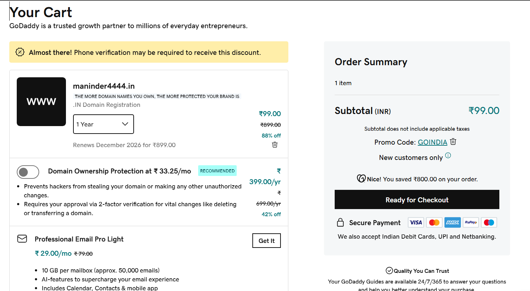

After the purchase, signin to the GoDaddy homepage to see the dashboard
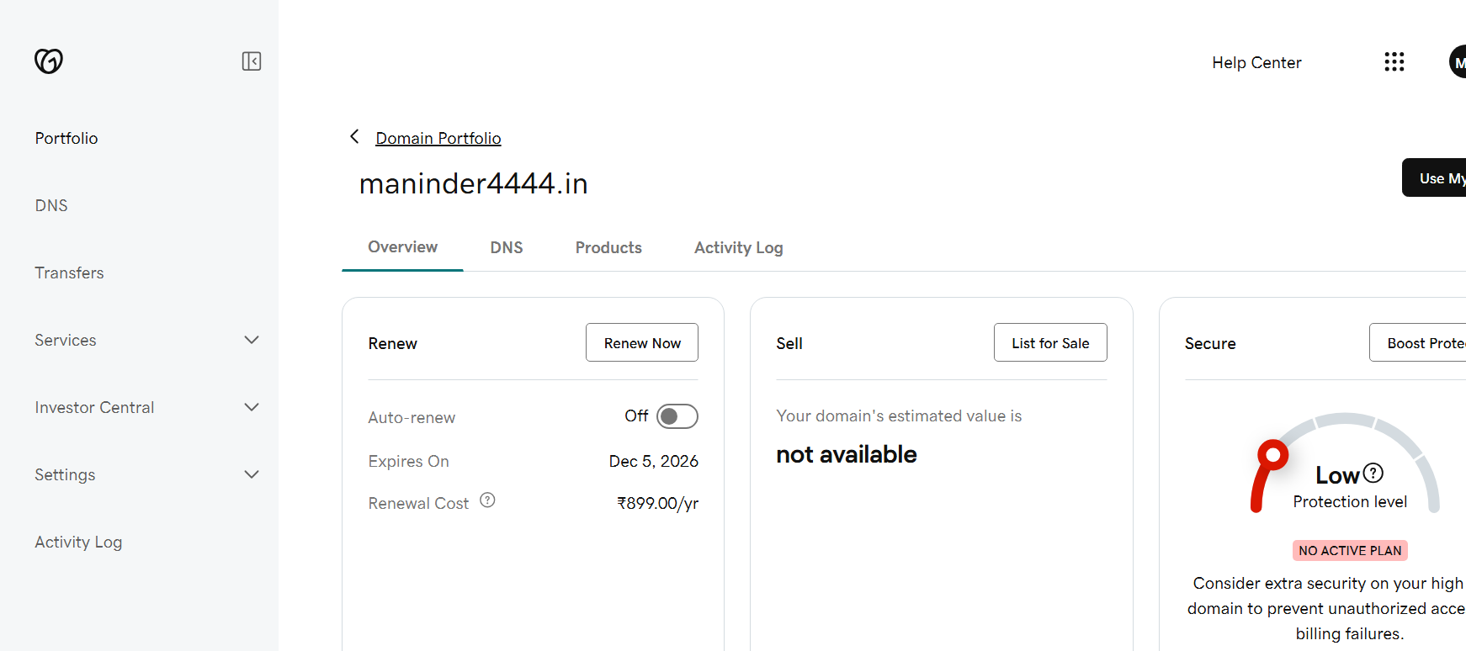
- Deploy static website in S3.
Downloaded the html code from https://www.tooplate.com/view/2150-living-parallax
Go to S3 service and click ‘create bucket’ and create the bucket with unique name and upload the html code files into the bucket.

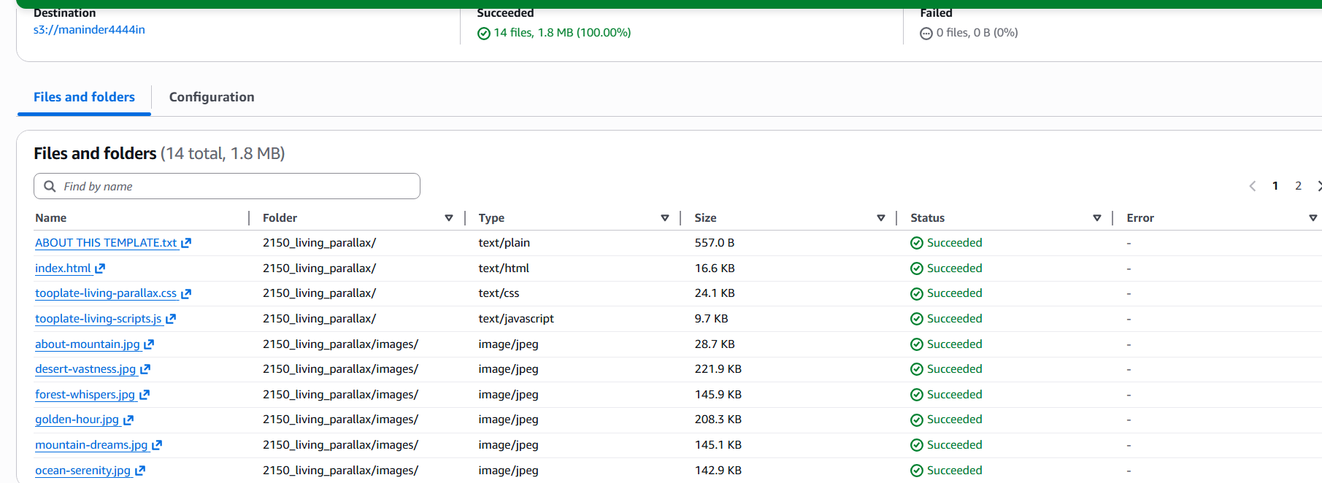

Select all the files and make the files public, Goto Actions-> make public using ACL
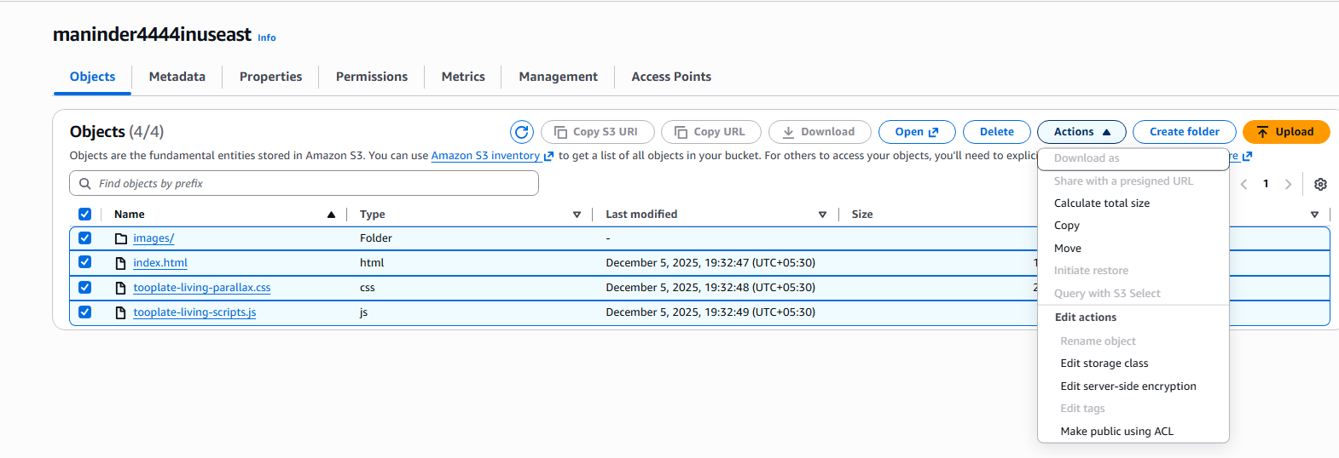
Now goto the bucket properties and go to static website hosting and enable it 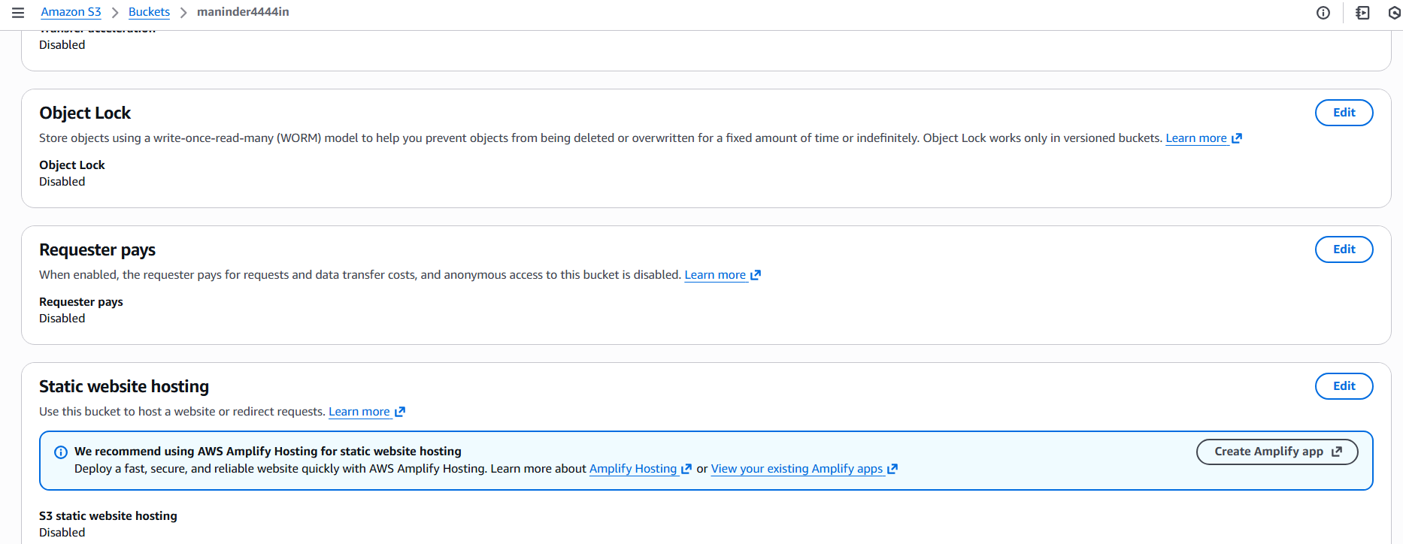
After enabling it, enter the index document (index.html) and the error.html
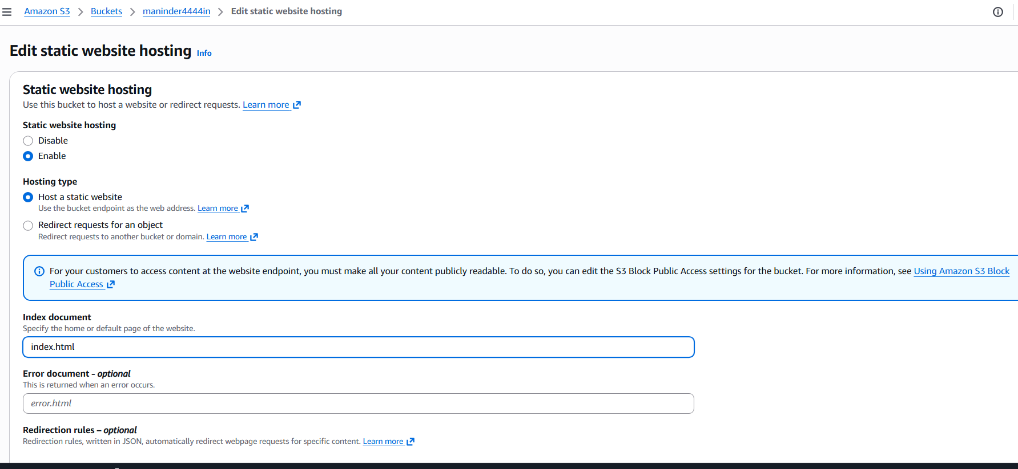

Now go to the bottom of the properties section and we can see the static website link as follows
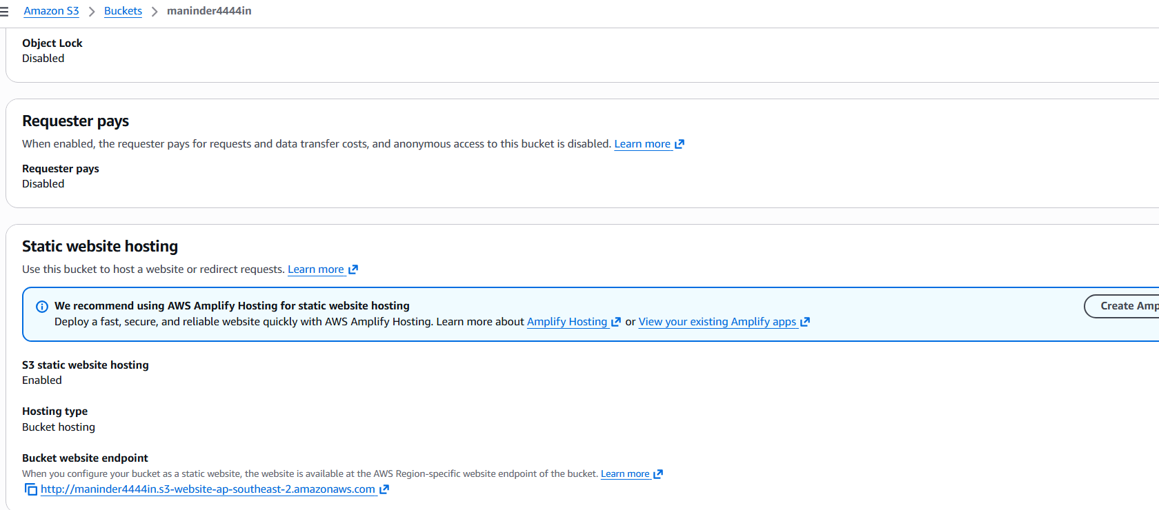
Now copy the address and paste it the URL section in the browser and click enter to lauch the static website from the S3
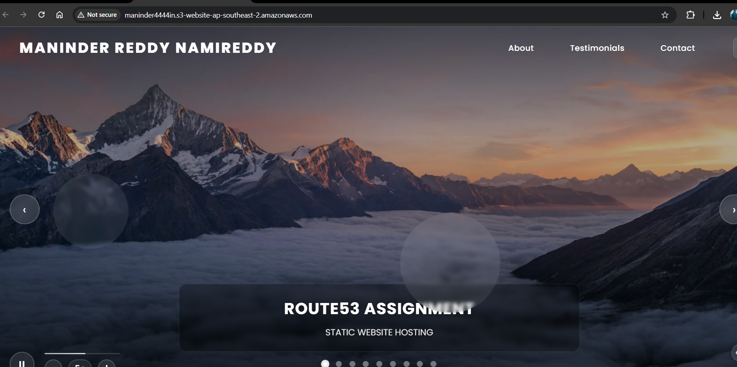

- Create a CDN and attach one SSL certificate.
Now we want to create the distribution and attach the ssl certification to the distribution created.
So go the AWS certificate Manager from the us-east-1 location and go to the certification and click Request certification.
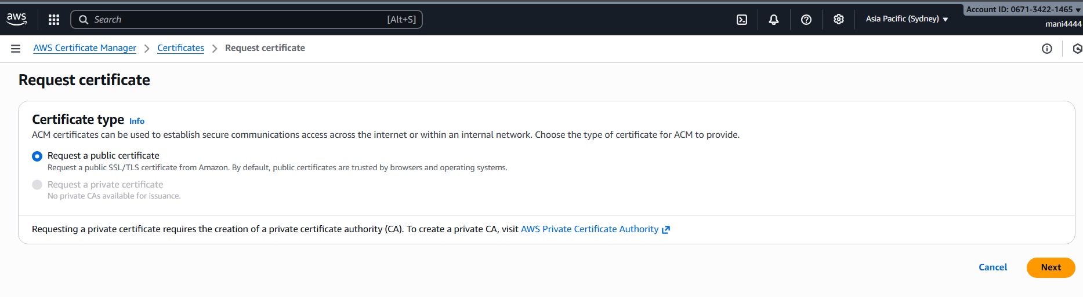
Enter the domain name which we have procured earlier (maninder4444.in) and select 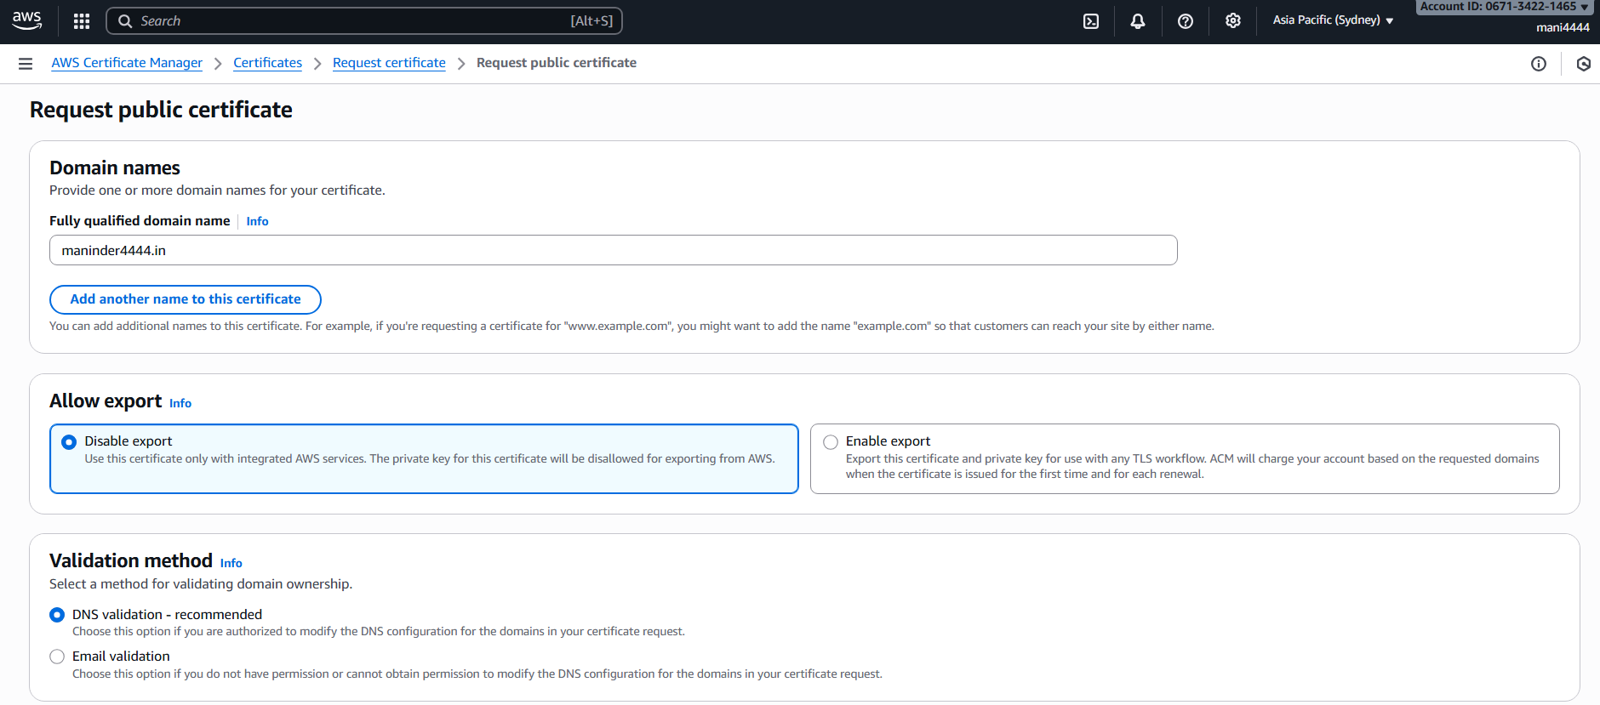
After the request has been made we can see the certificate is pending as follows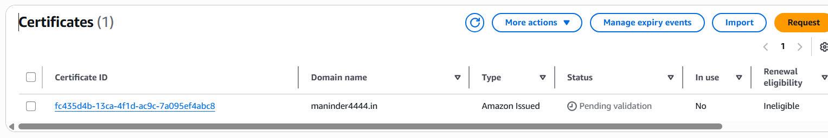
Now go to GoDaddy.com and Go to the DNS Records in the dashboard section
Goto add record and enter the CNAME and the Value in the record.
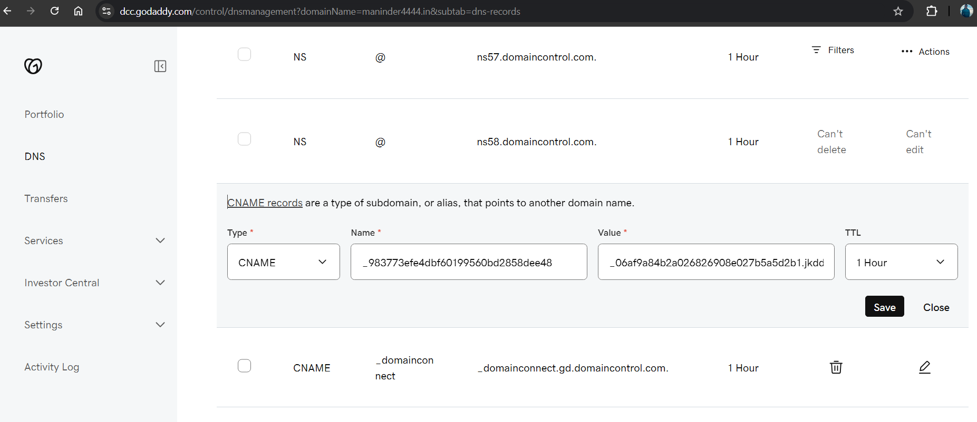
After a while, we can see the certficate status showing ‘issued’

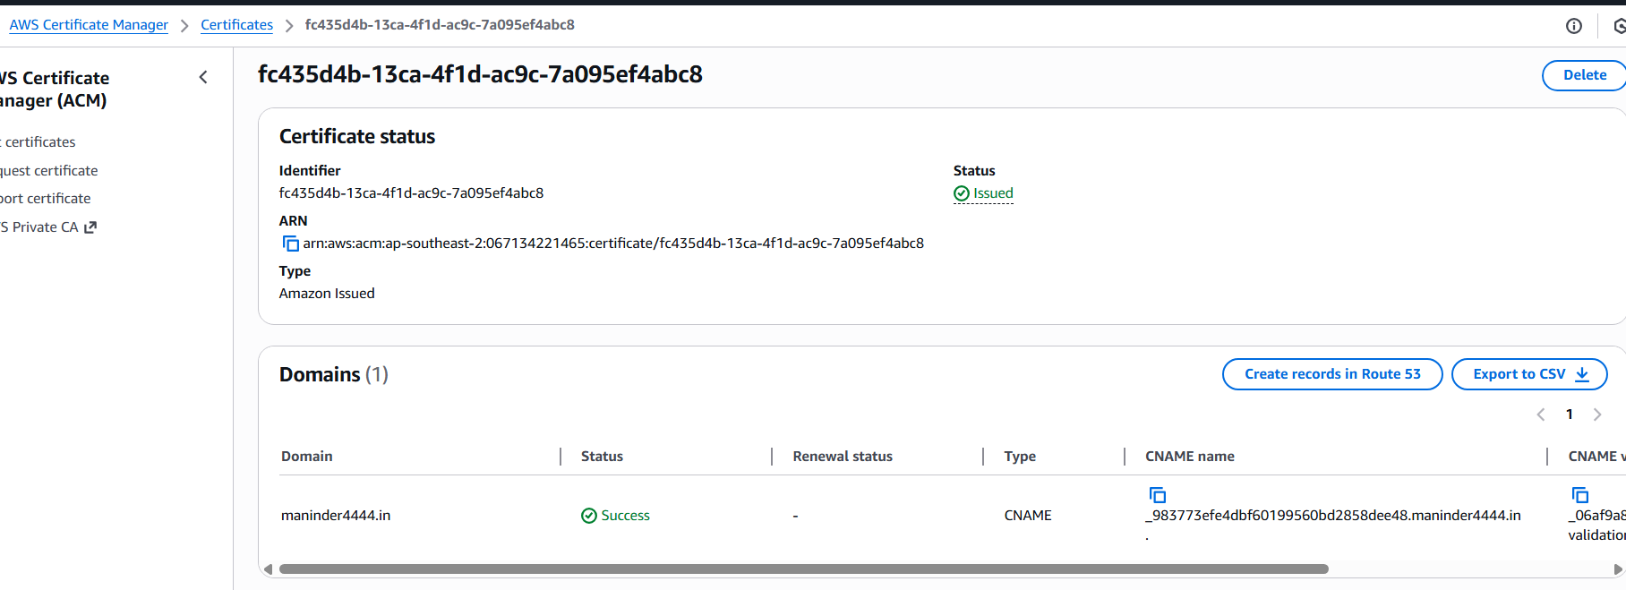

Go to CloudFront and create distribution
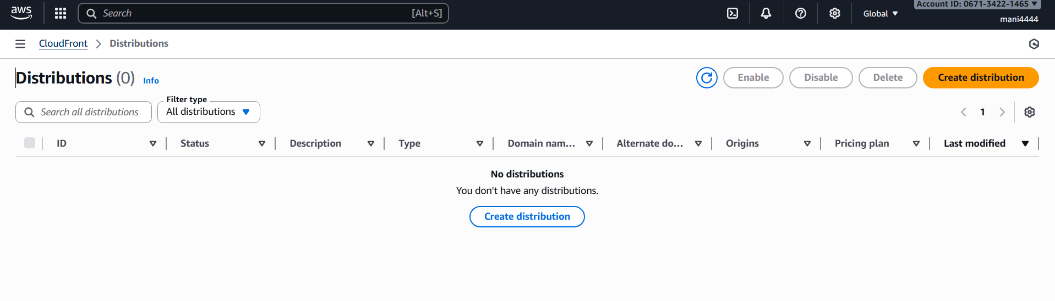
Click ‘create distribution’ give the name of the distribution name (MyAssign01) and click next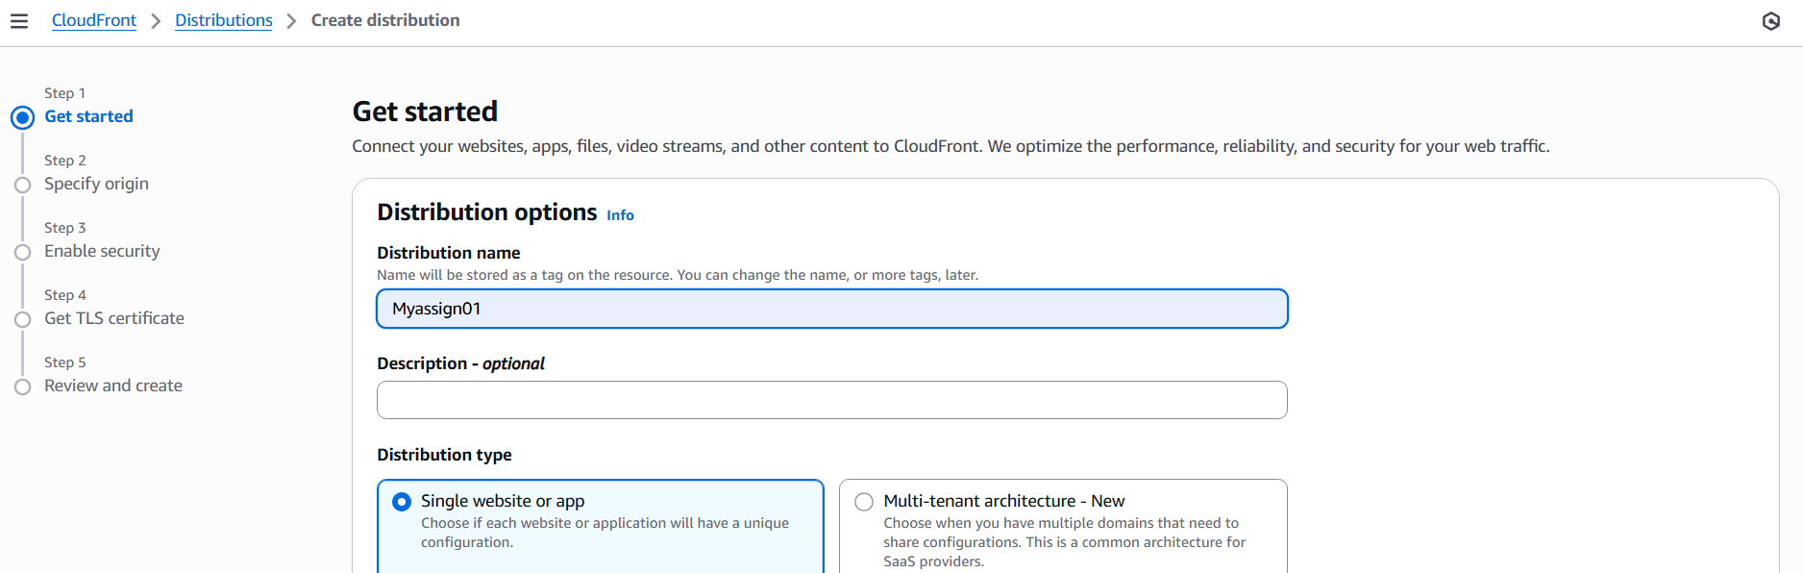

Now set the s3 origin bucket to the bucket created in the us-east-1 (maninder4444in)
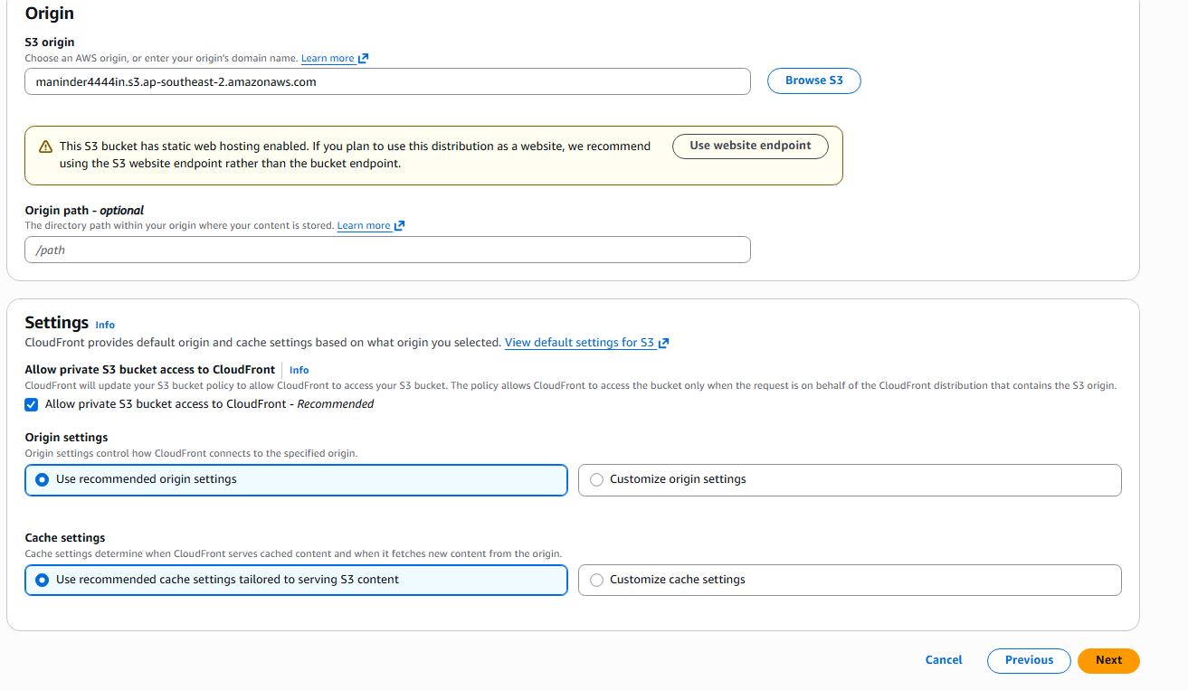
Go review the settings and click ‘create distribution’
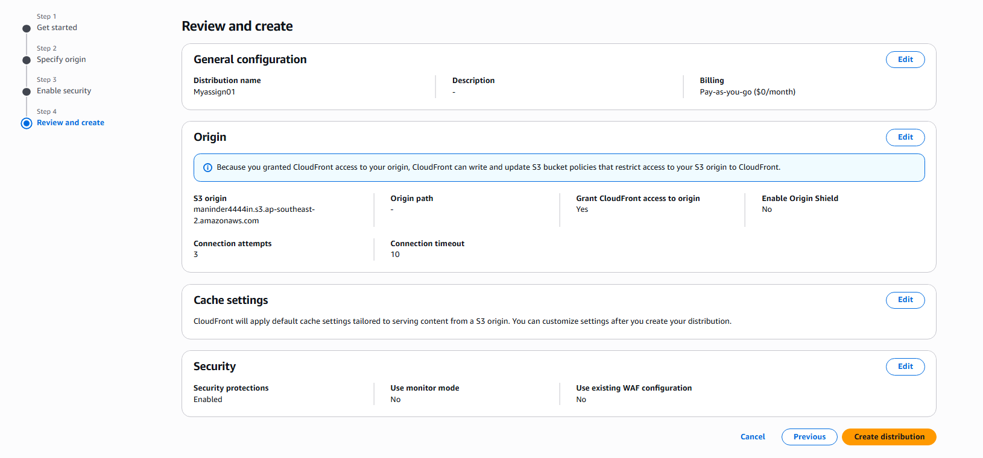

We can see that the distribution was created succesfully
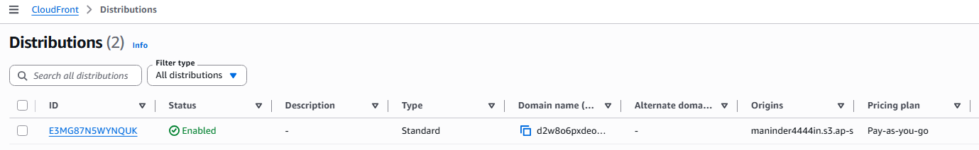
The details of the distribution created are as follows and now copy the distribution domain name link in the browser
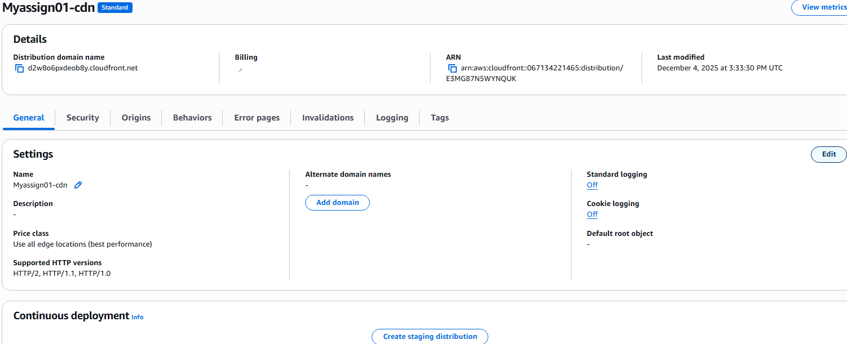
The website is up
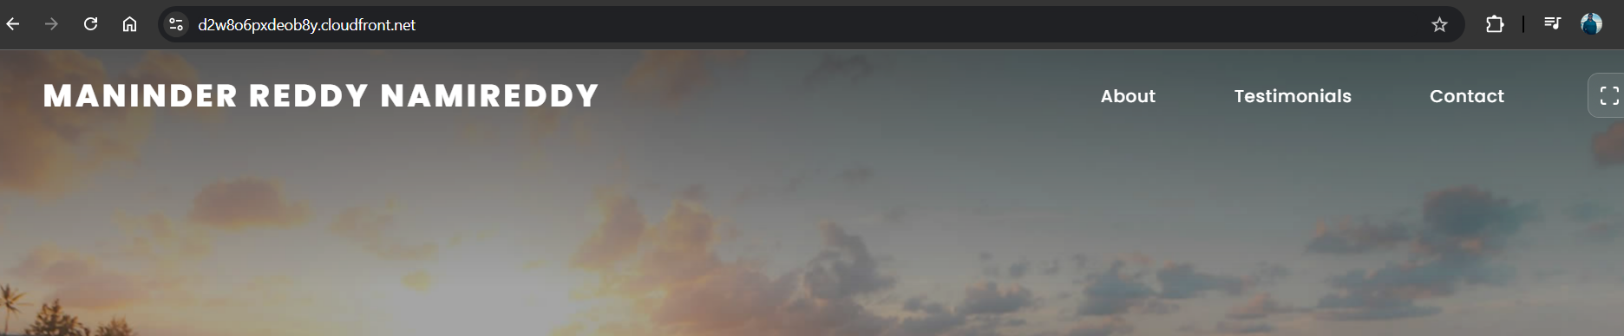
Now we have to link the distribution to the ssl

Go to the edit settings and AWS WAF web ACL and select the certificate which was issued earlier in the drop down menu as shown below.
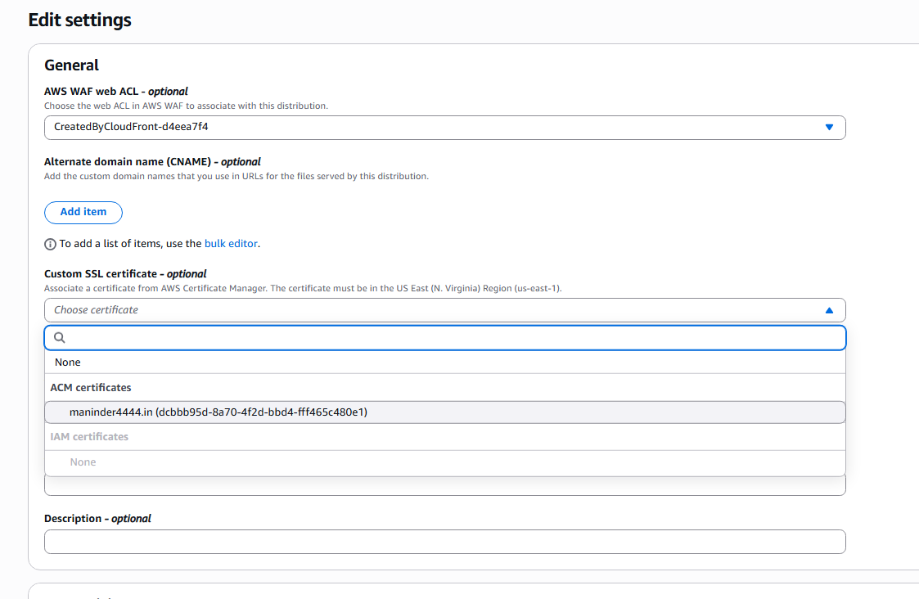
The certifciate is successfully added to the distribution as follows
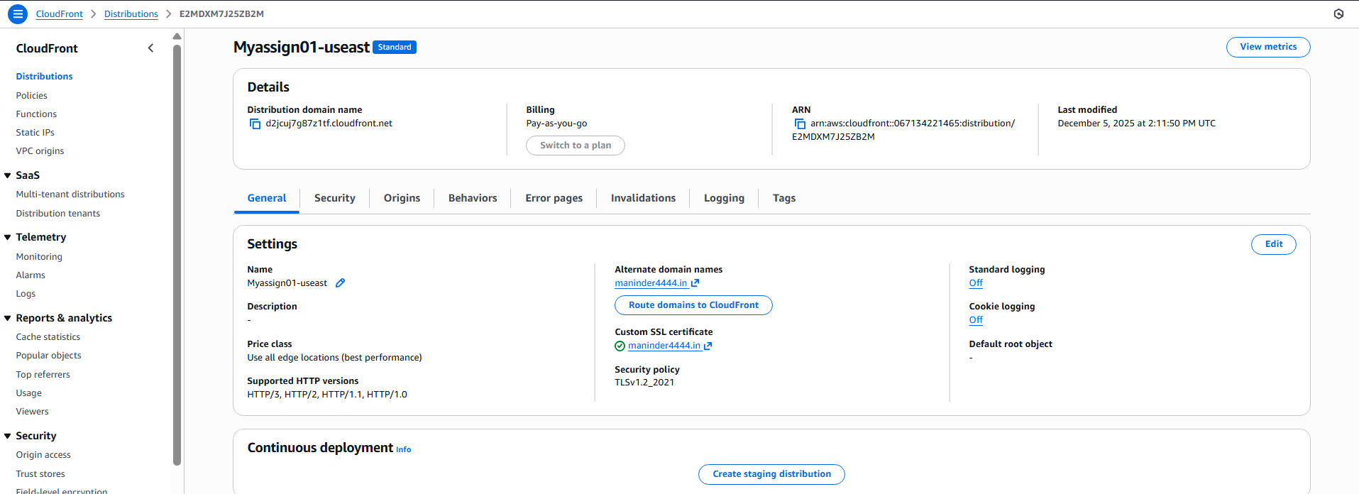

- Create a Route 53 hosted zone and map the domain with the CDN.
In this section we have to make the Route53 hosted zone and map the domain with the CDN
Goto the Route53 and enter create hosted zone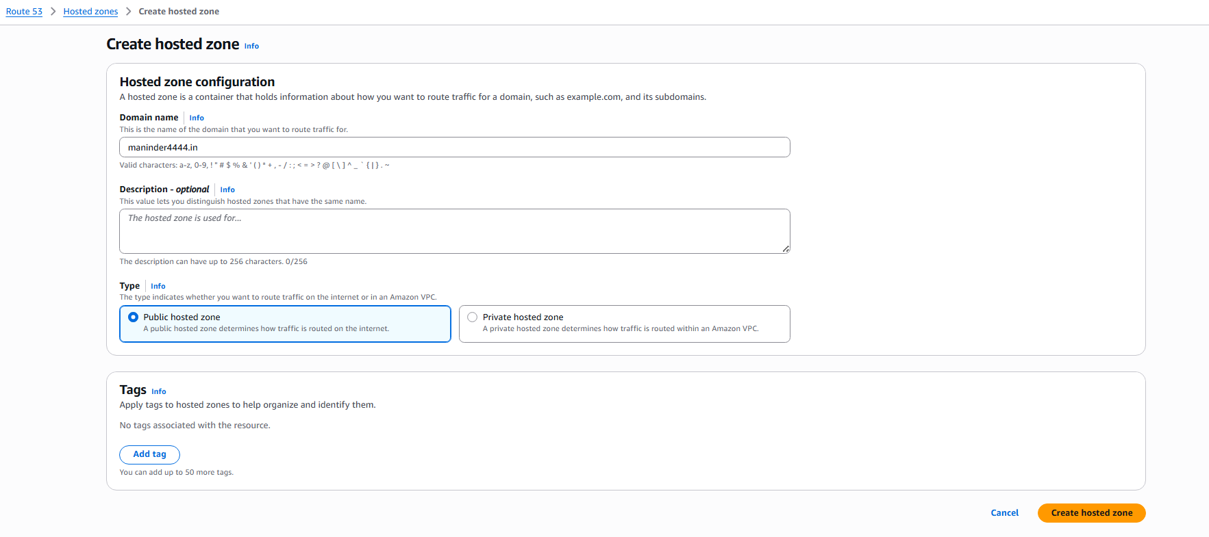

Got the hosted zone created and create the CNAME record
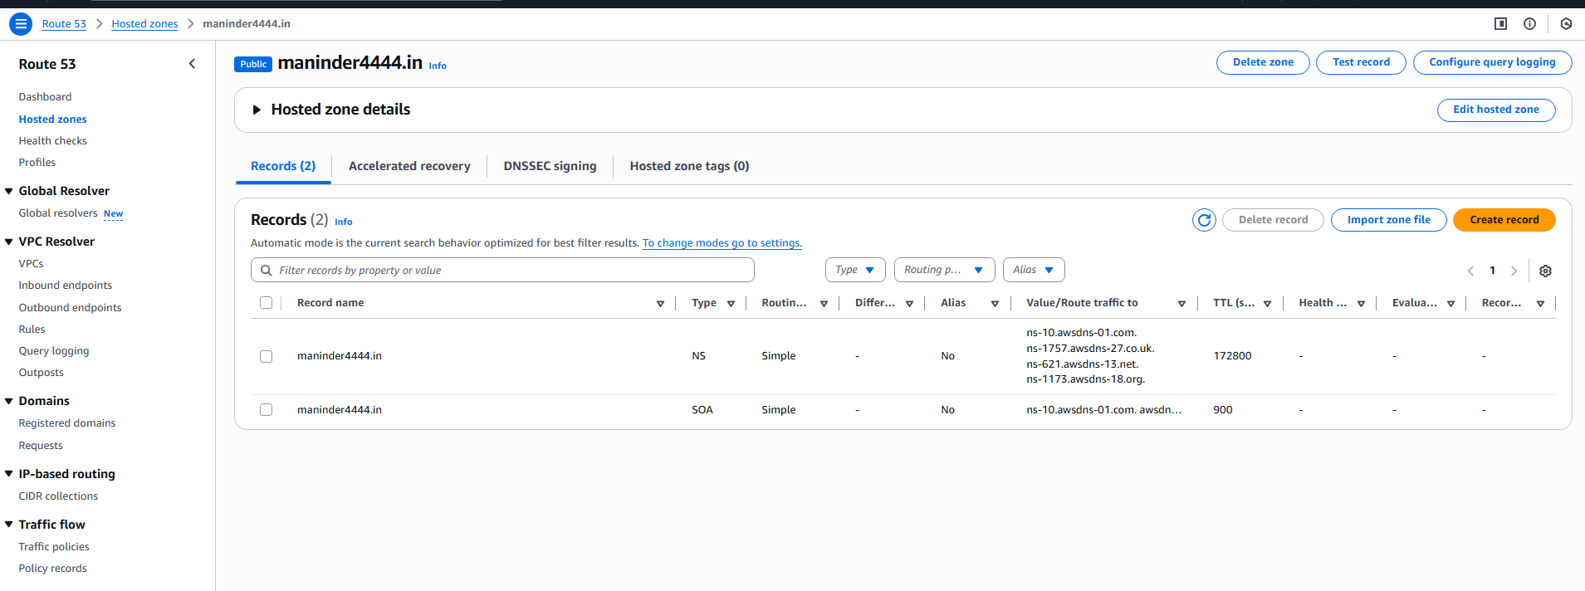
Create the Cname by giving the cname and the value and create record

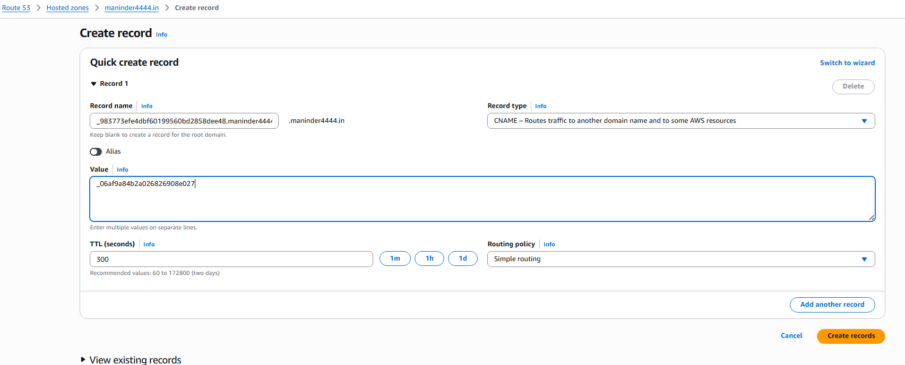

Create The A and AAA routing record through alias
Go to Route traffic to -> alias to CloudFront distribution
And select the distribution
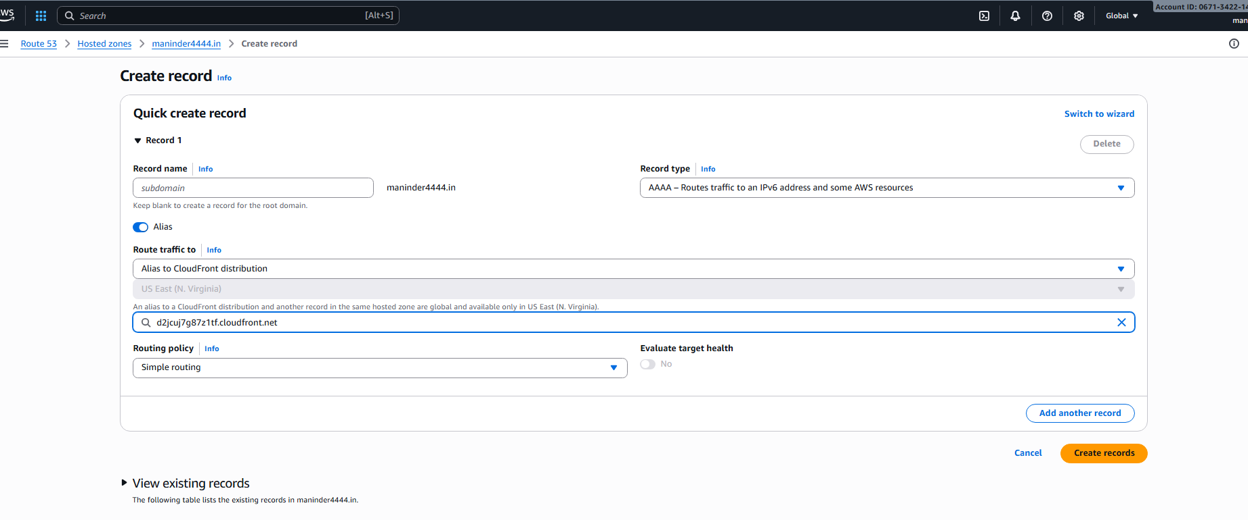
Now go to the goDaddy Dashboard, select the nameservers, select I’ll use my own nameservers.
Go to Route53 and copy the namespace servers value in the ns type,( Note: donot copy the . prefix into the edit nameservers in the godaddy website).
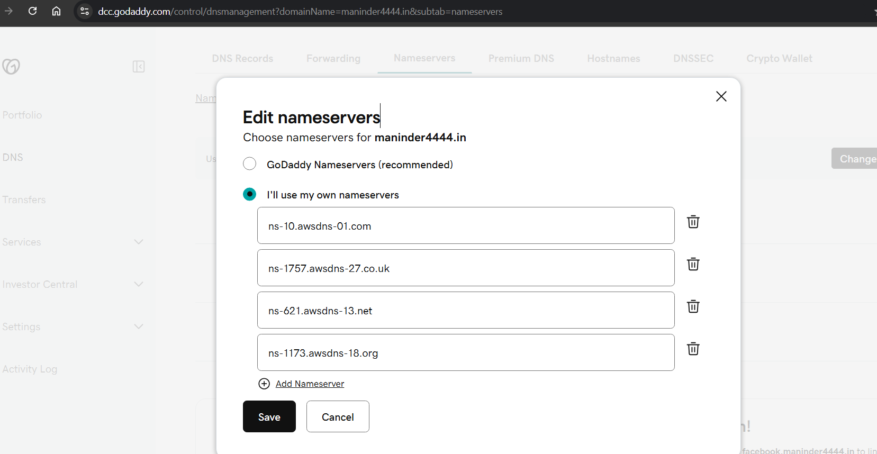

Now Go to the distribution in the cloudFront and create the invalidation and add object paths as /index.html and also /* and click copy to new

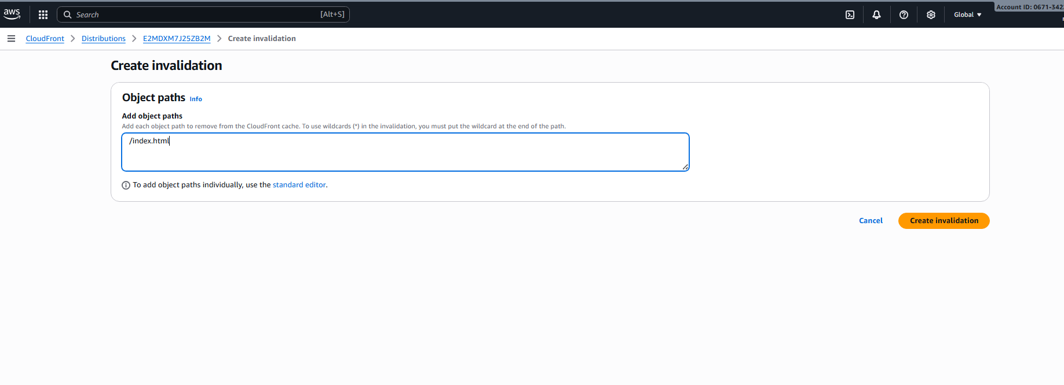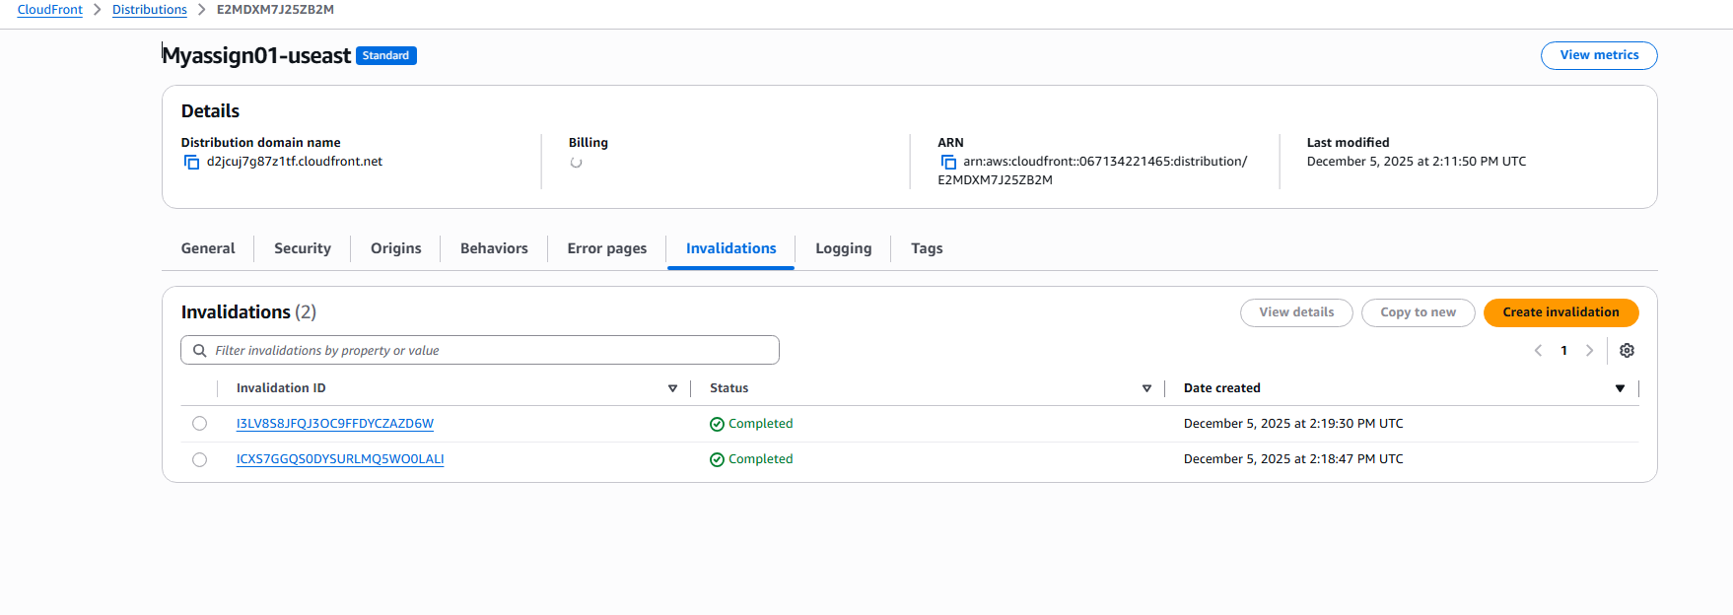
The invalidations are created as above which shows status as completed.

- Update the index.html in the S3 bucket and ensure the updated file is accessible using the domain name.
Update the index.html in the s3 with the local index.html and go to the link
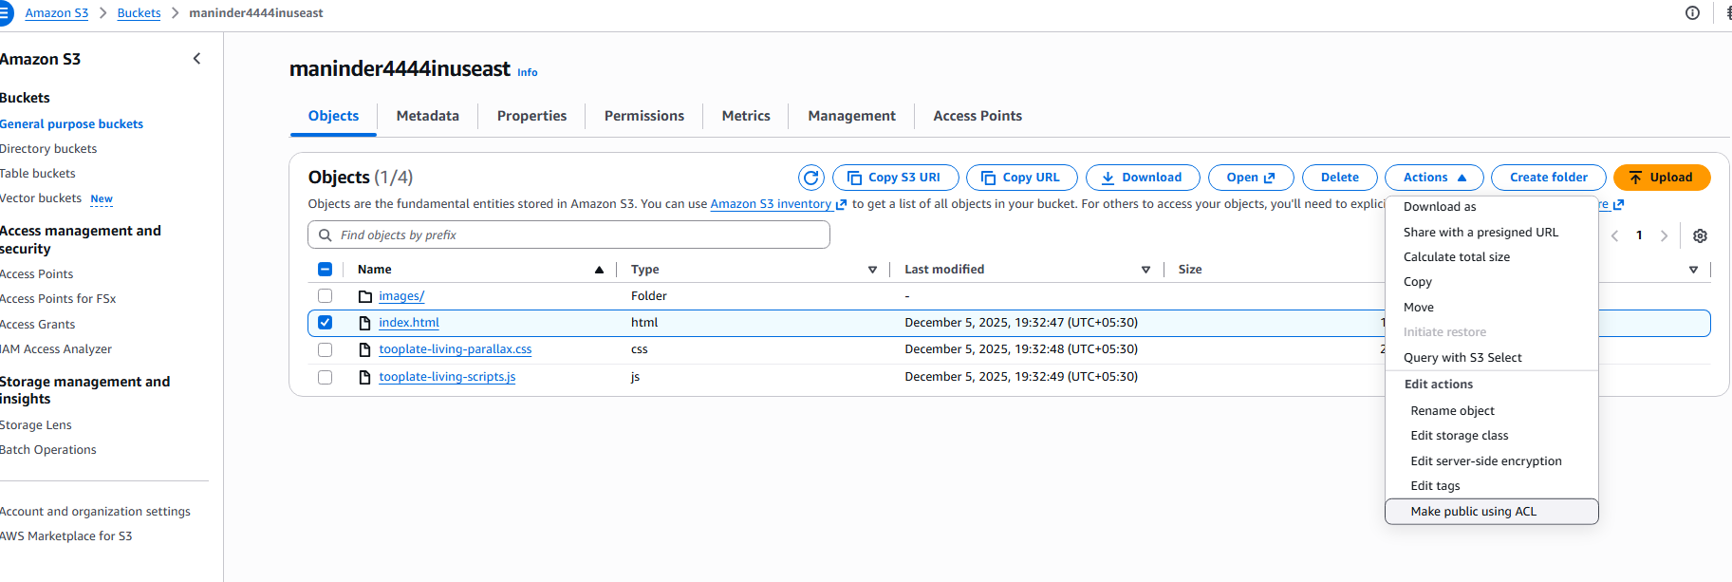

On accessing the link we can see the link is successfully up with the content we stored in the s3 bucket
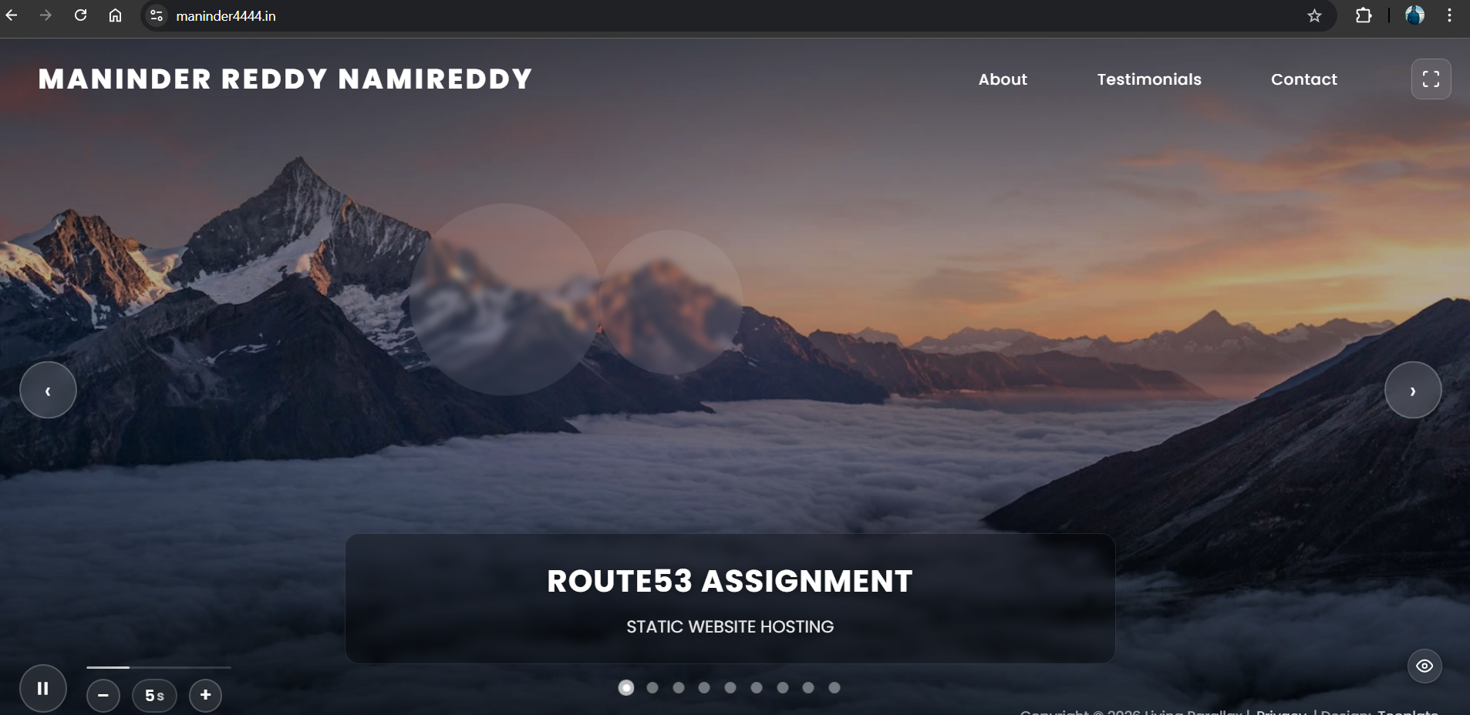
Share the domain name in Slack to test the connectivity.
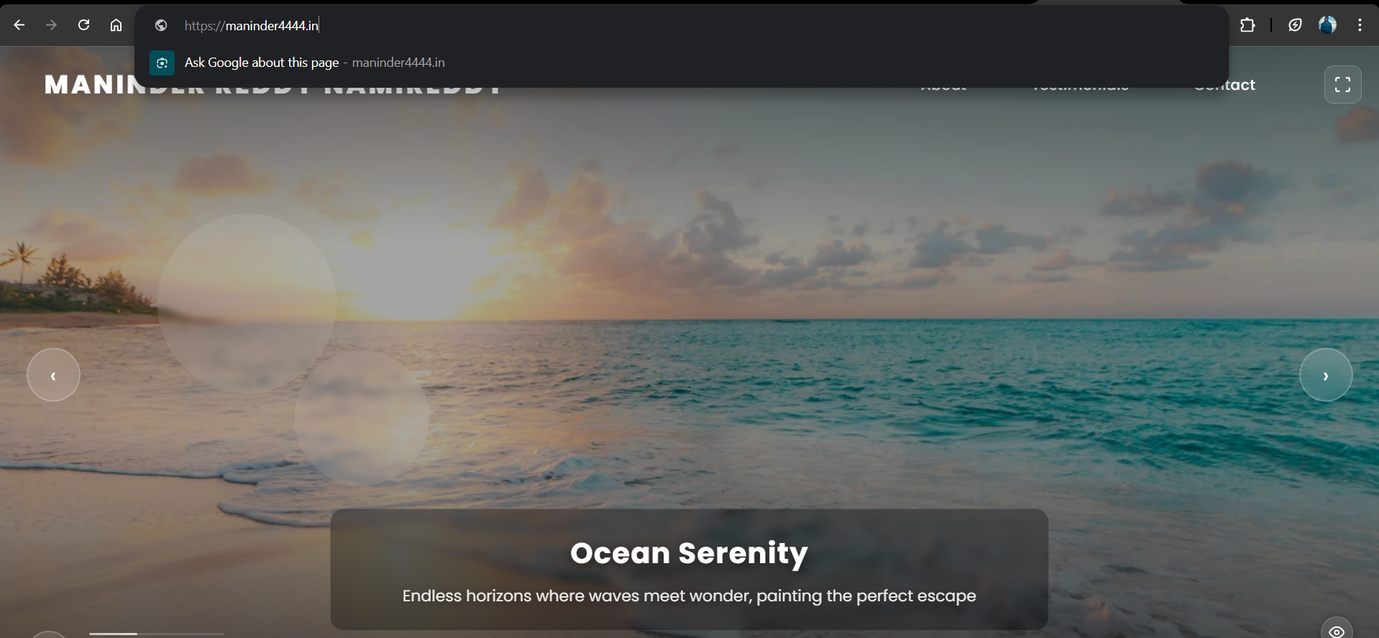

Troubleshooting steps:

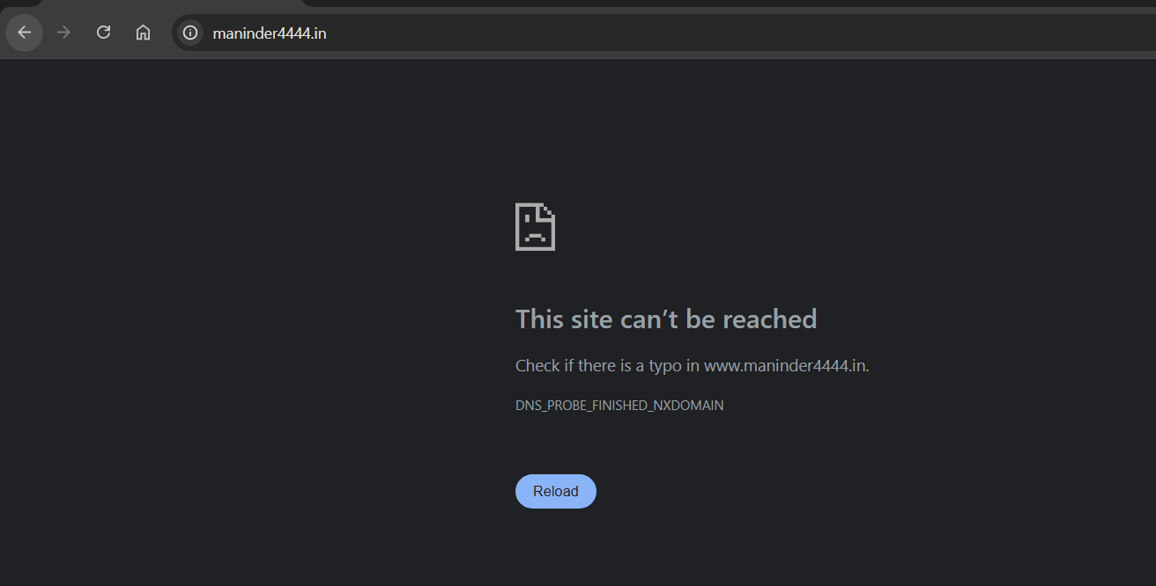
I have tried ‘curl -I http://maninder4444.in to see if there is any error with the link

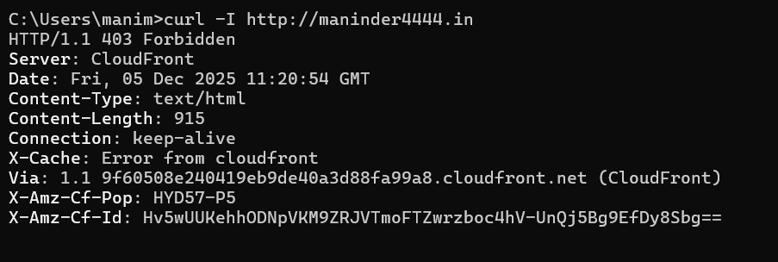

Checking CloudFront distribution status in console, if any recent invalidations are pending?
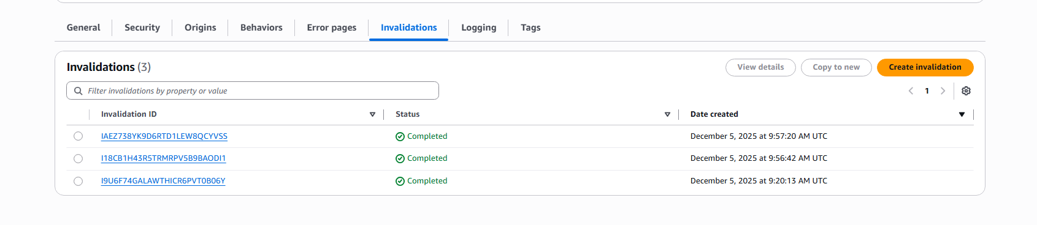
No pending invalidations are found,

Checking if cloud distribution name URL is working or not, it is working as follows

So, the problem is likely DNS/ACM
I have tried changing the CNAME Name, with the prefix content deleted, since the extension contained the prefix in the CNAME, But shown Error, when tried, I have rolledback to the previous state
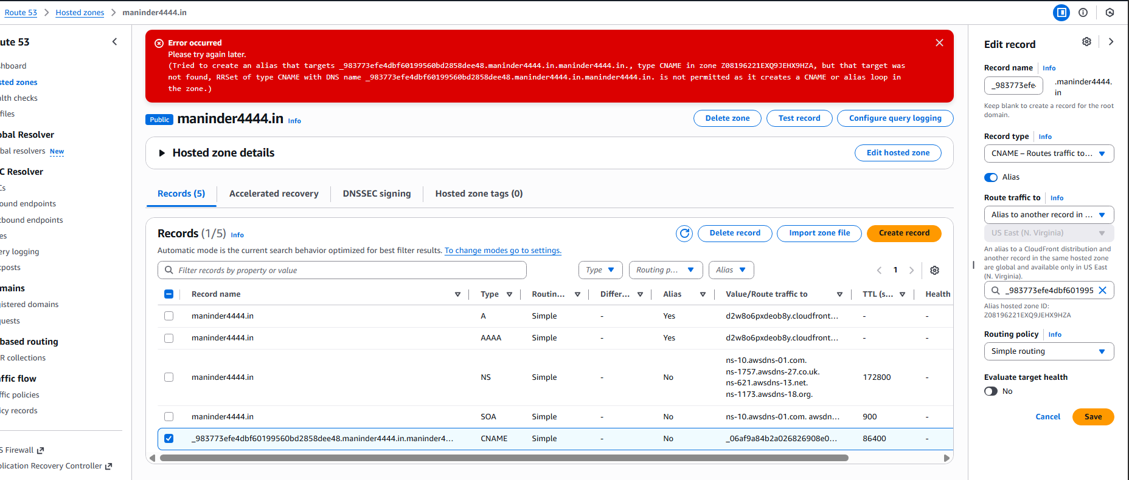

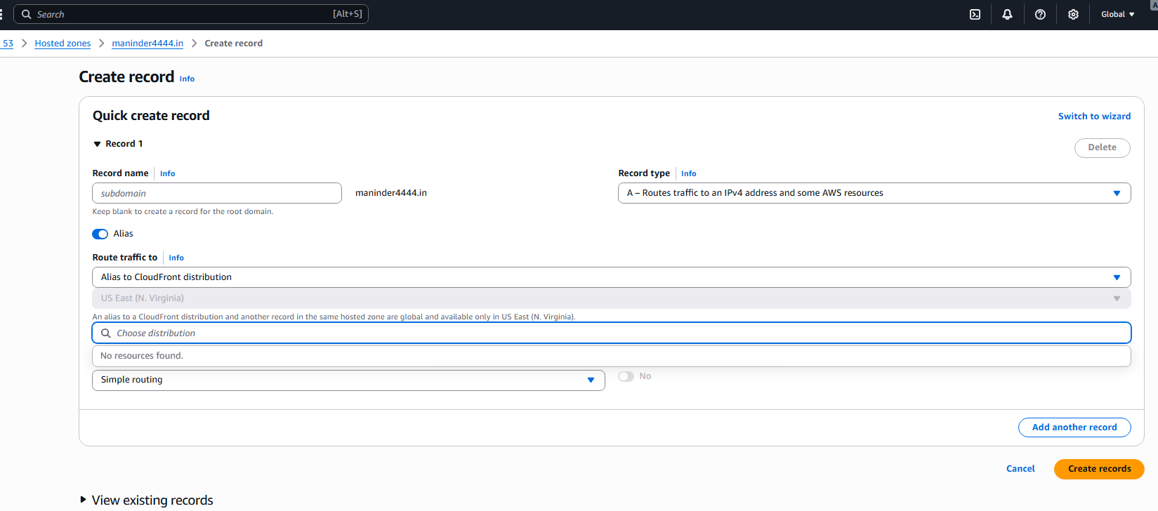
When trying to give the A route type when opted the Alias, Alias to CloudFront distribution the destination is not shown but I have given the distribution id explicitly before.

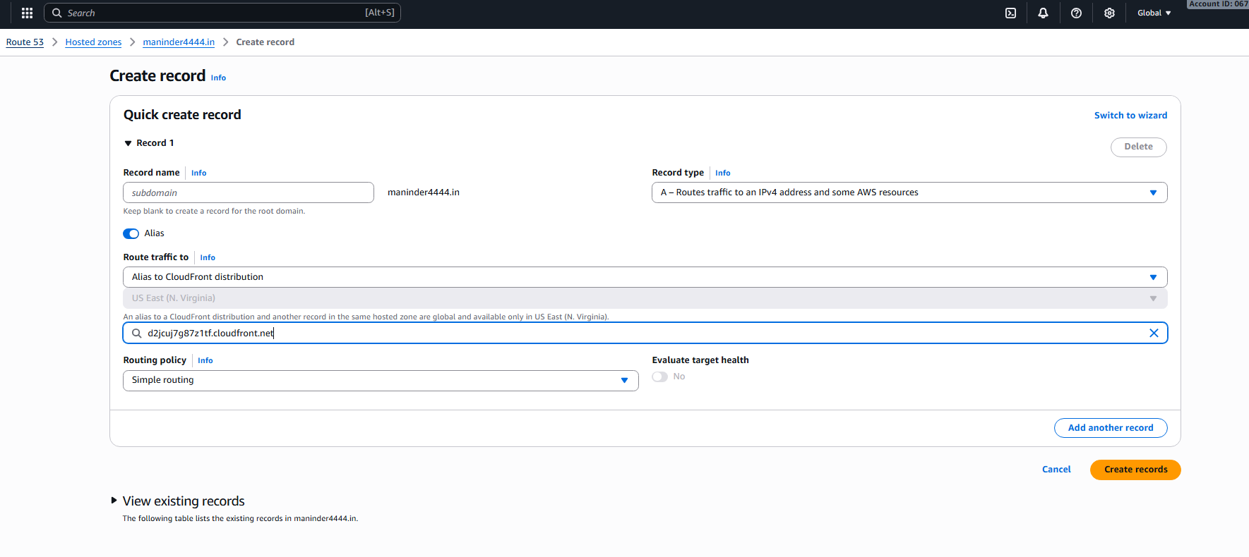
Now I have tried provisioning the s3 bucket from the us-east-1 and created a new distribution and did everything from the beginning and I obtained the ssl certificate from the us-east-1
Now when I have done the process from the beginning, I got the result as intended.

