Jenkins-Challenge-1

Use the below code and implement our CICD stages.
Source Code: https://github.com/betawins/hiring-app.git
Repository contains the application code for the hiring app.
1) Create one Declarative pipeline job
2) Create one Scripted pipeline job
3) Create one multi stage pipeline job
4) Create one parallel stage pipeline job

1) Task Title
1) Create one Declarative pipeline job
2) Create one Scripted pipeline job
3) Create one multi stage pipeline job
4) Create one parallel stage pipeline job

2) Objective
The objective of this task is to design and implement a complete CI/CD pipeline using Jenkins that automates the entire software delivery lifecycle for a Maven-based web application. The pipeline aims to:
- Automate source code checkout from GitHub
- Perform static code analysis using SonarQube
- Build and package the application using Maven
- Store versioned artifacts in Nexus Repository Manager
- Deploy the application automatically to an Apache Tomcat server
- Send real-time build status notifications to Slack

3) Prerequisites
- Jenkins installed and running with admin access
- Java (JDK 11 or above) installed on Jenkins server
- Maven installed and configured in Jenkins Global Tool Configuration (MVN_HOME)
- Git installed on Jenkins server
- SonarQube server up and reachable from Jenkins
- SonarScanner installed on Jenkins server
- Nexus Repository Manager (Maven hosted repository) configured and reachable
- Apache Tomcat 9.x running and reachable from Jenkins
- Required Jenkins plugins installed:
  - Pipeline
  - Git
  - Maven Integration
  - SonarQube Scanner
  - Nexus Artifact Uploader
  - Deploy to Container
  - Slack Notification
- Jenkins credentials configured:
  - Git (if private repo)
  - SonarQube token
  - Nexus credentials (mani)
  - Tomcat credentials (tomcat-cred-01)
  - Slack token (techiehorizon)
- Network connectivity between Jenkins ↔ GitHub ↔ SonarQube ↔ Nexus ↔ Tomcat

4) Step-by-Step Implementation (With Evidence)
1) Create one Declarative pipeline job
Step 1: Create a new Jenkins Pipeline Job (Declarative)
• Console path / UI path:
Jenkins Dashboard → New Item
• Explanation:
A new Jenkins job is created to implement CI/CD using a Declarative Pipeline.
The job name is provided as Jenkins_Challenge-1, and Pipeline is selected as the job type.
This job type allows defining the CI/CD workflow using a Jenkinsfile-style Groovy syntax.
• Evidence:
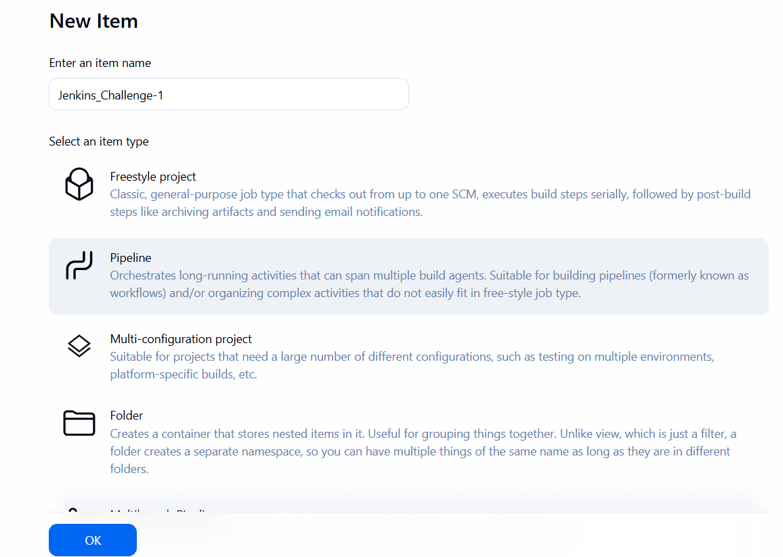

Step 2: Configure Pipeline Definition with Initial Git Clone Stage
• Console path / UI path:
Jenkins_Challenge-1 → Configure → Pipeline section
• Explanation:
The pipeline definition is set to Pipeline script.
A Declarative pipeline structure is added with:
- agent any
- stages block
- A Git Clone stage that clones the source code from the GitHub repository
https://github.com/betawins/hiring-app.git using the main branch.
This verifies Jenkins agent connectivity and GitHub access.
• Evidence:
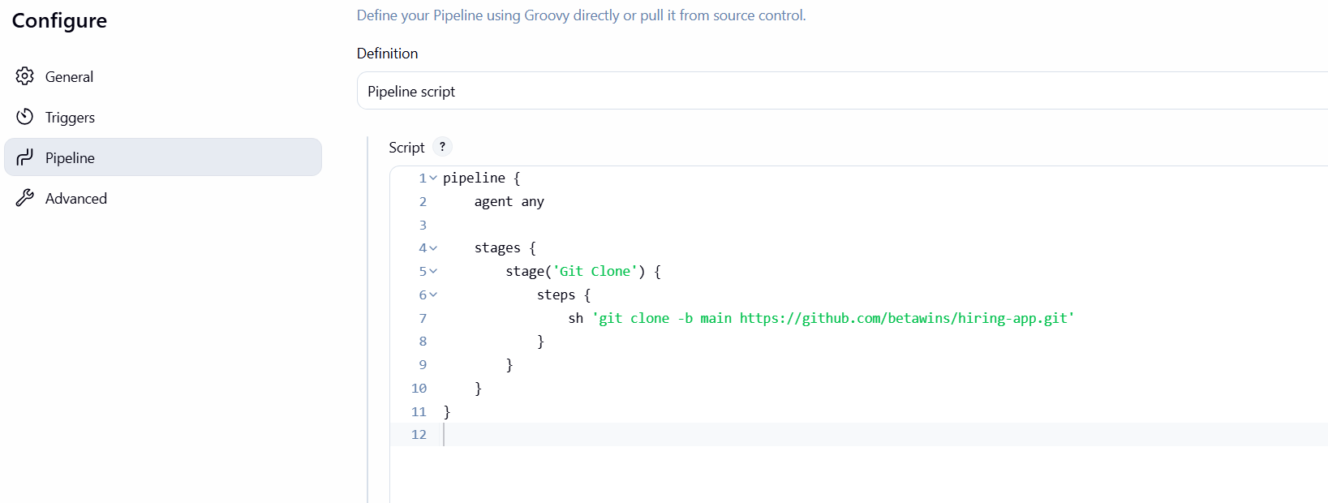
Step 3: Execute Pipeline and Verify Successful Git Clone
• Console path / UI path:
Jenkins_Challenge-1 → Build Now → Console Output
• Explanation:
The pipeline is executed manually.
Jenkins allocates a workspace and runs the Git Clone stage successfully.
The repository is cloned into the Jenkins workspace without errors.
• Evidence:
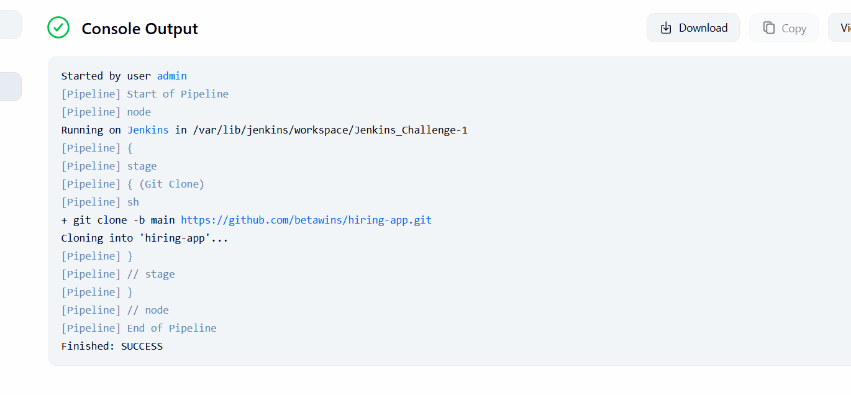
Step 4: Add SonarQube Analysis Stage to the Declarative Pipeline
• Console path / UI path:
Jenkins_Challenge-1 → Configure → Pipeline section
• Explanation:
A second stage named SonarQube Analysis is added.
The stage uses:
- withSonarQubeEnv('sonarqube-Docker')
- Sonar Scanner installed at /opt/sonar-scanner/bin/sonar-scanner
Static code analysis parameters include:
- sonar.projectKey=hiring-app
- sonar.projectName="hiring Maven Webapp"
- sonar.sources=.
- Java files excluded from analysis
This integrates code quality checks into the CI pipeline.
• Evidence:
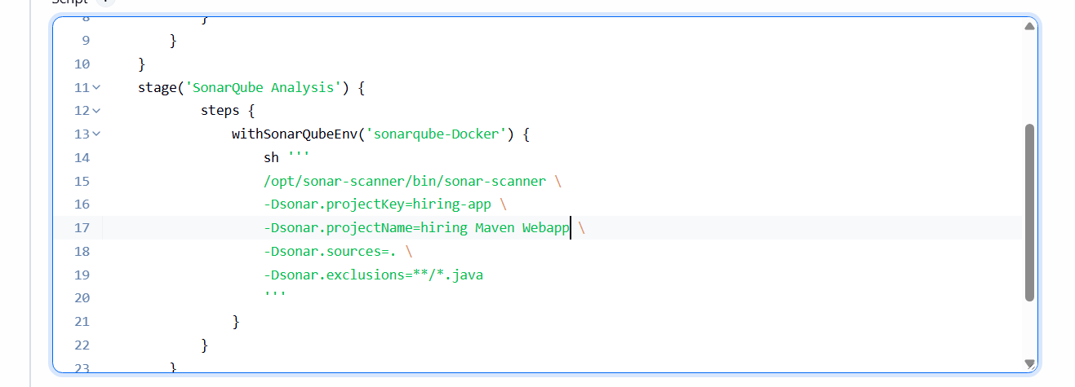
Step 5: Resolve Groovy Compilation Error (Stage Outside stages Block)
• Console path / UI path:
Jenkins_Challenge-1 → Build Now → Console Output
• Explanation:
Pipeline execution fails with the error:
Undefined section "stage"
Root cause:
The SonarQube Analysis stage was placed outside the stages {} block, which is invalid in Declarative pipelines.
The pipeline is corrected by placing both Git Clone and SonarQube Analysis stages inside a single stages {} block.
• Evidence:
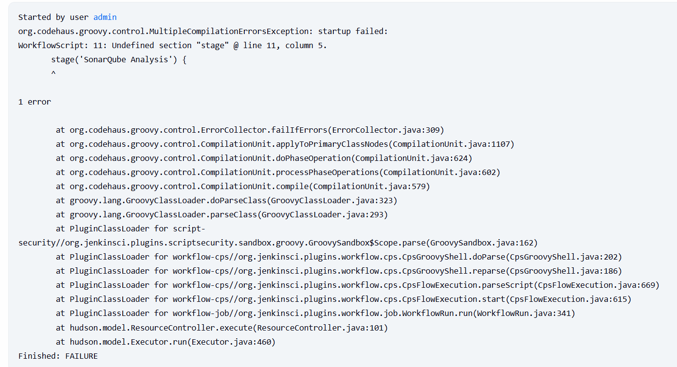
Step 6: Fix Git Clone Failure Due to Existing Directory
• Console path / UI path:
Jenkins_Challenge-1 → Configure → Pipeline section
• Explanation:
On re-running the pipeline, Git clone fails with:
destination path 'hiring-app' already exists and is not an empty directory
To fix this, the pipeline is updated to:
- Remove the existing directory before cloning using rm -rf hiring-app
This ensures idempotent pipeline execution.
• Evidence:
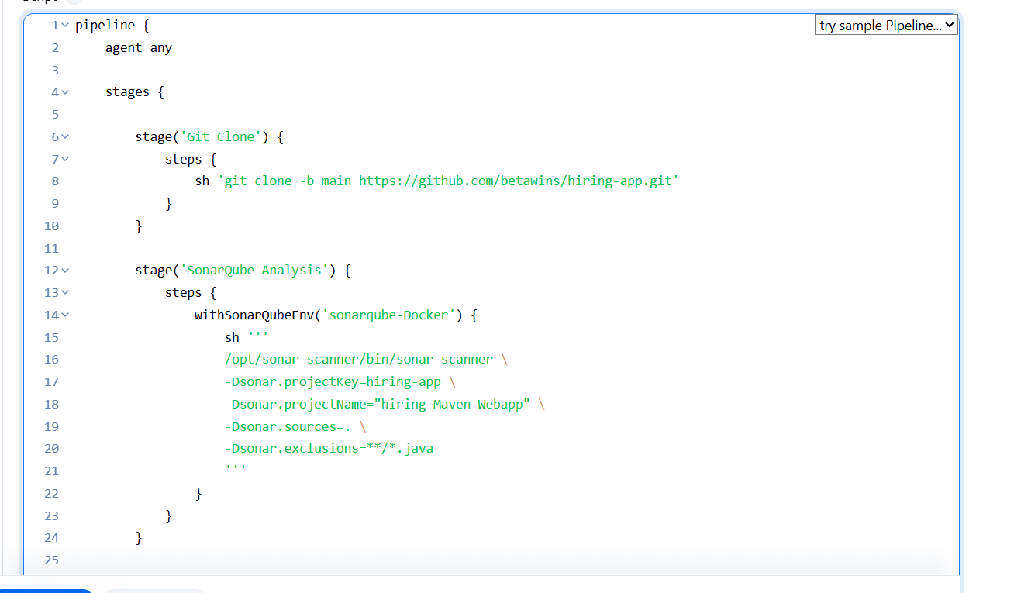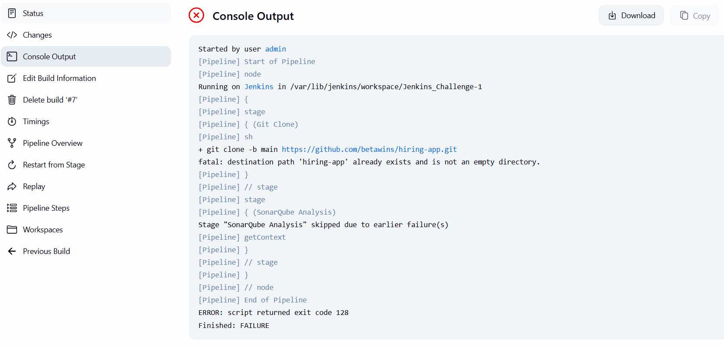
Step 7: Successful SonarQube Analysis Execution
• Console path / UI path:
Jenkins_Challenge-1 → Build Now → Console Output
• Explanation:
After fixing both Groovy syntax and Git clone issues:
- Git clone completes successfully
- SonarQube analysis runs without errors
- Analysis report is uploaded to the SonarQube server
- Pipeline completes with SUCCESS
This confirms successful CI integration with SonarQube.
• Evidence:
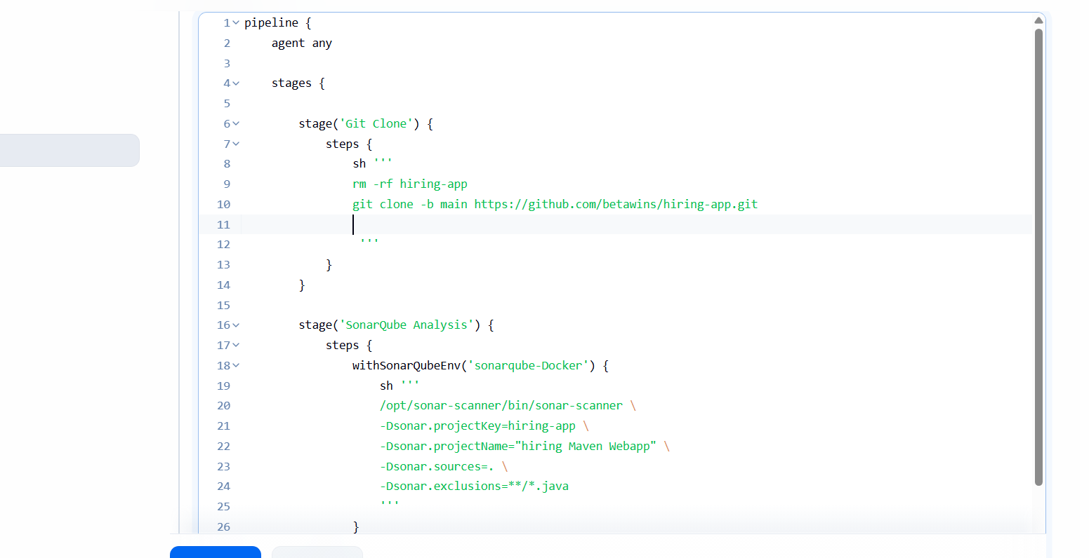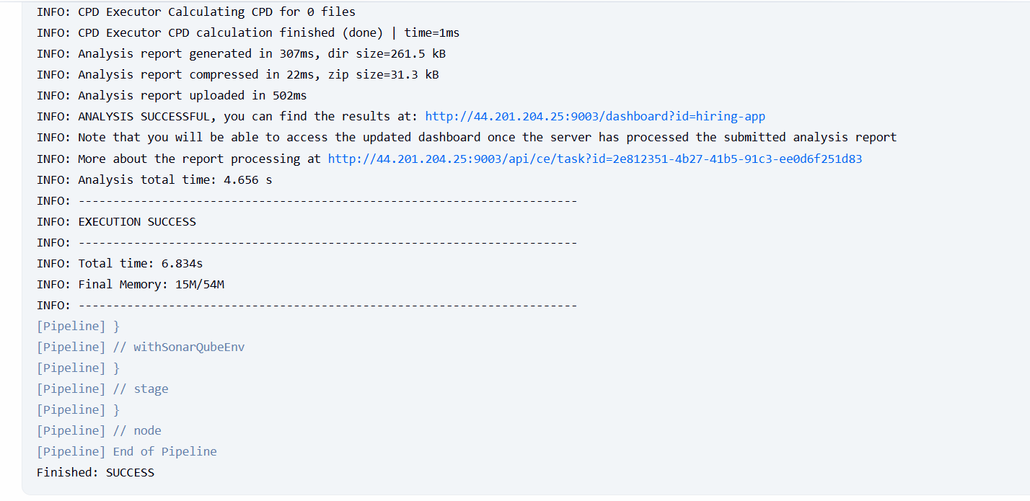
Step 8: Add Maven Build Stage to the Existing Declarative Pipeline
• Console path / UI path:
Jenkins_Challenge-1 → Configure → Pipeline section
• Explanation:
A new stage named Maven Build is added to the Declarative pipeline to build the application using Maven.
The build command mvn clean package is introduced inside the stage to compile the code and generate a WAR artifact.
• Evidence:
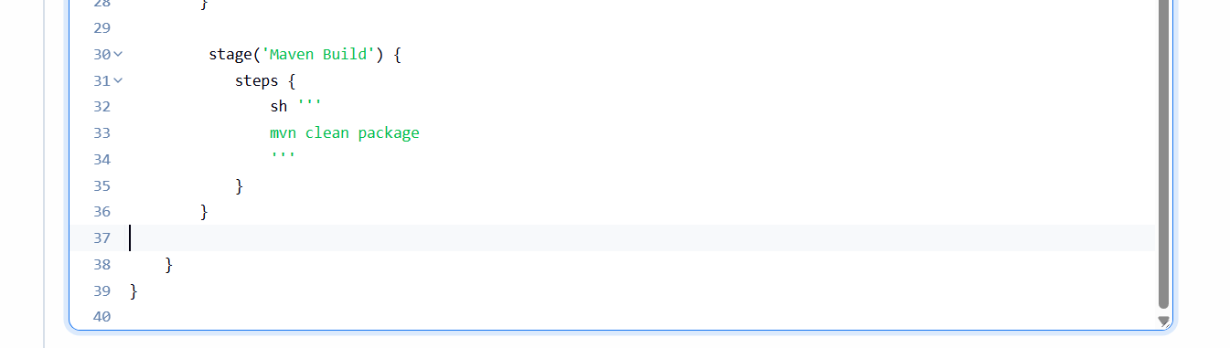Step 9: Maven Command Not Found Error During Pipeline Execution
• Console path / UI path:
Jenkins_Challenge-1 → Build Now → Console Output
• Explanation:
Pipeline execution fails with the error:
mvn: command not found
This indicates Maven is not available in the Jenkins runtime PATH, even though the command exists in the pipeline.
• Evidence:
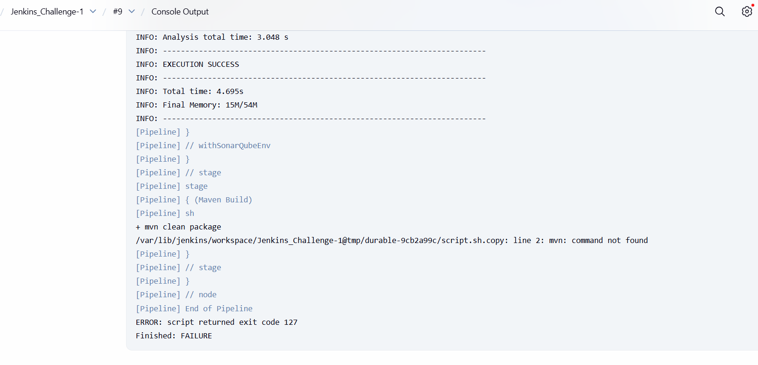Step 10: Configure Maven as a Jenkins Tool in Declarative Pipeline
• Console path / UI path:
Jenkins_Challenge-1 → Configure → Pipeline section
• Explanation:
The issue is resolved by explicitly configuring Maven using the tools directive in the Declarative pipeline.
The pipeline is updated with:
- tools { maven 'MVN_HOME' }
This ensures Jenkins injects Maven into the PATH before executing build stages.
• Evidence:
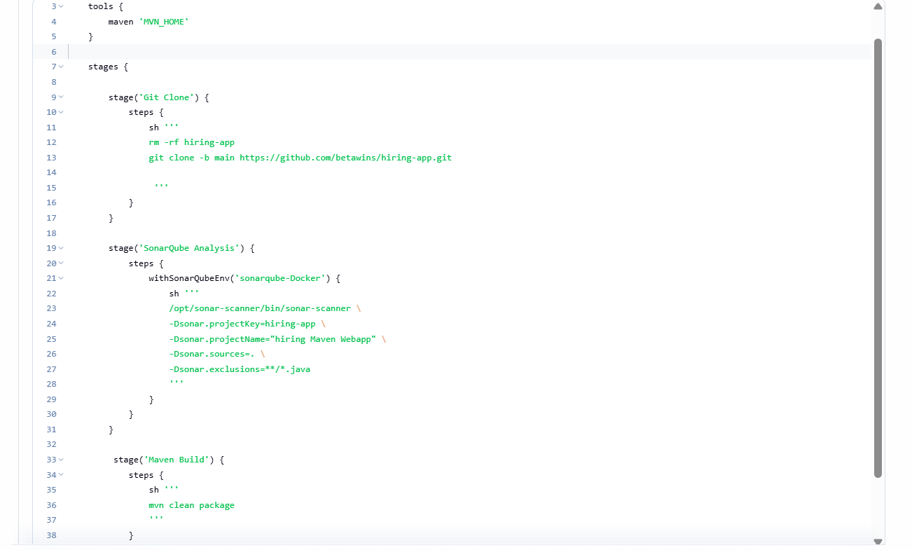
Step 11: Maven Build Fails Due to Missing POM File
• Console path / UI path:
Jenkins_Challenge-1 → Build Now → Console Output
• Explanation:
After enabling Maven, the build fails again with the error:
There is no POM in this directory
Root cause:
The repository is cloned into a subdirectory (hiring-app), but Maven is executed from the workspace root, where pom.xml does not exist.
• Evidence:
Image showing:
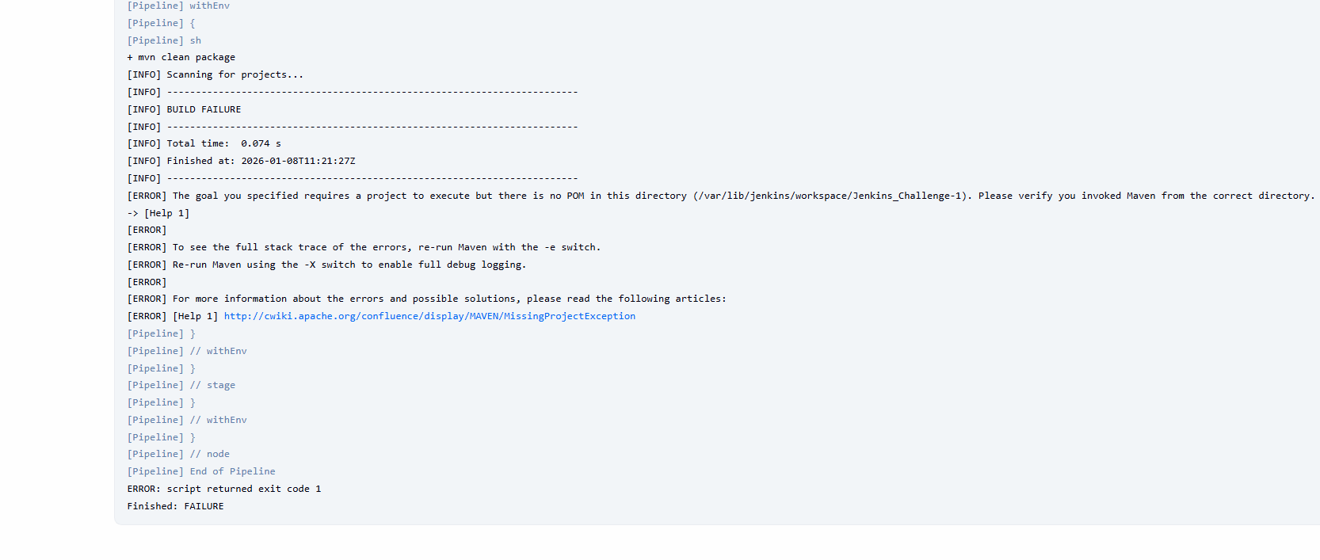
Step 12: Fix Maven Execution Path Using dir() Block
• Console path / UI path:
Jenkins_Challenge-1 → Configure → Pipeline section
• Explanation:
The pipeline is corrected by executing Maven inside the hiring-app directory using the dir() directive.
Changes applied:
- dir('hiring-app') added in SonarQube Analysis stage
- dir('hiring-app') added in Maven Build stage
This ensures both Sonar Scanner and Maven run from the correct project location.
• Evidence:
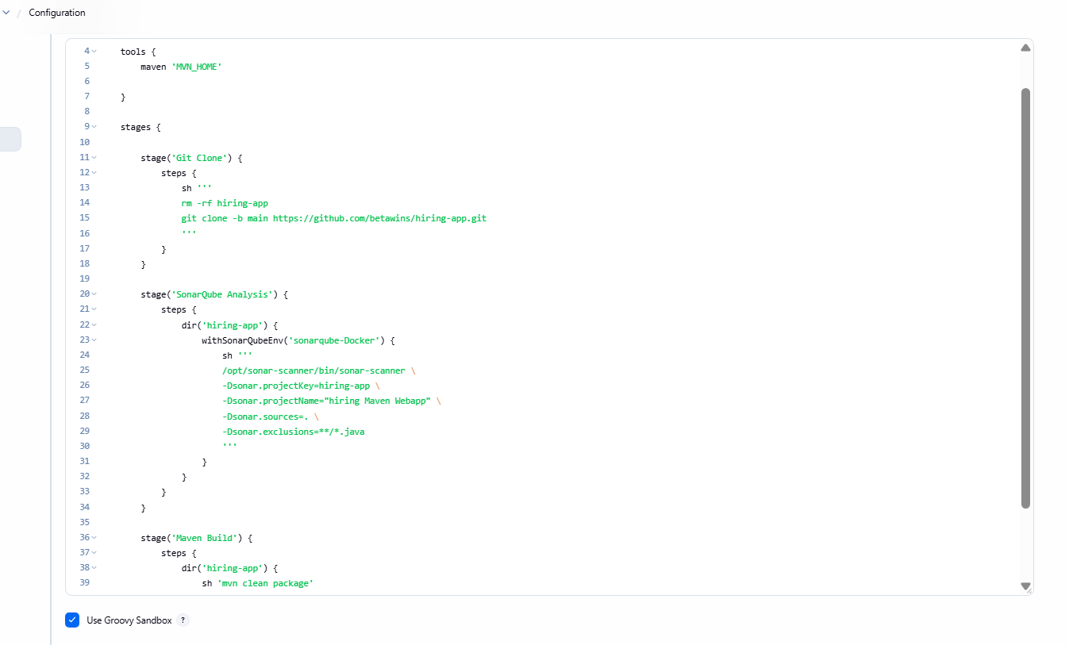
Step 13: Successful Maven Build and Artifact Generation
• Console path / UI path:
Jenkins_Challenge-1 → Build Now → Console Output
• Explanation:
After correcting the execution directory:
- Maven successfully compiles the project
- WAR file is generated under target/
- Pipeline completes all stages successfully
This confirms:
- Tool configuration is correct
- Workspace navigation is correct
- Build stage is fully functional
• Evidence:
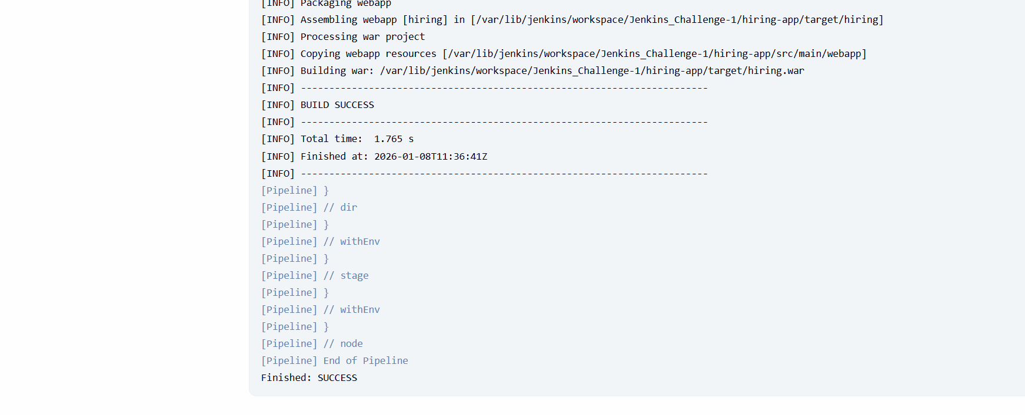
Step 14: Create Maven Hosted Repository in Nexus Repository Manager
• Console path / UI path:
Nexus Repository Manager → Settings → Repositories → Create Repository
• Explanation:
A new Maven2 (hosted) repository is created in Nexus to store build artifacts generated by the Jenkins pipeline.
This repository will act as the artifact repository for WAR file uploads from Jenkins.
Repository configuration details:
- Name: Jenkins-Challenge-1
- Format: maven2
- Type: hosted
- Version policy: Mixed
- Layout policy: Permissive
- Repository set to Online
• Evidence:
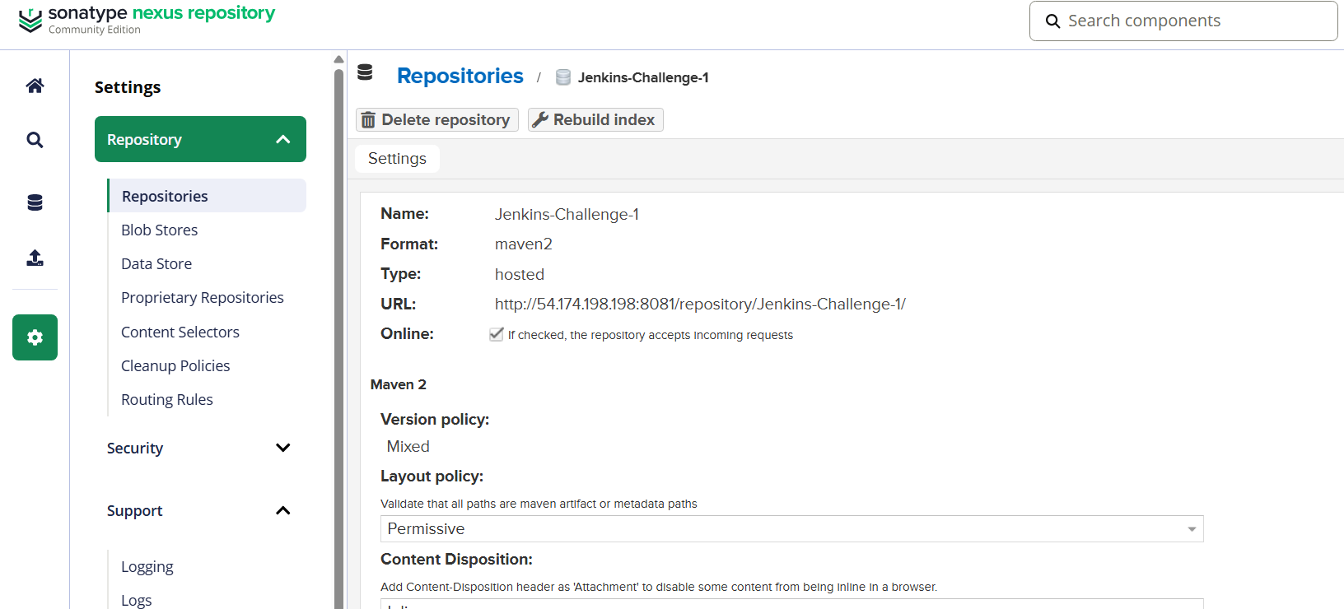Step 15: Validate Maven Coordinates from Application POM File
• Console path / UI path:
GitHub Repository → pom.xml
• Explanation:
The application’s Maven coordinates are reviewed to align Nexus upload parameters correctly.
Key values identified from pom.xml:
- groupId: in.javahome
- artifactId: hiring
- packaging: war
- version: 0.1
- Final artifact name: hiring.war
These values must match the Nexus artifact upload configuration.
• Evidence:
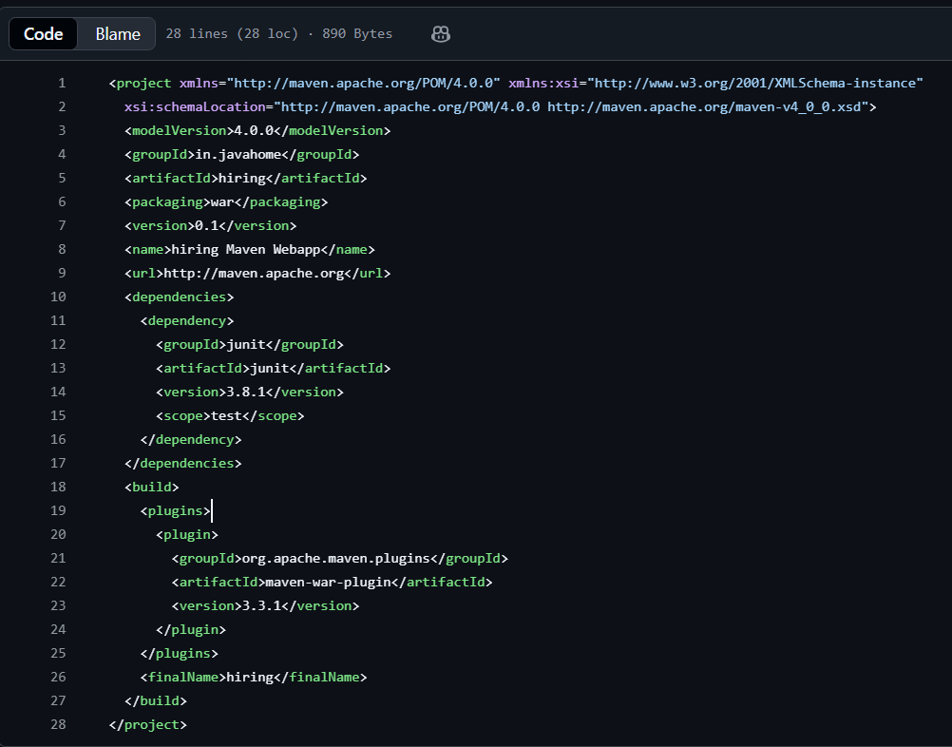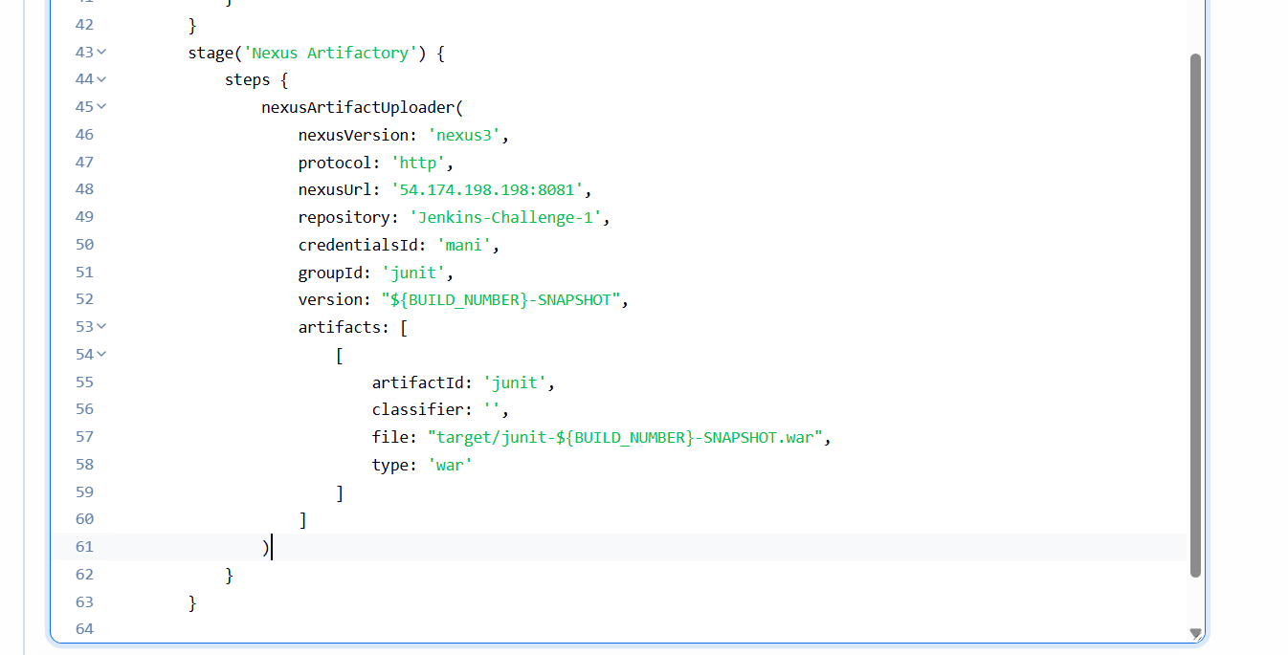
Step 16: Add Nexus Artifact Upload Stage to Jenkins Pipeline
• Console path / UI path:
Jenkins_Challenge-1 → Configure → Pipeline section
• Explanation:
A new stage named Nexus Artifactory is added to the Declarative pipeline.
The stage uses the nexusArtifactUploader step to push the WAR artifact to Nexus.
Initial configuration includes:
- Nexus version: nexus3
- Protocol: http
- Nexus URL: 54.174.198.198:8081
- Repository: Jenkins-Challenge-1
- Credentials ID: mani
- Artifact metadata defined inside artifacts block
• Evidence:

Step 17: Nexus Upload Failure Due to Incorrect Artifact File Name
• Console path / UI path:
Jenkins_Challenge-1 → Build Now → Console Output
• Explanation:
Pipeline execution fails with the error:
junit-14-SNAPSHOT.war file doesn't exist
Root cause:
- The artifact name configured in the Nexus uploader (junit-*.war) does not match the actual generated WAR file name (hiring.war).
• Evidence:
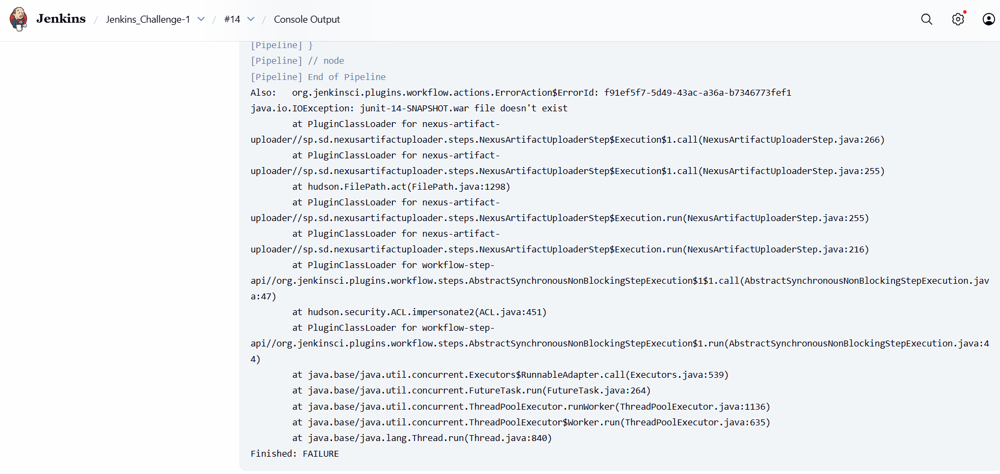
Step 18: Correct Nexus Artifact Metadata to Match Build Output
• Console path / UI path:
Jenkins_Challenge-1 → Configure → Pipeline section
• Explanation:
The Nexus upload configuration is corrected to align with the Maven build output and POM file.
Corrections made:
- groupId: in.javahome
- artifactId: hiring
- file: target/hiring.war
- type: war
- Version set dynamically using ${BUILD_NUMBER}-SNAPSHOT
• Evidence:
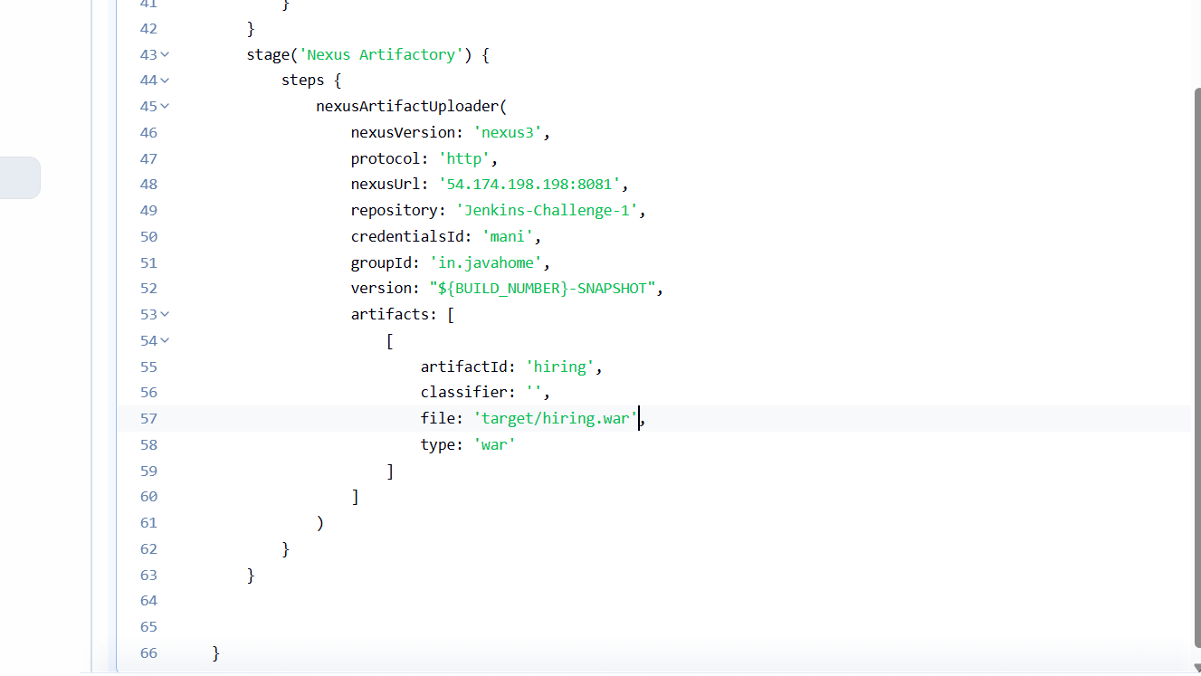
Step 19: Execute Nexus Upload from Correct Directory
• Console path / UI path:
Jenkins_Challenge-1 → Configure → Pipeline section
• Explanation:
The Nexus upload step is wrapped inside:
dir('hiring-app')
This ensures Jenkins executes the upload from the same directory where the Maven build generated the WAR file.
• Evidence:
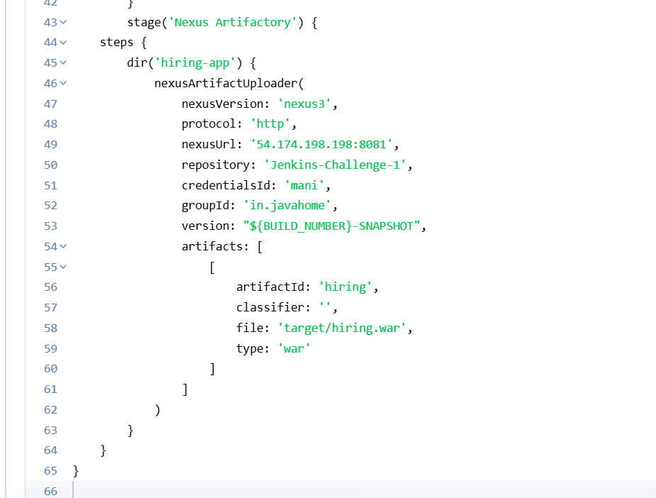Step 20: Successful Artifact Upload to Nexus Repository
• Console path / UI path:
Jenkins_Challenge-1 → Build Now → Console Output
• Explanation:
After correcting artifact metadata and execution path:
- Jenkins successfully uploads hiring.war to Nexus
- Snapshot metadata files are generated and uploaded
- Pipeline completes successfully
• Evidence:
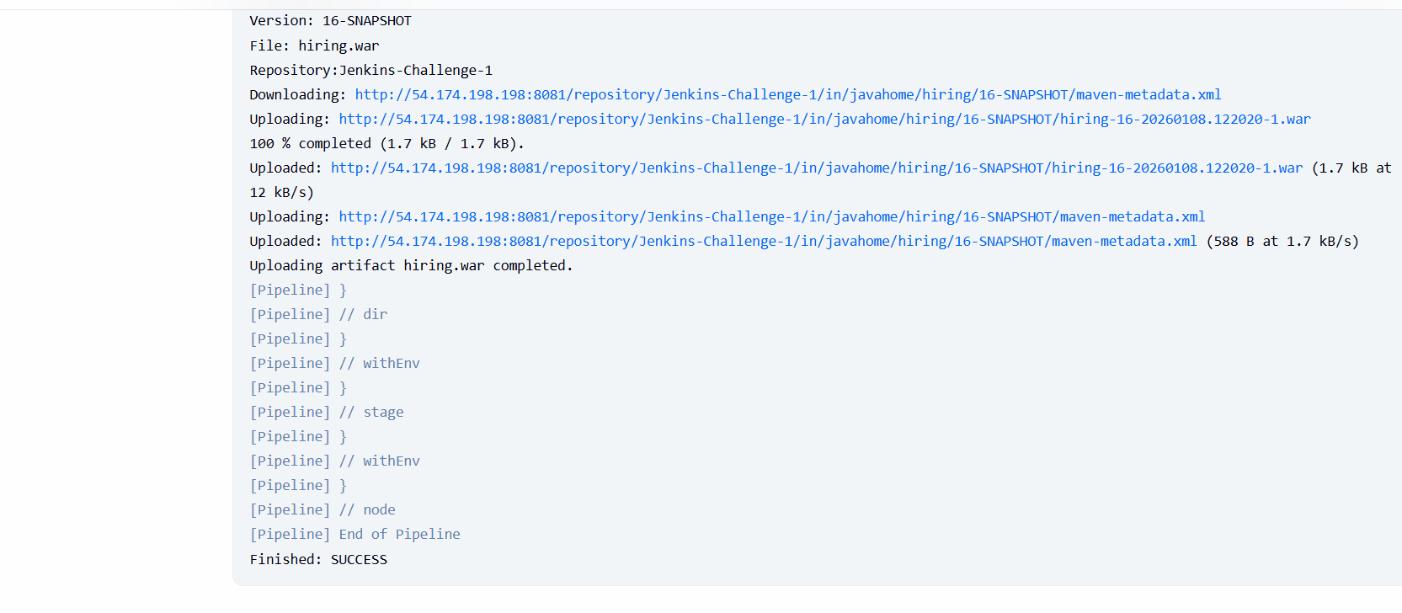Step 21: Verify Artifact in Nexus Repository Browser
• Console path / UI path:
Nexus Repository Manager → Browse → Jenkins-Challenge-1
• Explanation:
The uploaded artifact is verified directly in Nexus by browsing the repository path.
Verified path structure:
- in/javahome/hiring/16-SNAPSHOT/
- WAR file present with timestamped snapshot
- maven-metadata.xml and checksum files available
This confirms successful CI artifact publishing.
• Evidence:
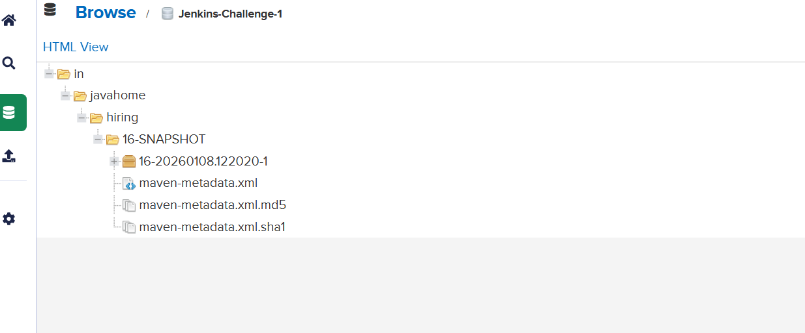
Step 22: Add Deployment Stage to Deploy WAR to Tomcat Server
• Console path / UI path:
Jenkins_Challenge-1 → Configure → Pipeline section
• Explanation:
A new stage named Deploy to Tomcat is added to the Declarative pipeline using the Deploy to Container plugin.
This stage is configured to deploy the generated WAR file to a remote Tomcat 9.x server.
Initial configuration includes:
- Adapter: tomcat9
- Credentials ID: tomcat-cred-01
- Tomcat URL: http://50.19.57.109:8080/
- Context path: sabear
- WAR path: target/*.war
• Evidence:
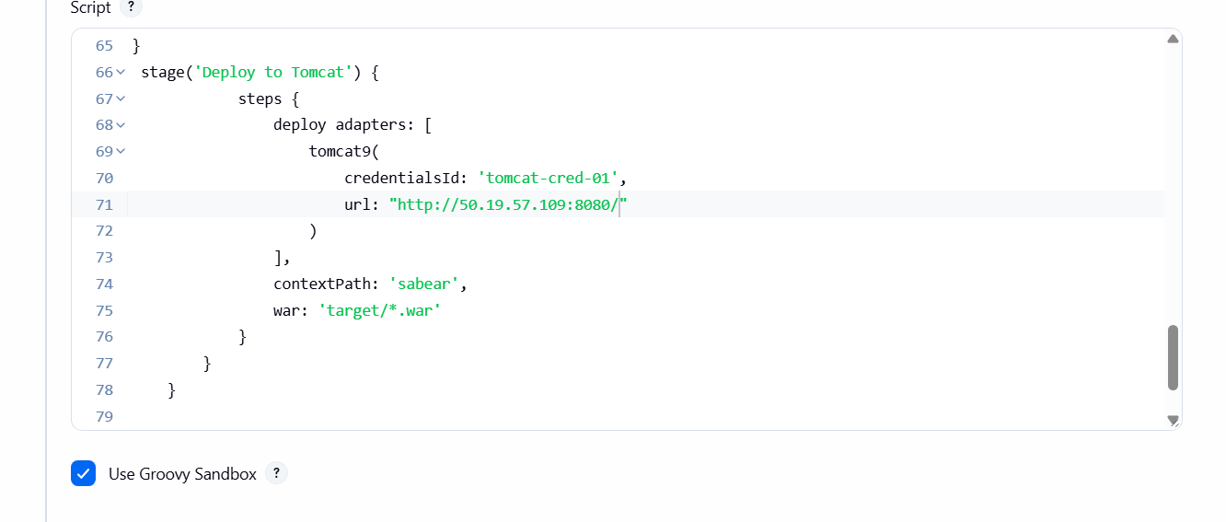
Step 23: Deployment Failure Due to WAR File Not Found
• Console path / UI path:
Jenkins_Challenge-1 → Build Now → Console Output
• Explanation:
Pipeline execution fails during deployment with the error:
[DeployPublisher][WARN] No wars found. Deploy aborted.
Root cause:
- Jenkins is executing the deploy step from the workspace root
- The WAR file exists inside hiring-app/target/, not in the root directory
• Evidence:
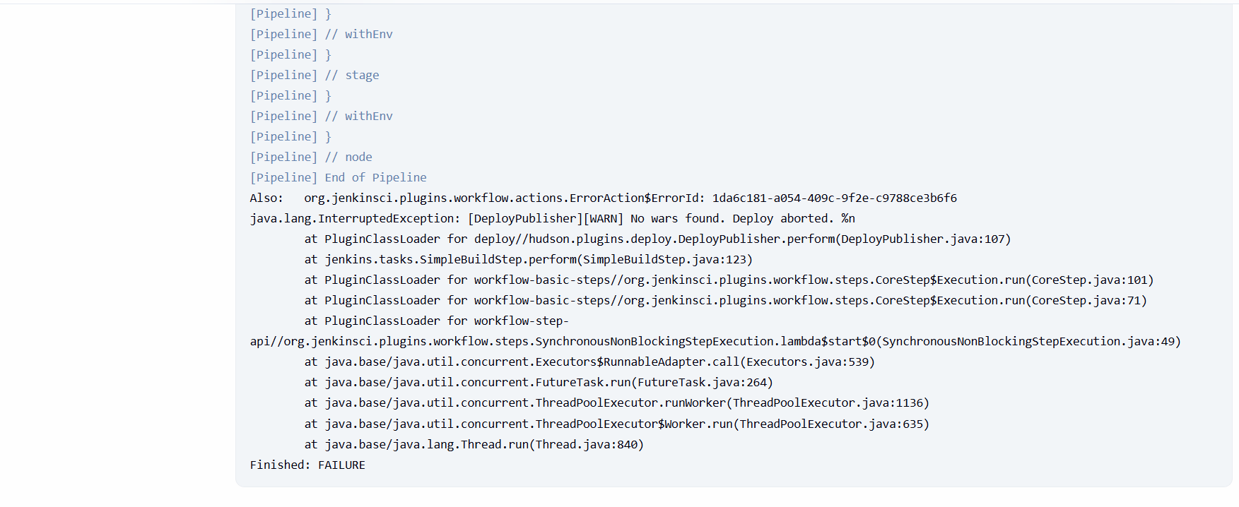
Step 24: Fix Deployment Path Using dir() Block
• Console path / UI path:
Jenkins_Challenge-1 → Configure → Pipeline section
• Explanation:
The deployment stage is corrected by wrapping the deploy step inside:
dir('hiring-app')
Additionally:
- WAR path is explicitly set to target/hiring.war
- Ensures Jenkins executes deployment from the directory where the WAR exists
• Evidence:
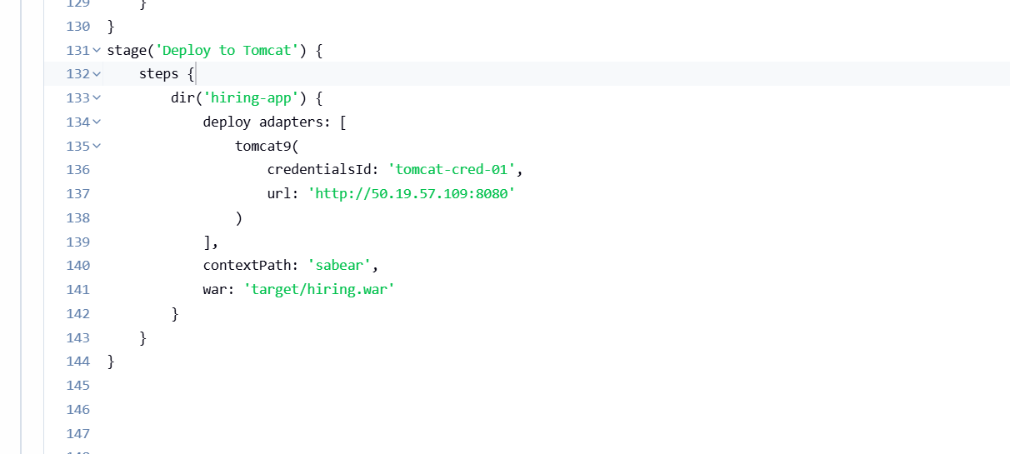Step 25: Successful Deployment to Tomcat Server
• Console path / UI path:
Jenkins_Challenge-1 → Build Now → Console Output
• Explanation:
After fixing the execution directory:
- Jenkins successfully detects the WAR file
- Existing deployment is undeployed (if present)
- New WAR is deployed to Tomcat
- Pipeline completes successfully
Deployment logs confirm:
- Redeploying WAR
- Undeploying old WAR
- Deploying new WAR
• Evidence:
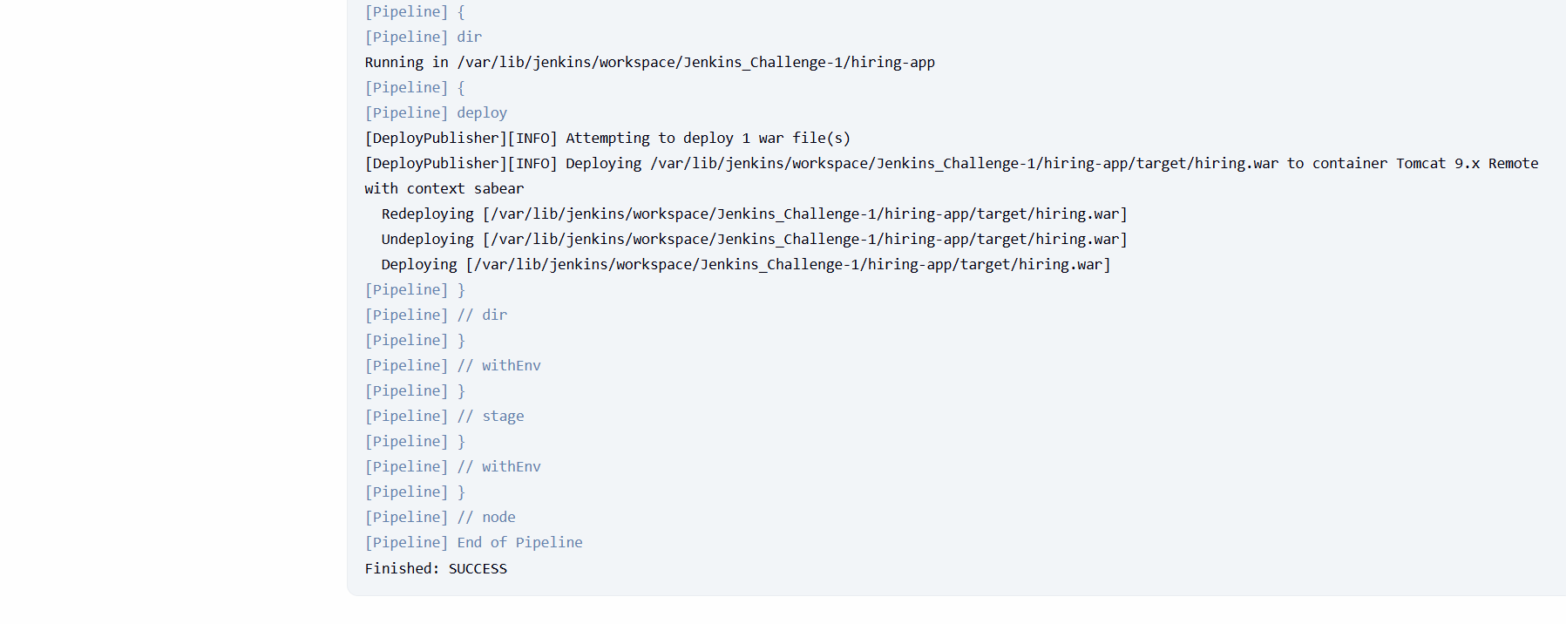
Step 26: Verify Application Access via Browser
• Console path / UI path:
Web Browser → http://50.19.57.109:8080/hiring/
• Explanation:
Post-deployment, the application is accessed via the Tomcat URL to confirm successful deployment.
The application loads successfully, confirming:
- WAR deployment is correct
- Tomcat server is running
- CI/CD pipeline deployment stage is functional
• Evidence:
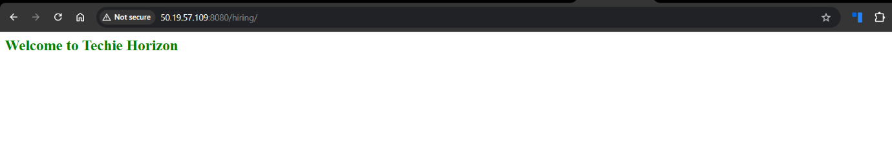
Step 27: Add Post-Build Actions for Slack Notifications
• Console path / UI path:
Jenkins_Challenge-1 → Configure → Pipeline section
• Explanation:
A post block is added inside the Declarative pipeline to send build notifications to Slack based on the pipeline result.
Two conditions are configured:
- success → Sends a green notification
- failure → Sends a red notification
The Slack message dynamically includes:
- Job name
- Build number
- Build URL
This ensures stakeholders are notified automatically after each pipeline execution.
• Evidence:
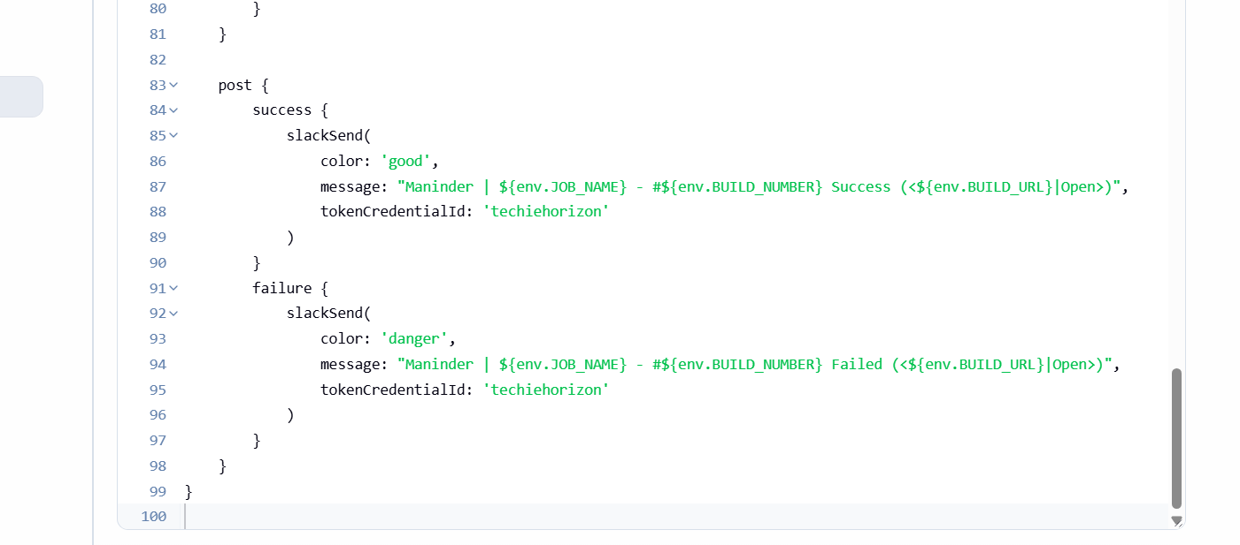Step 28: Successful Pipeline Execution Including Post Actions
• Console path / UI path:
Jenkins_Challenge-1 → Build Now → Console Output
• Explanation:
After adding the post block:
- All pipeline stages execute successfully
- Post-build section is triggered automatically
- Jenkins logs show Declarative: Post Actions
- Slack notification step runs without errors
This confirms the post block is syntactically correct and properly placed.
• Evidence:
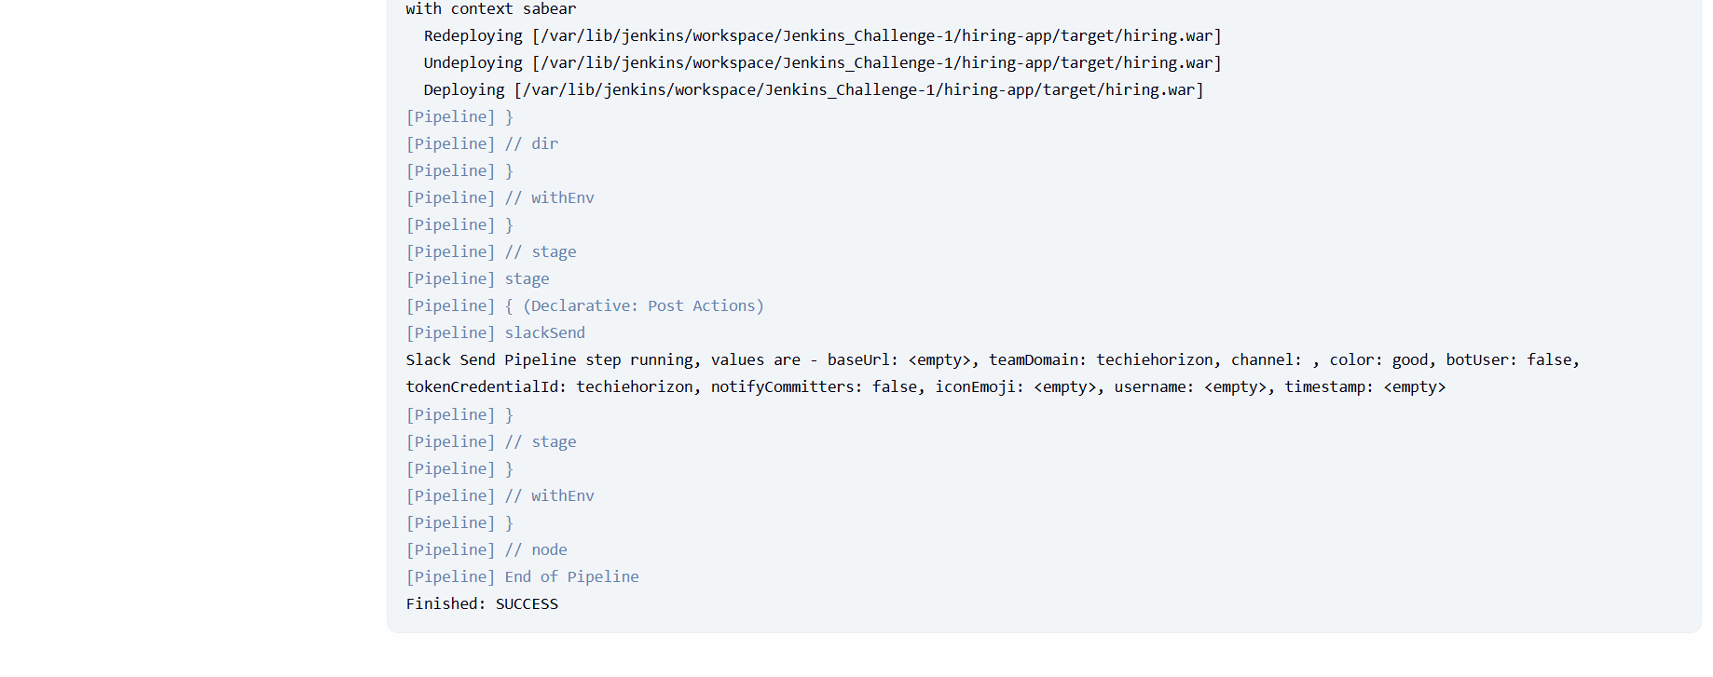
Step 29: Verify Slack Notification Delivery
• Console path / UI path:
Slack Workspace → Channel view
• Explanation:
Slack messages are successfully delivered after pipeline completion.
The message confirms:
- Job name: Jenkins_Challenge-1
- Build number
- Status: Success
- Clickable link to Jenkins build
This validates end-to-end CI/CD visibility and alerting.
• Evidence:
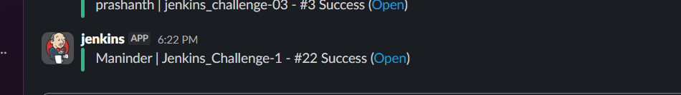
The following code was generated by the end of the task:
pipeline {
agent any

tools {
maven 'MVN_HOME'
}

stages {

stage('Git Clone') {
steps {
sh '''
rm -rf hiring-app
git clone -b main https://github.com/betawins/hiring-app.git
'''
}
}

stage('SonarQube Analysis') {
steps {
dir('hiring-app') {
withSonarQubeEnv('sonarqube-Docker') {
sh '''
/opt/sonar-scanner/bin/sonar-scanner \
-Dsonar.projectKey=hiring-app \
-Dsonar.projectName="hiring Maven Webapp" \
-Dsonar.sources=. \
-Dsonar.exclusions=**/*.java
'''
}
}
}
}

stage('Maven Build') {
steps {
dir('hiring-app') {
sh 'mvn clean package'
}
}
}

stage('Nexus Artifactory') {
steps {
dir('hiring-app') {
nexusArtifactUploader(
nexusVersion: 'nexus3',
protocol: 'http',
nexusUrl: '54.174.198.198:8081',
repository: 'Jenkins-Challenge-1',
credentialsId: 'mani',
groupId: 'in.javahome',
version: "${BUILD_NUMBER}-SNAPSHOT",
artifacts: [
[
artifactId: 'hiring',
classifier: '',
file: 'target/hiring.war',
type: 'war'
]
]
)
}
}
}

stage('Deploy to Tomcat') {
steps {
dir('hiring-app') {
deploy adapters: [
tomcat9(
credentialsId: 'tomcat-cred-01',
url: 'http://50.19.57.109:8080'
)
],
contextPath: 'sabear',
war: 'target/hiring.war'
}
}
}
}

post {
success {
slackSend(
color: 'good',
message: "Maninder | ${env.JOB_NAME} - #${env.BUILD_NUMBER} Success (<${env.BUILD_URL}|Open>)",
tokenCredentialId: 'techiehorizon'
)
}
failure {
slackSend(
color: 'danger',
message: "Maninder | ${env.JOB_NAME} - #${env.BUILD_NUMBER} Failed (<${env.BUILD_URL}|Open>)",
tokenCredentialId: 'techiehorizon'
)
}
}
}

6) Issues Faced (Optional)
- Groovy compilation error due to stage defined outside stages {} block
- Git clone failure because repository directory already existed in workspace
- Maven command not found as Maven was not configured via tools {}
- Missing POM error due to Maven executed from incorrect directory
- Nexus upload failure caused by mismatched artifact name and path
- WAR file not found during deployment due to incorrect execution directory
- Deploy to Tomcat aborted because Jenkins could not locate WAR in workspace root
- Post block placement issue when post {} was defined outside pipeline {}

7) Conclusion
A complete end-to-end CI/CD pipeline was successfully implemented using Jenkins.
The pipeline automates:
- Source code checkout from GitHub
- Static code analysis using SonarQube
- Build and packaging using Maven
- Artifact storage in Nexus Repository
- Application deployment to Tomcat server
- Real-time build notifications via Slack

2) Create one Scripted pipeline job

Step-by-Step Implementation (With Evidence)
Step 1: Create a New Jenkins Pipeline Job (Scripted Pipeline)
• Console path / UI path:
Jenkins Dashboard → New Item
• Explanation:
A new Jenkins pipeline job is created to implement the same CI/CD workflow using a Scripted Pipeline instead of Declarative syntax.
Job details:
- Job name: Jenkins_Challenge-1.2
- Job type selected: Pipeline
This step differentiates the implementation by using Groovy-based scripted pipeline syntax.
• Evidence:
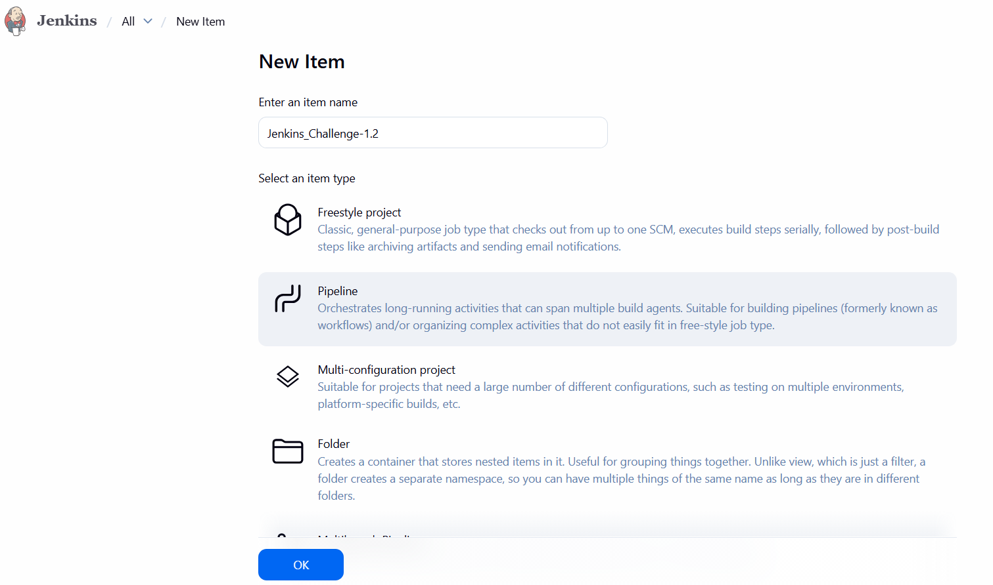
Step 31: Configure Scripted Pipeline and Define Maven Tool
• Console path / UI path:
Jenkins_Challenge-1.2 → Configure → Pipeline → Script
• Explanation:
A Scripted Pipeline is defined using the node {} block.
Maven is explicitly loaded using Jenkins tool configuration:
- Maven tool name: MVN_HOME
- Tool type: maven
This ensures Maven is available inside the pipeline runtime.
• Evidence:
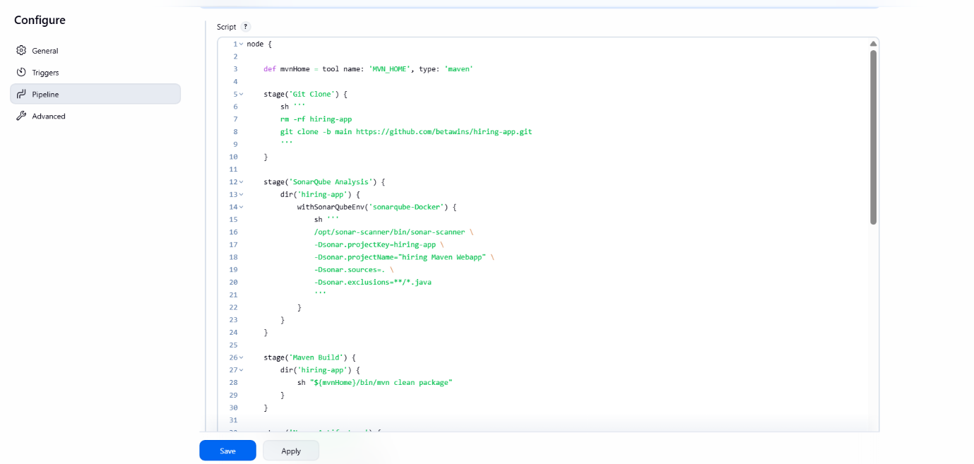
Step 32: Git Clone Stage in Scripted Pipeline
• Console path / UI path:
Jenkins_Challenge-1.2 → Configure → Pipeline → Script
• Explanation:
A Git Clone stage is defined to fetch the application source code from GitHub.
Actions performed:
- Remove existing hiring-app directory (if present)
- Clone the repository from the main branch
• Evidence:
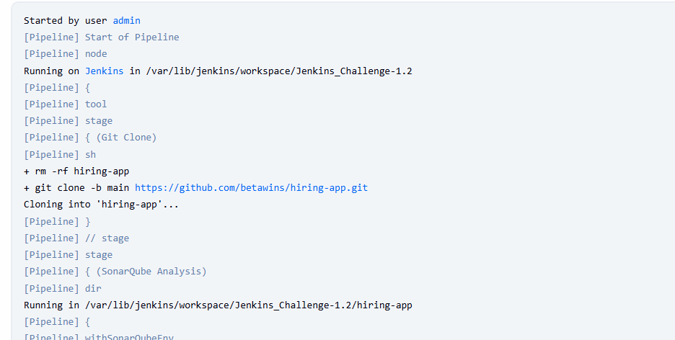
Step 33: SonarQube Analysis Stage in Scripted Pipeline
• Console path / UI path:
Jenkins_Challenge-1.2 → Configure → Pipeline → Script
• Explanation:
Static code analysis is performed using SonarQube inside the Scripted Pipeline.
Key details:
- Execution directory: hiring-app
- SonarQube environment: sonarqube-Docker
- SonarScanner executed from /opt/sonar-scanner/bin/sonar-scanner
• Evidence:
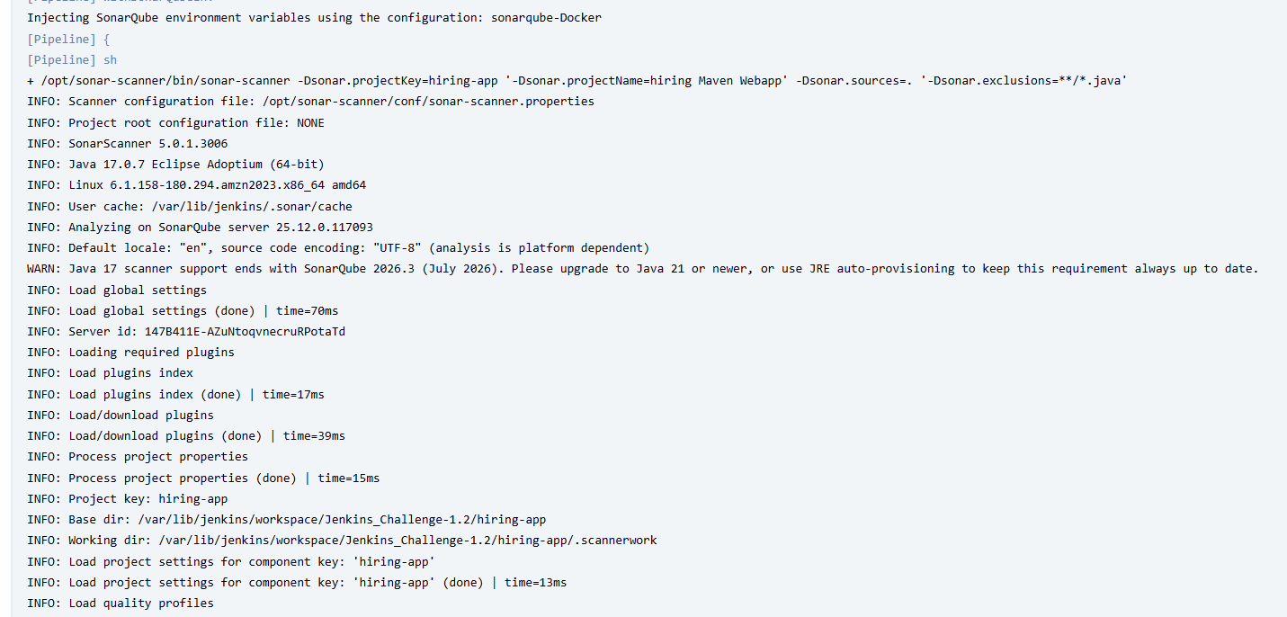
Step 34: Maven Build Stage Using Scripted Pipeline
• Console path / UI path:
Jenkins_Challenge-1.2 → Configure → Pipeline → Script
• Explanation:
The application is built using Maven inside the Scripted Pipeline.
Key points:
- Build runs from hiring-app directory
- Maven executable is referenced using ${mvnHome}
- WAR file is generated in target/
• Evidence:
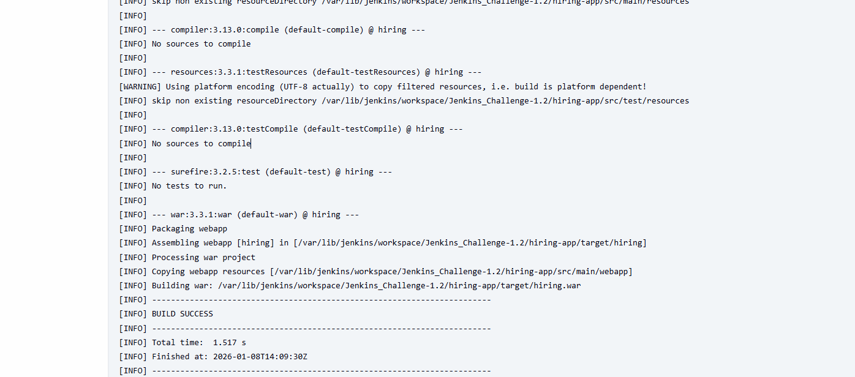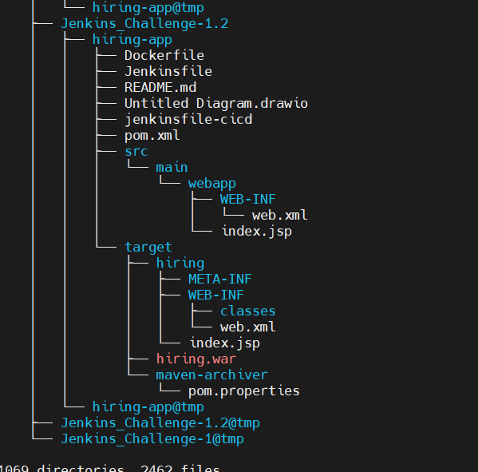
Step 35: Create a New Nexus Maven Hosted Repository
• Console path / UI path:
Nexus Repository Manager → Settings → Repositories
• Explanation:
A separate Maven hosted repository is created to store artifacts from the scripted pipeline job.
Repository details:
- Name: Jenkins-challenge-1.2
- Format: maven2
- Type: hosted
- Version policy: Mixed
- Repository set to Online
• Evidence: 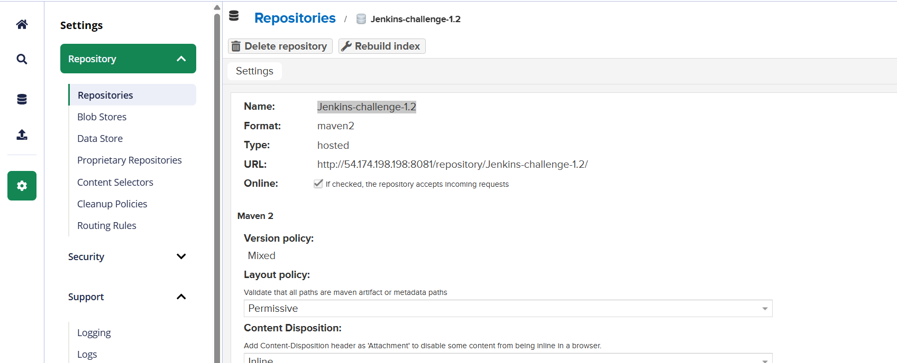
Step 36: Nexus Artifact Upload from Scripted Pipeline
• Console path / UI path:
Jenkins_Challenge-1.2 → Build Now → Console Output
• Explanation:
The WAR artifact generated by Maven is uploaded to Nexus from the Scripted Pipeline.
Details confirmed in logs:
- Artifact name: hiring.war
- Snapshot version generated using build number
- maven-metadata.xml uploaded
- Upload completed successfully
• Evidence:
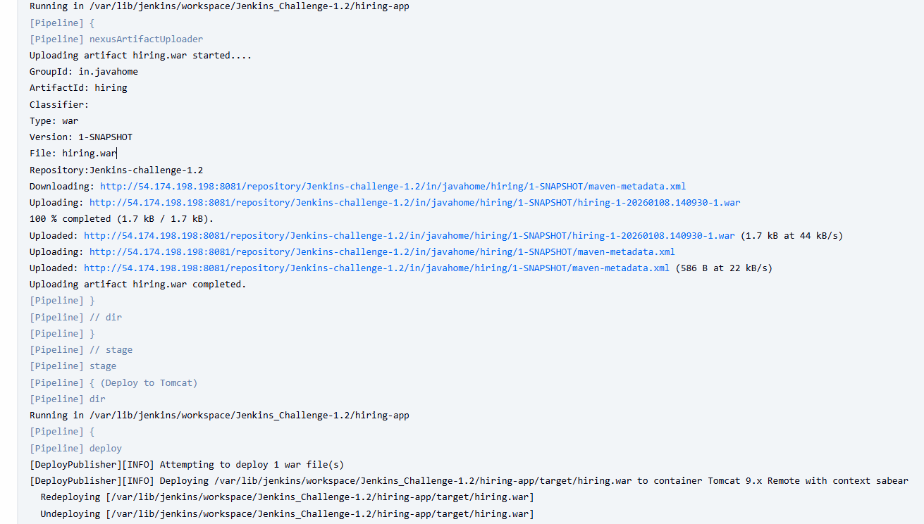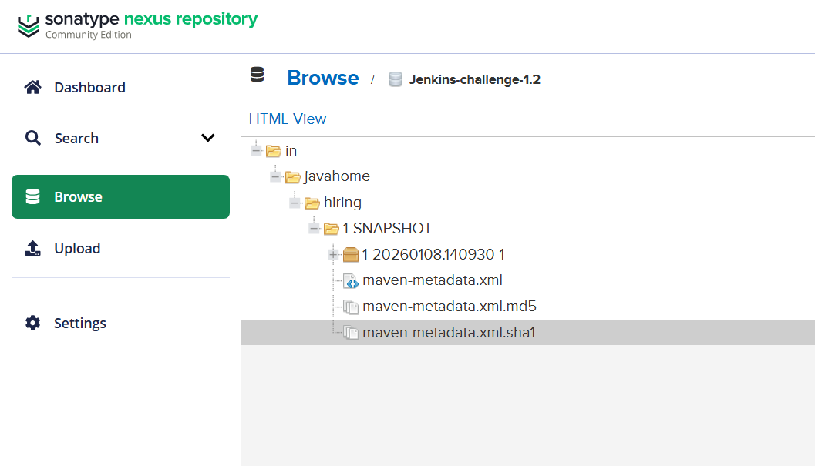
Step 37: Deploy WAR to Tomcat from Scripted Pipeline
• Console path / UI path:
Jenkins_Challenge-1.2 → Build Now → Console Output
• Explanation:
The application is deployed to a remote Tomcat 9.x server using the Deploy to Container plugin.
Deployment actions:
- WAR file located under hiring-app/target/
- Existing deployment undeployed
- New WAR deployed with context path sabear
• Evidence:
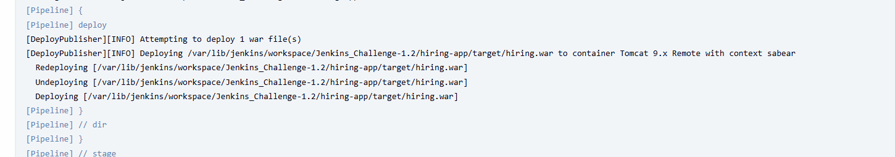 
Step 38: Verify Scripted Pipeline Stage View
• Console path / UI path:
Jenkins_Challenge-1.2 → Stage View
• Explanation:
The Jenkins Stage View confirms successful execution of all scripted pipeline stages:
- Git Clone
- SonarQube Analysis
- Maven Build
- Nexus Artifactory
- Deploy to Tomcat
All stages are marked green, confirming pipeline stability.
• Evidence:
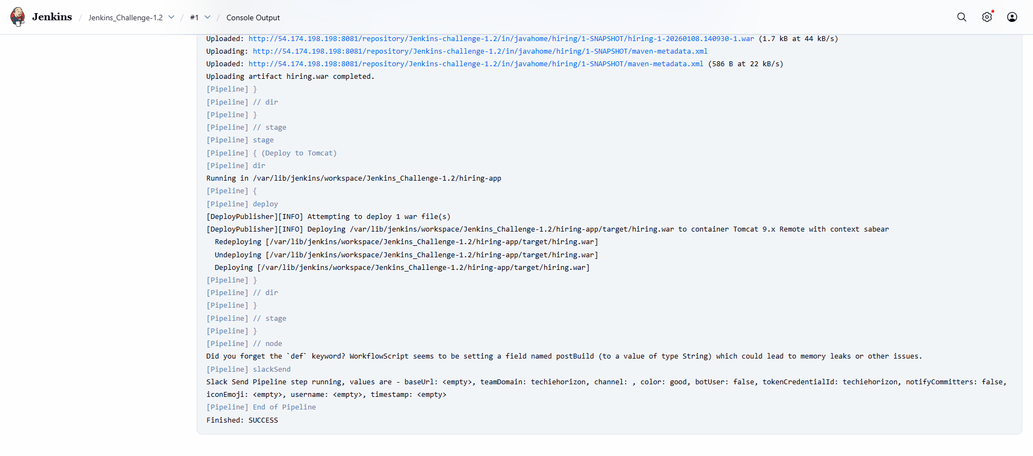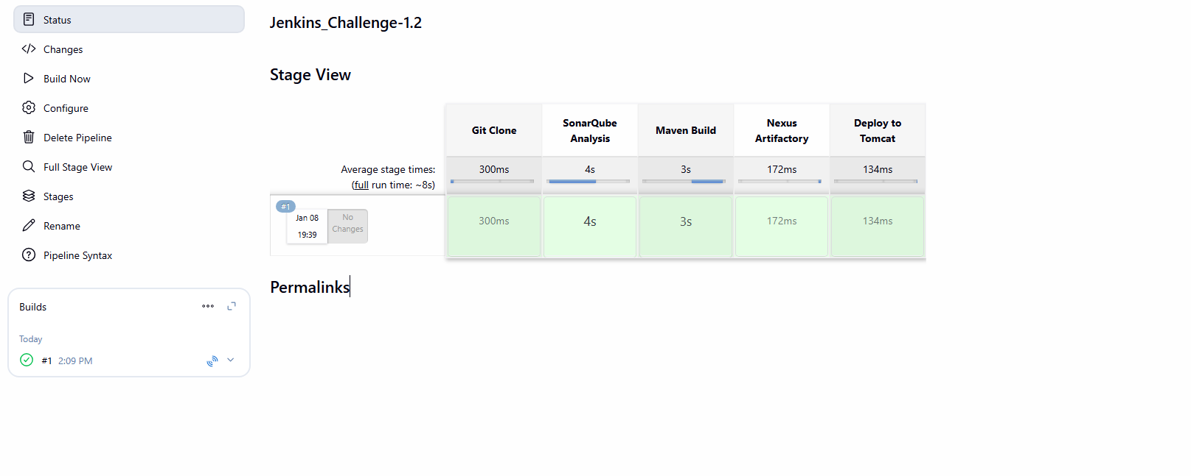
Step 39: Slack Notification Triggered from Scripted Pipeline
• Console path / UI path:
Jenkins_Challenge-1.2 → Console Output → Slack
Slack Workspace → Channel View
• Explanation:
Slack notification is triggered at the end of the Scripted Pipeline execution.
Confirmation includes:
- Job name: Jenkins_Challenge-1.2
- Build number: #1
- Status: Success
- Clickable Jenkins build link
• Evidence:
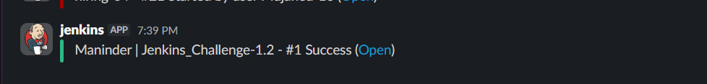


The following code was generated by the end of the task:
node {

def mvnHome = tool name: 'MVN_HOME', type: 'maven'

stage('Git Clone') {
sh '''
rm -rf hiring-app
git clone -b main https://github.com/betawins/hiring-app.git
'''
}

stage('SonarQube Analysis') {
dir('hiring-app') {
withSonarQubeEnv('sonarqube-Docker') {
sh '''
/opt/sonar-scanner/bin/sonar-scanner \
-Dsonar.projectKey=hiring-app \
-Dsonar.projectName="hiring Maven Webapp" \
-Dsonar.sources=. \
-Dsonar.exclusions=**/*.java
'''
}
}
}

stage('Maven Build') {
dir('hiring-app') {
sh "${mvnHome}/bin/mvn clean package"
}
}

stage('Nexus Artifactory') {
dir('hiring-app') {
nexusArtifactUploader(
nexusVersion: 'nexus3',
protocol: 'http',
nexusUrl: '54.174.198.198:8081',
repository: 'Jenkins-challenge-1.2',
credentialsId: 'mani',
groupId: 'in.javahome',
version: "${env.BUILD_NUMBER}-SNAPSHOT",
artifacts: [
[
artifactId: 'hiring',
classifier: '',
file: 'target/hiring.war',
type: 'war'
]
]
)
}
}

stage('Deploy to Tomcat') {
dir('hiring-app') {
deploy adapters: [
tomcat9(
credentialsId: 'tomcat-cred-01',
url: 'http://50.19.57.109:8080'
)
],
contextPath: 'sabear',
war: 'target/hiring.war'
}
}
}

postBuild = currentBuild.currentResult

if (postBuild == 'SUCCESS') {
slackSend(
color: 'good',
message: "Maninder | ${env.JOB_NAME} - #${env.BUILD_NUMBER} Success (<${env.BUILD_URL}|Open>)",
tokenCredentialId: 'techiehorizon'
)
} else {
slackSend(
color: 'danger',
message: "Maninder | ${env.JOB_NAME} - #${env.BUILD_NUMBER} Failed (<${env.BUILD_URL}|Open>)",
tokenCredentialId: 'techiehorizon'
)
}

3) Create one multi stage pipeline job
Multistage Pipelines: A pipeline is broken down into a series of distinct, logical stages (e.g., Build, Test, Staging, Production) that execute sequentially. Each stage represents a phase in the delivery process and typically must complete successfully before the next one begins. This approach provides clear visibility, structure, and control over the flow of changes through different environments.

Step-by-Step Implementation (With Evidence)

Step 40: Create a New Jenkins Pipeline Job for Jenkins_Challenge-1.3
• Console path / UI path:
Jenkins Dashboard → New Item
• Explanation:
A new Jenkins pipeline job is created to implement another Scripted Multi-Stage Pipeline.
Job details:
- Job name: Jenkins_Challenge-1.3
- Job type selected: Pipeline
This job is used to validate repeatability and consistency of the scripted pipeline approach.
• Evidence:
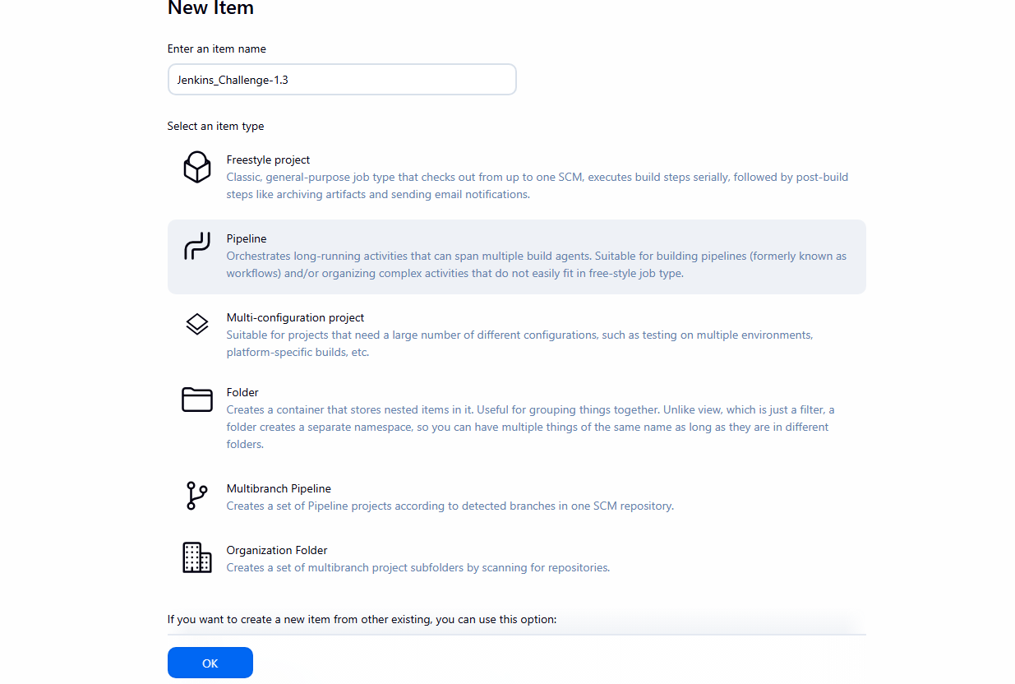
Step 41: Configure Pipeline Definition as Scripted Pipeline
• Console path / UI path:
Jenkins_Challenge-1.3 → Configure → Pipeline
• Explanation:
The pipeline definition is configured to use a Pipeline script written directly in Groovy.
The Groovy Sandbox is enabled to allow safe execution of the scripted pipeline.
• Evidence:
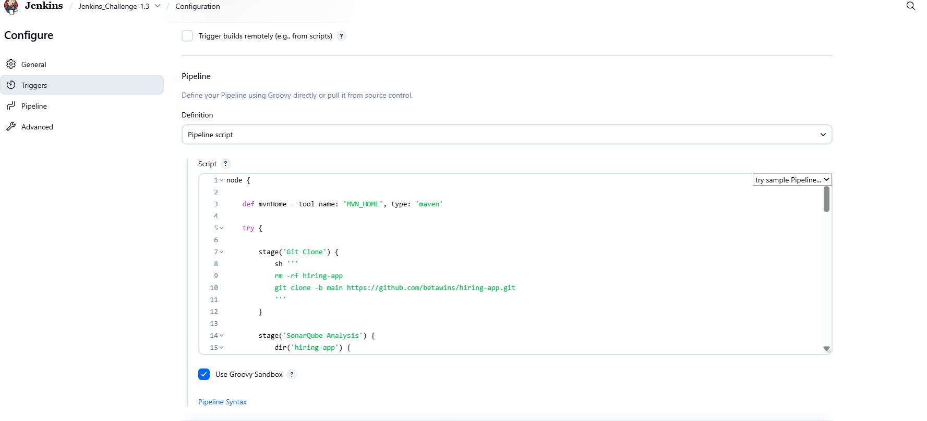 Step 42: Define Node Block and Maven Tool in Scripted Pipeline
• Console path / UI path:
Jenkins_Challenge-1.3 → Configure → Pipeline → Script
• Explanation:
The pipeline execution is wrapped inside a node {} block.
Maven is loaded dynamically using Jenkins tool configuration.
Key configuration:
- Maven tool name: MVN_HOME
- Tool type: maven
This ensures Maven availability during runtime.
• Evidence:

Step 43: Implement Git Clone Stage
• Console path / UI path:
Jenkins_Challenge-1.3 → Configure → Pipeline → Script
• Explanation:
The Git Clone stage fetches the source code from GitHub.
Actions performed:
- Clean existing workspace directory
- Clone repository from the main branch
• Evidence:
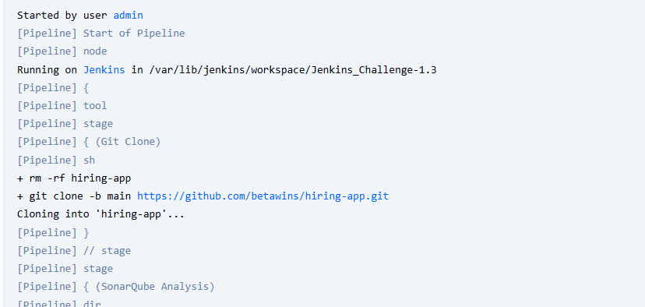
Step 44: Implement SonarQube Analysis Stage
• Console path / UI path:
Jenkins_Challenge-1.3 → Configure → Pipeline → Script
• Explanation:
Static code analysis is performed using SonarQube within the hiring-app directory.
Key details:
- SonarQube environment: sonarqube-Docker
- SonarScanner executed from /opt/sonar-scanner/bin/sonar-scanner
- Project key and name defined
• Evidence:
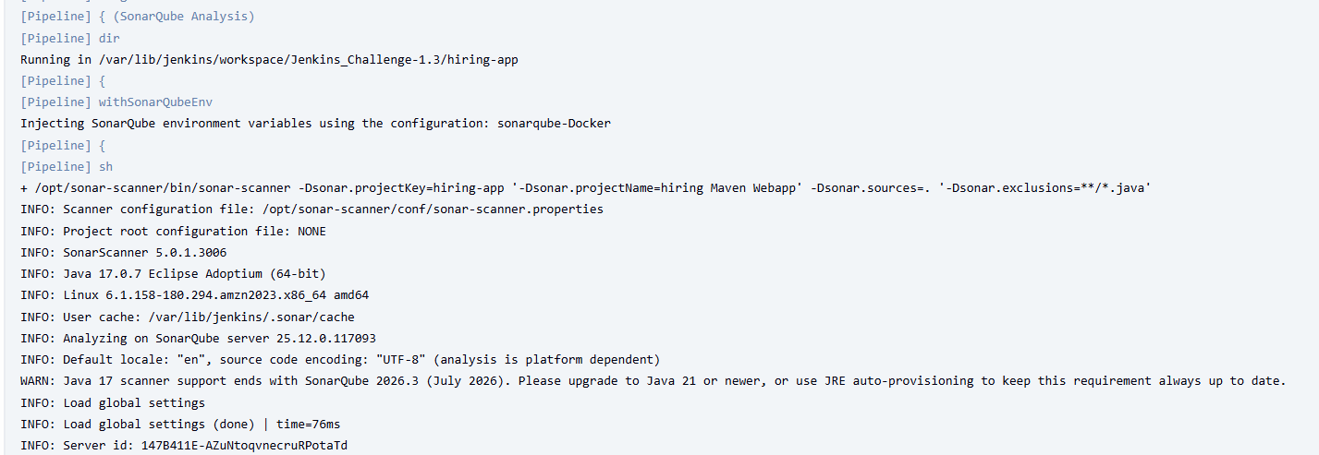
Step 45: Implement Maven Build Stage
• Console path / UI path:
Jenkins_Challenge-1.3 → Configure → Pipeline → Script
• Explanation:
The application is built and packaged using Maven.
Key points:
- Build executed inside hiring-app
- Maven invoked using ${mvnHome}
- WAR artifact generated under target/
• Evidence:
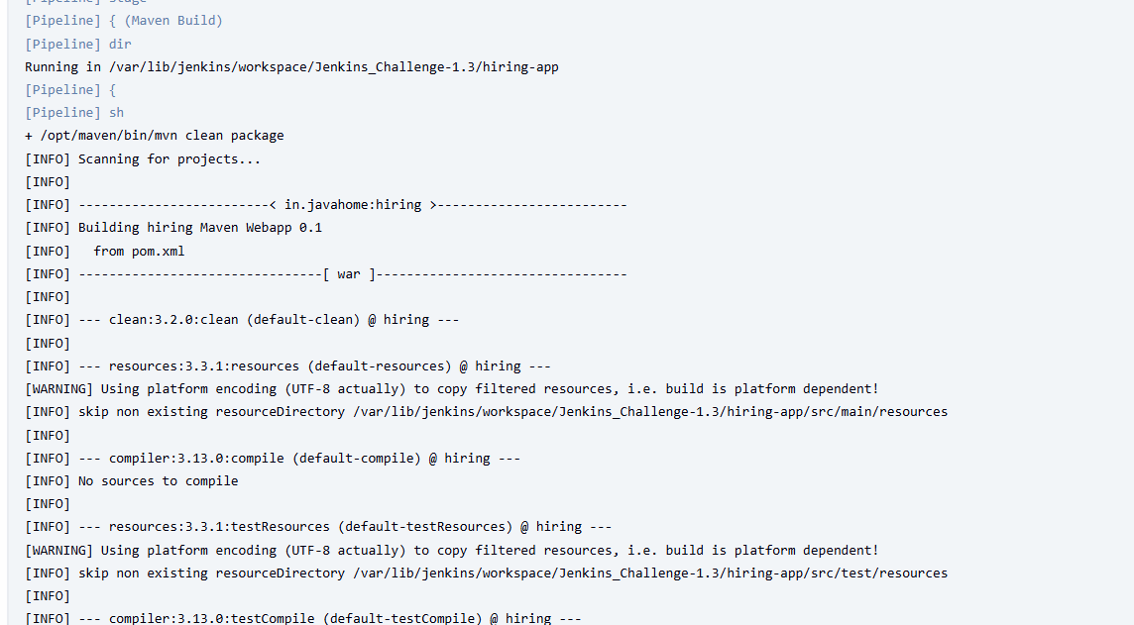 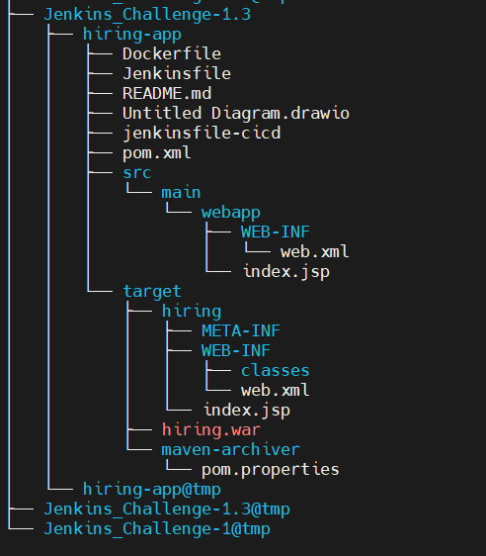
Step 46: Create Nexus Maven Hosted Repository for Jenkins_Challenge-1.3
• Console path / UI path:
Nexus Repository Manager → Settings → Repositories
• Explanation:
A new Maven hosted repository is created to store artifacts for this pipeline job.
Repository details:
- Name: jenkins-challenge-1.3
- Format: maven2
- Type: hosted
- Version policy: Mixed
- Repository status: Online
• Evidence: 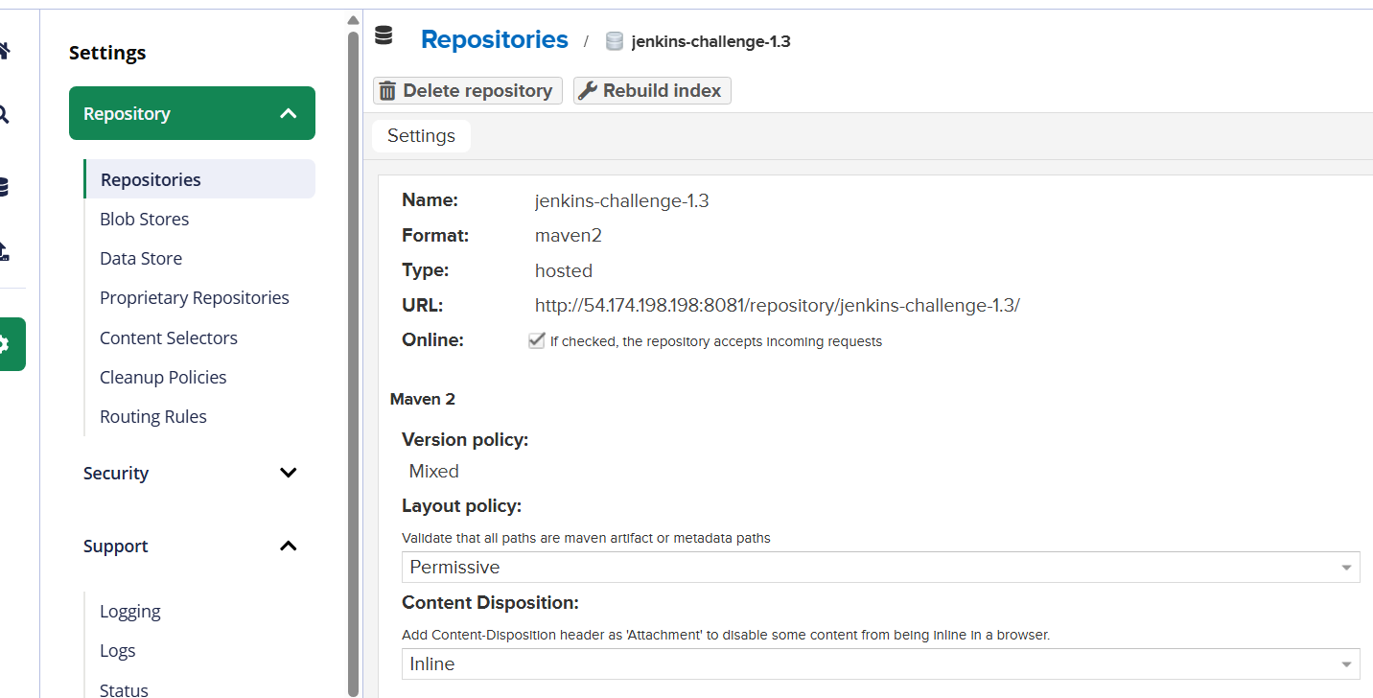
Step 47: Upload Artifact to Nexus from Scripted Pipeline
• Console path / UI path:
Jenkins_Challenge-1.3 → Build Now → Console Output
• Explanation:
The generated WAR file is uploaded to the Nexus repository.
Observed results:
- Snapshot version directory created
- hiring.war uploaded
- Metadata files generated (maven-metadata.xml, checksum files)
• Evidence:
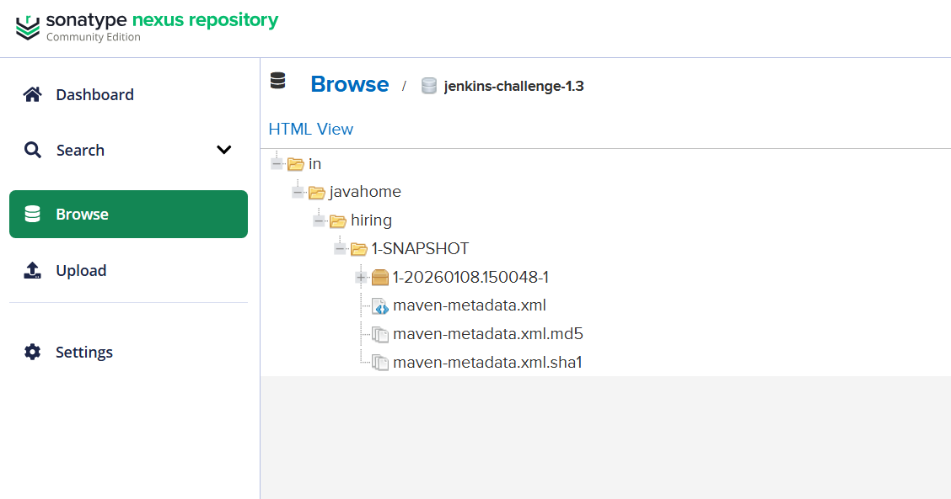
Step 48: Deploy Application to Tomcat Server
• Console path / UI path:
Jenkins_Challenge-1.3 → Build Now → Console Output
• Explanation:
The WAR file is deployed to a remote Tomcat 9.x server.
Deployment flow:
- Jenkins locates WAR file
- Existing application is undeployed
- New WAR deployed with context path sabear
• Evidence:
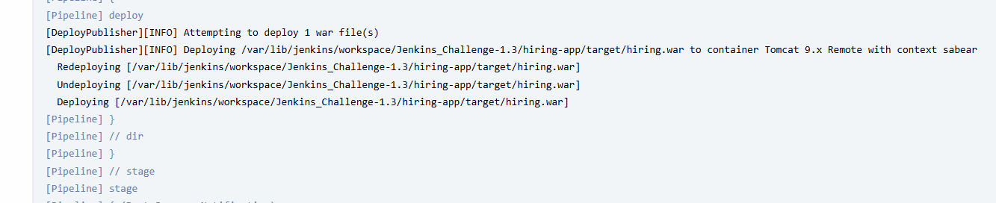 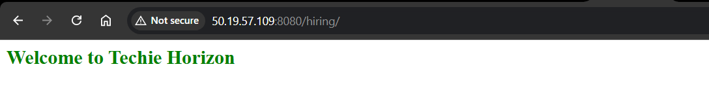 Step 49: Verify Successful Pipeline Execution in Stage View
• Console path / UI path:
Jenkins_Challenge-1.3 → Stage View
• Explanation:
The Jenkins Stage View confirms all pipeline stages executed successfully.
Stages visible:
- Git Clone
- SonarQube Analysis
- Maven Build
- Nexus Artifactory
- Deploy to Tomcat
- Post Success Notification
All stages are marked green, confirming successful execution.
• Evidence:
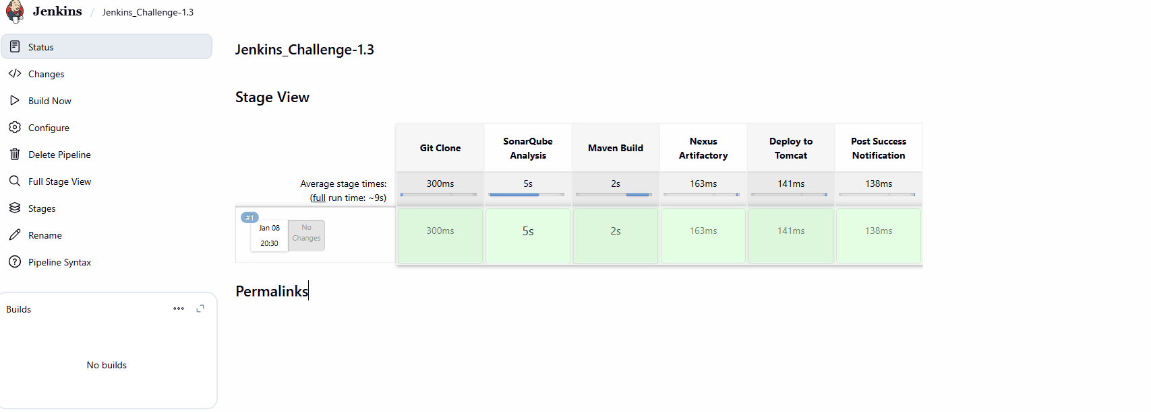 Step 50: Slack Notification Triggered on Successful Build
• Console path / UI path:
Jenkins_Challenge-1.3 → Console Output
Slack Workspace → Channel View
• Explanation:
A Slack notification is sent automatically after successful pipeline execution.
Notification includes:
- Job name: Jenkins_Challenge-1.3
- Build number: #1
- Status: Success
- Direct Jenkins build link
• Evidence:
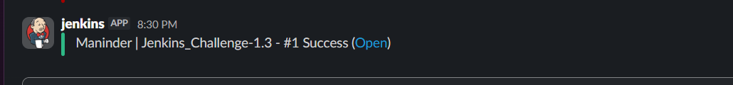 Step 51: Verify Application Deployment via Browser
• Console path / UI path:
Web Browser → http://50.19.57.109:8080/hiring/
• Explanation:
The deployed application is accessed via browser to confirm successful deployment.
The page loads correctly, displaying the application welcome message.
• Evidence:
 Step 52: Verify Artifact Availability in Nexus Repository
• Console path / UI path:
Nexus Repository Manager → Browse → jenkins-challenge-1.3
• Explanation:
The uploaded artifact is verified directly in Nexus.
Observed structure:
- Group ID path
- Artifact ID directory
- Snapshot version folder
- WAR file and metadata present
This confirms artifact storage and versioning are functioning correctly.
• Evidence:

The following script was generated by the end of the task:
node {

def mvnHome = tool name: 'MVN_HOME', type: 'maven'

try {

stage('Git Clone') {
sh '''
rm -rf hiring-app
git clone -b main https://github.com/betawins/hiring-app.git
'''
}

stage('SonarQube Analysis') {
dir('hiring-app') {
withSonarQubeEnv('sonarqube-Docker') {
sh '''
/opt/sonar-scanner/bin/sonar-scanner \
-Dsonar.projectKey=hiring-app \
-Dsonar.projectName="hiring Maven Webapp" \
-Dsonar.sources=. \
-Dsonar.exclusions=**/*.java
'''
}
}
}

stage('Maven Build') {
dir('hiring-app') {
sh "${mvnHome}/bin/mvn clean package"
}
}

stage('Nexus Artifactory') {
dir('hiring-app') {
nexusArtifactUploader(
nexusVersion: 'nexus3',
protocol: 'http',
nexusUrl: '54.174.198.198:8081',
repository: 'Jenkins-Challenge-1',
credentialsId: 'mani',
groupId: 'in.javahome',
version: "${env.BUILD_NUMBER}-SNAPSHOT",
artifacts: [
[
artifactId: 'hiring',
classifier: '',
file: 'target/hiring.war',
type: 'war'
]
]
)
}
}

stage('Deploy to Tomcat') {
dir('hiring-app') {
deploy adapters: [
tomcat9(
credentialsId: 'tomcat-cred-01',
url: 'http://50.19.57.109:8080'
)
],
contextPath: 'sabear',
war: 'target/hiring.war'
}
}

stage('Post Success Notification') {
slackSend(
color: 'good',
message: "Maninder | ${env.JOB_NAME} - #${env.BUILD_NUMBER} Success (<${env.BUILD_URL}|Open>)",
tokenCredentialId: 'techiehorizon'
)
}

} catch (err) {

stage('Post Failure Notification') {
slackSend(
color: 'danger',
message: "Maninder | ${env.JOB_NAME} - #${env.BUILD_NUMBER} Failed (<${env.BUILD_URL}|Open>)",
tokenCredentialId: 'techiehorizon'
)
}

throw err
}
}

4.Create one parallel stage pipeline job

Step 65: Define Declarative Pipeline Structure for Jenkins_Challenge-1.4
• Console path / UI path:
Jenkins → Jenkins_Challenge-1.4 → Configure → Pipeline → Script
• Explanation:
A Declarative Pipeline structure is defined using the pipeline {} block. This establishes a clean, maintainable CI/CD workflow with clearly defined stages and post actions.
Key elements included:
- agent any to allow execution on any Jenkins agent
- Maven tool configuration using MVN_HOME
- Structured stages {} block
• Evidence:
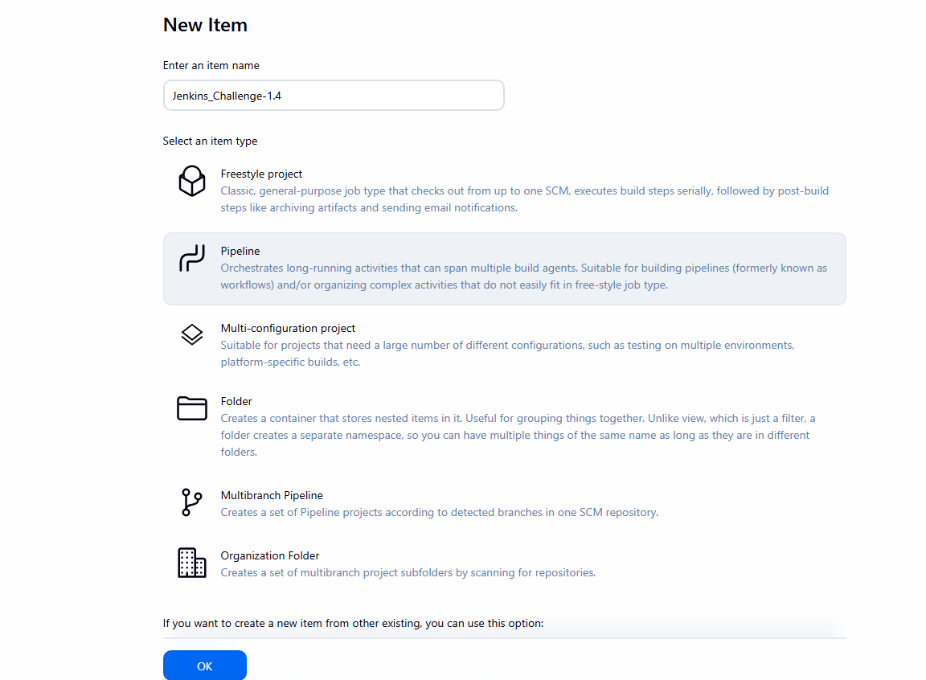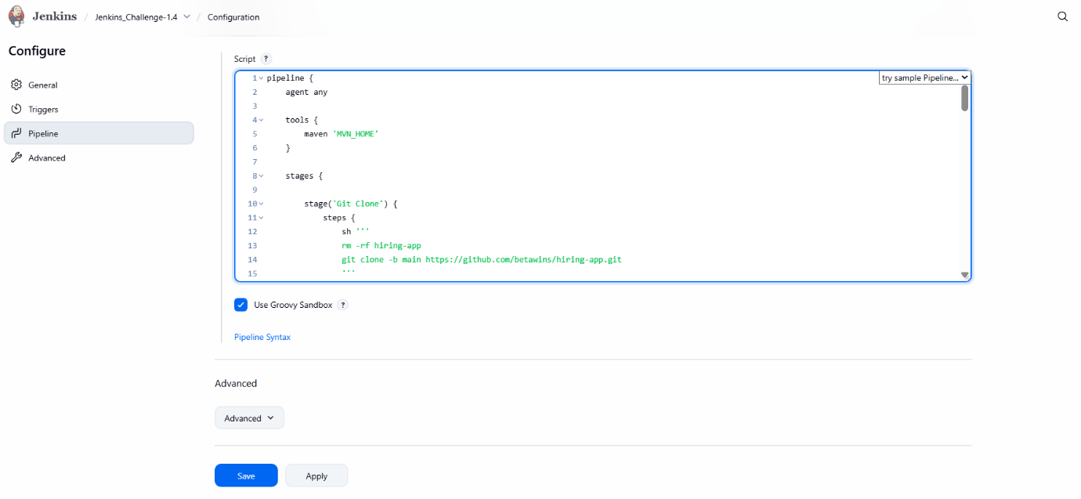
Step 66: Enable Groovy Sandbox for Pipeline Security
• Console path / UI path:
Jenkins_Challenge-1.4 → Configure → Pipeline
• Explanation:
Groovy Sandbox is enabled to safely execute pipeline scripts without requiring script approval from Jenkins administrators.
• Evidence:

Step 67: Create Maven Hosted Repository in Nexus (jenkins-challenge-1.4)
• Console path / UI path:
Nexus Repository Manager → Settings → Repositories → Create Repository → maven2 (hosted)
• Explanation:
A new Maven hosted repository is created to store build artifacts generated by the pipeline.
Repository configuration:
- Name: jenkins-challenge-1.4
- Format: maven2
- Type: hosted
- Version policy: Mixed
- Layout policy: Permissive
- Blob store: default
- Online: Enabled
• Evidence:
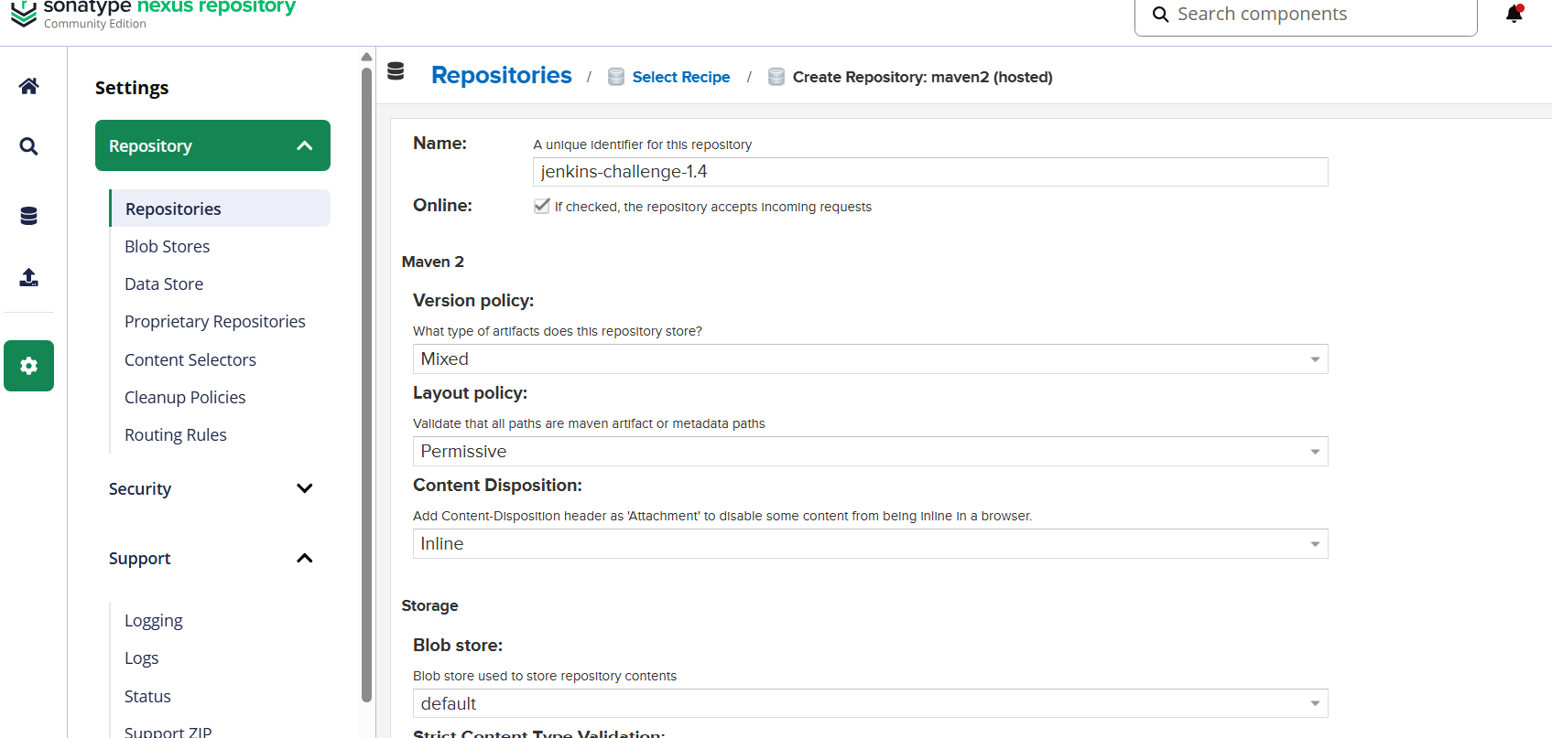Step 68: Save and Trigger Pipeline Execution
• Console path / UI path:
Jenkins_Challenge-1.4 → Save → Build Now
• Explanation:
After saving the pipeline configuration, the job is manually triggered to validate the pipeline flow and integrations.
• Evidence:
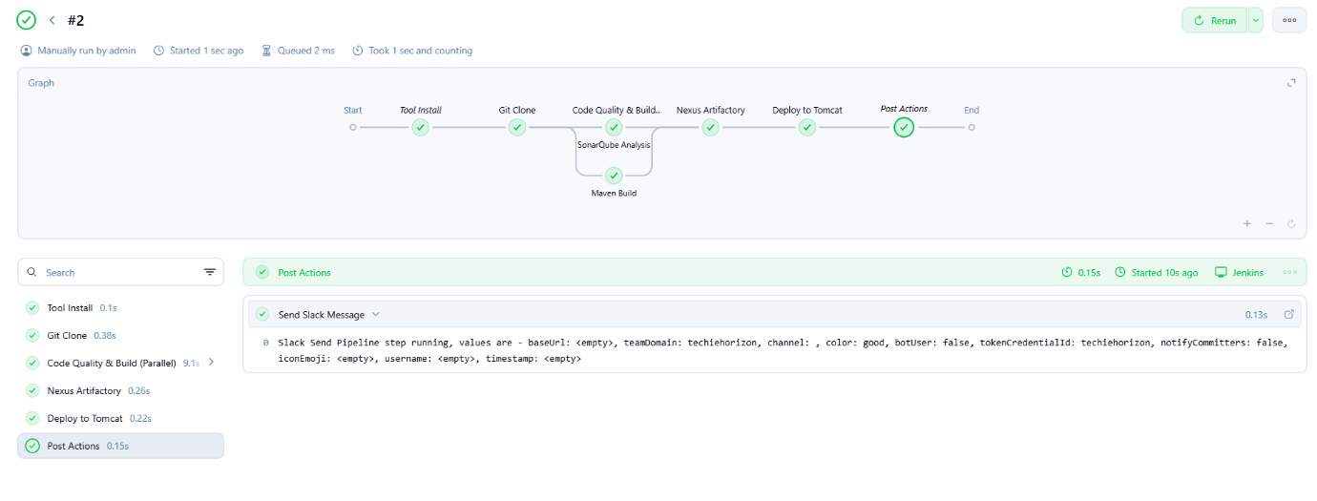
Step 69: Tool Installation Stage Execution
• Console path / UI path:
Jenkins_Challenge-1.4 → Build #2 → Graph / Stage View
• Explanation:
The pipeline automatically installs and initializes the configured Maven tool before executing subsequent stages.
• Evidence:
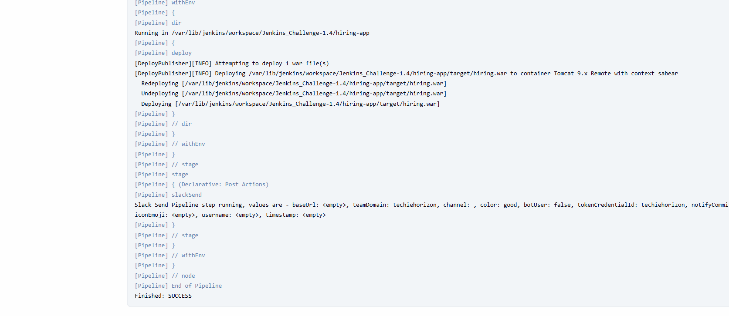
Step 70: Git Clone Stage Execution
• Console path / UI path:
Jenkins_Challenge-1.4 → Build #2 → Console Output
• Explanation:
The source code is cloned from the GitHub repository into the Jenkins workspace.
Actions observed:
- Workspace cleanup
- Repository cloned from main branch
• Evidence: 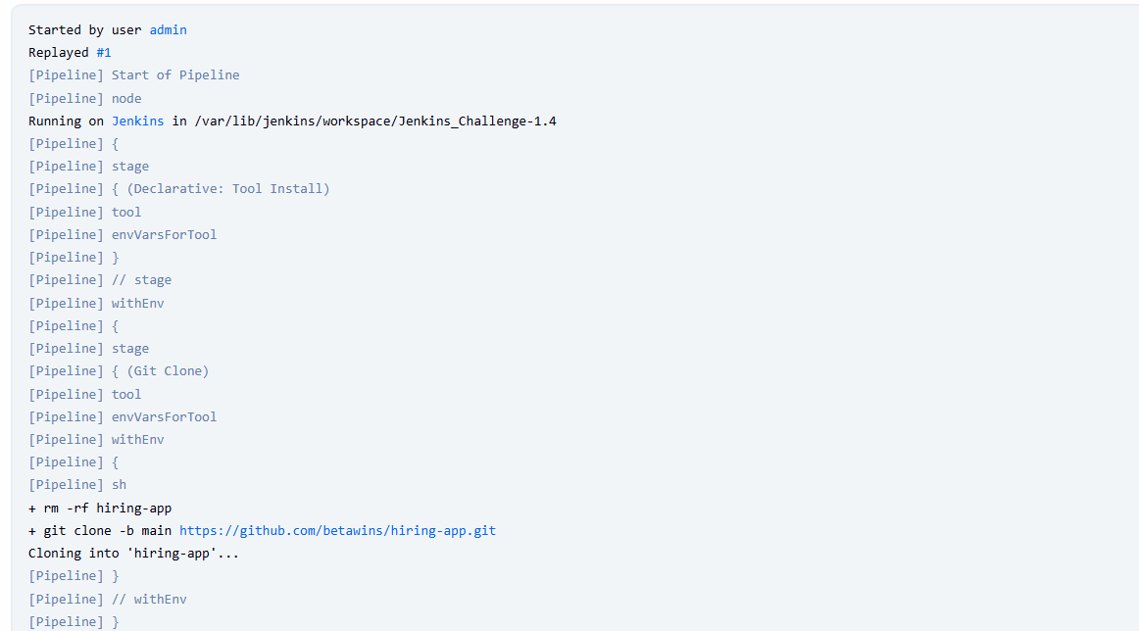
Step 71: Execute Parallel Stage – Code Quality & Build
• Console path / UI path:
Jenkins_Challenge-1.4 → Build #2 → Graph View
• Explanation:
The pipeline enters a parallel stage named Code Quality & Build, where:
- SonarQube Analysis
- Maven Build
run simultaneously, reducing total pipeline execution time.
• Evidence:
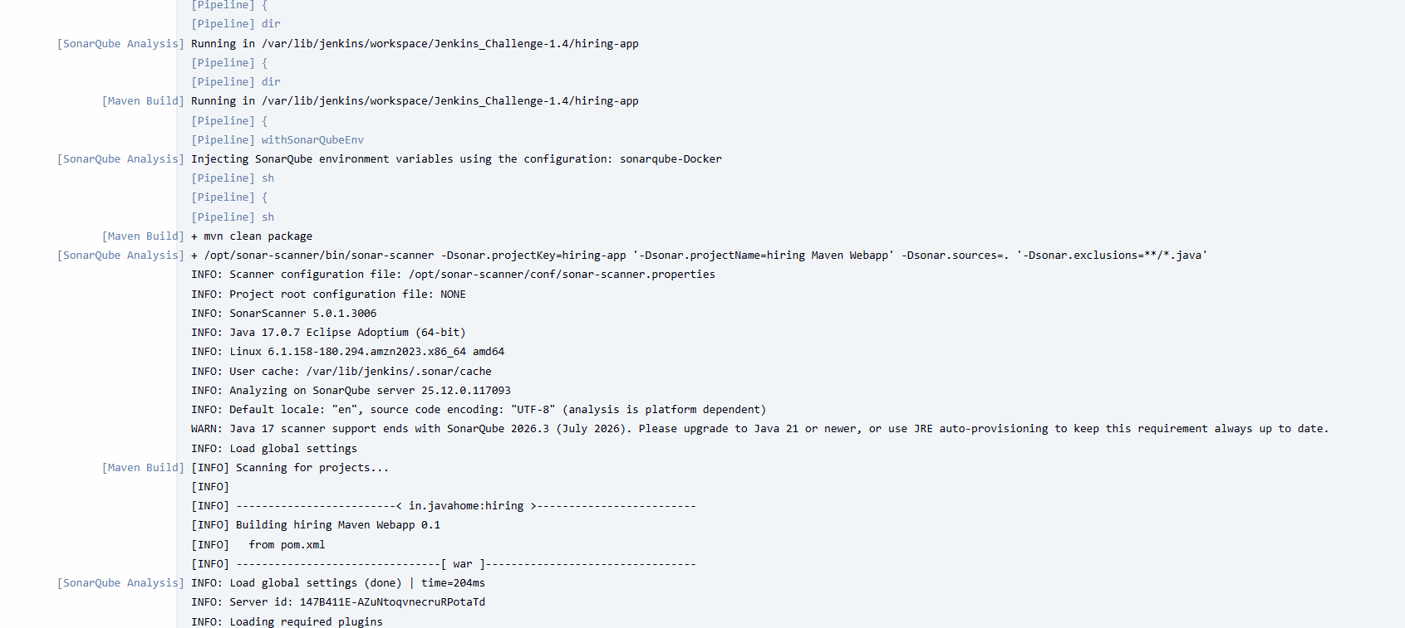
Step 72: SonarQube Analysis Execution in Parallel Branch
• Console path / UI path:
Jenkins_Challenge-1.4 → Build #2 → Console Output
• Explanation:
SonarQube static code analysis is executed with injected environment variables.
Key observations:
- SonarScanner 5.0.1 executed
- Java 17 runtime detected
- Project analyzed on SonarQube server
- Analysis completed successfully
• Evidence:
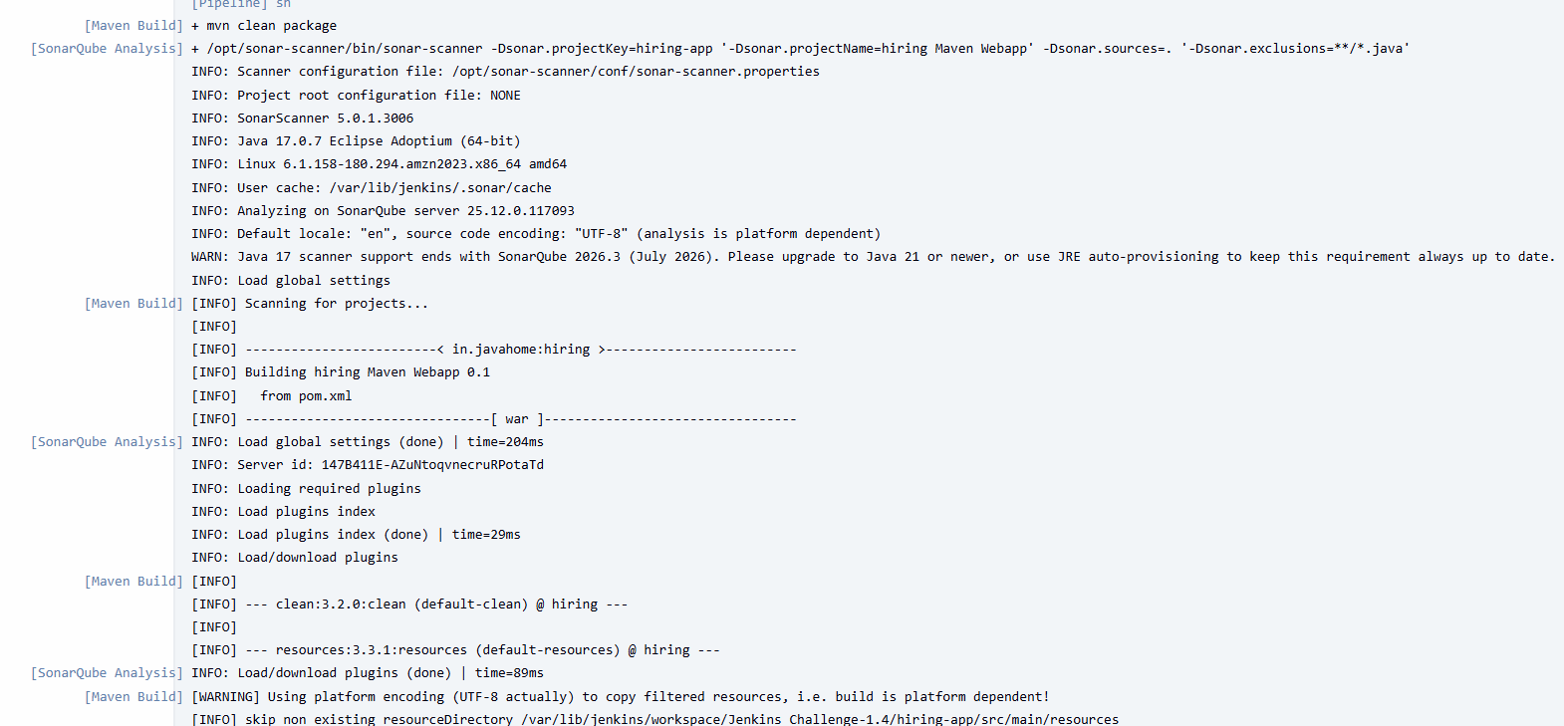
Step 73: Maven Build Execution in Parallel Branch
• Console path / UI path:
Jenkins_Challenge-1.4 → Build #2 → Console Output
• Explanation:
The Maven build runs in parallel with SonarQube analysis.
Key actions:
- mvn clean package executed
- WAR artifact generated from pom.xml
• Evidence:
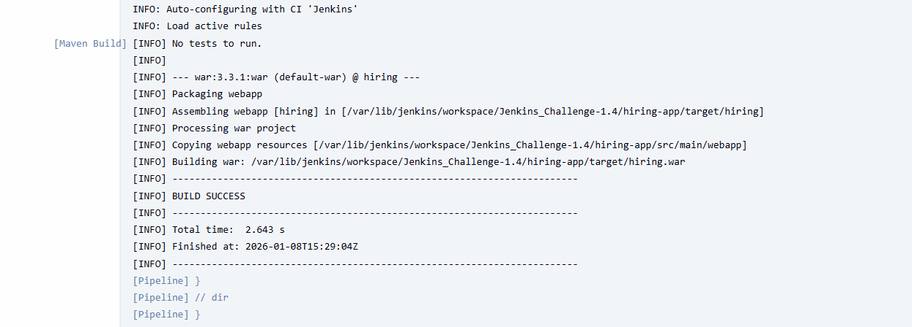
Step 74: Upload Artifact to Nexus Repository
• Console path / UI path:
Jenkins_Challenge-1.4 → Build #2 → Console Output
Nexus Repository Manager → Browse
• Explanation:
The generated WAR file is uploaded to the Nexus Maven hosted repository.
Details:
- Group ID: in.javahome
- Artifact ID: hiring
- Version: BUILD_NUMBER-SNAPSHOT
- Repository: jenkins-challenge-1.4
• Evidence:
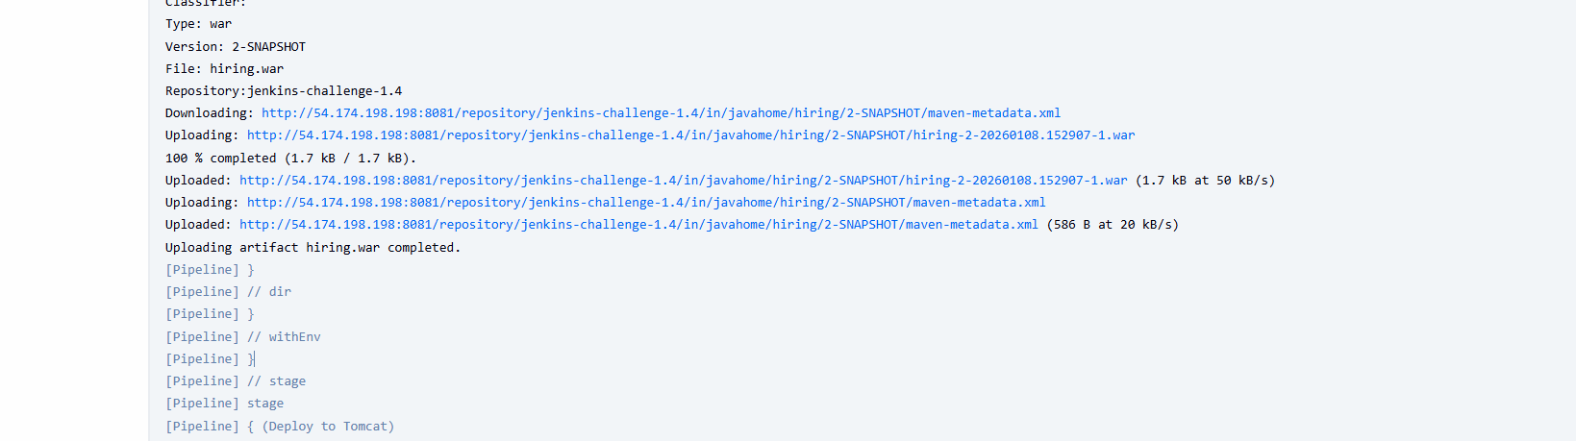Step 75: Deploy WAR File to Tomcat Server
• Console path / UI path:
Jenkins_Challenge-1.4 → Build #2 → Console Output
• Explanation:
The WAR file is deployed to a remote Tomcat 9.x server using Jenkins Deploy Plugin.
Deployment flow:
- Existing WAR undeployed
- New WAR deployed
- Context path applied successfully
• Evidence:
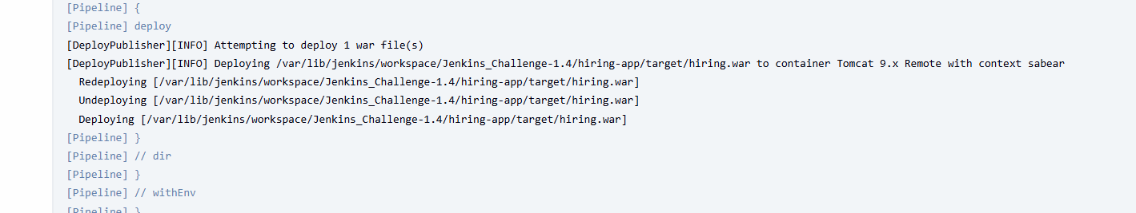Step 76: Execute Post Actions – Slack Notification
• Console path / UI path:
Jenkins_Challenge-1.4 → Build #2 → Post Actions → Console Output
• Explanation:
The pipeline executes the post section after successful completion.
Slack notification details:
- Jenkins job name
- Build number
- Success status
- Build link
• Evidence:
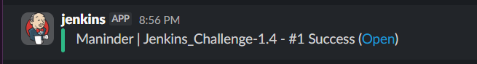
Step 77: Validate Pipeline Execution via Graph View
• Console path / UI path:
Jenkins_Challenge-1.4 → Build #2 → Graph View
• Explanation:
The Graph View confirms end-to-end pipeline success with all stages completed, including parallel execution and post actions.
• Evidence:
Step 78: Verify Application Availability After Deployment
• Console path / UI path:
Web Browser → Application URL
• Explanation:
The deployed application is accessed via browser to validate deployment success.
Result:
- Application loads successfully
- Confirms CI/CD pipeline correctness
• Evidence:
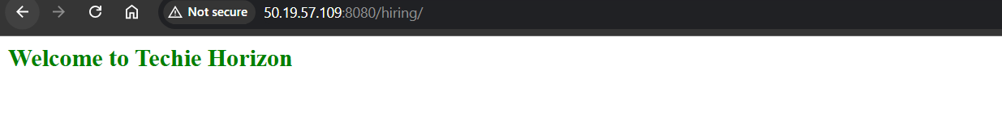

The following code was generated by the end of the task:
pipeline {
agent any

tools {
maven 'MVN_HOME'
}

stages {

stage('Git Clone') {
steps {
sh '''
rm -rf hiring-app
git clone -b main https://github.com/betawins/hiring-app.git
'''
}
}

stage('Code Quality & Build (Parallel)') {
parallel {

stage('SonarQube Analysis') {
steps {
dir('hiring-app') {
withSonarQubeEnv('sonarqube-Docker') {
sh '''
/opt/sonar-scanner/bin/sonar-scanner \
-Dsonar.projectKey=hiring-app \
-Dsonar.projectName="hiring Maven Webapp" \
-Dsonar.sources=. \
-Dsonar.exclusions=**/*.java
'''
}
}
}
}

stage('Maven Build') {
steps {
dir('hiring-app') {
sh 'mvn clean package'
}
}
}
}
}

stage('Nexus Artifactory') {
steps {
dir('hiring-app') {
nexusArtifactUploader(
nexusVersion: 'nexus3',
protocol: 'http',
nexusUrl: '54.174.198.198:8081',
repository: 'Jenkins-Challenge-1',
credentialsId: 'mani',
groupId: 'in.javahome',
version: "${BUILD_NUMBER}-SNAPSHOT",
artifacts: [
[
artifactId: 'hiring',
classifier: '',
file: 'target/hiring.war',
type: 'war'
]
]
)
}
}
}

stage('Deploy to Tomcat') {
steps {
dir('hiring-app') {
deploy adapters: [
tomcat9(
credentialsId: 'tomcat-cred-01',
url: 'http://50.19.57.109:8080'
)
],
contextPath: 'sabear',
war: 'target/hiring.war'
}
}
}
}

post {
success {
slackSend(
color: 'good',
message: "Maninder | ${env.JOB_NAME} - #${env.BUILD_NUMBER} Success (<${env.BUILD_URL}|Open>)",
tokenCredentialId: 'techiehorizon'
)
}
failure {
slackSend(
color: 'danger',
message: "Maninder | ${env.JOB_NAME} - #${env.BUILD_NUMBER} Failed (<${env.BUILD_URL}|Open>)",
tokenCredentialId: 'techiehorizon'
)
}
}
}

Conclusion
This Jenkins pipeline automates the complete CI/CD process from code checkout to deployment. It improves efficiency by running SonarQube analysis and Maven build in parallel, enforces early code quality checks, securely stores build artifacts in Nexus, and automatically deploys the application to Tomcat. Slack notifications ensure real-time visibility of build success or failure. Overall, it delivers a fast, reliable, and production-ready CI/CD workflow.

