RDS-Assignment-01

- Create MariaDB DB on EC2.
- Task Title:
Create MariaDB Database on EC2
- Objective:
Launch an EC2 instance, install and configure MariaDB, secure the installation, and verify successful root login into the MariaDB server.
- Prerequisites:
• AWS account
• EC2 key pair
• Security group allowing SSH (22) and database port (3306)
- Step-by-Step Implementation (With Evidence):
Step 1: Launch the EC2 Instance
Console path: EC2 Console > Instances > Launch Instance
Explanation: Create an EC2 instance using Amazon Linux 2023 AMI and t3.micro instance type. Assign a security group allowing SSH, HTTP/HTTPS (optional), and MariaDB port 3306.
Evidence:
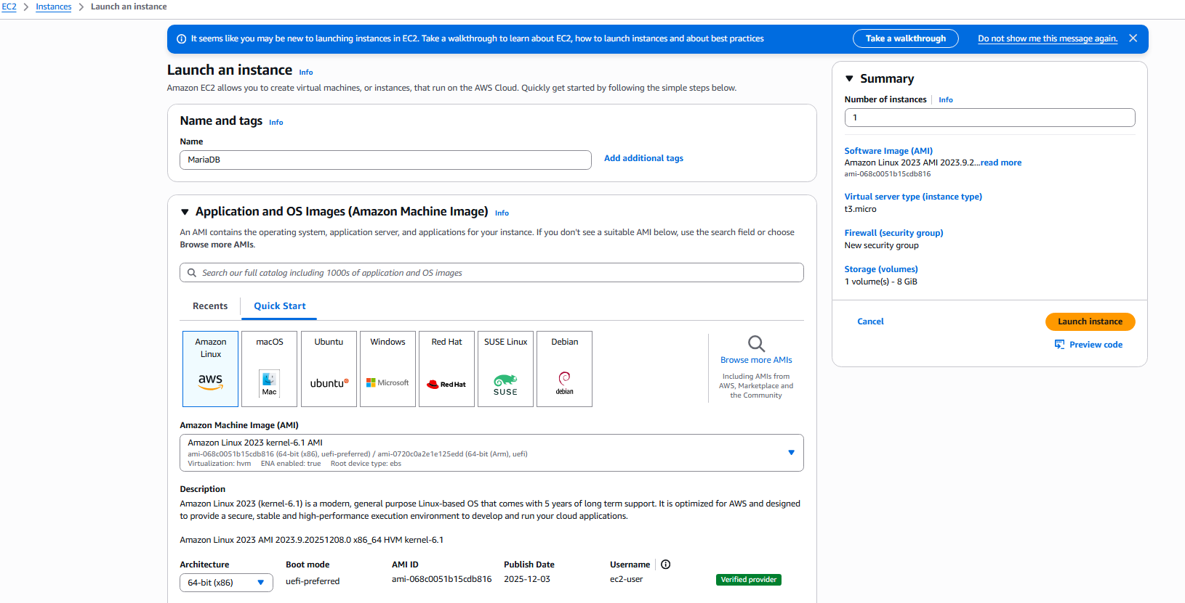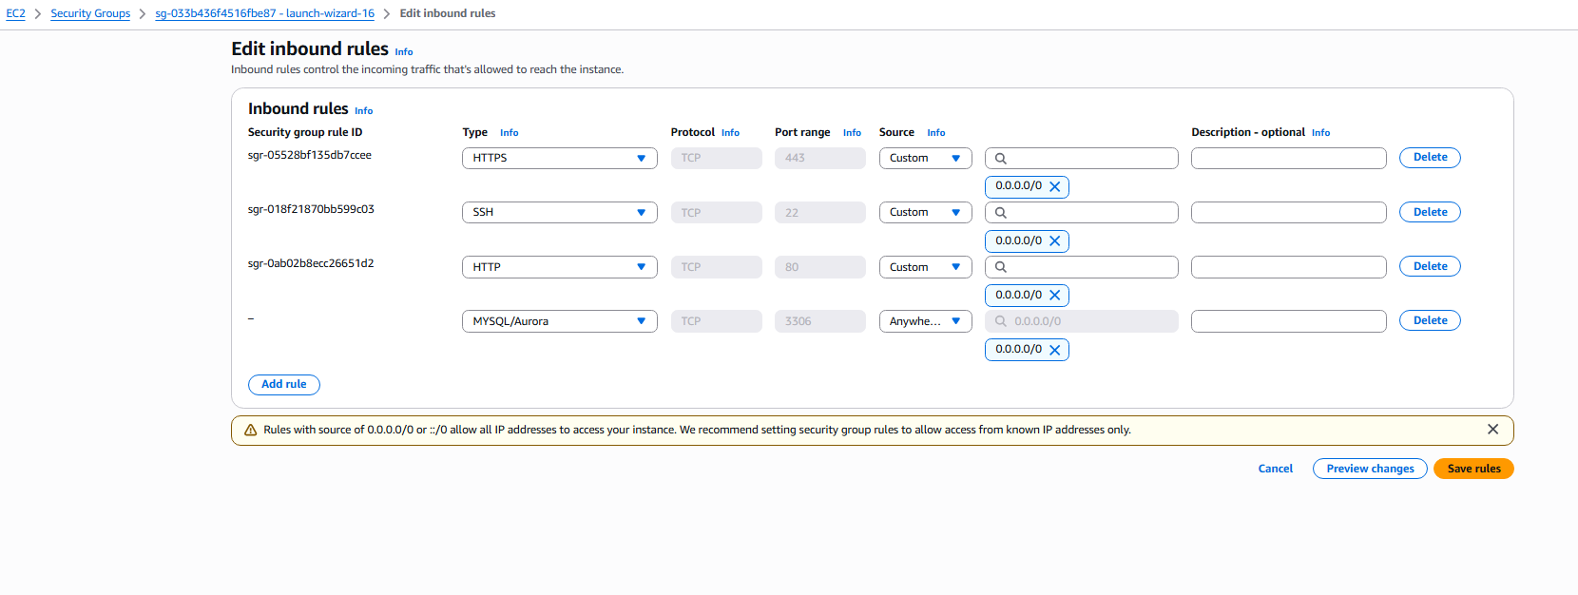
Step 2: Verify EC2 Instance Status
Console path: EC2 Console > Instances > Select Instance
Explanation: Ensure the instance is in Running state and note the public IP address for SSH connection.
Evidence:
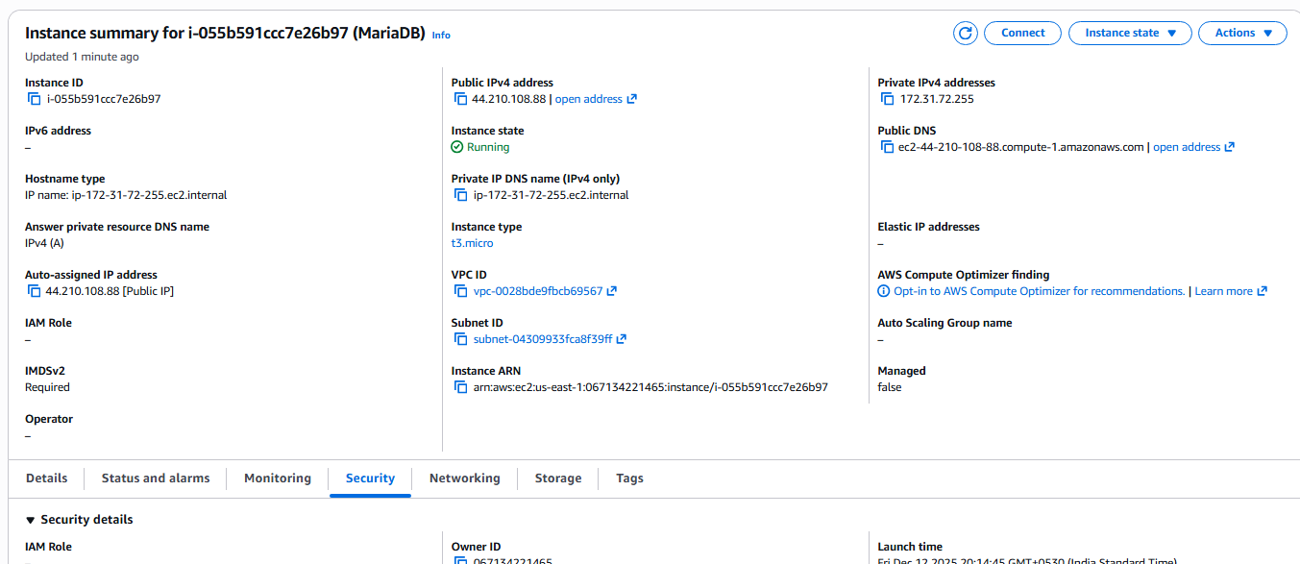
Step 3: Install MariaDB Server
Console path / CLI command:
sudo dnf update -y
sudo dnf install mariadb105-server -y
sudo systemctl start mariadb
sudo systemctl enable mariadb
Explanation: Install MariaDB server, start it, and enable auto-start at boot.
Evidence:
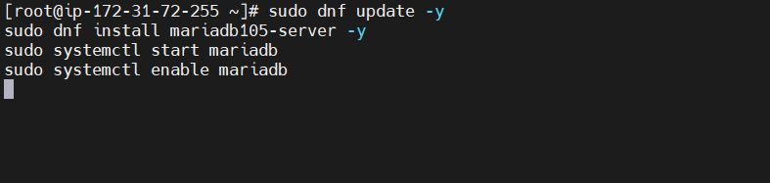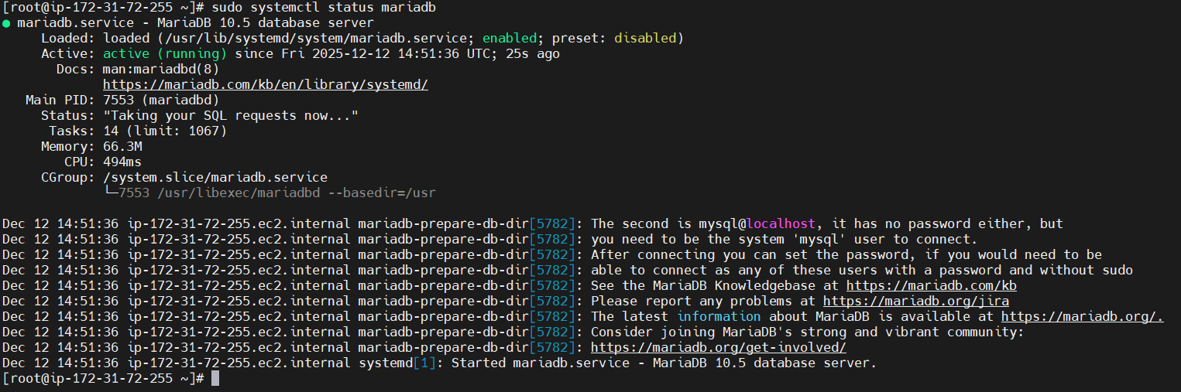
Step 4: Secure MariaDB
Console path / CLI command:
sudo mysql_secure_installation
Explanation: Remove anonymous users, disable remote root login, remove test database, set root password, and reload privileges. This step increases security for MariaDB.
Evidence:
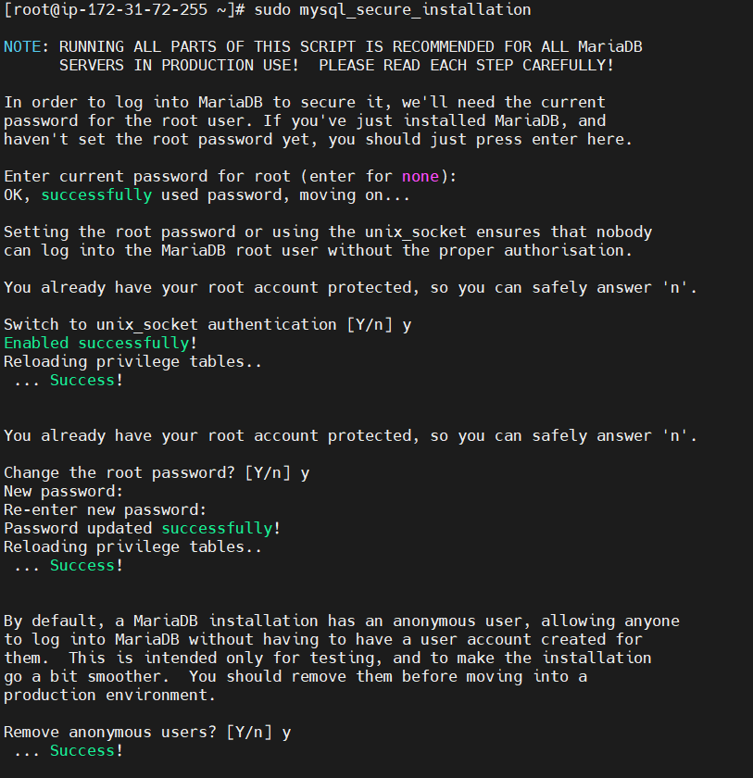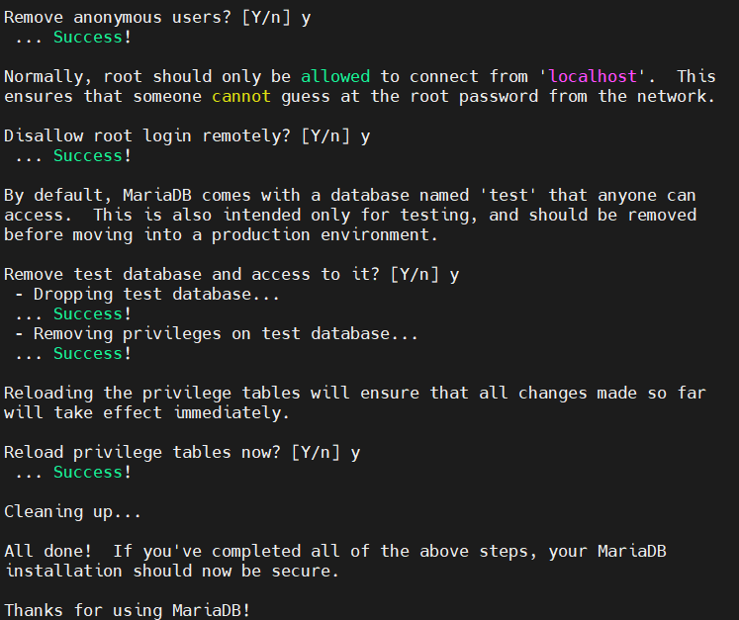
Step 5: Log in to MariaDB
Console path / CLI command:
sudo mysql -u root -p
Explanation: Log in using the root password set during mysql_secure_installation to confirm successful installation and configuration.
Evidence:
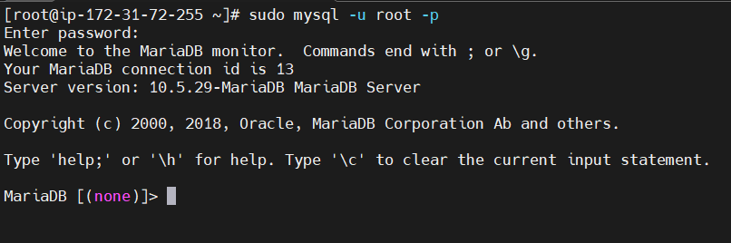
- Validation Steps (Mandatory, With Evidence):
- Validation : 
Issues Faced (Optional):
Security group inbound rule for port 3306, initially I went with default security group without adding the 3306 port, after encountering the error I have entered rule in the security group.

- Conclusion:
MariaDB was successfully installed on the EC2 instance. The database server is active, reachable over SSH, and root access was tested.
- Insert some dummy data.

- Task Title:
Insert Some Dummy Data into MariaDB
- Objective:
Log in to MariaDB, create a database and table, insert sample records, and verify the inserted data successfully.
- Prerequisites:
• EC2 instance with MariaDB installed and running
• Root password configured
• SSH access to the EC2 instance
• Basic SQL knowledge
- Step-by-Step Implementation (With Evidence):
Step 1: Log in to MariaDB as root
Console path / CLI command:
sudo -i
mysql -u root -p
Explanation:
Switched to the Linux root user and logged in to MariaDB using the root password to gain full database privileges.
Evidence:
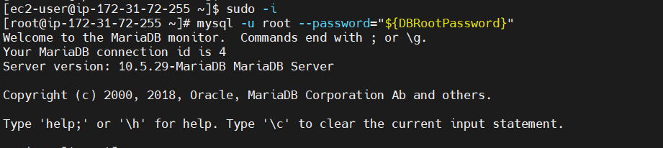
Step 2: Verify Existing Databases
Console path / CLI command:
SHOW DATABASES;
Explanation:
Listed existing databases to confirm the current MariaDB state before creating a new database.
Evidence:
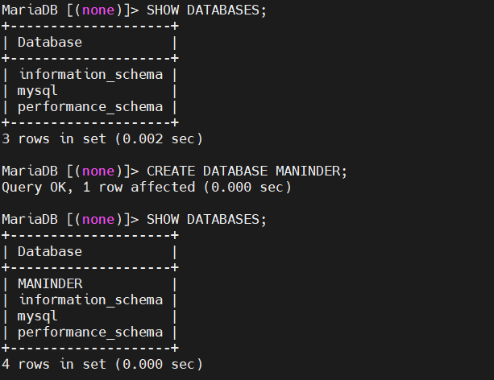
Step 3: Create a New Database
Console path / CLI command:
CREATE DATABASE MANINDER;
SHOW DATABASES;
Explanation:
Created a new database named MANINDER and verified that it was created successfully.
Evidence:

Step 4: Create a Table in the Database
Console path / CLI command:
USE MANINDER;
CREATE TABLE USERS ( id INT, name VARCHAR(45) );
Explanation:
Switched to the MANINDER database and created a USERS table with id and name columns.
Evidence:
Step 5: Insert Dummy Data
Console path / CLI command:
INSERT INTO USERS VALUES
(1,'MANI'),
(2,'SHASHI'),
(3,'PRANIDHAR'),
(4,'MANOJ');
Explanation:
Inserted multiple dummy records into the USERS table to simulate sample application data.
Evidence:
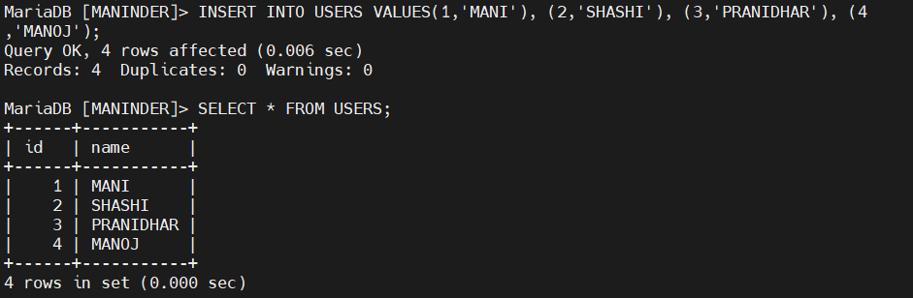

- Validation Steps (Mandatory, With Evidence):
Verify Inserted Data
Console path / CLI command:
SELECT * FROM USERS;
Explanation:
Queried the USERS table to verify that all dummy records were inserted correctly.
Evidence:
- Issues Faced (Optional):
• Access denied error occurred when attempting to log in as ec2-user due to unix_socket authentication being enabled for the root user
• SQL syntax error occurred when multiple SQL commands were executed without proper semicolon separation
- Conclusion:
The MariaDB database was successfully created, populated with dummy data, and validated. All operations were executed cleanly, and common authentication and syntax-related issues were identified and resolved.

- Take the backup of dummy data on EC2.
  - Task Title: Take the backup of dummy data on EC2

  - Objective:
To create a backup of the dummy data stored in the MANINDER MariaDB database on an EC2 instance using mysqldump.

3. Prerequisites:
MariaDB installed and running on EC2
MANINDER database with dummy data available
Root or backup user credentials
SSH access to the EC2 instance

4. Step-by-Step Implementation (With Evidence):

Step 1:
Console path / CLI command:
mysql -u root -p

Explanation:
Login to the MariaDB server to verify the database and dummy data exist.

Evidence: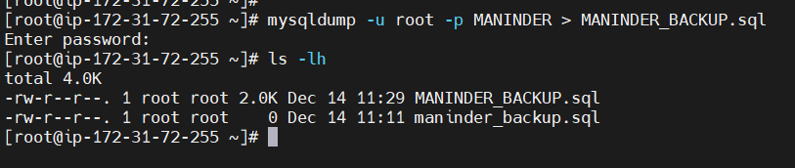
Issues Faced (Optional):
mysqldump was initially executed inside the MariaDB prompt, causing ERROR 1064 SQL syntax error. This was resolved by exiting the MariaDB client and running the command from the Linux shell.

Conclusion:
The dummy data from the MANINDER MariaDB database was successfully backed up on the EC2 instance using mysqldump and validated for correctness.

- Launch MariaDB RDS instance.
  - Task Title: Launch MariaDB RDS instance

  - Objective:
To launch a MariaDB RDS instance in AWS and connect it securely with an EC2 instance for database operations.

  - Prerequisites:
AWS account with RDS and EC2 permissions
Existing EC2 instance in the same VPC
Basic understanding of RDS and VPC networking

Step-by-Step Implementation (With Evidence):

Step 1:
Console path / CLI command:
AWS Console → Aurora and RDS → Databases → Create database

Explanation:
Initiated the database creation process from the RDS service.

Evidence:
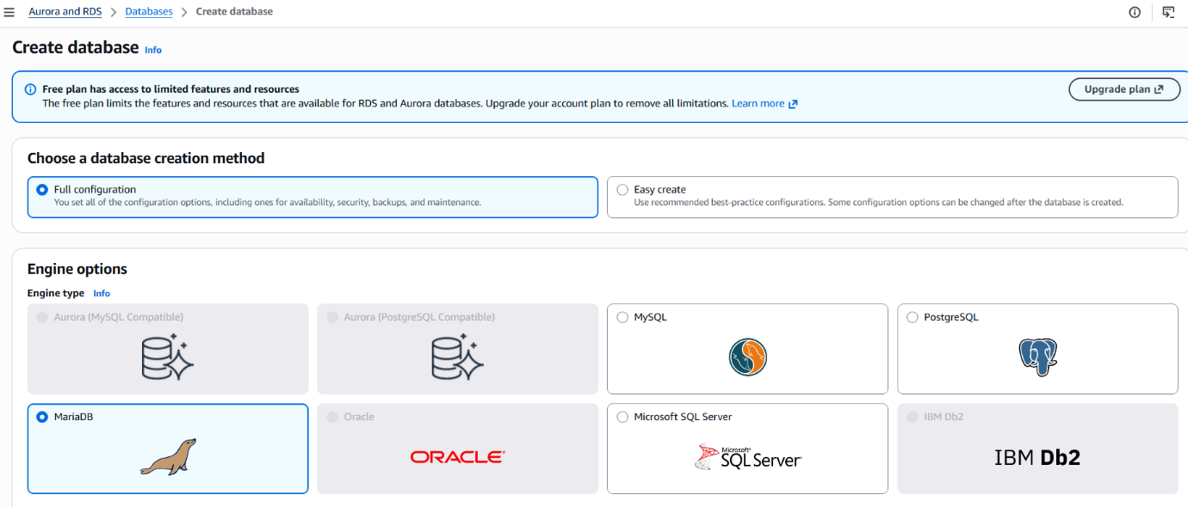
Step 2:
Console path / CLI command:
Choose database creation method → Full configuration

Explanation:
Selected Full configuration to manually control engine, instance size, storage, connectivity, and security settings.

Evidence: 

Step 3:
Console path / CLI command:
Engine options → MariaDB

Explanation:
Selected MariaDB as the database engine.

Evidence: 

Step 4:
Console path / CLI command:
Settings → DB instance identifier: maninder-db
Credentials → Master username: admin
Credentials management → Self managed
Master password configured

Explanation:
Configured database name and master credentials for the RDS instance.

Evidence: 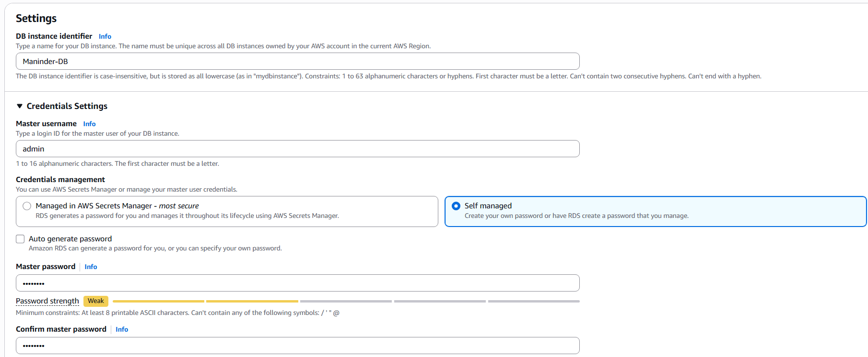

Step 5:
Console path / CLI command:
Instance configuration → Burstible classes → db.t4g.micro

Explanation:
Selected a cost-effective instance class suitable for testing and learning.

Evidence: 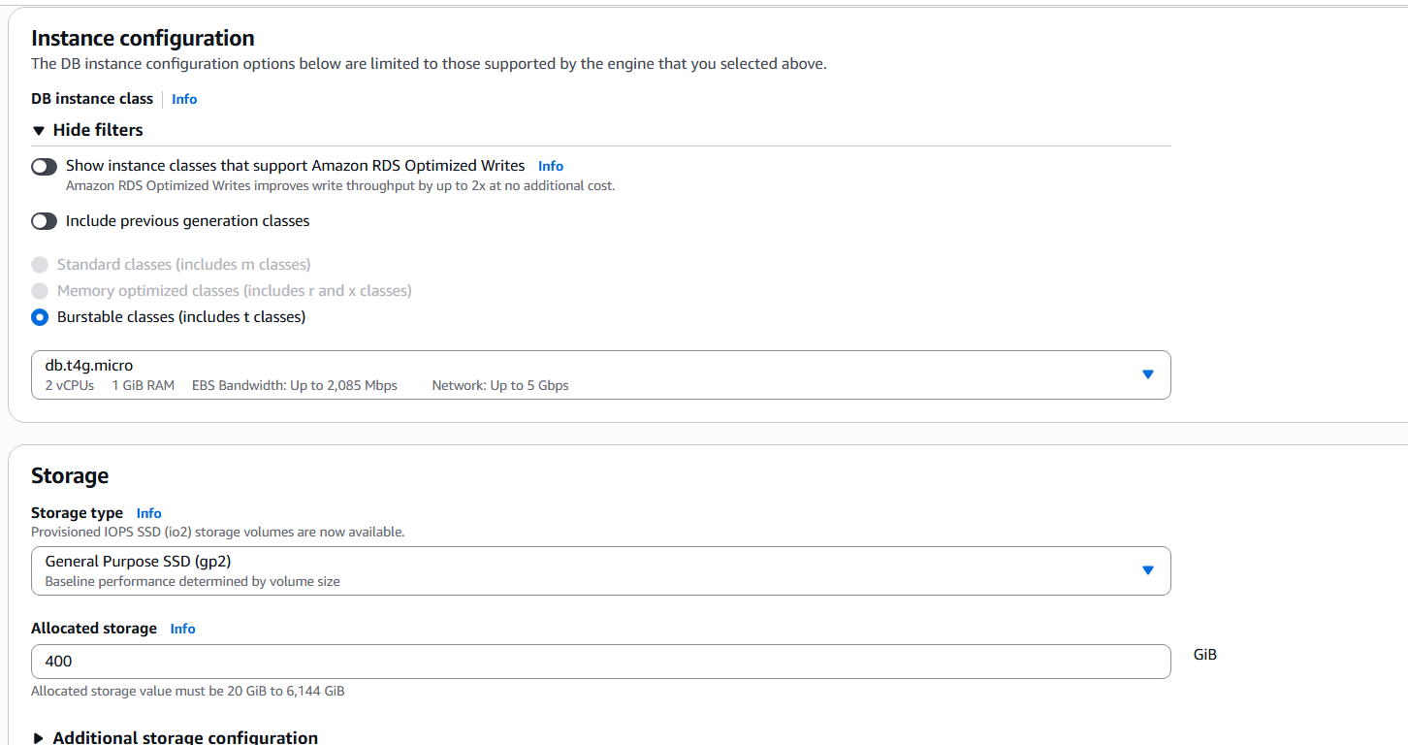

Step 6:
Console path / CLI command:
Storage → General Purpose SSD (gp2)
Allocated storage: 400 GiB

Explanation:
Configured storage type and size for the database.

Evidence:


Step 7:
Console path / CLI command:
Availability & durability → Do not create a standby instance

Explanation:
Disabled Multi-AZ deployment to reduce cost.

Evidence:
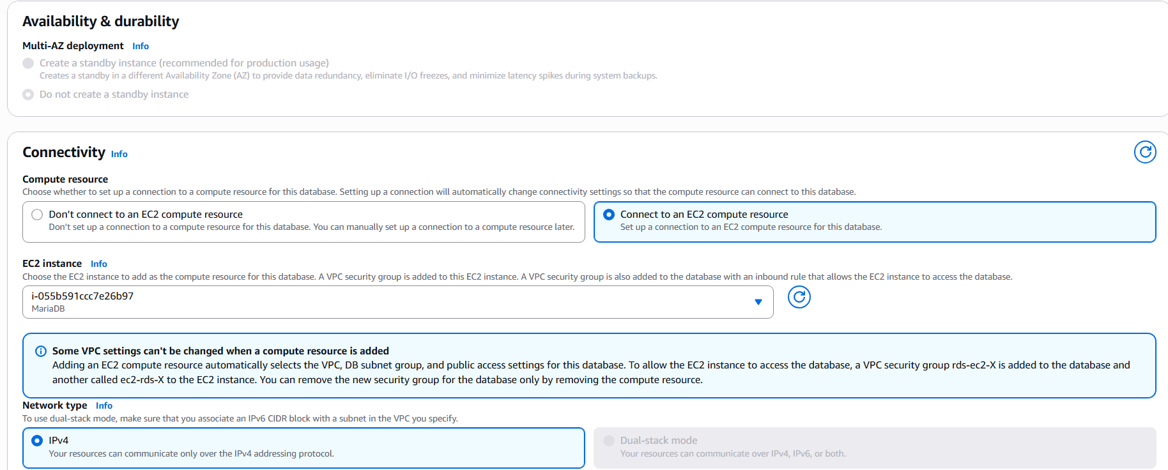
Step 8:
Console path / CLI command:
Connectivity → Connect to an EC2 compute resource
Selected EC2 instance
Network type → IPv4

Explanation:
Configured connectivity so the selected EC2 instance can access the RDS database automatically.

Evidence:

Step 9:
Console path / CLI command:
VPC → Default VPC
DB subnet group → Automatic setup
Public access → No
VPC security group → Existing security group

Explanation:
Ensured the database is private and accessible only within the VPC.

Evidence: 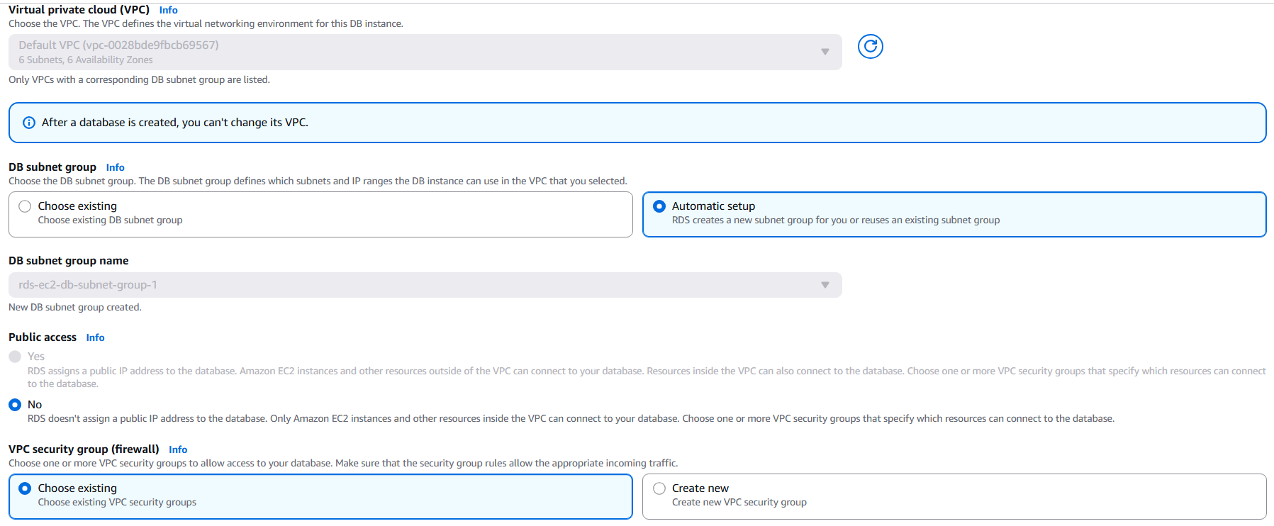

Step 10:
Console path / CLI command:
Create database

Explanation:
Launched the MariaDB RDS instance with the configured settings.

Evidence:
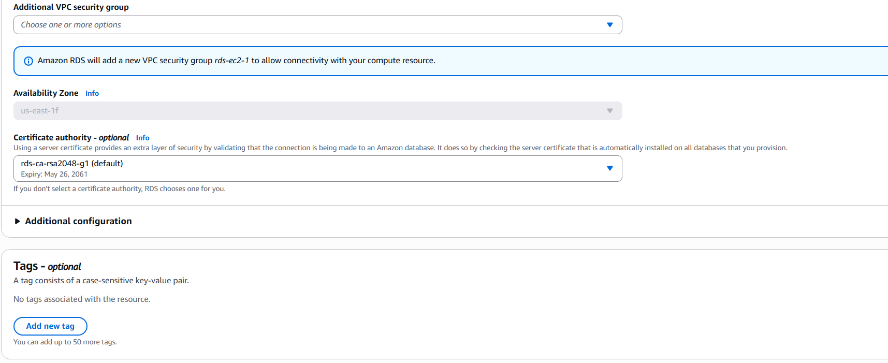
Validation Steps (Mandatory, With Evidence):
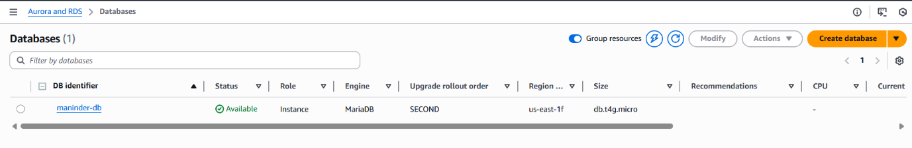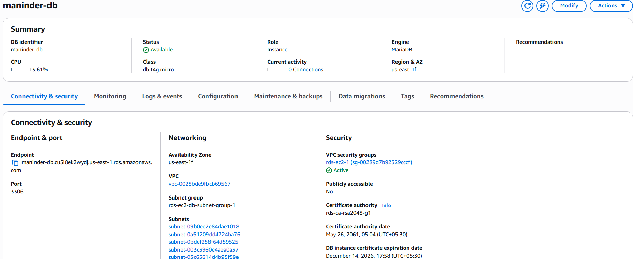
Issues Faced (Optional):
No issues encountered during RDS instance creation.

Conclusion:
The MariaDB RDS instance was successfully launched, secured within a private VPC, and connected to the EC2 instance for database operations.

- Migrate database from EC2 to RDS.
Task Title: Migrate database from EC2 to RDS

Objective:
To migrate an existing MariaDB database from an EC2 instance to an Amazon RDS MariaDB instance and verify successful data transfer.

Prerequisites:
Running EC2 instance with MariaDB installed
Existing database and data on EC2
Running MariaDB RDS instance
Network connectivity between EC2 and RDS
Database credentials for EC2 and RDS

Step-by-Step Implementation (With Evidence):

Step 1:
Console path / CLI command:
EC2 → Instances → Select instance → Actions → Networking → Connect RDS database

Explanation:
Initiated the process to connect the EC2 instance with the RDS database. This automatically configures security groups to allow communication.

Evidence:
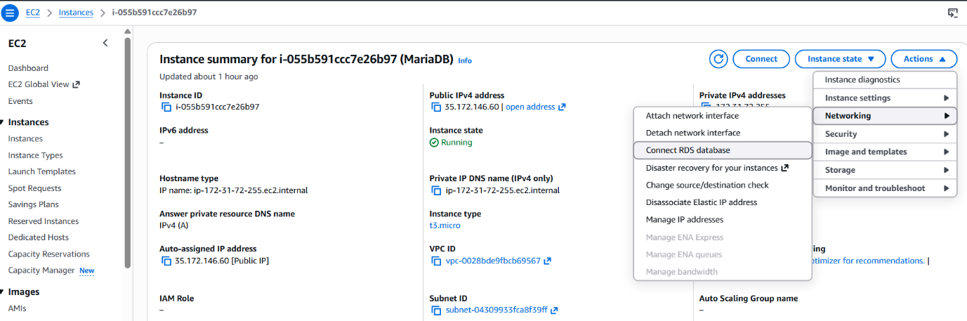
Step 2:
Console path / CLI command:
Select RDS database → Database role: Instance → Click Connect

Explanation:
Selected the MariaDB RDS instance to associate it with the EC2 instance.

Evidence:
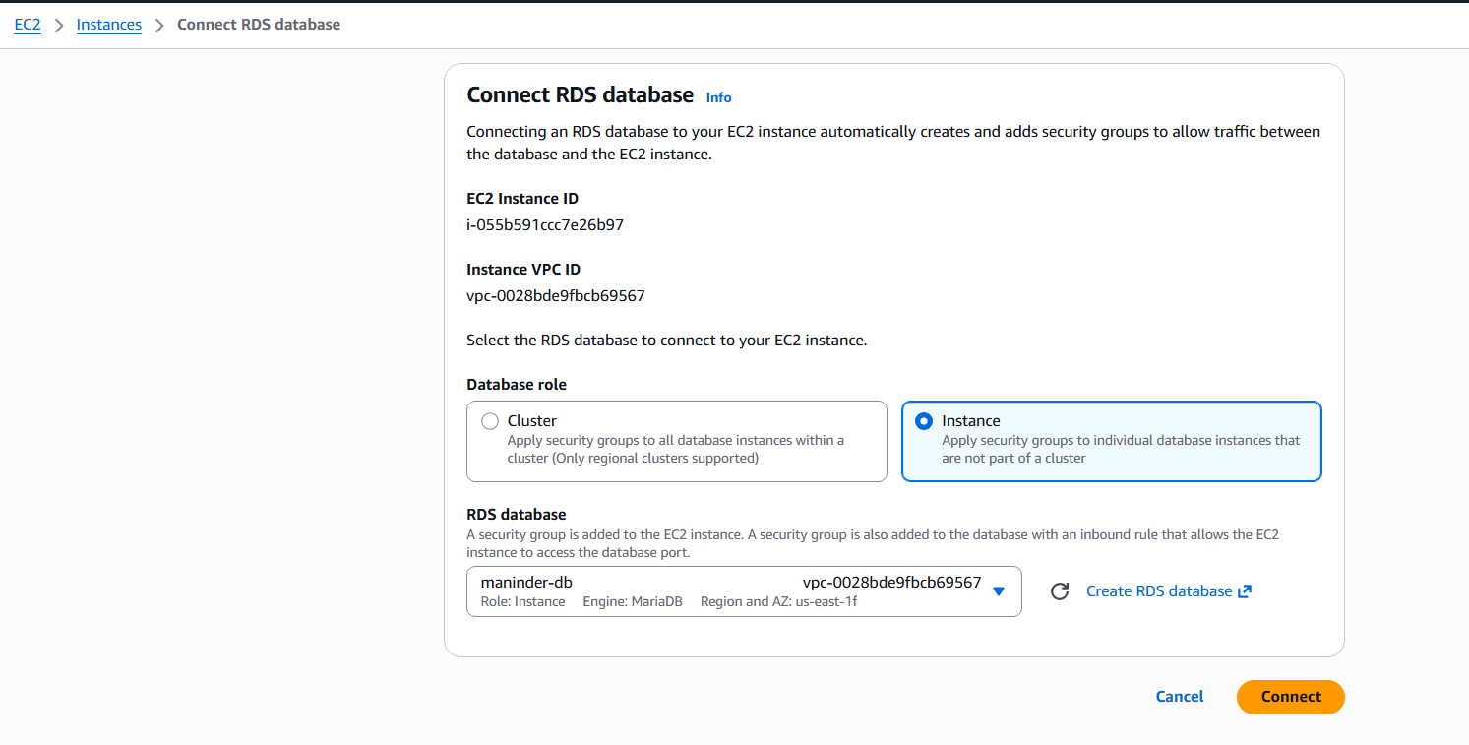
Step 3:
Console path / CLI command:
mysql -h maninder-db.cu5i8ek2wydj.us-east-1.rds.amazonaws.com -P 3306 -u admin -p

Explanation:
Connected from EC2 to the RDS MariaDB instance using the RDS endpoint.

Evidence:
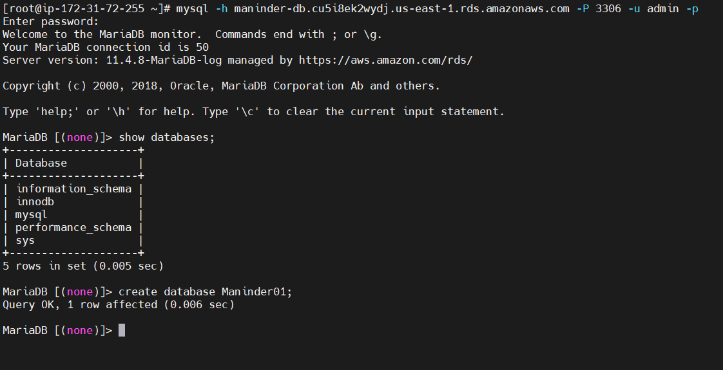
Step 4:
Console path / CLI command:
show databases;

Explanation:
Listed existing databases on the RDS instance to confirm connectivity.

Evidence:

Step 5:
Console path / CLI command:
create database Maninder01;

Explanation:
Created a new target database on RDS to restore data from EC2.

Evidence:
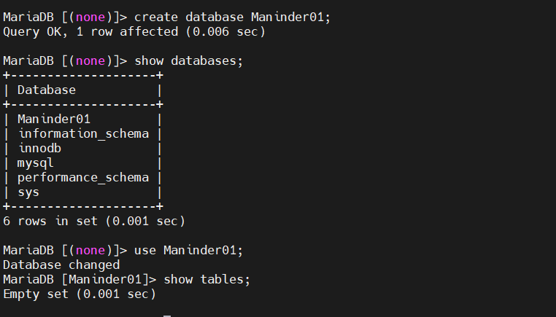
Step 6:
Console path / CLI command:
show databases;
use Maninder01;
show tables;

Explanation:
Verified that the new database exists and is currently empty.

Evidence:

Step 7:
Console path / CLI command:
mysql -u root -p

Explanation:
Logged into the local MariaDB server on EC2 to verify the source database.

Evidence:
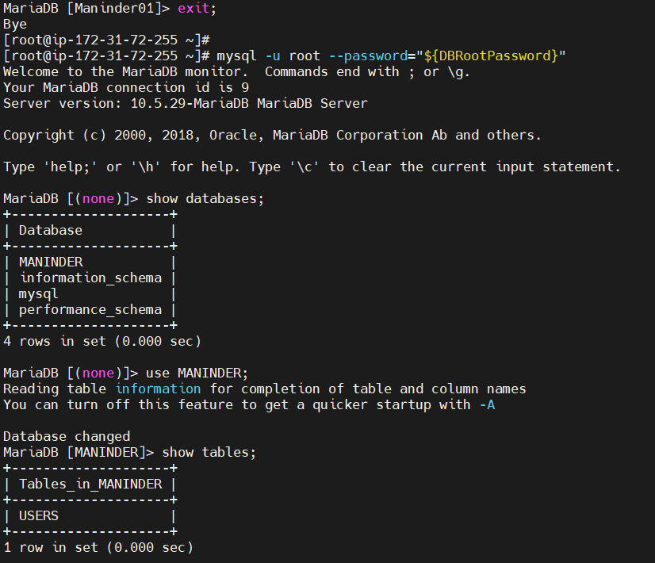
Step 8:
Console path / CLI command:
show databases;
use MANINDER;
show tables;

Explanation:
Verified the source database and tables on EC2 that need to be migrated.

Evidence:

Step 9:
Console path / CLI command:
mysqldump -u root -p MANINDER > MANINDER_BACKUP.sql

Explanation:
Created a logical backup of the MANINDER database from EC2.

Evidence:
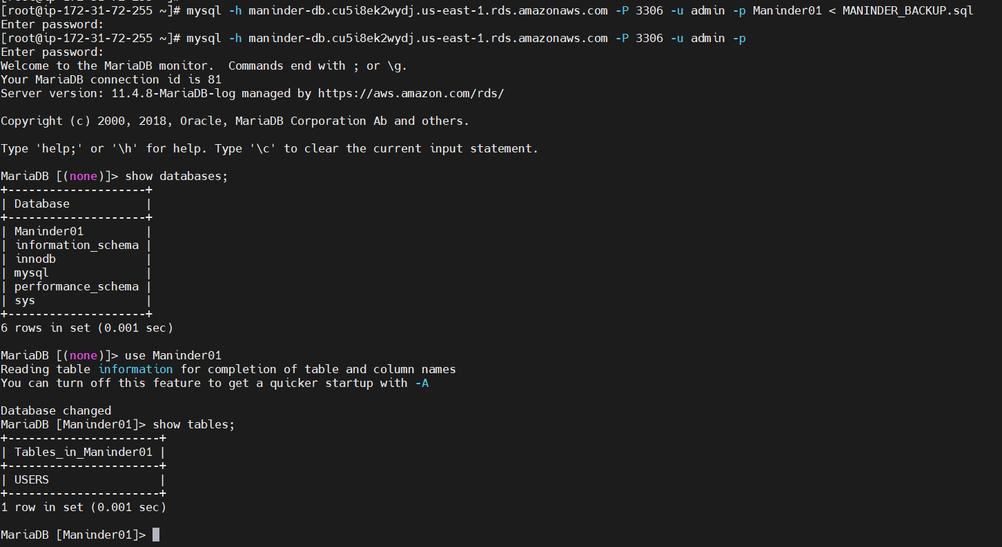
Step 10:
Console path / CLI command:
mysql -h maninder-db.cu5i8ek2wydj.us-east-1.rds.amazonaws.com -P 3306 -u admin -p Maninder01 < MANINDER_BACKUP.sql

Explanation:
Restored the EC2 database backup into the RDS database.

Evidence:

Validation Steps (Mandatory, With Evidence):
Console path / CLI command:
mysql -h maninder-db.cu5i8ek2wydj.us-east-1.rds.amazonaws.com -P 3306 -u admin -p
show databases;
use Maninder01;
show tables;

Explanation:
Validated that the database and tables were successfully migrated to RDS.

Evidence:


Issues Faced (Optional):
Attempted to restore the backup file into the RDS MariaDB instance without selecting a target database.

Evidence:
Image: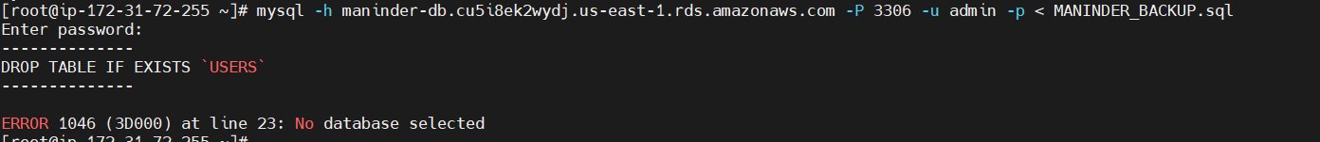
Error displayed: ERROR 1046 (3D000): No database selected

Conclusion:
The MariaDB database was successfully migrated from the EC2 instance to the Amazon RDS MariaDB instance, and data integrity was verified through post-migration validation steps.
- Install MySQL DB on EC2.
Task Title: Launch MySQL client on EC2 to connect with MySQL RDS
Validation Steps (With Evidence):

Validation 1: MySQL repository download and configuration
Example:
Download and install MySQL 8.0 community repository on EC2.

Evidence:
mysql80-community-release RPM downloaded successfully and repository configured. 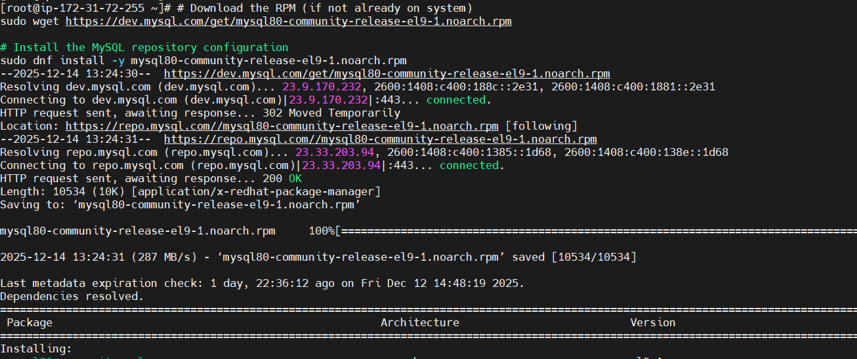

Validation 2: MySQL client and server package installation
Example:
Install MySQL community server and client packages using dnf.

Evidence:
mysql-community-server, mysql-community-client, and dependencies installed successfully without errors.
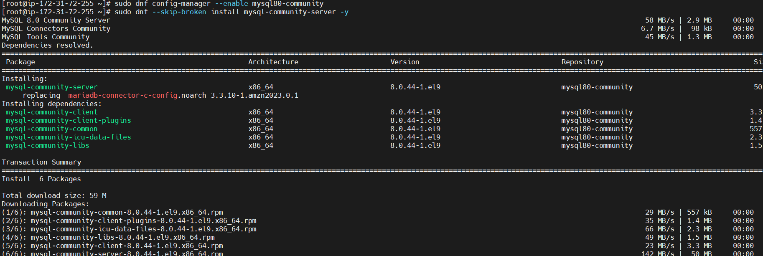

Validation 3: MySQL/MariaDB service status check
Example:
Verify database service is running on EC2.

Evidence:
mariadb.service status shows Active (running), confirming database service availability. 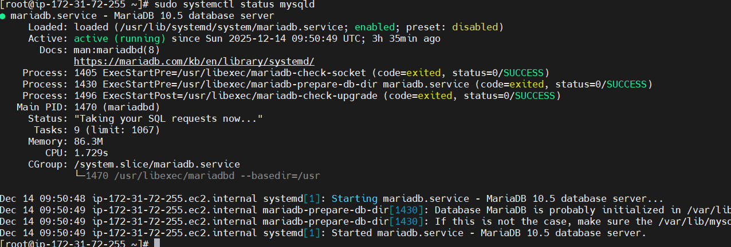

Validation 4: Repository access issue handling
Example:
Attempt to re-install MySQL repository using incorrect or incomplete URL.

Evidence:
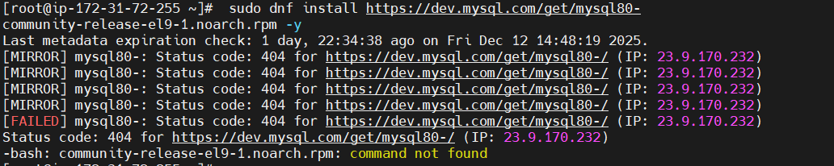
Conclusion:
The MySQL repository and client setup on the EC2 instance was validated successfully. MySQL packages were installed correctly, the database service was running, and repository access issues were identified and understood, ensuring readiness for MySQL RDS connectivity.
- Launch MySQL RDS image.
1. Task Title
Launch MySQL RDS Instance (Free Tier)
2. Objective
To create and deploy an Amazon RDS MySQL database instance using the Free Tier configuration and establish secure connectivity with an EC2 instance.

3. Prerequisites
List all requirements before starting:
• Active AWS account
• Existing VPC with subnets
• Running EC2 instance in the same VPC

4. Step-by-Step Implementation (With Evidence)

Step 1: Start RDS database creation
Console path / CLI command:
AWS Console → Aurora and RDS → Databases → Create database

Explanation:
Initiated database creation using Full configuration to manually control engine, availability, instance type, and connectivity settings.

Evidence:
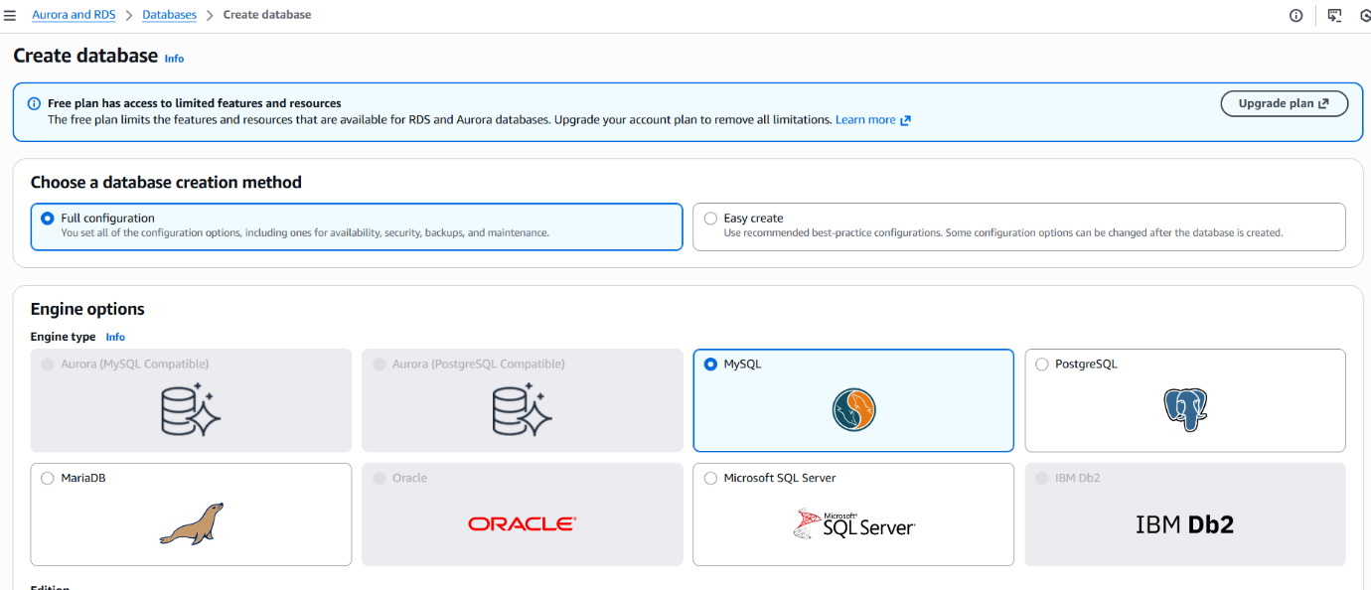
Step 2: Configure engine options and template
Console path / CLI command:
Create database → Engine options → Templates

Explanation:
Selected MySQL Community Edition with engine version MySQL 8.0.43 and chose the Free tier template.

Evidence:
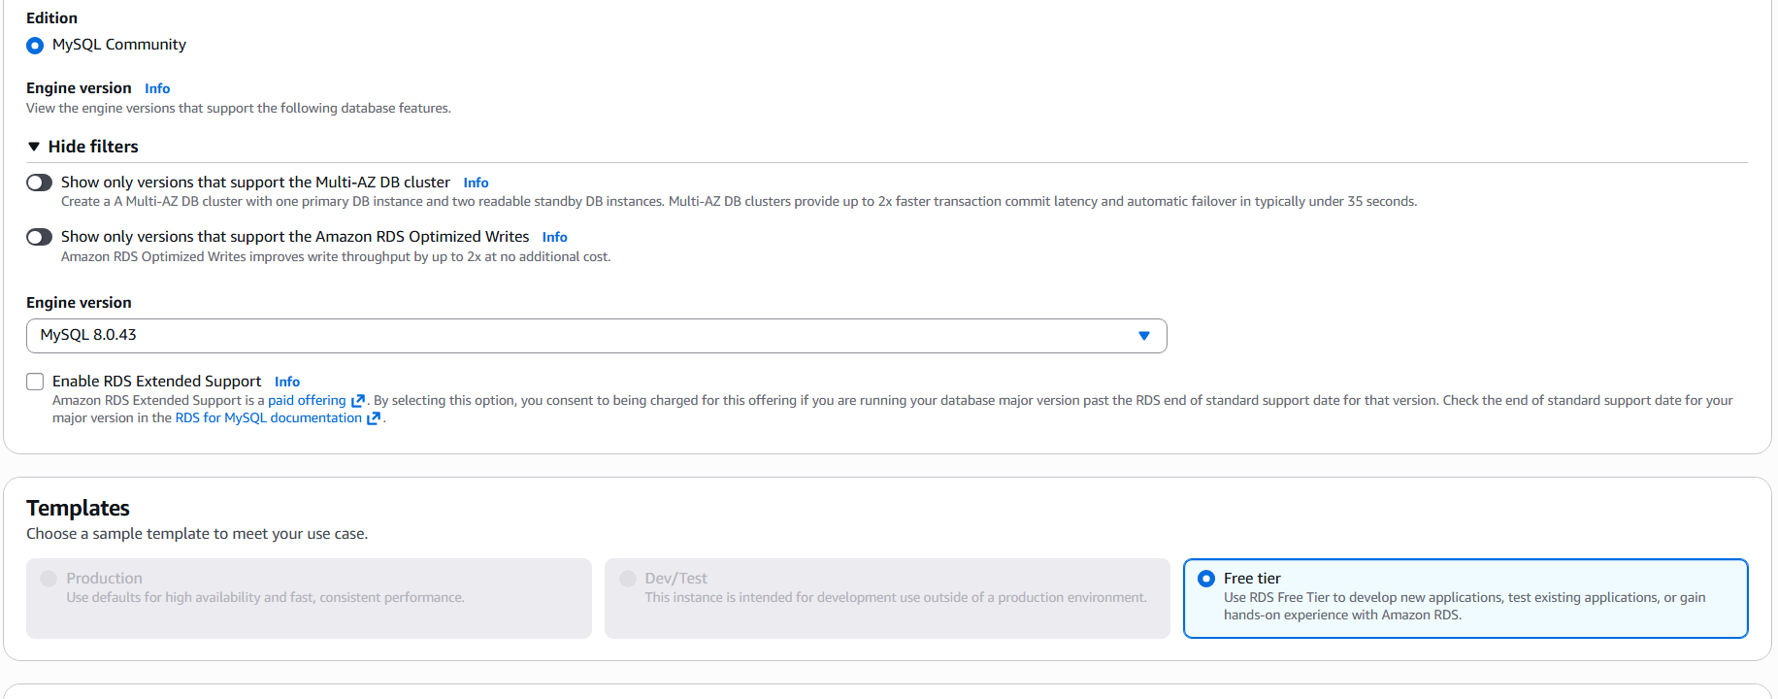
Step 3: Configure availability and DB settings
Console path / CLI command:
Create database → Availability and durability → Settings

Explanation:
Configured Single-AZ DB instance deployment for cost efficiency and set DB instance identifier as mysql-db.

Evidence:
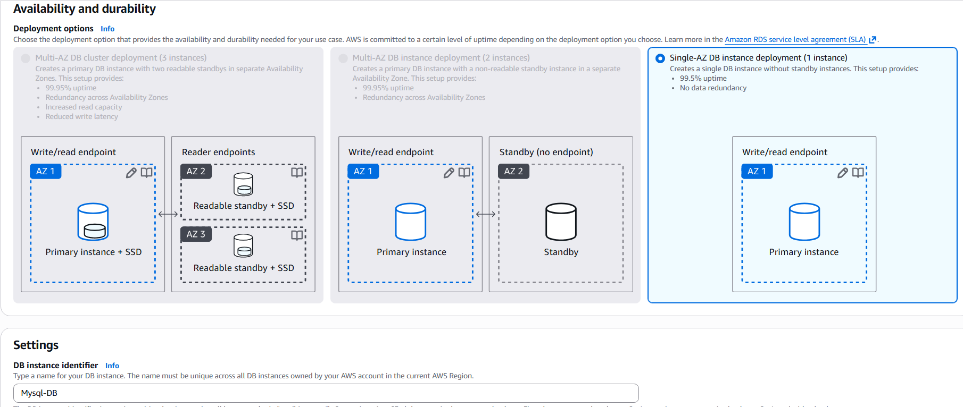
Step 4: Configure database credentials
Console path / CLI command:
Create database → Credentials settings

Explanation:
Configured master username as admin and selected self-managed credentials with a custom password.

Evidence:
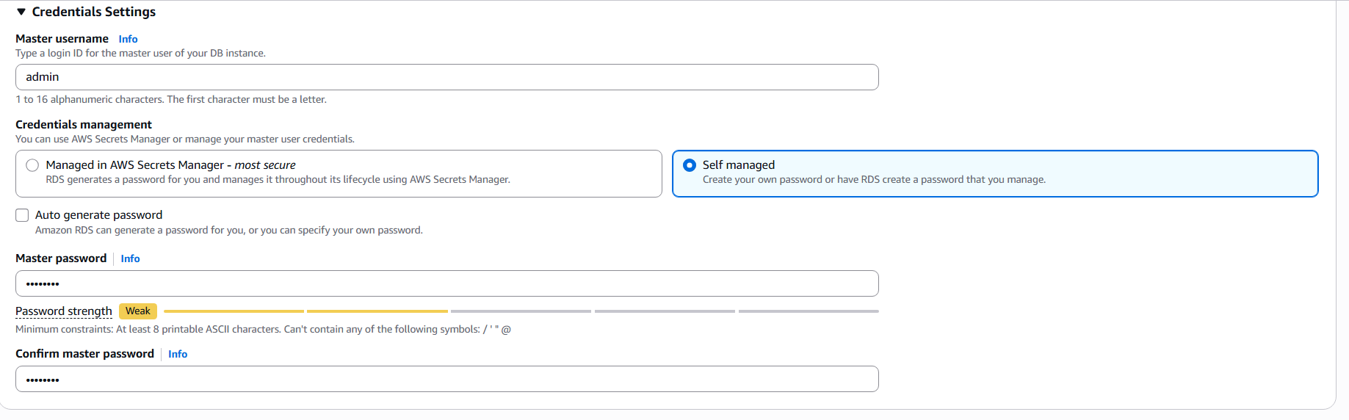

Step 5: Configure instance class and storage
Console path / CLI command:
Create database → Instance configuration → Storage

Explanation:
Selected db.t4g.micro burstable instance class and configured General Purpose SSD (gp2) with 20 GiB allocated storage.

Evidence:
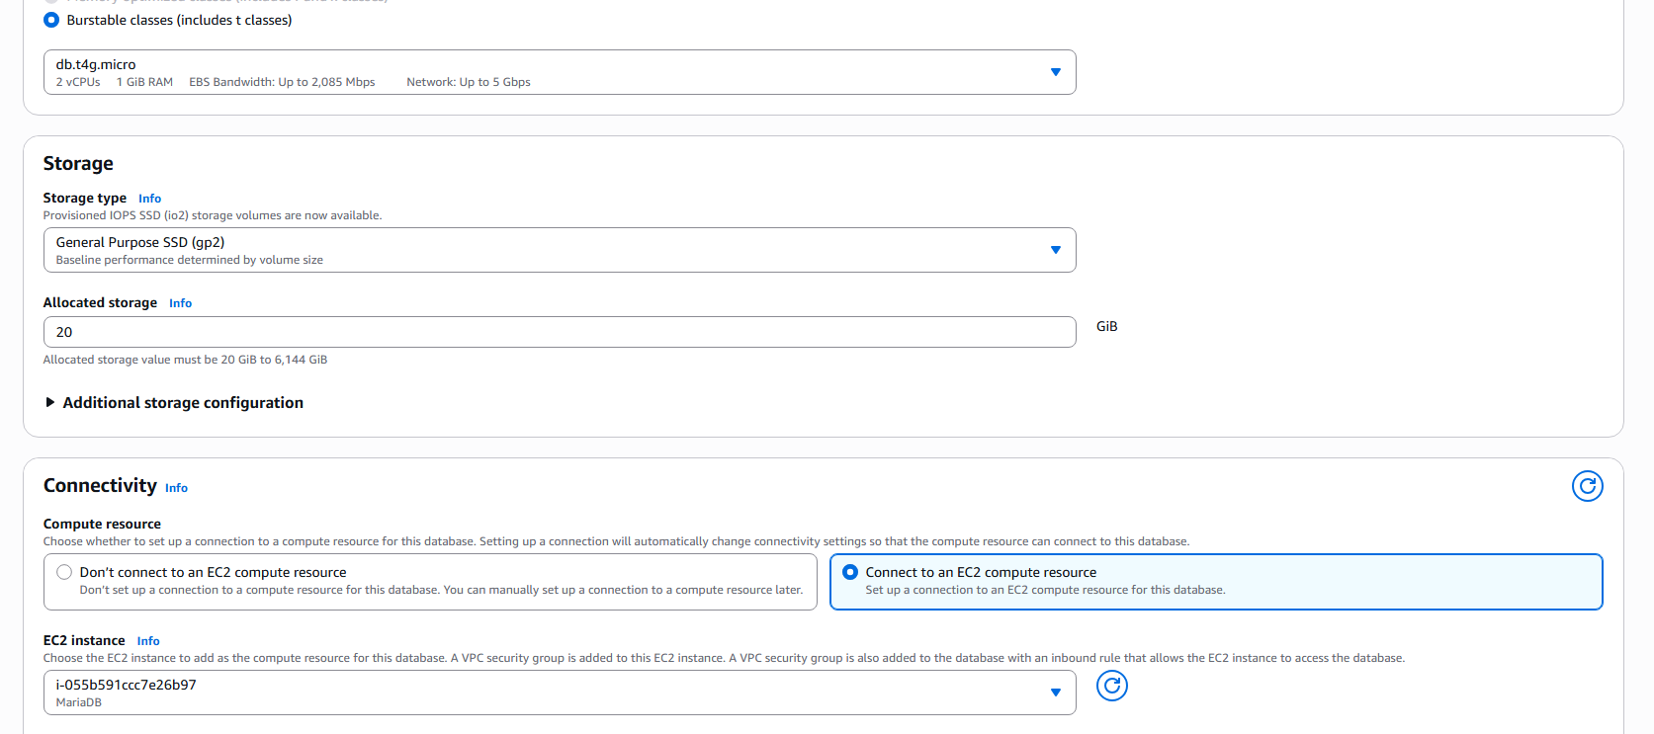
Step 6: Configure connectivity with EC2
Console path / CLI command:
Create database → Connectivity

Explanation:
Connected the RDS instance to an existing EC2 compute resource, allowing automatic security group configuration. Public access was disabled.

Evidence:
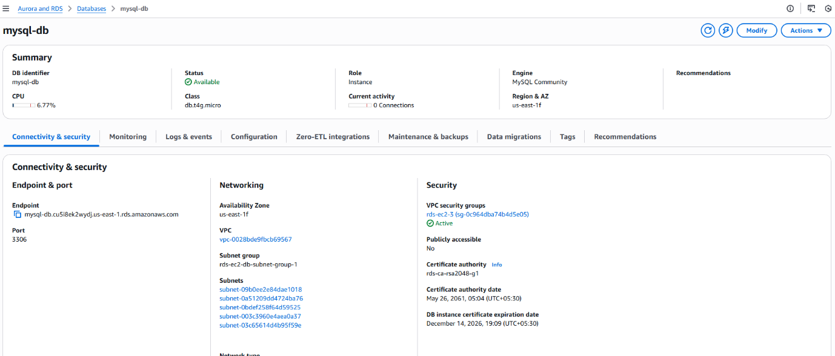
5. Validation Steps (Mandatory, With Evidence)
Console path / CLI command:
Aurora and RDS → Databases → mysql-db

Explanation:
Verified that the MySQL RDS instance was created successfully and is in Available state.

Evidence:


6 Issues Faced (Optional)
No issues were encountered during the execution. The database was created successfully on the first attempt.

7 Conclusion
The MySQL RDS instance was successfully launched using the Free Tier configuration and securely connected to an EC2 instance. The database is operational and ready for use.

- Configure Multi-AZ.
Configuring Multi-AZ is not possible with the free account
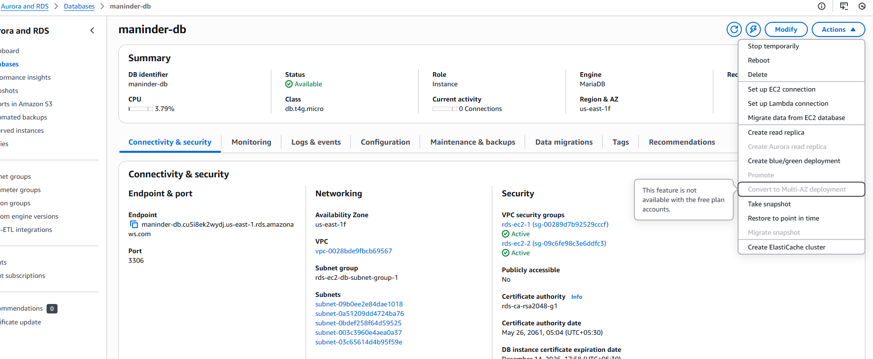
- Take backup of DB and restore the DB.
- Task Title:
Take Backup of RDS Database and Restore the Database
- Objective:
Create a manual snapshot of an Amazon RDS MariaDB instance and verify that the database backup is successfully created and available for restore operations.
- Prerequisites:
• AWS account with RDS permissions
• Running RDS MariaDB instance
- Step-by-Step Implementation (With Evidence):
Step 1: Navigate to the RDS Database
Console path / CLI command:
AWS Console > Aurora and RDS > Databases > maninder-db
Explanation:
Selected the running RDS MariaDB instance to initiate a manual backup operation.
Evidence:
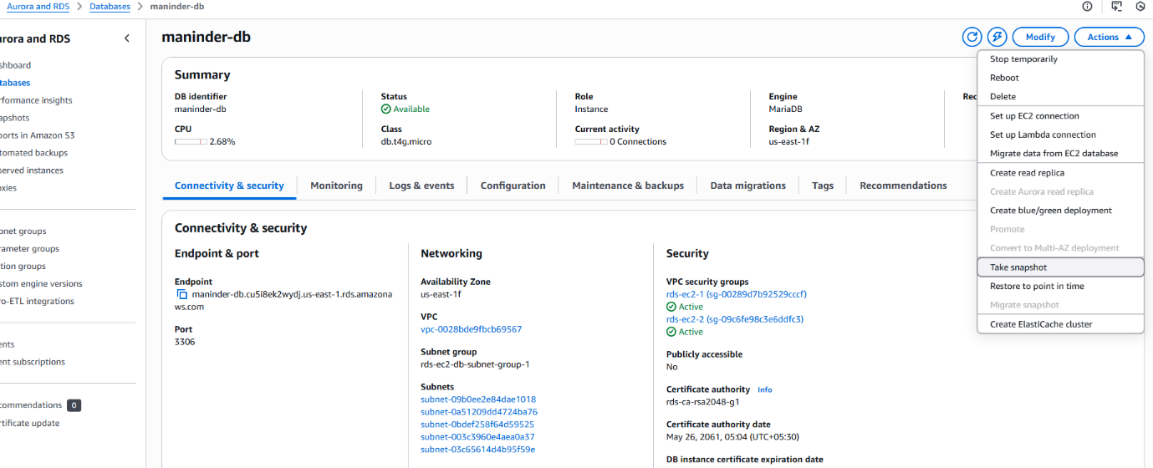
Step 2: Initiate Manual Snapshot
Console path / CLI command:
Actions > Take snapshot
Explanation:
Started the snapshot creation process from the Actions menu of the selected RDS instance.
Evidence:

Step 3: Provide Snapshot Details
Console path / CLI command:
Snapshots > Take snapshot
Explanation:
Selected snapshot type as DB instance, verified the DB identifier, and provided a snapshot name to uniquely identify the backup.
Evidence:
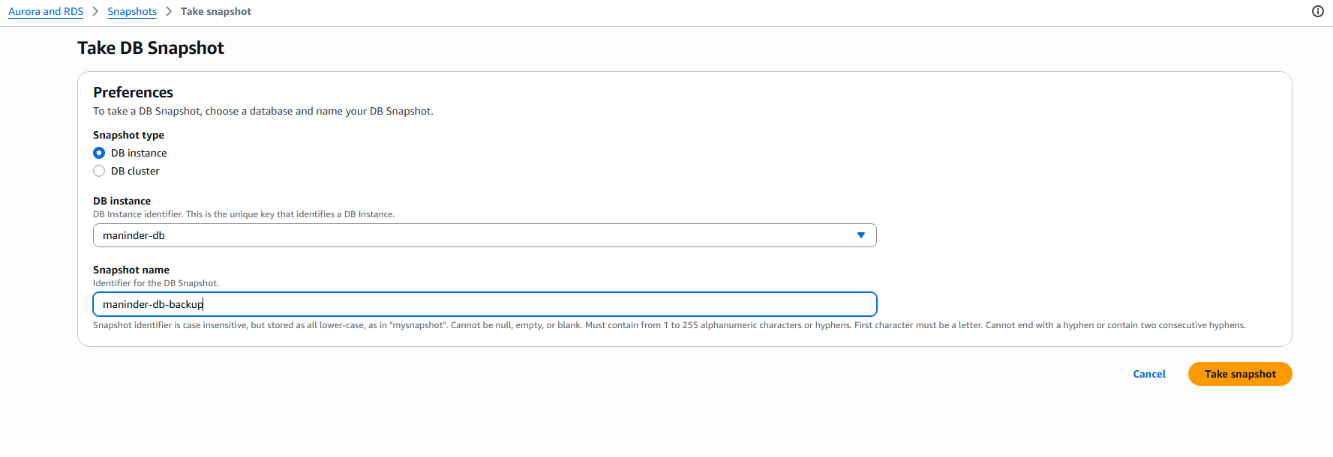
Step 4: Verify Snapshot Creation
Console path / CLI command:
Aurora and RDS > Snapshots > maninder-db-backup
Explanation:
Confirmed that the snapshot was created successfully and validated key details such as engine type, status, and creation time.
Evidence:
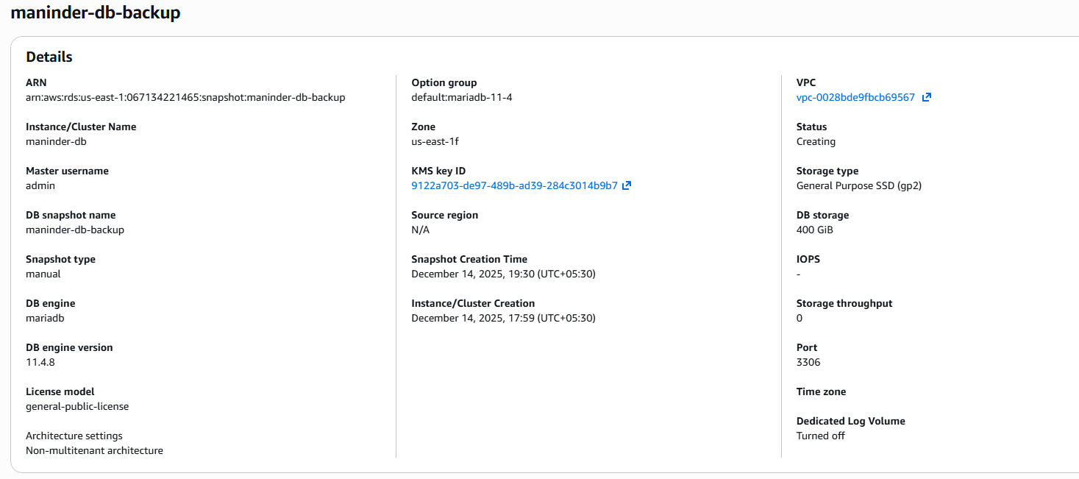
- Validation Steps (Mandatory, With Evidence):

Restore Database from Snapshot:
Console path / CLI command:
Snapshots > Select snapshot > Actions > Restore snapshot
Explanation:
A snapshot can be restored to create a new RDS instance with the same data and configuration as the original database at the time of backup.
Evidence:

- Issues Faced (Optional):
• Snapshot creation may take time depending on database size
• Restore option is disabled if the snapshot is still in Creating state
- Conclusion:
The RDS MariaDB database was successfully backed up using a manual snapshot.

- Create read replica.
- Task Title:
Create Read Replica for RDS MariaDB
- Objective:
Create a read replica for an existing Amazon RDS MariaDB instance to support read scalability and improve database performance for read-heavy workloads.
- Prerequisites:
• Running Amazon RDS MariaDB primary instance
• Automated backups enabled on the source DB
• IAM permissions for RDS read replica creation
• Source DB in Available state
- Step-by-Step Implementation (With Evidence):
Step 1: Navigate to the Source RDS Database
Console path / CLI command:
AWS Console > Aurora and RDS > Databases > maninder-db
Explanation:
Selected the primary RDS MariaDB instance from which the read replica will be created.
Evidence:
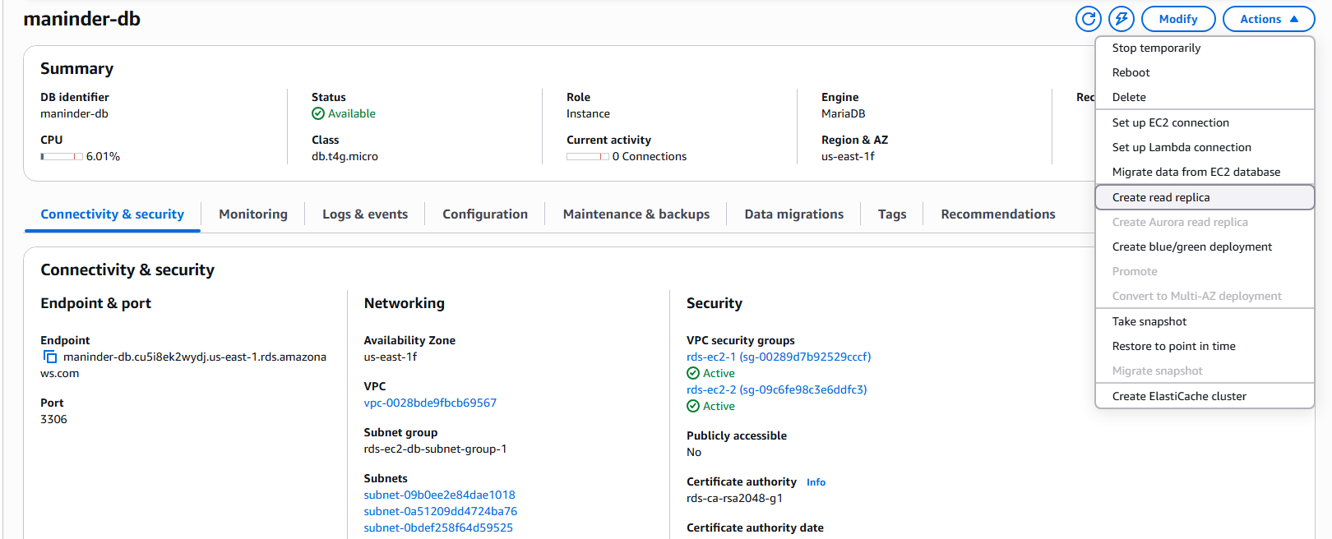
Step 2: Initiate Read Replica Creation
Console path / CLI command:
Actions > Create read replica
Explanation:
Started the read replica creation process from the Actions menu of the source database.
Evidence:

Step 3: Configure Read Replica Settings
Console path / CLI command:
Databases > Create read replica
Explanation:
Provided a unique DB instance identifier for the read replica, selected the same AWS Region, instance class, storage type, and networking configuration as the source database.
Evidence:
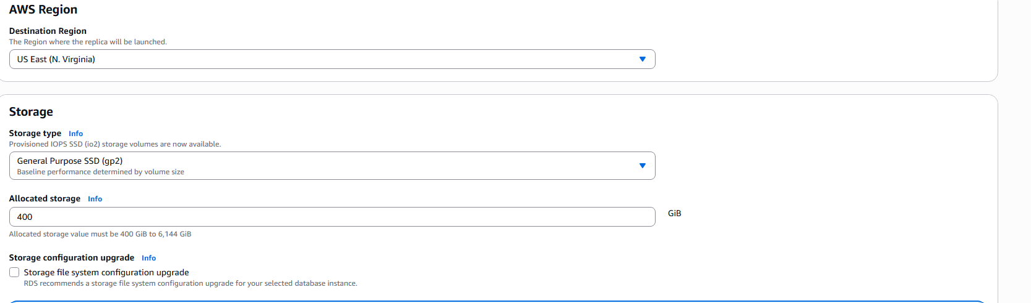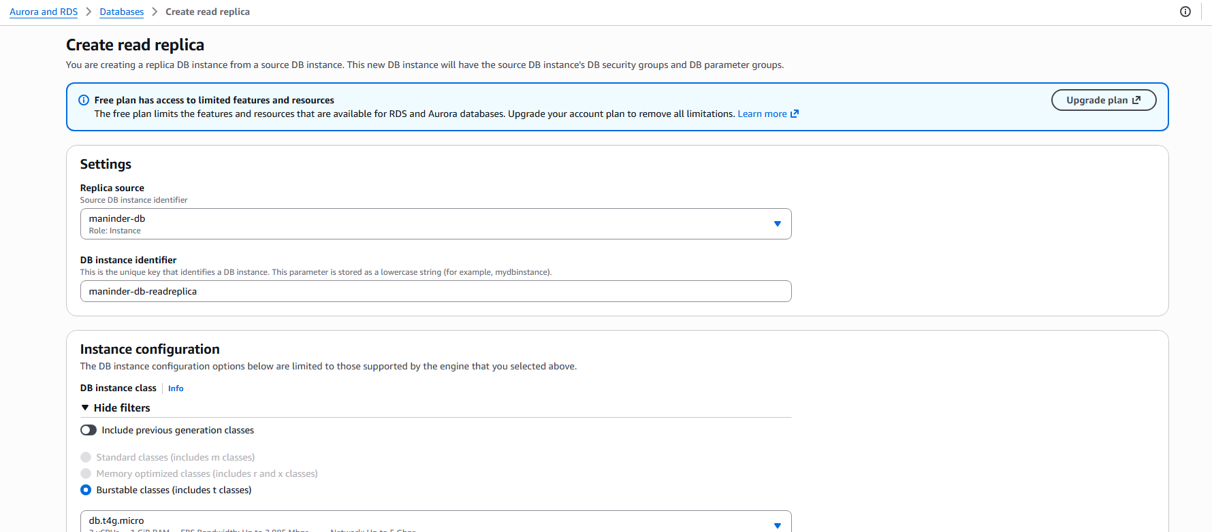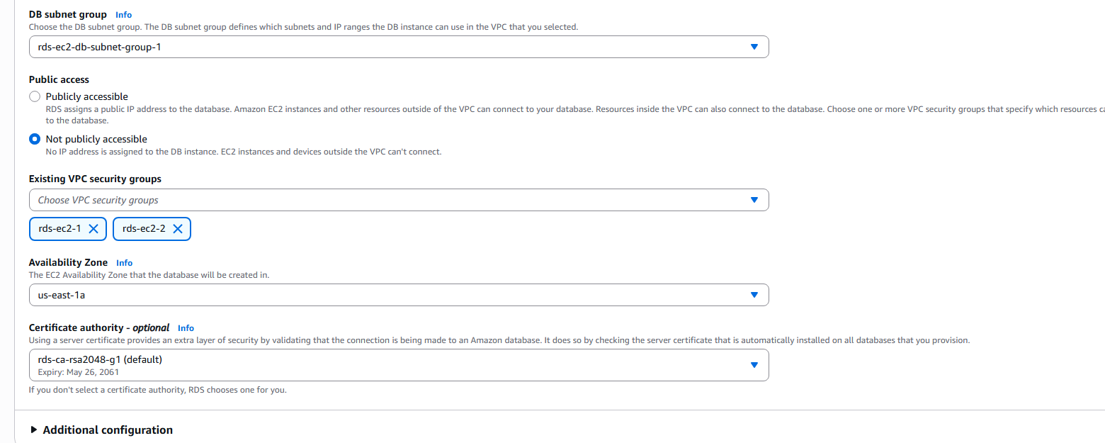
Step 4: Review Backup, Security, and Maintenance Settings
Console path / CLI command:
Create read replica > Additional configuration
Explanation:
Verified encryption, KMS key, VPC security groups, subnet group, and maintenance options before proceeding.
Evidence:
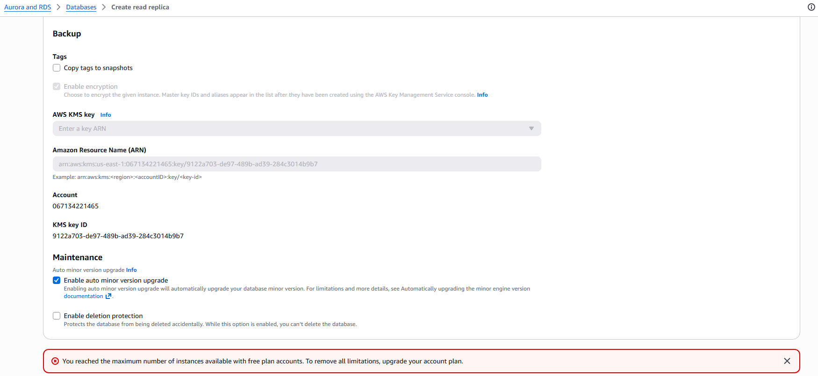
Step 5: 
- Validation Steps (Mandatory, With Evidence):
Create the Read Replica
Console path / CLI command:
Create read replica
Explanation:
Submitted the configuration to initiate the read replica creation process. Evidence:
Issues Faced (Optional):
• Read replica creation failed due to free plan account limits on the maximum number of RDS instances
• Upgrade of the AWS account plan is required to remove read replica limitations

- Conclusion:
The read replica creation process was initiated successfully from the primary RDS MariaDB instance. However, account-level limitations prevented completion.

