Jenkins-Assignment-04-Task01

- Setup Jenkins CICD pipeline using freestyle job using Docker containers using below code. https://github.com/betawins/hiring-app.git Stages:
Git Clone
SonarQube Integration
Maven Compilation
Nexus Artifactory
Slack Notification
Deploy On tomcat

1) Task Title:
Create a Jenkins Job with Git Clone, SonarQube Code Quality Check, and Slack Notification

2) Objective:
To create a Jenkins job that automates source code checkout from GitHub, performs static code analysis using SonarQube, and sends build status notifications to Slack for better CI/CD visibility.

3) Prerequisites:
• AWS EC2 instance running Amazon Linux
• Jenkins installed and running
• Java installed (Amazon Corretto)
• Git installed
• SonarQube server running on port 9000 (Docker-based)
• SonarQube Scanner plugin installed in Jenkins
• Slack workspace and incoming webhook or Slack plugin configured
• Network access between Jenkins and SonarQube
• GitHub repository access: https://github.com/betawins/hiring-app.git

4) Step-by-Step Implementation (With Evidence):

Step 1: Launch EC2 instance for SonarQube using Docker
• Console path / CLI command:
AWS Console → EC2 → Instances → Launch instance

• Explanation:
An EC2 instance named SonarQube-Docker-Assignment_04 was launched using Amazon Linux 2023 AMI with instance type m7i-flex.large. This instance is used to host SonarQube via Docker.

• Evidence:
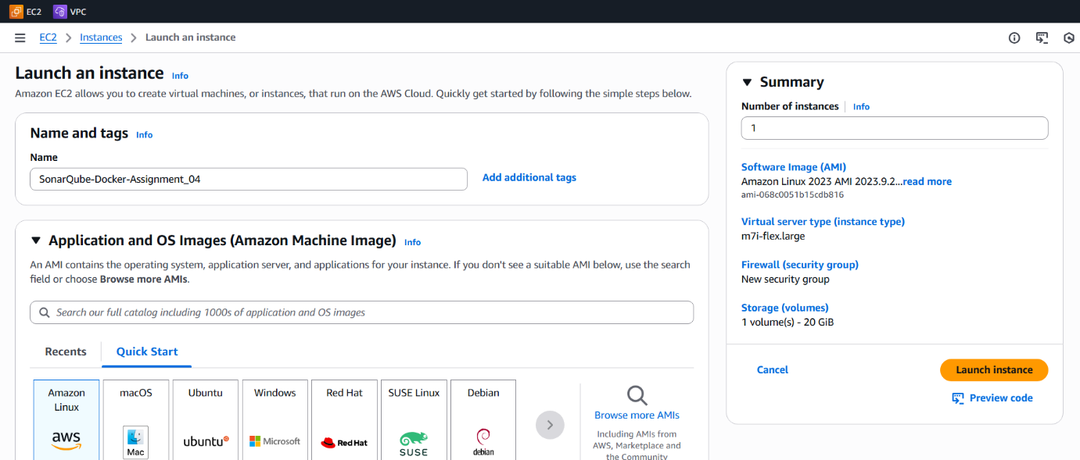
Step 2: Configure Security Group inbound rules
• Console path / CLI command:
EC2 → Instance → Security → Inbound rules

• Explanation:
Inbound rules were configured to allow required traffic:

SSH (22) for server access

HTTP (80) and HTTPS (443) for web access

Custom TCP (9000) to access SonarQube web UI

• Evidence:
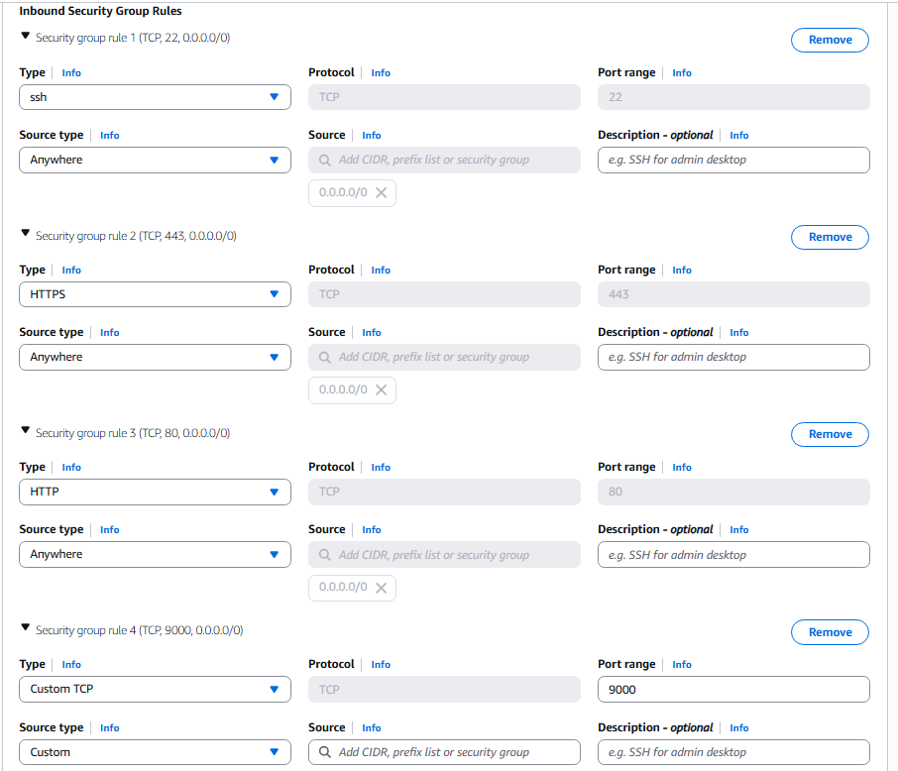
Step 3: Verify EC2 instance status and connectivity details
• Console path / CLI command:
EC2 → Instances → Instance summary

• Explanation:
The instance entered the Running state with a public IPv4 address and public DNS assigned, confirming successful launch and readiness for SSH access.

• Evidence:
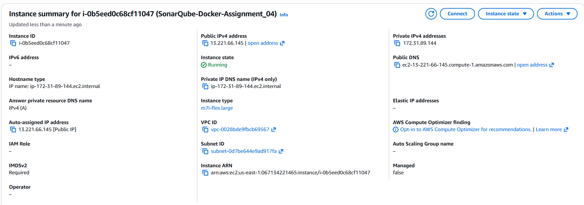
Step 4: Connect to EC2 instance via SSH
• Console path / CLI command:

ssh -i "us-east-1.pem" ec2-user@ec2-13-221-66-145.compute-1.amazonaws.com

• Explanation:
SSH connection was established to the EC2 instance using the key pair. Root access was obtained to perform Docker installation and configuration.

• Evidence:
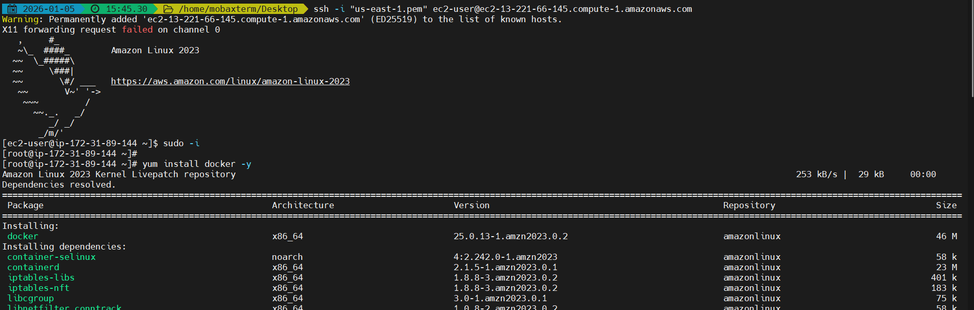
Step 5: Install and start Docker service
• Console path / CLI command:

yum install docker -y
systemctl start docker.service
systemctl enable docker.service
systemctl status docker.service

• Explanation:
Docker was installed using yum. The Docker service was started, enabled to run on boot, and verified to be in active running state.

• Evidence:
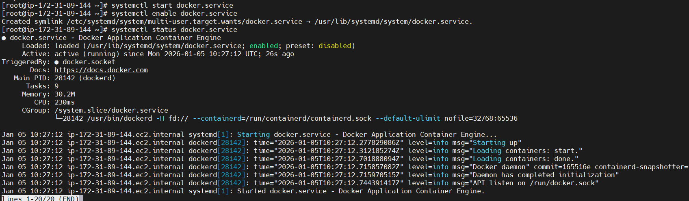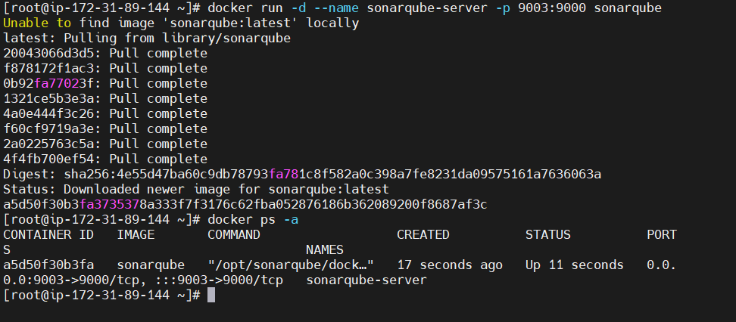
Step 6: Deploy SonarQube using Docker container
• Console path / CLI command:

docker run -d --name sonarqube-server -p 9003:9000 sonarqube
docker ps -a

• Explanation:
The official SonarQube Docker image was pulled and run as a container. Port 9000 inside the container was mapped to port 9003 on the EC2 instance to expose the SonarQube web interface.

• Evidence:

Step 7: Access SonarQube web interface and initiate project creation
• Console path / CLI command:
Browser → http://<EC2-Public-IP>:9003

• Explanation:
The SonarQube Community Edition web interface was accessed successfully. The project creation screen confirms SonarQube is running and ready for integration with Jenkins.

• Evidence:
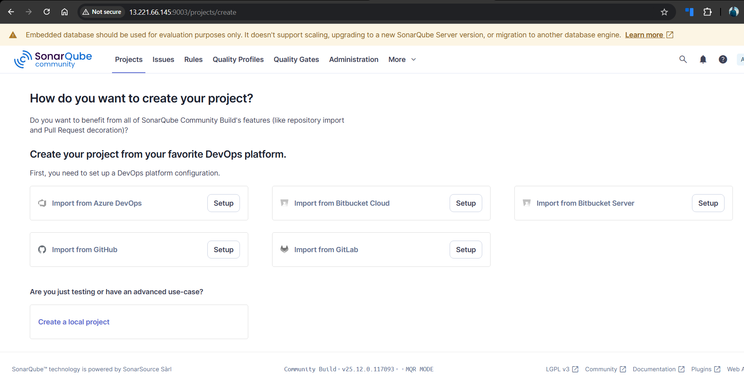

Step 8: Launch EC2 instance for Jenkins server
• Console path / CLI command:
AWS Console → EC2 → Instances → Launch instance

• Explanation:
A new EC2 instance named Jenkins_Assignment-04 was launched using Amazon Linux 2023 AMI and instance type m7i-flex.large to host the Jenkins server.

• Evidence:
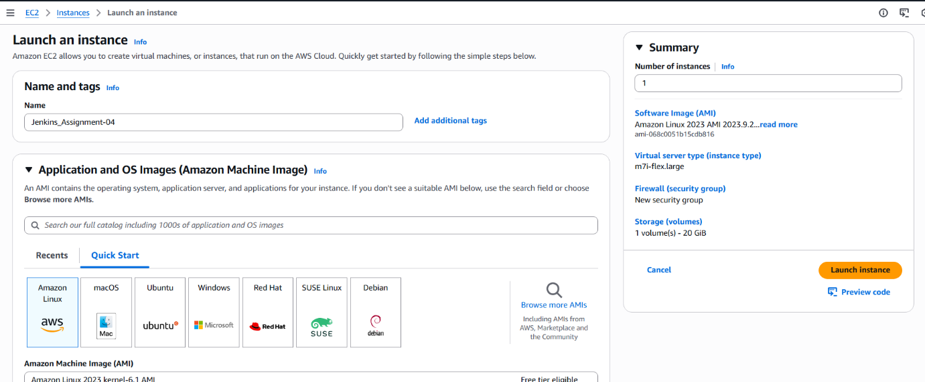
Step 9: Configure Security Group inbound rules for Jenkins
• Console path / CLI command:
EC2 → Instance → Security → Inbound rules

• Explanation:
Inbound rules were configured to allow:

SSH (22) for administrative access

HTTP (80) and HTTPS (443)

Custom TCP (8080) to access Jenkins web UI

• Evidence:
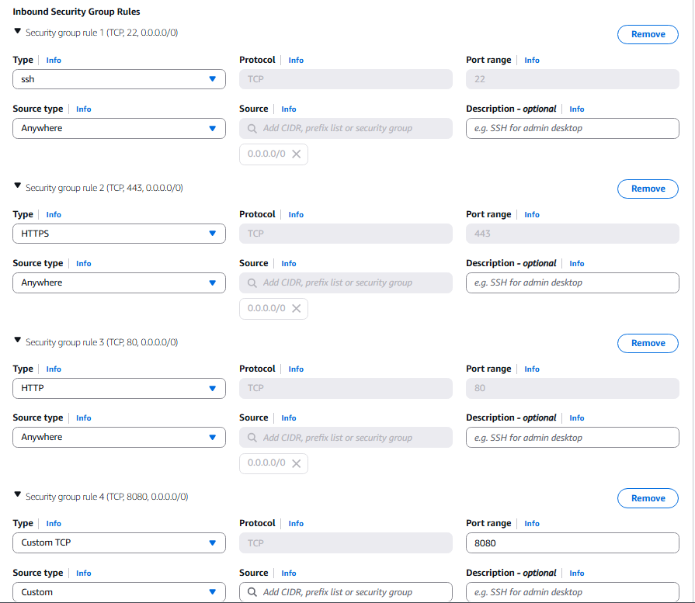
Step 10: Install Jenkins using EC2 user data script
• Console path / CLI command:
EC2 → Launch instance → Advanced details → User data

• Explanation:
A user-data bash script was provided to automatically update the system, install Java 17 (Amazon Corretto), install Jenkins, and start the Jenkins service during instance boot.

• Evidence:
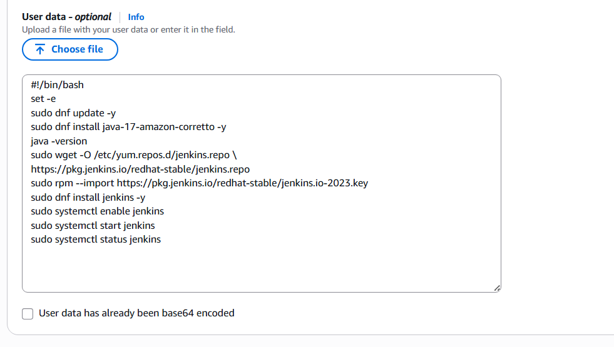
Step 11: Verify Jenkins EC2 instance status
• Console path / CLI command:
EC2 → Instances → Instance summary

• Explanation:
The Jenkins EC2 instance entered the Running state with public IP and DNS assigned, confirming it is accessible over the network.

• Evidence:
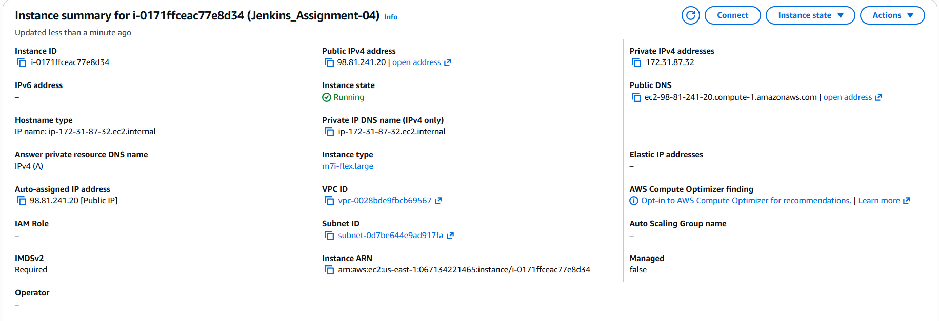
Step 12: Unlock Jenkins using initial admin password
• Console path / CLI command:
Browser → http://<Jenkins-Public-IP>:8080

cat /var/lib/jenkins/secrets/initialAdminPassword

• Explanation:
The Jenkins unlock page was accessed and the initial administrator password was retrieved from the server to complete the Jenkins setup wizard.

• Evidence:
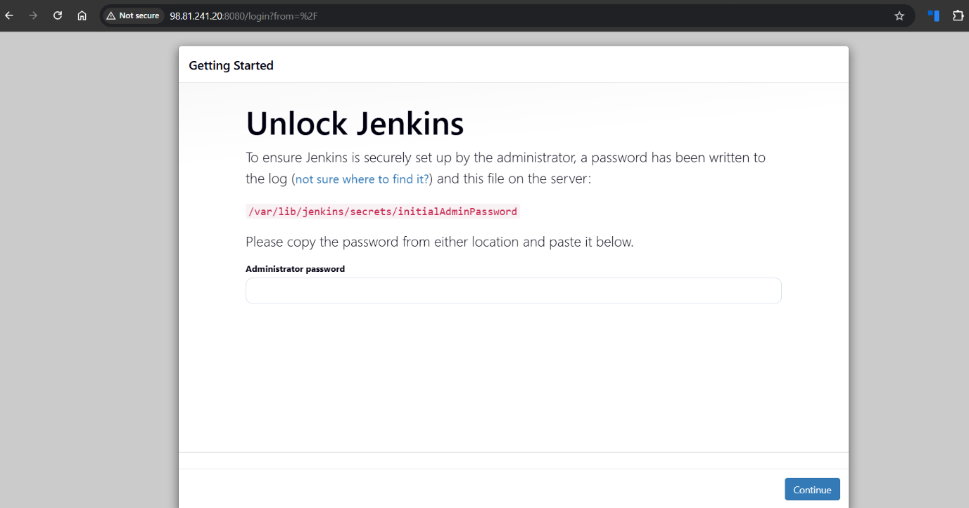
Step 13: Access Jenkins dashboard
• Console path / CLI command:
Browser → http://<Jenkins-Public-IP>:8080

• Explanation:
After unlocking Jenkins and completing the setup, the Jenkins dashboard was successfully accessed.

• Evidence:
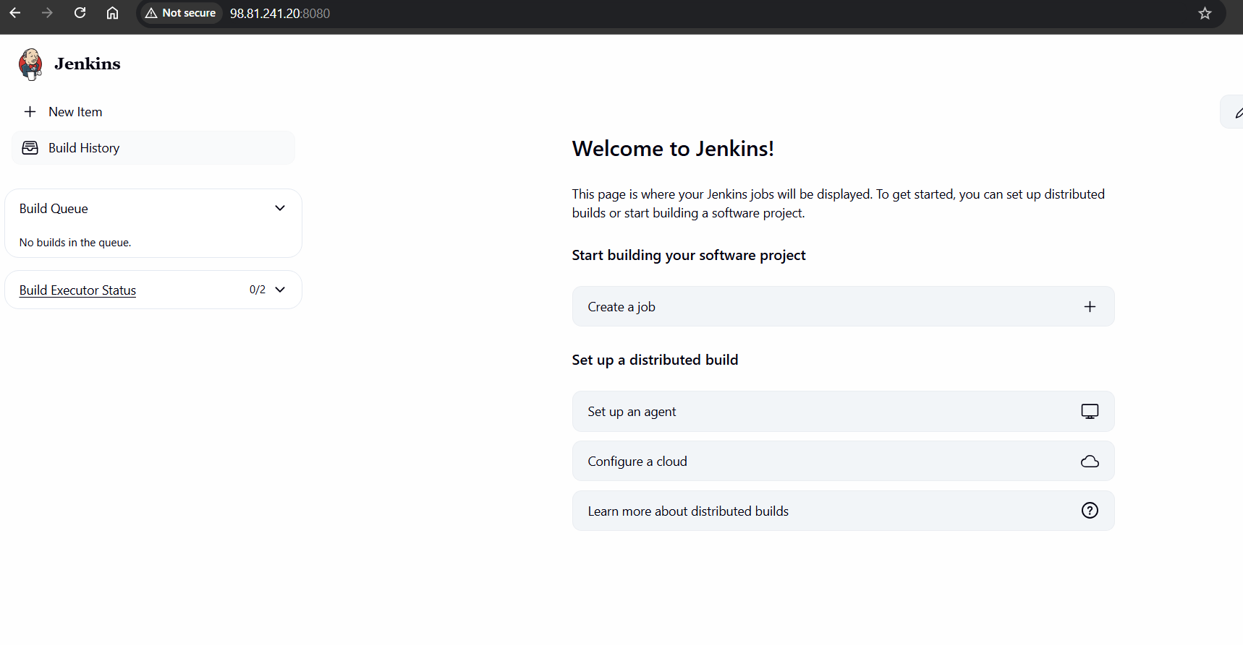
Step 14: Create a new Jenkins Freestyle job
• Console path / CLI command:
Jenkins Dashboard → New Item

• Explanation:
A new Jenkins job named Jenkins_Assignment04_Task01 was created using the Freestyle project option.

• Evidence:
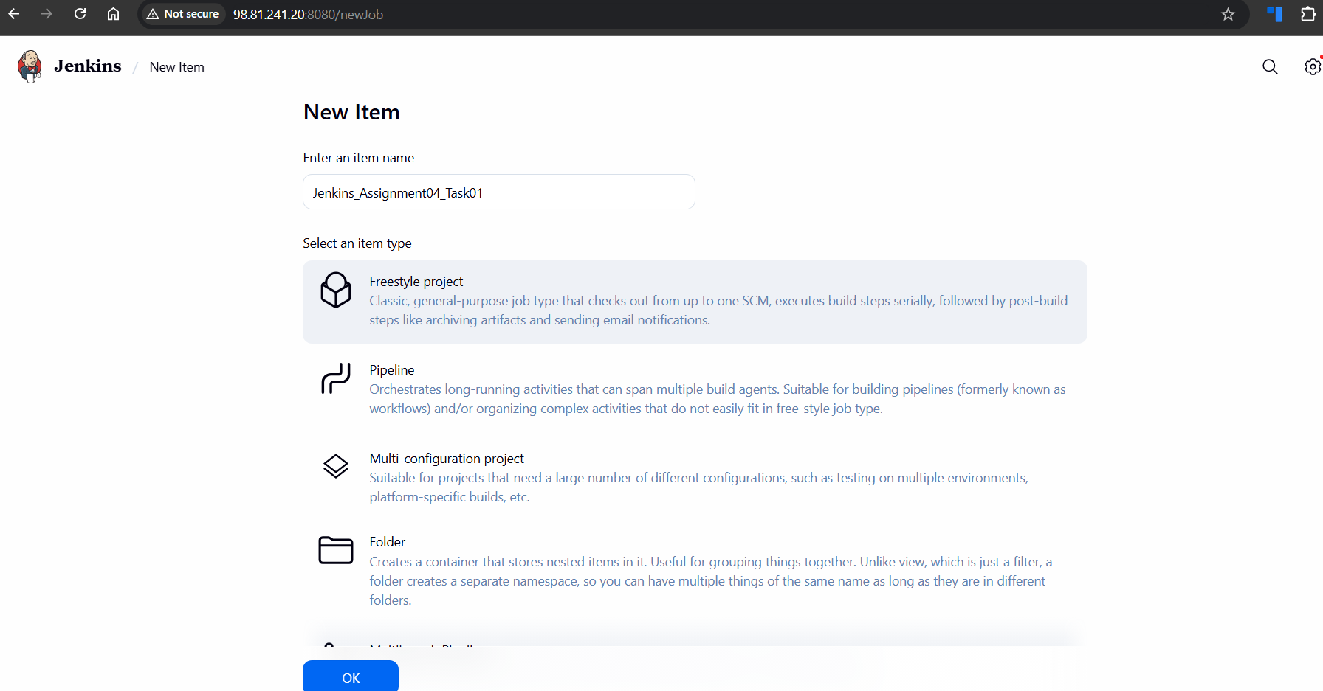
Step 15: Install Git on Jenkins server
• Console path / CLI command:

yum install git -y

• Explanation:
Git was installed on the Jenkins server to enable source code checkout from the GitHub repository.

• Evidence:
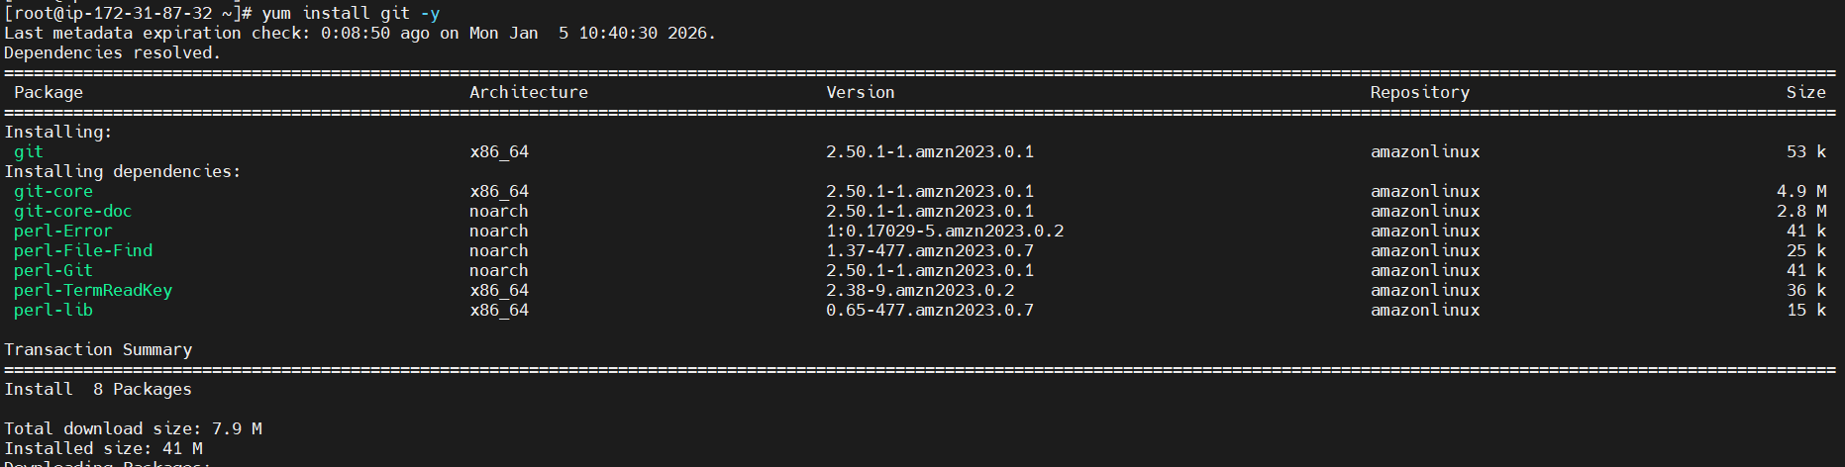
Step 16: Configure Git repository in Jenkins job (Stage 1: Git Clone)
• Console path / CLI command:
Jenkins Job → Configure → Source Code Management → Git

• Explanation:
The GitHub repository https://github.com/betawins/hiring-app.git
was configured with branch specifier /main to enable source code checkout as the first stage.

• Evidence:
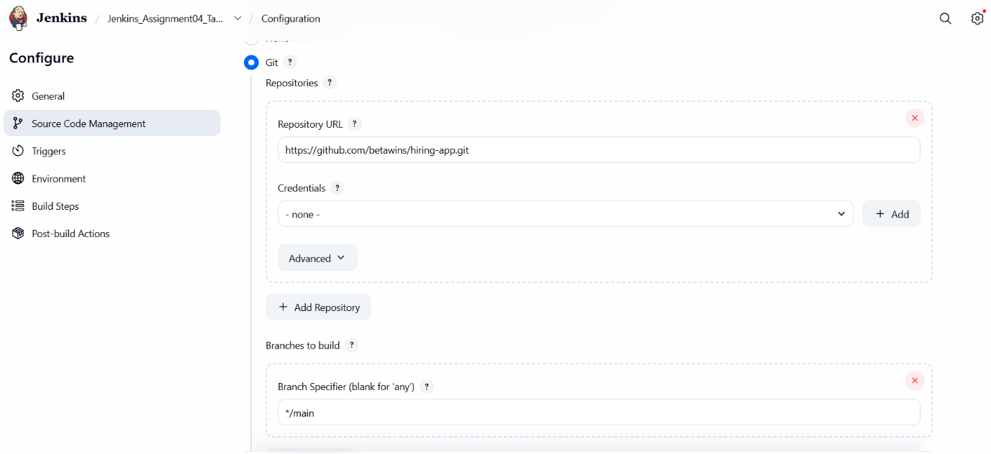
Step 17: Execute Jenkins job and verify Git clone
• Console path / CLI command:
Jenkins Job → Build Now → Console Output

• Explanation:
The Jenkins job was executed successfully. Console output confirms Git repository initialization, fetch, checkout of the main branch, and successful build completion.

• Evidence:
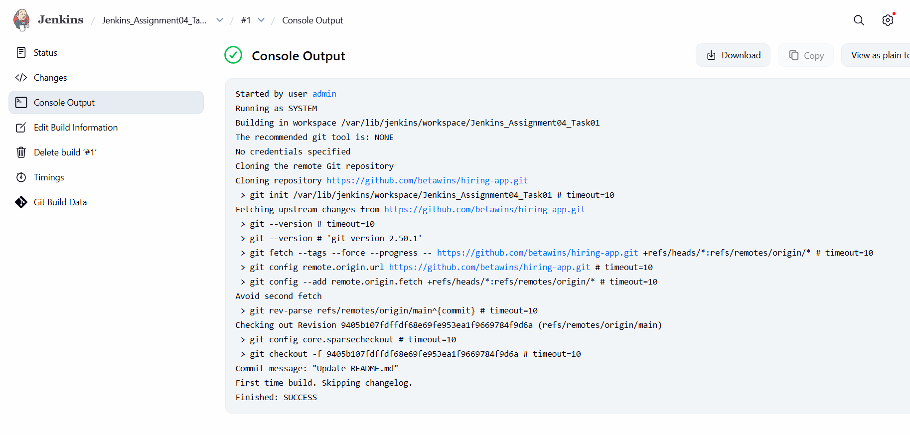

Step 18: Generate SonarQube authentication token
• Console path / CLI command:
SonarQube UI → Administrator → Security → Generate Tokens

• Explanation:
A new SonarQube user token named Jenkins_Assignment-04 was generated. This token is required for Jenkins to authenticate securely with the SonarQube server during code analysis.

• Evidence:
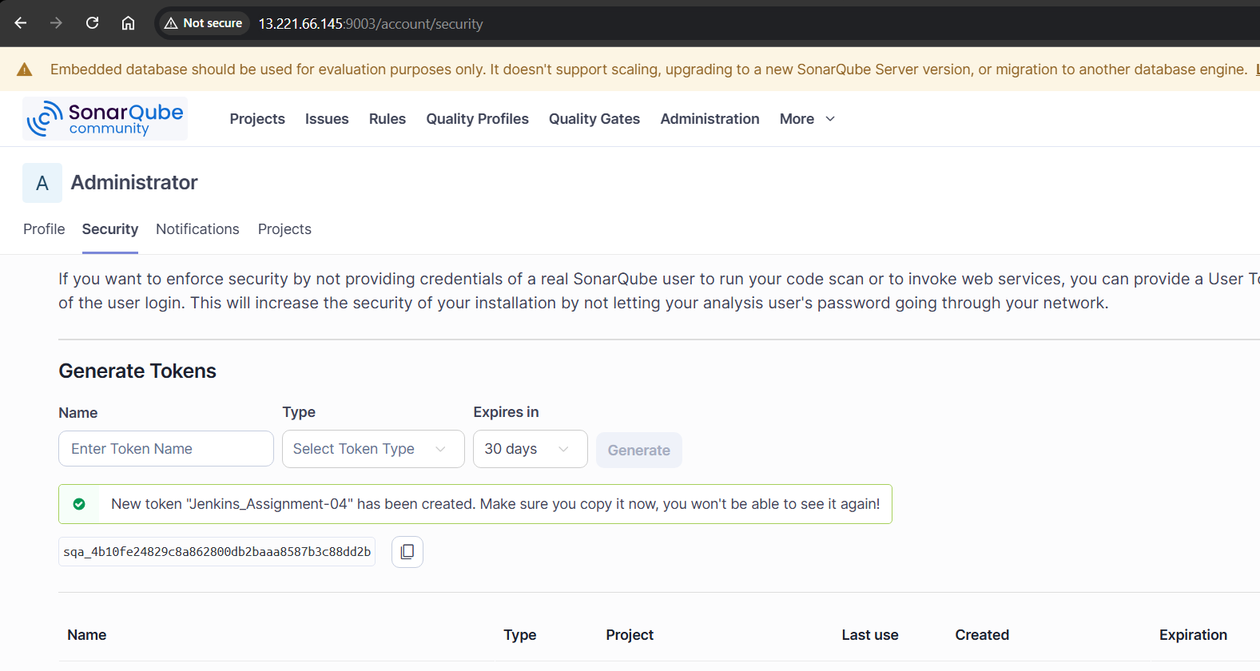
Step 19: Add SonarQube token to Jenkins credentials
• Console path / CLI command:
Jenkins → Manage Jenkins → Credentials → System → Global credentials → Add Credentials

• Explanation:
The generated SonarQube token was added to Jenkins as a Secret Text credential with ID Sonarqube-Docker, enabling Jenkins jobs to use the token securely.

• Evidence:
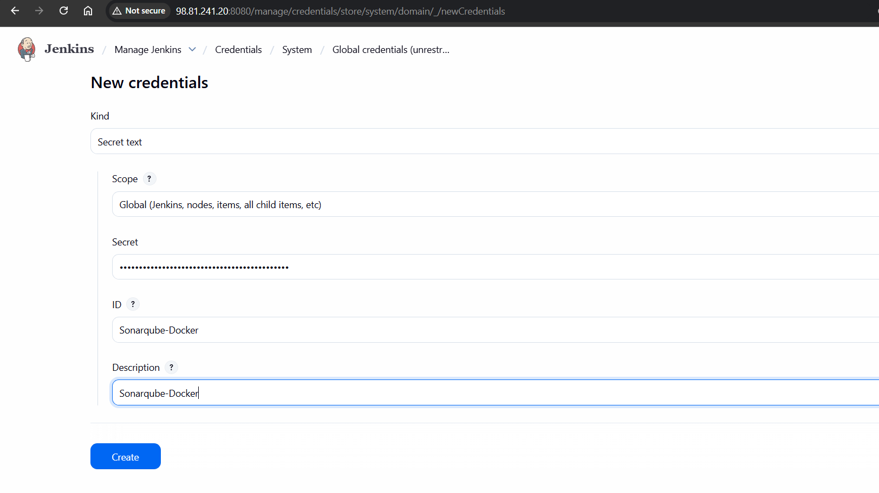
Step 20: Install SonarQube Scanner plugin in Jenkins
• Console path / CLI command:
Jenkins → Manage Jenkins → Plugins → Available plugins → Search “sonar”

• Explanation:
The SonarQube Scanner plugin was selected and installed to enable Jenkins–SonarQube integration.

• Evidence:
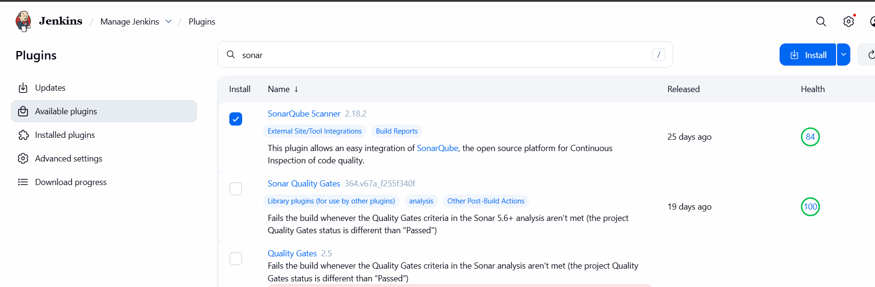
Step 21: Verify SonarQube Scanner plugin installation
• Console path / CLI command:
Jenkins → Manage Jenkins → Plugins → Download progress

• Explanation:
Plugin installation completed successfully, and all dependent components were installed without errors.

• Evidence:
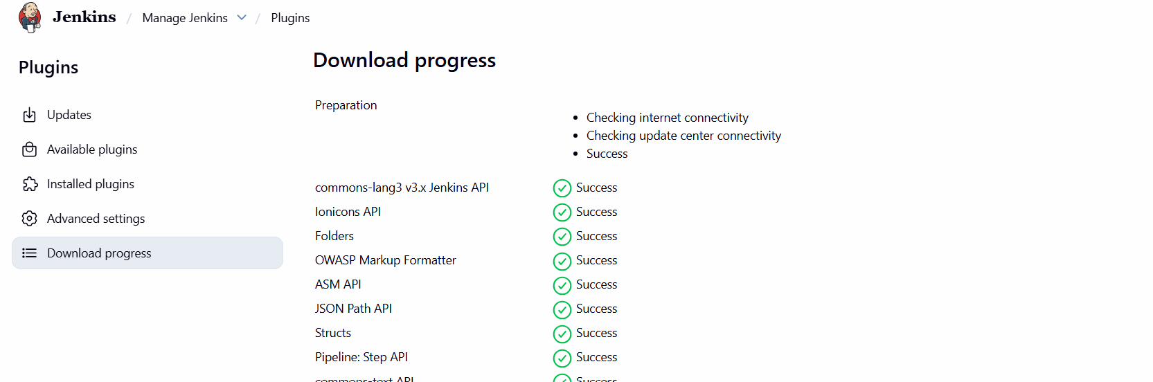
Step 22: Install SonarScanner CLI on Jenkins server
• Console path / CLI command:

cd /opt
wget https://binaries.sonarsource.com/Distribution/sonar-scanner-cli/sonar-scanner-cli-5.0.1.3006-linux.zip
unzip sonar-scanner-cli-5.0.1.3006-linux.zip
mv sonar-scanner-5.0.1.3006-linux sonar-scanner
chown -R jenkins:jenkins /opt/sonar-scanner
chmod +x /opt/sonar-scanner/bin/sonar-scanner

• Explanation:
SonarScanner CLI was downloaded, extracted, renamed, and permissions were updated so Jenkins can execute the scanner.

• Evidence:
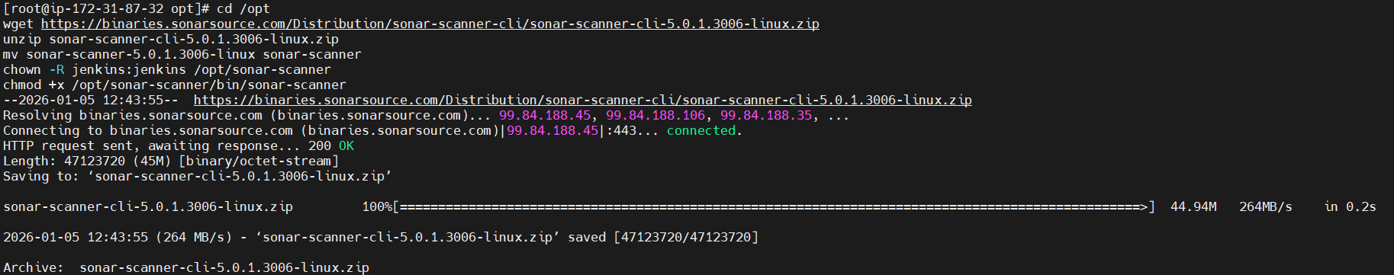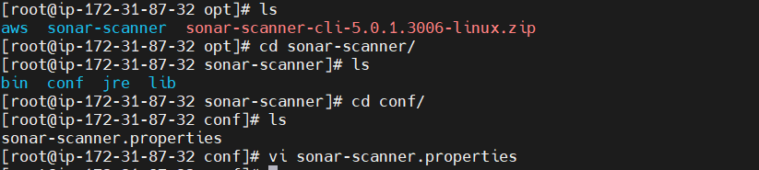
Step 23: Configure SonarScanner properties
• Console path / CLI command:

vi /opt/sonar-scanner/conf/sonar-scanner.properties

• Explanation:
The SonarQube server URL was configured in the scanner properties file to point to the Docker-based SonarQube instance.

• Evidence:
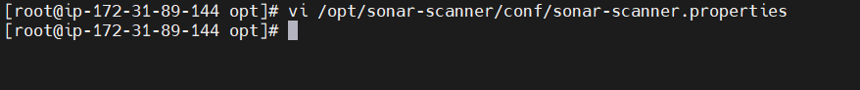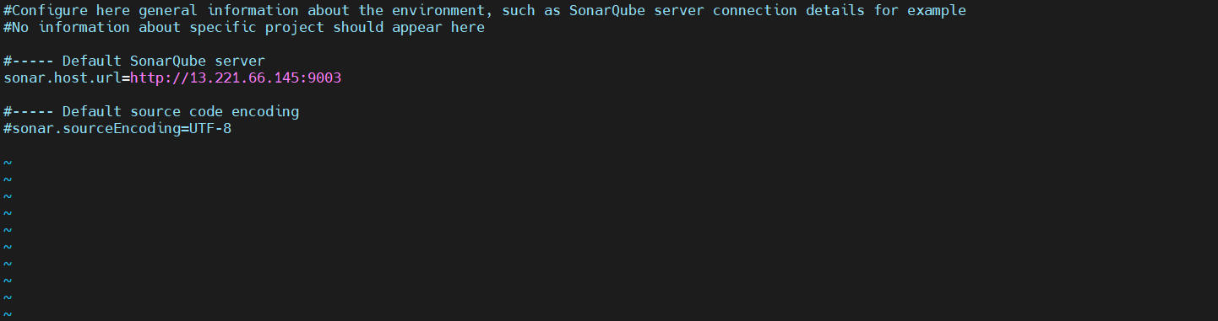
Step 24: Configure SonarQube server details in Jenkins
• Console path / CLI command:
Jenkins → Manage Jenkins → System → SonarQube installations

• Explanation:
A SonarQube installation named sonarqube-Docker was added with the server URL and authentication token mapped from Jenkins credentials.

• Evidence:
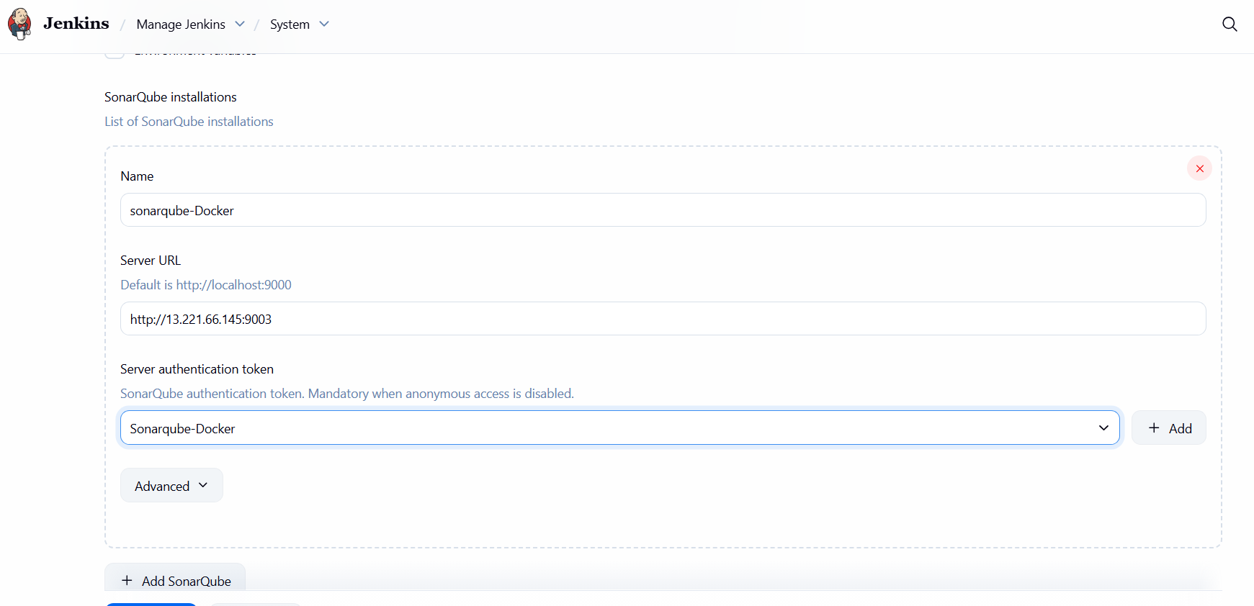
Step 25: Configure SonarQube analysis stage in Jenkins job
• Console path / CLI command:
Jenkins Job → Configure → Build Steps → Execute shell

• Explanation:
A shell build step was added to run SonarScanner. Java home, PATH, project key, source directory, and workspace were configured to perform static code analysis on the cloned repository.

• Evidence:
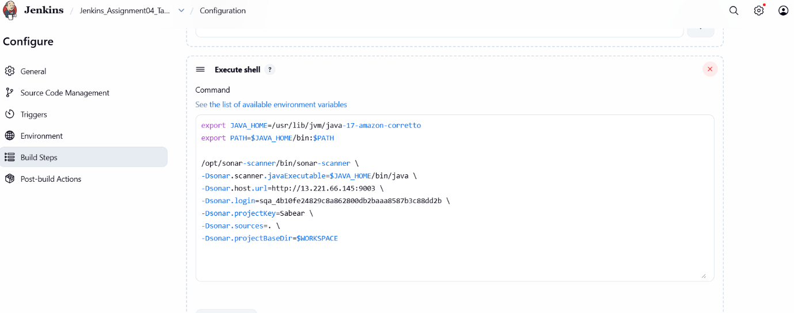

Step 26: Trigger Jenkins job with SonarQube analysis enabled
• Console path / CLI command:
Jenkins Job → Build Now → Console Output

• Explanation:
The Jenkins job Jenkins_Assignment04_Task01 was triggered manually. The console output confirms Git checkout followed by execution of the SonarScanner stage.

• Evidence:
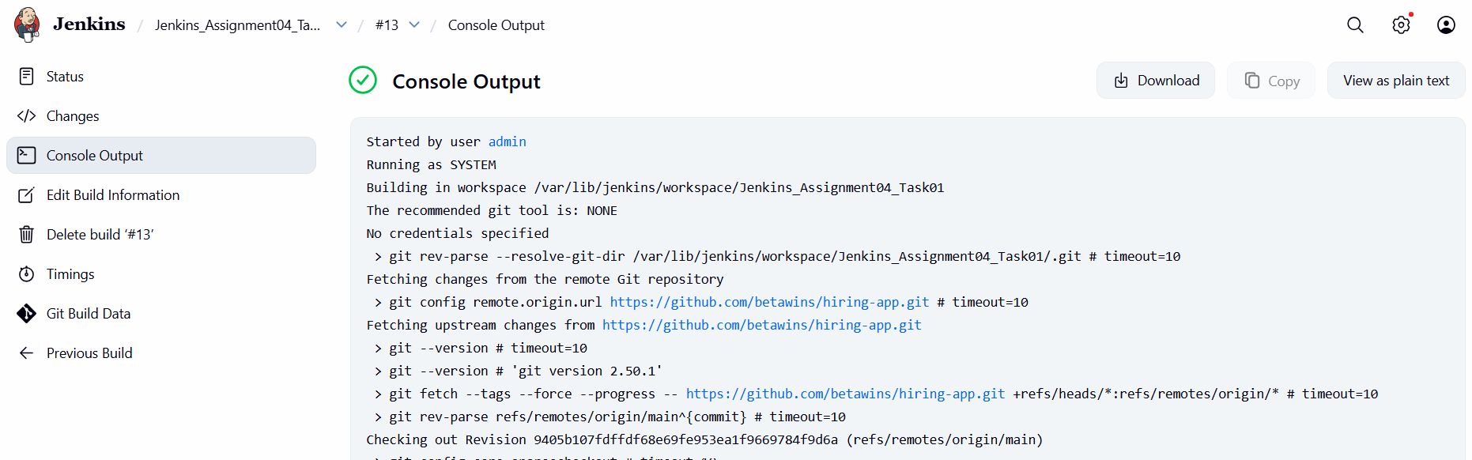
Step 27: Validate project creation and analysis result in SonarQube
• Console path / CLI command:
SonarQube UI → Projects

• Explanation:
The project created by Jenkins analysis is visible in SonarQube. The Quality Gate status is marked as Passed, confirming successful static code analysis.

• Evidence:
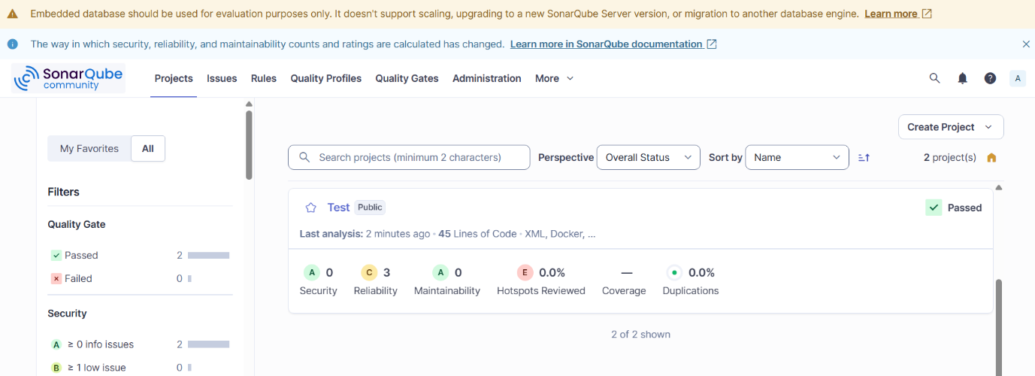
Step 29: Install Slack Notification plugin in Jenkins
• Console path / CLI command:
Jenkins → Manage Jenkins → Plugins → Available plugins → Search “slack”

• Explanation:
The Slack Notification plugin was selected and installed to enable Jenkins build notifications to Slack channels.

• Evidence:
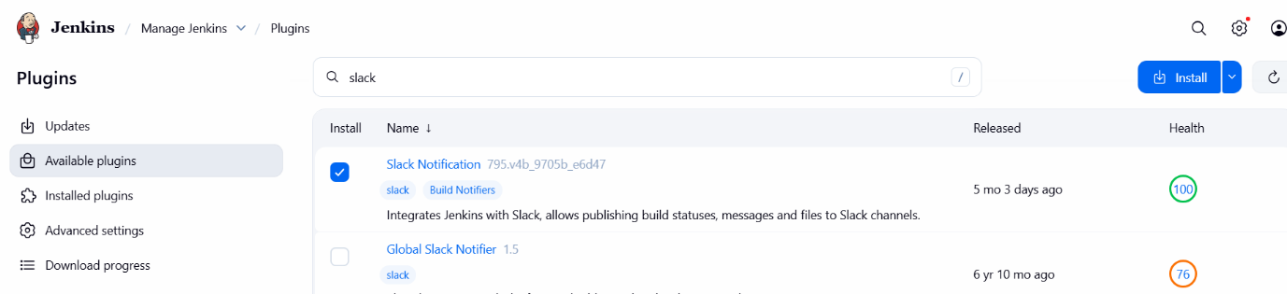
Step 30: Configure Slack Notification as post-build action
• Console path / CLI command:
Jenkins Job → Configure → Post-build Actions → Add post-build action → Slack Notifications

• Explanation:
Slack Notifications were added as a post-build action to send alerts based on build results.

• Evidence:
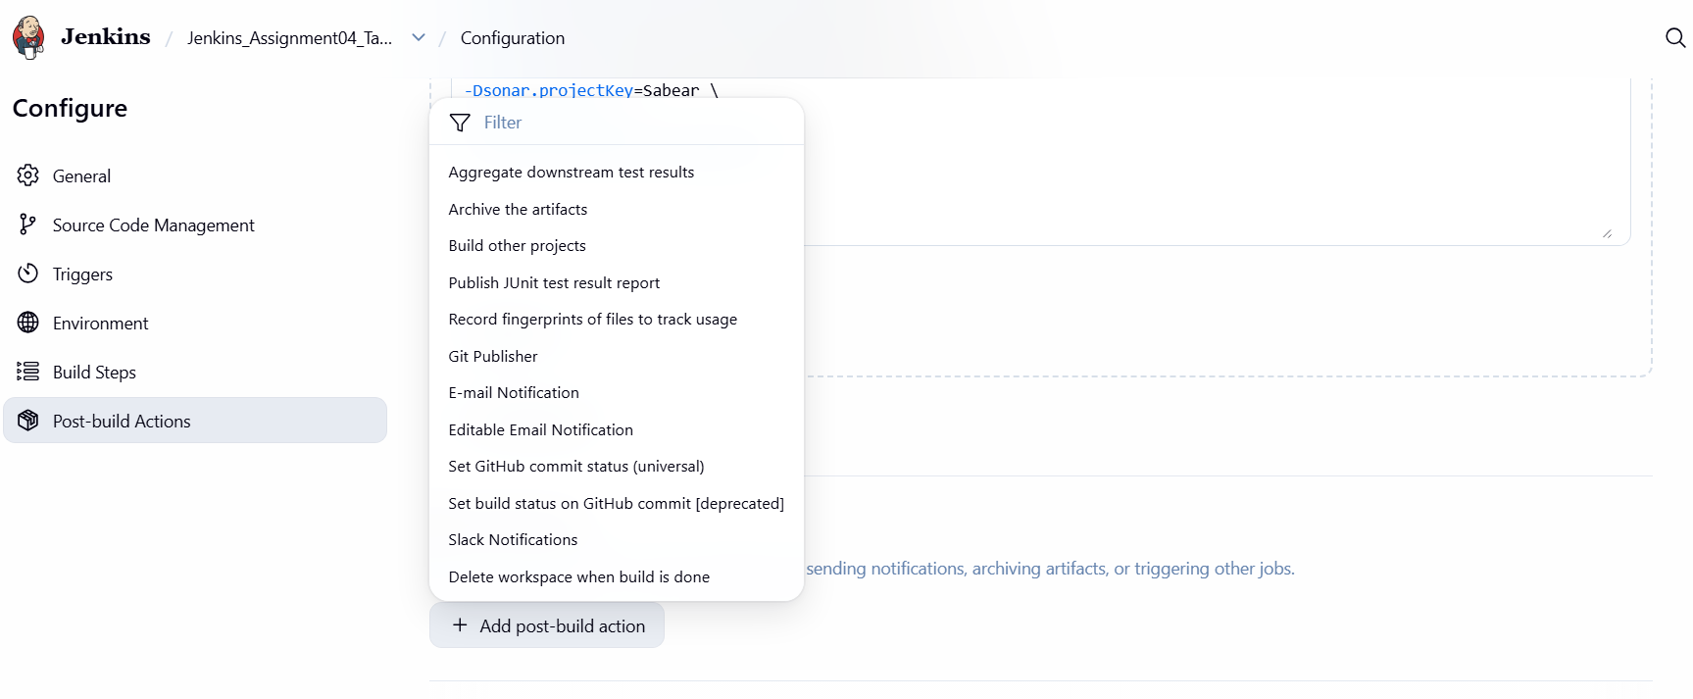
Step 31: Configure Slack notification trigger conditions
• Console path / CLI command:
Jenkins Job → Configure → Post-build Actions → Slack Notifications

• Explanation:
Slack notifications were configured to trigger on Notify Success, ensuring a message is sent to Slack when the Jenkins build completes successfully.

• Evidence:
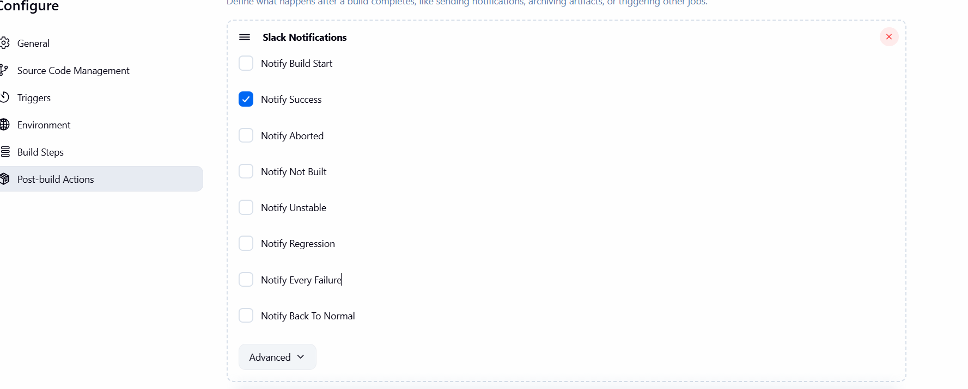

Step 32: Verify Slack notification delivery
• Console path / CLI command:
Slack Workspace → Channel

• Explanation:
Upon Jenkins job execution, a notification message was successfully delivered to the configured Slack channel, confirming proper integration.

• Evidence:
Step 33: Download Apache Maven binary
• Console path / CLI command:
Browser → https://maven.apache.org/download.cgi

• Explanation:
Apache Maven version 3.9.12 binary distribution was selected for download to support Java build operations if required.

• Evidence:
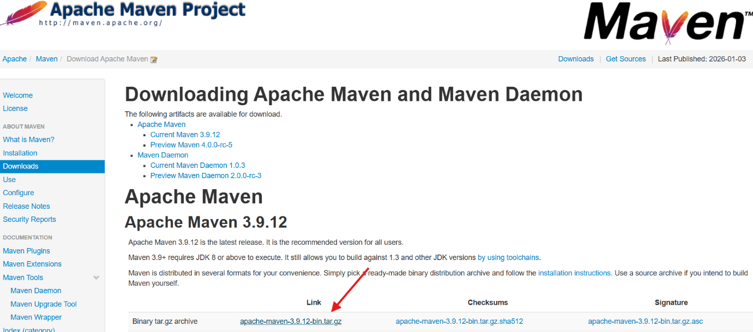
Step 34: Install Apache Maven on Jenkins server
• Console path / CLI command:

cd /opt
wget https://dlcdn.apache.org/maven/maven-3/3.9.12/binaries/apache-maven-3.9.12-bin.tar.gz
tar -xvf apache-maven-3.9.12-bin.tar.gz
mv apache-maven-3.9.12 maven

• Explanation:
Apache Maven was downloaded, extracted, and renamed to a standard directory for ease of configuration.

• Evidence:
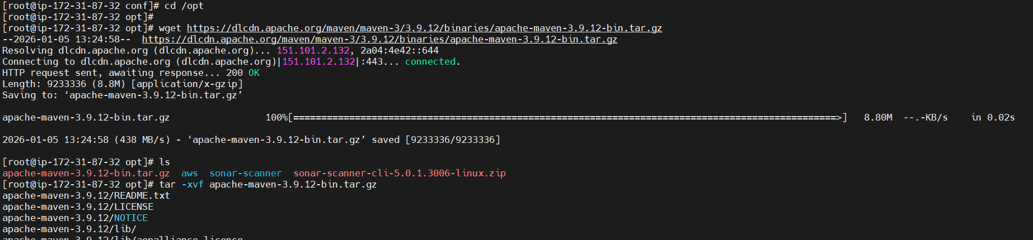
Step 35: Configure Maven environment variables
• Console path / CLI command:

vi ~/.bash_profile
source ~/.bash_profile

• Explanation:
Maven environment variables were configured by setting MAVEN_HOME and updating the PATH to include Maven binaries.

• Evidence:
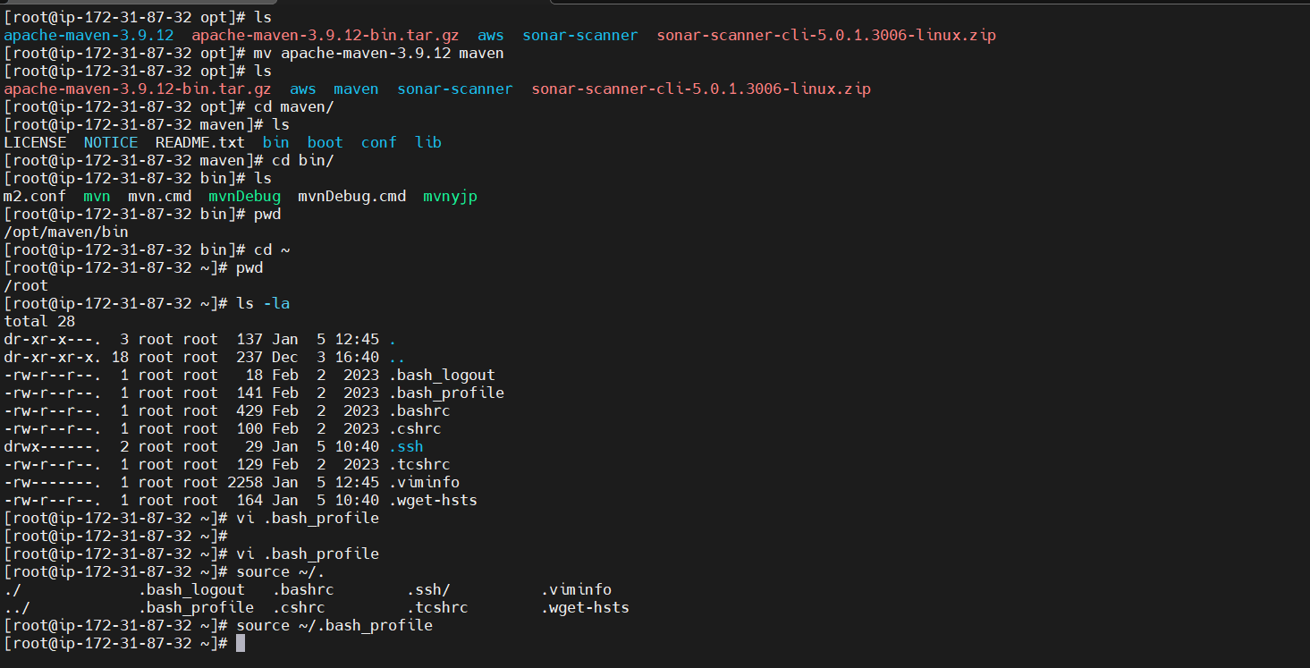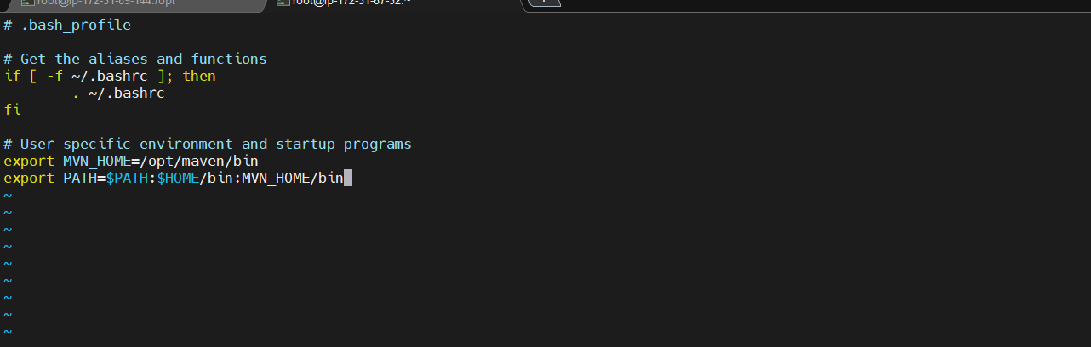

Step 35: Verify and Prepare Maven Installation on Server
Console path / CLI command:
cd /opt && ls && mv apache-maven-3.9.12 maven && cd /opt/maven/bin && ls
Explanation: Verified Apache Maven files, renamed the directory to maven, and confirmed Maven binaries are present.
Evidence:

Step 36: Configure Maven Environment Variables
Console path / CLI command:
vi ~/.bash_profile
source ~/.bash_profile
Explanation: Configured MVN_HOME and updated PATH so Maven can be executed globally.
Evidence:
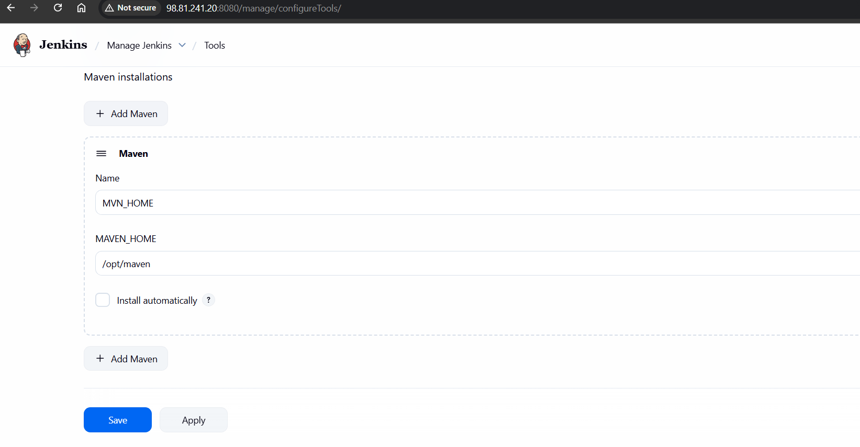
Step 37: Configure Maven in Jenkins Global Tools
Console path / UI path:
Jenkins → Manage Jenkins → Tools → Maven Installations
Explanation: Added Maven manually in Jenkins with name MVN_HOME and path /opt/maven.
Evidence: 

Step 38: Configure Maven Build Step in Jenkins Job
Console path / UI path:
Jenkins Job → Configure → Build Steps → Invoke top-level Maven targets
Explanation: Selected Maven version MVN_HOME and configured goal clean install.
Evidence:
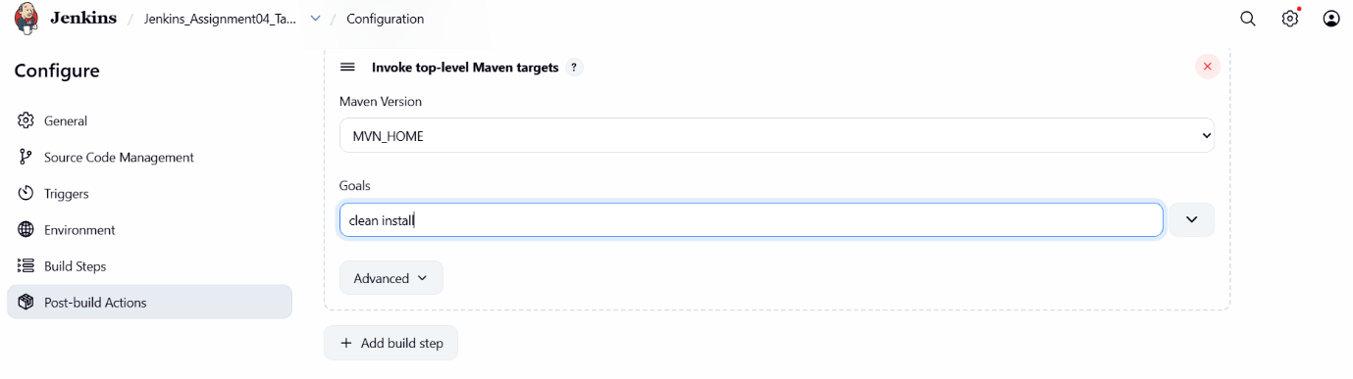
Step 39: Execute Jenkins Job and Validate Maven Build
Console path / UI path:
Jenkins Job → Build Now → Console Output
Explanation: Jenkins executed Maven build successfully and completed the job execution.
Evidence:
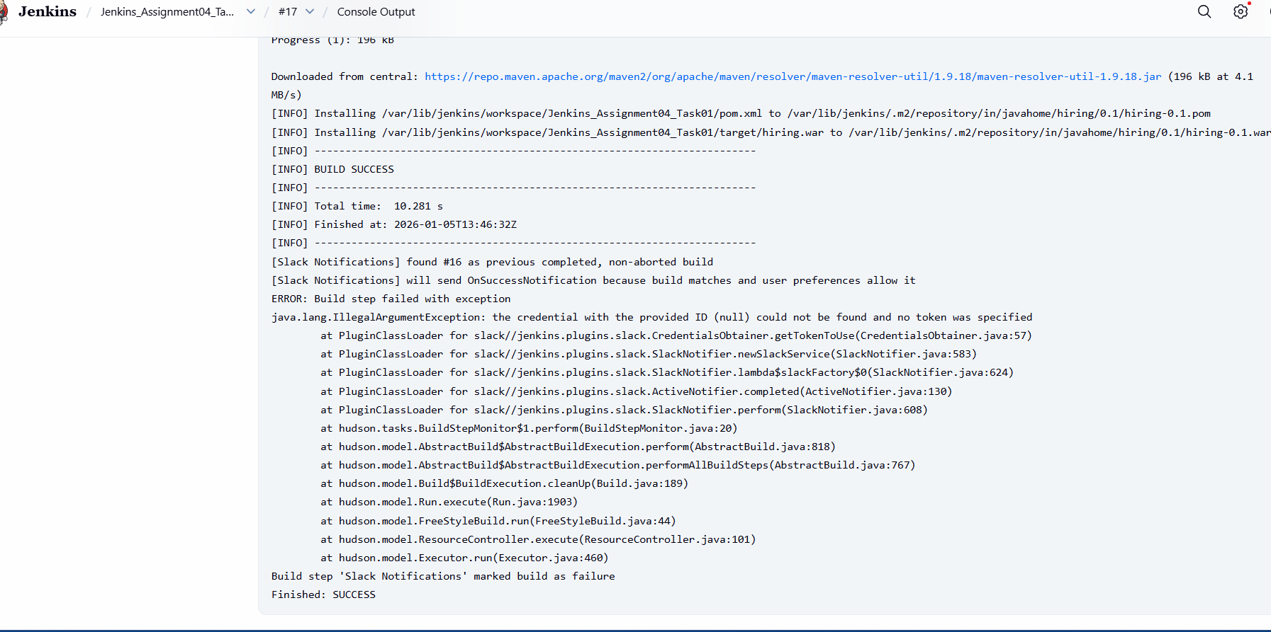
Step 40: Verify Artifact Generated in Jenkins Workspace
Console path / CLI command:
cd /var/lib/jenkins/workspace/Jenkins_Assignment04_Task01/target && ls
Explanation: Verified that the WAR artifact was generated after successful Maven build.
Evidence:
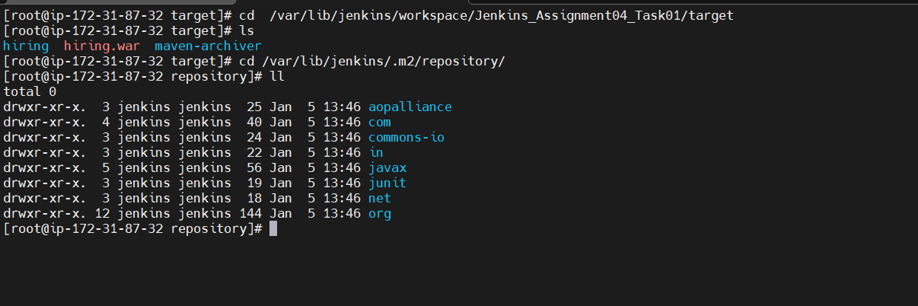
Step 41: Verify Artifact Installed in Maven Local Repository
Console path / CLI command:
cd /var/lib/jenkins/.m2/repository && ls
Explanation: Confirmed that Maven dependencies and project artifacts are stored in the local repository.
Evidence:

Step 42: Verify Nexus EC2 Instance Details

• Action: Checked Nexus EC2 instance status, public IP, and DNS
• Explanation: Ensured Nexus server instance is running and reachable
• 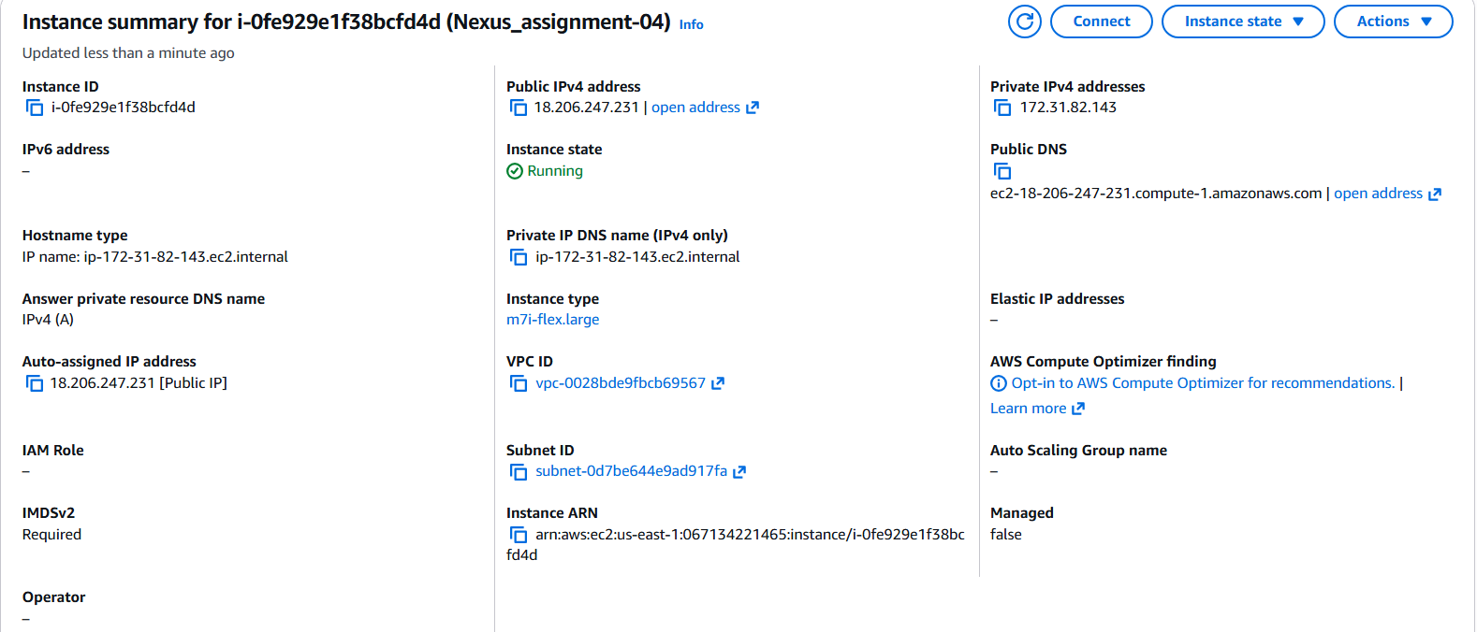

Step 43: Connect to Nexus EC2 Instance via SSH

• Action: Logged into Nexus EC2 using SSH and PEM key
• Explanation: Accessed server to install and configure Nexus Repository
• Evidence: 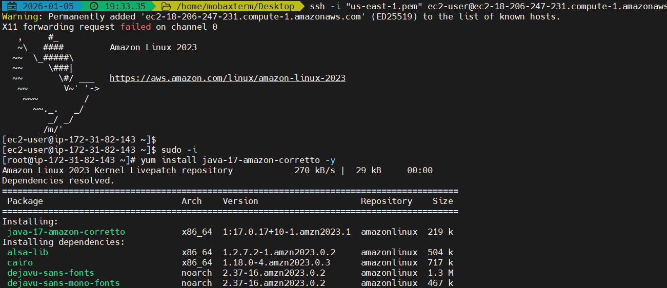

Step 44: Install Java on Nexus Server

• Action: Installed Java 17 Amazon Corretto
• Explanation: Java is mandatory to run Nexus Repository Manager
• Evidence: 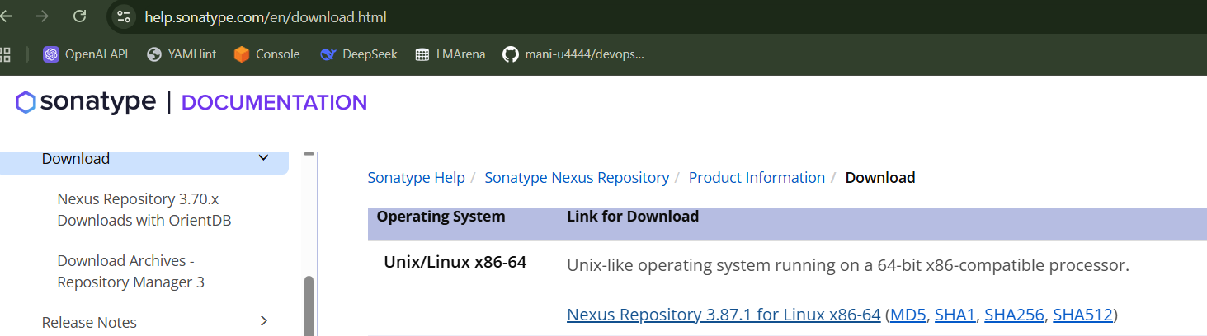

Step 45: Download Nexus Repository Binary

• Action: Downloaded Nexus Repository tar file from Sonatype
• Explanation: Retrieved official Nexus Repository Manager package
• Evidence: 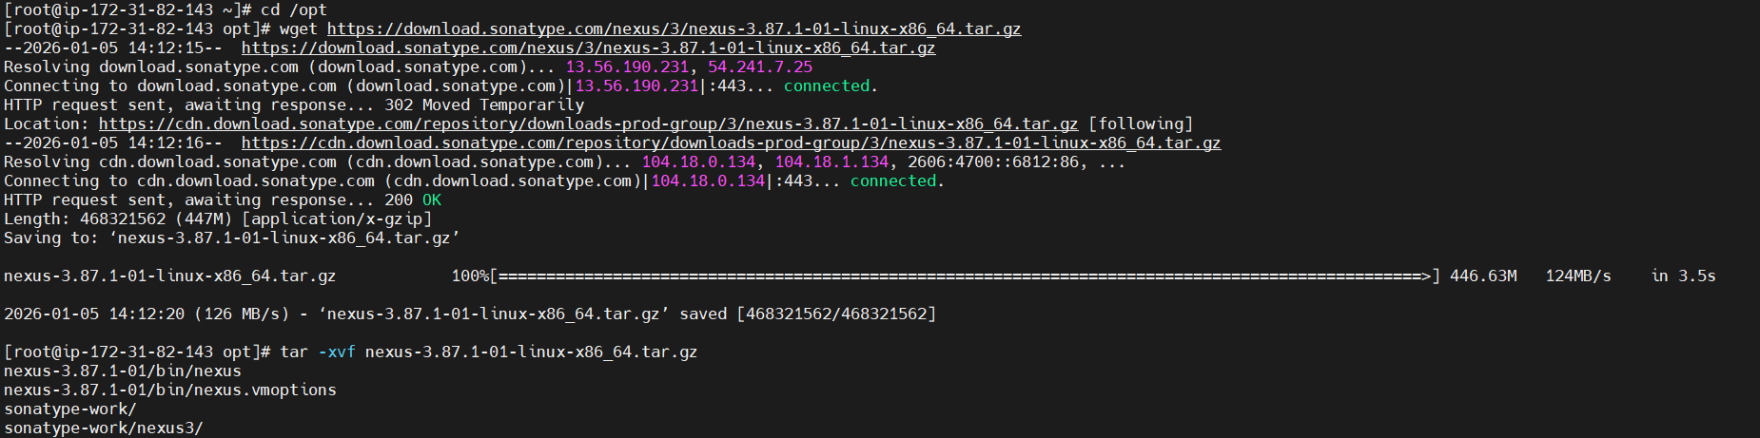

Step 46: Extract Nexus Repository Archive

• Action: Extracted downloaded Nexus tar.gz file
• Explanation: Unpacked Nexus binaries and work directory
• Evidence: 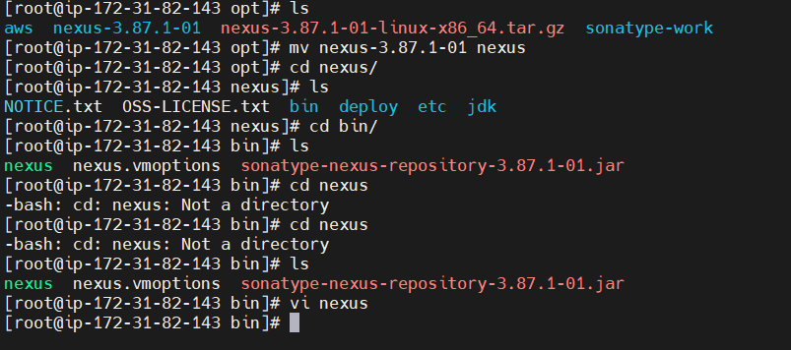

Step 47: Rename and Navigate Nexus Directory

• Action: Renamed extracted folder and navigated into Nexus directories
• Explanation: Standardized Nexus installation path
• Evidence: 

Step 48: Configure Nexus to Run as ec2-user

• Action: Edited Nexus startup script and set run_as_user=ec2-user
• Explanation: Recommended practice to avoid running Nexus as root
• Evidence: 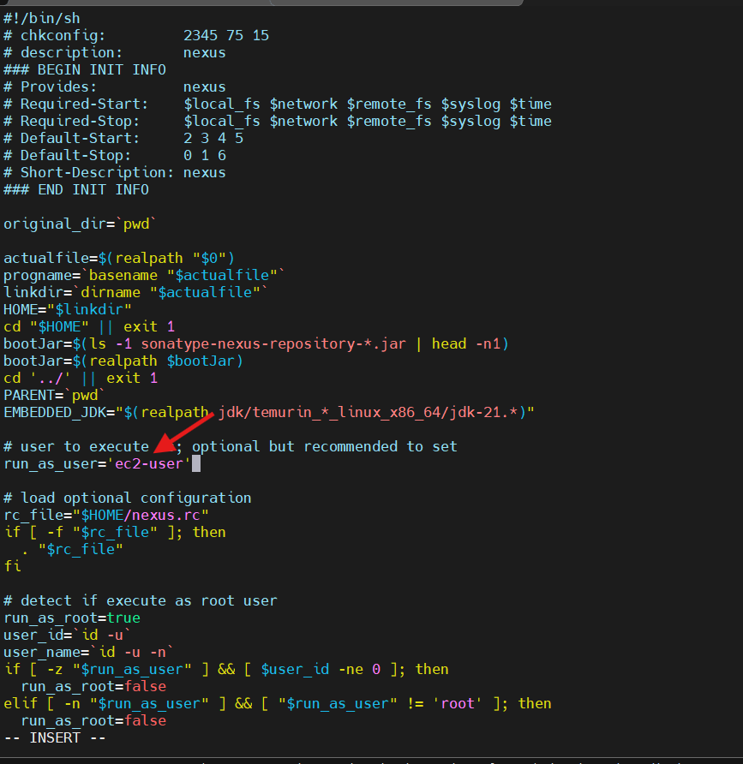

Step 49: Set Ownership and Permissions

• Action: Changed ownership and permissions for Nexus and sonatype-work
• Explanation: Allowed Nexus to read/write required directories
• Evidence: 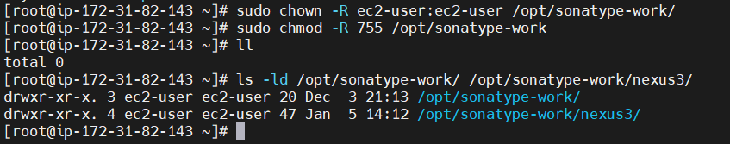

Step 50: Start Nexus Repository Service

• Action: Started Nexus service using startup script
• Explanation: Brought Nexus Repository Manager online
• Evidence: 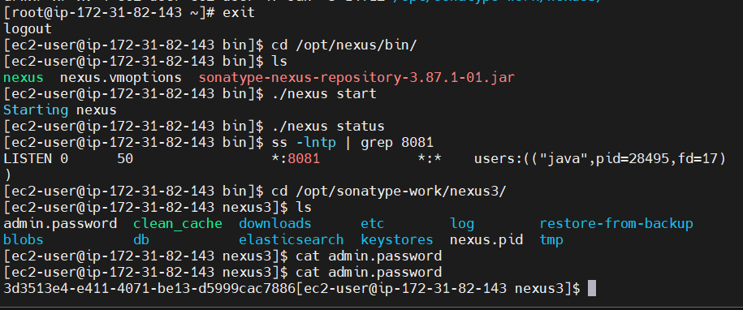

Step 51: Verify Nexus Service and Port

• Action: Verified Nexus is listening on port 8081
• Explanation: Confirmed Nexus service is running successfully
• Evidence: 

Step 52: Access Nexus Repository Web UI

• Action: Accessed Nexus UI using public IP and port 8081
• Explanation: Verified successful Nexus installation via browser
• Evidence: 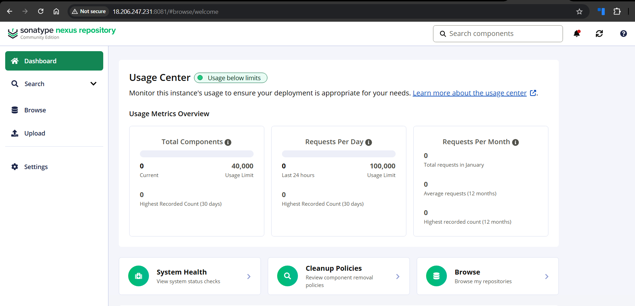

Step 53: Retrieve Nexus Admin Password

• Action: Viewed initial admin password from admin.password file
• Explanation: Required for first-time login to Nexus UI
• Evidence: 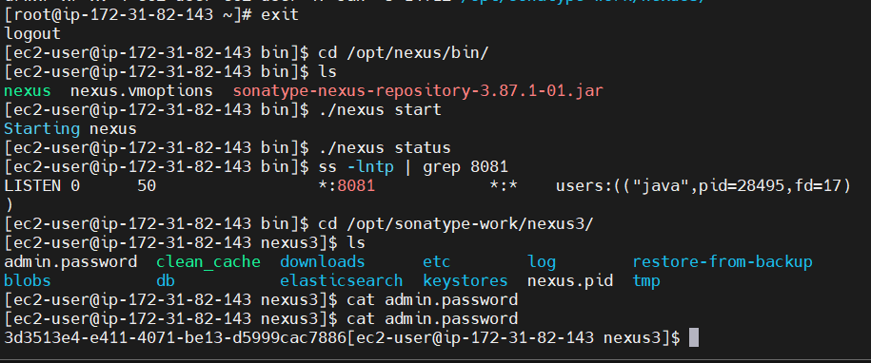

Step 54: Nexus Dashboard Validation

• Action: Logged into Nexus UI and viewed dashboard
• Explanation: Confirmed Nexus Repository Manager is fully operational
• Evidence: 

Step 55:
Open Jenkins → Manage Jenkins → Plugins → Available plugins, search for Nexus, and select Nexus Artifact Uploader plugin for installation.
Image: 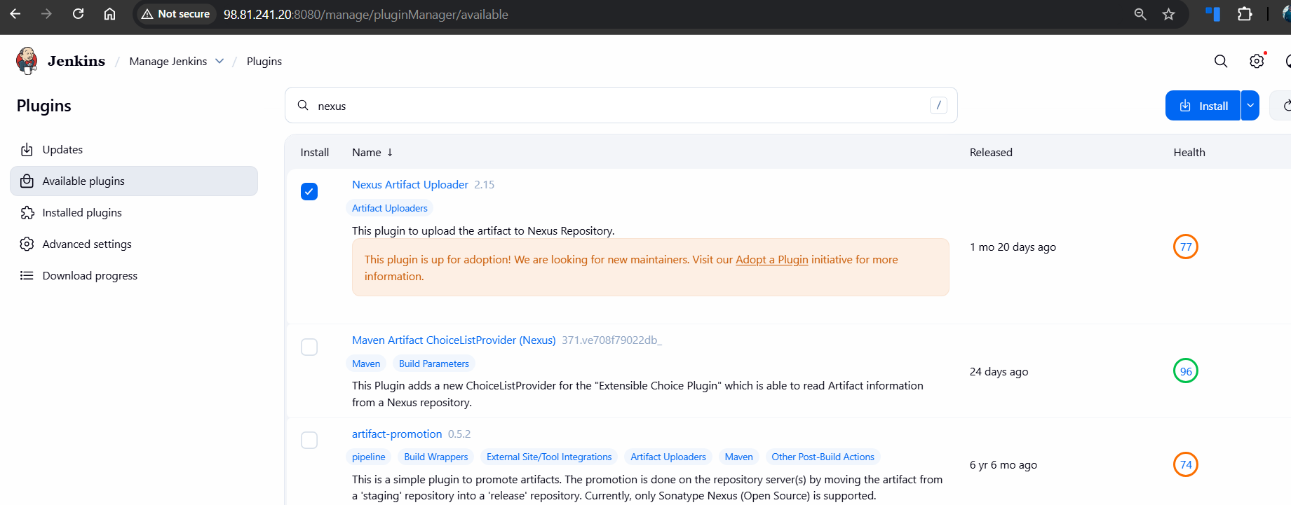

Step 56:
Monitor the Download progress page and confirm that all required plugins are installed successfully without errors.
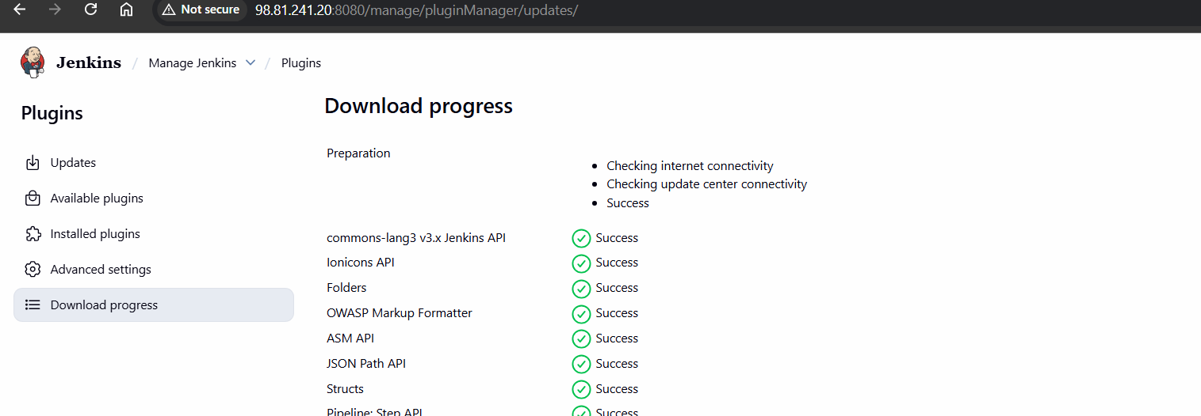
Step 57:
Login to Nexus Repository UI, navigate to Settings → Repository → Repositories, and click Create repository.
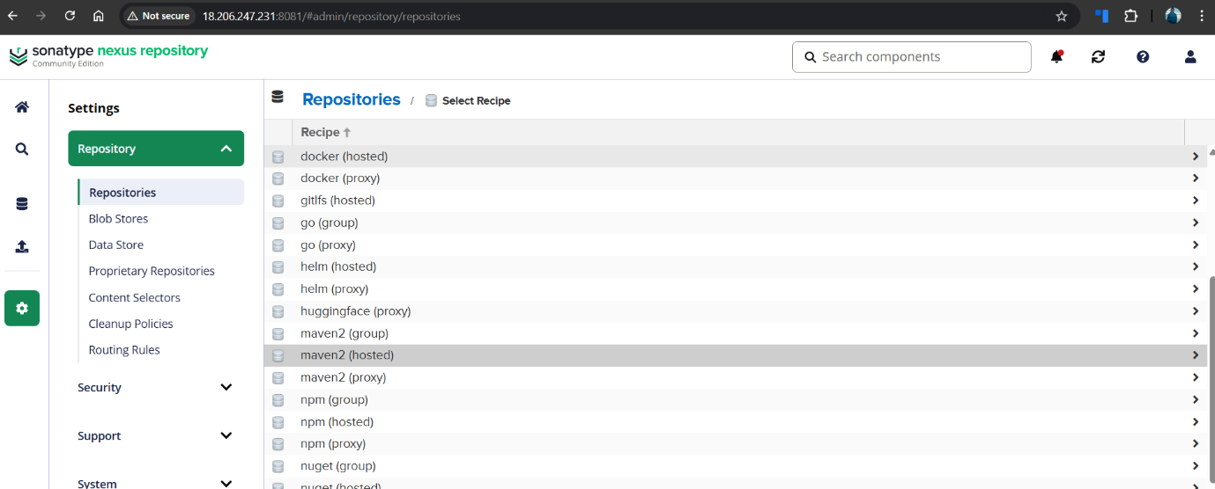
Step 58:
Select maven2 (hosted) as the repository recipe from the available list.
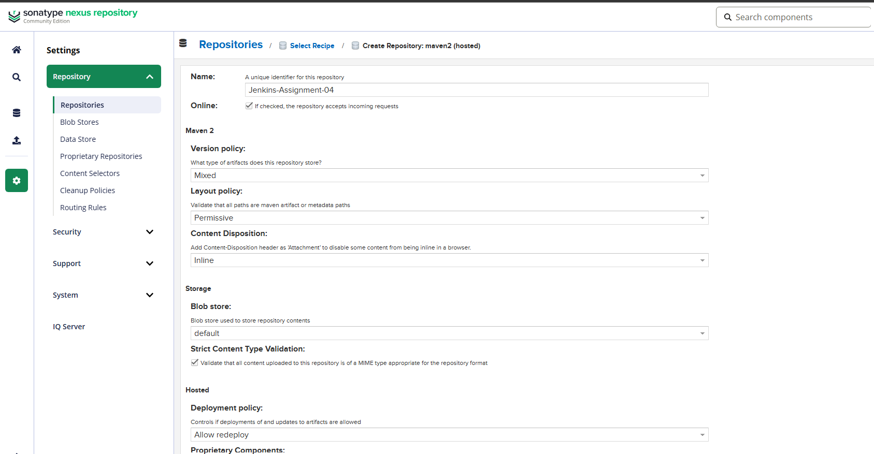
Step 59:
Configure the Maven hosted repository by providing the repository name and required policies, then save the configuration.
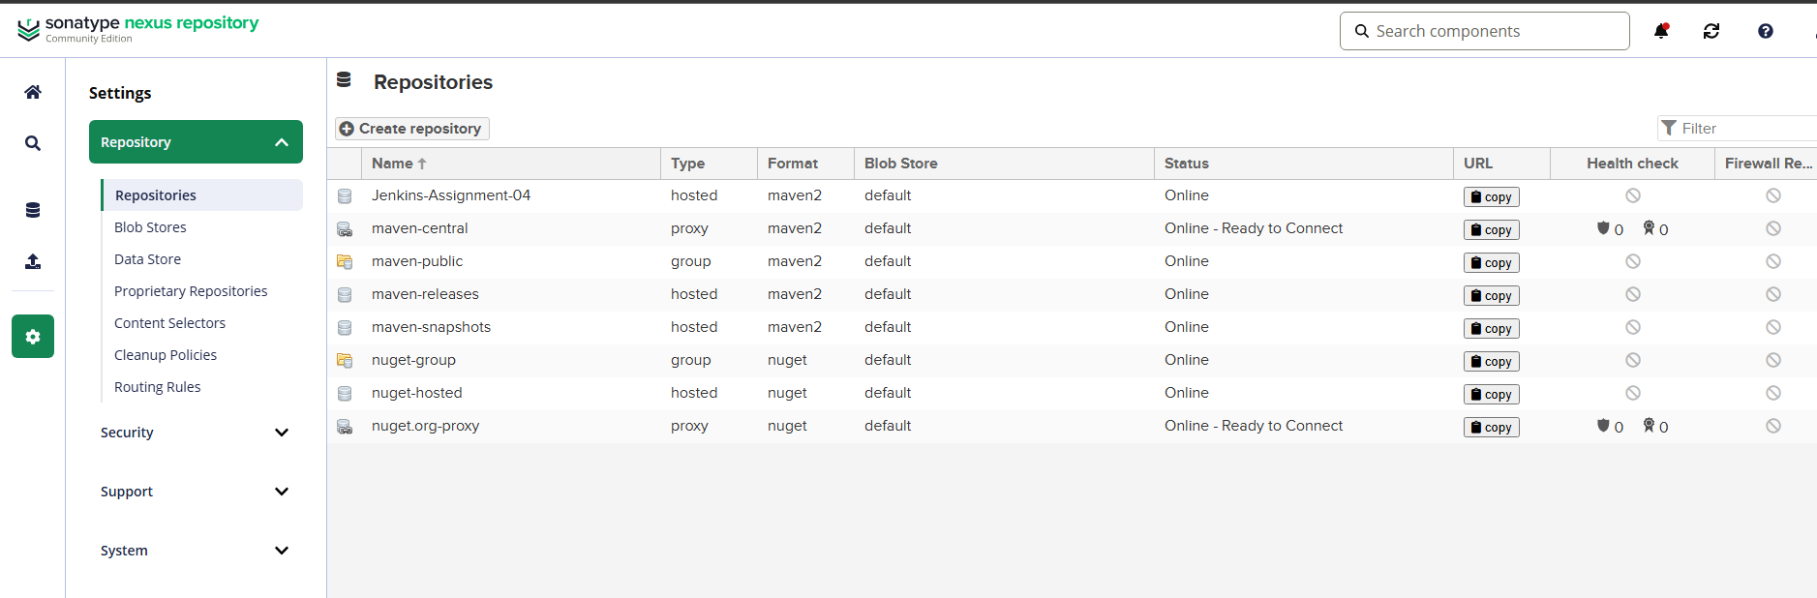
Step 60:
Verify that the newly created repository appears in the Repositories list with Online status.

Step 61:
Go to the Jenkins job configuration → Post-build Actions, add Nexus Artifact Uploader, and enter Nexus server details.
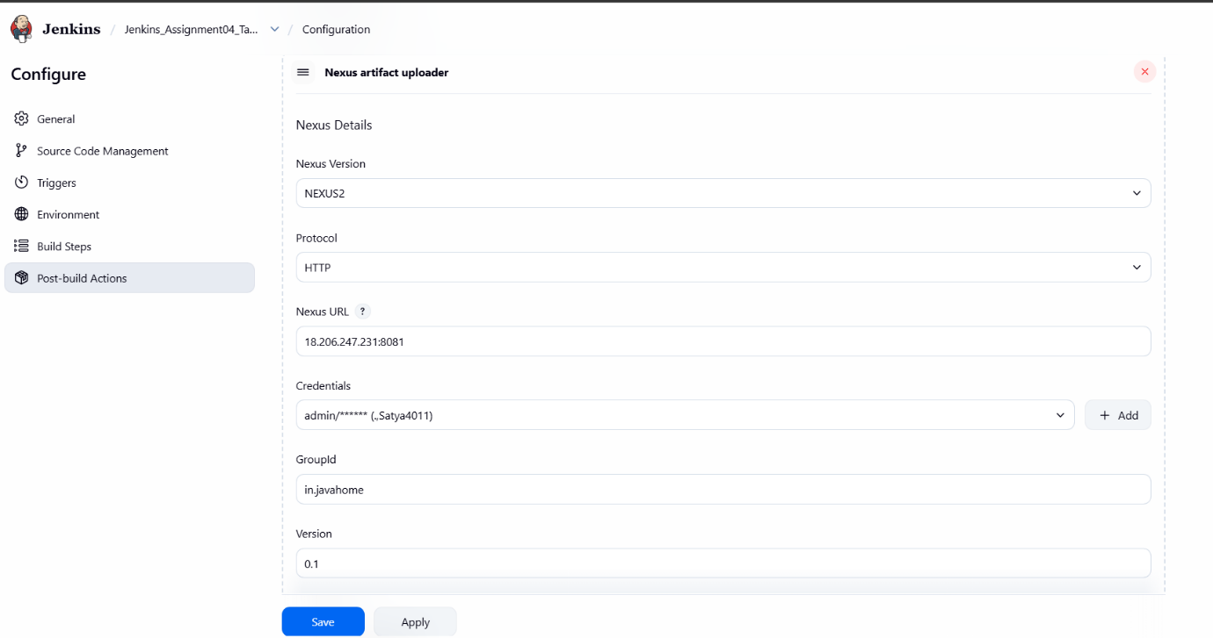
Step 62:
Configure the artifact details such as ArtifactId, Type (war), and File path, then save the job configuration.
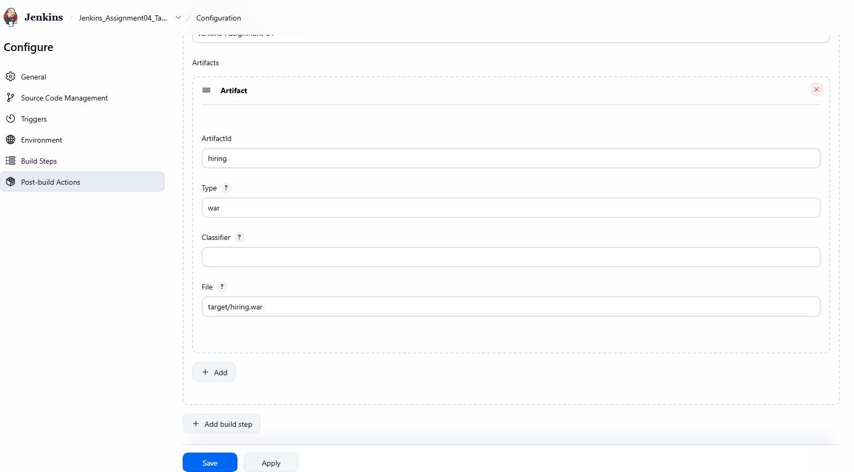
Step 63:
Trigger a Jenkins build and verify that the build completes successfully.
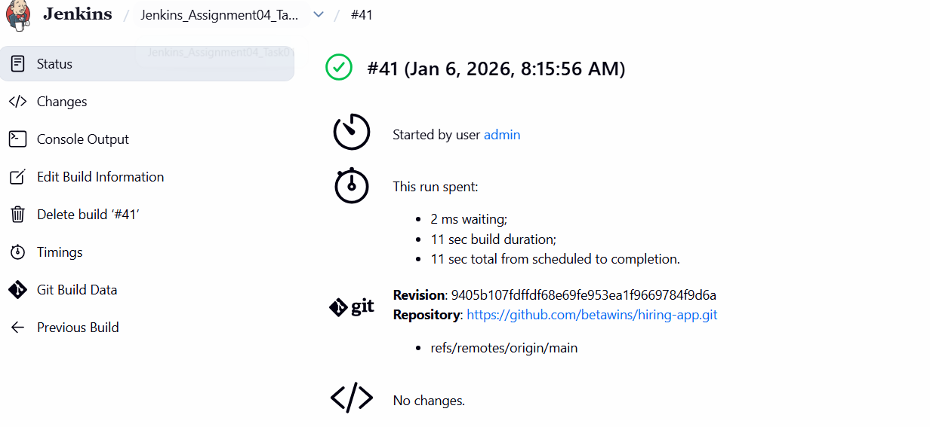
Step 64:
In Nexus UI, navigate to Browse, open the created Maven repository, and confirm that the artifact is uploaded successfully.
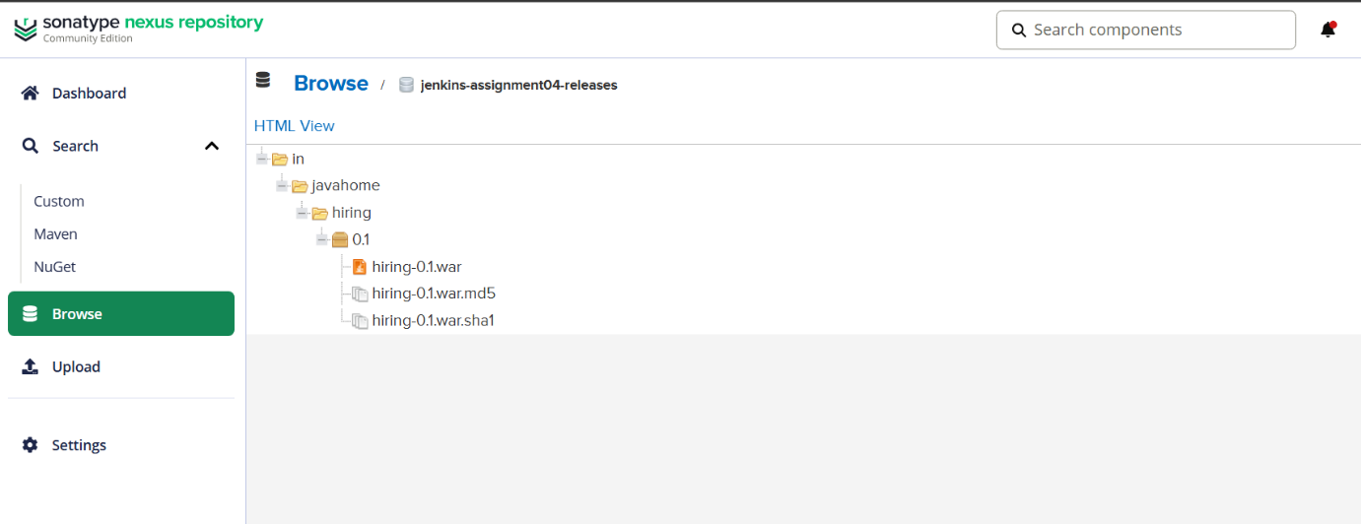

Step 65: Launch EC2 Instance for Jenkins and Tooling
Console path / CLI command:
AWS Management Console → EC2 → Instances → Launch instance

Explanation:
An EC2 instance is initiated to host Jenkins, SonarQube Scanner, and required build tools. The instance is named Tomcat_Assignment04. Amazon Linux 2023 AMI is selected with instance type t3.small, which is sufficient for Jenkins and SonarQube scanning in a lab setup. A new security group is created, and default 20 GiB storage is allocated.

Evidence:
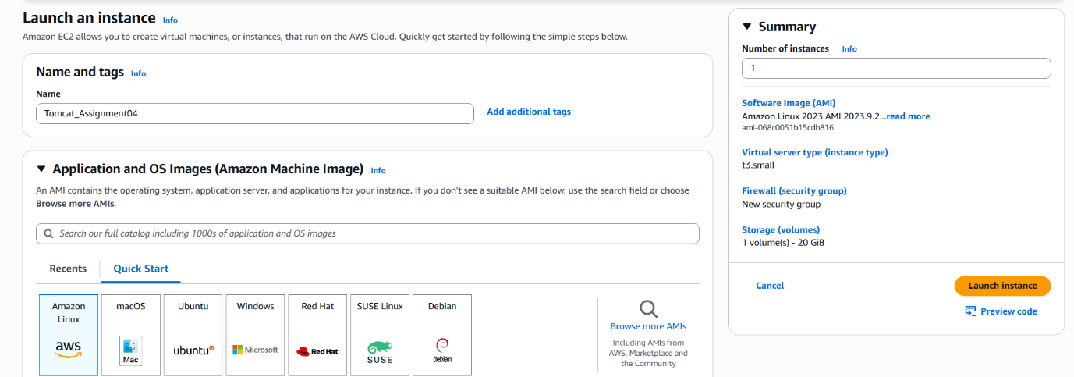

Step 66: Launch EC2 instance and install Tomcat (with user‑data script)

Console path / CLI command:
AWS Console → EC2 → Instances → Launch instance
Explanation:
Gave the instance a name Tomcat_Assignment04.
Selected Amazon Linux 2023 AMI and instance type t3.small.
Left default 20‑GiB root volume.
In “User data” pasted a bash script that updates OS, installs Java 17, downloads and installs Tomcat 9.0.111 into /opt/tomcat, sets ownership/permissions and creates a tomcat.service systemd unit so Tomcat starts automatically.
#!/bin/bash
sudo dnf update -y
sudo dnf install java-17-amazon-corretto -y
java -version
sudo groupadd tomcat || true
sudo useradd -g tomcat -d /opt/tomcat -s /bin/nologin tomcat || true
cd /tmp
wget https://dlcdn.apache.org/tomcat/tomcat-9/v9.0.111/bin/apache-tomcat-9.0.111.tar.gz
sudo mkdir -p /opt/tomcat
sudo tar -xvf apache-tomcat-9.0.111.tar.gz -C /opt/tomcat --strip-components=1
sudo chown -R tomcat:tomcat /opt/tomcat
sudo chmod -R 755 /opt/tomcat
cat <<EOF | sudo tee /etc/systemd/system/tomcat.service
[Unit]
Description=Apache Tomcat Web Application Server
After=network.target[Service]
Type=forking
User=tomcat
Group=tomcat
Environment="JAVA_HOME=/usr/lib/jvm/java-17-amazon-corretto"
Environment="CATALINA_PID=/opt/tomcat/temp/tomcat.pid"
Environment="CATALINA_HOME=/opt/tomcat"
Environment="CATALINA_BASE=/opt/tomcat"
ExecStart=/opt/tomcat/bin/startup.sh
ExecStop=/opt/tomcat/bin/shutdown.sh
RestartSec=10
Restart=always[Install]
WantedBy=multi-user.target
EOFsudo systemctl daemon-reload
sudo systemctl start tomcat
sudo systemctl enable tomcat
sudo systemctl status tomcat
Evidence:
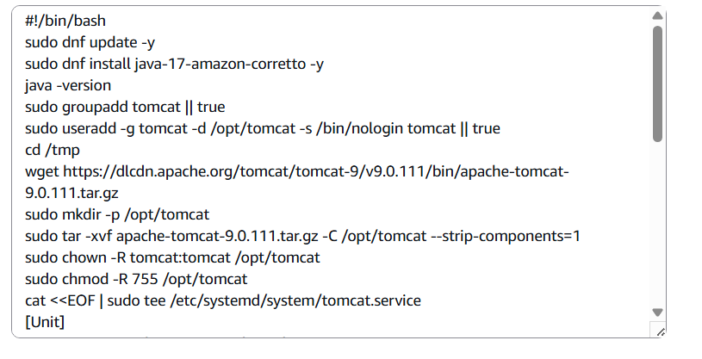
Step 67: Configure Security Group to allow access

Console path / CLI command:
While launching instance → Network settings → Edit security group
Explanation:
Created a new security group and added inbound rules:
SSH (TCP 22) from Anywhere – for remote administration.
HTTPS (TCP 443) from Anywhere – for possible SSL use.
HTTP (TCP 80) from Anywhere – standard web traffic.
Custom TCP (TCP 8080) from Anywhere – to access Tomcat default port from browser.
Evidence:
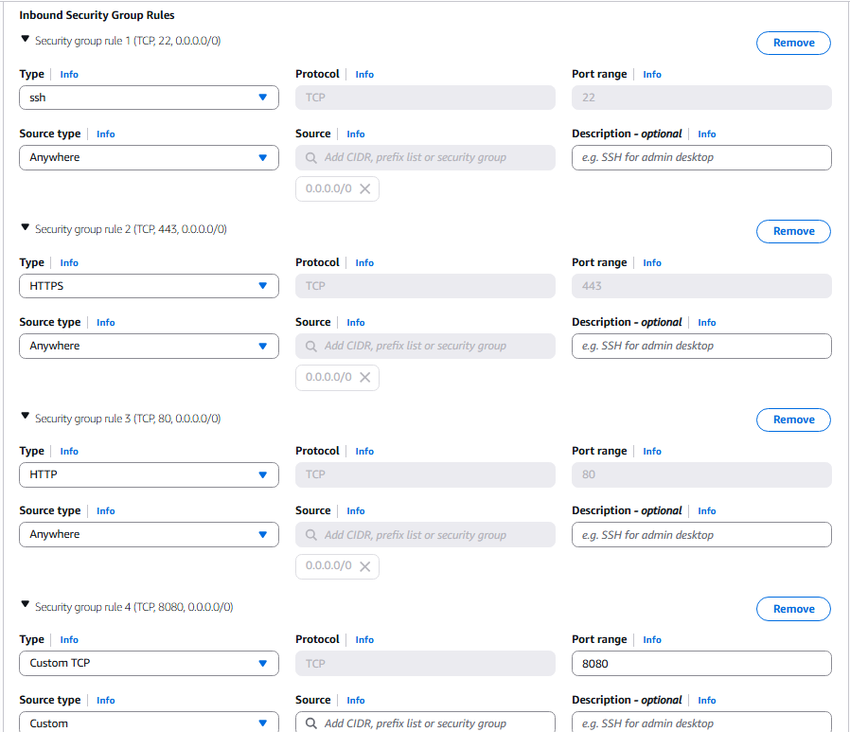Step 68: Verify Tomcat home page

Console path / CLI command:
From local browser: http://<EC2-Public-IP>:8080
Explanation:
After instance finished booting and cloud-init user‑data ran, Tomcat service started and listened on port 8080.
Accessing the public IP with port 8080 confirms Tomcat installation and that the security group and service are working.
Evidence:
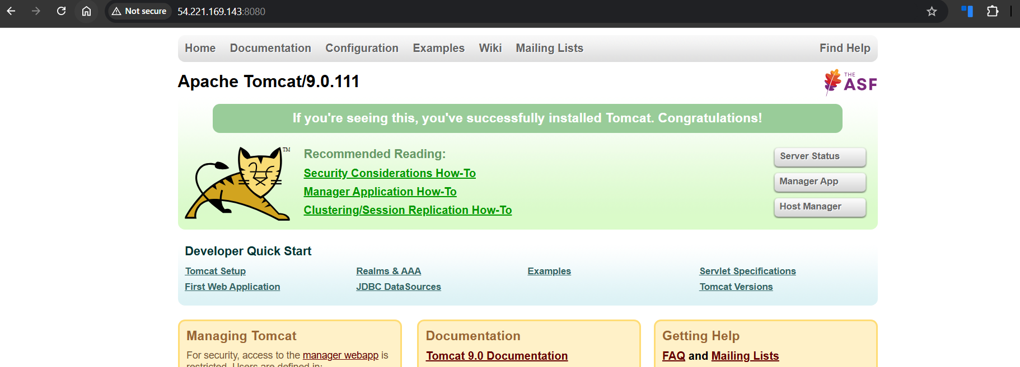Step 69: Locate and edit context.xml for manager access

Console path / CLI command:
Bash

find / -name context.xml
vi /opt/tomcat/webapps/manager/META-INF/context.xml
Explanation:
Used find to identify all context.xml files; edited the one for the manager app.
Opened the file to review default configuration which restricts access; no functional change was shown in the screenshot yet (only content view).
Evidence:
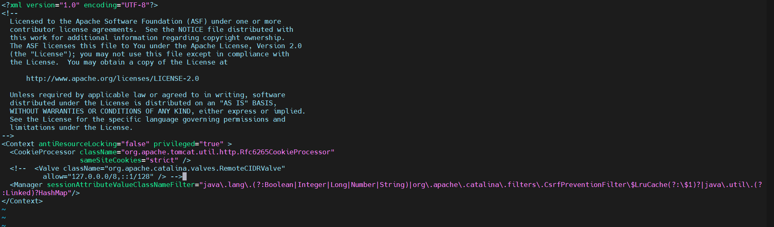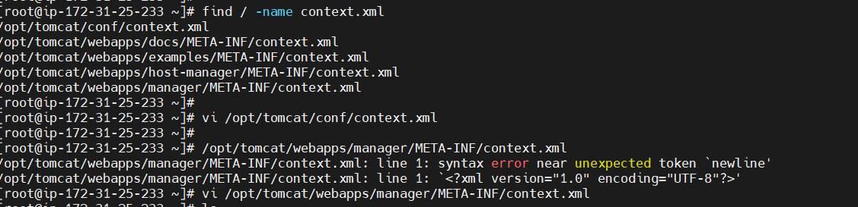Step 70 : Configure Tomcat users and roles for Manager GUI

Console path / CLI command:
Bash

vi /opt/tomcat/conf/tomcat-users.xml
Explanation:
Uncommented sample role definitions and added custom roles and users that can log into the HTML Manager.
Defined roles: manager-gui, manager-script, manager-jmx, manager-status.
Created users such as:
admin with password admin and all manager roles.
deployer with role manager-script.
tomcat with password s3cret and role manager-gui.
Evidence:
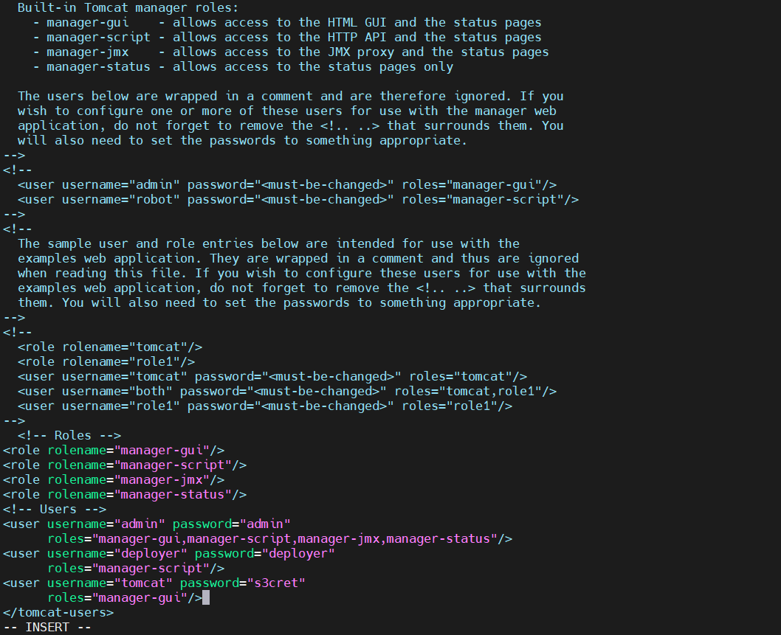XML

<role rolename="manager-gui"/>
<role rolename="manager-script"/>
<role rolename="manager-jmx"/>
<role rolename="manager-status"/>
...
<user username="admin" password="admin"
roles="manager-gui,manager-script,manager-jmx,manager-status"/>
<user username="deployer" password="deployer"
roles="manager-script"/>
<user username="tomcat" password="s3cret"
roles="manager-gui"/>
Step 71 : Access Tomcat Manager Web Application

Console path / CLI command:
Browser → http://<EC2-Public-IP>:8080 → click Manager App
Login with username admin and its password.
Explanation:
Clicking “Manager App” triggers HTTP Basic Auth.
Successfully authenticating using the configured user proves the tomcat-users.xml config is correct and that manager webapp security is working.
Evidence:
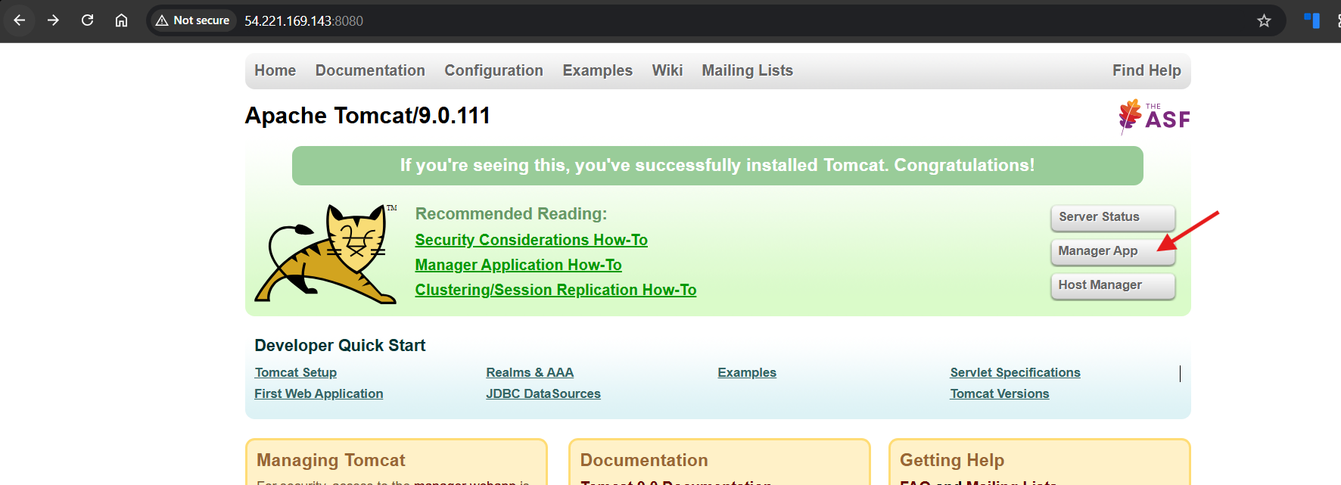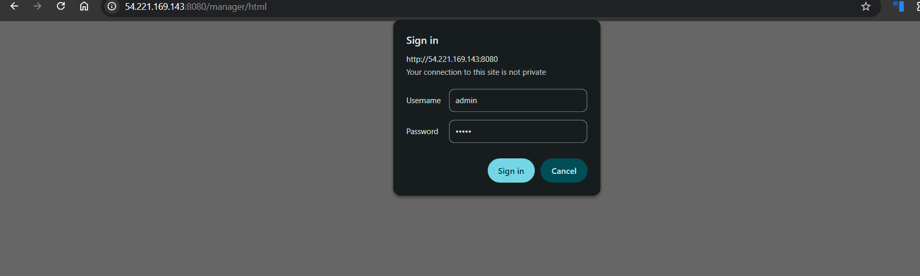

Step 71: Verify Tomcat Manager Accessibility

• Console path / CLI command:
Browser → http://54.221.169.143:8080/manager/html

• Explanation:
Accessed the Tomcat Web Application Manager to confirm Tomcat is running and the Manager application is enabled with proper authentication.

• Evidence:
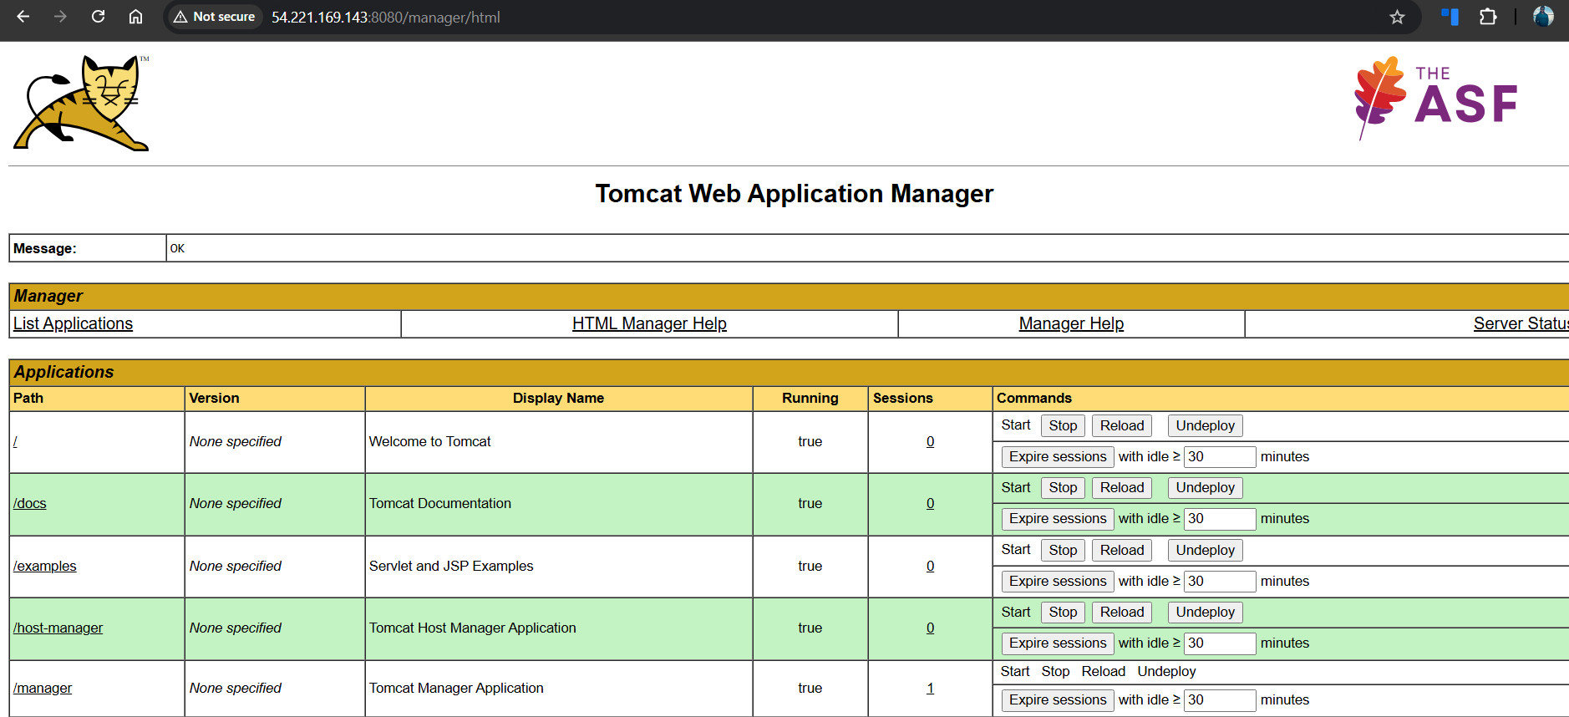
Step 72: Install “Deploy to Container” Plugin in Jenkins

• Console path / CLI command:
Jenkins Dashboard → Manage Jenkins → Plugins → Available plugins → Search Deploy to container → Install

• Explanation:
Installed the required Jenkins plugin to enable WAR file deployment to external containers like Apache Tomcat after a successful build.

• Evidence:
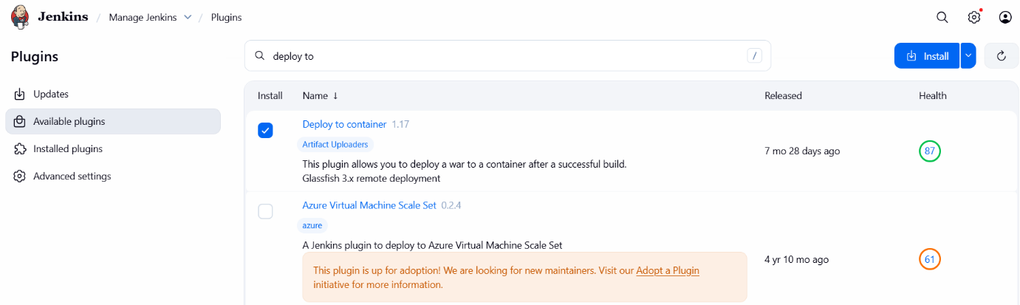
Step 73: Verify Plugin Installation Status

• Console path / CLI command:
Jenkins Dashboard → Manage Jenkins → Plugins → Download progress

• Explanation:
Validated that the plugin installation completed successfully and all plugin extensions were loaded without errors.

• Evidence:
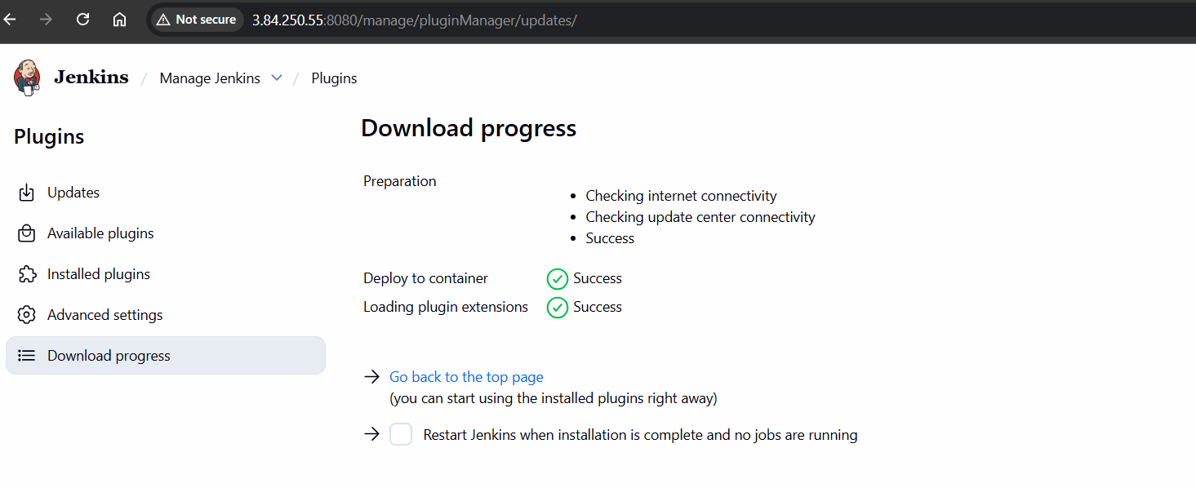
Step 74: Create Tomcat Credentials in Jenkins

• Console path / CLI command:
Manage Jenkins → Credentials → System → Global credentials → Add Credentials

• Explanation:
Created Jenkins global credentials using Tomcat Manager username and password to allow authenticated remote deployment.

• Evidence:
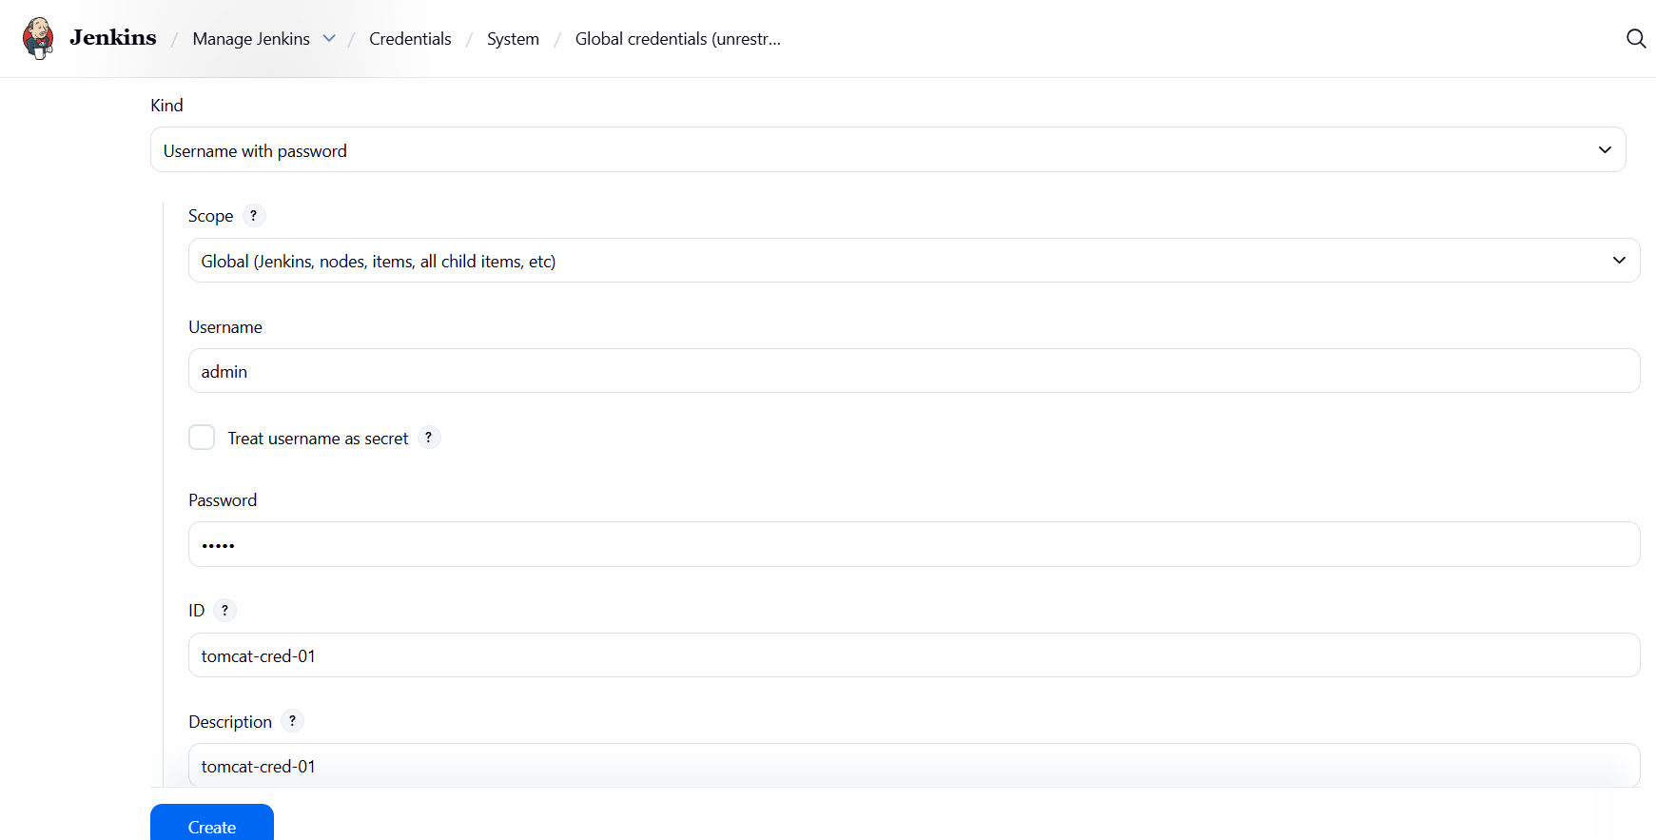
Step 75: Configure Post-Build Action – Deploy WAR

• Console path / CLI command:
Jenkins Job → Configure → Post-build Actions → Deploy war/ear to a container

• Explanation:
Configured Jenkins job to deploy the generated WAR file automatically to the Tomcat server after a successful build.

• Evidence:
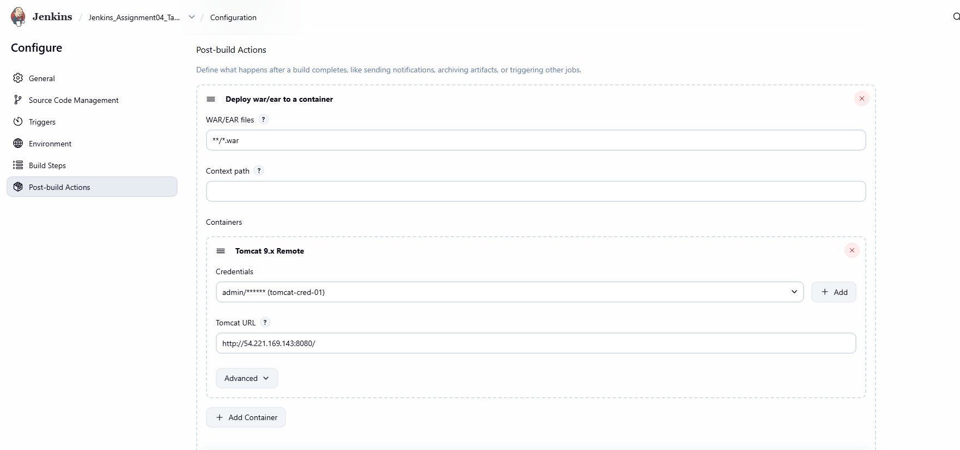
Step 76: Configure Tomcat Remote Container Details

• Console path / CLI command:
Jenkins Job → Configure → Post-build Actions → Tomcat 9.x Remote

• Explanation:
Provided Tomcat server URL and mapped Jenkins credentials to enable remote deployment via Tomcat Manager.

• Evidence:

Step 77: Execute Jenkins Build with Deployment

• Console path / CLI command:
Jenkins Job → Build Now → Console Output

• Explanation:
Triggered the Jenkins job which performed Git checkout, SonarQube analysis, WAR generation, and deployment to Tomcat.

• Evidence:
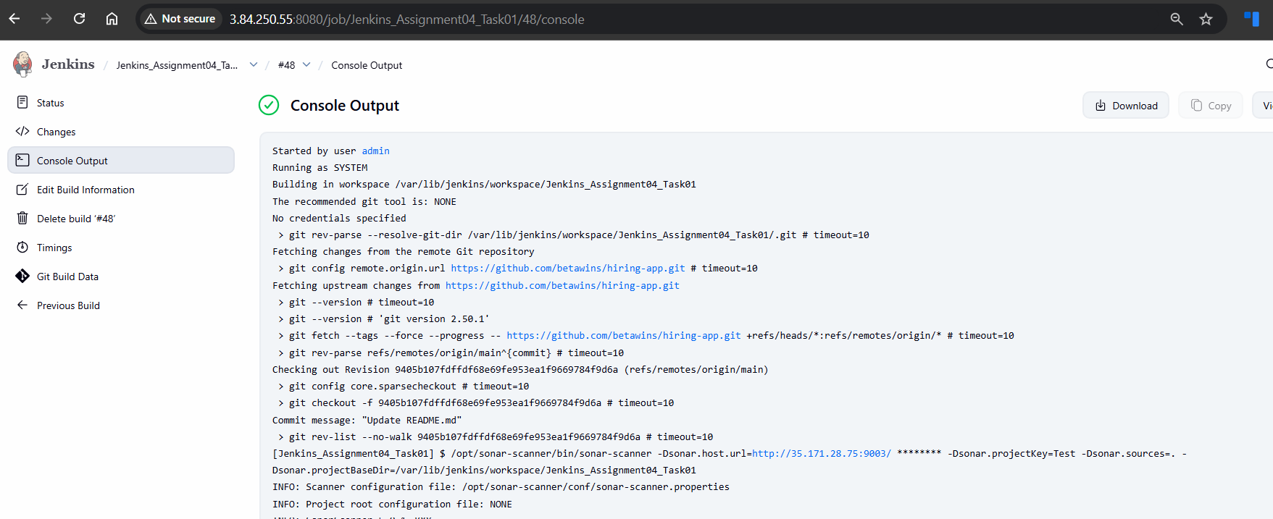
Step 78: Validate Application Deployment on Tomcat

• Console path / CLI command:
Browser → http://54.221.169.143:8080/hiring/

• Explanation:
Verified that the deployed application is accessible via Tomcat, confirming successful WAR deployment from Jenkins.

• Evidence:
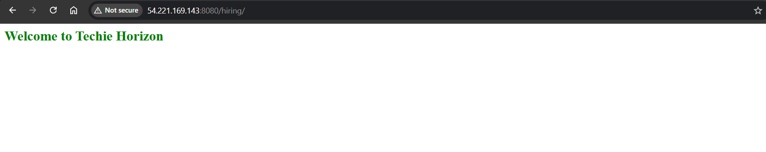
Step 79: Verify Slack Notification Trigger from Jenkins

• Console path / CLI command:
Slack Workspace → Jenkins App Channel

• Explanation:
Confirmed that Jenkins successfully sent build status notifications to Slack after job execution. The Slack integration validates real-time alerting for job start and job success events.

• Evidence: 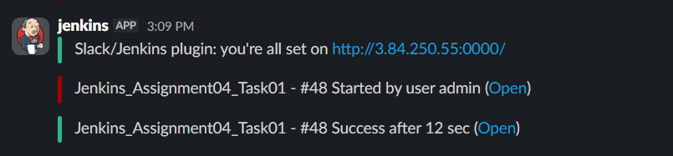

Conclusion:
The Jenkins job was successfully created with three stages: Git clone, SonarQube code quality analysis, and Slack notification. The CI pipeline executed correctly, validating code quality and providing real-time alerts, fulfilling the assignment requirements.

