2. Setup a Jenkins CICD pipeline using Declarative pipeline using feature-1.1 branch. https://github.com/betawins/sabear_simplecutomerapp/tree/feature-1.1
stages:
Git Clone
SonarQube Integration
Maven Compilation
Nexus Artifactory
Slack Notification
Deploy On tomcat

Task Title
Setup a Jenkins CI/CD Pipeline Using Declarative Pipeline for feature-1.1 Branch with SonarQube, Maven, Nexus, Tomcat, and Slack Integration
Objective
To design and implement an end-to-end Jenkins CI/CD pipeline using a Declarative Pipeline that automatically:
- Pulls source code from a GitHub feature branch
- Performs code quality analysis using SonarQube
- Builds the application using Maven
- Publishes build artifacts to Nexus Repository
- Deploys the application to an Apache Tomcat server
- Sends build status notifications to Slack
This pipeline ensures continuous integration, quality checks, artifact management, automated deployment, and real-time notifications.
Prerequisites
- Jenkins server installed and running
- Required Jenkins plugins installed:
  - Pipeline
  - Git
  - SonarQube Scanner
  - Nexus Artifact Uploader
  - Deploy to Container
  - Slack Notification
- GitHub repository with feature-1.1 branch
https://github.com/betawins/sabear_simplecutomerapp
- SonarQube server configured and reachable from Jenkins
- Maven installed on Jenkins server
- Nexus Repository Manager (Nexus 3) configured
- Apache Tomcat server installed and running
- Jenkins credentials configured for:
  - SonarQube
  - Nexus
  - Tomcat
  - Slack
- Network access between Jenkins, SonarQube, Nexus, and Tomcat

4) Step-by-Step Implementation (With Evidence)
Git Clone
Step 1: Create a New Jenkins Pipeline Job

Console path / UI path:
Jenkins Dashboard → New Item

Explanation:
A new Jenkins job is created to implement a CI pipeline. The job name is provided as Jenkins_Assignment04_Task02. The job type selected is Pipeline, which allows defining multiple stages using a declarative Jenkinsfile-style Groovy script.

Evidence: 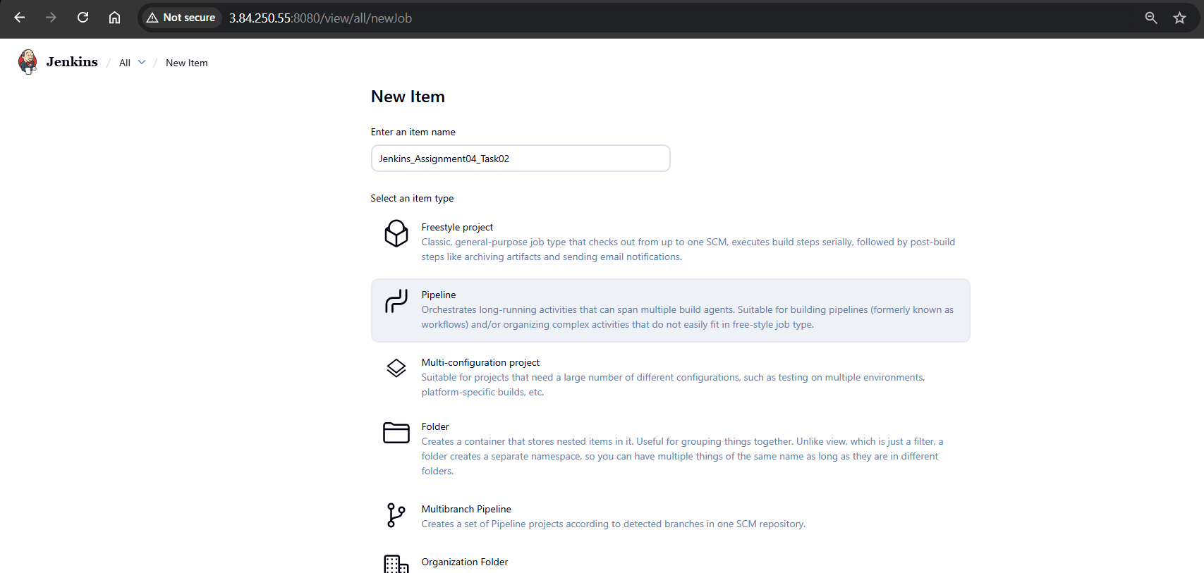

Step 2: Configure Pipeline Script for Git Clone Stage

Console path / UI path:
Jenkins Dashboard → Jenkins_Assignment04_Task02 → Configure → Pipeline

Explanation:
The pipeline definition is set to Pipeline script.
A declarative pipeline is written with:

agent any to allow execution on any available Jenkins agent

stages block defining the pipeline stages

Git Clone stage using the git step to clone source code from the GitHub repository

This stage ensures the application source code is downloaded into the Jenkins workspace.

Pipeline logic implemented (observed in UI):

Stage name: Git Clone

Branch: feature-1.1

Repository URL configured in the pipeline script

Evidence:
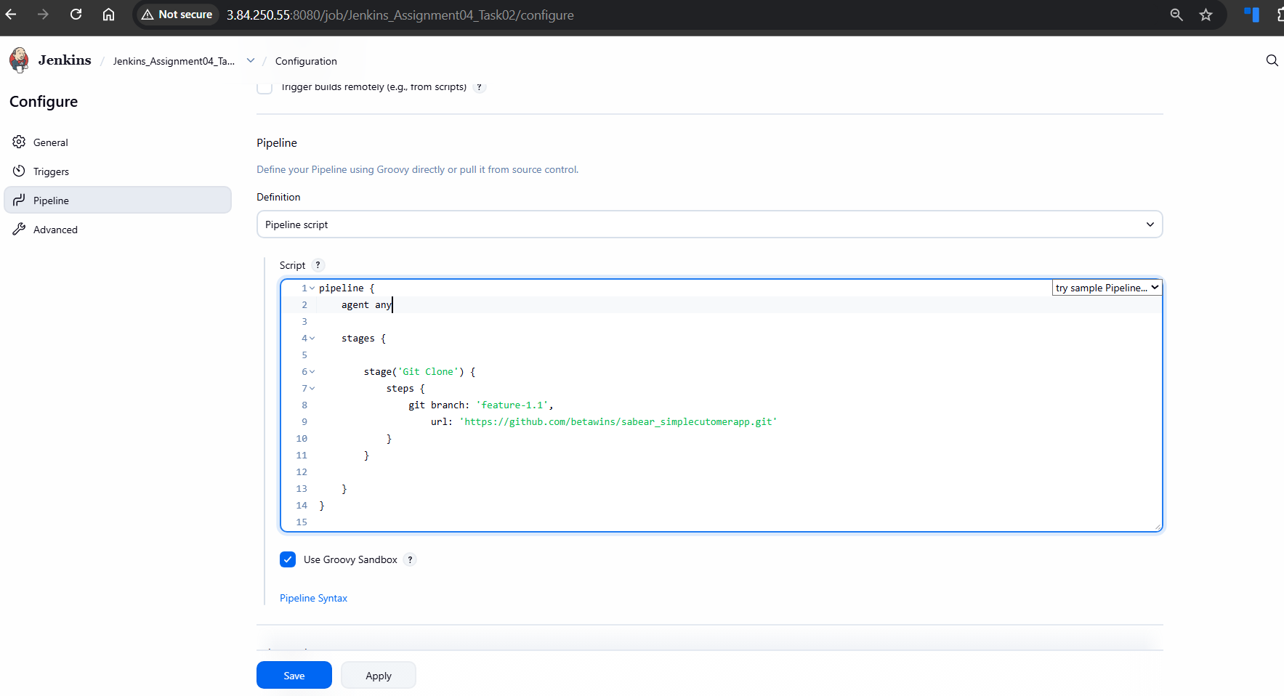

Visible Groovy pipeline code with pipeline { agent any … stage('Git Clone') … }

Step 3: Execute Pipeline and Verify Git Clone Stage

Console path / UI path:
Jenkins Dashboard → Jenkins_Assignment04_Task02 → Build Now → Stage View

Explanation:
The pipeline is triggered manually using Build Now.
The pipeline executes successfully and the Git Clone stage completes without errors, indicating that:

Jenkins is able to connect to GitHub

Repository cloning is successful

Pipeline syntax is valid

Evidence:
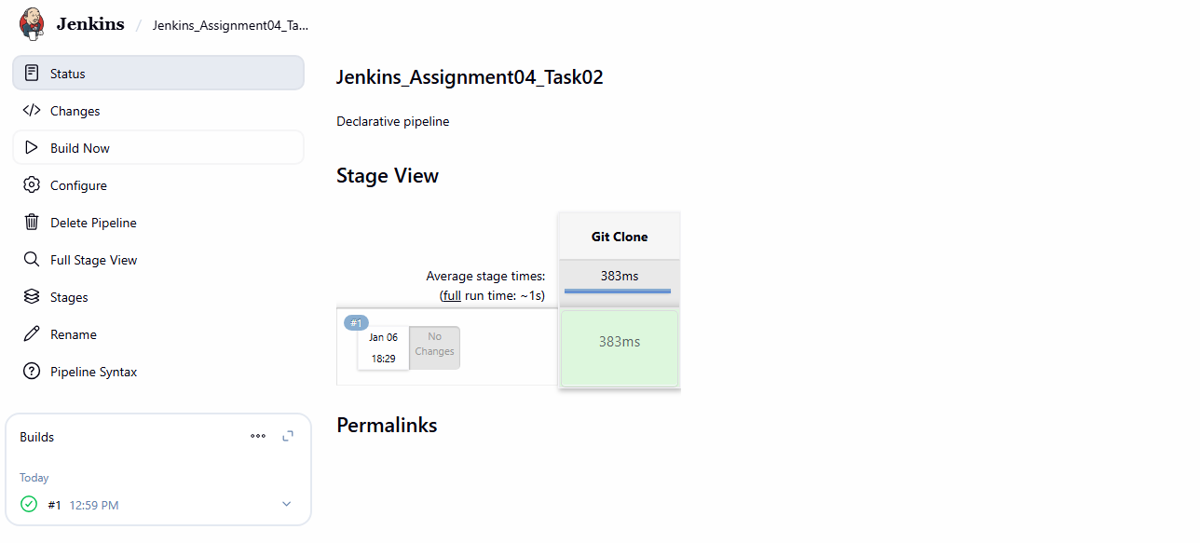
SonarQube Integration
Step 4: Add SonarQube Analysis Stage to Jenkins Pipeline

Console path / UI path:
Jenkins Dashboard → Jenkins_Assignment04_Task02 → Configure → Pipeline

Explanation:
A new pipeline stage named SonarQube Analysis is added after the Git Clone stage.
The stage uses withSonarQubeEnv() wrapper to connect Jenkins with the configured SonarQube server and executes the Sonar Scanner installed on the Jenkins server.
The scanner command includes project key, project name, source directory, and file exclusions.

Evidence:

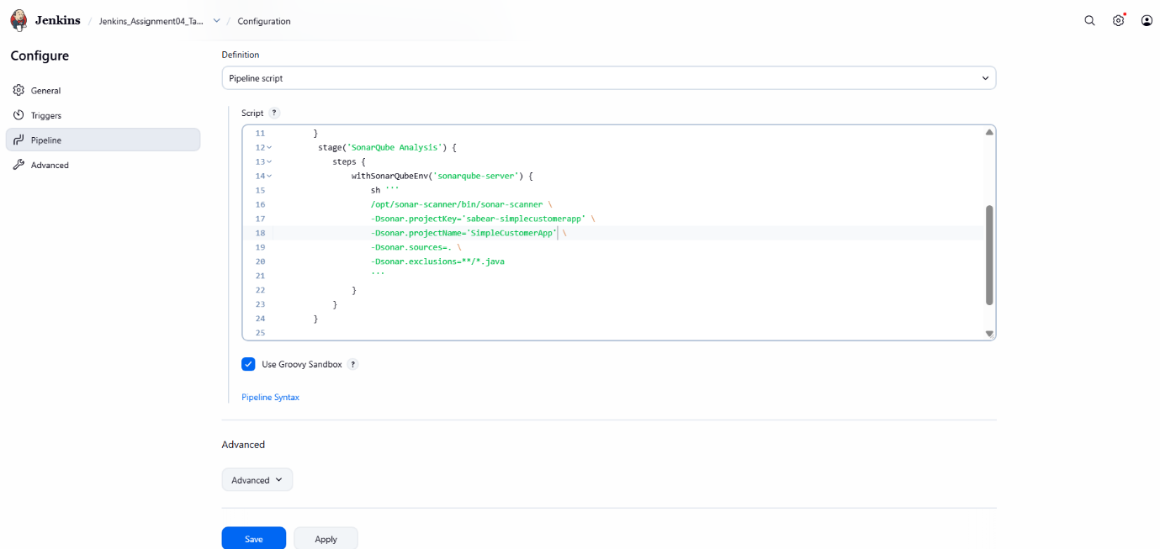
Step 5: Execute Pipeline and Identify SonarQube Configuration Error

Console path / UI path:
Jenkins Dashboard → Jenkins_Assignment04_Task02 → Build Now → Build #2 → Console Output

Explanation:
The pipeline is executed after adding the SonarQube stage.
The Git Clone stage completes successfully.
The pipeline fails during the SonarQube Analysis stage due to a mismatch between the SonarQube installation name used in the pipeline and the one configured in Jenkins global settings.

Observed error:
SonarQube installation defined in this job does not match any configured installation.

Evidence:
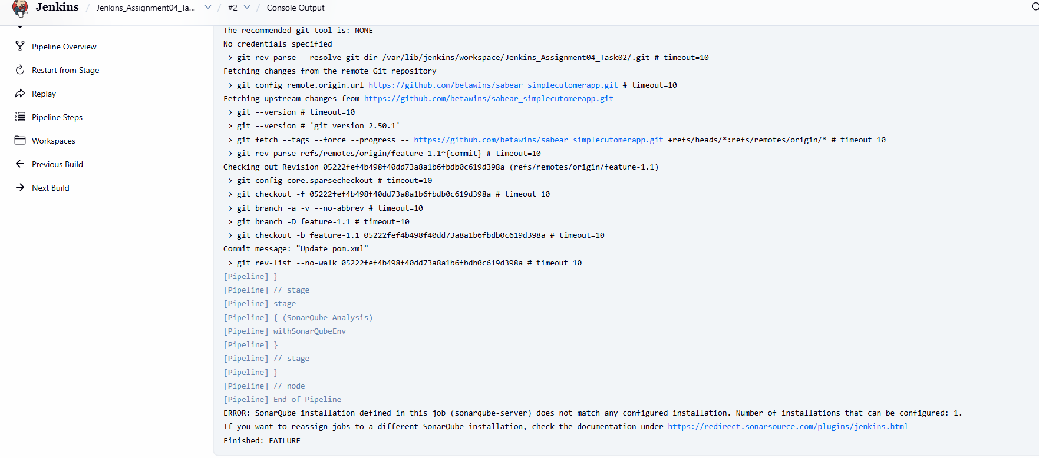

Step 6: Configure SonarQube Server in Jenkins Global Settings

Console path / UI path:
Jenkins Dashboard → Manage Jenkins → System → SonarQube installations

Explanation:
The SonarQube server is configured in Jenkins global settings.
A SonarQube installation is added with:

Name: sonarqube-Docker

Server URL pointing to the SonarQube server running on port 9003

Authentication token selected from Jenkins credentials

This ensures Jenkins pipelines can correctly reference the SonarQube server.

Evidence:

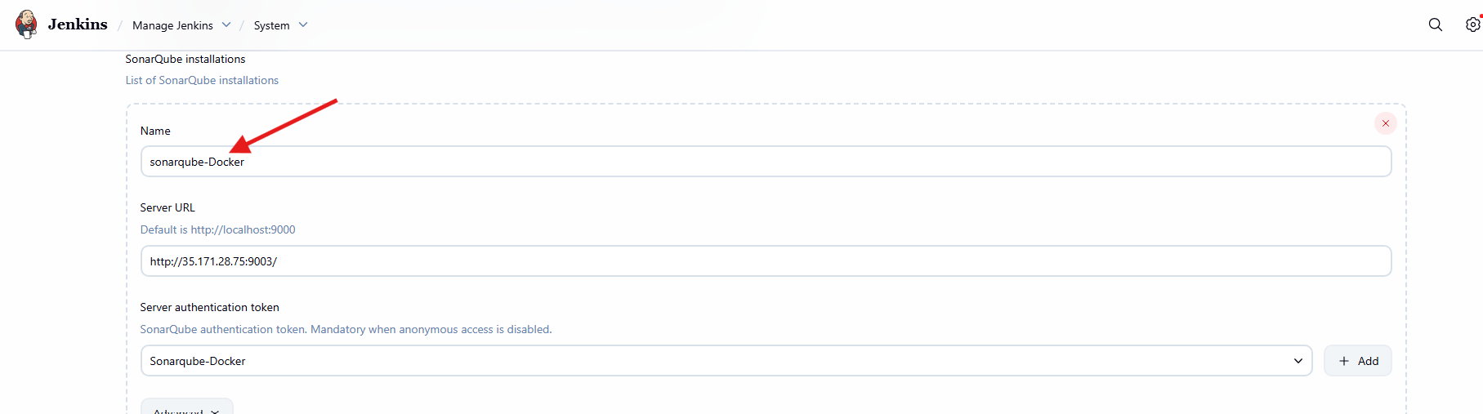
Step 7: Update Pipeline to Use Correct SonarQube Installation Name

Console path / UI path:
Jenkins Dashboard → Jenkins_Assignment04_Task02 → Configure → Pipeline

Explanation:
The pipeline script is updated to match the SonarQube installation name configured in Jenkins.
The withSonarQubeEnv() wrapper is modified from the previous name to sonarqube-Docker.
This change aligns the pipeline configuration with Jenkins global SonarQube settings.

Evidence:
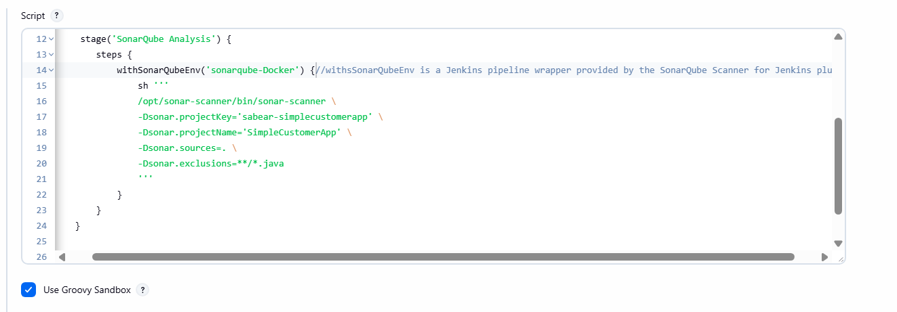
Console path / UI path:
Jenkins Dashboard → Jenkins_Assignment04_Task02 → Build Now → Build #3 → Console Output

Explanation:
The pipeline is executed again after correcting the SonarQube configuration.
The SonarQube Analysis stage runs successfully:

Source files are analyzed

Analysis report is generated and uploaded

SonarQube dashboard URL is displayed in console output

The pipeline completes without errors.

Evidence:

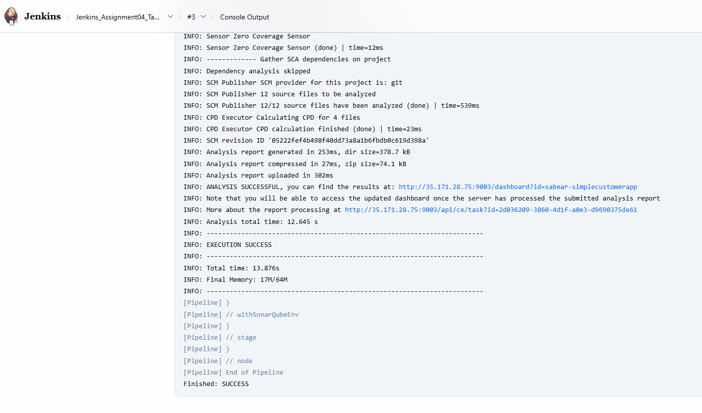
Maven Compilation
Step 9: Add Maven Build Stage to Jenkins Pipeline

Console path / UI path:
Jenkins Dashboard → Jenkins_Assignment04_Task02 → Configure → Pipeline

Explanation:
A new pipeline stage named Maven Build is added after the SonarQube Analysis stage.
This stage is intended to build the Java application using Maven by executing the command mvn clean package.
The command is placed inside a shell (sh) step within the declarative pipeline.

Evidence:
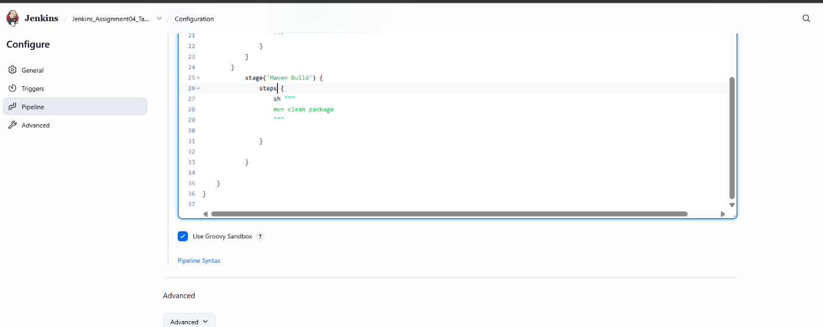
Step 10: Execute Pipeline and Identify Maven Command Error

Console path / UI path:
Jenkins Dashboard → Jenkins_Assignment04_Task02 → Build Now → Build #4 → Console Output

Explanation:
The pipeline is executed after adding the Maven Build stage.
The SonarQube Analysis stage completes successfully.
The pipeline fails during the Maven Build stage because Maven is not available in the execution environment.

Observed error:
mvn: command not found
Exit code 127 returned by the shell step.

This indicates Maven is not configured as a tool in Jenkins or not available in the agent PATH.

Evidence:

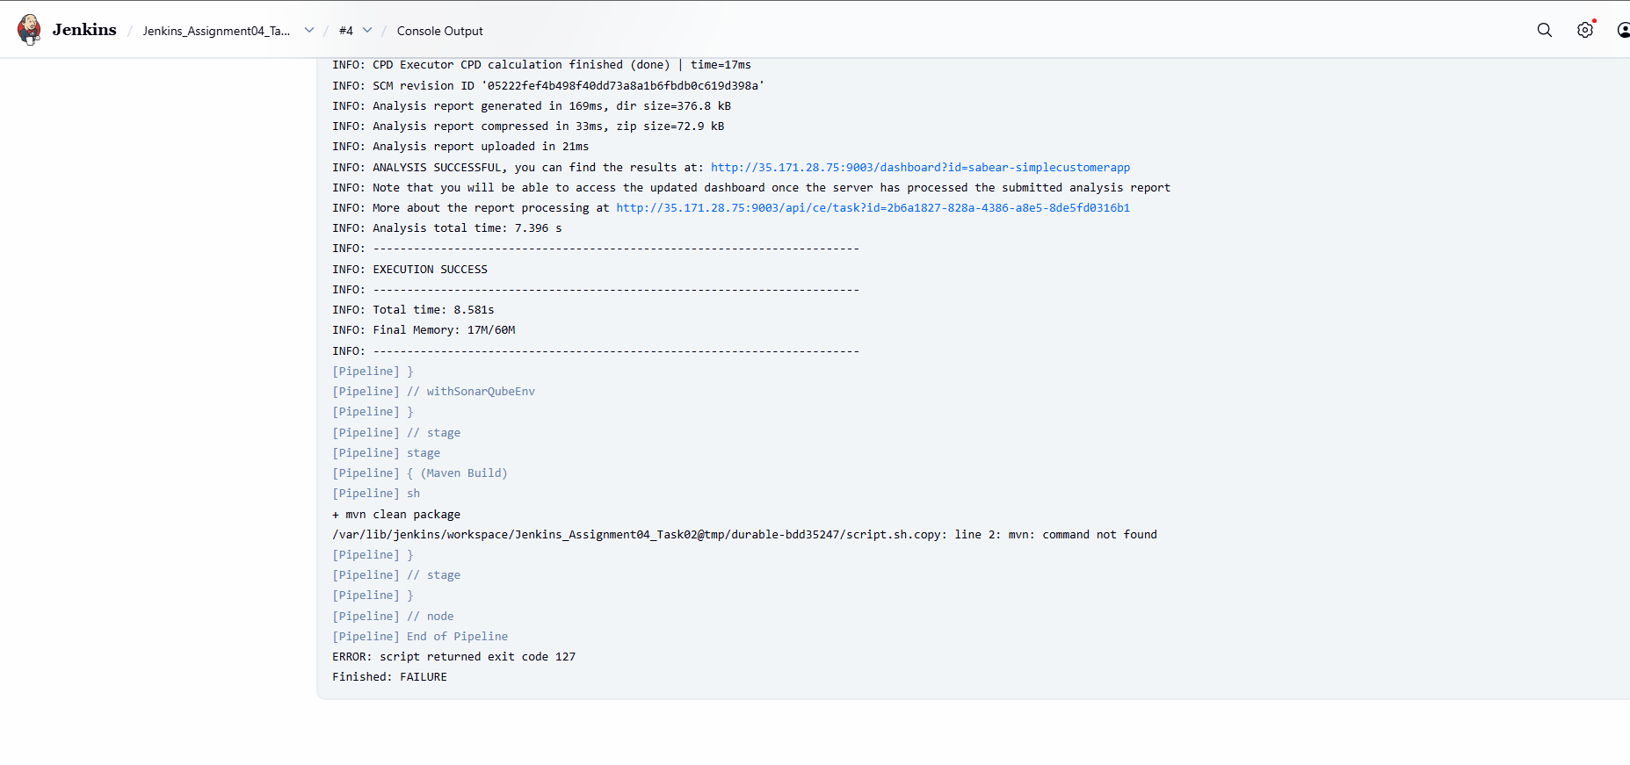
Step 11: Configure Maven as a Jenkins Tool in Pipeline

Console path / UI path:
Jenkins Dashboard → Jenkins_Assignment04_Task02 → Configure → Pipeline

Explanation:
The pipeline is updated to explicitly configure Maven using the Jenkins tools directive.
A Maven installation named MVN_HOME is referenced, allowing Jenkins to automatically inject Maven into the build environment and make the mvn command available.

Pipeline update observed:

Addition of tools { maven 'MVN_HOME' } at the top of the pipeline

Ensures Maven binaries are available during execution

Evidence: 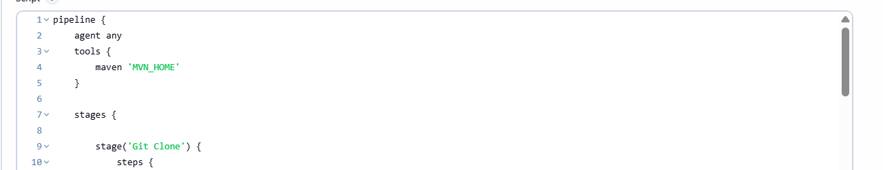
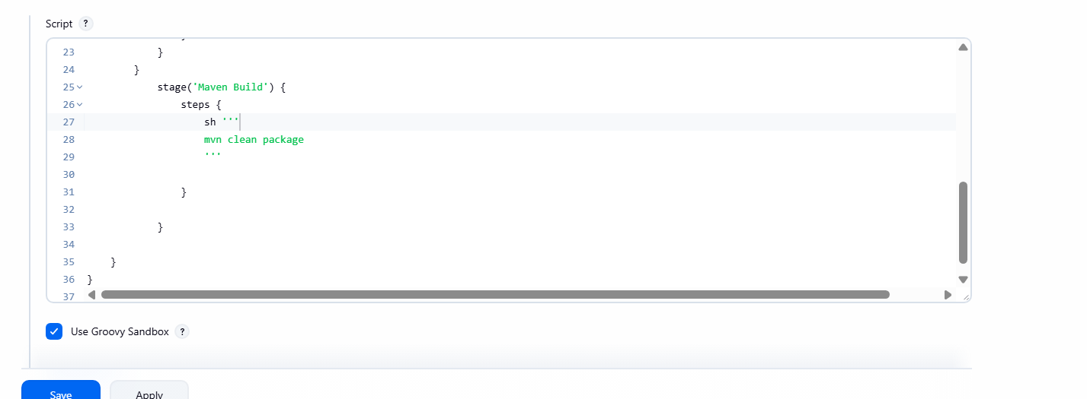
Step 12: Re-run Pipeline and Verify Successful Maven Build

Console path / UI path:
Jenkins Dashboard → Jenkins_Assignment04_Task02 → Build Now → Build #7 → Console Output

Explanation:
The pipeline is executed again after configuring Maven as a tool.
The Maven Build stage runs successfully:

Dependencies are downloaded from Maven Central

Application is packaged as a WAR file

Build completes without errors

The generated WAR file is created in the Jenkins workspace under the target directory.

Evidence:

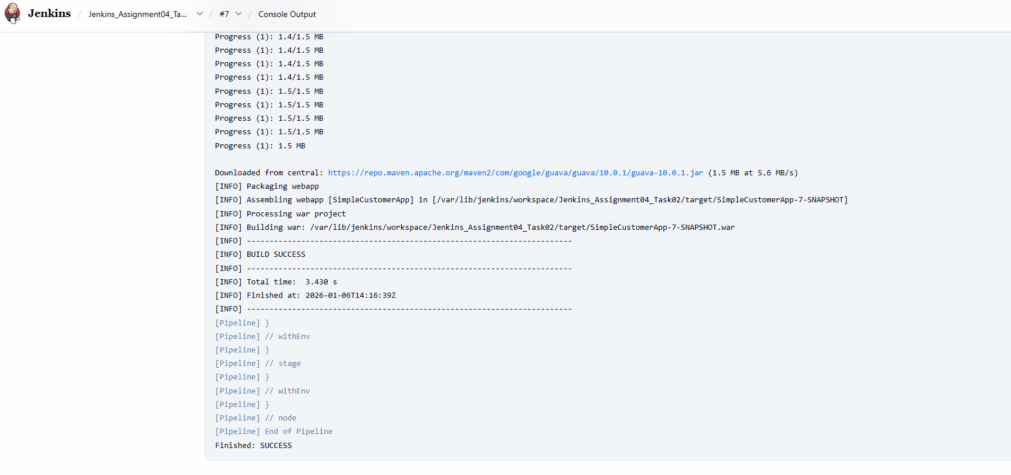

Nexus Artifactory
Step 13: Create a Hosted Maven Repository in Nexus

Console path / UI path:
Nexus Repository Manager → Settings → Repositories → Create repository → Maven (hosted)

Explanation:
A new hosted Maven repository is created in Nexus to store build artifacts generated by Jenkins.
The repository is configured with Maven2 format and enabled to accept incoming artifact uploads from Jenkins.

Evidence:

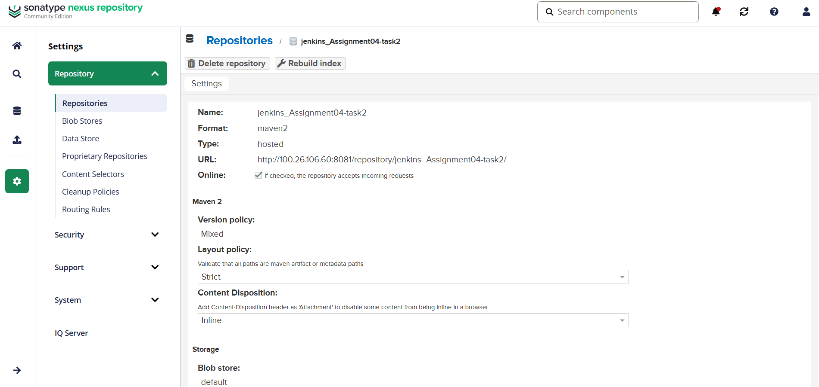
Step 14: Configure Nexus Credentials in Jenkins

Console path / UI path:
Jenkins Dashboard → Manage Jenkins → Credentials → System → Global credentials → Update credentials

Explanation:
Nexus authentication credentials are added to Jenkins so that the pipeline can upload artifacts securely.
A username and password credential is configured with a unique credential ID, which will be referenced in the pipeline.

Evidence:

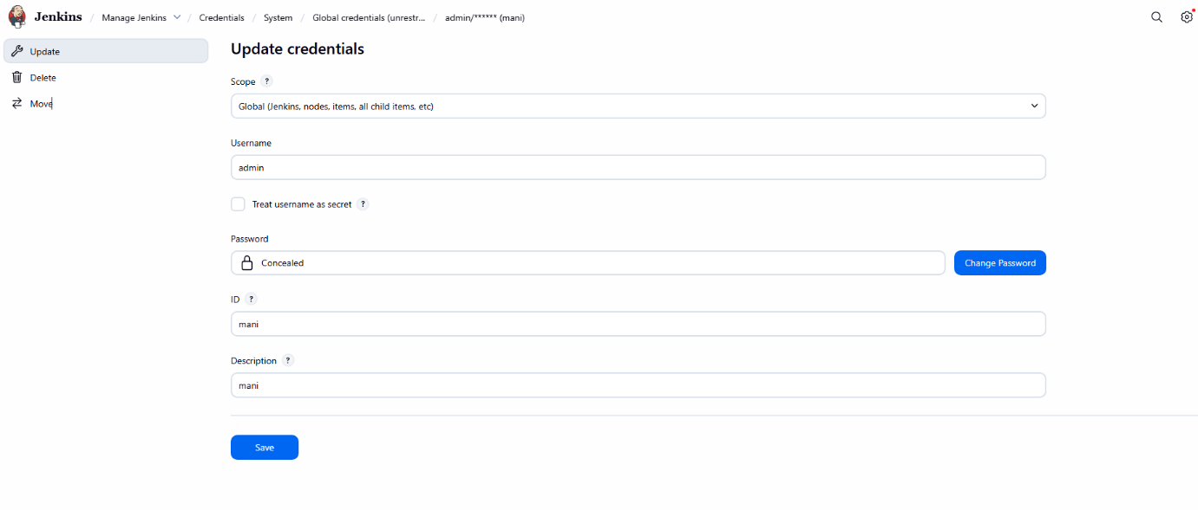
Step 15: Maven Project Versioning in pom.xml

Console path / UI path:
GitHub Repository → sabear_simplecutomerapp → pom.xml

Explanation:
The Maven project version is in pom.xml to use the Jenkins build number dynamically.
This ensures each build generates a uniquely versioned artifact suitable for Nexus deployment.

Evidence:

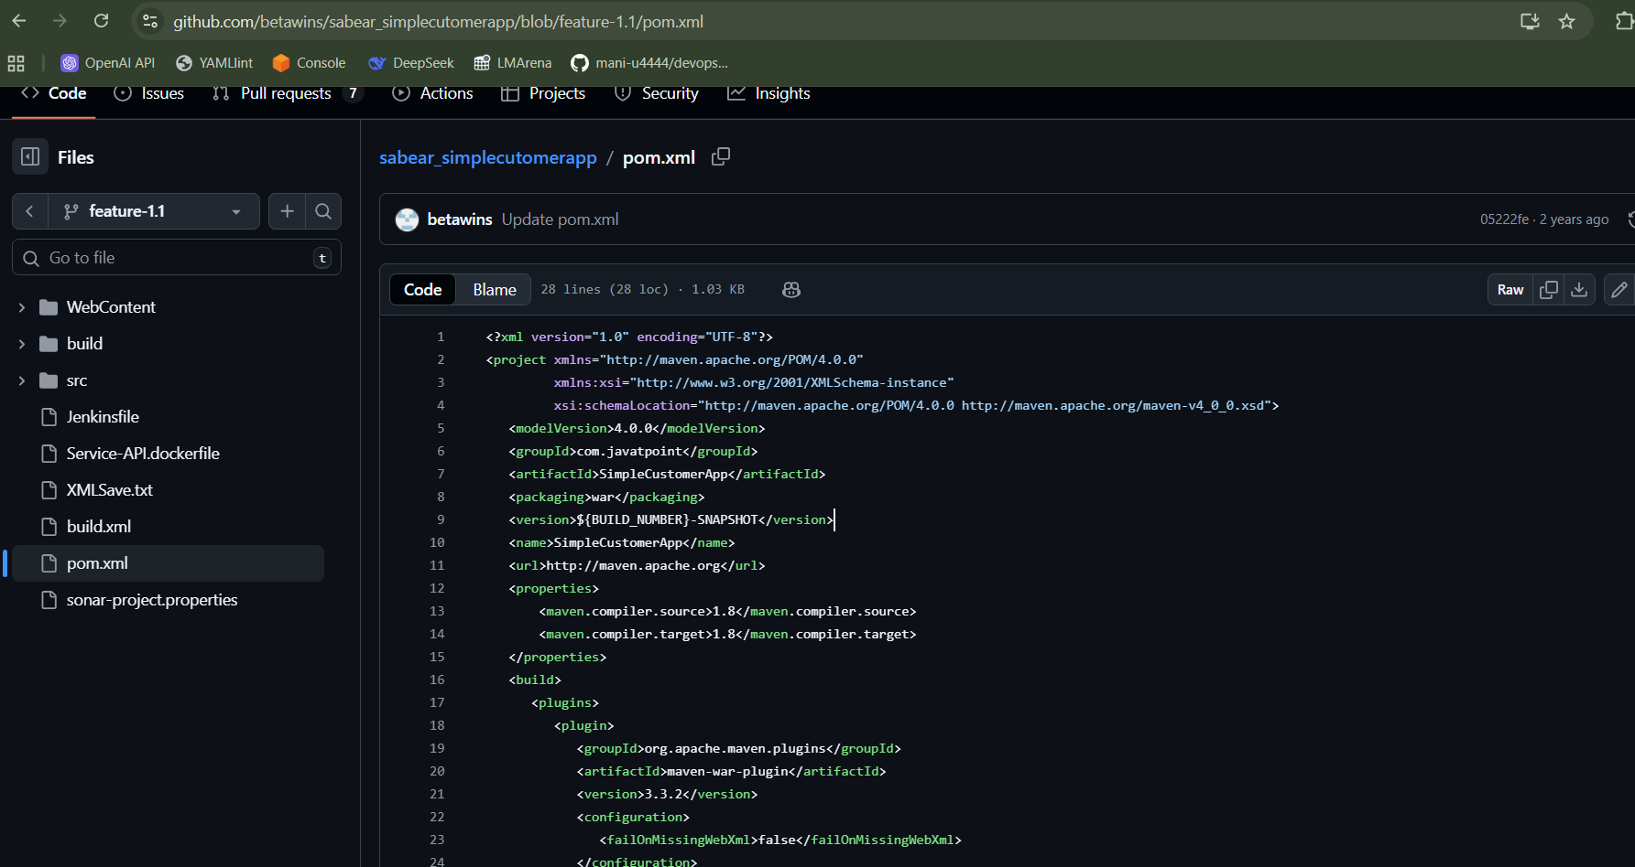
Step 16: Add Nexus Artifact Upload Stage to Jenkins Pipeline

Console path / UI path:
Jenkins Dashboard → Jenkins_Assignment04_Task02 → Configure → Pipeline

Explanation:
A new pipeline stage named Nexus Artifactory is added to upload the generated WAR file to Nexus.
The nexusArtifactUploader step is used with Nexus 3 configuration, repository name, credentials ID, groupId, artifactId, version, and artifact file details.

Evidence:

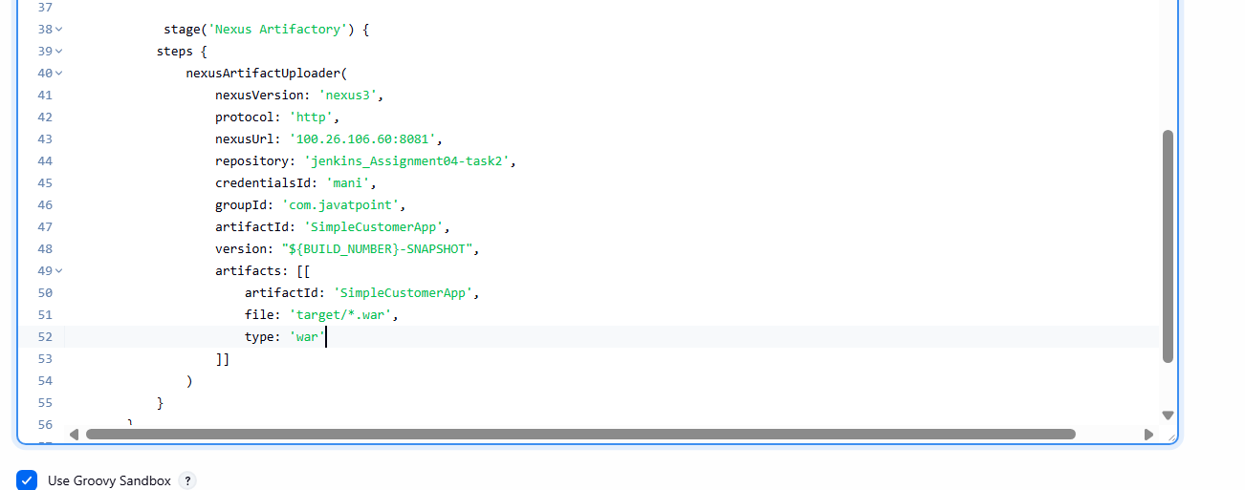
Step 17: Execute Pipeline and Identify Nexus Upload Script Error

Console path / UI path:
Jenkins Dashboard → Jenkins_Assignment04_Task02 → Build #8 → Console Output

Explanation:
The pipeline execution fails during the Nexus Artifactory stage due to an invalid parameter usage in the pipeline script.
The error indicates misuse of artifactId outside the artifacts block.

Observed error:
Invalid parameter "artifactId", did you mean "artifacts"?

Evidence:
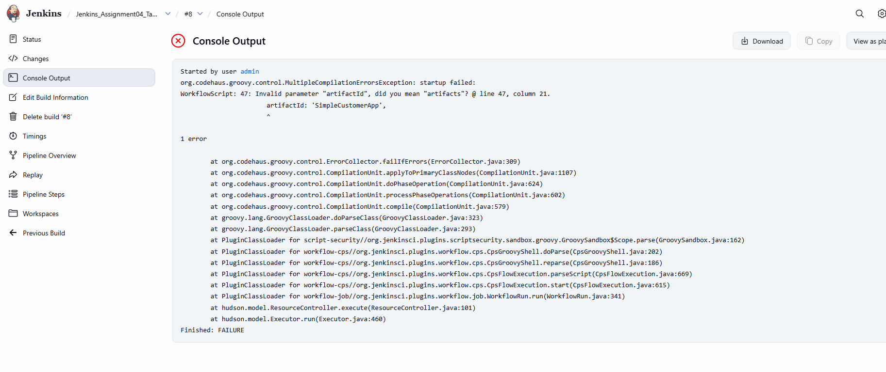
Step 18: Correct Nexus Artifact Uploader Configuration

Console path / UI path:
Jenkins Dashboard → Jenkins_Assignment04_Task02 → Configure → Pipeline

Explanation:
The pipeline script is corrected by moving artifact-related parameters inside the artifacts block.
The correct WAR file path is specified, matching the generated artifact name from the Maven build.

Evidence:
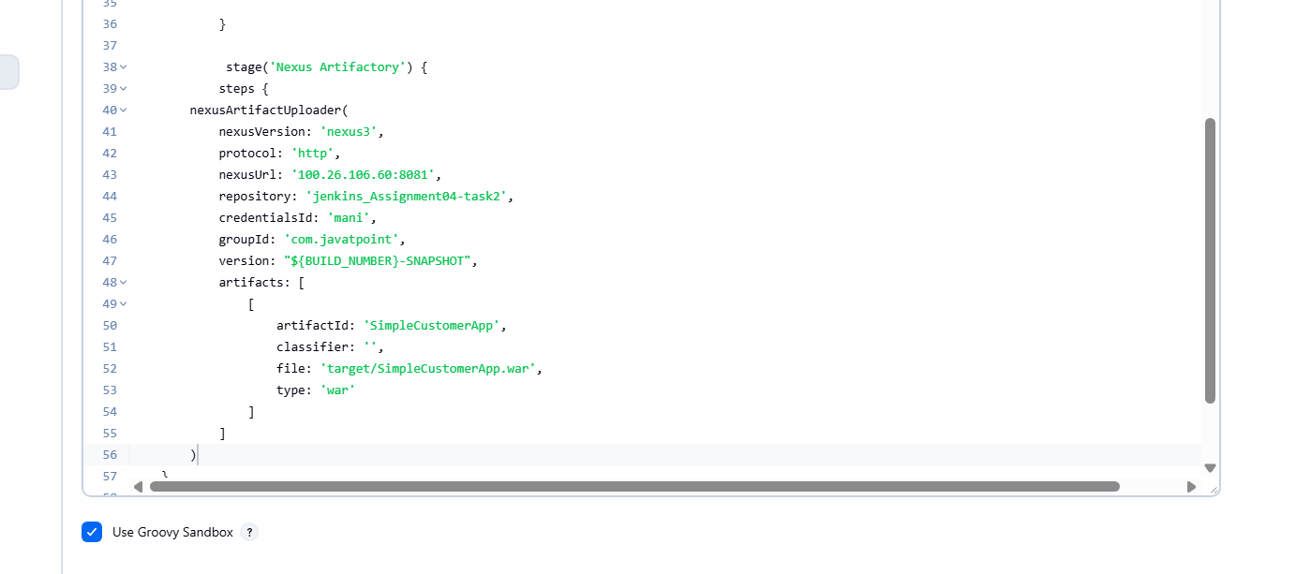
Step 19: Re-run Pipeline and Identify Artifact File Path Issue

Console path / UI path:
Jenkins Dashboard → Jenkins_Assignment04_Task02 → Build #9 → Console Output

Explanation:
The pipeline is executed again after correcting the script structure.
The build fails because the specified WAR file name does not exist at the given path.

Observed error:
SimpleCustomerApp.war file doesn't exist

This indicates a mismatch between the Maven-generated artifact name and the file path used in the Nexus upload step.

Evidence:

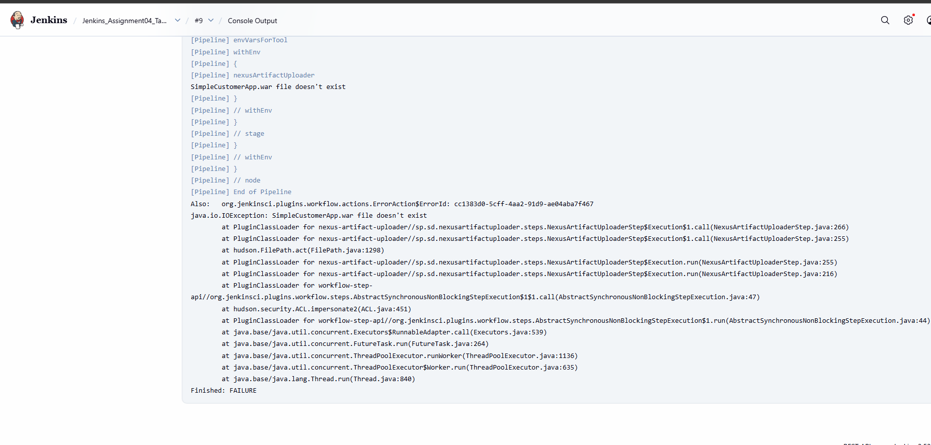
Step 20: Update Artifact File Name to Match Maven Output

Console path / UI path:
Jenkins Dashboard → Jenkins_Assignment04_Task02 → Configure → Pipeline

Explanation:
The artifact file name in the Nexus upload stage is updated to exactly match the Maven-generated WAR file, including build number and snapshot version.
This ensures the Nexus uploader can locate and upload the artifact successfully.

Evidence:

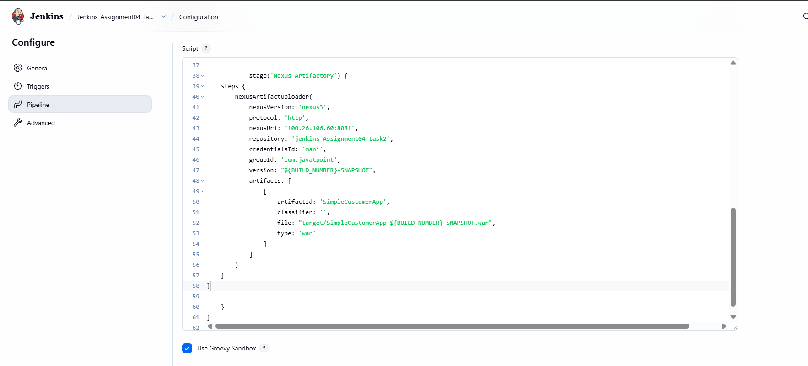
Step 21: Re-run Pipeline and Verify Successful Artifact Upload to Nexus

Console path / UI path:
Jenkins Dashboard → Jenkins_Assignment04_Task02 → Build #10 → Console Output

Explanation:
The pipeline is executed again after correcting the artifact file path.
The Nexus Artifactory stage completes successfully:

WAR file upload starts

Metadata is generated

Artifact is uploaded to the Nexus hosted repository

The pipeline completes without errors.

Evidence:

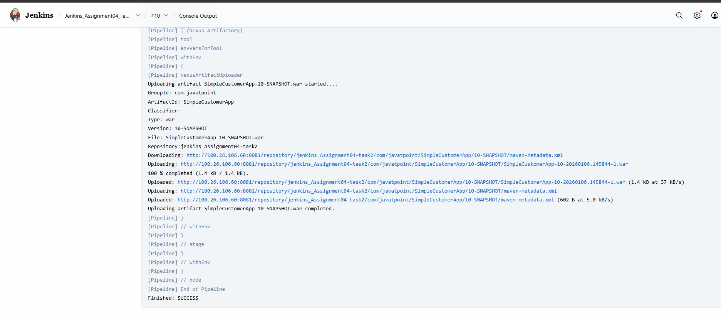

Deploy On tomcat
Step 22: Create Tomcat Credentials in Jenkins

Console path / UI path:
Jenkins Dashboard → Manage Jenkins → Credentials → System → Global credentials → Add / Update credentials

Explanation:
Tomcat server credentials are configured in Jenkins to allow automated deployment of the WAR file.
A Username with password credential is created for authenticating with the remote Tomcat server manager.

Configured details observed:

Username: admin

Credential ID: tomcat-cred-01

Scope: Global

This credential ID will be referenced in the Jenkins pipeline during deployment.

Evidence:
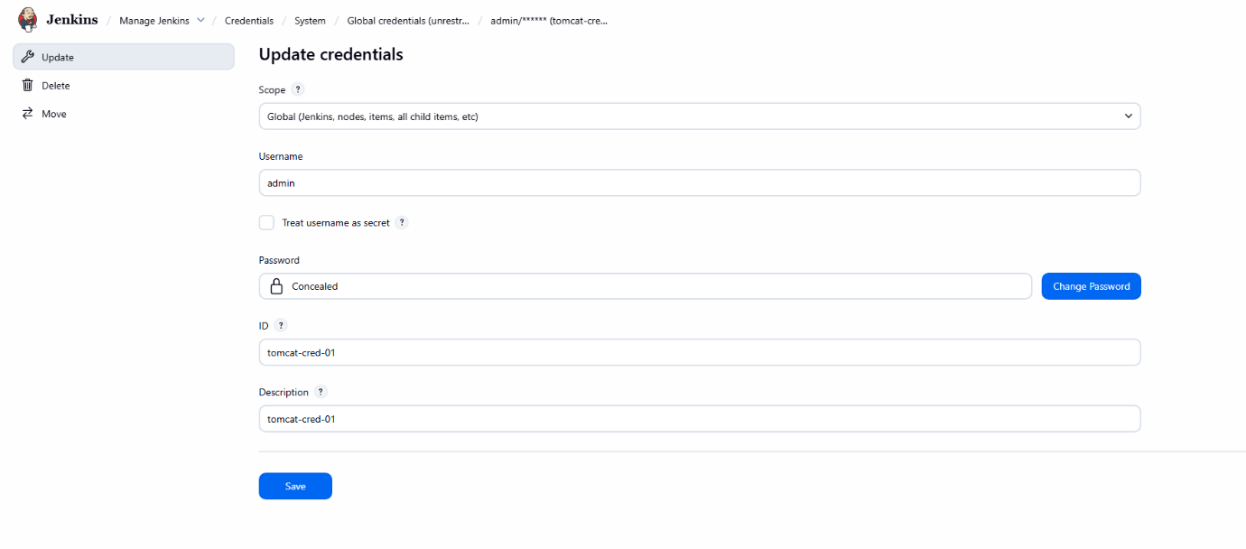
Step 23: Add “Deploy to Tomcat” Stage in Jenkins Pipeline

Console path / UI path:
Jenkins Dashboard → Jenkins_Assignment04_Task02 → Configure → Pipeline

Explanation:
A new pipeline stage named Deploy to Tomcat is added to deploy the WAR file to a remote Tomcat 9 server.
The deployment uses the Deploy to container plugin with Tomcat 9 adapter configuration.

Pipeline configuration observed:

Adapter: tomcat9

Credentials ID: tomcat-cred-01

Tomcat URL: http://54.221.169.143:8080/

Context path: sabear

WAR file path: target/*.war

Evidence:

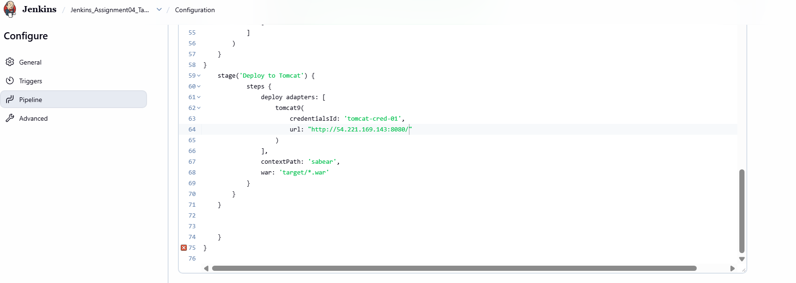
Step 24: Execute Pipeline and Identify Pipeline Syntax Error

Console path / UI path:
Jenkins Dashboard → Jenkins_Assignment04_Task02 → Build #11 → Console Output

Explanation:
The pipeline execution fails due to a Groovy syntax error caused by mismatched or extra closing braces in the pipeline script.

Observed error:
unexpected token: } at line 75, column 1

This indicates an incorrect pipeline structure that must be corrected before deployment can proceed.

Evidence:

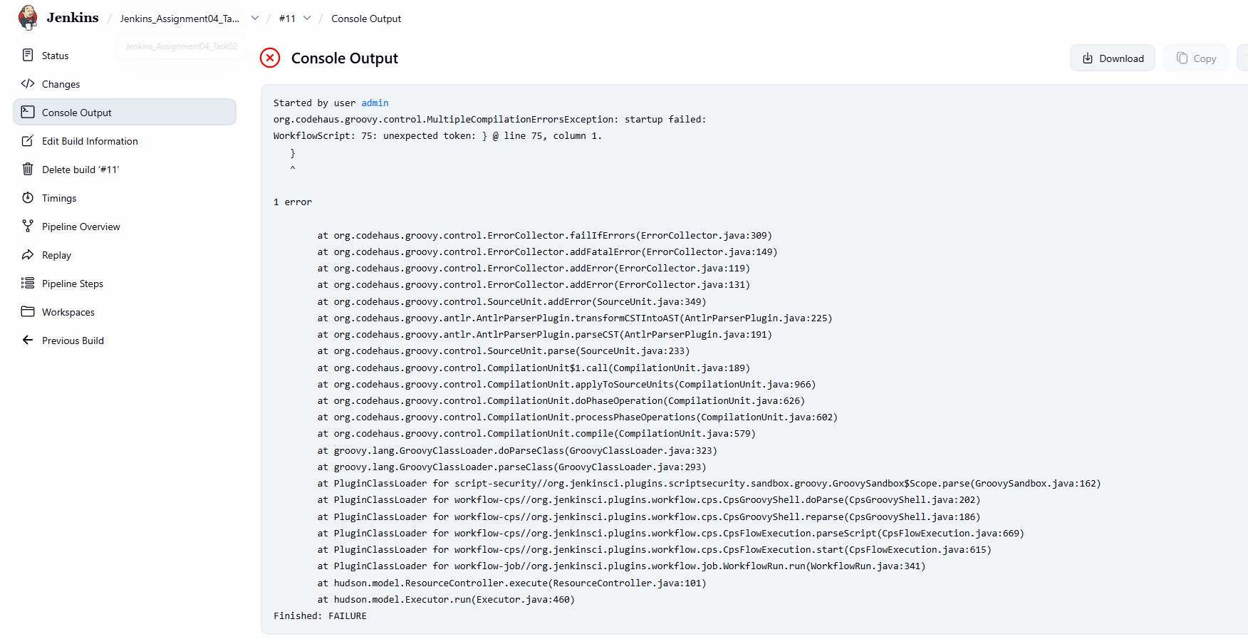
Step 25: Correct Pipeline Syntax and Structure

Console path / UI path:
Jenkins Dashboard → Jenkins_Assignment04_Task02 → Configure → Pipeline

Explanation:
The pipeline script is corrected by fixing unmatched or extra curly braces.
After correction, the pipeline follows a valid declarative structure with properly closed pipeline, stages, and stage blocks.

Evidence:

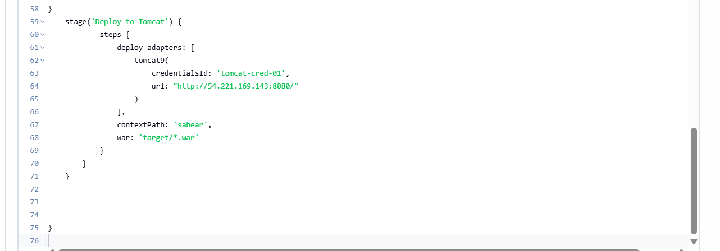
Step 26: Re-run Pipeline and Verify Successful Nexus Upload

Console path / UI path:
Jenkins Dashboard → Jenkins_Assignment04_Task02 → Build #12 → Console Output

Explanation:
The pipeline is executed again after correcting the syntax.
The Nexus Artifactory stage runs successfully, and the updated WAR file is uploaded to the Nexus repository with a new snapshot version.

Evidence:

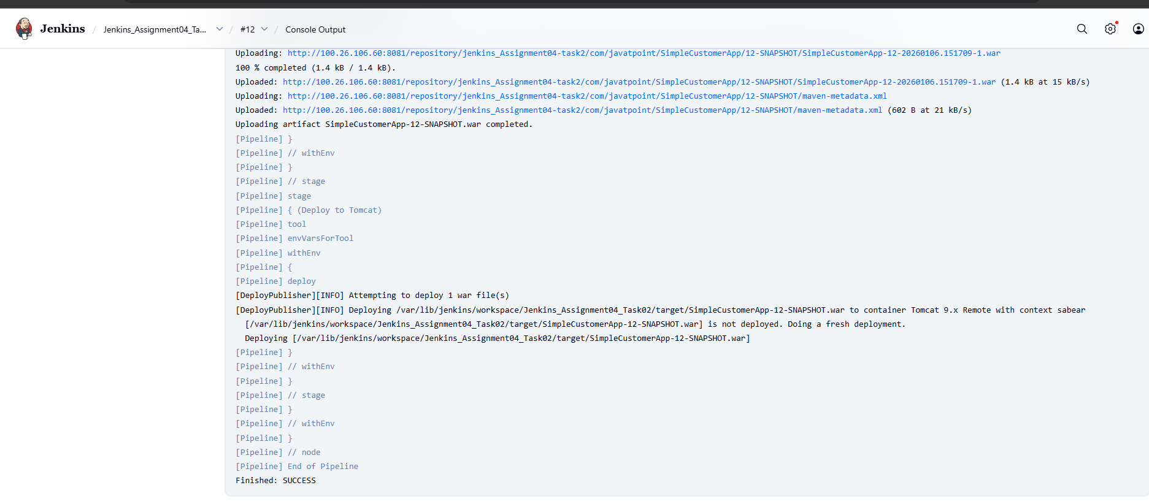
Step 27: Verify Successful Deployment to Tomcat Server

Console path / UI path:
Jenkins Dashboard → Jenkins_Assignment04_Task02 → Build #12 → Console Output

Explanation:
After successful artifact upload, the Deploy to Tomcat stage executes.
Jenkins deploys the WAR file to the remote Tomcat 9 server using the configured credentials and context path.

Observed deployment logs:

WAR file deployment initiated

Fresh deployment performed

Deployment completed without errors

Evidence:

Step 28: Create Slack Token Credential in Jenkins

Console path / UI path:
Jenkins Dashboard → Manage Jenkins → Credentials → System → Global credentials → Add / Update credentials

Explanation:
A Secret Text credential is created in Jenkins to store the Slack Bot/User Token securely.
This token is required by the Jenkins Slack plugin to send build notifications.

Configured details observed:

Credential type: Secret Text

Credential ID: techieorizon

Scope: Global

This credential ID is later referenced in the pipeline using tokenCredentialId.

Evidence:

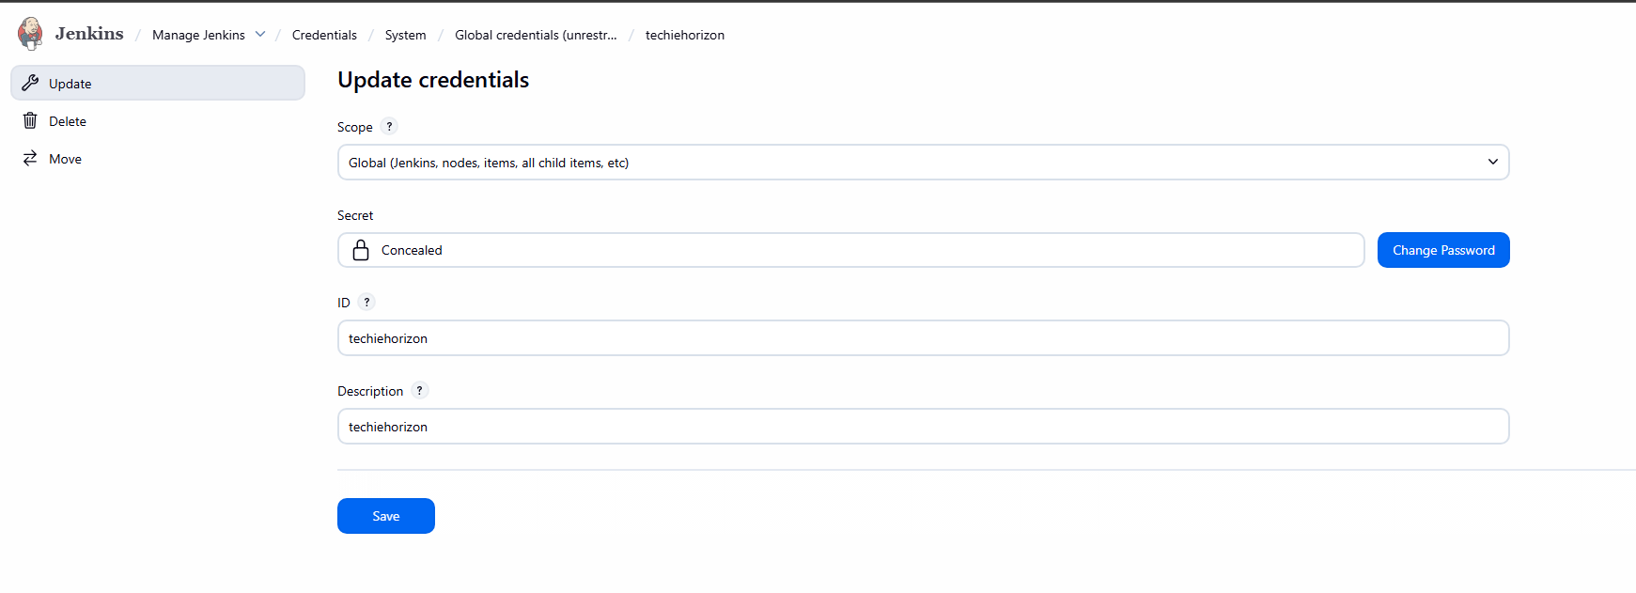
Step 29: Add Slack Notification Configuration in Pipeline (Post Section)

Console path / UI path:
Jenkins Dashboard → Jenkins_Assignment04_Task02 → Configure → Pipeline

Explanation:
A post block is added to the declarative pipeline to send Slack notifications based on build status.
Two conditions are configured:

success → Sends a green notification

failure → Sends a red notification

The Slack message dynamically includes:

Job name

Build number

Build URL

Pipeline logic observed:

slackSend step used

color: 'good' for success

color: 'danger' for failure

tokenCredentialId: 'techieorizon'

Evidence:
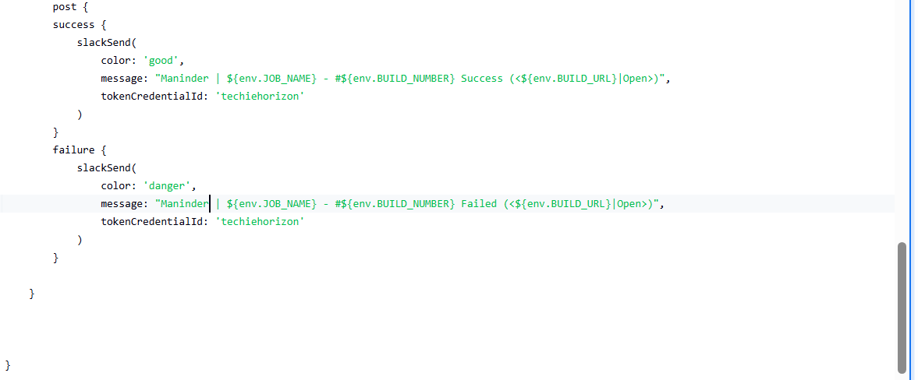
Step 30: Execute Pipeline and Identify Groovy Syntax Error in Post Block

Console path / UI path:
Jenkins Dashboard → Jenkins_Assignment04_Task02 → Build #13 → Console Output

Explanation:
Pipeline execution fails due to a Groovy syntax issue in the post section.
The error indicates a missing or mismatched closing brace at the end of the pipeline script.

Observed error:
expecting '}', found '' @ line 92, column 1

This confirms the pipeline structure is incomplete.

Evidence:
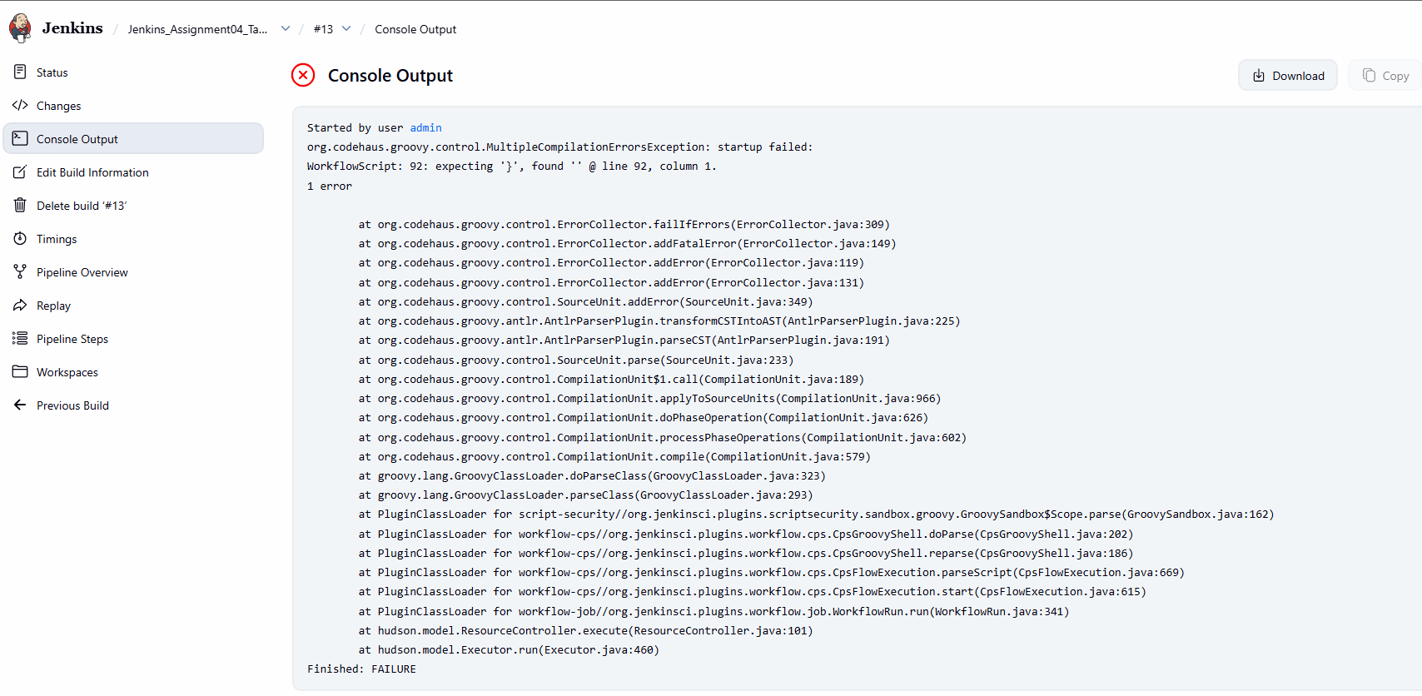
Step 31: Correct Post Block and Close Pipeline Properly

Console path / UI path:
Jenkins Dashboard → Jenkins_Assignment04_Task02 → Configure → Pipeline

Explanation:
The pipeline script is corrected by properly closing:

post block

stages block

pipeline block

This ensures a valid declarative pipeline structure and resolves the Groovy parsing error.

Evidence:

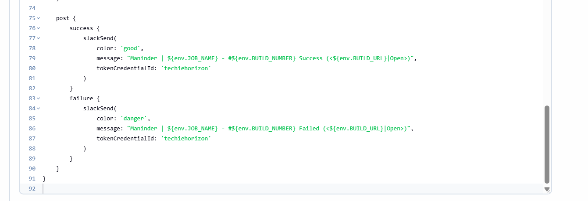
Step 32: Re-run Pipeline and Verify Slack Notification Execution

Console path / UI path:
Jenkins Dashboard → Jenkins_Assignment04_Task02 → Build #16 → Console Output

Explanation:
The pipeline is executed again after fixing the syntax.
All stages execute successfully:

Git Clone

SonarQube Analysis

Maven Build

Nexus Artifact Upload

Deploy to Tomcat

The post section executes after pipeline completion and triggers the Slack notification.

Evidence:

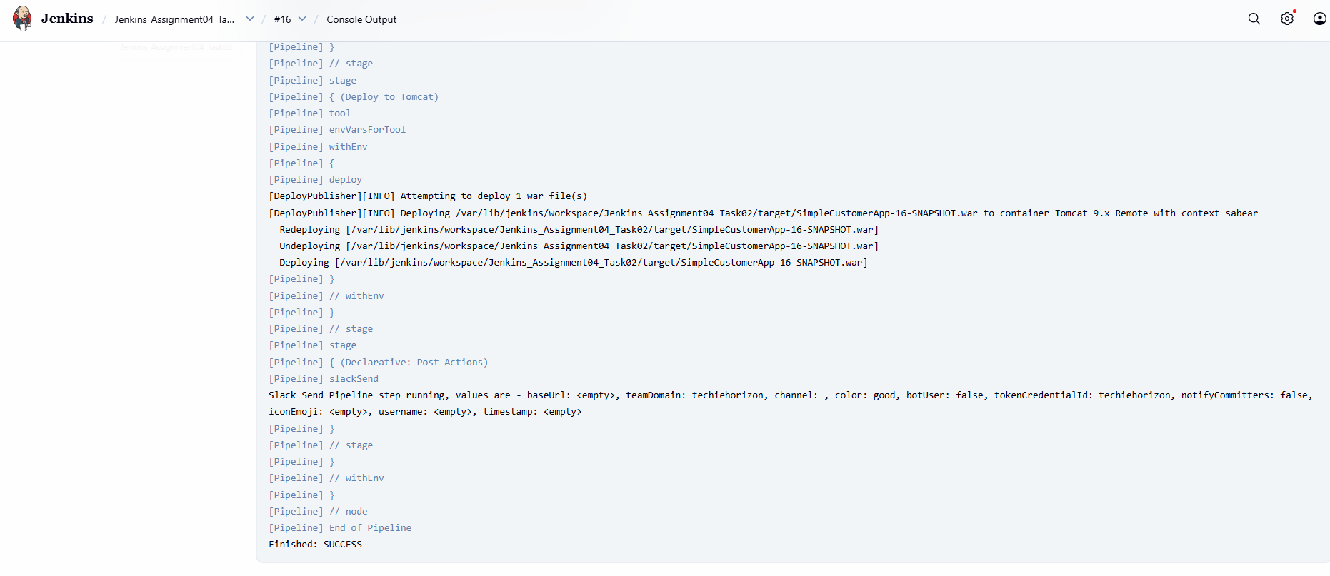
Step 33: Verify Slack Notification in Slack Channel

Console path / UI path:
Slack Workspace → Configured Channel

Explanation:
A Slack message is successfully delivered indicating the Jenkins build result.
The notification confirms:

Job name

Build number

Build status (Success)

Clickable build URL

Evidence:
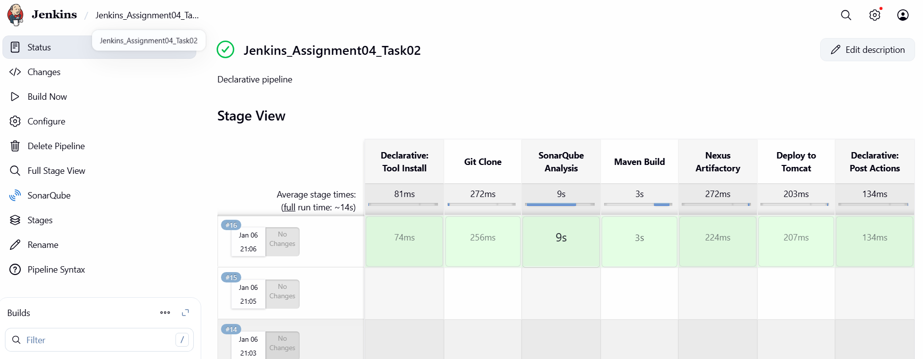

PIPELINE CODE BY END OF THE TASK AS FOLLOWS:
pipeline {
agent any

tools {
maven 'MVN_HOME'
}

stages {

stage('Git Clone') {
steps {
git branch: 'feature-1.1',
url: 'https://github.com/betawins/sabear_simplecutomerapp.git'
}
}

stage('SonarQube Analysis') {
steps {
withSonarQubeEnv('sonarqube-Docker') {
sh '''
/opt/sonar-scanner/bin/sonar-scanner \
-Dsonar.projectKey=sabear-simplecustomerapp \
-Dsonar.projectName=SimpleCustomerApp \
-Dsonar.sources=. \
-Dsonar.exclusions=**/*.java
'''
}
}
}

stage('Maven Build') {
steps {
sh '''
mvn clean package
'''
}
}

stage('Nexus Artifactory') {
steps {
nexusArtifactUploader(
nexusVersion: 'nexus3',
protocol: 'http',
nexusUrl: '100.26.106.60:8081',
repository: 'jenkins_Assignment04-task2',
credentialsId: 'mani',
groupId: 'com.javatpoint',
version: "${BUILD_NUMBER}-SNAPSHOT",
artifacts: [
[
artifactId: 'SimpleCustomerApp',
classifier: '',
file: "target/SimpleCustomerApp-${BUILD_NUMBER}-SNAPSHOT.war",
type: 'war'
]
]
)
}
}

stage('Deploy to Tomcat') {
steps {
deploy adapters: [
tomcat9(
credentialsId: 'tomcat-cred-01',
url: "http://54.221.169.143:8080/"
)
],
contextPath: 'sabear',
war: 'target/*.war'
}
}
}

post {
success {
slackSend(
color: 'good',
message: "Maninder | ${env.JOB_NAME} - #${env.BUILD_NUMBER} Success (<${env.BUILD_URL}|Open>)",
tokenCredentialId: 'techiehorizon'
)
}
failure {
slackSend(
color: 'danger',
message: "Maninder | ${env.JOB_NAME} - #${env.BUILD_NUMBER} Failed (<${env.BUILD_URL}|Open>)",
tokenCredentialId: 'techiehorizon'
)
}
}
}

6) Issues Faced

Maven Command Not Found

Cause: Maven not configured in Jenkins tools.

Resolution: Configured Maven using tools { maven 'MVN_HOME' }.

Nexus Artifact Upload Errors

Cause: Incorrect parameters (artifactId placed outside artifacts block).

Resolution: Corrected Nexus Artifact Uploader syntax.

WAR File Not Found During Nexus Upload

Cause: Mismatch between generated WAR name and file path.

Resolution: Updated file path to match ${BUILD_NUMBER}-SNAPSHOT naming.

Groovy Compilation Errors

Cause: Missing or extra closing braces in pipeline script.

Resolution: Corrected pipeline structure and ensured proper block closures.

Slack Notification Failure (Initial)

Cause: Missing Slack token credential.

Resolution: Created Secret Text credential and referenced it using tokenCredentialId.

7) Conclusion

The Jenkins CI/CD pipeline was successfully implemented with end-to-end automation covering source code checkout, code quality analysis, build, artifact management, deployment, and notifications.
The pipeline integrates GitHub, SonarQube, Maven, Nexus Repository, Tomcat, and Slack, demonstrating a complete DevOps workflow.

