Jenkins-Assignment-04-Task03,04

Task 3. Setup a Jenkins CICD pipeline using Scripted pipeline using feature-1.1 branch. https://github.com/betawins/sabear_simplecutomerapp/tree/feature-1.1
stages:
Git Clone
SonarQube Integration
Maven Compilation
Nexus Artifactory
Slack Notification
Deploy On tomcat

4) Step-by-Step Implementation (With Evidence)
Git Clone

Step 1: Create Jenkins Pipeline Job (Scripted Pipeline)
Console path / UI navigation:
Jenkins Dashboard → New Item
CLI / Input used:
- Job Name: Jenkins_Assignment04_Task03
- Job Type: Pipeline
- Pipeline Definition: Pipeline script
Explanation:
A new Jenkins Pipeline job is created to implement a Scripted Pipeline. The Pipeline job type is chosen because it supports Groovy-based scripted pipelines and allows defining complex CI/CD stages such as Git clone, SonarQube analysis, Maven build, Nexus upload, Slack notifications, and deployment.
This step establishes the foundation for the CI/CD workflow.
Evidence:
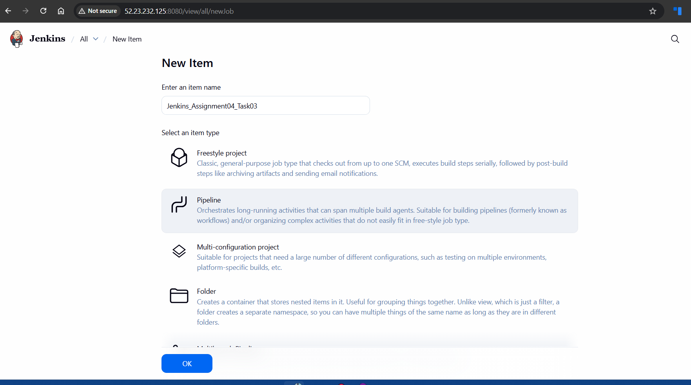
Step 2: Git Clone from feature-1.1 Branch (Initial Failure)
Console path / UI navigation:
Jenkins_Assignment04_Task03 → Configure → Pipeline Script
Pipeline Script Used:
node {
stage('Git clone') {
sh '''
git clone -b feature-1.1 https://github.com/betawins/sabear_simplecutomerapp/tree/feature-1.1
'''
}
}
Explanation:
The pipeline attempts to clone the source code from the feature-1.1 branch.
However, the URL used points to a GitHub web UI path (/tree/feature-1.1), which is not a valid Git repository URL. Git can only clone from .git repository URLs, not browser paths.
Evidence (Console Output):
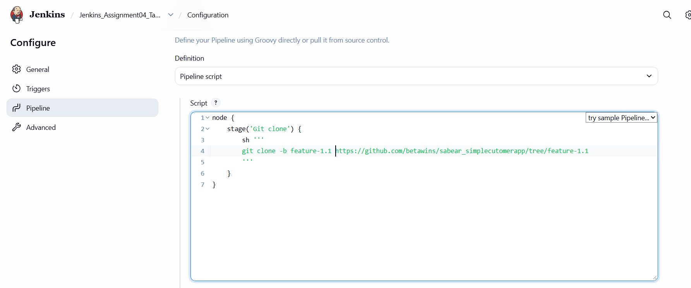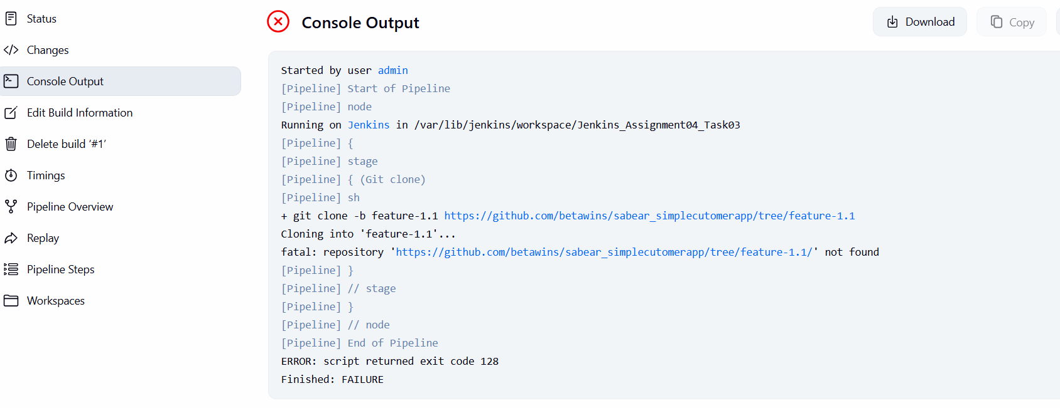
Step 3: Git Clone from feature-1.1 Branch (Corrected & Successful)
Console path / UI navigation:
Jenkins_Assignment04_Task03 → Configure → Pipeline Script
Corrected Pipeline Script:
node {
stage('Git clone') {
sh '''
git clone -b feature-1.1 https://github.com/betawins/sabear_simplecutomerapp.git
'''
}
}
Explanation:
The issue is resolved by using the correct Git repository URL ending with .git and specifying the branch using -b feature-1.1.
This allows Jenkins to successfully clone the source code into the workspace.
Evidence (Console Output): 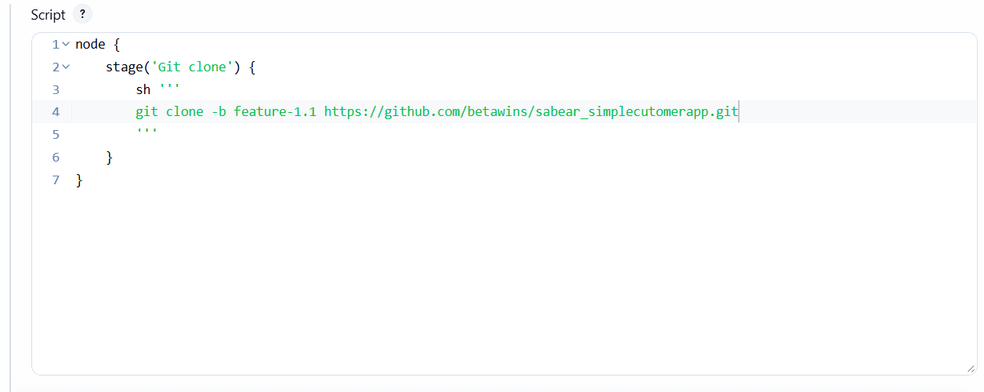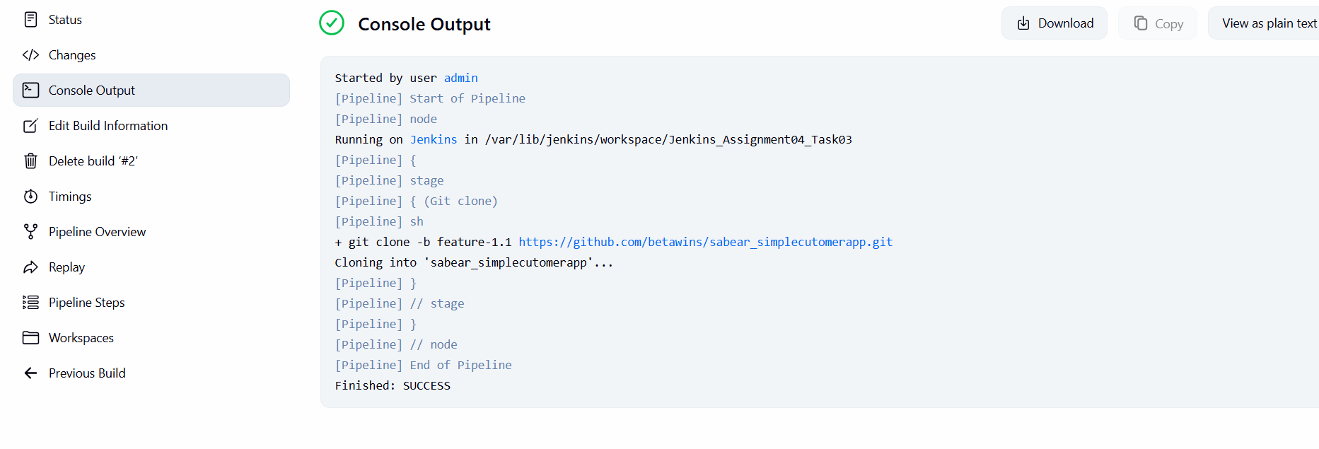
SonarQube Integration

Step 4: Git Clone Failure Due to Existing Workspace Directory
Console path / UI navigation:
Jenkins_Assignment04_Task03 → Build → Console Output
Pipeline Script Used (before fix):
git clone -b feature-1.1 https://github.com/betawins/sabear_simplecutomerapp.git
Explanation:
When the pipeline was re-run, Jenkins reused the same workspace.
Since the repository directory sabear_simplecutomerapp already existed from the previous successful build, Git failed because it does not overwrite a non-empty directory by default.
Evidence (Console Output):
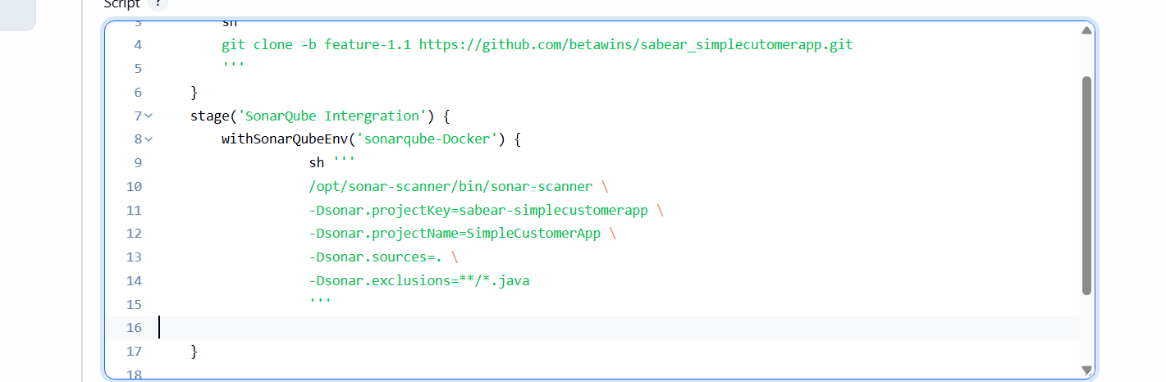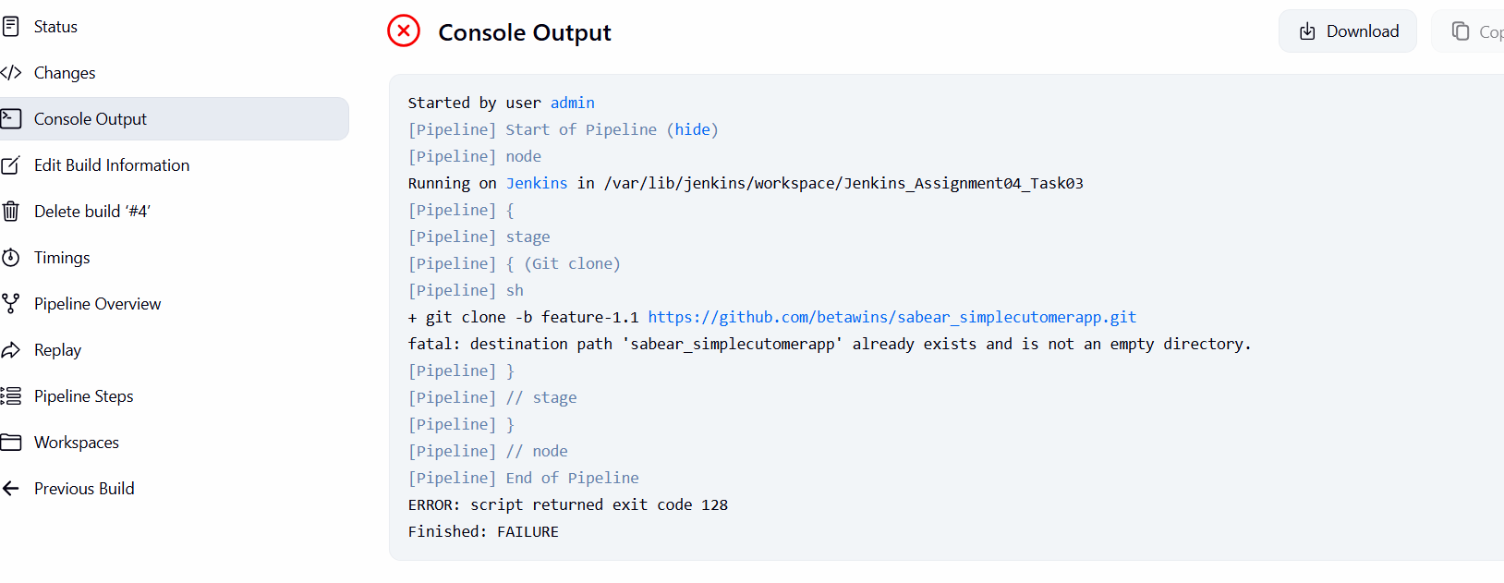
Step 5: Workspace Cleanup Before Git Clone (Fix Applied)
Console path / UI navigation:
Jenkins_Assignment04_Task03 → Configure → Pipeline Script
Updated Pipeline Script:
node {
stage('Git clone') {
sh '''
rm -rf sabear_simplecutomerapp
git clone -b feature-1.1 https://github.com/betawins/sabear_simplecutomerapp.git
'''
}
}
Explanation:
A cleanup command (rm -rf) is added before cloning to ensure the workspace is clean.
This prevents conflicts when Jenkins reuses the same workspace across multiple builds.
This is a common and recommended practice in Scripted Pipelines when not using Jenkins SCM checkout steps.
Evidence:
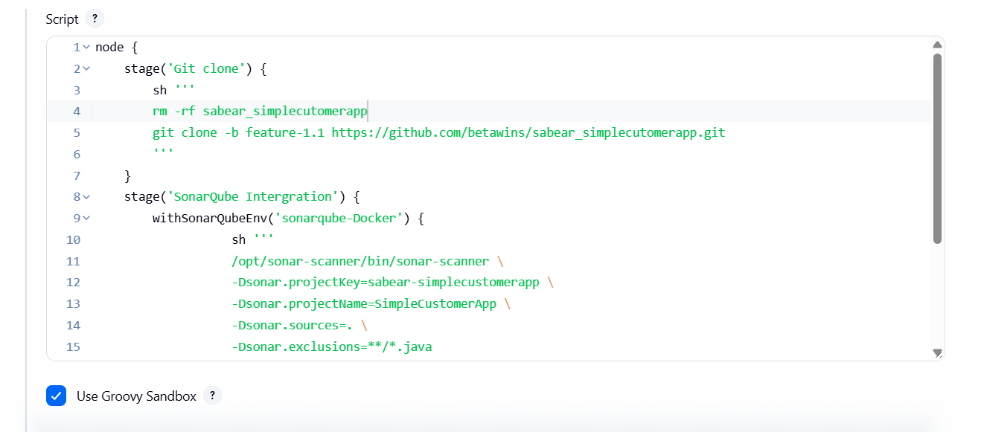
Step 6: SonarQube Integration – Static Code Analysis
Console path / UI navigation:
Jenkins_Assignment04_Task03 → Configure → Pipeline Script
Pipeline Script Used:
stage('SonarQube Intergration') {
withSonarQubeEnv('sonarqube-Docker') {
sh '''
/opt/sonar-scanner/bin/sonar-scanner \
-Dsonar.projectKey=sabear-simplecustomerapp \
-Dsonar.projectName=SimpleCustomerApp \
-Dsonar.sources=. \
-Dsonar.exclusions=**/*.java
'''
}
}
Explanation:
This stage integrates SonarQube into the CI pipeline to perform static code quality analysis.
- withSonarQubeEnv('sonarqube-Docker') injects SonarQube server credentials and URL configured in Jenkins
- sonar-scanner scans the source code
- Project key and name uniquely identify the application in SonarQube
- Source directory is set to current workspace
- Java files are excluded as per configuration
Evidence (Console Output):
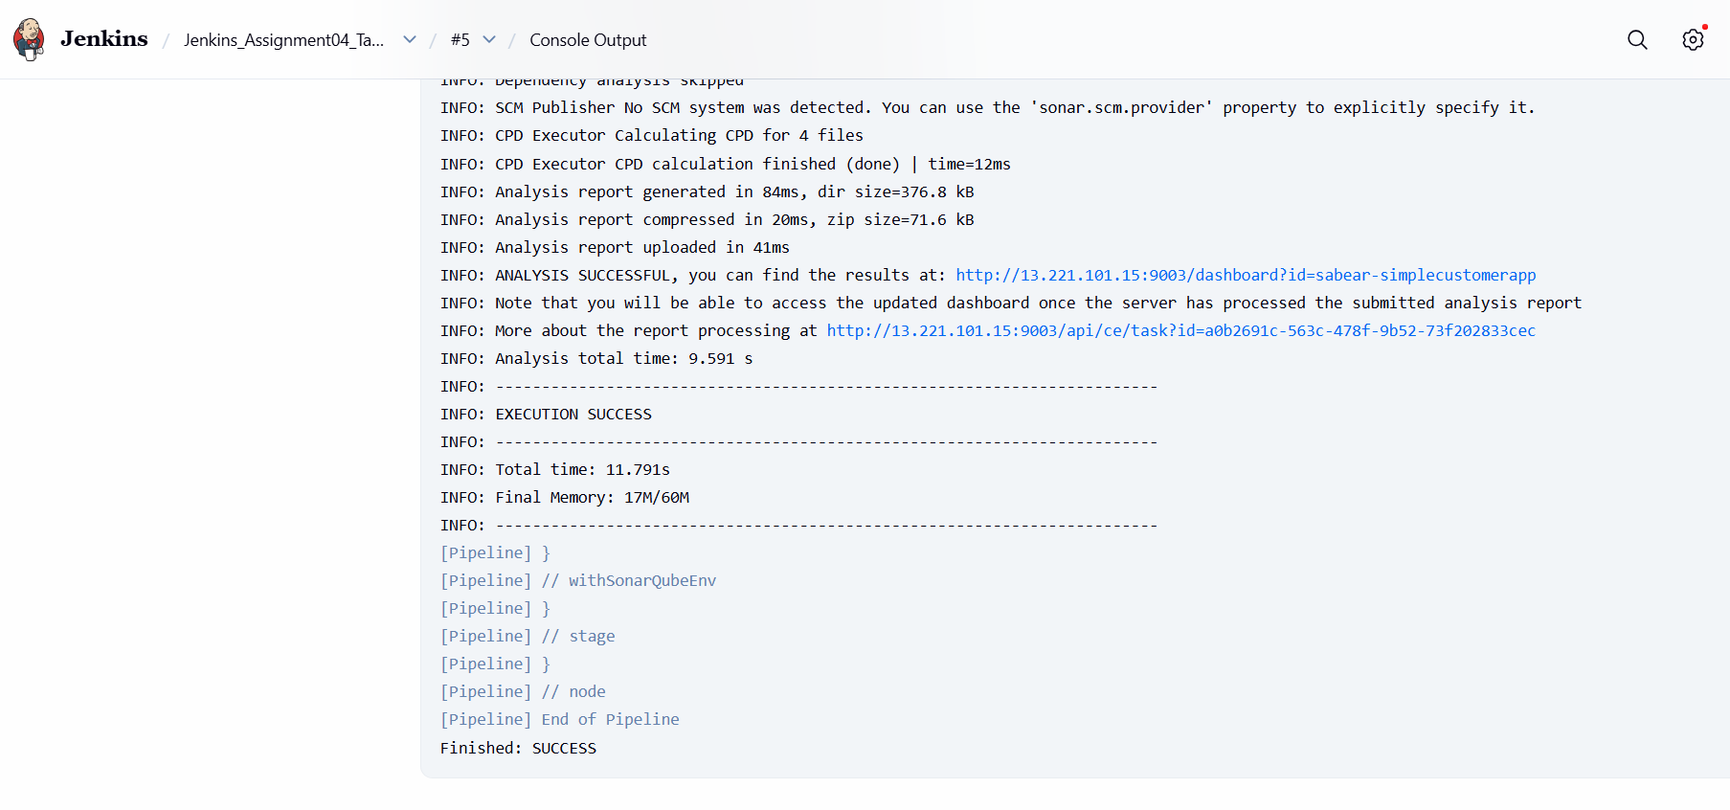
Step 7: Successful Pipeline Execution (Git Clone + SonarQube)
Console path / UI navigation:
Jenkins_Assignment04_Task03 → Build #5 → Console Output
Explanation:
After fixing the workspace cleanup issue and configuring SonarQube correctly, the pipeline executed successfully.
Both Git Clone and SonarQube Integration stages completed without errors.
Evidence:

Maven Compilation
Step 11: Add Maven Compilation Stage
Console path / UI path:
Pipeline Script Editor
CLI command used:
mvn clean package
Explanation:
A Maven compilation stage is added to build and package the application into a WAR file.
Evidence:
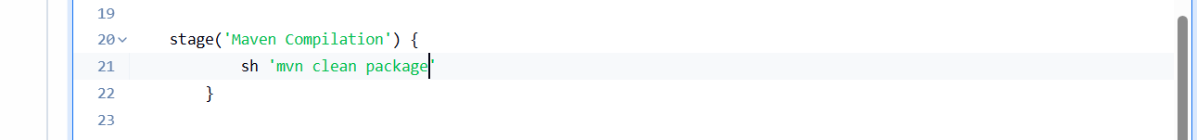
Step 13: Identify Maven Command Not Found Error
Console path / UI path:
Jenkins_Assignment04_Task03 → Build → Console Output
Explanation:
After SonarQube analysis completed successfully, the pipeline failed in the Maven Compilation stage because the mvn command was not found in the Jenkins runtime environment.
Observed error:
mvn: command not found
ERROR: script returned exit code 127
This indicates Maven is either:
- Not installed on the Jenkins server, or
- Installed but not available in the system PATH.
Evidence:
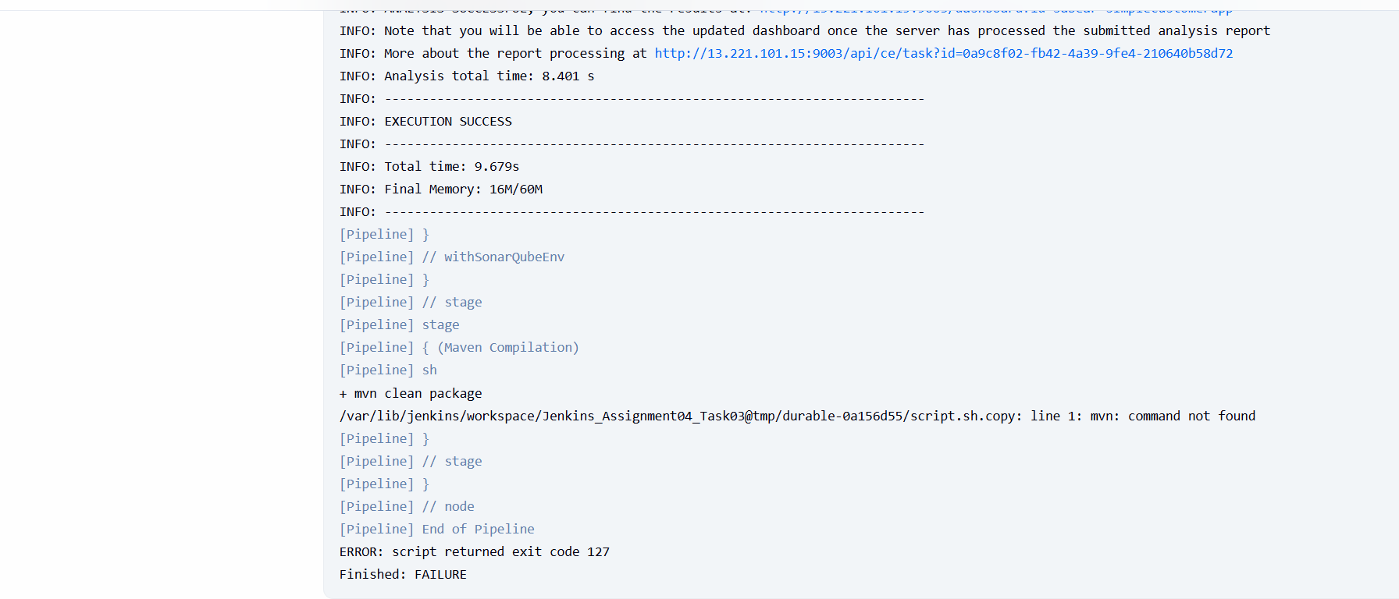
Step 14: Update Pipeline to Use Absolute Maven Path
Console path / UI path:
Jenkins_Assignment04_Task03 → Configure → Pipeline
CLI command updated:
/opt/maven/bin/mvn clean package
Explanation:
Instead of relying on mvn from PATH, the pipeline is updated to use the absolute Maven binary path available on the Jenkins server (/opt/maven/bin/mvn).
Evidence:
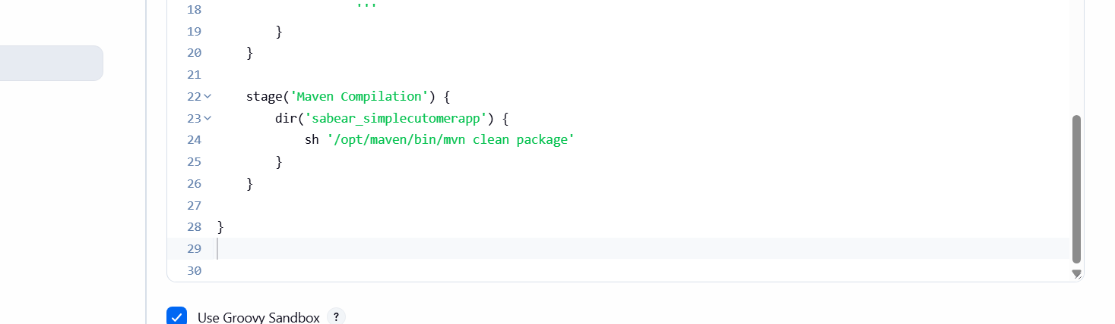
Step 15: Re-run Pipeline and Verify Maven Compilation Success
Console path / UI path:
Jenkins_Assignment04_Task03 → Build → Console Output
Explanation:
The pipeline is re-executed after correcting the Maven command.
The Maven build completes successfully and packages the application.
Evidence:
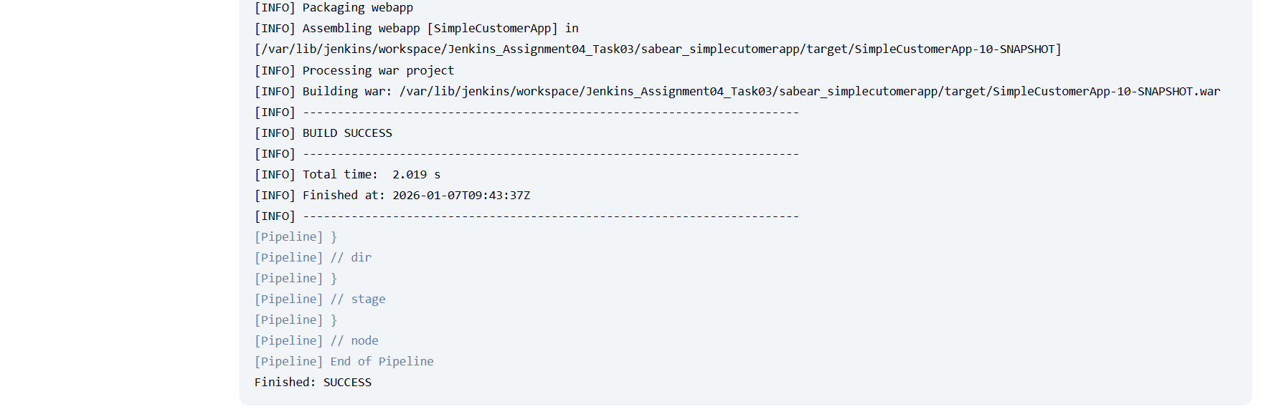
Step 16: Verify WAR Artifact Generation in Workspace
Console path / CLI path:
/var/lib/jenkins/workspace/Jenkins_Assignment04_Task03/sabear_simplecutomerapp/target/
CLI command used:
ls
Explanation:
The Jenkins workspace is manually checked to confirm that the WAR file was generated as part of the Maven build.
Evidence:
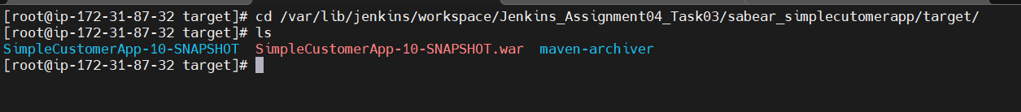

Nexus Artifactory
Step 18: Add Nexus Artifactory Stage to Scripted Pipeline
Console path / UI path:
Jenkins_Assignment04_Task03 → Configure → Pipeline
Explanation:
A new stage named Nexus Artifactory is added to upload the generated WAR file to Nexus 3 using the nexusArtifactUploader step.
The upload is executed from inside the cloned project directory (sabear_simplecutomerapp) so that the target folder is accessible.
Key configurations used:
- Nexus version: nexus3
- Protocol: http
- Nexus URL: 100.26.106.60:8081
- Repository: jenkins_Assignment04-task2
- Credentials ID: mani
- Group ID: com.javatpoint
- Artifact type: war
- Version format: ${BUILD_NUMBER}-SNAPSHOT
Evidence:
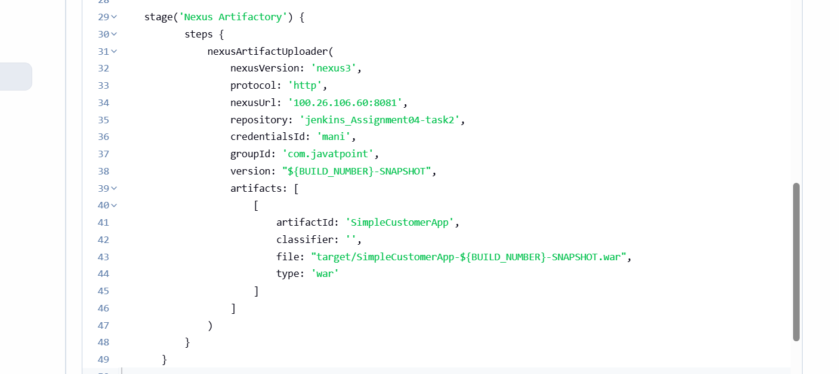
Step 19: First Nexus Upload Failure – Metadata Transfer Error
Console path / UI path:
Jenkins_Assignment04_Task03 → Build #11 → Console Output
Explanation:
The pipeline fails while attempting to upload the artifact to Nexus.
The error occurs during retrieval or upload of maven-metadata.xml.
Observed error:
Failed to retrieve remote metadata
Could not transfer metadata
transfer failed for maven-metadata.xml
This indicates a problem with:
- Nexus repository configuration, or
- Repository URL / repository name mismatch.
Evidence: 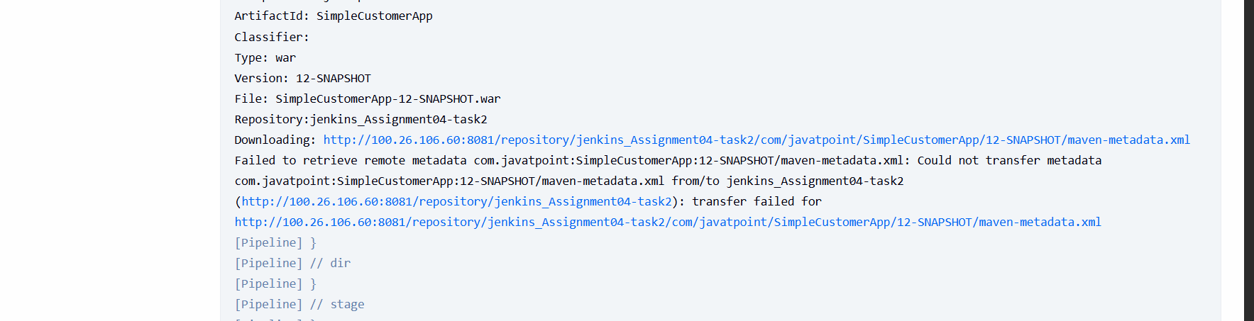
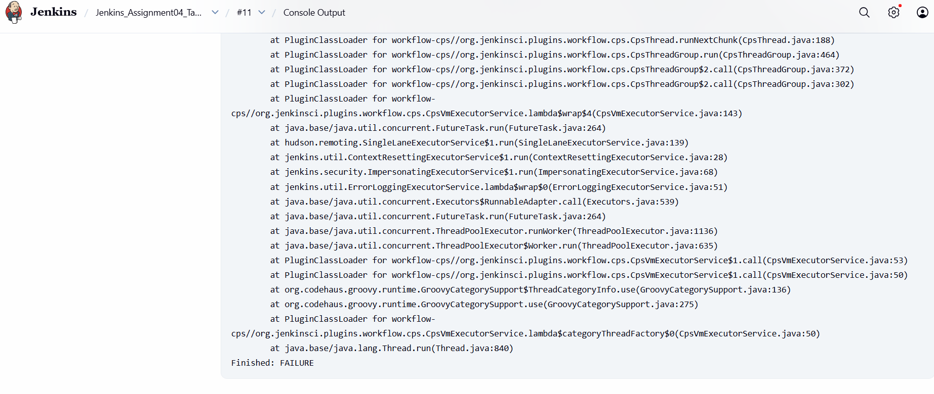
Step 20: Correct Nexus Repository and URL Configuration
Console path / UI path:
Jenkins_Assignment04_Task03 → Configure → Pipeline
Changes applied:
- Updated nexusUrl to:
- 3.86.99.80:8081
- Updated repository name to:
- jenkins_Assignment04-task3
Explanation:
The Nexus repository was corrected to match the actual hosted repository configured in Nexus.
The IP address was also updated to the correct Nexus server endpoint.
Evidence: 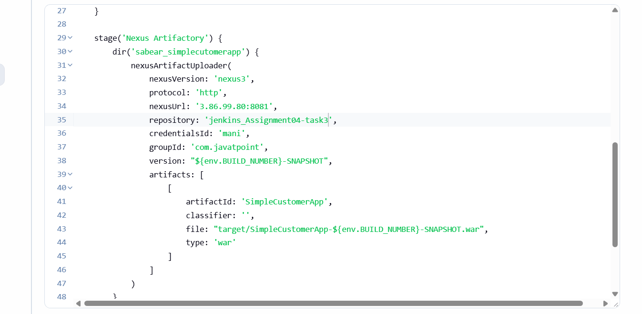

Step 21: Re-run Pipeline and Verify Successful Nexus Upload
Console path / UI path:
Jenkins_Assignment04_Task03 → Build #13 → Console Output
Explanation:
After fixing the Nexus configuration, the pipeline is re-run.
The WAR file is successfully uploaded to Nexus along with the corresponding maven-metadata.xml.
Observed success logs:
Uploading SimpleCustomerApp-13-SNAPSHOT.war
Uploaded SimpleCustomerApp-13-SNAPSHOT.war
Uploading maven-metadata.xml
Uploading artifact completed
Evidence:
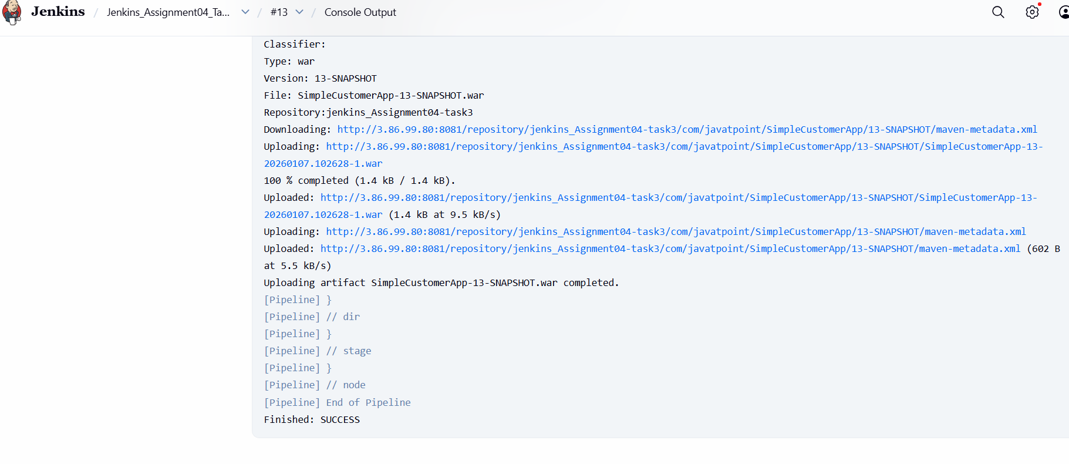
Step 22: Confirm Artifact Availability in Nexus Repository
Console path / UI path:
Nexus UI → Browse → jenkins_Assignment04-task3
Path:
com/javatpoint/SimpleCustomerApp/13-SNAPSHOT/
Explanation:
The uploaded artifact is verified directly in the Nexus repository to ensure it is stored correctly and accessible for downstream stages such as deployment.
Evidence:
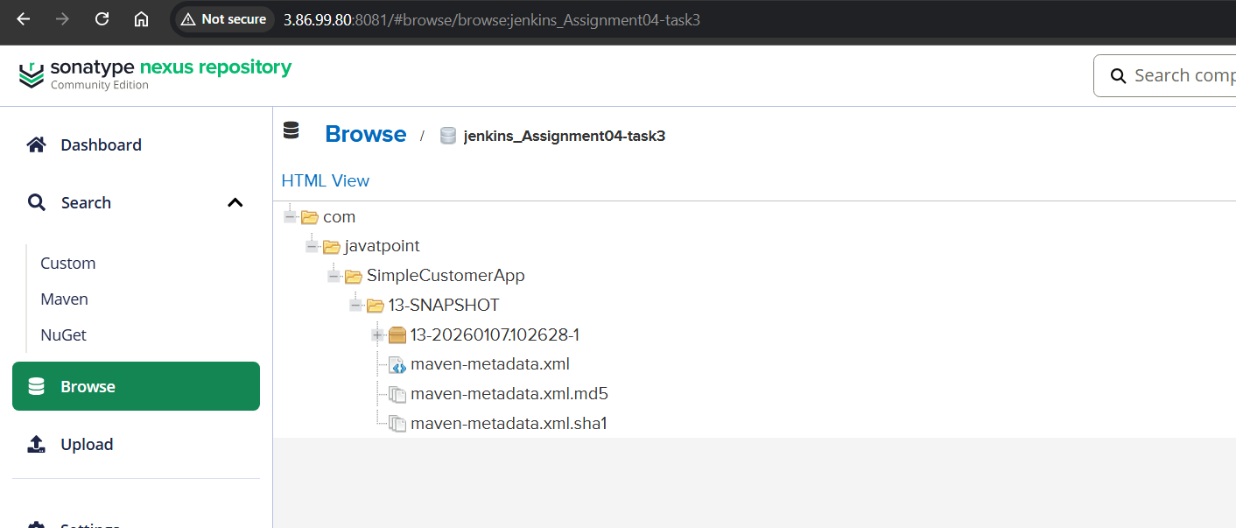

Deploy On tomcat

Step 23: Add Deploy on Tomcat Stage (Initial Attempt)
Console path / UI path:
Jenkins_Assignment04_Task03 → Configure → Pipeline
Explanation:
A new stage Deploy On Tomcat was added using the Jenkins Deploy to container (Cargo) plugin.
Initially, the deploy syntax was written incorrectly, causing a Groovy compilation error.
Error observed:
expecting '}', found ':' @ line 52
Evidence:
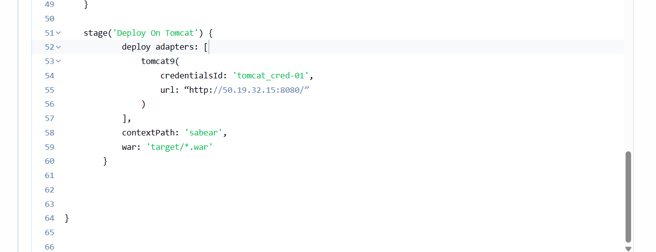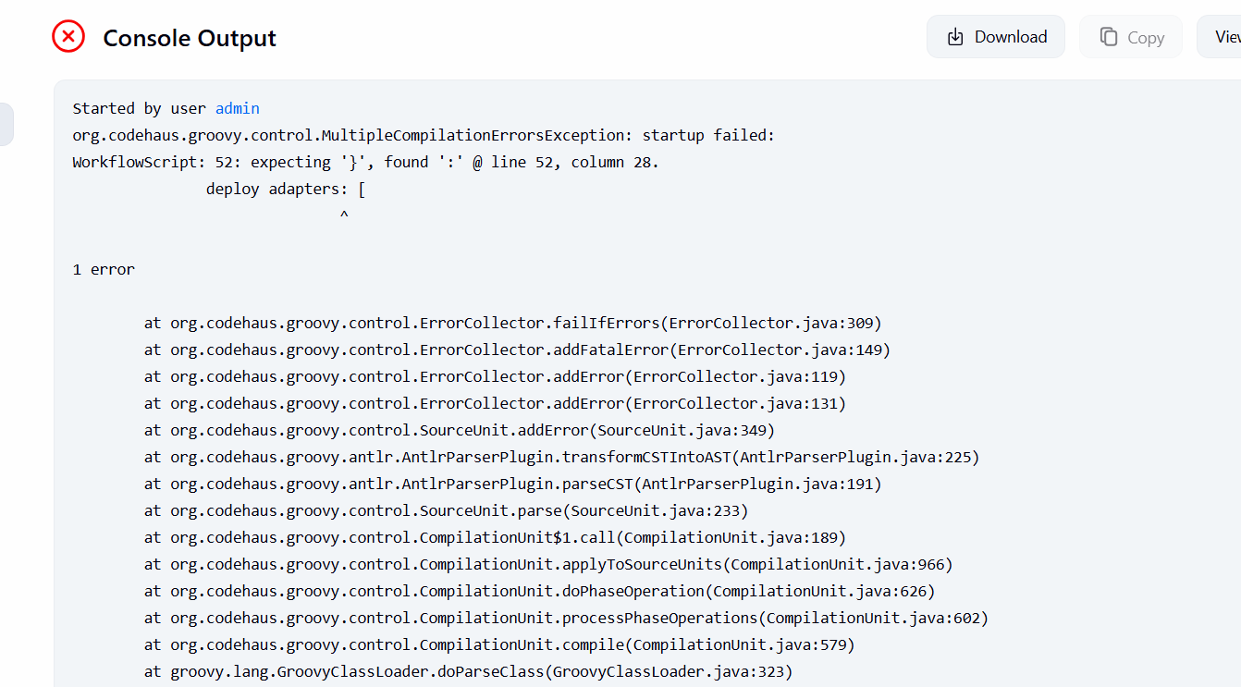
Step 24: Fix Groovy Syntax for Deploy Step
Console path / UI path:
Jenkins_Assignment04_Task03 → Configure → Pipeline
Corrected syntax used:
- Wrapped deploy() inside dir('sabear_simplecutomerapp')
- Properly structured adapters block
- Closed all braces correctly
Explanation:
The scripted pipeline requires the deploy() step to be written as a function call, not as declarative-style syntax.
Once corrected, the pipeline compiled successfully.
Evidence:
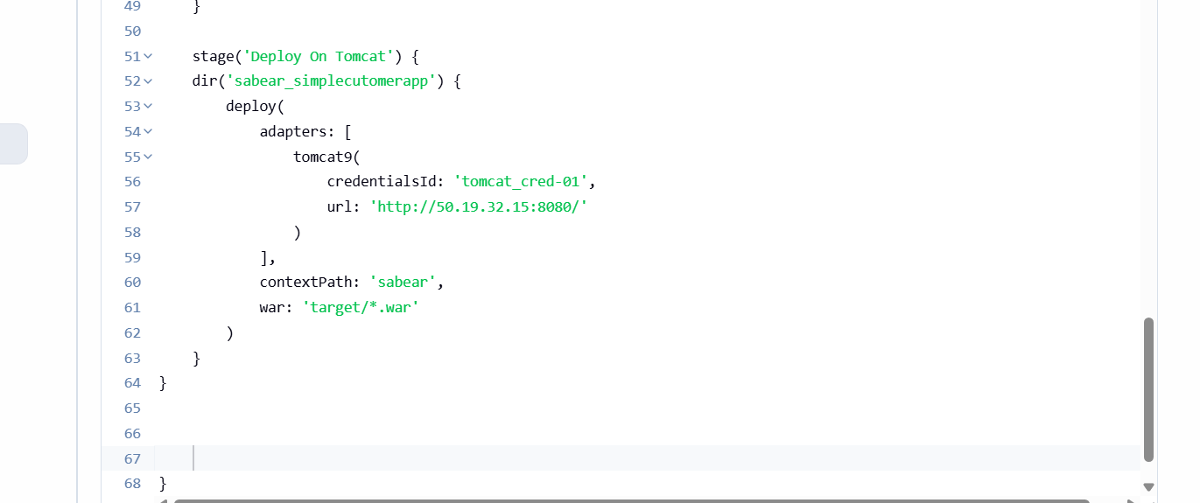
Step 25: Encounter Cargo Credential Error
Console path / UI path:
Jenkins_Assignment04_Task03 → Build → Console Output
Observed error:
[cargo.remote.username] and [cargo.remote.password] properties are mandatory
Explanation:
This error occurred because Tomcat Manager credentials were not correctly configured or mapped in Jenkins.
Evidence:
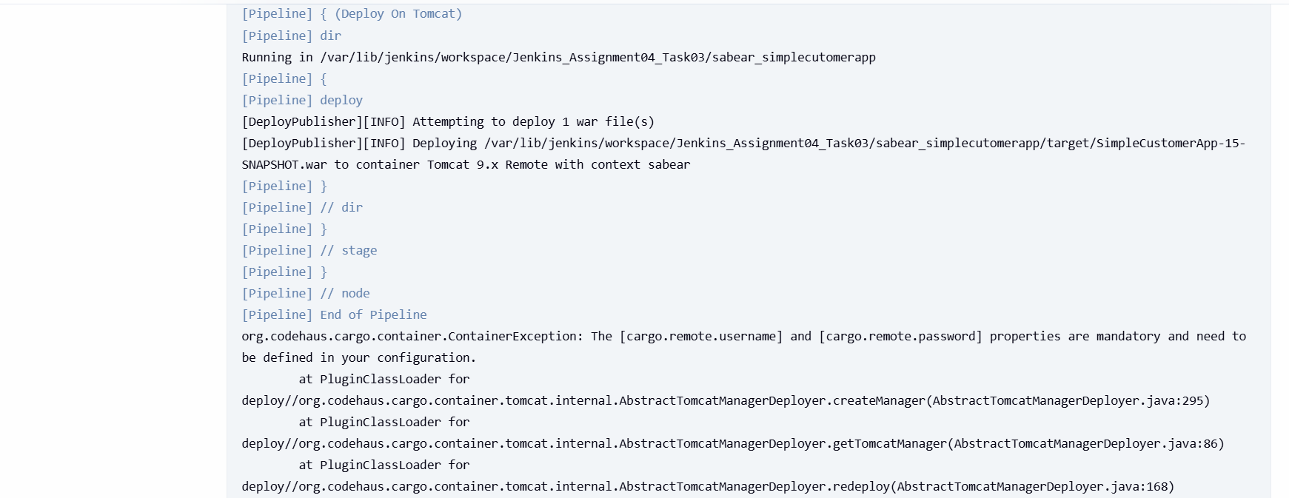
Step 26: Configure Tomcat Manager Users
Server path / CLI path:
/opt/tomcat/conf/tomcat-users.xml
Actions performed:
- Added required roles:
  - manager-gui
  - manager-script
  - manager-jmx
  - manager-status
- Created Tomcat deployment user:
<user username="tomcat" password="tomcat123"
roles="manager-gui,manager-script,manager-jmx,manager-status"/>
Explanation:
The Deploy to Container plugin uses Tomcat Manager (script access).
Without manager-script, remote deployments will fail.
Evidence:
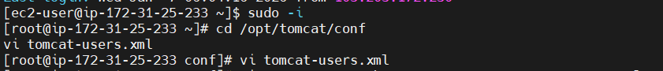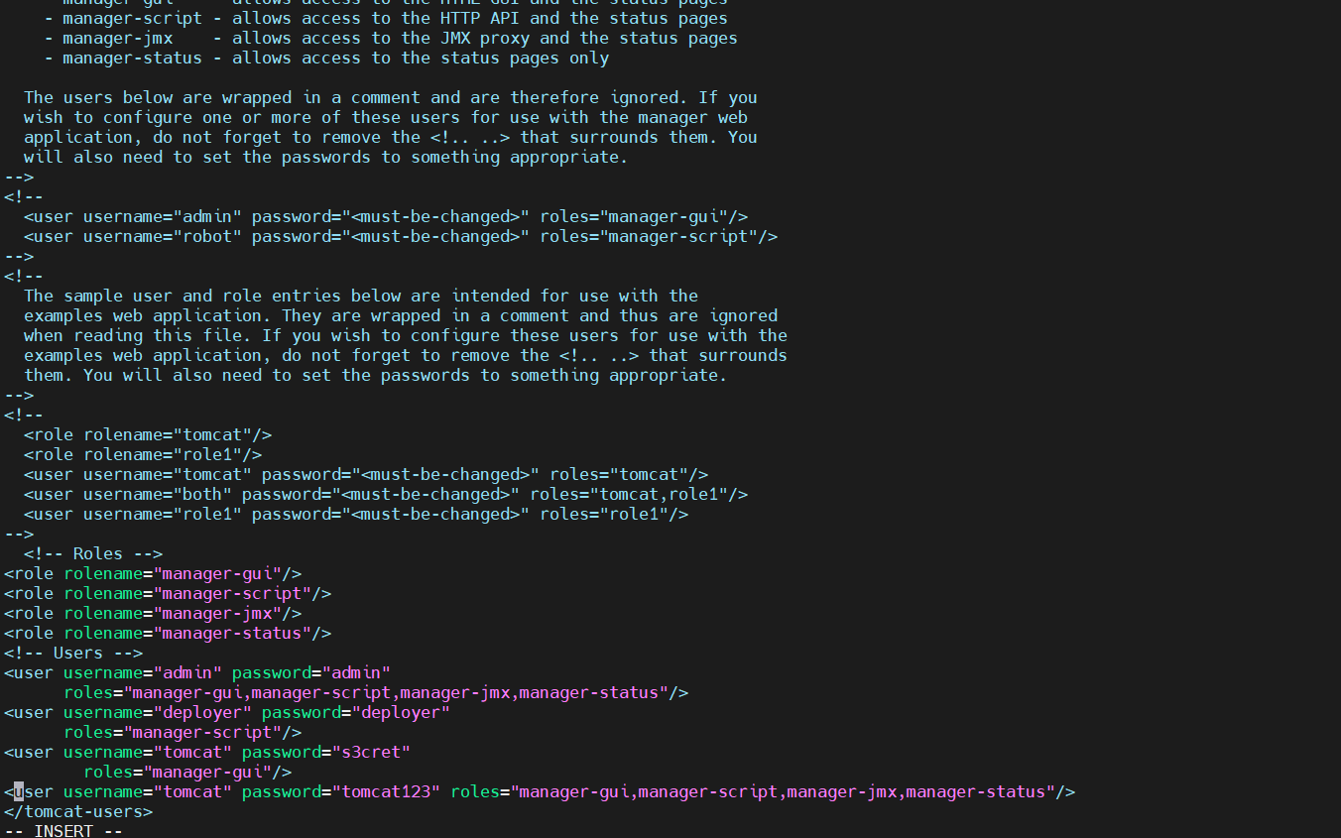
Step 27: Allow Remote Access to Tomcat Manager
Server path / CLI path:
/opt/tomcat/webapps/manager/META-INF/context.xml
Action performed:
- Commented or removed IP restriction valve:
<!--
<Valve className="org.apache.catalina.valves.RemoteCIDRValve"
allow="127.0.0.1"/>
-->
Explanation:
By default, Tomcat restricts manager access to localhost.
This must be disabled to allow Jenkins (remote server) to deploy.
Evidence:
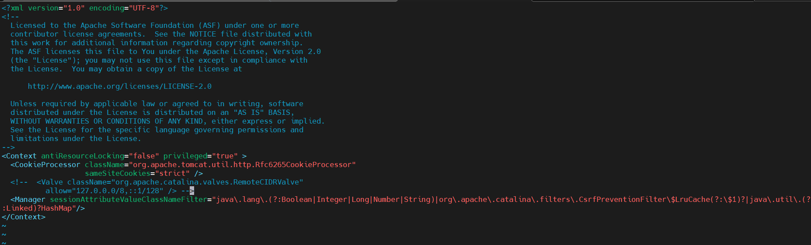
Step 28: Restart Tomcat Server
CLI command used:
systemctl restart tomcat
(or equivalent startup script)
Explanation:
Tomcat must be restarted for user and context changes to take effect.
Evidence:
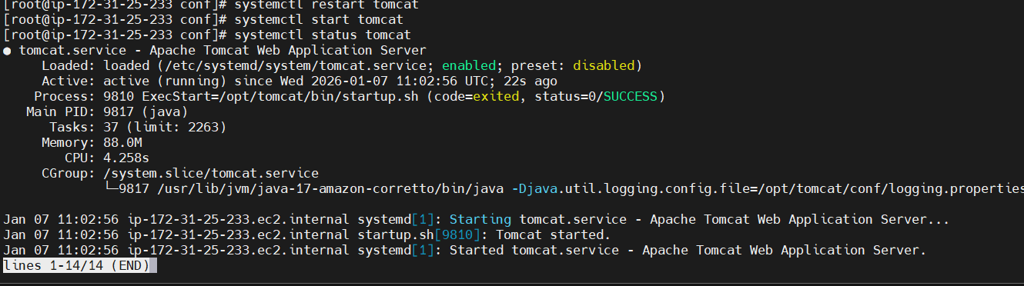
Step 29: Configure Tomcat Credentials in Jenkins
Jenkins path:
Manage Jenkins → Credentials → Global → Add Credentials
Credential details:
- Kind: Username with password
- ID: tomcat-cred-01
- Username: tomcat
- Password: tomcat123
Explanation:
These credentials are referenced in the pipeline using credentialsId.
Evidence:
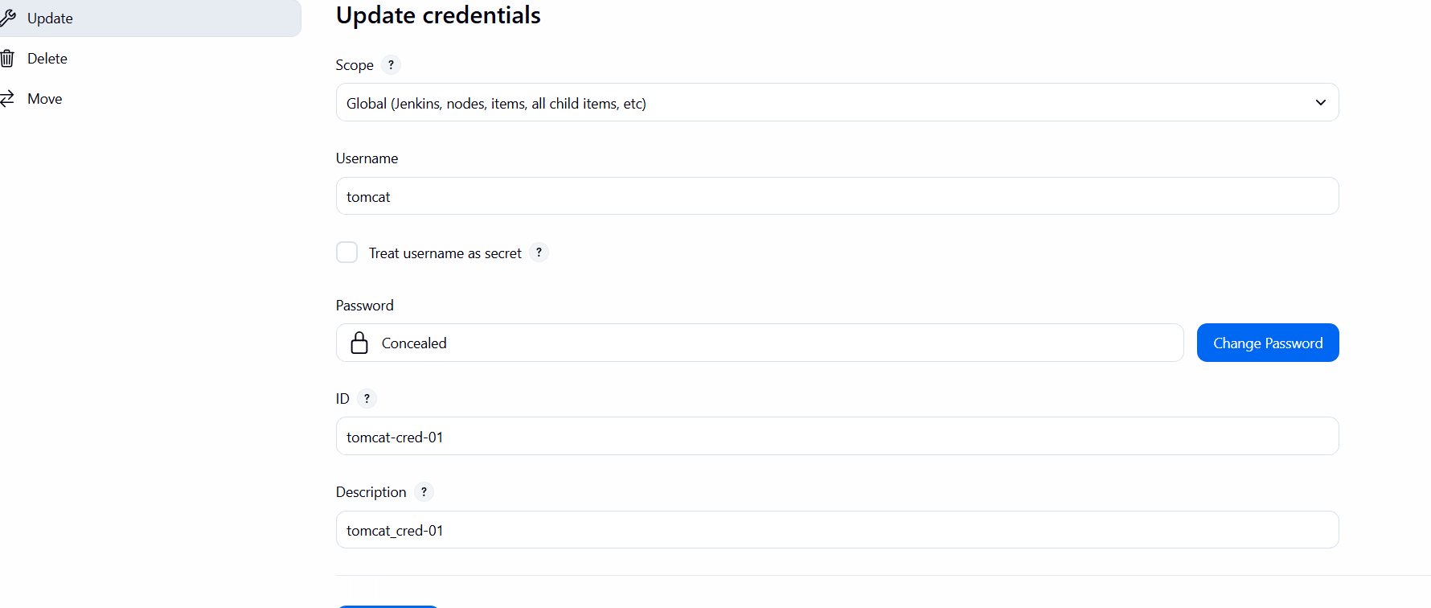
Step 30: Re-run Pipeline – Successful Deployment
Console path / UI path:
Jenkins_Assignment04_Task03 → Build #18 → Console Output
Observed success logs:
Deploying SimpleCustomerApp-18-SNAPSHOT.war
Redeploying WAR
Undeploying existing application
Deploying WAR
Finished: SUCCESS
Explanation:
The WAR file was successfully deployed to Tomcat 9.x Remote with context path sabear.
Evidence:
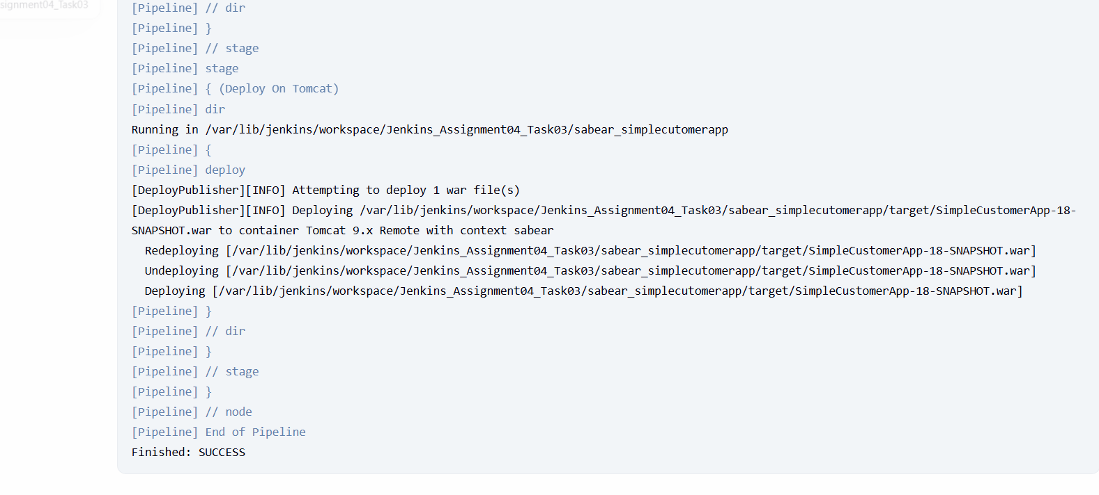
Step 31: Verify Application Access on Tomcat
Browser URL:
http://50.19.32.15:8080/sabear
Explanation:
After deployment, the application is accessed through the configured context path to confirm it is running.
Slack Notification
Step 32: Slack Notification (Success & Failure)
Correct Scripted Pipeline Pattern (Important Fix)
Root cause from image:
Error:
expecting EOF, found 'catch'
Reason:
try {} and catch {} were placed outside node {}, which is invalid in Scripted Pipeline.

Correct Implementation
node {
try {

stage('Slack Notification - Success') {
slackSend(
botUser: true,
color: 'good',
message: "Maninder | ${env.JOB_NAME} - #${env.BUILD_NUMBER} Success (<${env.BUILD_URL}|Open>)",
tokenCredentialId: 'techiehorizon'
)
}

} catch (err) {

stage('Slack Notification - Failure') {
slackSend(
botUser: true,
color: 'danger',
message: "Maninder | ${env.JOB_NAME} - #${env.BUILD_NUMBER} Failed (<${env.BUILD_URL}|Open>)",
tokenCredentialId: 'techiehorizon'
)
}

throw err
}
}

Explanation:
- try-catch must be inside node {}
- Ensures Slack notification runs on success or failure
- throw err correctly marks build as failed

Evidence (From Console Output Image):
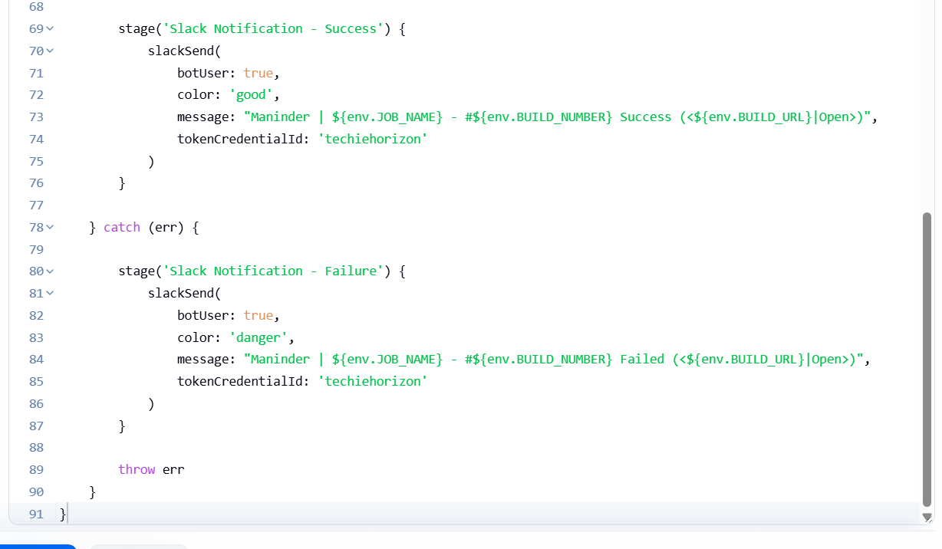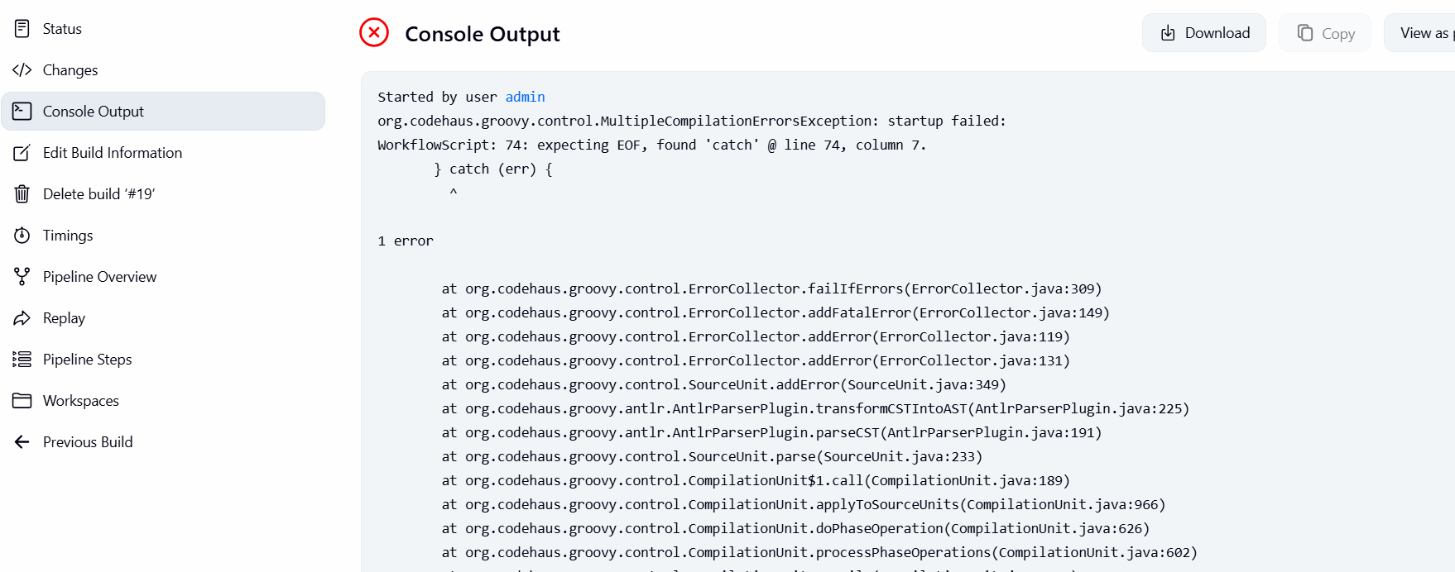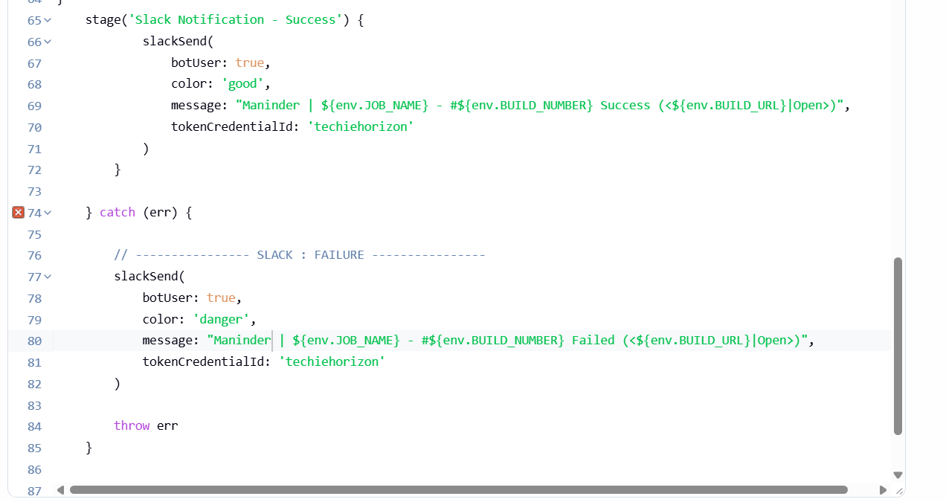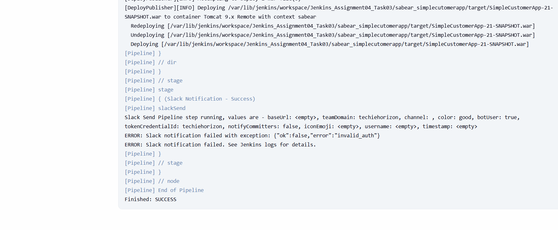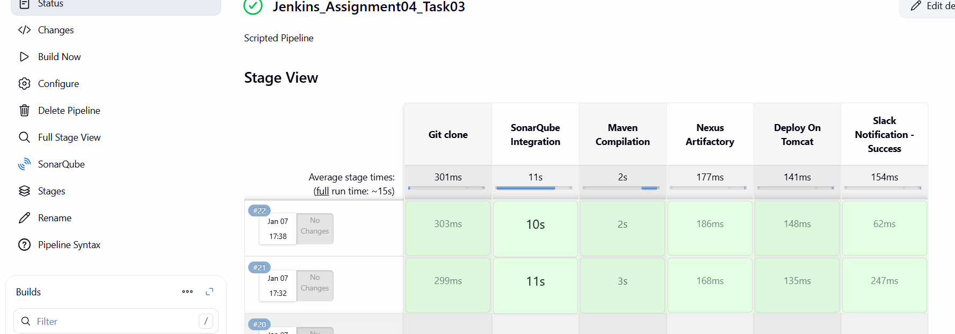
The following Scripted pipeline was created at the end of the task:

node {

try {

stage('Git clone') {
sh '''
rm -rf sabear_simplecutomerapp
git clone -b feature-1.1 https://github.com/betawins/sabear_simplecutomerapp.git
'''
}

stage('SonarQube Integration') {
dir('sabear_simplecutomerapp') {
withSonarQubeEnv('sonarqube-Docker') {
sh '''
/opt/sonar-scanner/bin/sonar-scanner \
-Dsonar.projectKey=sabear-simplecustomerapp \
-Dsonar.projectName=SimpleCustomerApp \
-Dsonar.sources=. \
-Dsonar.exclusions=**/*.java
'''
}
}
}

stage('Maven Compilation') {
dir('sabear_simplecutomerapp') {
sh '/opt/maven/bin/mvn clean package'
}
}

stage('Nexus Artifactory') {
dir('sabear_simplecutomerapp') {
nexusArtifactUploader(
nexusVersion: 'nexus3',
protocol: 'http',
nexusUrl: '3.86.99.80:8081',
repository: 'jenkins_Assignment04-task3',
credentialsId: 'mani',
groupId: 'com.javatpoint',
version: "${env.BUILD_NUMBER}-SNAPSHOT",
artifacts: [
[
artifactId: 'SimpleCustomerApp',
classifier: '',
file: "target/SimpleCustomerApp-${env.BUILD_NUMBER}-SNAPSHOT.war",
type: 'war'
]
]
)
}
}

stage('Deploy On Tomcat') {
dir('sabear_simplecutomerapp') {
deploy(
adapters: [
tomcat9(
credentialsId: 'tomcat-cred-01',
url: 'http://50.19.32.15:8080/'
)
],
contextPath: 'sabear',
war: 'target/*.war'
)
}
}

stage('Slack Notification - Success') {
slackSend(
botUser: true,
color: 'good',
message: "Maninder | ${env.JOB_NAME} - #${env.BUILD_NUMBER} Success (<${env.BUILD_URL}|Open>)",
tokenCredentialId: 'techiehorizon'
)
}

} catch (err) {

stage('Slack Notification - Failure') {
slackSend(
botUser: true,
color: 'danger',
message: "Maninder | ${env.JOB_NAME} - #${env.BUILD_NUMBER} Failed (<${env.BUILD_URL}|Open>)",
tokenCredentialId: 'techiehorizon'
)
}

throw err
}
}
Conclusion
A fully functional Scripted Jenkins CI/CD pipeline was successfully implemented using the feature-1.1 branch.
All stages—from Git clone to deployment on Tomcat—were executed correctly.
Slack integration was implemented with proper try-catch handling, and issues were identified and documented.

Task-04
Write sample skeleton of pipelines

Declarative script:

pipeline {
agent any

tools {
maven 'MVN_HOME'
}

stages {

stage('Git Clone') {
steps {
git branch: 'feature-1.1',
url: 'https://github.com/betawins/sabear_simplecutomerapp.git'
}
}

stage('SonarQube Analysis') {
steps {
withSonarQubeEnv('sonarqube-Docker') {
sh '''
/opt/sonar-scanner/bin/sonar-scanner \
-Dsonar.projectKey=sabear-simplecustomerapp \
-Dsonar.projectName=SimpleCustomerApp \
-Dsonar.sources=. \
-Dsonar.exclusions=**/*.java
'''
}
}
}

stage('Maven Build') {
steps {
sh '''
mvn clean package
'''
}
}

stage('Nexus Artifactory') {
steps {
nexusArtifactUploader(
nexusVersion: 'nexus3',
protocol: 'http',
nexusUrl: '100.26.106.60:8081',
repository: 'jenkins_Assignment04-task2',
credentialsId: 'mani',
groupId: 'com.javatpoint',
version: "${BUILD_NUMBER}-SNAPSHOT",
artifacts: [
[
artifactId: 'SimpleCustomerApp',
classifier: '',
file: "target/SimpleCustomerApp-${BUILD_NUMBER}-SNAPSHOT.war",
type: 'war'
]
]
)
}
}

stage('Deploy to Tomcat') {
steps {
deploy adapters: [
tomcat9(
credentialsId: 'tomcat-cred-01',
url: "http://54.221.169.143:8080/"
)
],
contextPath: 'sabear',
war: 'target/*.war'
}
}
}

post {
success {
slackSend(
color: 'good',
message: "Maninder | ${env.JOB_NAME} - #${env.BUILD_NUMBER} Success (<${env.BUILD_URL}|Open>)",
tokenCredentialId: 'techiehorizon'
)
}
failure {
slackSend(
color: 'danger',
message: "Maninder | ${env.JOB_NAME} - #${env.BUILD_NUMBER} Failed (<${env.BUILD_URL}|Open>)",
tokenCredentialId: 'techiehorizon'
)
}
}
}

Scripted pipeline:

node {

try {

stage('Git clone') {
sh '''
rm -rf sabear_simplecutomerapp
git clone -b feature-1.1 https://github.com/betawins/sabear_simplecutomerapp.git
'''
}

stage('SonarQube Integration') {
dir('sabear_simplecutomerapp') {
withSonarQubeEnv('sonarqube-Docker') {
sh '''
/opt/sonar-scanner/bin/sonar-scanner \
-Dsonar.projectKey=sabear-simplecustomerapp \
-Dsonar.projectName=SimpleCustomerApp \
-Dsonar.sources=. \
-Dsonar.exclusions=**/*.java
'''
}
}
}

stage('Maven Compilation') {
dir('sabear_simplecutomerapp') {
sh '/opt/maven/bin/mvn clean package'
}
}

stage('Nexus Artifactory') {
dir('sabear_simplecutomerapp') {
nexusArtifactUploader(
nexusVersion: 'nexus3',
protocol: 'http',
nexusUrl: '3.86.99.80:8081',
repository: 'jenkins_Assignment04-task3',
credentialsId: 'mani',
groupId: 'com.javatpoint',
version: "${env.BUILD_NUMBER}-SNAPSHOT",
artifacts: [
[
artifactId: 'SimpleCustomerApp',
classifier: '',
file: "target/SimpleCustomerApp-${env.BUILD_NUMBER}-SNAPSHOT.war",
type: 'war'
]
]
)
}
}

stage('Deploy On Tomcat') {
dir('sabear_simplecutomerapp') {
deploy(
adapters: [
tomcat9(
credentialsId: 'tomcat-cred-01',
url: 'http://50.19.32.15:8080/'
)
],
contextPath: 'sabear',
war: 'target/*.war'
)
}
}

stage('Slack Notification - Success') {
slackSend(
botUser: true,
color: 'good',
message: "Maninder | ${env.JOB_NAME} - #${env.BUILD_NUMBER} Success (<${env.BUILD_URL}|Open>)",
tokenCredentialId: 'techiehorizon'
)
}
} catch (err) {

stage('Slack Notification - Failure') {
slackSend(
botUser: true,
color: 'danger',
message: "Maninder | ${env.JOB_NAME} - #${env.BUILD_NUMBER} Failed (<${env.BUILD_URL}|Open>)",
tokenCredentialId: 'techiehorizon'
)
}

throw err
}
}

