Jenkins-Assignment-04-Task05,06

5. Create a parameterized job in Jenkins. https://github.com/betawins/spring3-mvc-maven-xml-hello-world-1.git

1) Task Title
Create a Parameterized Job in Jenkins
GitHub Repository:
https://github.com/betawins/spring3-mvc-maven-xml-hello-world-1.git

2) Objective
To create a Jenkins parameterized Freestyle job that allows users to:
- Select deployment environment (DEV / QA / PROD)
- Specify the Git branch dynamically
- Optionally skip unit tests during Maven build
and execute a Maven build accordingly with Slack notifications enabled.

3) Prerequisites
• Jenkins installed and running
• Git plugin installed in Jenkins
• Maven configured in Jenkins Global Tool Configuration
• Slack Notification plugin installed and configured
• Internet access to GitHub repository

4) Step-by-Step Implementation (With Evidence)

Step 1: Create a New Jenkins Job
• Console path / UI path:
Jenkins Dashboard → New Item
• Explanation:
A new Freestyle project named Jenkins_Assignment04_Task05 is created to support parameterized builds.
• Evidence:
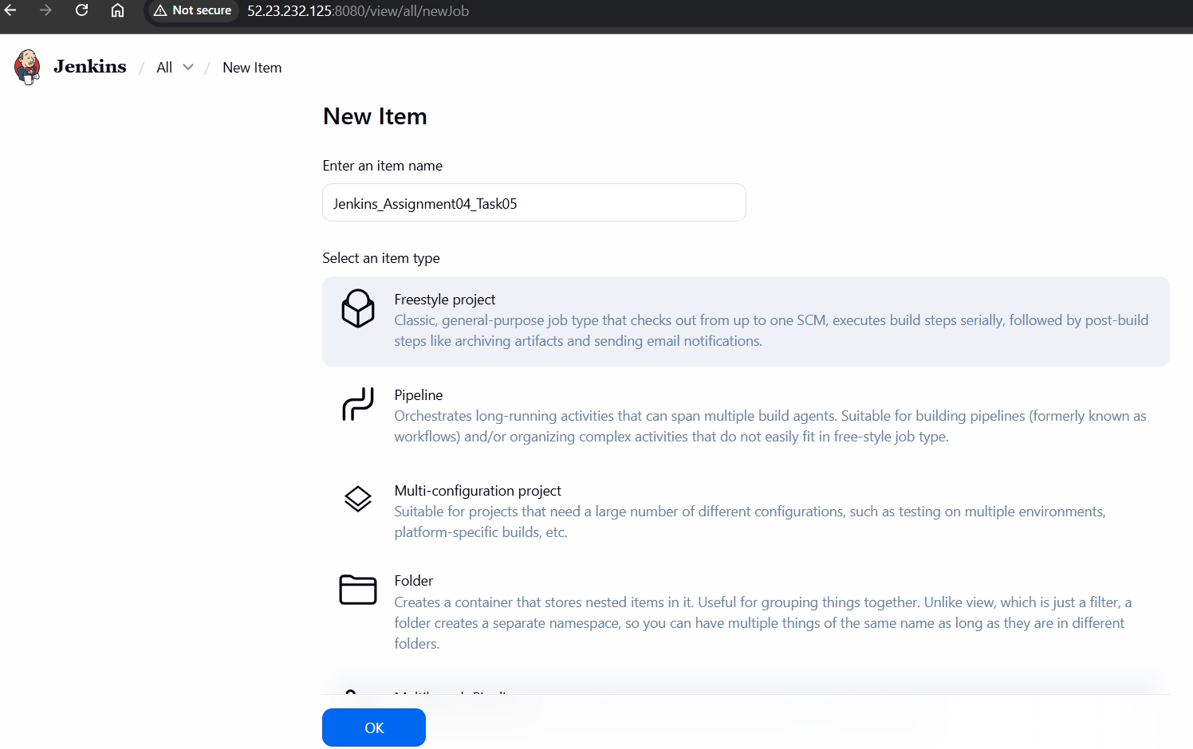

Step 2: Enable Parameterized Build
• Console path / UI path:
Job → Configure → General → This project is parameterized
• Explanation:
Parameterized builds allow dynamic input values at runtime. Three parameters were added:
- Choice Parameter (ENV)
- String Parameter (GIT_Branch)
- Boolean Parameter (Skip_Tests)
• Evidence:
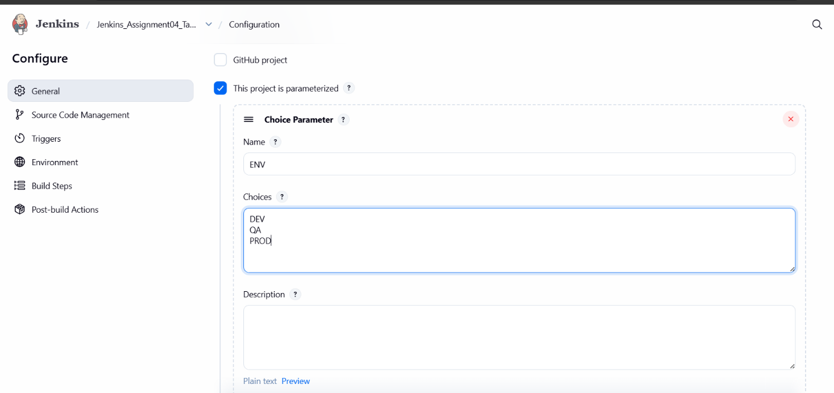

Step 3: Configure Build Parameters
• Console path / UI path:
Job → Configure → General → Add Parameter
• Explanation:
Choice Parameter
- Name: ENV
- Values: DEV, QA, PROD
String Parameter
- Name: GIT_Branch
- Default Value: Master
Boolean Parameter
- Name: Skip_Tests
- Description: SKIP UNIT TESTS
These parameters control environment selection, branch checkout, and test execution.
• Evidence:
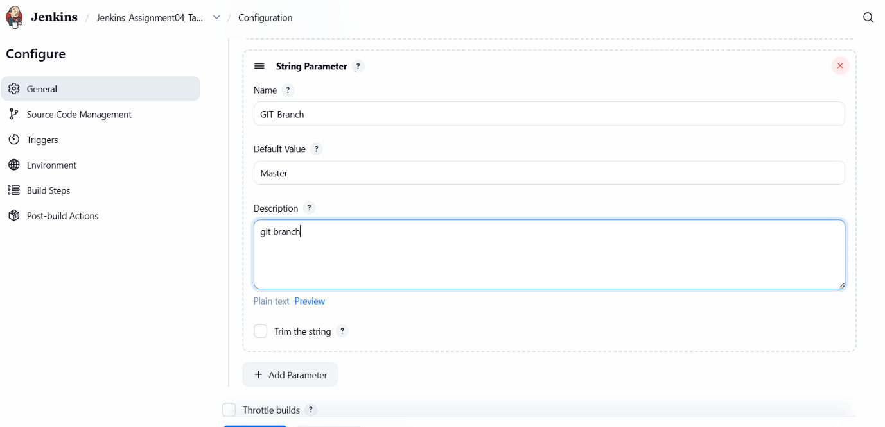

Step 4: Configure Git Source Code Management
• Console path / UI path:
Job → Configure → Source Code Management → Git
• Explanation:
The Git repository is configured with dynamic branch selection using the GIT_Branch parameter.
Repository URL:
https://github.com/betawins/spring3-mvc-maven-xml-hello-world-1.git
Branch Specifier:
*/${GIT_Branch}
• Evidence:
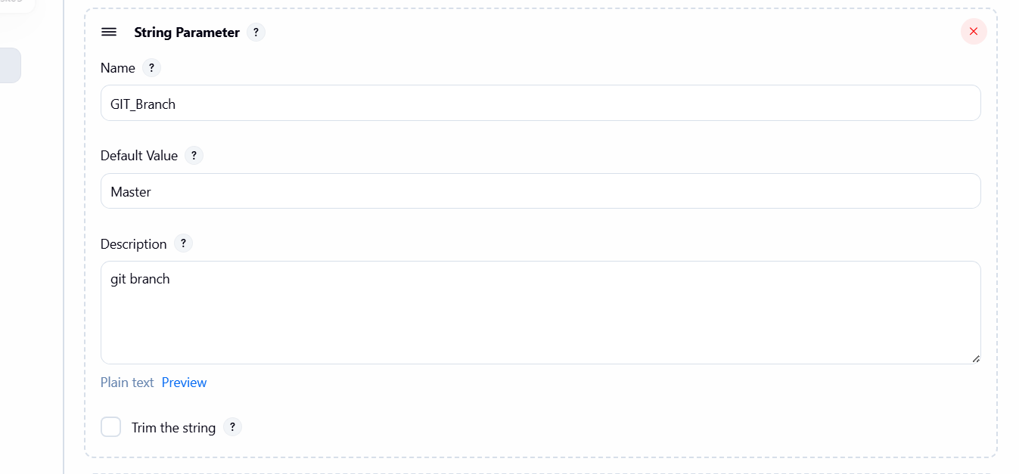

Step 5: Configure Maven Build Step
• Console path / UI path:
Job → Configure → Build Steps → Invoke top-level Maven targets
• Explanation:
Maven goals are configured to optionally skip unit tests based on the Boolean parameter.
Goals:
clean package -DskipTests=${Skip_Tests}
This ensures flexible builds without modifying the pipeline.
• Evidence:
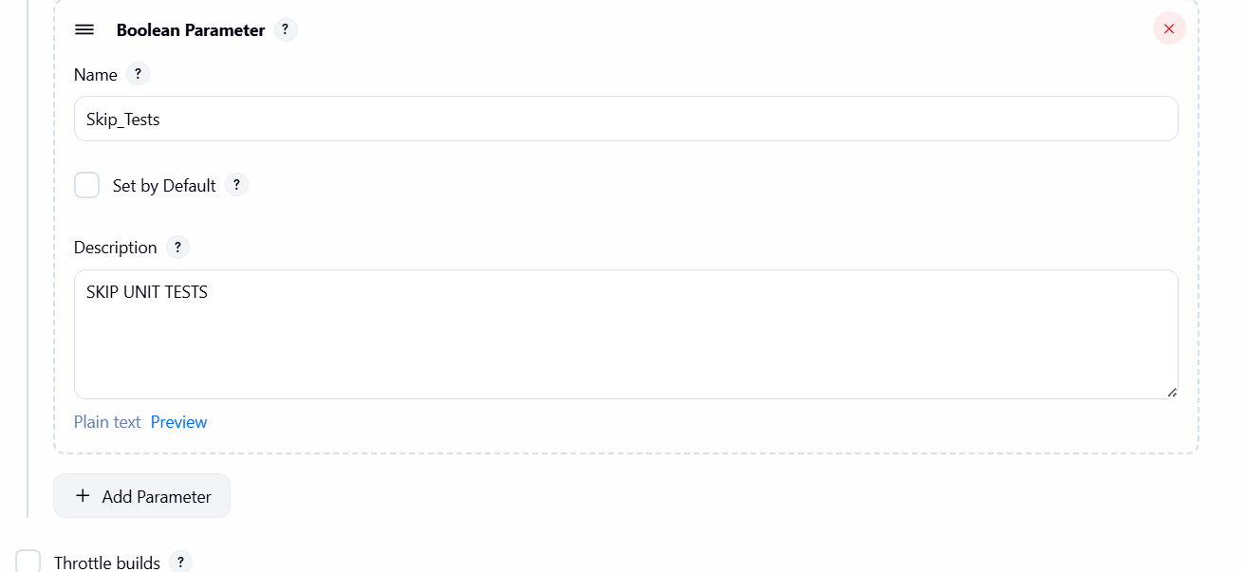

Conclusion
A fully functional Jenkins parameterized Freestyle job was successfully created.
The job supports environment selection, dynamic Git branch checkout, optional test execution, Maven build automation, and Slack notifications.
This setup improves flexibility, reusability, and visibility of CI processes in Jenkins.

6. Setup one slave machine for Jenkins.

1) Task Title
Setup one slave (agent) machine for Jenkins

2) Objective
To configure a separate EC2 instance as a Jenkins slave (agent) and enable Jenkins to execute jobs on this remote machine using SSH-based communication.

3) Prerequisites
• Jenkins master server running and accessible
• AWS EC2 instance launched for slave
• SSH connectivity between Jenkins master and slave
• Java installed on slave node
• Jenkins admin access
• Git installed on slave node
• Required security group ports open (22, 80, 443, 8080)

4) Step-by-Step Implementation (With Evidence)

Step 1: Launch EC2 Instance for Jenkins Slave
Console path / CLI command:
AWS Console → EC2 → Launch Instance
Explanation:
A new EC2 instance named Jenkins_Assignment-04-slave was launched using Amazon Linux 2023 AMI. Security group rules were configured to allow SSH (22), HTTP (80), HTTPS (443), and Jenkins (8080). Java 17 was installed via user data during instance launch.
Evidence:
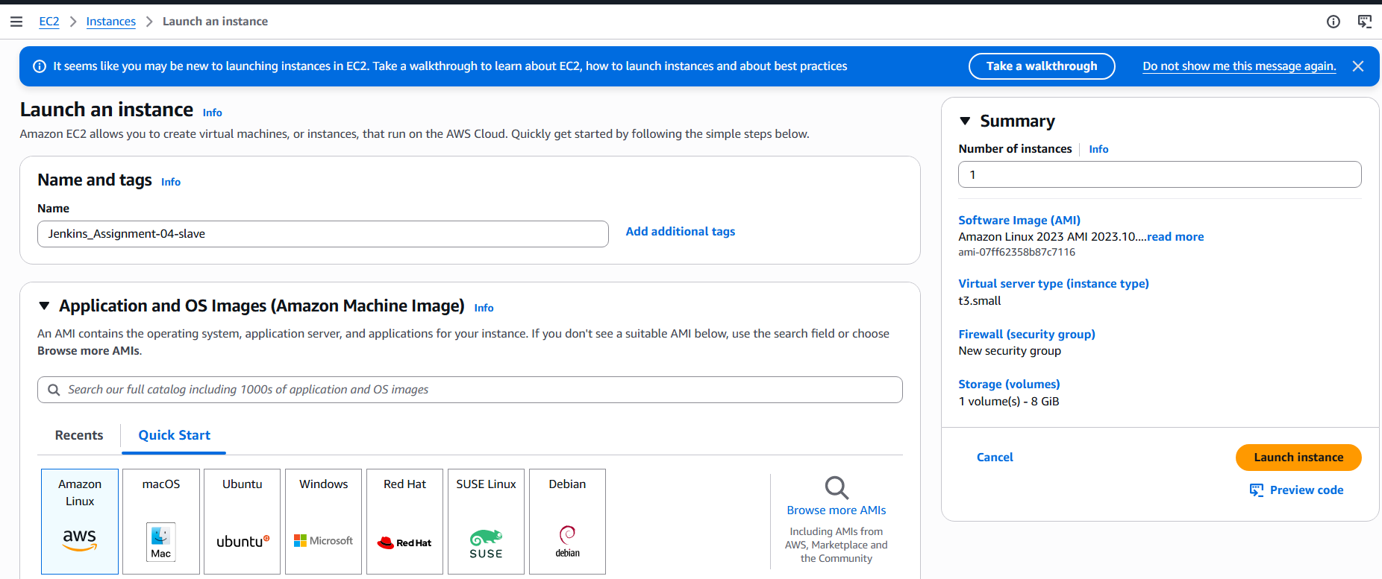 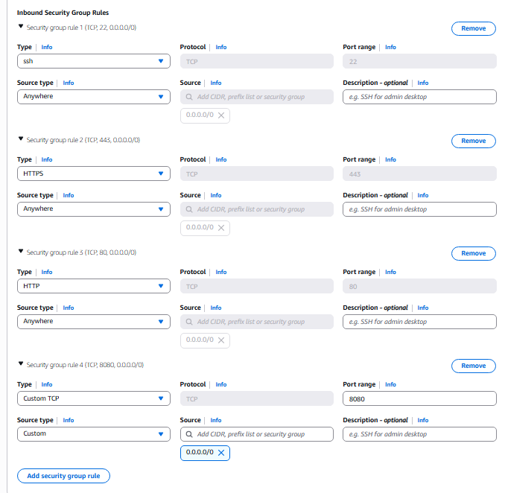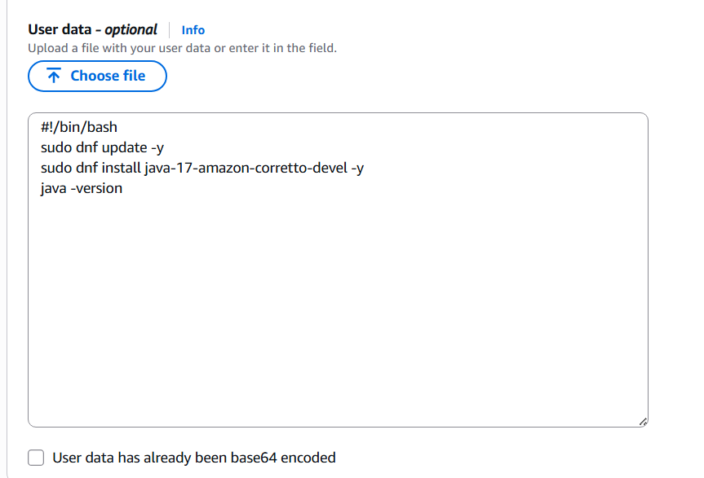

Step 2: Configure SSH Access on Slave Node
Console path / CLI command:
sudo -i
ssh-keygen
cd /root/.ssh
cat id_rsa.pub > authorized_keys
chmod 700 authorized_keys
Explanation:
SSH key pair was generated on the slave instance. The public key was added to authorized_keys to allow passwordless SSH authentication from Jenkins master.
Evidence:
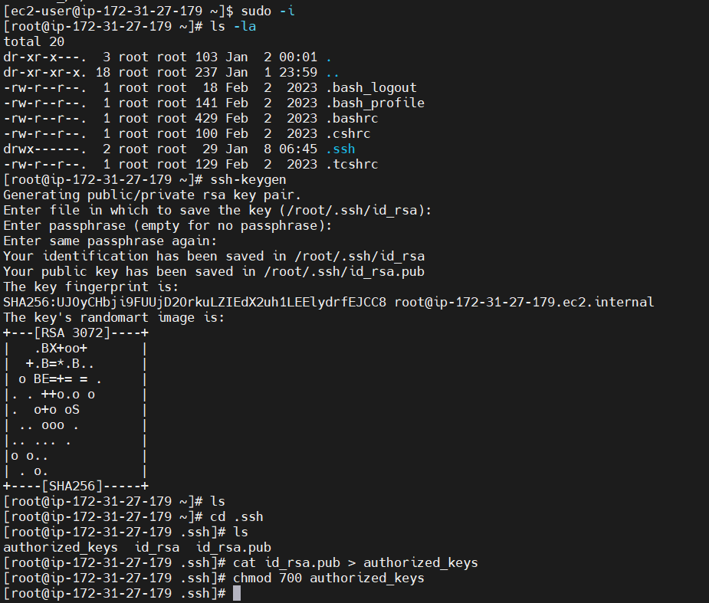

Step 3: Configure Jenkins Master for SSH Trust
Console path / CLI command:
mkdir -p /var/lib/jenkins/.ssh
ssh-keyscan -H 54.221.128.175 >> /var/lib/jenkins/.ssh/known_hosts
Explanation:
The slave host fingerprint was added to Jenkins master’s known_hosts file to avoid SSH authenticity prompts during agent connection.
Evidence:
• 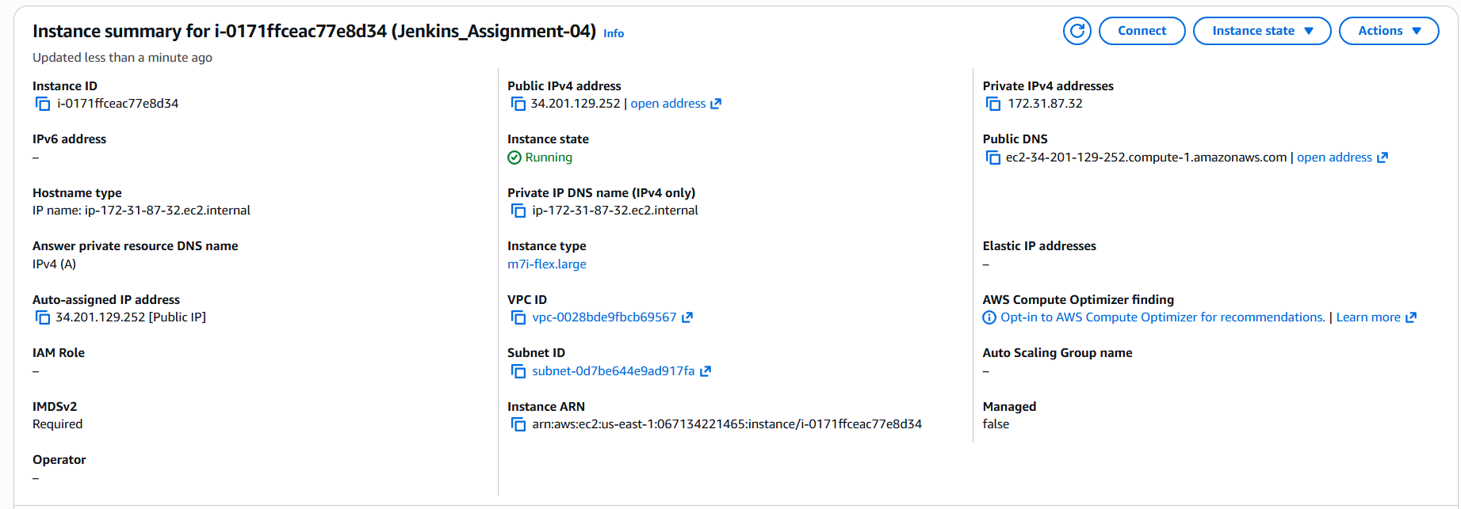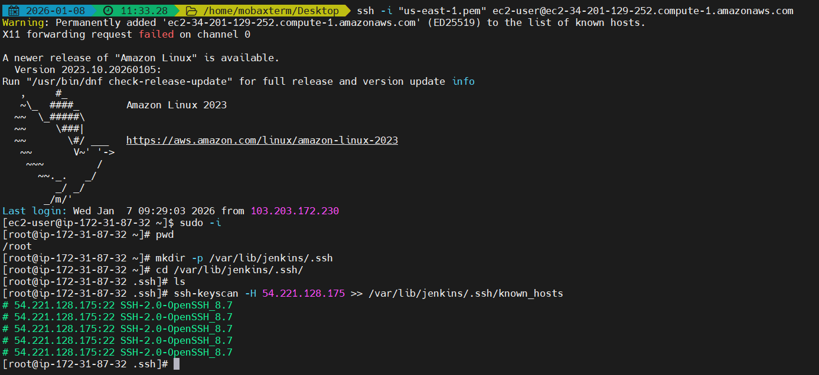

Step 4: Create Jenkins Node (Slave)
Console path:
Jenkins → Manage Jenkins → Nodes → New Node
Explanation:
A new permanent agent named slave was created. Configuration included executors, remote root directory, label, and SSH launch method.
Evidence:
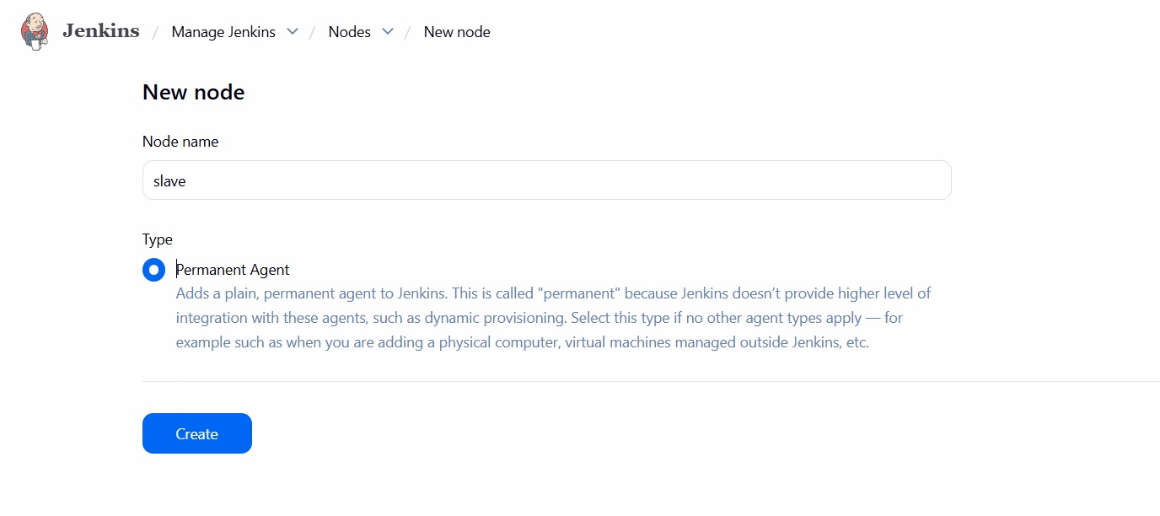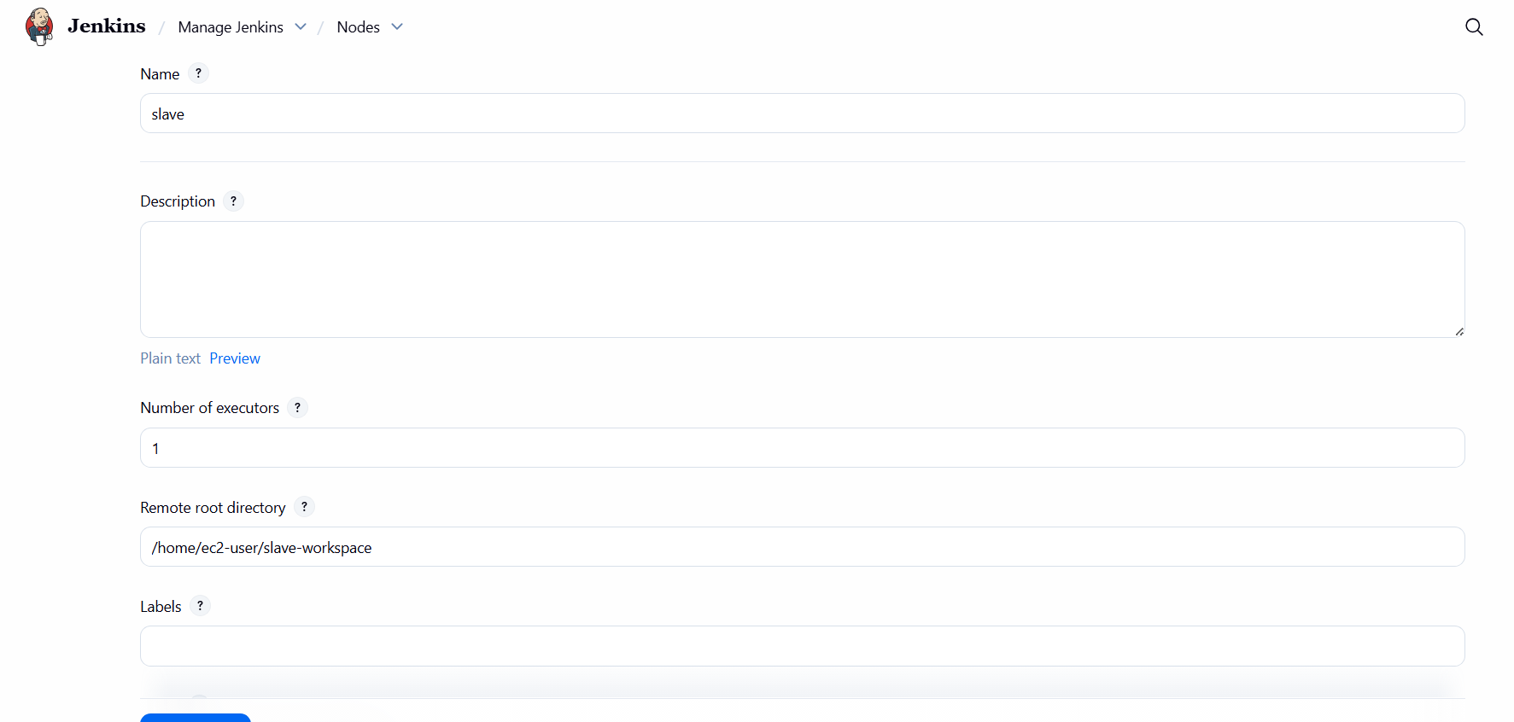

Step 5: Configure SSH Credentials in Jenkins
Console path:
Jenkins → Manage Jenkins → Credentials → Global → Add Credentials
Explanation:
An SSH credential of type “SSH Username with private key” was created with ID Slave01_key and username ec2-user. The private key from the slave node was pasted directly.
Evidence:
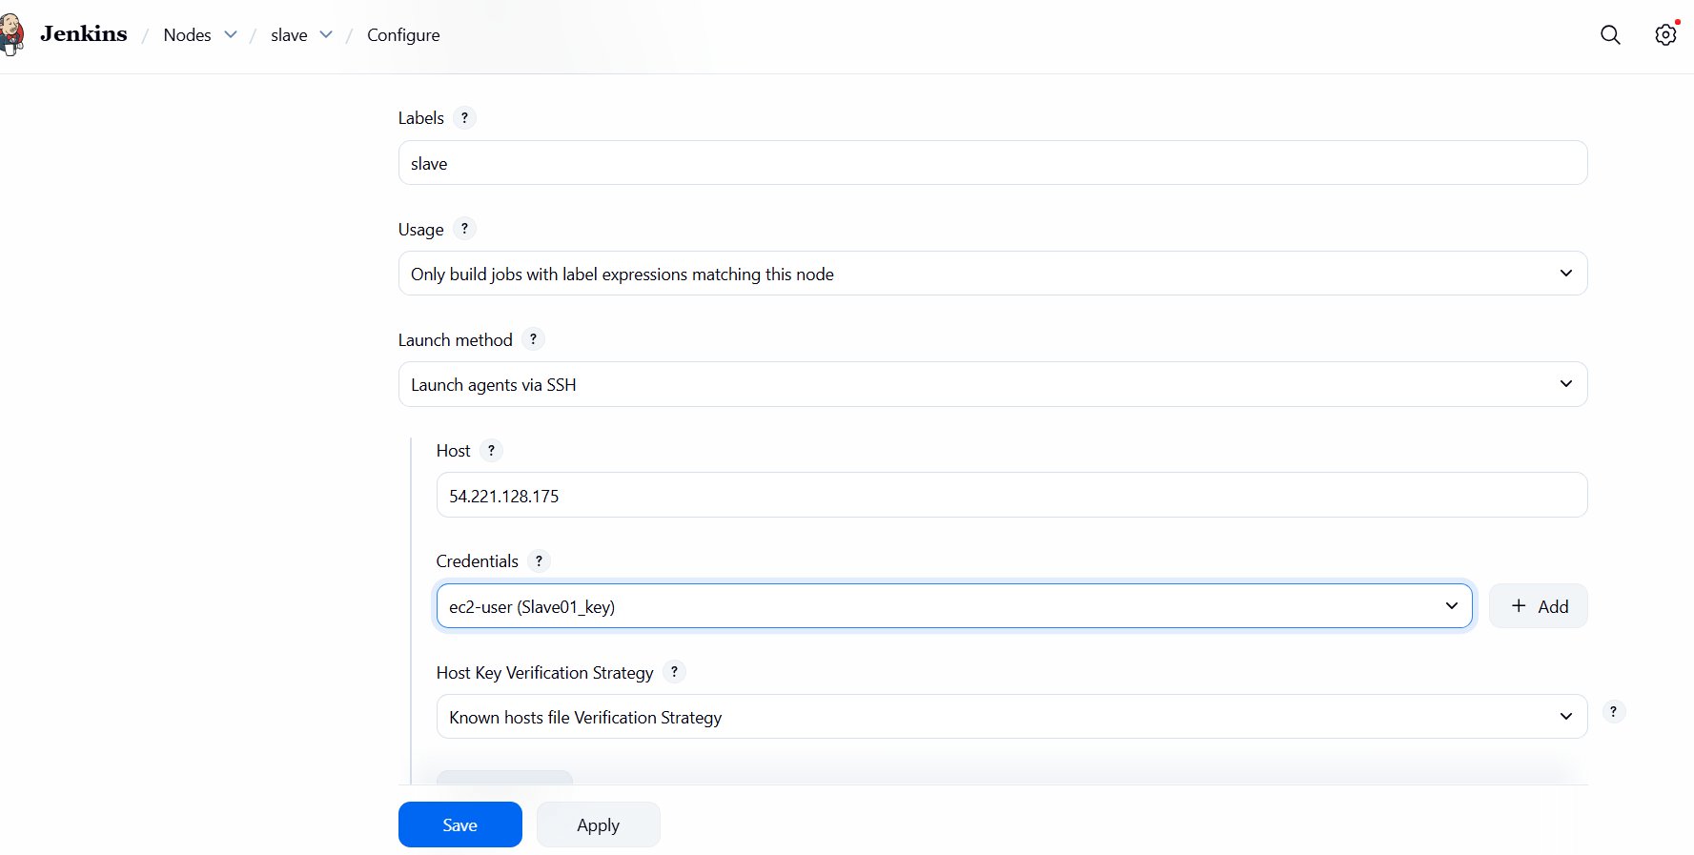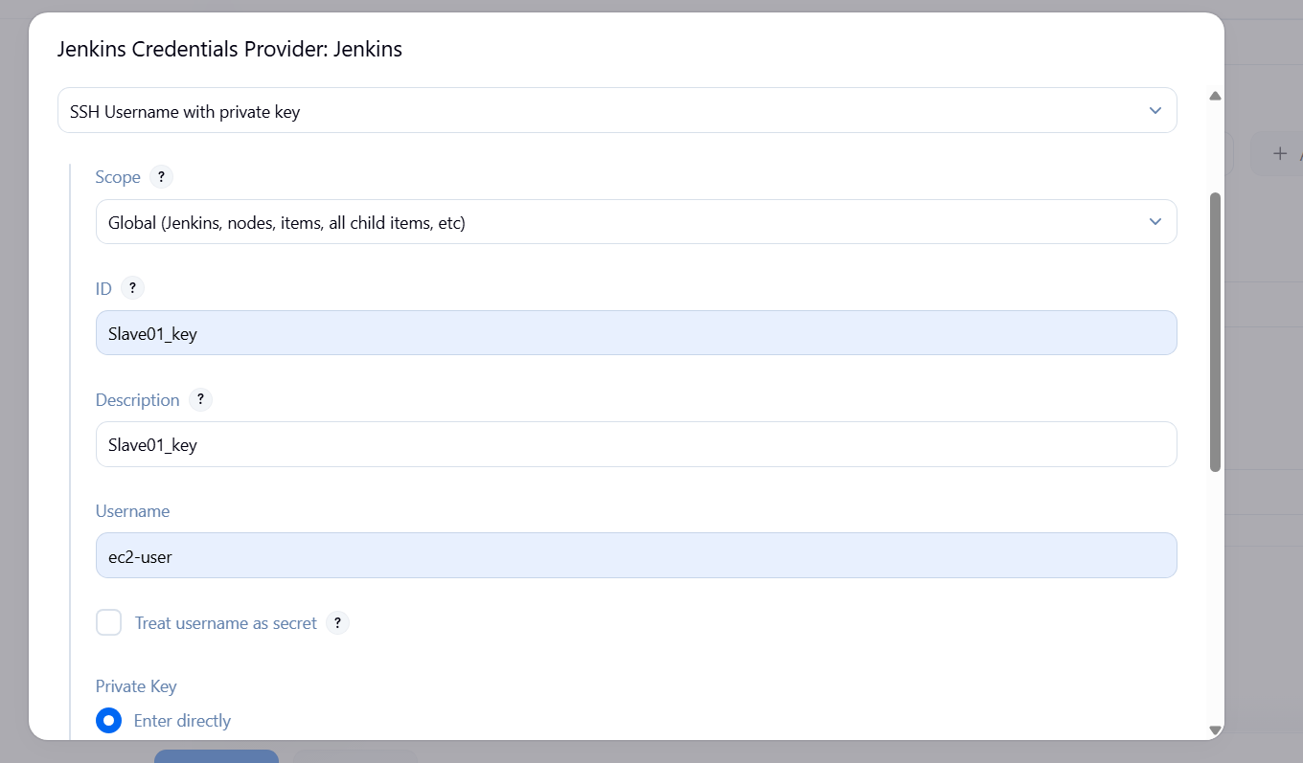

Step 6: Attach Credentials to Slave Node
Console path:
Jenkins → Manage Jenkins → Nodes → slave → Configure
Explanation:
Slave node was configured to launch agents via SSH using host IP 54.221.128.175, credential Slave01_key, and known hosts verification strategy.
Evidence:


Step 7: Create Jenkins Job Targeting Slave
Console path:
Jenkins → New Item → Freestyle Project
Explanation:
A freestyle job Jenkins_Assignment04_Task06 was created and restricted to run only on nodes with label slave. Git SCM was configured with a public GitHub repository.
Evidence:
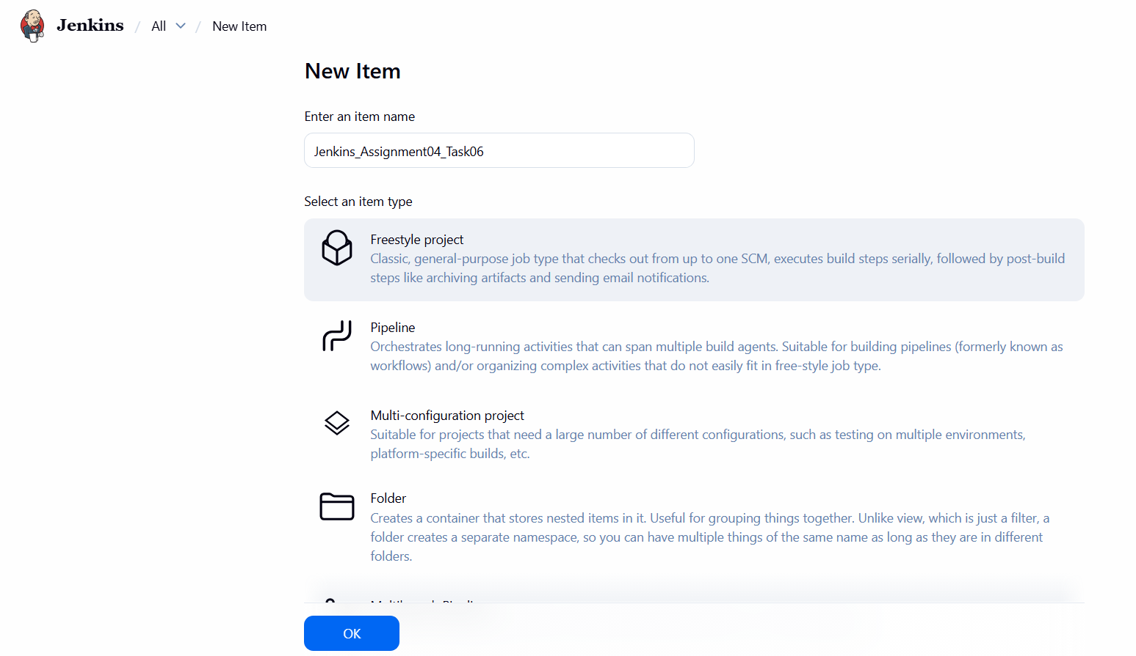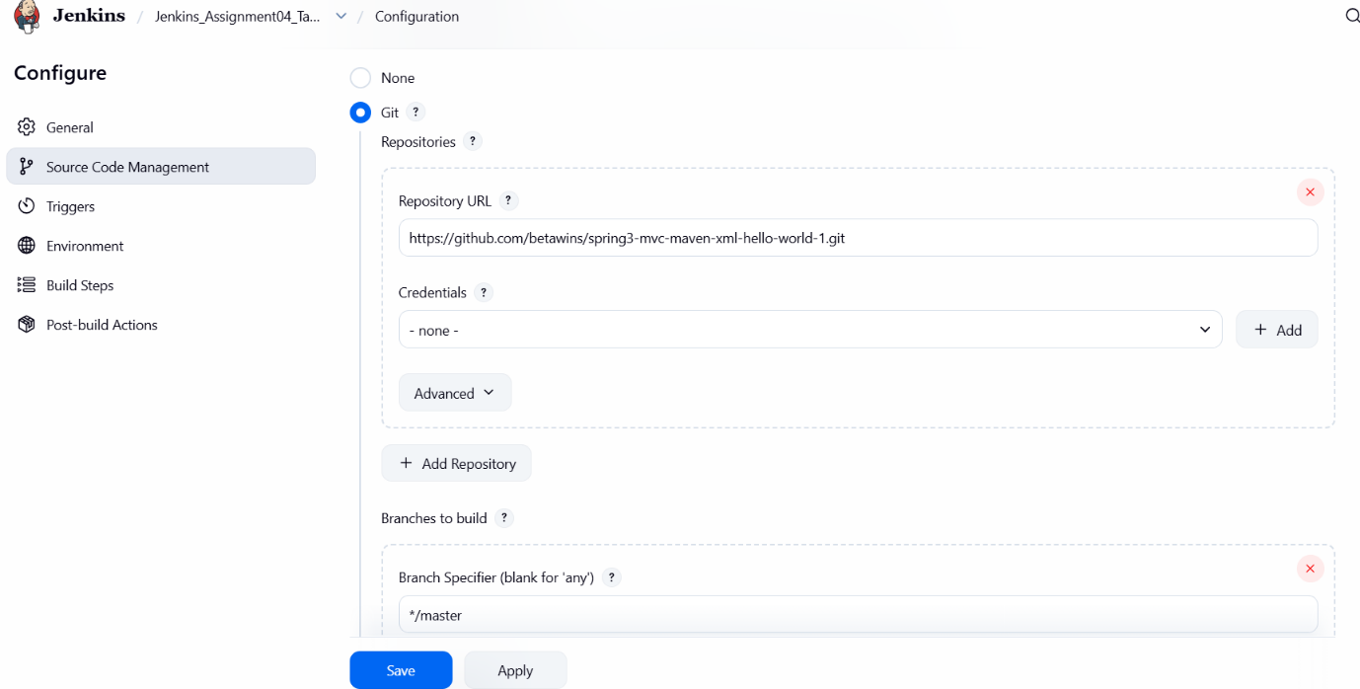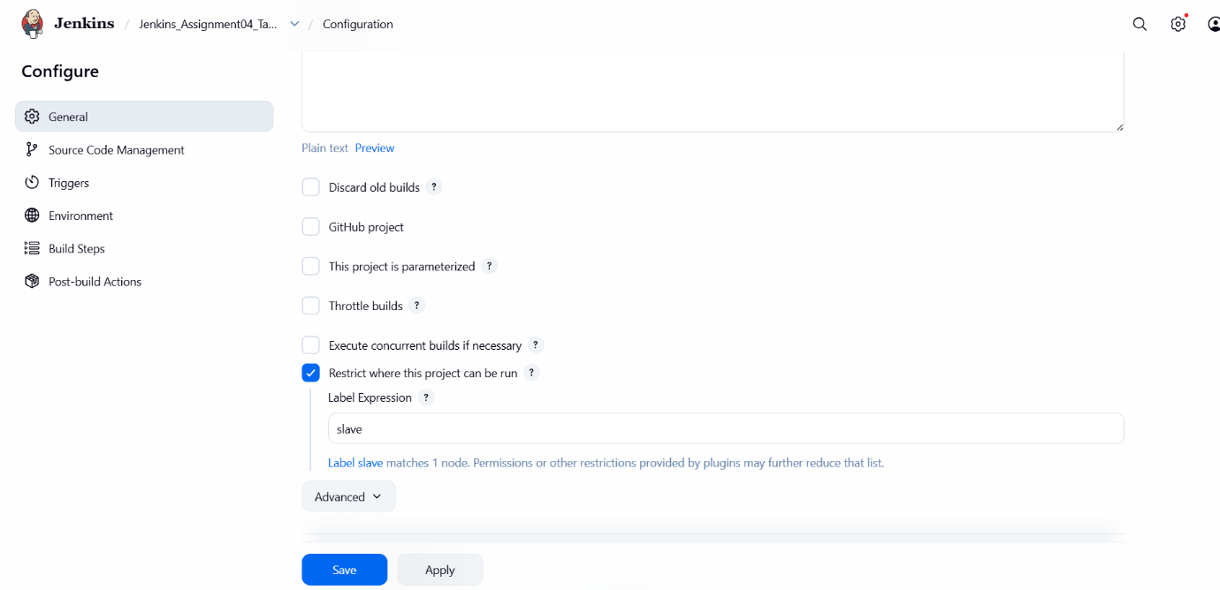

Step 8: Resolve Build Failure (Git Missing)
Console path / CLI command:
sudo yum install git -y
Explanation:
Initial build failed because Git was not installed on the slave node. After installing Git, the job was re-run successfully.
Evidence:
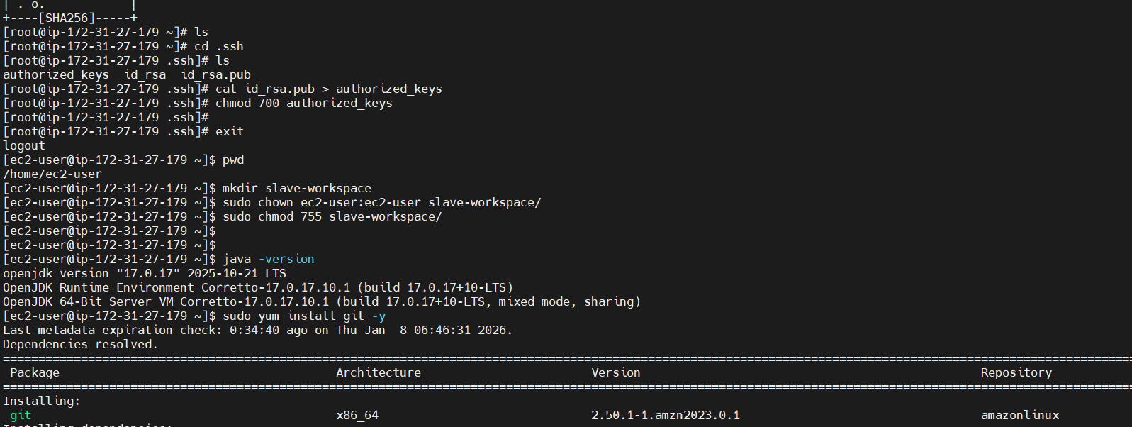

5) Validation Steps (Mandatory, With Evidence)

Validation 1: Resource Health
Example:
Check Jenkins Nodes dashboard
Evidence:
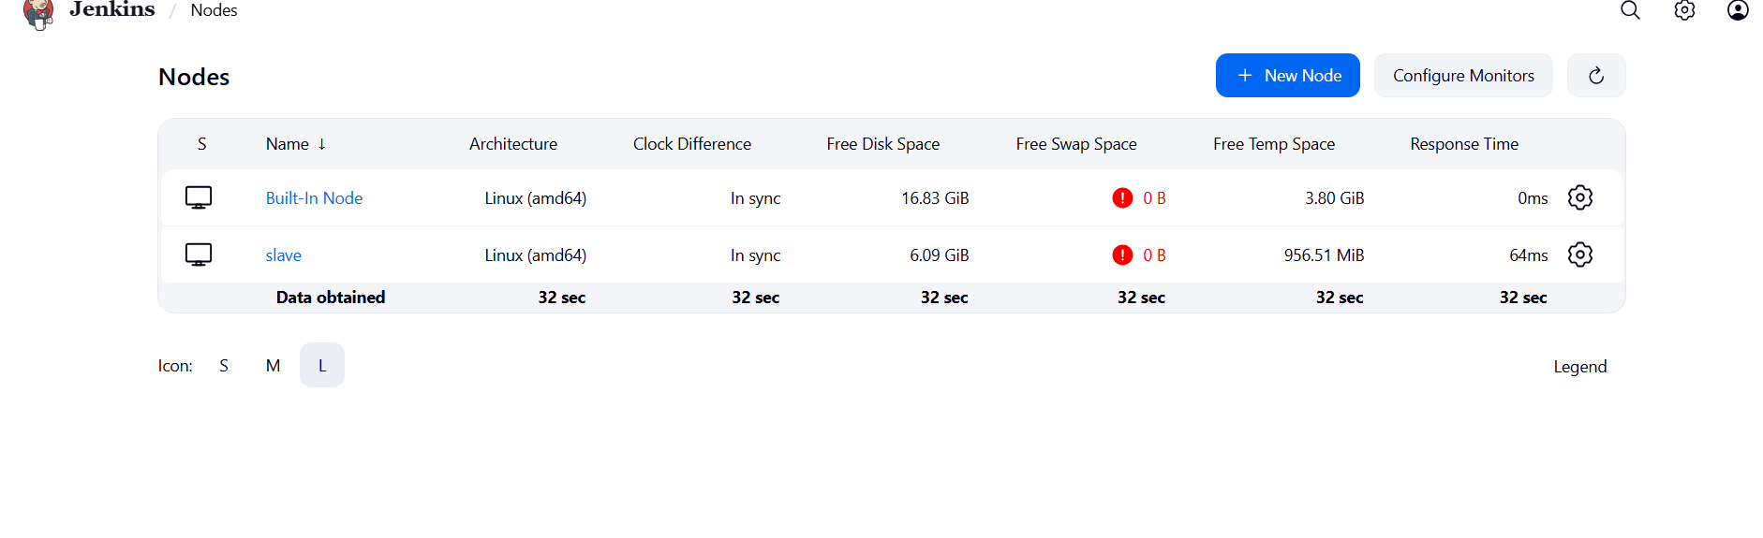

Validation 2: Functional Check
Example:
Run Jenkins job on slave
Evidence:
• 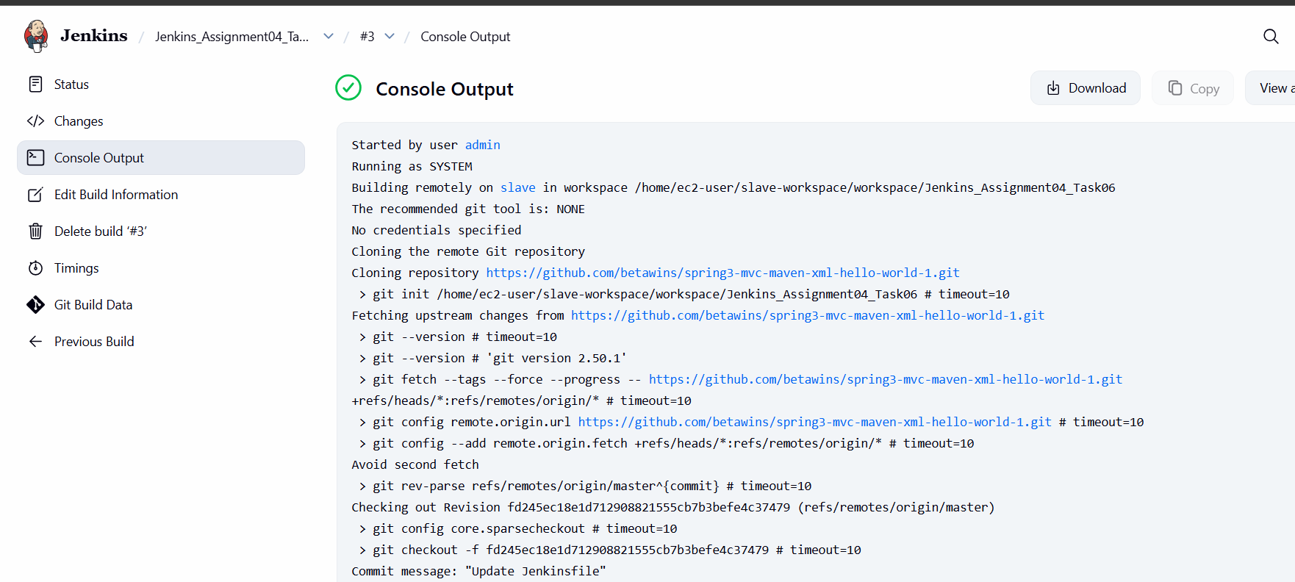

Validation 3: Network Check
Example:
SSH connectivity between master and slave
Evidence:
• 

Validation 4: Access Check
Example:
Workspace creation on slave
Evidence:
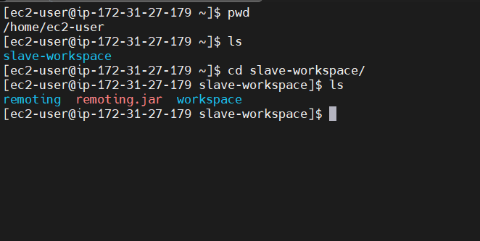

6) Issues Faced (Optional)
• Jenkins job failed initially due to missing Git binary on slave
• Issue resolved by installing Git using yum install git -y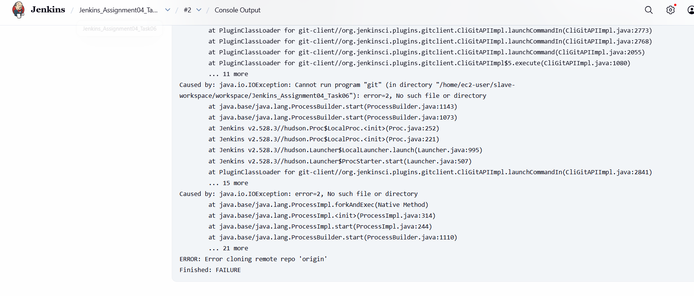

7) Conclusion
The Jenkins slave machine was successfully configured using an EC2 instance and integrated with the Jenkins master via SSH.

