Jenkins-Assignment-03

Task 1
Create one Jenkins job using the below code and create three stages:
stage1: Git clone to download the source code.
stage2: Sonarqube Integration to check the quality of code.
stage3: Slack Integration to send the alerts to slack.
URL: https://github.com/betawins/VProfile-1.git

Task Title
Install SonarQube, integrate with PostgreSQL, configure Jenkins SonarQube Scanner, and enable Slack notifications

Objective
To deploy SonarQube with PostgreSQL backend, integrate it with Jenkins for code quality analysis using SonarQube Scanner, and configure Slack notifications for Jenkins build status.

Prerequisites
• 2 x EC2 instances with M7.large instance type
• Java installed
• Jenkins installed and running
• Slack workspace

Step-by-Step Implementation (With Evidence)

Step 1: Launch Jenkins EC2 Instance

Created an EC2 instance using Amazon Linux 2023 with public IP enabled.

Console path:
EC2 → Instances → Launch instance

Key configuration:
• Instance name: jenkins-Sonarqube
• AMI: Amazon Linux 2023
• Instance type: t3.small / t3.micro
• Auto-assign public IP: Enabled

Evidence:
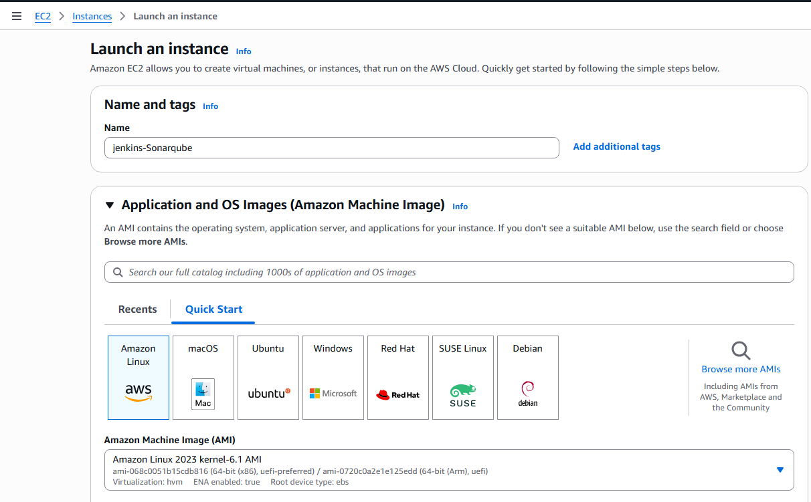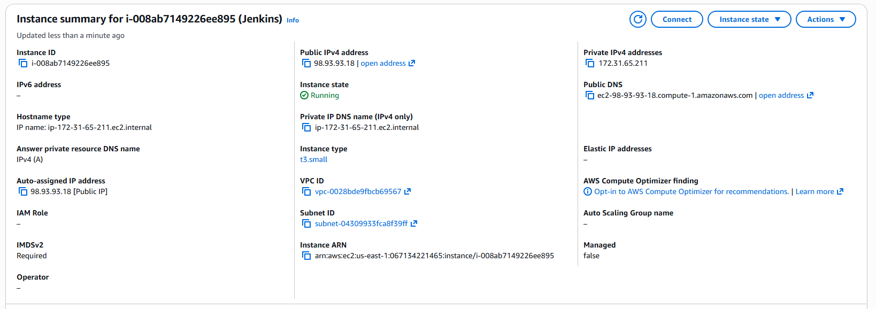
Step 2: Install Jenkins Using User Data Script

User data script used during EC2 launch to install Jenkins automatically.

Script used:

#!/bin/bash
set -e
dnf update -y
dnf install java-17-amazon-corretto -y
wget -O /etc/yum.repos.d/jenkins.repo https://pkg.jenkins.io/redhat-stable/jenkins.repo
rpm --import https://pkg.jenkins.io/redhat-stable/jenkins.io-2023.key
dnf install jenkins -y
systemctl enable jenkins
systemctl start jenkins

Evidence:
Image names:
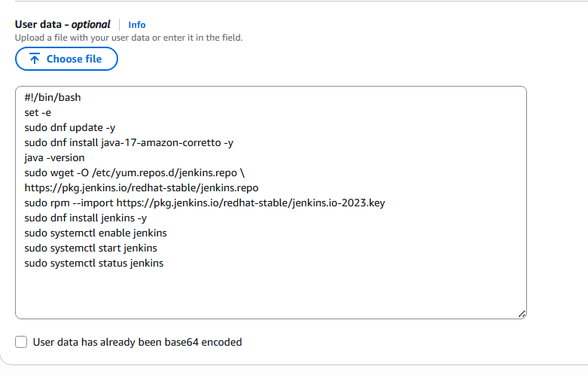
Step 3: Verify Jenkins Instance Status

Verified Jenkins EC2 instance is running and accessible via browser on port 8080.

URL format:
http://<public-ip>:8080

Evidence:
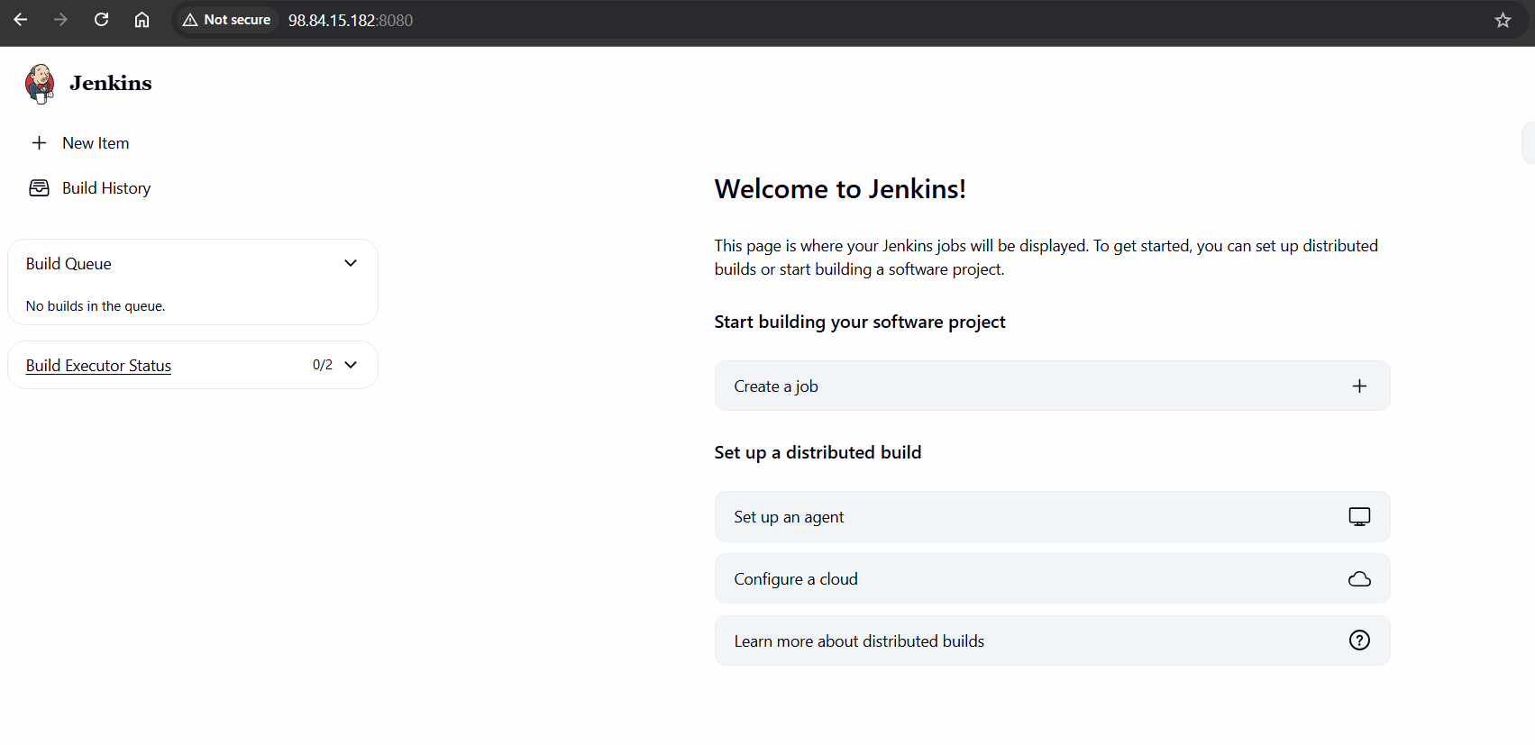
Step 4: Create Jenkins Job (Freestyle Project)

Created a Jenkins job for GitHub repository integration.

Jenkins path:
Jenkins Dashboard → New Item

Configuration:
• Job name: Betawins / stage_1
• Job type: Freestyle project

Evidence:
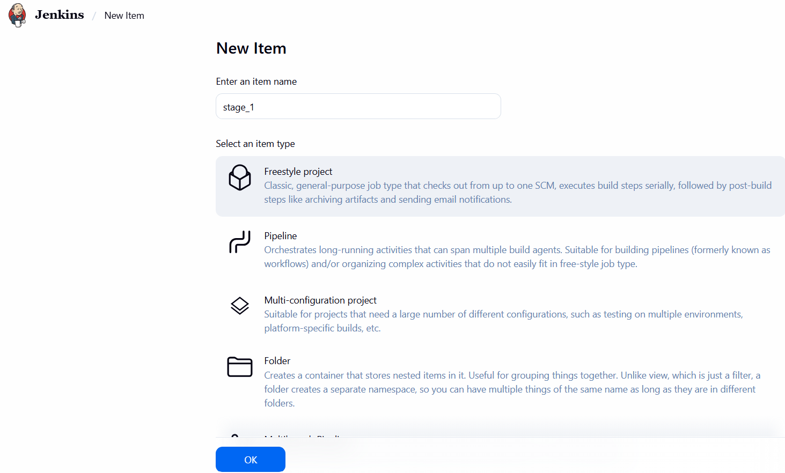

Step 5: Configure Jenkins System Settings

Configured Jenkins master node executors and labels.

Jenkins path:
Manage Jenkins → System

Settings:
• Number of executors: 2
• Label: Master
• Usage: Use this node as much as possible

Evidence:
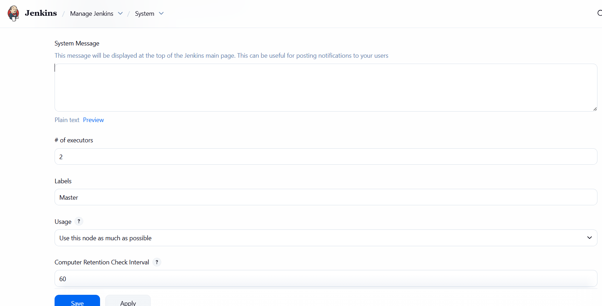
Step 6: Configure Source Code Management (GitHub)

Connected Jenkins job with GitHub repository.

Repository URLs used:
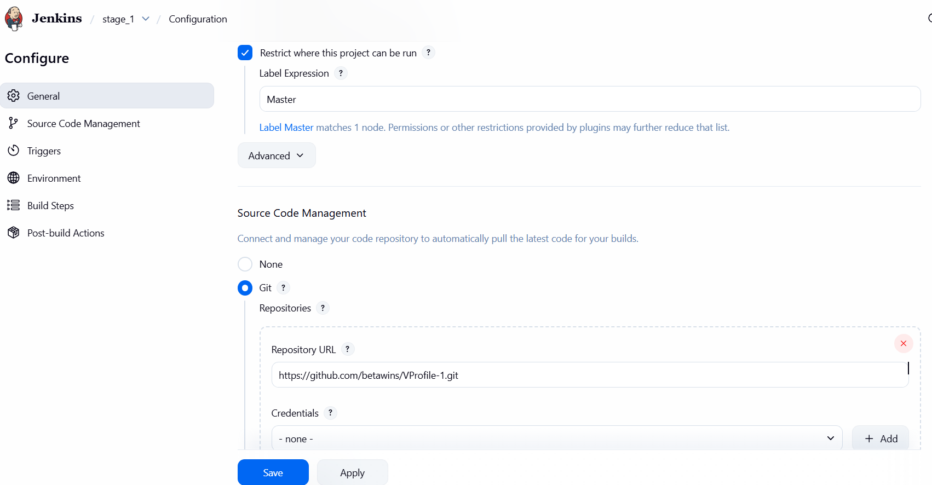
• https://github.com/betawins/VProfile-1.git

Branch configuration:
• */master

Step 7: Trigger Jenkins Build and Verify Console Output

Manually triggered build and verified successful Git clone and checkout.

Result:
• Build Status: SUCCESS
• Code successfully cloned from GitHub

Evidence:
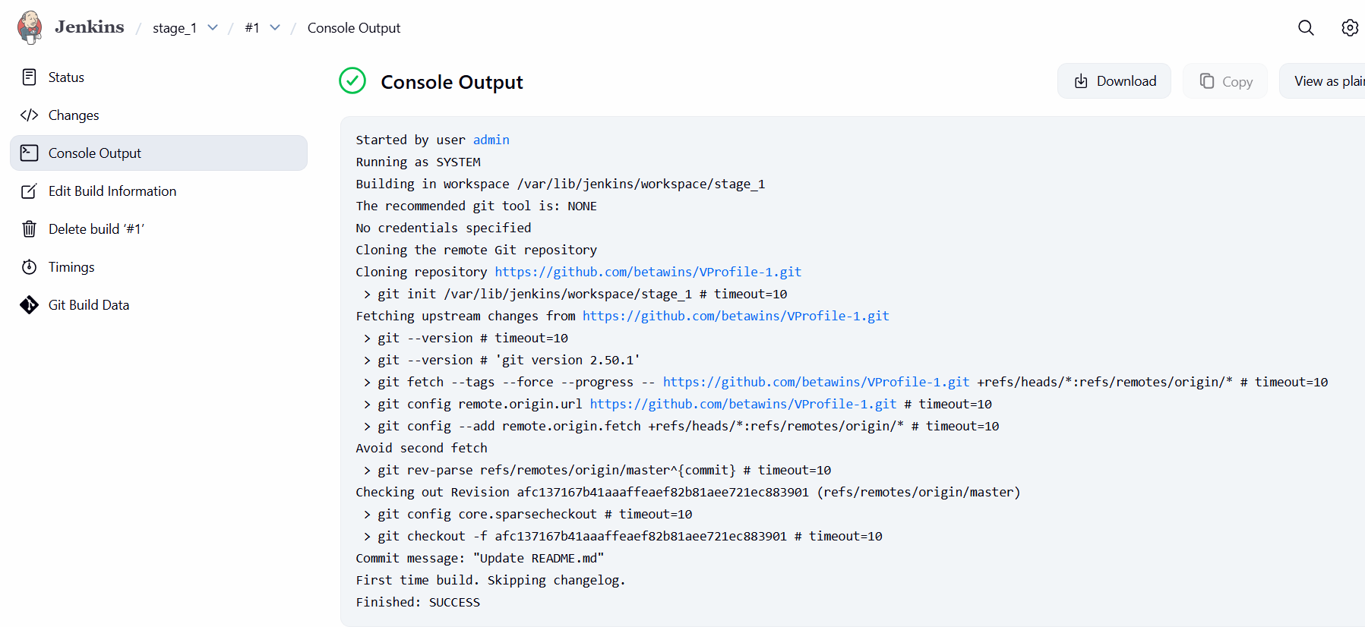
Step 8: Prepare SonarQube Installation

Selected SonarQube Community Edition LTA (9.9.x).

Downloaded SonarQube locally and transferred to EC2 using SCP.

Command used:

scp -i us-east-1.pem sonarqube-9.9.8.100196.zip ec2-user@<sonarqube-ec2-ip>:/tmp

Evidence:
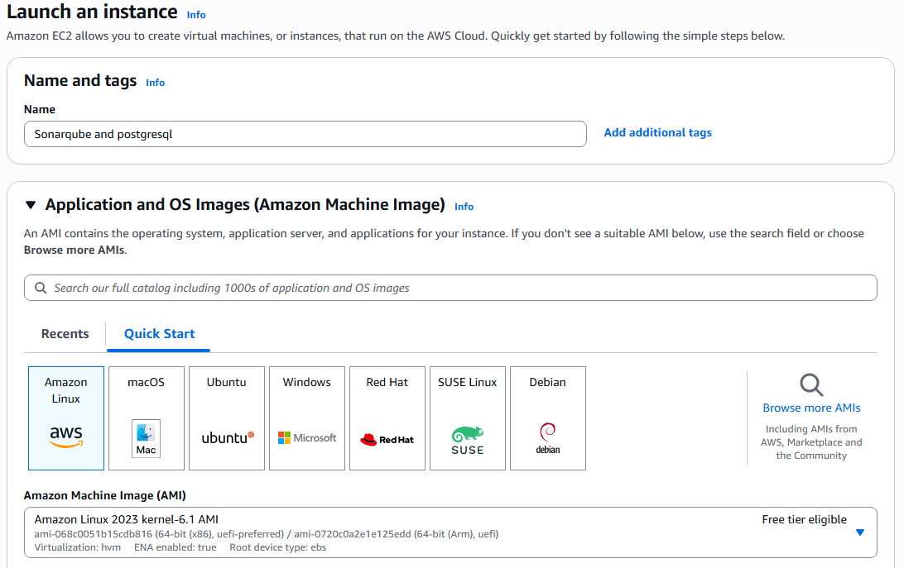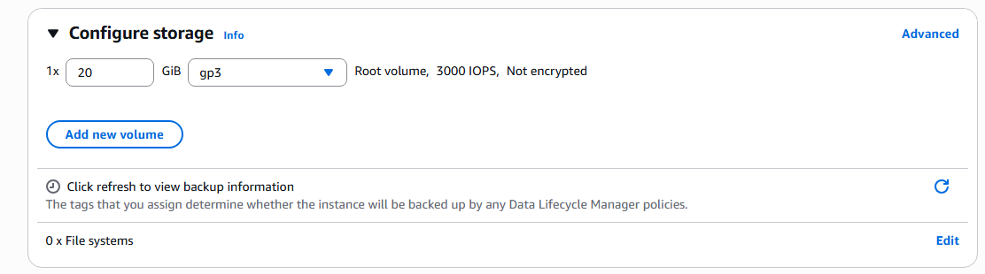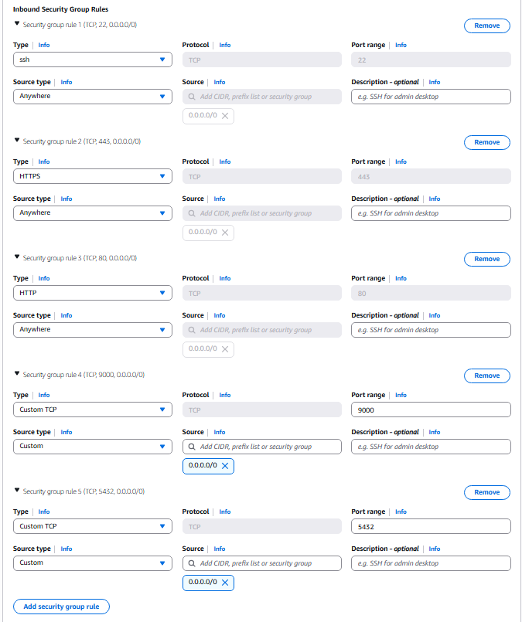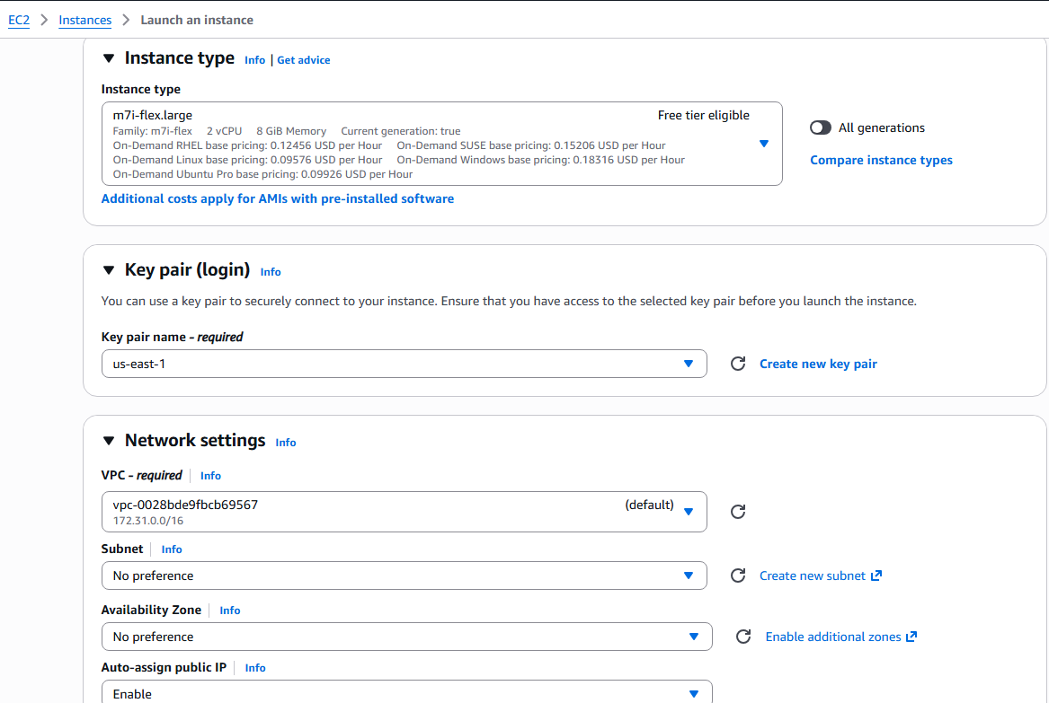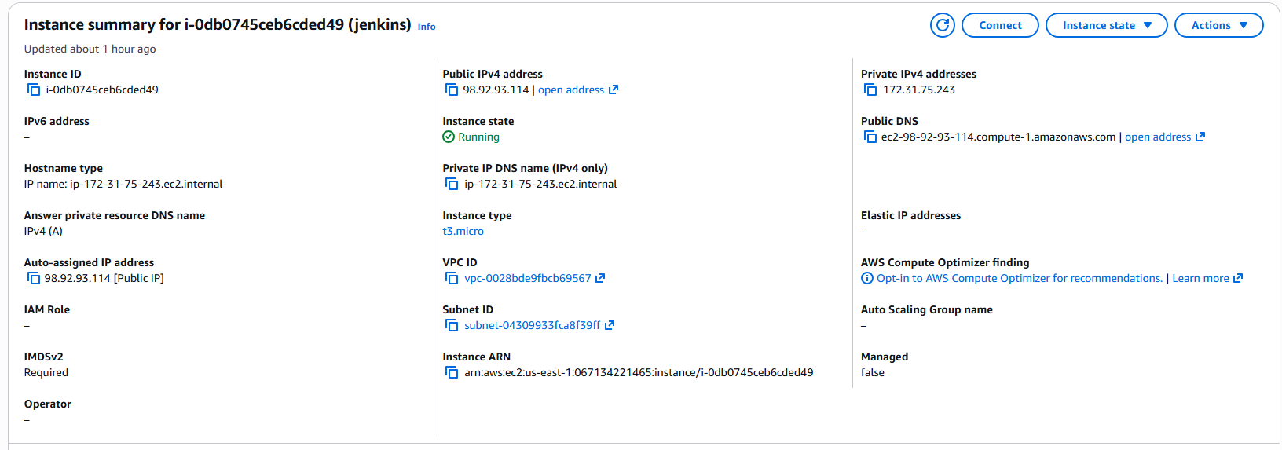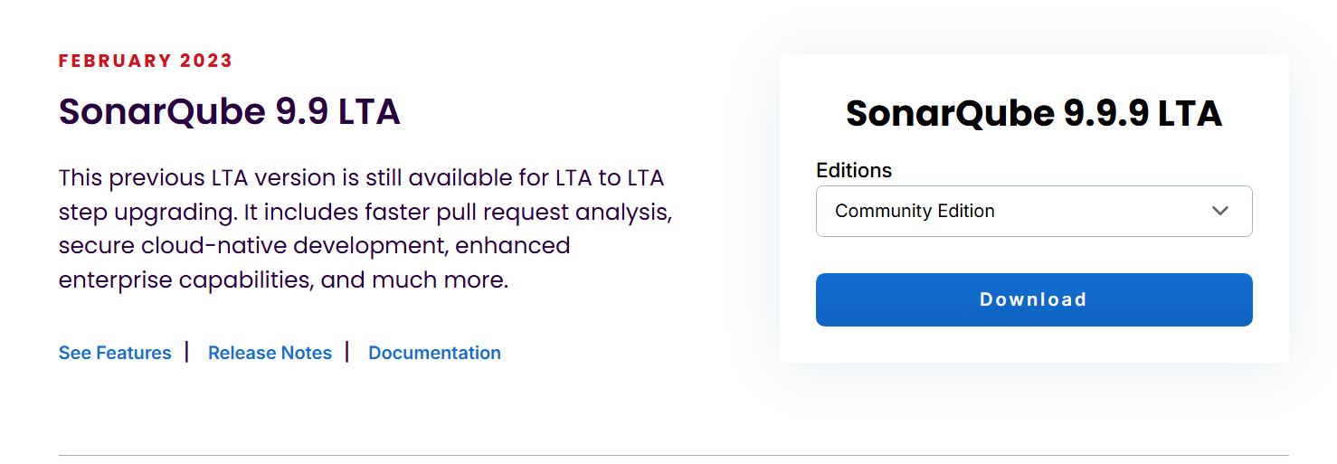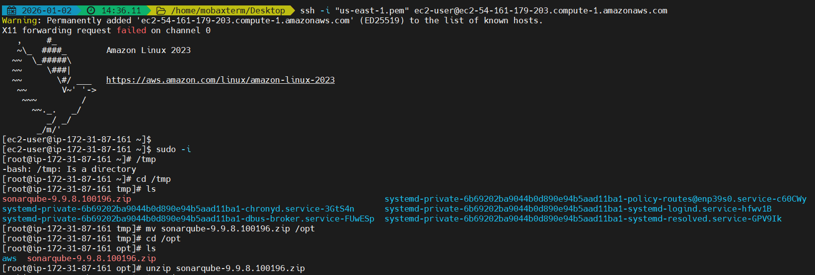Step 12: Initialize PostgreSQL database
Console path / CLI command
postgresql-setup --initdb
systemctl start postgresql
systemctl enable postgresql
systemctl status postgresql

Explanation
Initializes PostgreSQL data directory, starts the service, and enables it on boot.

Evidence
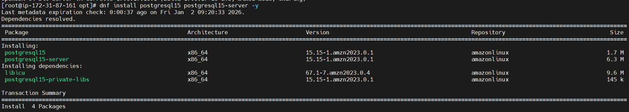
Step 13: Create SonarQube database and user
Console path / CLI command
su - postgres
psql
CREATE DATABASE sonarqube;
CREATE USER sonar WITH ENCRYPTED PASSWORD 'Sonar@123';
GRANT ALL PRIVILEGES ON DATABASE sonarqube TO sonar;
ALTER DATABASE sonarqube OWNER TO sonar;

Explanation
Creates a dedicated database and user for SonarQube with required privileges.

Evidence
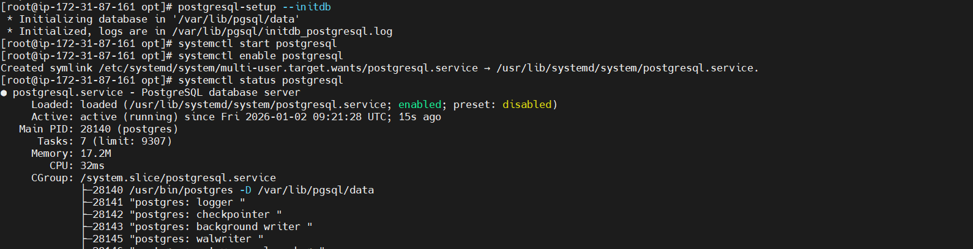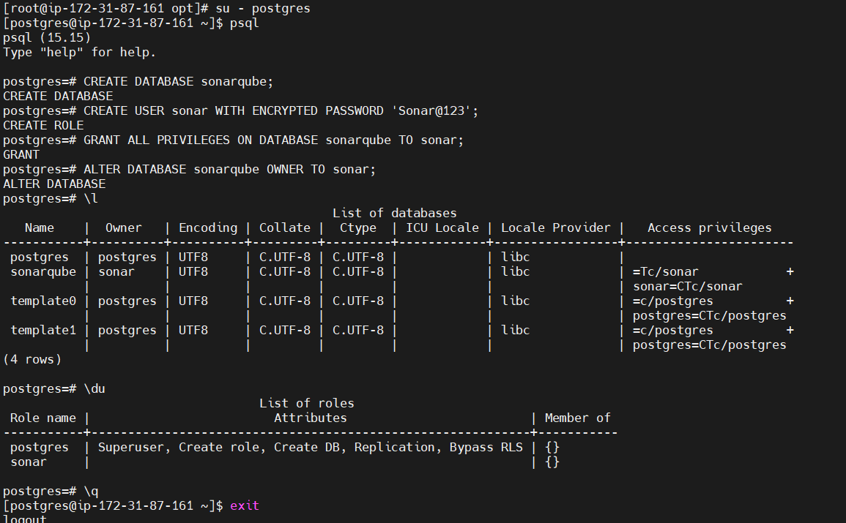
Step 14: Download and set up SonarQube
Console path / CLI command
useradd sonar
chown -R sonar:sonar /opt/sonar
chmod -R 775 /opt/sonar

Explanation
Creates a sonar user and assigns ownership and permissions to SonarQube directory.

Evidence
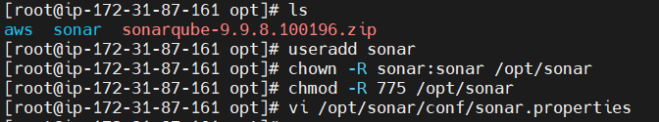
Step 15: Configure SonarQube database connection
Console path / CLI command
vi /opt/sonar/conf/sonar.properties

Configuration
sonar.jdbc.username=sonar
sonar.jdbc.password=Sonar@123
sonar.jdbc.url=jdbc:postgresql://localhost:5432/sonarqube
sonar.web.host=0.0.0.0
sonar.web.port=9000

Explanation
Configures SonarQube to use PostgreSQL and exposes the web interface.

Evidence
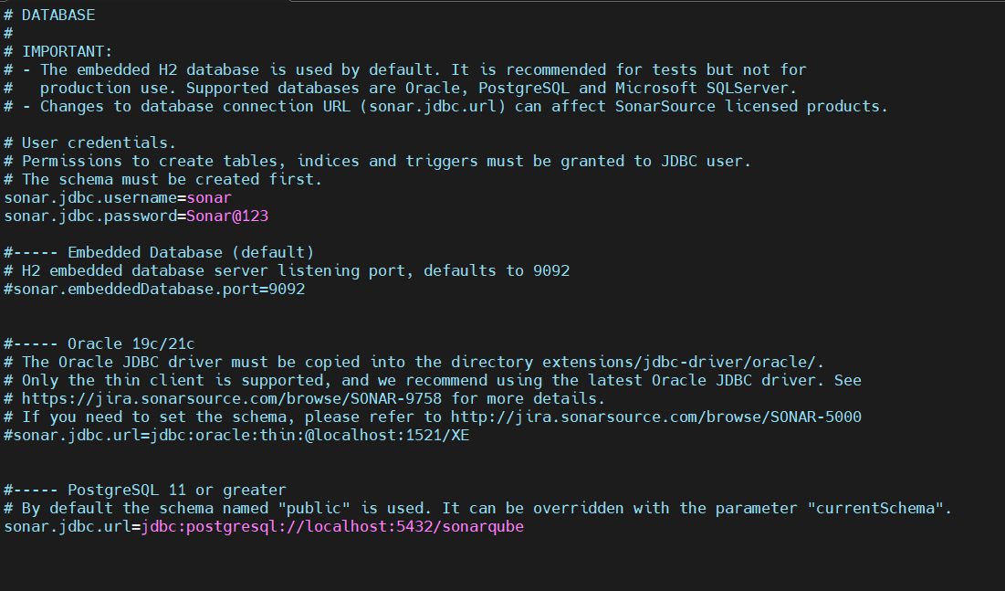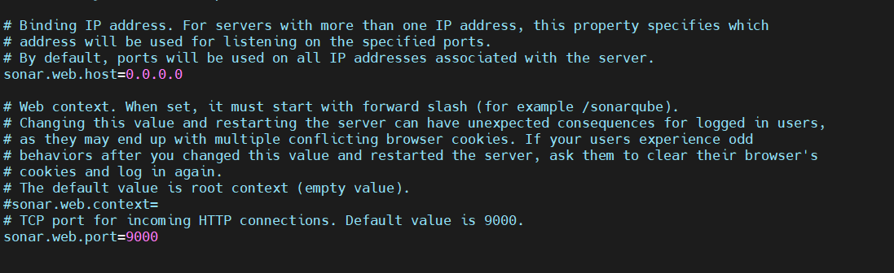
Step 16: Start SonarQube
Console path / CLI command
su - sonar
cd /opt/sonar/bin/linux-x86-64
./sonar.sh start
./sonar.sh status

Explanation
Starts SonarQube service and verifies it is running.

Evidence
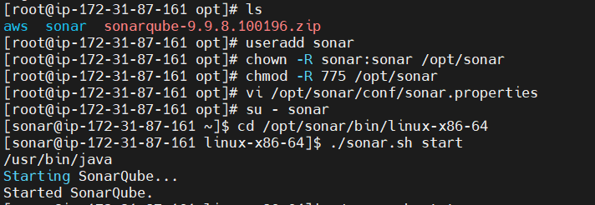
Step 17: Access SonarQube UI and reset admin password
URL
http://<EC2-PUBLIC-IP>:9000

Explanation
Logs in with default admin credentials and updates password for security.

Evidence
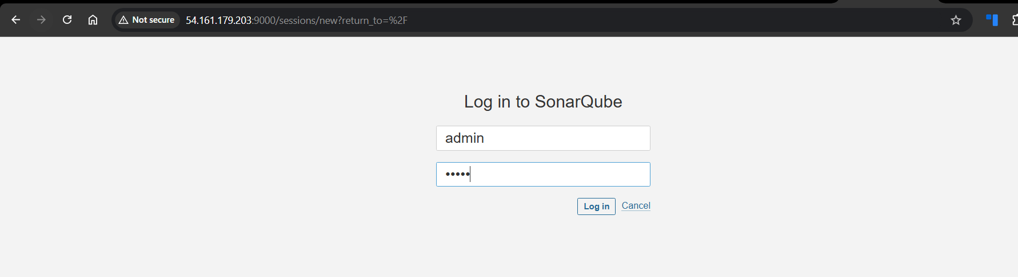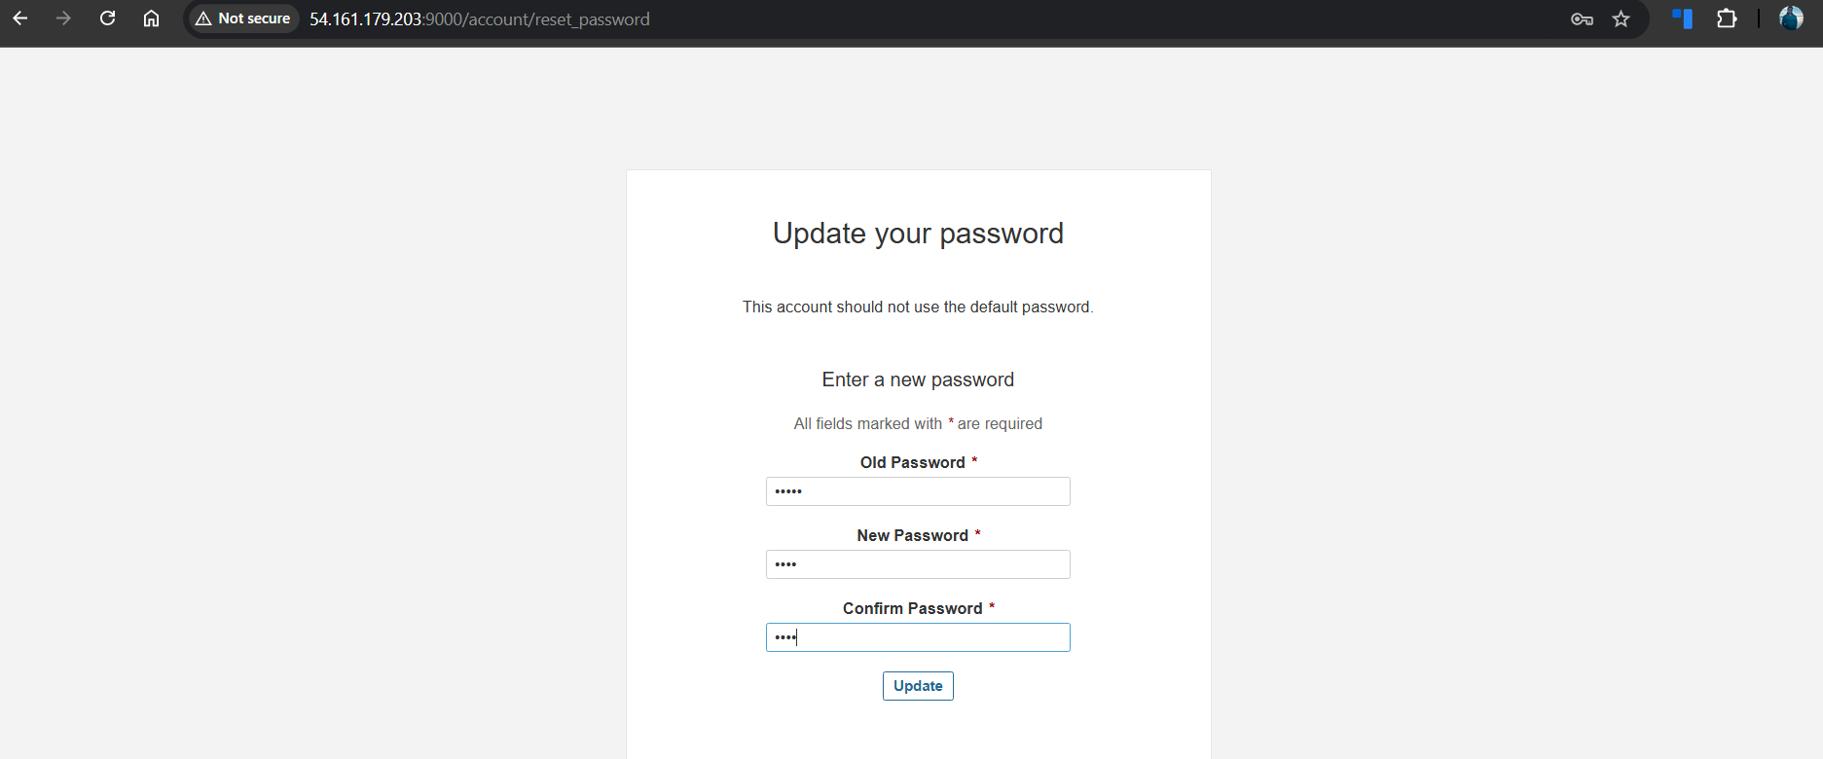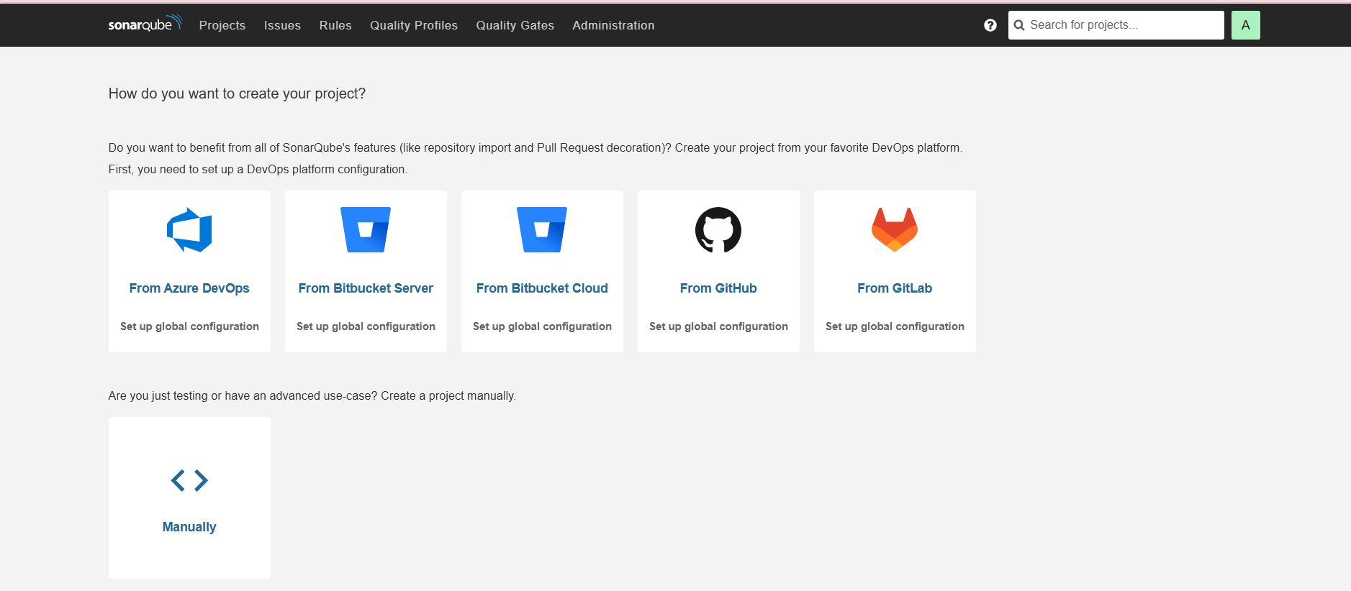
Step 18: Generate SonarQube authentication token
SonarQube path
Profile → Security → Tokens

Explanation
Creates a global token to authenticate Jenkins with SonarQube.

Evidence
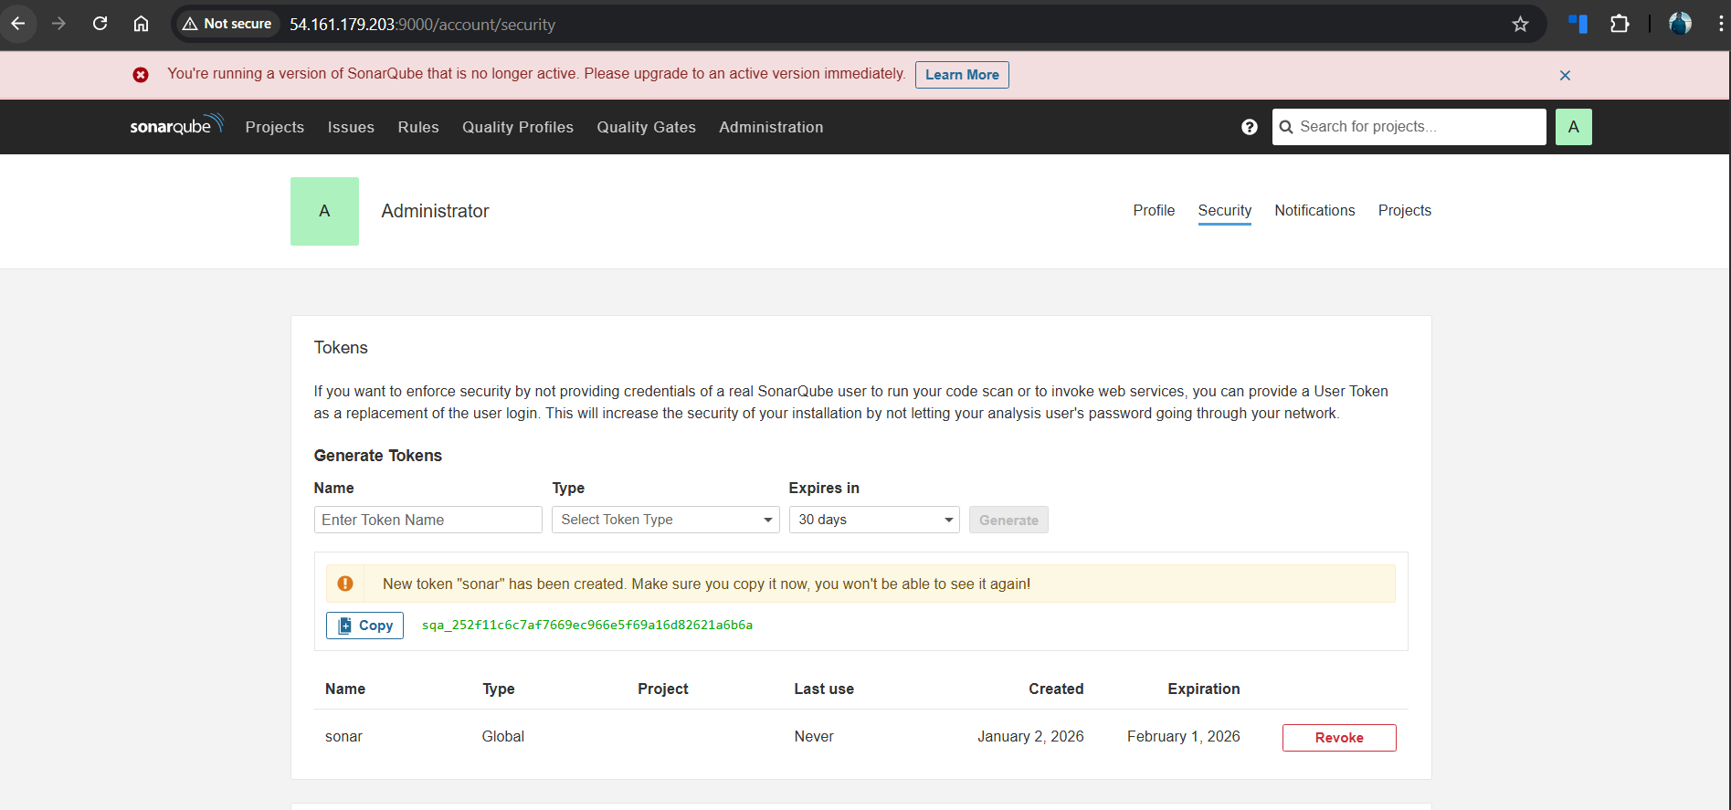
Step 19: Install SonarQube Scanner plugin in Jenkins
Jenkins path
Manage Jenkins → Plugins → Available plugins

Explanation
Installs SonarQube Scanner plugin for Jenkins integration.

Evidence
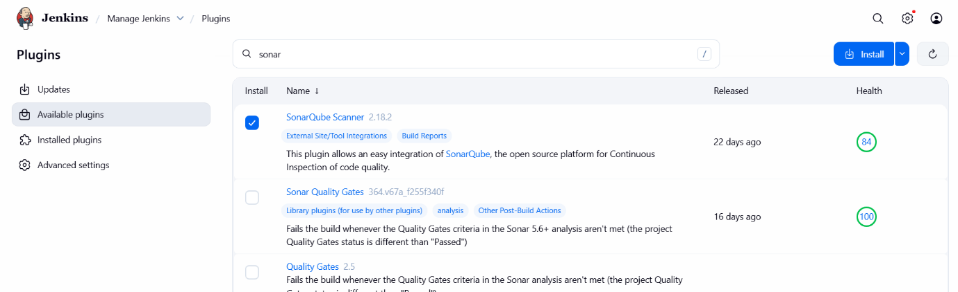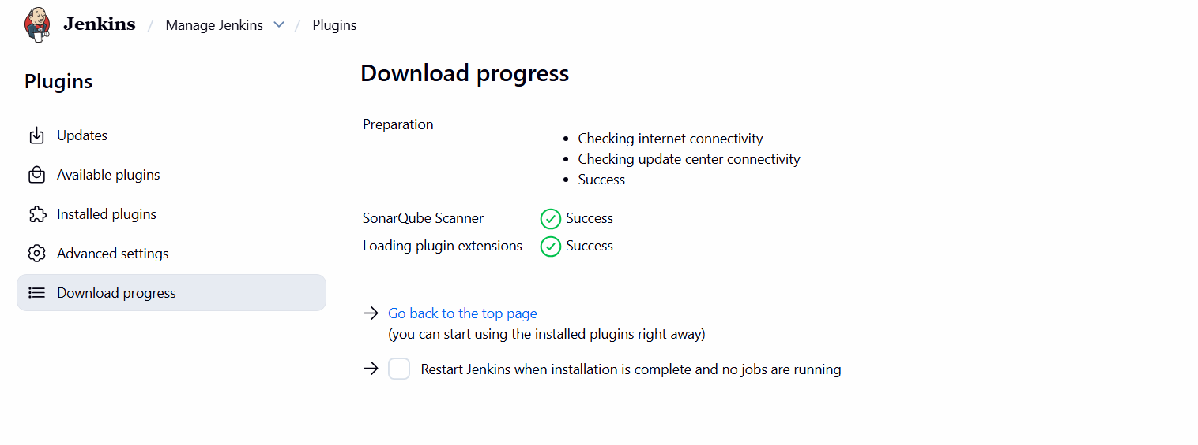
Step 20: Configure SonarQube server in Jenkins
Jenkins path
Manage Jenkins → System → SonarQube servers

Configuration
Name: sonarqube
Server URL: http://<EC2-PUBLIC-IP>:9000
Authentication token: sonar

Explanation
Registers SonarQube server details in Jenkins.

Evidence
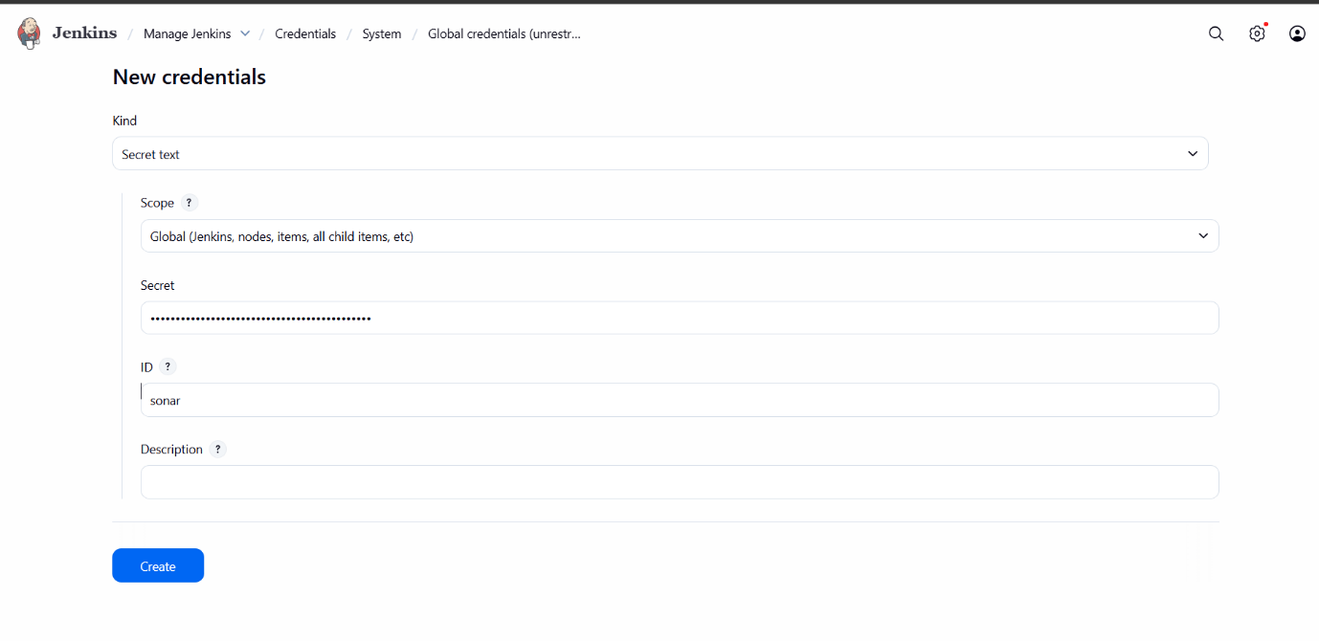
Step 21: Configure SonarQube Scanner tool
Jenkins path
Manage Jenkins → Tools → SonarQube Scanner installations

Configuration
Name: sonar
SONAR_RUNNER_HOME: /opt/sonar_scanner

Explanation
Defines the SonarQube Scanner installation path.

Evidence
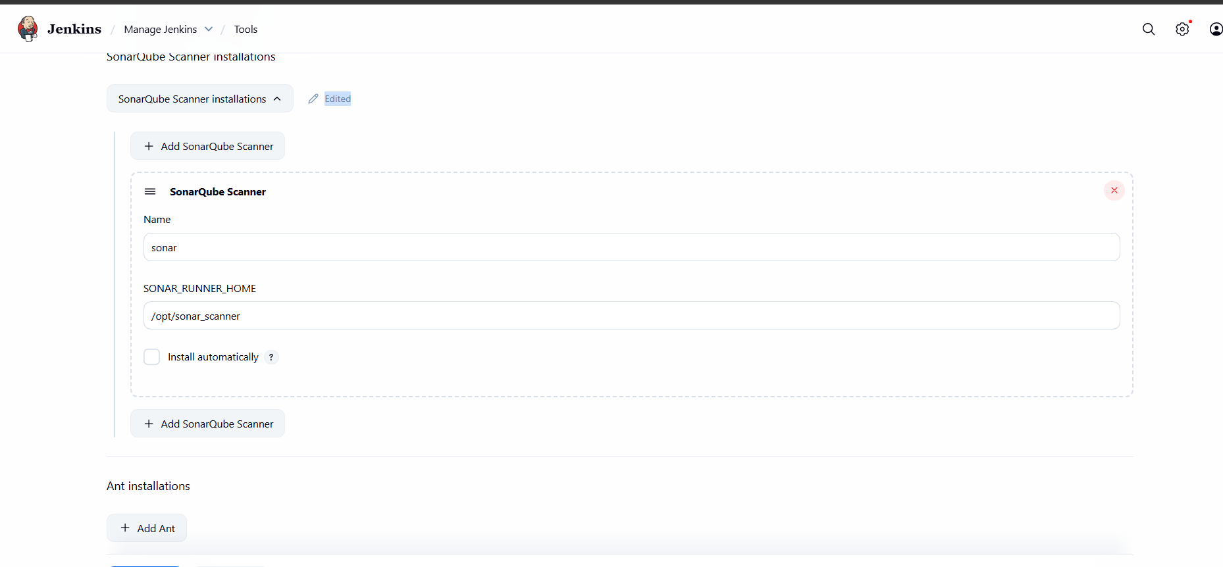
Step 21: Install Slack Notification plugin
Jenkins path
Manage Jenkins → Plugins → Available plugins

Explanation
Installs Slack Notification plugin for build alerts.

Evidence
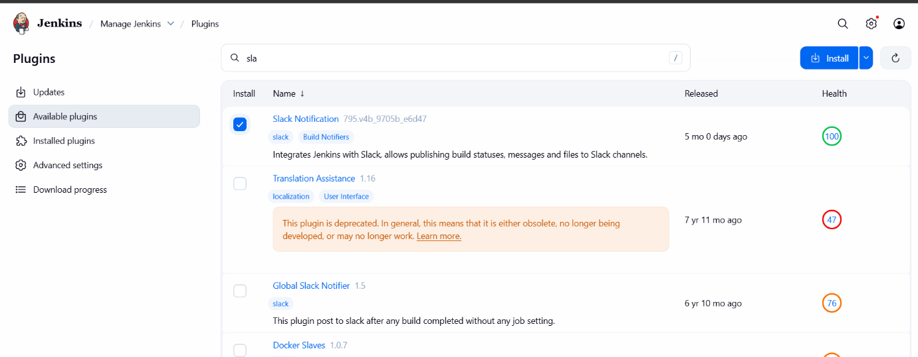
Step 22: Add Slack credentials in Jenkins
Jenkins path
Manage Jenkins → Credentials → Global credentials

Explanation
Stores Slack token securely as Jenkins credential.

Evidence 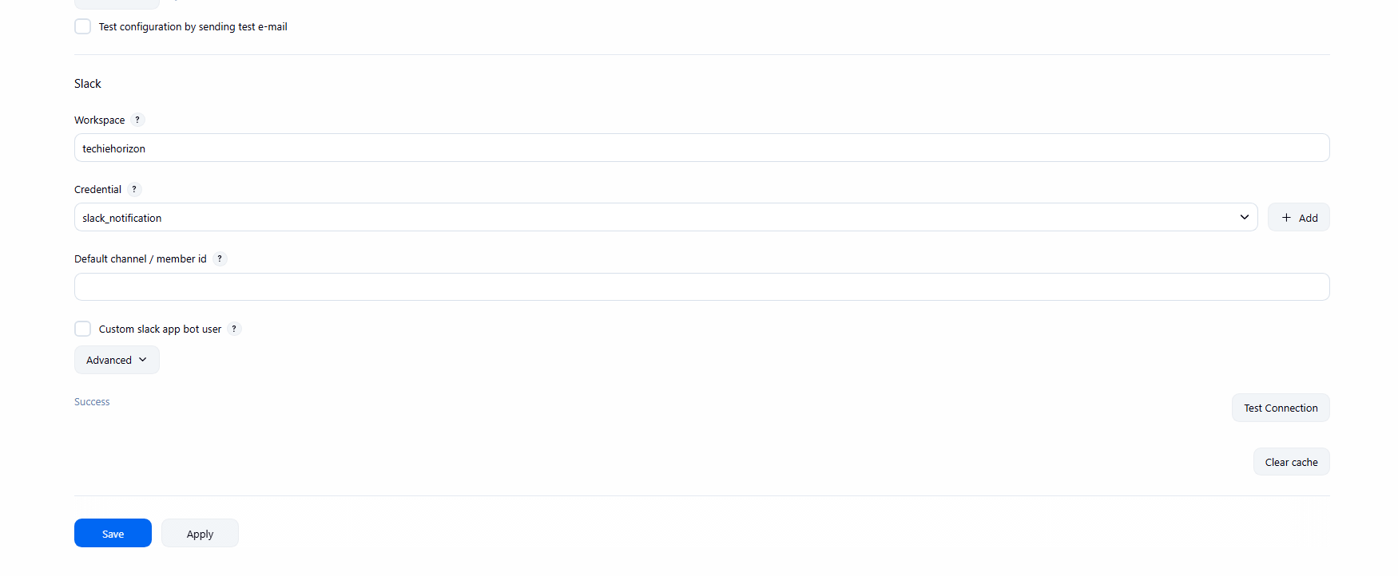

Step 23: Configure Slack in Jenkins system settings
Jenkins path
Manage Jenkins → System → Slack

Configuration
Workspace: techiehorizon
Credential: slack_notification

Explanation
Connects Jenkins to Slack workspace and verifies connectivity.

Evidence 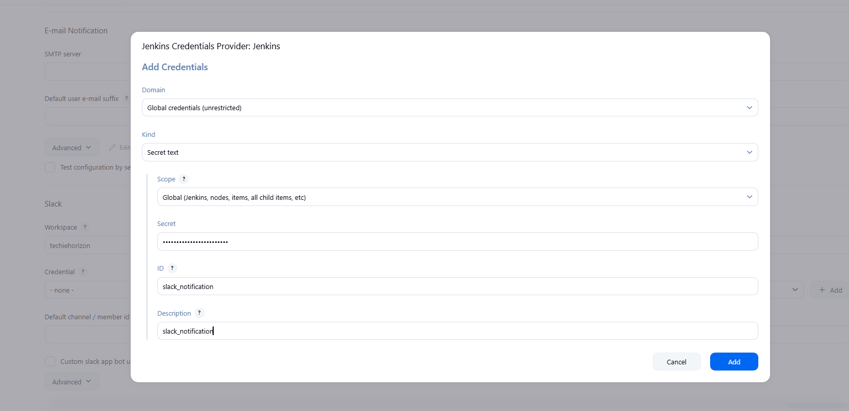

Step 24: Enable Slack notifications in Jenkins job
Jenkins path
Job → Configuration → Post-build Actions → Slack Notifications

Explanation
Configures job to send notifications on build start and success.

Evidence
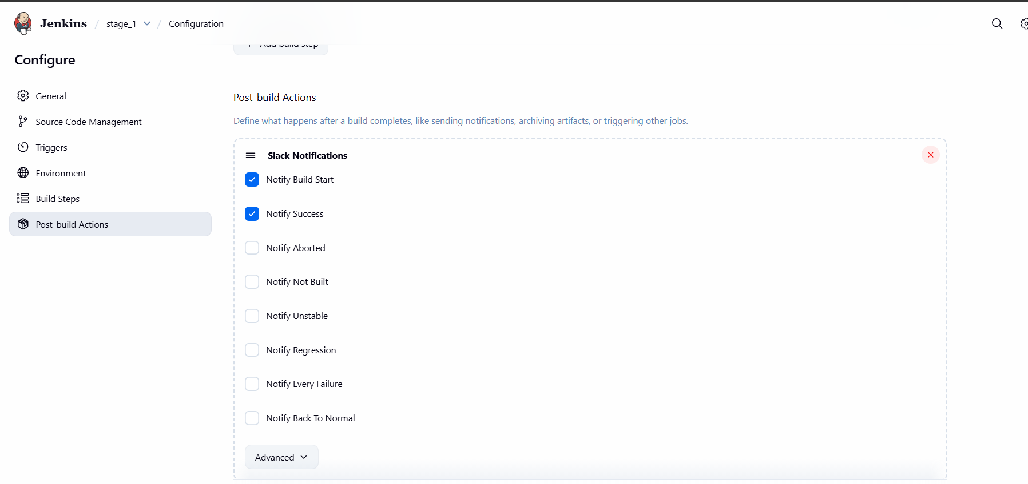
Step 25: Run Jenkins job with SonarQube analysis
Jenkins path
Job → Build Now → Console Output

Explanation
Executes SonarQube scan and publishes results to SonarQube dashboard.

Evidence
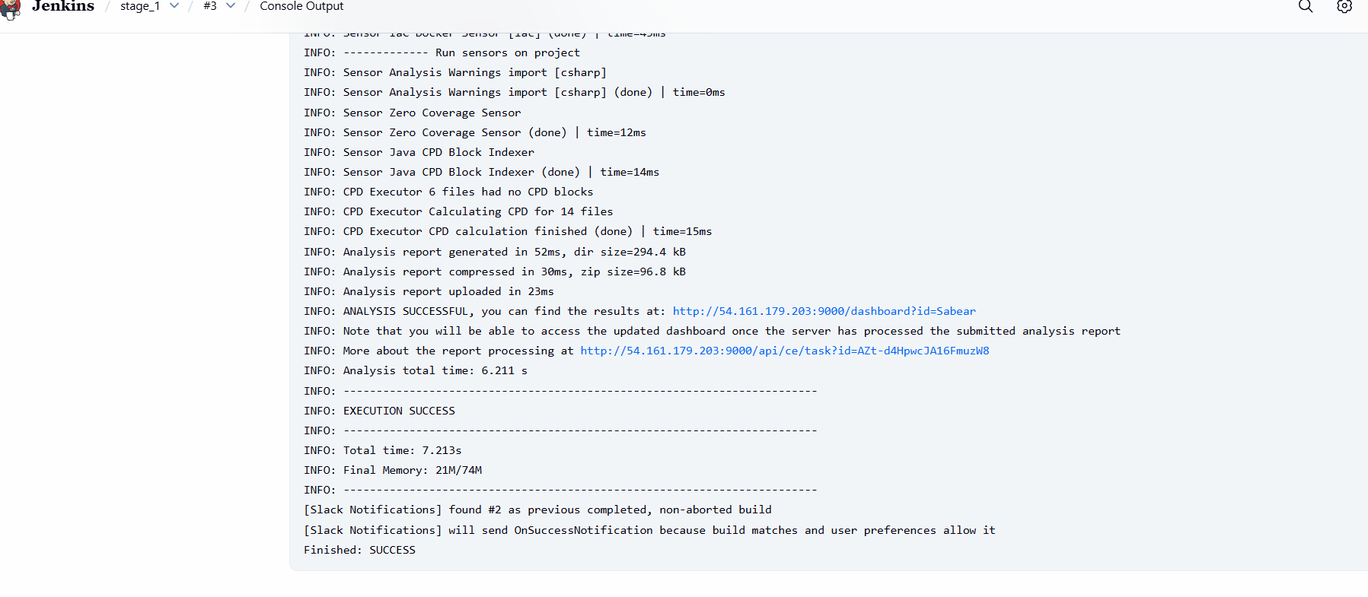
Step 26: Verify Slack notifications
Slack channel
#jenkins-integration

Explanation
Confirms Jenkins build notifications are delivered to Slack.

Evidence
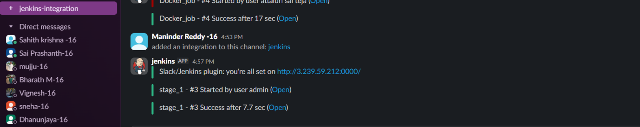
Step 27: Install SonarQube Scanner on Jenkins node
Console path / CLI command
wget https://binaries.sonarsource.com/.../sonar-scanner-cli-4.6.2.2472-linux.zip

unzip sonar-scanner-cli-4.6.2.2472-linux.zip
mv sonar-scanner-4.6.2.2472-linux sonar_scanner

Explanation
Installs SonarQube Scanner CLI on Jenkins node.

Evidence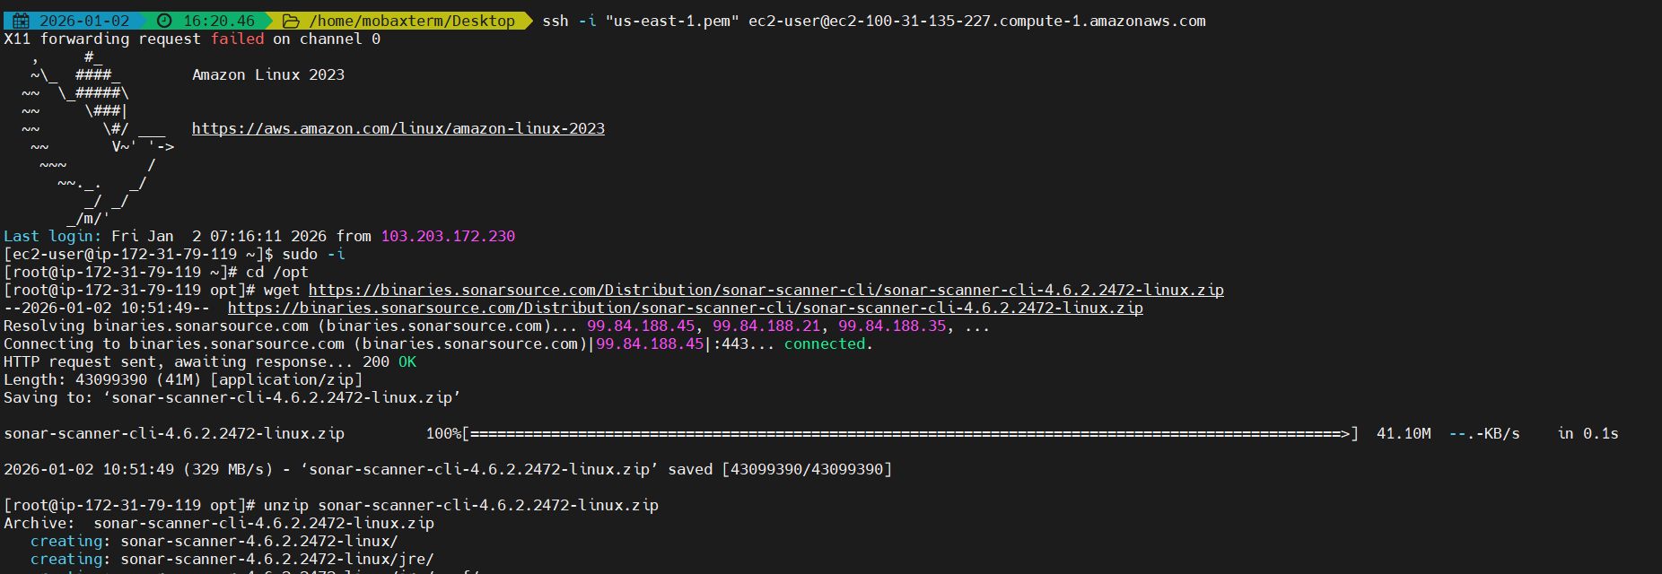
Step 28: Configure SonarQube Scanner properties
Console path / CLI command
vi /opt/sonar_scanner/conf/sonar-scanner.properties

Configuration
sonar.host.url=http://<EC2-PUBLIC-IP>:9000

Explanation
Configures default SonarQube server URL for scanner.

Evidence
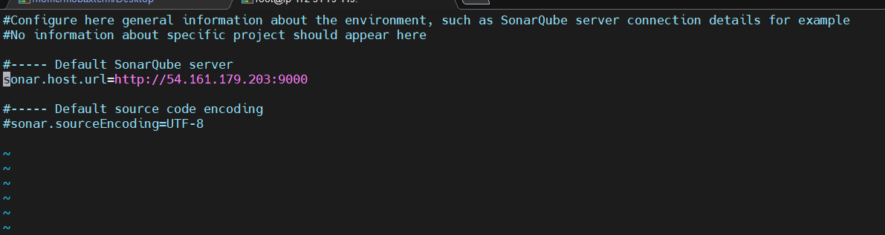
Validation Steps (Mandatory, With Evidence)

Validation 1: Resource Health
Check PostgreSQL and SonarQube service status.
Evidence:  

Validation 2: Functional Check
Verify project analysis appears in SonarQube dashboard.
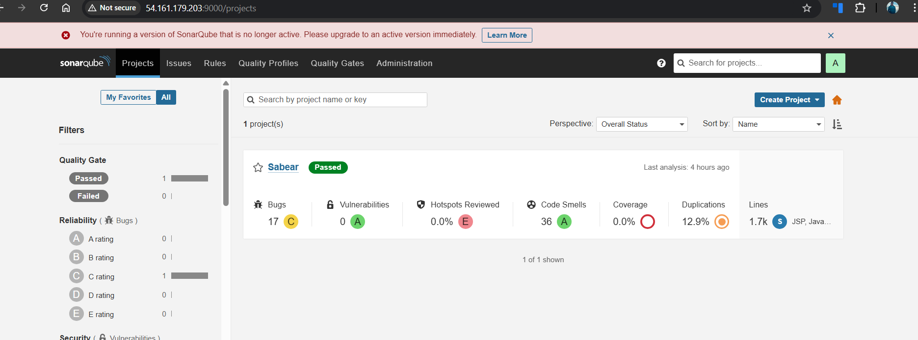
Validation 3: Network Check
Access SonarQube UI via browser on port 9000.

Validation 4: Notification Check
Confirm Slack receives Jenkins build notifications.
Evidence 

Issues Faced
• Initially I have downloaded the latest version of sonarqube and later I have encountered the that the sonarqube is not running, I have deleted the latest version and installed the sonarqube9.9.8 version and the sonarqube was up and running.
• I have changed the instance type of the Jenkins server to m7.large and I was able to get the builds, before that I have used the t2.small and on changing the instance type I was able to get the builds.

Conclusion
SonarQube was successfully deployed with PostgreSQL, integrated with Jenkins using SonarQube Scanner, and Slack notifications were enabled to monitor Jenkins build status effectively.

Task 2
Create one Jenkins job using the below code and create three stages:
stage1: Git clone to download the source code.
stage2: Sonarqube Integration to check the quality of code.
stage3: Slack Integration to send the alerts to slack.
URL: https://github.com/betawins/hiring-app.git

Task Title:
Create a Jenkins job with Git clone, SonarQube code quality check, and Slack notification

Objective:
To create a Jenkins job that pulls source code from a GitHub repository, performs static code analysis using SonarQube to validate code quality, and sends build status notifications to a Slack channel.

Prerequisites:
• AWS EC2 instances for Jenkins server and SonarQube server
• Amazon Linux 2023 installed on both instances
• Jenkins installed and accessible on port 8080
• Docker installed and running on SonarQube server
• SonarQube running in Docker on port 9003
• SonarQube user token generated
• SonarQube Scanner installed on Jenkins server
• Java 17 installed and configured on Jenkins server
• Git installed on Jenkins server
• GitHub repository access: https://github.com/betawins/hiring-app.git

• Slack workspace with Incoming Webhook or Jenkins Slack plugin configured

Step-by-Step Implementation (With Evidence):

Step 1: Launch EC2 instances for Jenkins and SonarQube
• Console path / CLI command: AWS Console → EC2 → Launch Instance
• Explanation: Two EC2 instances were launched using Amazon Linux 2023. One instance was used for Jenkins and another for SonarQube. Required security group rules were added for SSH, Jenkins (8080), and SonarQube (9003).
• Evidence:
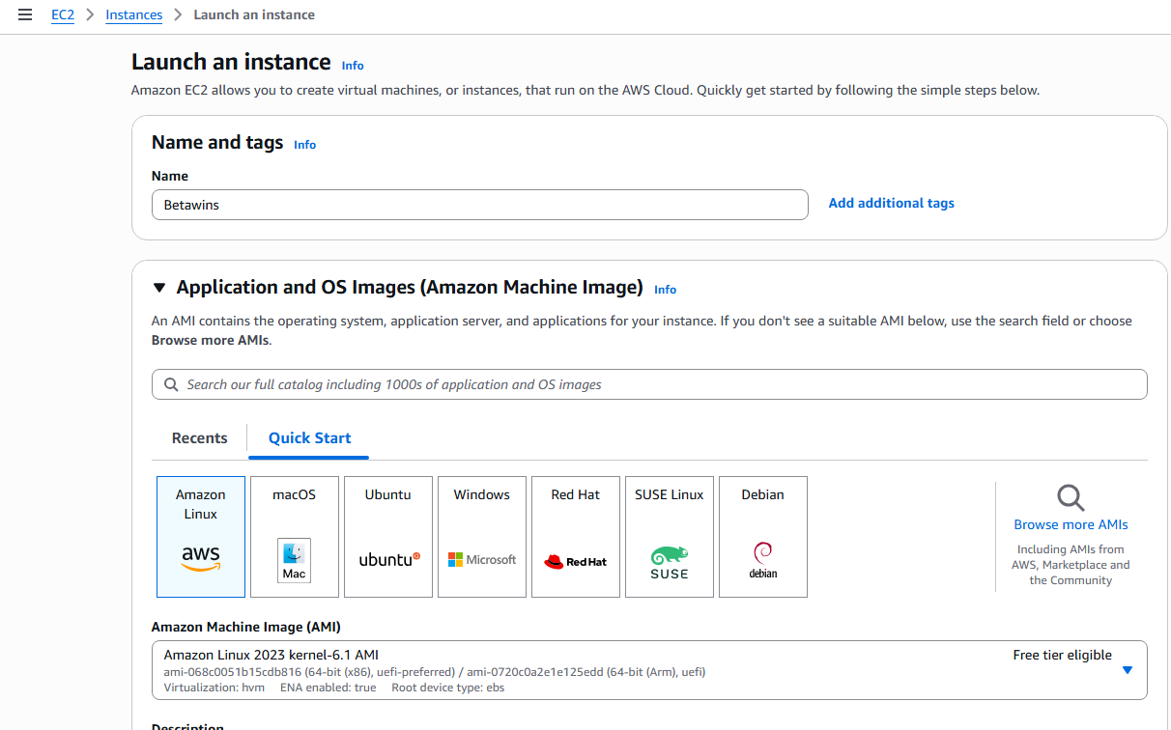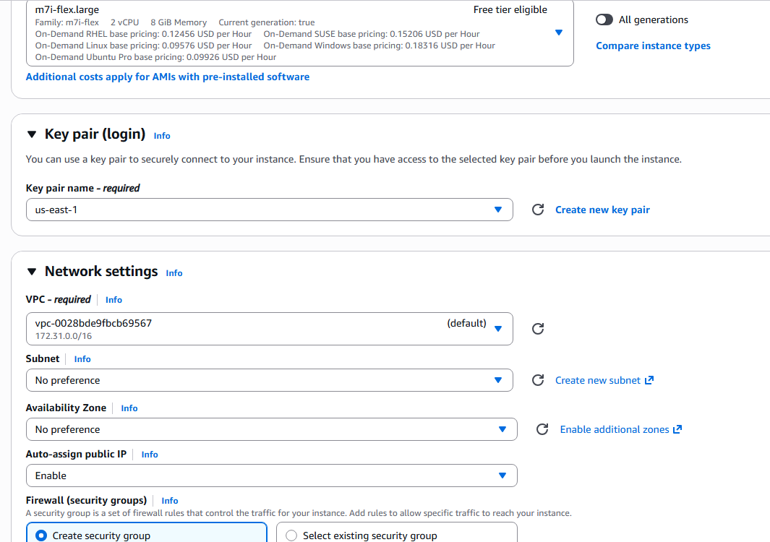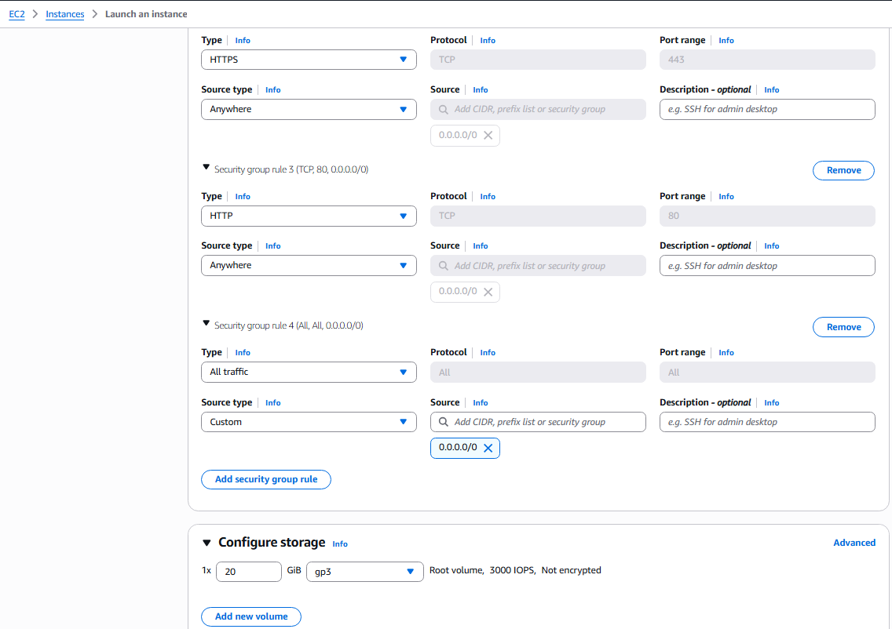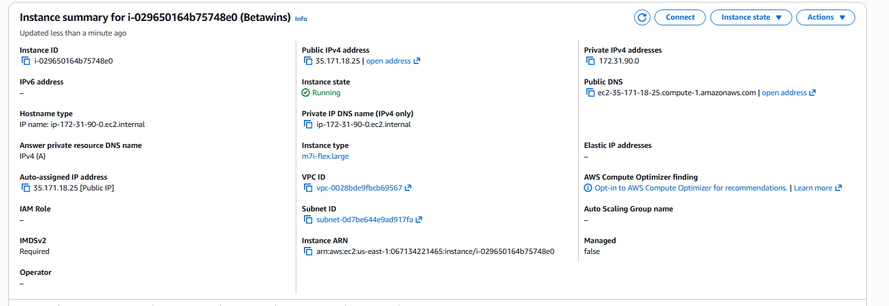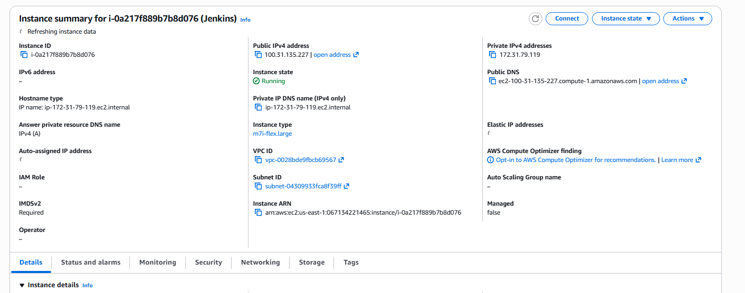
Step 2: Install and start Jenkins on Jenkins server
• Console path / CLI command:
sudo yum install java-17-amazon-corretto -y
sudo yum install jenkins -y
sudo systemctl start jenkins
sudo systemctl enable jenkins
• Explanation: Jenkins was installed, started, and enabled to run on system boot. Jenkins UI was accessed using the public IP and port 8080.
• Evidence:
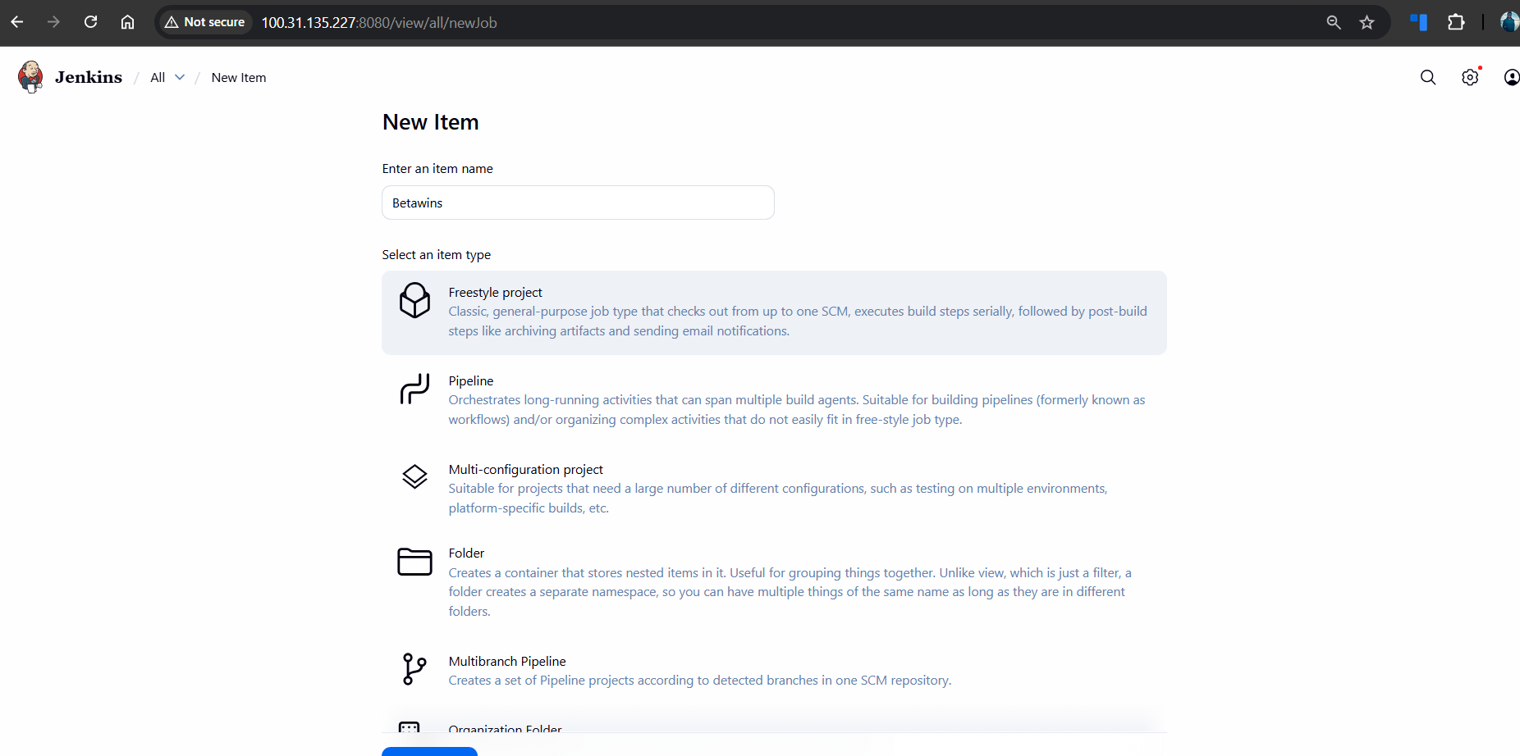
Step 3: Create Jenkins job and configure Git SCM
• Console path / CLI command: Jenkins UI → New Item → Freestyle Project
• Explanation: A freestyle Jenkins job named “Betawins” was created. Git was configured as the Source Code Management with the repository URL and main branch.
• Evidence:

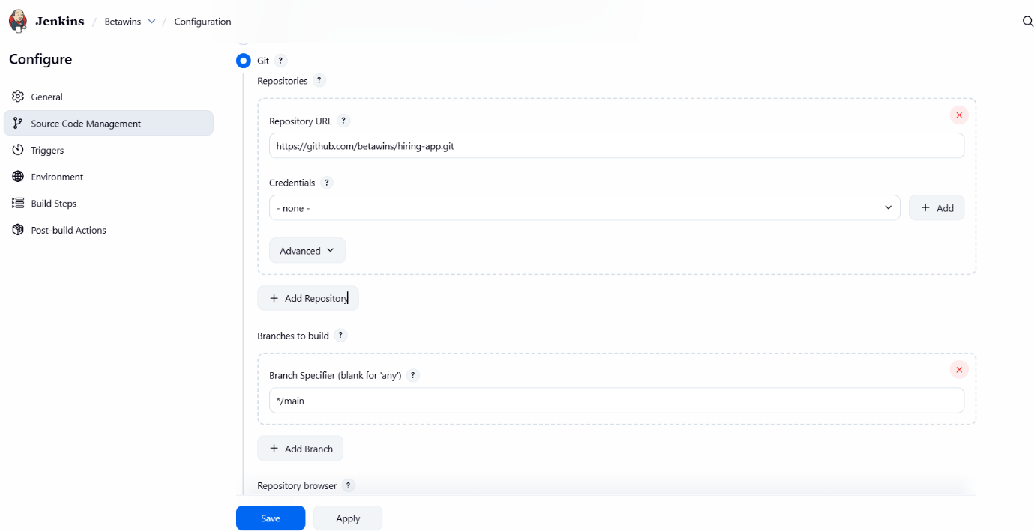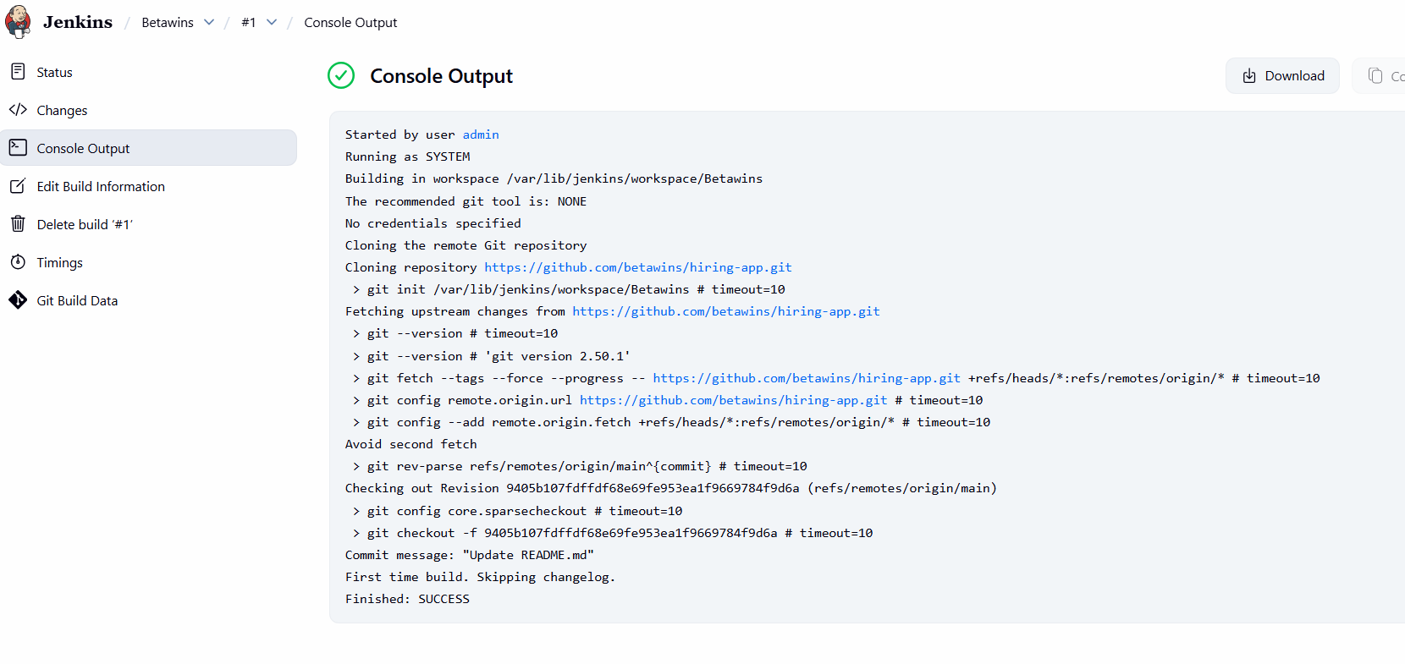Step 4: Install Docker and run SonarQube container
• Console path / CLI command:
sudo yum install docker -y
sudo systemctl start docker
sudo systemctl enable docker
docker run -d --name sonarqube-server -p 9003:9000 sonarqube
• Explanation: Docker was installed and SonarQube was deployed as a container. SonarQube UI was accessed via browser using port 9003.
• Evidence:
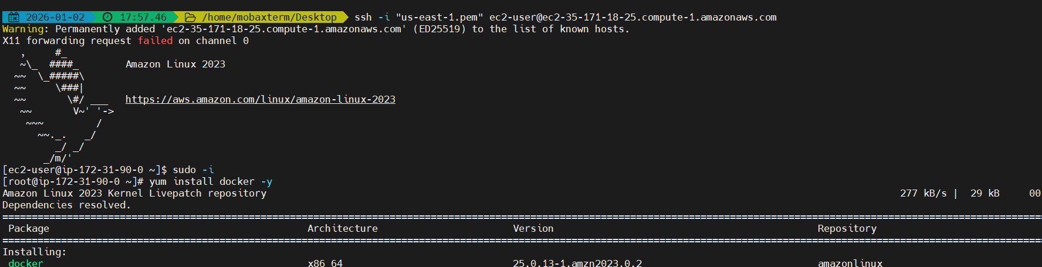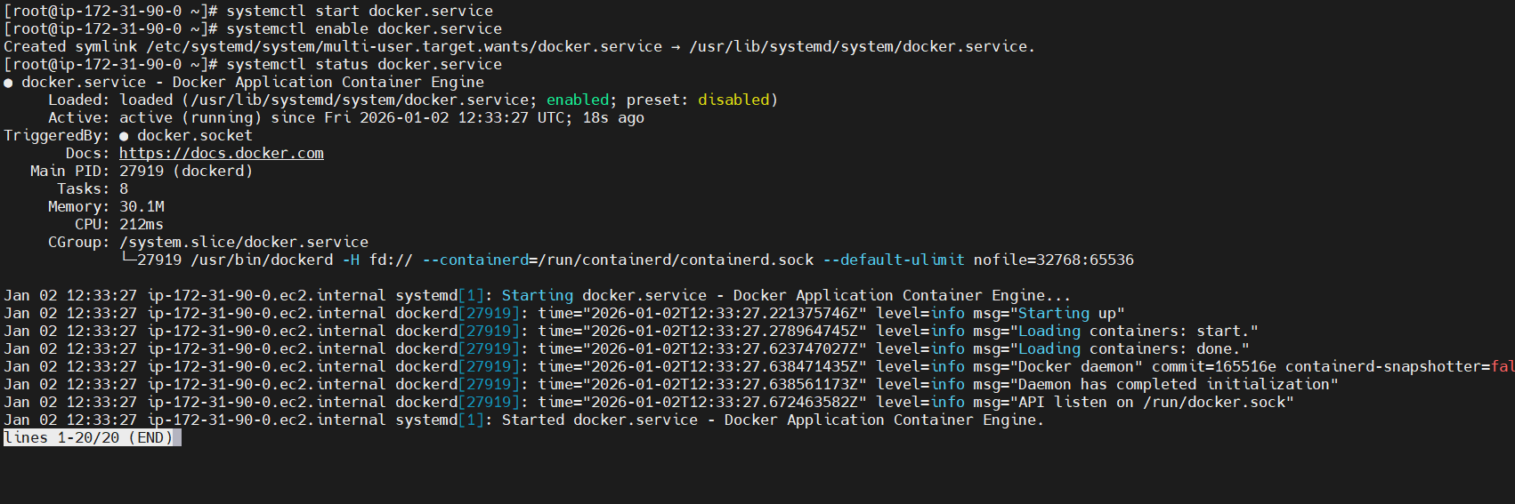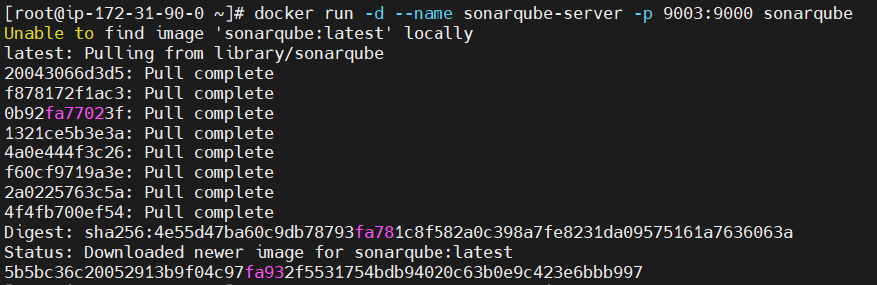
Step 5: Generate SonarQube authentication token
• Console path / CLI command: SonarQube UI → Administrator → Security → Tokens
• Explanation: A SonarQube user token was generated to allow Jenkins to authenticate securely with the SonarQube server.
• Evidence:
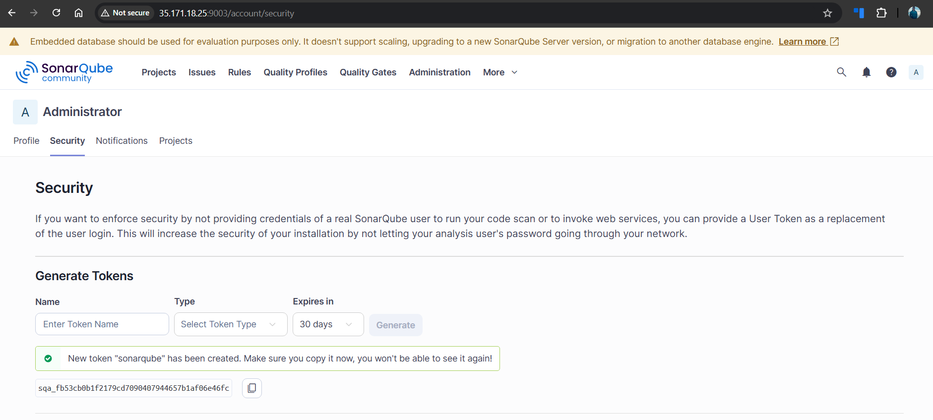
Step 6: Add SonarQube token to Jenkins credentials
• Console path / CLI command: Jenkins → Manage Jenkins → Credentials → Global → Add Credentials
• Explanation: The SonarQube token was stored in Jenkins as a Secret Text credential for secure usage during builds.
• Evidence:
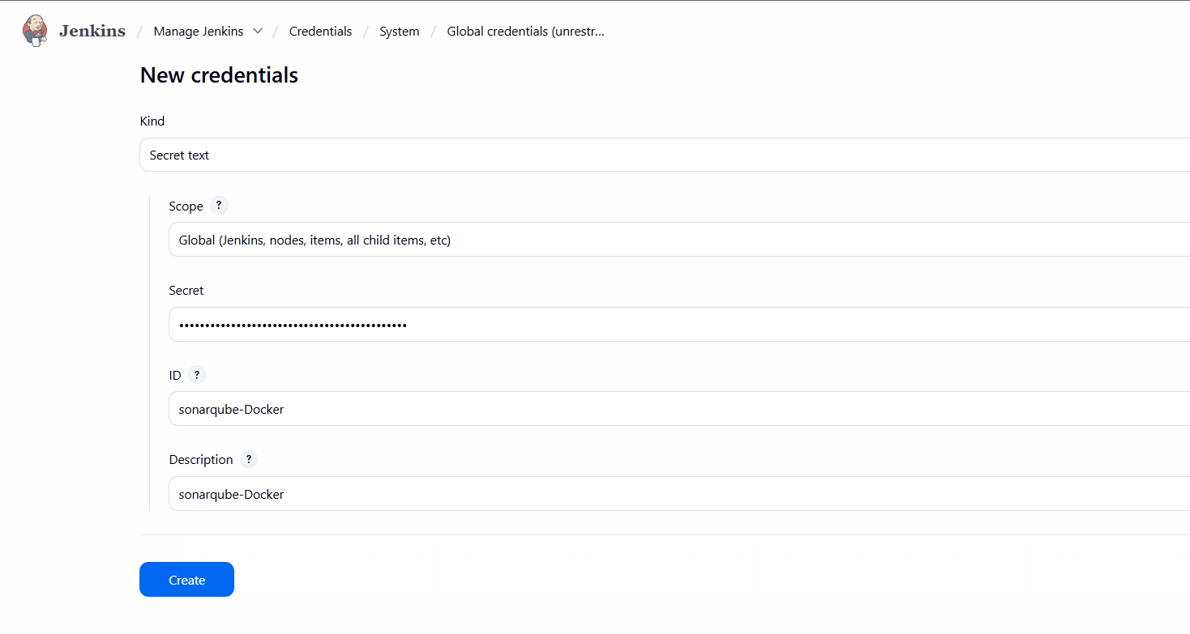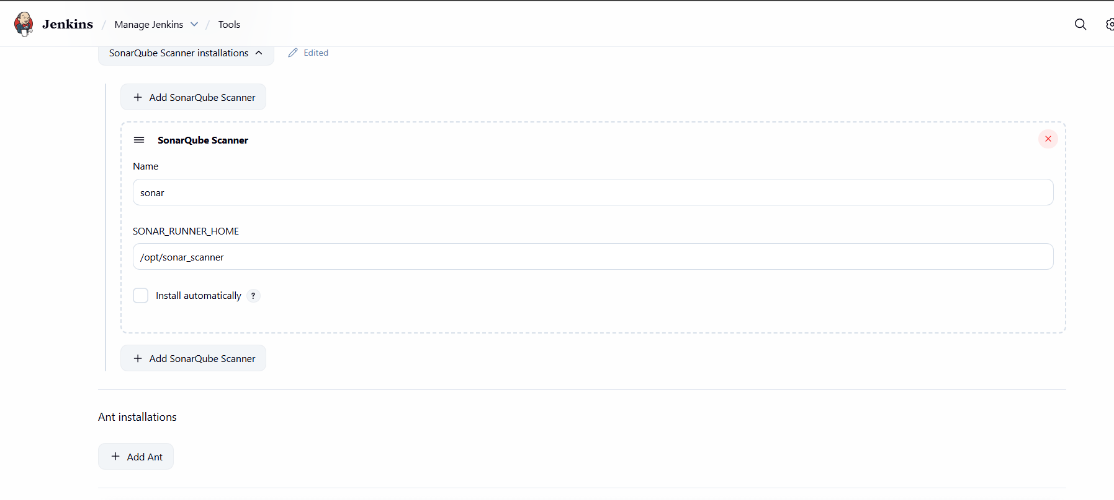
Step 7: Install and configure SonarQube Scanner
• Console path / CLI command:
Extract sonar-scanner and configure properties file
/opt/sonar_scanner/conf/sonar-scanner.properties
• Explanation: SonarQube Scanner version 5.0.1.3006 was installed and configured with the SonarQube server URL and Java executable path.
• Evidence:
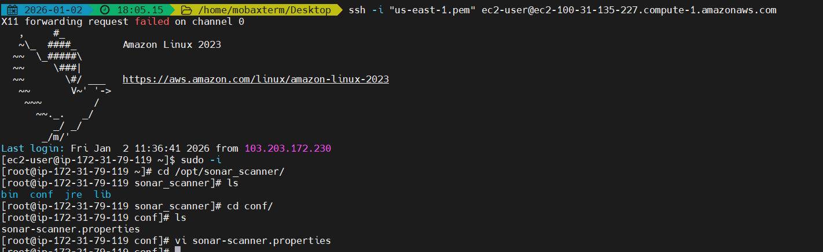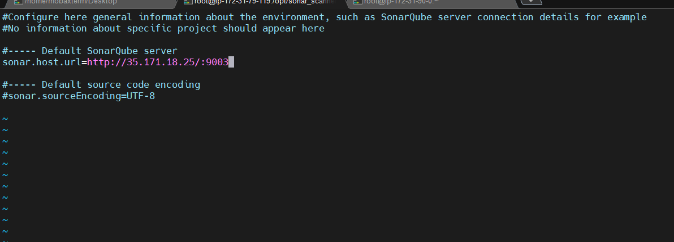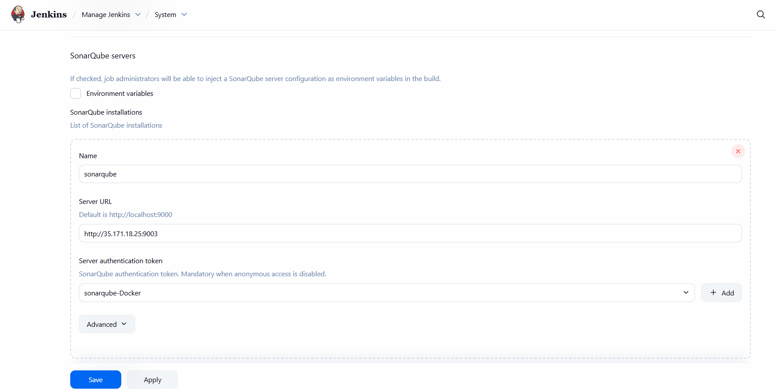
Step 8: Configure SonarQube in Jenkins system settings
• Console path / CLI command: Jenkins → Manage Jenkins → System → SonarQube servers
• Explanation: A SonarQube server entry was added with server URL and authentication token to enable Jenkins-SonarQube integration.
• Evidence:
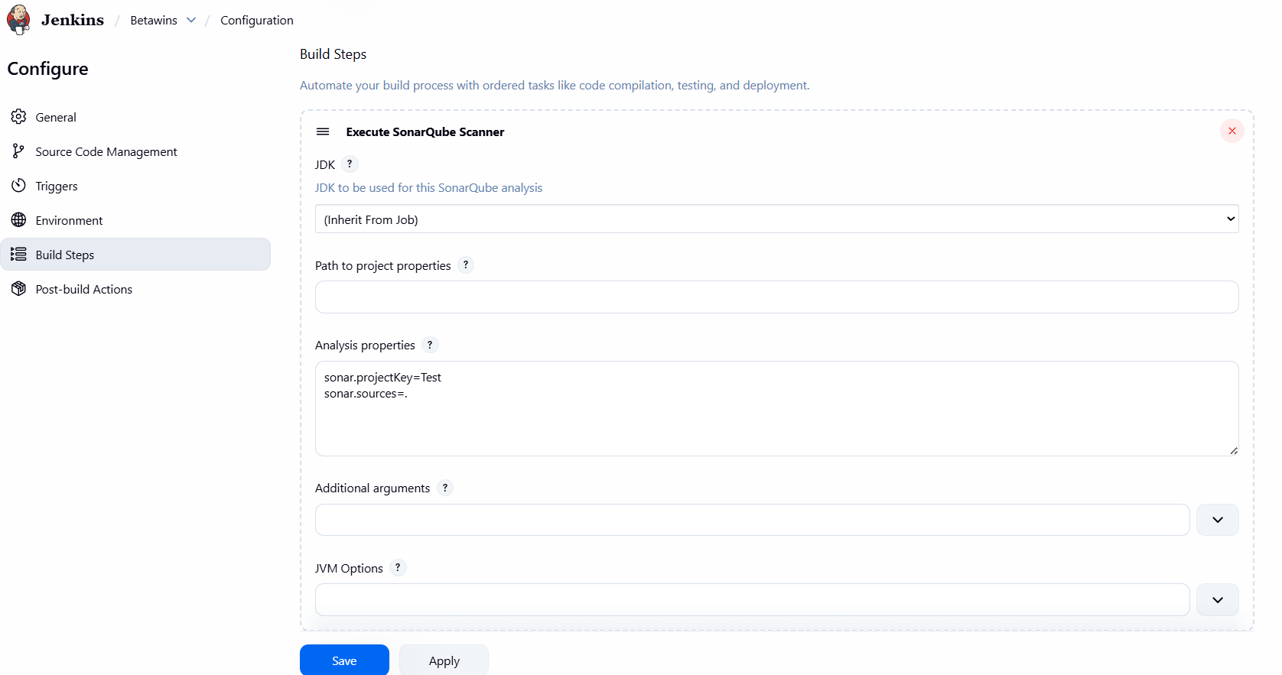

Step 9: Add SonarQube analysis stage in Jenkins job
• Console path / CLI command: Jenkins Job → Configuration → Build Steps
• Explanation: SonarQube analysis was configured using Execute Shell with JAVA_HOME and SonarScanner command to analyze the source code.
• Evidence:
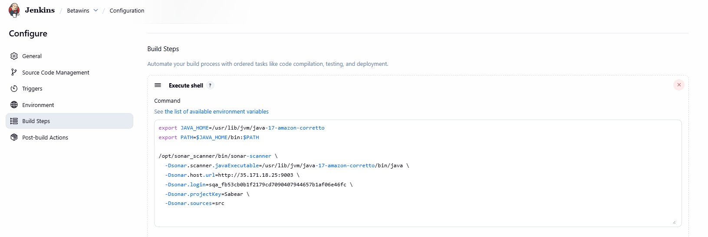

Step 11: Verify SonarQube analysis results
• Console path / CLI command: SonarQube UI → Projects
• Explanation: The project appeared successfully in SonarQube with Quality Gate status marked as Passed.
• Evidence:
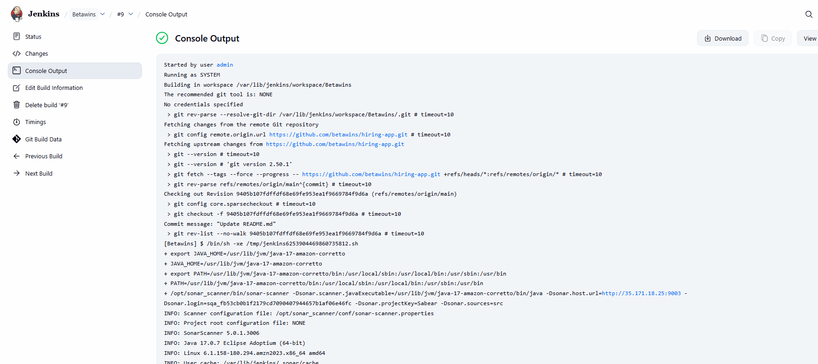
Validation Steps (Mandatory, With Evidence):
Configure Slack integration and validate notifications
• Console path / CLI command: Jenkins → Post-build Actions → Slack Notifications
• Explanation: Slack notifications were configured to send build start and success messages. Successful build notifications were received in Slack.
• Evidence:
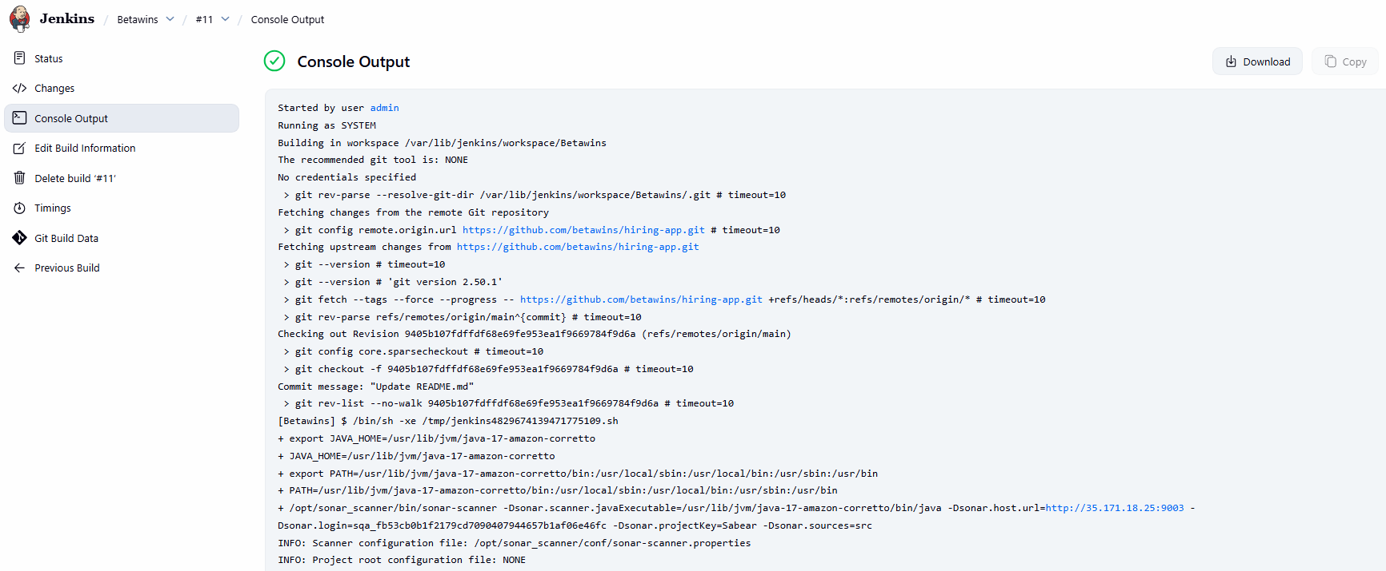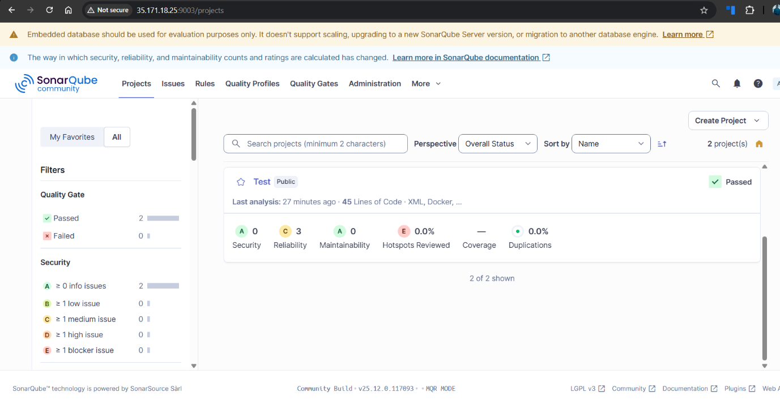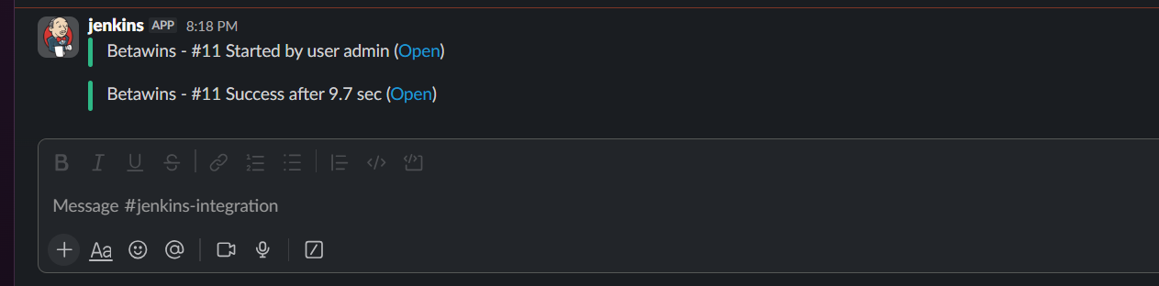

Issues Faced (Optional):
• SonarScanner execution failed due to Java class version mismatch
• Resolved by reinstalling SonarScanner 5.0.1 and explicitly configuring Java 17 as the runtime
Step 10: Fix Java version mismatch and rerun scan
• Console path / CLI command:
Reinstall correct SonarScanner version and configure Java 17
• Explanation: Initial build failed due to Java class version mismatch. The scanner was reinstalled and configured to use Java 17, resolving the issue.
• Evidence:
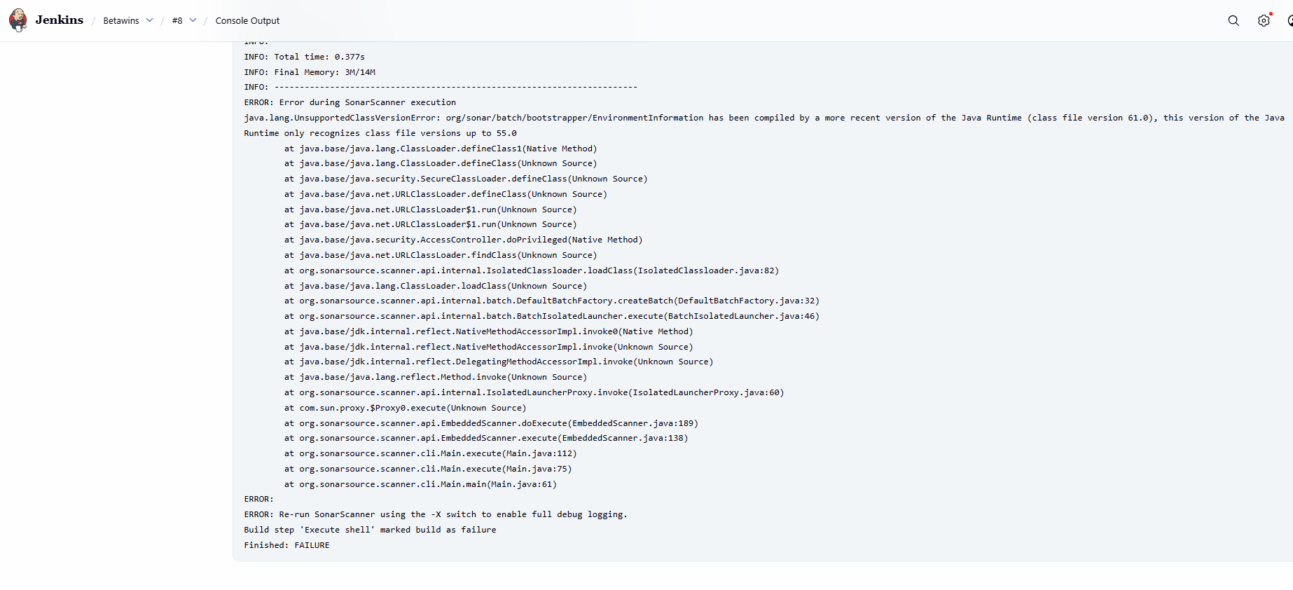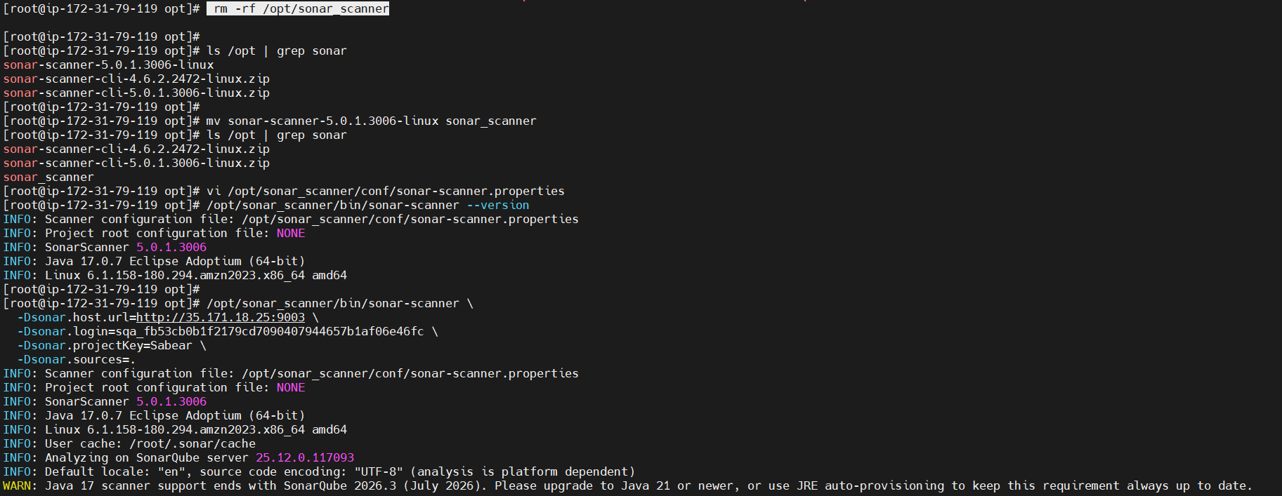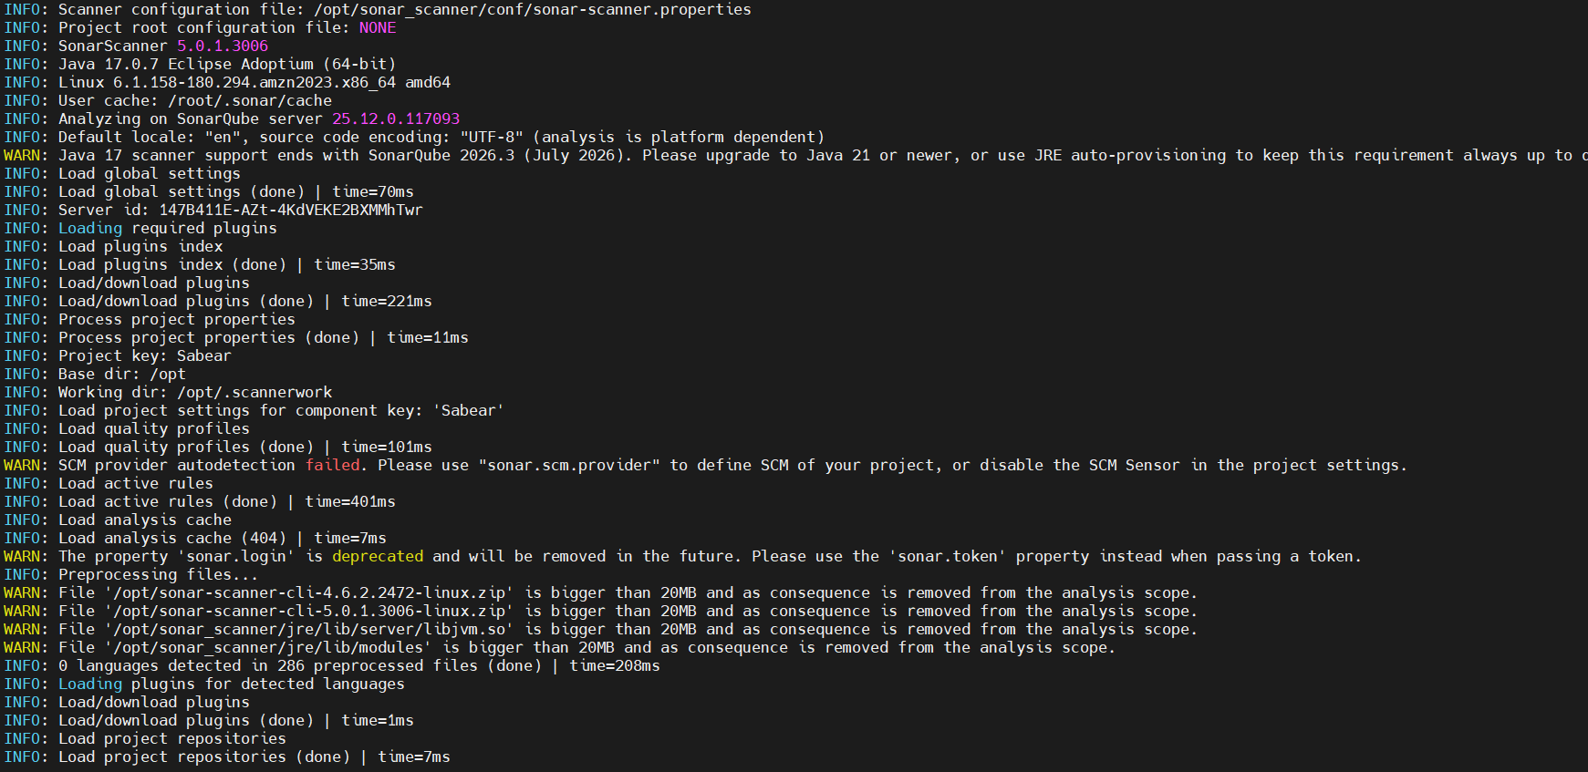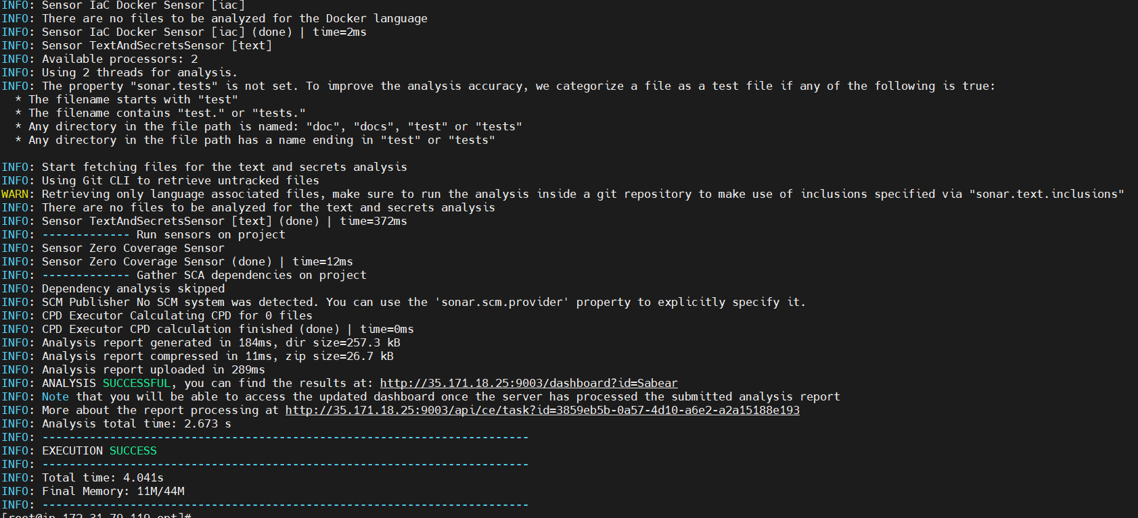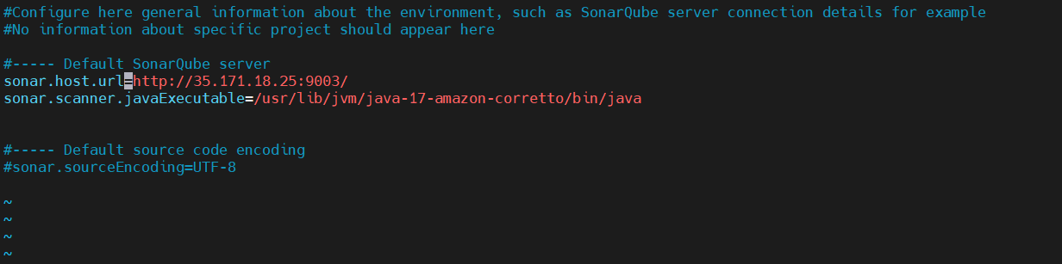
Conclusion:
The Jenkins job was successfully created with Git, SonarQube, and Slack integrations. Source code analysis completed successfully, quality gates passed, and build notifications were delivered to Slack as expected.

