Jenkins-Assignment-01

- Task Title: Install Jenkins and run Jenkins on port number 8081. Secure Jenkins server. Create users called DevOps and Testing in Jenkins with limited access. Configure labels and restrict the jobs to execute based on label only. Create three sample jobs using the GitHub repository https://github.com/betawins/Techie_horizon_Login_app.git
- Objective:
To install and configure Jenkins on an EC2 instance, change the default Jenkins port to 8081, secure the Jenkins server using role-based access, create limited-access users, configure node labels for controlled job execution, and create multiple Jenkins jobs integrated with a public Git repository.
- Prerequisites:
• AWS account with EC2 access
• Running Amazon Linux EC2 instance with public IP
• Security group allowing ports 22, 80, 443, and 8081
• Java installed on the EC2 instance
• Internet connectivity from the EC2 instance
• GitHub repository access (public repository)
- Step-by-Step Implementation (With Evidence):
Step 1: Launch EC2 instance and install Jenkins
• Console path / CLI command:
AWS Console → EC2 → Launch Instance
sudo yum update -y
sudo yum install java-21-openjdk -y
sudo wget -O /etc/yum.repos.d/jenkins.repo https://pkg.jenkins.io/redhat-stable/jenkins.repo
sudo rpm --import https://pkg.jenkins.io/redhat-stable/jenkins.io-2023.key
sudo yum install jenkins -y
• Explanation:
An EC2 instance is launched and Jenkins is installed using the official Jenkins repository after installing Java.
• Evidence:
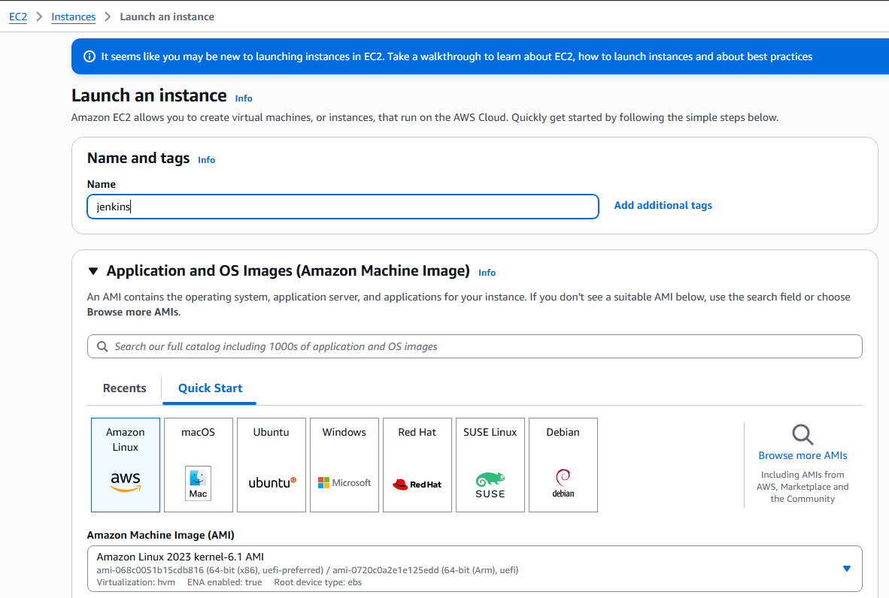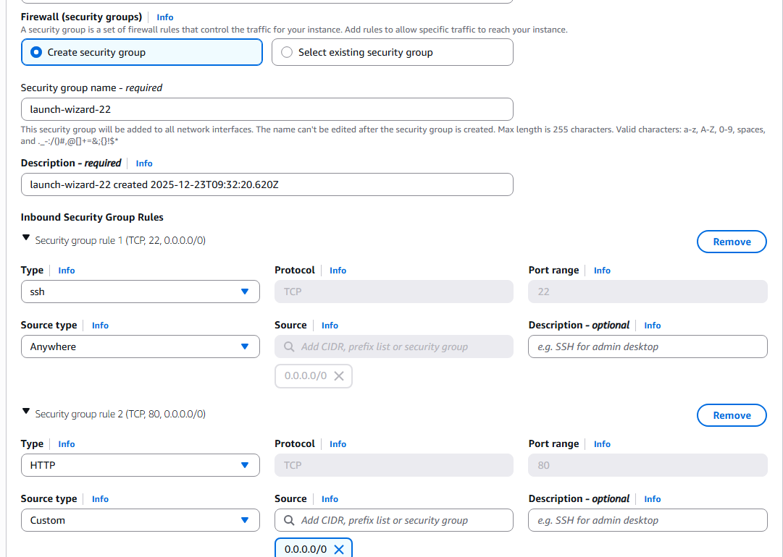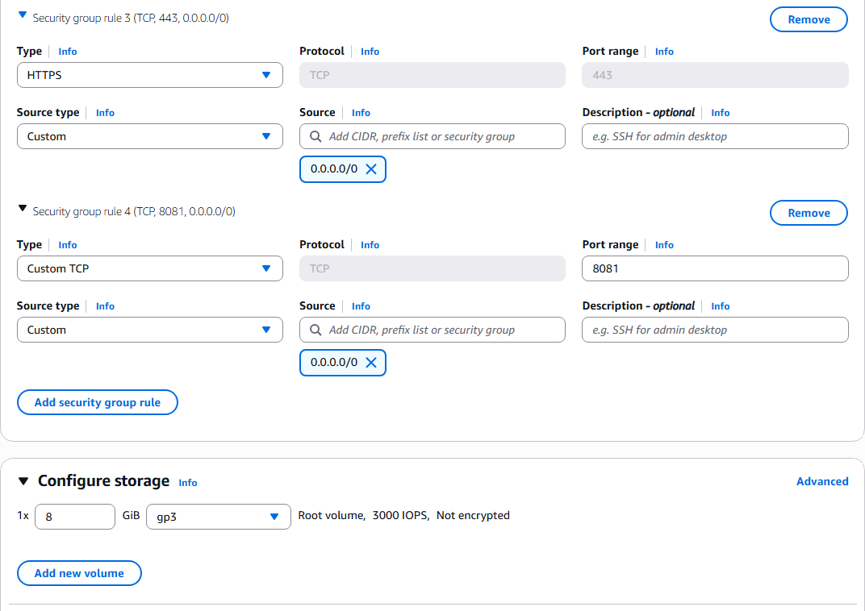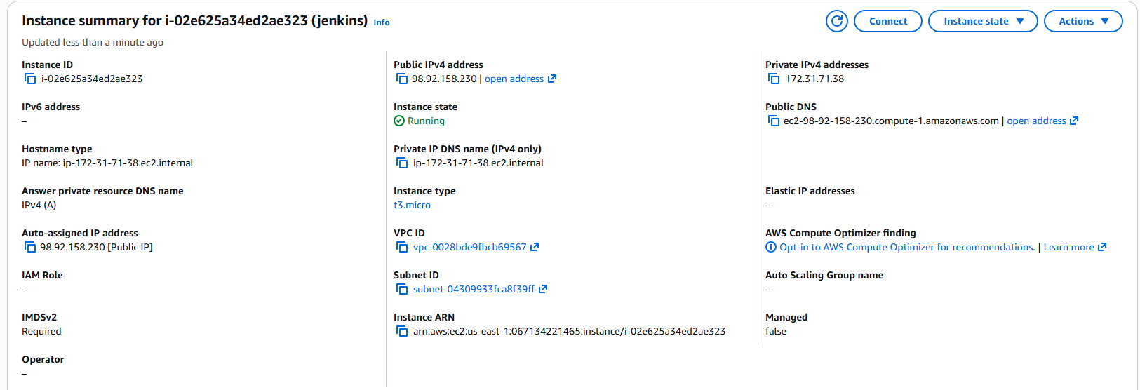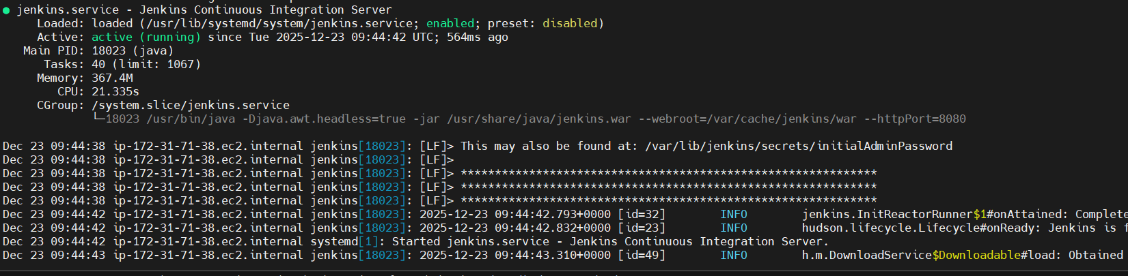
Step 2: Change Jenkins port to 8081 and start service
• Console path / CLI command:
sudo vi /usr/lib/systemd/system/jenkins.service
Set Environment="JENKINS_PORT=8081"
sudo systemctl daemon-reload
sudo systemctl restart jenkins
sudo systemctl status jenkins
• Explanation:
Jenkins default port is changed from 8080 to 8081 and the service is restarted to apply changes.
• Evidence: 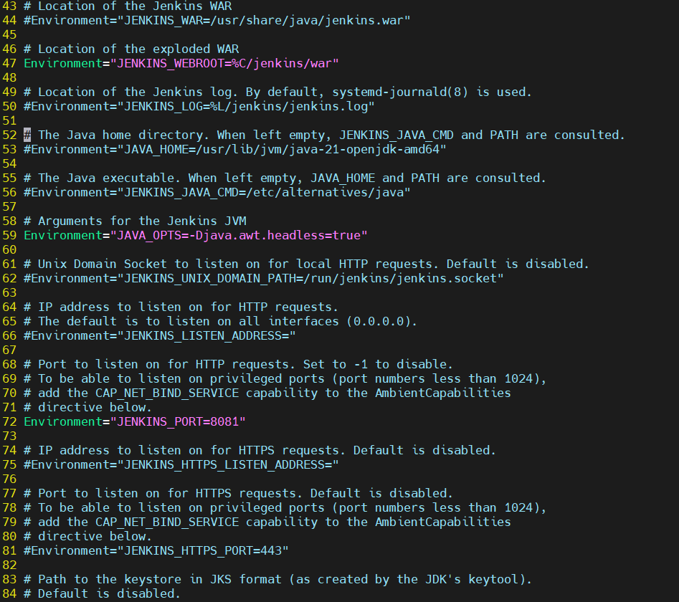

Step 3: Unlock Jenkins and complete initial setup
• Console path / CLI command:
sudo cat /var/lib/jenkins/secrets/initialAdminPassword
• Explanation:
The initial admin password is retrieved and used to unlock Jenkins via the browser.
• Evidence:
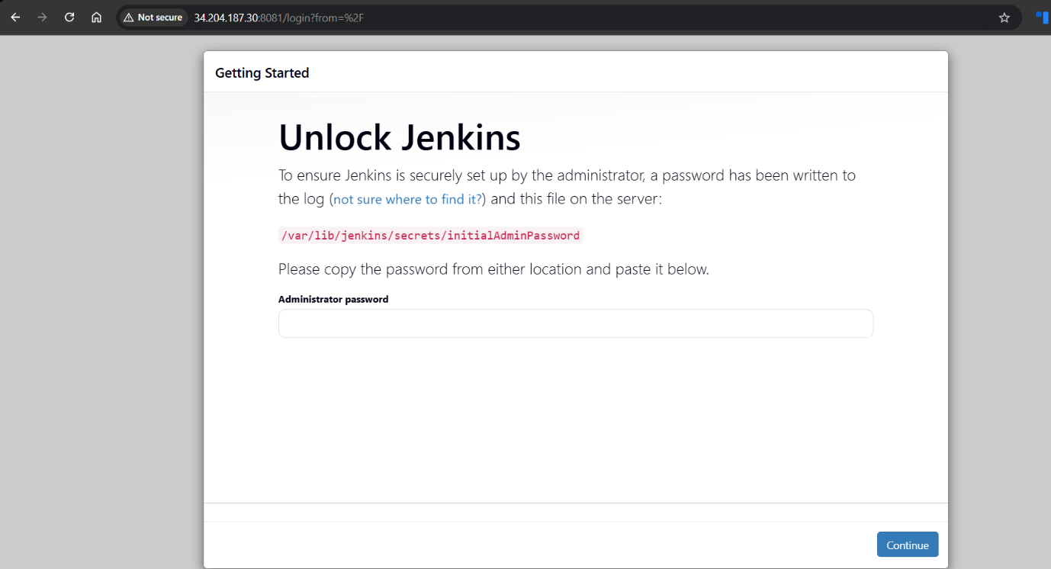
Step 4: Install required plugins
• Console path / CLI command:
Jenkins Dashboard → Manage Jenkins → Plugins
• Explanation:
Required plugins such as Role-based Authorization Strategy and Git plugin are installed.
• Evidence:
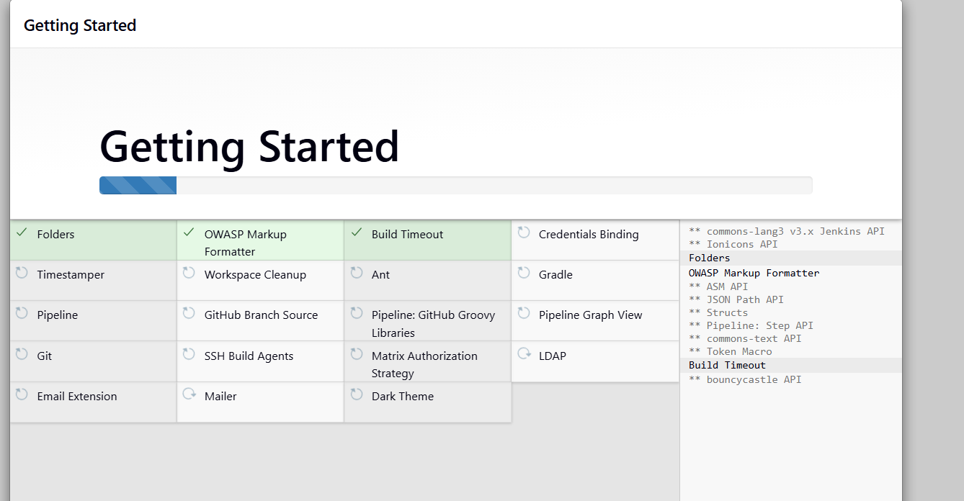
Step 5: Secure Jenkins and create users
• Console path / CLI command:
Jenkins Dashboard → Manage Jenkins → Security
Jenkins Dashboard → Manage Jenkins → Users → Create User
• Explanation:
Jenkins security is configured and users DevOps and Testing are created using Jenkins’ own user database.
• Evidence:
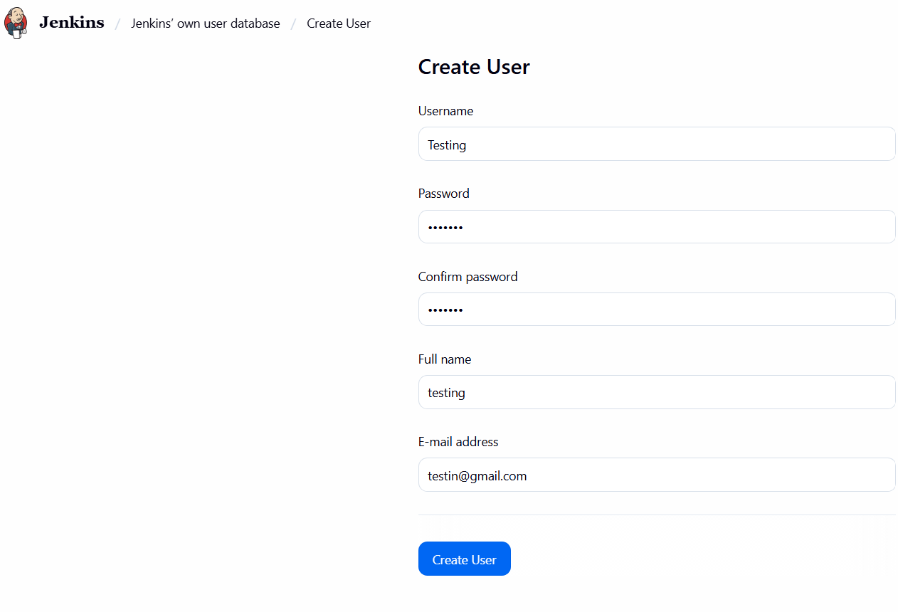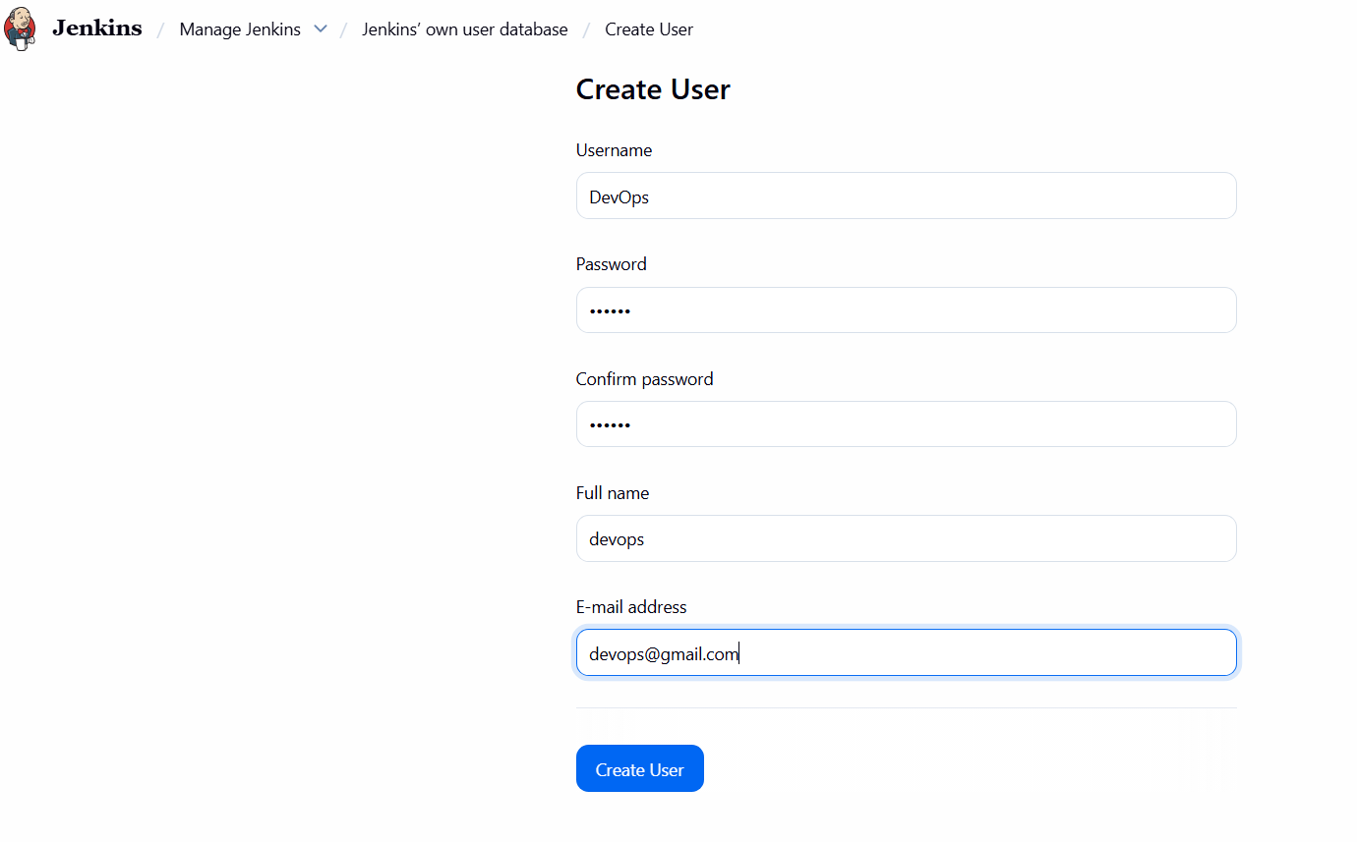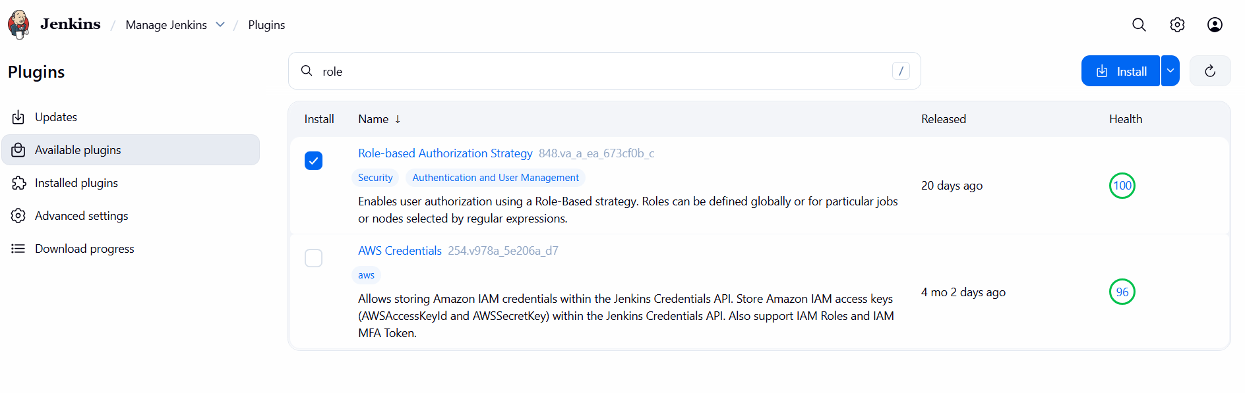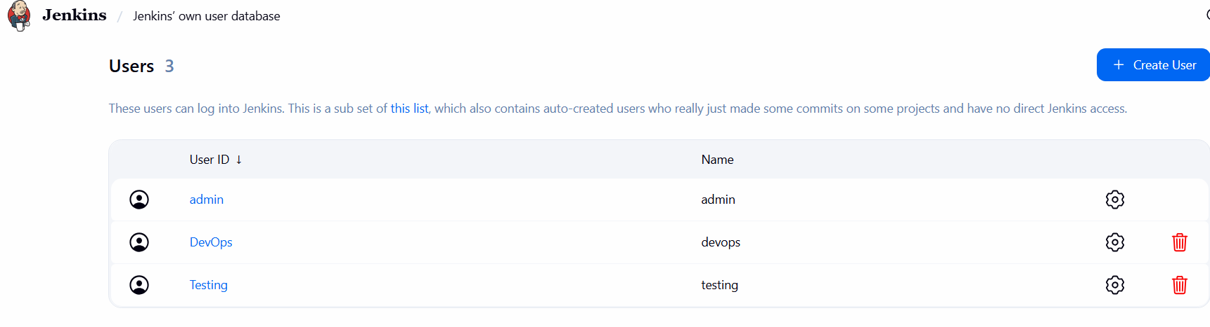
Step 6: Configure role-based access
• Console path / CLI command:
Jenkins Dashboard → Manage Jenkins → Security → Authorization
• Explanation:
Project-based Matrix Authorization Strategy is configured to provide limited access to DevOps and Testing users while retaining full access for admin.
• Evidence:
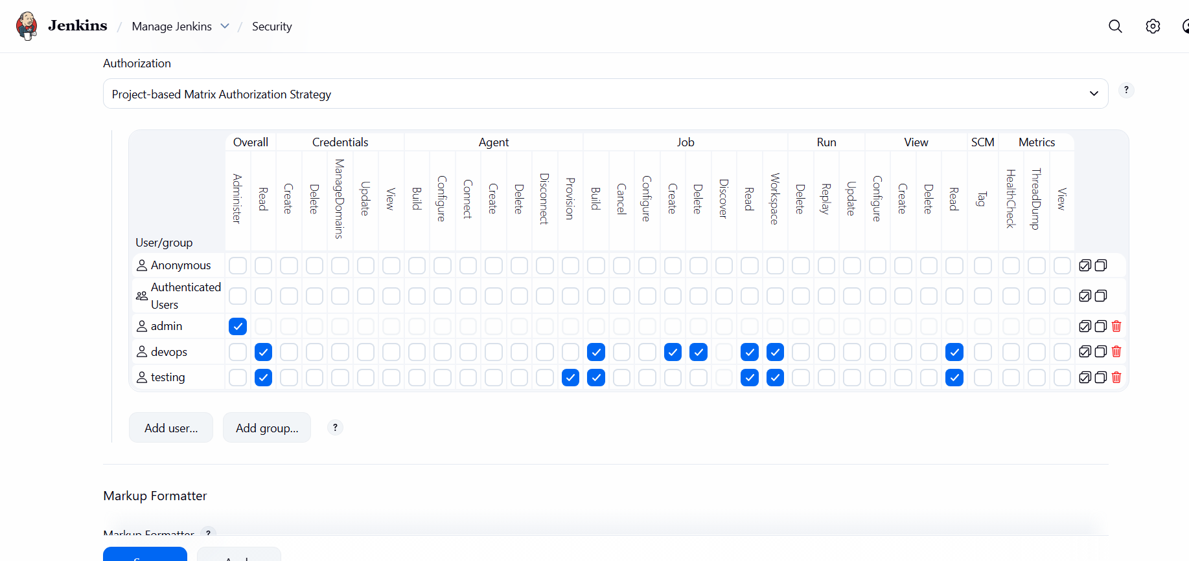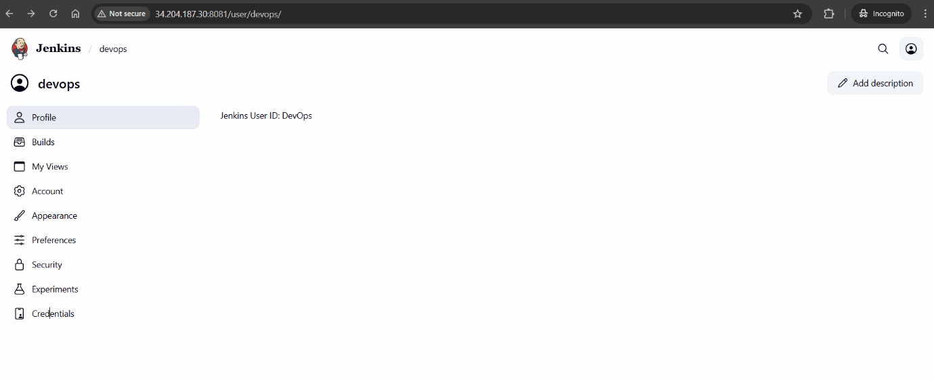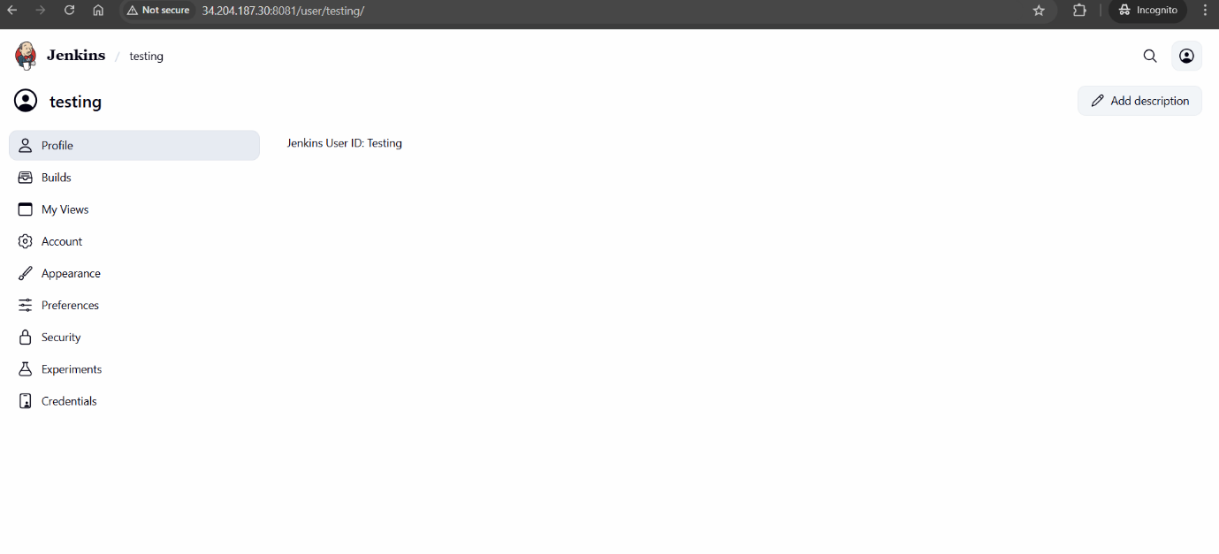
Step 7: Configure node label
• Console path / CLI command:
Jenkins Dashboard → Manage Jenkins → System
• Explanation:
A node label named Git_executor is configured and executor usage is restricted to jobs matching this label.
• Evidence:
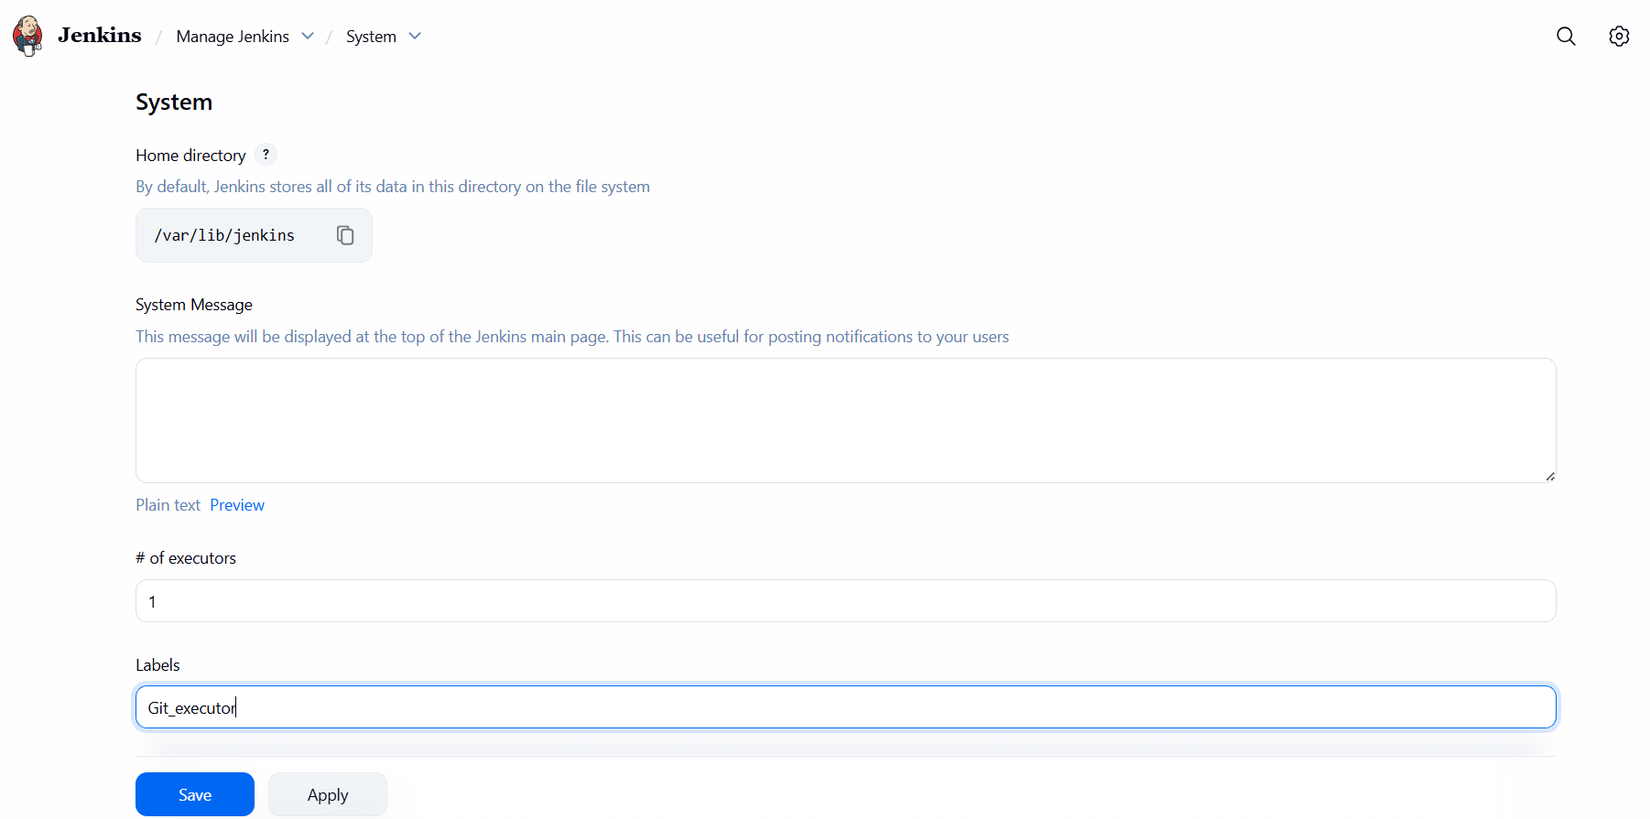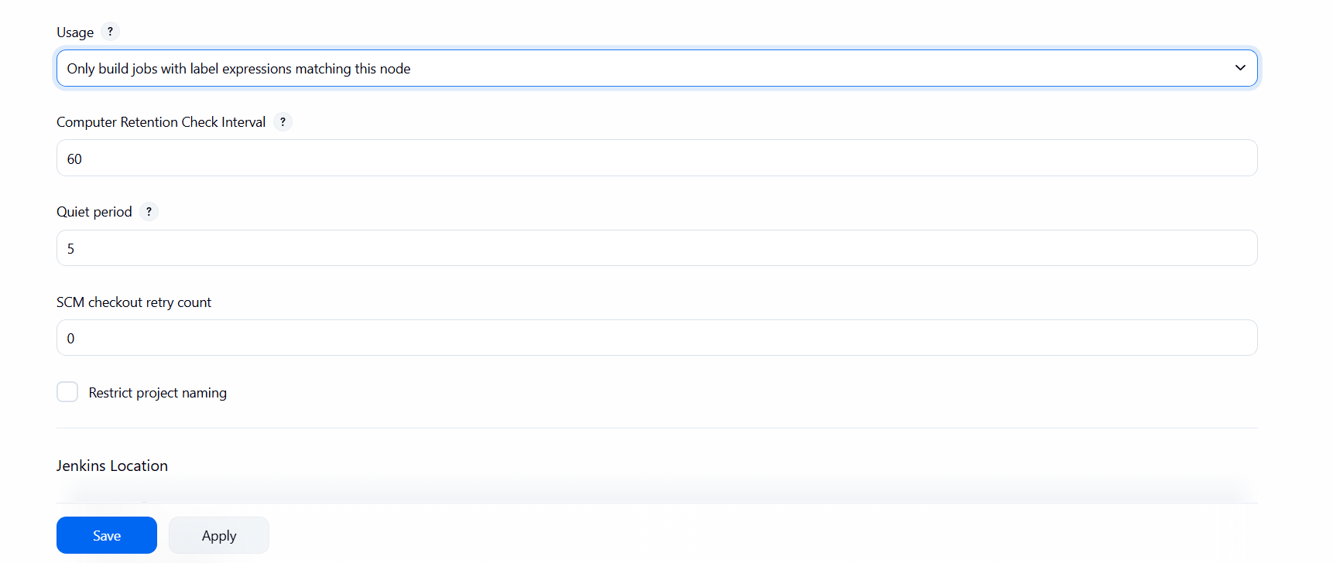
Step 8: Install Git on Jenkins server
• Console path / CLI command:
sudo yum install git -y
git --version
• Explanation:
Git is installed on the Jenkins server to enable repository checkout during job execution.
• Evidence:
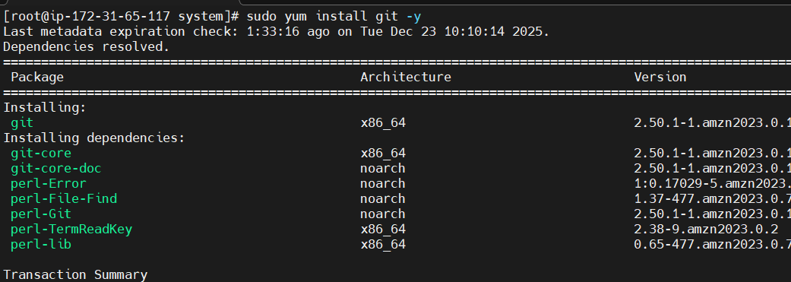
Step 9: Create Jenkins jobs and configure label restriction
• Console path / CLI command:
Jenkins Dashboard → New Item → Freestyle Project
• Explanation:
Three Jenkins freestyle jobs are created. Each job is restricted to run only on nodes with the Git_executor label and configured with the public Git repository URL.
• Evidence:
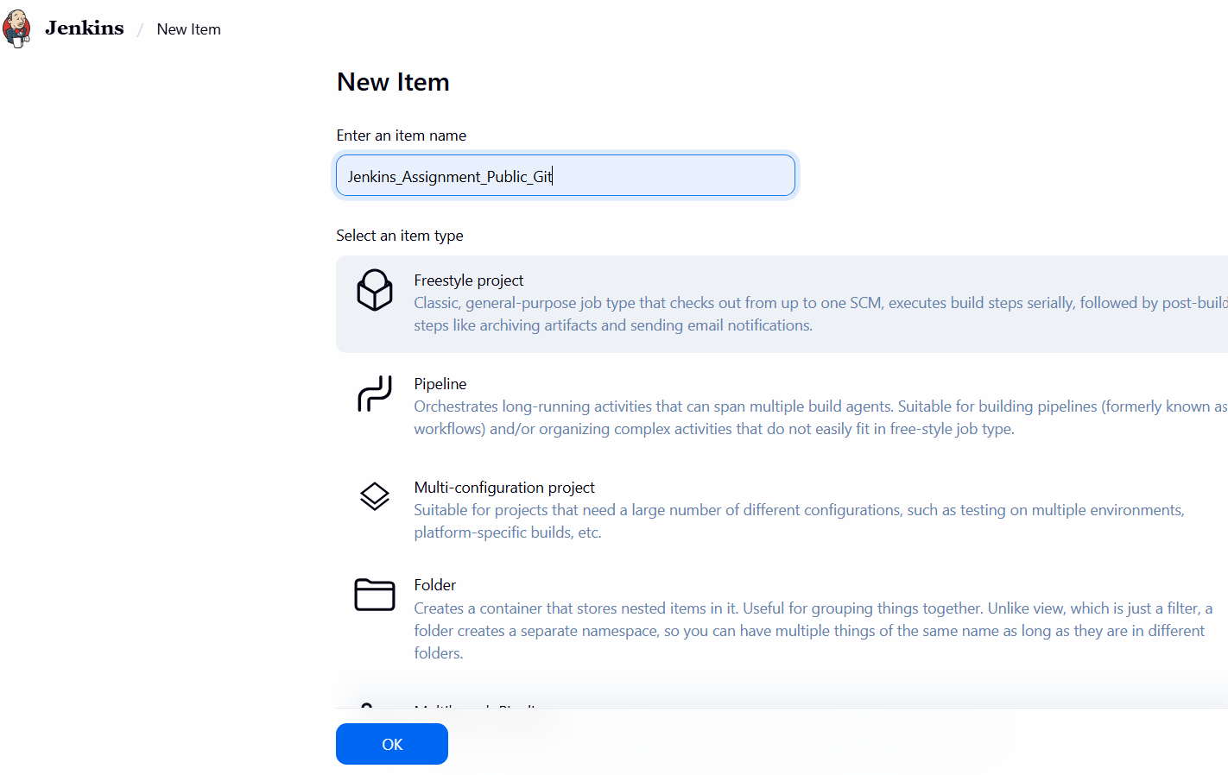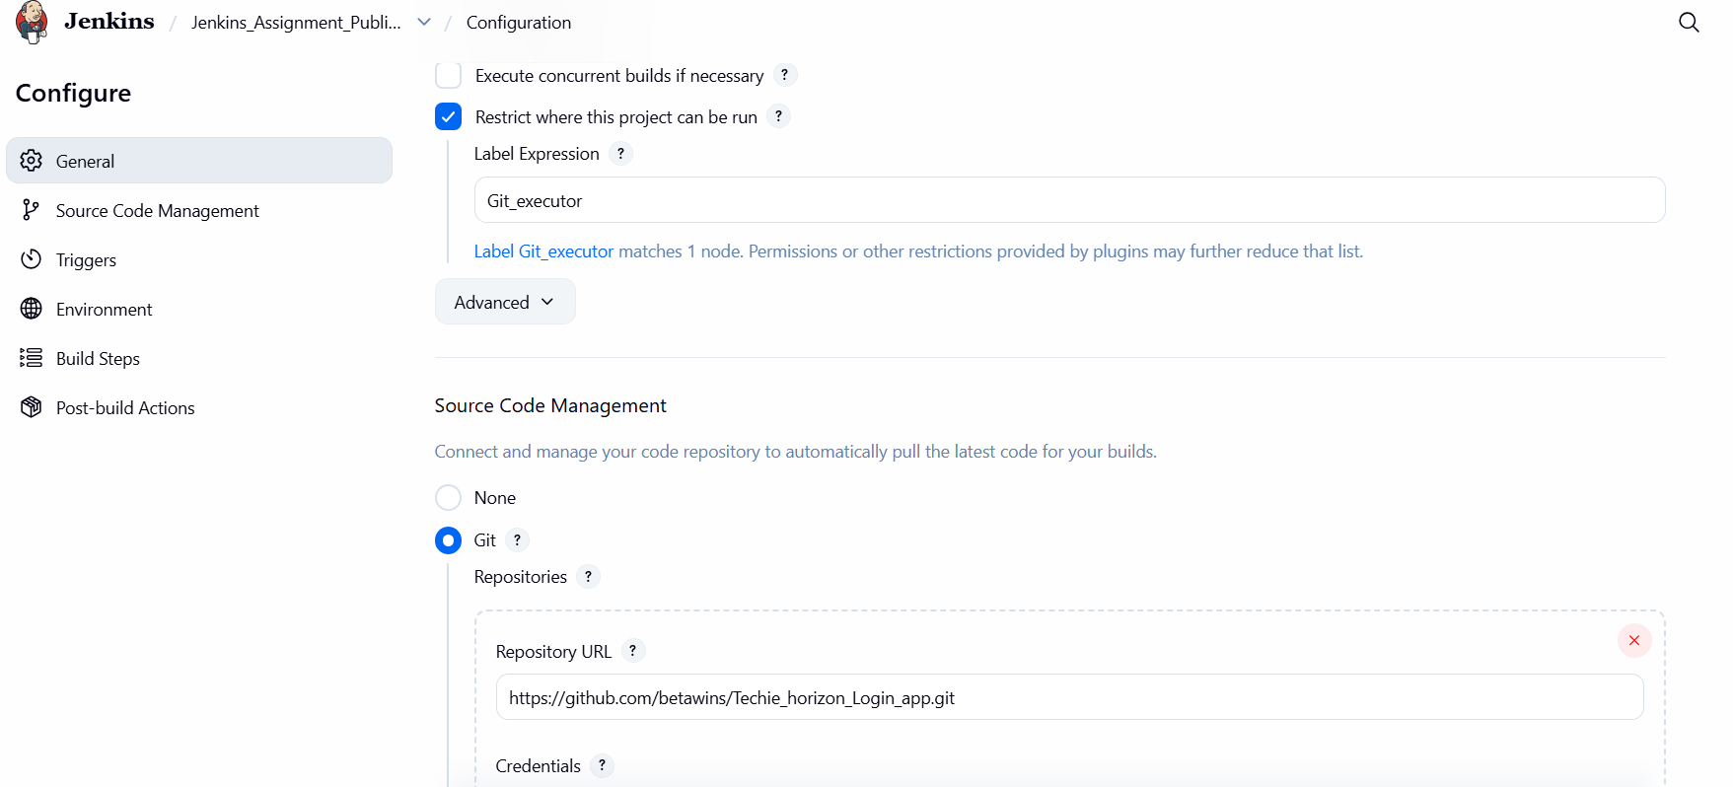
- Validation Steps (Mandatory, With Evidence):
• Console path / CLI command:
Jenkins Dashboard → Job → Build Now
• Explanation:
Jobs are triggered manually and successfully clone the GitHub repository and complete execution.
• Evidence:
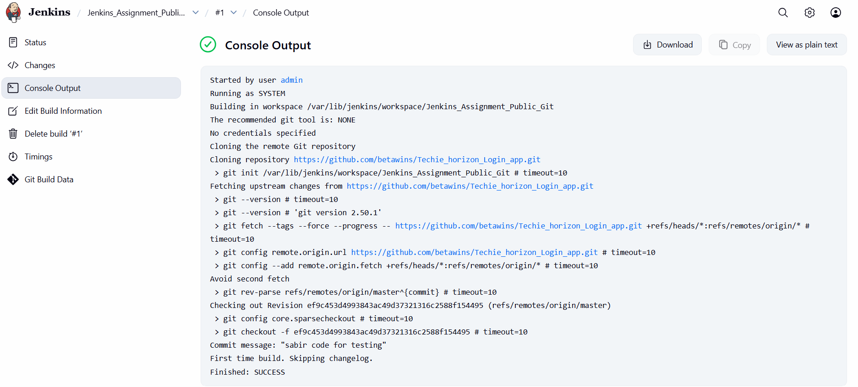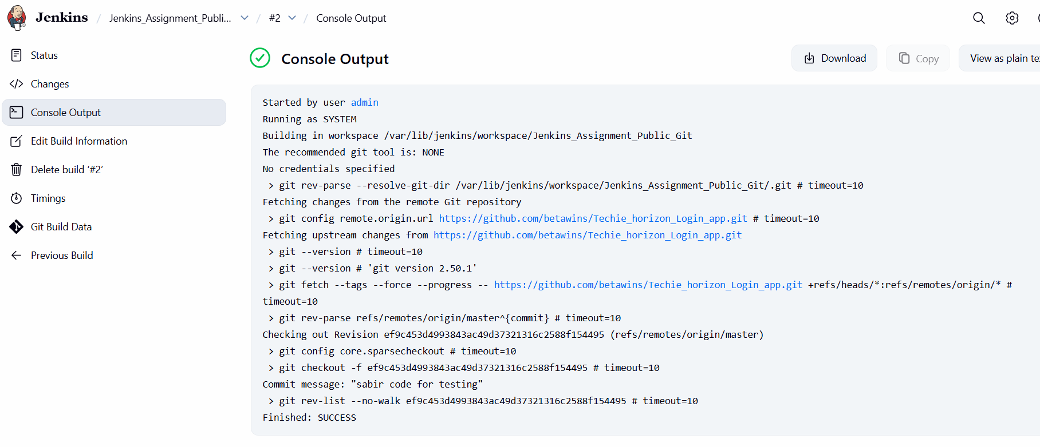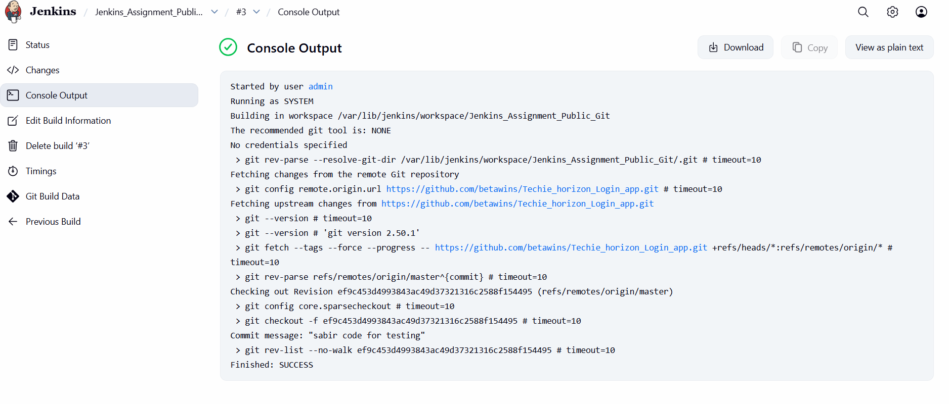

Issues Faced (Optional):
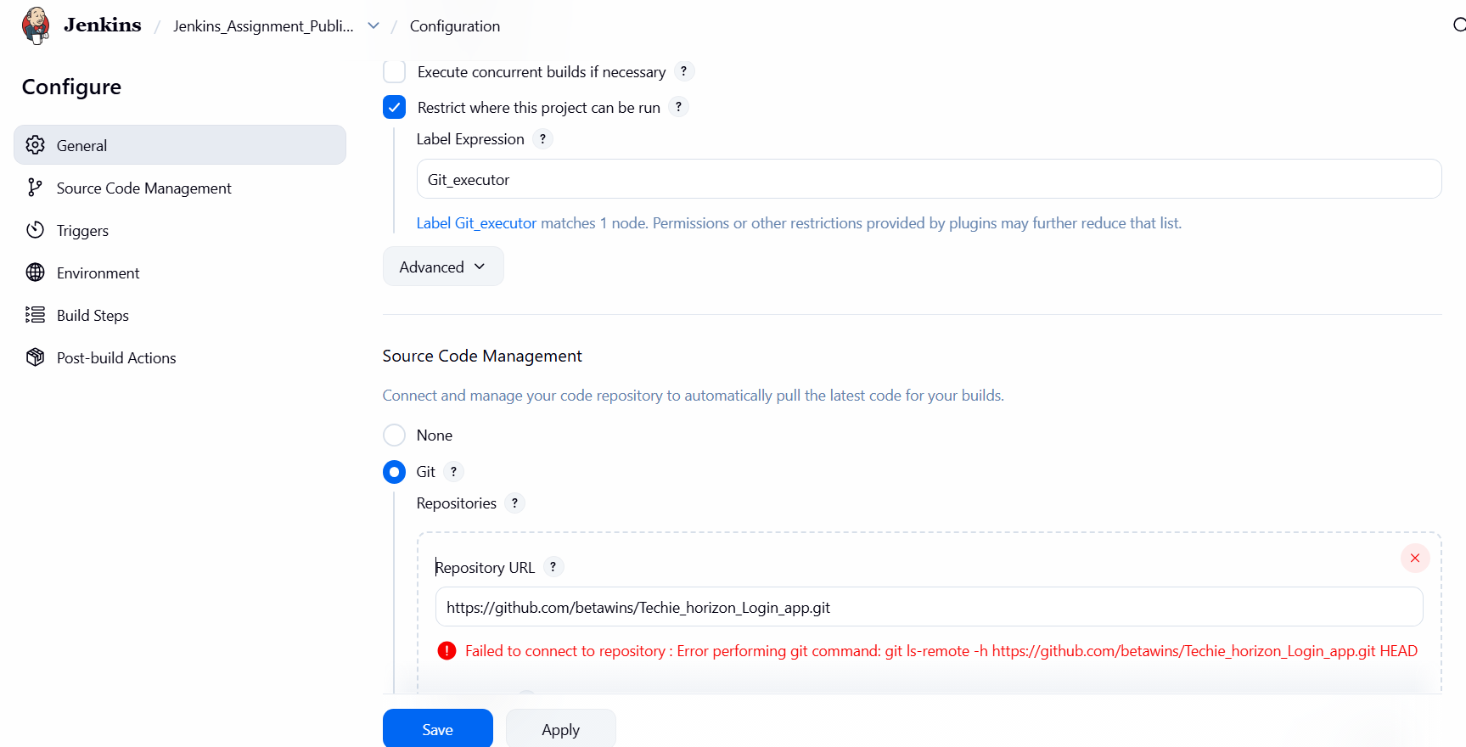
• Initial Git checkout failed due to Git not being installed on the server
• Issue resolved by installing Git using yum package manager
- Conclusion:
Jenkins was successfully installed, secured, and configured on an EC2 instance with role-based access control, node labeling, and multiple jobs integrated with a GitHub repository.

- Task Title: Create one Jenkins job using GitHub Private Repository
- Objective:
To configure a Jenkins freestyle job that securely connects to a GitHub private repository using a Personal Access Token, successfully clones the repository, and executes a build without errors.
- Prerequisites:
• Jenkins server installed and running
• Jenkins accessible on port 8081
• Git installed on the Jenkins server
• GitHub account with a private repository
• GitHub Personal Access Token (classic) with repo scope
• Jenkins user with admin privileges
• Internet connectivity from Jenkins server to GitHub
- Step-by-Step Implementation (With Evidence):
Step 1: Generate GitHub Personal Access Token
• Console path / CLI command: GitHub → Settings → Developer Settings → Personal access tokens → Tokens (classic) → Generate new token
• Explanation:
A classic Personal Access Token was generated with repo scope to allow Jenkins to authenticate against the private GitHub repository over HTTPS. The token expiration and scope were configured as required.
Evidence: 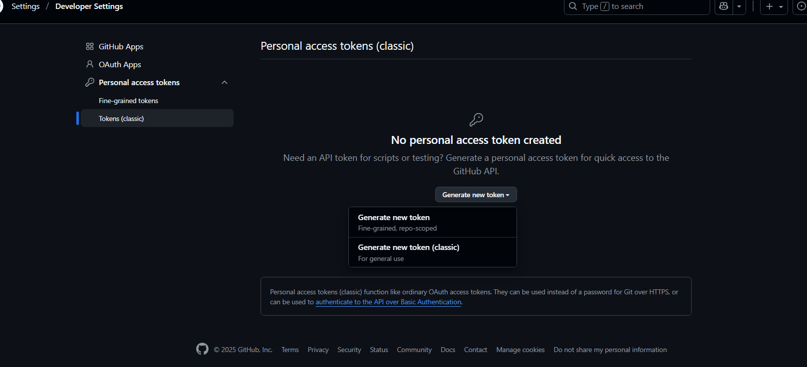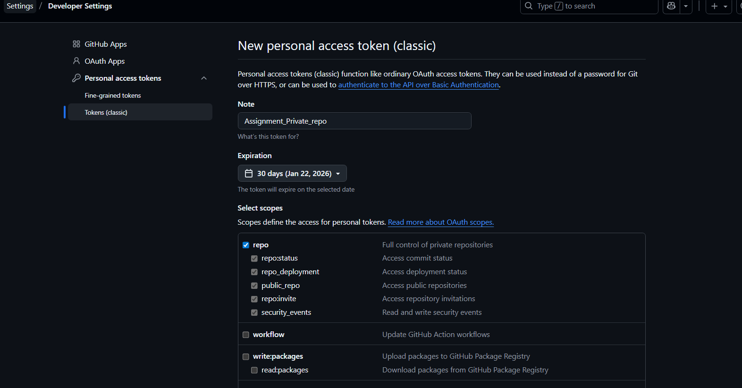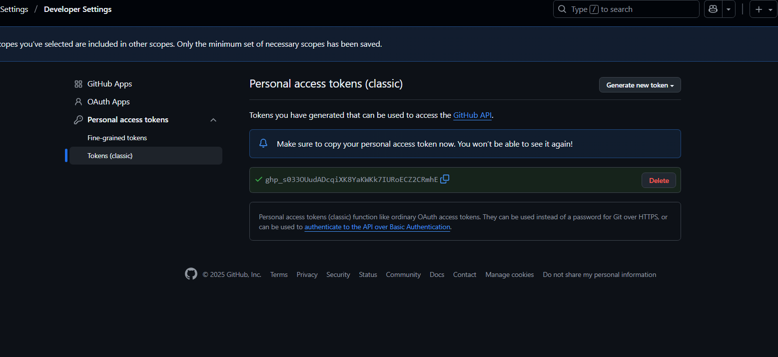
Step 2: Create Jenkins Freestyle Job
• Console path / CLI command: Jenkins Dashboard → New Item → Freestyle Project
• Explanation:
A new freestyle job was created with a meaningful name to connect Jenkins with the GitHub private repository.
Evidence: 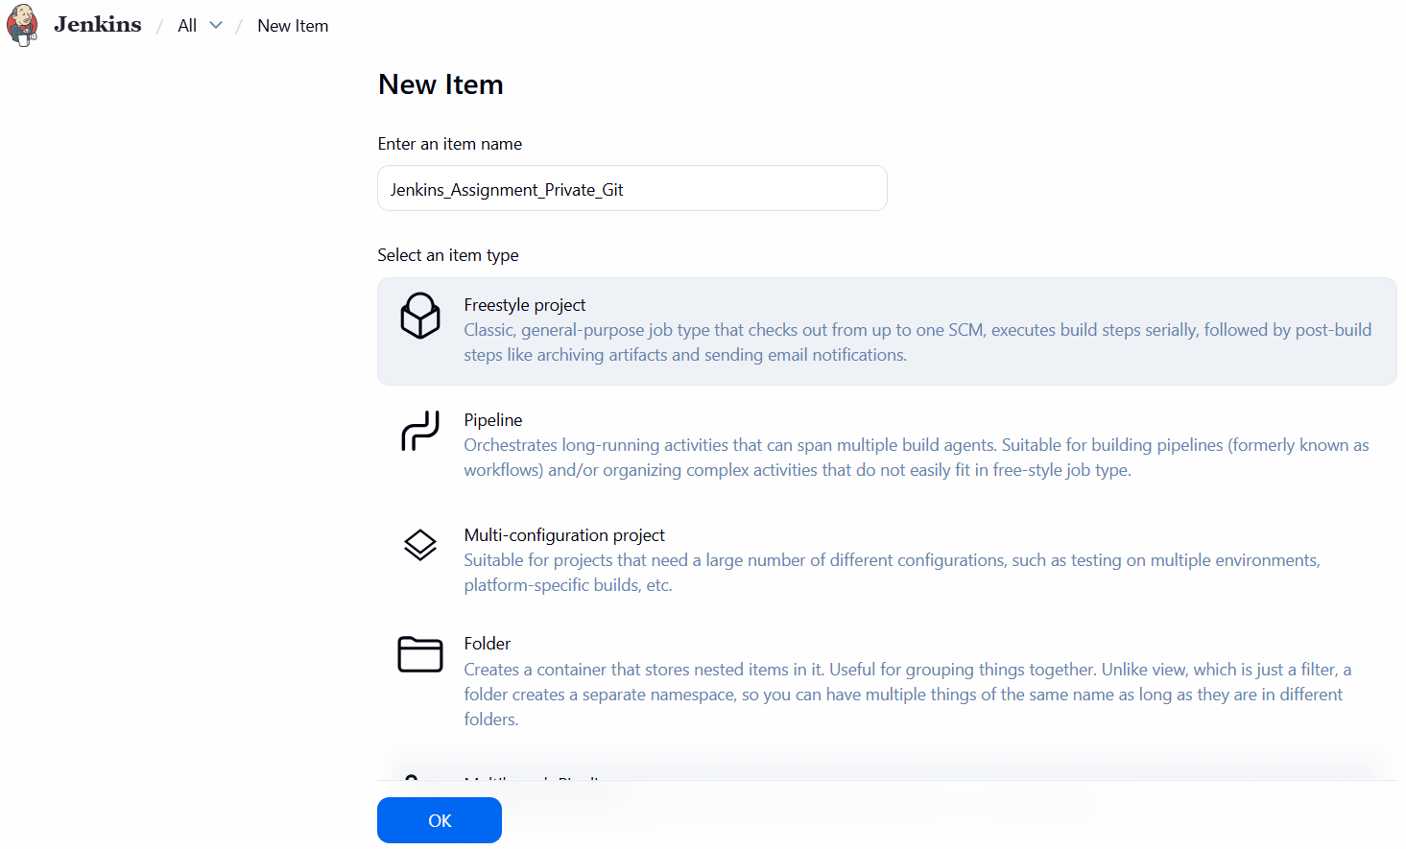 Step 3: Add GitHub Credentials in Jenkins
• Console path / CLI command: Jenkins → Manage Jenkins → Credentials → System → Global credentials → Add Credentials
• Explanation:
A new credential of type “Username with password” was added. The GitHub username was provided as the username and the Personal Access Token was used as the password. The credential ID was set to identify the private repository access.
Evidence: 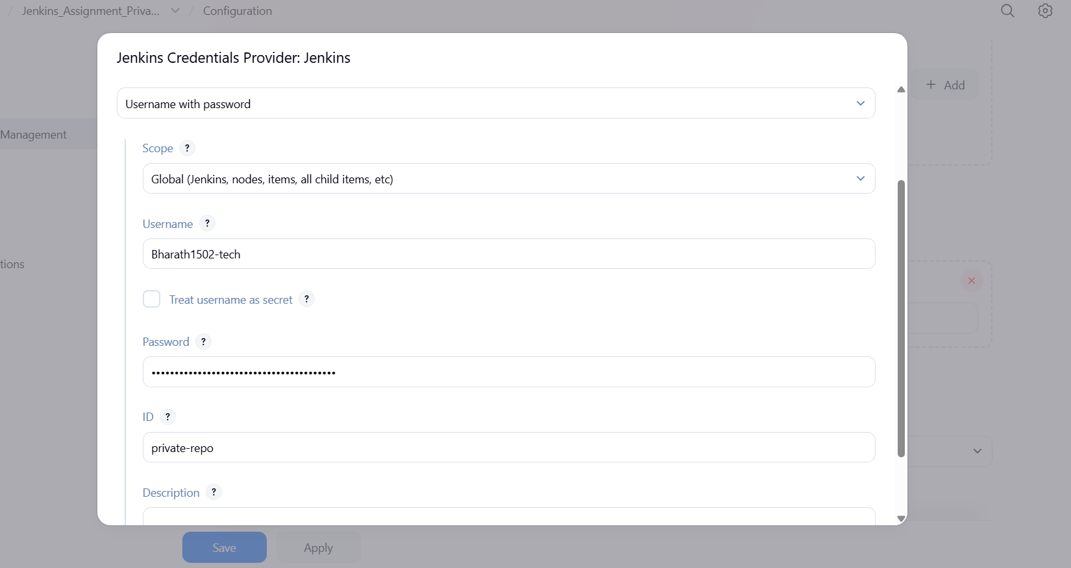
Step 4: Configure Source Code Management
• Console path / CLI command: Jenkins Job → Configure → Source Code Management → Git
• Explanation:
The GitHub private repository HTTPS URL was provided. The previously created Jenkins credential was selected. The branch specifier was updated to */main to match the default branch of the repository.
Evidence 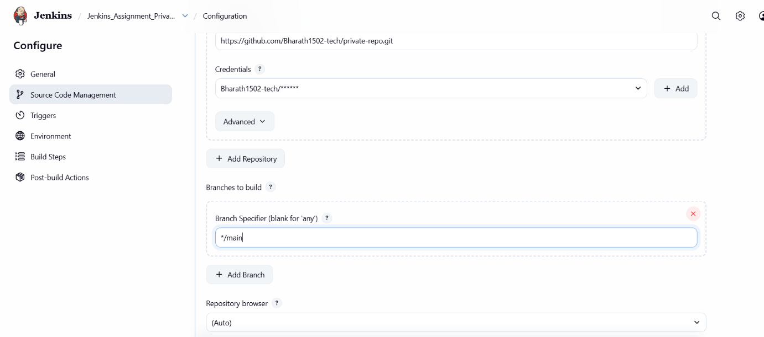
Validation Steps (Mandatory, With Evidence):
Build the Job
• Console path / CLI command: Jenkins Job → Build Now
• Explanation:
The job was triggered manually. Jenkins successfully authenticated using the token, fetched the repository, checked out the main branch, and completed the build.
Evidence: 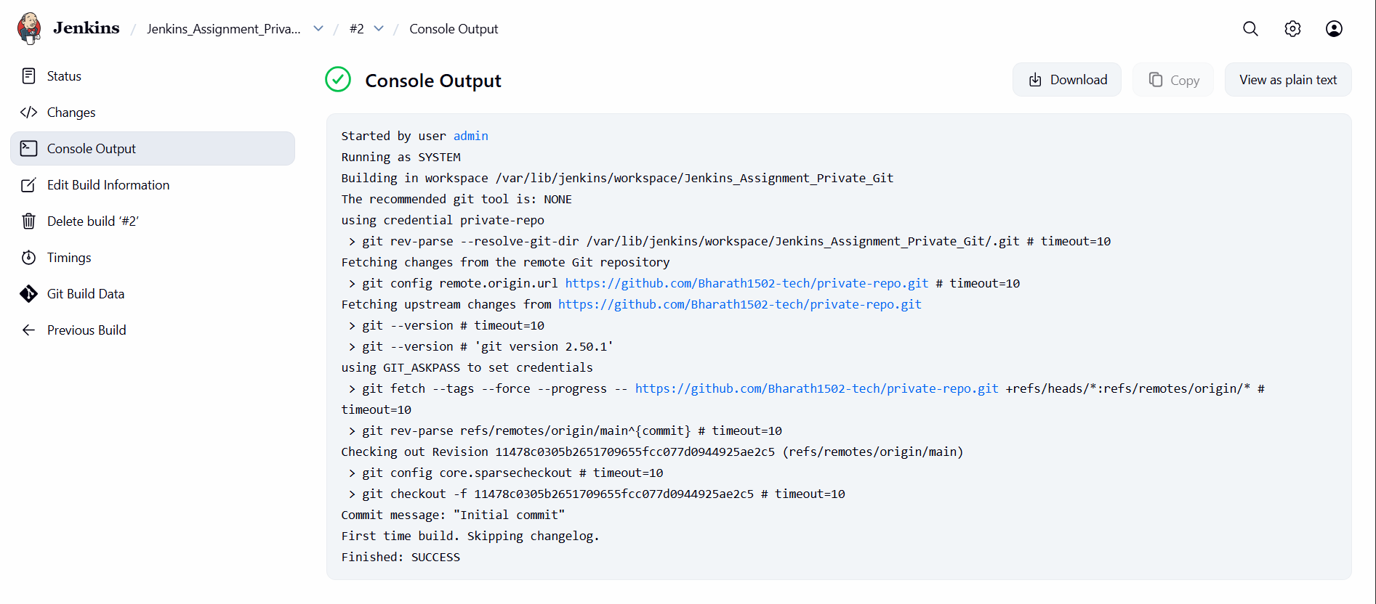
- Issues Faced (Optional): 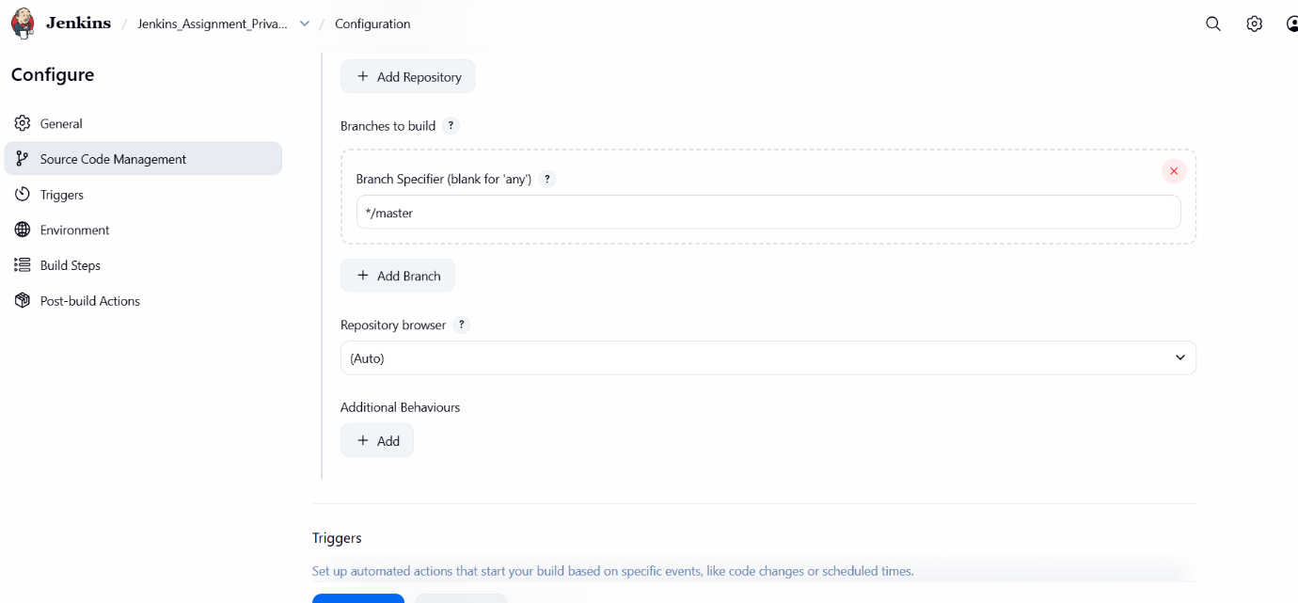 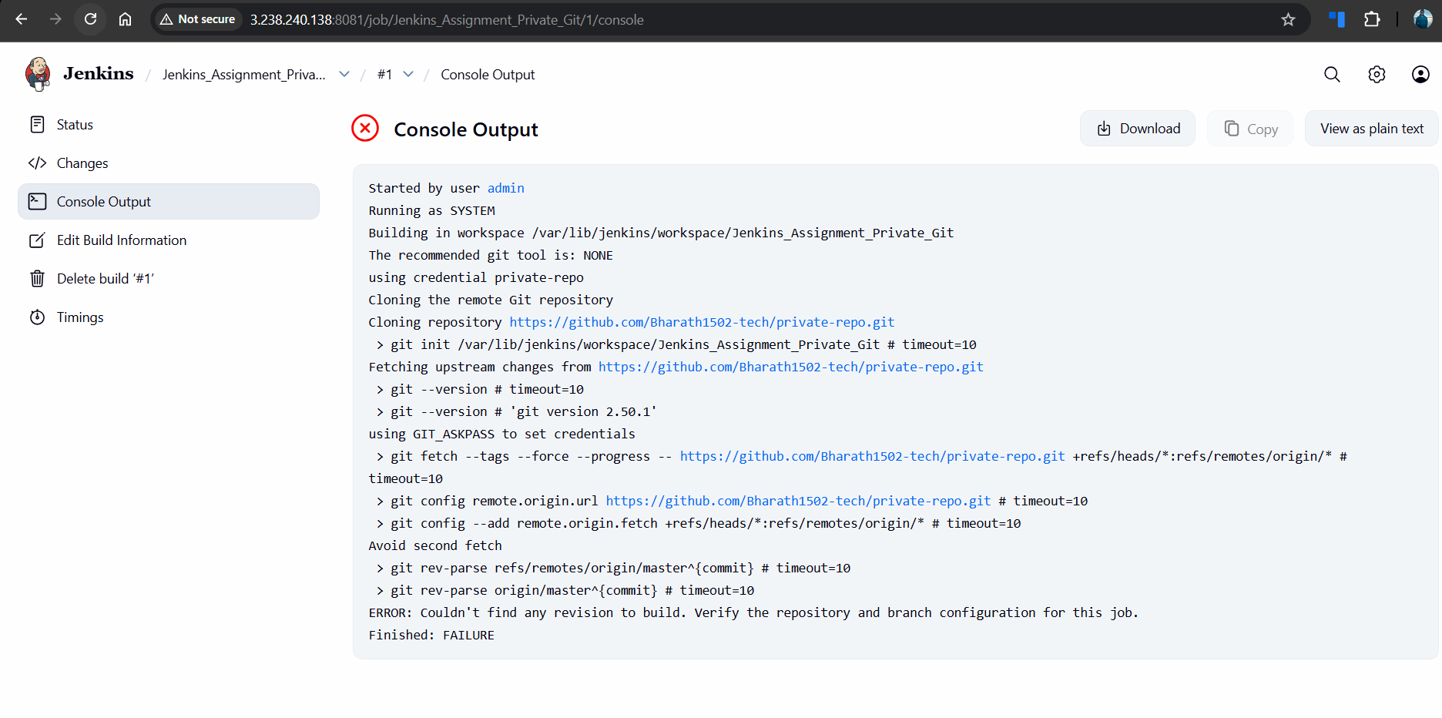
Initially, the build failed with the error “Couldn't find any revision to build” because the branch specifier was set to */master while the repository default branch was main. The issue was resolved by updating the branch specifier to */main.
- Conclusion:
The Jenkins job was successfully created and configured to access a GitHub private repository using secure credentials. The build executed successfully after correcting the branch configuration.

