Jenkins-Assignment-02

- Configure 2 slave machines in Jenkins master.
- Task Title: Configure 2 slave machines in Jenkins master
- Objective:
To configure two Jenkins slave (agent) machines and connect them to a Jenkins master using SSH-based authentication for distributed build execution.
- Prerequisites:
• Jenkins Master installed and running
• Two EC2 instances provisioned as slave machines
• Java 17 installed on master and slave machines
• Network connectivity between master and slaves (port 22 open)
• Jenkins user available on master
• SSH access to slave machines
- Step-by-Step Implementation (With Evidence):
Step 1: Launch Jenkins Master EC2 instance
• Console path / CLI command:
AWS Console → EC2 → Instances → Launch an instance
• Explanation:
A new EC2 instance is initiated for Jenkins Master with a defined name and Amazon Linux AMI.

Evidence:
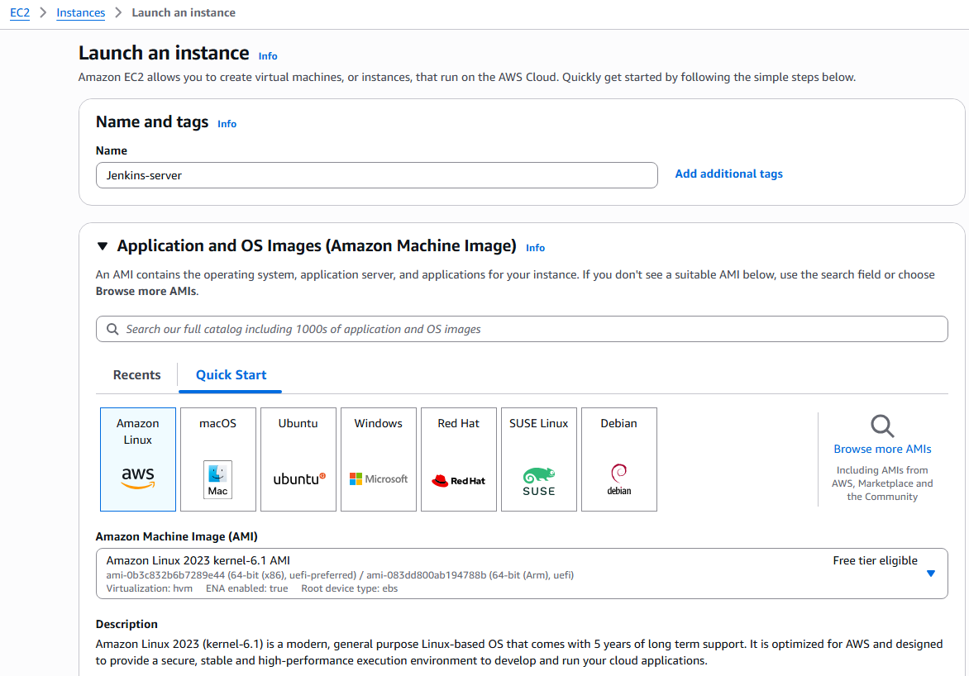
Step 2: Select Amazon Machine Image (AMI)
• Console path / CLI command:
EC2 → Launch instance → Application and OS Images

• Explanation:
Amazon Linux 2023 AMI is selected to ensure long-term support and compatibility with Jenkins and Java.

Evidence:

Step 3: Configure network and security group
• Console path / CLI command:
EC2 → Launch instance → Network settings

• Explanation:
Default VPC is selected with auto-assign public IP enabled. Security group rules are added to allow SSH (22), HTTP (80), HTTPS (443), and Jenkins (8080) access.

Evidence:
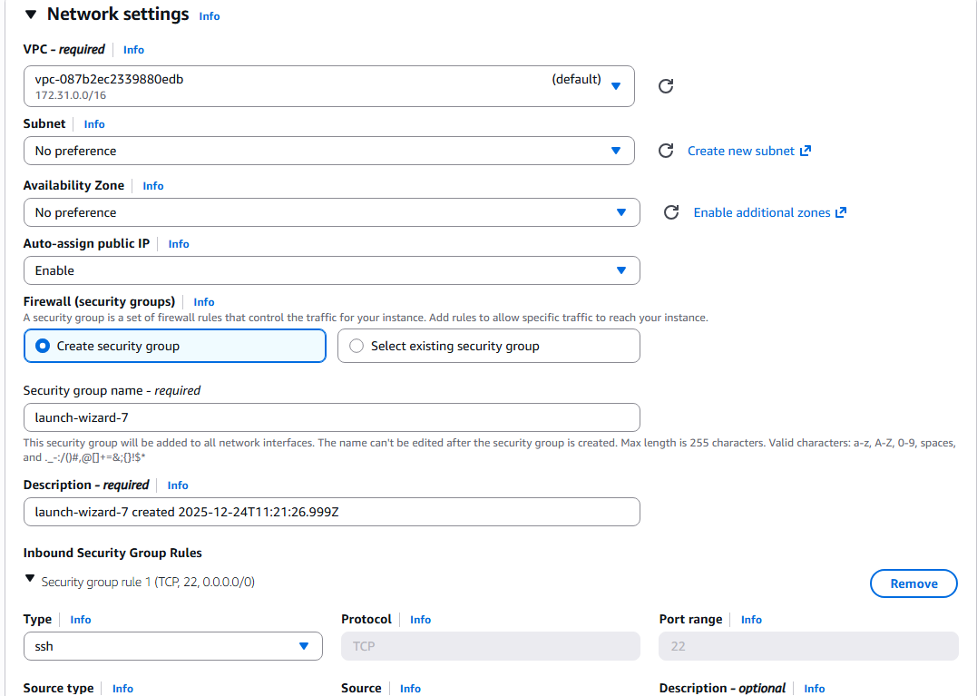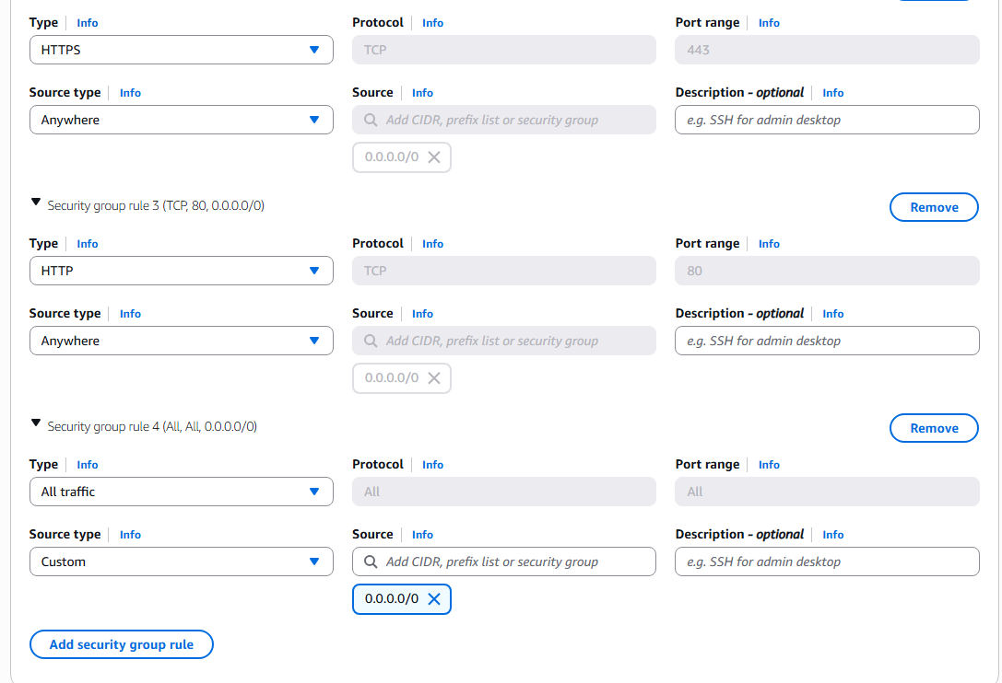
Step 4: Add Jenkins installation script using User Data
• Console path / CLI command:
EC2 → Launch instance → Advanced details → User data
#!/bin/bash
set -e
sudo dnf update -y
sudo dnf install java-17-amazon-corretto -y
java -version
sudo wget -O /etc/yum.repos.d/jenkins.repo \
https://pkg.jenkins.io/redhat-stable/jenkins.repo
sudo rpm --import https://pkg.jenkins.io/redhat-stable/jenkins.io-2023.key
sudo dnf install jenkins -y
sudo systemctl enable jenkins
sudo systemctl start jenkins
sudo systemctl status jenkins
• Explanation:
A bootstrap script is provided to install Java 17, configure Jenkins repository, install Jenkins, and start the Jenkins service automatically at instance launch.

Evidence:
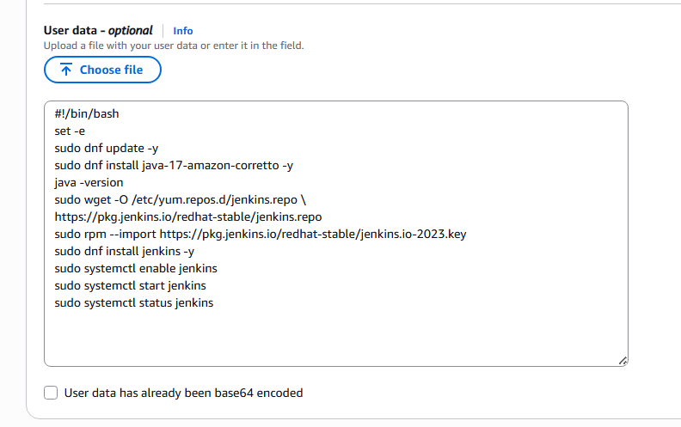
Step 5: Verify Jenkins Master instance status
• Console path / CLI command:
EC2 → Instances → Select Jenkins-Master

• Explanation:
The Jenkins Master EC2 instance is verified to be in running state with public and private IP addresses assigned.

Evidence:
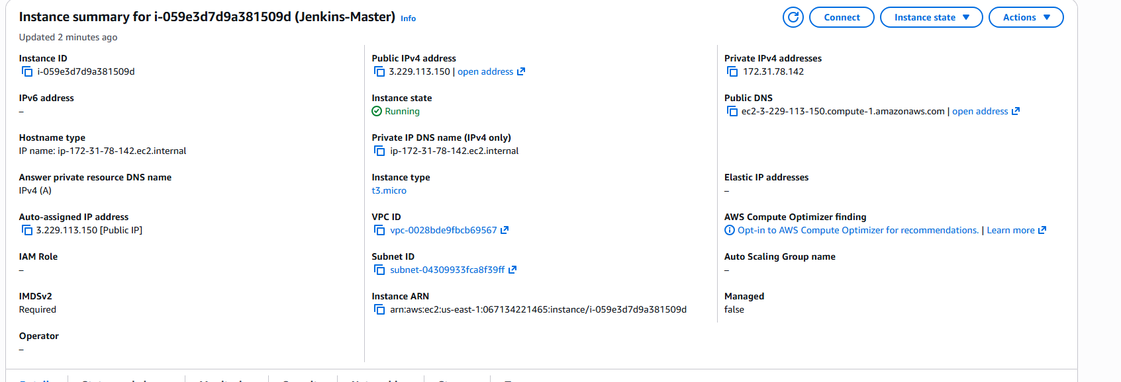
Step 6: Launch Jenkins Slave01 EC2 instance
• Console path / CLI command:
AWS Console → EC2 → Instances → Launch an instance

• Explanation:
A separate EC2 instance is launched for Jenkins-Slave01 using similar AMI and security group configuration.

Evidence:
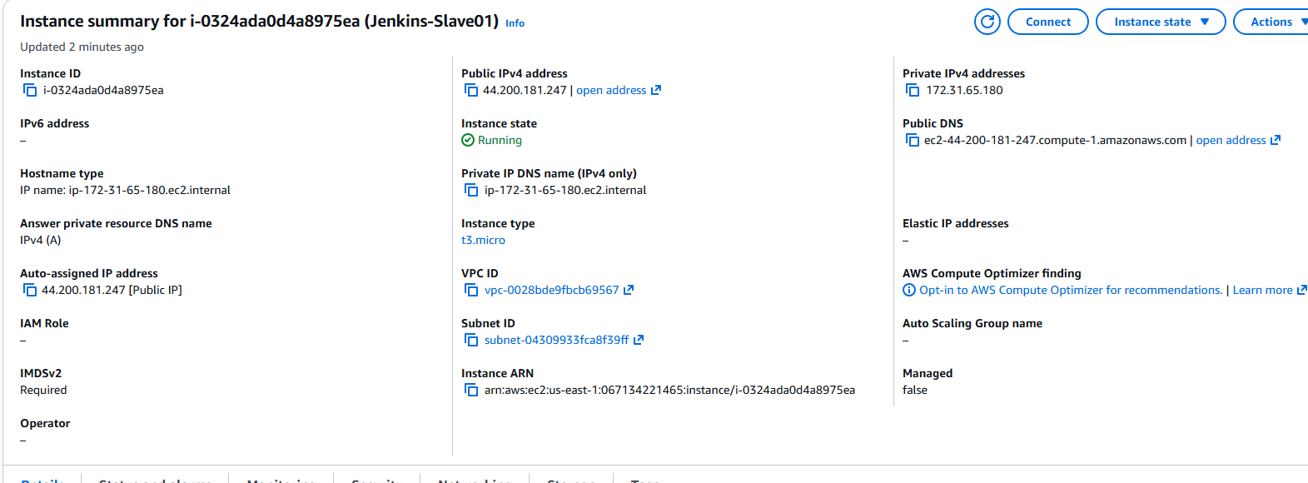

Step 8: Launch Jenkins Slave02 EC2 instance
• Console path / CLI command:
AWS Console → EC2 → Instances → Launch an instance

• Explanation:
Another EC2 instance is launched to act as Jenkins-Slave02 to support distributed builds.

Evidence:
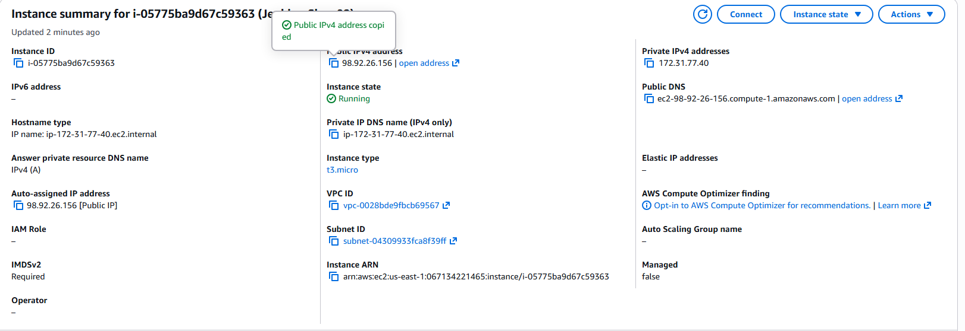
Step 2: Configure SSH keys on Slave machines
• Console path / CLI command:
cd ~/.ssh
cat id_rsa.pub > authorized_keys
chmod 700 authorized_keys
• Explanation:
The public key is added to the authorized_keys file on each slave machine to allow SSH access from Jenkins master.
Evidence:
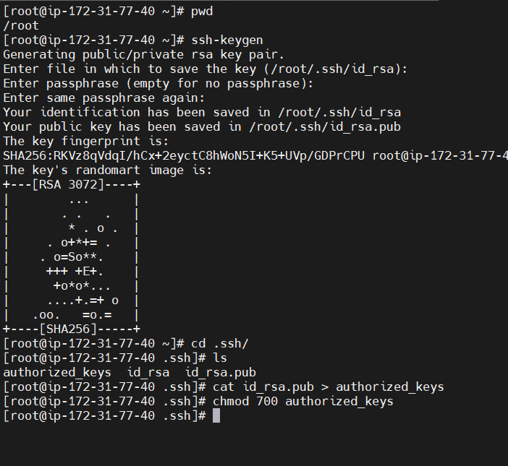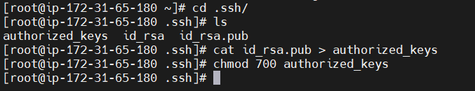
Step 9: Prepare Jenkins user SSH configuration on Master
• Console path / CLI command:
mkdir -p /var/lib/jenkins/.ssh
ssh-keyscan -H <slave01_public_ip> >> /var/lib/jenkins/.ssh/known_hosts
ssh-keyscan -H <slave02_public_ip> >> /var/lib/jenkins/.ssh/known_hosts
chown jenkins:jenkins known_hosts
chmod 700 known_hosts
• Explanation:
Known hosts file is populated to avoid SSH host key verification issues during agent launch.
Evidence:
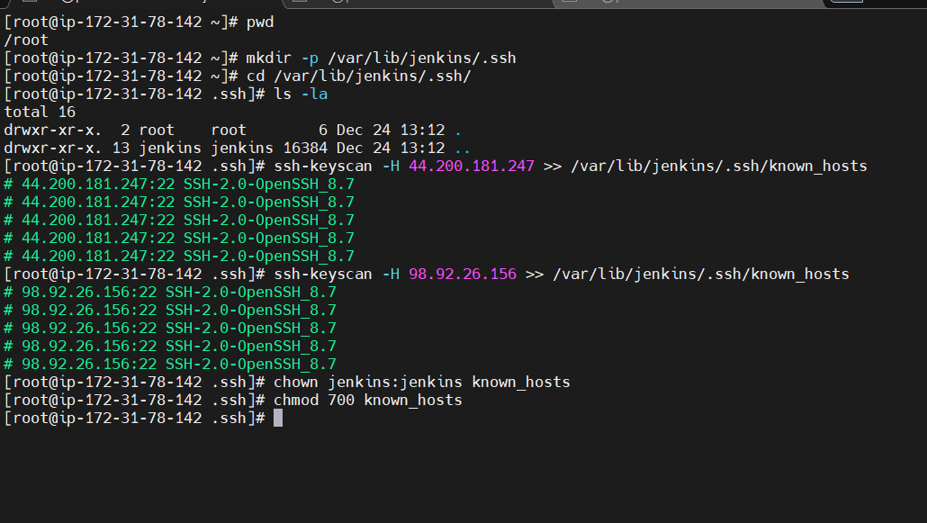
Step 10: Create Jenkins slave01 node
• Console path / UI path:
Manage Jenkins → Nodes → New Node
• Explanation:
A permanent agent named jenkins-slave01 is created with SSH launch method and appropriate labels.
Evidence:
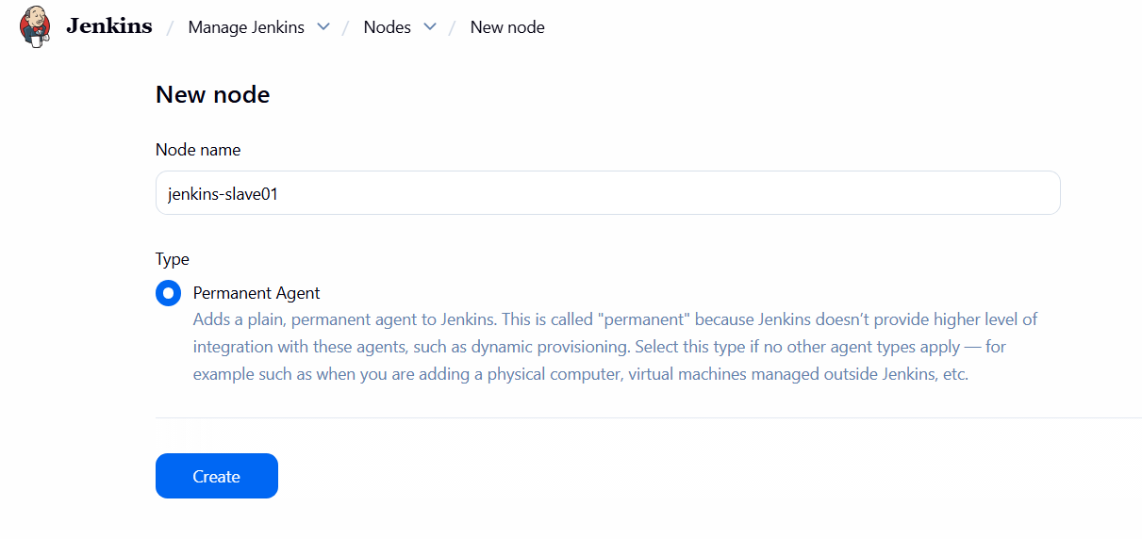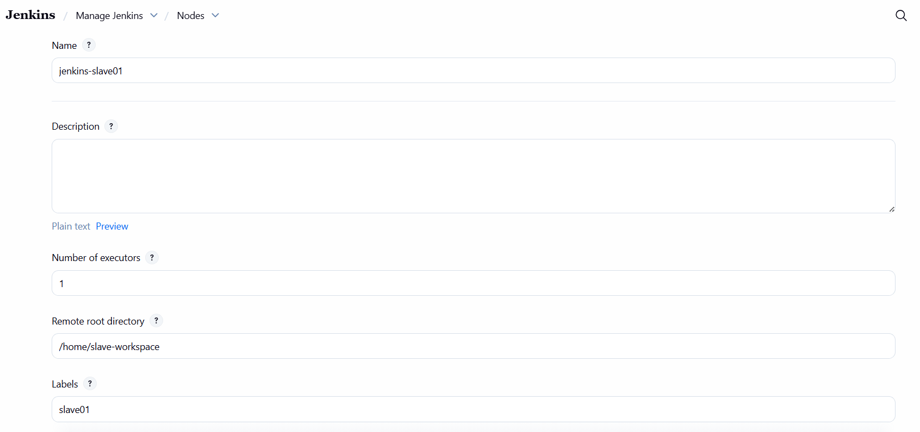
Step 12: Configure credentials for slave01
• Console path / UI path:
Manage Jenkins → Credentials → Global → Add Credentials
• Explanation:
SSH username with private key credential is added for slave01 authentication.
Evidence:
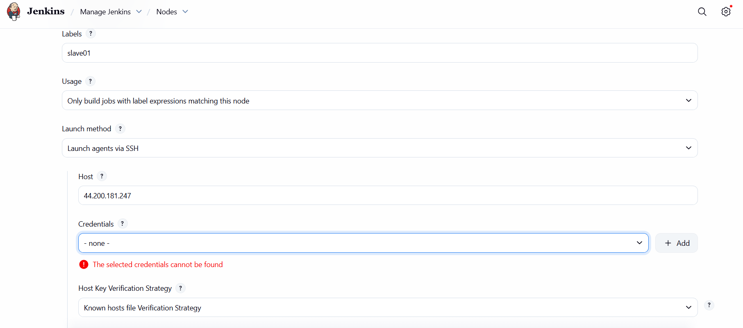 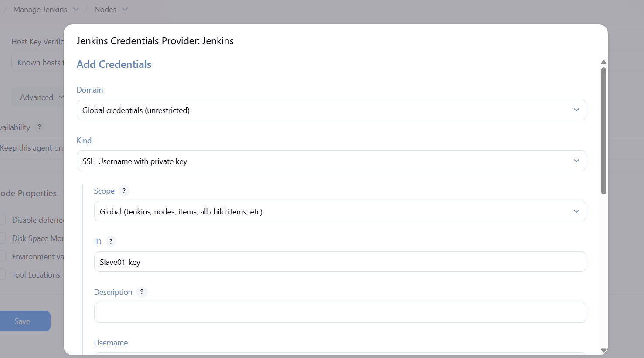 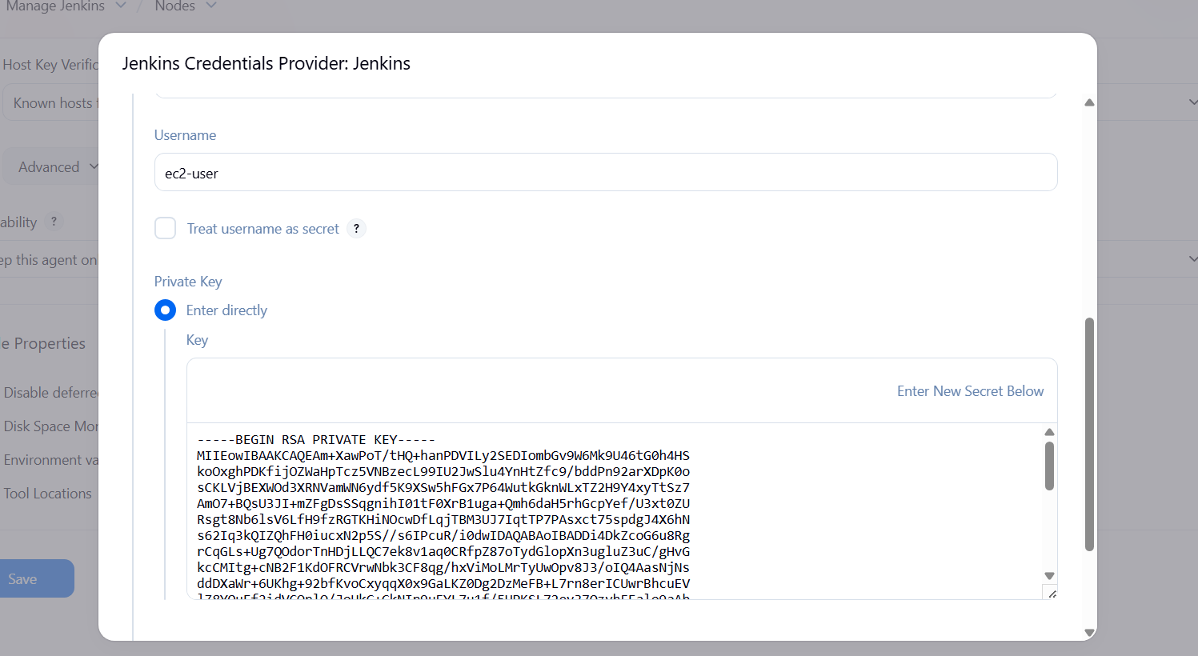
Step 13: Validate and bring slave01 online
• Console path / UI path:
Manage Jenkins → Nodes → jenkins-slave01
• Explanation:
Initial offline issue is observed due to missing configuration and later resolved after credential and workspace corrections.
Evidence:
Step 14: Prepare workspace on slave02
• Console path / CLI command:
mkdir /home/ec2-user/slave02-workspace
chmod 755 /home/ec2-user/slave02-workspace
chown ec2-user:ec2-user /home/ec2-user/slave02-workspace
java --version
• Explanation:
Workspace directory is created and Java installation is verified on slave02.
Evidence:
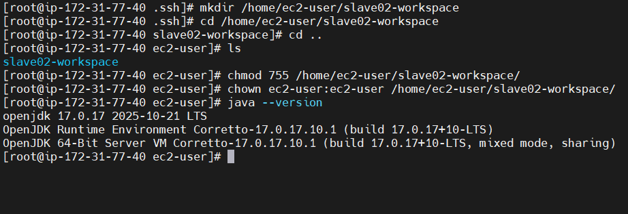
Step 15: Create Jenkins slave02 node
• Console path / UI path:
Manage Jenkins → Nodes → New Node
• Explanation:
A permanent agent named jenkins-slave02 is configured using SSH with ec2-user credentials.
Evidence:
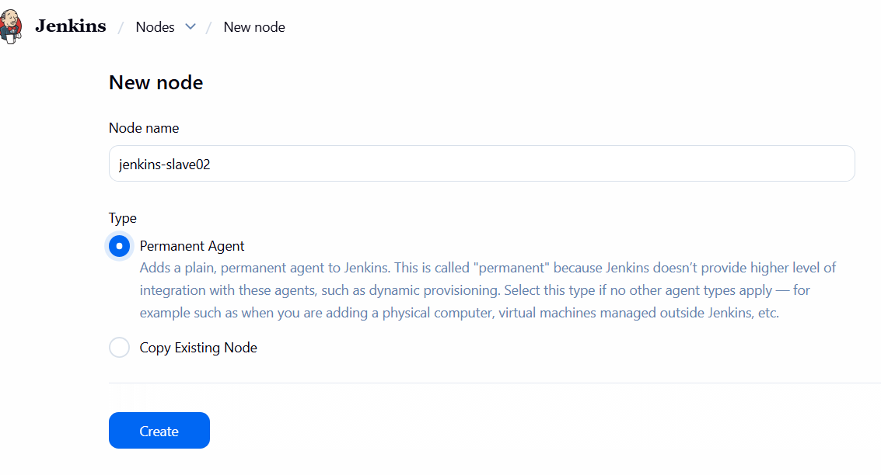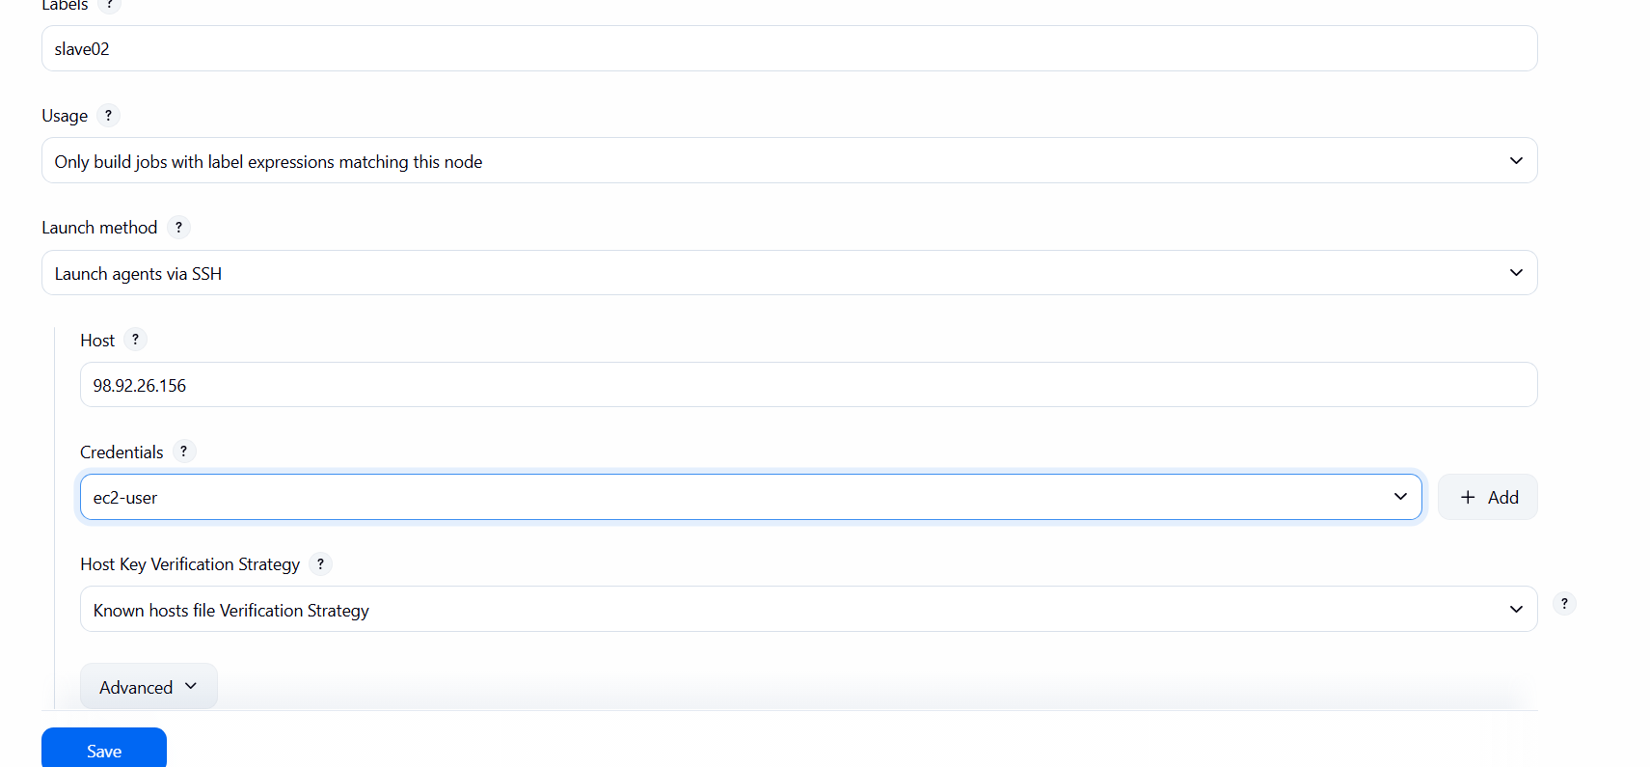
- Validation Steps (Mandatory, With Evidence):

Verify both agents are online
• Console path / UI path:
Manage Jenkins → Nodes
• Explanation:
Both jenkins-slave01 and jenkins-slave02 are successfully connected and shown as online with available disk and response time.
Evidence:
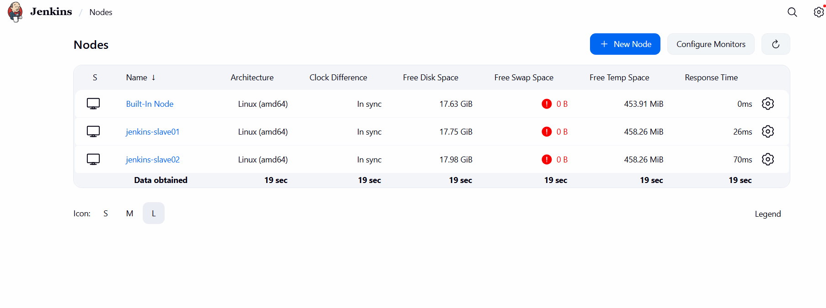
- Issues Faced (Optional):
Initial agent offline issue due to missing workspace permissions, resolved by configuring and correcting ownership. 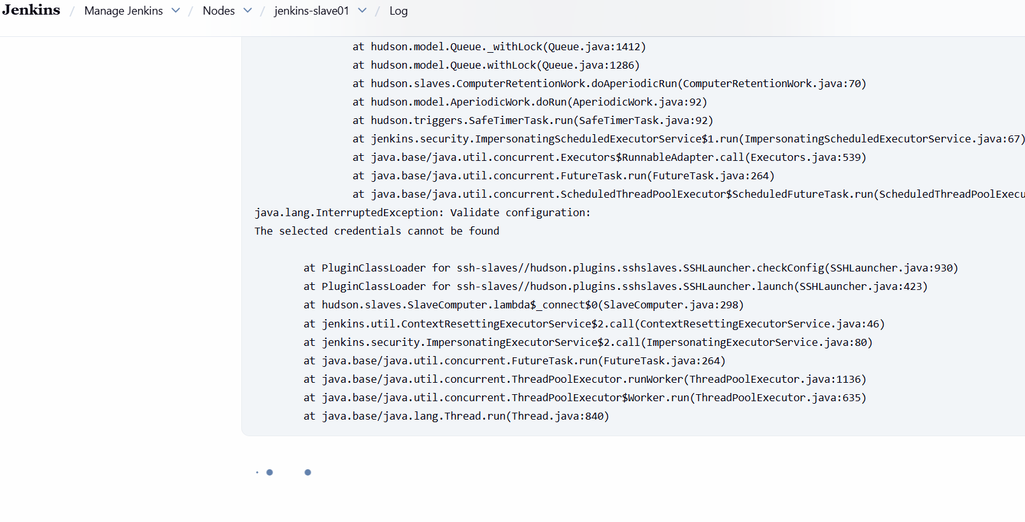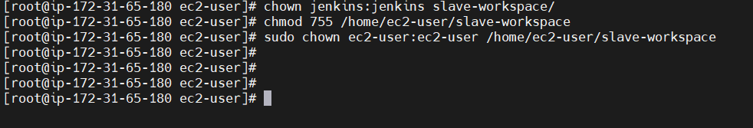
- Conclusion:
Two Jenkins slave machines were successfully configured and connected to the Jenkins master, enabling distributed build execution.

- Configure webhooks to Jenkins job.
- Task Title: Configure webhooks to Jenkins job
- Objective:
To configure GitHub webhooks so that any code push to a GitHub repository automatically triggers a Jenkins job and executes a build successfully.
- Prerequisites:
• Jenkins server installed and running on EC2
• Jenkins accessible over port 8080
• Git installed on Jenkins server
•
- Step-by-Step Implementation (With Evidence):
Step 1: Verify Jenkins EC2 instance and Jenkins UI access
• Console path / CLI command:
AWS Console → EC2 → Instances
• Explanation:
The Jenkins EC2 instance is verified to be in running state, and Jenkins UI is accessed using the public IP on port 8080.
Evidence:
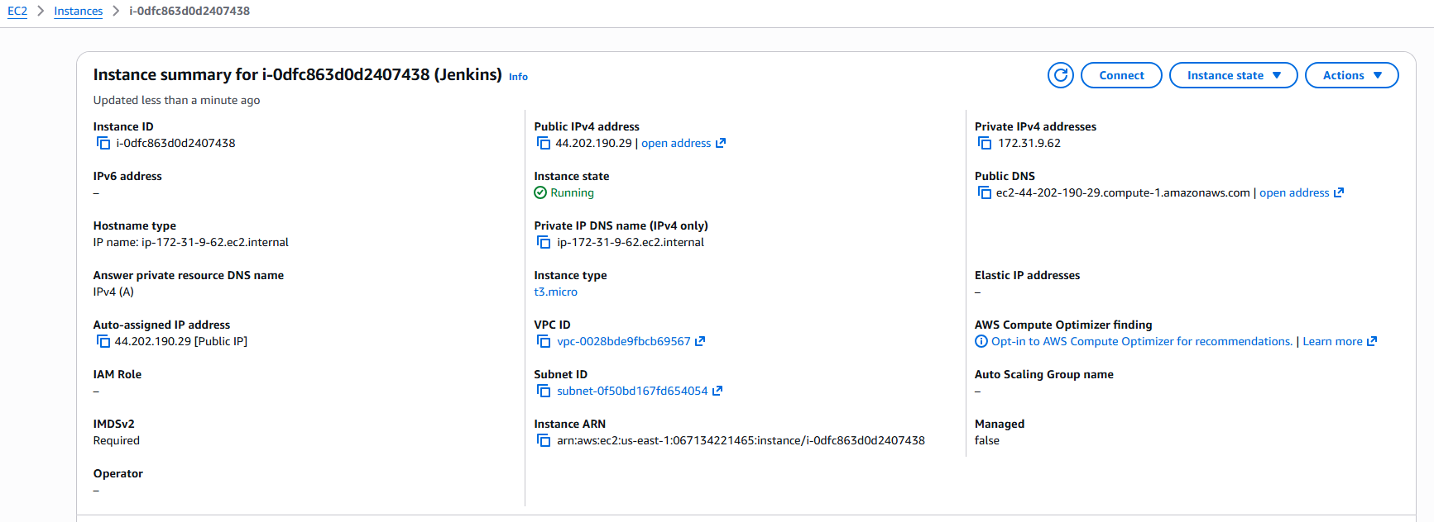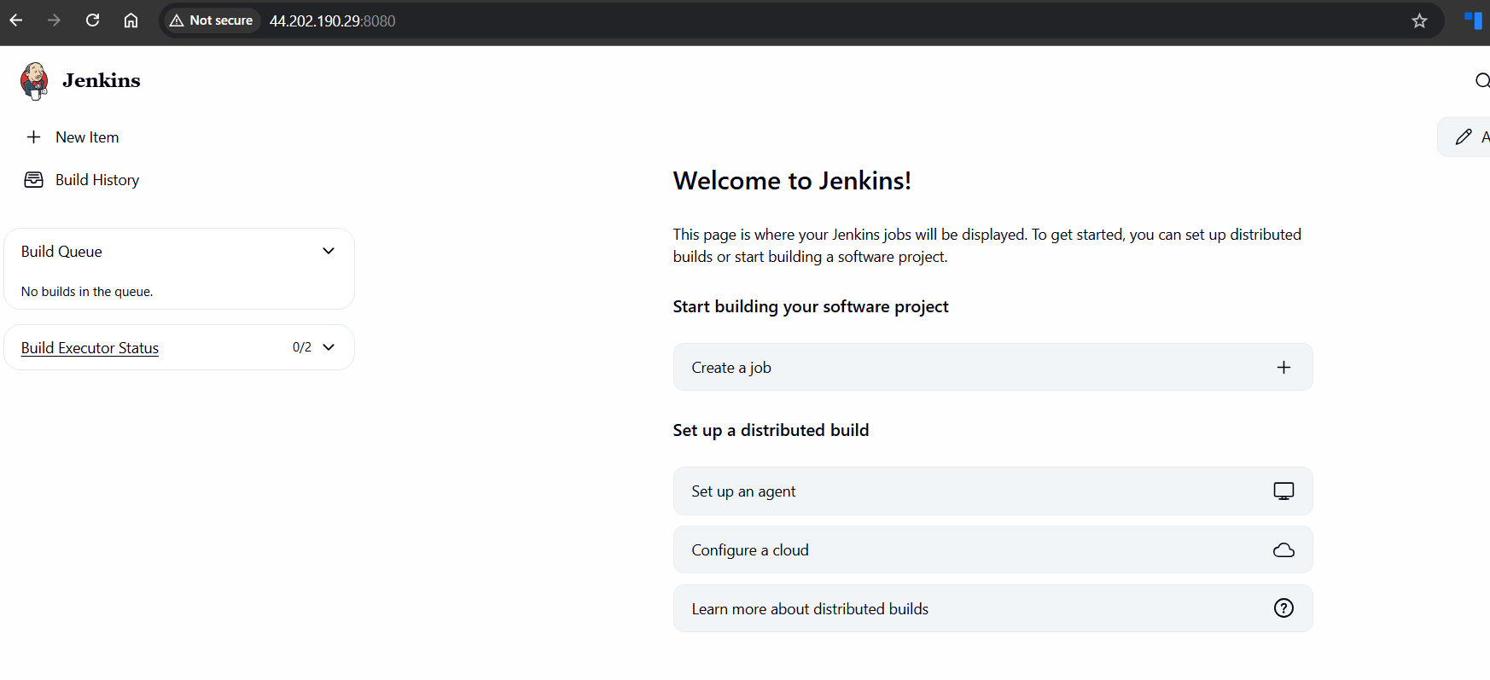
Step 2: Verify GitHub repository
• Console path / CLI command:
GitHub → Repository → Code
• Explanation:
A public GitHub repository named jenkins is verified with an existing README file.
Evidence:
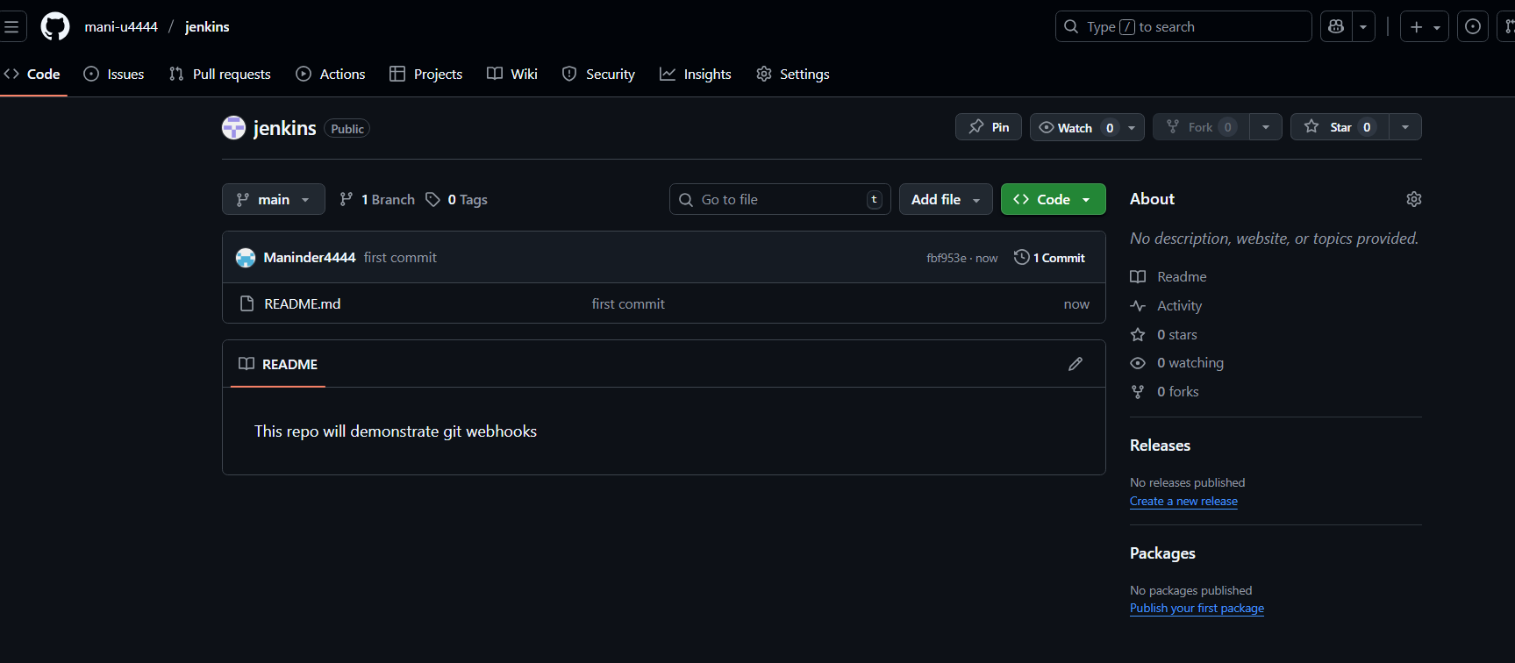
Step 3: Configure GitHub webhook
• Console path / CLI command:
GitHub → Repository → Settings → Webhooks → Add webhook
• Explanation:
Webhook is configured with Jenkins webhook URL (http://<jenkins-public-ip>:8080/github-webhook/), content type is set, events are selected, and webhook is activated.
Evidence:
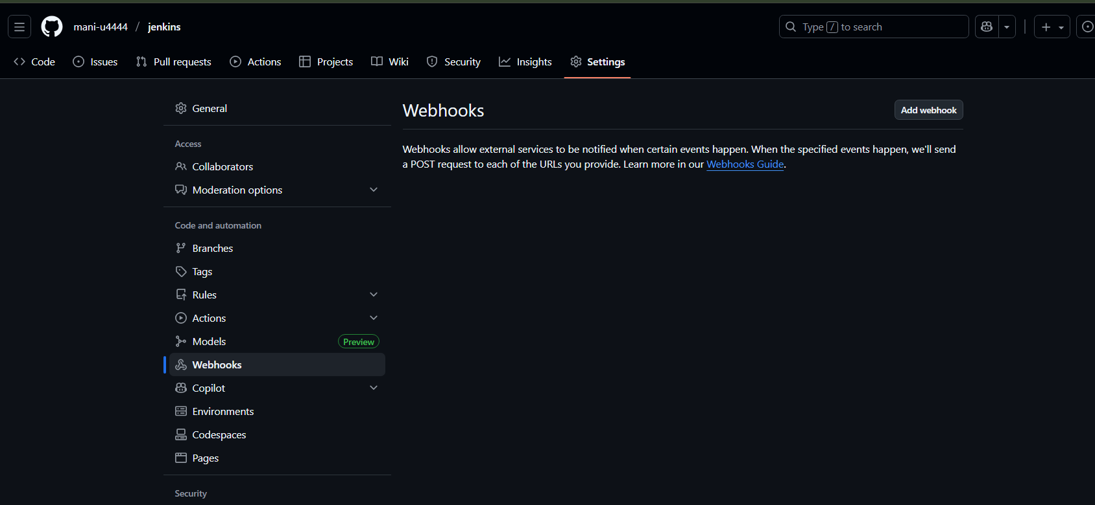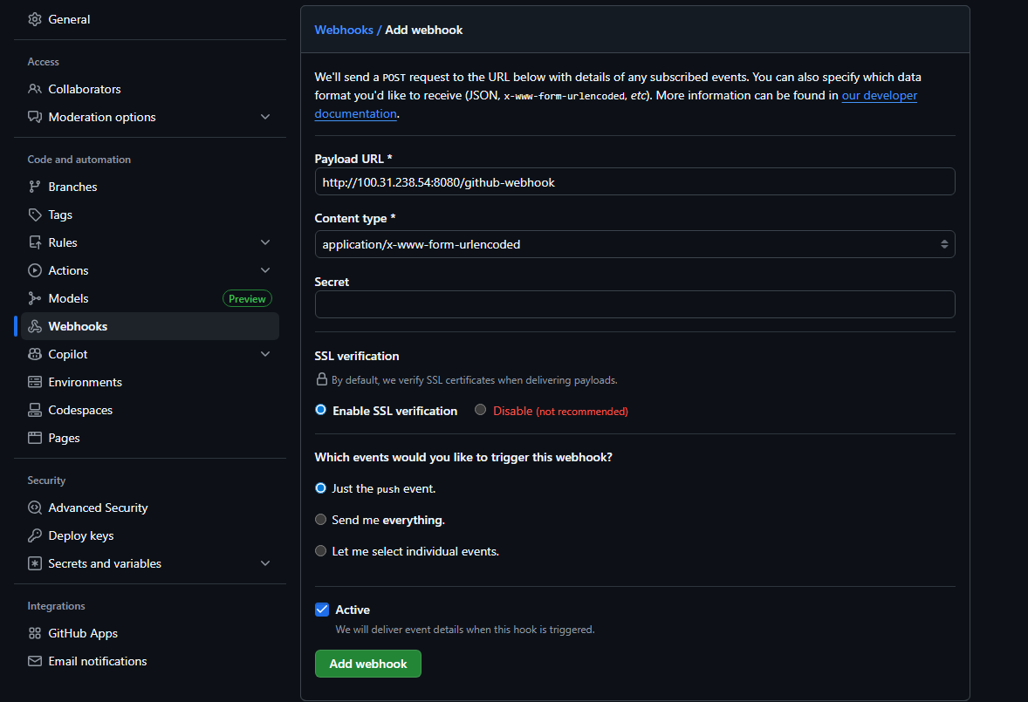
Step 5: Create Jenkins freestyle job
• Console path / CLI command:
Jenkins → New Item
• Explanation:
A new freestyle project named Web-hook is created to integrate GitHub SCM and webhook triggers.
Evidence:
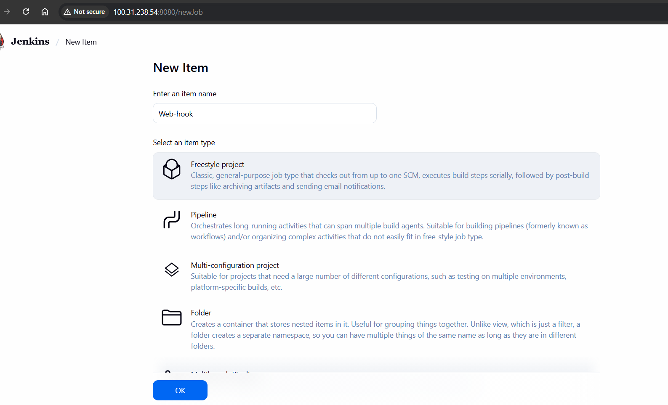
Step 6: Configure Source Code Management in Jenkins
• Console path / CLI command:
Jenkins → Job → Configuration → Source Code Management
• Explanation:
Git SCM is selected and GitHub repository URL is configured. Initial connection error is resolved after installing Git on Jenkins server.
Evidence:
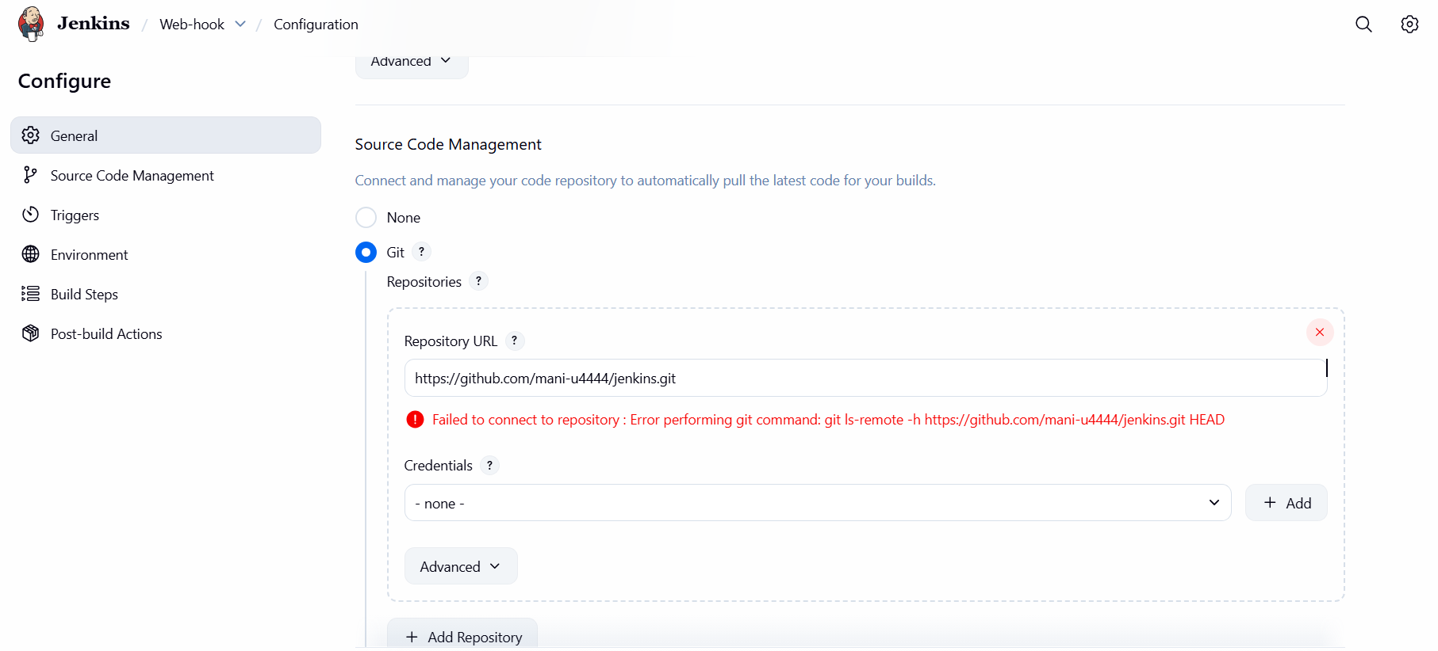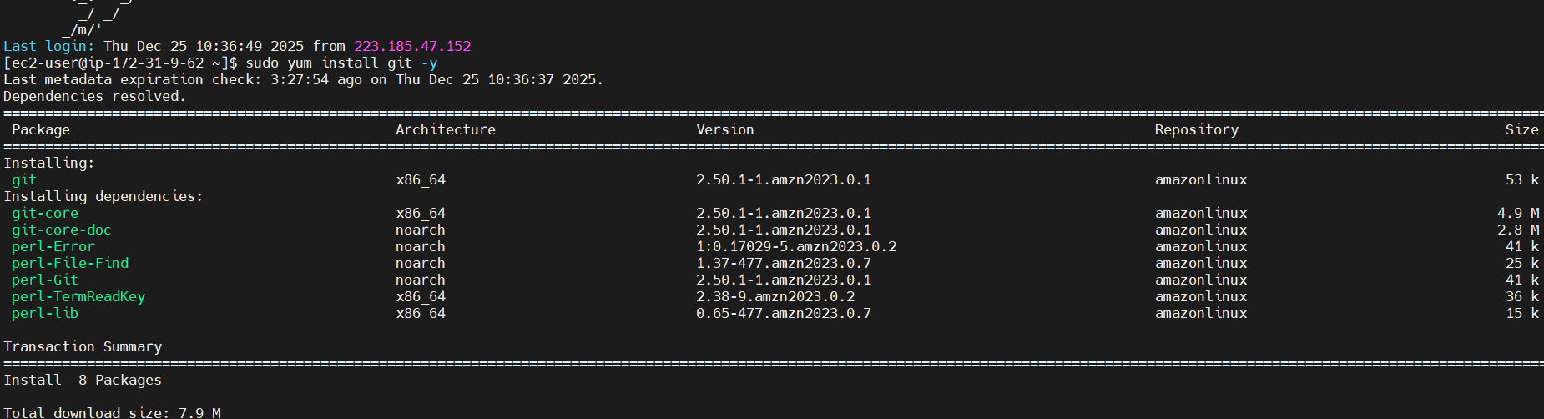
Step 7: Install Git on Jenkins server
• Console path / CLI command:
sudo yum install git -y
• Explanation:
Git is installed on the Jenkins EC2 instance to allow Jenkins to clone the GitHub repository.
Evidence:

Step 8: Configure Jenkins build trigger
• Console path / CLI command:
Jenkins → Job → Configuration → Build Triggers
• Explanation:
The option “GitHub hook trigger for GITScm polling” is enabled to allow webhook-based build triggering.
Evidence:
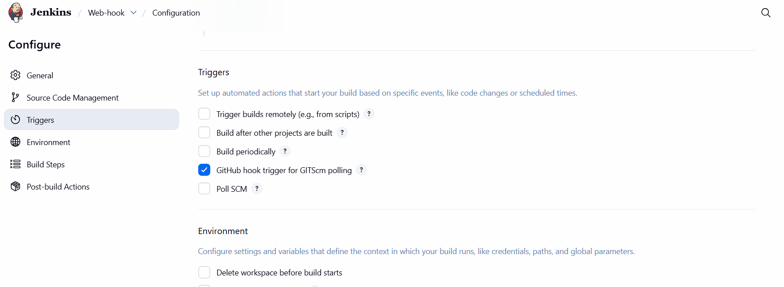 Step 8: Validate webhook delivery status
• Console path / CLI command:
GitHub → Repository → Settings → Webhooks
• Explanation:
Webhook delivery status is checked and confirmed as successful after configuration.
Evidence:
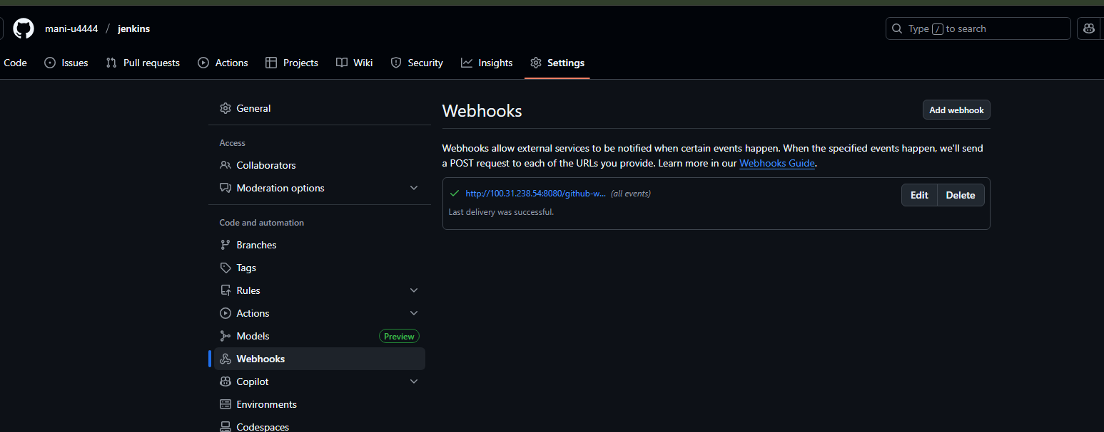

Step 9: Push code changes to GitHub repository
• Console path / CLI command:
touch file1
git add .
git commit -m "test file"
git push origin main
• Explanation:
A new file is added and pushed to the GitHub repository to trigger the webhook.
Evidence:
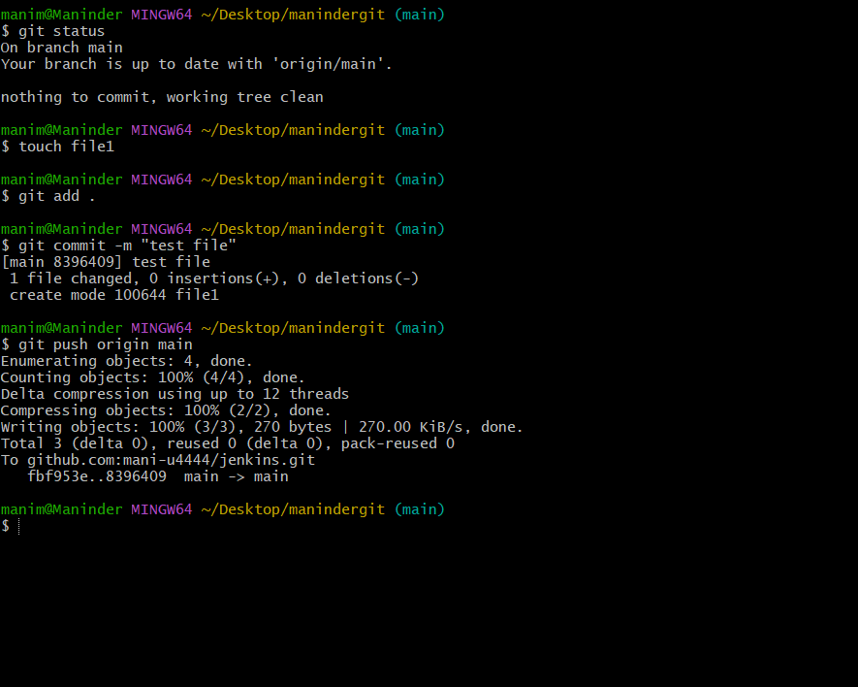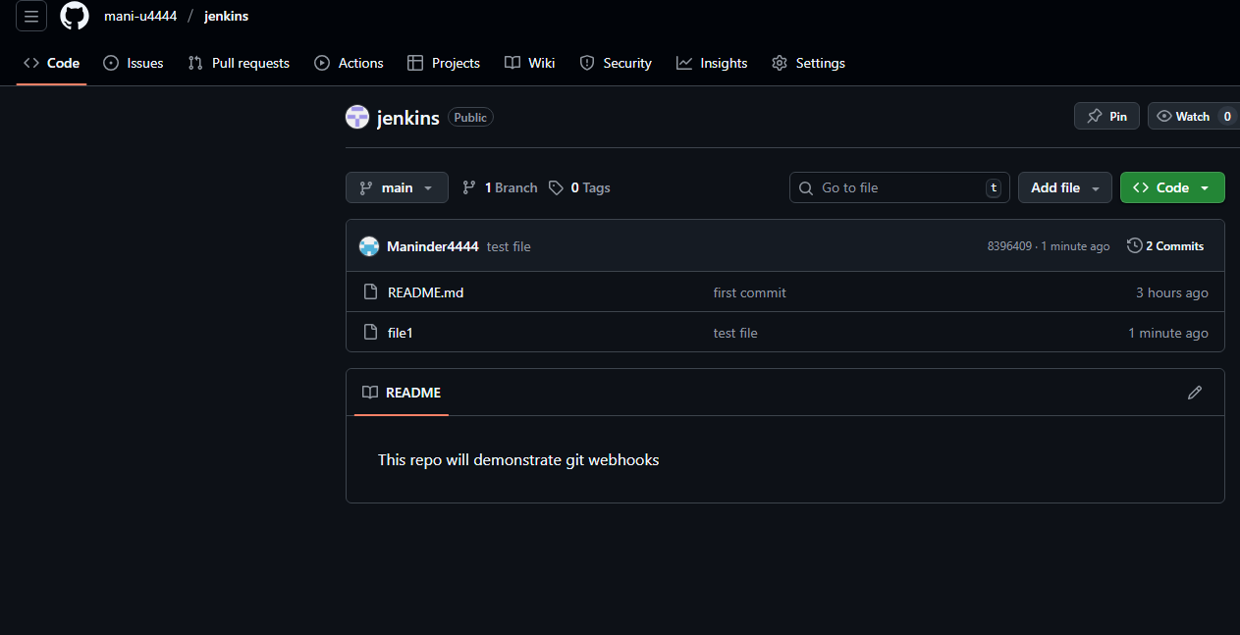
Step 10: Verify Jenkins job execution
• Console path / CLI command:
Jenkins → Job → Build History → Console Output
• Explanation:
Jenkins job is automatically triggered by GitHub push event, repository is cloned, and build completes successfully.
Evidence:

- Validation Steps (Mandatory, With Evidence):
Example: Jenkins able to clone GitHub repository
Evidence: 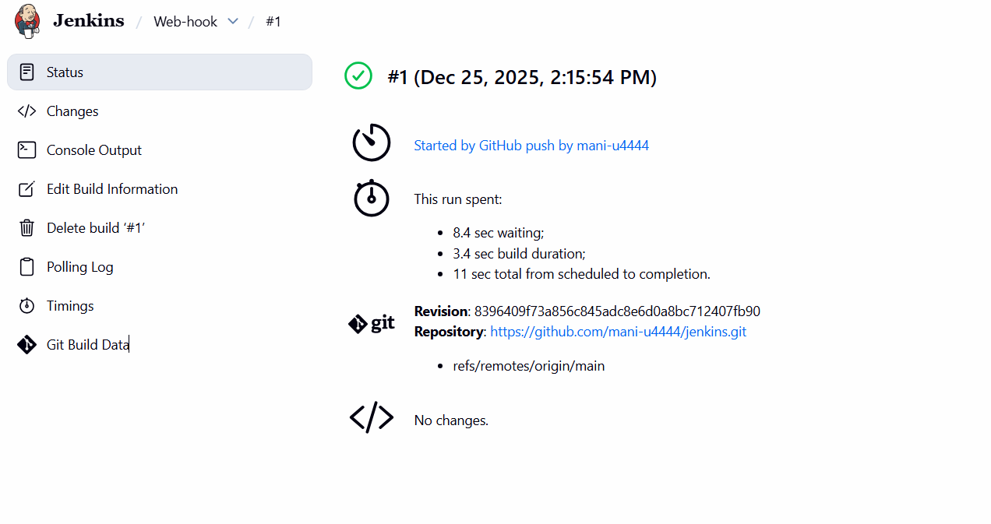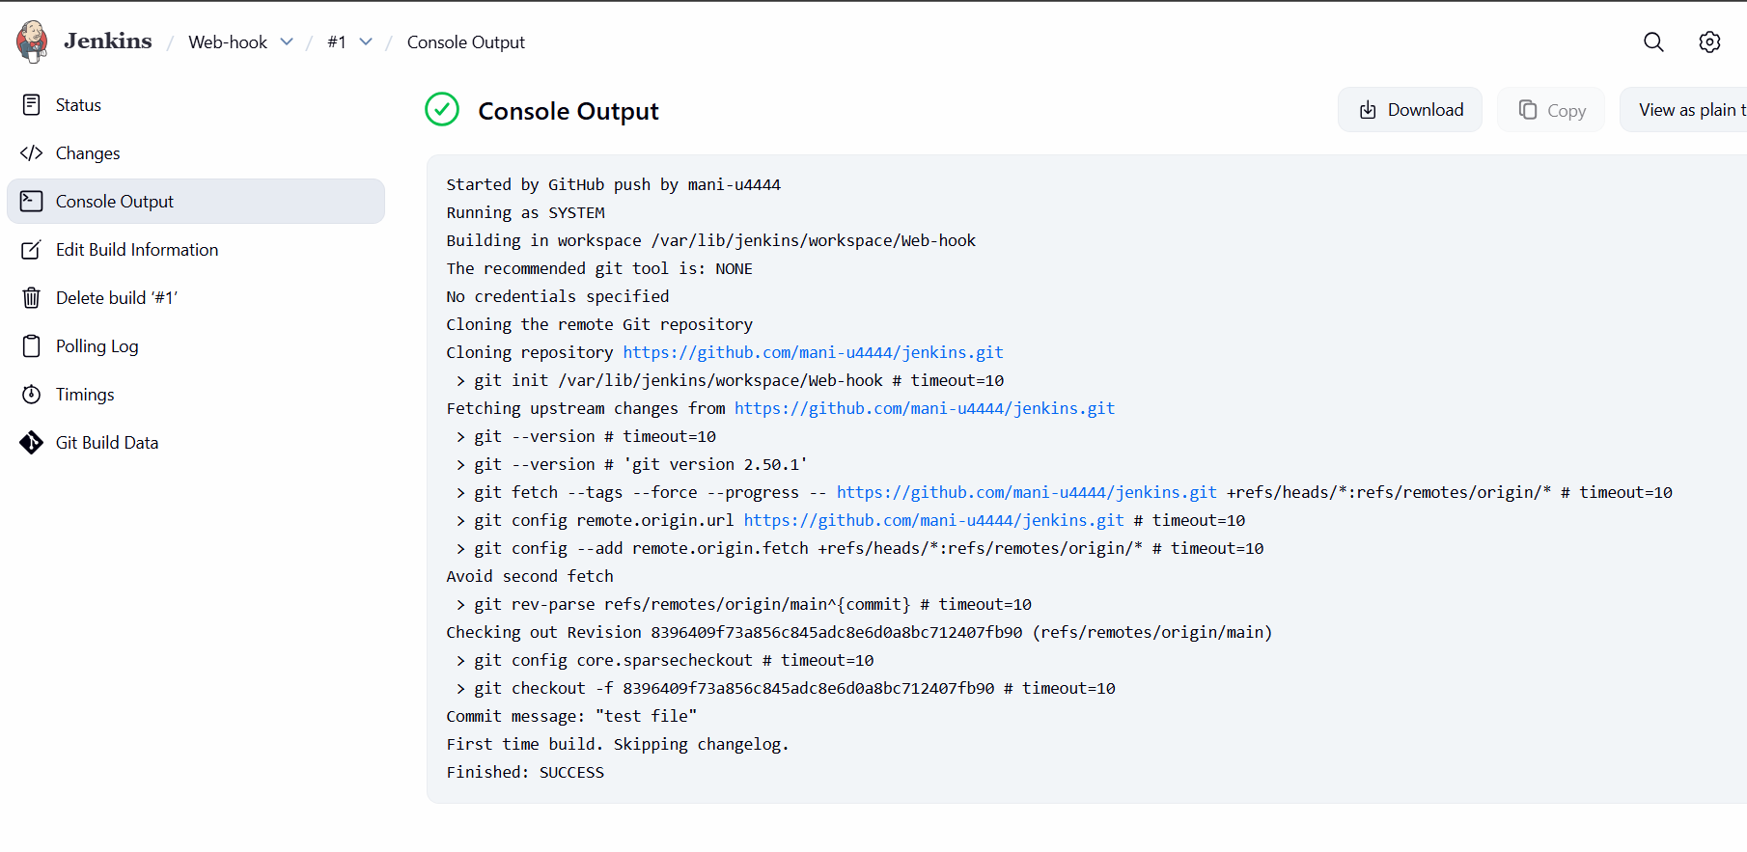
- Issues Faced (Optional):
Initial Git SCM connection failed due to Git not being installed on Jenkins server; resolved by installing Git 
- Conclusion:
GitHub webhooks were successfully configured with Jenkins, enabling automatic job execution on every code push to the repository.

- Configure poll scm and build periodical options in Jenkins job.
  - Task Title: Configure PollSCM to Jenkins job

  - Objective:
To configure Jenkins Poll SCM so that Jenkins periodically checks the GitHub repository for changes and automatically triggers a build when a new commit is detected.

3. Prerequisites:
• Jenkins server installed and running
• Jenkins accessible via browser
• Git installed on Jenkins server
• GitHub repository created and accessible
• Jenkins user with job creation permissions

4. Step-by-Step Implementation (With Evidence):

Step 1: Create a new Jenkins job
• Console path / CLI command:
Jenkins Dashboard → New Item

• Explanation:
A new Jenkins job named PollSCM is created using the Freestyle project option.

Evidence:
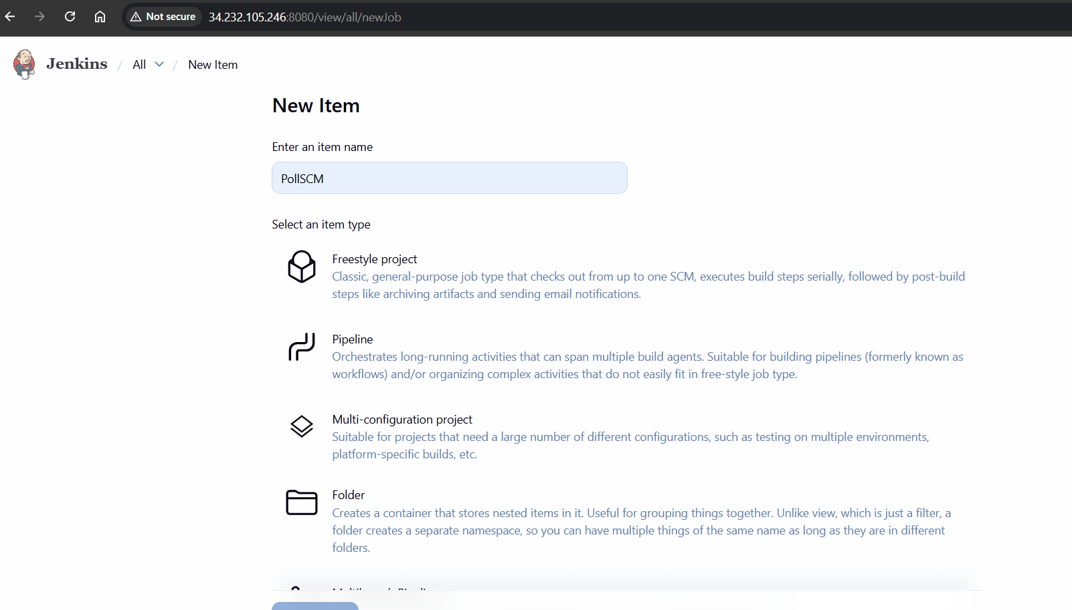
Step 2: Configure Source Code Management
• Console path / CLI command:
Jenkins → PollSCM → Configure → Source Code Management

• Explanation:
Git is selected as the SCM, and the GitHub repository URL is configured with branch specifier set to */main. No credentials are required as the repository is public.

Evidence:
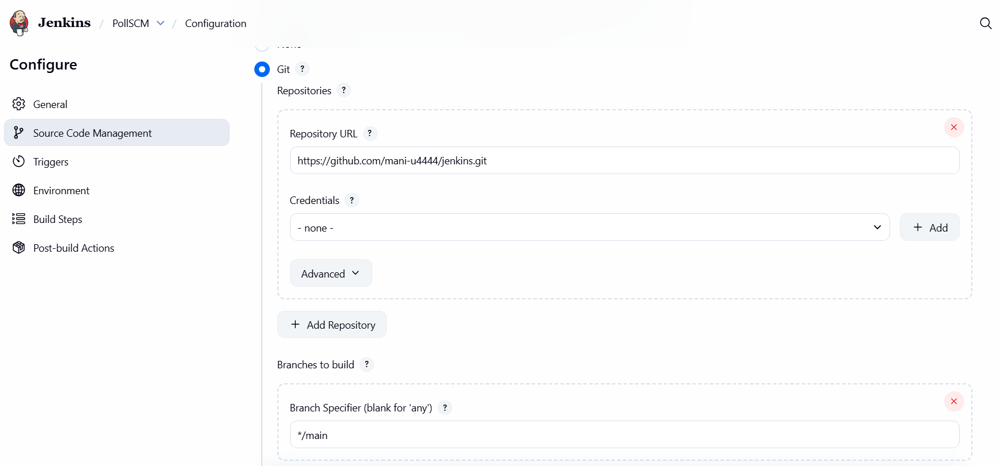
Step 3: Configure Poll SCM trigger
• Console path / CLI command:
Jenkins → PollSCM → Configure → Triggers

• Explanation:
Poll SCM is enabled with the schedule set to * * * * *, instructing Jenkins to poll the repository every minute for changes.

Evidence:
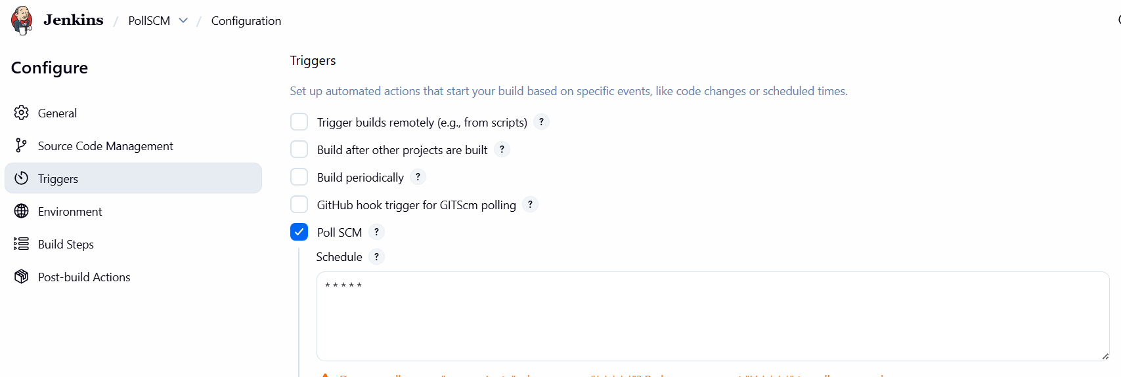
Step 4: Save job configuration and monitor polling
• Console path / CLI command:
Jenkins → PollSCM → Git Polling Log

• Explanation:
Git polling log confirms that Jenkins successfully checks the repository and identifies whether new commits are present.

Evidence:
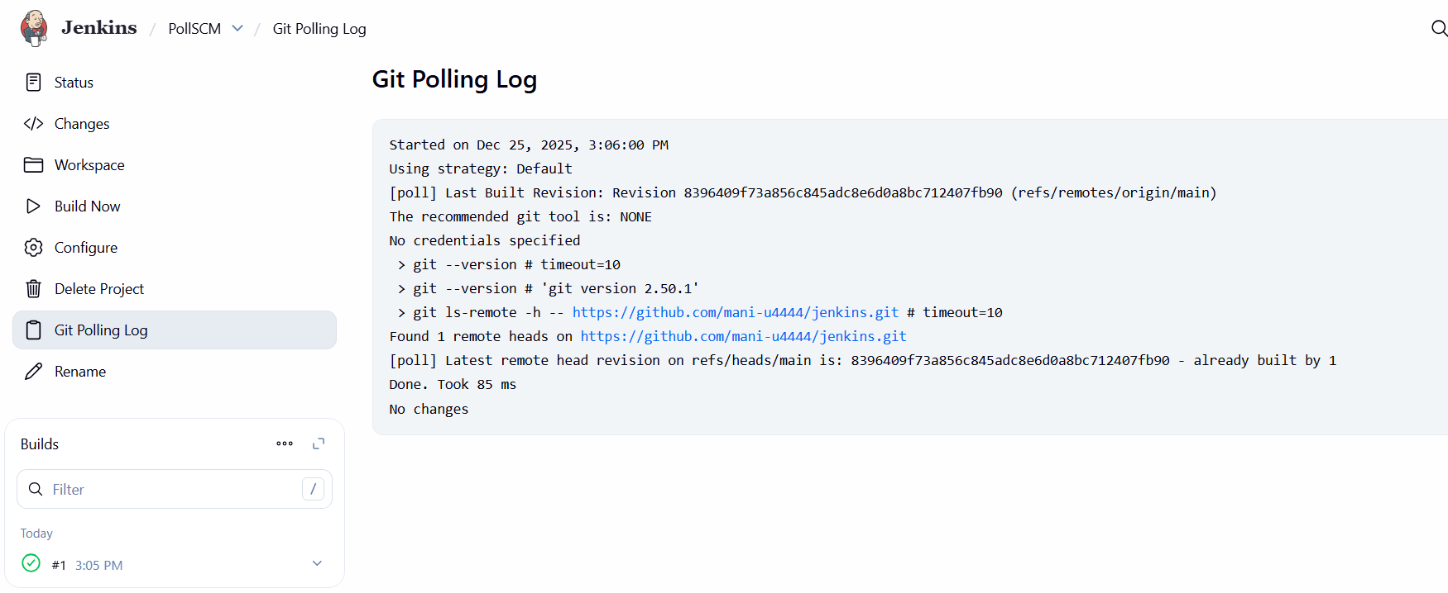
Step 5: Commit and push changes to GitHub repository
• Console path / CLI command:
git status
touch PollSCM
git add .
git commit -m "PollSCM"
git push origin main

• Explanation:
A new file is created, committed, and pushed to the GitHub repository to trigger Poll SCM detection.

Evidence:
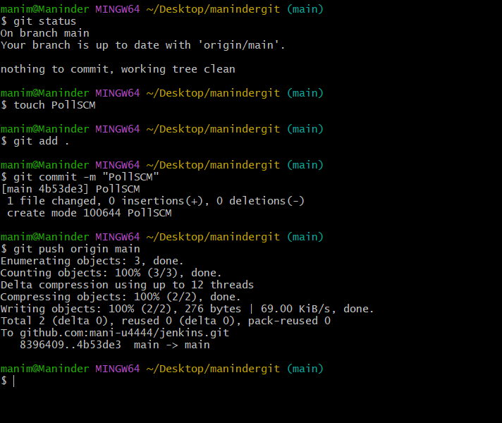
Step 6: Verify Jenkins job execution
• Console path / CLI command:
Jenkins → PollSCM → Build History → Console Output

• Explanation:
Jenkins automatically detects the SCM change during polling, checks out the updated revision, and completes the build successfully.

Evidence: 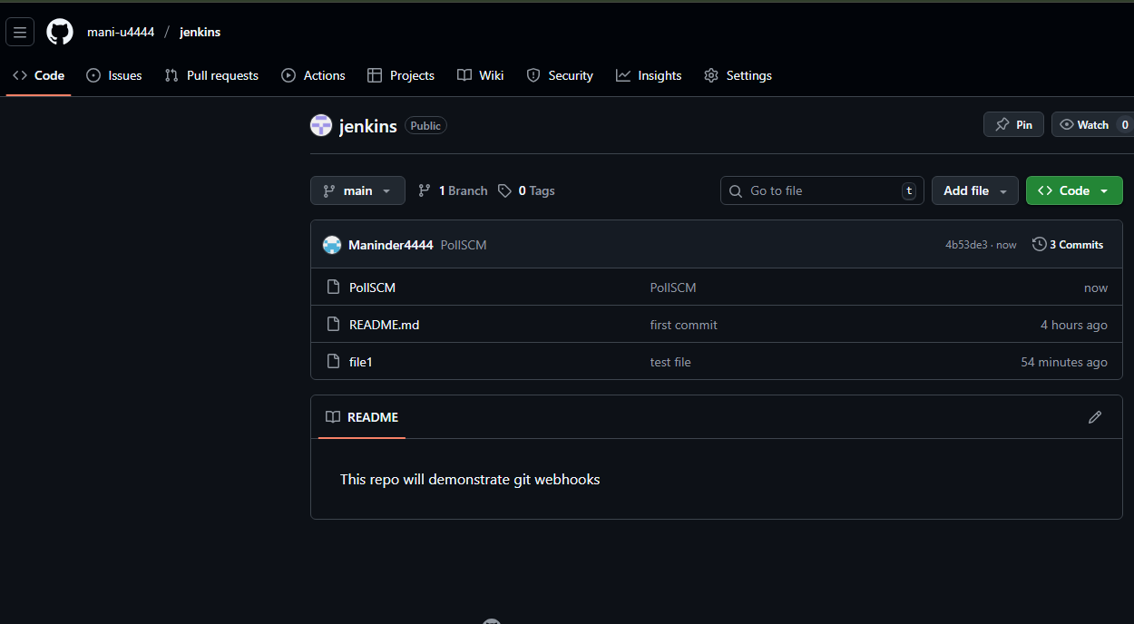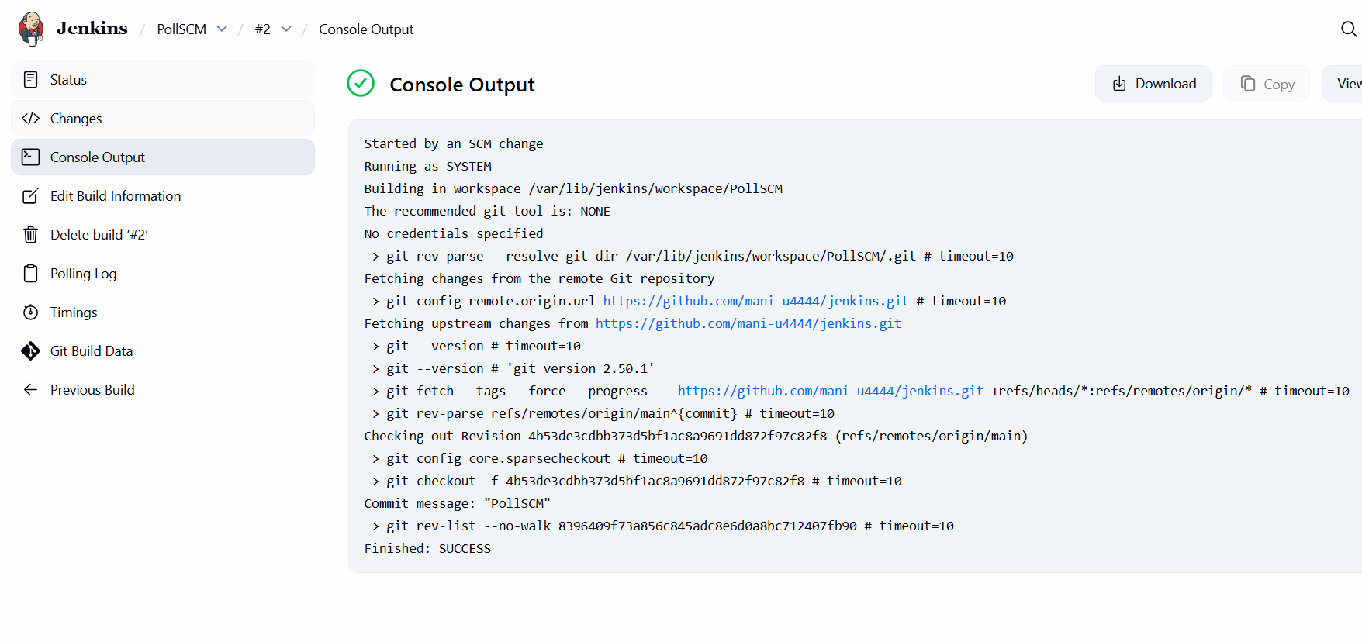5) Validation Steps (Mandatory, With Evidence):
Access Check
Example: Workspace path /var/lib/jenkins/workspace/PollSCM is created and populated during execution
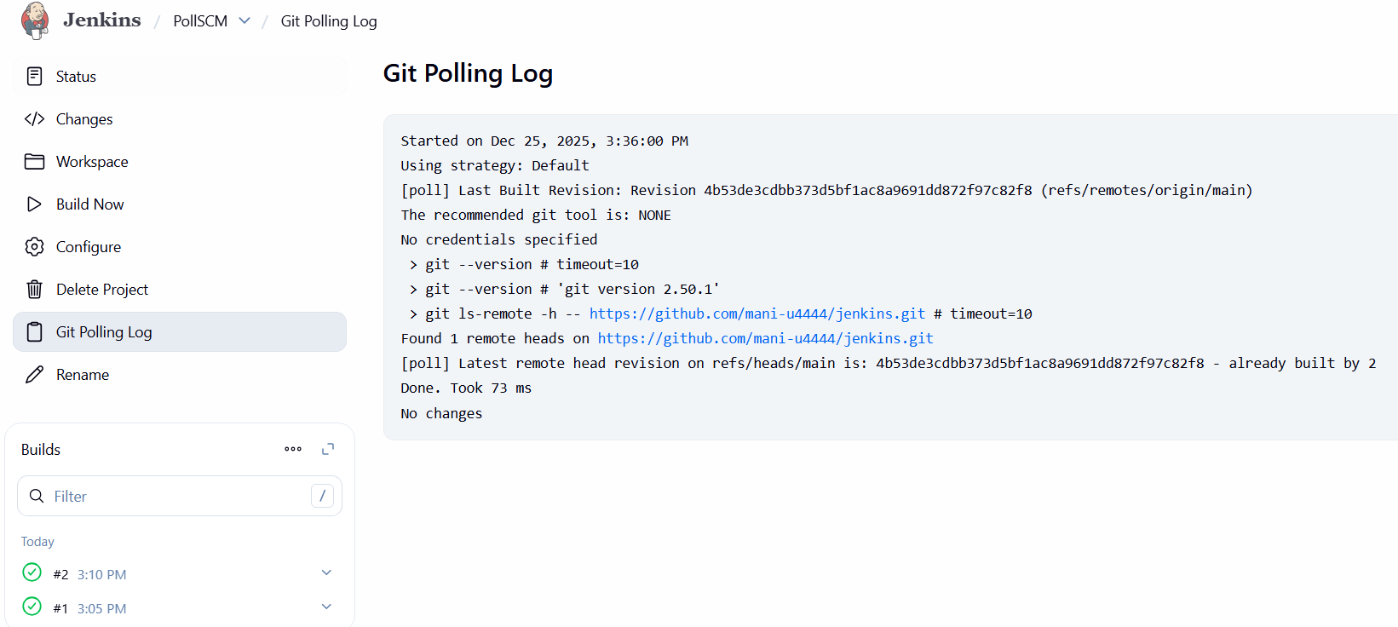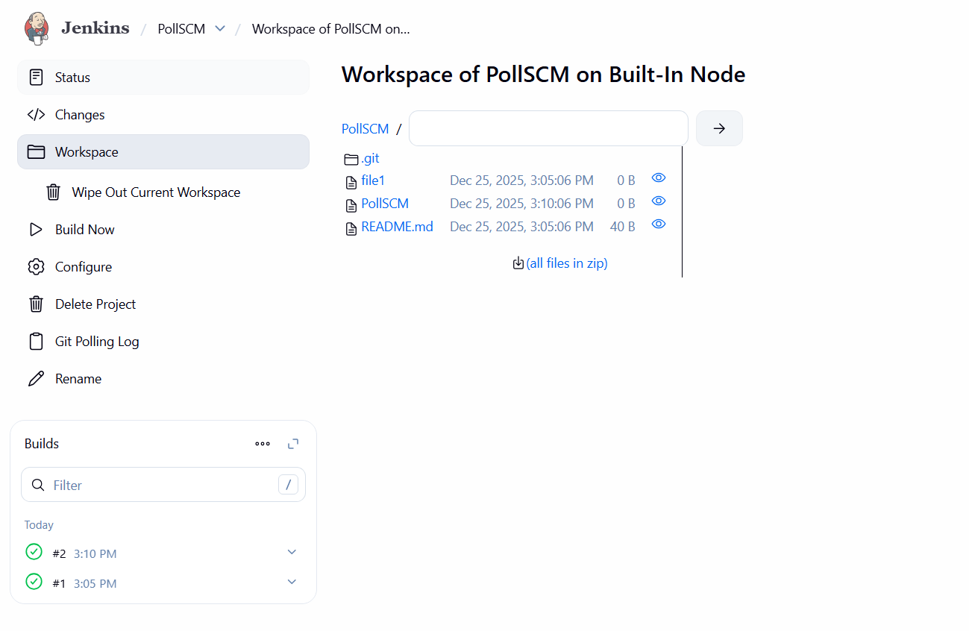

Build periodically
Step 1: Create a new Jenkins job
• Console path / CLI command: Jenkins Dashboard → New Item
• Explanation: A new Freestyle project named Build periodically is created to demonstrate time-based job execution.
• Evidence: 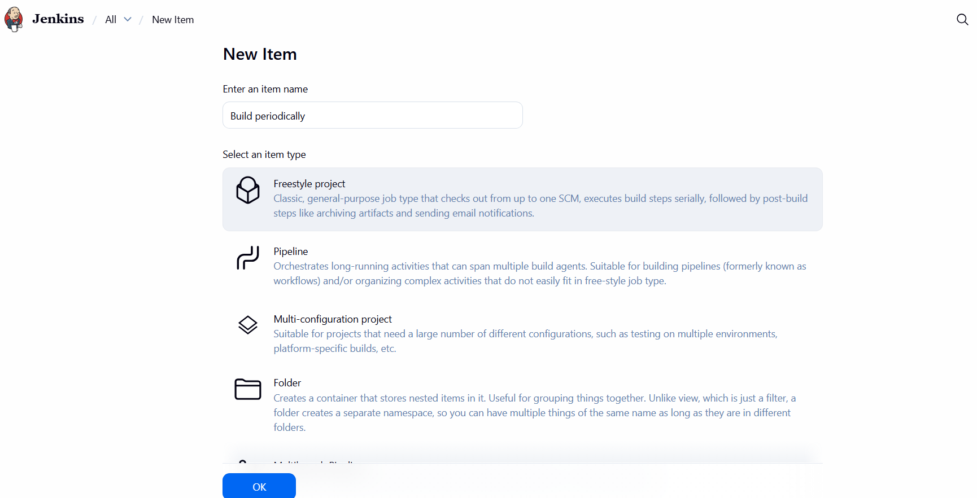

Step 2: Configure Source Code Management
• Console path / CLI command: Jenkins Job → Configure → Source Code Management → Git
• Explanation: The GitHub repository URL https://github.com/mani-u4444/jenkins.git is configured with branch specifier */main. No credentials are required as the repository is public.
• Evidence: 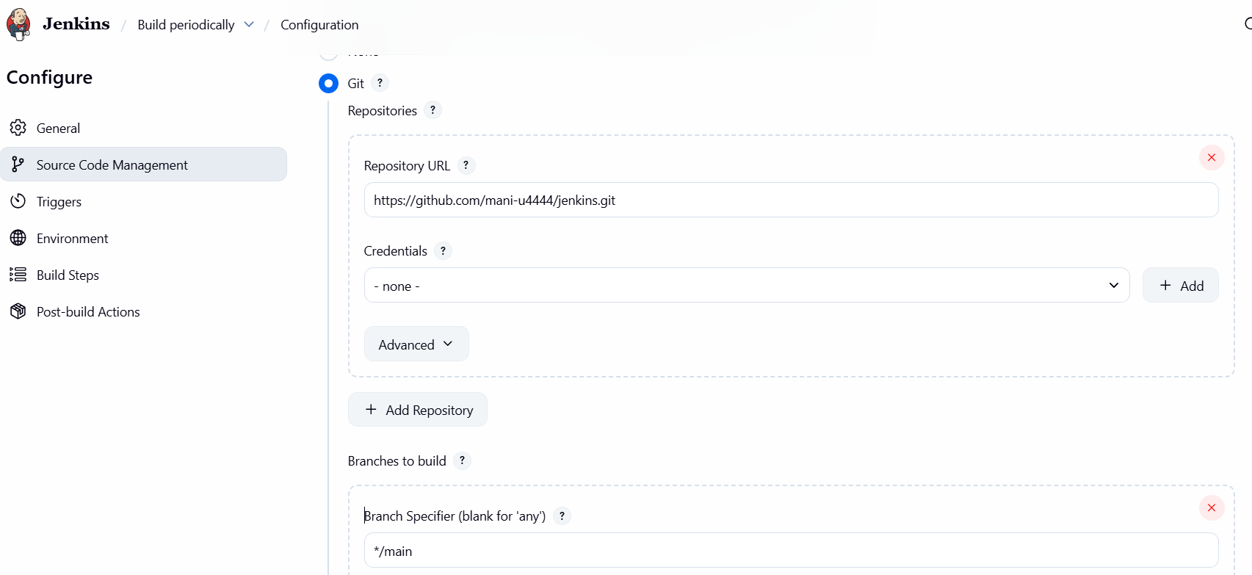

Step 3: Enable Build Periodically trigger
• Console path / CLI command: Jenkins Job → Configure → Triggers → Build periodically
• Explanation: The schedule is configured using cron syntax * * * * *, which triggers the job every minute.
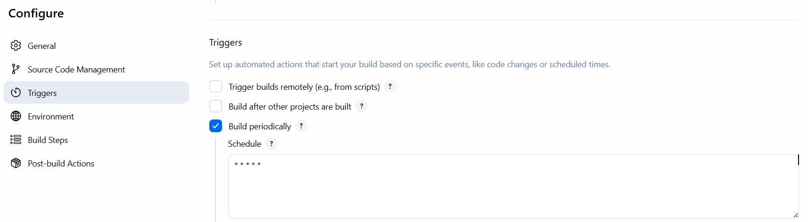
5) Validation Steps (Mandatory, With Evidence):

Access Check
Example: Workspace path /var/lib/jenkins/workspace/Build periodically is created and populated during execution.
Evidence: 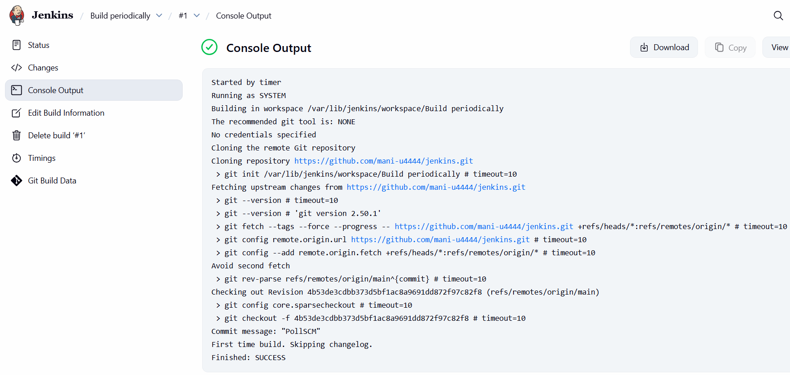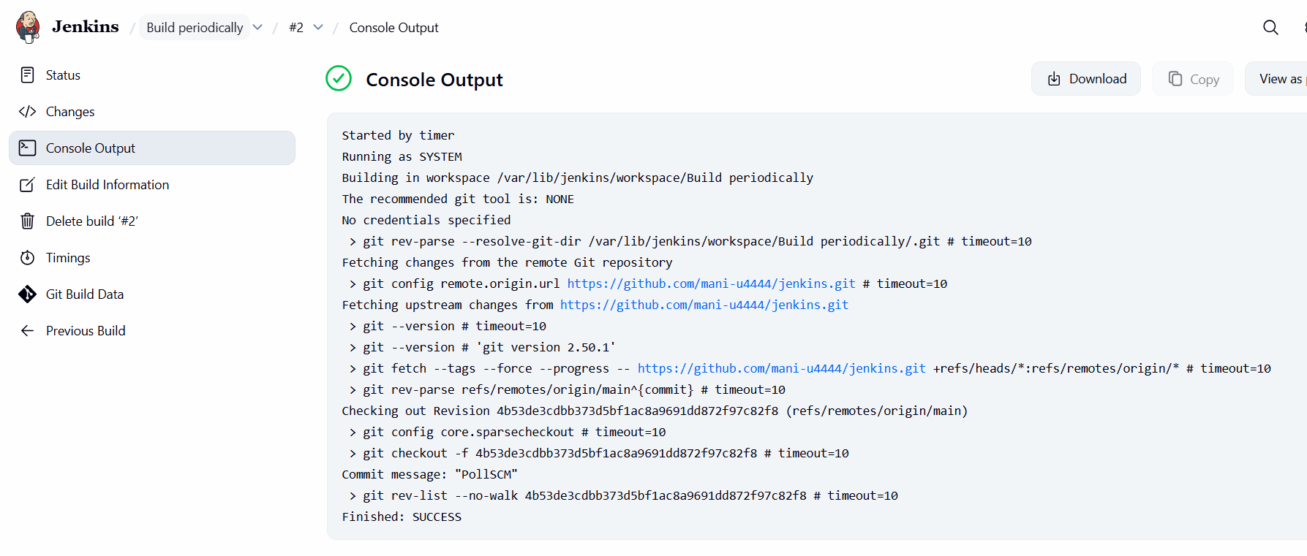
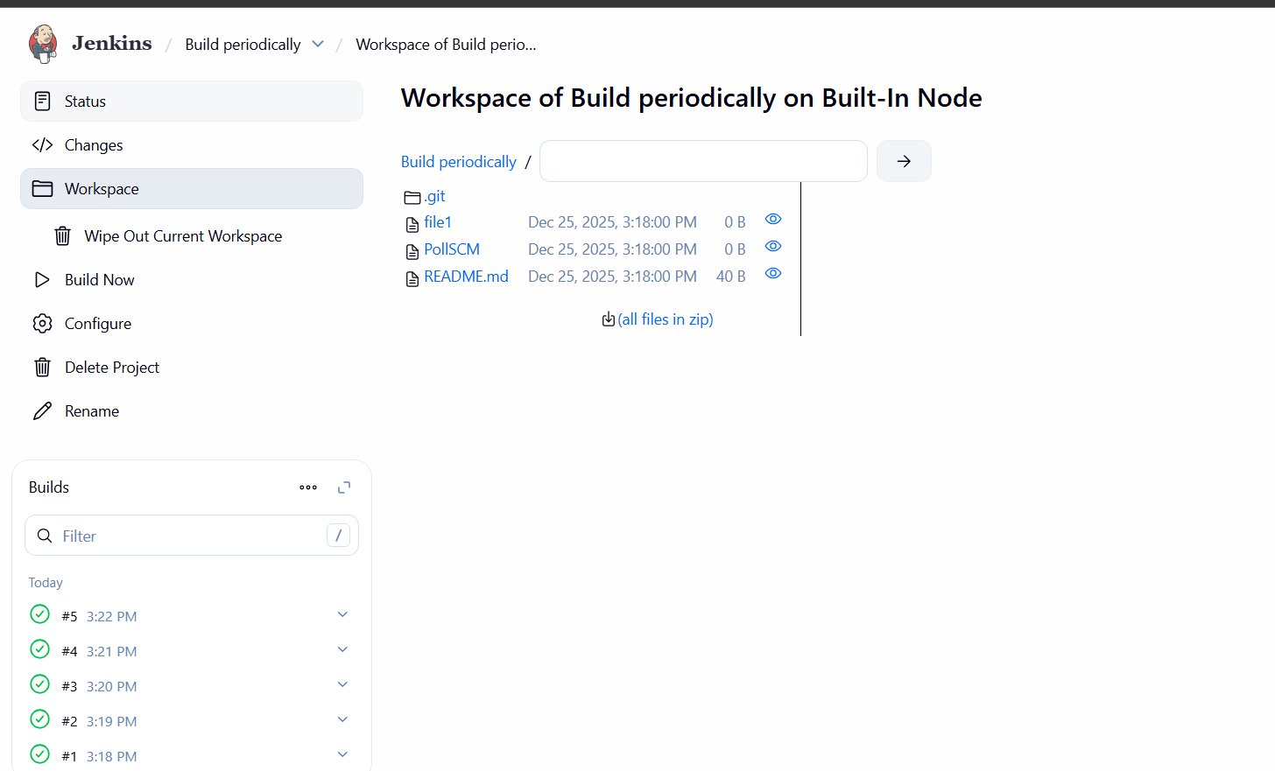
- Take backup of Jenkins server by using bash script.
In this task I have documented the task 4 and task 5 combined.
  - Task: Take backup of Jenkins server using bash script and set up a new Jenkins server and restore the backup
  - Objective
To take a full Jenkins backup from the existing Jenkins server using a bash script, transfer the backup archive to a newly launched Jenkins server, restore the data into the Jenkins home directory, and validate that all jobs, configurations, and plugins are successfully recovered.
  - Prerequisites
• Existing Jenkins server running on EC2
• New EC2 instance launched with Amazon Linux 2023
• Jenkins installed on both servers
• SSH key (.pem) file with proper permissions
• Network connectivity between Jenkins servers
• Root or sudo access
• Jenkins service running and accessible on port 8080

5. Step-by-Step Implementation (With Evidence)

Step 1: Verify existing Jenkins server details
• Console path: AWS Console → EC2 → Instances → Instance Summary
• Explanation: Confirm the source Jenkins EC2 instance is running and note the public IP and instance details.
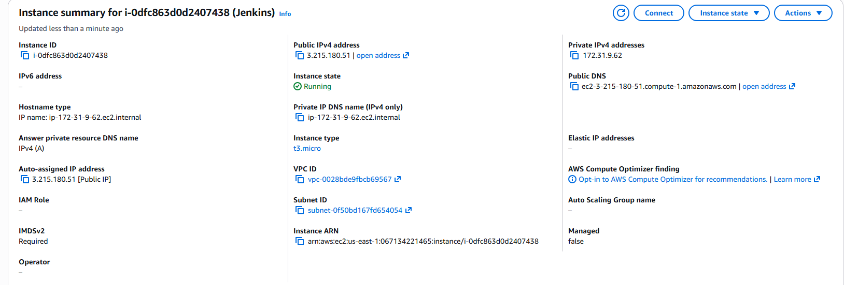
Step 2: Launch a new EC2 instance for Jenkins restore
• Console path: AWS Console → EC2 → Launch Instance
• Explanation: Launch a new EC2 instance with Amazon Linux 2023 and name it for Jenkins backup restoration.
• Evidence: 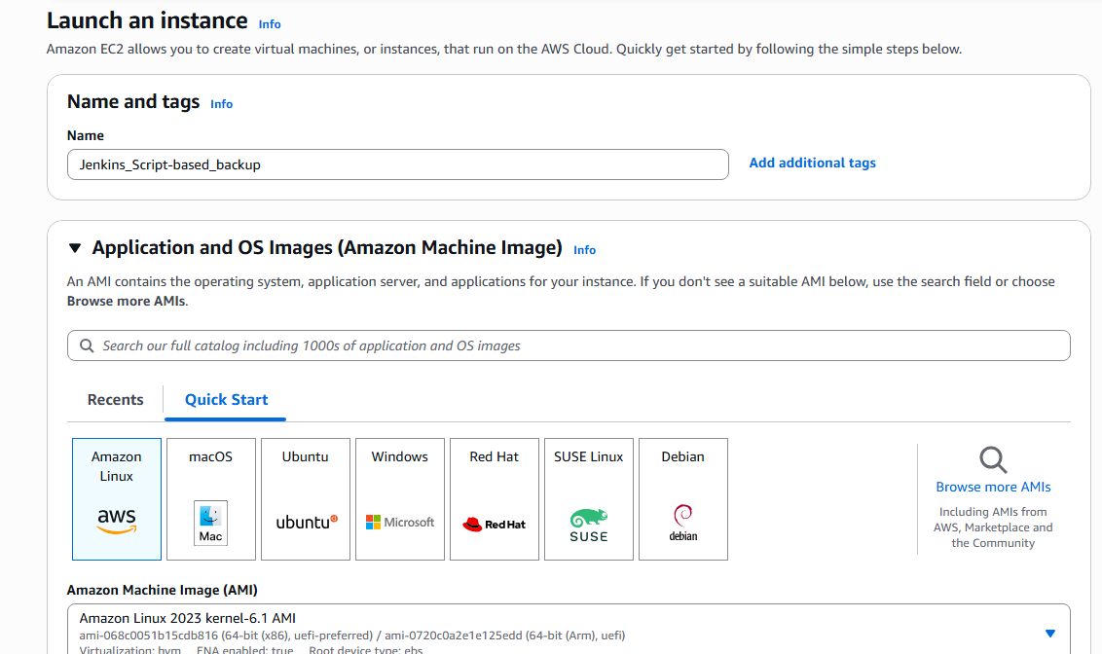

Step 3: Configure User Data to install Jenkins on new instance
• Console path: EC2 Launch Wizard → Advanced details → User data
• CLI / Script used:

#!/bin/bash
set -e
sudo dnf update -y
sudo dnf install java-17-amazon-corretto -y
sudo wget -O /etc/yum.repos.d/jenkins.repo https://pkg.jenkins.io/redhat-stable/jenkins.repo
sudo rpm --import https://pkg.jenkins.io/redhat-stable/jenkins.io-2023.key
sudo dnf install jenkins -y
sudo systemctl enable jenkins
sudo systemctl start jenkins

• Explanation: Automatically installs Java and Jenkins during instance launch.
• Evidence: 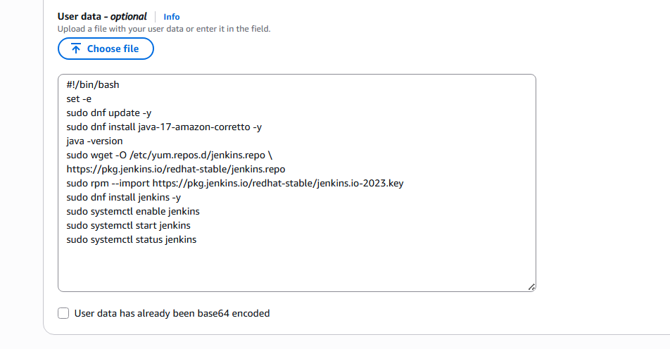

Step 4: Verify new Jenkins instance is running
• Console path: AWS Console → EC2 → Instance Summary
• Explanation: Ensure the new Jenkins backup instance is in running state and reachable via public IP.
• Evidence: 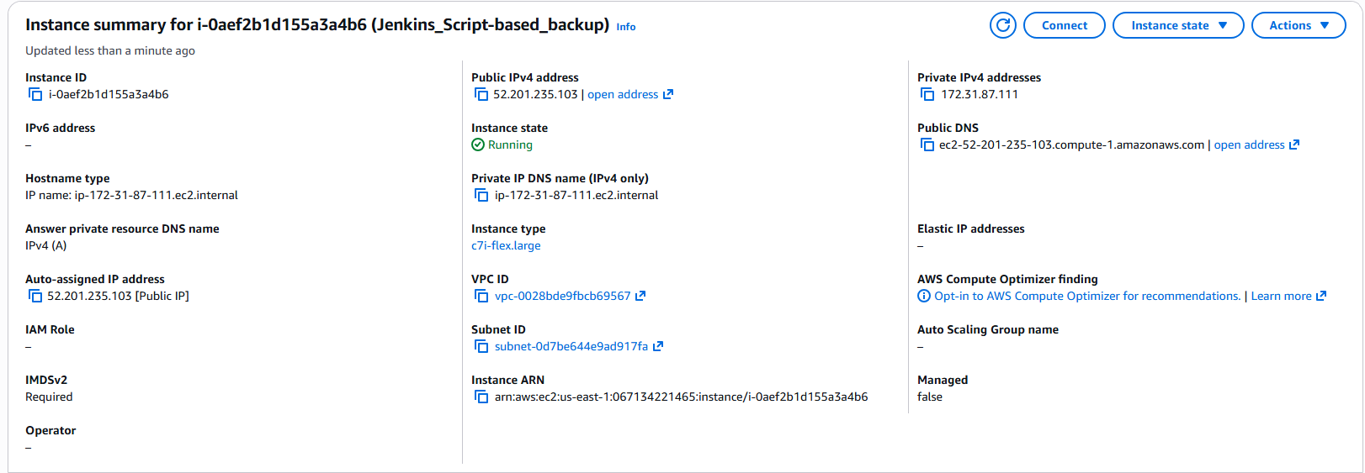

Step 5: SSH into source Jenkins server
• CLI command:
ssh -i "us-east-1.pem" ec2-user@<source-public-ip>
sudo -i
• Explanation: Login to the existing Jenkins server to execute the backup script.
• 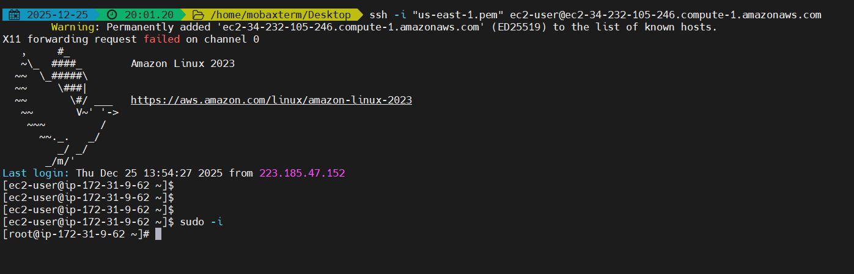

Step 6: Create and execute Jenkins backup bash script
• File name: jenkins_backup-script.sh
• Explanation: Script collects Jenkins jobs, plugins, configs, secrets, users, nodes, and workspace, then compresses them into a timestamped tar.gz file.
Script:
#!/bin/bash -xe
set -o pipefail
date=$(date +"%d%m%y%H%M")
readonly JENKINS_HOME="/var/lib/jenkins"
readonly DEST_FILE="/root"
readonly CUR_DIR=$(cd "$(dirname "${BASH_SOURCE:-$0}")" && pwd)
readonly TMP_DIR="${CUR_DIR}/tmp"
readonly ARC_NAME="jenkins-backup"
readonly ARC_DIR="${TMP_DIR}/${ARC_NAME}"
readonly TMP_TAR_NAME="${TMP_DIR}/${date}.tar.gz"
backup_jobs() {
local run_in_path="$1"
local rel_depth=${run_in_path#${JENKINS_HOME}/jobs}
rel_depth=${rel_depth#/}
[ -d "${run_in_path}" ] || return 0
cd "${run_in_path}"
find . -maxdepth 1 -type d | while read -r job_name; do
[ "${job_name}" = "." ] && continue
[ "${job_name}" = ".." ] && continue
mkdir -p "${ARC_DIR}/jobs/${rel_depth}/${job_name}"
find "${run_in_path}/${job_name}" -maxdepth 1 \( -name "*.xml" -o -name "nextBuildNumber" \) -print0 \
| xargs -0 -r -I {} cp {} "${ARC_DIR}/jobs/${rel_depth}/${job_name}/"
if [ -f "${run_in_path}/${job_name}/config.xml" ] &&
grep -q "com.cloudbees.hudson.plugins.folder.Folder" "${run_in_path}/${job_name}/config.xml"; then
backup_jobs "${run_in_path}/${job_name}/jobs"
fi
done
cd "${OLDPWD:-/}" || true
}
cleanup() {
rm -rf "${ARC_DIR}"
}
main() {
rm -rf "${ARC_DIR}" "${TMP_TAR_NAME}"
for dir in plugins jobs users secrets nodes workspace; do
mkdir -p "${ARC_DIR}/${dir}"
done
cp "${JENKINS_HOME}/"*.xml "${ARC_DIR}" 2>/dev/null || true
cp "${JENKINS_HOME}/plugins/"*.[hj]pi "${ARC_DIR}/plugins" 2>/dev/null || true
cp "${JENKINS_HOME}/plugins/"*.[hj]pi.pinned "${ARC_DIR}/plugins" 2>/dev/null || true
[ -d "${JENKINS_HOME}/users" ] && cp -R "${JENKINS_HOME}/users/"* "${ARC_DIR}/users" 2>/dev/null || true
[ -d "${JENKINS_HOME}/secrets" ] && cp -R "${JENKINS_HOME}/secrets/"* "${ARC_DIR}/secrets" 2>/dev/null || true
[ -d "${JENKINS_HOME}/nodes" ] && cp -R "${JENKINS_HOME}/nodes/"* "${ARC_DIR}/nodes" 2>/dev/null || true
[ -d "${JENKINS_HOME}/workspace" ] && cp -R "${JENKINS_HOME}/workspace/"* "${ARC_DIR}/workspace" 2>/dev/null || true
[ -d "${JENKINS_HOME}/jobs" ] && backup_jobs "${JENKINS_HOME}/jobs"
cd "${TMP_DIR}"
tar -czvf "${TMP_TAR_NAME}" "${ARC_NAME}"
cd "${OLDPWD:-/}" || true
mv -f "${TMP_TAR_NAME}" "${DEST_FILE}"
cleanup
exit 0
}
main
• 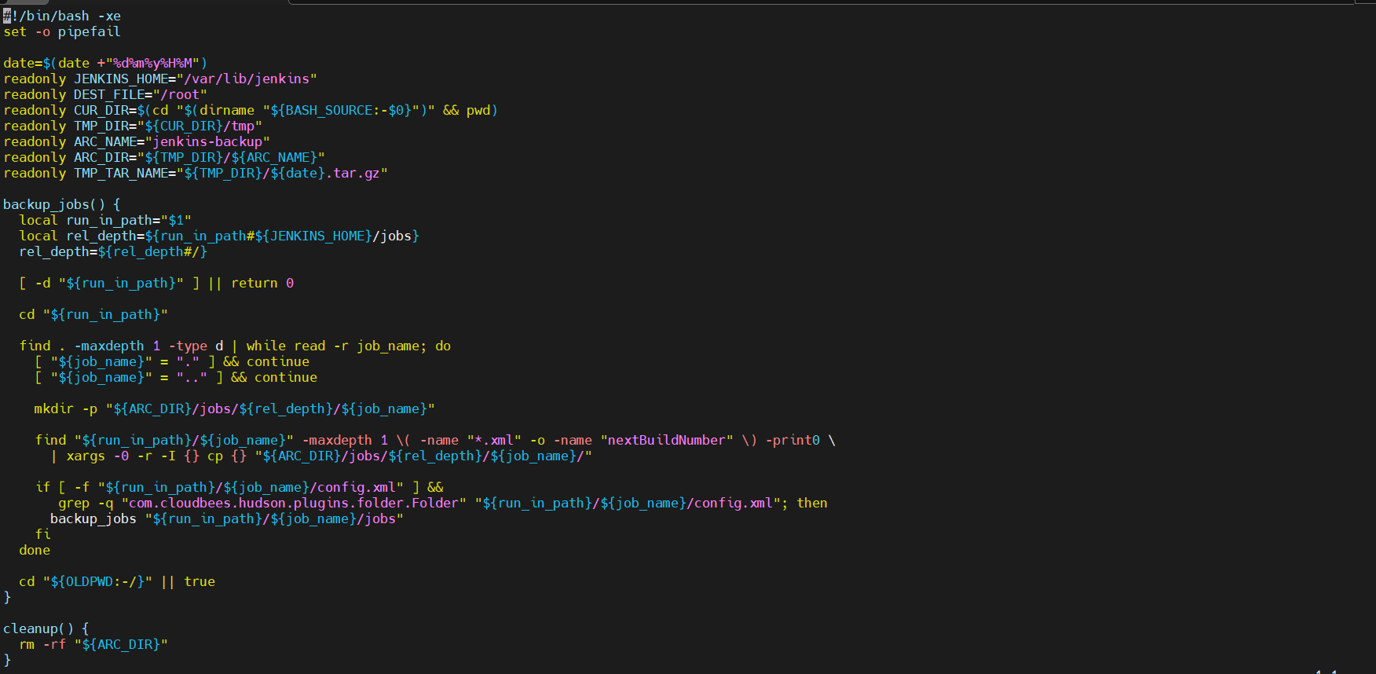

Step 7: Validate backup archive creation
• CLI command:
• Explanation: Confirm that the Jenkins backup tar.gz file is successfully created.
• Evidence: 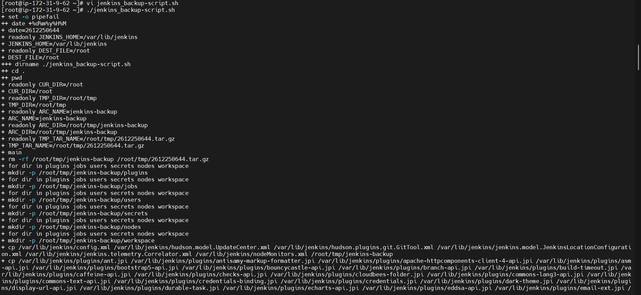

Step 8: Create PEM file for destination Jenkins server
• CLI path: Source Jenkins server
• Explanation: Create and secure the PEM file to allow SCP transfer to the new Jenkins instance.
• Evidence: 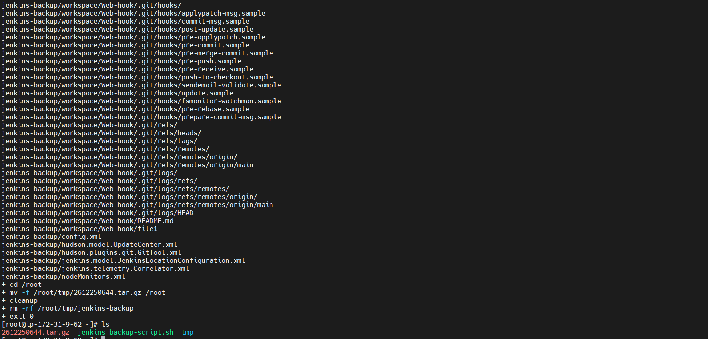

Step 9: Transfer backup archive to new Jenkins server
• CLI command:
scp -i jenkins_backup_instance.pem <backup-file>.tar.gz ec2-user@<destination-public-ip>:/home/ec2-user/
• Explanation: Securely copy the Jenkins backup archive to the new Jenkins server.
• Evidence: 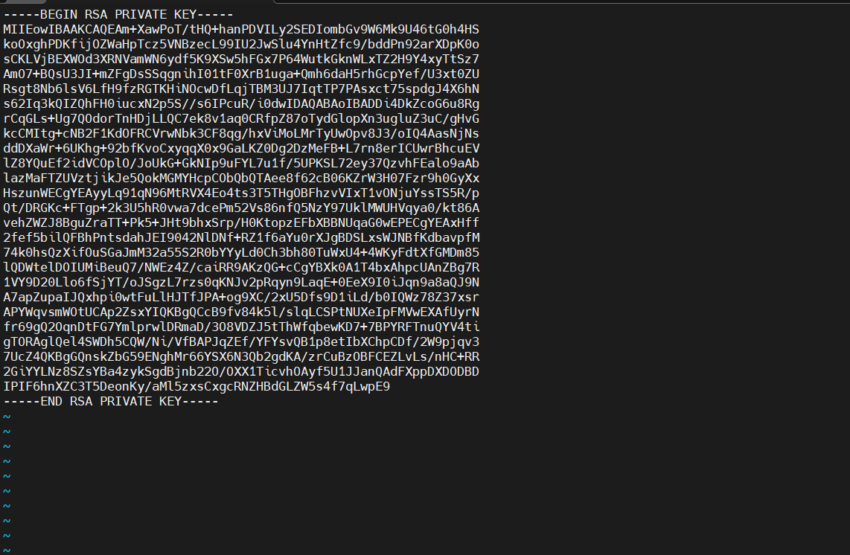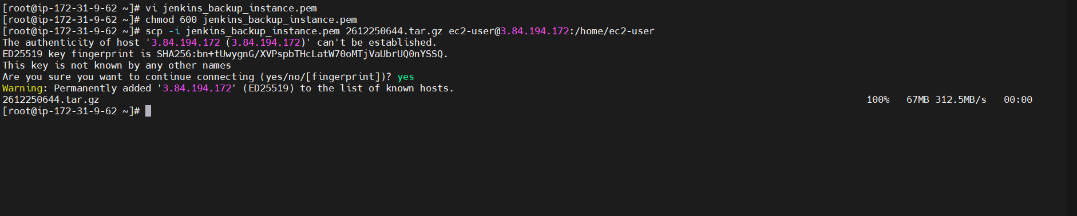

Step 10: SSH into new Jenkins server
• CLI command:
ssh -i "us-east-1.pem" ec2-user@<destination-public-ip>
sudo -i
• Explanation: Login to the new Jenkins server where restore will be performed.
• Evidence: 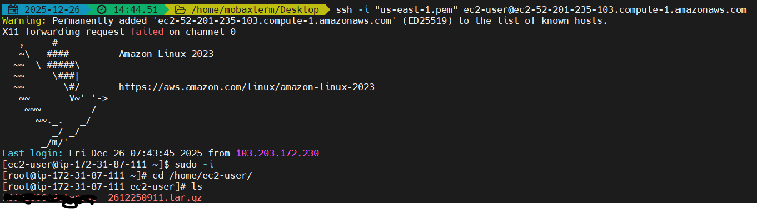

Step 11: Move backup archive to Jenkins home directory
• CLI command:
cp <backup-file>.tar.gz /var/lib/jenkins/
cd /var/lib/jenkins/
• Explanation: Place backup file inside Jenkins home directory for restoration.
• Evidence:

Step 12: Extract Jenkins backup archive
• CLI command:
tar -xzf <backup-file>.tar.gz
• Explanation: Extract all Jenkins data including jobs, plugins, and configuration files.
• Evidence: 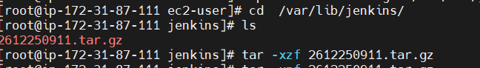

Step 13: Restart Jenkins service
• Browser path:
http://<jenkins-public-ip>:8080/restart
• Explanation: Restart Jenkins to load restored configurations and jobs.
• Evidence: 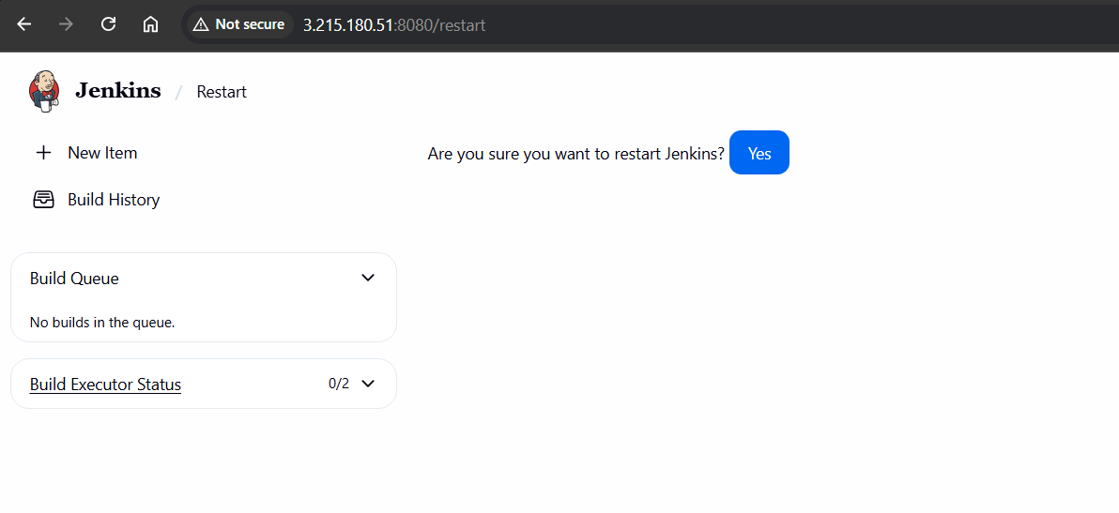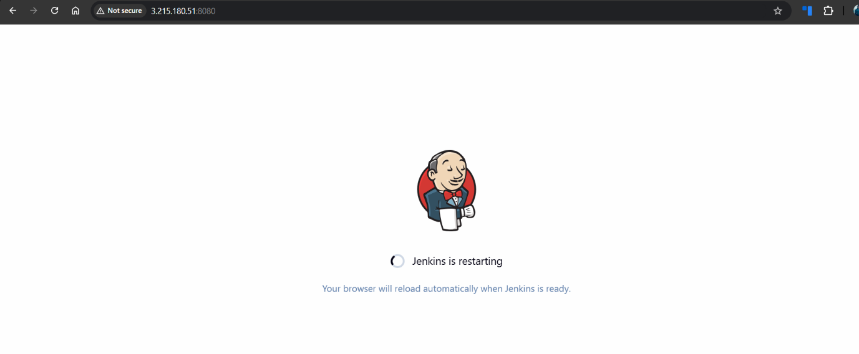

Step 14: Login to Jenkins after restart
• Browser path:
http://<jenkins-public-ip>:8080

• Explanation: Verify Jenkins login page loads successfully after restoration.
• Evidence: 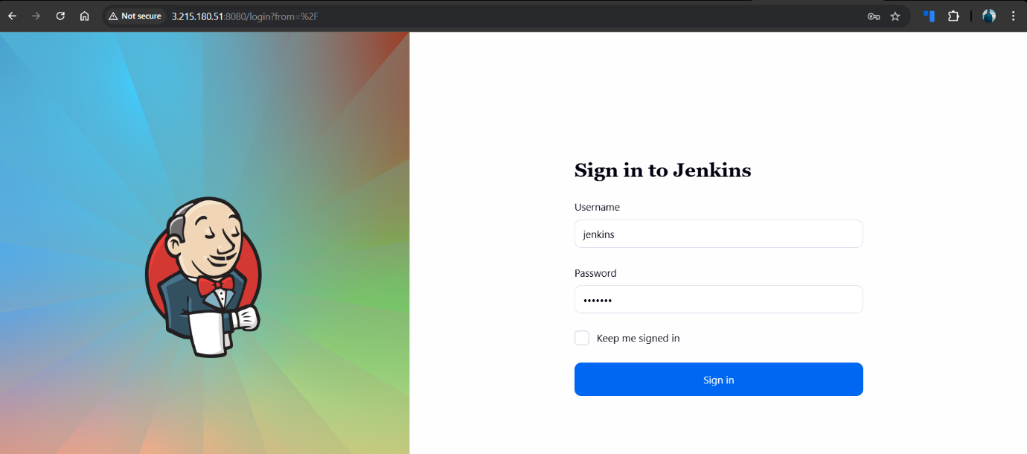

6.Validation Steps (Mandatory, With Evidence)

Validation : Access Check
• Check: Jenkins login successful with existing credentials
• Evidence: 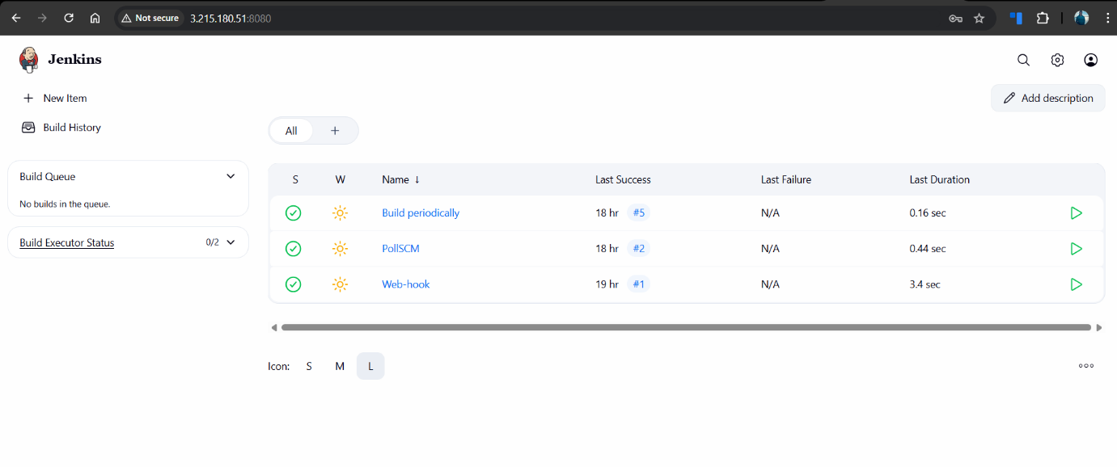
Issues Faced (Optional)
• Initial SSH host authenticity prompt during SCP transfer
• Resolved by accepting the host fingerprint and proceeding
7.Conclusion
The Jenkins server backup was successfully taken using a bash script, transferred to a new Jenkins server, restored into the Jenkins home directory, and validated. All jobs, configurations, and plugins were recovered successfully on the new Jenkins instance.
- Take backup of Jenkins using ThinBackup backup plugin.

  - Task Title
Take backup of Jenkins using ThinBackup plugin

  - Objective
To configure and use the ThinBackup Jenkins plugin to take a full backup of Jenkins configuration, jobs, and metadata, and verify that the backup is successfully created on the Jenkins server.

  - Prerequisites
• Jenkins server running on EC2
• Jenkins accessible via browser on port 8080
• Admin access to Jenkins

  - Step-by-Step Implementation (With Evidence)

Step 1: Verify Jenkins EC2 instance status
• Console path: AWS Console → EC2 → Instances → Instance Summary
• Explanation: Confirm that the Jenkins EC2 instance is running and reachable using its public IP.
• Evidence: 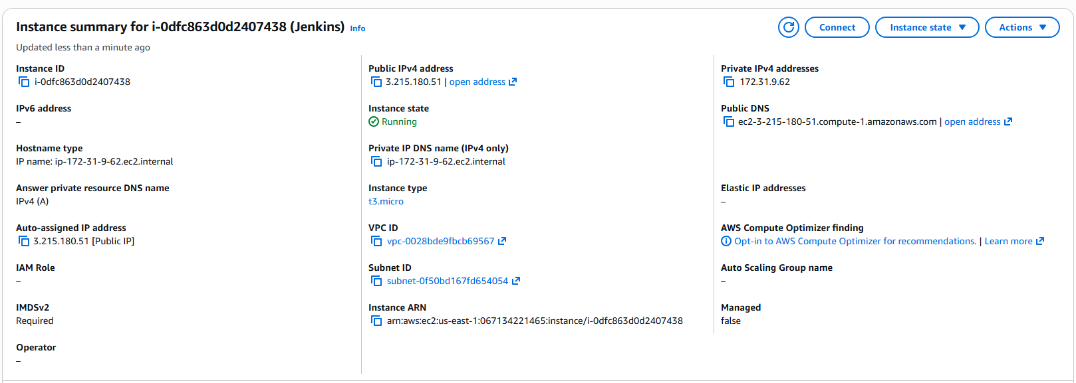

Step 2: Access Jenkins dashboard
• Browser path:
http://<jenkins-public-ip>:8080
• Explanation: Open Jenkins dashboard to confirm Jenkins is accessible and jobs are present.
• Evidence: 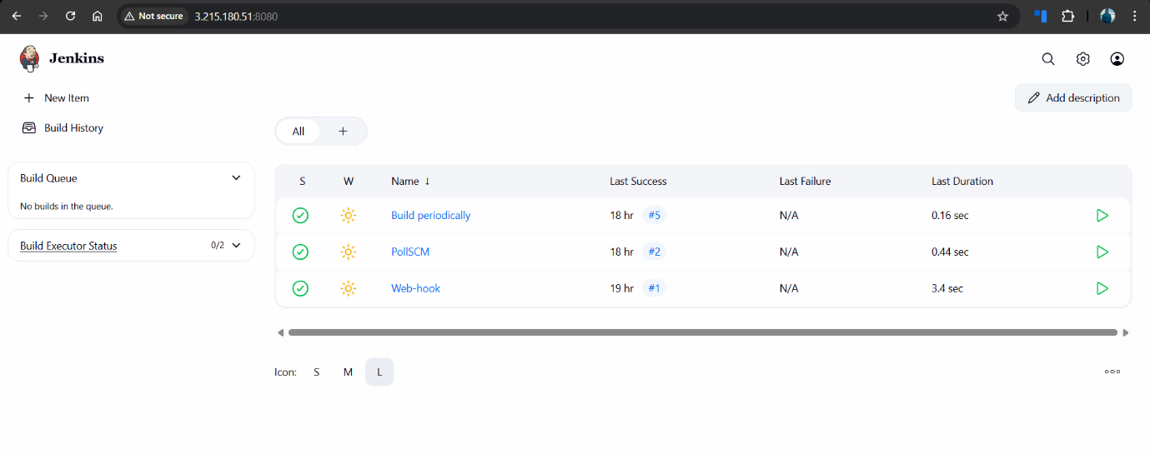

Step 3: Navigate to Jenkins Plugin Manager
• Console path: Jenkins → Manage Jenkins → Plugins → Available plugins
• Explanation: Open the plugin manager to search and install the ThinBackup plugin.
• Evidence: 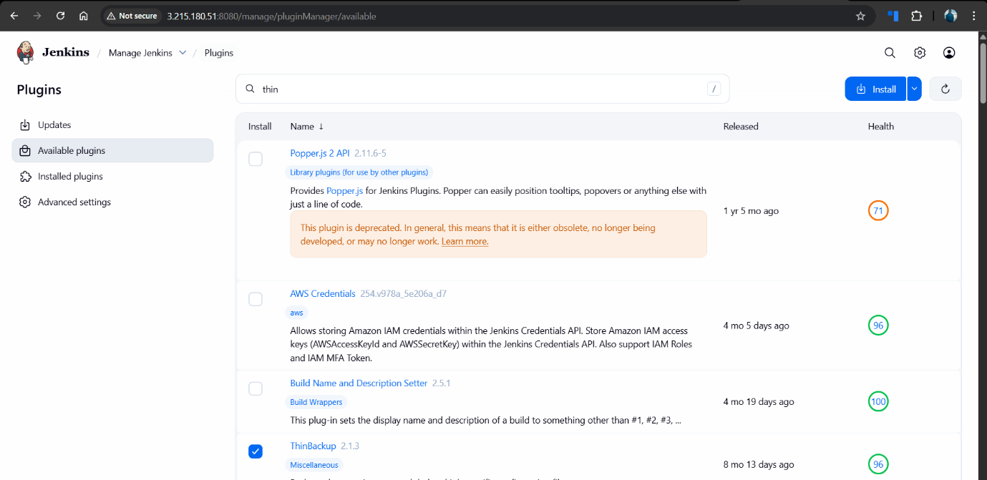

Step 4: Install ThinBackup plugin
• Plugin name: ThinBackup
• Explanation: Select ThinBackup plugin and install it without restarting immediately.
• Evidence: 

Step 5: Verify ThinBackup plugin installation
• Console path: Jenkins → Manage Jenkins → Plugins → Download progress
• Explanation: Confirm ThinBackup plugin installation completed successfully.
• Evidence: 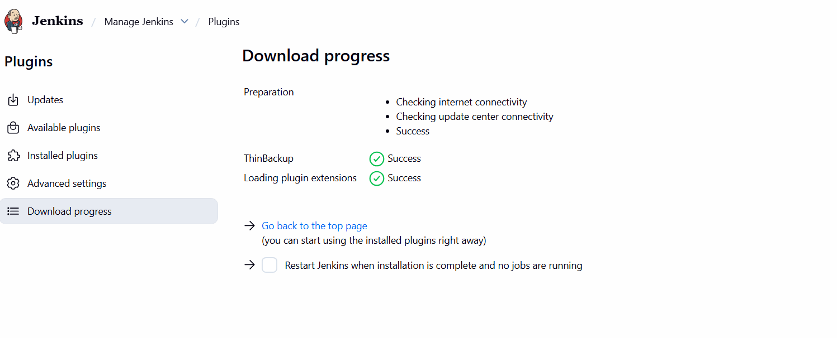

Step 6: Access ThinBackup from Manage Jenkins
• Console path: Jenkins → Manage Jenkins
• Explanation: Verify ThinBackup option is visible under Tools and Actions.
• Evidence: 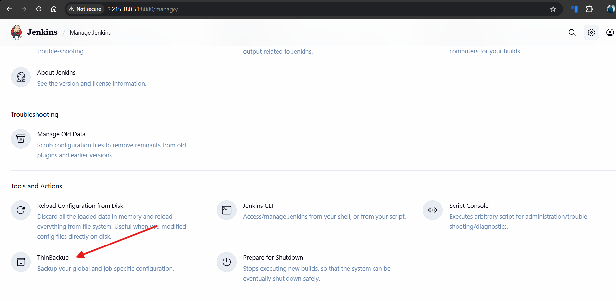

Step 7: Open ThinBackup interface
• Console path: Jenkins → Manage Jenkins → ThinBackup
• Explanation: Open ThinBackup dashboard to perform backup and restore operations.
• Evidence: 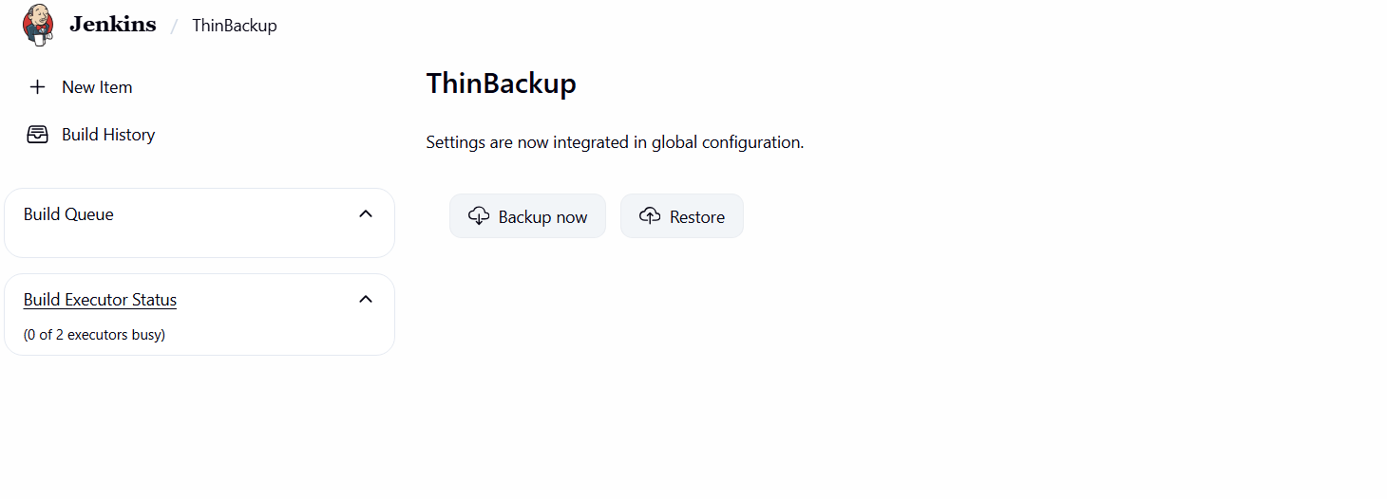

Step 8: Configure ThinBackup settings
• Console path: Jenkins → Manage Jenkins → System → ThinBackup Configuration
• Configuration used:
• Backup directory:
/var/lib/jenkins/thinbackup
• Max number of backup sets: -1
• Explanation: Configure backup directory and retention settings for Jenkins backups.
• Evidence: 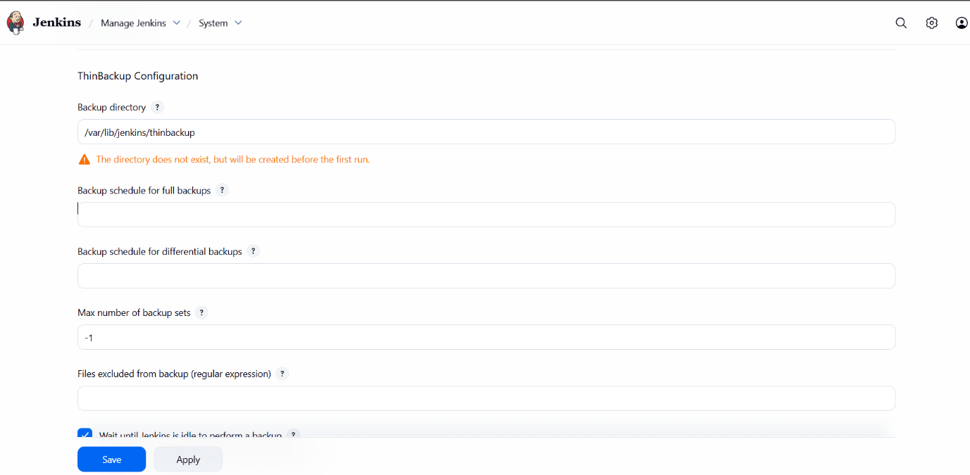

Step 9: Trigger Jenkins backup using ThinBackup
• Console path: Jenkins → Manage Jenkins → ThinBackup → Backup now
• Explanation: Manually trigger a full Jenkins backup using ThinBackup plugin.
• Evidence: 
5.Validation Steps (Mandatory, With Evidence)

Validation : Access Check
Verify backup files on Jenkins server
• CLI commands:

cd /var/lib/jenkins/thinbackup/
ls
• Explanation: Confirm that a timestamped FULL backup directory is created successfully.
• Evidence 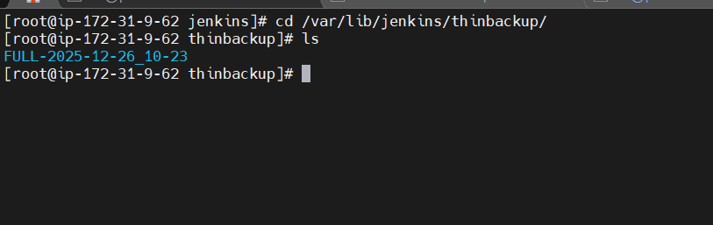
- Issues Faced (Optional)
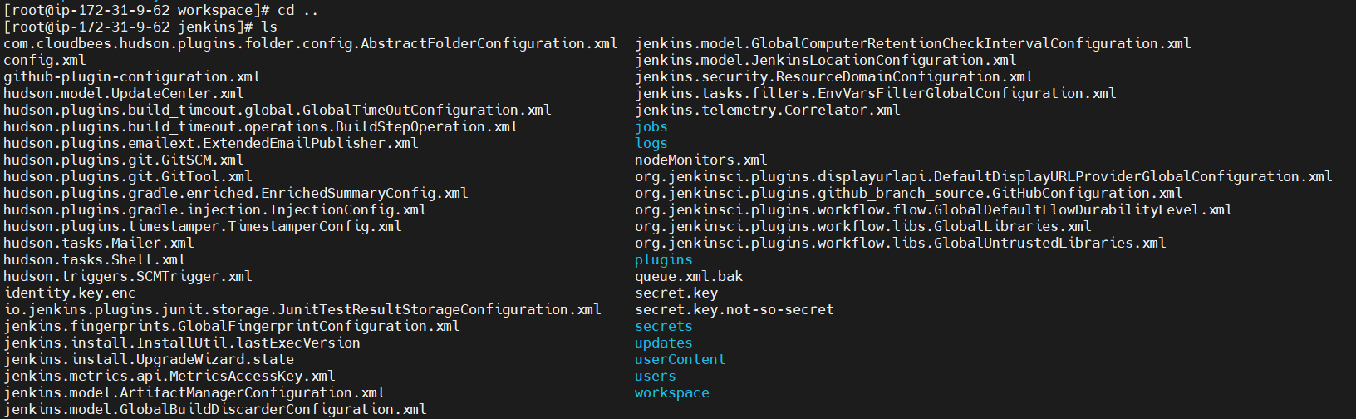
• Backup directory did not exist initially and when execueted backupnow then now where we are finding the backup later on, entered the backup directory in the managejenkins->system->ThinBackup Configuration, then backup are visible

- Conclusion
The Jenkins backup was successfully configured and executed using the ThinBackup plugin. The backup files were created in the specified directory.

