Terraform-Assignment-01

Install Terraform on your PC
Execute all the templates shown in video.
- Note down below points, Terraform Init Terraform Plan Terraform Apply Terraform Provider.
- Integrate a sample Terraform template in Jenkins.

1) Task Title: Install Terraform on your PC, Terraform Init Terraform Plan Terraform Apply Terraform Provider.

2) Objective
The objective of this task is to successfully install Terraform on a Windows-based system, configure it correctly by adding it to the system environment variables, and verify that the Terraform CLI is accessible globally. This ensures the system is ready to perform Infrastructure as Code (IaC) operations using Terraform for provisioning and managing cloud and on-premises resources.

3) Prerequisites
Before installing Terraform, the following prerequisites must be met:
- A Windows operating system (Windows 10/11)
- Administrator access to modify system environment variables
- Internet connectivity to download Terraform binaries
- Basic familiarity with command-line tools (Command Prompt / Git Bash / PowerShell)
- Sufficient disk space to store the Terraform binary
4) Step-by-Step Implementation (With Evidence)

Step 1: Download Terraform Binary for Windows
Console path / CLI command
Not applicable (Browser-based step)
Explanation
- Navigate to the official Terraform download page.
- Select Windows as the operating system.
- Download the 386 (32-bit) Terraform binary ZIP file (version 1.14.3 as shown).
- This ZIP contains the Terraform executable required to run Terraform commands on Windows.
Evidence
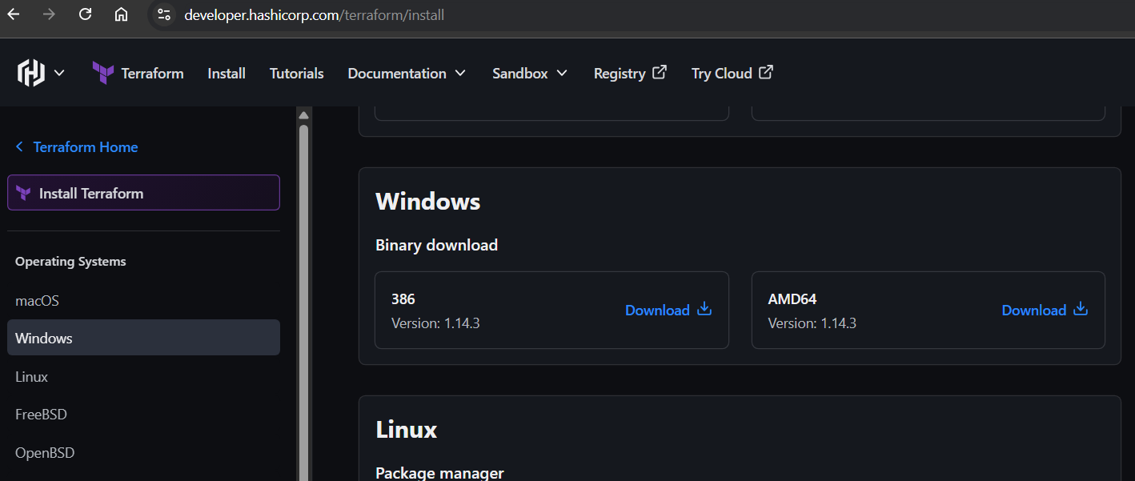
Step 2: Extract Terraform Binary
Console path / CLI command
Not applicable (GUI-based step)
Explanation
- Open the downloaded file:
- terraform_1.14.3_windows_386.zip
- Extract the contents.
- After extraction, the folder contains:
  - terraform.exe (Application)
  - LICENSE file
- This executable is what will be added to the system PATH.
Evidence
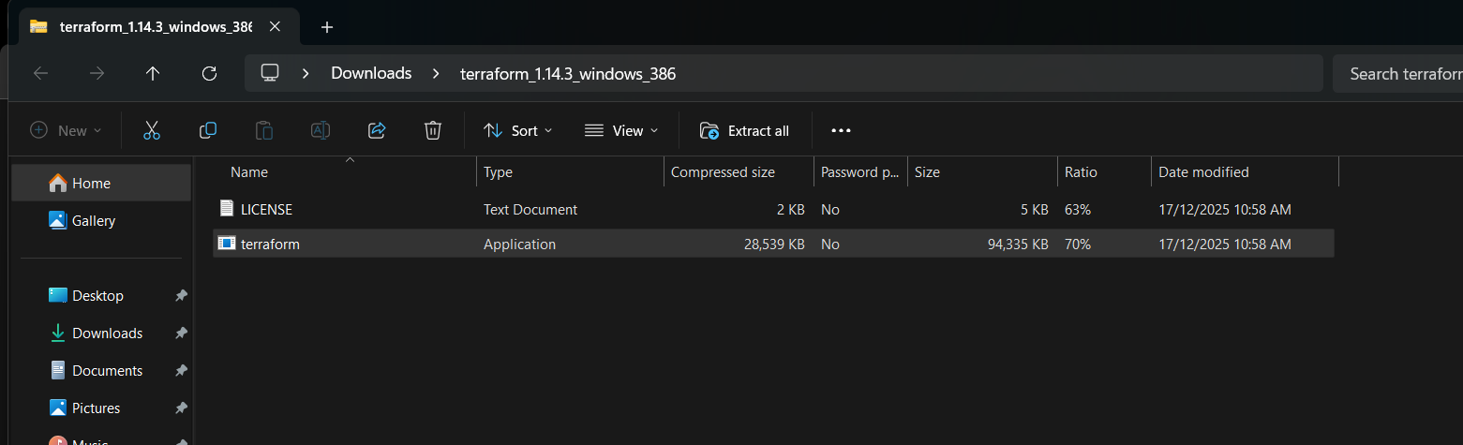
Step 3: Add Terraform to System PATH
Console path / CLI command
Not applicable (System configuration step)
Explanation
- Open Run → type sysdm.cpl
- Navigate to:
- System Properties → Advanced → Environment Variables
- Under System Variables, select Path → Click Edit
- Add a new entry pointing to the Terraform folder path:
- C:\Terraform
(or the folder where terraform.exe is placed)
- Click OK to save changes.
This ensures Terraform can be executed from any terminal.
Evidence
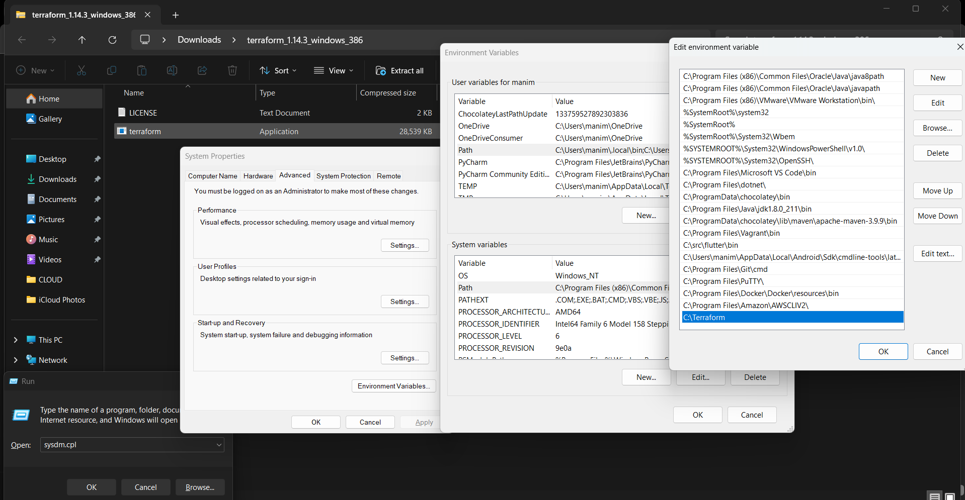 Step 4: Verify Terraform Installation Using CLI
Console path / CLI command
terraform -version
Explanation
- Open Git Bash / Command Prompt / PowerShell
- Run terraform -version
- This command verifies:
  - Terraform is correctly installed
  - PATH configuration is successful
  - Terraform binary is accessible system-wide
Evidence
- 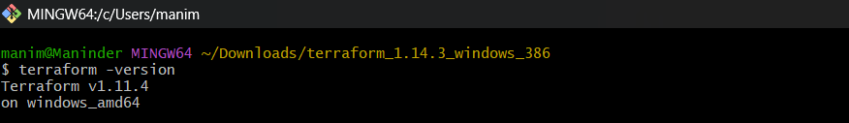.
Step 6: Create Terraform Configuration File
Console path / Action:
VS Code → Open Folder → Terraform → Create main.tf
Explanation:
- Defines Terraform configuration using local provider and local_file resource.
Code Used:
terraform {
}

provider "local" {
}

resource "local_file" "my_pet" {
filename = "pets.txt"
content = "My pet is a dog."
}
Evidence:
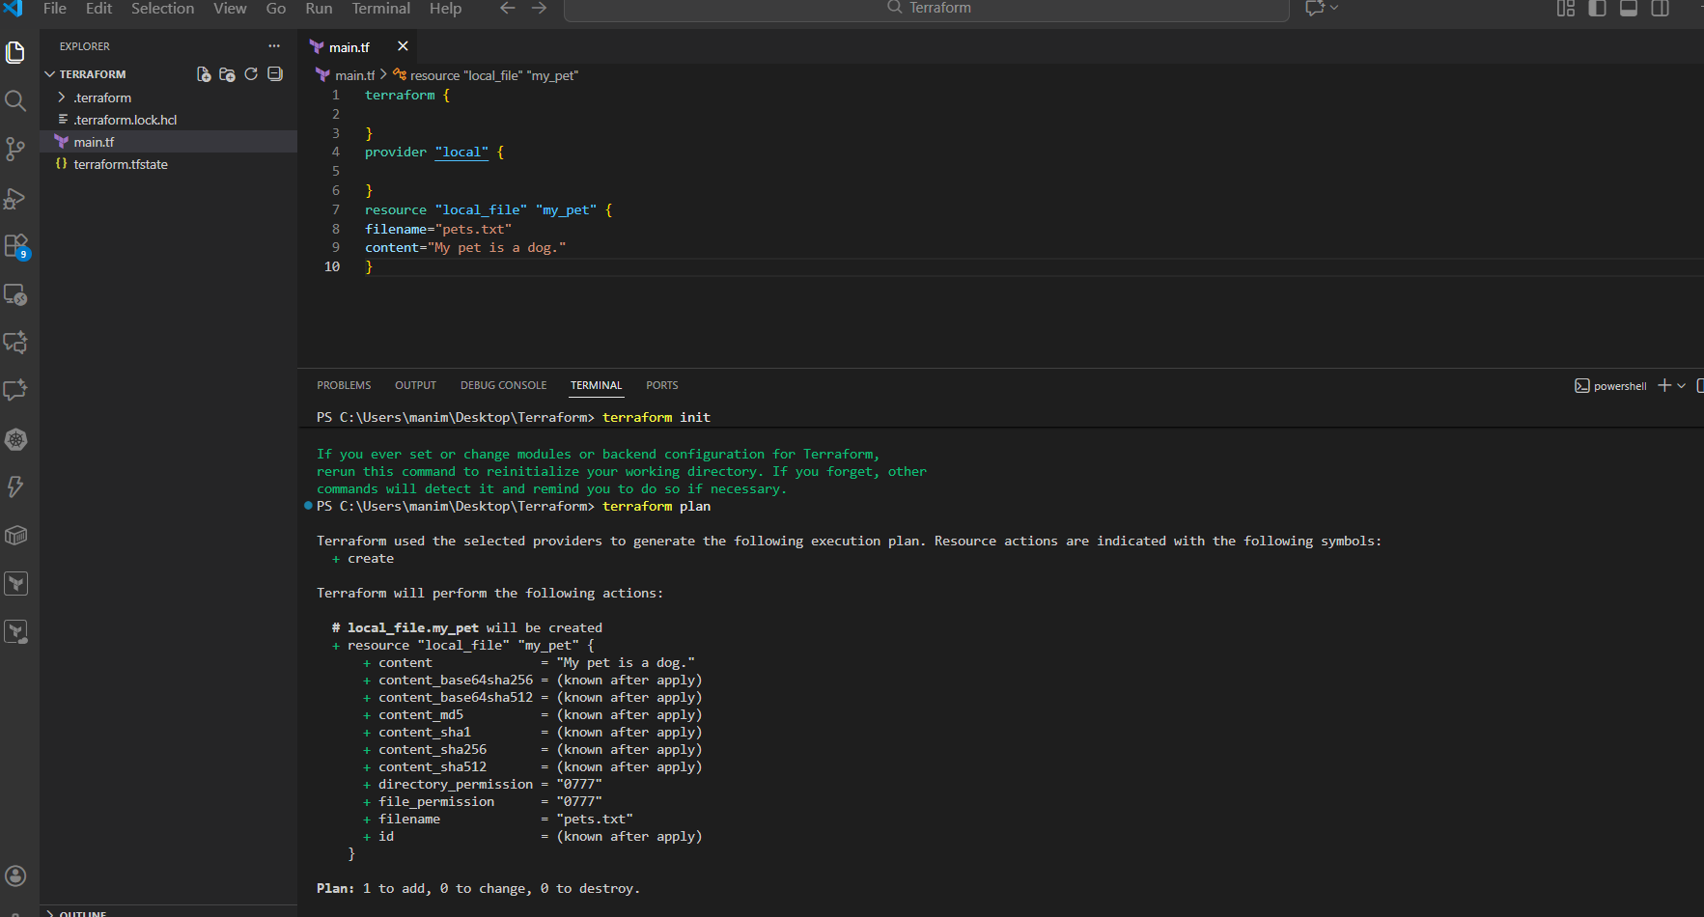
Step 7: Initialize Terraform
Console path / CLI command:
terraform init
Explanation:
- Downloads required provider plugins.
- Initializes .terraform directory.
Evidence:

Step 8: Generate Execution Plan
Console path / CLI command:
terraform plan
Explanation:
- Shows what Terraform will create before applying changes.
- Confirms local_file.my_pet will be created.
Evidence:

Step 9: Apply Terraform Configuration
Console path / CLI command:
terraform apply
Explanation:
- Applies the planned changes.
- Prompts for confirmation.
User Input:
yes
Evidence:
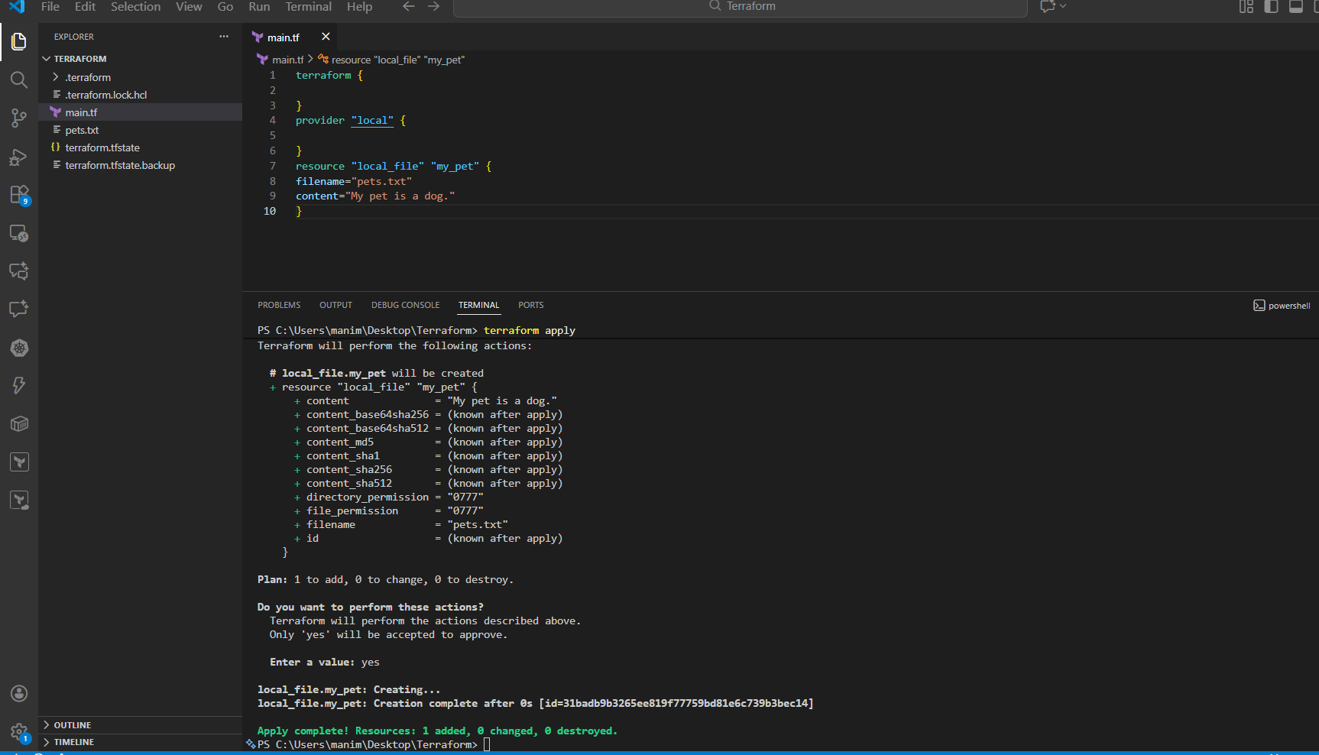
Step 10: Verify Resource Creation
Console path / Action:
VS Code Explorer / File System
Explanation:
- Terraform creates the file defined in configuration.
Evidence:
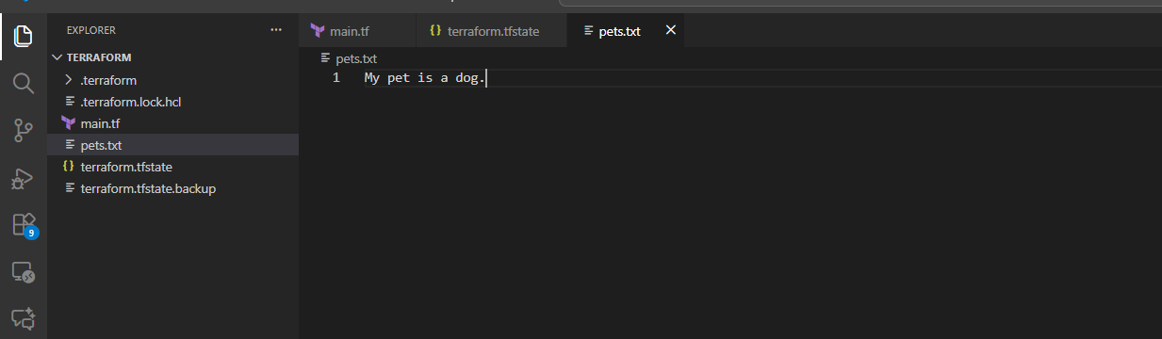
Step 11: Verify Terraform State Files
Console path / Action:
VS Code Explorer
Explanation:
- Terraform automatically tracks infrastructure state.
Evidence:
- 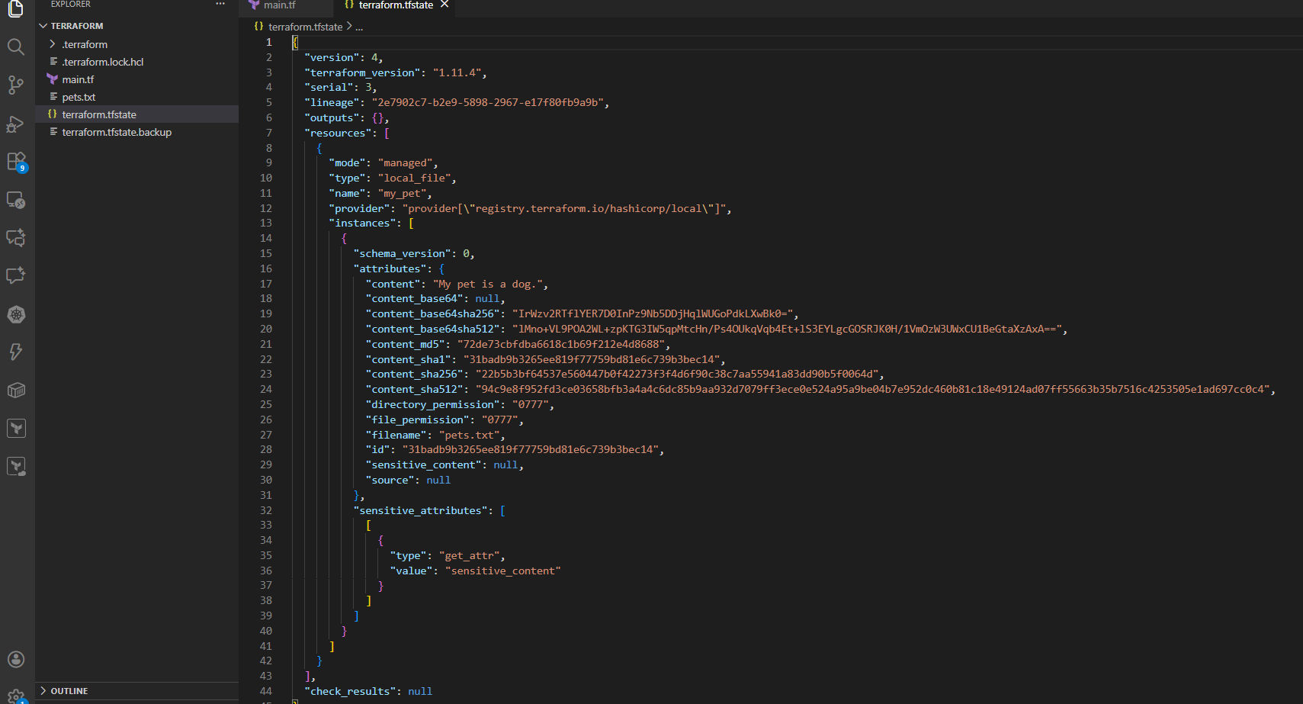

1) Task Title
Integrate a Sample Terraform Template with Jenkins Pipeline

2) Objective
The objective of this task is to integrate Terraform with Jenkins by creating a declarative Jenkins pipeline that pulls Terraform code from a Git repository and executes Terraform lifecycle commands (init, plan, and apply). This demonstrates Infrastructure as Code (IaC) automation using Jenkins CI/CD.

3) Prerequisites
- Jenkins server up and running
- Admin access to Jenkins
- Internet connectivity from Jenkins server
- Terraform plugin installed in Jenkins
- Terraform tool configured in Jenkins Global Tool Configuration
- Git installed on Jenkins server
- GitHub repository containing Terraform code (main.tf)
- Jenkins agent with Linux OS (recommended)

4) Step-by-Step Implementation (With Evidence)

Step 1: Install Terraform Plugin in Jenkins
Console path / UI path:
Manage Jenkins → Plugins → Available plugins
Explanation:
The Terraform plugin enables Jenkins to recognize Terraform as a build tool and allows Terraform commands to be executed inside Jenkins pipelines.
Evidence:
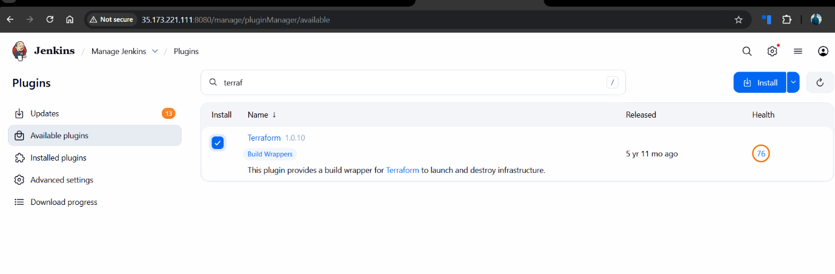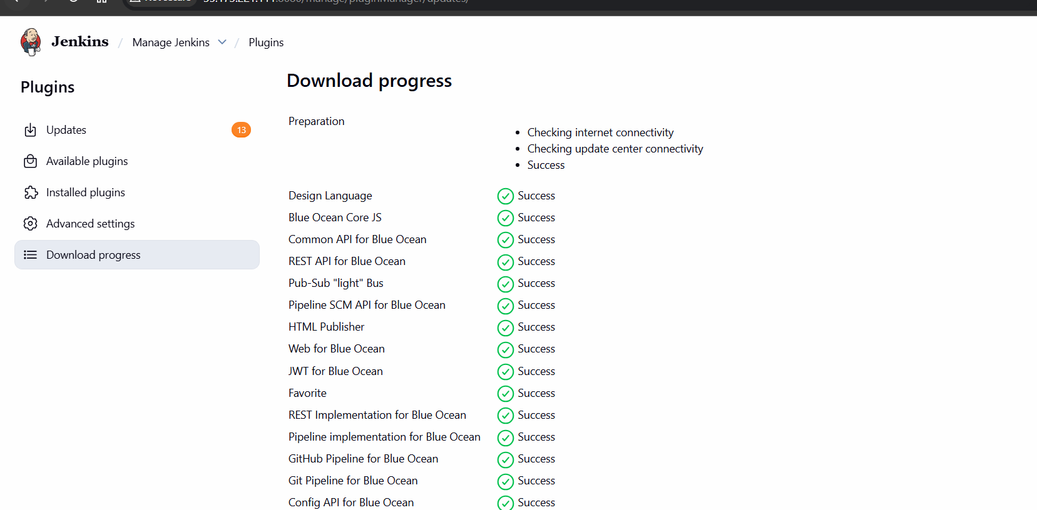
Step 2: Configure Terraform Tool in Jenkins
Console path / UI path:
Manage Jenkins → Global Tool Configuration → Terraform
Explanation:
Terraform must be configured as a global tool so that Jenkins pipelines can invoke it using the tools { terraform 'Terraform' } directive.
Configuration Done:
- Tool Name: Terraform
- Install automatically: Enabled
- Version: Linux (amd64)
Evidence:
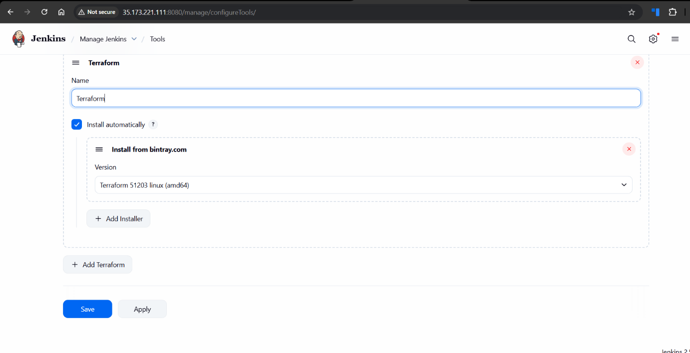
Step 3: Create Terraform Git Repository
Console path / CLI command:
git clone https://github.com/mani-u4444/Terraform-jenkins.git
Explanation:
A GitHub repository is created to store Terraform configuration. The repository contains a simple local_file resource to validate Terraform execution.
Terraform Code (main.tf):
terraform {
}

provider "local" {
}

resource "local_file" "sample_file" {
filename = "jenkins-tf.txt"
content = "Terraform integration with jenkins"
}
Evidence:
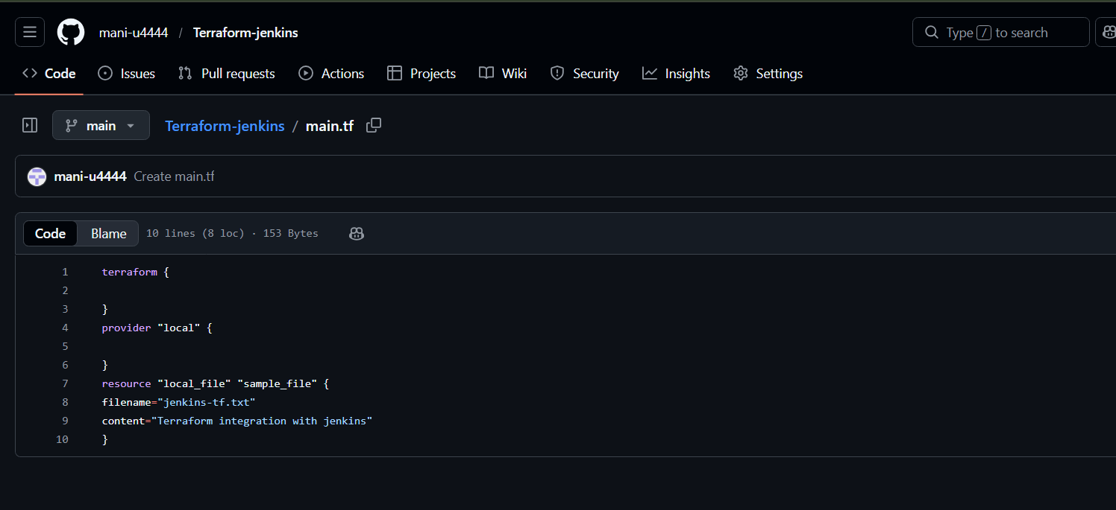
Step 4: Create Jenkins Pipeline Job
Console path / UI path:
Jenkins Dashboard → New Item → Pipeline
Explanation:
A pipeline job is created to automate Terraform execution.
Job Name:
Terraform-jenkins
Pipeline Type:
Declarative Pipeline
Evidence:
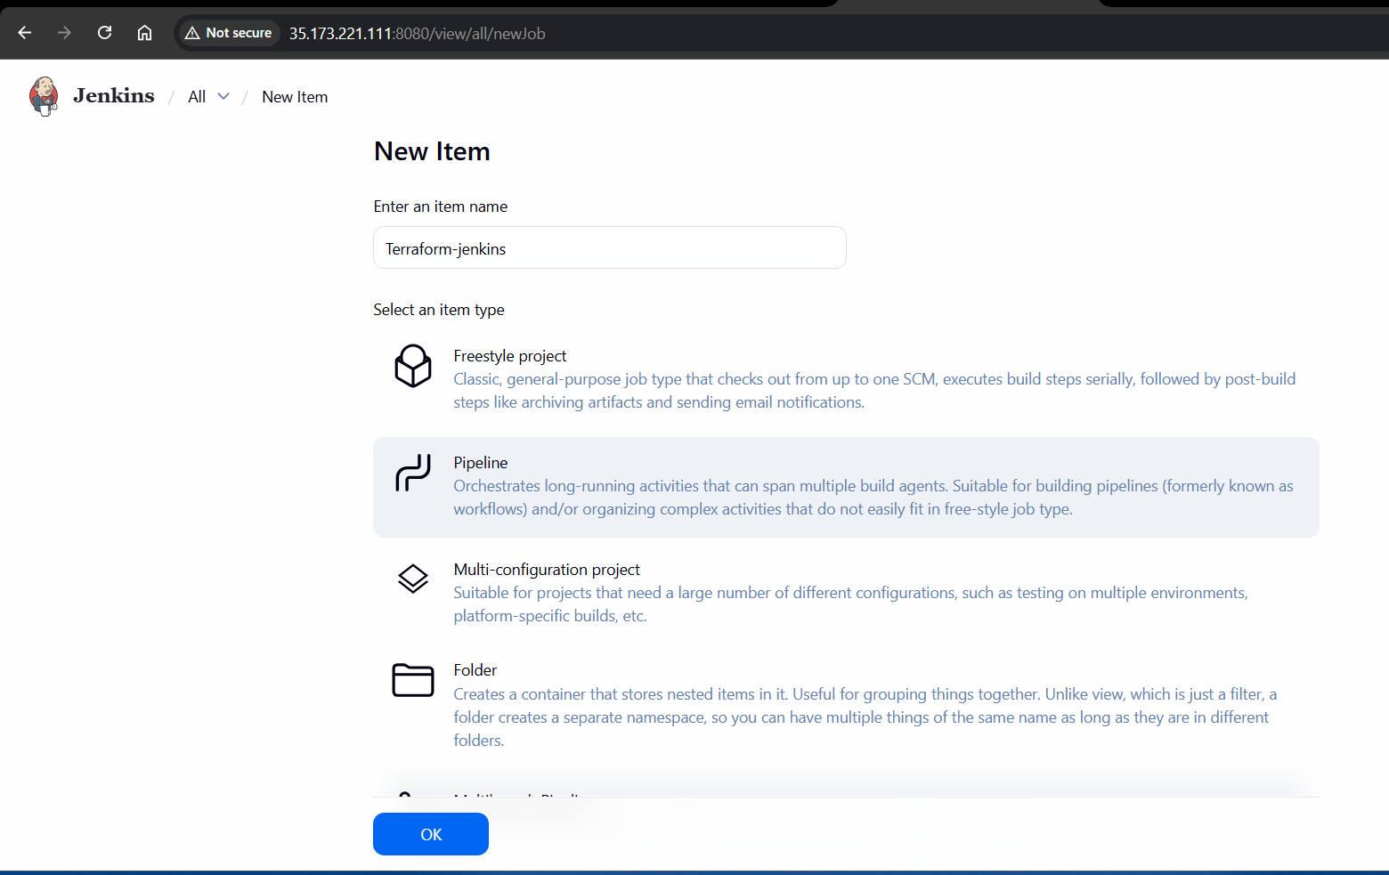
Step 5: Configure Jenkins Pipeline Script
Console path / UI path:
Terraform-jenkins → Configure → Pipeline
Pipeline Script Used:
pipeline {
agent any

tools {
terraform 'Terraform'
}

stages {

stage('Git Clone') {
steps {
git branch: 'main',
url: 'https://github.com/mani-u4444/Terraform-jenkins.git'
}
}

stage('Terraform Init') {
steps {
sh 'terraform init'
}
}

stage('Terraform Plan') {
steps {
sh 'terraform plan'
}
}

stage('Terraform Apply') {
steps {
sh 'terraform apply -auto-approve'
}
}
}
}
Explanation:
- Git Clone: Pulls Terraform code
- Terraform Init: Initializes provider and backend
- Terraform Plan: Shows execution plan
- Terraform Apply: Creates the resource automatically
Evidence:
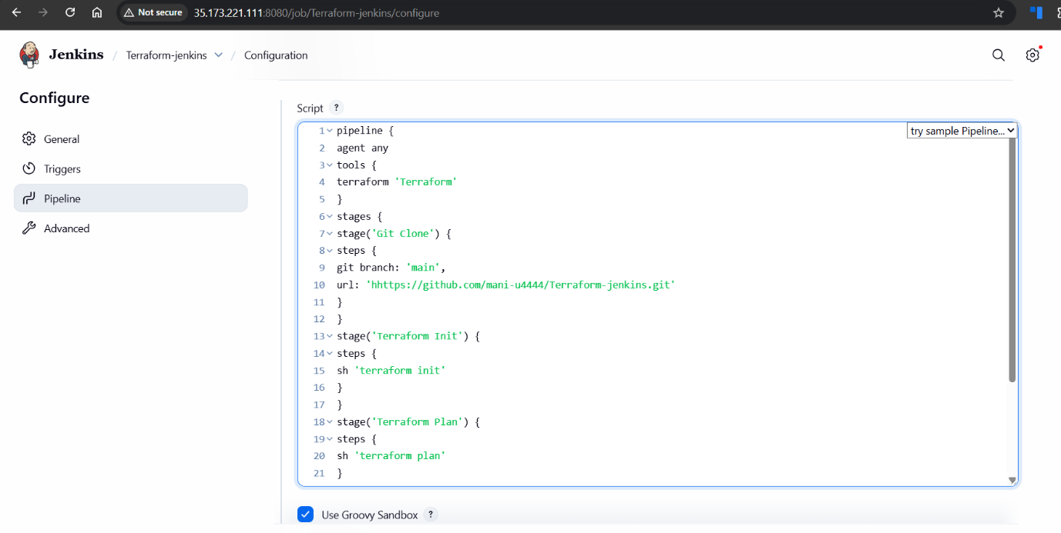Step 6: Execute the Pipeline
Console path / UI path:
Terraform-jenkins → Build Now
Explanation:
Triggers the Jenkins pipeline to execute Terraform commands sequentially.
Evidence:
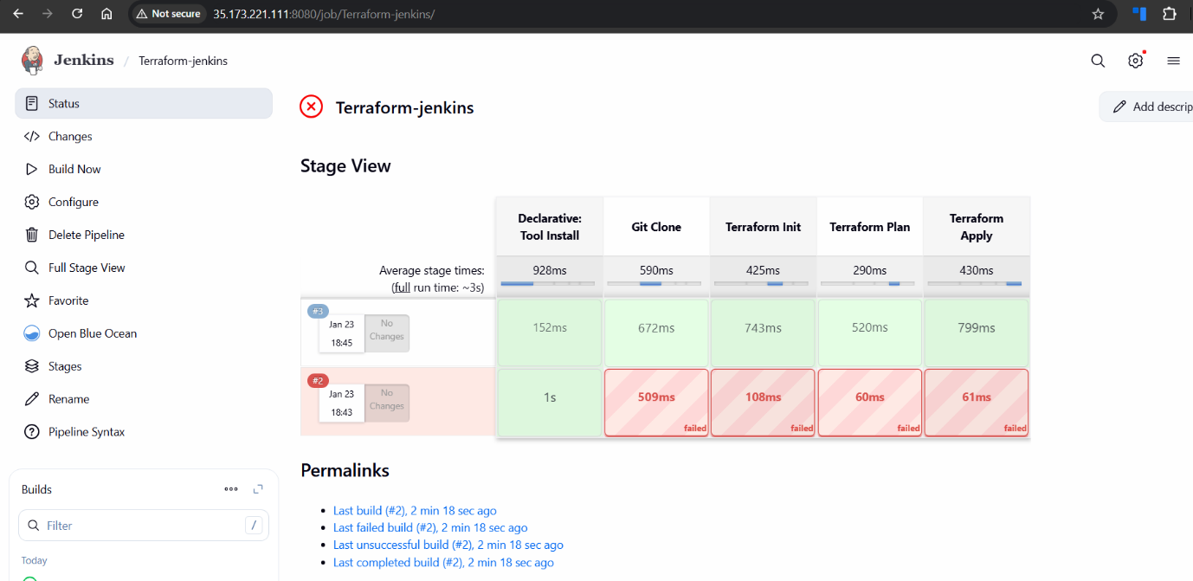
5) Validation Steps (Mandatory, With Evidence)

Validation 1: Resource Health Check
Check:
Terraform state file created successfully.
Evidence:
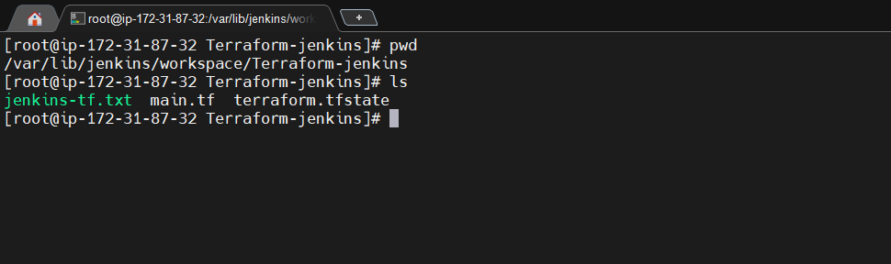
Validation 2: Functional Check
Check:
Terraform resource creation confirmed.
Evidence:
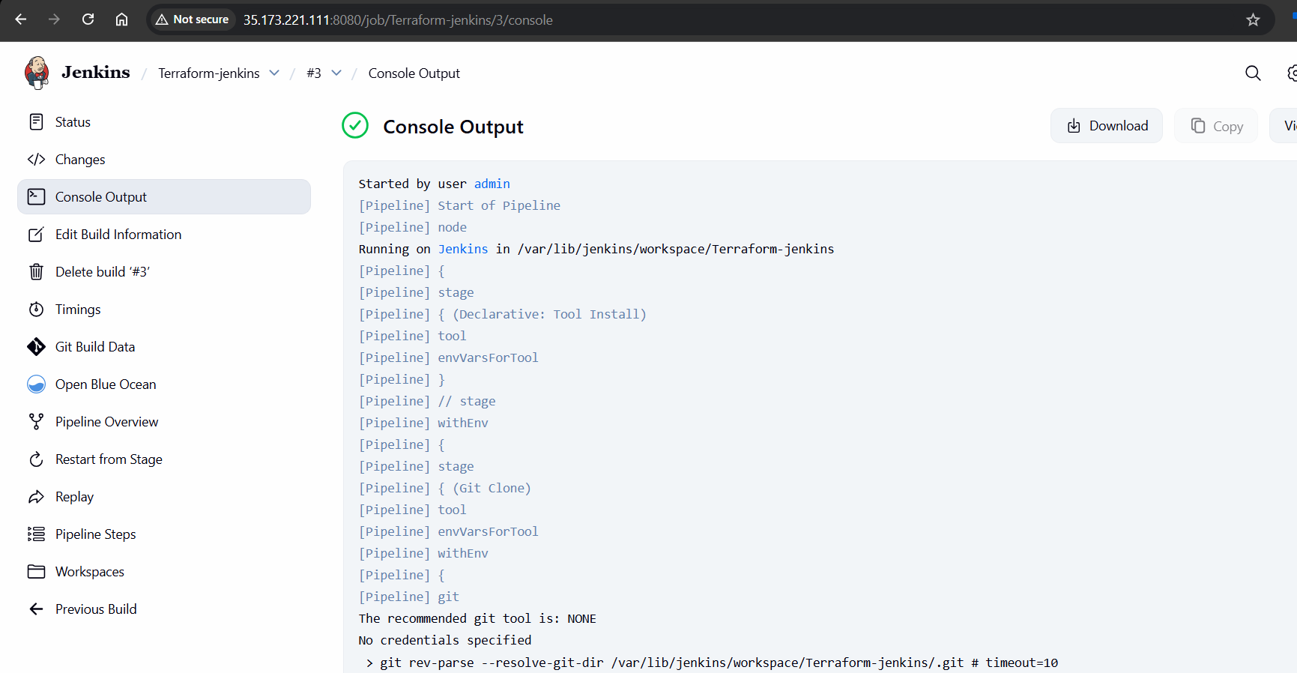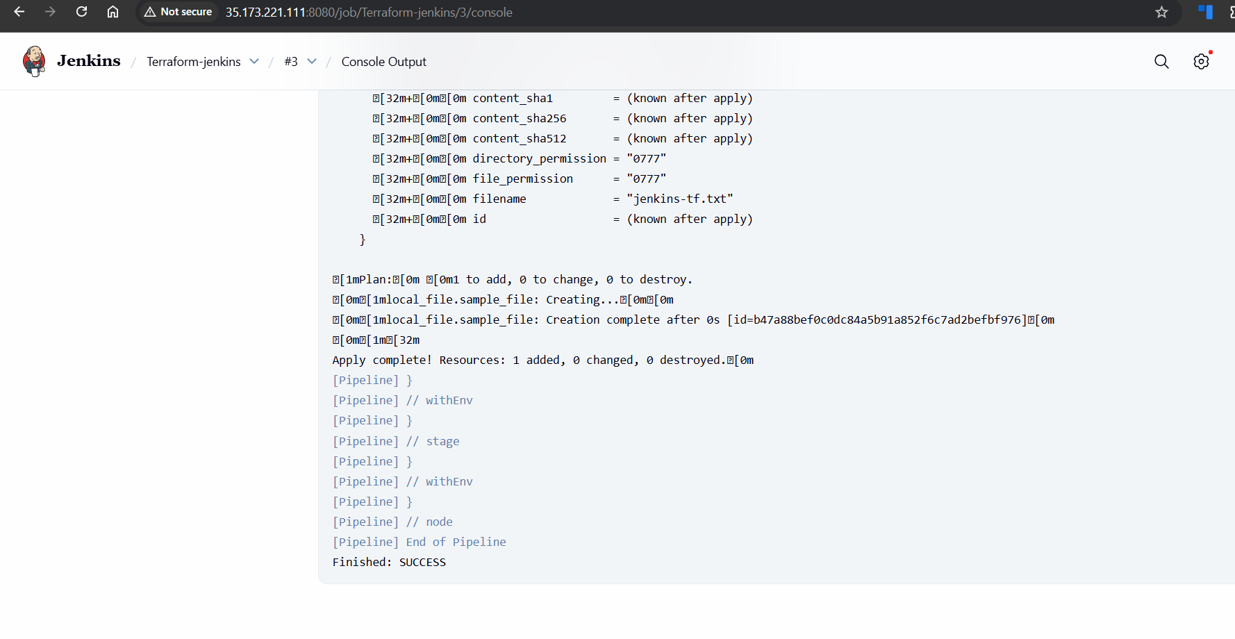
6) Issues Faced (Optional)
- Initial pipeline failures due to Terraform tool not configured
- Git tool warning (recommended git tool: NONE)
- Resolved by configuring Terraform in Global Tool Configuration
- Ensured Jenkins agent had execution permissions

7) Conclusion
In this task, Terraform was successfully integrated with Jenkins using a declarative pipeline. The pipeline automated the complete Terraform lifecycle—code checkout, initialization, planning, and application—demonstrating Infrastructure as Code automation using CI/CD. This setup forms a strong foundation for real-world Terraform deployments in DevOps environments.

