Jenkins-Challenge-2

Create a Declarative Jenkins parameterized pipeline for simplecustomerapp.
Requirements:
- Create a Pipeline job in Jenkins.
- Use a Git repository for simplecustomerapp.
- Add parameters:
• BRANCH_NAME (string, default: main)
• ENV (choice: dev, qa)
- Define environment variables:
• APP_NAME = simplecustomerapp
- Implement stages:
• Checkout (based on BRANCH_NAME)
• Build (mvn clean compile)
• Test (mvn test)
• Package (mvn package)
- Add post actions:
• Success → print success message with environment
• Failure → print failure message
- Trigger using Build with Parameters.

1) Task Title
Create a Declarative Jenkins Parameterized Pipeline for simplecustomerapp

2) Objective
The objective of this task is to design and implement a parameterized declarative Jenkins pipeline that automates the build lifecycle of a Maven-based Java web application (simplecustomerapp).
The pipeline enables:
- Dynamic Git branch selection using parameters
- Environment-based execution (DEV / QA)
- Automated build, test, and package stages using Maven
- Clear post-build feedback for both success and failure scenarios
This improves build flexibility, repeatability, and visibility while following CI best practices.

3) Prerequisites
- Jenkins server installed and running
- Jenkins Pipeline plugin enabled
- Maven installed and configured in Jenkins Global Tool Configuration (MVN_HOME)
- Git installed on Jenkins node
- Access to GitHub repository:
  - https://github.com/mani-u4444/SimpleCustomerApp.git
- Java (JDK 8 or higher) installed on Jenkins node
- Basic understanding of:
  - Declarative Jenkins pipelines
  - Maven build lifecycle
  - Parameterized builds
4) Step-by-Step Implementation (With Evidence)

Step 1: Create a New Pipeline Job
Console path / UI navigation:
Jenkins Dashboard → New Item
Explanation:
A new Jenkins Pipeline job is created to implement a declarative, parameterized pipeline for simplecustomerapp.
Actions performed:
- Enter job name: Jenkins_Challenge-2
- Select Pipeline
- Click OK
Evidence:
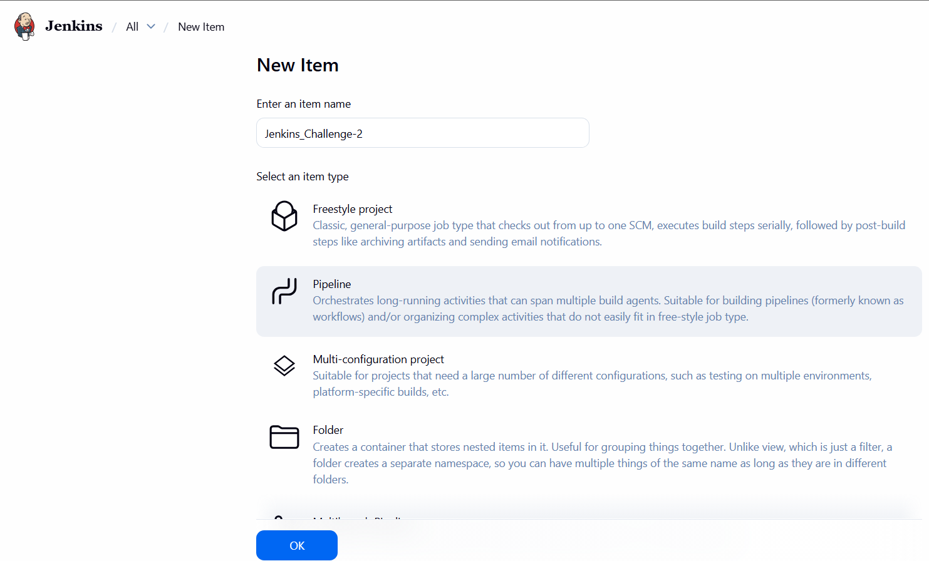
Step 2: Enable Parameterized Build – BRANCH_NAME
Console path / UI navigation:
Jenkins_Challenge-2 → Configure → General
Explanation:
A string parameter is added to allow dynamic selection of the Git branch during build execution.
Actions performed:
- Enable This project is parameterized
- Add String Parameter
  - Name: BRANCH_NAME
  - Default Value: master
  - Description: (optional)
Evidence:
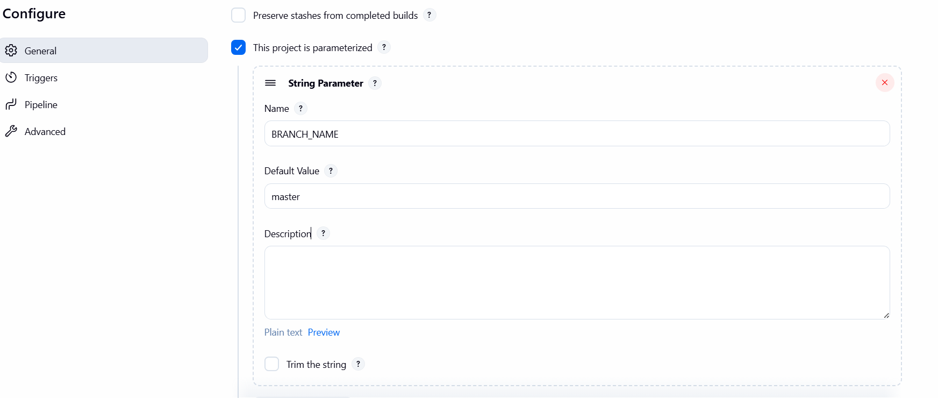
Step 3: Add Choice Parameter – ENV
Console path / UI navigation:
Jenkins_Challenge-2 → Configure → General
Explanation:
A choice parameter is added to select the deployment environment at build time.
Actions performed:
- Add Choice Parameter
  - Name: ENV
  - Choices:
  - DEV
  - QA
Evidence:
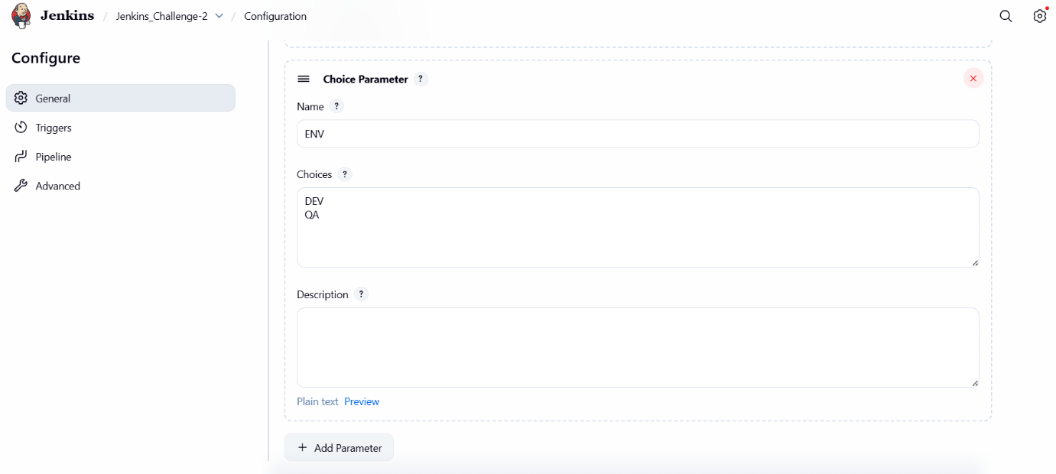
Step 4: Define Declarative Pipeline Script
Console path / UI navigation:
Jenkins_Challenge-2 → Configure → Pipeline
Explanation:
The pipeline is defined using declarative syntax with parameters, environment variables, stages, and post actions.
Key configurations implemented in script:
- Parameters:
  - BRANCH_NAME
  - ENV
- Environment variable:
  - APP_NAME = simplecustomerapp
- Git checkout based on BRANCH_NAME
Evidence:
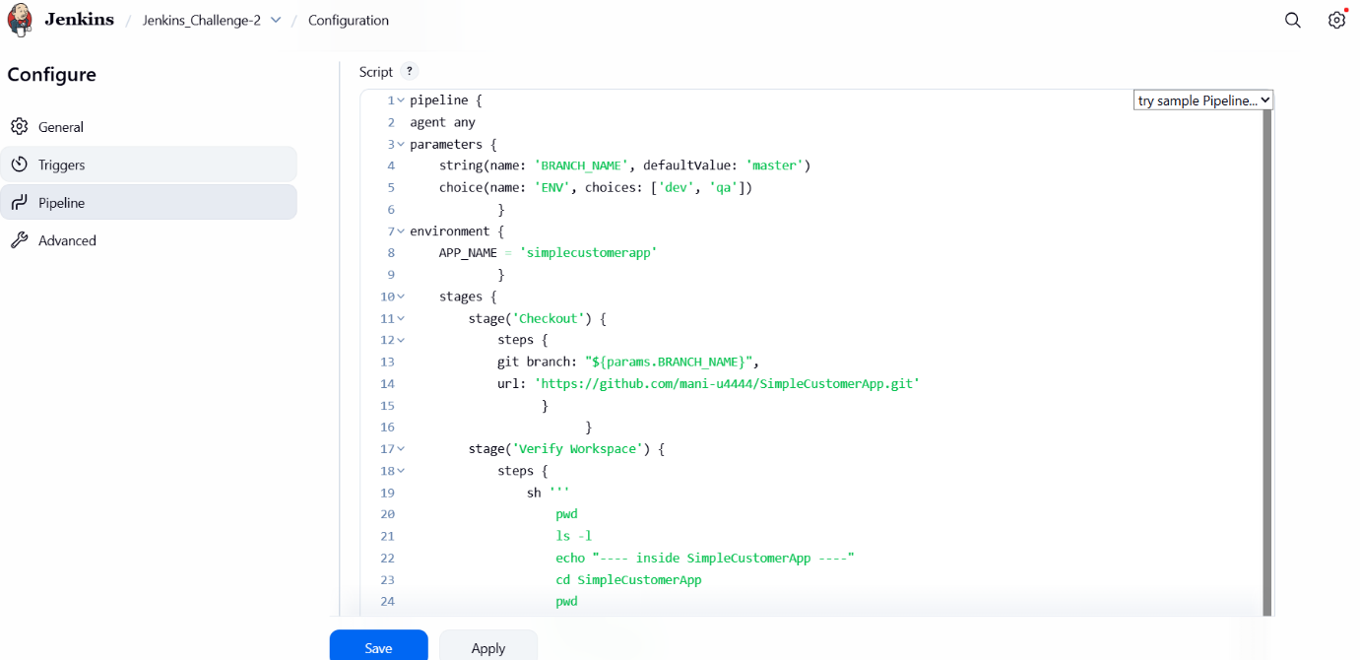
Step 5: Checkout Stage
Console path / CLI command:
Executed inside Jenkins pipeline
Explanation:
Source code is fetched dynamically from GitHub using the selected branch.
Command used:
- Git repository:
https://github.com/mani-u4444/SimpleCustomerApp.git
Evidence:
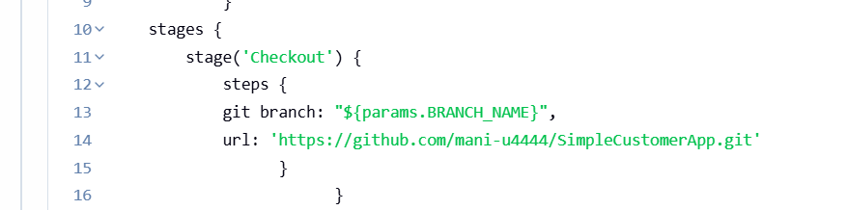
Step 6: Test Stage
Console path / CLI command:
Executed inside Jenkins pipeline workspace
Explanation:
Unit tests are executed using Maven to validate application correctness.
Command used:
mvn test
Evidence:
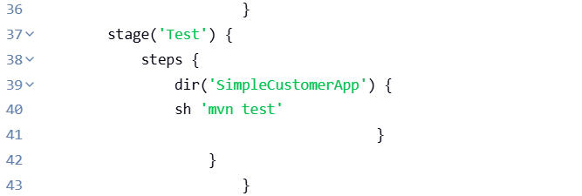
Step 7: Package Stage
Console path / CLI command:
Executed inside Jenkins pipeline workspace
Explanation:
The application is packaged into a deployable artifact using Maven.
Command used:
mvn package
Evidence:
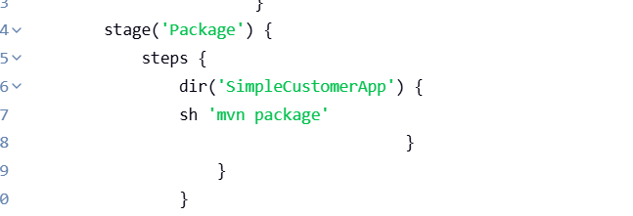
Step 8: Post Actions Configuration
Console path / CLI command:
Declarative post {} section in pipeline
Explanation:
Post-build actions provide clear feedback on pipeline execution status.
Actions implemented:
- Success:
  - Prints success message with application name and selected environment
  - Lists generated artifacts
- Failure:
  - Prints failure message with application name
Evidence:
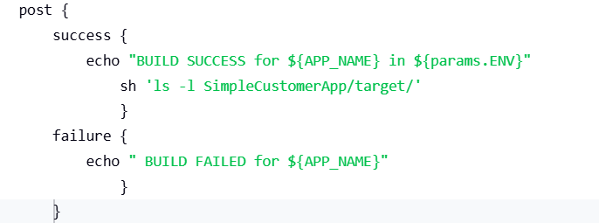

Step 9: Trigger Pipeline Using “Build with Parameters”
Console path / UI navigation:
Jenkins Dashboard → Jenkins_Challenge-2 → Build with Parameters
Explanation:
The pipeline is manually triggered with user-defined parameters to validate parameterized execution.
Actions performed:
- BRANCH_NAME: master
- ENV: DEV
- Click Build
Evidence:
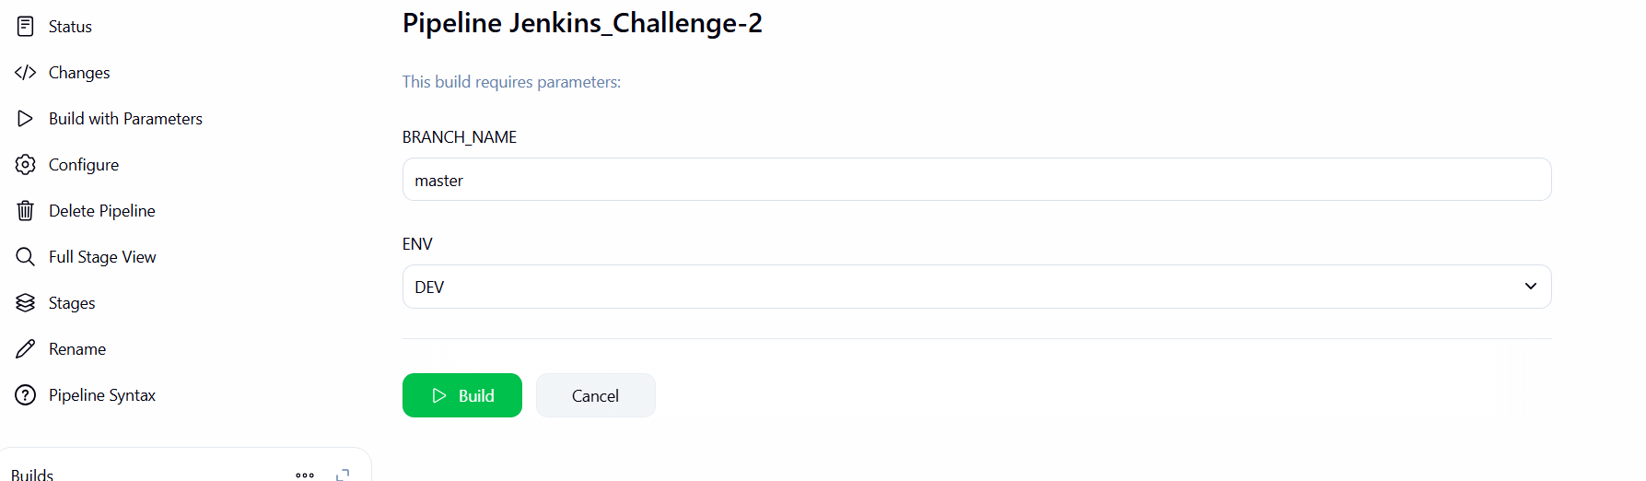
Step 10: Observe Initial Build Failure (Package Stage)
Console path / UI navigation:
Jenkins_Challenge-2 → Build #2 → Console Output
Explanation:
The pipeline failed during the Package stage due to a Maven WAR plugin configuration issue. As per declarative behavior, subsequent stages were skipped and post-failure action executed.
Observed error:
- ERROR: script returned exit code 127
- Package stage marked as skipped due to earlier failure(s)
Evidence:
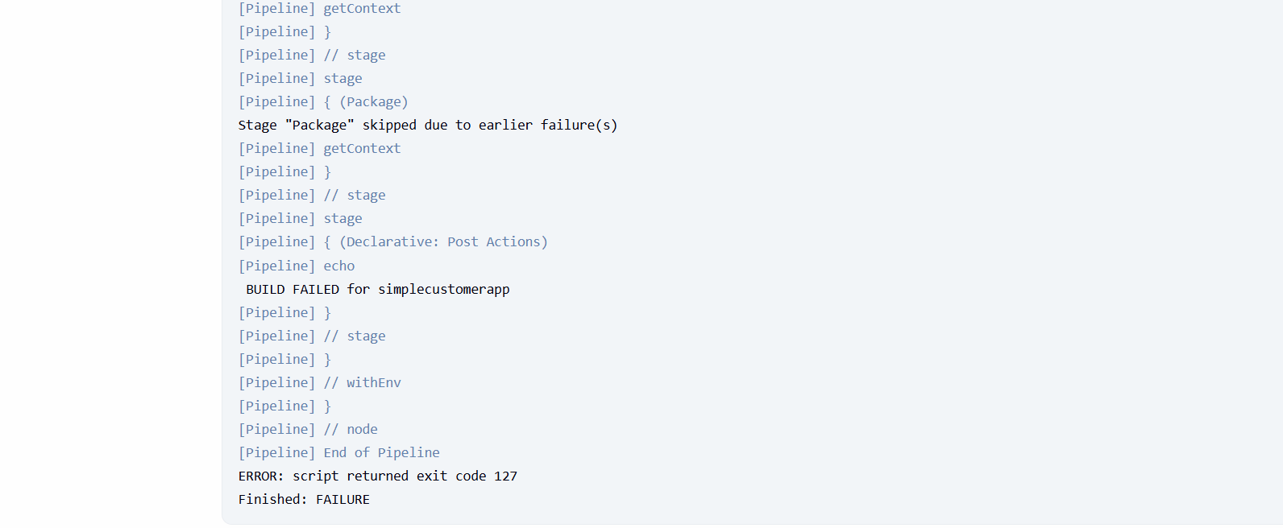
Step 11: Analyze Maven WAR Plugin Error
Console path / UI navigation:
Jenkins_Challenge-2 → Build #2 → Console Output
Explanation:
Detailed Maven logs reveal the root cause of the failure during WAR packaging.
Root cause identified:
Error assembling WAR: webxml attribute is required
(or pre-existing WEB-INF/web.xml)
This indicates that the project is a WAR-packaged application but lacks:
- WEB-INF/web.xml
OR
- Proper Maven WAR plugin configuration to bypass this requirement
Evidence:
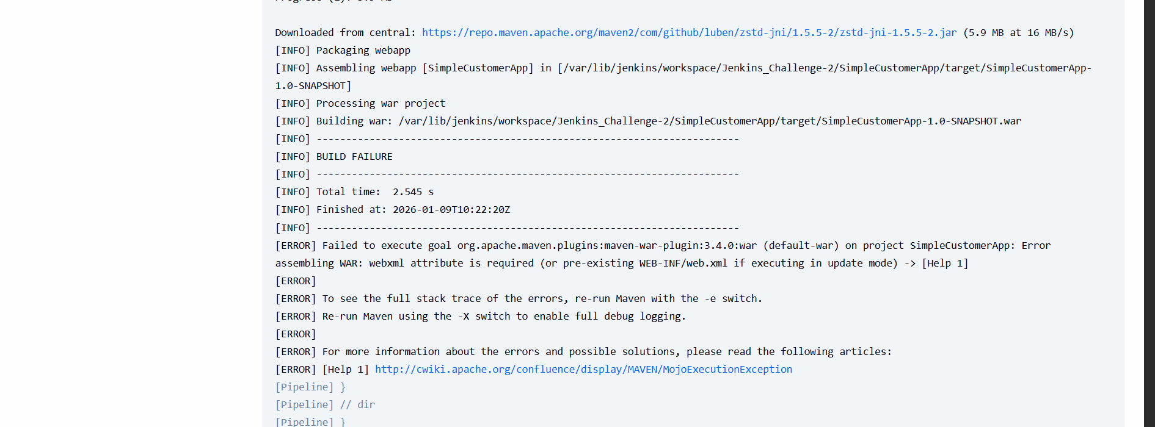Step 12: Verify pom.xml Configuration in Git Repository
Console path / UI navigation:
GitHub → SimpleCustomerApp repository → pom.xml
Explanation:
The pom.xml file is inspected to confirm WAR packaging and plugin configuration.
Findings:
- <packaging>war</packaging> is present
- maven-war-plugin configured with:
- <failOnMissingWebXml>false</failOnMissingWebXml>
This confirms the fix was applied at the source level to allow WAR creation without web.xml.
Evidence:
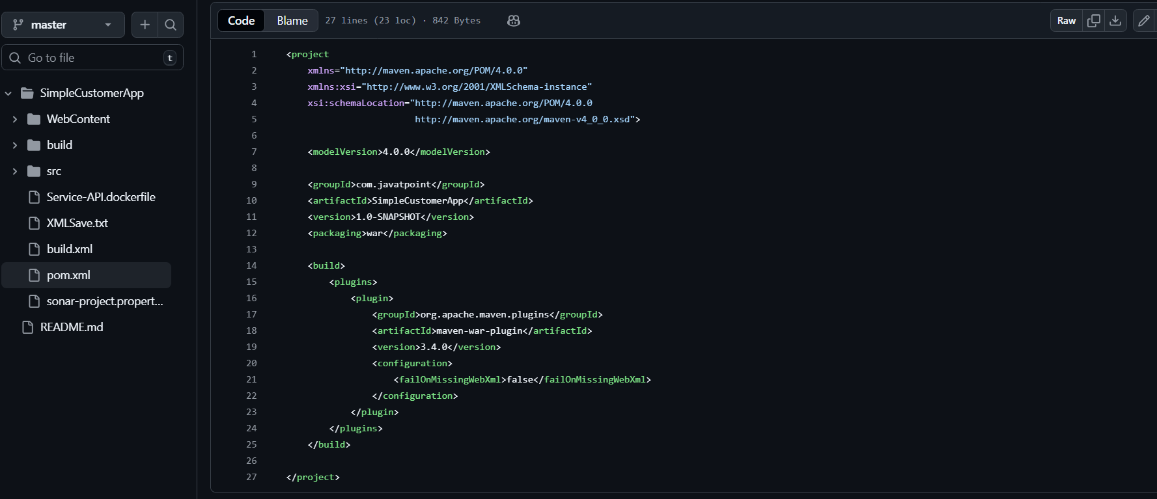
Step 13: Rebuild Pipeline After Fix
Console path / UI navigation:
Jenkins_Challenge-2 → Build with Parameters
Explanation:
Pipeline is re-triggered after validating the Maven configuration fix.
Actions performed:
- BRANCH_NAME: master
- ENV: DEV
- Click Build
Evidence:
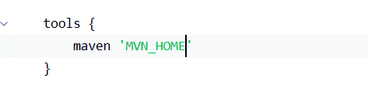
Step 14: Successful Package Stage Execution
Console path / UI navigation:
Jenkins_Challenge-2 → Build #3 → Console Output
Explanation:
Maven successfully generates the WAR artifact during the Package stage.
Successful output observed:
- WAR file created:
- SimpleCustomerApp-1.0-SNAPSHOT.war
- No Maven errors
Evidence:
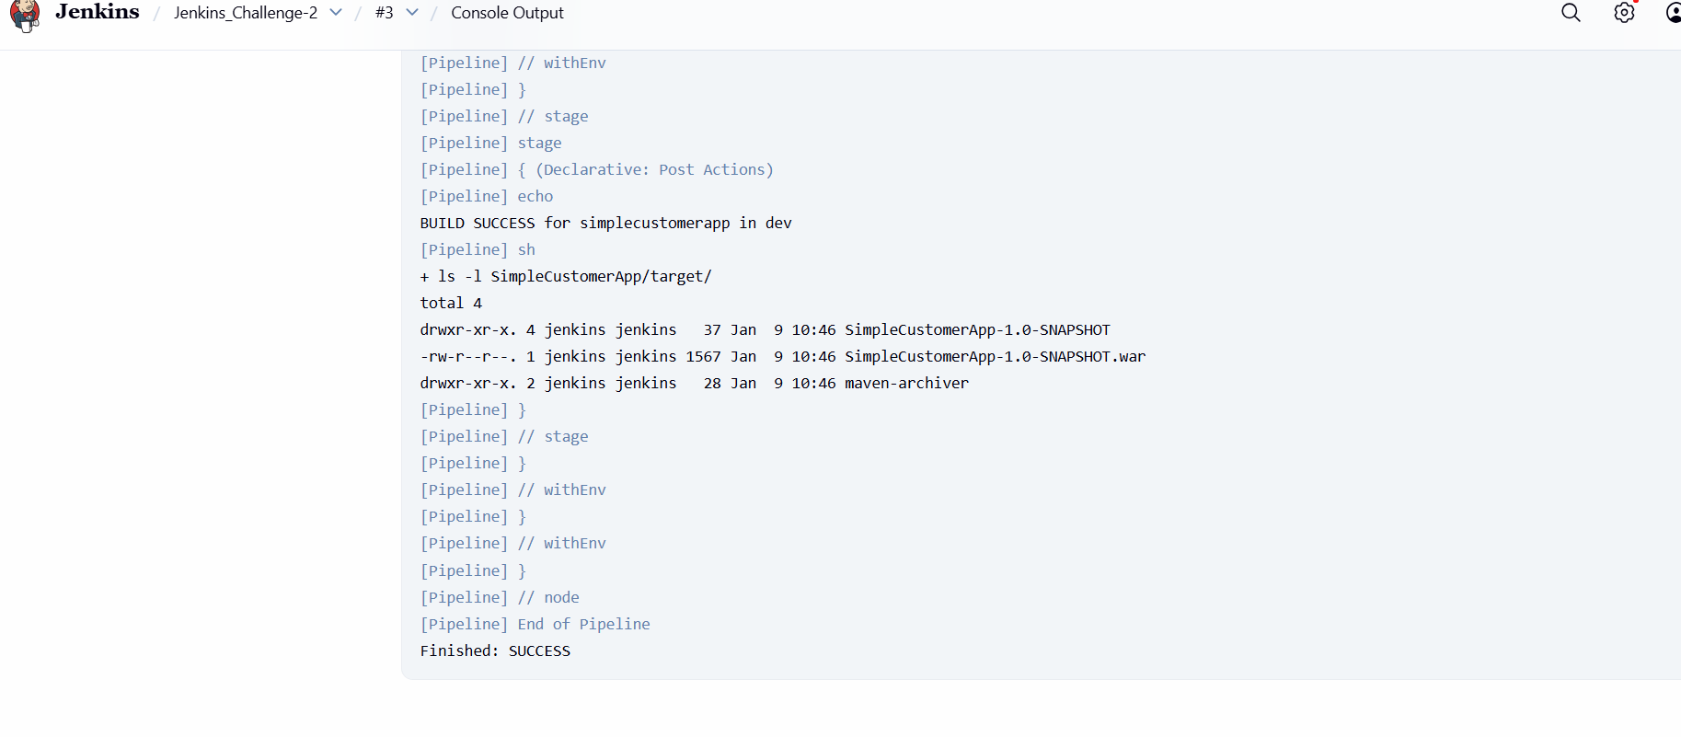
5) Validation Steps (Mandatory, With Evidence)

Verify Post Actions – Success Case
Console path / UI navigation:
Jenkins_Challenge-2 → Build #3 → Console Output / Stage View
Explanation:
Post-success actions execute as expected, printing confirmation messages and listing generated artifacts.
Outputs verified:
- Success message:
- BUILD SUCCESS for simplecustomerapp in dev
- Artifact listing:
- ls -l SimpleCustomerApp/target/
Evidence:
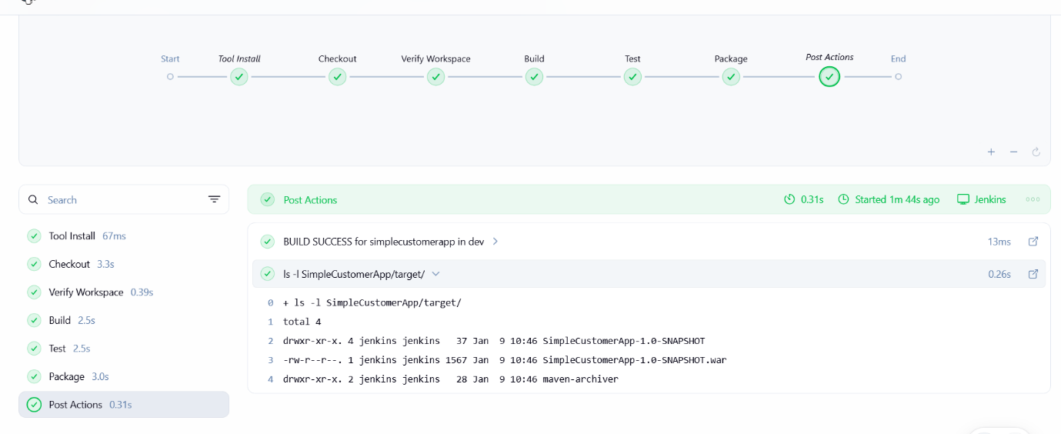

The Following code is generated by the end of the task:
pipeline {
agent any

tools {
maven 'MVN_HOME'
}

parameters {
string(name: 'BRANCH_NAME', defaultValue: 'master')
choice(name: 'ENV', choices: ['dev', 'qa'])
}

environment {
APP_NAME = 'simplecustomerapp'
}

stages {
stage('Checkout') {
steps {
git branch: "${params.BRANCH_NAME}",
url: 'https://github.com/mani-u4444/SimpleCustomerApp.git'
}
}

stage('Verify Workspace') {
steps {
sh '''
pwd
ls -l
echo "---- inside SimpleCustomerApp ----"
cd SimpleCustomerApp
pwd
ls -l
ls -l pom.xml
'''
}
}

stage('Build') {
steps {
dir('SimpleCustomerApp') {
sh 'mvn clean compile'
}
}
}

stage('Test') {
steps {
dir('SimpleCustomerApp') {
sh 'mvn test'
}
}
}

stage('Package') {
steps {
dir('SimpleCustomerApp') {
sh 'mvn package'
}
}
}
}

post {
success {
echo "BUILD SUCCESS for ${APP_NAME} in ${params.ENV}"
sh 'ls -l SimpleCustomerApp/target/'
}
failure {
echo "BUILD FAILED for ${APP_NAME}"
}
}
}

6) Issues Faced (Optional)
Issue 1: Maven WAR Packaging Failure
Problem:
Pipeline failed during the Package stage with the error:
Error assembling WAR: webxml attribute is required
Root Cause:
The application was packaged as a WAR but did not contain a WEB-INF/web.xml file, and Maven WAR plugin enforcement was enabled by default.
Resolution:
Updated pom.xml to include:
<failOnMissingWebXml>false</failOnMissingWebXml>
Outcome:
WAR file was successfully generated in subsequent builds.

Issue 2: Command Not Found (Exit Code 127)
Problem:
Pipeline returned:
ERROR: script returned exit code 127
Root Cause:
Maven was not correctly resolved in the pipeline execution environment initially.
Resolution:
Configured Maven in Jenkins Global Tool Configuration and referenced it using:
tools {
maven 'MVN_HOME'
}
Outcome:
Build executed successfully.

7) Conclusion
This task successfully demonstrated the implementation of a declarative, parameterized Jenkins pipeline for a Maven-based Java application.

