A.P.J.ABDUL KALAM BIRTH, BIOGRAPHY, FULL NAME, AWARDS, DEATH.

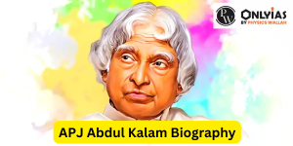

A.P.J.ABDUL KALAM BIOGRAPHY :

Dr. Avul Pakir Jainulabeem Abdul kalam, popularly known as APJ Abdul Kalam, was an extraordinary scientist, visionary leader, and one of India’s most beloved personalities. Born on October 15, 1931, in Rameswaram, Tamil Nadu, Dr. Kalam’s life journey serves as an inspiration to millions around the globe. From humble beginnings to becoming the 11th President of India, his story exemplifies the powee of perservencs, knowledge, and a deep-rooted love for his country.

Kalam’s journey to become one of the India’s most beloved and repected figures started with a modest upbringing. He hailed from a simple family and faced numerous challenges in hi early life. However , he had a strong desire for knowledge and an insatiable curiosity about science and technology.

A.P.J. Abdul kalam Birth :

AVUL PAKIR JAINULABDEEN ABDUL KALAM was born to a Tamil Muslim family on October 15, 1931, in the piligrimage town of Rameshwaram on Pamban Island, which formerly part of the madras presidency and is now a state of Tamil nadu.

APJ Abdul kalam Full Name:

BD