ASSIGNMENT – 10

NAGA MANIKANTA CHIGURUPATI

S555681

1.Screen shot 4 of the index page on the local server

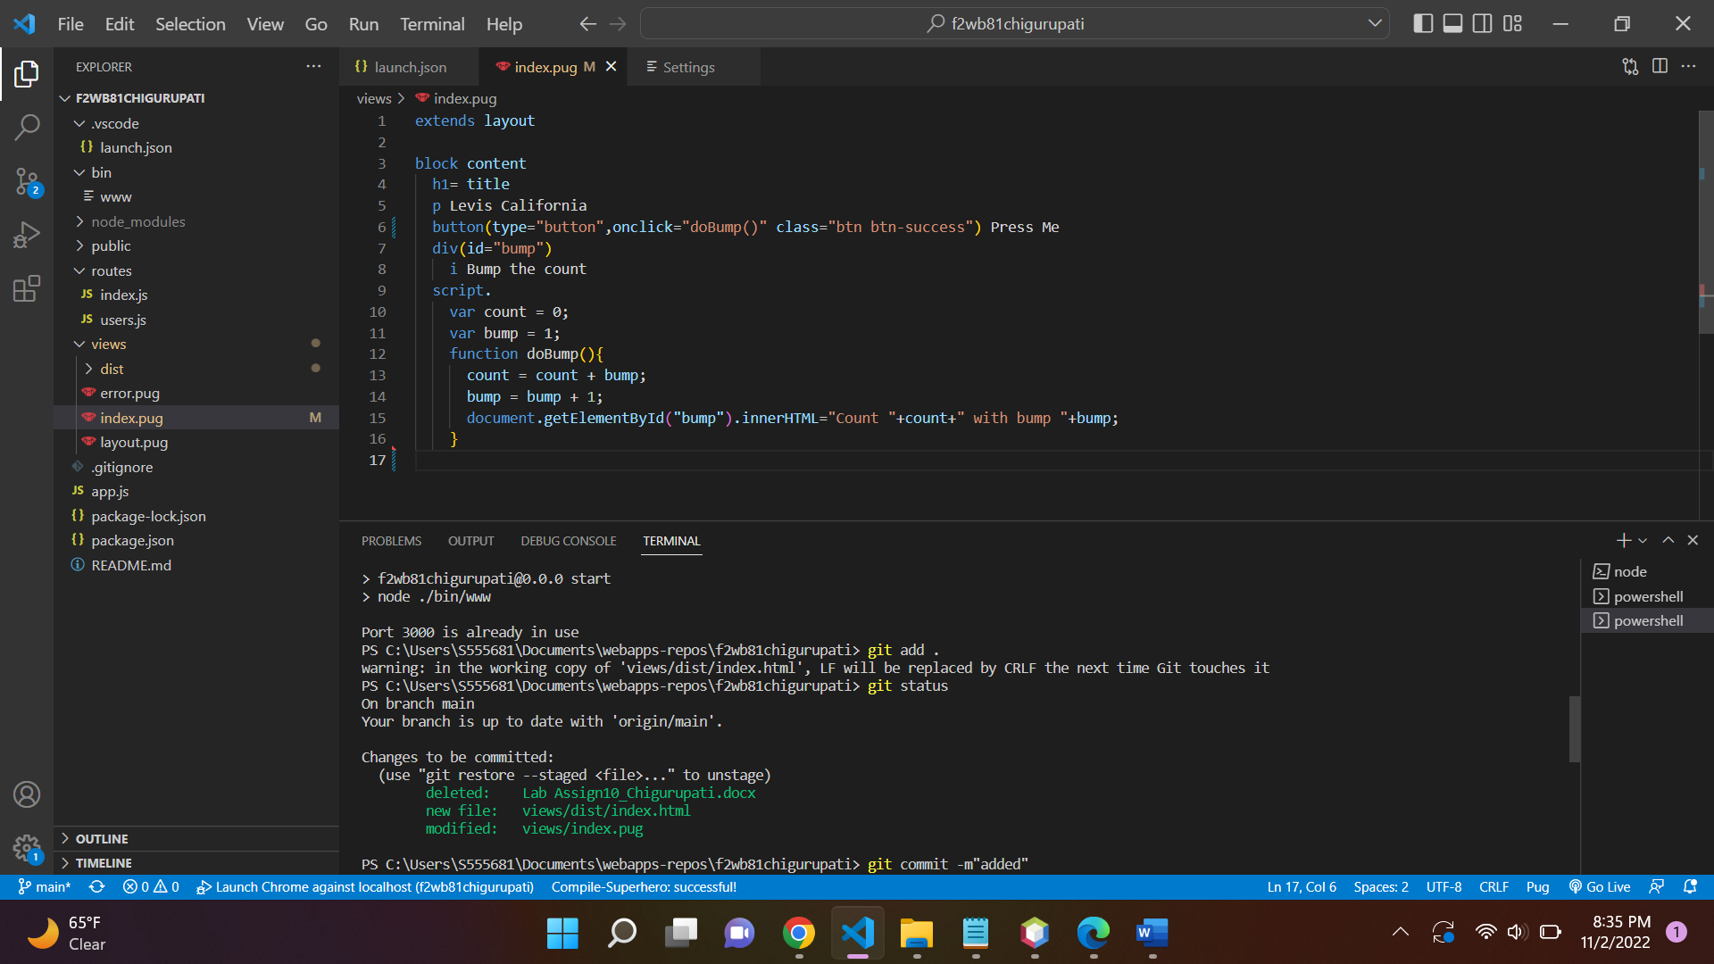

2.Screen shot 5 of your “search results” page on the local server.

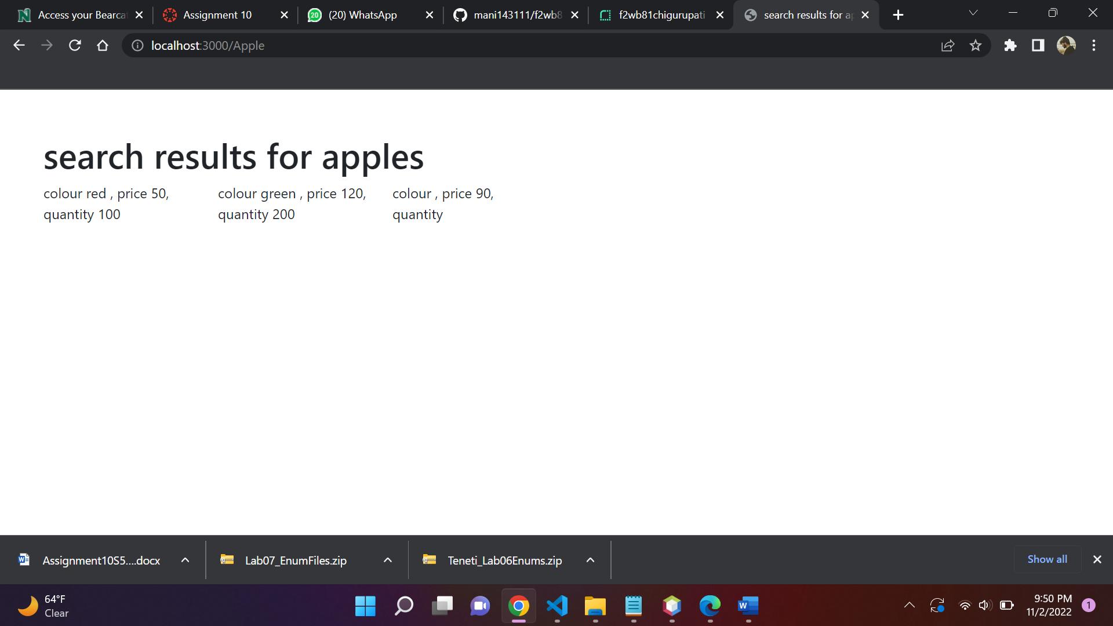

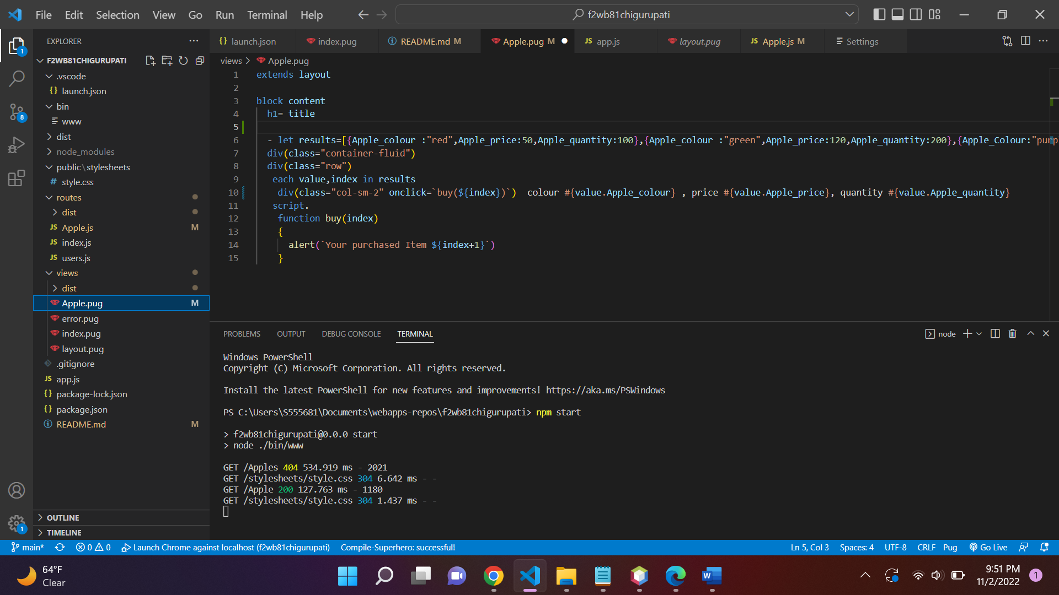

3. Screen shot 6 of your gridbuild page on the local server

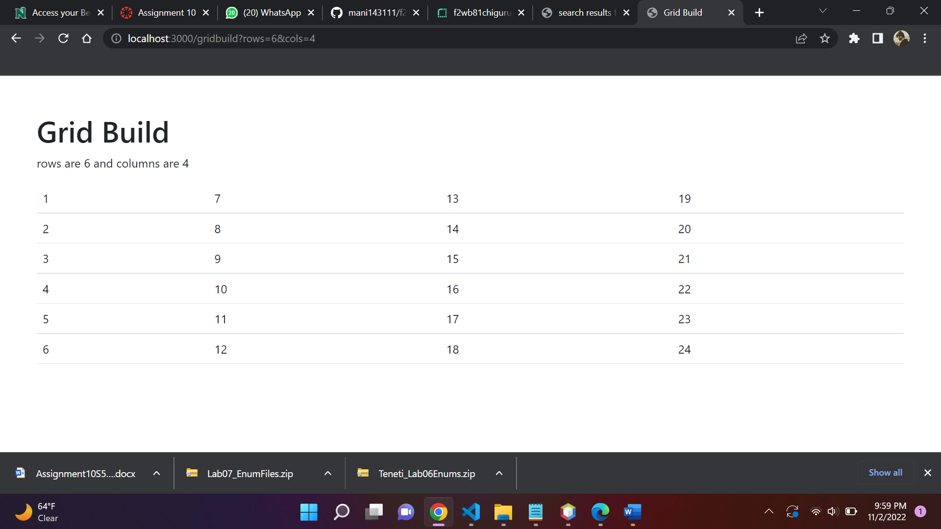

4.Screen shot 7 of your selector page on the local server.

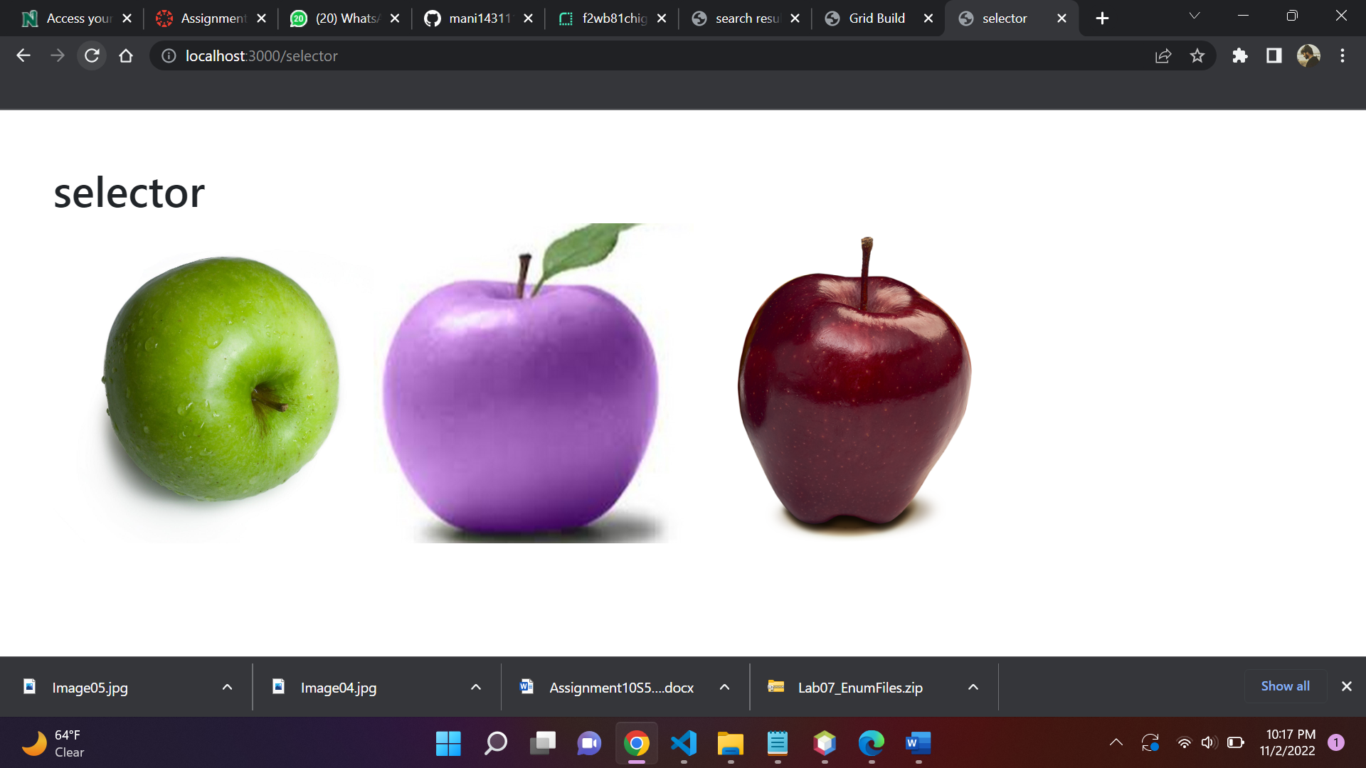

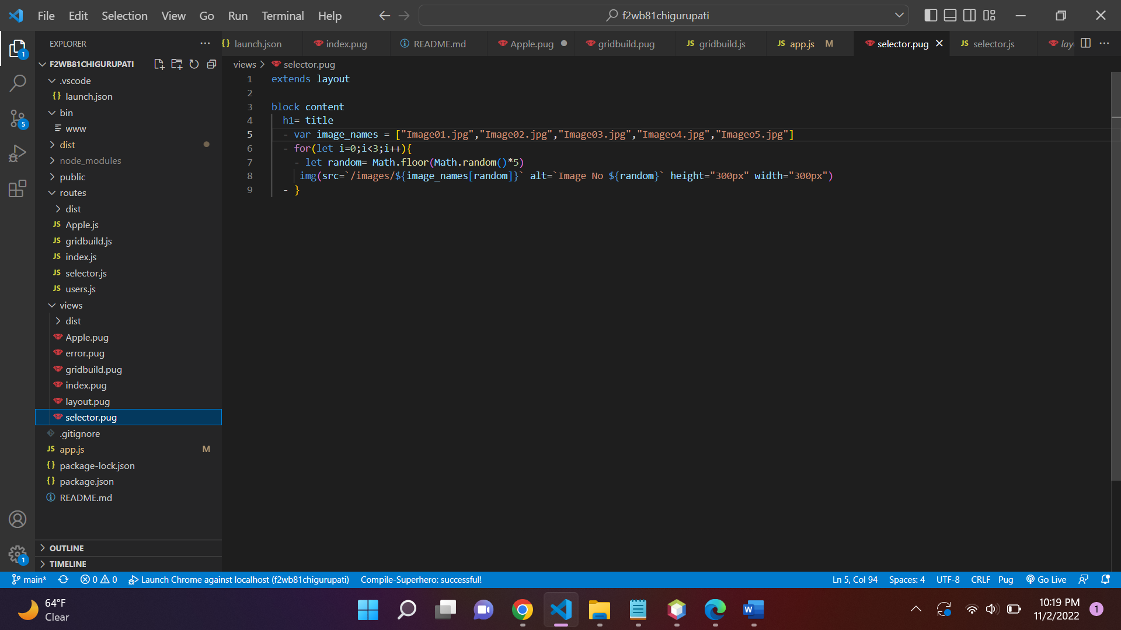

BONUS :

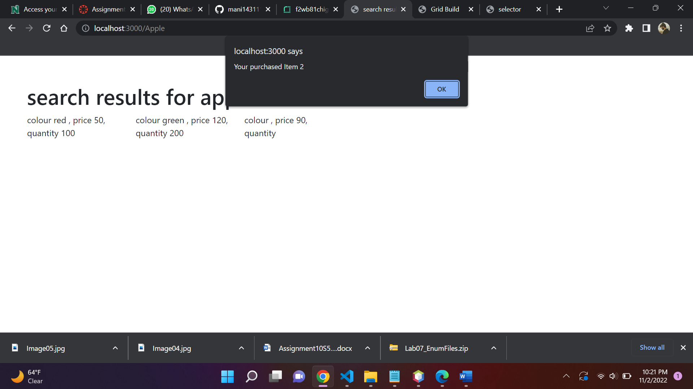

Render link : <https://f2wb81chigurupati.onrender.com>

Repo link : <https://github.com/mani143111/f2wb81chigurupati>