Use Case Specification

DMT/RM01/TMP

|  |  |
| --- | --- |
| Project Code | **PRJ_eClassroom_001** |
| Project Name | **eClassroom** |

|  |  |  |
| --- | --- | --- |
| Prepared/Modified by | Role | Date of Preparation |
| **Abishek Suresh** | **Test Engineer** | **27th October, 2017** |
| Reviewed by | Role | Date of Review |
|  |  |  |
| Approved by | Role | Date of Approval |
|  |  |  |
| Circulation List |  | Version Number of the template: **1.1** |
| Version Number | **1.1** |  |

<<Customer>> REVIEW HISTORY

<<Customer comments on the Use case along with the signed off is tracked here>>

|  |  |  |  |  |  |  |
| --- | --- | --- | --- | --- | --- | --- |
| Version | 1.1 |  |  |  |  |  |
| Date | <<Date of Review>> |  |  |  |  |  |
| Reviewed by | << Reviewer Name>> |  |  |  |  |  |
| Reviewed UI Specification doc | << Whether UI Specification doc is reviewed >> |  |  |  |  |  |
| All Open Queries/issues closed | << Whether all the open queries and issues resolved>> |  |  |  |  |  |
| Agreement on Assumptions | <<Whether all the assumptions have been agreed upon by the customer>> |  |  |  |  |  |
| Sign Off | <<Signature>> |  |  |  |  |  |

Disclaimer:

The scope of the project ‘**eClassroom’** is restricted to the contents of this signed off use case.

TABLE OF CONTENTS

1. Use Case Name: Login to the eClassroom 5

2. Actor(s) 5

3. Preconditions 5

4. Flow of Events 5

4.1 Basic Flow 5

4.2 Alternative Flows 5

4.2.1 Alternate Flow 1: Login to eClassroom on Second attempt and successful updation of User Profile 5

4.2.2 Alternate Flow 2 : Login to eClassroom and user updates correct Profile details on Second attempt 6

Exception Flow 1: Exceeded Login Attempts 6

Exception Flow 2: Web Server Down 6

Exception Flow 3: Database Connectivity Error 6

Exception Flow 4: Network Connectivity Error 7

5. Post Conditions 7

6. Special Requirements 8

Performance 8

Availability 8

User Interface 8

Security 8

7. Extension Points 8

Extension in Alternate Flow 1: 8

8. Business Rules 8

9. Diagrams 9

Use Case Diagram for 9

10. Scenarios 10

Success Scenarios 10

Failure Scenarios 10

11. Issues 10

12. UI Specifications 10

13. Inter System Dependencies 10

14. Integration with an already existing System of the <<Customer>> 10

15. Assumptions 11

1. Use Case Name: Login to E ClassRoom

**Use Case ID:**  USER.PROFILE.EC_001

**Brief Description:** This Use Case describes the process by which the employees login to E class room

System and update their profile

1. Actor(s)

Employee (User)

1. Preconditions
2. The url is loaded and the website is working correctly
3. User is the employee of the company
4. User has valid employee ID
5. User’s login and password for the first login is his/her employee ID
6. Flow of Events

4.1 Basic Flow

Name: Login to eClassroom and successfull updation of user profile.

1. User clicks on the **Login** link of the eClassroom home page.
2. The system displays **Login** page
3. User enters **Username**
4. User enters **Password**
5. User clicks on the **Login** button
6. The system validates **Username** & **Password**
7. The system navigates user to the **Dashboard**
8. User clicks on my profile option
9. System opens the Profile Updation page
10. User updates the password.
11. User enters the First name
12. User enters the last name
13. User enters the email
14. User enters the display name
15. User selects the timezone
16. User enters the M.I.
17. User enters the Optional Informations (Phone,Employee Id, Title, Affirmation)
18. User clicks on Submit
19. System displays that profile updation is successful.
    1. Alternative Flows
       1. Alternate Flow 1:

Name: login to E ClassROOM on second attempt AND Successfull updation OF USER profile

1. User clicks on the **Login** link on the eClassroom home page
2. The system displays Login page
3. User enters Username
4. User enters Password
5. User clicks on the Login button
6. The system validates Username & Password
7. The system validation fails due to invalid user credentials
8. The system propmts the user to re-enter the username and password
9. The step 3 of Basic flow is followed.

* + 1. Alternate Flow 2 :

Name: Login to e classROOM and user updates CORRECT profile details ON SECOND ATTEMPT

1. User clicks on the **Login** link on the eClassroom home page.
2. The system displays **Login** page
3. User enters **Username**
4. User enters **Password**
5. User clicks on the **Login** button
6. The system validates **Username** & **Password**
7. The system navigates user to the **Dashboard**
8. User clicks on the my profile
9. System opens the Profile Updation page
10. User enters the login and new password.
11. User retypes the incorrect new password
12. User enters the First name
13. User enters the last name
14. User enter the incorrect email
15. User enters the display name
16. User selects the timezone
17. User enters the M.I.
18. User enters the Optional Informations (Phone, Employee Id, Title, Affirmation)
19. User clicks on Submit
20. System prompts the user that password doesn’t match and email address is incorrect
21. User fills the details correctly
22. System displays that profile updation is successful.

Exception Flow 1:

Name: Exceeded Login Attempts

1. User clicks on the **Login** link on the eClassroom home page
2. The system displays **Login** page
3. User enters **Username**
4. User enters **Password**
5. User clicks on the **Login** button
6. The system validates **Username** & **Password** for 3rd time.
7. The system validation fails due to invalid user credentials and no more login attempts remaining
8. The system temporarily blocks the user account
9. The system informs the user’s account has been temporarily blocked.

Exception Flow 2:

name: Web Server Down

1. User clicks on the **Login** link on the eClassroom home page
2. The system displays an error message regarding web server unavailability problem

Exception Flow 3:

Name: Database Connectivity Error

1. User clicks on the **Login** link on the eClassroom home page.
2. The system displays **Login** page.
3. User enters **Username**
4. User enters **Password**
5. User clicks on the **Login** button
6. The system validates **Username** & **Password**
7. The system displays an error message regarding database connectivity problem.

Exception Flow 4:

Name: Network Connectivity Error

1. User clicks on the **Login** link on the eClassroom home page.
2. The system displays **Login** page.
3. User enters **Username**
4. User enters **Password**
5. User clicks on the **Login** button
6. The system validates **Username** & **Password**
7. The system displays an error message regarding network connectivity problem.
8. Post Conditions

| Flow Name | Post Condition |
| --- | --- |
| Login to eClassroom and successful updation of user profile. | User will be logged in to the eClassroom successfully and system should navigate user to the dashboard and user updates the profile successfully. |
| Login to eClassroom on Second attempt and successful updation of User Profile | User will be logged in to the e class room successfully and system should navigate user to the dashboard and user updates the profile successfully. |
| Login to eClassroom and user updates correct Profile details on Second attempt | User will be logged in to the eClassroom successfully and system should navigate user to the dashboard and user updates the profile successfully. |
| Exceeded Login Attempts | The system should suspend the user account and should inform the user that his/her account has been blocked. |
| Web Server Down | The system should display an error message to the user regarding web server unavailability problem. |
| Database Connectivity Error | The system should display an error message to the user regarding the database connectivity problem. |
| Network Connectivity Error | The system should display an error message to the user regarding the network connectivity problem. |

1. Special Requirements

Performance

1. The Ok button of login when clicked shall display the Dashboard page within 5 seconds of user request

Availability

* 1. The Employees can update profile on working days 24x7 but cannot register on national holidays.

User Interface

* 1. The Labels of the form shall be bold
  2. All the by drop down menus should have a default option
  3. Mandatory fields should be marked by astricks
  4. The logout and back button should be available on every page of the application

Security

1. Remember my Credentials option should save username and password in html cookies.
2. The eClassroom will allow the user to Cancel the application at any point.
3. Extension Points

Extension in Alternate Flow 1:

In step 7, if the employee has entered wrong user credentials :

1. The system prompts the user to re-enter the credentials

2. User enters the username and password

3. The system takes user to the **Step 3** of **Basic Flow**

1. Business Rules

| Business Rule Name | Business Rule Description | System action (if BR fails) |
| --- | --- | --- |
| BR01 | User must be valid | User is prompted to re-enter the login credentials |
| BR02 | Required Fields on the my profile  Page should be filled | Displays error message “Please fill the required fields” |
| BR03 | Password should be of correct pattern | Display error message ”Enter the password in prescribed format” |

1. Diagrams

Use Case Diagram for

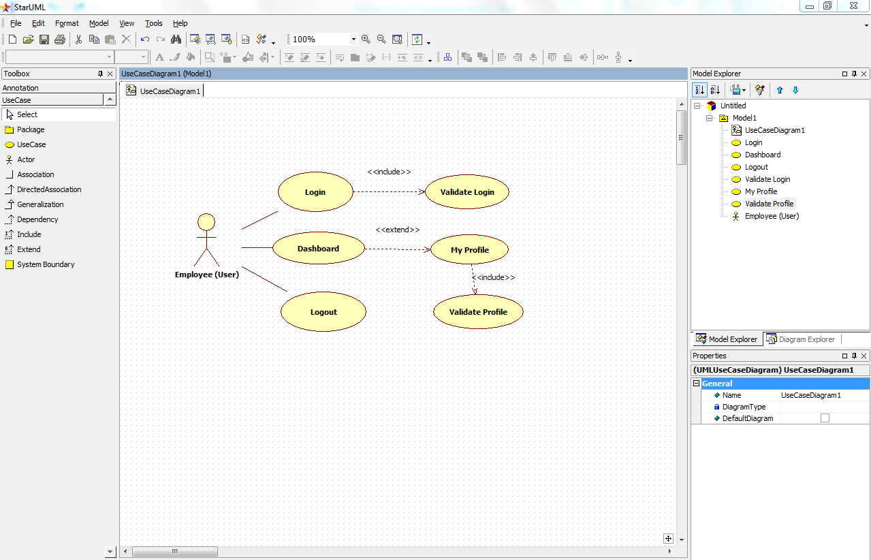

1. Scenarios

Success Scenarios

* Login to eClassroom and successfull updation of user profile.
* Login to eClassroom on second attempt and successfull updation of user profile
* Login to eClassroom and user updates correct Profile details on Second attempt

Failure Scenarios

* Exceeded Login Attempts
* Web Server Down
* Database Connectivity Error
* Network Connectivity Error

1. Issues

* What is the maximum size of username and password ?
* What if the user is blocked after invalid login attempts after three times ?

1. UI Specifications

<< Provide a link to the UI specification document of the Use case. Please don’t embed the document here>>

1. Inter System Dependencies

**Module: ‘Dashboard**’ gets impacted due to :

Use case name: Alternate Flow 1

**Impact**: If the user tries to update profile without login, he should be denied to do so.

1. Integration with an already existing System of the <<Customer>>

*<< This is especially applicable if the project at hand is an enhancement to an existing system.>>*

1. Assumptions

*<< List down all the assumptions considered by this use case>>*

1. The User should be authenticate.
2. User should know the valid URL of the eClassroom website.
3. User should have Google chrome browser for best view of site.

REVISION HISTORY OF THE WORK PRODUCT

<to be maintained by projects>

|  |  |  |  |  |  |
| --- | --- | --- | --- | --- | --- |
| # | Date | Version # | Section Changed | Details of changes made | Approved By |
| 1 |  |  |  |  |  |
| 2 |  |  |  |  |  |