4. Prepare a Jenkins pipeline job (DSL / groovy script) to satisfy following CI-Cd pipeline :

* Send approval email to Release Manager after the application packaging phase

Trigger the Jenkins job on reception of the approval email for the above job

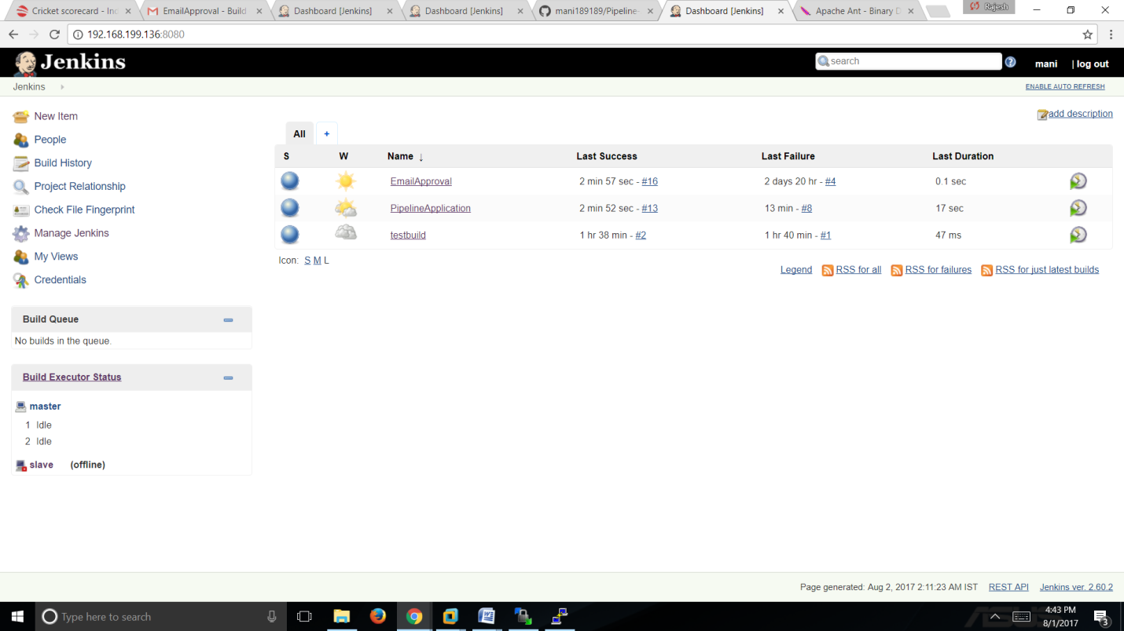

Pipeline for Application Packaging

Configuring Pipeline :

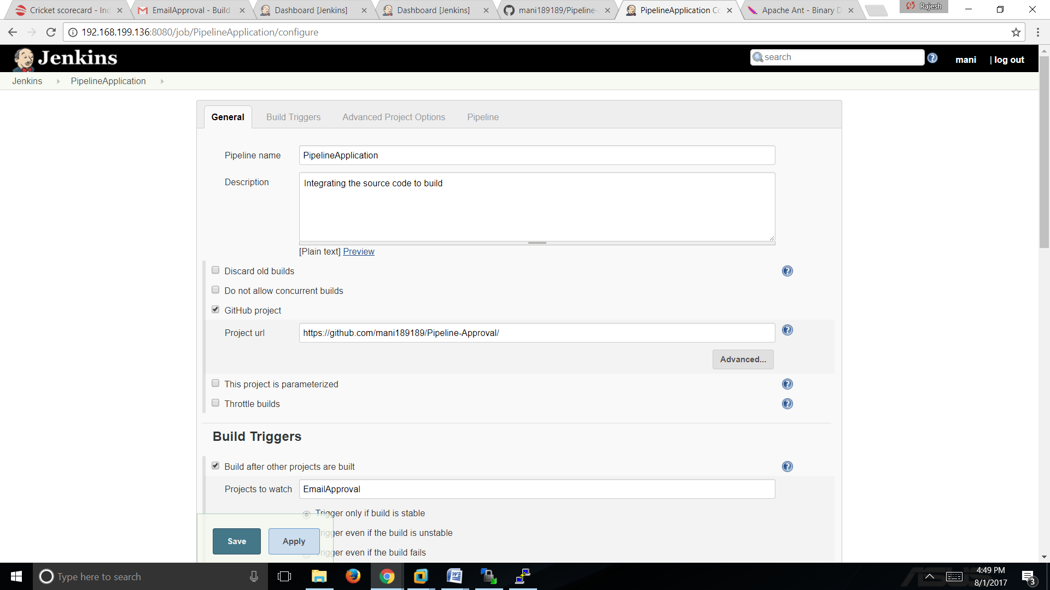

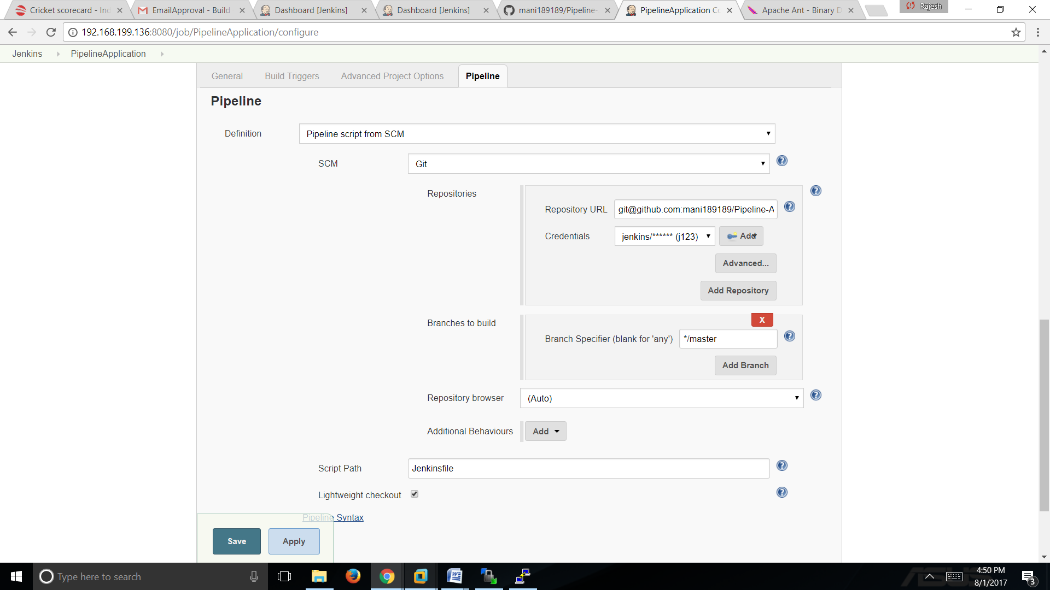

Now Apply and save the file

Configuring EmailApproval :

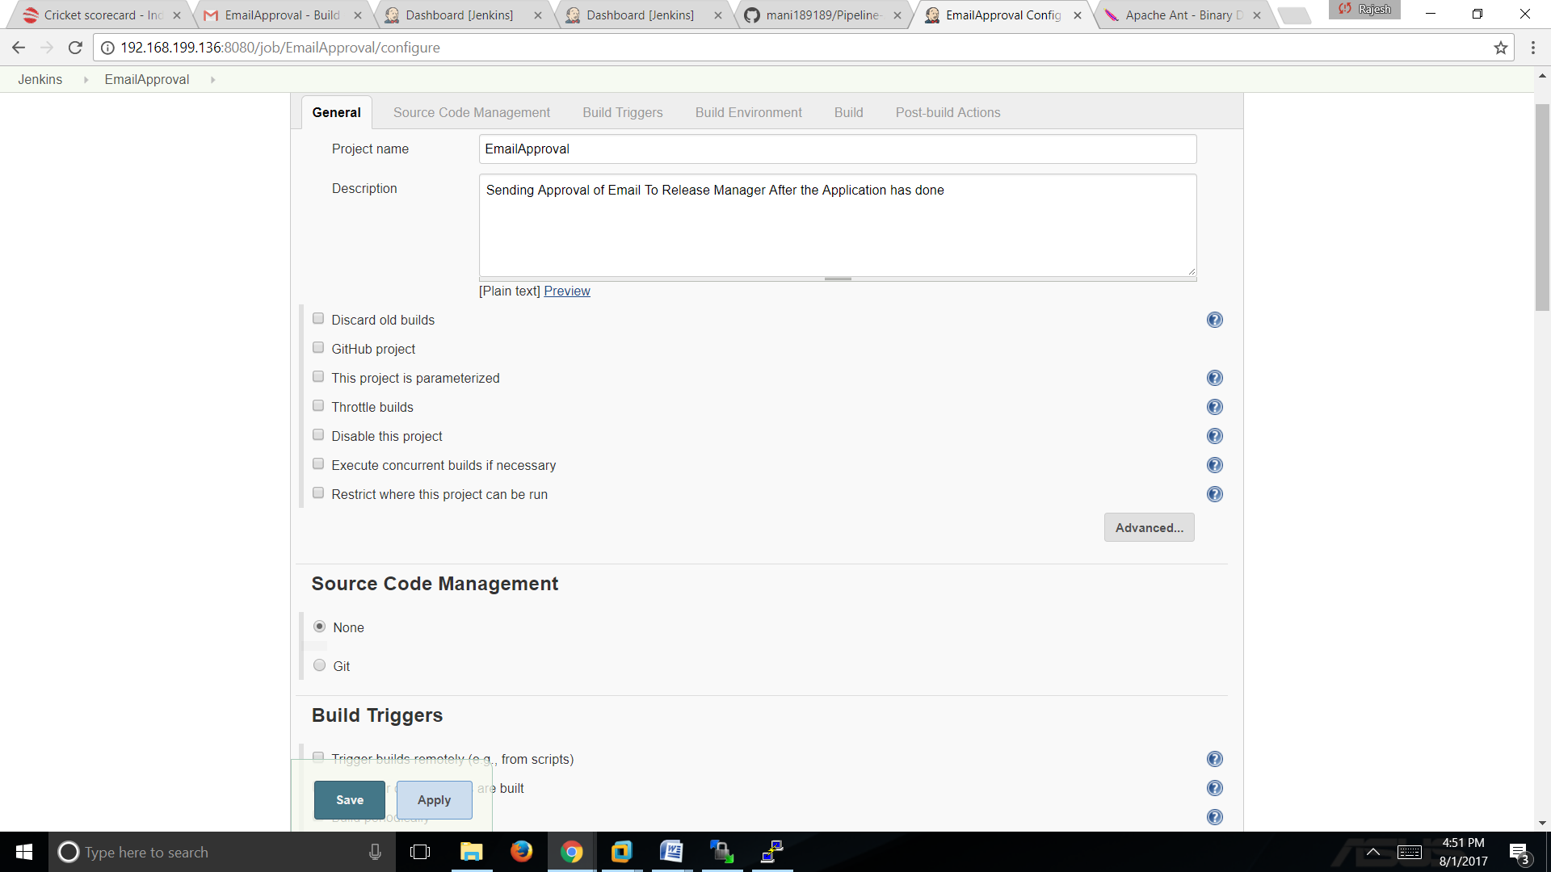

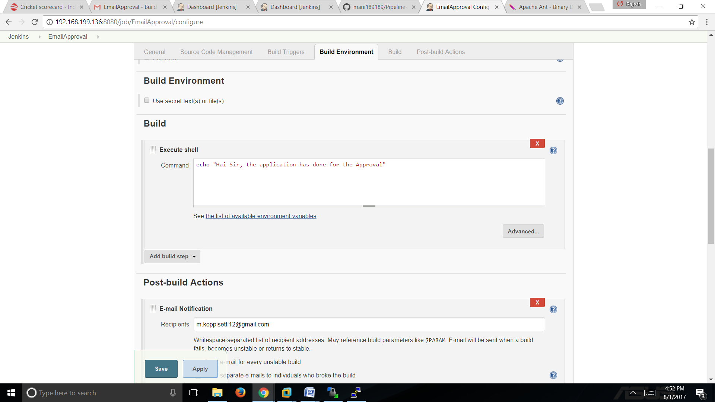

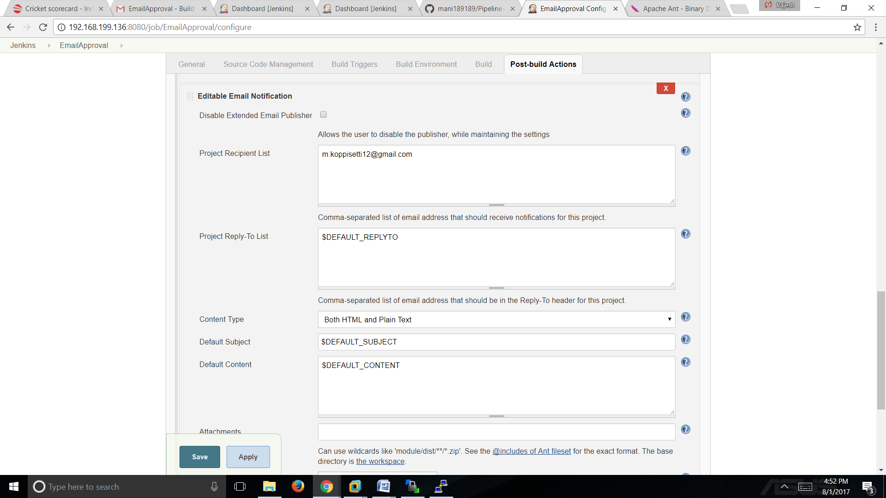

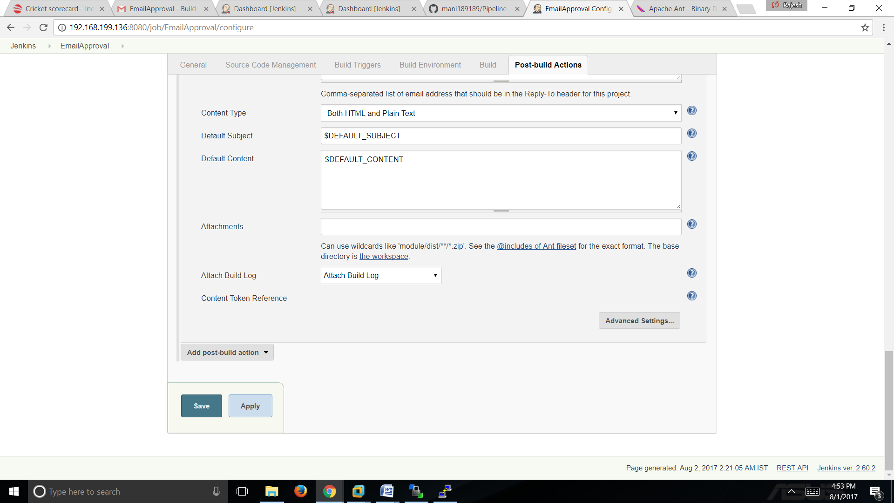

Now Apply and Save

Before This we have to configure Email SMTP Server in the ManageJenkins>>"configure Sytem"

Now Build the Email Approval after that build sucessfull it triggers the pipelinejob to execute :

EmailApproval Success Build :

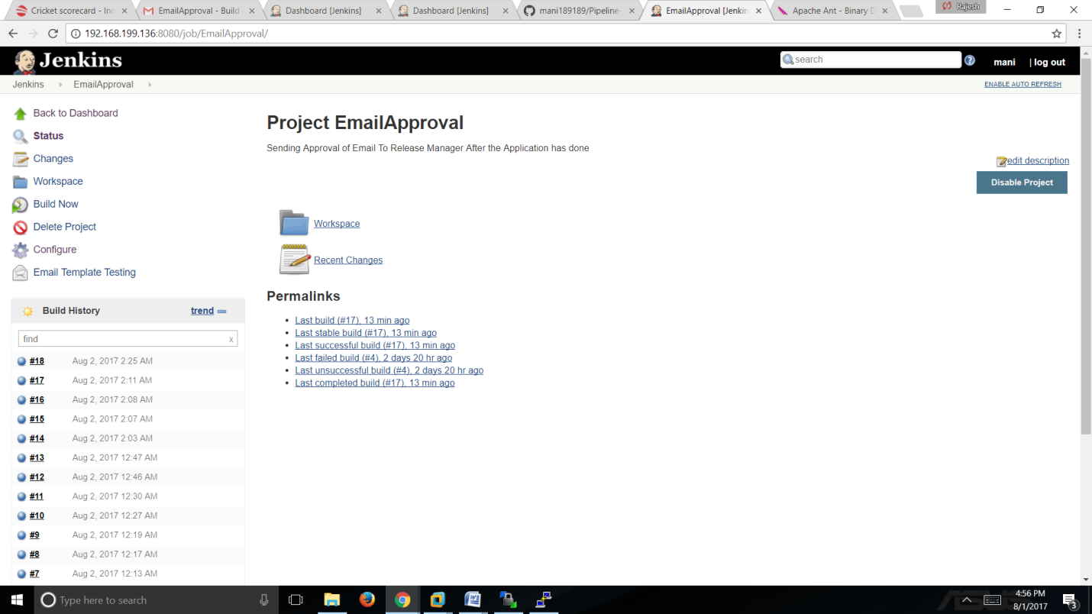

Trigger Job PipelineApplication Success Build :

deliver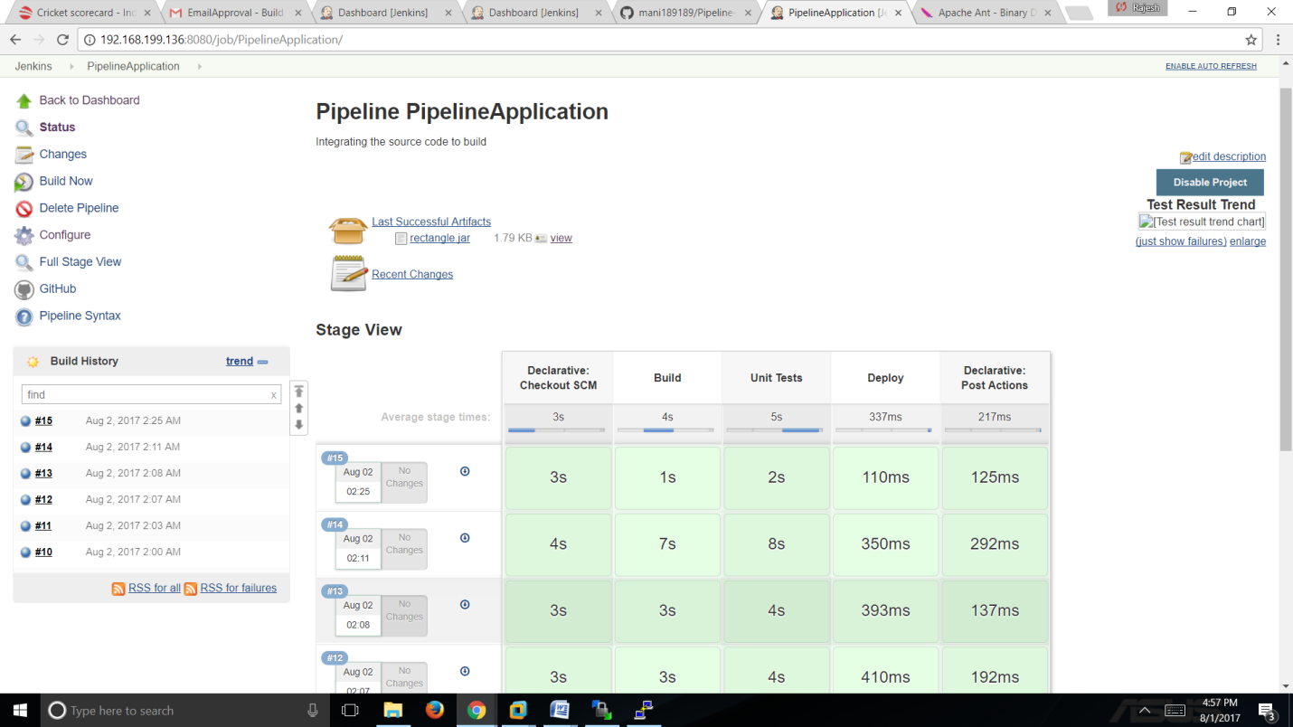

Delivered Email Successfull build Message :

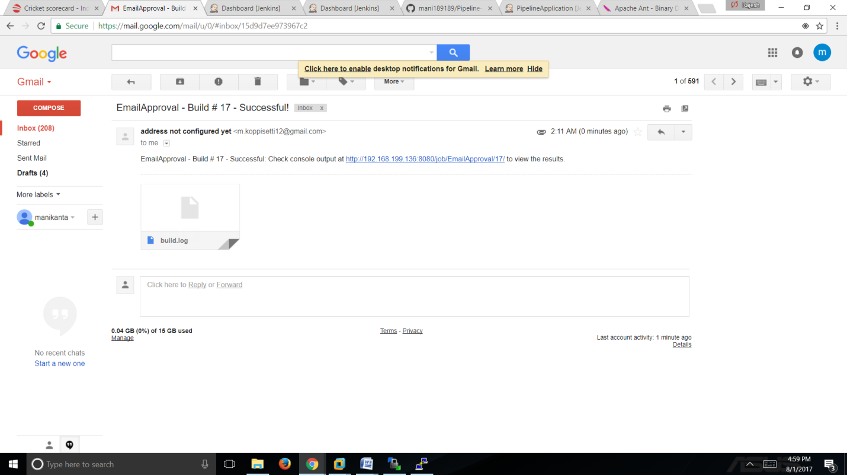

submitting Remaining Jenkinsfile,Source code through github url

thanking you sir/madam