1.PIN GENERATOR:

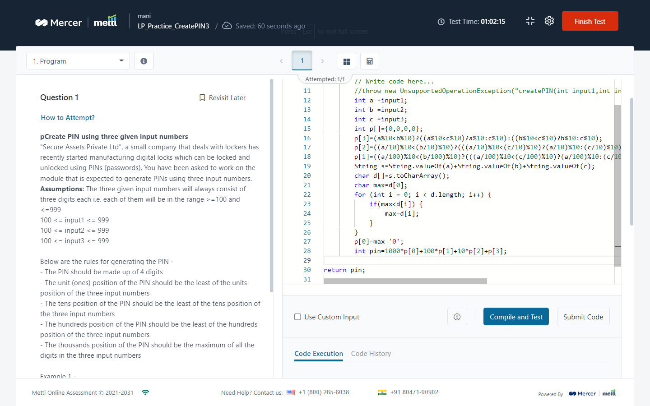

2.WEIGHT OF HILL PATTERN: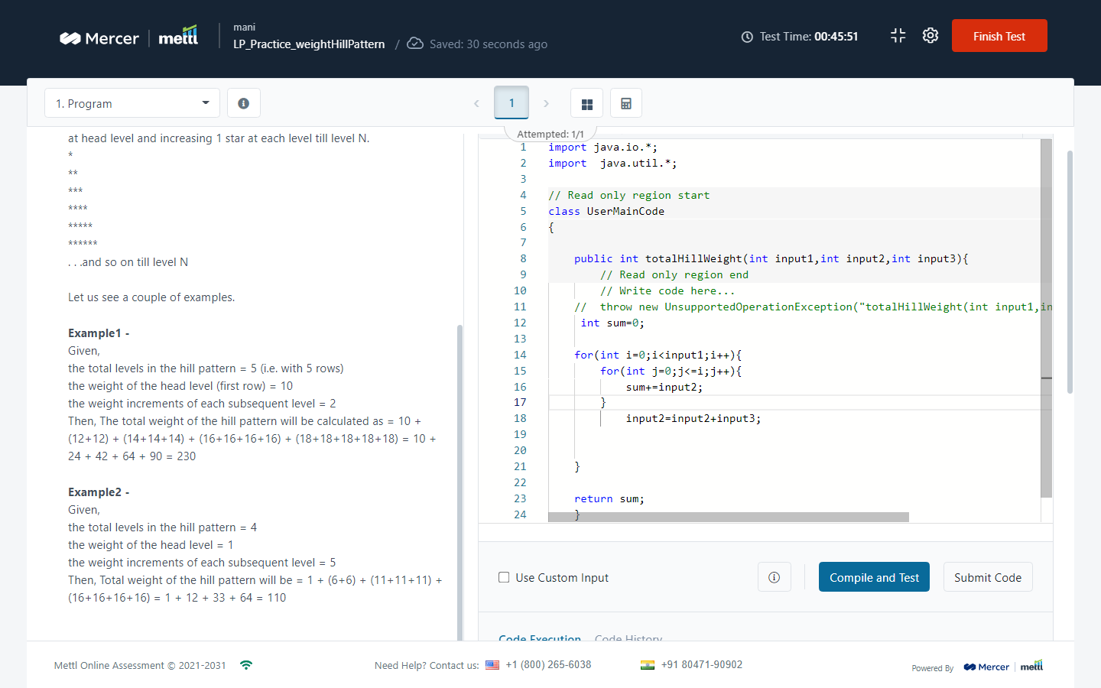

3.CHANGE SECOND WORD TO UPPERCASE :

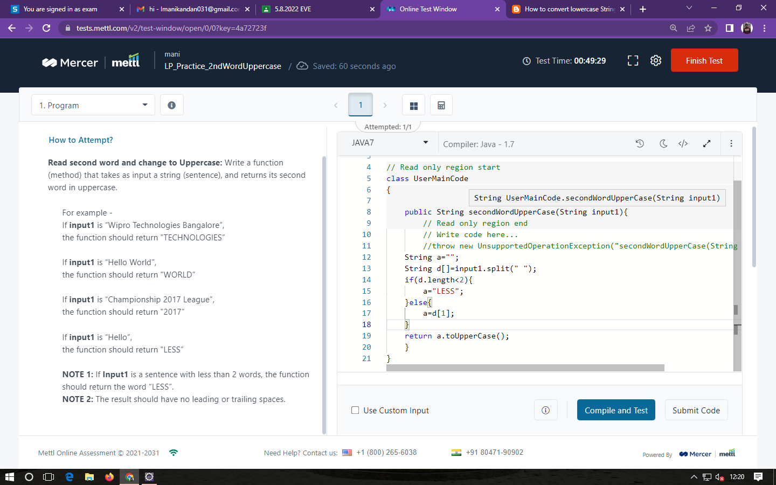

4.PALINDROME:

