**Bio-Data**

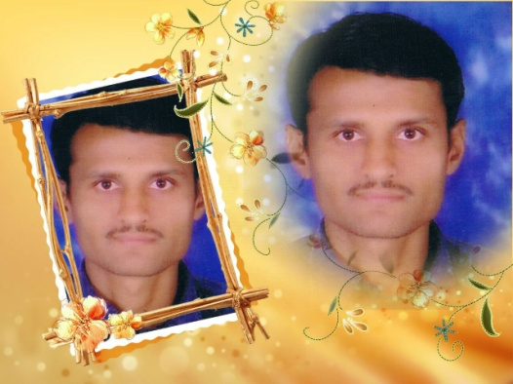

* **Name:** Rasikbhai Karshanbhai Bhalani
* **Date Of Birth:** 16/10/1978
* **Work At:** Own Diamond Factory
* **Marital Status:** Divorsed
* **Study:** 9 Pass
* **Language Known:** Gujrati , hindi, English
* **Permanent Address:**

To, Kalyanpur.

Near Primary school,

Ta- Vallbhipur , Dist- Bhavnagar

* **Contact No:** 9904267144
* **Email –** [rkbhalani1610@gmail.com](mailto:rkbhalani1610@gmail.com)
* **Family Details:**
* **Father :** Karshanbhai Thakarsibhai Bhalani
* **Mother :** Devkuvarben Karshanbhai Bhalani
* **Brother:** Vineshbhai karshanbhai Bhalani **(married)**
* **Maternal Detail (Village:** Rajpara**):**
* **Uncle:** Kalubhai Ranchhodbhai Jivani
* **Uncle:** Rameshbhai Ranchhodbhai Jivani
* **Uncle:** Sureshbhau Ranchodbhai Jivani