**Tasks:**

# 1. Industry Identification:

**Healthcare Industry:**

* **Enhanced Care Access:** Artificial Intelligence can improve health care access, particularly for people living in rural places, by utilizing virtual health assistants and telemedicine.
* **Diagnostic Accuracy:** AI systems are sometimes even more accurate than human experts in diagnosing diseases from medical imagery.
* **Personalized medicine:** By using AI to evaluate large datasets, medical professionals can better treat patients by customizing regimens based on their unique genetic profiles.
* **Operational Efficiency:** AI might enhance hospital operations by streamlining everything from supply chain management to appointment scheduling, which lowers costs and enhances patient care.
* **Research and Drug Development:** Artificial Intelligence can expedite the process of finding new drugs by examining intricate molecular connections faster than conventional techniques.

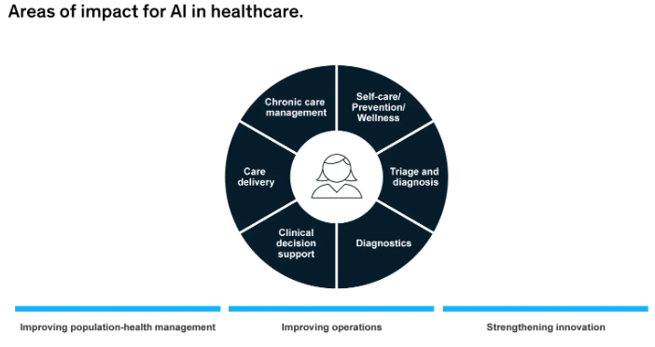

**Retail Industry:**

* **Customer Experience:** By evaluating consumer behavior and preferences, AI can tailor purchasing experiences, resulting in higher levels of happiness and loyalty.
* **Inventory management:** AI has the ability to optimize stock levels, forecast demand more precisely, and cut waste—all of which are critical for retail operations.
* **Supply Chain Optimization:** Through automated logistics and disruption prediction, artificial intelligence may improve supply chain efficiency.
* **Loss Prevention:** AI may support merchants by identifying and stopping shoplifting and fraud, protecting their profits.
* **Sustainability:** AI can optimize energy consumption in stores and cut waste, both of which are environmentally beneficial activities.

Technology breakthroughs and shifting customer expectations are causing both industries to change quickly. While the focus in retail is on improving customer experience and operational efficiency, there is a rising demand in healthcare for more effective and efficient care delivery. With the ability to use data analytics and machine learning to spur innovation and advancement in both fields, OpenAI apps are ideally suited to meet these demands.

# 2. SWOT Analysis: Perform a SWOT analysis specifically for 2 OpenAI applications

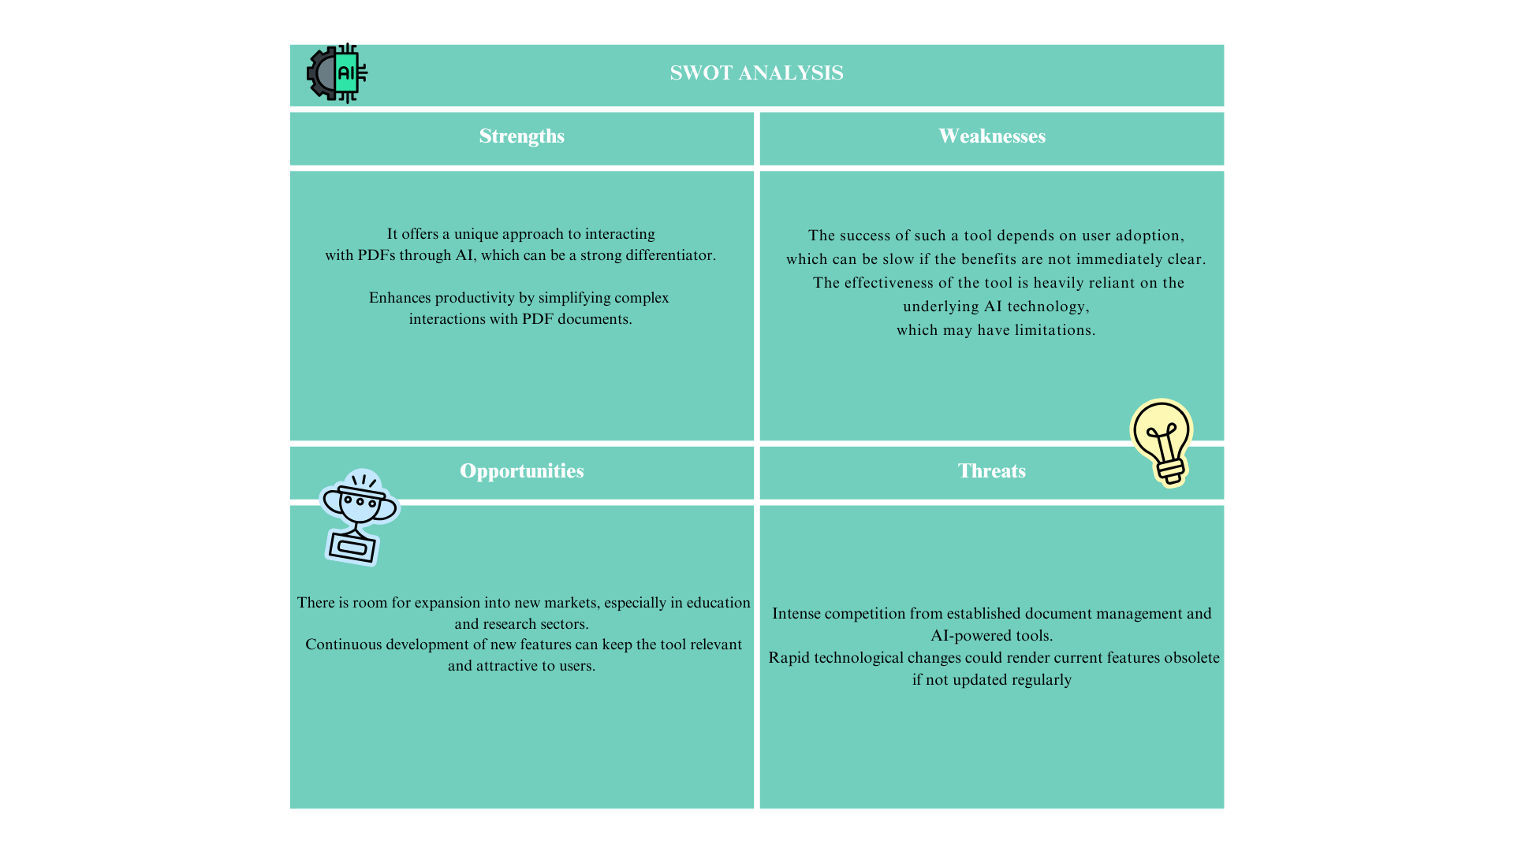

# 3. User Persona and Use Cases

## For Healthcare Industries

**User Persona: Dr. Aarav Mehta**

* **Age:** 38
* **Occupation:** Oncologist
* **Location:** Mumbai, India
* **Technological Proficiency:** Well-versed in machine learning and artificial intelligence, and at ease utilizing new technologies.
* **Objectives:** To enhance patient outcomes, tailor treatment programs, and give accurate diagnoses.
* Obstacles include overseeing a large patient load, being current on research, and making sure the practice is run effectively.

**Use Cases for OpenAI Applications:**

1. **Virtual Health Assistant:**
   * **Scenario:** Dr. Mehta wants to reduce the time spent on administrative tasks.
   * **Application:** Dr. Mehta may concentrate more on patient care by having an AI virtual assistant handle appointment scheduling, patient follow-ups, and routine question answering.
2. **AI-Powered Diagnostic Tool:**
   * **Scenario:** Dr. Mehta needs to diagnose a rare form of cancer.
   * **Application:** Dr. Mehta can identify the problem more quickly and precisely with the use of an AI system that analyzes medical pictures and patient data to provide probable diagnoses.
3. **Treatment Personalization:**
   * **Scenario:** Dr. Mehta has a patient with a unique genetic makeup.
   * **Application:** To provide a customized treatment plan that maximizes the chance of success, AI examines the patient's genetic information in conjunction with extensive medical databases.
4. **Research Analysis:**
   * **Scenario:** Dr. Mehta struggles to keep up with the latest cancer research.
   * **Application:** Without requiring Dr. Mehta to go through lengthy articles, an AI tool analyzes current studies and emphasizes pertinent findings.
5. **Operational Efficiency:**
   * **Scenario:** Dr. Mehta’s clinic experiences inventory management issues.
   * **Application:** AI ensures that necessary things are always in stock without overordering by optimizing the inventory of medical supplies based on consumption trends.

These use examples show how OpenAI apps might improve both the patient experience and the effectiveness of healthcare providers like Dr. Mehta by addressing real-world issues in the field.

## Retail Industries

**User Persona: Sagar Sharma**

* **Age:** 29
* **Occupation:** Retail Store Manager
* **Location:** Begumpet,Hyderabad
* **Technological Proficiency:** Highly adept with digital tools, keen on integrating AI to enhance business operations.
* **Goals:** To increase store revenue, improve customer satisfaction, and streamline inventory management.
* **Challenges:** Balancing inventory levels, predicting consumer trends, and providing a personalized shopping experience.

**Use Cases for OpenAI Applications:**

1. **Personalized Marketing:**
   * **Scenario:** Sagar wants to increase customer retention and sales.
   * **Application:** AI analyzes customer data to create personalized marketing campaigns, recommending products based on past purchases and browsing behavior.
2. **Demand Forecasting:**
   * **Scenario:** Sagar needs to optimize inventory for the upcoming season.
   * **Application:** AI predicts future product demand based on historical sales data, current market trends, and social media sentiment analysis.
3. **Virtual Shopping Assistant:**
   * **Scenario:** Sagar aims to enhance the online shopping experience.
   * **Application:** An AI chatbot assists online customers, providing product recommendations, answering queries, and offering styling advice.
4. **Fraud Detection:**
   * **Scenario:** Sagar is concerned about online transaction fraud.
   * **Application:** AI monitors transactions in real-time to detect and prevent fraudulent activities, safeguarding both the business and customers.
5. **Supply Chain Management:**
   * **Scenario:** Sagar wants to ensure timely product restocking and delivery.
   * **Application:** AI optimizes the supply chain, predicting delays, and finding the most efficient routes and methods for product distribution.

These use examples show how real-world issues in the retail sector might be resolved by OpenAI apps, assisting professionals like Sagar in achieving their objectives through increased productivity and client interaction.

# 4. Market Size and Growth Projection:

**Healthcare Industry:**

* **Market Size:** The market for AI in healthcare was valued at USD 19.27 billion globally in 2023 and is projected to expand at a compound annual growth rate (CAGR) of 38.5% between 2024 and 2030.
* **Adoption Rates:** According to a Microsoft-IDC survey, 79% of healthcare firms already use AI technology. This indicates that a sizable number of healthcare organizations are adopting AI.
* **Technological Advancements:** Medical imaging analysis, predictive analytics, tailored treatment planning, and drug development are just a few of the areas where AI in healthcare is making strides.
* **Market Trends:** Artificial Intelligence (AI) in healthcare is expanding due to the need for increased accuracy, efficiency, and improved patient outcomes.AI technology use has also increased as a result of the COVID-19 epidemic.

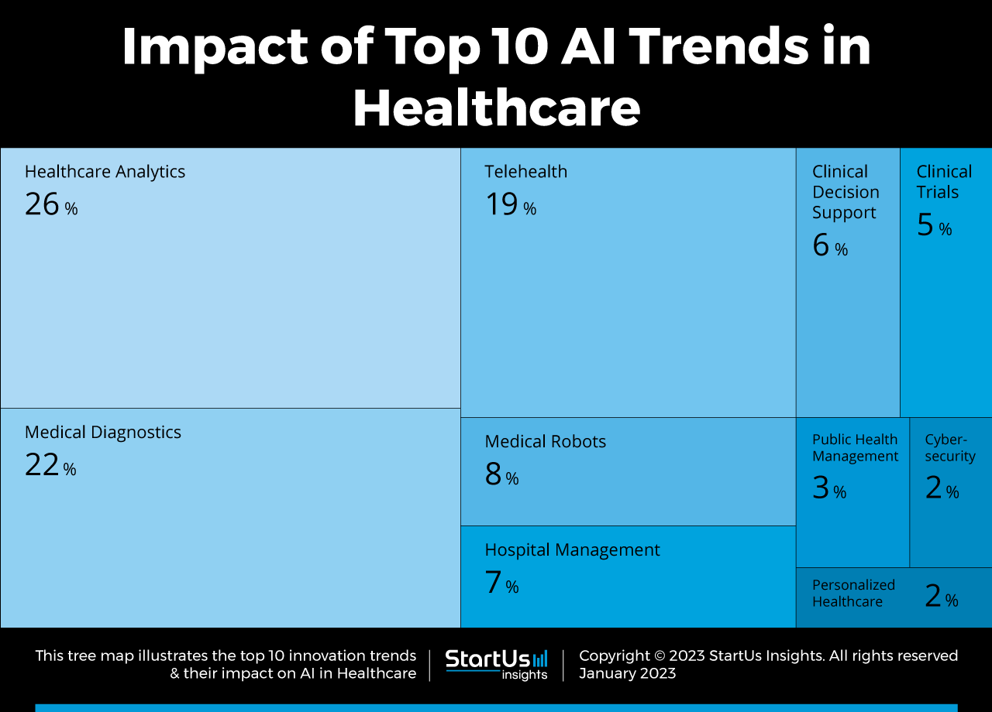

**Retail Industry:**

* **Market Size:** Estimated at USD 5.79 billion in 2021, the worldwide AI retail market is projected to grow at a compound annual growth rate (CAGR) of more than 23.9% from 2022 to 2030.
* **Adoption Rates:** AI is being used more and more in the retail industry; according to estimates, 73% of merchants now employ it, and another 15% have plans to do so.
* **Technological Advancements:** Artificial intelligence (AI) in retail is progressing in areas like computer vision, chatbots, and natural language processing, which are utilized for loss prevention, inventory management, and customer support.
* **Market Trends:** Artificial Intelligence (AI) in retail is growing due to factors including government regulations supporting digitalization, the growing number of internet users and smart gadgets, and the necessity of surveillance and monitoring at physical locations.

These facts indicate that both industries will see considerable development in the market for OpenAI applications. Because technology is being adopted at a faster pace and is essential to enhancing patient care and operational efficiency, the healthcare sector in particular is predicted to grow more quickly. Businesses may also benefit greatly from AI applications in the retail sector, which can improve customer satisfaction and streamline processes.