Test Strategy — Financial Data Processing Application
Author: Manivannan Ezhumalai
Version: 1.0
Application Layers Covered: Batch File Processing| Web UI | REST APIs

1. Objective

Ensure the financial data is accurate, the application works as expected, and the entire system is reliable across UI, API, and batch processes.

2. Data Flow Overview

The application reads instrument and position data from input csv files, applies transformation and generates positionReport.csv with calculated values.

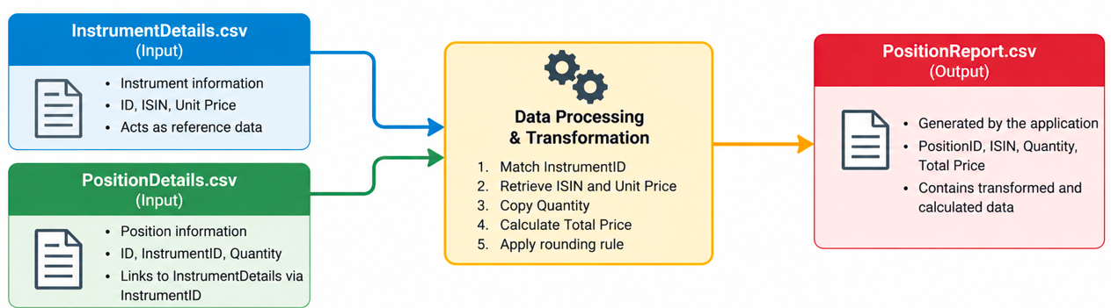

3. Test Scope

In Scope
- Data Processing & Batch File Layer:
  - Validate input files (InstrumentDetails.csv, PositionDetails.csv) for file format, schema, data types, mandatory fields, null values, duplicate records, referential integrity, and numeric range validations.
  - Validate batch processing and output files (PositionReport.csv) for data transformation rules, Total Price calculation, precision/rounding, record counts, source-to-target reconciliation, data completeness, and error handling & reporting.
- UI Layer: Use Selenium Page Object Model (POM) design pattern to validate key UI elements, payload displays, and user interactions.
- API Layer: Validate API contracts, schemas, status codes, payloads, response times, and negative scenarios for public APIs using RestAssured.

Out of Scope
- Performance/Load testing under high batch file throughput or concurrent REST API load.
- Security penetration testing and vulnerability scanning.
- Infrastructure provisioning or CI/CD runner maintenance.

4. Assumptions & Risks

4.1 Assumptions
- Input files follow a standard CSV layout with consistent headers across runs.
- Rounding policy for Total Price calculations defaults to Half-Up precision (2 decimal places) unless specified by external configuration.
- Required API endpoints and UI are available during test execution.
- Local Java runtime (JDK 17+) and Maven are configured properly on test execution nodes.

4.2 Risk Assessment & Mitigation
Risk | Impact | Mitigation
Csv file schema changes and incorrect source data. | Invalid or incorrect test results/data validation failures. | Automated data-validation checks before each run
Third-party API rate limiting during test execution. | Flaky API test execution results | Control request rate, retry temporary failures.
Brittle UI Locators: Changes in web portal DOM structure breaking automation scripts | High UI script maintenance effort. | Implement Page Object Pattern utilizing robust CSS selectors/XPaths, separating UI actions from assertions.

5. Coverage & Traceability Matrix
Requirement ID | Module / Area | Description | Test Type | Automated Strategy
REQ-DAT-01 | Data Layer | Referential Integrity (Every PositionDetails.InstrumentID must exist in InstrumentDetails.ID). | Functional / Data | Match InstrumentID from PositionDetails with ID from InstrumentDetails and identify unmatched records.
REQ-DAT-02 | Data Layer | Uniqueness constraints on Instrument ID, ISIN, and Position ID. | Data Integrity | Check each key field for duplicate values using a HashSet.
REQ-DAT-03 | Data Layer | Transformation Rule: Total Price= Quantity * Unit Price with rounding rules. | Data Calculation | Calculate expected Total Price using BigDecimal and compare with actual value.
REQ-DAT-04 | Data Layer | Handling malformed files, missing columns, empty files, and invalid formats. | Negative Data | Validate that invalid files are rejected with the expected error
REQ-DAT-05 | Data Layer | Mandatory fields must not be null or blank | Data Quality | Null/blank validation
REQ-DAT-06 | Data Layer | Quantity and Unit Price must be greater than zero | Data Quality | Numeric/range validation
REQ-DAT-07 | Data Layer | Output must not contain missing, duplicate or unexpected records | Data Integrity | Compare source PositionDetails records with PositionReport records to identify missing, duplicate, or extra records.
REQ-DAT-08 | Data Layer | Expected and actual total quantity/price must reconcile | Reconciliation | Compare expected and actual total Quantity and Total Price.
REQ-API-01 | API Layer | Validate response schema, field types, and response time against a configurable threshold. | API Functional | RestAssured JSON Schema Validator & time() checks.
REQ-API-02 | API Layer | Handling GET /api/users/23 (404 Not Found). | API Functional | Response status code and error payload assertion.
REQ-API-03 | API Layer | Validate successful and negative POST payload scenarios, including status code, ID, timestamp, and response payload. | API Functional | Validate status code, response payload, ID, timestamp, and negative payload handling.
REQ-UI-01 | UI Layer | Verification of homepage endpoint views and payload display | Web UI | Selenium POM element presence and text checks.
REQ-UI-02 | UI Layer | Navigation and verification of support page pricing plans. | Web UI | Selenium page navigation & DOM element verification.

6. Test data & Automation Approach

6.1 Test data
Generate mock InstrumentDetails.csv and PositionDetails.csv with positive and negative test data, and derive the expected PositionReport.csv using the defined transformation rules.

6.2 Automation Approach
Layer | Framework/Tooling | Approach
UI | Selenium with Java (Page Object Model), TestNG | Smoke and regression testing for key UI journeys, including endpoint selection, response display, and support-page validation.
API | RestAssured + TestNG/JUnit | Contract validation (schema), functional, negative, and status-code assertions.
Batch/Files | Java-based csv file validation & comparison utilities | Automated CSV validation, expected-vs-actual output comparison, record-count validation, and data reconciliation.
Reporting | Extent Reports | Consolidated test reports across all three layers.

7. Failure Triage Across Layers
When a test fails, identify the affected layer, check the relevant logs/evidence, and determine the root cause.

Data Layer: Check reconciliation reports for data, calculation, or transformation issues.

API Layer: Check status codes, response payloads, schema, and response time.

UI Layer: Check screenshots, UI elements, and browser logs for locator or functional issues.

Goal: Quickly identify whether the failure is related to data, API, UI, or the application itself and route it to the appropriate team.

8. Entry & Exit Criteria

8.1 Entry Criteria

Requirements and test scenarios are available and reviewed.

Test environment, application build, APIs, and batch process are ready.

Required test data and input files are available.

Automation framework and test scripts are ready for execution.

Required access and dependencies are available.

8.2 Exit Criteria

All planned tests are executed.

Critical and High severity defects are closed or formally accepted.

UI, API, batch, and data reconciliation validations are passed.

Regression testing is completed.

Test results and known issues are documented.

QA provides the final release recommendation.

9. Metrics / Reporting

Test cases planned, executed, passed, failed, and blocked.

Requirement and test coverage.

Defects by severity and status.

Automation coverage and pass percentage.

Batch/data reconciliation results.

API and UI test results.

10. Approval and Sign-off
Role | Responsibility | Sign-off
QA Lead / Test Manager | Approve test strategy, test results, and QA recommendation | ☐
Business / Product Owner | Confirm business requirements and acceptance criteria | ☐
Development Lead | Confirm defect fixes and application readiness | ☐
Data / Batch SME | Confirm data processing and reconciliation results | ☐
Project / Delivery Manager | Final release approval | ☐
Sign-off Criteria: Exit criteria are met, critical/high defects are closed or accepted, and all known risks are documented and approved.

