Low Level Design (Login Module)

Project Code | Team5
Project Name | Online Banking System

Prepared/Modified by | Role | Date of Preparation
Team 5 | Software Engineer | 01/01/2018
Reviewed by | Role | Date of Review
Team 5 | Software Engineer | 02/01/2018
Approved by | Role | Date of Approval
Rahul Vikash | Training Manager
Circulation List | Avijit.b.singh@capgemini.com, amrutha.bhat@capgemini.com, crista.crista@capgemini.com,  Asmita.a.chakraborty@capgemini.com,  Amir.e.khan@capgemini.com  Lekhya.burle@capgemini.com,  Atreyee.paul@capgemini.com | Version Number of the template:1.0
Version Number | 1.4

Table of Contents

1. Description Of The Unit 3
2 References 4
3. Dependencies / Assumptions 5
4. Class Diagrams 6
5. Sequence Diagrams 7
6. Design Components 8
a. List Of UI Components 8
7. Re-Usable Routines/Components 10
8. Messages 11
9. Configuration Files 12
10. Crud Matrix Table 13
11. Data Mapping Matrix 14
12. Action Flow Matrix 15
13. Stored Procedures 16
14. Program Specification / Pseudo Code 17
REVISION HISTORY OF THE WORK PRODUCT 19

Description Of The Unit

The login module allows the users of the application to login into the system using their valid credentials.

The userId and password entered by the user is validated from the database. If the entered credentials are valid then he/she is redirected to their respective pages based on their roles. Admin is redirected to Admin Page where options are provided to create customer account or view the the transactions. The admin based on his selection is redirected to View transaction details page where he/she can view all the transactions in daily, monthly, quarterly and yearly basis or to the create customer page he can create a customer account. Customer is redirected to Home Page where he/she can view transactions, view detailed/ mini-statement and transfer funds.

2 References

Reference | Description
Repository reference | https://IGTEBLRSVNTNG.igatecorp.com/svn/oct3_Team5
Class Diagram | /Project Documents/Design Documents/HLD/Class Diagrams
URS | /Project Documents/Requirements/Case Study/OnlineBnakingSystem-grp5.doc
UTP | /Project Documents/Test Plan/UTP/Test Cases/Login Module/UTP_LoginModule.xls
DB Design | /Project Documents/Design Documents/HLD/DB Design/E-Commerce_GROUP_DBDESIGN.xls

Dependencies / Assumptions

Assumptions:

- Admin Account Id and password are stored in the database. The customer details are stored in the database through Customer registration module.
- The Transaction details of the User already exist as it is entered when the user makes a transaction at the User End.

Class Diagrams

Class Diagram

Banking Bean Class Diagram:

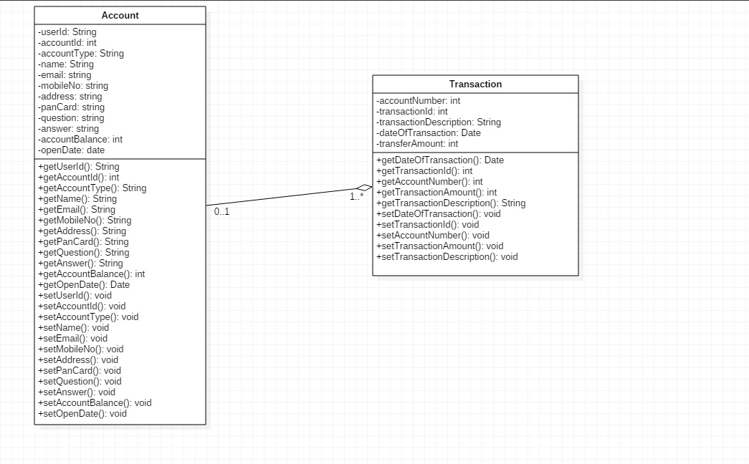

Banking Dao Class Diagram:

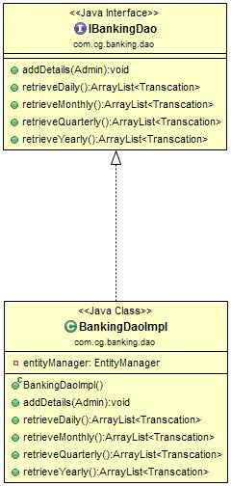

Banking Service Class Diagram:

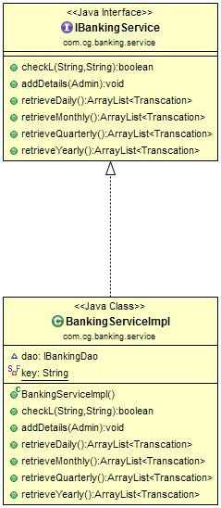

Banking Controller Class Diagram:

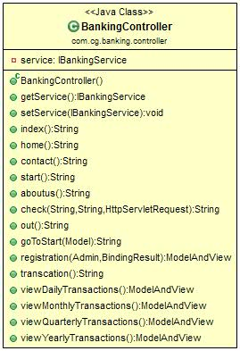

Sequence Diagrams

Sequence Diagram––
N/A

Design Components

List Of UI Components

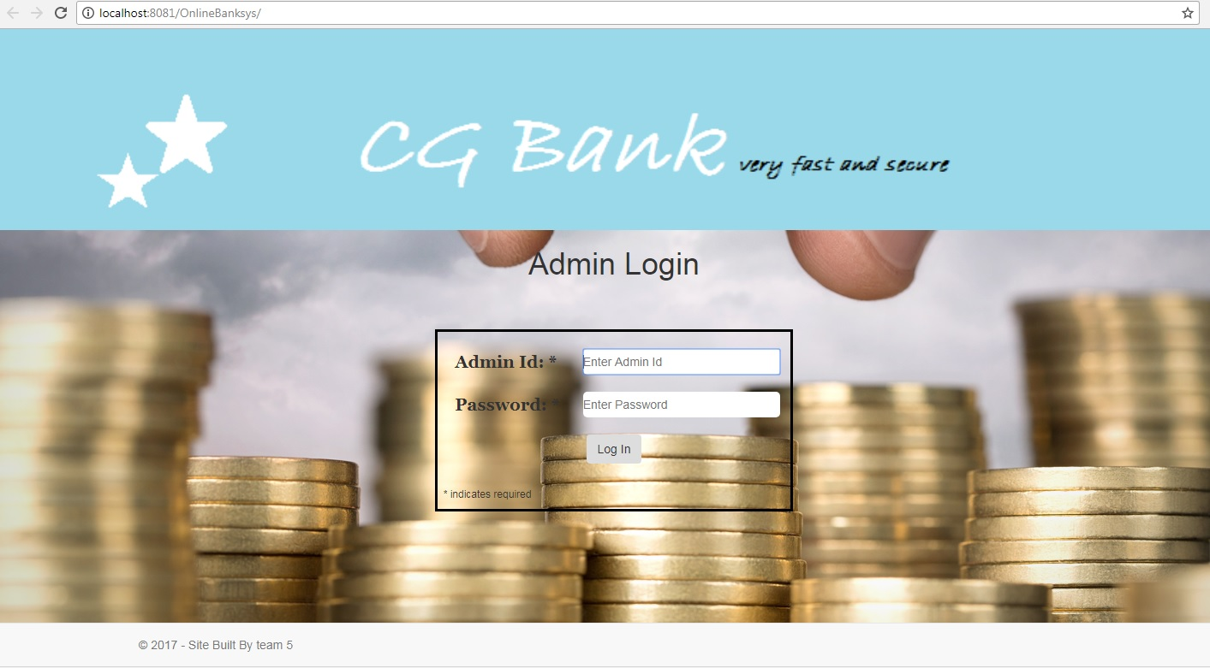

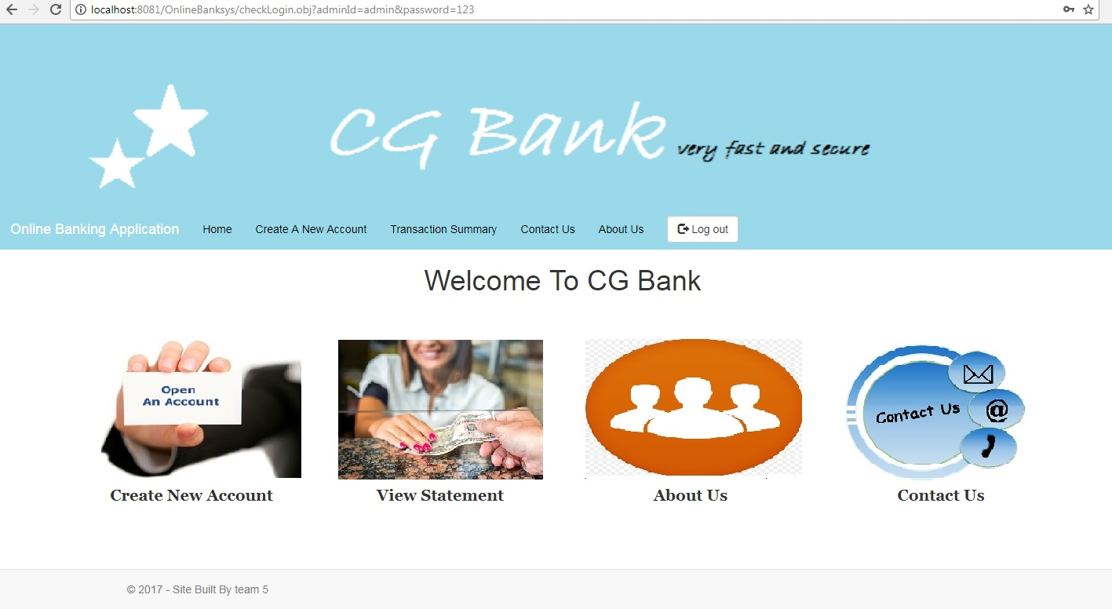

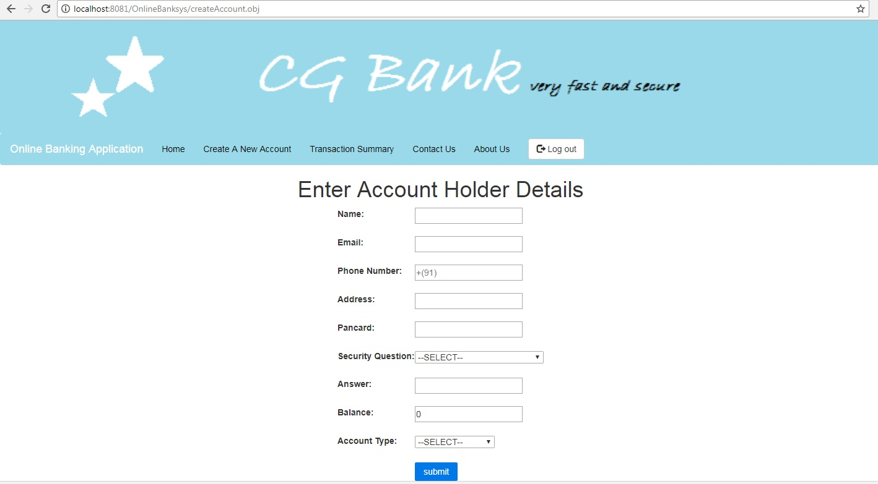

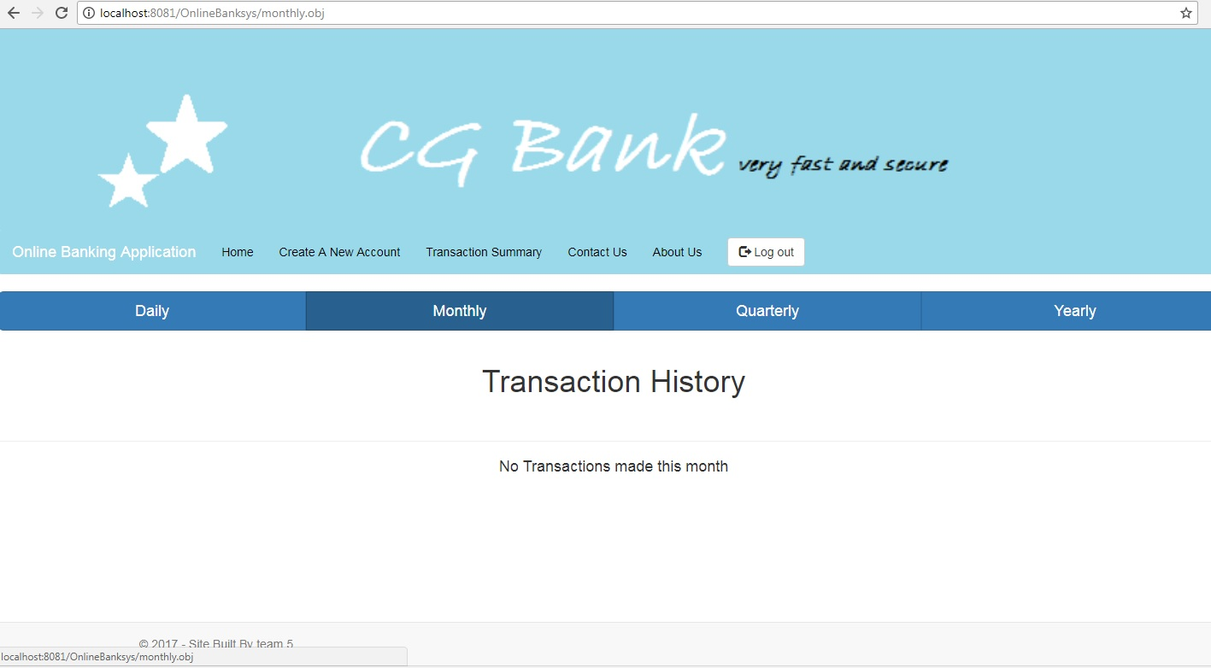

List Of Design Classes

Sr. No. | LLD Name | Class Name | Method Name | Method Description
1 | Admin Module | Admin and Transaction | Appropriate getters and setters methods | Getters retrieve the property values and setters set the property values
2 | Admin Module | Banking Controller | ckeckLogin(Model model):String  check(@RequestParam(“accountId”) String adminId,  @RequestParam(“password") String password, HttpServletRequest request  ):String | Sets the model attribute.  Calls checkL() of BankingServiceImpl class, if admin is present then it redirects to appropriate Home Page.
3 | Admin Module | BankingServiceImpl | checkL():admin  addDetails(Account admin)  retrieveDaily() retrieveMonthly() retrieveQuarterly() retrieveYearly() | checkL() checks the userid and password and returns the result to controller.  addDetails( Account admin) retrieveDaily() retrieveMonthly() retrieveQuarterly() retrieveYearly()calls the BankingDaoImpl class method
4 | Admin  Module | BankingDaoImpl | addDetails(Account admin)  retrieveDaily() retrieveMonthly() retrieveQuarterly() retrieveYearly() | Calls the addDetails() method and register user with appropriate data.  retrieveDaily() retrieveMonthly() retrieveQuarterly() retrieveYearly() retrives the transactions on daily monthly quarterly and yearly basis

Re-Usable Routines/Components

Re-Usable Routines/Components

- CSS files
- Javascript files
- DataAccessException class
- Database properties files

Messages

#. | Type | Message Text
M1. | Error | Invalid Admin Name/ Password
M2 | Error | Balance should be grater then 3000.

Configuration Files

File Name | Path | Description
Web.xml | /Development/WebContent | To configure the bean properties.
Dispatcher-servlet.xml | /Development/WebContent | To configure the request mapping and view resolver.
jpaContext.xml | /Development/WebContent | To provide information about the current JPA setup.

Crud Matrix Table
# | Table Name | Create | Read | Update | Delete
1 | Account | N | Y | Y | N
2 | Transaction | N | Y | Y | N

Data Mapping Matrix

Sr. No. | Screen Label | Field Source | Field Type | Data Type | Max Length | Data Flow | Mandatory
1 | accountId | N/A | Label | N/A | N/A | UI | N/A
2 | txtaccountId | Admin.account_id | TextBox | Varchar2 |  | UI→D | Yes
3 | Password | NA | Label | N/A | N/A | UI | N/A
4 | txtPassword | Admin.Password | TextBox | Varchar2 | 20 | UI→D | Yes
5 | Login | N/A | Button | N/A | N/A | UI | N/A

Legend

UI (User Interface Only)
UI → D (User Interface to Database)

Action Flow Matrix
Sr. No. | Action | Description | Process
1 | On click of Login Button | Valid User gets logged | AccountId and Password is validated from the database. If Admin is valid he/she is redirected to respective Admin Page.

Stored Procedures

# | Stored Procedure Name  (with Description) | Input/Out Parameters | Type | Size
1. | NA | NA | NA | NA

Program Specification / Pseudo Code

14. 1 <ACTION: ONPAGE_LOAD>

14. 2 <ACTION: LOGIN_CLICK>

Pseudo Code:

REVISION HISTORY OF THE WORK PRODUCT
# | Date | Version # | Section Changed | Details of changes made | Approved By
1 | 27/12/2017 | 1.0 | Document prepared | N/A | Rahul Vikash
2 | 28/12/2017 | 1.1 | List of design classes  Data Mapping Matrix | The controller’s name is changed to “BankingController”  Action Matrix was added. | Rahul Vikash
3 | 29/12/2017 | 1.2 | Reusable components,  References,  Data Mapping Matrix. | Reusable Components added.  File name with relative path is added in the references section.  The name of text boxes (screen label is changed). | Rahul Vikash
4 | 30/12/2017 | 1.3 | List of design classes, Pseudo Code | The names of the methods in list of design classes and pseudo code were changed as per the class diagram | Rahul Vikash
5 | 02/01/2018 | 1.4 | Messages | Changes made in Error Messages | Rahul Vikash
6 | 03/01/2018 | 1.5 | Configuration files,UI Components | Paths of the configuration files is updated and UI Components (Screen Shots) added. | Rahul Vikash

