Artificial Intelligence: Artificial Intelligence enables machines to think, learn, and make decisions like humans.
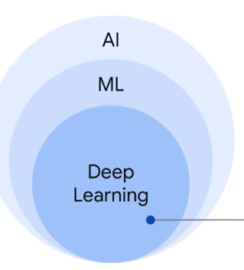
Machine Learning (ML)
- It is a program or system that trains a model from input data.
- The trained model can make useful predictions.\
- ML gives the computer the ability to learn without explicit programming.
Types of Machine Learning:
1. Supervised Machine Learning
- Data comes with labels (tags).
- You train the model using labelled data.
- The model learns from past examples to predict future values.
Example:
- Email → spam or not spam
- House price prediction
2. Unsupervised Machine Learning
- Data comes without labels (no tags).
- The model analyses raw data and finds patterns on its own.
- It checks if data naturally falls into groups (clusters).
Example:
- Customer segmentation
- Grouping similar products
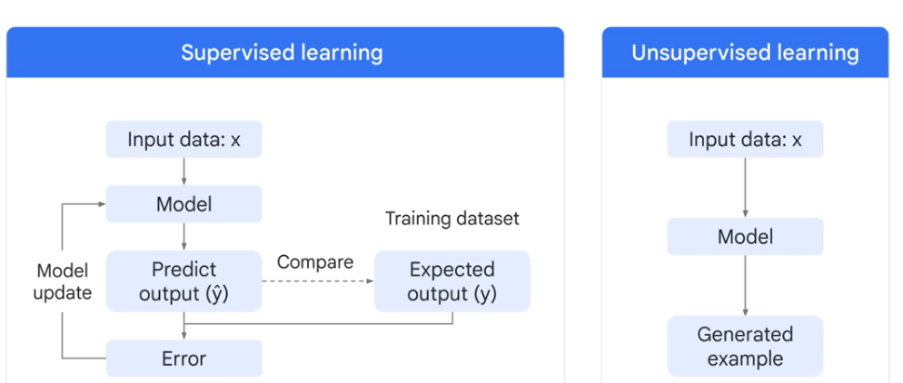

Deep Learning: Deep learning is the type of machine learning that uses artificial neural networks allowing them to process more complex patterns than machine learning

Generative AI: It is the subset of deep learning, it uses artificial neural networks can process both labelled and unlabelled data using supervised, unsupervised and semi-supervised methods 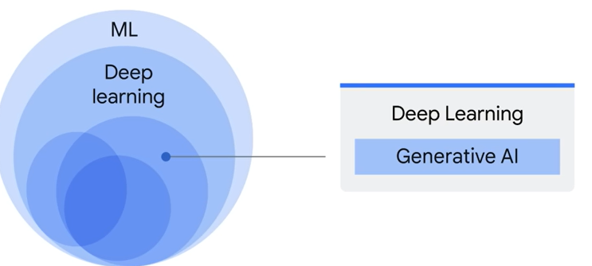
Deep learning models or machine learning models are divided into two types
1) Discriminative Model:
- It is typically trained on a datasets of labelled data
- A discriminative model focuses on classifying data.
- It looks at input data and decides the correct label.
- A discriminative model learns the decision boundary to classify input data into different categories

2) Generative Model:
- GenAI is the type of artificial intelligence that creates new content based on what it has learned from existing content
- A generative model focuses on understanding and creating data.
- The process of learning from existing content is called training and result in the creation of statistical model
- When prompt is given, Generative AI it uses the statistical model to predict what expected response might be and generates new content
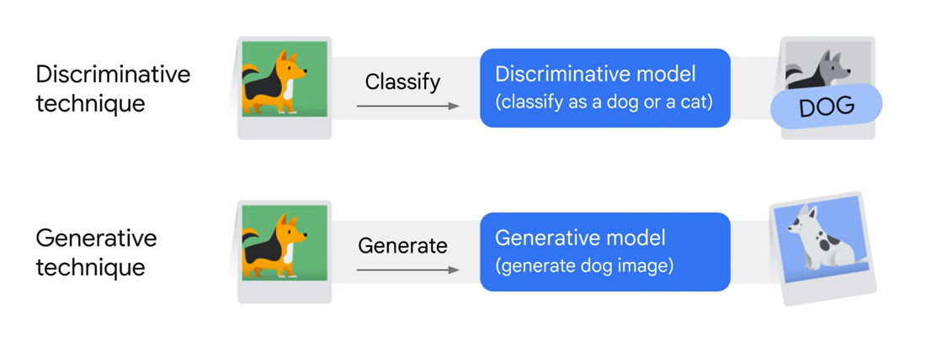
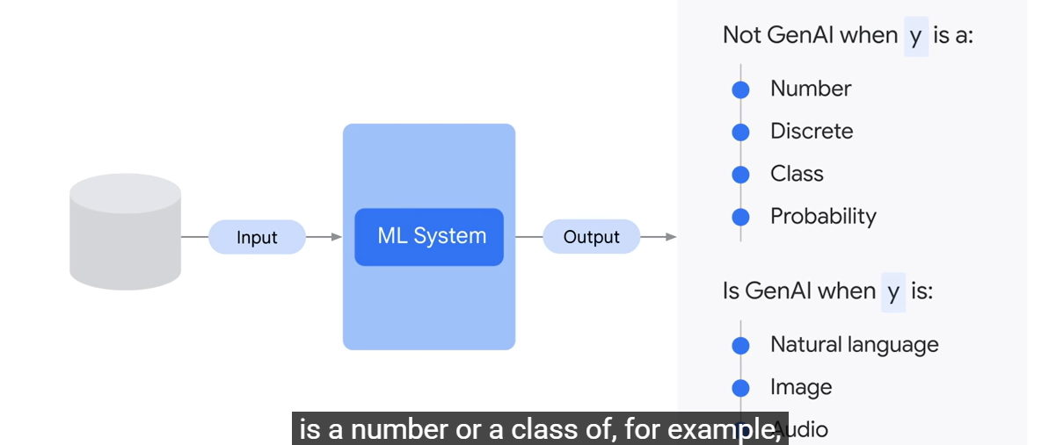
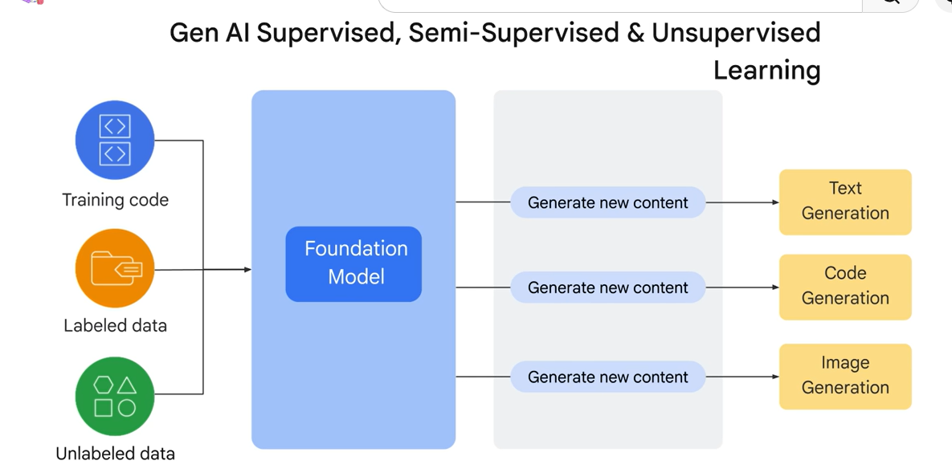
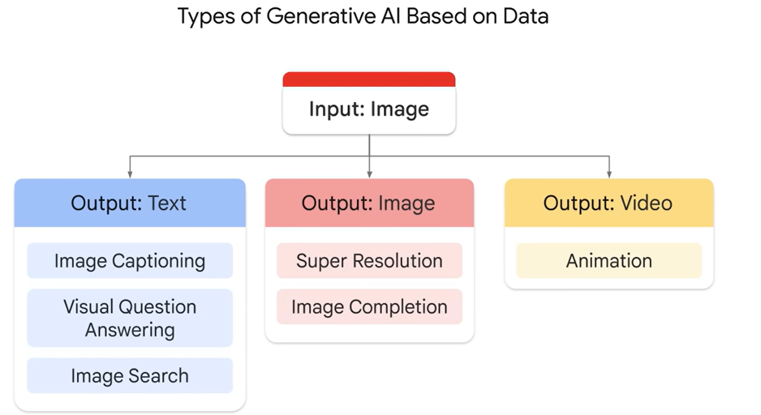

Generative Models are of two types:
- Generative language Model: Generative languages models learn about patterns in language through training data. Then give some text, they predict what comes next

- Generative Image Model: Generative image model produces new images using techniques like diffusion. Give prompt, it will generate images from prompts
Large Language Model (LLM):
- This is also subset of deep learning
- A specific type of NLP model
- LLMs are used to understand and generate human language for tasks like chatbots, content creation, coding, translation, and automation
- They are trained on massive text data to perform tasks like answering questions, writing, and summarizing.
Ex: Chatbots & Virtual Assistants, Content Creation, Code Generation, Translation, Question & Answering
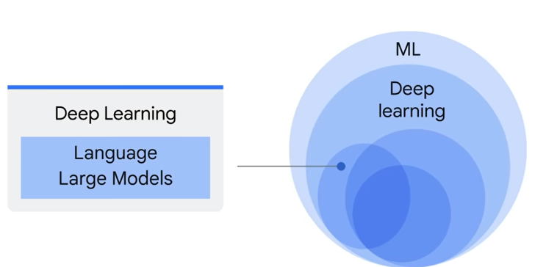
There are three kinds of LLM:
  - Generic Language Model
  - Instruction Tuned Model
  - Dialog Tuned Model

TOKEN
• A token is the smallest unit of text processed by an LLM.
• It can be a word or part of a word.
Why tokens matter:
• LLMs don’t read full sentences like humans.
• They process text token by token.
CONTEXT WINDOW
• A context window is the maximum number of tokens the model can “remember” at one time.

It includes:
• Your Question
• Relevant Chunks
• Conversation History

PROMPTING
• The six components which together help and guide the LLM to produce accurate and relevant responses:
- Task
- Context
- Examples
- Persona
- Format
- Tone
TASK
• Always start the task sentence with an action verb like Generate, Give, Write, Analyze, etc.
Example:
• Generate a 3-month diet program for me
CONTEXT
• Context in a prompt is the background information or situation you provide to help the model understand how to answer correctly.
Example:
• I have 8 years of experience in DevOps
PERSONA
• This tells AI who it should act as.
Examples:
• Act as an expert DevOps engineer
• Act as a professional resume writer

FORMAT
• This defines how the output should look.
• It includes structure, headings, and alignment.

EXAMPLES
• This shows sample input/output or format.
• Helps AI understand exact expectations.
Example:
Experience:
Company | Role | Duration
• Bullet points
TONE
• This defines the style of communication.
Examples:
• Professional
• Casual
• Technical
• Simple
• Friendly

EXAMPLE PROMPT
Act as an expert DevOps engineer and professional resume writer.
Task:
Generate a strong, ATS-friendly resume based on the given profile.
Context:
I have 8 years of experience in DevOps, CI/CD, AWS, Terraform, Docker, Kubernetes, Jenkins, Ansible, and automation.
Format:
• Professional Summary
• Skills (categorized)
• Professional Experience (with bullet points and action verbs)
• Projects
• Education
• Certifications
Tone:
• Professional
• Concise
• Impactful

Constraints:
• Avoid repetition
• Use strong action verbs
• Keep bullet points short and powerful
• Make it ATS-friendly
Few-shot prompting: Giving examples inside your prompt so the AI learns the pattern before answering.
Zero-shot prompting: Asking model to act without examples
Term | Actual Concept
Persona | Role prompting
Task | User prompt
Context | Additional input
Full system behaviour | System prompt

Retrieval Augmented Generation (RAG):
- Instead of AI answering from its memory, it first retrieves relevant data, then generates answer using that data
- RAG is a technique where relevant external data is retrieved and provided to an AI model to generate accurate responses.
- RAG enhances the capabilities of LLM by allowing them to access external data sources, to get most accurate and relevant responses by accessing the right chunks of data

Retrieval: The model searches in knowledge base (vector database) for relevant info
Augmented: The retrieved info added to the user prompt
Generation: The model generates an answer based only on that specific data

- RAG reduces hallucination by grounding responses in external data

How RAG works:
1️⃣ User asks question
2️⃣ System searches your data (docs, DB, PDFs)
3️⃣ Retrieves relevant chunks
4️⃣ Sends that data to AI model
5️⃣ AI generates answer based on it

Without RAG Flow:
- First user prompts the LLM with their question and generative model gives the response
LLM challenges:
  - No source
  - Out dated data

Natural Language Processing:
- NLP helps the machine to understand human language
- All techniques to make machines understand language
Word Embedding:
- Word embedding is a technique that converts words into numerical vectors or numbers. So that model can understand semantic relationship between them
- Words with similar meaning have similar vectors
- Embeddings help in semantic search instead of keyword search
- Semantic search = search based on meaning, not just exact words

Why do we need to transform words into numbers:
- The reason vectors are used to represent the words, most of the machine learning algorithms are incapable of processing plain text in its raw form
Without word embedding:
AI will do keyword match and results be poor
Ex: Query: How to list pods?
Document: kubectl get pods
No exact match → might fail
Example: dog and cat
- Their embeddings will be close in vector space
How it is used in RAG:
1️⃣ Convert documents into embeddings
2️⃣ Store in vector database
3️⃣ Convert user query into embedding
4️⃣ Find closest matching data
5️⃣ Send to LLM

Vector Database:
- A vector database stores numerical representations (embeddings) of data and retrieves the most similar ones based on meaning.
- Vector databases use similarity metrics like cosine similarity to find the closest vectors.

Example:
Documents:
Doc1: kubectl get pods
Doc2: kubectl logs <pod>
Doc3: terraform apply

Convert to embeddings:
Doc1 → [0.21, 0.78, ...]
Doc2 → [0.25, 0.74, ...]
Doc3 → [0.90, 0.10, ...] -> Store all in vector database
User asks question:
how to list the pods?
Convert to embedding:
Query → [0.22, 0.77, ...]
Search in vector DB:
Database finds closest vector
Result:
Closest to Doc1 → kubectl get pods

Chunking:
- split large data into multiple smaller chunks before processing
How tokens and chunking work together:
1️⃣ You do chunking → split document
2️⃣ Each chunk → converted into tokens
3️⃣ LLM processes tokens
Correct Flow in One Line:
Chunking → Embedding → Storage → Retrieval → Context Window → Tokens → LLM Output
Example:
Chunking = breaking book into chapters
Retrieval = picking relevant chapter
Context window = how many pages you can read at once
Tokens = words inside those pages

Retrieval Flow:
- Retrieval flow is the process of searching and selecting the most relevant information from stored data to help the AI to generate accurate answers.
- Retrieves top matching chunks
Step-by-step Retrieval Flow:
1️⃣ User asks question
2️⃣ Convert query → embedding: Text → numbers (vector)
3️⃣ Search in vector database: Compare with stored embeddings
4️⃣ Similarity check (Cosine similarity): Find closest vectors (most similar meaning)
5️⃣ Retrieve top matching chunks
6️⃣ Send to LLM (inside context window): Along with user question
7️⃣ LLM generates final answer

- Query → Embedding → Vector Search → Similarity → Retrieve Chunks → Send to LLM → Answer

LangChain:
- LangChain is the framework used to develop AI applications by chaining together LLMs, prompts, memory, external data source
- LangChain adds real memory systems
- LLMs don’t have built-in memory. Applications like ChatGPT simulate memory by passing previous conversation as context. Frameworks like LangChain provide persistent and customizable memory on top of LLMs.
Example:
- Stores chat history in DB
- Retrieves it when needed
- Sends relevant parts to LLM
This is called:
- Conversation Memory
- Vector Memory (embeddings)
Why LangChain is needed:
Normally LLMs (like GPT) have limitations:
  - No memory (forget past chats)
  - No access to real-time data
  - Cannot call APIs or databases
LangChain solves this by:
- Adding memory
- Connecting databases / APIs
- Creating multi-step workflows
Tool calling: LangChain allows LLMs to interact with external tools such as APIs, databases, and custom functions through tool calling
How it works (step-by-step)
- User asks a question
- LLM understands I need external data
- LangChain: Calls a tool (API / function)
- Tool returns data
- LLM generates final answer
User → LLM → Tool → LLM → Response
LangGraph:
→ User Question → LLM decides
→ Answer directly OR
→ Call API/tool → refine → answer
→ Loop until correct

AI Agents:
- LLMs are trained on large datasets and learn generalized patterns from past data. They are reactive systems that generate responses based on prompts but do not have real-time awareness by default.
- To overcome this limitation, techniques like RAG connect LLMs to external data sources for up-to-date information.
- AI Agents go a step further by combining LLMs with tools such as web search, APIs, and databases. They can plan, decide, and take actions autonomously, making them more powerful than standalone LLMs.
Agentic Workflow:
- Agentic AI is an approach where AI systems behave like agents
- An agentic workflow is a dynamic AI-driven process where a system autonomously plans, executes, and improves steps using tools to achieve a goal.
- In Agentic AI systems, Planner and Executor are two key roles that divide how an AI agent thinks vs acts.
Example:
Task: Deploy application
Traditional Workflow:
- Jenkins pipeline (fixed steps)
- If error → manual fix
Agentic Workflow
- Understand requirement
- Plan infrastructure
- Run Terraform
- Deploy app
- Check logs
- Fix errors automatically
- Retry
➡️ No fixed script — AI decides dynamically
Planner (Thinking part):
The Planner decides WHAT to do
- Breaks the user request into steps
- Creates a strategy or plan
- Decides which tools/actions are needed
- Thinks step-by-step (reasoning)

Executor (Action part):
The Executor does the actual work
- Executes each step from the plan
- Calls tools (APIs, DB, web search, etc.)
- Collects results
- Sends output back
Flow of execution:
User Query
↓
Planner (creates steps)
↓
Executor (runs steps)
↓
Results returned

LLMOPS:
- LLMOPS is a culture the helps in building, deploying, monitoring and continuously improving large language models in productions systems
AWS Bedrock:
- A fully managed service that lets you use pre-trained LLMs from multiple providers via API without managing infrastructure or training, enabling you to integrate AI into applications quickly.
AWS SageMaker:
- A full ML platform that lets you train, fine-tune, and deploy custom LLMs, providing complete control over the model, infrastructure, and lifecycle, suitable for building production-ready AI systems.

Bedrock = Use existing LLMs
SageMaker = Build/Develop or customize LLMs

