SIMATS ENGINEERING
CO1 - ASSESSMENT TOOL 1

NAME: G.Manikanta(12425310) COURSE CODE: ITA0517
_________________________________________________________________________________
1.Explain how how image formation models help in improving image quality in applications such as autonomous driving
Image formation models describe how a camera captures a real-world scene and converts it into a digital image. They explain the relationship between the camera, light, lens, and objects in the environment. These models help identify and correct image distortions, noise, blur, and lighting variations, resulting in clearer and more accurate images.
import cv2
Import numpy as np
Import matplotlib.pyplot as plt

# -----------------------------
# Load image
# -----------------------------
Image = cv2.imread(“road.jpg”) # Replace with your image
Image = cv2.cvtColor(image, cv2.COLOR_BGR2RGB)

# -----------------------------
# 1. Image Denoising
# -----------------------------
Denoised = cv2.fastNlMeansDenoisingColored(
Cv2.cvtColor(image, cv2.COLOR_RGB2BGR),
None,
10,
10,
7,
21
)

Denoised = cv2.cvtColor(denoised, cv2.COLOR_BGR2RGB)

# -----------------------------
# 2. Contrast Enhancement
# (Approximate Dehazing)
# -----------------------------
Lab = cv2.cvtColor(denoised, cv2.COLOR_RGB2LAB)
L, a, b = cv2.split(lab)

Clahe = cv2.createCLAHE(clipLimit=3.0, tileGridSize=(8,8))
L = clahe.apply(l)

Enhanced = cv2.merge((l, a, b))
Enhanced = cv2.cvtColor(enhanced, cv2.COLOR_LAB2RGB)

# -----------------------------
# 3. Sharpen Image
# -----------------------------
Kernel = np.array([[0,-1,0],
[-1,5,-1],
[0,-1,0]])

sharpened = cv2.filter2D(enhanced, -1, kernel)

# -----------------------------
# 4. Edge Detection
# -----------------------------
gray = cv2.cvtColor(sharpened, cv2.COLOR_RGB2GRAY)

edges = cv2.Canny(gray, 100, 200)

# -----------------------------
# Display Results
# -----------------------------
plt.figure(figsize=(15,8))

plt.subplot(2,3,1)
plt.imshow(image)
plt.title("Original Image")
plt.axis("off")

plt.subplot(2,3,2)
plt.imshow(denoised)
plt.title("Denoised")
plt.axis("off")

plt.subplot(2,3,3)
plt.imshow(enhanced)
plt.title("Contrast Enhanced")
plt.axis("off")

plt.subplot(2,3,4)
plt.imshow(sharpened)
plt.title("Sharpened")
plt.axis("off")

plt.subplot(2,3,5)
plt.imshow(edges, cmap="gray")
plt.title("Edge Detection")
plt.axis("off")

plt.tight_layout()
plt.show()applications such as autonomous driving
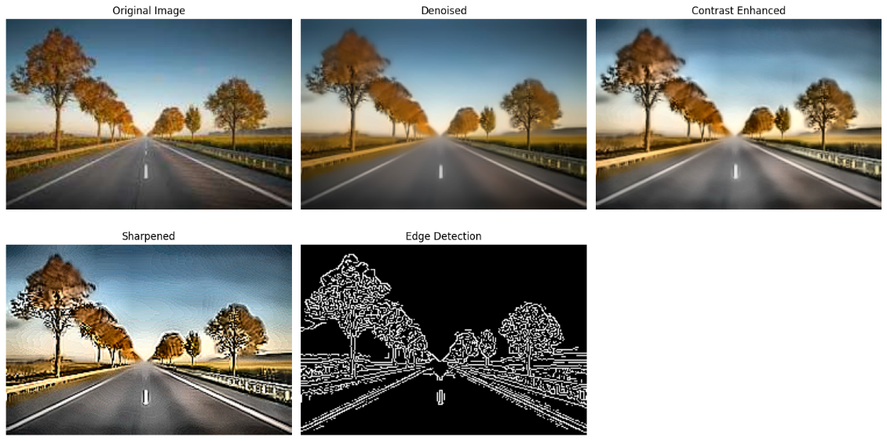
Conclusion
Image formation models significantly improve image quality by correcting distortions, reducing noise and blur, and compensating for lighting changes. In autonomous driving, these improvements lead to more accurate object detection, reliable lane recognition, better distance estimation, and safer driving decisions.

2. A digital image appears distorted due to improper image formation. Write a Python program to correct image distortion.
Image distortion occurs when a camera or imaging system fails to capture an accurate representation of a scene due to lens imperfections, camera misalignment, or improper image formation. This distortion causes objects to appear curved, stretched, compressed, or tilted, reducing the quality and accuracy of the image.
Image distortion correction is the process of removing these unwanted geometric distortions to restore the image to its original shape. In Python, this can be achieved using the OpenCV library, which provides functions such as cv2.undistort() to correct lens distortion using a camera matrix and distortion coefficients. Correcting distortion improves image quality and enables accurate feature extraction, object detection, and image analysis.

import cv2
import numpy as np
from google.colab.patches import cv2_imshow # Import for Colab

# Load the distorted image
image = cv2.imread("distorted.jpg")

# Camera matrix (example values)
camera_matrix = np.array([[800, 0, 320],
[0, 800, 240],
[0, 0, 1]], dtype=np.float32)

# Distortion coefficients (example)
dist_coeffs = np.array([-0.3, 0.1, 0, 0, 0], dtype=np.float32)

# Correct the distortion
corrected = cv2.undistort(image, camera_matrix, dist_coeffs)

# Save and display the corrected image
cv2.imwrite("corrected.jpg", corrected)

print("Original Image:")
cv2_imshow(image)
print("Corrected Image:")
cv2_imshow(corrected)
# cv2.waitKey(0) and cv2.destroyAllWindows() are not needed in Colab
Original Image:
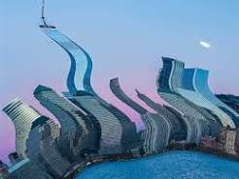
Corrected Image:
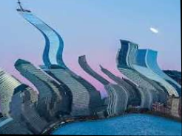
Applications
- Autonomous driving
- Computer vision systems
- Medical image processing
- Satellite and aerial imaging
- Robotics and navigation
- Document scanning and Optical Character Recognition (OCR)
This description is ideal for an assignment and naturally introduces the Python program that performs image distortion correction.

