**MARKET BASKET INSIGHTS**

**Definition**: Market basket insights is a data mining technique used be retailers to increase sales by better understanding customer purchasing patterns. It involves analyzing large data sets, such as purchase history, to reveal product groupings as well as products that are likely to be purchased together.

**INNOVATION**

To innovate on market basket insights, consider implementing the following design strategies:

1. Advanced Data Analytics: Utilize advanced data analytics techniques, such as machine learning and predictive modeling.
2. Personalization: Tailor product recommendations and marketing strategies based on individual customer’s past purchase history. Use AI algorithms to provide personalized product suggestions.
3. Real-time Analysis: Implement real-time data processing to analyze market basket data as it’s generated. This allows for immediate adjustments to pricing, promotions, and inventory management based on current trends and customer behavior.
4. A/B Testing: Using A/B testing to measure their impact on market basket composition and overall revenue.

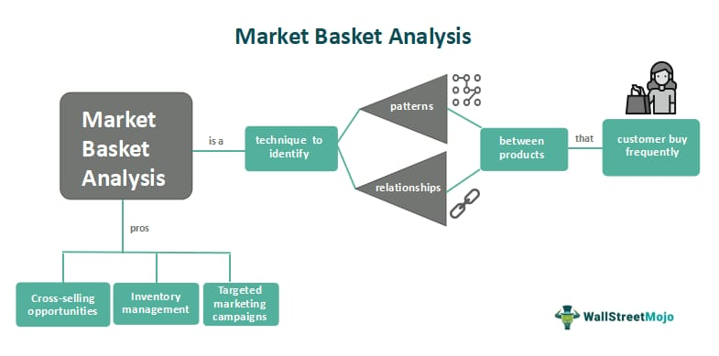

1. Mobile Integration: Mobile apps can facilitate easy browsing, purchasing and personalized recommendations.
2. Customer Feedback: Collect and analyze customer feedback to understand their needs and pain points. Use this information to refine your market basket insights and improve the overall shopping experience.

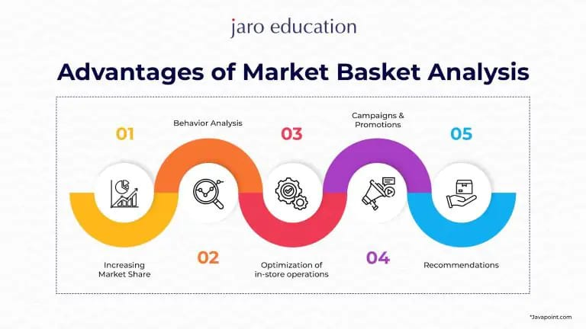

**DATA SET LINK -**

<https://www.kaggle.com/datasets/aslanahmedov/market-basket-analysis>

**PROGRAM:**

Step 1: Install Required Libraries

# You may need to install these libraries if you haven't already

# pip install pandas mlxtend

Step 2: Import Libraries

import pandas as pd

from mlxtend.frequent_patterns import apriori

from mlxtend.frequent_patterns import association_rules

Step 3: Transaction Data

# Load your data into a pandas DataFrame

data = pd.read_csv('Market Basket Insights')

Step 4: Preprocess Your Data

# You may need to clean and preprocess your data, e.g., handle missing values or encode categorical variables.

# This depends on your dataset and specific requirements.

Step 5: Encode Data for Apriori Algorithm

# Convert your data into a binary format suitable for the Apriori algorithm

def encode_data(data):

return data.applymap(lambda x: 1 if x else 0)

# Assuming you have columns for different items (e.g., item1, item2, item3)

data_encoded = encode_data(data)

Step 6: Run Apriori Algorithm to Find Frequent Itemsets

# Set a minimum support threshold

min_support = 0.2 # Adjust as needed

# Use the Apriori algorithm to find frequent itemsets

frequent_itemsets = apriori(data_encoded, min_support=min_support, use_colnames=True)

Step 7: Generate Association Rules

# Set a minimum confidence threshold

min_confidence = 0.5 # Adjust as needed

# Generate association rules from frequent itemsets

rules = association_rules(frequent_itemsets, metric='confidence', min_threshold=min_confidence)

Step 8: Explore and Interpret the Results

# You can now explore and interpret the association rules to gain insights into your market basket data.

# For example, you can see which items are often purchased together and their associated statistics.

print(rules)

**NAME :** MAREESWARI M

**IBM REG NO:** Au620821106053

**DEPARMENT:** B.E-ELECTRONICS AND COMMUNICATION ENGINEERING

**YEAR:** THIRD YEAR

**COLLEGE NAME:** GANANAMANI COLLEGE OF TECHNOLOGY

**MENTOR NAME:** Dr. K.ANAND (anandped2012@gmail.com)