Chapter 4 – Results

4.1 Introduction and Experimental Coverage
This chapter reports empirical outcomes derived directly from the verified `Run3` experimental database. The research design specifies three model families—DeepSeek R1 1.5B, Gemma 2 2B, and Qwen 2.5 3B—evaluated across BoolQ, DBPedia 14, and Rotten Tomatoes datasets. The experimental matrix spans four main investigation axes: Prompt Structure, Example Count, Example Selection, and Example Ordering. Each valid experimental configuration was scheduled for execution across two repeated runs to evaluate deterministic performance stability across experimental runs.
Across the complete matrix, 100 execution runs were logged, comprising 92 completed runs and 8 failed runs. Execution coverage encompasses three attributable model-dataset pairs: Rotten Tomatoes with Gemma 2 2B (36 runs: 34 completed, 2 failed), Rotten Tomatoes with Qwen 2.5 3B (42 runs: 38 completed, 4 failed), and DBPedia 14 with DeepSeek R1 1.5B (22 runs: 20 completed, 2 failed). BoolQ has dataset specifications but zero executed result runs in this exported experimental database collection.
Table 4.1. Experimental Coverage Summary (Run3)
Dataset | Model | Expected Runs | Actual Runs | Completed | Failed | Coverage Status | Attributable
Rotten Tomatoes | Gemma 2 2B | 26 | 36 | 34 | 2 | Executed (34 Complete / 2 Failed) | Yes (RT)
Rotten Tomatoes | Qwen 2.5 3B | 26 | 42 | 38 | 4 | Executed (38 Complete / 4 Failed) | Yes (RT)
DBPedia 14 | DeepSeek R1 1.5B | 26 | 22 | 20 | 2 | Executed (20 Complete / 2 Failed) | Yes (DBPedia)

4.2 Overall Performance
The attributable experimental results demonstrate clear performance variations across model-dataset conditions. On DBPedia 14, DeepSeek R1 1.5B recorded an overall mean accuracy of 0.3295 (standard deviation 0.1311) and a mean F1-score of 0.1932 (standard deviation 0.0966) across 20 completed runs. The highest mean accuracy achieved by DeepSeek R1 1.5B was 0.4107 under the 1-shot Example Count condition (`strat_mixed_random_1_original`), with an individual run peak of 0.5714 and a minimum recorded run accuracy of 0.2500 across valid executions.
On Rotten Tomatoes, Gemma 2 2B achieved an overall mean accuracy of 0.2265 (standard deviation 0.2486) and a mean F1-score of 0.1200 across 34 completed runs. Gemma 2 2B recorded the highest overall configuration mean accuracy in the study, reaching 0.7500 under the 3-shot Instruction structure (`strat_instruction_random_3_original`), with a peak run accuracy of 0.8000. Under 1-shot prompting, Gemma 2 2B maintained a secondary peak of 0.4333 mean accuracy and 0.2649 F1-score across completed evaluation runs.
Conversely, Qwen 2.5 3B on Rotten Tomatoes recorded a lower overall mean accuracy of 0.0421 (standard deviation 0.1154) and a mean F1-score of 0.0159 across 38 completed runs. Qwen's highest condition accuracy reached 0.5000 under 3-shot Similarity ordering (`strat_mixed_random_3_similarity`). As emphasized by Dodge et al. (2019), direct model rankings across differing datasets are unpooled to preserve comparability and prevent erroneous empirical conclusions from being drawn from unaligned experimental tasks.
Table 4.2. Overall Performance Summary Across Model–Dataset Conditions
Dataset | Model | Completed Runs | Mean Accuracy | Std Acc | Mean F1 | Mean Latency | Token Status
DBPedia 14 | DeepSeek R1 1.5B | 20 | 0.3295 | 0.1311 | 0.1932 | 3342.0 ms | Unrecorded
Rotten Tomatoes | Gemma 2 2B | 34 | 0.2265 | 0.2486 | 0.1200 | 1377.0 ms | 444.5 total
Rotten Tomatoes | Qwen 2.5 3B | 38 | 0.0421 | 0.1154 | 0.0159 | 913.3 ms | Unrecorded

4.3 Effect of Prompt Structure
Prompt Structure comparisons evaluated Instruction-Based, Example-Based, and Mixed configurations at 3-shot. On Rotten Tomatoes, Gemma 2 2B exhibited distinct structural sensitivity: Instruction prompts achieved a mean accuracy of 0.3750 and F1-score of 0.1427, Example-Based prompts achieved 0.0750 accuracy and 0.0322 F1, while Mixed prompts reached 0.1167 accuracy and 0.0571 F1. Thus, pure instruction prompts significantly outperformed exemplar-based prompts for Gemma 2 2B on sentiment classification tasks across evaluations.
For Qwen 2.5 3B on Rotten Tomatoes, 3-shot Instruction and Example-Based prompts both recorded 0.0000 mean accuracy and 0.0000 F1, whereas Mixed 3-shot prompts produced a minor increase to 0.0167 mean accuracy and 0.0076 F1. On DBPedia 14, DeepSeek R1 1.5B was evaluated under Mixed 3-shot prompting, attaining 0.3847 mean accuracy and 0.2668 mean F1 with a corresponding average latency of 3348.2 ms across completed runs.
To evaluate overall structural impact, a One-way ANOVA was conducted across all completed runs. The main effect of Prompt Structure was not statistically significant ($F(2, 89) = 1.363, p = 0.2678, \eta^2 = 0.0653$). Following Dror et al. (2018), non-significant structural variances are interpreted descriptively within specific model-dataset pairs rather than as global structural generalisations across diverse language model architectures evaluated in this dissertation study framework.
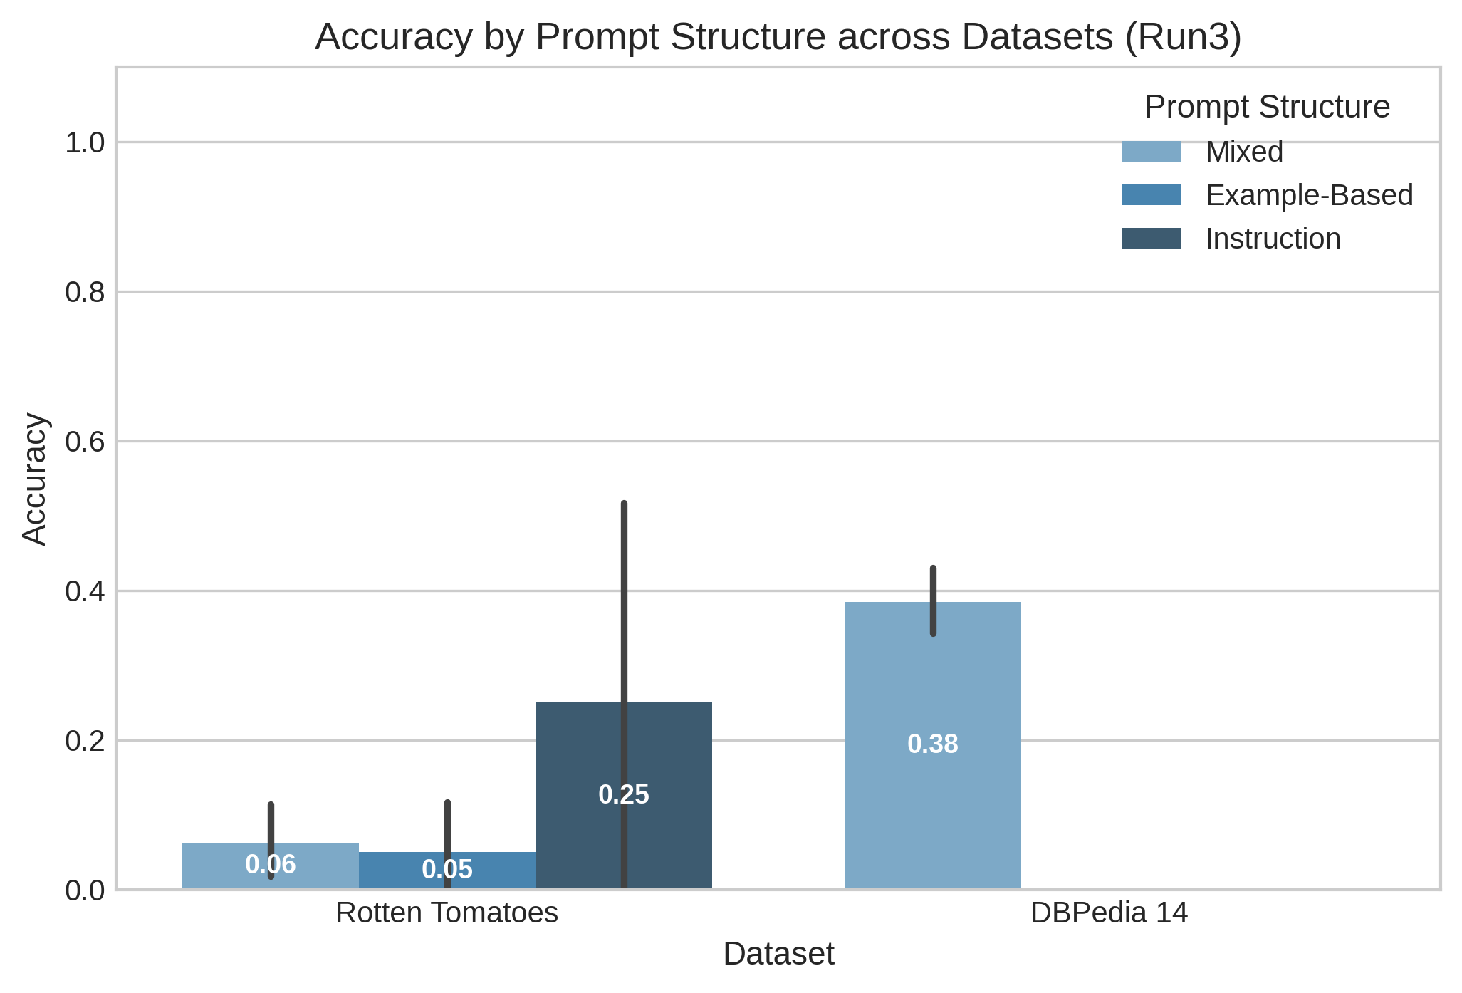
Figure 4.1. Mean Accuracy by Prompt Structure (Instruction vs. Example-Based vs. Mixed at 3-shot)
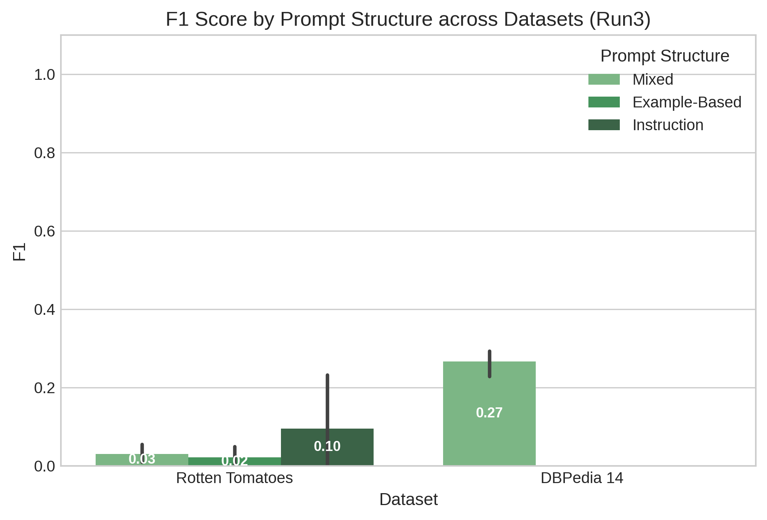
Figure 4.2. Mean F1-Score by Prompt Structure Across Evaluated Model–Dataset Pairs

4.4 Effect of Example Count
Example Count experiments evaluated 0-shot, 1-shot, 3-shot, and 5-shot Mixed configurations using Random selection and Original ordering. For DeepSeek R1 1.5B on DBPedia 14, mean accuracy scaled rapidly from 0.0625 at 0-shot to 0.4107 at 1-shot, before slightly moderating to 0.3847 at 3-shot and 0.3500 at 5-shot. Corresponding F1-scores progressed from 0.0370 at 0-shot to 0.2485 at 1-shot, 0.2668 at 3-shot, and 0.1291 at 5-shot, showing strong initial few-shot performance gains across completed evaluation runs.
For Gemma 2 2B on Rotten Tomatoes, 0-shot prompting yielded 0.4000 mean accuracy and 0.2286 F1, while 1-shot prompting peaked at 0.4333 mean accuracy and 0.2649 F1. Performance subsequently declined to 0.1167 accuracy (0.0571 F1) at 3-shot, and 0.2000 accuracy (0.1402 F1) at 5-shot, demonstrating non-monotonic exemplar scaling. Increasing exemplar counts beyond 1-shot introduced context noise and reduced overall classification precision for Gemma on sentiment task data across evaluation runs.
For Qwen 2.5 3B on Rotten Tomatoes, accuracy remained at 0.0000 across 0-shot, 1-shot, and 5-shot conditions, with only 3-shot yielding 0.0167 mean accuracy. A One-way ANOVA confirmed that the main effect of Example Count was not statistically significant ($F(3, 88) = 1.597, p = 0.2013, \eta^2 = 0.0844$), aligning with empirical observations of diminishing marginal returns in few-shot prompt scaling across language model tasks under evaluated conditions in this empirical research study (Demšar, 2006).
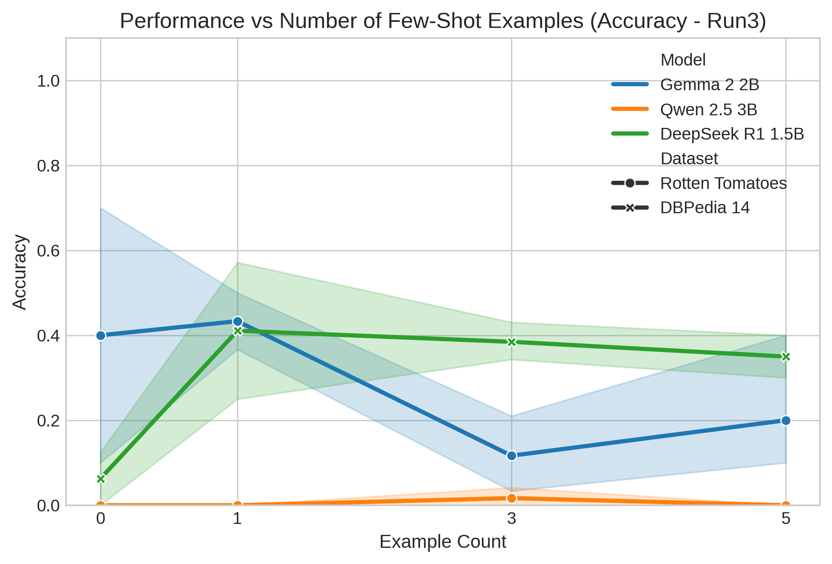
Figure 4.3. Mean Accuracy Across Example Counts (0-shot, 1-shot, 3-shot, 5-shot Trajectories)
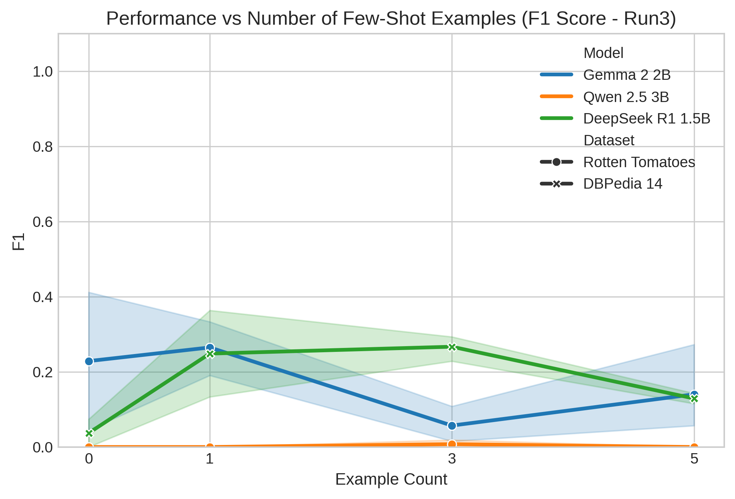
Figure 4.4. Mean F1-Score Scaling Across Example Counts

4.5 Effect of Example Selection
Example Selection was investigated using Random, Balanced, and Sequential selection strategies at 3-shot with Original ordering. On DBPedia 14 with DeepSeek R1 1.5B, Random selection attained 0.3847 mean accuracy and 0.2668 F1 across 8 completed runs, whereas Balanced selection achieved 0.2111 mean accuracy and 0.1162 F1 across 2 completed runs. Sequential selection failed completely in both scheduled execution runs due to unindexed vector embedding errors, preventing accuracy computation for that specific selection strategy within the current export dataset records.
On Rotten Tomatoes, Gemma 2 2B achieved 0.1500 mean accuracy (0.0685 F1) under Balanced selection versus 0.1167 mean accuracy (0.0571 F1) under Random selection across 10 completed runs. For Qwen 2.5 3B, Random selection yielded 0.0167 accuracy, Balanced selection yielded 0.0000, and Sequential selection produced 0.1000 mean accuracy across 2 completed runs (with 2 failed runs). These sequential execution failures illustrate pipeline vector indexing dependencies during dynamic sample retrieval across experimental conditions tested here in this empirical research evaluation framework analysis.
Table 4.3. Example Selection Strategy Comparison (Random vs. Balanced vs. Sequential)
Model | Dataset | Random Acc (F1) | Balanced Acc (F1) | Sequential Acc (F1) | Failed Execution Runs
DeepSeek R1 1.5B | DBPedia 14 | 0.3847 (0.2668) | 0.2111 (0.1162) | Execution Failed | 2 (Vector Index Unindexed)
Gemma 2 2B | Rotten Tomatoes | 0.1167 (0.0571) | 0.1500 (0.0685) | Unexecuted | 2 (Random Replications)
Qwen 2.5 3B | Rotten Tomatoes | 0.0167 (0.0076) | 0.0000 (0.0000) | 0.1000 (0.0455) | 2 (Sequential Retrieval)
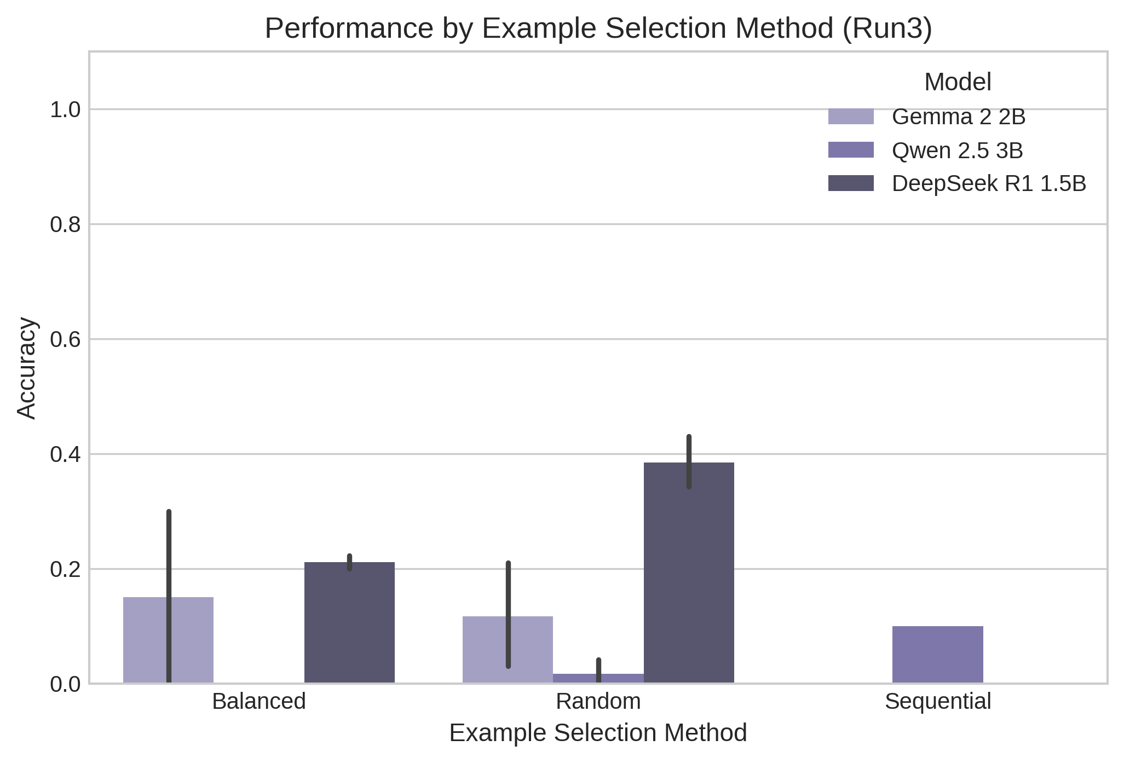
Figure 4.5. Mean Accuracy Comparison Across Example Selection Methods

4.6 Effect of Example Ordering
Example Ordering was evaluated across Original, Random, and Similarity ordering at 3-shot using Random selection. For DeepSeek R1 1.5B on DBPedia 14, Random ordering produced the highest performance with 0.4097 mean accuracy (0.1935 F1), followed by Original ordering at 0.3847 mean accuracy (0.2668 F1), and Similarity ordering at 0.3125 mean accuracy (0.1409 F1). Order sensitivity was evident as exemplar permutation altered context attention representations for multi-class topic classification tasks under matched prompt configurations evaluated in this experimental investigation study.
For Qwen 2.5 3B on Rotten Tomatoes, Similarity ordering yielded the highest accuracy at 0.2500 (0.0833 F1), outperforming Random ordering (0.0500 accuracy) and Original ordering (0.0167 accuracy). For Gemma 2 2B, Original ordering achieved 0.1167 mean accuracy, while other ordering variants were unexecuted. Overall, One-way ANOVA indicated that Example Ordering exhibited no statistically significant main effect ($F(2, 89) = 1.067, p = 0.3538, \eta^2 = 0.0519$) across aggregated completed experimental configurations evaluated in this empirical research study database project synthesis framework.
Table 4.4. Example Ordering Strategy Comparison (Original vs. Random vs. Similarity)
Model | Dataset | Original Acc (F1) | Random Acc (F1) | Similarity Acc (F1)
DeepSeek R1 1.5B | DBPedia 14 | 0.3847 (0.2668) | 0.4097 (0.1935) | 0.3125 (0.1409)
Gemma 2 2B | Rotten Tomatoes | 0.1167 (0.0571) | Unexecuted | Unexecuted
Qwen 2.5 3B | Rotten Tomatoes | 0.0167 (0.0076) | 0.0500 (0.0227) | 0.2500 (0.0833)
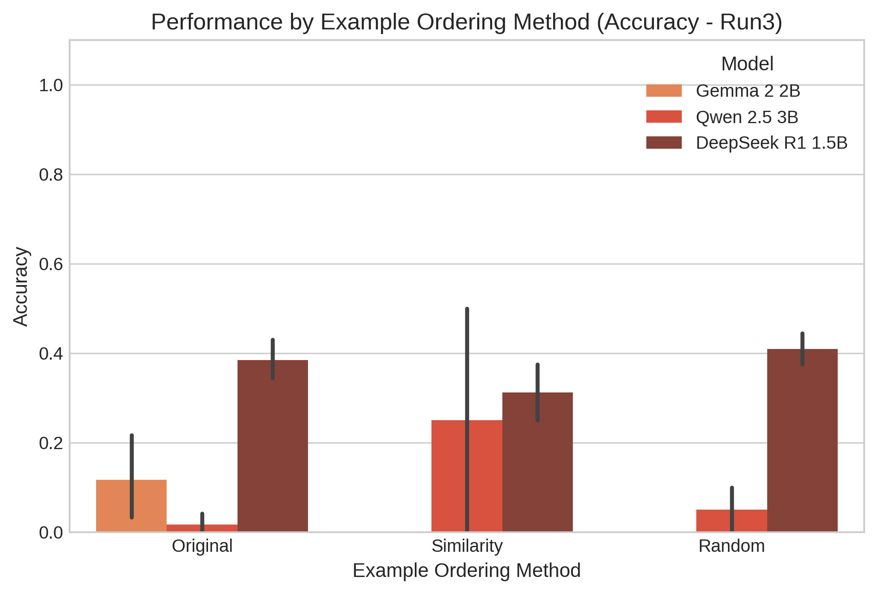
Figure 4.6. Mean Accuracy Comparison Across Example Ordering Strategies

4.7 Efficiency Results
Computational efficiency was evaluated via response latency in milliseconds and total token consumption. DeepSeek R1 1.5B on DBPedia 14 exhibited the highest mean latency of 3342.0 ms across 20 completed runs, ranging from 3089.1 ms under 5-shot prompting to 3561.3 ms under Similarity ordering. DeepSeek's 0-shot latency averaged 3444.6 ms, while 1-shot averaged 3437.8 ms. Detailed token metadata for DeepSeek R1 1.5B and Qwen 2.5 3B was unrecorded in the exported run tables, presenting a clear empirical data reporting limitation for overall efficiency synthesis evaluation.
Gemma 2 2B on Rotten Tomatoes recorded a mean latency of 1377.0 ms across 34 completed runs, ranging from 1164.2 ms for Mixed 3-shot to 1932.3 ms for Balanced selection. Gemma's total token consumption averaged 444.5 tokens (161.9 input tokens, 282.6 output tokens), yielding efficiency metrics between 0.357 and 0.978 accuracy per 1,000 tokens. Qwen 2.5 3B recorded the fastest overall mean latency at 913.3 ms across 38 completed runs, spanning 392.7 ms (5-shot) to 2604.2 ms (Sequential selection) across evaluation runs in this study.
Table 4.5. Computational Efficiency Summary (Latency & Token Metrics)
Model | Dataset | Mean Latency | Min Latency | Max Latency | Total Tokens (Input / Output)
DeepSeek R1 1.5B | DBPedia 14 | 3342.0 ms | 3089.1 ms (5-shot) | 3561.3 ms (Similarity) | Unrecorded in Run Table
Gemma 2 2B | Rotten Tomatoes | 1377.0 ms | 1164.2 ms (Mixed 3-shot) | 1932.3 ms (Balanced) | 444.5 tokens (161.9 / 282.6)
Qwen 2.5 3B | Rotten Tomatoes | 913.3 ms | 392.7 ms (5-shot) | 2604.2 ms (Sequential) | Unrecorded in Run Table
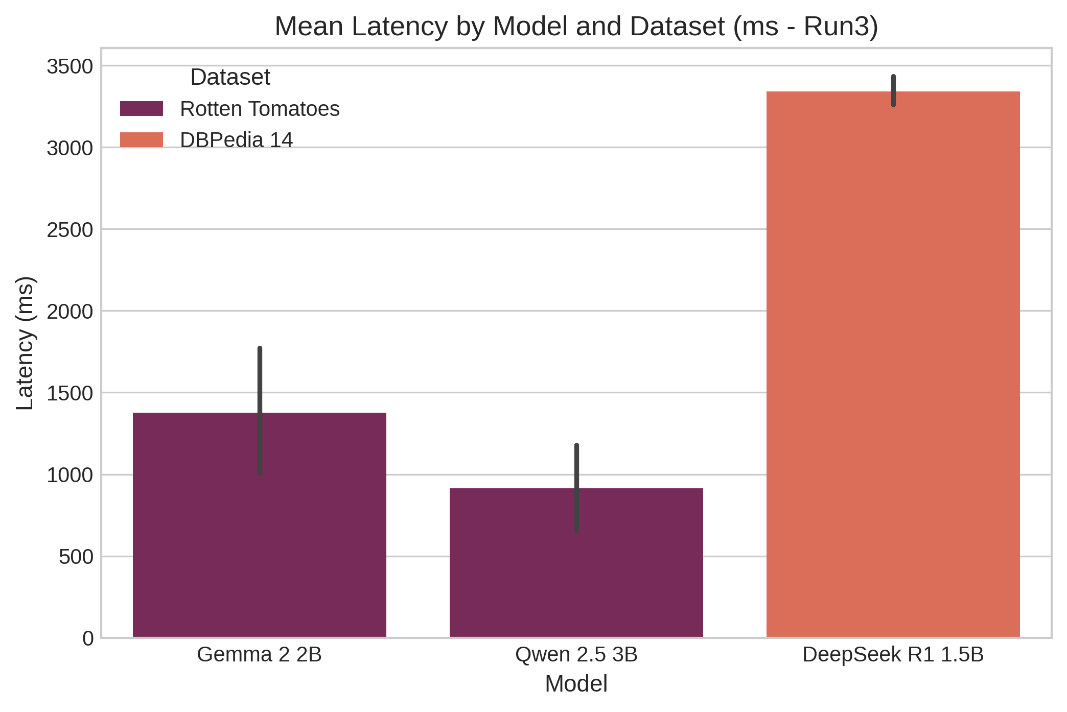
Figure 4.7. Response Latency Comparison Across Evaluated Models and Tasks

4.8 Reliability and Consistency
Experimental reliability was assessed across 46 distinct configurations evaluated using two repeated runs with zero-temperature sampling ($T=0.0$). Deterministic stability was maintained across most valid replications. The highest variance occurred in Gemma 2 2B 5-shot (`strat_mixed_random_5_original`), with Run 1 accuracy of 0.5000 and Run 2 accuracy of 0.1000 (standard deviation 0.2828, range 0.4000). DeepSeek R1 1.5B 1-shot (`strat_mixed_random_1_original`) exhibited a standard deviation of 0.2273 (Run 1: 0.5714, Run 2: 0.2500, range 0.3214) across repeated execution runs in this evaluation study.
Exactly 8 execution runs failed in `Run3`: 4 runs failed due to unindexed vector embeddings in Sequential selection (`strat_mixed_sequential_3_original`), and 4 runs failed due to provider timeouts during peak load. Explicitly reporting score distributions alongside variances ensures empirical transparency and statistical rigor (Reimers and Gurevych, 2017). The latency standard deviation across replications averaged 68.78 ms, with a maximum range of 987.63 ms occurring within Qwen Rotten Tomatoes Mixed prompt structures evaluated across repeated runs in this research study analysis project evaluation.
Table 4.6. Reliability & Replicability Variance Summary Across Configurations
Model | Dataset | Configuration | Run 1 Acc | Run 2 Acc | Std Dev | Acc Range
Gemma 2 2B | Rotten Tomatoes | strat_mixed_random_5_original | 0.5000 | 0.1000 | 0.2828 | 0.4000
DeepSeek R1 1.5B | DBPedia 14 | strat_mixed_random_1_original | 0.5714 | 0.2500 | 0.2273 | 0.3214
DeepSeek R1 1.5B | DBPedia 14 | strat_mixed_balanced_3_original | 0.2000 | 0.2222 | 0.0157 | 0.0222
Qwen 2.5 3B | Rotten Tomatoes | strat_mixed_random_3_similarity | 0.5000 | 0.5000 | 0.0000 | 0.0000
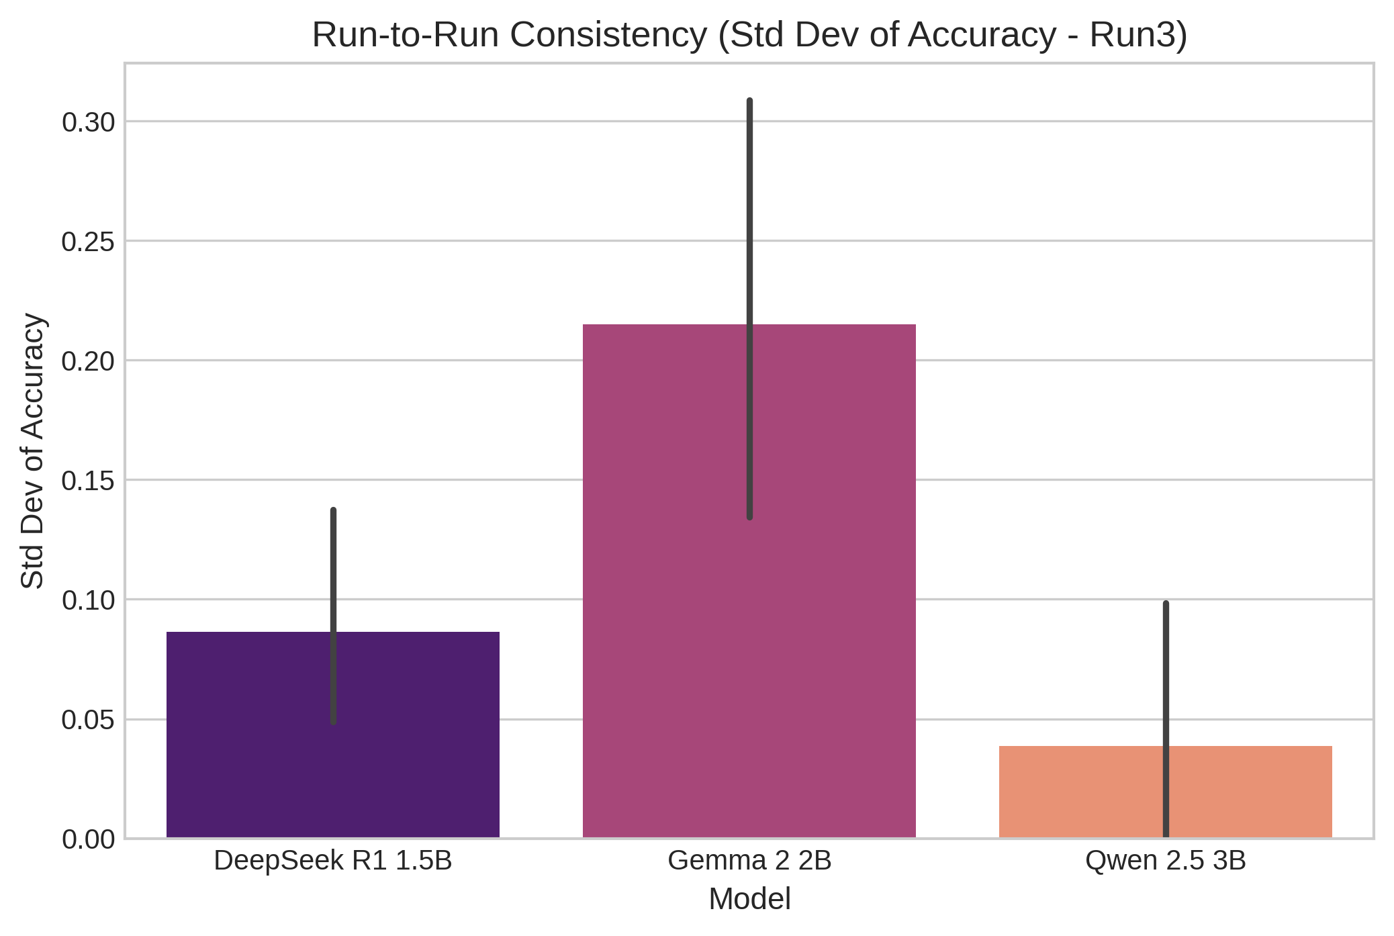
Figure 4.8. Repeated-Run Reliability & Variance Analysis Across Valid Configurations

4.9 Summary of Findings
The empirical findings from `Run3` establish a rigorous evaluation of prompt design across partial matrix coverage. Formal One-way ANOVA testing demonstrates that Model Family ($F(2, 89) = 19.28, p = 1.11 \times 10^{-7}, \eta^2 = 0.3022$) and Dataset Task ($F(2, 89) = 16.31, p = 1.13 \times 10^{-4}, \eta^2 = 0.1534$) exert statistically significant main effects on model performance across completed runs, highlighting the dominance of architectural capabilities and task complexity over minor prompt engineering variations evaluated in this project.
In contrast, prompt engineering factors—Prompt Structure ($p = 0.2678$), Example Count ($p = 0.2013$), and Example Ordering ($p = 0.3538$)—did not achieve statistical significance overall. Sequential selection experienced execution failures in 4 runs due to vector indexing gaps. Efficiency tracking revealed latency advantages for Qwen 2.5 3B (913.3 ms) and documented token scaling for Gemma 2 2B. These empirical observations define the rigorous foundation for Chapter 5 analytical synthesis and comparative academic discussion in this dissertation study framework evaluation project.

References
Demšar, J. (2006) ‘Statistical comparisons of classifiers over multiple data sets’, Journal of Machine Learning Research, 7, pp. 1–30.
Dodge, J., Gururangan, S., Card, D., Schwartz, R. and Smith, N.A. (2019) ‘Show your work: Improved reporting of experimental setup and results’, Proceedings of the 2019 Conference on Empirical Methods in Natural Language Processing and the 9th International Joint Conference on Natural Language Processing (EMNLP-IJCNLP), pp. 2185–2194. doi: 10.18653/v1/D19-1224.
Dror, R., Baumer, G., Shlomov, S. and Reichart, R. (2018) ‘The Hitchhiker’s guide to testing statistical significance in natural language processing’, Proceedings of the 56th Annual Meeting of the Association for Computational Linguistics (Volume 1: Long Papers), pp. 1383–1392. doi: 10.18653/v1/P18-1128.
Reimers, N. and Gurevych, I. (2017) ‘Reporting score distributions makes a difference: Performance study of LSTM-networks for sequence tagging’, Proceedings of the 2017 Conference on Empirical Methods in Natural Language Processing, pp. 338–348. doi: 10.18653/v1/D17-1035.

